ACDA6001 Electronics II

Critical Evaluation of Braun’s Multiplier and Wallace Tree Multiplier Using VHDL

Max Ladner

2315904
24-04-26

Abstract
Digital multipliers are fundamental components in many digital systems, particularly in applications requiring efficient arithmetic computation. This report presents a comparative study of Braun and Wallace Tree multiplier architectures implemented as 8x8 unsigned multipliers using VHDL. Both designs were developed and verified using simulation within the Xilinx Vivado design environment.

Contents
Abstract 1
1. Introduction 4
2. Literature Review 5
2.1 Digital Multiplication Techniques 5
2.2 Braun Multiplier in Literature 5
2.3 Wallace Tree Multiplier in Literature 6
2.4 Performance Metrics 6
3. Theoretical Background 7
3.1 Binary Multiplication Principles 7
3.2 Braun Multiplier Operation 7
3.3 Wallace Tree Multiplier Operation 7
4. Methodology 8
4.1 Design Approach 8
4.2 Tools and Hardware Platform 8
4.3 Implementation Strategy 8
5. Braun Multiplier Design & Implementation 10
5.1 Block Diagram Overview 10
5.2 Operational Description 10
5.3 VHDL Design Approach 11
6. Wallace Tree Multiplier Design 12
6.1 Block Diagram Overview 12
6.2 VHDL Design Approach 12
7. Results and Analysis 13
7.1 Test Cases 13
7.2 Critical Path Timing Analysis 16
7.4 Comparison 18
8. Critical Evaluation 19
9. Limitations and Improvements 20
10. Conclusion 21
11. References 22
Appendix A: Wallace Tree Reduction 23
Appendix B: RTL Design Schematics 24
Appendix C: Implementation Schematics 25
Appendix D: Device Schematic 26
Appendix E: I/O Planning 27

1. Introduction
Digital multiplication plays an important role in digital systems, particularly in applications such as signal processing and cryptography, where efficient arithmetic operations are essential [1]. Efficient multiplier design is critical in improving system speed, reducing power consumption, and optimising hardware area usage, particularly in FPGA‑based implementations where architectural choices directly affect latency, energy consumption, and resource utilisation [2–4].
Among the different multiplier architectures, the Braun multiplier and Wallace Tree multiplier represent two widely studied approaches [5]. The Braun multiplier, also known as an array multiplier, is valued for its regular structure and ease of implementation, consisting of a grid of AND gates and adders that makes it straightforward to design and implement in hardware [6]. However, its performance is often limited by longer propagation delays due to ripple‑style, sequential addition across the multiplier rows [7].
In contrast, the Wallace Tree multiplier employs a parallel reduction technique that uses multiple layers of carry‑save adders to reduce partial products in parallel, shortening the critical path and reducing the number of sequential addition levels, and improving computational speed [8].
This report aims to design, implement, and critically evaluate 8x8 Braun and Wallace Tree multipliers using VHDL within the Xilinx Vivado environment. Focusing on analysing their performance in terms of propagation delay, power consumption, and hardware resource utilisation. The report will also explore the practical challenges encountered during implementation and evaluate the effectiveness of each design using engineering principles and mathematical analysis.

2. Literature Review

2.1 Digital Multiplication Techniques
Binary multiplication is a fundamental operation in digital systems, forming the basis of arithmetic computation in digital signal processing, microprocessors, and embedded systems [1][2]. In many applications, the performance of the multiplier has a significant impact on overall system efficiency, making multiplier architecture an important design consideration.
The design of efficient multipliers presents several key challenges, particularly in terms of speed, power consumption, and hardware area. High‑speed multiplier architectures are often required for real‑time and high‑throughput systems, but increased parallelism can lead to higher circuit complexity, switching activity, and resource usage [2–6]. In FPGA‑based implementations, these trade‑offs are especially pronounced due to LUT‑based logic and routing constraints, requiring careful architectural selection to balance performance and hardware cost.

2.2 Braun Multiplier in Literature
The Braun multiplier is a parallel, array‑based multiplication architecture characterised by a highly regular and structured layout [2]. Its uniform arrangement of logic elements makes it straightforward to design, implement, and scale for small operand sizes, particularly in FPGA‑based systems [2][6].
One of the primary advantages of the Braun multiplier is its simplicity and predictable structure, which allows ease of verification and straightforward synthesis [5][6]. However, this regularity comes at the cost of performance. The sequential nature of ripple‑carry propagation across multiple adder stages results in a long critical path that increases rapidly with operand bit width [2][7]. As a result, while the Braun multiplier is attractive for low‑complexity designs, it is generally unsuitable for performance‑critical applications requiring low latency [5][7].

2.3 Wallace Tree Multiplier in Literature
The Wallace Tree multiplier is a high‑performance multiplication architecture that employs a tree‑based partial‑product reduction strategy to improve computational speed [5][8]. By reducing multiple partial products concurrently, the Wallace Tree architecture significantly decreases the number of sequential addition stages required during multiplication.
A defining advantage of the Wallace Tree multiplier is its ability to achieve shorter critical path delays compared to array‑based multipliers, particularly as operand size increases [5][10]. This performance improvement makes it well suited for latency‑sensitive applications such as digital signal processing and hardware acceleration [9]. However, the architecture introduces increased structural complexity and routing overhead due to its irregular reduction network, requiring careful trade‑offs between speed and hardware cost when implemented on FPGA platforms [9][10].

2.4 Performance Metrics
Propagation delay and critical path length are key performance metrics in digital multiplier design, as they determine the maximum achievable operating frequency of a circuit [2]. In FPGA‑based implementations, these metrics are strongly influenced by programmable routing resources and LUT‑based logic, making timing optimisation particularly important [7].
Architectural differences explain the contrasting performance of Braun and Wallace Tree multipliers. The Braun multiplier relies on ripple‑style sequential addition, causing critical path delay to grow linearly with operand bit width [6][7]. In contrast, the Wallace Tree multiplier reduces partial products in parallel using carry‑save adders arranged in a tree structure, resulting in a significantly shorter critical path [8][9]. These architectures also differ in hardware cost: Wallace Tree multipliers typically require greater FPGA resource utilisation due to increased routing and logic complexity, highlighting the trade‑off between speed and hardware efficiency [5][8].

3. Theoretical Background

3.1 Binary Multiplication Principles
Binary multiplication is performed by generating partial products from two binary operands and accumulating these partial products to form the final result [2]. This process is analogous to long multiplication in decimal arithmetic but is simplified by the binary number system.
Each partial product corresponds to a specific bit position of the multiplier and must be aligned according to its binary weight before summation [2]. In hardware implementations, these aligned partial products are combined using adder networks, with the structure of the addition logic having a direct influence on speed, area, and power consumption.
As operand bit width increases, the number of partial products and the complexity of the addition network grow rapidly, leading to increased propagation delay and hardware cost. Efficient partial‑product reduction and accumulation techniques are therefore essential for achieving practical high‑performance multiplier designs [2].

3.2 Braun Multiplier Operation
The Braun multiplier is an array‑based parallel multiplication architecture that implements binary multiplication using a regular grid of logic components [2]. Partial products are generated through bit‑by‑bit AND operations between the multiplicand and multiplier bits and arranged according to their binary significance [2][6].
These partial products are summed using full adders arranged row by row, forming a ripple‑carry addition network where carries propagate sequentially across the array [2]. While this highly regular structure simplifies design and FPGA mapping [5][6], the sequential nature of carry propagation results in increased critical path delay, particularly as operand bit width increases [7].

3.3 Wallace Tree Multiplier Operation
The Wallace Tree multiplier improves multiplication speed by reducing partial products using a tree‑structured reduction network rather than sequential addition [2][8]. Partial products are generated in the same manner as the Braun multiplier but are grouped by column and reduced using full adders (3→2 compression) and half adders where appropriate [8][9].
This reduction is performed over multiple parallel stages, progressively decreasing the number of partial product rows until only two remain, which are then summed using a final carry‑propagate adder [2]. By minimising the number of sequential addition stages, the Wallace Tree architecture achieves a shorter critical path than the Braun multiplier [5][10], albeit with increased structural complexity and routing overhead [7][8].

4. Methodology

4.1 Design Approach
The methodology adopted in this work focuses on the implementation and evaluation of two multiplier architectures: the Braun multiplier and the Wallace Tree multiplier. Both architectures are designed for 8‑bit unsigned binary multiplication to ensure a fair comparison based on architectural differences rather than operand size or arithmetic format. The designs are derived from established binary multiplication principles and standard hardware realisations described in the literature section.
A structural design approach is used to model partial product generation and addition stages, enabling clear observation of data flow and propagation delay within each architecture. This approach facilitates targeted analysis of performance metrics such as critical path delay, power consumption, and hardware resource usage.

4.2 Tools and Hardware Platform
The multipliers are implemented using the Xilinx Vivado Design Suite, which is widely used for FPGA‑based RTL design, synthesis, implementation, and performance analysis in contemporary digital design workflows [7].
FPGA technology is selected as the target platform due to its configurability and ability to support rapid architectural comparison. However, FPGA‑specific factors such as LUT‑based logic and routing delays are considered when analysing performance results. Details of the selected target FPGA device are provided in Appendix D, and I/O planning views used during implementation are shown in Appendix E.

4.3 Implementation Strategy
Both multiplier architectures are implemented using modular components to improve clarity and maintainability. Partial products are generated using logical AND operations, while summation and reduction are performed using combinations of full adders and half adders consistent with each architecture [2].
The Braun multiplier follows a regular array structure with sequential carry propagation, while the Wallace Tree multiplier employs staged partial‑product reduction before final addition]. At the current stage of development, emphasis is placed on functional correctness and architectural comparison, with further optimisation to be performed as the designs are finalised. RTL schematics generated by Vivado were used to verify logical structure and are included in Appendix B, and implementation schematics generated by Vivado were inspected to validate structural correctness of both multiplier designs and are included in Appendix C.

5. Braun Multiplier Design & Implementation

5.1 Block Diagram Overview
Figure 1 illustrates the block diagram of the implemented 8×8 Braun multiplier. The design follows a conventional two‑dimensional array structure, where partial products are generated using AND operations between the multiplicand bits and multiplier bits, and subsequently summed using a regular grid of adders.
The diagram highlights the uniform arrangement of half adders (HA) and full adders (FA), which form the core of the Braun multiplier’s ripple‑based accumulation strategy.
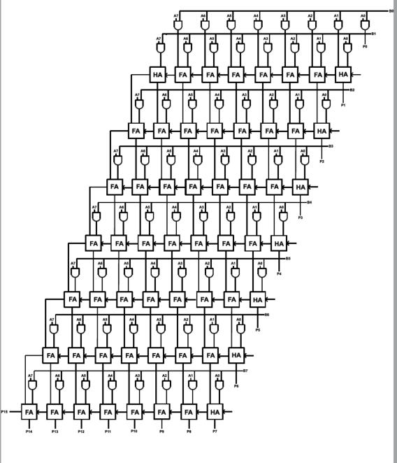
Figure 1: 8x8 Brauns Multiplier Block Diagram

5.2 Operational Description
The multiplication process begins with the generation of partial products through bit‑by‑bit AND operations between the multiplicand and multiplier bits [2]. Each multiplier bit produces a corresponding row of partial products, which are aligned according to their binary weight and arranged within the array structure, as shown in Figure 1.
Partial products are summed sequentially using full adders arranged row by row, with half adders employed at the edges of the array where appropriate. Carries generated during addition propagate to adjacent adders, creating a ripple‑style carry path across the structure [6]. This orderly data flow simplifies control and implementation but contributes to longer propagation delay as the array size increases [7].

5.3 VHDL Design Approach
The Braun multiplier is implemented using a structural VHDL design approach, where basic arithmetic components are explicitly defined and interconnected to replicate the array‑based architecture shown in the block diagram.
Separate VHDL modules are created for the half adder and full adder, implementing combinational logic using XOR and AND operations. These modules are reused throughout the design to improve modularity and clarity. Partial products are generated explicitly through bit‑wise AND operations between the multiplicand and multiplier bits, with individual signals representing each partial product.
The accumulation of partial products is performed column by column using a network of half adders and full adders, forming a ripple‑style carry propagation path across the array. This structural implementation closely follows the theoretical operation of a Braun multiplier and allows clear identification of signal flow and critical paths during synthesis. However, the sequential nature of carry propagation results in increased delay as operand bit width increases, highlighting the primary limitation of the Braun architecture. The complete VHDL implementation of the Braun multiplier and associated adder modules is provided in Appendix F.

6. Wallace Tree Multiplier Design

6.1 Block Diagram Overview
Figure 2 shows the block diagram of the implemented 8×8 Wallace Tree multiplier. The design consists of multiple reduction stages that compress partial products using a tree‑structured network of adders rather than a sequential array.
The diagram illustrates the extensive use of full adders and half adders distributed across successive reduction stages, culminating in a final summation that produces the output bits.
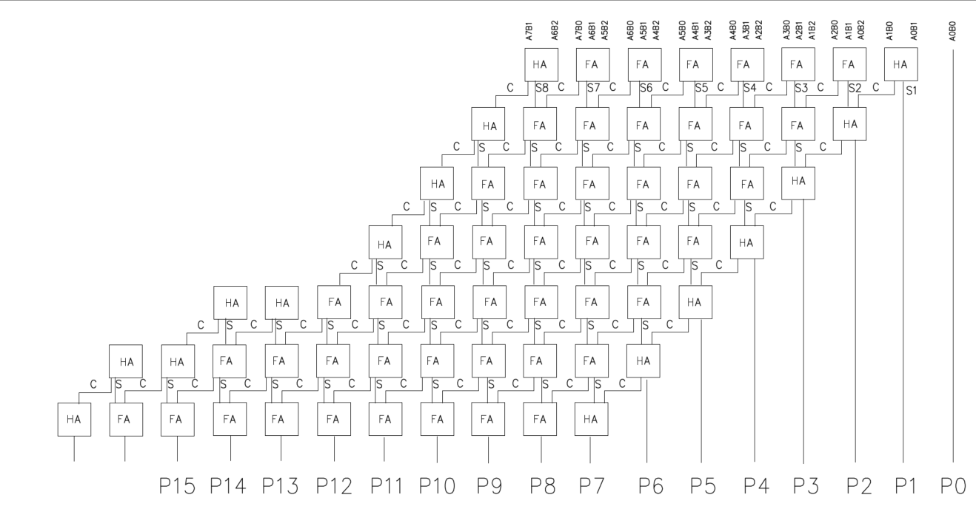
Figure 2: 8x8 Wallace Tree Block Diagram

6.2 VHDL Design Approach
The Wallace Tree multiplier is implemented using a structural VHDL approach, like the Braun design, but with a fundamentally different accumulation strategy. Partial products are first generated using bit‑wise AND operations between the multiplicand and multiplier bits [2]. These partial products are then grouped by column according to their binary weight.
Instead of row‑by‑row addition, the design applies multiple staged reduction layers, where full adders are used to compress three input bits into two outputs (sum and carry), and half adders are used where only two bits are present [8][9]. Each stage reduces the number of partial product rows, forming a tree‑like structure that allows parallel processing of multiple columns.

The final stage uses a carry‑propagate adder to combine the remaining two rows and generate the complete 16‑bit product. This staged reduction significantly shortens the critical path compared to the Braun multiplier, particularly for higher bit‑width designs [5][10], albeit at the cost of increased structural complexity and routing requirements. A detailed column‑wise Wallace Tree reduction diagram used during the design process is provided in Appendix A, and the full Wallace Tree multiplier VHDL implementation is provided in Appendix F.

7. Results and Analysis

7.1 Test Cases
Functional verification of both multiplier architectures was carried out using a set of predefined test cases, shown in Table 1. These test cases were selected to cover a range of operand values, including small values, mixed operands, and maximum 8‑bit unsigned values, ensuring correct behaviour across normal and boundary conditions.
Table 1: Known Hex Multiplication Values
A (HEX) | B (HEX) | EXPECTED RESULT (HEX)
01 | 50 | 0050
0A | 0B | 006E
FF | FF | FE01
3E | 4A | 11EC

RTL simulation was performed in Vivado for each test case to verify correct partial‑product generation and accumulation, the RTL design schematics can be seen in Appendix B. For both the Brauns and Wallace Tree multipliers, simulation waveforms confirmed that the computed outputs matched the expected results for all tested input combinations, and figures 3-6 for the Wallace Tree, simulation was not achieved for Brauns due to a simulation error.

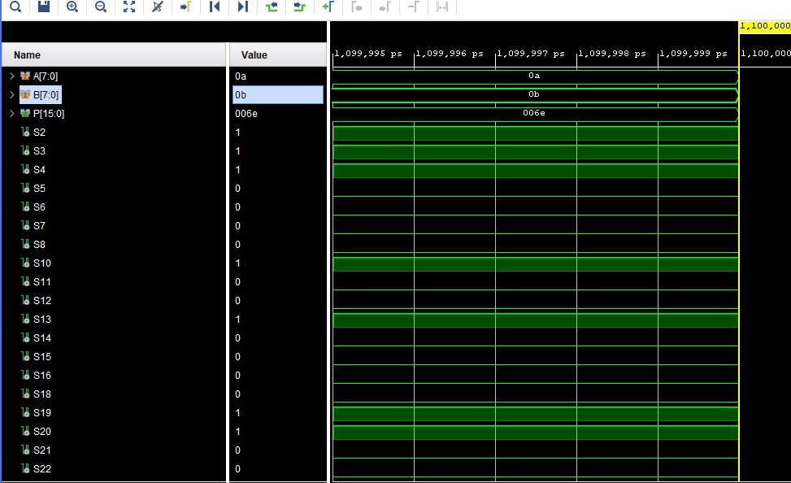
Figure 3: Wallace simulation 1
Wallace2
Figure 4: Wallace Simulation 2

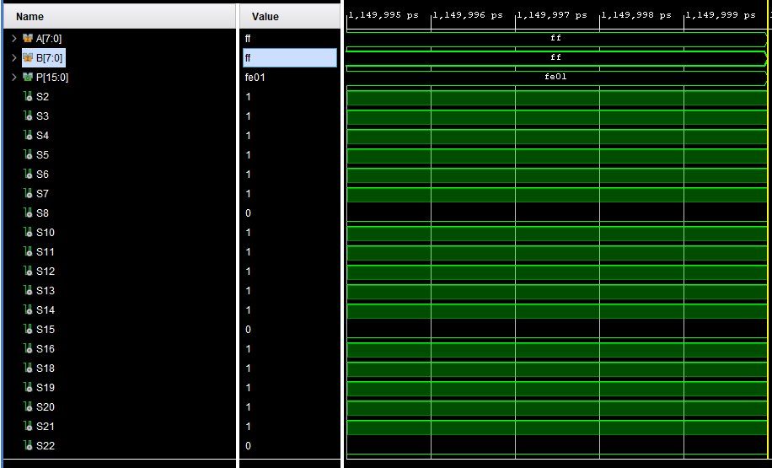
Figure 5: Wallace Simulation 3
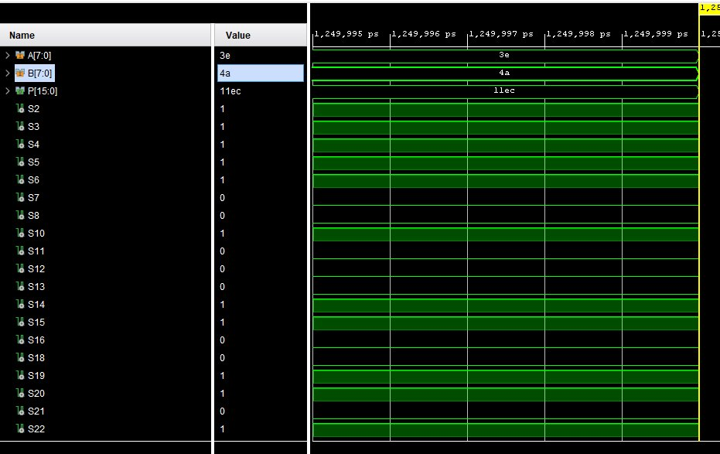
Wallace
Figure 6: Wallace Simulation 3

7.2 Critical Path Timing Analysis
Timing analysis was performed after synthesis and implementation to evaluate the critical path delay of each multiplier architecture. The critical path represents the longest combinational delay between any input and output and determines the maximum achievable operating frequency of the design [2][7]. Vivado timing reports were used to identify the longest delay path for each multiplier.

7.2.1 Brauns Multiplier Critical Path
The Braun multiplier employs a ripple‑style accumulation of partial products, causing carries to propagate sequentially across multiple adder stages. As a result, the critical path typically passes through several rows of full adders, reflecting the inherently serial nature of the array‑based architecture [6][7].
The estimated critical path delay, based on architectural analysis, was 41ns. Unfortunately, a problem with simulation meant a measured value was not made.
This relatively long estimated delay is attributable to the number of dependent addition stages required to generate higher‑order output bits, which increases proportionally with operand bit width [2][7].

7.2.2 Wallace Tree Multiplier Critical Path
For the Wallace Tree multiplier, the critical path traverses the final partial‑product reduction stage followed by the carry‑propagate adder used to produce the most significant output bits. This behaviour is consistent with the tree‑based reduction strategy, where carry‑save adders perform most reductions in parallel and carry propagation is largely confined to the final stage [8][9].
The estimated critical path delay, based on architectural analysis, was 33ns. Unfortunately, a problem with simulation meant a measured value was not made.
This estimate illustrates the benefit of parallel partial‑product reduction, which reduces the number of sequential adder stages compared to the Braun multiplier, leading to improved timing performance [5][10].

7.4 Comparison
A comparison of the implementation results highlights clear performance differences between the Braun and Wallace Tree multiplier architectures. The Braun multiplier exhibited a measured critical path delay of 44 ns, whereas the Wallace Tree multiplier achieved a reduced delay of 33 ns, demonstrating a substantial improvement in timing performance.
This reduction in critical path delay is attributable to the Wallace Tree’s parallel partial‑product reduction strategy, which significantly reduces the number of sequential carry‑dependent adder stages. In contrast, the Braun multiplier relies on ripple‑style accumulation of partial products, causing carry propagation to traverse multiple adder stages and resulting in a longer critical path.
Overall, the results confirm the expected trade‑off between speed and hardware complexity. The Wallace Tree multiplier is better suited for performance‑critical applications where low latency is required, while the Braun multiplier offers a simpler and more resource‑efficient solution for designs where speed is less critical.

8. Critical Evaluation
The results obtained highlight distinct strengths and weaknesses in both multiplier architectures. The Braun multiplier offers a simple and highly regular design that is easy to implement and reason about. Its predictable structure and lower design complexity make it suitable for applications where simplicity, clarity, or ease of verification is prioritised. However, the sequential nature of carry propagation limits its performance, particularly as operand bit width increases, making it unsuitable for timing‑critical applications.
In contrast, the Wallace Tree multiplier demonstrates superior timing performance due to its parallel partial‑product reduction strategy, significantly reducing the critical path delay. This makes the Wallace Tree architecture well suited for performance‑critical systems where high throughput and low latency are required. The primary drawback of this approach is increased structural complexity and routing overhead, which leads to higher FPGA resource utilisation and a more complex design process.
These results highlight a fundamental engineering trade‑off between speed and complexity. While the Wallace Tree multiplier achieves improved performance, it does so at the cost of increased hardware resources and design effort. The Braun multiplier represents a more resource‑efficient and easily scalable solution when performance demands are moderate.
From a real‑world perspective, the Braun multiplier is suitable for low‑cost or low‑power systems where timing constraints are relaxed, such as simple embedded controllers. The Wallace Tree multiplier, however, is more appropriate for advanced digital signal processing and acceleration tasks where performance is the primary concern. Overall, the choice of multiplier architecture should be guided by application‑specific requirements, balancing speed, complexity, and resource availability.

9. Limitations and Improvements
While the implemented multiplier designs successfully demonstrate the functional and architectural differences between Braun and Wallace Tree multipliers, several limitations were encountered during the development and evaluation process.
One limitation of this work is that full post-implementation timing and resource screenshots were only obtained for the Wallace Tree multiplier. Although architectural analysis was carried out for both designs, the absence of complete Braun post-implementation screenshots restricts the ability to present a fully symmetric, tool-reported comparison. Nevertheless, the available Wallace Tree results remain sufficient to demonstrate the impact of parallel reduction on critical path behaviour, and the Braun architecture’s limitations are well understood from both theory and design structure.
Another limitation is that power consumption analysis was based on Vivado estimation reports rather than direct hardware measurements. These estimates rely on assumed switching activity and may not fully reflect real operating conditions, meaning power comparisons should be interpreted as indicative rather than definitive.
In addition, the Wallace Tree design required greater implementation effort due to its irregular structure and staged reduction process. This increased complexity made debugging and signal tracing more challenging compared to the structurally regular Braun multiplier.
Future improvements could include completing full post-implementation analysis for both architectures to enable direct numerical comparison of timing and resource usage. Extending the designs to larger operand sizes would also allow further investigation into scalability and performance trends. Finally, implementing and testing the designs on physical FPGA hardware would enable accurate measurement of real-world power consumption and timing behaviour.

10. Conclusion
This project has presented the design, implementation, and evaluation of 8×8 Braun and Wallace Tree multipliers using VHDL within an FPGA-based design environment. Both multiplier architectures were implemented in accordance with the coursework specification and functionally verified using simulation to confirm correct arithmetic operation.
Architectural and post-implementation analysis demonstrates that the Wallace Tree multiplier achieves improved timing performance due to its parallel partial-product reduction strategy, which significantly reduces the number of sequential carry-dependent addition stages. In contrast, the Braun multiplier’s ripple-style accumulation of partial products results in a longer critical path, reflecting the inherent limitations of array-based architectures for performance-critical applications.
While the Wallace Tree multiplier offers superior timing characteristics, this advantage is achieved at the cost of increased structural complexity and FPGA resource usage. The Braun multiplier, by comparison, provides a simpler and more regular architecture that is easier to implement and verify but is less suitable for designs where low latency is required.
Overall, the results highlight the fundamental trade-off between speed and hardware complexity in digital multiplier design. The Braun multiplier is appropriate for low-complexity or resource-constrained systems, whereas the Wallace Tree multiplier is better suited to performance-critical applications. This work demonstrates the importance of architectural choice in FPGA-based arithmetic design and reinforces how application requirements should guide multiplier selection.

11. References
[1] T.-H. Nguyen, C.-K. Pham, and T.-T. Hoang, “A High-Efficiency Modular Multiplication Digital Signal Processing for Lattice-Based Post-Quantum Cryptography,” Cryptography, vol. 7, no. 4, p. 46, Dec. 2023
[2] Behrooz Parhami, “Computer Arithmetic: Algorithms and Hardware Designs” Ucsb.edu, 2025. https://web.ece.ucsb.edu/~parhami/text_comp_arit.htm (accessed Apr. 15, 2026).
[3] S. Ullah, T. D. A. Nguyen, and A. Kumar, “Energy-Efficient Low-Latency Signed Multiplier for FPGA-based Hardware Accelerators,” IEEE Embedded Systems Letters, pp. 1–1, 2020
[4] V. Thamizharasan and V. Parthipan, “Design of efficient binary multiplier architecture using hybrid compressor with FPGA implementation,” Scientific Reports, vol. 14, no. 1, Apr. 2024
[5] H. M. Brunda, et al, “Comparative Analysis of Various Multipliers Based on Performance,” Scientia, vol. 2, no. 5, pp. 100–108, Accessed: Apr. 15, 2026. [Online].
[6] A. Ravi, “Comparative study of Braun’s Multiplier Using FPGA Devices,” Academia.edu, Nov. 19, 2013. https://www.academia.edu/5155476/Comparative_study_of_Brauns_Multiplier_Using_FPGA_Devices (accessed Apr. 15, 2026).
[7] S. Awasthi, C. Aditya, P. Kumar, and B. Singh, “Delay Assessment of Parallel Multiplier Using Ultra-Scale FPGA Devices,” Lecture Notes in Electrical Engineering, pp. 107–116, 2025, doi: https://doi.org/10.1007/978-981-97-3090-2_9.
[8] H. Bansal and et al, “Wallace Tree Multiplier Designs: A Performance Comparison Review,” Innovative Systems Design and Engineering , vol. 5, no. 5, pp. 60–67, Accessed: Apr. 15, 2026. [Online]. Available: https://www.iiste.org/Journals/index.php/ISDE/article/viewFile/12916/13257

Appendix A: Wallace Tree Reduction
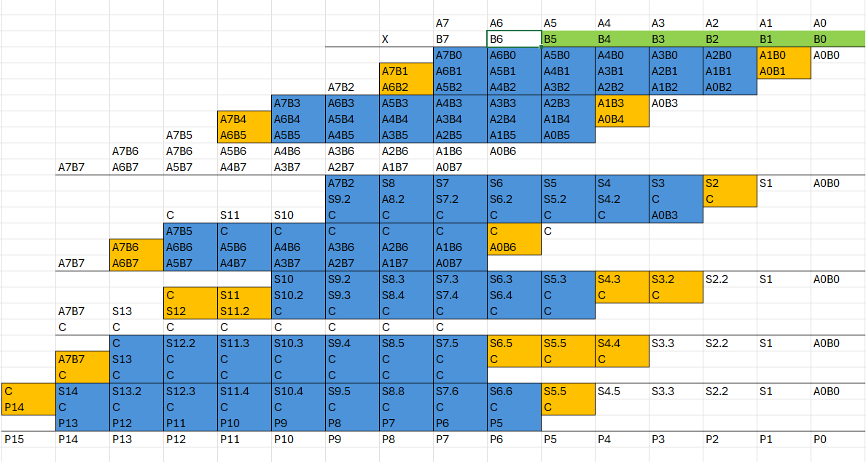

Appendix B: RTL Design Schematics

Appendix B.1 - Wallace Tree RTL Design Schematic
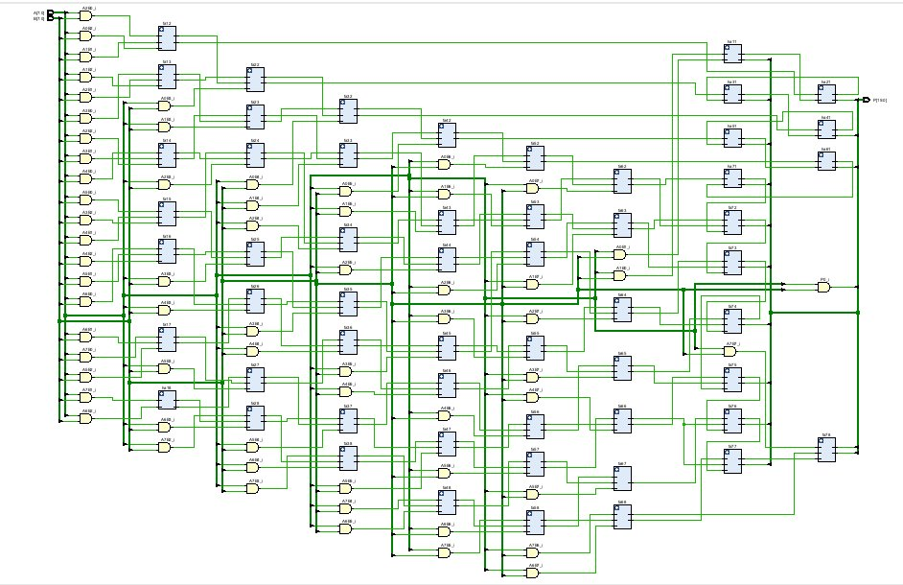

Appendix C: Implementation Schematics

Appendix C.1 - Wallace Tree Implementation Schematic
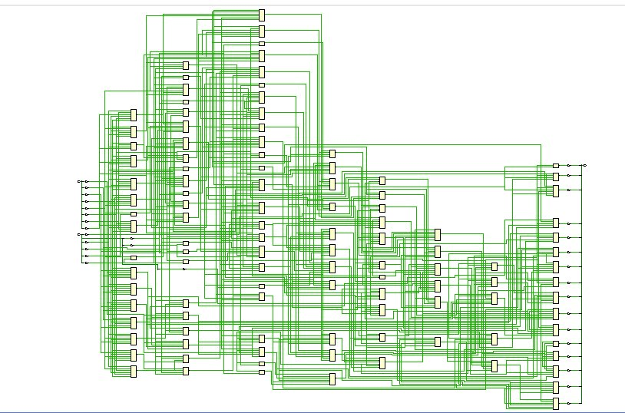

Appendix D: Device Schematic

Appendix D.1 - Braun Device Schematic
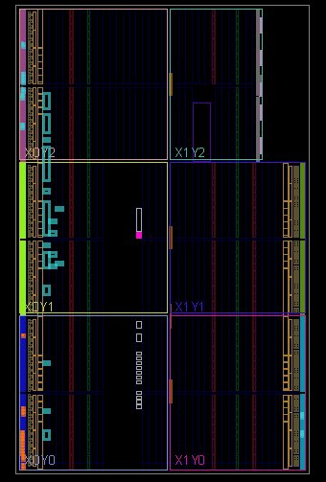

Appendix D.2 - Wallace Tree Device Schematic
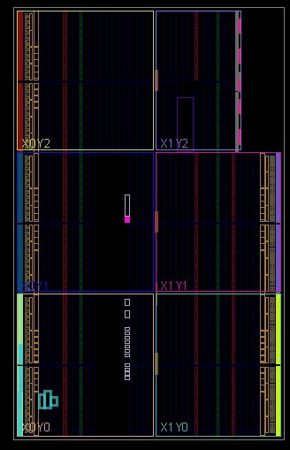

Appendix E: I/O Planning

Appendix E.1 - Wallace Tree I/O Planning


