Developing and Supporting Physical Development in Early Childhood
Reflective Journal

This reflective journal is based on my experience of developing physical development sessions within my school setting. I am the Year 2 teacher at Sea View Community Primary School in Swansea. The current Year 2 class is made up of 30 children. The school itself serves a largely deprived area and with the continuing effects of the Covid-19 pandemic, there are many concerns to our pupils’ wellbeing and physical development. Ayres states, “Most of the activity in the first 7 years of life is part of one process: the process of organising the sensations on the nervous system.” (Ayres, 2005 p13). The children in my class spent a long period of time in lockdowns and spent a lot of time within their homes which has quite clearly had an impact on their fundamental motor skills (FMS) and sensory integration. Even outside of lockdowns, most children in our school spend a lot of their spare time not outside pushing the boundaries of their physical and imaginative capabilities, but in contrast spend time indoors. This is a theory that Goddard Blythe reinforces, “We have seen how movement is an essential ingredient for a child’s development and capacity to learn, but children of today have less movement opportunities in their daily lives than any other generation” (Goddard Blythe, 2005 p130). Ayres states that “Children are designed to enjoy sensory activities that challenge them to experience new sensations and develop new motor functions. It is fun to ingrate sensations and form adaptive responses” (Ayres, 2005 p14). These natural instincts are rarely seen due to the society they live in and the effects of the Covid pandemic. The implementation of an intervention to support young children’s physical development may be significantly effective for schools based in deprived areas as it has been hypothesised by some that certain populations of children may be influenced by constraints that impede the development of FMS in early childhood (Goodway and Branta, 2003). I was interested to see what impact these sessions would have not only on the children’s physical development but also in other areas. I was inspired by the words of Goddard Blythe, “Something happens to attention, behaviour and motivation when children and young people become active.” (Goddard Blythe, 2005 p133).

Prior to embarking on this project, my knowledge and understanding of young children’s physical development was limited and I, like many others, thought that skills such as FMS would develop naturally over time. I soon realised that many children do not achieve proficiency in such skills (Stodden et al, 2008) and this has a detrimental effect on their ability to achieve specific sport skills later in life. FMS needs to be taught through tailored games suited to the children’s abilities (Goodway & Branta, 2003). My childhood experience of PE lessons is seen in the work of Stodden et al and their model which shows developmental mechanisms influencing physical activity trajectories of children. I think it is so important to set the level correctly for children, so we don’t set them up to fail. Children need to succeed so they can develop a positive spiral of engagement (see figure 1).

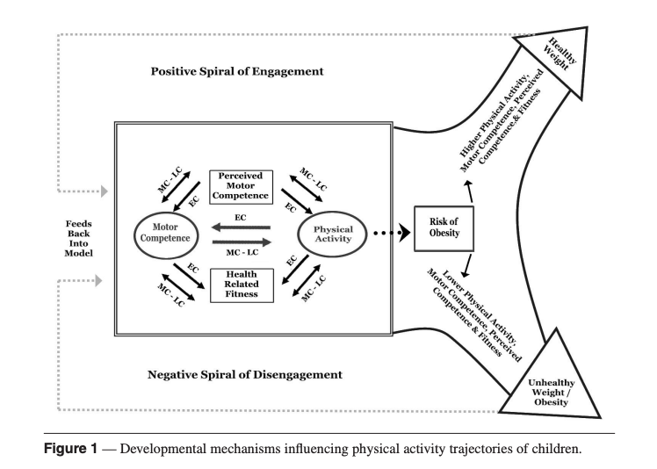
(Stodden et al, 2008 p294)

I decided to incorporate daily SKIP sessions into my weekly timetable. They have become part of a daily carousel of activities. I initially wanted every child to complete a SKIP session every day, but I soon realised that I was being too optimistic due to time constraints, space, weather etc. It became more realistic that every child completed 2-3 SKIP sessions a week. The sessions are conducted by me or by a TA who is given instructions on what to do.

I used my first week of SKIP sessions to make observations and assess the children. I wanted to create a baseline and ascertain the stages of development at which the children were able to run, hop, jump, gallop, skip, balance etc. I was surprised to find that some of the children who participated in sports clubs were presenting early stages of movement. Gallahue et al state that “Developing basic competence in locomotive skills is essential for engagement in meaningful physical activity for health and to move effectively in various sports, games and dances” (Goodway, Ozmun and Gallahue, 2019 p244-245).

At the beginning of the project, I took the whole class out to complete a SKIP session. I soon realised that this wasn’t very successful as there were too many children to observe and I couldn’t provide quality feedback. I decided to split the class into three groups and work with no more than 10 children at a time.

My sessions always begin with a warm up. They involve building a movement vocabulary. I cover body awareness (shape, ways of travelling and balance), spatial awareness (personal, levels, speed, direction and pathways) and relationships with people and objects (e.g. pairs, groups, over, under etc). At the beginning of the project, the children would move in one direction, close to their friends and in a circle. However, as I used clear instructions and verbal cues to enhance their creativity, a variety of movement was seen. For example, I would tell the children that they couldn’t move forward, or their movement had to be low level etc. I found looking at theories on movement concepts and the categories of human movement (Davies, 2003) was very useful.

Every movement concept needed to be modelled for the children, even though I was not very confident at first and I needed to check my notes regularly. It is important to model everything correctly so the children can attempt the movement effectively. The importance of this is noted in Goodway and colleagues research where they conclude, “The quality of the demonstration was very important and influenced the pattern of the motor skill performance” (Goodway, Crowe and Ward, 2003 p10). When observing examples of correct techniques, I highlighted this as a verbal cue to the whole group. For example, “I love how you are leaning forward when you are hopping.” The children wanted to copy so that they could be praised and please the teacher.

The focused tasks, after the warm up, were organised into gardens. At first, I set up too many gardens for the children and the children were confused and needed a lot of support. Transitions were taking a long time. This meant that I couldn’t focus and give the feedback I needed to give to the group I was working with. So I reduced the number of gardens to two as I only work with 10 children in a group and after that the gardens have worked well.

As the sessions progressed, I became more aware of the significance of the constraints highlighted in Newell’s model. Karl Newell (1986) suggested that there are three factors that affect movement: interactions of the individual, the environment in which the movement occurs, and the task to be undertaken. If any of these factors change, then the movement will change (Haywood and Getchell, 2019 p6). See figure 2 below.
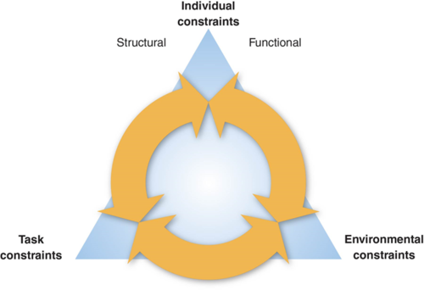
Figure 2 – Newell’s Model of Constraints
Haywood and Getchell, 2019 p6

In every session, I consider the need to adapt and manipulate one or more of the factors from Newells Constraints model in order to enable the children to access and become more confident with physical activity. For example, during a catching activity, I noticed a few children were demonstrating initial stages and I knew they needed to develop their tracking (links to Gallahue stages). They were not having much success with balls so I introduced scarves. Scarves made it easier for the children to catch as they move slower, allowing more time for the children to track it and catch it.

The gardens I use are really successful. They allow plenty of opportunities for the children to practise skills. They are great to organise differentiated tasks. All the children are focussed on their own garden and they don’t realise what others are doing. Every child has plenty of opportunities of success and don’t feel different to the group as everyone is still doing the same activity but with different constraints.

A recurring problem I came across was mismatching children. I constantly move children so that they are working with someone who is at the same stage as them. At first I thought it wasn’t a problem as the one could role model to the other, but I soon realised that the other child felt pressure to succeed and possibly felt a failure. Matching pairs of children with similar abilities allows me to make more progress with the children. For example, during catching activities I could progress with children who could catch, but at the same time I could change the task to rolling for the children who were delayed and hugging the ball.

I found teaching throwing tricky. I realised that I wasn’t always modelling the correct way to throw myself. For example, I noticed that one group of children needed to work on stepping with the opposite foot when throwing. I set up an activity to encourage this but realised I was breaking down the process of throwing into multiple steps and modelling the steps separately, rather than realising the steps all need to be done at the same time. In future sessions, I was conscious of the fact that I didn’t repeat this mistake.

During cycle two, I incorporated obstacle courses. They became part of one of my gardens and the children really enjoyed them. I used a variety of equipment that encouraged contralateral movements such as crawling and wobble spots and hurdles to encourage dynamic balance. Both of these are found to be prerequisites to proficiently performing FMS (Goodway, Ozmun and Gallahue, 2019). Some children, at the beginning, felt that it was a garden to just have fun and they played around with the equipment so I needed to model how to complete an obstacle course and what the expectations were. Soon they became independent with the obstacle courses and I could hear children explaining to others what they should do and how to they could move through the course successfully. This made me very happy to hear as I thought that if the children could coach their peers then they must be understanding what has been taught.

As the children became more confident and successful with completing obstacle courses, I set up challenges for the children to design their own obstacle course. The children were fully engaged, enthusiastic and motivated to complete the challenges. They were full of ideas and used a variety of equipment. The language and explanations of what they were doing when discussing the design were outstanding. The children were stimulated in accessing and experimenting with their environment and the children felt comfortable choosing the equipment they were confident in using so everyone was able to access without feeling any physical constraints.

In conclusion, my awareness of the importance of developing and supporting physical development in early childhood has increased significantly and has resulted in me allocating more time spent in the school day for physical activities. The knowledge I have gained regarding the developmental stages of FSM and the effects of constraints on such development has been key to supporting me in implementing the right activities for the children who are developing at different stages (Goodway, Ozmun and Gallahue, 2019). Other members of staff have become more confident in participating in SKIP sessions and have said that they can understand the development process better which in turns allow them to support the children more efficiently.

My next step is to run a parent workshop to share what I have been doing in school. I want to inform the parents of the importance of developing and supporting physical activity in early childhood and share with them what we can do to nurture and develop a lifelong enjoyment of physical activity and emotional wellness.

My project doesn’t end here. This is just the beginning of my journey into developing and supporting physical education in early childhood. I intend to continue researching information in this area and I will continue to deliver SKIP sessions daily in school. There is still so much to learn and so much to offer and I can’t wait to see the children progress even further.

Word Count: 2,045

Reference List

Goddard Blythe, S (2005). The Well Balanced Child: Movement and Early Learning (Early Years). Hawthorn Press.
Ayres, A. J., & Robbins, J. (2005). Sensory integration and the child: Understanding hidden sensory challenges. Western Psychological Services.
Davies, M. (2003). Movement and dance in early childhood. Sage.
Goodway, J. D., Ozmun, J. C., & Gallahue, D. L. (2019). Understanding motor development: Infants, children, adolescents, adults. Jones & Bartlett Learning..
Goodway, J.D. & Branta, C.F. (2003). ‘Influence of a motor skill intervention on fundamental motor skill development of disadvantaged preschool children’, Research Quarterly for Exercise and Sport, 74(1), 36-46.
Goodway, J.D., Crowe, H. & Ward, P. (2003). ‘Effects of Motor Skill Instruction of Fundamental Motor Skill Development’, Adapted Physical Activity Quarterly, 20(3), pp. 298-314.
Haywood, K. M., & Getchell, N. (2019). Life span motor development. Human kinetics.
Stodden, D. F., Goodway, J. D., Langendorfer, S. J., Roberton, M. A., Rudisill, M. E., Garcia, C., & Garcia, L. E. (2008). A developmental perspective on the role of motor skill competence in physical activity: An emergent relationship. Quest, 60(2), 290-306.

