INTRODUCTION
In the last two decades, the interest in entrepreneurship increased significatively and it is arguable by looking at the courses activated at universities and colleges around the world. There has been an epochal change in society and in the way of perceiving work, less interest in traditional careers and stable jobs but routines. Around the world, a significant number of people are trying to launch their entrepreneurial careers or have succeeded.
Figure 1: Entrepreneurial experience business
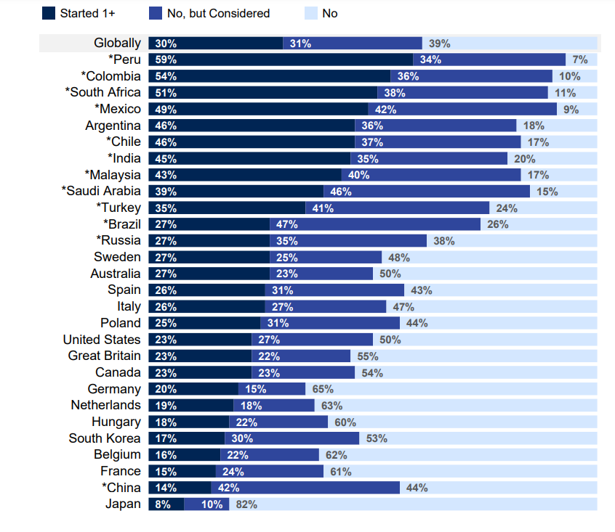
Source: (IPSOS, 2021)
The diagram above shows the percentage of people who have started a business or want to start by country. Nations with the highest percentage are emerging or developing ones, this is explained by the fact that due to a lack of job opportunities, many workers choose to follow an entrepreneurial or self-employment career. As Jean Monnet, one of the founding fathers of the European Union, argued: People only take action if it is strictly necessary and usually understand that they have to do something only in emergency situations. Today, at a time of constant crisis, first a health crisis, then a war and now an energy crisis, it seems the right time to start a business and take advantage of the many opportunities that the market offers. Starting a business is not easy, to manage a company you need to know how to manage the emergency and find strategic solutions that allow you to turn the crisis into opportunities. Crisis yes, but also a great opportunity. As it happens on the stock exchange, where financial speculators enter the market when everyone wants to go out, the same strategy should be used for those who have an idea in their mind and want to turn it into a business.

ENTREPRENEURSHIP
Entrepreneurship is the ability and willingness to create, plan, and manage a business venture, including all its associated risks, in order to make a profit. Consequently, "entrepreneurial possibilities" and "enterprising persons" are both included in the definition of entrepreneurship (Baporikar, 2020).
Many scholars defined the meaning of entrepreneurship over the decades. In the nineteenth century, the French economist Say described entrepreneurship as a process that involves the shift of financial resources from low production to bigger ones and higher profit. According to Schumpeter, entrepreneurship is a ‘meta-economic event’, such as the launch of a new technology that reshapes the market. Schumpeter argued, that when the market is unbalanced and customers' needs are not being satisfied, entrepreneurship is the process most likely to succeed. As an example, he considered how the introduction of aeroplanes has affected the global passenger ship sector that travels the oceans (Chaston, 2009). William Gartner suggested that entrepreneurship should be considered a distinct management process characterized by creative behaviour features combined with a strategic perspective on achieving profitability and growth (Gartner, 1989).
We could go on quoting famous economists and specialists who have contributed to the definition of entrepreneurship. However, we need to shift the focus to another topic: the entrepreneur. If it is true that entrepreneurship is the practice of an entrepreneur, it is essential to understand what an entrepreneur does and how he/she operates.
ENTREPRENEUR -DEFINITION AND THEORIES
As the economist, Mark Casson said: ‘The most difficult part of studying entrepreneurship is to define who and what an entrepreneur is’ (Casson, 1982). An entrepreneur is a French word and derives from the verb undertake. Writing a definition of an entrepreneur without referring to false myths is difficult; many have written about that and recently it’s a very hot topic. We will proceed step by step into the analysis of some definitions and theories of scholars and researchers.
Three are approaches in the literature to entrepreneurship: economic theories, psychological trait approach and social behaviour approach.
Figure 2: Timeline of entrepreneurship thought
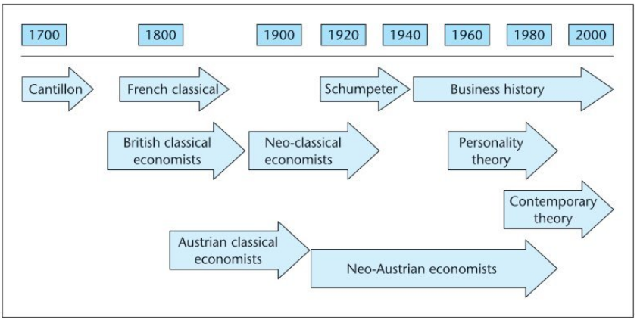
Source: (Carter, 2012)
As shown in the above figure, the first to find out the term entrepreneur in an economic context was Cotillon, a French economist in the mid-1700. He described an entrepreneur as a person who buys a raw item at an uncertain price and sells it at another unknown price. He acts among a few actors; he is a sort of intermediary that accepts the risk and takes it on. Risk is a crucial component of his theory (Dana, 2013). In the 20th century, the Austrian economist Schumpeter introduced the concept of innovation. According to his theory, an entrepreneur is someone able to transform a new idea or invention into a successful innovation, introducing a new product, a new production method, or a new market (Carter, 2012). In the early 1960s, Personality theories began to spread. They sought to identify common traits in the personalities of entrepreneurs. A great contribution was given by David McClelland, an American psychologist. In his theory of achievement, he argued that entrepreneurs need to achieve goals, to succeed, and that’s their strong drive to growth. They do things in a new and better way and make decisions in uncertain conditions (McClelland, 2009). Over the years researchers moved from a psychological approach to a social behaviour one, crossing through the economist Shackle theory, according to whom entrepreneurs are creative and imaginative because they imagine opportunities and have the creative ability to make choices.
ENTREPRENEUR CHARACTERISTICS
Over the last 20 years, the interest in the entrepreneurial world has grown more and more, leading research and academics to deepen some topics. A great interesting topic for the researchers is the personality of a successful entrepreneur. There is no scientific evidence linking certain types of personality to successful entrepreneurs, but recent academic studies have demonstrated the prevalence of common personality characteristics. Below are some of them in more detail.
SELF-ENHANCEMENT comprises the values of power and achievement. The need for achievement refers to an individual’s desire for fulfilment, the awareness of having skills and abilities that can achieve ambitious goals. Creating a business from its foundation means having great skills, this is motivating and pushing to reach bigger goals (Kerr, et al., 2018).
OPENNESS TO THE CHANGE Individuals who appreciate openness are independent thinkers and doers who enjoy life's challenges and thrills. These individuals like experimenting with innovative ideas and are not hesitant to challenge and ultimately eliminate established conservative roles. In addition, open-minded people love using their brains to produce unique things and find learning to be interesting. They love exploring new experiences and have the autonomy to set their own goals. In addition, entrepreneurs who are inspired by the principle of openness as a guiding principle of their lives will enjoy the flexibility offered by their entrepreneurial careers. The freedom to control schedule and work life (Shepherd, 2018).
RESILIENCE is the CAPACITY to resist failure and disappointment (Bolton & Thompson, 2013). Every entrepreneur must face every day small and big disappointments or failures, especially in the early stage, when the business has just started. Giving up or falling over after a disappointment shows a lack of resilience and a successful entrepreneur must possess massive quantities.
MODERATE RISK TAKER Successful entrepreneurs take the risk, but it is a very well-considered risk, in fact, if an entrepreneur never dared to invest and risk investment, his career would be stable but ordinary, with no chance of improvement ( Barringer & Ireland Duane R., 2015). Entrepreneurs have to take risks but evaluate them well, analysing data, the market, and profits, in a nutshell, evaluating all the factors of risk and advantage.
INTERNAL LOCUS OF CONTROL is one of the main characteristics of a good entrepreneur. As the Latin author, Appio Claudio Cieco, wrote in 300 B.C. ‘Homo faber fortunae suae’, meaning “man is the architect of his own destiny”. This concept is perfect for a successful entrepreneur. The successes and achievements, both in terms of profits and personal fulfilment of an entrepreneur, must be only the consequence of his hard work and abilities. There is no place for the idea of making one’s success dependent on external factors and circumstances (Bolton & Thompson, 2013). A good entrepreneur relies only on his strength.
Figure 3: process model of entrepreneurship
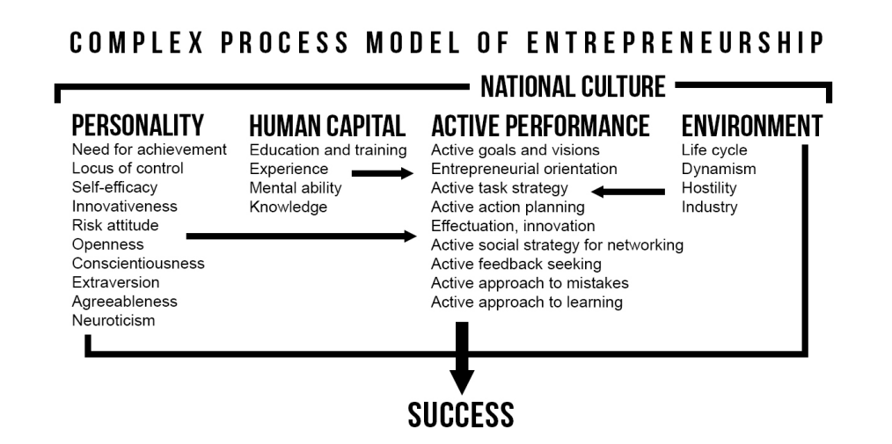
Source: (Kerr, et al., 2018)
As shown in the diagram above, Entrepreneurship is a process that results from a sequence of key aspects starting with the entrepreneur's personality traits, human capital, and environment creating the context for each attempt to start and manage a new business. As a result, various factors need to be analysed for an integrated study of business success, and a heterogeneous approach is required.

ENTREPRENEUR AND SMALL BUSINESS OWNER
Although the two actors are often confused, there is a significant difference between the entrepreneur and small business owner.
An entrepreneur is someone who starts and runs a business with the objective of profiting and expanding it. He demonstrates creative behaviour and will use strategic management practices in the business.
A small company owner is an individual who starts and maintains a business for achieving personal ambitions. The business will take up most of one's time and resources and must be the main source of revenue. The owner views their company as an extension of who they are. intricately linked to family preferences and needs (Carland, et al., 1984). Some economists realized that a lot of small business owners were more like managers in larger firms than they were like entrepreneurs.
Small business owners usually run small and family-run businesses, exploring routine needs and no high earnings. Some examples of small Businesses are restaurants, grocery stores, local auto repair, health care clinics, and service stations. Thus, they provide basic client services ( Barringer & Ireland Duane R., 2015). The entrepreneur focuses on innovative contexts, like start-ups, introducing new products and services into society and has had a major impact on people’s lives ( Barringer & Ireland Duane R., 2015). Entrepreneurial firms, provide new goods and services to the market. Creating value and then sharing it with consumers is a key component of entrepreneurship. The value here refers to worth, significance, or utility. Entrepreneurial businesses create possibilities and so advertise innovative goods and services by doing so. Entrepreneurial firms have introduced new products and services into society and have had a major impact on people’s lives ( Barringer & Ireland Duane R., 2015). when we talk about start-ups, they offer revolutionary product that improves the lives of individuals, making life easier. There are many examples of start-ups that have offered revolutionary products: Amazon has launched online commerce, social networks like Facebook, and biotech products that have improved people’s health.

SMALL BUSINESS OWNER TRAITS
While in the literature, there is no clear definition of what defines a small business, according to U.S. Census Bureau, a small business is defined by corporate income (ranging from $1 million to over $40 million) and by employment (from 100 to over 1,500 employees). Small companies are an essential part of local and national economies and a major factor in the financial growth of many big countries like the United States. They are typically started as small start-ups (Hait, 2021).
Proceeding with the analysis of a small business owner's characteristics, we'll see that many of them are the same as those of an entrepreneur, including resilience, internal locus of control, optimism, creativity, and goals-oriented mind.

ADAPTABILITY
A key quality to meet the constant challenges is your adaptability, that is, the ability to adapt to new practices, new technologies, and new methods without falling behind. It is a quality that makes it possible to succeed in the long term.
STRONG WORK ETHIC
Strong work ethic, that is, the ability to dedicate oneself to one’s own business completely, often giving up hobbies, family commitments, and night rest.
NETWORKING
Having a good network is essential to expand the number of customers and having a good network of contacts helps word of mouth which then may increase the number of customers. The small business owner must be able to develop network relationships through formal and informal networks, virtual and in-person, increasingly important today. In addition, fifty per cent of small business owners revealed that the inspiration for their company idea originated from networking relationships and/or
innovations, little modifications, or creative approaches to an existing business (Martinez & Aldrich, 2011).
LEADERSHIP
The small business owner manages a group of people and being a good leader is essential, knowing how to motivate the team, make them feel part of a team and make them share the vision of the company. Small business owners typically have a passion that is contagious to their employees.
The entrepreneur is part of the complex process of new venture creation. This approach to the study of entrepreneurship treats the organizations as the primary level of analysis and the individual is view in terms of activities undertaken to enable the organization to come into existence. The personality characteristics of an entrepreneur are ancillary to the entrepreneur’s behaviours. Research should focus on what the entrepreneur does and not who is (Gartner, 1989).

FOR-PROFIT AND NOT-FOR-PROFIT ORGANIZATIONS
A for-profit (FP) organization is an organisation whose main objective is to generate money and produce valuable products and services for customers. Obtaining profit and market share is the long-term objective. A few examples of for-profit businesses are airlines, construction firms, manufacturers, restaurants, shopping centres, and logistics companies.
A Not-for-profit organisation (NFPO) does not distribute their profit to the owner but exists to fulfil its organizational objectives. Not-for-profit organizations can be social clubs that exist to serve their members, social welfare organizations, civic leagues, labour organizations, business leagues, women's clubs, and sports clubs.
So, the first difference between them is in the purpose. The way they manage the profits is different: for-profit businesses can invest in a variety of activities, and the profits generated are split among the shareholders; the NFPO do not have shareholders and all the revenue earned is first used to pay off salaries whereas the remaining money is put back into the business (Sarros, et al., 2011).
NFPOs might receive donations for the business and are frequently tax-exempt, which means they are exempt from paying the majority of taxes, even if not all the businesses are always exempt. FPO receives money only from selling goods and services and pays all taxes.
NFPO have less strict accounting policies because they are not required to compel the reporting of revenues. FPO use the income statement, the balance sheet, and the cash flow statement for the financial statement.

A good example of an entrepreneurial NFPO is Betel rehabilitation centre by Elliott Tepper.He was a son of entrepreneurs, with a successful academic career in economics. He made the decision to create a rehabilitation centre for drug and alcohol addicts in Spain after testing the effects of the dependency issue on his own skin. After beginning with a small community, the model business was so successful that now Betel has communities throughout all of Europe and many other countries. It is a model of success that developed from the founder's personal needs combined with his entrepreneurial talents (Bolton & Thompson, 2013).

