Silviu-iulian Surel
UNIVERSITY OF WALES- TRINITY SAINT DAVID LONDON

ACADEMIC AND EMPLOYABILITY SKYLLS

--- MY PERSONAL DEVELOPMENT PLAN---
-7 JANUARY 2019-

Contents

Section 1: Personal Overview

3

Section 2: Skills Evaluation

4

Section 3: Action Plans

7

Section 4: Application

4.1.Looking after your data

10

4.2.Time management and organization

11

Section 5: Conclusion

12

Section 6: Appendices

13

Section 7: References 16

Section 1: personal overview
I will start this statement with one paragraph how come across to My Feelings in the last 2 years “The positive experience connected to motivation and doing is worthy of futher investigation”( Uusiautti & Maatta, 2015). After this quote I can present myself: Silviu Iulian Surel, born in Romania grew up in a simple family of workers, who ended up with a rather ugly divorce between my parents when I was thirteen years old and my brother five years old.

The first feelings of disappoiment, helpessness and self-mistrust came with the renunciation of the university only one month after the beginning of the year, than start my journey with a big step in my life moving in Italy to my mother.

There have been seven years in which I have changed many jobs, most of them have been unqualified without a chance to learn and practice a job that I like and open up my horizons to a harmonious ans satisfying development. I have not felt all this time that it will affect me in relationships with people around me and mainly about my future career.

The next chapter of my life is my arriving in United Kingdom about three years and half ago, I knew it would be hard but I had everything in my mind to succceed . From the first day I understood what I need to become better and I quote “Motivation, together with abilities, work knowledge and context-bound factors, leads to behaviour, which again leads to performance – one of the cornerstones in considerations of success.”( Uusiautti & Maatta, 2015).

section 2: skills evaluation

Skills for success
Developing skills for success within employability and the workplace are vital. It is important to consider these skills within myself and as well as how I can use and develop these skills to improve my career success. Employability is often considered as the characteristics within an individual that attribute them towards a particular career (McQuaid & Lindsay, 2005: n.p.). Therefore, ensuring that I develop characteristics that attribute me towards the workplace in general will allow me to strengthen my employable success. The development of skills with a future workplace in mind is considered “embedding skills” (Harvey, 2005: p.17). I intend to embed skills and develop my employability.

Key skills that are associated with higher employability success involve:
- Commercial awareness
- Communication
- Teamwork
- Negotiation and persuasion
- Problem solving
- Leadership
- Organisational
- Perseverance and motivation
- Working under pressure
- Confidence
(Almeida, Behrman &Robalino, 2012: p.12).

Self-evaluation
In order to embed these skills and develop my employable success, it is important to consider which of these skills I require developing further. In order to do this, it is important to self-evaluate and assess my own ability and competencies.

Research into self-evaluation suggests that it works as an effective reflective process (Mabe& West, 1982: n.p.). Not only is it productive within establishing skills and strengthening oneself, it is also important within learning about yourself and identifying both the pros and cons. It is useful to identify what I am good at and where my strengths lie, in order to enhance my confidence and self-efficacy, which will empower me within my work. Whilst establishing these strong points, it is also beneficial for me to identify the characteristics which I need to develop further (Iles, Forster &Tinline, 1996: n.p.). This is beneficial within the workplace for it will enable me to reflect on a regular basis and then ultimately strengthen myself, thus improving my work and my outlook to productivity within my career.

In order to self-evaluate, I have considered a model constructed by Rothwell, Herbert & Rothwell (2008: p.3) which considers the different aspects of the self and how these interact with employability. This model was constructed particularly in relation to university students and is useful for me to consider where my strengths lie, which skills require further development and how these interact with my employability opportunities.
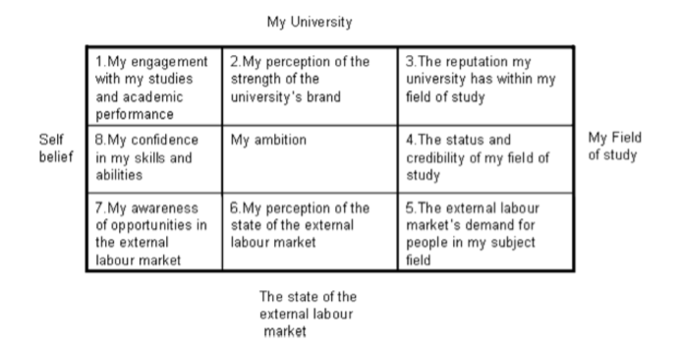
Figure 1. Self-perceived employability scale; Rothwell, Herbert & Rothwell, (2008: p.3).

For example, I can consider the following like so:
8. Confidence in my skills and abilities: I aim to develop my time management, confidence and communication skills as these are areas that I have strengths within in other areas of my life, such as with my family, but I would like to strengthen further in order to be more successful within my future career. Within my personal development plan, you can see the steps I aim to take in order to strengthen these skills further.Developing these particular skills will support the development of my overall confidence, leadership skills, communication and organizational skills. These are vital skills for the workplace and are therefore important to strengthen.

9. My ambition: This is a skill that I would particularly consider as one of my strengths. Having moved from Romania, I have had to be organised and courageous, these skills all accumulated into my ambition. I am ambitious to use my passion (computers and technology) to improve my life and my prospects within my career. I am also very motivated by my family and ambitious to be successful for them. Within my personal development plan, you will be able to see how I have considered balancing time between my family and work, it is important to me to establish effective time management in order to support my ambitions.
The development of these skills and also acknowledging that they are my strengths are important for the workplace. The particular skills that they refer to are teamwork, problem-solving and perseverance. In order to move from Romania, establish my home and then develop my career, I have already had to strengthen these particular skills. Therefore, I can use these skills to benefit me further within my employability options.
Considering this model will support me within acknowledging my skills and comparing these to the skills required for employable success. In order to do this, I can establish my strengths and weaknesses, identify which skills I particularly desire to develop and then apply these to an action plan in order to maintain focus within my goals.

section 3: action plans
 | Short-term Time Frame | Mid-term Time Frame | Long-term Time Frame
Section 1 – My Goals | Establish a routine which manages family, part-time employment and university work. | Strengthen communication and critical thinking skills, relating these to self-management and academic quality. | Apply communication and critical skillset to job applications.
Section 2 – Skills and Knowledge to be Learned | Time management  Scheduling  Prioritization  Sleep routine  Healthy lifestyle | Communication within leadership and team roles – group and project work  Problem solving  Time management – managing the completion of academic assignments | Understanding of application and interview stages  Applying experience directly to the requirements within a job specification  Personable presentation skills in preparation for interviews
Section 3 – Next Steps | Establish a daily routine within an overall weekly routine, ensuring that time is effectively distributed between family, employment and university work.  Complete a daily to-do list to ensure that time is being managed accordingly and progress is being made both within academia and life admin.  Maintain a healthy lifestyle ensuring that sleep, exercise and healthy eating are considered within everyday life. | Participate fully within group projects, strengthening communication with team members. Seize relevant opportunities to adopt a leadership role within these projects, e.g. establishing communication forums amongst members, leading work sessions, mediating between team members and discussing ideas.  Seek opportunities for developing communication and critical thinking skills both inside and outside of the requirements of the academic course.  Organising time effectively to complete academic assignments to a high standard. Linking this to skills develop within short-term plan. | Discuss employment opportunities with personal advisor and employment services at university.  Explore potential employment opportunities and establish main area to pursue.  Investigate this employment area and relate skills developed to this field. Also, establish any skillsets that could be developed further prior to application.
Section 4 – Resources | Personal advisor: discuss how to manage time effectively and establish a realistic routine.  University support services: make use of services and resources available by the university e.g. discuss with an advisor, attend lifestyle seminars, etc.  Daily and weekly calendar/ to-do list: maintain a calendar so time can be effectively monitored and organized. | Volunteering opportunities: explore volunteering schemes at university to discover whether there are opportunities for engaging within teamwork or leadership.  Course representative roles: explore roles within the department that develop communication and critical thinking such as course reps or extra participatory roles. | Personal advisor: discuss employment opportunities to gather understanding of the different possibilities.  Online employability databases: search online for the different roles available within these sectors. Research particular companies within these sectors and read up on their websites to establish different employment opportunities and roles.  Employability services at university: attend mock interview, application seminars, etc to receive advice and implement this within applications and interview preparation.  Practice interviews: with personal advisor, employment services or other resource, complete mock interviews in preparation for future interviews.
Section 5 – Time Schedule  What is my time schedule?  When will I start?  When do I expect to finish? | Begin imminently and revise effectiveness after a month, make adjustments where appropriate and continue until end of degree. If particularly effective, these time-management techniques can be deployed throughout the foreseeable future. | Begin seeking opportunities imminently. Establish time frame for participation within these opportunities and consider skills developed from short-term time frame when managing time for these opportunities. Ensure that they are included within a reasonable time frame. Also, consider this when engaging within departmental opportunities and academic projects. Revise this after the first term to establish whether time is being used as effectively as it could be for these opportunities. Withdraw from participating in extra-curricular activities (e.g. volunteering) during final year in order to focus time on academic work. | Begin researching employability options at the end of second year.  Begin refining applications and interview skills throughout final year, whilst simultaneously applying for relevant roles.
Section 6 - Completion | - __________  DATE | - __________  DATE | - __________  DATE
Section 6 - Completion | - __________  DATE | - __________  DATE | - __________  DATE
Section 6 - Completion | - __________  DATE | - __________  DATE | - __________  DATE

section 4: application

4.1. Looking after your data
Storing data is of utmost important, particularly in response to the recent GDPR guidelines introduced in 2018 (Carey, 2018: n.p.). The key points of the GDPR policy involve consensual data collection, secure storage that can only be accessible by those provided consent to and for data to only be used for specific purposes (Basin, Debois& Hildebrandt, 2018: n.p.).

When considering my own data protection, it is important to ensure that although I keep my data securely stored, I ensure that not only is privacy a concern, but also retrieval. Ensuring that I have my data backed up via relevant sources is important for avoiding any data loss which could subsequently impact my academic work. A recent report by Danezis et al (2015: p.4), on behalf of ENISA, identified the key requirements of businesses and engineers in particular to keep data secure. Their recommendations identified a “standardisation process” across departments to ensure “success privacy-friendly designs of systems and services” (Danezis et al, 2015: p.4). In light of the GDPR regulations and reports such as that by Danezis et al (2015: p.4), I have devised a standardized data protection system that I can implement in my own work.

Data Encryption: Encryption is an effective way of securing data with privacy at the forefront of concern. Encryption involves transforming information from the device into a mathematically-based formulae or algorithm with the intention of this newly formulated information being incomprehensible (Bhanot& Hans, 2015: n.p.). The encryption can only be transformed back to a comprehensible file by the user, thus ensuring sole privacy.

The Cloud: Storing data on The Cloud ensures that files are stored by a provider offsite and thus are not related to a specific local device (Li et al, 2017: p.3). This enables me to access these files from various devices. If hardware is compromised from another device, I am still able to access my data elsewhere.

External Hard Drive: It is also sensible to back-up data via an external hard drive. Such a portable device can be connected to any technical device and regularly backed up. They are easy to use and allow for another secure place to store my data. If The Cloud becomes problematic to access at any point, an external hard drive exists as a viable alternative.

Potential problems and how these systems will avoid disaster:
- Scenario: My laptop requires repairment and following the procedure my hardware is replaced.
  - Problem: Everything on my hardware has been lost.
  - Problem solved: Backing up all of my data via an external hard drive and the cloud ensures that I have my data secured outside of the main device.
- Scenario: iCloud fails to backup overnight.
  - Problem: Files are not securely backed up, potentially without my awareness.
  - Problem solved: Manually backing up my data onto an external hard drive on a regular basis will allow me to spot if anything hasn’t been automatically updated.
- Scenario: Data encrypted files can’t be transferred back into regular files.
  - Problem: I cannot fully access my files.
  - Problem solved: iCloud files automatically protect encrypted files without outward encryption, so I can access my files on the Cloud.
Maintaining these three types of data storage will ensure that I have a variety of secure systems to keep my data private, safe and retrievable.

4.2. Time management and organisation
Time management is very important within maintaining a productive and healthy lifestyle. A great deal of research highlightsthe negative impacts that poor time management can have upon individuals, especially students (Macan, Shahani, Dipboye& Phillips, 1990: p.760).

In order to ensure that I effectively manage my time, I can adopt the following practices throughout my degree.
- Daily/weekly planner: Using a planner will ensure that I structure my time effectively. Visualizing availability will allow me to identify where my free time is and where I will be particularly busy, therefore I will be able to effectively prioritize my time, avoiding time-wasting as well as over-working myself.
- Prioritizing: Ensuring that I prioritize effectively will avoid procrastination. Effective planning via identifying what my tasks will entail and how important they are will assist me in ensuring that I prioritize and use my time well.
- Micro-tasking: Identifying the individual tasks that are required to complete an overarching task is a strategic way of managing time well. At the beginning of a study session or assignment, I can list all of the individual tasks required to complete the task as a whole, ensuring that I set aside enough time to consider each stage of the process.
- Success observation:I will take time to reflect on what I have accomplished over the course of a day, week, month, etc., to ensure that I give myself credit for my small successes as well as my overall larger successes.

section 5: conclusion
In the coming three months according with (Dodd & Sundheim,2005) “Many time management experts prefer weekly calendars so you can better see how you’re using your time.” I need to completing a daily journal with my development in time management in some way to establish a daily routine within an overall weekly routine, ensuring that time is effectively distributed between family, my current job and university.

In one year I want to find and explore opportunities for developing communication and critical thinking skills both inside and outside of the requirements of the academic course in that way to complete my academic assignments to a high standard.

In the coming two years I have to implement all the skills assigned to be a vital resource on the job market and at the same time to become a better person for me and others. I’ll close my personal development plan with this properly qoute: “Whatever you choose to do, do it because it gives you more energy, clearer thinking, and the prospect of a longer, healthier life. No other reason will provide the motivation to keep you at it long-term.”( Dodd & Sundheim,2005).

section 6: appendices
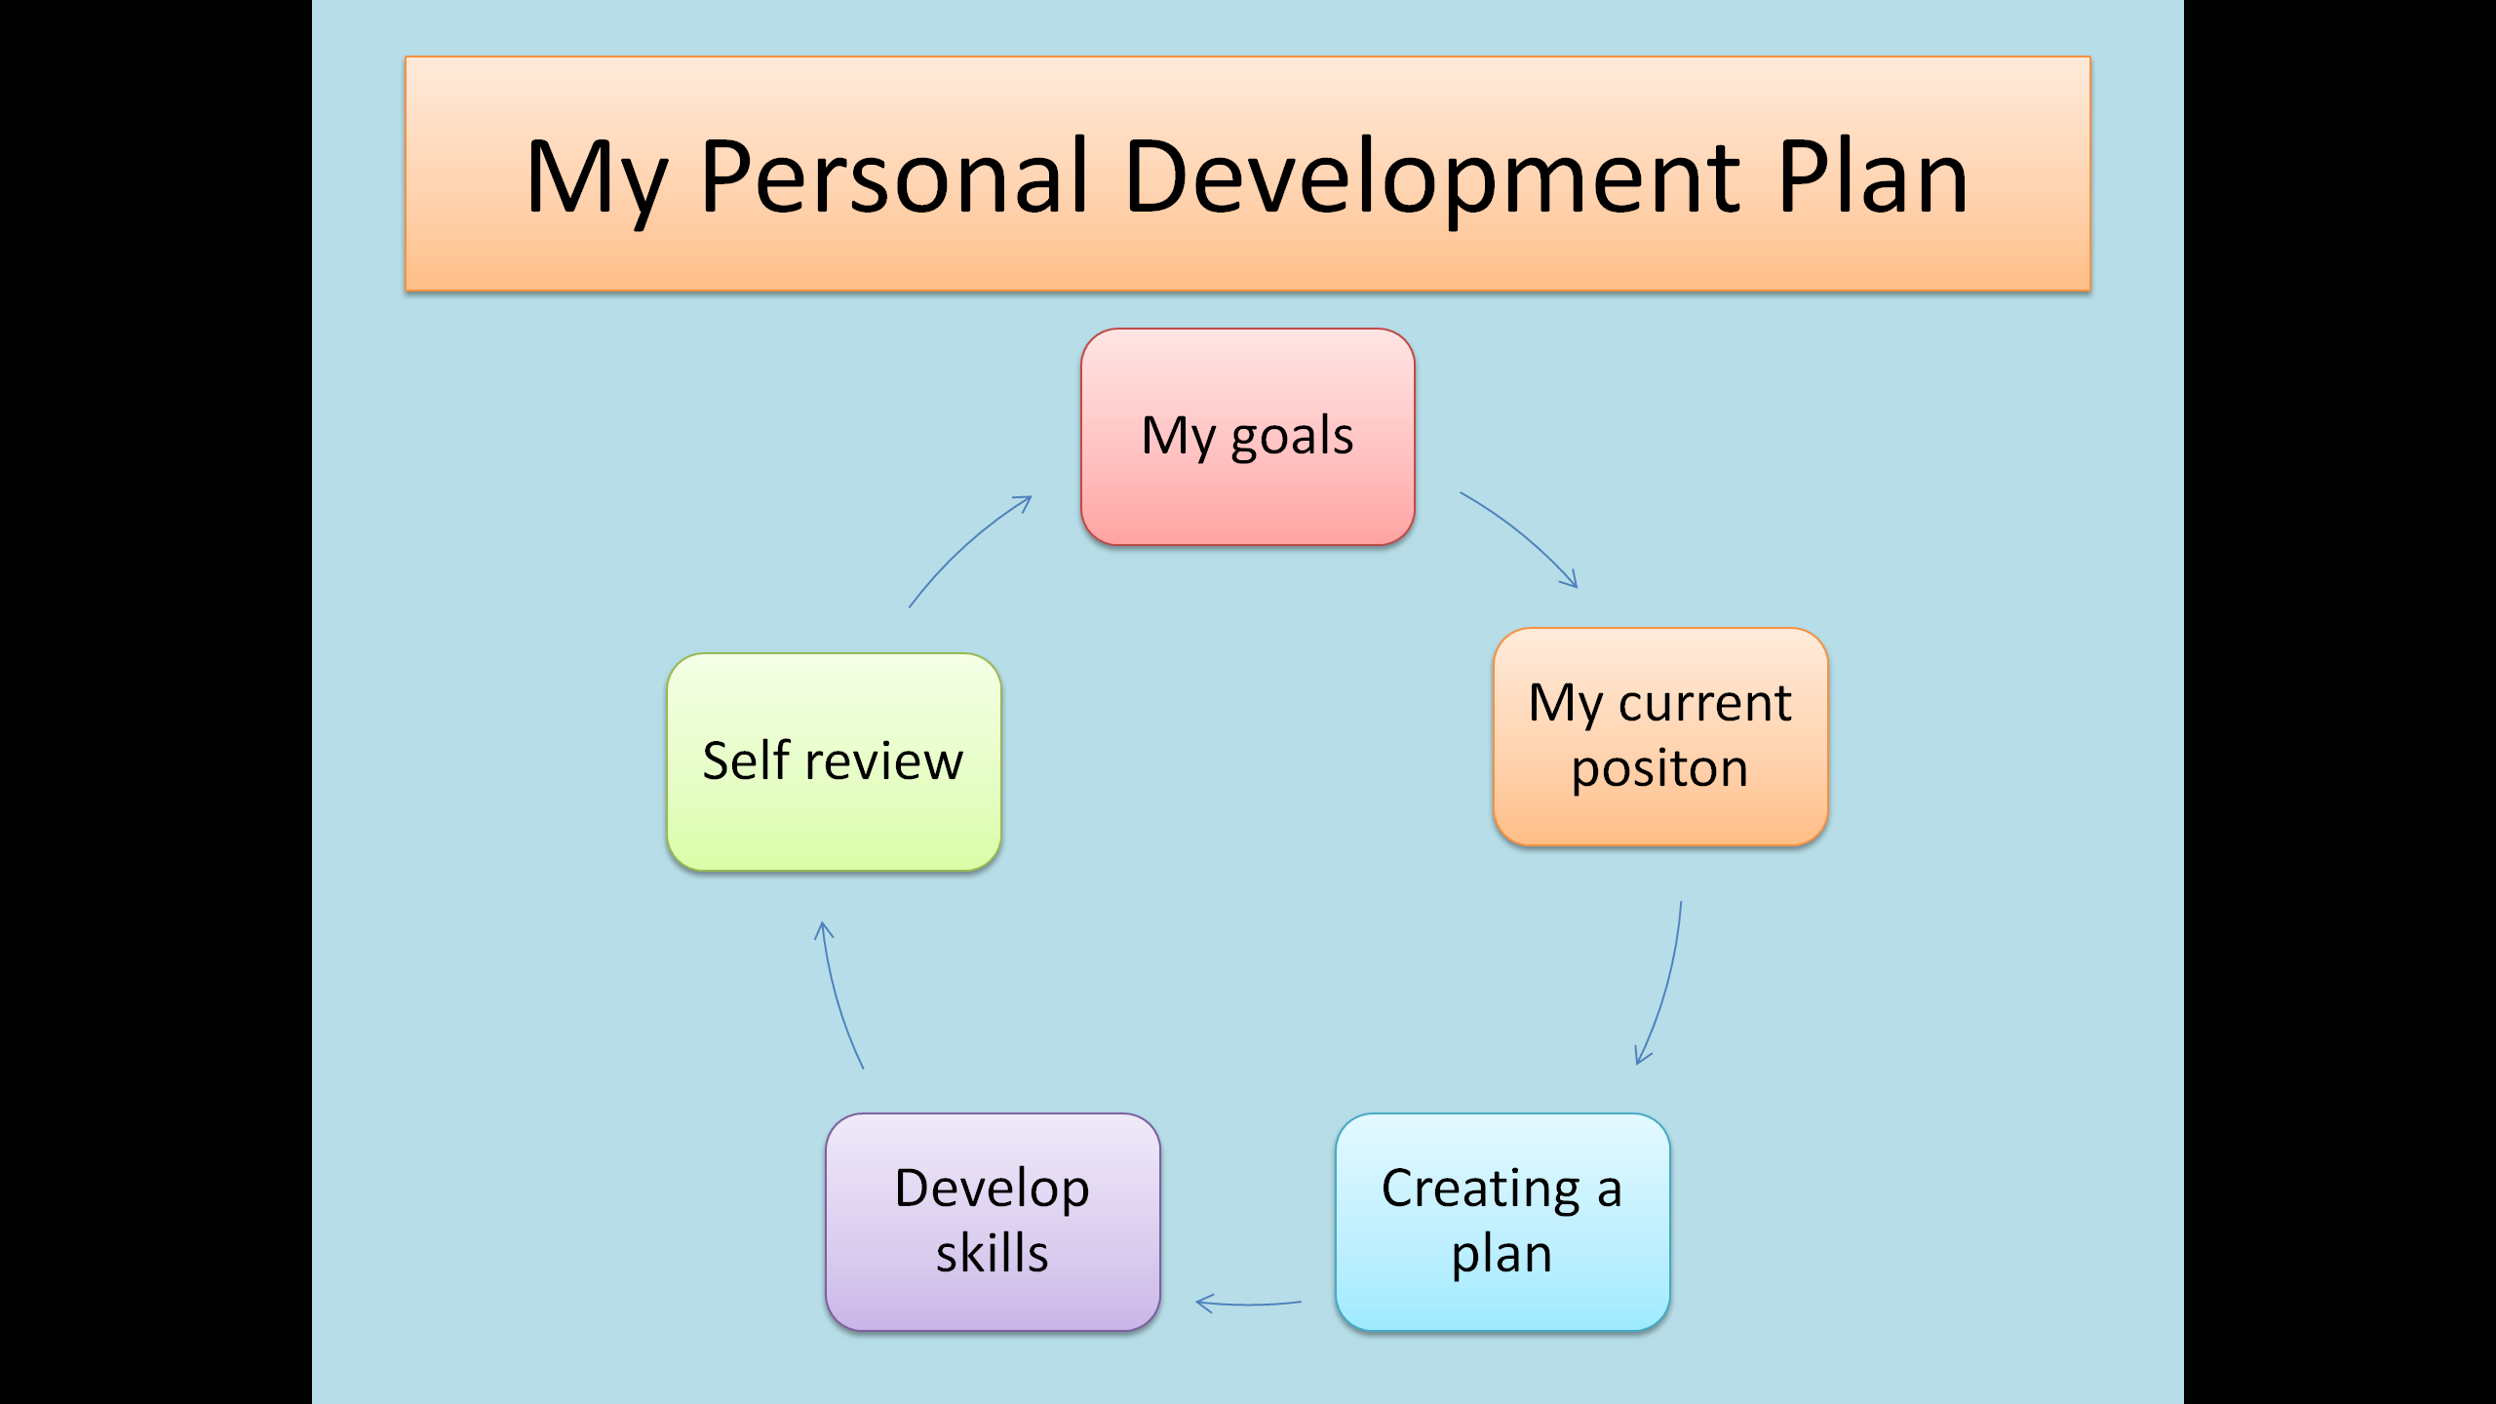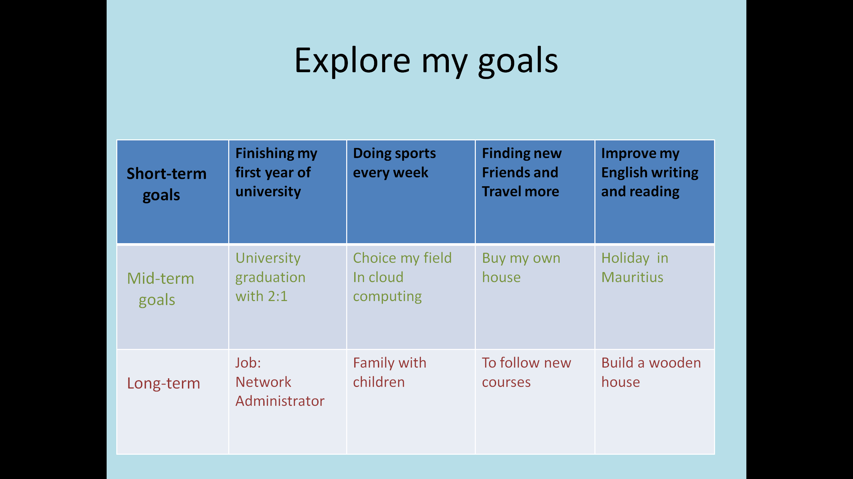
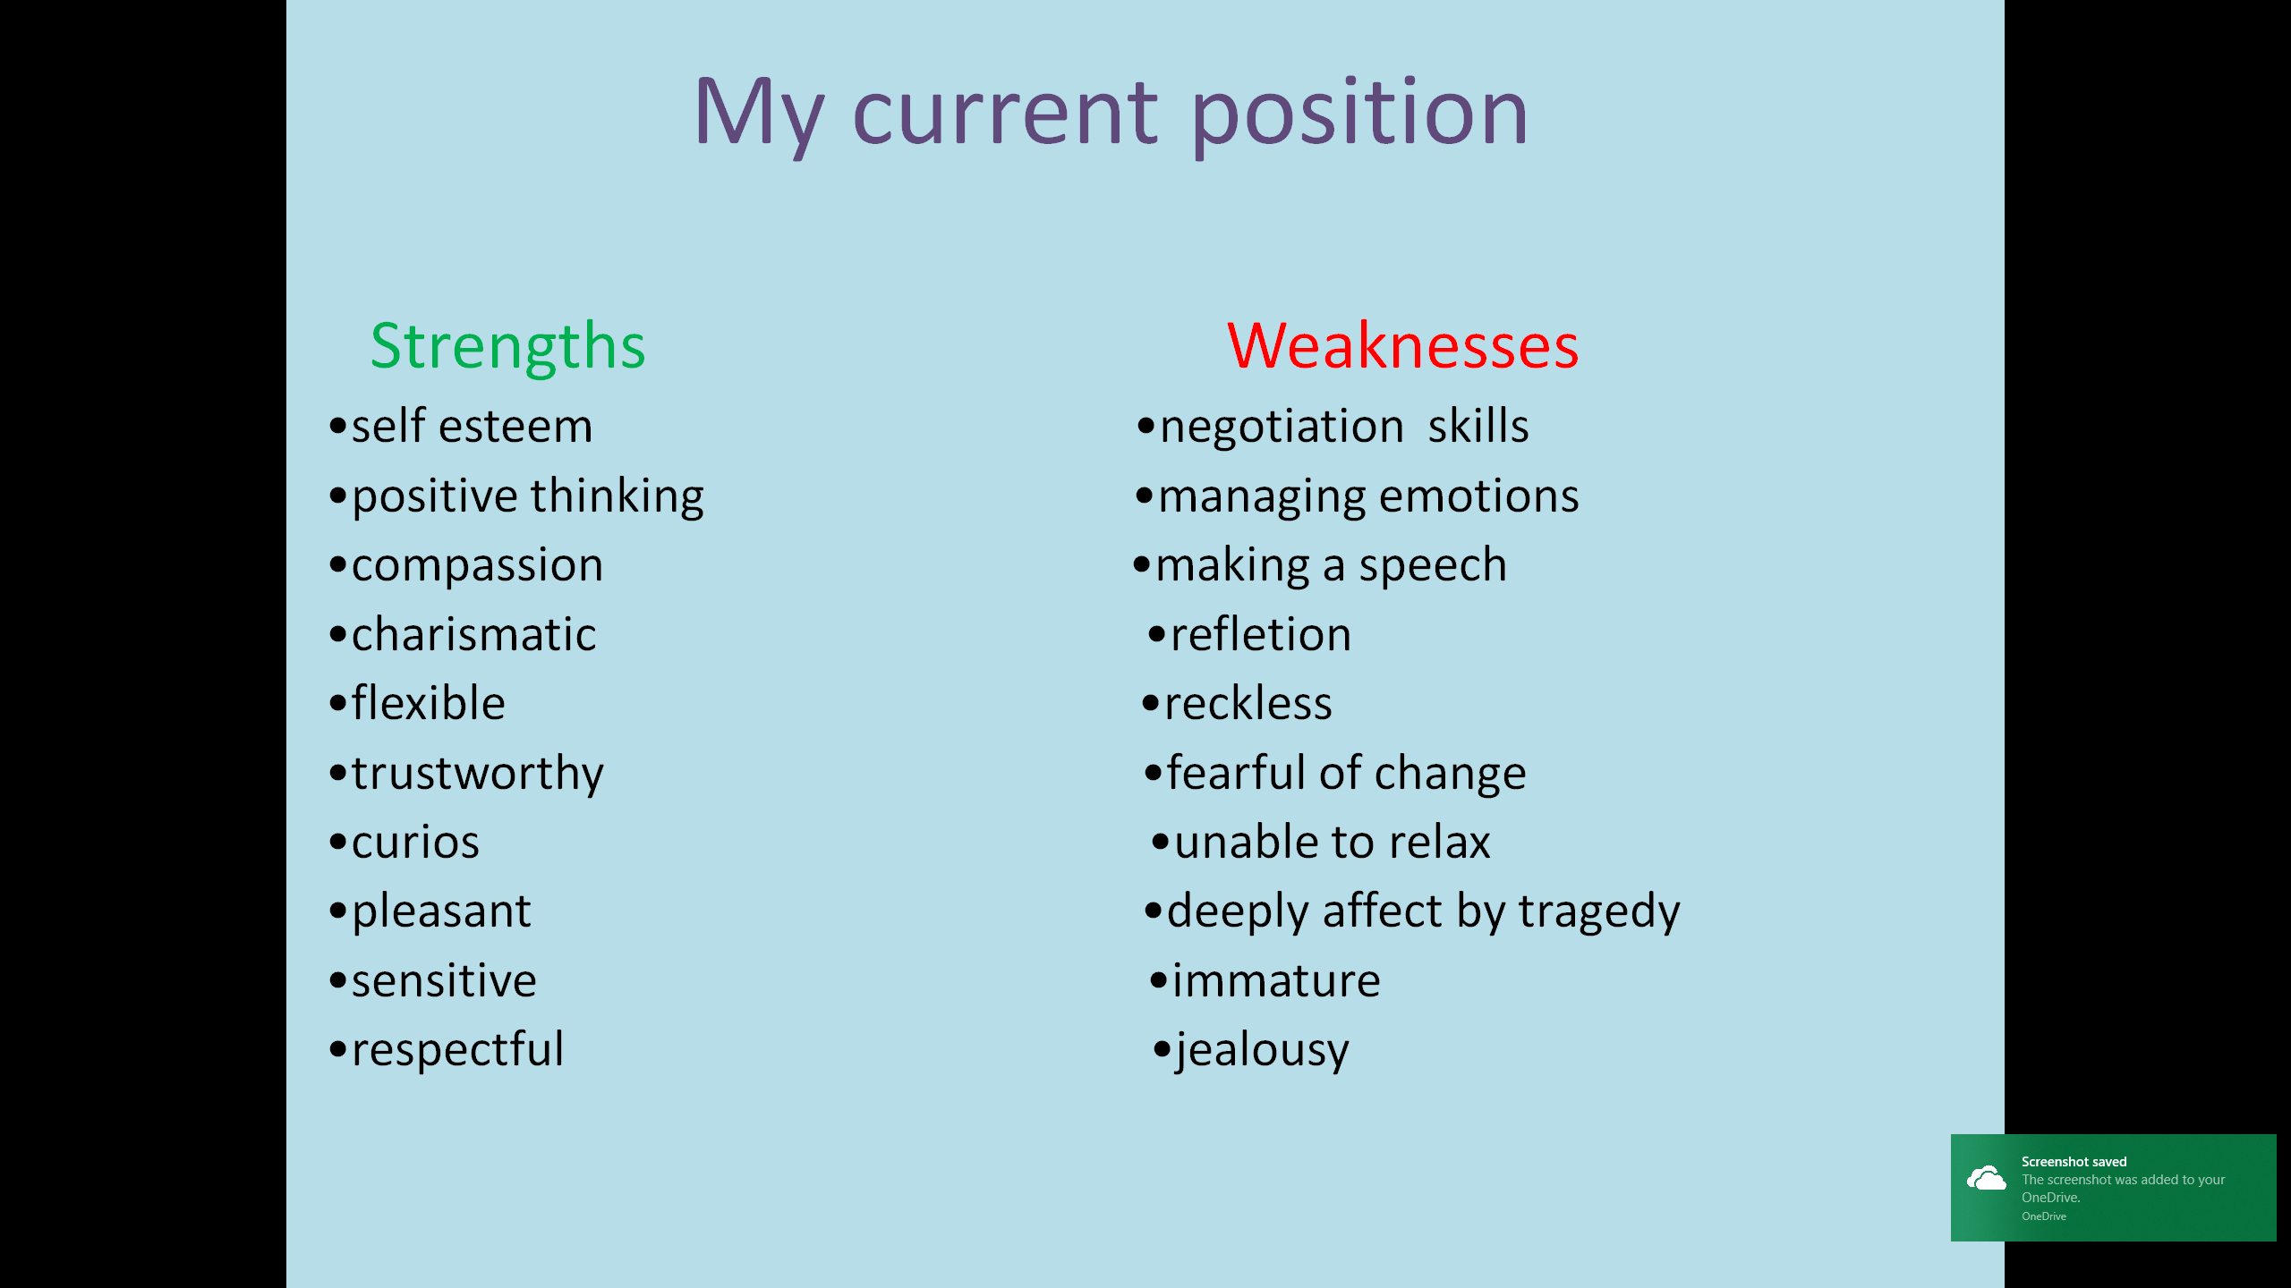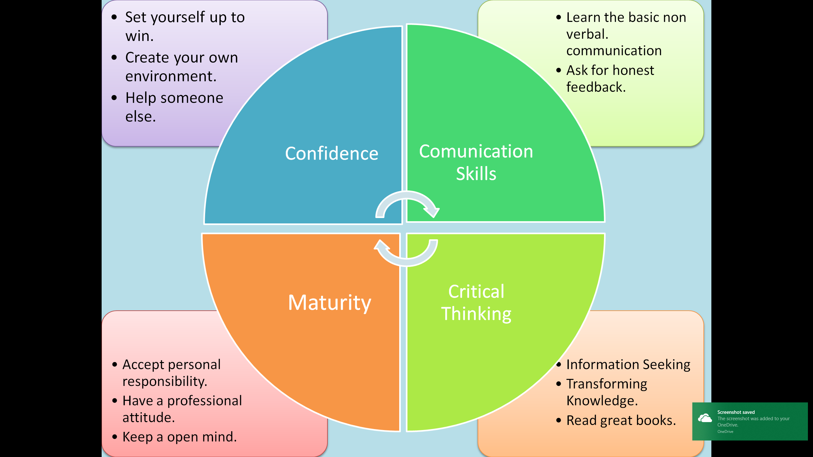
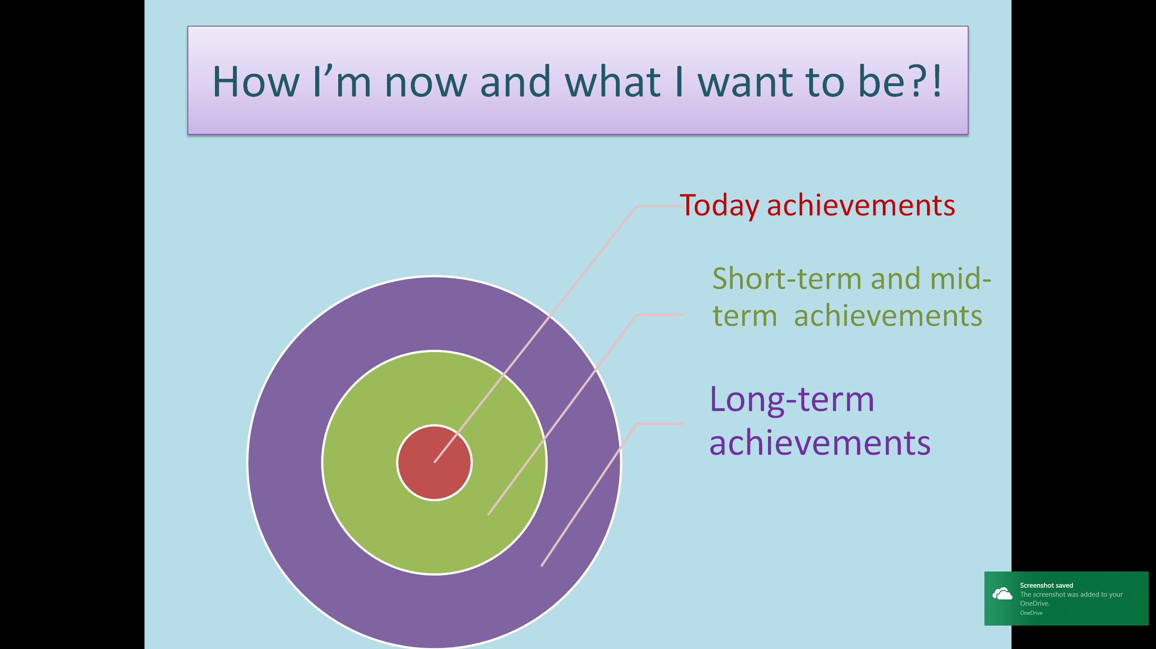

section 7: references
REFERENCE LIST
Almeida, R., Behrman, J. and Robalino, D. eds., 2012. The right skills for the job? Rethinking training policies for workers. The World Bank.
Basin, D., Debois, S. and Hildebrandt, T., 2018. On purpose and by necessity: compliance under the GDPR. Proceedings of Financial Cryptography and Data Security, 18.
Bhanot, R. and Hans, R., 2015. A review and comparative analysis of various encryption algorithms. International Journal of Security and Its Applications, 9(4), pp.289-306.
Blackmer, W.S., 2016. GDPR: getting ready for the new EU general data protection regulation. Information Law Group, InfoLawGroup LLP, Retrieved, 22(08), p.2016.
Carey, P., 2018. Data protection: a practical guide to UK and EU law. Oxford University Press, Inc..
Danezis, G., Domingo-Ferrer, J., Hansen, M., Hoepman, J.H., Metayer, D.L., Tirtea, R. and Schiffner, S., 2015. Privacy and Data Protection by Design-from policy to engineering. arXiv preprint arXiv:1501.03726.
Dodd P. and Sundheim D., 2005. The 25 Best Time Management Toolls & Techniques: How to Get More Done Without Driving Yuorself Crazy. p.22,p.109
Freiherr, A.V.D.B. and Zeiter, A., 2016. Implementing the EU General Data Protection Regulation: A Business Perspective. Eur. Data Prot. L. Rev., 2, p.576.
Garrido, M., Sullivan, J. and Gordon, A., 2010, December. Understanding the links between ICT skills training and employability: an analytical framework. In Proceedings of the 4th ACM/IEEE International Conference on Information and Communication Technologies and Development (p. 15). ACM.
Harvey, L., 2005. Embedding and integrating employability. New Directions for Institutional Research, 2005(128), pp.13-28.
Hillage, J. and Pollard, E., 1998. Employability: developing a framework for policy analysis. London: DfEE.
Iles, P., Forster, A. and Tinline, G., 1996. The changing relationships between work commitment, personal flexibility and employability: An evaluation of a field experiment in executive development. Journal of Managerial Psychology, 11(8), pp.18-34.
Kaaniche, N. and Laurent, M., 2017. Data security and privacy preservation in cloud storage environments based on cryptographic mechanisms. Computer Communications, 111, pp.120-141.
Li, Y., Gai, K., Qiu, L., Qiu, M. and Zhao, H., 2017. Intelligent cryptography approach for secure distributed big data storage in cloud computing. Information Sciences, 387, pp.103-115.
Mabe, P.A. and West, S.G., 1982. Validity of self-evaluation of ability: A review and meta-analysis. Journal of applied Psychology, 67(3), p.280.
Macan, T.H., Shahani, C., Dipboye, R.L. and Phillips, A.P., 1990. College students' time management: Correlations with academic performance and stress. Journal of educational psychology, 82(4), p.760.
MacCann, C., Fogarty, G.J. and Roberts, R.D., 2012. Strategies for success in education: Time management is more important for part-time than full-time community college students. Learning and Individual Differences, 22(5), pp.618-623.
McQuaid, R.W. and Lindsay, C., 2005. The concept of employability. Urban studies, 42(2), pp.197-219.
Rothwell, A., Herbert, I. & Rothwell, F., 2008. Self-perceived employability: Construction and initial validation of a scale for university students. Journal of Vocational Behaviour, 73, pp.1-12.
Uusiautti S. and Maatta K., 2015. The Psychology of Becoming a Successful Worker. pp.21-22..

