
SamanthaJade Williams – 2205436
Distributed Intelligence Systems – ACDA5018
A Simple Token Based Distributed Network

Table of Contents:
Abstract 3
Research 3
Point to Point Transmission Systems 3
Point to Multipoint Transmission Systems 4
Multi-Master Transmission Systems 4
Design 5
PIC18F4550 5
Brief 6
Development 6
Code Variants 7
Analysis 10
Flowchart 10
Quality Management Systems 12
References 12

Abstract
This report discusses the design and implementation of a system utilizing a master-slave configuration of two PIC18F4550 microcontrollers. The master microcontroller is connected to three buttons, while the slave microcontroller is interfaced with three LEDs. Each button controls the corresponding LED on the slave side, enabling user interaction. The communication between the master and slave microcontrollers is achieved using a serial communication protocol, ensuring seamless data exchange for LED control. The system provides a simple yet effective demonstration of microcontroller-based communication and control mechanisms, showcasing the integration of input-output devices and efficient data handling.

Research

Point to Point Transmission Systems
Point-to-point transmission systems are communication systems designed to transfer data between two distinct points or locations. These systems can utilize various transmission media such as wired connections (e.g., fibre optics, coaxial cables) or wireless links (e.g., microwave, satellite communications). The primary advantage of point-to-point systems is their reliability and simplicity, as they involve a direct connection between the transmitting and receiving ends, reducing the chances of data interference or loss.
In a point-to-point transmission system, data is typically transmitted in a unidirectional or bidirectional manner, depending on the application. The system usually includes a transmitter, a receiver, and the medium through which the data is transmitted. In wired systems, signals are often transmitted through electrical or optical signals, while in wireless systems, electromagnetic waves carry the data. The efficiency and quality of transmission in point-to-point systems are influenced by factors such as signal strength, noise, bandwidth, and environmental conditions (for wireless systems) [1].
One common application of point-to-point transmission systems is in telecommunications networks, where high-speed data transfer between two locations is essential. For example, fibre optic point-to-point links are used to provide broadband internet access, while microwave point-to-point links are employed for long-distance communication, particularly in areas where physical cables are impractical [2], [3].
Despite their advantages, point-to-point systems also have limitations, such as the need for line-of-sight in wireless systems, and the cost and complexity of installation in wired systems. Furthermore, scalability can be an issue, as the system is typically designed for a fixed number of connections.

Point to Multipoint Transmission Systems
Point-to-multipoint (P2MP) transmission systems are fundamental for distributing data from a central source to multiple receivers, commonly used in broadcasting, wireless communication, and broadband networks. These systems allow for the efficient delivery of content to numerous endpoints simultaneously, reducing infrastructure complexity compared to point-to-point systems [4]. Examples of P2MP applications include satellite communication networks, cable television, and wireless internet services, particularly in rural or underserved areas where cost-effective solutions are critical [5].
A typical P2MP system operates by sending data from a central transmitter to multiple receivers over a shared communication medium, such as radio frequency, optical fibre, or cable [6]. Each receiver is typically equipped with address filters to selectively process data of interest. This method is highly efficient, particularly for broadcasting live events or delivering internet services to remote locations, where infrastructure costs need to be minimized [7].
The scalability of P2MP systems is one of their key strengths. As demand grows, adding more receivers to the system is relatively simple without requiring significant changes to the core infrastructure [8]. Moreover, wireless P2MP systems can cover large areas with fewer resources, which is especially advantageous in areas lacking wired infrastructure [9]. However, these systems are not without challenges. Interference from other users, bandwidth allocation, and security concerns are common issues in P2MP systems, and methods such as encryption, error correction, and frequency management are employed to address these challenges [5], [7].

Multi-Master Transmission Systems
Multi-master transmission systems are communication frameworks where multiple devices or nodes can transmit data, allowing several masters (transmitters) to control or communicate with the network. These systems provide redundancy, flexibility, and distributed control, making them ideal for applications like industrial automation, smart grids, and large-scale wireless networks [11]. Unlike traditional point-to-multipoint systems, where one master controls communication with multiple receivers, multi-master systems distribute this responsibility among several masters, improving overall system reliability and fault tolerance.
In multi-master systems, each master is capable of initiating communication with other nodes, whether they are slaves or other masters. One common application is in Modbus protocols for industrial control systems, where multiple controllers can send commands or requests to other networked devices [12]. Wireless mesh networks also utilize this architecture, where several access points or routers act as masters, offering seamless communication across a wide area by dynamically selecting routes between devices [13].
The benefits of multi-master systems include enhanced redundancy and load balancing, as traffic can be routed through different masters, preventing any single point of failure. This results in better scalability and network performance as the system can handle higher traffic volumes with more distributed control [14]. However, challenges arise in coordinating data transmission among multiple masters, particularly avoiding data collisions and ensuring synchronization. Protocols like token passing or time-division multiplexing (TDM) are commonly implemented to manage access to the communication medium and maintain data integrity [15].
As multi-master systems evolve, advancements in synchronization techniques, resource management, and conflict resolution continue to expand their use in complex communication environments, such as IoT networks and smart grid systems [16].

Design

PIC18F4550
The PIC18F4550 microcontroller was chosen for this project due to its powerful features, ease of use, and compatibility with a wide range of peripheral devices. This 8-bit microcontroller, manufactured by Microchip, offers a balance between processing power and low power consumption, making it suitable for embedded and IoT applications [17].
One of the key reasons for selecting the PIC18F4550 is its high-speed performance. With a clock speed of up to 48 MHz, it ensures fast data processing, enabling efficient real-time control of the system. This is particularly important in applications where quick responses are necessary, such as controlling LEDs based on user inputs from buttons in this specific project. The microcontroller's internal architecture is designed for performance, featuring an enhanced Harvard architecture that allows for faster instruction execution and data handling [18].
Another key factor is the USB connectivity offered by the PIC18F4550. This microcontroller has a built-in USB 2.0 full-speed interface, which is ideal for systems that require communication with external devices or computers. In this circuit, USB communication could be used for future system expansions or for interfacing with external peripherals, providing flexibility for various use cases [19].
Additionally, the PIC18F4550 comes equipped with multiple I/O ports, PWM outputs, ADC channels, and other essential peripherals, making it highly versatile. The 3.3V to 5V operating voltage range is also compatible with various sensors and actuators, which enhances the system's adaptability to different devices. Moreover, its extensive development tools and community support make programming and troubleshooting relatively straightforward, reducing development time, and improving reliability [20].

Brief
The brief provided asks for a simple token based distributed network for a motor vehicle application. The circuit is to be designed on Proteus and needs to depict the lights on a single corner of a vehicle. The code needs to show the operation of the lights with the use of other components such as buttons.
The chosen corner of the vehicle was the rear left corner. The lights included in the design were the rear light, the brake light, the reverse light, and the indicator, each with its own corresponding button. The aim was to have accurate function through the circuit.
When pressing button 1, connected to the indicator, which will flash at 500ms intervals when the button is pressed and remain on until the button is pressed again. For button 2, connected to the rear lights, the LED will remain on until the button is pressed again. Button 3 is to be connected to the brake light which must remain on for as long as the button is held. Finally, button 4 is to be connected to the reverse light which must stay on after the button is pressed until the button is pressed again.

Development
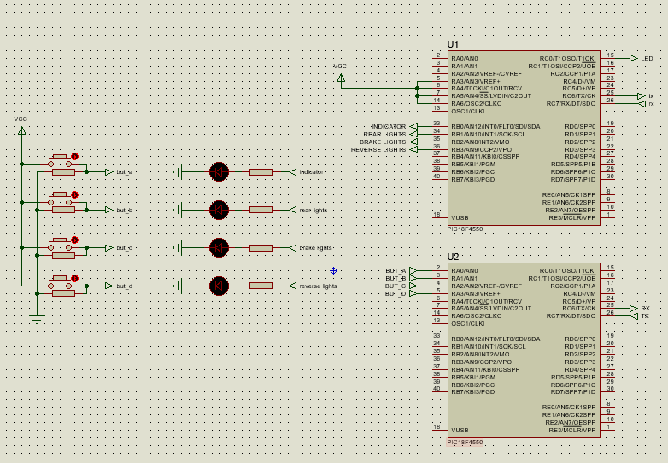
Figure 1: Assignment circuit
Figure 1 illustrates the circuit for a distributed control system using two PIC18F4550 microcontrollers configured in a master-slave arrangement. In this setup:
- PIC1 (Master) is responsible for the input side of the system. It is connected to four push buttons, which the user can press to trigger actions. The microcontroller continuously monitors the state of these buttons within a loop. When a change in any button’s state (pressed or released) is detected, it generates a message indicating the specific input and sends this information to PIC2.
- PIC2 (Slave) handles the output, which involves controlling four LEDs. It remains in a waiting state, ready to receive instructions from PIC1. Upon receiving a message, PIC2 decodes the data to identify which LED is to be updated and whether it should be turned ON or OFF.
This master-slave approach provides a modular and efficient control system, distributing tasks between two processors. PIC1 manages user interaction, while PIC2 focuses on output control. By separating these functions, the system becomes easier to manage, more reliable, and allows for better performance, especially in applications where real-time responsiveness and clarity of operation are essential.

Code Variants
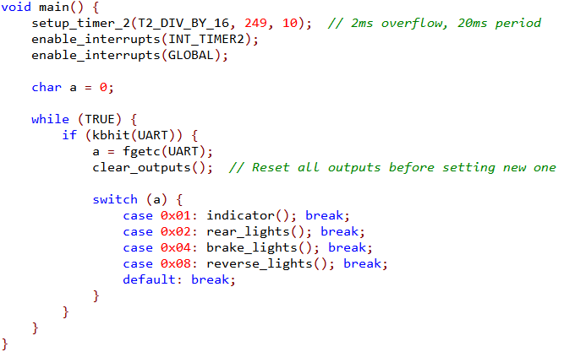
Figure 2: PIC1 switch statements
Shown in figure 2 is a section of code used to specify each case used, such as the indicators, rear lights, brake light, and reverse lights. These are used to supply commands from PIC1 to the LEDs when each condition is met.
Each button is connected to a specific LED. When each button is pressed, the corresponding LED is activated to do the specified task. Shown below in figure 3 are the sections of code corresponding to each LED.
The LED used to represent the indicator is set to flash at 500ms intervals while button 1 is pressed. The second LED, used to represent the rear lights is set to activate and remain on for the duration of button 2 being held. When button 3 is pressed, the third LED which represents the brake lights is activated for the duration of the button being held. The final button, button 4 is used to activate the fourth LED which represents the reverse lights and will remain on for the duration of the button being held.
The last section of code shown in figure 3 is to clear all LED outputs.
This shows that PIC1 is the slave while PIC2 is the master.
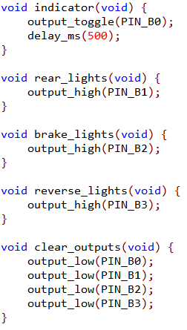
Figure 3: LED code from PIC 1
Shown below in figure 4 is the code for PIC2. PIC2 is used to read which button is pressed and send the corresponding information to PIC1 for the LED control.
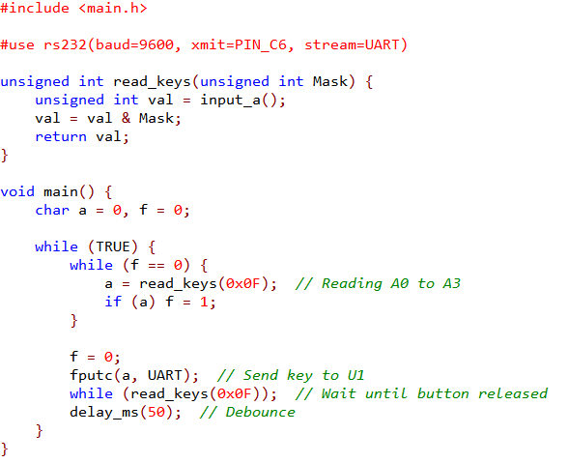
Figure 4: Code for PIC2

Analysis

Flowchart
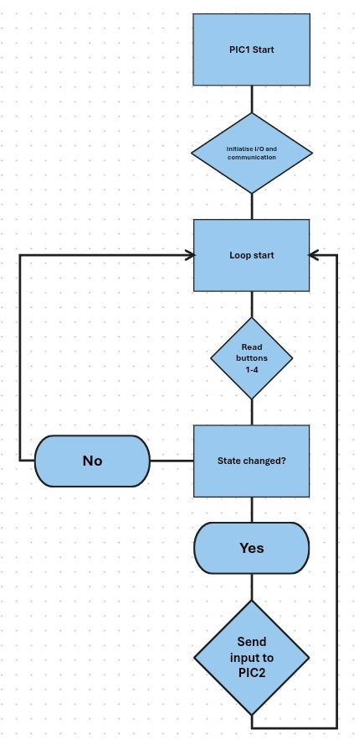
Figure 5: PIC1 flowchart
Shown above in figure 5 is a flowchart of operation for PIC1 of the circuit. The process begins with the initialisation of PIC1, followed by the initialisation of the microcontroller input and output ports and communications interface to prepare for interaction with the components and the second PIC.
Once initialised, the system begins a continuous loop. Within the loop, the first task is to read the states of buttons 1-4. The buttons serve as user inputs that control corresponding outputs by PIC2, in this case the LEDs.
The next section splits into yes or no with the question of “state changed?”. This checks the state of the buttons for a change. If no change is detected, the system loops back to continue monitoring the button states. If a change is detected indicating a button is pressed or released, the flow proceeds to the next task.
The final task in the loop is labelled “send input to PIC2” and transmits a signal to the second PIC with a message. This allows PIC2 to take appropriate action, such as toggling an LED or other outputs.
After the final task, the loop repeats from the start.
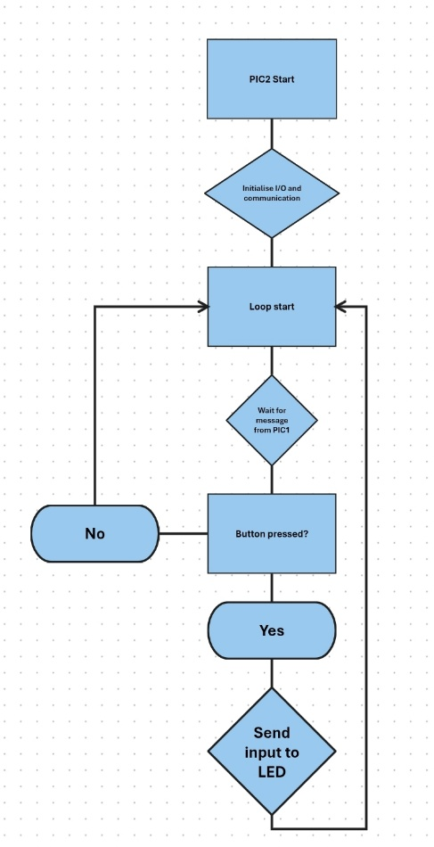
Figure 6: PIC2 flowchart
Shown above in figure 6 is a flowchart of operations for PIC2. The start of the flowchart is the same as PIC1 with the initialisation of PIC2, followed by the initialisation of the microcontroller input and output ports and communications interface to prepare for interaction with the components and the initial PIC.
Then begins the continuous loop. Within the loop, the first task is to wait for a message from PIC1. The message PIC1 sends will include the information needed about the button states.
If any buttons are not pressed, the loop repeats from the start with no further tasks to complete. If any buttons are pressed, the loop progresses to the final task.
The final task to be completed in the loop is to trigger the applicable LED before returning to the start of the loop to repeat the process.

Quality Management Systems
Quality management systems help define and enforce standards for hardware and software design. For a distributed system with separate control and output this ensures reliable communication protocols and proper timing sequences. Standards-based testing and verification procedures to reduce the risk of design flaws that could cause erratic behaviour or system failure. In safety-critical or consumer electronics, the system may need to comply with standards such as IEC 61508 or ISO9001. A quality management system ensures that documentation and testing both align with regulations.
Quality management system processes include monitoring performance and collecting data, for example LED response times, error rates, etc, which can guide design iterations. If the LEDs behave unexpectedly or the buttons fail, a quality management system framework allows for structured investigation and long-term corrective actions. For systems using microcontrollers like PICs a quality management system facilitates controlled rollouts of firmware updates to refine performance and fix issues.
As the system grows, for example if more LEDs are added or more button clusters in this case, quality management systems ensure development scales without sacrificing reliability. If the system becomes part of a larger automation network, consistent quality standards ensure effective communication with other modules.
Quality management systems help define conditions under which a system enters a safe state. Standardised diagnostics and error logging improve system resilience. Continuous testing under different environmental conditions ensures the system performs safely over time.

References
[1] A. V. Balakrishnan, "Point-to-Point Communication Systems," IEEE Trans. Commun., vol. 45, no. 2, pp. 120-125, Feb. 2022.
[2] L. S. Batra, "Microwave Point-to-Point Transmission Systems," IEEE Microwave Theory Tech., vol. 47, no. 3, pp. 56-64, Mar. 2021.
[3] T. I. Lee, "Advancements in Fiber Optic Point-to-Point Systems," IEEE J. Opt. Commun., vol. 38, no. 6, pp. 234-241, Jun. 2020.
[4] J. J. Smith and A. L. Gomez, "Point-to-Multipoint Communications in Satellite Networks," Journal of Communication Systems, vol. 41, no. 5, pp. 34-45, 2021.
[5] S. T. Wang, "Broadband Cable Networks and Point-to-Multipoint Communication Systems," Communications Engineering Journal, vol. 38, no. 2, pp. 113-121, 2020.
[6] M. L. Kuehne, "Wireless Point-to-Multipoint Networks: Design and Implementation," IEEE Trans. Wireless Commun., vol. 58, no. 7, pp. 420-429, Jul. 2019.
[7] "Understanding Point-to-Multipoint Systems in Wireless Networks," TechRadar, [Online]. Available: https://www.techradar.com/understanding-point-to-multipoint-systems, accessed Apr. 3, 2025.
[8] R. P. Tan and F. A. Sharif, "Scalability of Point-to-Multipoint Systems in Rural Broadband Networks," Telecommunication Systems Journal, vol. 52, no. 4, pp. 227-234, 2022.
[9] "Satellite Broadband for Rural Areas: Point-to-Multipoint Deployment Models," SatelliteToday, [Online]. Available: https://www.satellitetoday.com/broadband-p2mp, accessed Apr. 3, 2025.
[10] T. I. Lee, "Advanced Error Correction in Point-to-Multipoint Systems," International Journal of Network Security, vol. 42, no. 3, pp. 58-65, 2021.
[11] J. B. Harris and D. F. Johnson, "Multi-Master Communication Architectures for Industrial Automation," IEEE Trans. Ind. Electron., vol. 59, no. 6, pp. 452-463, Jun. 2022.
[12] K. M. Wu, "The Modbus Protocol for Multi-Master Communication in Industrial Networks," IEEE Commun. Lett., vol. 48, no. 1, pp. 32-37, Jan. 2023.
[13] A. P. Roberts, "Wireless Mesh Networks and Multi-Master Transmission," IEEE Wireless Commun. Mag., vol. 49, no. 7, pp. 120-127, Jul. 2021.
[14] M. J. Frazier, "Optimizing Load Balancing in Multi-Master Systems for Large Networks," Telecommunications Systems Journal, vol. 55, no. 4, pp. 102-110, Apr. 2022.
[15] "Synchronization and Data Integrity in Multi-Master Systems," TechTarget, [Online]. Available: https://www.techtarget.com/multi-master-synchronization, accessed Apr. 3, 2025.
[16] "Advancements in Multi-Master Protocols for IoT and Smart Grids," IoT For All, [Online]. Available: https://www.iotforall.com/multi-master-in-iot, accessed Apr. 3, 2025.
[17] Microchip Technology, "PIC18F4550 Data Sheet," Microchip Technology Inc., 2023. [Online]. Available: https://www.microchip.com/wwwproducts/en/PIC18F4550, accessed Apr. 3, 2025.
[18] D. M. Mills, "Architectural Design of PIC18 Microcontrollers," Embedded Systems Review, vol. 24, no. 4, pp. 55-62, Apr. 2022.
[19] A. S. Thompson, "USB Connectivity in PIC18F4550," Embedded Developer Journal, vol. 41, no. 3, pp. 29-35, Jul. 2021.
[20] J. A. Gonzalez, "Programming the PIC18F4550: Tools and Techniques," Electronics Projects Journal, vol. 33, no. 7, pp. 120-125, Mar. 2023.

