

Component 1: Online portfolio of set exercises
Changemakers: Creativity and Value Creation Professions (BMHP5014)
Student name: Laura Gando
Student number: 2428547
Lecturer’s name: Laila Surani

Contents
Introduction 2
Task 1 – Defining Key Concepts in Practice 2
Task 2 - Mind Map 3
Task 3 – Self-Reflection of Group Activity (Gibbs’ Reflective Cycle) 4
Task 4 -Examination of a UK Innovation Case Study..................................................................5
Task 5– Research Task: NHS Waiting Times..............................................................................6
Task 6– Exploring Digital Innovation in Health and Social Care..................................................7
Task 7- Understanding the NHS Leadership Framework...........................................................9
Task 8 - Self-Reflection Journal Entry ....................................................................................10
Conclusion..........................................................................................................................10
Reference List......................................................................................................................11

Introduction
This portfolio focuses on creativity, innovation, value creation, and leadership within the health and social care sectors. It draws on relevant theories and evidence to illustrate how creative thinking, digital innovation, and reflective practice enhance person-centred care, service quality, and professional development, equipping practitioners to address the evolving needs of health care.

Task 1 – Defining Key Concepts in Practice
Innovation
Innovation involves applying new ideas, technologies, or methods to improve the quality and effectiveness of services (Nolte, 2018). From my experience, innovation is vital in health and social care, as it helps organisations respond to increasing demands and improve patient outcomes. For example, telehealth services allow for remote healthcare access, making care more convenient and reducing the necessity for hospital visits. Rogers’ Diffusion of Innovation Theory explains how organisations gradually adopt new ideas (Rogers, 2003).
Creativity
Creativity is defined as the ability to generate innovative and beneficial ideas that address issues or improve practices (Corazza, 2016). Completing this assignment has deepened my understanding of creativity’s value in health and social care, as practitioners often need to adapt treatments to individual needs. For instance, carers can design activities specifically intended to improve engagement and well-being for people with dementia. Amabile and Pratt’s (2016) Dynamic Componential Model posits that expertise, motivation, and original thinking skills drive creativity.
Creation of value.
Involves maximising resource utilisation while improving outcomes and experiences for service consumers (Gray, 2017). This was a crucial concept, in my opinion, as health and social care groups had to deliver high-quality care on a tight budget. One example is that interdisciplinary cooperation may improve the coordination of treatment and communication and lead to improved patient outcomes. In the Triple Aim Framework, Berwick, Nolan, and Whittington (2008) emphasise the importance of generating value by improving patient experiences, advancing population health, and reducing costs.
Change
Change refers to introducing new processes or systems with the aim of improving organisational effectiveness and the delivery of services (Harrison et al., 2021). I have learned that health and social care systems must adapt to advances in technology, policy updates, and evidence-based approaches. For example, the COVID-19 pandemic led to the introduction of automated consultations, which improved access to healthcare. According to Lewin’s change management framework, developing strategies for transformation, adopting new practices, and embedding them into everyday care are essential steps (Burnes, 2020).

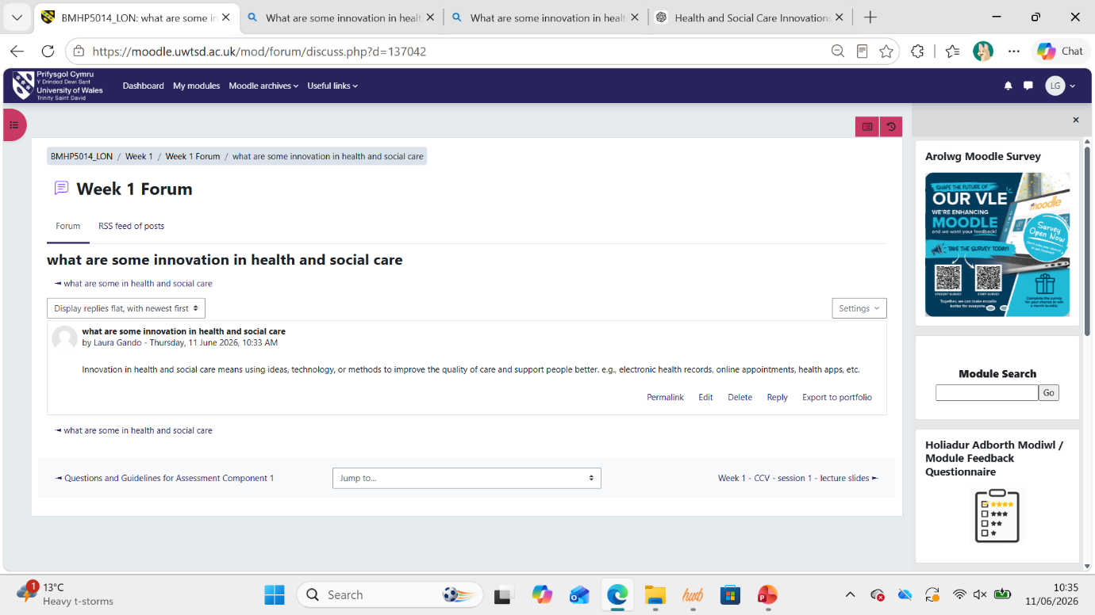

Task 2 - Mind Map
Drug abuse in Kennington
Causes
Poverty and unemployment
Mental health problems
Family breakdown
Peer pressure
Social isolation
Easy availability of drugs
Cannabis
Cocaine Heroin
Synthetic drugs

Impacts
Individuals
Addiction
Poor physical health
Poor mental health
Increased risk of overdose

Solutions
Drug education programmes
Community awareness campaigns
Rehabilitation services
Mental health support
Family support services
Community outreach programmes

  - Explanation of the Mind Map
Drug misuse in Kennington is a significant health and social care problem affecting individuals, families, and the community. Making this mind map made it easier for me to comprehend how several factors, such as poverty, unemployment, mental health issues, family dissolution, peer pressure, and drug availability, contribute to drug misuse. It can lead to substance misuse such as cannabis, cocaine, and heroin. Addiction, poor physical and mental health, overdose, family disruption, and an increase in the need for social and health care services are some of the consequences. The Social Determinants of Health Framework explains that social and economic conditions affect health outcomes and substance misuse, which points to the importance of prevention (World Health Organisation, 2010).
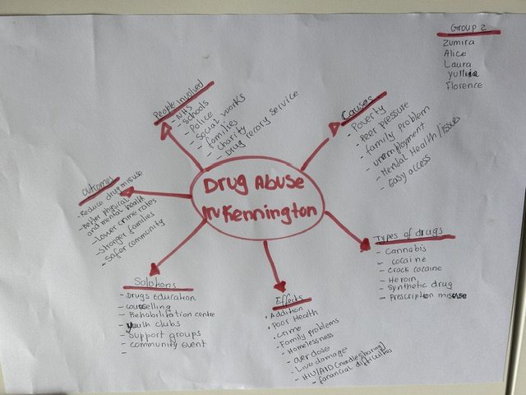

Task 3 – Self-Reflection of Group Activity (Gibbs’ Reflective Cycle)
I have utilised Gibbs’ Reflective Cycle (Gibbs, 1988) to reflect upon the convergent and divergent thinking group exercise.
Description: In the activity, our group performed divergent thinking to produce various options and then convergent thinking to determine the best alternative. We were unable to reach consensus, so I suggested that we write pros and cons based on our research criteria, which helped the group reach a collective opinion.
Feelings: The brainstorming was fun as a creative and open discourse. But I was disappointed in the group’s inability to establish consensus. I felt more secure and was able to participate productively since I had scientific material to refer to.
Evaluation and Analysis: This activity has helped me realise that divergent thinking supports the production of diverse ideas, whereas convergent thinking focuses on examining data to determine the most appropriate alternative (Benedek & Fink, 2019). I realised I naturally tended toward convergent thinking, as I enjoyed structuring my thoughts and testing them against the evidence provided. I used Gibbs’ technique to critically reflect on my contribution, showing that organised reflection enhances learning and professional judgement (Nguyen et al. 2014).
Conclusion and Action Plan: I have learnt that excellent cooperation involves a balance between invention and critical thinking.
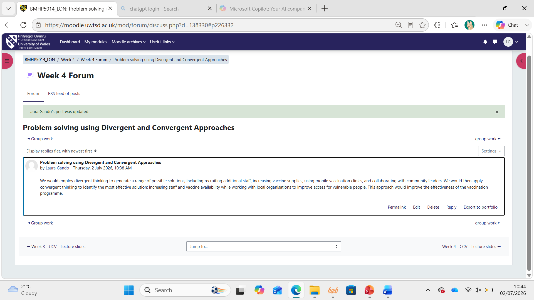

Task Four – Examination of a UK Innovation Case Study
An example of innovation in UK health and social care is the Technology Integrated Health Management (TIHM) for Dementia project, which was created as part of the NHS Test Beds programme. TIHM employs smart home sensors, wearable devices, and artificial intelligence to help monitor individuals with dementia in their homes (NHS England, 2023). I learnt that the innovation was introduced because an increasing number of people with dementia require support to live independently while health and social care services face growing demand and workforce shortages. Traditional care often relies on reactive responses after people become unwell. Creativity is demonstrated by combining digital technology with health and social care to provide continuous monitoring. Smart home sensors detect changes in daily routines, including reduced movement, poor sleep and unusual door activity, enabling healthcare professionals to intervene early before problems worsen (Wherton et al., 2025). This proactive approach improves safety, supports independent living and reduces avoidable hospital admissions. The innovation creates value by improving independence and reassuring family carers. Healthcare staff benefit from real-time information that supports clinical decision-making and more efficient resource use. Rogers' Diffusion of Innovation Theory explains why TIHM is likely to be adopted because it offers clear advantages over traditional care and demonstrates observable benefits sustainably.
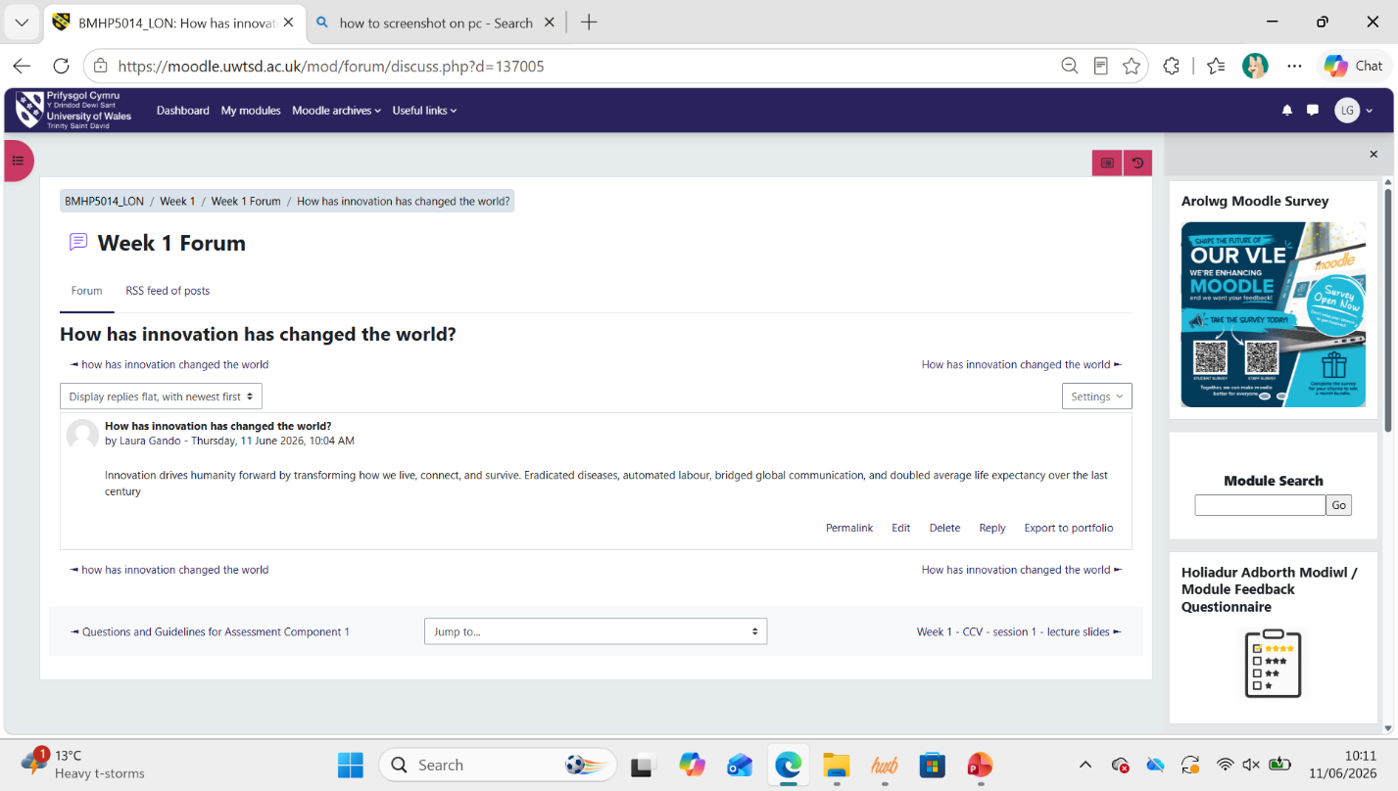

Task Five – Research Task: NHS Waiting Times
Long NHS waiting times remain a major challenge because they delay treatment and worsen patient outcomes. Reviewing this research helped me understand that waiting times result from several interconnected factors. Paling et al. (2020) found that emergency department delays increase because of high bed occupancy, rising patient demand, and delays transferring patients to inpatient wards, showing that pressures affect the whole healthcare system rather than one department.
Reichert and Jacobs (2018) examined waiting times in mental health services and found that longer delays were linked to poorer health outcomes because access to treatment was postponed. I found that this particularly affects patients who require early intervention to support recovery and wellbeing.
Both studies agree that long waiting times reduce the quality of patient care and highlight the need for service improvement. However, Paling et al. (2020) focus on organisational pressures, whereas Reichert and Jacobs (2018) emphasise the impact on individual patients. This comparison strengthened my understanding of systems theory, which explains how problems in one part of the healthcare system affect others. In NHS practice, staff shortages, limited hospital beds, and increasing demand continue to contribute to delayed patient care (Paling et al., 2020; Reichert and Jacobs, 2018).
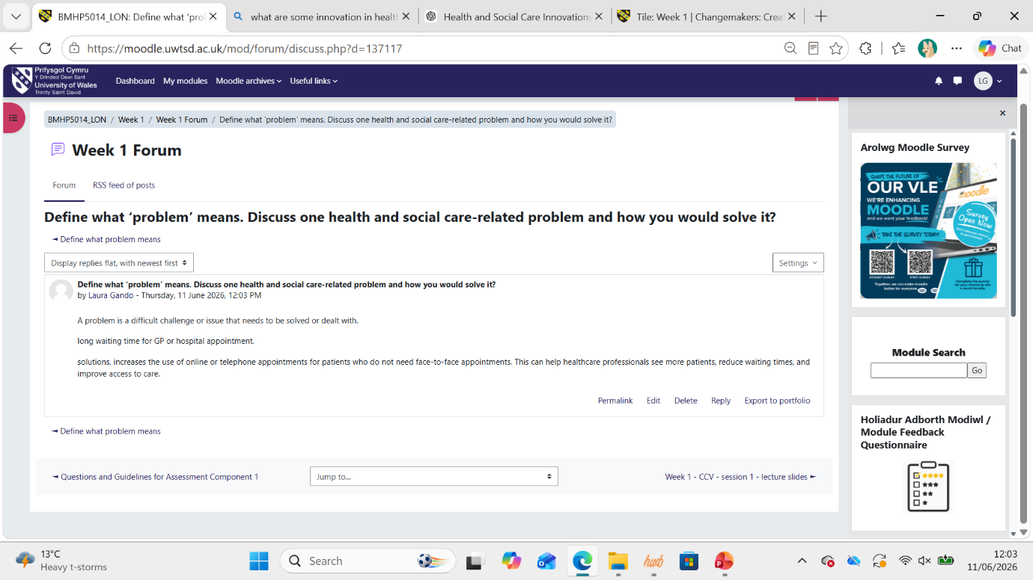

Task Six – Exploring Digital Innovation in Health and Social Care
Wearable health technologies, such as the Fitbit Charge, support people with chronic conditions by monitoring physical activity, heart rate and sleep. I learned that this information helps users manage their health and encourages healthier lifestyle choices. For example, a person with type 2 diabetes can use a Fitbit Charge to monitor daily exercise and improve blood glucose control. Healthcare professionals can also review the data to provide personalised advice. Recent evidence suggests that wearable devices improve self-management by encouraging behavioural change and increasing patient engagement (Gagnon et al., 2024). According to the Technology Acceptance Model, continued use depends on whether people perceive the technology as beneficial and simple to use (Davis, 1989). However, I recognised that some users may experience barriers such as digital literacy or the cost of wearable devices, which could limit their effectiveness.

Electronic Health Records (EHRs)
Electronic Health Records (EHRs) enhance communication by enabling healthcare providers to securely exchange patient data, such as medical history, prescriptions, and test results. I learnt from this section that this minimises duplication, promotes continuity of care, and lowers the risk of medication errors (Robertson et al., 2022). For instance, when a patient is discharged from hospital, their GP can instantly access updated records and continue treatment without delay. The Technology Acceptance Model indicates that healthcare professionals are more likely to use digital systems if they enhance clinical practice and are easy to integrate into existing workflows (Davis, 1989). While EHRs support collaboration, I found that organisations must ensure that staff receive proper training and maintain strict data security standards to maximise their benefits.
Health Promotion and Preventative Care
Digital technology promotes preventative care by enabling individuals to track their health and detect risks before illnesses arise. For example, a Fitbit Charge can monitor physical activity, heart rate, and sleep while encouraging users to achieve personalised fitness goals. Healthcare professionals can use this information to recommend lifestyle changes before health problems develop. Researching this topic helped me understand that wearable technologies improve health awareness and encourage healthier behaviours, particularly among older adults (Sun et al., 2025). The Technology Acceptance Model indicates that people are more likely to engage with digital health tools when they recognise their value and consider them easy to use (Davis, 1989). In my future practice, I will view digital technologies as tools that should complement, rather than replace, professional healthcare, ensuring that individuals without access to technology are not disadvantaged.

Task Seven – Understanding the NHS Leadership Framework
The NHS Healthcare Leadership Model highlights key behaviours for effective leadership in health and social care. It emphasises that leadership is a shared responsibility among all staff, regardless of their roles, and encourages collaborative work to enhance patient outcomes (NHS Leadership Academy, 2013). The model outlines behaviours such as caring leadership, vision sharing, team engagement, influencing outcomes, information evaluation, service connection, and accountability. These behaviours support leaders in building positive workplaces where staff feel valued, motivated, and empowered to provide safe, person-centred care. Strong leadership boosts communication, teamwork, decision-making, and ongoing learning, all of which lead to improved care quality and patient experiences. The framework also drives innovation by encouraging leaders to involve staff in service improvements and adapt to changing healthcare needs (West et al., 2017).
Leading with Care
Leading with care involves demonstrating compassion, empathy, and respect for staff and patients. Leaders who value staff wellbeing create trusting environments where employees feel confident sharing ideas and suggesting improvements. This encourages creativity because team members feel safe challenging existing practices and developing innovative solutions. For example, a manager who listens to staff feedback may identify new ways to improve patient communication or reduce waiting times. This behaviour reflects transformational leadership, where leaders inspire and motivate others to achieve positive change through encouragement, support, and a shared vision (Bass and Avolio, 1994).
Reflective Journal Entry
This module has greatly deepened my understanding of creativity and value creation in health and social care. I used to think creativity was mostly about bringing in new technology, but I now see it also involves everyday changes that improve patient care. Learning about the NHS Healthcare Leadership Model and Transformational Leadership showed me that compassionate leadership encourages innovation by supporting staff and valuing different perspectives. Class activities and discussions helped me appreciate the importance of collaboration, reflection, and continuous improvement. In my future career, I will aim to apply these principles by encouraging teamwork, listening to others, and promoting person-centred, innovative practices that improve outcomes for both patients and colleagues.
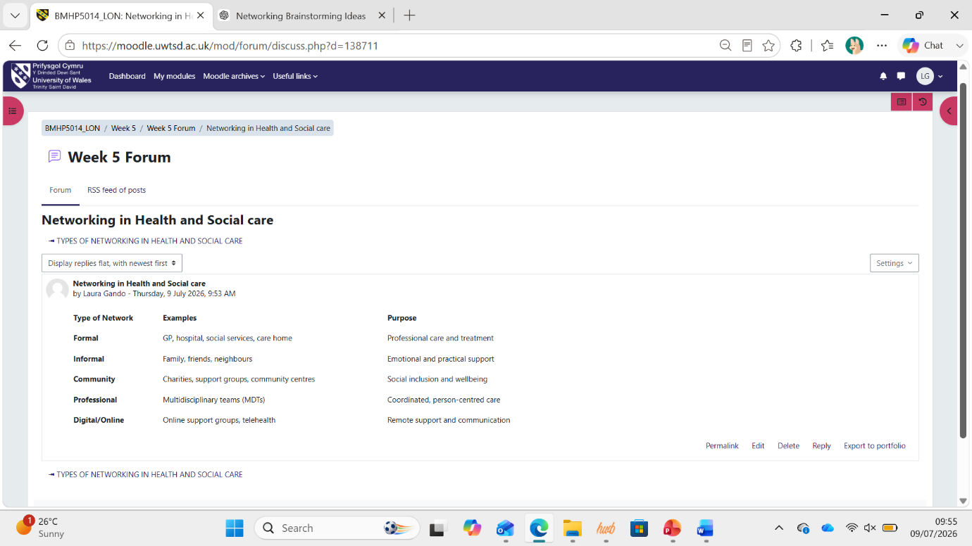

Task Eight – Self-Reflection Journal Entry

This module changed my understanding of creativity, innovation, and value creation in health and social care. Before, I believed creativity mainly involved developing new technology or major service changes. However, during Week 4, the lecturer asked us to draw three health and social care-related pictures using only a circle. This activity challenged my thinking and showed me that creativity involves seeing familiar situations from different perspectives. Using Gibbs' Reflective Cycle (1988), I realised that innovation often begins with simple ideas and reflective thinking rather than with complex solutions. This experience taught me that small, creative changes can improve communication, problem-solving, and patient experiences. In future placements and professional roles, I will encourage colleagues to share ideas, remain open to different approaches, and reflect regularly on practice. I will carry forward the belief that creativity is a practical skill that supports continuous improvement and person-centred care every day.

Conclusion
This portfolio has deepened my understanding of creativity, innovation, and leadership within health and social care. I have discovered that reflection, teamwork, and evidence-based practice are essential for ongoing improvement. These learnings will equip me to deliver person-centred care, adopt innovative approaches, and play a valuable role in enhancing services in my future career.

Reference List
Amabile, T.M. and Pratt, M.G. (2016) 'The dynamic componential model of creativity and innovation in organizations: Making progress, making meaning', Research in Organizational Behavior, 36, pp. 157–183.
Bass, B.M. and Avolio, B.J. (1994) Improving Organizational Effectiveness through Transformational Leadership. Thousand Oaks, CA: Sage.
Benedek, M. and Fink, A. (2019) 'Toward a neurocognitive framework of creative cognition: The role of high-level control processes', Annals of the New York Academy of Sciences, 1476(1), pp. 5–19. Available at: https://doi.org/10.1111/nyas.14130
Berwick, D.M., Nolan, T.W. and Whittington, J. (2008) 'The Triple Aim: Care, health, and cost', Health Affairs, 27(3), pp. 759–769.
Burnes, B. (2020) 'The origins of Lewin's three-step model of change', The Journal of Applied Behavioral Science, 56(1), pp. 32–59.
Corazza, G.E. (2016) 'Potential originality and effectiveness: The dynamic definition of creativity', Creativity Research Journal, 28(3), pp. 258–267.
Davis, F.D. (1989) 'Perceived usefulness, perceived ease of use, and user acceptance of information technology', MIS Quarterly, 13(3), pp. 319–340.
Gagnon, M.-P., Ouellet, S., Attisso, E., Supper, W., Amil, S., Rhéaume, C., Paquette, J.-S., Chabot, C., Laferrière, M.-C. and Sasseville, M. (2024) 'Wearable devices for supporting chronic disease self-management: Scoping review', Interactive Journal of Medical Research, 13, e55925. Available at: https://doi.org/10.2196/55925
Gibbs, G. (1988) Learning by Doing: A Guide to Teaching and Learning Methods. Oxford: Oxford Polytechnic.
Gray, M. (2017) 'Value based healthcare', BMJ, 356, j437. Available at: https://doi.org/10.1136/bmj.j437
Harrison, R., Fischer, S., Walpola, R.L., Chauhan, A., Babalola, T. and Mears, S. (2021) 'Where do models for change management, improvement and implementation meet? A systematic review of the applications of change management models in healthcare', Journal of Healthcare Leadership, 13, pp. 85–108.
Nguyen, Q.D., Fernandez, N., Karsenti, T. and Charlin, B. (2014) 'What is reflection? A conceptual review of reflective practice', Academic Medicine, 89(5), pp. 701–712. Available at: https://doi.org/10.1097/ACM.0000000000000322
NHS England (2023) NHS Test Beds Programme: Technology Integrated Health Management (TIHM) for Dementia. Available at: https://www.england.nhs.uk/aac/what-we-do/how-can-the-aac-help-me/test-beds/ (Accessed: 2 June 2026).
NHS Leadership Academy (2013) Healthcare Leadership Model. Leeds: NHS Leadership Academy. Available at: https://www.leadershipacademy.nhs.uk/resources/healthcare-leadership-model/ (Accessed: 14 July 2026).
Nolte, E. (2018) How Do We Ensure That Innovation in Health Service Delivery and Organisation Is Implemented, Sustained and Spread? Copenhagen: World Health Organization.
Paling, S., Jones, D., Morton, A. and Clements, G. (2020) 'Exploring the factors associated with longer patient waits for emergency admission in English hospitals using routinely collected daily data', Emergency Medicine Journal, 37(12), pp. 781–786.
Reichert, A. and Jacobs, R. (2018) 'The impact of waiting time on patient outcomes: Evidence from early intervention in psychosis services in England', Health Economics, 27(11), pp. 1772–1787.
Robertson, S.T., Callen, J., Mumford, V., Li, J. and Westbrook, J.I. (2022) 'The effect of the electronic health record on interprofessional practice: A systematic review', Journal of Interprofessional Care, 36(6), pp. 825–838. Available at: https://doi.org/10.1080/13561820.2027422
Rogers, E.M. (2003) Diffusion of Innovations. 5th edn. New York: Free Press.
Sun, Y., Chen, J., Ji, M. and Li, X. (2025) 'Wearable technologies for health promotion and disease prevention in older adults: Systematic scoping review and evidence map', Journal of Medical Internet Research, 27, e69077.
West, M., Eckert, R., Collins, B. and Chowla, R. (2017) Caring to Change: How Compassionate Leadership Can Stimulate Innovation in Health Care. London: The King's Fund.
Wherton, J., Sugarhood, P., Procter, R., Greenhalgh, T., Rouncefield, M., Dewsbury, G., Hinder, S. and Porter, A. (2025) 'Adopting and embedding home sensors in social care: Lessons from implementation', Journal of Long-Term Care. Available at: https://journal.ilpnetwork.org/articles/10.31389/jltc.369 (Accessed: 29 June 2026).
World Health Organization (2010) A Conceptual Framework for Action on the Social Determinants of Health. Geneva: World Health Organization

