

A review into Policing Mental Health: Are the police the right service to respond to a mental health crisis?

Amy Sharp
1815874
BSC Professional Policing Practice
Word Count: 8345

Acknowledgements

I would like to thank my family and friends, in particular, my husband and my parents, for their constant support and encouragement throughout the last three years of my studies.
I would also like to thank my dissertation supervisor, Jane Thomas, for her time and support throughout this dissertation. Your guidance and assistance has been invaluable these past few months.
Last, but not least, I would like to give a special thank you to my Nan who always believed I would make it to her ‘graduation’ photo wall even when I didn’t think I could.

Declaration
This work has not previously been accepted in substance for any degree and is not being concurrently submitted in candidature for any degree.

Signed:
Date: 25/11/2021

Statement 1:

This dissertation is being submitted in partial fulfilment of the requirements for the degree of BA.

Signed:
Date: 25/11/2021

Statement 2:

This dissertation is the result of my own independent work/investigation, except where otherwise stated.

Other sources are acknowledged by footnotes giving explicit references. A bibliography is appended.

Signed:
Date: 25/11/2021

Statement 3:

I hereby give consent for my dissertation, if accepted, to be available for photocopying and for interlibrary loan, and for the title and summary to be made available to outside organisations.

Signed
Date: 25/11/2021

Statement 4:

I hereby give consent for my dissertation, if accepted, to be available on the university’s IT system to those who have consent to use the system.

Signed:
Date: 25/11/2021

Abstract
The aim of this dissertation was to investigate the police service’s current involvement with mental health incidents and ascertain whether or not they are the best service to respond to a mental health crisis. The researcher carried out an in-depth analysis into the current and historical academic literature surrounding the topic of policing mental health.
To assist with the understanding of policing mental health, primary research was conducted in the form of an online survey to better understand the public’s perception of mental health and the degree in which the police are involved in responding to a mental health crisis.
The findings of this dissertation support the literature analysed in chapter two and identified key themes including the preference for a multi-agency approach.
Following the completion of this project, the dissertation achieved its aim to answer the question: Are police the best service to respond to a mental health crisis?” with the data from the primary research aligning with views of key policing authorities and the academic literature.

Table of Contents

Chapter 1: Introduction 7
1.1 Background 7
1.2 Aims and Objectives 10
1.3 Structure 10
1.4 Conclusion 11
Chapter 2: Literature Review 12
2.0 Introduction 12
2.1 Mental Health in the UK 13
2.2 Police Intervention 14
2.3 Liaison and Diversion 15
2.4 Street Triage 16
2.5 Crisis Intervention Teams 17
2.6 Conclusion 18
Chapter 3: Research Methodology 19
3.0 Introduction 19
3.1 What is Research? 19
3.2 Research Strategy 20
3.3 Sampling Bias 21
3.4 Limitations 22
3.5 Ethical Considerations 23
3.6 Conclusion 23
Chapter 4: Analysis of Results 23
4.0 Introduction 23
4.1 Data Analysis 23
4.2 Questionnaire findings 24
4.3 Conclusion 27
Chapter 5: Findings and Recommendations 27
5.0 Introduction 27
5.1 Main Findings 27
5.2 Recommendations 28
5.3 Conclusions 30
6.0 Bibliography 31
7.0 Appendices 36
7.1 Appendix 1- Copy of Questionnaire 36
7.2 Appendix 2 – Questionnaire Answers 41
7.3 Appendix 3 – Individual Answers to question 8 46
7.4 Appendix 4 – Individual answers to question 10 46
7.5 Appendix 5 – Individual answers to question 12 46
7.6 Appendix 6 – Individual Answers to question 15 47

Chapter 1: Introduction

The purpose of this dissertation is to review the police service’s current involvement with Mental Health and to what extent they are involved. It will also look to answer the question “Are the police the best service to respond to a mental health crisis?”. This chapter of the dissertation provides the context for this study and explains why research in this area is important.

Background

The topic of mental health has never been as prevalent in society as it is today. The suicides of some popular culture figureheads in recent years such as Robin Williams in 2014, Chester Bennington in 2017 and Caroline Flack in 2020. This combined with social media has raised an awareness to an otherwise taboo subject.
The Coronavirus Pandemic has also played its part in bringing Mental Health to the forefront. It has been seen to heighten many existing mental health issues that some may have been unaware of, as their day to day ‘coping mechanisms’ and access to support were put under lockdown restrictions. According to the World Health Organisation (WHO), mental health is said to impact one in four people in the world, making it the leading cause for ill health and disability worldwide (WHO, 2001).
In a report conducted by the Office of National Statistics, 5,691 people committed suicide in England and Wales in 2019. This was nearly a 6% increase in the number of recorded suicides in 2018 (ONS, 2019). As of today, there are no official figures that document the impact the Coronavirus pandemic has had but it is not unreasonable to suggest these may have increased as a direct result.
Throughout the history of policing, the police service has played a part in managing mental health and supporting vulnerable people in society. The introduction of the Mental Health Act in 1983 provided police officers with the power to detain a person who they believed to be going through a mental health crisis and transport them to a place of safety for a mental health assessment (MHA 1983). However, in recent years police involvement in mental health has become more frequent. In a report conducted by the Partnership Council Wales it was found in 2018 that 70% to 80% of calls made to the police were non crime related. This included vulnerable persons and mental health (PCW, 2018).
In a study published in October 2020 it was found in Wales, between December 2019 and February 2020, 950 people per day had contacted the emergency services regarding their mental health. 232 of these calls were made directly to police services across Wales and there were 5 assessments per day conducted under Section 136 Mental Health Act 1983 (Mills et al, 2020). As the years have gone on austerity has continued to hit the community health services which has in turn put more and more pressure on to the police service to deal with mental health. However, are the police the best service to be handling these types of calls?
Although police have been granted additional powers to assist with mental health incidents, this should be viewed as a last resort rather than a ‘first response’. The college of policing states that officers should use the National Decision Model (NDM) when guiding their approach and should “always consider de-escalation and act in the least restrictive way possible” (College of Policing, November 2020).
Those going through a mental health crisis need the support and help of mental health experts. They do not need to be locked up in a prison cell or held for hours by police officers in a van or a Section 136 suite for their own safety.
Despite this the police service should have a role in protecting those who are vulnerable i.e. having a mental health crisis. However, as previously mentioned, austerity has had an impact on the police service, meaning less officers and resources on the streets to deal with crime, let alone being used increasingly to get those who are having a mental health crisis the help they need. This usually involves taking a minimum of two police officers off the street for hours on end to do this.
In a statement made by HM Chief Inspector of Constabulary, Sir Thomas Winsor:
“There will always be situations where someone in crisis needs a rapid response from the emergency services. But too often, our public services are failing to work together to prevent the crisis in the first place…..Blue lights should not have to flash for someone to get the help they need in time.” (HMICFRS, 2018)
There are multi-agency policies and procedures in place to tackle mental health. The ‘Crisis Care Concordat’ was introduced in 2015 in Wales and involves 22 different agencies and services, including the police. The Concordat is a statement of commitment between the services and covers what needs to happen when someone is having a mental health crisis (Welsh Government and Partners, 2015). However, to what extent are the police meant to be involved versus the reality and what would the public like to see in terms of help for mental health, are they supportive of police involvement?
The modern police service is modelled after Sir Robert Peels ‘Policing by Consent’ approach. If the police service don’t have the support of the public then there is a potential for the whole organisation to collapse. This is reflected in initial research where a mental health organisation appear to infer on their website that the police may not be the best service to be dealing with these types of incidents. The Mind Charity website contained details on how to make a complaint about the police following an interaction with them as a result of mental health. There is nothing wrong with this as the police are a service and the public have every right to make a complaint. However, it is the clear differences in terms of levels of information and guidance MIND have provided on their website for making a complaint to the police versus the health boards which is where the inference lies. For the police, they have provided a clear guide on how to make a complaint including an extensive list of ‘hints & tips’ and can be found under its own hyperlink. This is very different to the section they have about making a complaint about the treatment a person may have had by a health practitioner or at a hospital. The information is limited and buried within a long information guide on what to expect when getting treated. It is difficult to determine whether this is intentional however, it does seem to suggest a certain bias (MIND, 2021).

Aims and Objectives

The aim of this research project is: To ascertain whether or not the police are the best service to be dealing with Mental Health. As well as: To look to make recommendations for any improvements or alternative approaches.

These aims will be achieved by competing the following objectives:
- To critically research and analyse previous and current academic literature. As well as review current processes and procedures and look at their effectiveness when dealing with Mental Health incidents.

- To identify the most suitable research approach required to appropriately conduct the research project and the sensitive topic of mental health.

- To analyse the data collected to understand the public’s perception of who responds to a mental health crisis and whether or not the police are the best service to do this.

- To present the findings acquired in this dissertation and to make recommendations on who is best to tackle a mental health crisis and how this may be achieved.

Structure

In order to obtain a balanced review and to ensure a successfully completion of the stated objectives, chapters will be dedicated to each objective.
Chapter two of the dissertation will analyse previous and current academic literature in relation to police involvement with mental health. It will also review current processes and procedures, looking at their effectiveness when dealing with Mental Health incidents.
Chapter three will look to identify the most suitable research approach and methodology for primary research collection.
Chapter four will then analyse the data that has been collected as a result of the proposed research method in chapter three and identify key themes from the data analysis.
The final chapter, chapter five, will look to achieve the final objective by addressing the findings identified in this dissertation and make recommendations.

1.4 Conclusion

This chapter has successfully presented the background surrounding the research topic of policing mental health and it has outlined the key aims and objectives. As previously stated the next chapter will critically analyse the literature that is available for this research topic.

Chapter 2: Literature Review

2.0 Introduction

This chapter of the dissertation will seek to achieve objective one: To critically research and analyse previous and current academic literature. As well as review current processes and procedures and look at their effectiveness when dealing with Mental Health incidents.
The literature review will cover topics such as the evolution of mental health approaches in the UK and police involvement and intervention strategies currently in place. It will also look to cover existing research surrounding suicide and self-harm, the realities mental health has had on the police service and impact of austerity measures on both the police and mental health services. This will provide a springboard for the researcher to carry out primary research. It will also provide more clarity on police involvement with mental health and establish what their role is during a mental health crisis including the extent in which the police service should be involved.

2.1 Mental Health in the UK

Historically individuals who were perceived to be suffering with a mental health disorder were treated much the same as those who had broken the law. As a result, it was predominantly the role of the police to enforce this. Those considered to be mentally ill would often be taken to institutions, such as asylums, as a way to segregate them from the rest of society, with many never leaving. The conditions in the asylums were extremely poor and in many of these institutions’ patients were often mistreated and even used as entertainment, allowing members of the public to go in like a tourist attraction. In 1744 The Mad House Act was brought in to try and regulate the institutions however mistreatment of patients continued right the way into the 20th century. It wasn’t until the 1970’s that the treatment of mental health started to move away from an institutional based approach to a more community-based approach that is still used today (Killaspy, 2007)
The term ‘mental health’ refers to an individual’s emotional, psychological and social well-being which can affect the way a person acts day to day. There are three main areas that can affect a person’s mental health. These include biological factors, like genes or brain chemistry, life experiences for example, trauma or abuse and family history of mental health. Some of these can have a temporary effect on an individual and can be managed through treatment. However, others can have long term effects and require life-time care and support. 1 in 4 will experience problems with their mental health each year and 1 in 5 will commit suicide (MIND n.d). The number of people trying to access mental health services is increasing year on year however due to austerity measures, funding for these services is decreasing. The impact of austerity and the subsequent financial cuts to the relevant mental health services can be seen to have an effect on suicide rates. If there is insufficient support for individuals suffering with mental health, in particular early intervention programmes then it is more likely to lead to self-harm or even suicide.
Antonkakis et al (2016) reviewed this link following the financial crisis in Europe in 2008. It was concluded that a 1% reduction in government spending is associated with an increase in suicides by 1.38% in the short term, 2.32% in the medium term and 3.38% in the long term (Antonkakis et al, 2016). In a report produced by the London School of Economics it was found that mental illness equates to nearly half of all ill health suffered by those under the age of 65 in the UK but only receives 13% of the National Health Service Expenditure (LSE, 2012).

2.2 Police Intervention

The number of mental health calls to the police has increased considerably over the last 5 years. In 2019 police forces in England saw a 41% increase in mental health calls since 2015. This is reflective in a report released by The Royal College of Psychiatrists (2020) stating that nearly 40% of people waiting for mental health support from the NHS ended up seeking support from emergency services, such as crisis teams and the police.
Although the role of a police officer includes protecting the vulnerable, which includes those going through a mental health crisis, they are being used more and more as first response, rather than a last resort. There are circumstances where police would need to attend these calls as a first response, for example if there was an immediate threat to life, police would be required to attend in order to protect the individual and anybody else that may be around them. However, not every call involving a mental health crisis requires an immediate response from the police. When police officers are dealing with mental health calls, they are often time consuming which takes away resources from other victims who may need police assistance. In an interview with the BBC in September 2019, Chief Constable Mark Collins of Dyfed Powys Police, stated “All the time we are dealing with mental health matters we are taking officers off the street…sometimes waiting for doctors to come for sometimes 10-12 hours” (BBC New, 2019).
Police are not specifically trained in mental health, the majority of their knowledge and training is acquired through on the job experience. Although officers are given basic training with regards to mental health calls, they are not experts. Police officers do not get the same level of training as mental health practitioners, yet are expected to attend these calls and deal with them in the same way a qualified mental health practitioner would do. This was highlighted in a recent study that found that police officers, whilst they believe it is their duty to protect those who are going through a mental health emergency, they sometimes lack the knowledge, skills and confidence in decision making (Marsdem, Nigam, Lemetyinen & Edge 2020). This would ultimately impact on the service the person would be getting. Her Majestys Chief Inspector of Constabulary (2018) warned that the over-reliance on police had become a “national crisis” due to a “broken mental health system” (HMIC, 2018)
The police take on the role of “gatekeeper” when dealing with mental health calls, as they try to facilitate services required for the individual (Kane & Evans, 2018). In the UK there are currently four main interventions involving the police service that are commonly used when dealing with persons with a mental health disorder. These are Liaison and Diversion, Street Triage, specialists in contact control rooms and Crisis Intervention Teams (CIT).

2.3 Liaison and Diversion

Liaison and Diversion programmes aim to ‘divert’ persons with mental health to the relevant services at the earliest possible point they come into contact with the Criminal Justice System (CJS). It was designed to ‘improve the health and justice outcomes for adults and children…..where a range of complex needs are identified as factors in their offending behaviour’ (Together UK, n.d). This was a recommended approach following the release of the Bradley Report in 2009 that looked at persons with mental health problems or learning disabilities within the criminal justice system. The aim of this approach is to improve overall health outcomes and reduce further police contact and re-offending rates (Kane et al, 2019). This would subsequently reduce the demand and pressures put on to the police service and other services within the Criminal Justice System. Disley et al (2021) conducted a review of Liaison and Diversion service users from 2017 and found the number of referrals to mental health services had increased. Individuals who would have previously been dealt with through the criminal justice process were being ‘diverted’ to the relevant support services. It also found that those referred through the programme were more likely to receive a reduced custodial sentence and therefore saw significant savings in the Criminal Justice System which equated between £13.1 million and £41.5 million. However, the study found it did not have an impact on offending rates. As the number of referrals increased the demand on health services subsequently increased, therefore putting more pressure on an already stretched and underfunded health service (Disley et al, 2021) This could account for the reason why there was not a reduction in re-offending rates, despite the referrals being made and other methods of disposal being used i.e. reduced custodial sentences, as the health services are unable to manage the increased demand and put the relevant support in place for these offenders.
In a study conducted by Kane et al (2020) it was found the Liaison and Diversion programmes reduced offending rates in both prolific and non-prolific offenders by nearly 37%. It also found a reduction in the number of detentions by police under Section 136 Mental Health Act 1983, suggesting the programme was having a positive impact on mental health (Kane et al, 2020)
Health services in England were on track to deliver the Liaison and Diversion programme with 92% coverage of the population by April 2019 and 100% delivery expected by March 2020 (Department of Health, 2019). However, due to the Coronavirus pandemic it is difficult to determine whether or not this was achieved. The pandemic caused a number of services to temporarily close or change to offer remote services. This would have isolated a number of individuals referred to the programme as many have chaotic lifestyles and therefore things like the internet or a reliable contact number would be difficult for them to obtain. It is possible we will not know the true impact the pandemic has had on the Liaison and Diversion programme for a few years.

2.4 Street Triage

Street Triage is a collaborative approach between mental health workers and the police with an aim to improve the emergency response to those experiencing a mental health crisis (Horspool et al, 2016). Following the introduction of the Mental Health Act 1983, the police have been provided with specific powers to detain a person deemed to be having a mental health crisis and take them to a place of safety for their own protection and sometimes for the protection of others. However, these powers were often overused by the police and the popular interpretation of ‘a place of safety’ resulting in many being taken to custody, rather than being dealt with by the relevant mental health services (HMIC, 2013). A survey conducted of individuals who had experienced a mental health crisis between 2011 and 2014 found that 82% felt they did not receive the correct response to their mental health crisis (Care Quality Commission, 2015).
The introduction of the street triage strategy aimed to reduce the number of section 136 admissions by having a mental health nurse accompany officers to assess the individual and instigate the support services without the need of arresting. This strategy was trialled by nine forces across the UK and in 2016 it was found “All but two of the nine street triage schemes resulted in a reduction in the use of s136 detentions when compared with an equivalent timeframe from the previous year” (Reveruzzi & Pilling, 2016)
As previously discussed, the reduction in funding within the mental health services means the practicality and likelihood of having a mental health nurse or practitioner attend these calls with officers is limited. However, some forces have adapted and have mental health nurses based in their contact centres to assist officers over the phone whilst in attendance. A pilot scheme of this approach was conducted in Oldham, Greater Manchester. Police officers were able to contact a dedicated phone line that was staffed 24 hours a day with a mental health nurse. They could discuss the call they were attending at and the nurse would guide them to the appropriate service and on occasion speak to the service-user directly. This approach meant that there was no longer a need for the service-users and the police to attend A&E for an assessment, they could instead go straight to a dedicated 136 suite (Edmundson et al, 2013). This approach was well received by local officers and improved inter-agency working. Despite its success it does not appear to be standard practice across all force areas in the UK and this could be as a direct result of limited funding and resources within the mental health services.

2.5 Crisis Intervention Teams

The concept of a Crisis Intervention Team is something that has come out of the USA following a fatal shooting of an individual who was going through a mental health crisis, by a police officer in 1988. The incident highlighted a gap in policing and the need for specific mental health training for officers (Watson and Fulambarker, 2012)
The College of Policing state Crisis Intervention Teams (CIT) “aim to improve the outcomes of police interactions with individuals with a mental illness”. In this approach a specially trained Crisis Intervention Team Officer will attend the call in place of a non-Crisis Intervention Team officer and will act as both “law enforcer and community supporter” (College of Policing, 2020).
Since their introduction a number of studies have been conducted on Crisis intervention Teams and have produced positive findings with regards to this method in terms of officers being able to guide the individuals to the relevant services. However, the evidence also appeared to suggest there was very little impact on the number of arrests of those having a mental health crisis (Taheri, 2016). A review by Compton et al (2008) stated that very little could be said with confidence surrounding Crisis Intervention Teams.
Leading police officers have stated that mental health incidents will continue to be a key function of the police services. However, the demand will continue to increase as funding continues to reduce for existing mental health services and health based places of safety i.e. Dedicated Mental Health assessment units (Lord Adebowale CBE, 2013). Since 2010 there has been a 30% cut to the number of beds available for Mental health units and an 8% cut to the budget (Unison, 2019). There has also been a considerable reduction in staff within Mental Health Services. Between June 2017 and May 2018, 23,686 mental health staff left the NHS. Analysis conducted by the NHS Support Federation found in 2018 there was 1 mental health doctor to every 256 mental health patients and 1 mental health nurse to every 39 patients (TUC, 2018). As a result, until the mental health services are resourced and funded accordingly, the police service will continue to be utilised to “plug the gap” austerity measures have left behind.

2.6 Conclusion

This chapter has now achieved objective one: To critically research and analyse previous and current academic literature. As well as review current processes and procedures and look at their effectiveness when dealing with Mental Health incidents.
It has identified a number of strategies and procedures in place to address mental health incidents, involving the police service. However, one thing these strategies have in common is that they were formed on the basis of a multi-agency approach but the reality of this is very different. This will be explored further in chapters four and five following the results of the primary research.
The next chapter of this dissertation will look to identify the methodology that will be most suitable to conduct primary research for this dissertation.

Chapter 3: Research Methodology

3.0 Introduction

The previous chapter of the dissertation achieved objective one of this study after analysing key existing literature surrounding the topic of mental health and the current strategies in place to tackle it, from a frontline perspective. This chapter of the dissertation seeks to achieve objective two, which is: To identify the most suitable research approach required to appropriately conduct the research project and the sensitive topic of mental health.

3.1 What is Research?

Research has been used to support and investigate many a hypothesis in a number of fields of study, from health and social care to product marketing strategies. Goddard and Melville (2001) define research as “a process of expanding the boundaries of our ignorance” (Goddard and Melville, 2001). Research is ultimately a process of fixed and clear steps that can be replicated with an aim to reveal something that is unknown, poorly understood or even to assess something that is already known, a statement of fact (Hoffman, 2017).
There are two main types of research, these are primary and secondary research. Primary research involves collection of data first-hand that is specific to a particular project or study of interest (Gratton & Jones 2010). When primary research produces original results and data it allows for researchers to try and answer questions that may not have been asked before around the chosen subject (Bouchrika, 2021). Secondary research involves an analysis of data of literature that has been previously published by others. This can be combined with primary research to allow for a broader perspective on the chosen subject matter (Bryman, 2016). As a result, this research project will be combing the two methods.

3.2 Research Strategy

There are a number of different research strategies that can be used in order to obtain primary data. This project will be collecting data in the form of surveys. Surveys are a popular way to collect data by asking questions about an individual’s emotions, beliefs, attitudes, or behaviours (Mrug, 2012). The fixed questions make data analysis easier, compared to an interview where questions could potentially be changed depending on the individual (Bouchrika, 2021). Pinsonneault and Kraemer (1993) defined a survey as a “means for gathering information about the characteristics, actions, or opinions of a large group of people” (Pinsonneault et al, 1993).
Surveys allow for information to be gathered from large samples of the population, helping to give a more accurate measurement, as well as ascertaining demographic data that can describe the makeup of the sample (Mcintyre, 1999). This will be important for this research project as it will help to identify and segregate the participants into three categories for analysis, serving police officers, medical practitioners and members of the public outside of these services. The main aim of targeting this demographic is to provide a well rounded data analysis in to the chosen subject.
Further to that the survey will be published online with an aim to try and reach a broader demographic and increase the participation rates. Internet usage has increased considerably since it was first introduced in 1989 and as such has changed the landscape in the way in which people communicate (Roser et al, 2015). As a result, the use of electronic surveys is a popular type of research method. Large companies and organisations utilise this method as a way to monitor and assess their consumer’s needs. Online surveys provide convenience to the participants as they are able to access it on the go and at any time of the day. This will prove beneficial with this research as the demographic the survey is aimed at are likely to be operating on a shift-based work pattern. The survey will be distributed to serving police officers, mental health practitioners and members of the public outside of these services.
Another popular research strategy are interviews which can provide the researcher with qualitative data. Beck and Manuel (2008) suggest that interviews are a good choice of data gathering when you want to explore “finely shaded human issues” and the questions are best answered openly rather than in the form of numbers. This method also assists with exploring trends, experiences and identifying key themes (Beck and Manual, 2008). However, due to time constraints this method would not be practical for this research project.
There are also cost benefits to using online surveys compared to interviews and other survey methods. Street surveys would often require long hours from the researchers for minimal return. Mail-in surveys have costs associated with printing and postage, as well as it having a slow return rate, making the data collection process slow and inefficient. Online surveys have minimal costs with survey platforms often being free. They are also more practical and less time consuming in comparison to interviews and other survey methods. The online platform allows for the researcher to obtain data instantly, rather than waiting for replies in the mail.

3.3 Sampling Bias

Although an online survey will be the most practical research strategy, careful consideration must be taken in relation to how the survey will be distributed. As the project aims to get responses from three specific demographics, an element of the survey will need to be published in an open forum, for example through social media. However, by doing this it will be difficult to determine the response rate. The response rate is important to be aware of when it comes to analysing the data and drawing conclusions from it, as a low response rate can be seen to give rise to sampling bias, especially when the non-response rate is unequal amongst participants (Lindeman, 2021). For example, this research aims to get a response from an equal number of serving police officers, medical practitioners and members of the public outside of these services. The main aim of this project is to ascertain whether or not the police service are the most suitable service to respond to mental health incidents. As a result, if the response rate for police officers is higher than the other two categories, this could have an effect on the validity of the results as could be perceived to be bias and not representative of the overall population.
Representativeness refers to how well a sample selected for the survey compares with the population of interest. The researcher needs to provide an assurance the sample of participants reflects “elements of the population with breadth and depth” (Fincham, 2008). Cook et al (2000) suggest “Representativeness is more important than response rate in survey research. However, response rate is important if it bears representativeness” (Cook et al, 2000). One way in which response rates can be accurately calculated is by emailing the link to the survey to potential participants. This allows the researcher to be able to track how many people have been invited to participate and will still allow for the responses to remain anonymous. To ensure the participants are truly representative of a population sampling should be random and as diverse as possible. This increases the probability subjects will have an equal opportunity of being included in the study (Bouchrika, 2021).

3.4 Limitations

Due to time constraints for this research project, analysing large amounts of data will not be practical. As a result, a random sample of the responses will be taken amounting to no more than 30 in total, with an aim to have 10 from each of the three participant categories, previously mentioned.

3.5 Ethical Considerations

When conducting a research project on a sensitive issue, such as mental health, ethical considerations need to be made. As a result, an ethics form was completed at the start of the project to ensure approval was gained for the project. To ensure the project remains ethical, participants will be provided full details as to the nature of the project as well as how their data will be utilised. The participation for the project will be voluntary and all participants will have the option to withdraw and refuse to participate. As the survey will be conducted online the anonymity of the participants will be maintained and any data collated will be stored on a secured device.

3.6 Conclusion

This chapter has identified and demonstrated the most suitable and appropriate form of methodology used for the dissertation. The next chapter of the dissertation will present and analyse the date collected during the collection phase of the research project.

Chapter 4: Analysis of Results

4.0 Introduction

The previous chapter looked at the methods and methodology of this research and achieved objective two. This chapter aims to achieve the third objective which is: To analyse the data collected to understand the public’s perception of who responds to a mental health crisis and whether or not the police are the best service to do this.
This chapter with present and analyse the data that was sourced through the researcher’s primary research. An online survey was created to accomplish this, which collected 104 respondents from a range of different occupations, including those from the health and police services to provide a broader perspective. During this chapter reference will be made to some of the comments made by the respondents in the free text boxes provided as part of the survey.

4.1 Data Analysis

A survey was produced using the online facility ‘Survey Legend’, this was then distributed via social media in order to increase the chance of getting a successful response rate. There were a total of 104 responses to the survey, 40% of the participants were members of the public, 28% of the participants were serving police officers and 32% of the participants were working in the health profession, which included carers, mental health workers, doctors and members of the ambulance service. Due to time constraints, in order to analyse the data efficiently, a sample of the participants was taken. A random sample of 10 participants was taken from the three categories identified above to make 30 respondents in total.
The respondents were categorised into the three types, members of the public, police and health professions based on their answers to the question ‘What is your Occupation?’. The respondents included in the ‘member of the public’ category were done as their specified occupation did not include the police service or any aspect of the health profession.

4.2 Questionnaire findings

Which service do you think responds to an Emergency Mental Health Crisis?
When analysing the sample of 30 respondents, it was found that there was an even number of respondents that believed the police and the mental health crisis team were the services that responded to a Mental Health Crisis. Both of these received 46% of the answers each. It is possible that the use of the term ‘Mental Health Crisis’ may have guided the answers for many of the respondents as the wording was similar to that of one of the options. The respondent may have answered what they thought the researcher wanted rather than choosing their true opinion. However, after further review of the responses 42% of those that answered ‘Mental Health Crisis Team’ where employed in the health profession and 50% of those that answered ‘police’ were employed by the police service. This was highlighted in the literature review where it was found that due to challenges faced by those trying to access help through the NHS many were turning to support from emergency services, such as the police and crisis teams. As a result, professional bias may play a part in their responses, as those working in those professions may perceive their respective professions being the ones to respond to a Mental Health Crisis over and above anyone else.
Public perception of dealing with a mental health crisis: Who would you contact if you were going through a mental health crisis?
From reviewing the responses identified as ‘members of the public’, rather than those working in the health profession or police service, it is clear that they would contact a health-based service over and above the police for support for their mental health. When asked the question ‘Who would you contact if you were going through a mental health crisis?’ the responses were 80% health services. This included 50% saying they would contact their GP, 20% staying they would contact the Mental Health Crisis Team and 10% stating they would contact NHS Direct (111). Only 1 respondent stated they would contact the police in a Mental Health Crisis. This also coincides with the results to the question ‘Which service you think responds to an emergency mental health crisis?’ with 70% of the responses being health-based services. This highlights the public believe that mental health is a medical issue and not necessarily a police issue. As per the literature review, this opinion is also shared with other scholars and organisations who have conducted their own reviews.
It could be argued that the responses are based on opinion rather than personal experience, however 60% of the respondents identified as ‘members of the public’ had a stated they had a personal experience with mental health and in each case they contacted their GP in the first instance. There was only one respondent who stated the GP was not the best service for them as they “Just gave me tablets”. As a result, the data produced from this survey indicates a strong reliability.
Should police officers be responding to a mental health crisis?
This response to this question is pinnacle to this research as this is the title of this research paper. 46% of the sample respondents answered ‘no’ to this question. Those that answered ‘no’ were made up of 57% police officers, 14% were health care workers and 29% were members of the public.
As outlined in the literature review, it is not surprising that there was a significantly higher response from police officers, as they are dealing with a lot of mental health calls as part of their day to day role. As a result, there could be some bias here. However, what is surprising is the low number of ‘no’ respondents from health care workers with only 1 answering ‘no’. Health care workers are also utilised on the frontline for mental health related incidents, so this is a surprising outcome. In the category of health care workers, there appeared to be a divide between the responses with 40% of health care respondents answering ‘yes’ but a staggering 50% were unsure about whether or not the police should have a role in the response to mental health. As part of the survey, respondents were given the opportunity to elaborate their reasoning behind their chosen answer. One of the respondents, an Emergency Medical Technician (EMT), stated that police should respond to these incidents “If the person is suspected of causing harm to himself or others. Police have the power to section unlike the ambulance service”. This was interesting to see from a member of the ambulance service. Could a solution to this be to provide powers to the medical professions to reduce the need for the police? This also opens the question of whether or not police are actually attending to prevent harm or are they attending to tick a legal box to get the individual the help they need such as Section 136 of the Mental Health Act of the Mental Capacity Act? This will be explored further in the next chapter.
Other health professions who answered ‘yes’ to this question had similar reasons for police involvement, with the common theme being to protect everyone involved and keep them safe from harm, which ultimately is the main role of a police officer. Above all else the main purpose of a police officer is ‘To preserve life’.
There was also an uncertainty from the respondents identified as members of the public with only 40% stating that the police should not be responding to a mental health crisis. One respondent stated ‘It’s not a crime to have mental health issues’ and another stating ‘Police should be dealing with criminal acts’. 40% of these respondents answered ‘unsure’ to the question and provided similar reasoning behind this being that the police should be involved in circumstances where the person is a danger to themselves or to somebody else. This supports the joint services approaches identified in the literature review, such as the street triage approach that involved a mental health nurse accompanying officers to the calls where there was a mental health crisis, which saw a reduction in Section 136 powers being used by officers, as the individuals could be guided to the appropriate help at first point of contact, thus freeing up officers to return to their duties.

4.3 Conclusion

This chapter achieved the objective of: To analyse the data collected to understand the public’s perception of who responds to a mental health crisis and whether or not the police are the best service to do this.
In conclusion, the present study identified that their needed to be a specific service that responded to a mental health crisis. However, it would not replace the need for the police in it’s entirety as many respondents believed that the police were still required to still attend in instances where the person was a danger to themselves or anyone else or to assist with police powers to remove a person to ‘a place of safety’.
This chapter has successfully analysed the data and discovered the perceptions of the general public, members of the police and health professionals. The last chapter will achieve the final objective on providing recommendations on who is best to tackle a mental health crisis and how this may be achieved.

Chapter 5: Findings and Recommendations

5.0 Introduction

The previous chapter analysed the data acquired by both qualitative and quantitative date collection methods. This chapter aims to achieve the final objective which is: To present the findings acquired in this research paper and to make recommendations on who is best to tackle a mental health crisis and how this may be achieved.

5.1 Main Findings

Throughout this research paper, multiple findings have been present throughout each process. Gaps have been identified in the response to a Mental Health Crisis particularly in relation to the availability of specialist services when they are most needed. The analysis highlighted that the police should still attend some mental health calls however they should not be the only service dealing with mental health calls. With many of the respondents stating there should be a dedicated mental health crisis team to respond. This outcome was expected however, one of the key most surprising outcomes that has come out of this review were the responses from participants working in the health care sector. As only 14% of the respondents answered ‘no’ to the question ‘Should Police Officers be Responding to a Mental Health Crisis?’ were health care workers. One participant, an Emergency Medical Technician (EMT), provided further insight into their reasoning behind police attendance stating “police have the power to section unlike the ambulance service”.

5.2 Recommendations

As a result of analysis conducted from both the literature review and the results achieved through the survey. The following recommendations can be made.
The first recommendation that can be made is the need for additional funding and resources into mental health services. By addressing an individual’s mental health concerns at the earliest opportunity this could help to reduce the number of mental health crisis calls received to both the police and ambulance services. As previously highlighted in the literature review, since 2010 there has been a 30% cut to the number of beds available for Mental Health Units and an 8% cut to the budget (Unison, 2019). There has also been a considerable reduction in staffing numbers within mental health services in the NHS. In a reported conducted by the NHS support Federation it was found between June 2017 and May 2018. 23,686 mental health staff had left the NHS. It was also found there was 1 mental health doctor to every 256 mental health patients and 1 mental health nurse to every 39 patients (TUC, 2018). Austerity measures have played a big role in the decline in mental health services, so a simple solution is to increase the funding. However, obtaining additional funding is never ‘simple’. The added pressures and constraints the Coronavirus pandemic has brought to the health services and to the economy will continue to make this solution less achievable in the coming years. However, at the time of writing this, the Chancellor Rishi Sunak was due to release his plans for the Budget, setting out the governments tax and spending plans.
The second recommendation that can be made is in relation to more powers to be given to ambulance and health services in relation to ensuring an individual gets help for their mental health. Currently ambulance services do not have any powers to detain a person who is deemed to be having a mental health crisis. In a document produced by South Central Ambulance Services on their Mental Health Policy they have stated ‘The main role for the ambulance service under the Mental Health Act is to provide transport for patients who have been detained (i.e. sectioned)’ (NHS Foundation Trust, 2019). As a result, police services are often called to assist with detention, however police do not have powers to detain a person deemed to be having a mental health crisis if they are in a private dwelling. This is a clear gap in the process and procedures dealing with mental health related incidents. The Mental Capacity Act 2005 was introduced to provide services with clearer guidance and to formalise ‘the concept of acting in someone’s best interest’ (Gaisford, 2018) However, the NHS Foundation Trust state that the Mental Capacity Act 2005 cannot be used ‘to detain anyone who needs treatment for a mental disorder’ (NHS Foundation Trust, 2019). This can often lead to longer times spent at scene with the individual, as services spend time either trying to convince them to be assessed voluntarily or until the situation escalates to a point where intervention can be deemed to be reasonable in the interests of the individual. The Mental Capacity Act 2005 can be used in the case of providing lifesaving treatment. For example, if that individual has caused injuries to themselves deemed to be life threatening. It cannot be used if a person is just making threats to harm themselves or stating they are suicidal even if they have the means to do so by any service (police included). Although common law powers allow for anyone to use force to restrain someone in order to prevent harm, they should not have been put in that position in the first place.
Understandably in situations where an individual is actively harming themselves, members of the health service cannot be expected to put themselves in harms way without the means to protect themselves. As a result, police intervention would be the best approach in this instance, however police should be a last resort not the only resort. This then leads onto the third and final recommendation for a joint response approach to a mental health crisis. Where police officers, paramedics and mental health teams respond together. This could take the form of a specialised ambulance or emergency response team that are trained in both medical/mental health practices and have policing powers. This concept has already been discussed in the literature review in the form of Crisis Intervention Teams (CIT). This is where a specially trained Crisis Intervention Team Officer will attend a call and act as both “law enforcer and community supporter (College of Policing, 2020). Further research into this approach and practical application would be required in order to establish whether or not this is a viable approach.

5.3 Conclusions

This chapter achieved the objective of: To present the findings acquired in this dissertation and to make recommendations on who is best to tackle a mental health crisis and how this may be achieved.
To conclude, the foundations and policies for an effective mental health response are already in place with a number of multi-agency strategies that have been developed to tackle the issue. These include Liaison and Diversion, Street Triage and Crisis Intervention Teams as previously discussed in the literature review section of this research paper. The Mental Health Crisis Care Concordat was also published in 2015 which is an official agreement between several partners including, general health services, mental health services, local authorities and police forces. The Concordat outlines a shared commitment to responding to a mental health crisis. It works to ‘ensure that any intervention is carried out without recourse to unnecessary or inappropriate placement; for example, within police custody’ (Welsh Government, 2015)
The reality for both the health and police services is that they are under a great deal of pressure to be able to provide the services they are designed for. Unless there is a dramatic change in funding for either service, the police will continue to be used to “plug the gap” austerity measures have left behind. A gap that continues to grow as the demand for mental health services continues to be on the increase causing it to outweigh the funding and resources provided by the government. People experiencing a mental health crisis should receive expert support and should be cared for in a healthcare setting and the support should be available to them 24/7. This is an expectation from the public as indicated in the research conducted for this paper, where 80% of the respondents stated they would contact health services if they were going through a mental health crisis. As a result, it would not be unreasonable to suggest that those individuals asking for help from the health services would be surprised to see uniformed police officers at their door in response to their request for help. The HM Inspector of Constabulary, Zoe Billingham, summarises it best stating “The system is failing people when they most need help. This is not a problem that that police alone can solve. Other services need to stop relying on the 24/7 availability of the police” (HMICFRS, 2018).

6.0 Bibliography

- Antonakakis, N., Collins, A. (2016) ‘The impact of fiscal austerity on suicide mortality: Evidence across the ‘Eurozone periphery’’. Soc. Sci. Med., VOL.145, P.63–78.

- Beck, S.E. and Manuel, K. (2008) Practical research methods for librarians and information professionals, Neal-Schuman: New York

- Bouchrika, Imed (2021) Primary Research vs Secondary Research: Definitions, Differences and Examples, Available at < https://www.guide2research.com/research/primary-research-vs-secondary-research> (Accessed 28/08/21)

- Bryman, A (2016) Social Research Methods, 5TH Ed, Oxford University Press: Oxford

- Care Quality Commission (2015) Right Here, Right Now, Available at https://www.cqc.org.uk/sites/default/files/20150611_righthere_mhcrisiscare_summary_3.pdf (Accessed 26/07/21)

- College of Policing (July 2020) Crisis Interventions Teams (CITs), Available at https://whatworks.college.police.uk/toolkit/Pages/Intervention.aspx?InterventionID=63 (Accessed 26/07/21)

- College of Policing (November 2020) Mental Health Detention, available at https://www.app.college.police.uk/app-content/mental-health/mental-health-detention/ (accessed 14/05/21)

- Compton, M.T, Bahora, M., Watson, A.C. & Oliva, J. R(2008) ‘A Comprehensive review of extant research on crisis intervention team (CIT) programs. Journal of the American Academy of Psychiatry and Law, Vol. 36, P.47-55

- Cook, C., Heath, F. and Thompson, R.L. (2000) A meta-analysis of response rates in web or internet based surveys, Education and Psychological Measures, V.60 (6): P. 821-836

- Department of Health (2019) Liaison and Diversion bulletin number 23, Department of Health: London

- Disley, E., Gkousis, E., Hulme, S., Morley, K.I., Pollard, J., Saunders, C.l., Sussex, J., Sutherland, A. (2021), Outcome Evaluation of the National Model for Liaison and Diversion, RAND: Santa Monica CA

- Edmondson, D., & Cummins, I. (2014). Oldham Mental Health Phone Triage/RAID Pilot Project Evaluation Report.

- Fincham, J. (2008) Response Rates and Responsiveness for Surveys, Standards and the Journal, American Journal of Pharmaceutical Education, V.27(2), P.43

- Gaisford, M (2018) A guide to the Mental Capacity Act for Paramedics, Available at <https://www.paramedicpractice.com/features/article/a-guide-to-the-mental-capacity-act-for-paramedics> (accessed 01/11/21)

- Goddard, W. and Melville, S. (2001) Research Methodology: An Introduction, 2nd ed, Juta & Co Ltd: Lansdowne

- Gratton, C. and Jones, !. (2010) Research methods for Sports Studies, 2nd ed, Taylor and Francis: London

- HMIC (2013) A Criminal Sue of Police cells? The use of police custody as a place of safety for people with mental health needs, Available at https://www.justiceinspectorates.gov.uk/hmicfrs/media/a-criminal-use-of-police-cells-20130620.pdf (Accessed 26/07/21)

- HMICFRS (2018) Policing Mental Health: Picking up the Pieces, Available at https://www.justiceinspectorates.gov.uk/hmicfrs/wp-content/uploads/policing-and-mental-health-picking-up-the-pieces.pdf (accessed 01/11/2021)

- Hoffman, J (2017) Principles of Data Management and Presentation, University of California Press: Berkeley, CA

- Horspool, K., Drabble, S.J. and O’Cathain, A. (2016) ‘Implementing street triage: a qualitative study of collaboration between police and mental health services’, BMC Psychiatry, Vol 16(313)

- Kane, E., Evans, E., Mitsch, J., Jilani, Tahseen (2020) Are Liaison and Diversion interventions in policing delivering the planned impact: A Longitudinal evaluation in two constabularies?

- Kane, Eddie and Evans, Emily (2018) ‘Mental Health and Policing interventions: implementation and impact’, The Mental Health Review, Vol.23 (2), P.86-93

- Kilaspy, H (2007) ‘From the asylum to community care: learning from experience’, British Medical Bulletin, Vol.79-80 (1), P.245-258

- Lindeman, N. (2021) What’s the average survey response rate? Available at < https://surveyanyplace.com/blog/average-survey-response-rate/> (Accessed 30/08/21)

- London School of Economics (2012) How Mental Illness Loses Out in the NHS, Available at https://cep.lse.ac.uk/pubs/download/special/cepsp26.pdf (Accessed 25/07/21)

- Lord Adebowale CBE (2013) Independent Commission on Mental Health and Policing, Available at https://amhp.org.uk/app/uploads/2017/08/independent_commission_on_mental_health_and_policing_main_report.pdf (Accessed 26/07/21)

- Malina, M. Hanne S. Selto, F. (2011) ‘Lessons learned: advantages and disadvantages of mixed method research’ in Qualitative Research in Accounting and Management, Vol. 8(1) P.59-71

- Marsdem, M., Nigam, J., Lemetyinen, H. & Edge, D. (2020) Investigating police officers’ perceptions of their role in pathways to mental healthcare, Health and Social Care in the Community, Vol.28(3), P. 913-921

- McIntyre, L.J. (1999) The practical Skeptic: Core concepts in sociology, Mayfield Publishing: Mountain View, CA
- Mills, S. Bagshaw, R. and Watt, A. (2001) Beyond The Call: National Review of Access to Emergency Services for those experiencing Mental Health and/or Welfare concerns , National Collaborative Commissioning Unit

- MIND (n.d) Mental Health Facts and Statistics, Available at https://www.mind.org.uk/information-support/types-of-mental-health-problems/statistics-and-facts-about-mental-health/how-common-are-mental-health-problems/ (accessed 24/07/21)

- Mrug, S (2012) Encyclopedia of Research Design, Sage: Thousand Oaks, CA
- NHS Foundation Trust (2019) ‘Mental Health Policy’ Available at < https://www.scas.nhs.uk/wp-content/uploads/Mental-Health-Policy.pdf> (accessed 01/11/21)

- Office of National Statistics (2019) Suicides in England and Wales: 2019 Registrations, Available at https://www.ons.gov.uk/peoplepopulationandcommunity/birthsdeathsandmarriages/deaths/bulletins/suicidesintheunitedkingdom/2019registrations (accessed 14/05/21)

- Partnership Council for Wales (2018) Policing and Partnership in Wales: Everything is connected to everything else available at <https://gov.wales/sites/default/files/publications/2019-04/180510-partnership-council-for-wales-meeting-paper2.pdf> (accessed 14/05/21)

- Pinsonneault, A. and Kraemer, K.L. (1993) Survey research methodology in management information systems: An assessment, Journal of Management Information Systems, V.10, P.75-105

- Reveruzzi, B. and Piling, S (2016) Street Triage Report on the evaluation of nine pilot schemes in England, Department of Clinical, Health and Educational Psychology: University College of London

- Roser, M., Ritchie, H. and Ortiz-Ospina, E. (2015) Internet, Available at <https://ourworldindata.org/internet> (Accessed 26/08/21)

- Section 136 Mental Health Act (1983) available at https://www.legislation.gov.uk/ukpga/1983/20/section/136 (accessed 16/05/21)

- Taheri, S.A (2016) ‘Do crisis intervention teams reduce arrests and improve officer safety? A systematic review and meta-analysis’, Criminal Justice Policy Review, Vol. 27 (1), P.76-96

- Together UK (n.d) Liaison and Diversion in Police Settings, Available at <https://www.together-uk.org/our-mental-health-services/criminal-justice-mental-health/liaison-and-diversion/> (Accessed on 17.07.21)

- TUC (2018) Breaking Point: the crisis in mental health funding, Available at https://www.tuc.org.uk/sites/default/files/Mentalhealthfundingreport2_0.pdf (Accessed 26/07/21)

- Unison (2019) Mental Health Services ‘Broken and heading for crisis’ Available at https://www.unison.org.uk/news/2019/04/mental-health-services-broken-heading-crisis/ (accessed 26/07/21)

- Watson, A.C and Fulambarker, A.J. (2012) ‘The Crisis Intervention Team Model of Police Response to Mental Health Crises: A Primer for Mental Health Practitioners’, Best Practice Mental Health, Vol 8 (2)

- Welsh Government (2015) Mental Health Crisis Care Concordat, Available at < https://gov.wales/sites/default/files/publications/2019-03/mental-health-crisis-care-concordat.pdf> (accessed 01/11/21)

- Welsh Government and Partners (2015) Mental Health Crisis Concordat: Improving the care and support for people experiencing or at risk of mental health crisis and who are likely to be detained under section 135 or section 136 of the Mental Health Act 1983), Welsh Government: Wales

- World Health Organisation (2001) The World Health Report 2001: Mental Disorders affect one in four people, Available at https://www.who.int/news/item/28-09-2001-the-world-health-report-2001-mental-disorders-affect-one-in-four-people (Accessed 14/05/21)

7.0 Appendices

7.1 Appendix 1- Copy of Questionnaire
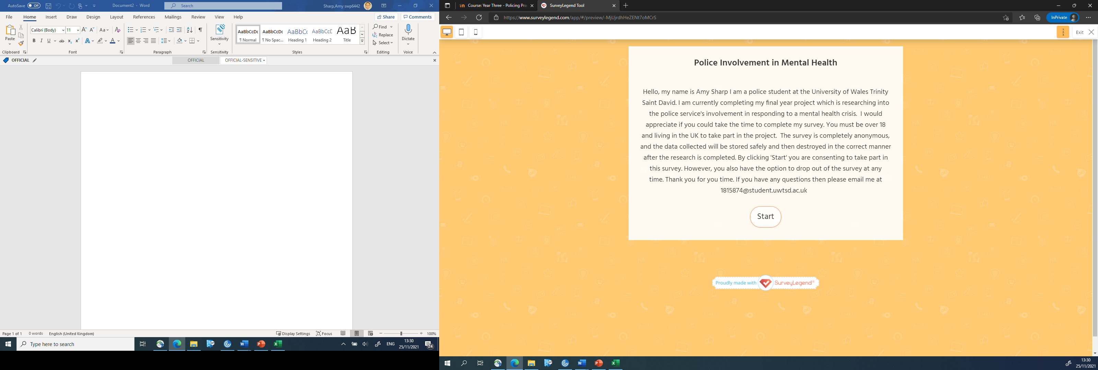

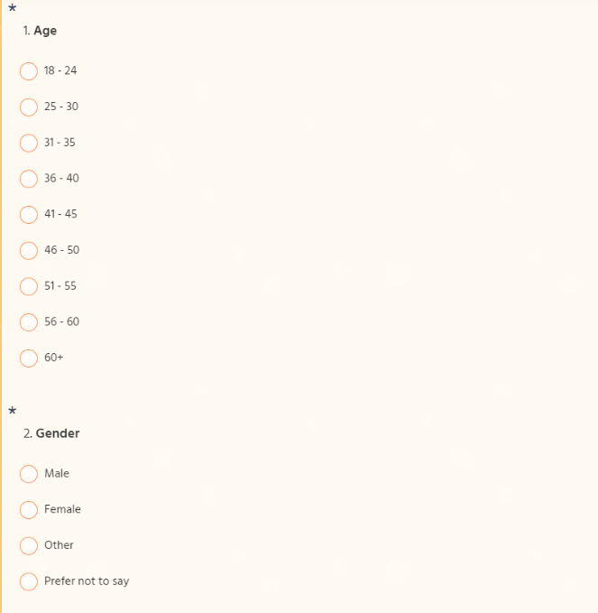
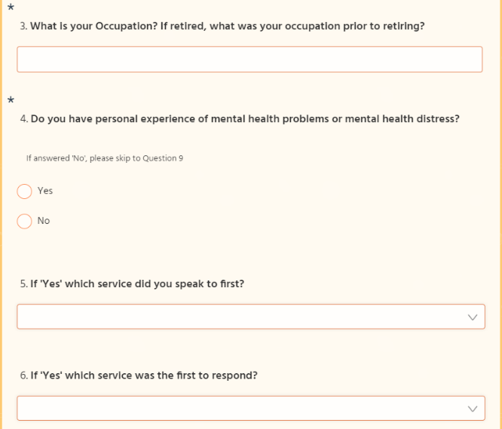

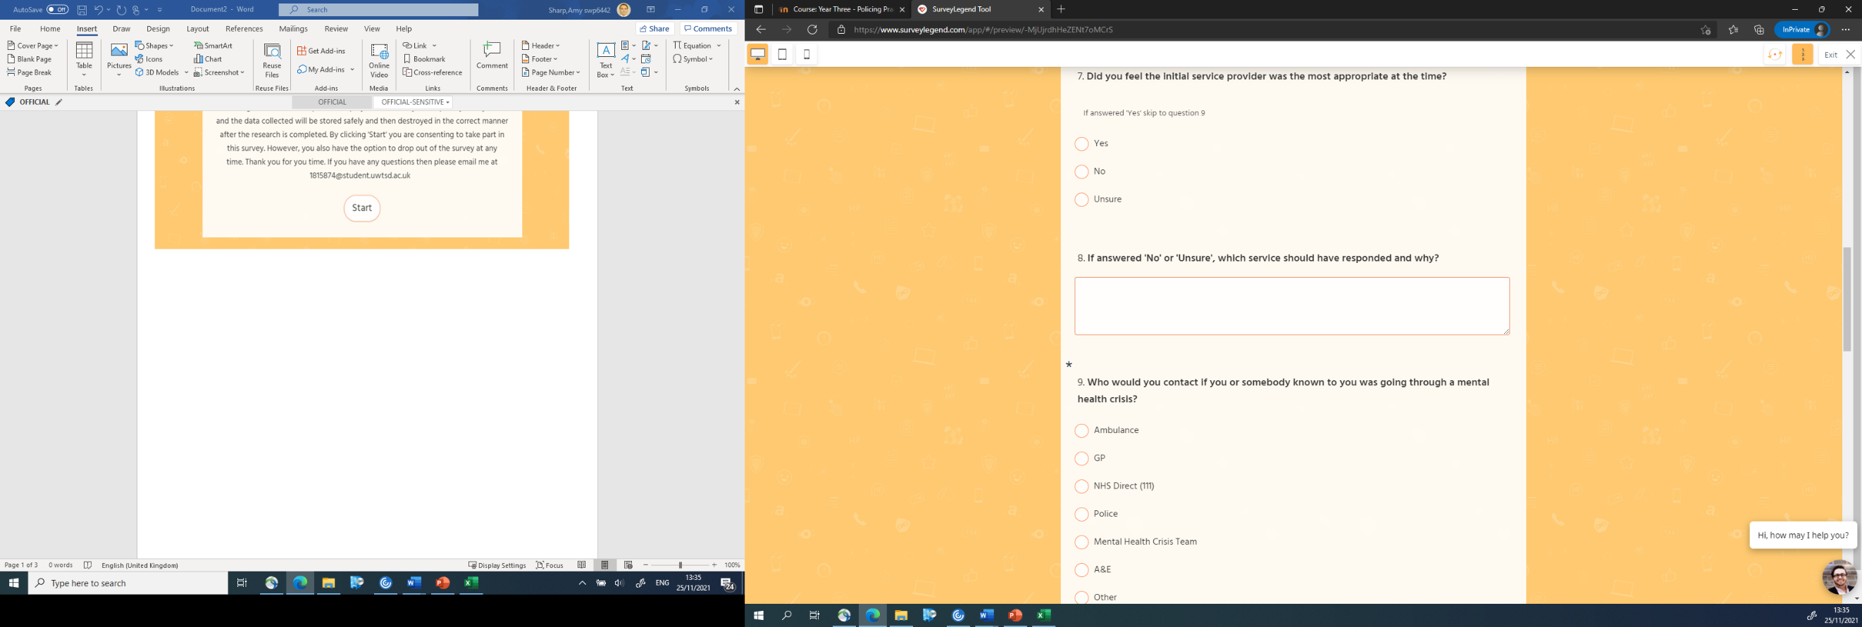

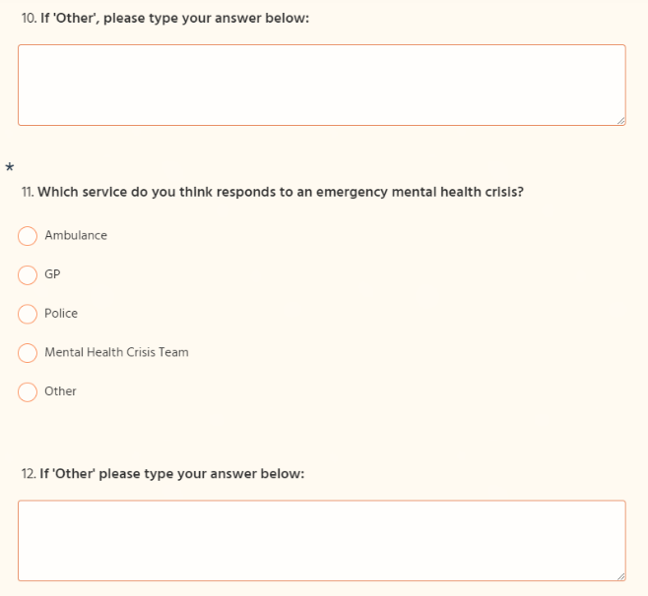

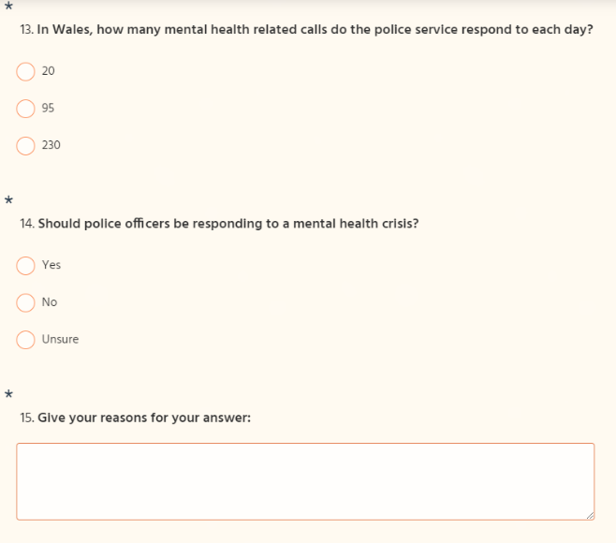

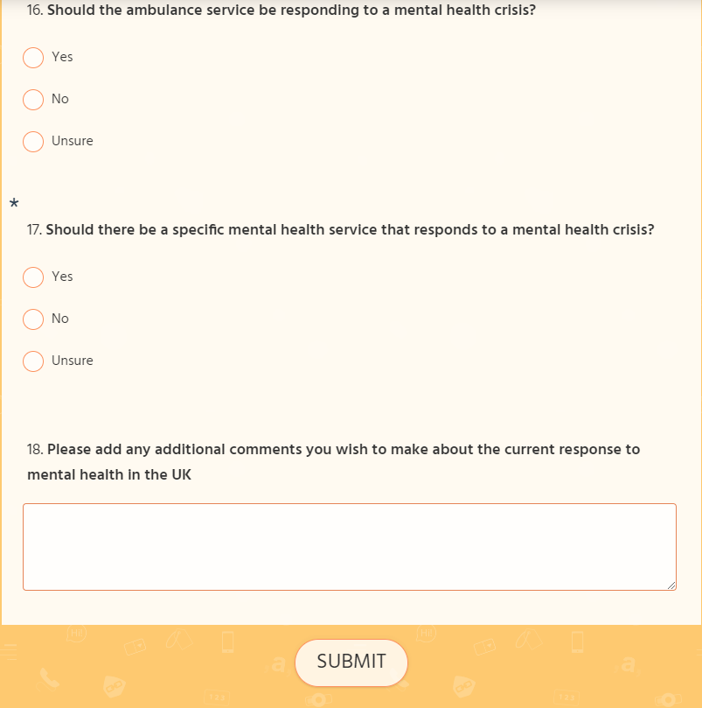

7.2 Appendix 2 – Questionnaire Answers
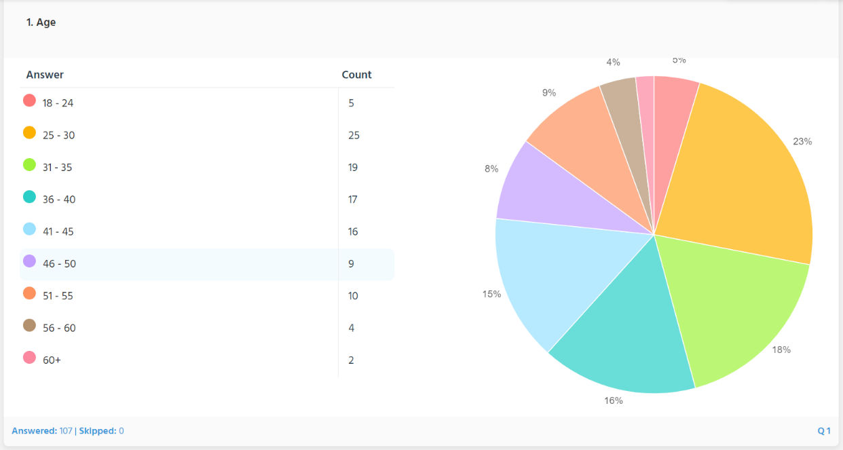

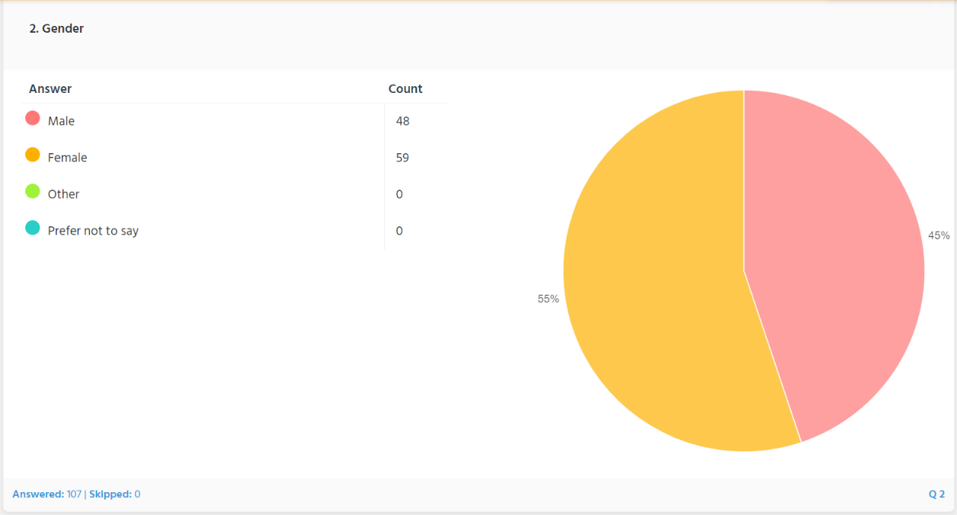

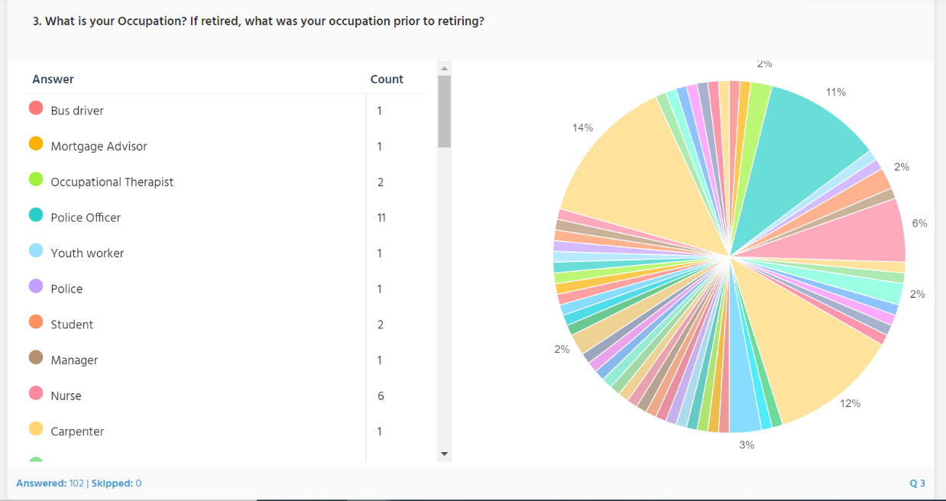

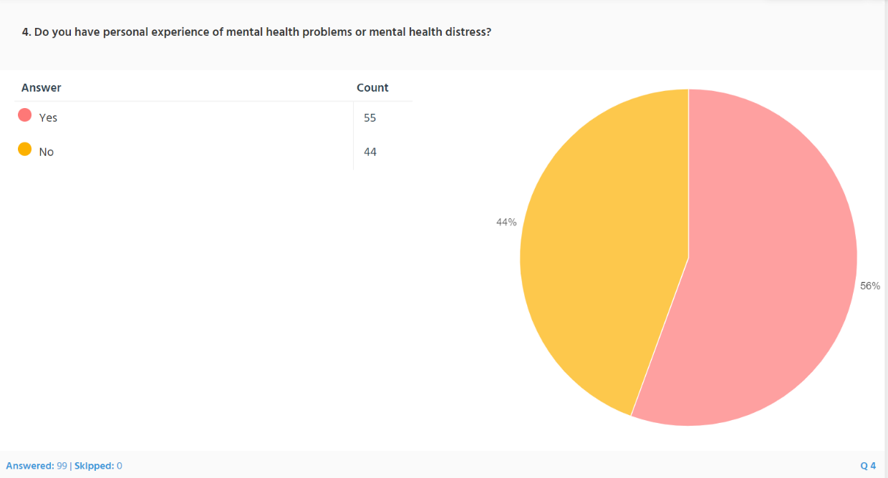

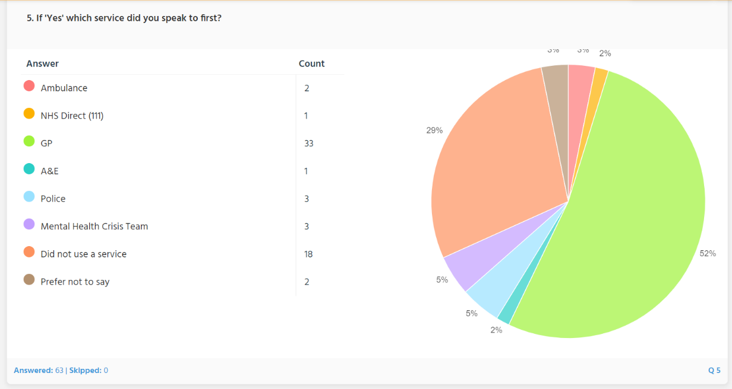

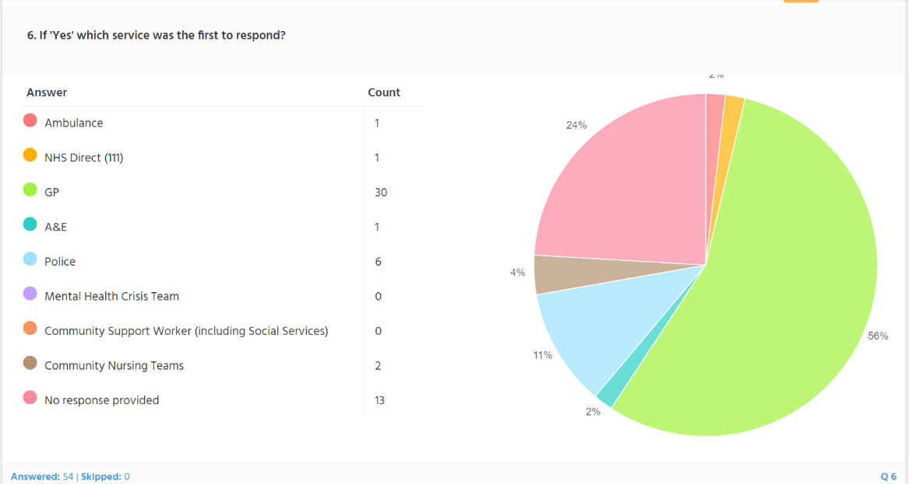

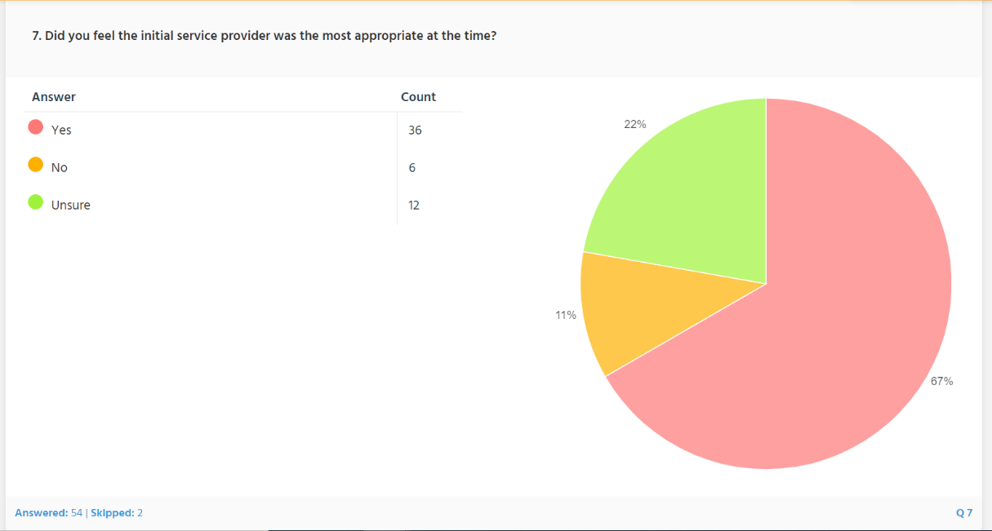

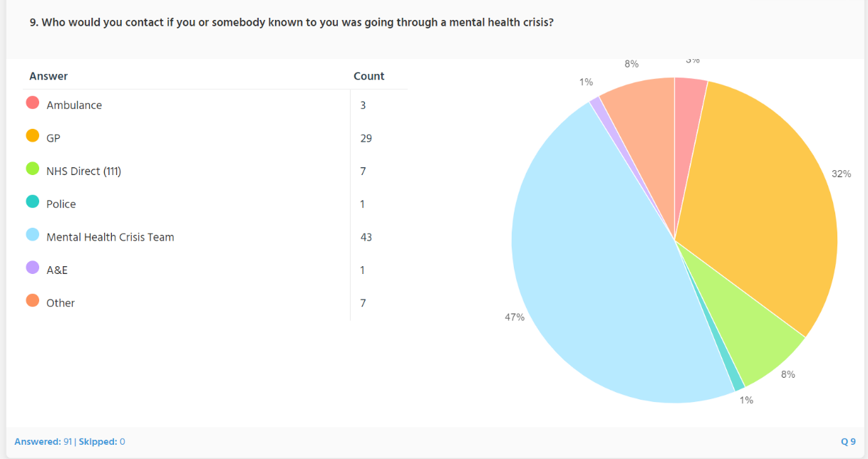

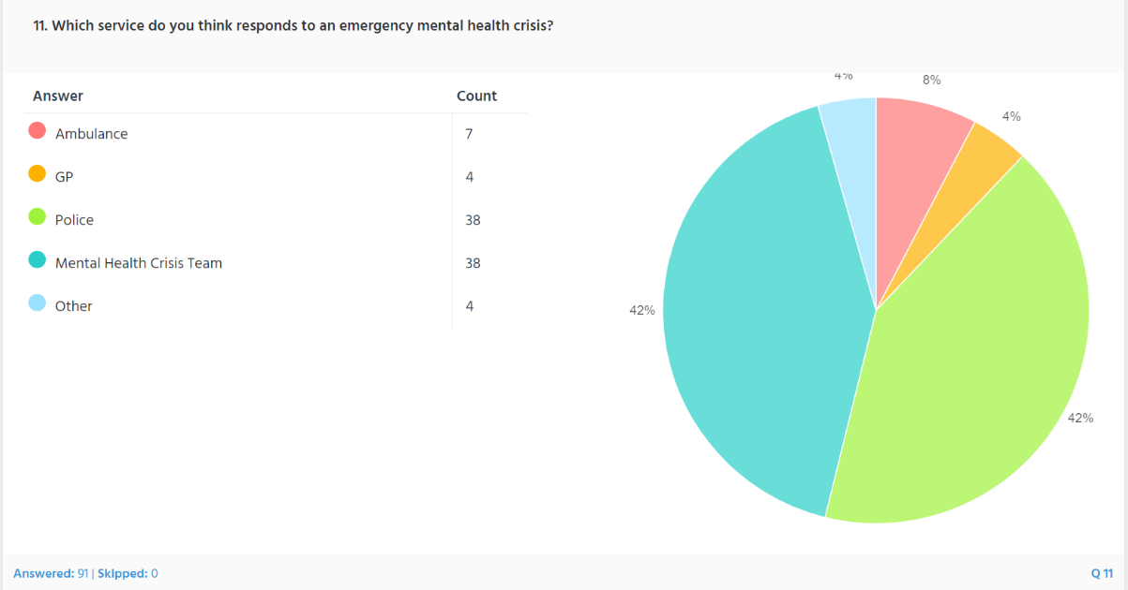

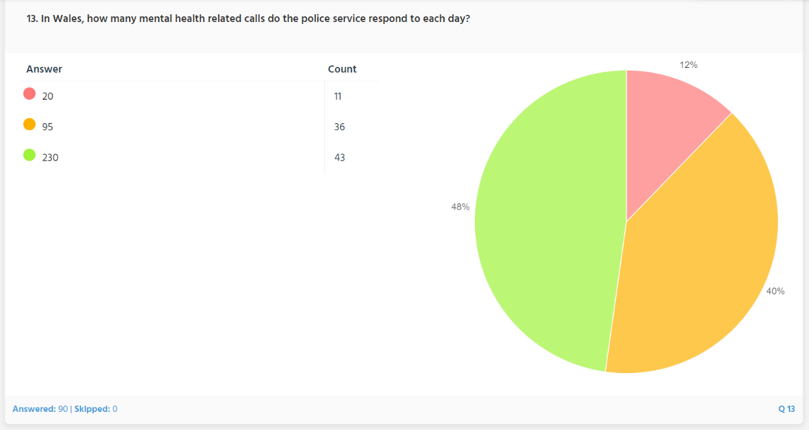

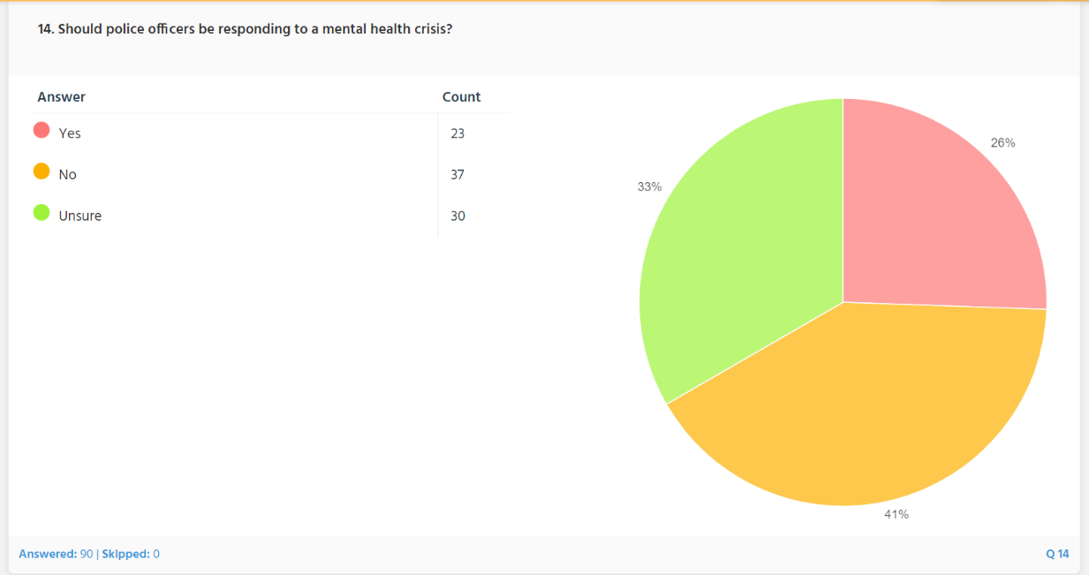

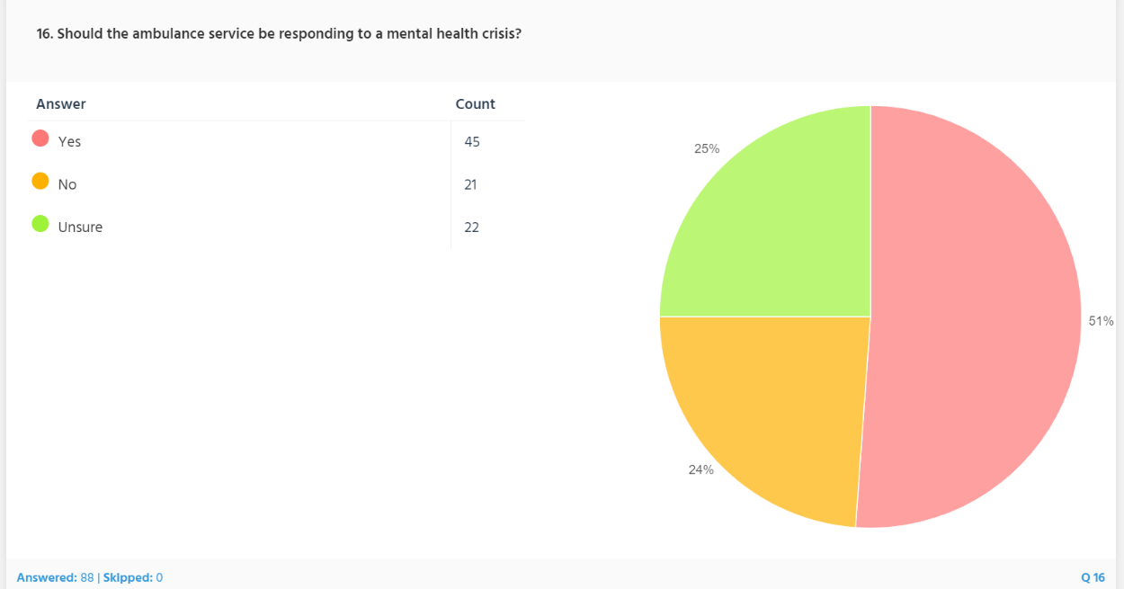

7.3 Appendix 3 – Individual Answers to question 8

I was just given tablets and that was all
The contact I dealt with was Military and was adequate.
GP
Ambulance or mental health professionals
Mental health crisis team
Doctor at first
Actually the first service I sought were occupation-related support services which I did not find helpful and later sought private counselling, then GP.

The GP listened but reached an unhelpful diagnosis. But I was obliged to speak to the GP to get time off work

7.4 Appendix 4 – Individual answers to question 10

Would depend if they were associated with MH services such as crisis team etc. If the individual was experiencing an episode of distress and is not associated with services then A&E would be most suitable. If the individual presents as an immediate risk to themselves or the public then police would maybe be best option.

Family
Depending on the situation, as a retired nurse I may assess that counselling or occupational health may be better - or perhaps the gp. It would depend on the circumstances.
Samaritans
The Samaritans
Depends on the circumstances and severity. Can I keep them safe until hospital/GP are they a risk to themselves or others etc.

It depends on the severity of the crisis. Gp for stress / mild depression, advise going to ED if acutely psychotic & call the police if a danger to others

7.5 Appendix 5 – Individual answers to question 12

All of them in different situations
Ambulance, Police, Crisis Team
All 4
All the above

7.6 Appendix 6 – Individual Answers to question 15

Police should be dealing with criminal acts

A combined approach would help secure the safety of all involved

It is a medical issue and should be dealt with by medical professionals.
Only if there is a emergency in regards to life of the subject or members of the public should Police attend.
At present, police seem to be filling the GAP for the under resourced NHS and this should not be the case.

Other services that are solely trained in specialist mental health are better equipped to deal with a crisis

Depends if the person is being a danger to others

They may be a danger to themselves or others

It would be preferable to combine the two services of MH nursing and police as they are beginning to introduce around the country.

It's not a crime to have mental health issues

Personally I think it should be people of the medical profession answering to mental health

If risk to individuals safety/life then a combined approach including the police may be appropriate

The person may be a danger to themselves or others

Only if the person is a danger to the public

They do not receive the appropriate training and have other things to deal with such as crime.
Depending on circumstance and situation / danger to themselves or others

We’re not trained in Mental Health!!

Sometimes they are the same boy service who can detain the person immediately

Police officers are not trained enough to deal with mental health. It shouldn’t fall to the police to respond to, it’s a medical emergency.

Its not their primary concern or training. Obv there are times when they are needed to protect people from harm but should be dedicated teams of mental health professionals to deal. Police should be more a sign post, ear to help and guide but not the a first responder

I think a mental health team should be supported by the police if the request their assistance.

Police are treated as a 2nd way NHS Mental Health service, due to this Police emergencies go missed.

A lot of people are scared of Police and have bad prior experiences with them. People associate the police with having committed a crime and may fear arrest. Additionally police officers are not mental health professional in any way, they cannot diagnose, prescribe medicine for or assess mental health issues/illnesses.

Having a mental health episode is not a crime, police should only be involved if there is a criminal element to the matter. Crisis Team should take primacy.

If someone is a suicide risk, police might be faster, but they might not be fully equipped to deal.

If there is no threat of harm to anyone, then there should be no requirement for police to attend. Ambulance/mental health professionals should be attending in the first instance. Only if there is a risk of harm to those attending then police should attend, but only to assist/prevent any risk to ambulance. They should take primacy as it is a medical issue.

Because they could be a danger to other people as well as themselves.

Because they arent trained to do so and are over used to deal with jobs like this. It wastes countless hours of police time dealing with MH when all they do is get to the job and end up calling MH services anyway who don't always answer or take ages to get back to you. So you have 3/4 Cops stuck on one job

Police are not trained to deal with this I believe

Police services have little training in MH. Most of the time ambulance/health care are more suitable to respond to these incidents unless the person in crisis is posing an immediate risk to the public.

Yes Rapid response and risk management
No there should be a dedicated service joint working police and mh

It depends on the the situation if there's violence or weapons involved

Police should be about stopping people committing crimes not about helping with mental health. Resource for this is stretched enough as it is.

Although their assistance may be required. However, in an ideal world they should be there to support. Unfortunately in our current situation they are often used as the first - and sometimes only - line!

People in mental heath crisis do not want to see police. It gives them the opinion that they have done something wrong and they don't associate police with trying to help and support them

Dependant on the severity, if a medial/ambulance worker could be in danger then yes.

Depends on circumstances but to save life or limb also protect members of the public

Not trained enough to deal with complex health issues
No way near enough resources to combat crime and mental health

Some people have very violent reactions to their issues. They've never been diagnosed or properly medicated.

We are not medically trained for it and it seems like the police are used and abused when other services cannot provide the service that is expected. For the police, we have no one to fall back on and when the added work of MH is put into the picture, we as a police service cannot cope and it’s seen upon our fault if something goes wrong

Police should respond in the few instances in which immediate intervention is required. Otherwise mental health services should respond, as too much Police time is committed with it.
Being in a mental health crisis is not a crime or an offence. Police are given basic training for mental health and they are not a service which should be used for mental health

I have answered yes on the presumption that the person may cause harm to themselves or others therefore I believe that specialist police assistance would be the best option

First line of contact for many people

They are trained to respond, restrain and deal with difficult situations bringing the person in need back to a professional and safe place to be dealt with.

Takes up a lot of their time and maybe they need extra training

In the initial stages if there is an immediate threat to life and ambulance are unable to get there in the first instance or if the person in crisis states they will hurt anyone who tries to stop them
There should be designated teams for this who are trained.

Police are not trained medical specialists.

This is a very specific & specialist area - I feel the police have enough matters to deal with outside of this

Police attend to ensure the subject is safe and get the right people on the scene. Would be good to have another service that attends and deals with the initial scene

They may be in danger or someone in their care may be compromised

They’re often first on the scene. They need to be trained for these scenarios

Not health care practitioner and not specialised in mental health

Not sure if they are fully trained to dal with all aspects of mental health issues and in some circumstances the presence of police could exacerbate the situation.

If the person is suspected of causing harm to himself or others. Police have the power to section unlike the ambulance service.

Even thought police officers receive training on how to deal with a mental health crisis we are not professionals. Sometimes the fact we have turned up can make the situation worse.

Yes for safety, no as it could cause more distress

The police should be dealing with crime. They aren’t mental health trained and don’t always understand

They can physically manage the risk, however specialists far better trained to deal

First responders to most incidents - prior to using other relevant agencies

I have had loads of support from police but feel they get called when really mental health services should be more available

Could be other issues like traffic jams or maybe others in danger.

The level of staffing in police is not sufficient to deal with the ever rising amount of calls relating to metal health crisis. Police resources are often spent as mediation for people suffering, in order to make contact with specifically trained organisations for mental health. Not only does this use up limited police resources but also causes a delay in contact to professionally trained mental health professionals as it is deemed that as a person in crisis is with Police resources, they are not in immediate danger and as such there response time is lengthier.

Not qualified to deal with mental health

The police are there to deal with criminal matters. It is ultimately for the NHS to treat and deal. Especially since police have so little training on mental health issues.

Should be focused on proper policing issues ie crime

Not sure they would be my first call but I would contact if someone was in physical danger
You need a familiar face your gp is more likely to calm you down than a stranger in uniform, it's daunting for a young police officer to deal with a mentaly unbalanced person not to mention dangerous, and in all honesty without the right training even police officers with the best intentions can often make things worse

Yes if the person is at risk or others at risk as a result of the person in crisis
There are some cases when the police should be responding. If there is immediate threat to life or someone in distress is threatening harm to others. However, I think that mental health services have become so reliant on the police to pick up after their inadequacies that these genuine emergencies are diluted and officers are questioning every call- this is inevitably going to end with a genuine emergency going unanswered (like the boy who cried wolf fable) and someone will unfortunately die.

If there is a risk to a person or persons then the police may be required to maintain the queen's leave, or enact a s. 136 if required. However, I don't feel Police attendance should be routine
Police officer and mental health worker. In case of danger to the mental health worker

I think it depends on the crisis.

Depends on the nature of the mental health crisis.

Police have the power to section someone and bring them to place of safety. Paramedics do not have that authority.

Not trained

Sometimes they should if patient is potentially a danger to self or others and violent

Wasted resource..unless risk to public. And restraint required.

To ensure safety of the individual involved and of others. HOWEVER, I feel the majority of cases do NOT require the involvement of the Police or A&E and should go directly to the Crisis Team.
Whilst an asset to urgent situations, it would be difficult to train police officers fully to deal with Mental Health Crises and their other duties and have every single duty be at the highest standard.

If the person is endangering another person eg with a weapon or about to jump off a high building. currently police attend to suicidal patients who abscond but not sure this should be required of them.

In an ideal world there would be greater capacity of the mental health service to care for mental health crisis. However if there is an immediate threat to life and the police are nearby it is suitable for them to intervene

Police have a responsibility for the safety of the public and have a duty to protect them for harm, but a dedicated service may be better due to the sheer numbers and pressure on the emergency services

Again whether they respond depends on the gravity of the case. Danger to property & life is police remit. The problem is that the general public don't know who to call or how to access services. Also police might be called for neighbours who have mental illness who are causing disruption & local nuisance. Although I am aware little is done by the police in these cases.

