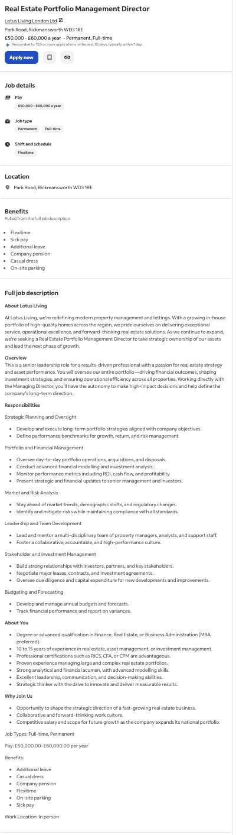
JOB ADVERTISEMENT

Mary Njonjo

COVER LETTER
ABC
56 CDXE Street, London
Hiring Manager
DEF Ltd
London
12/11/2025
Dear Joseph,
I wish to apply for the role of Real Estate Portfolio Management Director, currently being advertised on the website. Please find enclosed my CV for your consideration.
As you can see from my attached CV, I have over 12 years’ experience in the real estate industry, and I believe my proven record in strategic portfolio oversight, and operational leadership during this time make me the perfect candidate for the role.
In my current role as a business Development Director at ABC Company, I have been responsible for leading portfolio strategy, managing high-value assets, delivering financial modelling and investment analysis, and ensuring the strong performance of a diverse property portfolio.
Through this experience, I have gained extensive knowledge of portfolio growth planning, risk mitigation, market analysis, and stakeholder engagement. I have led multi-disciplinary teams, overseen due diligence processes, profitability, and cash-flow performance. I have also developed advanced modelling and forecasting capabilities that directly support strategic decision-making and long-term organisational growth.
All of this, coupled with my enthusiasm and dedication to operational excellence, leadership, and strategic innovation, has helped deliver measurable improvements in asset performance, tenant satisfaction, and investment returns.
I am confident that I can bring this level of success and help the company continue to build upon its reputation as a forward-thinking, high-quality, service-driven residential property group. With my previous experience and expertise, I believe my contribution will have an immediate and positive impact on portfolio performance, long-term strategy, and the next phase of your national expansion.
Thank you for considering my application. I look forward to the opportunity to discuss how my experience, leadership, and strategic approach can contribute to the continued success and growth of DEF Limited.
Yours faithfully,
ABC

CV
MARY NJONJO
London, United Kingdom
■ +44 7568 752228 | +44 7990 363506
■ mary@cicluk.co.uk | ■ www.cicluk.co.uk
PROFESSIONAL PROFILE
Dynamic and results-oriented business development professional with over 15 years of progressive
experience in real estate investment, international trade facilitation, and diaspora engagement across the
UK, Kenya, and wider African markets. Founder and Business Development Director of Connect Integrated
Company UK Limited (CICL-UK), with a proven track record of forging strategic partnerships, driving
cross-border investment, and delivering sustainable business growth.
Known for visionary leadership, operational excellence, and the ability to navigate complex global markets, I
bring a strong background in strategic planning, stakeholder engagement, marketing, and team leadership
— all grounded in a passion for innovation, collaboration, and economic empowerment.
CORE SKILLS & EXPERTISE
Strategic Leadership & Business Development
• Founder and Business Development Director at CICL-UK, London – driving bilateral trade between the
UK and Kenya.
• Over 11 years’ experience in market expansion, investment strategy, and stakeholder engagement.
• Proven success in establishing subsidiaries, managing multi-sector portfolios, and achieving sustained
business growth.
Partnerships, Networking & Diaspora Engagement
• Forged partnerships with British African Business Alliance (BABA), NDDIS, and Kenya High Commission
in London.
• Mobilized diaspora communities, promoting investment opportunities and sustainable development
linkages.
• Appointed Investments Director, London African Business Alliance (LABA) and Head of Investments,
Kenya Business Alliance.
Marketing, Branding & Event Management
• Successfully launched and marketed MI-VIDA Homes, Diaspora Housing Management Ltd, and Kings
Developers Ltd in the UK.
• Organized international investment events with 100–200+ professionals in attendance.
• Skilled in digital, print, and social media marketing to boost brand visibility.
Financial & Operational Management
• Maintained financial compliance and audit accuracy across multiple organizations.
• Achieved 25% annual revenue growth through efficient operations and targeted strategies.
• Experienced in project funding, import/export trade, and investment management.
International Trade & Market Entry
• Assisted African companies in expanding into UK and EU markets through consulting and partnership
building.
• Deep understanding of trade frameworks, diaspora remittances, and investment facilitation.
• Founded Diaspora Housing Management Ltd (KSh 380M project, 120 units).
Team Leadership & Staff Development
• Built and led high-performing marketing and digital teams.
• Mentored staff toward innovation, accountability, and professional growth.
• Encouraged collaboration and customer-centric operations.
PROFESSIONAL EXPERIENCE
Connect Integrated Company UK Limited (CICL-UK) — London, UK
Founder & Business Development Director | April 2023 – Present
• Leads strategic partnerships, investment facilitation, and diaspora engagement programs between the
UK and Kenya.
• Expanded service portfolio across Real Estate, Finance, Education, and Agriculture.
• Organized investment summits and business expos attended by 100–200+ professionals.
• Achieved 25% annual revenue growth and built key industry relationships.
Leo Capital Holdings Ltd (Heri Homes Ltd) — London, UK / Nairobi, Kenya
Diaspora Marketing Director (UK Region) | Nov 2017 – Apr 2023
• Set up the UK subsidiary and expanded brand visibility across 40+ UK and EU cities.
• Raised company capital portfolio from KSh 500M to KSh 5Billion through real estate remittances.
• Sold over 1,000 properties to investors in the UK, Europe, and Africa.
• Directed marketing teams, executed multi-channel campaigns, and coordinated investor forums.
Wakanjo Electrical Hardware & Cement Export (Kenya–South Sudan)
Director | 2005 – 2016
• Founded and managed a successful hardware export business, doubling turnover within two years.
• Secured bulk cement supply deals with Bamburi Cement for distribution to Juba, South Sudan.
• Navigated regional logistics and market challenges while sustaining profitability.
China–Kenya Import Business
Entrepreneur | 2005 – 2016
• Imported construction, electrical, and plumbing fittings from China, building supplier relationships in
Shanghai, Guangzhou, and Beijing.
• Enhanced cost efficiency and product availability in Kenya’s construction market.
Marriott Hotel / US Cafeteria, Frankfurt, Germany
Customer Service / Cashier | 1996 – 2002
• Delivered excellent customer service in hospitality environments.
• Strengthened cross-cultural communication and operational skills.
EDUCATION & QUALIFICATIONS
• Diploma in Food Science and Technology — Kenya Polytechnic University College (1993 – 1996)
• ASET Certificate in Care Skills | OCR Level 1 (New CLAiT) — Milton Keynes College, UK (2003 – 2005)
• CPD Certification (24 Points) — Continuing Professional Development, London, UK
HOBBIES & INTERESTS
• Traveling, exploring scenic destinations, and attending business expos.
• Watching documentaries, cooking, and community volunteering.
• Sports: Volleyball and badminton.
REFERENCES
Available upon request.

