

Managing Enterprise in the 21st Century

Business Plan
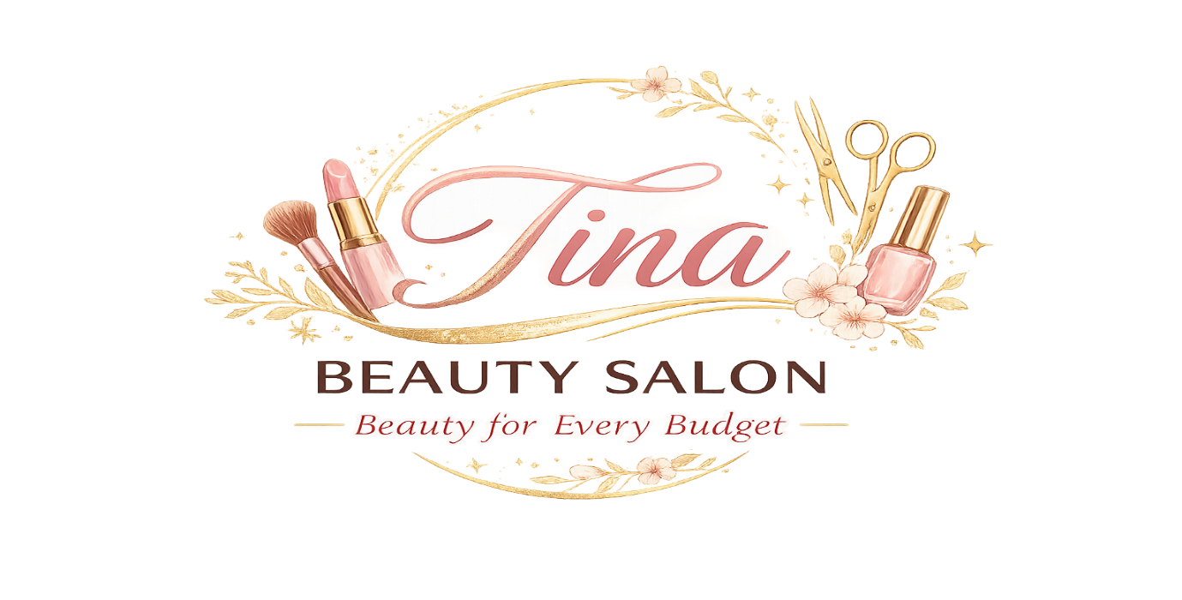

Module Code: LCLM4006
Module Name: Enterprise and Entrepreneurship
Student Name: Florentina Tifachi
Student Number: 2514649
Submission Date:27.07.2026
Lecturer: Shengfeng Mei

Contents
Introduction 3
Section 1 - Overview of the Business Idea 4
Section 2 - Legal Format and Management Structure 4
Section 3 - PESTEL Analysis 6
Section 4 - Target Market and Marketing Strategies 7
Section 5 - Funding Requirements and Allocation 7
Start-up Costs 8
Operational Costs – Fixed Costs 8
Variable Costs 8
Financial Forecast – First Six Months 9
Break-even Point 9
Total Fund Needed 9
Reference List 10
Appendix 11
Nail Services 11

Introduction

My name is Florentina Tifachi, and I am the founder and owner of Tina Beauty Salon. I am interested in the beauty industry, and I enjoy helping people feel confident and good about themselves. My role will be to manage the business, make important decisions and make sure customers receive good service.
I decided to start Tina Beauty Salon because I believe beauty services should be available to people with different budgets. My idea is to create a friendly and welcoming salon where customers can choose affordable or premium services depending on how much they want to spend.
My passion for beauty and customer care motivates me to develop this business. My vision is to make Tina Beauty Salon a trusted and affordable local salon, with the main idea “Beauty for Every Budget.” The salon will also support the community and use more sustainable products and practices where possible.

Section 1 - Overview of the Business Idea

Different beauty services will be offered at Tina Beauty Salon. These will include haircuts, hair styling, hair coloring, nails, eyebrows, eyelashes and make-up. The salon will be welcoming, modern and affordable.

The theme of the salon will be “Beauty for Every Budget”. There will be different options for customers ranging from Basic, Standard and Premium. For instance, customers who have limited budgets will get the Basic services while those who prefer more luxurious products will go for the Standard and Premium services.

This beauty salon will target students, the working population, parents and others in the community. This means that I would like customers to feel welcomed when visiting the salon.

Sustainability will also be considered by the business. The salon will aim to use cruelty-free and environmentally friendly products wherever possible. In addition, there will be recycling of packaging material, reduced use of plastic, energy-efficient LED lighting and provision of digital receipts. I would also wish to promote the community through the provision of student discounts and discount days.

Section 2 - Legal Format and Management Structure

Tina Beauty Salon will initially operate as a sole trader. I opted for a sole trader because it is a straightforward and easy way to start a small-scale business. As a sole trader, I will be in charge of making important decisions regarding the business. According to GOV.UK (2026), a sole trader conducts her business individually.

Initially, there will be an owner/manager and two beauty employees in the business. The owner will be responsible for managing the business, finances, personnel, suppliers, and marketing. The employees will be responsible for providing services to the clients.
- Florentina Tifachi – responsible for managing the business, personnel, finances and marketing
- Cristina Mocanu – responsible for hair and beauty services
- Florentina Tifachi – responsible for nails and other beauty services
- Paula Maftei-responsible for bookings and reception

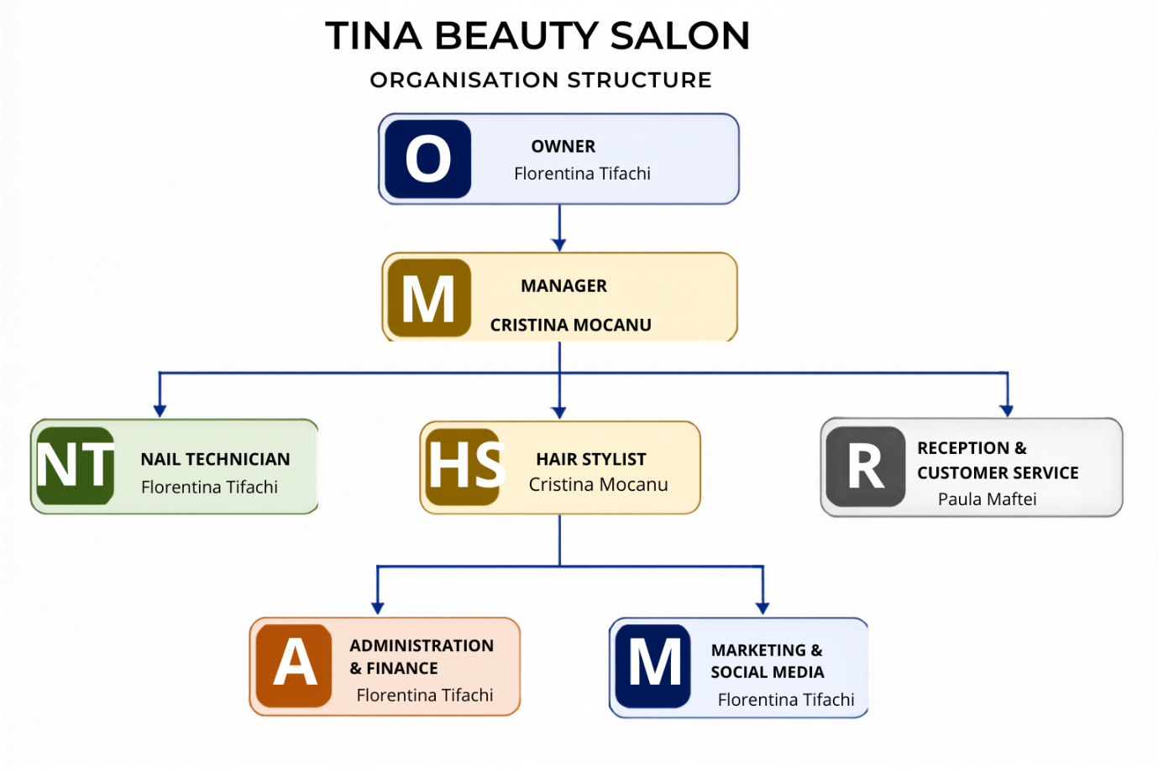

Section 3 - PESTEL Analysis

Industry: Beauty and personal care industry in the UK.

Political: Laws and taxes set by the government may influence the salon. The salon should comply with the regulations set for small enterprises.

Economic: There is an increase in cost of living while people may have lower disposable incomes. For this reason, Tina Beauty Salon will offer affordable prices and various pricing options.

Social: People like to have their hair and beauty services done. The popularity of beauty trends in social media also influences this factor positively and will help to attract more clients.

Technological: The salon may implement such technologies as booking online and paying using cards. Instagram, TikTok and Facebook are useful to promote the services, offers and before and after photos.

Environmental: The salon will aim to cut down waste and plastic usage. The salon can recycle its packaging, install LED lighting and use environmentally friendly products where it is possible.

Legal: The salon must comply with laws concerning health and safety, employment, consumer rights protection and data protection.

Section 4 - Target Market and Marketing Strategies

The STP model stands for Segmentation, Targeting and Positioning. This framework is used by companies in order to identify various customer segments and then to select the customers they want to target (Kotler and Armstrong, 2021).

Segmentation: The salon will divide customers into groups according to age, income, lifestyle and needs regarding beauty. The salon will be attractive to various customers; however, it will focus on those who expect high-quality services without paying expensive prices.

Targeting: Our major customers will be students, working adults and parents. Our clients can need regular beauty treatments, but they do not want to pay high prices.

Positioning: Tina Beauty Salon will be seen as a friendly and affordable salon. Major slogans will be "Beauty for Every Budget". Clients will be able to select the service corresponding to their budget.

We will promote our salon via Instagram, TikTok and Facebook. We will be able to post photos and videos of our work and offer different deals. First-time visitors will receive a 20% discount. Students will get discounts on selected days. Visitors will have an opportunity to collect a loyalty card to get an award after some visits. Another deal could be "Bring a Friend – Both get 5£ off.

Section 5 - Funding Requirements and Allocation

Tina Beauty Salon will need funding to open the salon and cover the costs during the first months. The money will be used for equipment, furniture, products, renovation and other business costs.

Start-up Costs
These are costs that I will pay once before opening the salon.
Start-up Cost | Amount
Salon furniture | £4,000
Hair equipment | £2,500
Nail and beauty equipment | £1,500
Products | £1,500
Renovation and decoration | £3,000
Website and booking system | £500
Marketing and signs | £500
Insurance and other costs | £500
Total Start-up Cost | £14,000

Operational Costs – Fixed Costs
These are costs that the salon will pay regularly, and they will stay approximately the same each month.
Fixed Cost | Per Month
Rent | £1,500
Business rates | £300
Staff salaries | £3,600
Insurance | £100
Accountant | £100
Internet and phone | £100
Marketing | £200
Total Fixed Cost | £5,900

Variable Costs
These costs can change depending on the number of customers and how busy the salon is.

Variable Cost | Month 1 | Month 2 | Month 3 | Month 4 | Month 5 | Month 6
Electricity & water | £250 | £300 | £350 | £400 | £450 | £500
Beauty products | £400 | £500 | £600 | £700 | £800 | £900
Other materials | £150 | £200 | £250 | £300 | £350 | £400
Total | £800 | £1,000 | £1,200 | £1,400 | £1,600 | £1,800

Financial Forecast – First Six Months
Financial | Month 1 | Month 2 | Month 3 | Month 4 | Month 5 | Month 6
Fixed Costs | £5,900 | £5,900 | £5,900 | £5,900 | £5,900 | £5,900
Variable Costs | £800 | £1,000 | £1,200 | £1,400 | £1,600 | £1,800
Total Costs | £6,700 | £6,900 | £7,100 | £7,300 | £7,500 | £7,700
Revenue | £4,500 | £6,000 | £7,500 | £8,500 | £9,500 | £10,500
Profit/Loss | -£2,200 | -£900 | £400 | £1,200 | £2,000 | £2,800

Break-even Point
Tina Beauty Salon is expected to reach its monthly break-even point in Month 3. In Month 3, the expected revenue is £7,500, and the total costs are £7,100, giving the salon a £400 monthly profit.

Total Fund Needed
Total Fund Needed = Start-up Cost + Losses before break-even
£14,000 + £2,200 + £900 = £17,100
Therefore, Tina Beauty Salon will need approximately £17,100 in funding to start the business and cover the expected losses before reaching monthly break-even.

Reference List
GOV.UK (2026) Business and self-employed. Available at: GOV.UK – Business and self-employed (Accessed: 21 July 2026).
GOV.UK (2026) Set up as a sole trader. Available at: GOV.UK – Set up as a sole trader (Accessed: 21 July 2026).
Health and Safety Executive (HSE) (2026) Health and safety at work. Available at: Health and Safety Executive (Accessed: 21 July 2026).
Information Commissioner’s Office (ICO) (2026) Data protection and your business. Available at: ICO – For organisations (Accessed: 21 July 2026).
Kotler, P. and Armstrong, G. (2021) Principles of Marketing. 18th edn. Harlow: Pearson.

Appendix

Hair Services | Basic | Standard | Premium
Haircut | £15 | £25 | £35
Wash & Blow Dry | £20 | £30 | £40
Hair Colour | £35 | £55 | £80
Highlights | £40 | £60 | £90
Hair Treatment | £15 | £25 | £35

Nail Services
Nail Services | Basic | Standard | Premium
Manicure | £15 | £20 | £25
Gel Nails | £25 | £35 | £45
Nail Extensions | £30 | £40 | £50
Pedicure | £20 | £30 | £40
Nail Art | £5 | £10 | £15
Basic – simple service using standard products.
Standard – more options and better-quality products.
Premium – premium products and more personalised service.

