

Design and Development of a Web-Based Exam Management System Integrated
with Tribal SITS
By
Nicholas Aldous

Supervisor: Nathan Morgan
Second Marker: Gaynor Thomas

Project submitted as part of the requirements for the award of BSc (Hons) Computing (Software Engineering)

July 2026
DECLARATION

I, Nicholas Aldous declare that I am the sole author of this Project; that all references cited have been consulted; that I have conducted all work of which this is a record, and that the finished work lies within the prescribed word limits.

This work has not previously been accepted as part of any other degree submission.

Date : 20/07/2026

FORM OF CONSENT

I, Nicholas Aldous hereby consent that my Project, submitted in candidature for the B.Sc.(Hons) Computing (Software Engineering) degree, if successful, may be made available for inter-library loan or photocopying (subject to the law of copyright), and that the title and abstract may be made available to outside organisations.

Date : 20/07/2026

ABSTRACT

Universities have a legal duty under the Equality Act 2010 to make reasonable adjustments for disabled students, and exam concessions such as extra time are among the most common ways that duty is met. At the University of Wales Trinity Saint David, the exam department administered concessions, exam reporting and exam documentation through three separate Microsoft Access databases. These were disconnected from the university's Tribal SITS student records system, so student data was copied by hand and fell out of date, the same concessions were recorded in several inconsistent forms, and no record was kept of who changed what. The aim of this project was to replace them with a single, secure, web-based Exam Management System integrated with SITS.

The project was a single-site case study following a pragmatist research philosophy with a mixed methods approach. The system was built using an iterative approach based on Rapid Application Development, structured around three meetings with the exam department, with requirements prioritised using the MoSCoW technique. It was developed in ASP.NET Core MVC with C# and SQL Server. Student and exam data is read live from SITS through database views, so SITS remains the single source of truth, and access is controlled through the university's single sign-on and a dedicated Active Directory group, with an audit trail on every change.

All six essential requirements and all four second tier requirements were delivered, along with one optional requirement, the generation of exam documents as Portable Document Format (PDF) files. Functional testing produced 52 passes from 54 tests, and a usability evaluation with exam staff produced a mean System Usability Scale score of 80.8, rated excellent, with a 96% task success rate. The system has been deployed to the live environment. The report concludes that the aim was met and recommends migrating concession storage into SITS following that platform's recent upgrade, adding a history of concession changes, formal accessibility testing, automated testing, and measuring the system's impact over a full exam cycle.

TABLE OF CONTENTS

CHAPTER 1 INDEPENDENT PROJECT INTRODUCTION 8
1.1 Introduction 8
1.2 Aim and Objectives 8
1.3 Structure of the Report 9
CHAPTER 2 RESEARCH & REVIEW OF LITERATURE 10
2.1 Introduction 10
2.2 Digital Transformation of Administrative Processes in Higher Education 10
2.3 Reasonable Adjustments in Higher Education: Legislation, Policy and Institutional Practice 12
2.4 A Critical Review of Existing Exam Management and Case Management Systems 13
2.5 Web Application Architecture, Technology Choices and Integration 14
2.6 Authentication, Authorisation and Data Protection 15
2.7 Accessibility and Inclusive Design in Web Systems 16
2.8 Usability and Evaluation of Staff Facing Software 17
2.9 Summary 18
CHAPTER 3 RESEARCH AND DEVELOPMENT METHODOLOGY 19
3.1 Introduction 19
3.2 Research Methodology 19
3.3 Development Methodology 20
3.4 Tools and Technologies 22
3.5 Testing and Evaluation 22
3.6 Ethics 22
CHAPTER 4 DESIGN & IMPLEMENTATION 23
4.1 Introduction 23
4.2 Requirements 23
4.3 System Architecture 24
4.4 Database Design 25
4.5 System Modelling 26
4.6 Interface Design 29
4.7 Implementation 32
4.8 Summary 38
CHAPTER 5 EVALUATION 39
5.1 Introduction 39
5.2 Evaluation Against Objectives 39
5.3 Functional Testing 41
5.4 System Usability Scale (SUS) Evaluation 42
5.5 Discussion in Relation to the Literature 43
5.6 Meeting the Aim 45
5.7 Limitations and Future Work 46
5.8 Summary 47
CHAPTER 6 CONCLUSIONS AND RECOMMENDATIONS 49
6.1 Introduction 49
6.2 Conclusions 49
6.3 Recommendations 50
CHAPTER 7 REFLECTION 52
7.1 Introduction 52
7.2 What Went Well 52
7.3 What Was Difficult 52
7.4 What I Would Do Differently 53
7.5 Personal Development 53
CHAPTER 8 REFERENCES 54
CHAPTER 9 BIBLIOGRAPHY 59
CHAPTER 10 APPENDICES 60
10.1 AI Declaration 60
10.2 Documentation and Evidence 61
10.3 Abbreviations 61

TABLE OF FIGURES

Fig. 1 - | EMS MoSCoW Requirements Prioritisation | 16
Fig. 2 - | EMS Gantt Chart | 17
Fig. 3 - | EMS Layered System Architecture | 20
Fig. 4 - | EMS Database Entity Relationship Diagram | 21
Fig. 5 - | EMS Use Case Diagram | 22
Fig. 6 - | EMS Authentication and Authorisation Flow | 23
Fig. 7 - | EMS Data Import Process | 23
Fig. 8 - | EMS: Initial Student Concession Wireframe Page | 24
Fig. 9 - | EMS: Finished Student Concession Page | 24
Fig. 10 - | EMS: Dashboard Page | 25
Fig. 11 - | EMS: Exam Report Page | 26
Fig. 12 - | EMS: Formatted Mass Entry (FME) Import Page | 26
Fig. 13 - | EMS: Manage Concessions Page | 26
Fig. 14 - | Parameterised Construction of the Dynamic Report Filter | 27
Fig. 15 - | Transaction Handling in the Formatted Mass Entry (FME) Import | 27
Fig. 16 - | Generated Exam Timetable Portable Document Format (PDF) | 29
Fig. 17 - | Generated Exam Register Portable Document Format (PDF) | 30
Fig. 18 - | Generated Desk Labels Portable Document Format (PDF) | 31
Fig. 19 - | EMS MoSCoW Requirements Prioritisation Results | 33
Fig. 20 - | System Usability Scale Results | 35

CHAPTER 1
INDEPENDENT PROJECT INTRODUCTION

1.1 Introduction
Universities are under growing pressure to modernise the administrative processes that support their students. One of the most sensitive of these is the administration of exam concessions, the adjustments such as extra time or additional support that disabled students are legally entitled to under the Equality Act 2010. As the number of students disclosing a disability continues to rise, the systems used to record and apply these adjustments matter more each year, both for the staff who operate them and for the students who depend on them.

At the University of Wales Trinity Saint David, this work was carried out using three separate Microsoft Access databases, one for assigning concessions, one for producing exam reports and one for generating exam documents. None of them connected to the university's Tribal SITS student records system, so student data was copied across and was often out of date. Concessions were frequently duplicated, which meant the same adjustment was recorded in several different forms and even a simple count of affected students was unreliable. No record was kept of who made changes or when. These weaknesses created real risk in a process whose purpose is to meet a legal duty.

This project addressed that problem by designing, building and deploying a replacement. The result is the Exam Management System (EMS), a secure web application that reads its student and exam data live from SITS, records concessions from a controlled bilingual catalogue, produces reports and exam documents, and keeps an audit trail of changes. The project began with a focus on concessions alone, and its scope grew during development into a full exam management system at the request of the exam department.

1.2 Aim and Objectives
The aim of the project was to replace the exam department's three legacy Access systems with a single, secure, web-based exam management system integrated with the university's SITS student records system. To achieve this aim, the project set the following objectives.

- To review the literature on digital transformation in higher education, reasonable adjustments, existing exam and case management systems, and the architecture, security, accessibility and usability of web systems.
- To gather and prioritise the exam department's requirements using the MoSCoW technique.
- To design and implement a secure web application that reads student and exam data live from SITS, controls access through the university's single sign-on, and records an audit trail of changes.
- To test the system functionally and evaluate its usability with the staff who will use it.
- To deploy the finished system to the university's live environment.

1.3 Structure of the Report
The remainder of this report follows the progress of the project. Chapter 2 reviews the literature and identifies the gap the project addresses. Chapter 3 explains the research and development methodologies chosen and why. Chapter 4 covers the requirements, design and implementation of the system. Chapter 5 evaluates the finished system against its objectives, through functional and usability testing, and against the systems it replaced. Chapter 6 draws conclusions and makes recommendations, and Chapter 7 reflects on the project as a learning experience.

CHAPTER 2
RESEARCH & REVIEW OF LITERATURE

2.1 Introduction
This chapter reviews the literature relevant to the design of a web-based exam management system for a university exam department. The system manages exam concessions for disabled students, produces reports, and generates exam documents, all integrated with the university's central records system. Among these functions, the recording of concessions is the most important, and it is the aspect this review examines most closely. The review evaluates the relevant work critically and identifies the gap the project addresses.

The central argument connecting these sections is that digitalising an administrative process of this kind is worthwhile, but that its success depends as much on people, law, inclusion and usability as on the technology. Each section develops one part of that argument, moving from the digital transformation of administrative processes and the legal duty to make reasonable adjustments, through a review of existing systems, to the technical foundations of the project, covering architecture and integration, security and data protection, accessibility, and the usability principles used to measure its success.

Two limitations in the available literature shape the review. Firstly, there is little peer reviewed work on office exam administration, as opposed to online exam delivery, so several comparable systems come from outside the United Kingdom. Secondly, some evidence on disability and assessment is qualitative and connects to its context. Where this happens, it is noted, and United Kingdom sources are used to support the specific legal and statistical claims the project relies on.

2.2 Digital Transformation of Administrative Processes in Higher Education
Digital transformation in higher education is a broad field of study, although its key terms are often blurred together. Gkrimpizi et al. [1], in a review of 44 studies, distinguish three related ideas. Digitisation means converting analogue material into digital form. Digitalisation means using technology to automate an existing process. Digital transformation is the wider organisational change that may follow. This project belongs mainly to the second category, since it rebuilds an existing administrative process rather than reshaping the institution as a whole.

It is often assumed that such projects simply replace paper, yet the starting point is frequently an ageing digital system. Gkrimpizi et al. [1] describe institutional data as "dispersed across multiple silos of information" and observe that separate legacy systems often force staff to import and export data manually. This closely reflects the situation the present project addresses, where the previous tools were built on Microsoft Access and did not connect to the university's central records.

Most of the literature agrees that moving such work onto a stronger platform brings measurable benefits. Souli and Pierrakeas [2], in a scoping review of 52 studies, found that student information systems act as central platforms linking students, staff and faculty, and that digital tools automate repetitive tasks such as registrations. Kayanja et al. [3] reached a comparable conclusion in a case study of a business school, where staff reported less paperwork and faster access to results. However, neither offers strong evidence for a single system. Kayanja et al. [3] drew on a small sample within one institution, while Souli and Pierrakeas [2] examined marketing and artificial intelligence as much as administration.

A more consistent finding is that the main obstacles are human and organisational rather than technical. Gkrimpizi et al. [1] report that the most common barriers are limited digital skills, resistance to change and constrained budgets, and Saini et al. [4], focusing on the United Kingdom, argue that a shortage of digital skills is the foundational barrier. A Jisc [5] report on 24 UK institutions agrees, concluding that digital transformation is "more than ‘an IT Services thing'". As practical guidance rather than peer reviewed research, it carries less evidential weight, but its agreement with the academic findings reinforces the view that the human side matters most. What the literature does not address is a focused system that rebuilds a single administrative process and integrates it directly with the institution's records. This project sits within that gap.

2.3 Reasonable Adjustments in Higher Education: Legislation, Policy and Institutional Practice
The exam concessions that this project manages exist because universities have a legal duty to support disabled students, set out in the Equality Act 2010 [6]. Section 20 requires an organisation to make reasonable adjustments where a policy or practice puts a disabled person at a substantial disadvantage compared with others, and Schedule 13 applies this duty to further and higher education [6]. In an exam setting, a fixed format such as a timed, handwritten paper is the kind of practice that can place a disabled student at a disadvantage. These adjustments are what the present project records and applies as concessions.

In practice, an adjustment usually changes the conditions of the exam rather than its content, through measures such as extra time, rest breaks, a separate room or the use of a computer [7]. The aim is to remove the disadvantage without lowering the standard being tested, and a concessions system has to capture each student's particular combination of arrangements accurately.

The wider research shows that granting an adjustment does not guarantee a fair outcome. In a systematic review of 20 studies, Fernández-Batanero et al. [8] found that examinations are a point where staff struggle most to adjust, and where disabled students meet the least flexibility. Tai et al. [7] question the underlying model, arguing that making individual adjustments case by case is slow and likely to become overwhelmed as more disabled students enter higher education. They also report that staff attitudes, and whether an agreed plan is actually delivered on the day, matter as much as the plan on paper. The present project responds by making the recording and application of concessions faster and more consistent, though Tai et al. [7] note that making the process more efficient is not enough on its own.

A further point concerns the students that never enter the system. Tai et al. [7] report that only around 5% to 6% of students disclose a disability, below the estimated figure of about 20%, linking this gap to stigma and the cost of diagnosis. In the United Kingdom the declared figure is higher and rising, with HESA [9] recording that around 16.5% of all students had a known disability in 2022/23, up from 13.9% five years earlier. Even then, recording an adjustment does not mean a student receives it, as a survey by Disabled Students UK [10] found only around 35% felt they had the support they needed. Much of the study evidence here comes from outside the United Kingdom, while the UK sources ground the scale of the problem.

Alongside disability law, a system built for a Welsh university must also meet the Welsh language duty. The Welsh Language (Wales) Measure 2011 gives the Welsh language official status, and the Welsh Language Standards (No. 6) Regulations 2017 set out the duties that apply to universities [11]. The university's policy requires any system producing information seen by students to be bilingual, and although the present project is mainly a staff tool, its outputs reach students, which is where the duty applies. It reflects this by requiring both an English and a Welsh name whenever a concession type is created, so that none can reach a student in one language only.

2.4 A Critical Review of Existing Exam Management and Case Management Systems
The system built for this project is part exam administration tool and part case management tool, since it keeps a record for each student and tracks the linked concessions. IBM [12] describes case management as software built around a stored case record that staff follow through to its outcome. Reviewing comparable systems therefore means looking in two directions, at how universities have built exam administration systems and at how they record and manage support for individual students.

A close technical comparison comes from Jin et al. [13], who describe an exam management system built for a Chinese university. Its design uses the same three layer structure as the present project and is built on ASP.NET and SQL Server with role-based permissions. They record the same weaknesses in the systems they replaced, namely incomplete functions, generic vendor interfaces and poor stability under load. The main limit of this source is its setting, since it describes a system built outside the United Kingdom around an earlier generation of the same technology. Tan [14] offers a second example on a different stack, but reaches the same layered design, and names the problem directly, describing separate tools that cannot share information and so create "information islands". This is the same fragmentation the present project sets out to eliminate.

A more recent source shows the administrative side rather than the architecture. Chaplin et al. [15] report a web tool built for a university registrar to schedule exams, replacing a manual process that had taken months. Their account of the old process matches this project's starting point closely, describing staff with "limited internal tools to access supporting data" [15]. The tool was built alongside the exam department who would use it, which mirrors how this project gathered its requirements. Its technical core is different, as it solves a scheduling problem this project does not attempt. The disability side is covered best by Mendoza-González et al. [16], whose guidelines for a student accessibility service recommend a central record of disabled students to produce reliable figures, which is close to what a concessions register does. They list the same adjustments this project handles and warn that support is too often "made on the fly" [16], echoing the reactive model criticism previously stated.
Taken together, these sources support the design of this project, but from different angles rather than as a single body of comparable work. Jin et al. [13] and Tan [14] confirm the layered, database backed architecture but in other institutions and countries, Chaplin et al. [15] show a modern staff facing build but for a different task, and Mendoza-González et al. [16] describe the right domain but as an office rather than a system. What is missing is a recent, peer reviewed account of a system that administers exam adjustments for disabled students and connects to a central student record. That absence reflects a real gap rather than a failure of searching, and it is part of the reason this project is worth building.

2.5 Web Application Architecture, Technology Choices and Integration
The way a system is structured affects how easy it is to build, maintain and extend. Liu et al. [17] describe the widely used three tier model, which separates a system into a front end for the user interface, a middle tier for the business logic, and a back end database. The Model-View-Controller (MVC) pattern applies the same idea of separation. Ahmad et al. [18] explain that MVC splits an application into a model, a view and a controller, and note that this supports extensibility, reusability and maintainability, while acknowledging that MVC can add complexity and cause the view and controller to become too closely linked. The present project uses this layered MVC structure.

Choosing a framework is a related decision. Poudel [19] built the same application with ASP.NET Core and the PHP framework Laravel, and found that ASP.NET Core produced the lowest page latency and smallest data transfer in every test. This is a single developer's study, so its qualitative judgements are subjective, but its measured results are consistent. Yusuf et al. [20] found that MVC gives clear separation of concerns and strong performance for simpler applications, though it is weaker at highly interactive interfaces. For a focused administrative tool, that trade-off favours MVC. Together these findings support building the project on ASP.NET Core using MVC.

The database is where accuracy matters most. Harrington [21] explains that unnecessary duplicated data is difficult to keep consistent as a database grows, and describes referential integrity, the rule that every foreign key must match an existing record, as the most important constraint in a relational database. These principles matter for a concessions system, where each record must stay correctly linked to the right student, so the project uses a relational database.

The final decision is how the system connects to the university's records. Banerjee [22] warns that connecting systems directly, one to another, creates a fragile, tangled mesh that is hard to maintain. Garcia and Abílio [23] describe integrating around twenty systems at a single university, and stress that keeping data consistent depends on a deliberate integration layer rather than ad hoc connections. Sasmito [24] adds that good integration removes data silos and establishes a "single source of truth". The present project follows this principle by reading from the central student records system rather than copying its data, avoiding the duplication the literature warns against.

2.6 Authentication, Authorisation and Data Protection
A system that holds sensitive student information has to control who can log in, limit what each user can do, and protect the data.

Authentication confirms a user's identity. The project delegates this to the university's Microsoft identity provider using single sign-on. Al Shabi and Marie [25] describe how the OpenID Connect protocol allows a user to authenticate once with an identity provider and then reach an application without separate credentials, so the application never stores passwords. They also caution that this concentrates trust in the identity provider and is not free of risk, demonstrating an attack against a poorly protected implementation. For this project the trade-off is reasonable, since the university already runs and secures its identity provider.

Authorisation decides what an authenticated user may do. The common approach is role-based access control, which Tang and Zhang [26] apply in a student information system, separating staff, who can change sensitive records, from students, who can only view their own. Jin et al. [27] argue that ordinary role-based control is not always precise enough, and extend the model so that a role also defines which records a user can see. This principle of least privilege matters here, because concession records include sensitive disability information. The present project applies it by restricting access to a dedicated Active Directory group, so that only exam department staff can view concession records.

The final concern is protecting the data, governed in the United Kingdom by data protection law. Martin and Kung [28] warn that engineers too often leave privacy to policy documents rather than building it into how a system is designed. Hjerppe et al. [29] make the same case at the level of architecture, proposing that the less personal data is spread across a system, the easier it is to protect, and Kosenkov et al. [30] add that privacy must be designed in from the requirements stage. Angeloska-Galevska and Bakreski [31] list the practical measures involved in a university, including encryption, access control and staff training. The present project follows these ideas by reading student data from the central records system rather than copying it, keeping personal data in as few places as possible. This connects directly to the disabled students discussed earlier, whose information the system is built to protect.

2.7 Accessibility and Inclusive Design in Web Systems
A system that produces information for students has to be usable by everyone, including people with disabilities. The main standard for this is the Web Content Accessibility Guidelines (WCAG). Singh et al. [32] explain that these guidelines set out how web content should be built so that it does not create barriers. In the United Kingdom, The Public Sector Bodies (Websites and Mobile Applications) (No. 2) Accessibility Regulations 2018 [33] make this a legal duty, requiring public sector organisations, including universities, to make their websites and applications accessible in line with WCAG. For the present project, any output reaching a student must meet these requirements.

Meeting the standard cannot be taken for granted, because the evidence shows it is widely ignored. Singh et al. [32] report that over 90% of websites in the United Kingdom lack basic accessibility. Their study audited examination boards rather than university websites, but the pattern is a clear warning that accessibility must be treated as a deliberate design goal.
A stronger approach than adjusting a system afterwards is to design it to suit as many users as possible from the start. In education this idea is known as Universal Design for Learning. Almeqdad et al. [34] reviewed this framework and found through meta-analysis that it can improve learning outcomes, but reported considerable variation between studies, so the benefit is real but not uniform. Harris et al. [35] connect this to disabled students directly. They argue that systems which respond to each student with individual accommodations rarely produce fair outcomes, especially for students who face more than one form of disadvantage, and that flexibility should instead be built into assessment itself. This is a small Australian study, but its argument echoes the reactive model criticism raised earlier. The present project sits between these two positions. It makes the administration of concessions faster and more consistent, but administering adjustments efficiently is not the same as designing assessment inclusively, and building flexibility into assessment is beyond what a management system alone can deliver.

2.8 Usability and Evaluation of Staff Facing Software
Because this project is built for administrative staff rather than technical users, how easy it is to use matters as much as what it does. Brooke [36] draws on the ISO 9241 standard to describe usability through three measures. Effectiveness is whether users can complete their tasks. Efficiency is the effort this takes. Satisfaction is how the user feels about the system. For a tool used by exam department staff, all three matter, since it is only an improvement on the previous tools if staff can work accurately, quickly and without frustration.

The best known principles guiding usable design are the usability heuristics developed by Nielsen [37], a set of general rules such as keeping the user informed of the system's status, matching the system to familiar language, preventing errors, and favouring recognition over recall. Nielsen and Molich [38] apply these through heuristic evaluation, a low cost method in which evaluators check an interface against the heuristics, and found that no single evaluator catches every problem, but that three to five working together produce a reliable result. These principles informed the design of the present project.

Designing for usability is only the first step, since the result also has to be measured. The System Usability Scale (SUS), introduced by Brooke [36] as a "quick and dirty" measure, gives a single score from 0 to 100 using a ten item questionnaire, and is fast, inexpensive and technology independent. A quick measure could be dismissed as too simple, but Bangor et al. [39] analysed more than two thousand responses across over two hundred studies and found the scale highly reliable, adding benchmark data that help interpret a score. This is why the present project uses it to evaluate how staff experience the system, though it measures perception rather than performance.

2.9 Summary
This review has examined the fields that inform the design of a web-based exam management system for a university exam department, whose most distinctive function is the recording of exam concessions for disabled students. Taken together, the literature supports the central argument that digitalising an administrative process of this kind is worthwhile, but that its success rests as much on people, law, inclusion and usability as on the technology.
The review of comparable systems found that the layered, database backed architecture the project adopts is well established, but that no recent, peer reviewed account describes a system administering exam adjustments for disabled students and connected to a central student record. This is the gap the project occupies. The technical literature supports its main design decisions, including an ASP.NET Core MVC structure, a relational database, integration that treats the central records system as the single source of truth, delegated authentication, least privilege access control, and privacy built in by design.

Two themes run throughout. The first is that reacting to each case individually, whether in adjustments or in system integration, is fragile and hard to sustain, which supports designing for consistency from the outset. The second is that efficient administration is not the same as genuine inclusion or proven usability, both of which must be judged against evidence rather than assumed. These conclusions frame the requirements and design decisions set out in the following chapters.

CHAPTER 3
RESEARCH AND DEVELOPMENT METHODOLOGY

3.1 Introduction
This chapter explains the methods used to research and build the system. It covers the research philosophy and how the literature was reviewed, the development approach and why it was chosen, the implementation tools, the testing carried out, and the ethical considerations that applied throughout.

3.2 Research Methodology
The project produced two kinds of evidence, so it followed a pragmatist research philosophy with a mixed methods approach [40], [41]. Saunders et al. [40] describe pragmatism as choosing whatever methods best answer the research problem, which suits a software build, where the question is whether the system works and helps its users. The quantitative strand was objective and measurable, through functional tests with defined pass criteria and the SUS. The qualitative strand was interpretive, through open feedback from staff about how the system felt to use [41]. A deductive approach was still taken overall, applying established knowledge of web architecture, database design and security to a specific real world problem rather than developing new theory [40].

The research strategy was a single site case study based at the University of Wales Trinity Saint David. This was appropriate because the system was developed within the university, which gave direct access to the exam department staff, the existing Access databases and the Tribal SITS environment. A single site case study suited a project aimed at solving one institution's problem in depth rather than producing findings meant to generalise across many settings [40].

The literature review was carried out in a structured way, guided by the principles of the Preferred Reporting Items for Systematic Reviews and Meta-Analyses (PRISMA) reporting framework [42]. While the review was thematic rather than a full systematic review, PRISMA's emphasis on transparent searching and clear selection criteria was followed. Searches were run across the UWTSD Library, IEEE Xplore and Google Scholar, using defined terms for each section, and sources were selected on relevance and credibility, with preference given to recent peer reviewed work.

3.3 Development Methodology
An iterative approach based on Rapid Application Development (RAD) was used to build the system. RAD builds software through short cycles of prototyping and continuous user involvement rather than a single linear sequence [43]. Comparative studies of development methods have found that iterative approaches tend to suit projects that are small and subject to changing requirements, while linear methods such as Waterfall suit projects whose requirements are fixed and well understood from the start [44]. Shaydulin and Sybrandt [43] make the same point, noting that approaches of this kind work best on smaller projects that can be handled by small teams, which describes this project well. Waterfall was therefore rejected, because the scope grew during development from a concessions tool into a full exam management system, and a method that assumes fixed requirements would have handled this poorly [44]. The main risk of RAD, that a fast pace of prototyping can weaken design if longer term quality is ignored [43], was managed by keeping a clear layered architecture and using version control throughout.

The iterative approach was built around three meetings with the exam department. The first, at the start, agreed the scope and the initial requirements. A second, midway through development, presented a working prototype for feedback and to gather further detail on features that were in scope but not a priority at the outset. A third, at the end, reviewed the finished system and identified improvements for future work. Requirements were prioritised using the MoSCoW technique, which was developed for use with RAD [45] and sorts requirements into must have, should have, could have and won't have (Fig. 1). Progress was planned against a Gantt chart [46] covering the full timeline (Fig. 2), and version control was managed throughout using GitHub, which logged changes throughout the development cycle and allowed earlier versions to be restored if needed.

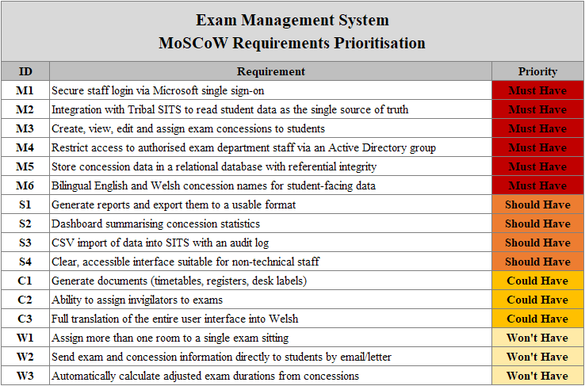
Fig. 1 - EMS MoSCoW Requirements Prioritisation

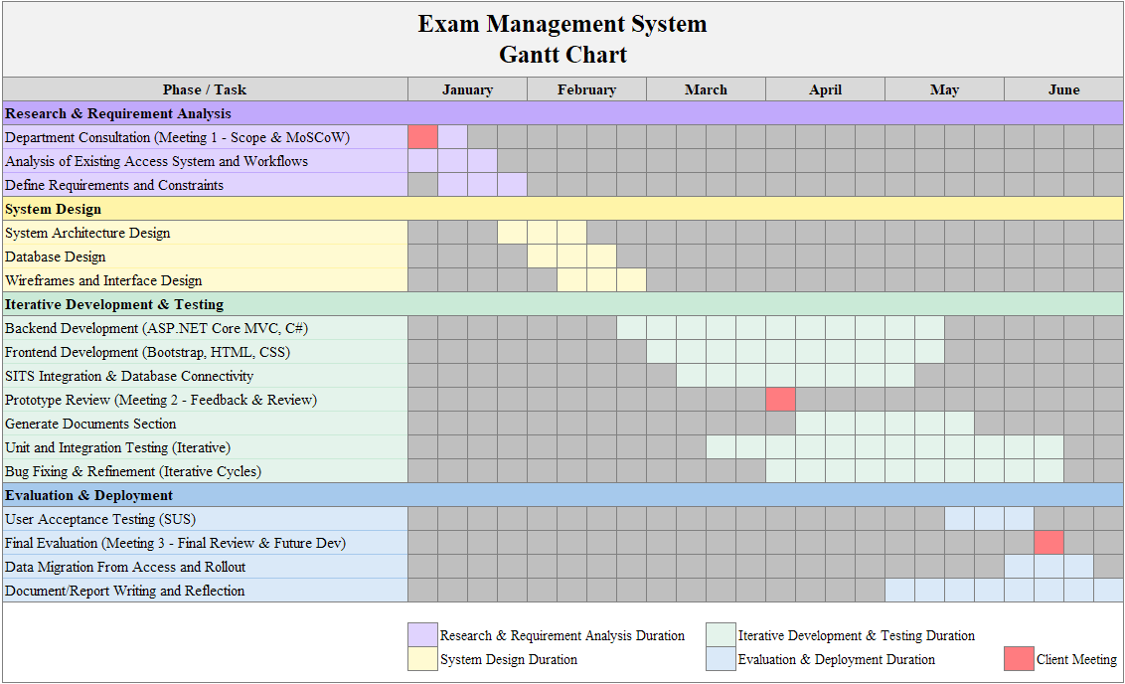
Fig. 2 - EMS Gantt Chart

3.4 Tools and Technologies
The system was built in Microsoft Visual Studio using ASP.NET Core MVC with C#. During development the application was run locally through IIS Express, a lightweight development web server built into Visual Studio, which allowed the system to be tested on the university network against the SITS test environment before being deployed to a full IIS server. SQL Server managed the database, with Entity Framework Core handling the mapping between the application and the database, and Bootstrap, HTML and CSS provided the interface. No specialist hardware was required, as development was carried out on a university machine connected to the secure network. Development was also supported by AI assistance, and its specific use in developing certain components is recorded in the Appendices.

3.5 Testing and Evaluation
Testing was structured in two stages. Functional testing, carried out by the developer against defined pass criteria, covered each area of the system and confirmed that the application, its database and the SITS connection worked together. A user evaluation then had exam staff complete realistic tasks under observation. The System Usability Scale was used during this testing to produce a measurable usability score [36], as it is a validated and reliable instrument rather than a source of informal feedback [39]. As this was a single site project, the results were intended to apply to the university's exam department rather than to be generalised more widely.

3.6 Ethics
Ethical approval was obtained through the university's ethics process before any testing or data collection took place. The completed ethics approval form is provided in Appendix H. Informed consent was gained from all staff who took part in meetings or testing, and their feedback was recorded in a way that protected their privacy [40]. Student data used during development was handled under the Data Protection Act 2018 [47] and the university's own policies, stored only on university managed servers, and accessed only by approved personnel. Access to sensitive concession data within the system was further restricted to authorised exam department staff.

CHAPTER 4
DESIGN & IMPLEMENTATION

4.1 Introduction
This chapter describes how the system was designed and built. It focuses on the decisions that shaped the system and the reasons behind them, giving most attention to the parts where the design choices mattered most. It covers the requirements, the architecture, the database design, the system models, the interface, and the implementation of the most technically interesting parts of the system.

4.2 Requirements
The requirements were gathered at the first meeting with the exam department and prioritised using the MoSCoW technique with the full prioritised list provided in Fig. 1. For design purposes, these requirements can be separated into functional requirements, which describe what the system must do, and non-functional requirements, which describe the qualities the system must have.

The functional requirements define what the system does, and are covered by the features described in this chapter. The most important, drawn from the "must have" priorities, were recording and assigning exam concessions, reading student and exam data from the SITS student records system, and securely storing the exam department's own data.

The non-functional requirements shaped how the system was built. Security was paramount, as the system handles sensitive disability information, as was data integrity, since the exam department depends on the information being accurate. Usability mattered because the users are administrative rather than technical staff, and maintainability was needed so the system can be supported and extended in future.

Finally, the system had to run against both a test and a live environment without code changes, allowing safe deployment. These qualities are revisited throughout the chapter, as they are the reasons behind many of the design decisions that follow.

4.3 System Architecture
The system was built as an ASP.NET Core MVC application on .NET 10, following a layered structure (Fig. 3). Controllers handle incoming requests and decide what to return, services contain the business logic and all database access, models describe the shape of the data, and Razor views render the pages. Separating the system in this way was a deliberate decision, because it keeps each concern in its own place and allows one part to be changed without disturbing the others, which supports the maintainability that Liu et al. [17] and Ahmad et al. [18] identify as the main benefit of a layered design.

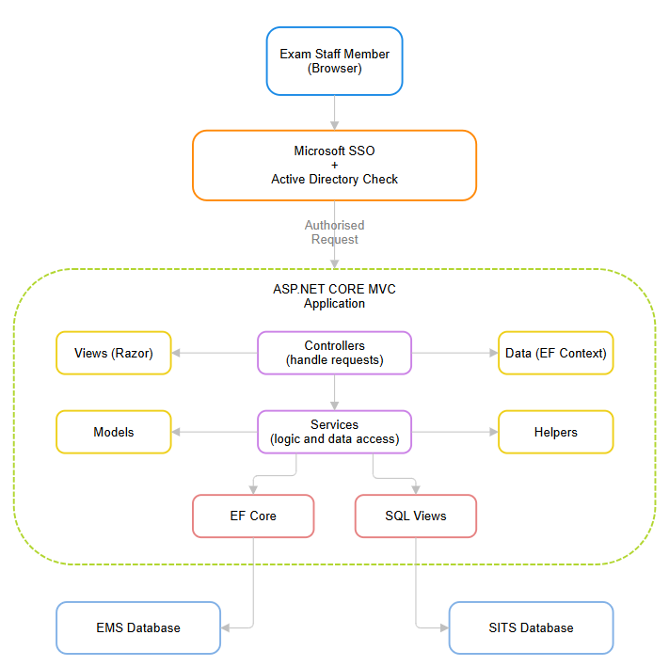
Fig. 3 - EMS Layered System Architecture

The most important architectural decision was how the system handles data. The application uses two databases on the same server. It has a small EMS database of four tables, which holds only the data the exam department needs that SITS does not provide, and it reads student, module and exam data from the SITS database. Rather than copying data out of SITS, the system reads it through a set of SQL views. This keeps SITS as the single source of truth, which avoids the duplication and inconsistency that Sasmito [24] and Garcia and Abílio [23] warn against, and means the system never holds an unreliable copy of a student's record. A further benefit of this approach is that the name of the SITS database appears only inside the views and in one configuration setting, never in the application code. As a result, moving the system from the test environment to the live environment is a configuration change rather than a code change, which makes deployment safer and more repeatable.

4.4 Database Design
The four tables the system owns are shown in the following EMS Database Entity Relationship Diagram (Fig. 4). ConcessionTypes holds the catalogue of available concessions, each with an English and a Welsh name. StudentConcessions stores which concessions have been assigned to which student, and links back to ConcessionTypes through a foreign key, so that referential integrity keeps every assigned concession pointing at a valid type. StudentNotes holds a single free text note per student, enforced by a unique index on the student code, and ImportLog records the outcome of every data import attempt.

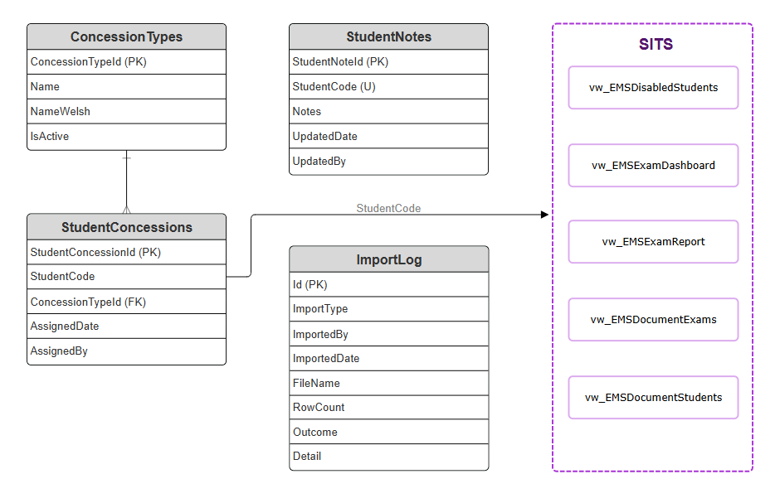
Fig. 4 - EMS Database Entity Relationship Diagram

A deliberate design choice was to link the system's own records to SITS using only the student code, rather than duplicating any student details into the EMS database. The student's name, course and disabilities are always read live from SITS through the views, so the EMS database never holds personal data that is not required. This follows the principle set out by Hjerppe et al. [29] that the less personal data is spread across a system, the easier it is to protect.

The system connects to the database as a single shared login following the trusted subsystem model, where the user has already been identified by single sign-on and one specific database account carries out the data access. This account is given only the permissions it needs. It can read and write the EMS database, but it can only read the SITS database, with the single exception of inserting into one table during the data import function. Limiting the account in this way follows the principle of least privilege, which Tang and Zhang [26] and Jin et al. [27] apply through role-based access control, and reduces the risk if the account was ever compromised.

4.5 System Modelling
The main interactions between the exam staff members and the system are shown in the EMS Use Case Diagram (Fig. 5). The member of staff signs in, searches for students, assigns/removes concessions, manages concession types, generates reports and documents, and imports data. Microsoft Entra and SITS appear as external systems that the application depends on but does not control. The diagram also shows that most of the system's functions read data from SITS, while only the data import writes to it, which reflects the single write point design used to protect the university's records.
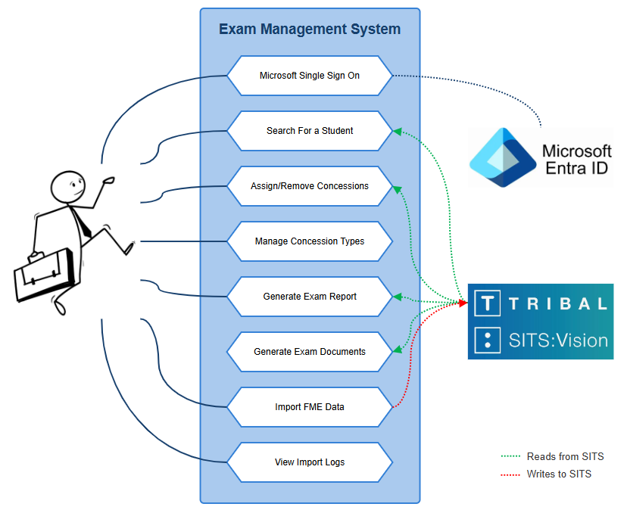
Fig. 5 - EMS Use Case Diagram

Two processes are worth modelling in more detail as they involve important decisions. The first is how a user is granted or denied access (Fig. 6). Every request is checked to confirm the user has signed in and belongs to the correct Active Directory group before any page is shown, and a user who is signed in but not in the group is sent to a dedicated access denied page. The second is the data import process (Fig. 7), which checks the file, previews it, validates its codes against SITS, and only writes to SITS after the user confirms, recording the outcome of every attempt.

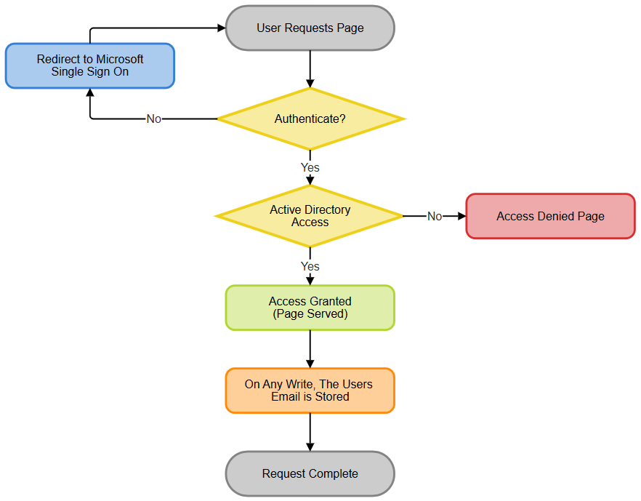
Fig. 6 - EMS Authentication and Authorisation Flow

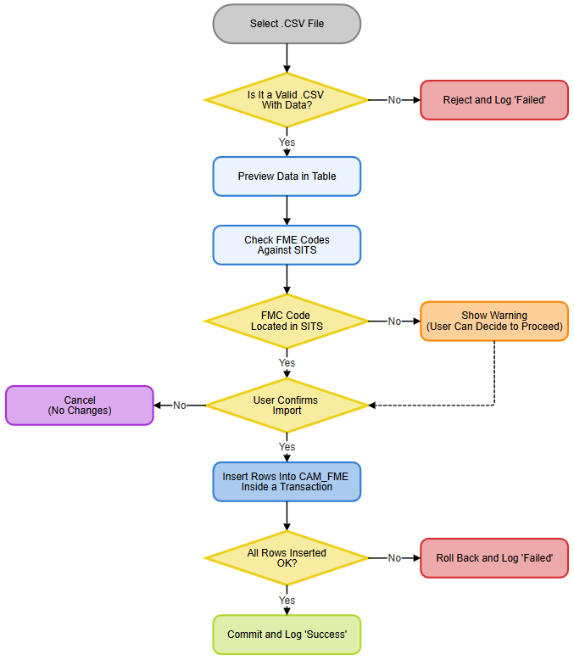
Fig. 7 - EMS Data Import Process

4.6 Interface Design
The interface was first designed as a range of wireframe designs before any code was written, so the layout and navigation could be agreed early. Figs. 8 and 9 show an early wireframe of the student concession screen alongside the finished page. The overall layout, with a fixed navigation panel on the left and the main content on the right, was carried through from the wireframe to the finished system, although some of the wording and features changed as the project developed. This reflects the iterative approach described previously, where early designs were refined in response to feedback rather than fixed at the outset.

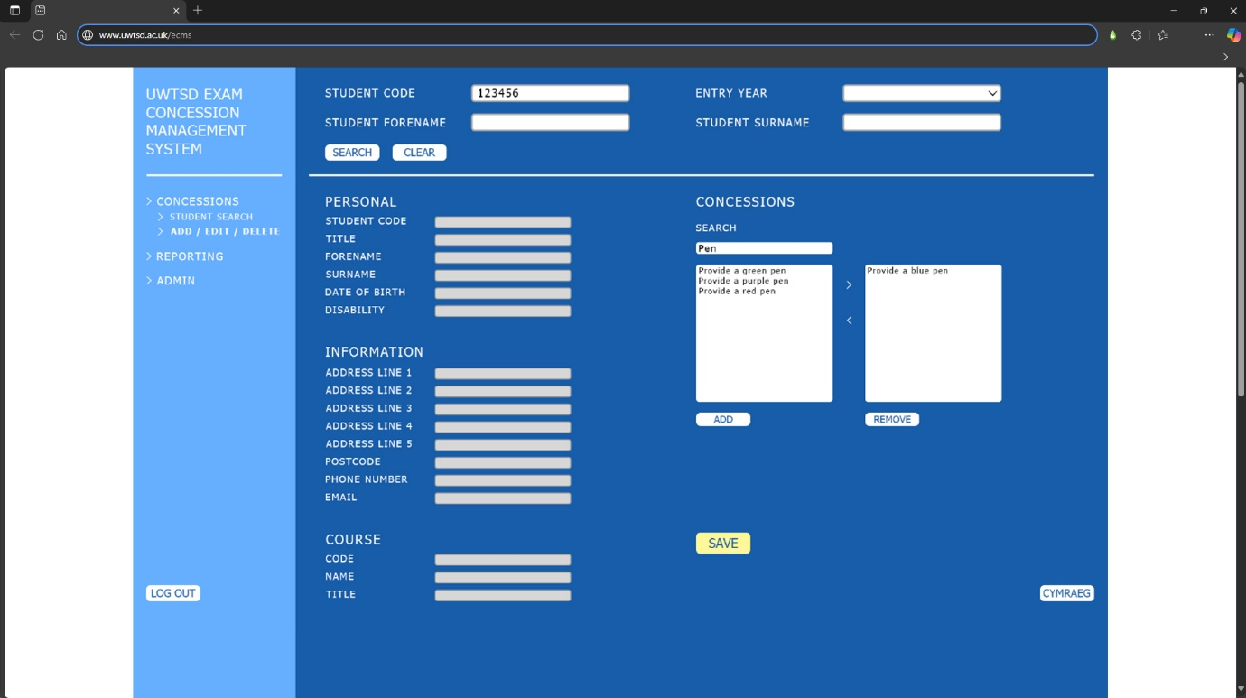
Fig. 8 - EMS: Initial Student Concession Wireframe Page

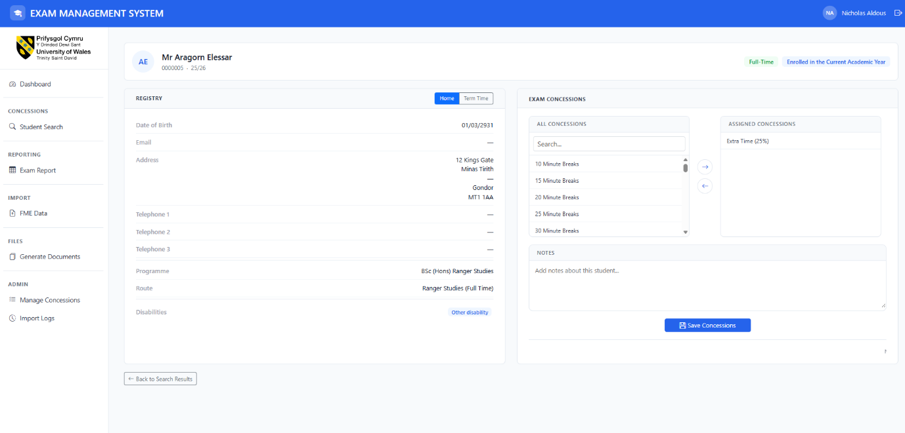
Fig. 9 - EMS: Finished Student Concession Page

The finished interface was designed to be clear and consistent for users who are not technical, following the usability principles reviewed earlier. The same header, navigation and colour scheme appear on every page, so that a user who has learned one page already understands the others. On the student page (Fig. 9), concessions are moved between an "available" list and an "assigned" list using arrow buttons, which is a simple and recognisable pattern that applies Nielsen's principle of favouring recognition over recall [37], since the user sees the options rather than having to remember them.

The design of each page reflects the task it supports. The dashboard (Fig. 10) gives an overview of upcoming exams and outstanding concessions, so users can see what needs attention first. The exam report page (Fig. 11) presents the filtering options as clearly labelled ‘include’ and ‘exclude’ lists, so that a complex query can be built without any knowledge of the underlying data. The data import page (Fig. 12) shows the uploaded data in a preview table before anything is saved, so the user can verify the data and must actively confirm before it is written to the university's records.

Several validation rules were built into the interface to prevent mistakes. The save button on the student page (Fig. 9) stays disabled until a genuine change is made, which prevents empty or accidental saves. The notes box is locked until at least one concession is assigned, so a note can never be recorded against a student with no concessions, and this rule is enforced both in the browser and again on the server so it cannot be bypassed. On the concession catalogue (Fig. 13), both the English and the Welsh name are required before a new concession can be saved, which enforces the bilingual requirement at the point the data is created. Preventing errors before they happen in this way follows another of Nielsen's usability principles [37]. Images of the full application can be seen in Appendix A.

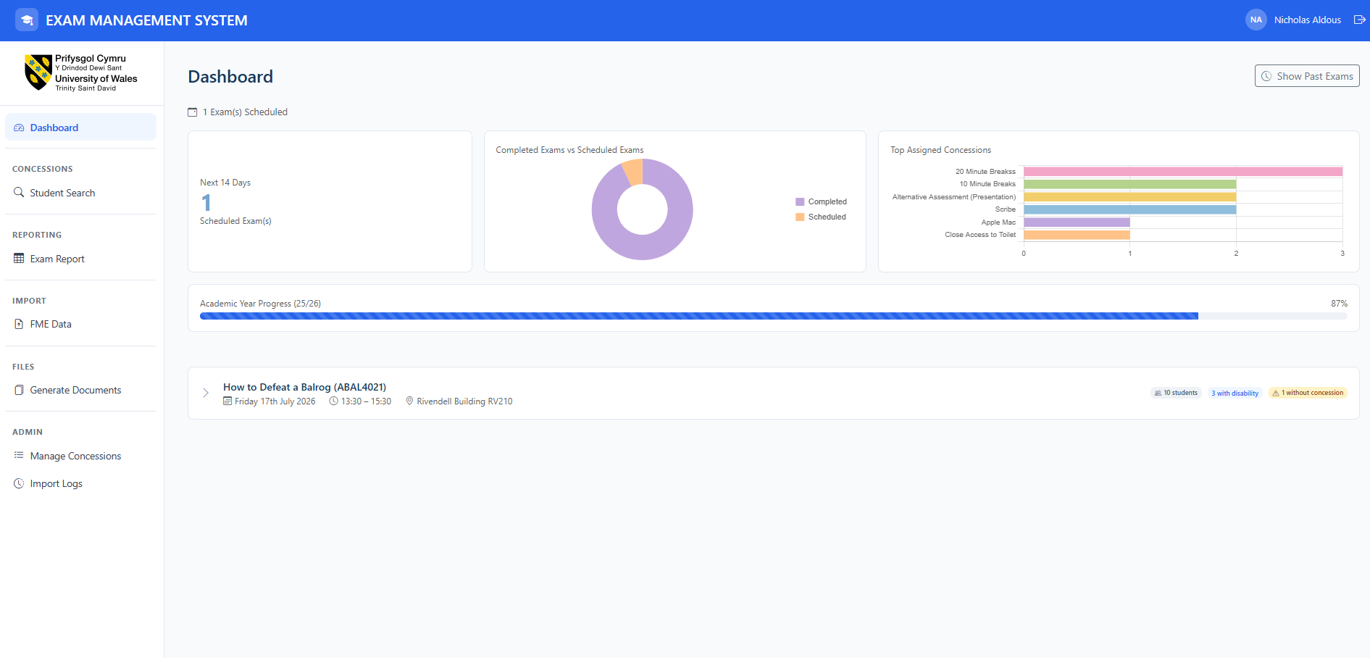
Fig. 10 - EMS: Dashboard Page

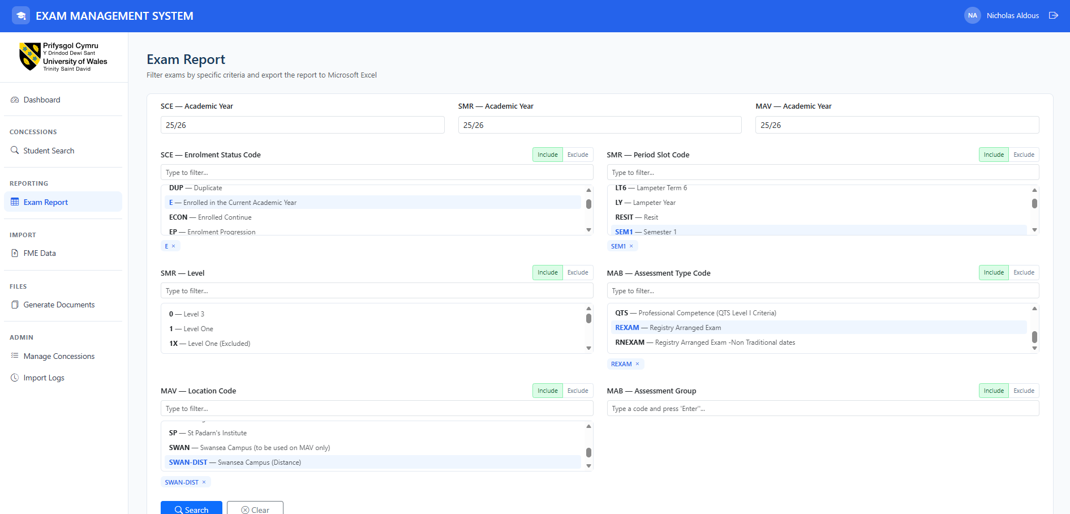
Fig. 11 - EMS: Exam Report Page

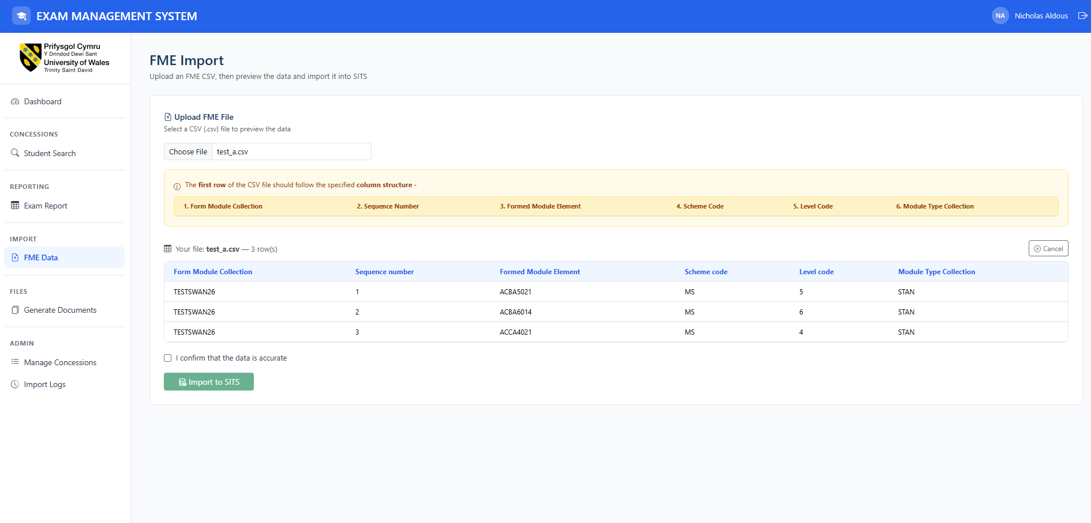
Fig. 12 - EMS: Formatted Mass Entry (FME) Import Page

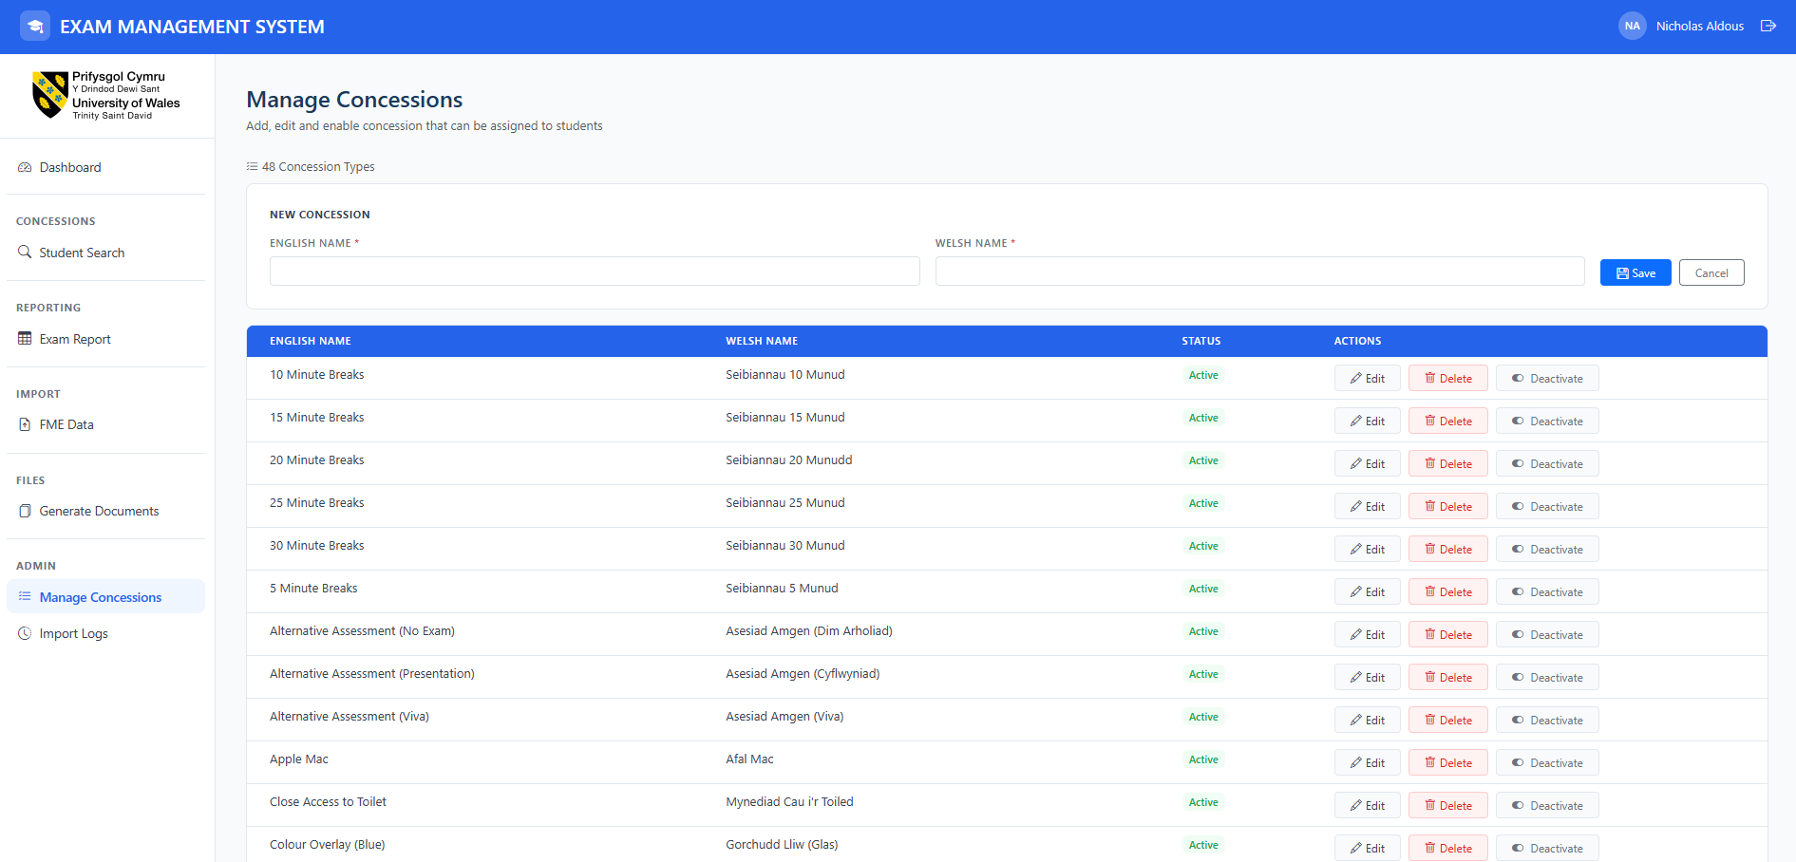
Fig. 13 - EMS: Manage Concessions Page

4.7 Implementation
Three parts were more technically interesting and are described here in terms of how they work. All three were developed with AI assistance, as recorded in the Appendices.

Safe Dynamic Filtering in the Exam Report
The exam report lets the user filter on several fields, selecting any number of criteria in each and choosing whether to include or exclude them. This means the query cannot be written in advance. Building a query from user input is the classic cause of SQL injection, one of the most serious and common web application security risks [48]. For each value the user selects, the code adds a numbered placeholder to the query text, and adds the real value separately as a parameter, shown in Fig. 14.

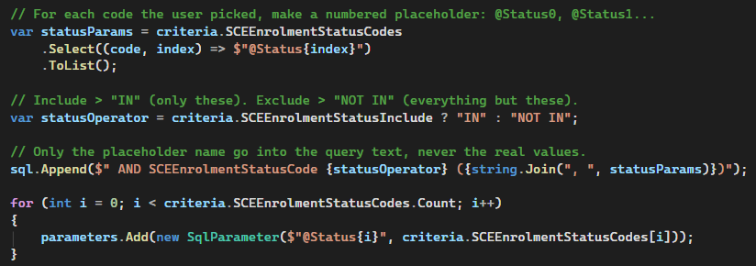
Fig. 14 - Parameterised Construction of the Dynamic Report Filter

Because the values never become part of the query itself, they cannot change what it does, which is the defence against injection that OWASP recommends [48], even though the query is built dynamically. Parameterisation is not the only safeguard. The filterable fields are fixed by the application rather than taken from the request, and further hardening could add stored procedures, allow list validation of supplied values, and a database account with minimum permissions. The same pattern is reused for every filter, and a single boolean flips it between "include" and "exclude".

Writing to SITS Safely
The Formatted Mass Entry (FME) import is the only place the system writes to SITS, so it was built to be safe if anything goes wrong. All the rows are inserted inside a single database transaction, so that either every row is saved or none is, shown in Fig. 15.

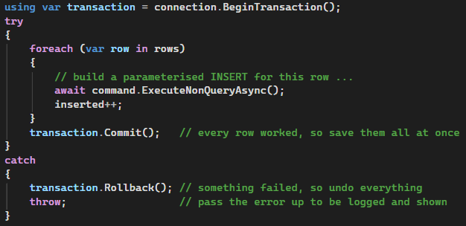
Fig. 15 - Transaction Handling in the Formatted Mass Entry (FME) Import
If any row fails, the transaction is rolled back so a half finished import can never be left in the university's records, and the error is passed up so that the failure is recorded in the import log and shown to the user. Every value is supplied as a parameter, and missing or invalid data in the file is turned into a database null rather than being allowed to crash the import. This means one bad row in a file cannot corrupt SITS or stop the system working.

Generating Exam Documents
The Generate Documents feature produces the printed paperwork the exam department needs for each sitting, namely timetables, registers and desk labels, as Portable Document Format (PDF) files. The user searches for exams over a date range, selects the ones required, and the system builds each document from the exam and student data read live from SITS. A key requirement here was that the concessions held by each student had to appear on the register and desk labels, so that invigilators can see at a glance which students have arrangements in place. Figs. 16 to 18 show an example generated timetable, register and desk labels. Producing these as PDF files means the output is fixed and print ready.

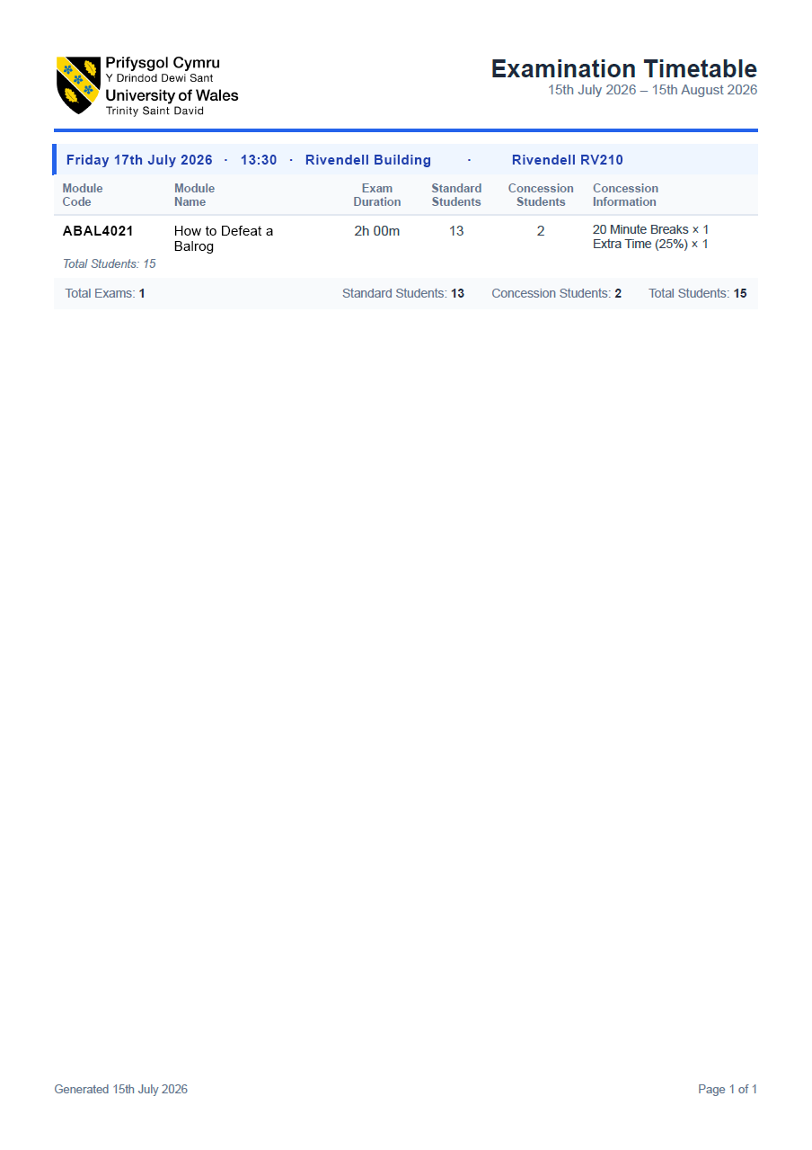
Fig. 16 - Generated Exam Timetable Portable Document Format (PDF)

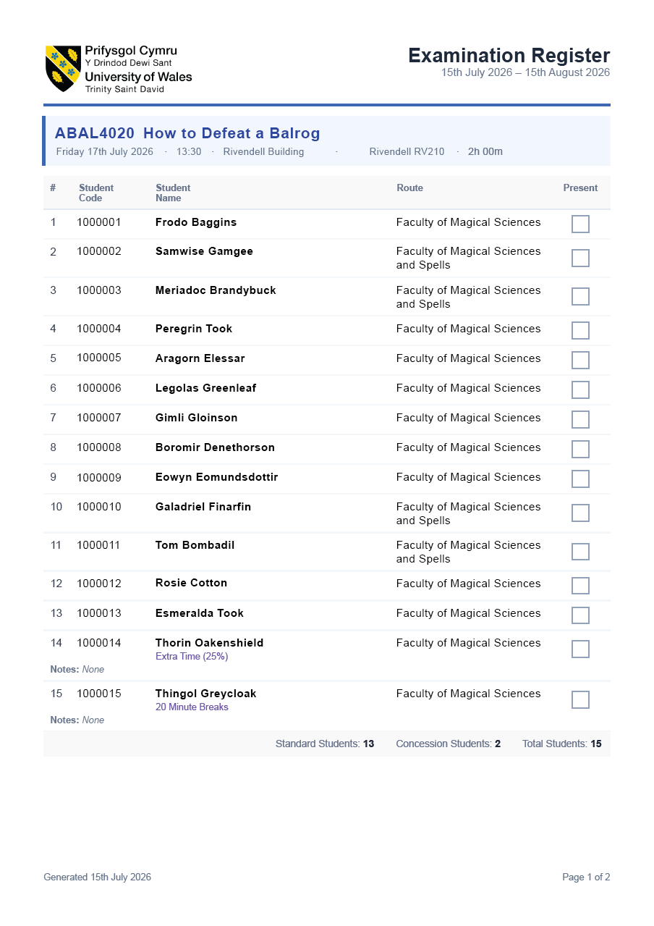
Fig. 17 - Generated Exam Register Portable Document Format (PDF)

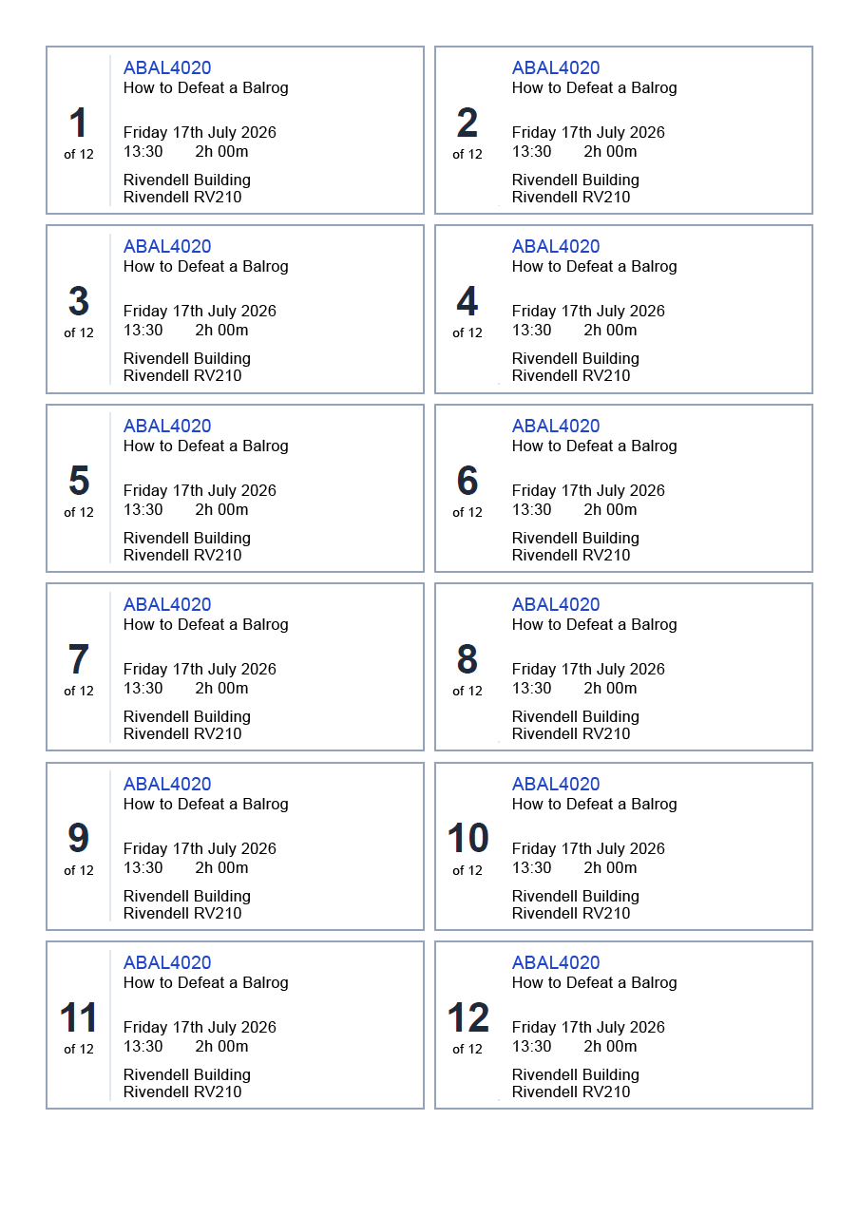
Fig. 18 - Generated Desk Labels Portable Document Format (PDF)

4.8 Summary
This chapter has described the design and construction of the system, focusing on the most important decisions. The layered architecture and the two database design keep the system maintainable and ensure SITS is the single source of truth. The database design and the restricted database account protect the data the system holds, and the interface was designed and validated to be clear and reliable for non-technical users. The implementation of the exam report and the data import shows how the system handles user input and writes to the university's records safely.

CHAPTER 5
EVALUATION

5.1 Introduction
This chapter evaluates the finished system in two ways, first against the objectives set at the start, and then against the legacy Microsoft Access systems it replaced.

There are two forms of evidence that support the evaluation. Functional testing, carried out against a structured test plan, confirms whether each part of the system works correctly and handles invalid input safely. A usability evaluation with users from the exam department, using the System Usability Scale, measures how usable they found it in practice. The chapter then considers how far the results agree with the literature review, whether the overall aim was met, and what a future version should improve.

5.2 Evaluation Against Objectives
The clearest measure of the project's success is how far it delivered the requirements agreed at the start. The first objective, the literature review, was met in Chapter 2, and its findings shaped the requirements and design decisions evaluated here. The requirements were prioritised using the MoSCoW technique, and Fig. 19 shows the outcome for each requirement against that prioritisation.

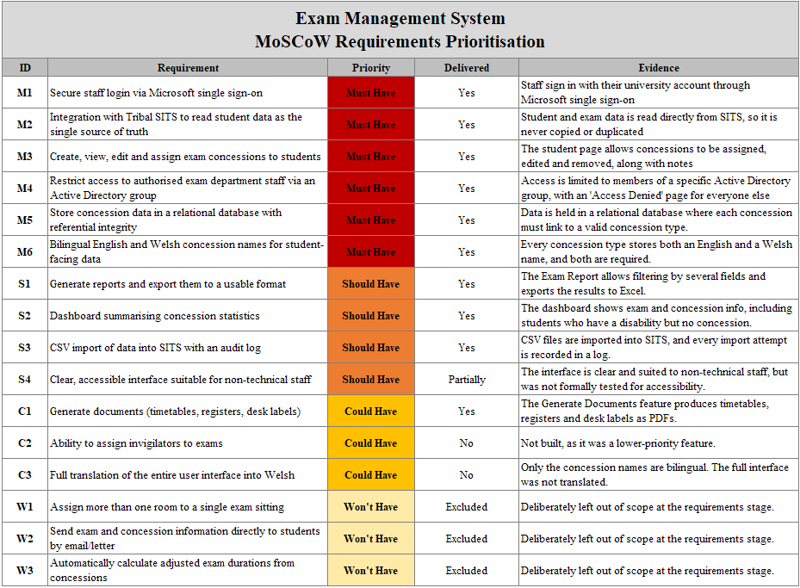
Fig. 19 - EMS MoSCoW Requirements Prioritisation Results

The system delivered all six of the "must have" requirements. Staff sign in with their university account through Microsoft single sign-on, access is restricted to members of an Active Directory group, and the system reads student and exam data live from SITS rather than holding its own copy. Concessions can be created, assigned and edited, they are stored in a relational database with enforced referential integrity, and each concession type holds both an English and a Welsh name. As these were the requirements judged essential, delivering all of them is the central evidence that the project met its core objectives.

All four "should have" requirements were also delivered, though one carries a limitation. The exam report with its filtering and Excel export, the dashboard of statistics, and the audited comma separated values (CSV) import were all completed as intended. The fourth, a clear and accessible interface, was delivered in the sense that matters most, since the interface is consistent and designed for non-technical users, and is examined further through the usability evaluation later. It was not, however, formally tested for accessibility against standards such as WCAG, so accessibility in that stricter sense is better described as partially met and is returned to as an area for future work.

Of the three "could have" requirements, one was delivered. The Generate Documents part, which produces timetables, registers and desk labels as PDF files, was built in full. Delivering an optional requirement to this standard shows the project went beyond its essential baseline rather than only meeting it. The remaining two, assigning invigilators to exams and translating the entire interface into Welsh, were not built. Both were low priority by the project's own prioritisation, and the bilingual requirement that genuinely mattered, the concession names shown to students, was delivered under the "must have" M6. The three "won't have" requirements had been placed outside the scope by agreement at the requirements stage.

Overall, the delivery record is strong. Measured against its own objectives, the project succeeded.

5.3 Functional Testing
The first form of evaluation was functional testing, carried out by the developer against a structured test plan in the test environment. The plan covered 54 individual tests across eleven areas of the system, including authentication, navigation, the dashboard, student search, concessions, the concession catalogue, the import logs, the Formatted Mass Entry (FME) import, the exam report, document generation, and general error handling. Each test defined a clear pass criterion in advance, so that the outcome was judged against a fixed standard rather than a subjective impression. The full test documentation is provided in Appendix B.

Of the 54 tests, 52 passed and 2 failed, giving an overall result of "pass with issues". Importantly, the testing was designed to check not only that the system works when used correctly, but also that it behaves safely when it does not. Several tests deliberately used invalid input, and the system handled each case as intended. An empty import file produced a clear "the file contained no data" message and was recorded as a failed import rather than causing an error (FME05). An invalid academic year format was caught by validation, which blocked the search until it was corrected (ER01 to ER03). A user who was signed in but not a member of the Active Directory group was shown the access denied page rather than a broken error screen (AUTH04). This confirms that the safeguards described previously, such as the validation rules and the controlled import process, work in practice.

The two failures were both minor and specific. The first (DASH05) was an incorrect date format in the file name of an exported Excel file, and the second (LOG02) was the "Imported By" column on the import logs not displaying the signed in user's email address. Neither affected the core function of the system or the integrity of any data, and both have since been corrected. Recording these failures openly, rather than presenting an unbroken set of passes, reflects the purpose of testing, which is to find issues so they can be fixed. The high pass rate, together with the correct handling of every invalid input case, gives confidence that the system is functionally sound.

5.4 System Usability Scale (SUS) Evaluation
The second form of evaluation was a usability study carried out with participants from the exam department, the intended users of the system. This was measured using the SUS. Users completed the specific ten item questionnaire, and to ensure the sessions were conducted consistently, the developer followed a testing guide written for this purpose, which can be found in Appendix C. Three members of staff took part. Each completed a set of eight realistic tasks covering the main features of the system, such as searching for a student, assigning concessions, generating a report and producing exam documents, and then completed the questionnaire based on their experience. The full participant responses are provided in Appendix D.

The results were strong. The three participants gave scores of 87.5, 72.5 and 82.5, producing a mean of 80.8. Against the published benchmarks, where the average score across studies is about 68, a score of 80.8 corresponds to a grade of A and a rating of "excellent", and falls within the range considered acceptable [39]. The task success rate was also high, with 23 of the 24 tasks completed successfully across the three participants, a rate of 96%. The full results are documented in Appendix E.

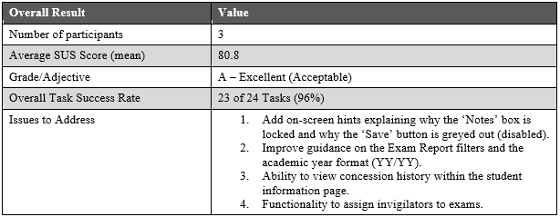
Fig. 20 - System Usability Scale Results

The open feedback was consistent with these scores and, usefully, identified specific points for improvement rather than general dissatisfaction. Two of the three participants found a validation feature unclear at first, one noting that the reason the notes box was locked was not obvious, and another that the disabled save button was confusing until its purpose became clear. This is a valuable finding, because it shows that a design decision intended to prevent mistakes, described earlier, was effective but not self-explanatory, and would benefit from a short hint on the screen. One participant also found the exam report filters and the academic year format took time to understand. Beyond usability, participants suggested additional functionality, including the ability to assign invigilators to exams and to view a student's concession history, one of which was under the "could have" C2 and the other recorded as future work.

Although the sample of three participants is small, which is acknowledged as a limitation, the System Usability Scale is considered reliable even with small numbers of participants [39], and the consistency of the three scores and the feedback gives reasonable confidence in the result. Taken together with the functional testing, the usability evaluation indicates that the system is not only functionally sound but also genuinely usable by the users it was built for.

5.5 Discussion in Relation to the Literature
A key part of evaluation is considering whether the results agree with the research reviewed in the Literature Review. On the whole they do, and in several places they provide practical support for arguments that the literature made in principle.

The usability results align closely with the literature on usability measurement. The mean score of 80.8 places the system in the "excellent" band of the benchmarks established by Bangor et al. [39], and the fact that three separate participants produced scores clustered in the "good" to "excellent" range is consistent with their finding that the System Usability Scale gives reliable results even with small samples. Brooke [36] argued that a tested scale gives better evidence than informal impressions. The clear result obtained here supports that argument.

The feedback also connected directly to the discussed usability principles. The two participants who were initially unsure why the notes box was locked or the save button was disabled had encountered features designed to prevent errors, which is one of the heuristics developed by Nielsen [37]. The same set of heuristics, however, also requires that a system keeps the user informed of its status [37], and the feedback shows that the design had satisfied the first principle and not the second. Preventing the mistake was not enough on its own, because the user also needed to understand why the system was stopping them. This is a useful real world example of a trade off the literature describes, and it points to a specific, evidence based improvement rather than a vague one.

The design decisions evaluated here also supported the arguments made in the literature on data and integration. The system's use of SITS as the single source of truth, reading data live rather than copying it, delivered the consistency that Sasmito [24] and Hjerppe et al. [29] associate with that approach, and the testing confirmed that the student data shown in the system matched its source. This stands in direct contrast to the duplication and drift that characterised the legacy Access systems and provides concrete support for the principle that minimising the spread of data improves its integrity.

Finally, the evaluation reflects the more cautious argument from the disability and assessment literature. Tai et al. [7] and Harris et al. [35] argued that making the administration of adjustments more efficient is valuable but is not the same as making assessment genuinely inclusive. The results here are consistent with that distinction. The system clearly improves how efficiently and consistently concessions are recorded and applied, which the staff feedback supports, but it does not change the underlying model of individual, reactive adjustment that those authors critique. The evaluation therefore agrees with the literature that a management system of this kind is a genuine improvement to administration, while recognising the limits of what it can achieve for inclusion.

5.6 Meeting the Aim
The wider aim of the project was to replace the exam department's legacy Microsoft Access systems with a single, secure, integrated application that the department could rely on. Evaluating that aim means comparing the finished system against what it replaced.

The legacy arrangement consisted of three separate Access databases, one for concessions, one for exam reporting and one for producing exam documents, shown in Appendix F. The same information had to be maintained in more than one place, and nothing connected them to the university's central records, so student data copied from SITS by hand was out of date from the moment it arrived. With no adequate search to locate existing entries, users recorded the same concession in different ways. For example, "25% Extra Time", "Extra Time 25%" and "ET = 25%" were all created as separate concessions, so even a simple count of students with a particular concession was unreliable. There was also no audit trail, so no record existed of who made changes or when.

The finished system addresses each of these weaknesses directly. It is a single application rather than three separate files, so information is entered once and used everywhere. It reads student and exam data live from SITS through database views, so the data is never copied and cannot fall out of step with its source. Concessions are selected from a controlled catalogue rather than typed, so the duplication that made the legacy data unreliable is no longer possible. Every change records the email address of the member of staff who made it, and every data import is logged with its outcome, so there is now an audit trail where previously there was none. Access is restricted to members of a specific Active Directory group and the system is reached through the university's single sign-on, rather than depending on file level access to a shared database.

On the evidence gathered, the aim was met. The functional testing confirms that the system works as intended, the usability evaluation confirms that its users find it usable, and it resolves the specific weaknesses that made the legacy systems unsatisfactory. The system has been deployed to the live environment and is currently in departmental evaluation ahead of full rollout, which is the strongest practical evidence that it is fit for its purpose. However, the efficiency increases the system is expected to deliver, such as the time saved preparing exam documents, have not yet been measured over a full exam cycle. The claim made here is that the system is demonstrably better designed and better integrated than what it replaced, not that a quantified saving has been proven.

5.7 Limitations and Future Work
No project of this size is without limitations, and identifying them honestly is part of evaluating it properly.

The functional testing was carried out by the developer rather than independently, which means it confirms the system behaves as its designer expected rather than providing a fully impartial check. The tests were also run manually, so there is no automated test suite to catch regressions when the system is changed in future. The usability study involved only three participants, which, although sufficient to produce a reliable System Usability Scale result [39] and to surface consistent issues, is a small sample from which to generalise. A larger study, and testing over a complete exam cycle, would give a firmer basis for the conclusions drawn.

The system also has known limitations. Two planned features were not built, namely the ability to assign invigilators to exams and the full translation of the interface into Welsh, both of which were low priority by the project's own prioritisation. One participant independently asked for invigilator assignment, suggesting it was a genuine requirement despite being deprioritised. The interface was designed to be clear for non-technical users, and the usability results support that, but it was not formally tested against accessibility standards such as the Web Content Accessibility Guidelines, which is a gap given the system's own subject matter. The system also records who last changed a student's concessions, but does not keep a full history of those changes, so it is not possible to see how a student's arrangements have altered over time. This was requested by a participant during testing and would be a valuable addition. The audit trail is also enforced by the application rather than the database. All changes reach the database through one shared service account, so a change made outside the application would not be attributed to an individual.

Finally, performance under load was not formally tested. Every page reads SITS live through views, so response times depend on SITS and on the complexity of those views, the same stability risk Jin et al. [13] criticised in earlier systems. The user base is a handful of staff rather than thousands of students, which limits the practical risk, though no measurements confirm it. Caching slowly changing data, such as the concession catalogue and dashboard statistics, would cut the number of live queries at the cost of briefly out of date results. The data import also writes rows one at a time inside a transaction, which is safe but would not scale to very large files.

The most significant development, however, is external to the project. During the later stages of the work, the university's SITS platform was upgraded and now provides its own facility for recording concessions against a student record. This does not invalidate the system, which was designed correctly against the platform as it existed when the requirements were agreed, and which continues to meet its objectives. It does, though, change what the ideal long term design would look like. Storing concessions directly in SITS would take the single source of truth principle discussed throughout this report to its logical conclusion, holding the concession data in the same system as the student record it belongs to. The architecture chosen for this project means that evolution would be a manageable change rather than a rebuild, because the system already reads its student data from SITS through views, and the concession data could be redirected in the same way. The most valuable next step for the system would therefore be to migrate concession storage into SITS while retaining the interface, reporting and document generation that this project has delivered, none of which SITS provides.

5.8 Summary
This chapter has evaluated the finished system against its objectives and against the legacy systems it replaced. Measured against its objectives, the project succeeded, delivering all six essential requirements, all four second tier requirements and one optional requirement.

The evidence supports this. Functional testing produced 52 passes from 54 tests, with both failures minor and since corrected, and the usability evaluation produced a mean System Usability Scale score of 80.8, rated excellent against published benchmarks, with 96% of tasks completed successfully. These results agree with the literature review, both in what the system achieved and in the limitation it did not resolve, since making the administration of adjustments more efficient is not the same as making assessment inclusive.

The wider aim was also met. The system replaces three disconnected Access databases with a single application that reads its data live from SITS, records concessions from a controlled catalogue, restricts access to authorised staff, and keeps an audit trail of who changed what. It has been deployed to the live environment and is in departmental evaluation ahead of full rollout. What has not yet been demonstrated is a measured efficiency saving over a complete exam cycle, and the limitations noted in the previous section remain areas for future development. The most significant of these is the opportunity created by the recent SITS upgrade, which would allow concession data itself to be held in the student records system, completing the single source of truth principle that shaped this project's design.

CHAPTER 6
CONCLUSIONS AND RECOMMENDATIONS

6.1 Introduction
This chapter draws together what the project achieved, what its results mean, and what should happen next. It first sets out the conclusions that can be drawn from the work, then makes recommendations arising from the evaluation.

6.2 Conclusions
The project set out to replace three separate and disconnected Microsoft Access databases with a single web-based system for administering exam concessions, exam reporting and exam documentation, integrated with the university's Tribal SITS student records system. On the evidence presented in the previous chapter, it achieved that aim.

The first conclusion is that the project met its objectives. Every essential requirement was delivered, every second tier requirement was fulfilled, and one optional requirement was completed. The requirements that were not built were the lowest priority by the project's own prioritisation. Functional testing across 54 tests and a usability evaluation with the users of the system support the conclusion that what was delivered works and is usable.

The second conclusion concerns the value of the architectural decisions. The choice to regard SITS as the single source of truth, reading student and exam data live through database views rather than copying it, proved to be the most consequential decision of the project. This removed the duplication that had made the legacy data unreliable. The system reads student data directly from SITS, so it can never show a record that differs from the university's own. The controlled catalogue of concessions had a similar effect, preventing the same concession from being recorded in several different forms. Together, these two decisions address the main causes of the legacy system's weaknesses rather than only improving its interface, and they are the reason the evaluation could conclude the system is better designed and better integrated than what it replaced.

The third conclusion is that the system is usable by the people it was built for. This was not a foregone conclusion, since the system is used by administrative staff rather than technical users, and a well-engineered system that staff cannot navigate would have failed in practice. A mean System Usability Scale score of 80.8, rated excellent against published benchmarks, together with a 96% task success rate, gives reasonable confidence that the interface achieved what it set out to.

The fourth conclusion is more measured. The system improves the administration of exam concessions, but it does not, and could not, address the deeper question raised in the literature, which is whether a model based on individual, reactive adjustments serves disabled students well in the first place. The system makes that model faster, more consistent and more auditable. It does not replace it. This is a genuine limit on what the project achieved, and it is one the literature anticipated.

Finally, the project demonstrates that a well-chosen architecture creates room for change. The upgrade to SITS during the final stages of the work, which introduced a facility for recording concessions, could have rendered a more tightly coupled system obsolete. Because this system already reads its data from SITS through a replaceable layer of views, that change becomes an opportunity to evolve rather than a reason to rebuild. That is a conclusion about method as much as about this particular system.

6.3 Recommendations
Arising from the evaluation, the following recommendations are made.

Migrate Concession Storage Into SITS
During the later stages of this project the SITS platform was upgraded and now provides its own facility for recording concessions. Holding concession data in SITS would complete the single source of truth principle that shaped this project, placing the concession alongside the student record. The system's existing architecture allows this change to be made without a rebuild, and the interface, reporting and document generation would stay the same.

Add a Full History of Concession Changes
The system currently records who last changed a student's concessions but does not store a history of those changes. A member of staff requested this during usability testing. Recording each change as a dated entry would allow the department to see how a student's arrangements have evolved, which is valuable both administratively and for accountability.

Improve the Visibility of the System's Validation Rules
The usability evaluation found that two of the safeguards built into the system, the locked notes box and the disabled save button, prevented errors effectively but were not self-explanatory. Adding short on screen explanations of why a control is unavailable would keep the protection while removing the confusion.

Carry Out Formal Accessibility Testing
The interface was designed to be clear for non-technical staff and the usability results support that, but it has not been tested against the Web Content Accessibility Guidelines. Given that the system exists to support disabled students, formal accessibility testing should be treated as a priority.

Introduce Automated Testing
All testing to date has been carried out manually by the developer. An automated test suite would allow the system to be changed with confidence, particularly if the concession storage is migrated to SITS as recommended above.

Complete the Deferred Features
Assigning invigilators to exams was requested independently by a participant during usability testing, confirming it as a genuine requirement, and full Welsh translation of the interface would extend the bilingual provision that the system currently applies only to concession data.

Measure the System's Impact Over a Full Exam Cycle
The efficiency gains claimed for the system remain untested. Recording the time taken to prepare exam documentation before and after adoption would establish the value of the system in evidence rather than in principle.

CHAPTER 7
REFLECTION

7.1 Introduction
This chapter reflects on the project as a learning experience and evaluates the way I worked, what the project taught me, and how it developed me as a developer and as a person. Because reflection is personal, this chapter is written in the first person.

7.2 What Went Well
The decisions that served the project best were structural ones made early. Reading SITS through database views, rather than naming its database in the application code, meant that moving from test to live was a configuration change rather than a code change. Holding secrets in server environment variables had the same character. Both cost some thought at the start and repaid it at the most stressful point, which was deployment. Working in small verifiable steps during the live migration was equally valuable, because checking each stage before moving on meant that any fault was easy to locate. Writing documentation as I went felt like overhead at the time, but producing the test records and the developer reference guide in Appendix G forced me to understand what I had built rather than assume that I did.

7.3 What Was Difficult
The difficulties began before any code was written. When I first set up Visual Studio, the application would not run at all, because the default path that IIS Express expected did not exist, and I resolved it by creating a new environment variable pointing to the correct location. It was a small fault, but it taught me an early lesson, which is that the development environment can fail just as easily as the code.

A constant challenge was that I was learning as I built. I had not worked with this combination of technologies before, so many features began with research rather than code, drawing on developer resources such as Microsoft Learn, W3Schools, and tutorial videos. I also used AI assistance from Claude, both as a learning aid for explaining unfamiliar concepts and diagnosing errors, and for a number of complex components recorded in the Appendices, to generate initial implementations that I then adapted and integrated myself. Working this way was slower than building from existing knowledge, but it taught me to judge the quality of an answer, whatever its source, and to test everything before trusting it.

The migration to the live environment brought a different kind of difficulty, which was depending on another department. The server access, permissions and settings the system needed had to be arranged through the IT Systems and Infrastructure department, and each request needed authorisation from their management before work could begin. The waiting was outside my control, and I learned to raise requests as early as possible and to plan other work around the delays.

7.4 What I Would Do Differently
The clearest change I would make is to involve the users more often. The three meetings with the exam department worked, but they were spaced far apart, and I would instead meet regularly throughout development, demonstrating the system in sections as each part was built. Gathering feedback from user testing early would have identified faults and usability improvements while they were still easy to fix. A number of small issues, such as the unclear validation controls, were only found near the end when staff sat down and used the system. I would also spend longer on the data model at the start, because the limitations previously noted, such as the absence of a concession history, trace back to early modelling decisions that I made quickly and never revisited.

7.5 Personal Development
The project developed me in ways that go beyond technical skill. Working with the exam department taught me to listen carefully, to translate what staff described into requirements, and to accept feedback on something I had built, while depending on the IT Systems and Infrastructure department taught me to communicate requests clearly and to work within another team's priorities. Being my own reviewer taught me a discipline of self-checking that I did not have before, after one early mistake showed me the cost of trusting memory over the source. Above all, I now understand the difference between a system that works and a system that is engineered well. I built something that works and is deployed, but the process behind it could have been better, and recognising that gap is the most valuable thing I have learned.

CHAPTER 8
REFERENCES

[1] | T. Gkrimpizi, V. Peristeras, and I. Magnisalis, “Classification of Barriers to Digital Transformation in Higher Education Institutions: Systematic Literature Review,” Education Sciences, vol. 13, no. 7, p. 746, July 2023, doi: 10.3390/educsci13070746.
[2] | S. P. Souli and C. Pierrakeas, “Contemporary Trends in University Administration with the Integration of Digital/New Technologies,” Administrative Sciences, vol. 15, no. 11, p. 437, Nov. 2025, doi: 10.3390/admsci15110437.
[3] | W. Kayanja, M. Kyambade, and T. Kiggundu, “Exploring Digital Transformation in Higher Education Setting: The Shift to Fully Automated and Paperless Systems,” Cogent Education, vol. 12, no. 1, Apr. 2025, doi: 10.1080/2331186x.2025.2489800.
[4] | S. Saini, K. Gomis, Y. Polychronakis, M. Saini, and S. Sapountzis, “Identifying Challenges in Implementing Digital Transformation in UK Higher Education,” Quality Assurance in Education, vol. 33, no. 1, pp. 109-123, 2025, doi: 10.1108/QAE-05-2024-0076.
[5] | T. Newman, L. McGill, and S. Knight, “How to approach digital transformation in higher education,” 2025. [Online]. Available: https://repository.jisc.ac.uk/9910/
[6] | Equality Act 2010. 2010. [Online]. Available: https://www.legislation.gov.uk/ukpga/2010/15
[7] | J. Tai et al., “How Are Examinations Inclusive for Students with Disabilities in Higher Education? A Sociomaterial Analysis,” Assessment & Evaluation in Higher Education, vol. 48, no. 3, pp. 390-402, 2023, doi: 10.1080/02602938.2022.2077910.
[8] | J. M. Fernández-Batanero, M. Montenegro-Rueda, and J. Fernández-Cerero, “Access and Participation of Students with Disabilities: The Challenge for Higher Education,” International Journal of Environmental Research and Public Health, vol. 19, no. 19, p. 11918, Sept. 2022, doi: 10.3390/ijerph191911918.
[9] | Higher Education Statistics Agency (HESA), “Higher Education Student Statistics: UK, 2022/23 - Student Numbers and Characteristics,” HESA, 2024. [Online]. Available: https://www.hesa.ac.uk/news/08-08-2024/sb269-higher-education-student-statistics/numbers
[10] | Disabled Students UK, “Access Insights Report 2023,” Disabled Students UK, 2023. [Online]. Available: https://disabledstudents.co.uk/wp-content/uploads/2023/11/Disabled-Students-UK_Access-Insights-2023-Report.pdf
[11] | The Welsh Language Standards (No. 6) Regulations 2017. 2017. [Online]. Available: https://www.legislation.gov.uk/wsi/2017/90/contents/made
[12] | IBM, “Case Management Overview,” IBM, June 2026. [Online]. Available: https://www.ibm.com/docs/en/baw/26.0.x?topic=overview-case-management
[13] | J. Jin, H. Feng, and L. Gu, “Design and Implementation of an Intelligent Exam Management System Based on B/S Structure for Hebei University,” Journal of Intelligent & Fuzzy Systems, vol. 31, no. 4, pp. 2167-2175, Sept. 2016, doi: 10.3233/JIFS-169056.
[14] | J. Tan, “The Design and Implementation of University Educational Administration System,” Journal of Physics: Conference Series, vol. 1345, no. 6, p. 062012, Nov. 2019, doi: 10.1088/1742-6596/1345/6/062012.
[15] | C. Chaplin et al., “Final Exam Scheduling at Bucknell University: A Case Study and Open-Source Tool,” INFORMS Journal on Applied Analytics, May 2026, doi: 10.1287/inte.2025.0262.
[16] | R. Mendoza-González, S. Luján-Mora, S. Otón, M. Sánchez-Gordón, M. Rodríguez-Díaz, and R. Reyes-Acosta, “Guidelines to Establish an Office of Student Accessibility Services in Higher Education Institutions,” Sustainability, vol. 14, no. 5, p. 2635, Feb. 2022, doi: 10.3390/su14052635.
[17] | X. Liu, J. Heo, and L. Sha, “Modeling 3-Tiered Web Applications,” 13th IEEE International Symposium on Modeling, Analysis, and Simulation of Computer and Telecommunication Systems, 2005, doi: 10.1109/mascots.2005.40.
[18] | S. I. Ahmad, T. Rana, and A. Maqbool, “A Model-Driven Framework for the Development of MVC-Based (Web) Application,” Arabian Journal for Science and Engineering, Aug. 2021, doi: 10.1007/s13369-021-06087-4.
[19] | A. Poudel, “A Comparative Study of Project Management System Web Applications Built on ASP.Net Core and Laravel MVC Frameworks,” Culminating Projects in Computer Science and Information Technology, vol. 27, 2018.
[20] | A. Yusuf, R. Fitri, A. S. B. Nugroho, and A. Rozaq, “Evaluating the Performance of Architectural Patterns in Web Application Development,” 2024 Ninth International Conference on Informatics and Computing (ICIC), pp. 1-6, Oct. 2024, doi: 10.1109/icic64337.2024.10957712.
[21] | J. L. Harrington, Relational Database Design and Implementation: Clearly Explained. Amsterdam/Boston: Morgan Kaufmann/Elsevier, 2009.
[22] | P. Banerjee, “System Integration, from Middleware to APIs,” International Journal of Computer Trends and Technology, vol. 72, no. 3, pp. 37-45, Mar. 2024, doi: 10.14445/22312803/ijctt-v72i3p106.
[23] | C. Garcia and R. Abílio, “Systems Integration Using Web Services, REST and SOAP: A Practical Report,” Revista De Sistemas De Informação Da FSMA, vol. 1, no. 19, June 2017.
[24] | G. W. Sasmito, “Perspective Chapter: Higher Education Data Independence Architecture - Integration, Interoperability and Security,” Data Quality Matters - Best Practices for Integrity and Assurance, 2025, doi: 10.5772/intechopen.1013586.
[25] | M. Al Shabi and R. R. Marie, “Analyzing Privacy Implications and Security Vulnerabilities in Single Sign-On Systems: A Case Study on OpenID Connect,” International Journal of Advanced Computer Science and Applications, vol. 15, no. 4, 2024, doi: 10.14569/ijacsa.2024.0150465.
[26] | Y.-F. Tang and Y.-S. Zhang, “Design and Implementation of College Student Information Management System Based on Web Services,” in 2009 IEEE International Symposium on IT in Medicine & Education, 2009, pp. 1044-1048. doi: 10.1109/ITIME.2009.5236230.
[27] | G. Jin, D. Wang, D. Yang, D. Hong, Q. Dong, and Y. Wang, “Role and Object Domain-Based Access Control Model for Graduate Education Information System,” Procedia Computer Science, vol. 176, pp. 1241-1250, 2020, doi: 10.1016/j.procs.2020.09.133.
[28] | Y.-S. Martin and A. Kung, “Methods and Tools for GDPR Compliance through Privacy and Data Protection Engineering,” in 2018 IEEE European Symposium on Security and Privacy Workshops (EuroS&PW), 2018, pp. 108-111. doi: 10.1109/EuroSPW.2018.00021.
[29] | K. Hjerppe, J. Ruohonen, and V. Leppänen, “The General Data Protection Regulation: Requirements, Architectures, and Constraints,” in 2019 IEEE 27th International Requirements Engineering Conference (RE), 2019, pp. 265-275. doi: 10.1109/RE.2019.00036.
[30] | O. Kosenkov, E. Zabardast, D. Fucci, D. Mendez, and M. Unterkalmsteiner, “Privacy by Design: Aligning GDPR and Software Engineering Specifications with a Requirements Engineering Approach,” Information and Software Technology, vol. 190, p. 107946, Feb. 2026, doi: 10.1016/j.infsof.2025.107946.
[31] | N. Angeloska-Galevska and O. Bakreski, “Personal Data Protection in the Academic Environment: Regulations, Challenges and Practices,” The Annual of the Faculty of Philosophy in Skopje, vol. 78, no. 1, pp. 81-91, Dec. 2025, doi: 10.37510/godzbo2578181ag.
[32] | U. Singh, J. Divya Venkatesh, A. Muraleedharan, K. S. Saluja, A. J H, and P. Biswas, “Accessibility Analysis of Educational Websites Using WCAG 2.0,” Digital Government: Research and Practice, vol. 5, no. 3, Sept. 2024, doi: 10.1145/3696318.
[33] | The Public Sector Bodies (Websites and Mobile Applications) (No. 2) Accessibility Regulations 2018 (SI 2018/952). 2018. [Online]. Available: https://legislation.gov.uk/uksi/2018/952
[34] | Q. I. Almeqdad, A. M. Alodat, M. F. Alquraan, M. A. Mohaidat, and A. K. Al-Makhzoomy, “The Effectiveness of Universal Design for Learning: A Systematic Review of the Literature and Meta-analysis,” Cogent Education, vol. 10, no. 1, 2023, doi: 10.1080/2331186x.2023.2218191.
[35] | L. R. Harris, J. Tai, P. Mahoney, J. Dargusch, M. Bearman, and R. Ajjawi, “An Intersectional Analysis of Students with Disabilities’ Exam Experiences,” Teaching in Higher Education, vol. 31, no. 2, pp. 304-322, 2026, doi: 10.1080/13562517.2025.2573703.
[36] | J. Brooke, “SUS: A Quick and Dirty Usability Scale,” in Usability Evaluation in Industry, London: Taylor & Francis, 1996, pp. 189-194.
[37] | J. Nielsen, “Enhancing the Explanatory Power of Usability Heuristics,” Proceedings of the SIGCHI Conference on Human Factors in Computing Systems Celebrating Interdependence, pp. 152-158, 1994, doi: 10.1145/191666.191729.
[38] | J. Nielsen and R. Molich, “Heuristic Evaluation of User Interfaces,” Proceedings of the SIGCHI Conference on Human Factors in Computing Systems Empowering People, Mar. 1990, doi: 10.1145/97243.97281.
[39] | A. Bangor, P. T. Kortum, and J. T. Miller, “An Empirical Evaluation of the System Usability Scale,” International Journal of Human-Computer Interaction, vol. 24, no. 6, pp. 574-594, July 2008, doi: 10.1080/10447310802205776.
[40] | M. Saunders, P. Lewis, and A. Thornhill, Research Methods for Business Students, 9th ed. United Kingdom: Pearson, 2023.
[41] | J. W. Creswell and J. D. Creswell, Research Design: Qualitative, Quantitative & Mixed Methods Approaches, 6th ed. Los Angeles: Sage, 2018.
[42] | M. J. Page et al., “The PRISMA 2020 Statement: An Updated Guideline for Reporting Systematic Reviews,” Systematic Reviews, vol. 10, no. 1. 2021. doi: 10.1186/s13643-021-01626-4.
[43] | R. Shaydulin and J. Sybrandt, “To Agile, or not to Agile: A Comparison of Software Development Methodologies,” arXiv (Cornell University), Jan. 2017, doi: 10.48550/arxiv.1704.07469.
[44] | A. Mishra and Y. Alzoubi, “Structured Software Development versus Agile Software Development: A Comparative Analysis,” International Journal of Systems Assurance Engineering and Management, vol. 14, June 2023, doi: 10.1007/s13198-023-01958-5.
[45] | D. Clegg and R. Barker, Case Method Fast-Track: A RAD Approach. United Kingdom: Addison-Wesley, 1994.
[46] | J. M. Wilson, “Gantt Charts: A Centenary Appreciation,” European Journal of Operational Research, vol. 149, no. 2, pp. 430-437, Sept. 2003, doi: 10.1016/S0377-2217(02)00769-5.
[47] | Data Protection Act 2018. 2018. [Online]. Available: https://www.legislation.gov.uk/ukpga/2018/12
[48] | OWASP, “SQL Injection Prevention, OWASP Cheat Sheet Series,” Owasp.org, 2025. [Online]. Available: https://cheatsheetseries.owasp.org/cheatsheets/SQL_Injection_Prevention_Cheat_Sheet.html

APTER 9
BIBLIOGRAPHY

A. Troelsen and P. Japikse, Pro C# 10 with .NET 6. Apress, 2022.

Microsoft, “Microsoft Learn: Build skills that open doors in your career,” learn.microsoft.com. https://learn.microsoft.com

Stack Overflow, “Stack Overflow - Where Developers Learn, Share, & Build Careers,” Stack Overflow, 2019. https://stackoverflow.com

A. Freeman, Pro ASP.NET Core 7, Tenth Edition. Simon and Schuster, 2023.

freeCodeCamp, “freeCodeCamp.org,” www.freecodecamp.org. https://www.freecodecamp.org

I. Ben-Gan, Microsoft SQL Server 2008 : T-Sql Fundamentals. Redmond, Wash.: Microsoft Press, 2009.

W3Schools, “W3Schools Online Web Tutorials,” W3schools.com, 2019. https://www.w3schools.com

Anthropic, “Claude,” Claude.ai, 2025. https://claude.ai/

J. Duckett, G. Ruppert, and J. Moore, JavaScript & JQuery: Interactive Front-End Web Development. Indianapolis, In: John Wiley & Sons, 2014.

J. Albahari, C# 12 in a Nutshell. O’Reilly Media, Inc., 2023.

CHAPTER 10
APPENDICES

10.1 AI Declaration
The following assistance was provided by AI (Anthropic Claude) during the development of the application. In each case, the work was reviewed, adapted and integrated by me.

Dynamic Exam Report Filtering
This feature builds the exam report query from whichever filters the user selects, adding each chosen condition to the query safely through parameters. An initial structure of this filtering logic was generated with assistance, which I then reviewed, adapted and integrated into the application myself.

FME Data Import
This feature reads an uploaded CSV or Excel file and writes its rows into SITS within a single database transaction, so that the import either completes in full or not at all. An initial structure of this import was generated with assistance, which I then reviewed, adapted and integrated into the application myself.

Document Generation
This service produces the exam timetables, registers and desk labels as PDF files using the QuestPDF library. An initial structure of the service was generated with assistance, which I then reviewed, adapted and integrated into the application myself.

Interface Design and Layout
Assistance was used for ideas on the structural and aesthetic design of the application, such as page layout and the frontend visual. The designs were then chosen and applied by me.

Formatting
Assistance was also used to tidy the structure and layout of existing code, such as indentation and spacing, to improve its readability. This did not change how the code worked.

10.2 Documentation and Evidence
Appendix A - EMS: Application
https://drive.google.com/drive/folders/1vKr_VdTndcUkOauedU0dwzkYGe1StUTT?usp=sharing

Appendix B - EMS: Full Test Documentation
https://drive.google.com/drive/folders/1GawkX5Uya6RbjPa5CuZxWu9HKxtile3n?usp=sharing

Appendix C - EMS: Testing Guide
https://drive.google.com/drive/folders/1jAhe4lOuAmWCJP4u_itquOVafwS1Y74t?usp=sharing

Appendix D - EMS: SUS Questionnaire (1-3)
https://drive.google.com/drive/folders/1te565ErAWxXYzoc-3DsPJSBTwDATzyvK?usp=sharing

Appendix E - EMS: SUS Results
https://drive.google.com/drive/folders/15f4kLYzPtROU9Vib0-jj5GysXvzW4ig2?usp=sharing

Appendix F - EMS: Original Microsoft Access Systems
https://drive.google.com/drive/folders/1AjW1N5I7oEM3RL9YB3JTwqjd8y6QHlxu?usp=sharing

Appendix G - EMS: Developer Reference Guide
https://drive.google.com/drive/folders/1_8j36LYv8EGPjDiyN5fFwyaq3L-3_cDu?usp=sharing

Appendix H - Ethics Form
https://drive.google.com/drive/folders/1lVV_3M1ldqWehB8Hl_uIfCPvWFE0__MM?usp=sharing

10.3 Abbreviations
1. | CSV | Comma Separated Values
2. | EMS | Exam Management System
3. | FME | Formatted Mass Entry
4. | MVC | Model-View-Controller
5. | PDF | Portable Document Format
6. | PRISMA | Preferred Reporting Items for Systematic Reviews and Meta-Analyses
7. | RAD | Rapid Application Development
8. | SUS | System Usability Scale
9. | WCAG | Web Content Accessibility Guidelines

