University of Wales Trinity St David
School of Engineering
GD&T and Drafting
Iwan Thomas
P147756
BSc Motorsport Engineering
CAD & FEA M6X02210

Contents
1.0 Introduction Page 3
2.0 Figures and Tables Page 4
3.0 Literature Review
3.1 Geometrical Dimensioning and Tolerances Page 5
3.2 CAD/Solidworks Page 6
3.3 Triple Clamps Page 6
4.0 CAD Drawings
4.1 Top Yoke Page 7
4.2 Bottom Yoke Page 8
4.3 Stem Page 9
4.4 Bottom Insert Page 10
4.5 Top Insert Page 11
4.6 Assembly Page 12
6.0 References Page 13

1.0 Introduction
An assembly of a set of triple clamps off a Honda CRF 450 was provided to complete this assignment. These triple clamps need to be modified according to the tolerances calculated and researched. It’s required for a set of engineering drawings to be created showing all the required dimensions and tolerances needed to create the components shown in the assembly. The triple clamp is assembled using five individual parts; top yoke, stem, bottom insert, upper insert and a bottom yoke as well as all bolts required. An assembly view of the drawings will be shown to demonstrate how each of the five parts fit together; this is where the bolts will be included. Any notes such as thread sizes/pitches and a Bill of Materials will be created for this assembly. All tolerances that were used will be included in the report and displayed how these were found as well as what materials were used and why. Research will be conducted on GD&T (Geometrical Dimensioning and Tolerances) reporting all findings. A literature review will be included outlining the research read through the use of books and the internet.

2.0 Figures and Tables
Figure 1: GD&T Symbols Page 5
Figure 2: Triple Clamps Page 6
Figure 3: Top Yoke Page 7
Figure 4: Bottom Yoke Page 8
Figure 5: Stem Page 9
Figure 6: Bottom Insert Page 10
Figure 7: Top Insert Page 11
Figure 8: Assembly View 1 Page 12
Figure 9: Assembly View 2 Page 12
Figure 10: Assembly Cost Page 12
Figure 11: Exploded View Page 12

3.0 Literature review
3.1 Geometrical Dimensioning and Tolerances
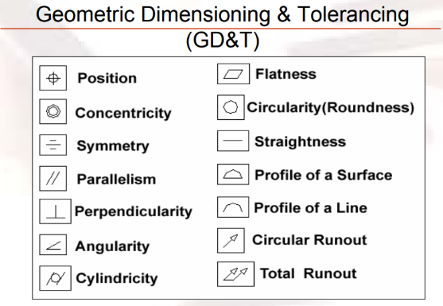
For a deeper understanding of this text we must first clarify the definition of tolerancing. The Oxford Dictionary definition of tolerancing is "An allowable amount of variation of a specified quantity, especially in the dimensions of a machine or part” (Anon, n.d.). It’s needed due to the fact that no one or thing is perfect hence, engineers have devised a way to allow parts to be close to perfect as possible by specifying tolerances. There’s inevitably going to be variation from, the drawing to the part therefore a degree of variation much be specified. Large variation in the sizes may cause and effect the functionality of the part created whereas a small variation will affect the cost of the part due to the time taken to create a specific, precise part and a smaller tolerance will inevitably add more parts to the rejection number. Tolerances become exceptionally important in assemblies due to the parts will often not fit together well if their dimensions do not fall within the specified range of values. Tolerances are important as well due to interchangeability. Therefore, if a replacement part needs to be created, it must be a duplicate of the original part within the limits of the tolerances set (Anon, n.d.). In tolerancing, there are three types of fit; Clearance, Interference and Transition. A clearance fit have limits of size where it always results in clearance when mating parts are assembled. Interference fits have a fit whereby the assembled parts will have to be pressed into place and there won’t be any clearance at all. A transition fit has limits of size indicating that they are either clearance or interference may result when mating parts are assembled (Anon, n.d.). In terms of cost of manufacturing parts, the tighter the tolerance the cost will generally increase therefore as an engineer, it’s their job to decide on the best tolerance for the part being manufactured. Parts will smaller tolerances often require specialised methods of manufacture. Tolerances give limits on the size of a part whether its length, width, height or diameter are given on the engineering drawing. Geometric tolerancing allows for specification of tolerance for the geometry of the part individual from its size. GD&T uses special symbols to control different geometric features of a part as seen in the image on the right.
Figure 1: GD&T Symbols (Anon, n.d.)

3.2 CAD/Solidworks
Computer Aided Design or CAD is a computer software that is used to design and create products whilst documenting the design process which first flourished in the 1980’s. Computer Aided Design can facilitate the manufacturing process by creating detailed, technical designs and diagrams whilst also including the materials used, processes used to create the product, tolerances and dimensions, complying by specific conventions for the item in question at the same time. CAD software is having to become more clever each version launched due to the ever growing complexity of technology and mechanical products of today. CAD can be used to create two dimensional (2D) or three dimensional (3D) diagrams, whilst being able to be reotated and viewed from any angle, even from the inside looking outwards. CAD is used in many industies especially design and engineering industries. CAD is used to create and design detailed engineering drawings through 2D and 3D of the physical component in question. It’s also used conceptual designs as well as strength and dynamic analysis of an assembly and the manufactuing process (Anon, n.d.).

3.3 Triple Clamps
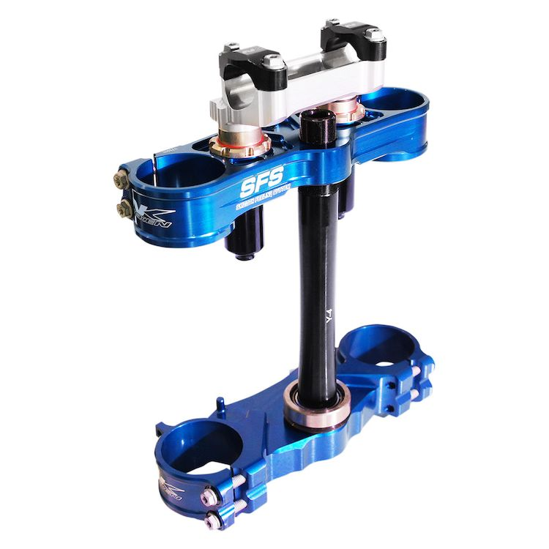
A motorcycle forks are what is used to connect the front wheel to the handlebars, often throuygh the use of a yoke or triple clamp. A triple clamp consists of three main components; an upper yoke, lower yoke and a steeringn stem. Motorcycle’s often have their handlebars attached to the triple clamp either just above or just below the upper yoke. Conventionally, the fork stanchions are secured at the top by a triple clamp, often secured by clamping the stanchions in place through the parallel holes and secured using the bolts found on then side (Anon, 2019). Altering the triple clamp offset by milimeters can change the way the bike handles drastically. Reducing the fork offset by 2mm can increase trail. Trail is the measured distance between the point of the front whel’s conact with the ground and the axis of the stanchions (Lindemann, 2015). A lower offset should theoretically cause the bike to steer slower and improve the overall stability of the bike, but this isnt always the case (Anon, 2017).
Figure 2: Triple Clamps (Anon, n.d.)
4.0 CAD Drawings
4.1 Top Yoke
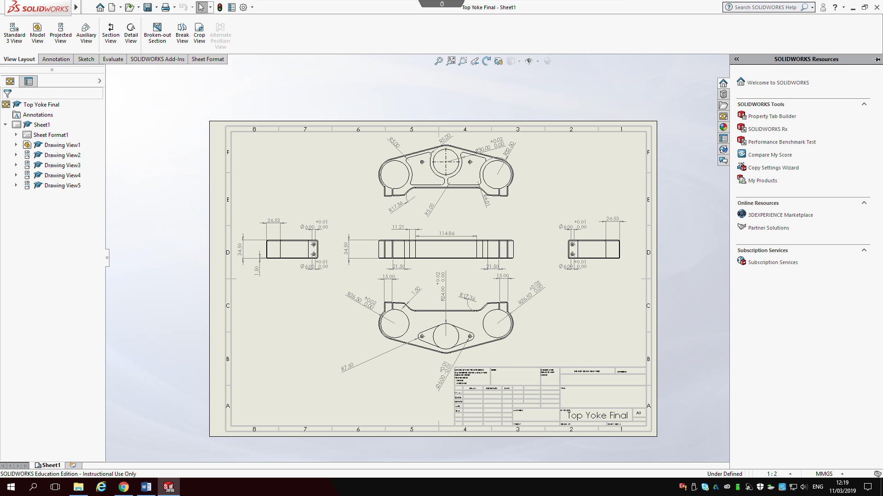
Figure 3: Top Yoke (Thomas, 2019)
This drawing shows the Top Yoke of the triple clamp. This part has a general tolerance of 0.5mm for the whole part unless otherwise stated. This part will be created from 6061 aluminium due to its use in high strength applications. 6061 aluminium is known for its structural strength and toughness as well as its surface finish offering excellent resistance to any corrosion when exposed to atmosphere and water. This aluminium also offers ease of machinability as well as the advantage of being able to be welded and joined. On the downside, once heat from a welder has been applied there will be a reduction in overall strength of the component, but may be heat treated to restore the structural strength. The maximum tensile strength that this aluminium can withstand is 45,000psi (3.1x10⁸) and a yield strength of 40,000psi (2.8x10⁸). The maximum shear strength of this aluminium is approximately 31,000psi (2.1 x10⁸) with Brinell hardness rating of 95 (Anon, 2017). The holes where the stanchions sit will have a H7 tolerance due to the need for a “Locational clearance fit provides snug fit for locating stationary parts; but can be freely assembled and disassembled.” (Anon, n.d.). The bolt holes to clamp the stanchions in place must be tolerance also allowing the desirable bolt to fir through. This fit will be considered a clearance fit but also a “Sliding fit not intended to run freely, but to move and turn freely and locate accurately” (Anon, n.d.). Due to the lightness of aluminium, this part weighs 680.33 grams and would cost approximately $37 (£28.25) to create; $0.847/lb as of 08/03/19 (Anon, n.d.). If this part was to be cast, it would be cheaper but another material would have to be used. A 7079 alloy aluminium would be used, costing just under $15 (£11) to create according to Solidworks.
4.2 Bottom Yoke
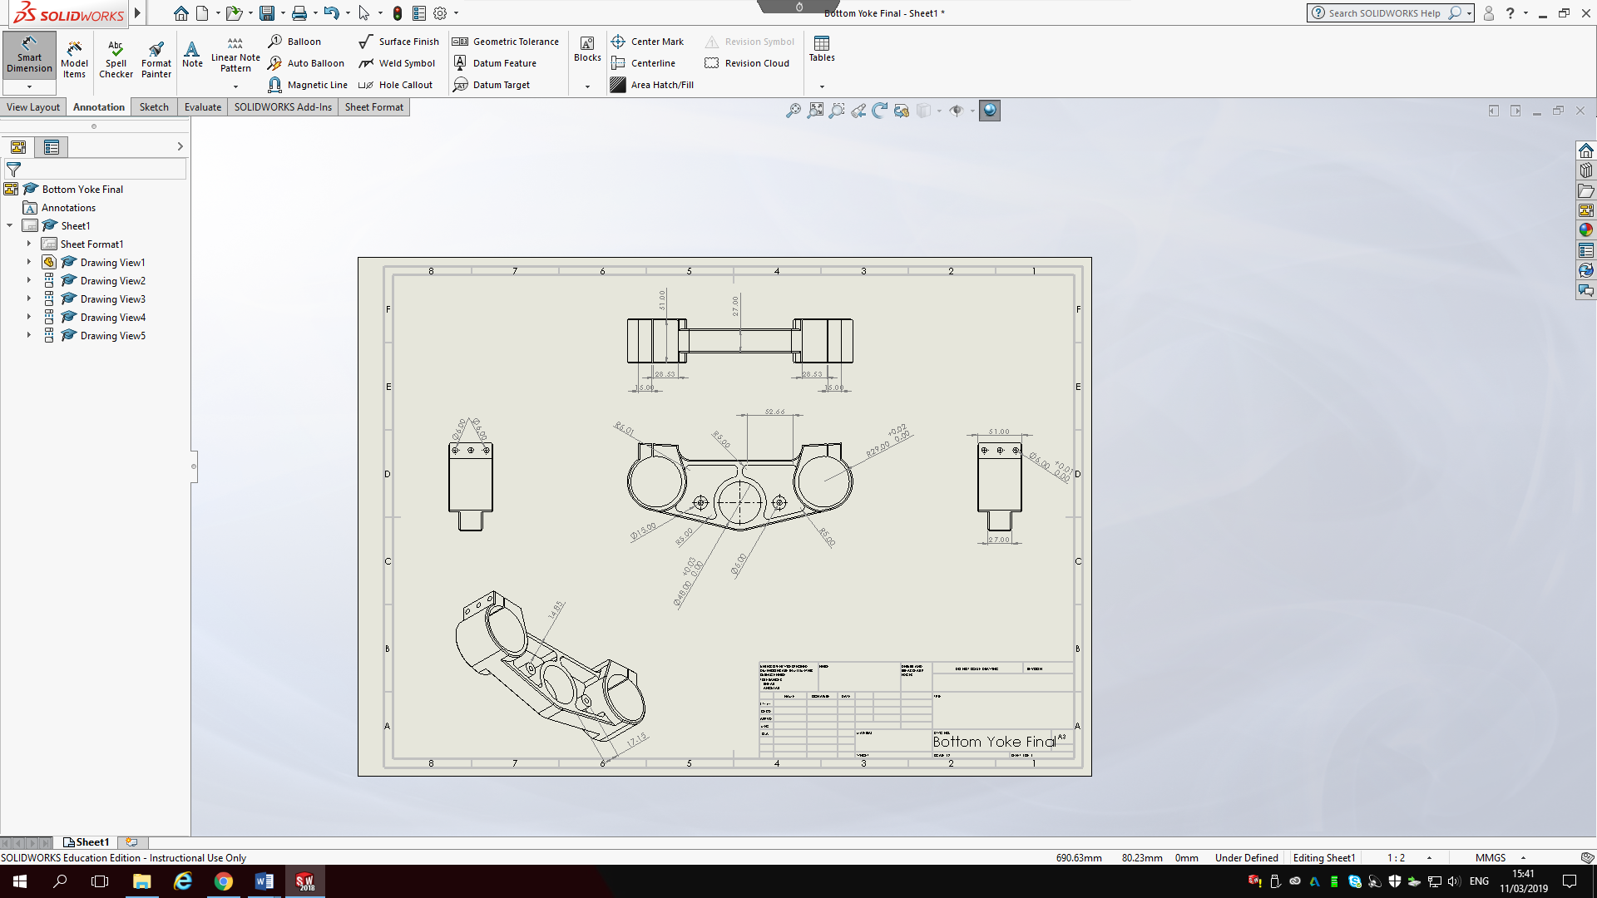

Figure 4: Bottom Yoke (Thomas, 2019)
This is an engineering drawing of the bottom yoke of the triple clamp. Just like the top yoke this part will be created from 6061 aluminium due to its strength, durability and toughness. 6061 aluminium was chosen to create these two parts instead of another aluminium such as 7075 aluminium due to a number of factors. The first main factor was the tendancy for the 7075 aluminium to corrode in water and atmosphere. Even though the 7075 aluminium is stronger at a almost double the tensile strength (87,000psi) and has a similar strength to most steels, the 6061 aluminium is generally more versitile, can be used for more applications and it’s easier to machine the chosen aluminium. Another upside to the 6061 it’s commonly employed in the automotive inductry therefore more than caple of withstanding the imacts of a motorcycle (Anon, n.d.). The centre hole for the bottom yoke features a ever so slightly looser tolerance than the outer two holes. This is due to the outer two holes being used to clamp the stanchions in place whilst the centre hole is only being used to hold the centre shaft in place. The outer two holes need to have a snug fit with the stanchions due to the need to grip them tightly to stop them slipping up and outwards but not too snug whereby the stanchiosn will crease/buckle. To machine this part out of a block of 6061 aluminium it would come in at a weight of 7.84lbs, a whole 2lbs heavier than the top yoke. It would cost $50 (£38) to machine this part. If this part was to be sand cast out of 7079 aluminium, it would cost the same as the top yoke; just under $15 (£11). This could be the optimum way to create this part. The only downside to using the casting method is that the 7079 aluminium isnt as strong as the 6061. The main downside of using sand casting is the dimensional accuracy isnt as precise as the accuracy of machining (Anon, n.d.).
4.3 Stem
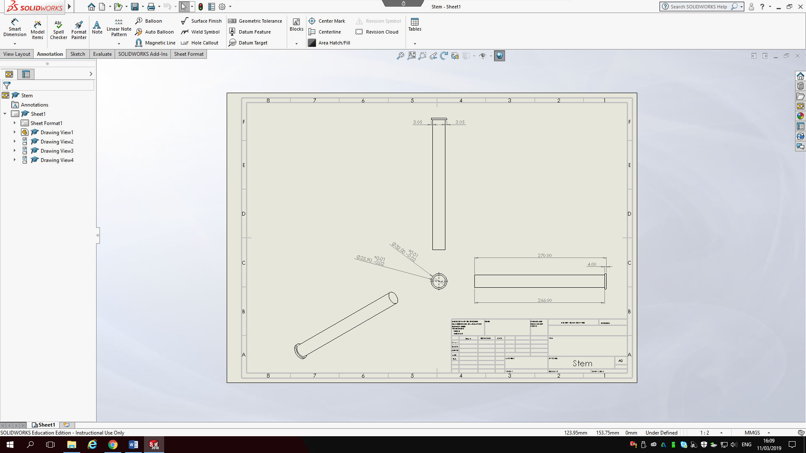
Figure 5: Stem (Thomas, 2019)
This simple part is accountable for holding the two yokes together at a set distance appart. This part will be created from a stanless steel bar. Stainless steel was chosen as this part needs to be strong and cant flex under high stess and impact. This stainless steel features a very high tensile strength of 74,493psi (5.1x10⁸) and a yield strength of 24,995psi (1.7x10⁸). Compared to the 6061 aluminium, stainless steel has a very high shear strength of 11,167,905psi (7.7x10¹⁰) therefore this part is ideal for the application in question. A transitional tolerance has been applied to the two size shafts as they’ve got to slide rather slugly within the two yokes. A “locational transition fit for accurate location, a compromise between clearance and interference” (Anon,n.d.) has been applied to ensure this snug fit is found. A general tolerance of +/- 0.5mm has been applied to the whole assembly of parts. If this part was to be machined out of a cylinder of stainless steel it would cost $13 (£10) per unit made. Whereas, if this part was to be cast out of a steel, it would cost $16 (£12), therefore, machining this part is cheaper than casting it due to the simplicity of the part whilst keeping the accuracy of the machining process.

4.4 Bottom Insert
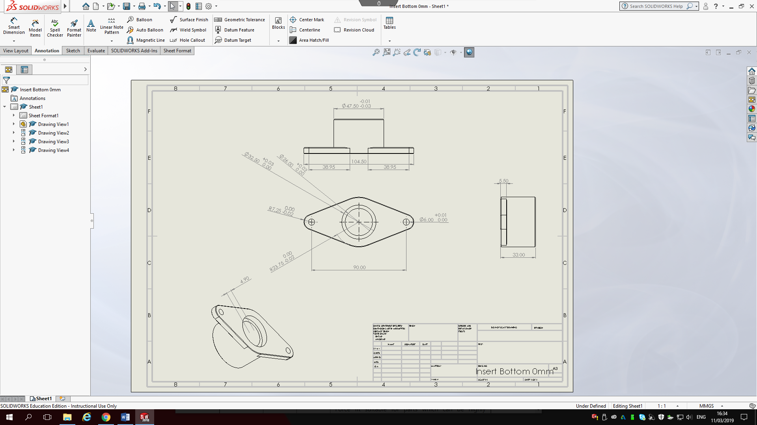

Figure 6: Bottom Insert (Thomas, 2019)
This is the lower insert that holds the stem to the lower yoke. This part has a general tolerance of +/- 0.5mm for the whole part unless otherwise stated. This part will also be created from 6061 aluminium due to its use in high strength applications. Starting from the top, a transitional fit will be applied due to the need for this part to fit rather snugly within the lower yoke. The less movement within the parts, the longer these parts will last and more reliable they’ll be. Due to the stem is created out of a stronger material than this 6061 aluminium a tight tolerance has been created in the centre hole, if there was any sign of movement, this part would begin to wear and eventually the centre hole will be way too big and the stell wont have a nice snug fit within the lower insert. The countersunk part will require a tight tolerance too due to the stem sits in this area and there will be issues with wear if theres any movement. The countersunk part has a tolerance whereby the hole can’t become any bigger and can only be slightly smaller. The two outer holes has a tolerance where it cant become any smaller, this is needed for the bolt to fit through but cant be too big where the head of the bolt will fall through. The outer curve ahs to be a specific size as this is sunk into the lower yoke and may need to be replaced therefore cant be an interferance fit. That’s why a clearance fit has been chosen whereby the lower insert can be slightly smaller than the insert.to machine this part out of a block of 6061 aluminium, it would cost a total of $55 (£41) to produce. If this part was to be cast out of 7079 aluminium it would lose some of its strength but it would only cost $14 (£11). Casting may be a viable option for this part due to lesser need for strength in this component.

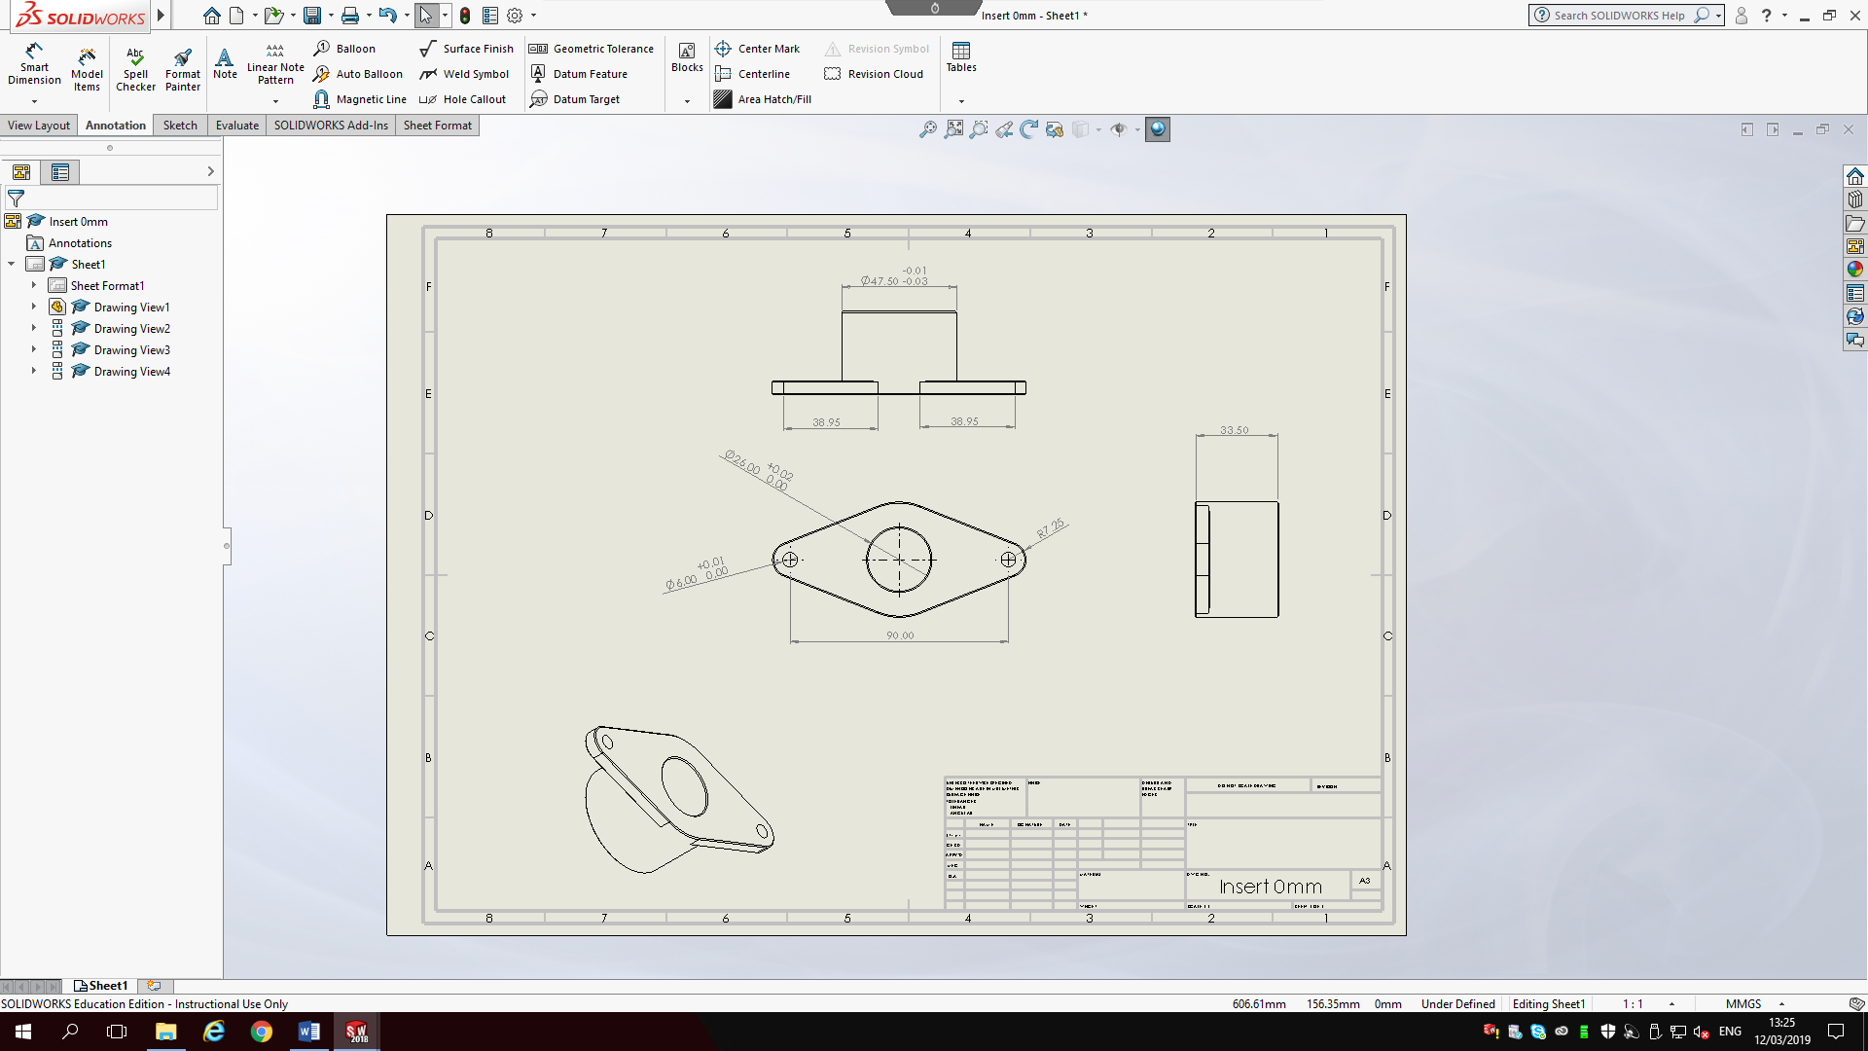
4.5 Top Insert

Figure 7: Top Insert 0mm (Thomas, 2019)
The image above shows my top insert, attaching to the top yoke. Just the same as the bottom insert, this part will be made out of 6061 aluminium due to its use in high strength applications. Starting from the top, a clearance fit has been applied; this is the same tolerance as what’s found on the bottom insert. This tolerance has been chosen to do the necessary replacement of this part, ensuring it will be quick and easy, a locational clearance fit has been applied. A “Locational clearance fit provides snug fit for locating stationary parts; but can be freely assembled and disassembled.” (Anon, n.d.). Secondly, a centre hole clearance fit has been applied to the need for the stem to fit inside. The hole cant be too small otherwise the stem wont be able to fit through; that’s why this tolerance was chosen to ensure the stem will fit through but at the same time, the hole isnt too big for the stem to move about. The whole assembly has a +/-0.5mm tolerance throughout unless otherwise stated. The bolt holes have a tolerance on them due to the need for a bolt to fit through them; if the hole is too tight, the bolt wont fit but if the hole is too big, the head of the bolt wont hold the part in place. This part will cost $52 (£39) to machine out of a block of 6061 aluminium and would cost $14 (£11) to cast out of aluminium. Just like the bottom insert, this poart doesn’t need as much strength as some of the other components so casting may be a viable option.
4.6 Assembly
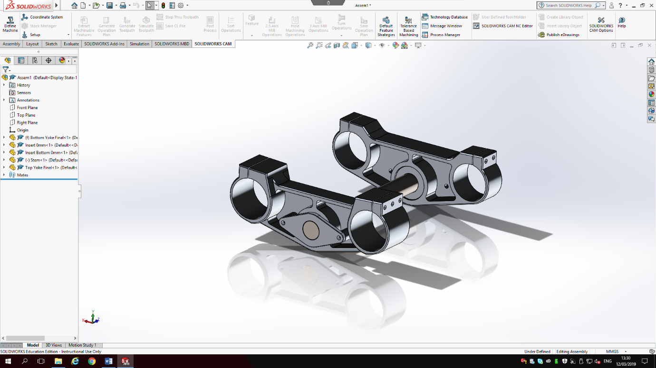
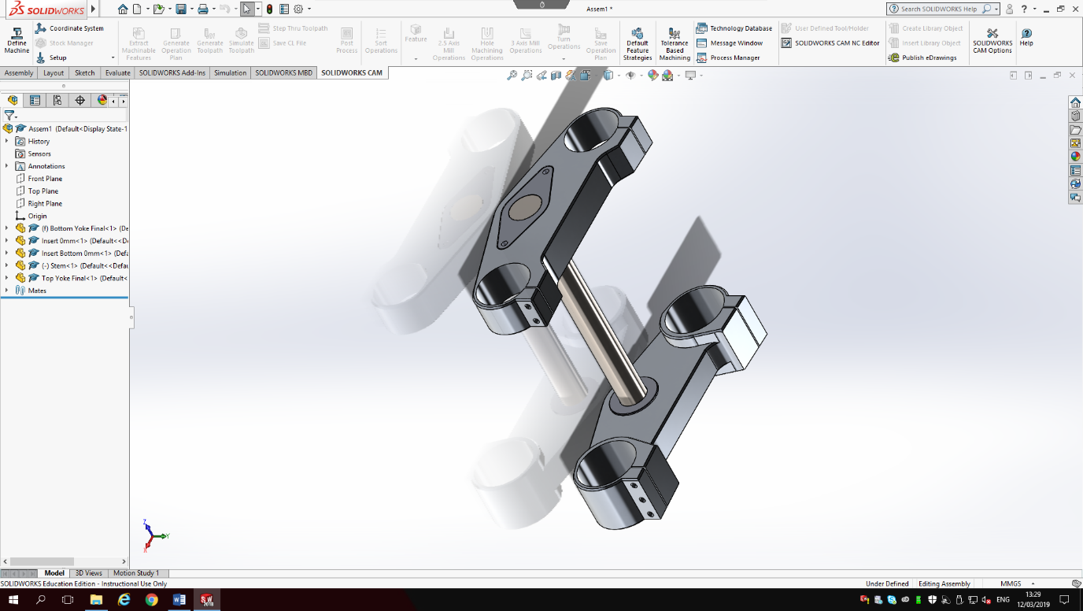

Figure 9: Assembly View 2 (Thomas, 2019)
Figure 8: Assembly View 1 (Thomas, 2019)

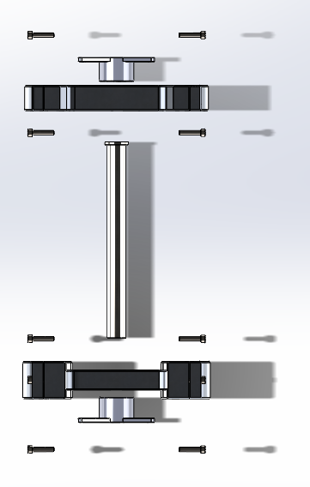
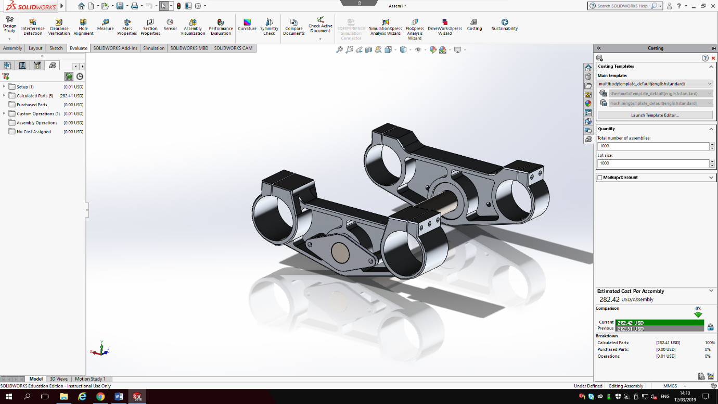
Above are two views of my assembly; figure 8 demonstrating a top view and figure 9 showing a view from underneath. All parts except for the centre stem are made out of 6061 aluminium. The centre stem is made out of stainless steel for strength and rigidity in the assembly. To create this part, it will cost approximately $282 (£215) if the whole assembly was created at the same time according to Solidworks. If each part was created seperately and then assembled, it would cost $207 (£156), $75 (£57) cheaper. Triple clamps similar to the ones seen in the assembly above sell for around $800 (£610), therefore this would be a profit of over $500 (£380) per unit sold. The total weight of this component is 2.62kg therefore it’s a rather light weight part compared to some on the market currently. If this assembly was to be cast, it would cost $74 (£56) which is cheaper but the accuracy and strength of the part will be comprimised. If this part is being used on a low impact bike that doesn’t require tight tolerances, this would be the perfect way to produce the part. For this application, machining will be the best way to produce this assembly.
Figure 10: Assembly cost (Thomas, 2019)

Figure 11: Exploded View (Thomas, 2019)
5.0 References
Anon, (n.d.). Oxford Dictionaries. Definition of Tolerance in English. Available at: https://en.oxforddictionaries.com/definition/tolerance
Anon, (n.d.). Department of Mechanical Engineering and Mechanics. Fundamentals of Computer Aided Design – Geometrical Dimensioning and Tolerancing (GD&T). Available at: http://www.pages.drexel.edu/~rcc34/Files/Teaching/MEM201%20L6-Tolerance_RC.pdf
Anon, (n.d.). Project Lead the Way. Tolerances. Available at: https://www.lancasterschools.org/cms/lib/NY19000266/Centricity/Domain/291/Tolerances.ppt
Anon, (n.d.) Techopedia. Computer-Aided Design (CAD). Available at: https://www.techopedia.com/definition/2063/computer-aided-design-cad
Anon, (2019). Wikipedia. Motorcycle Fork. Available at: https://en.wikipedia.org/wiki/Motorcycle_fork
Anon, (2017). Motocross Action. TEN THINGS YOU NEED TO KNOW ABOUT TRIPLE CLAMP OFFSET. Available at: https://motocrossactionmag.com/ten-things-about-triple-clamp-offset/
Anon, (n.d.). RevZilla Motorsports. Neken SFS Triple Clamps Yamaha YZ85 2014-2017. Available at: https://www.revzilla.com/motorcycle/neken-sfs-triple-clamps-yamaha-yz85-2014-2017
Anon, (2017). Clinton Aluminium. 6061 VS. 7075. Available at: https://www.clintonaluminum.com/6061-vs-7075/
Anon, (n.d.). AmesWeb. PREFERRED FITS AND TOLERANCES CHARTS (ISO & ANSI METRIC STANDARDS). Available at: https://www.amesweb.info/FitTolerance/PreferredTolerances.aspx
Anon, (n.d.). InvestmentMine. 1 Week Aluminium Prices and Price Charts. Available at: http://www.infomine.com/investment/metal-prices/aluminum/1-week/
Anon, (n.d.). ChinaSavvy. Pros and Cons of different types of Casting Processes. Available at: https://www.chinasavvy.com/pros-and-cons-of-casting-processes

