Organisational Consultancy
BMIH 6005

Report – The McCall House, Oak Street, Department- Management
Lecturer Name: Jaliya de Silva
Student Name: Alexandra Felicia Ivanovici
Student Number: 2027274

Name of the Consultancy Company – Semicor Consultancy Company


Source: (Author)
Date of Delivery Report-

Table of Contents
Introduction 8
Analysis 10
Description of the Issue with Cause and Impact 10
PESTEL analysis of The McCall House, Oak Street 14
SWOT Analysis of The McCall House, Oak Street 17
TOWS analysis for The McCall House, Oak Street 19
Recommendation and Change Management 22
Identification of Recommendations 22
Change Management Practices and Procedures 28
Measuring Success 30
Potential Benefits 30
Costs Associated with The Recommendations 30
Action Plan 31
Conclusion 36
References 38

Executive Summary
The understanding of the organisational consultancy for The McCall House has been defined in the report. The details of the hotel industry identified as a crucial issue within the business area have been shown in the assignment. The hotel firm, The McCall House has faced management issues in the business field. Due to this issue, this respective hotel business also encounters customer service issues, high turnover issues and many more challenges. Thus, the staff of the management has provided some critical issues that interrupt the potential consumers to engage in this business of the hotel.
The issues of the management department of The McCall House are at stake at this time. For this issue of the hotel firm, the employees also take high turnover as they are getting enough fair pay and respect. These are the barriers that are relevant to the management issues of the selected hotel. Apart from this, this barrier leads to less market expansion in the international market for the chosen hotel business. This has resulted in the disruption of the brand image and reputation of The McCall House which is Oak Street-based. Thus, this is a drastic and dreadful issue in the hotel firm that has been elected.
The main findings of the organisational consultancy report regarding a crucial hitch of The McCall House. There have been used charts and figures for better identification of the raised hurdle.
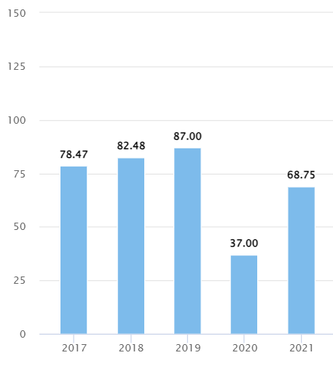
Source: (statista, 2021)
The statistical evidence of the hotel revenue of the US market can be proof of the issues that have been raised. This figure shows that in 2019, the revenue generated from the hotel industry was 87.00 billion USD. However, in the year 2020, the hotel sector faced less generated revenue from the market which was 37.00 billion USD. Later, the specific sector of the US, the hotel industry made recoveries such as 68.75 billion USD made in 2021. Thereupon, The McCall House also caused some management hassle that led to less revenue generation. This would be the statistical proof of the influence of the raised hurdles.
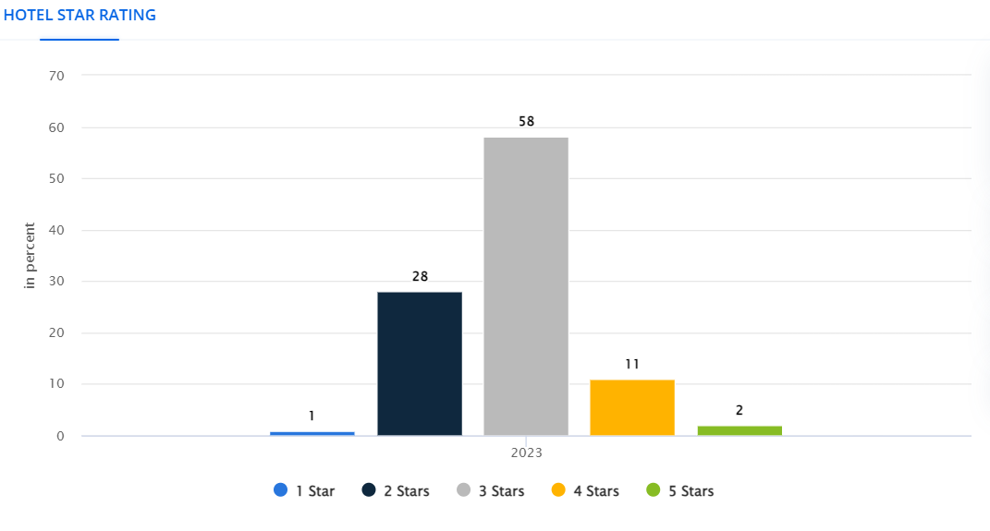
Source: (siteminder, 2024)
The US-based hotel sectors cannot make any significant reputation from the consumer segment. From the given statistical figure, it is depicted that, the hotel industries get less reputation from the market level. 58% of the hotel sectors of the US have gained 3 stars from potential consumers. Only, 2% of the hotel industry has earned 5 stars as reviews or feedback from customers or guests. In this regard, merely 11% of the hotel sector has acquired 4 stars according to the year 2023. This statistic aids in observing that, The McCall House also get less reputation due to its management issue or the muddle in the customer service. This consultancy report has provided issue-based recommendations for the selected organisation.
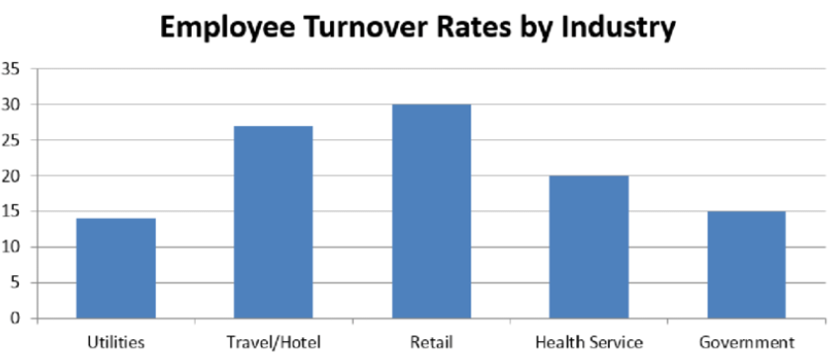
Source: (statista, 2021)
From the hurdle in the management field in the hotel industries of the US, the rate of employee turnover has been high from the past decades to recent times. This statistical data shows that the rate of worker turnover from the other sectors such as health service, government and utilities was significantly low as compared to the hotel industries. According to 2020, the hotel sector faced a prohibitive turnover of labourers. The high rate was 27% for the hotel firms in the US. This means the employees did not get sufficient value in terms of salary, health and safety concerns and support.
Thus, their turnover percentage was high in the hotel and hospitality industries. Hence, this chart proves that The McCall House also has faced this major turnover due to a management hitch. There can be added protrusive recommendations for the selected Hotel company named The McCall House in the location of Oak Street. From the above facts and figures of the statistical data, the hotel industry has faced several problematic situations. To overcome this situation and obstacles, the selected hotel can take some actions as recommendations. These recommendations would be relevant to the effective training and development of the employees. By giving training and development skills to the management department, the hotel business may lead to positive changes. Apart from that, by comprehending sustainable initiatives in the management team of The McCall House, the raised issue could be overcome. These would be the best suggestions for the US hotel industry and The McCall House.
To minimise the issues of customer service, high turnover and fewer market expansion hurdles from the management disturbance, the hotel can get some additional recommendations. Taking feedback from the consumers may be the other essential suggestion for The McCall House. This could diminish the issue of customer service. Along with that, providing high quality and affordable price-based services and products for the potential guests in the hotel rooms would be the distinguished advice. These would be the most appropriate recommendations for the selected hotel business.
In conclusion the overall report of the organisational consultancy for the issue of hotel firms in Oak Street has shown the inducement of the raised issue of the management area. The repercussions of the management hurdles of The McCall House have been contained in the assignment report. The main key findings are pertinent to the identification of the issue, the reason, and the overall footprint of the issues. To change management, some recommendations have been outlined in the report assessment. These are the key findings of the hotel business.

Introduction
The study of the hotel industry based on core issues or hurdles with recommendations will be developed in the following report. The barriers that will be addressed are management issues for The McCall House, Oak Street. This is the major concern for the chosen hotel to overcome to get more market expansion, huge customer engagement and more reputation. The management issue is drastic and problematic as this also causes less customer satisfaction, interruptions in market expansion, and less generated revenue from the market field. Thus, the raised management issues are too problematic for The McCall House. This is a major concern for the hotel to overcome.
The introduction and the short background of the chosen hotel are described with location and room size. The McCall House is located on Oak Street Ashland, Oregon. This is a luxury hotel that offers only 10 designed rooms in the hotel infrastructure. The age of this hotel is perhaps 41 years. This hotel was built in 1883 to provide hotel services for potential consumers. The hotel room size is 9 - 23 sq. m. Moreover, the prices of the hotel rooms are affordable for the guests or the consumers to stay at this hotel. This is a significant background of The McCall House which is Oak Street-based (mccallhouse, 2024).
The most apt details and the background of the created consultancy firm are mentioned. The name of the consultancy firm is Semicor consultancy firm which will be indulged to minimise issues of the hotel. This consultancy firm will be located in Oak Street City. This firm would offer some analysis of the future difficulties for the hotel industry. To deprecate the raised challenges in the hotel sector of Oak Street, this consultancy firm would be situated. Thus, the consultancy company, Semicor would provide essential advice for managing the issues that hotels are now resisting. This is a short introduction or background of the consultancy firm.
The different portions of the report will include a fair few theories and models to analyse the identified issue. The relevancy of the frameworks such as PESTLE, TOWS and SWOT with the hurdle of the hotel will be constructed. To analyse the contribution of the external forces in the hotel issues, the PESTLE analysis will be included in the following report assignment.
The other frameworks, such as TOWS and SWOT analysis, will be added to the report to analyse the internal business environment that is responsible for the hotel issue. To inform the positive aspects and activities of the hotel, the model of SWOT analysis will be included in the report. Apart from that, the effective model called TOWS to inform the probable future directions for The McCall House will be outlined in the assignment report. Thus, these are the intentions for choosing these models for the Hotel issue. These frameworks will highlight the nuisance more effectively and can give some potential paths for overcoming the hitches.
The report will also design a certain number of recommendations for the changes within the hotel firm. An effective action plan will be included for the hotel business for the best outcomes. The overall discussion of the organisational consultancy will outline the prospects of the management hurdles. Some relevant figures, diagrams and charts for the hotel issue evidence will be depicted in the report assessment. Moreover, a few models will be added for the hotel prospects. Therefore, the association of the hotel issues and some recommendations will be constructed in the report.

Analysis

Description of the Issue with Cause and Impact

Source: (mccallhouse, 2024)
The selected hotel is The McCall House in Oak Street. This is observed that, nowadays, hotel industries face copious issues within the business operation. Therefore, the selected hotel, The McCall House, has faced some vital mishaps in the business market. Management issue is the biggest drawback of this hotel firm they interrupt huge market expansion. This hotel business nowadays faces its management department nodus that gives the issue of customer service. Due to these customer service barriers, The McCall House cannot get huge engagement from potential consumers. Therefore, the management hurdle of this hotel is a major concern for future development and expansion (Buttrick, 2009).
Causes of the Raised Issue
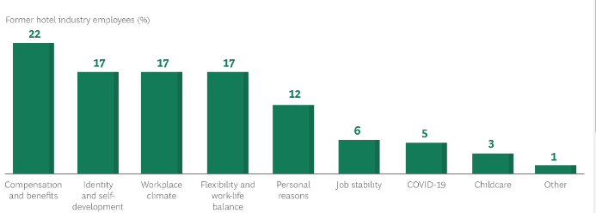
Source: (Bogicevic, et al., 2022)
The US-based hotel firms recently faced high employee turnover. From the above statistic, this can be evidenced. Less compensation and benefits lead to a 22% employee reduction in 2022. Less self-development leads to 17% of worker turnover. Lack of flexibility has given 17% employee turnover in the hotel industry in 2022. This is the major reason for encountering the drawback.
- Causes
Poor communication
- Poor communication is the main reason behind the raised issue of management in The McCall House. Through not maintaining proper and effective communication, this selected hotel has met customer service issues (Burnes, 2014).
Poor teamwork
- The next notable reason for raising the management issue of The McCall House is the poor teamwork. The employees and the other team members are not collaborative and cooperative (Walker, 2021).
Staff turnover
- High staff turnover is another weighty cause for the management predicament in The McCall House. Through the high rate of worker turnover, the hotel industry has faced management issues (Rutherford, 2021).
Impact of the Issue
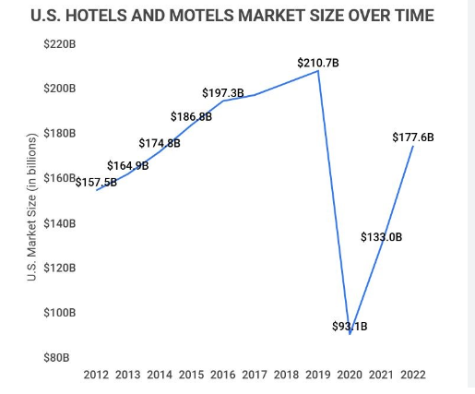
Source: (McCain, 2023)
The hotel industries of the US market have encountered profuse significant issues. Thus, hotel businesses have seen their downfall in the revenue generated and the market size. According to the above statistical data, in 2019, the US-based hotel firms had a market size of 210.7 billion USD. In addition, this market size has fallen by 93.1 billion USD in the year of 2020. After that, in 2021 and 2022, the hotel industry recovered for the best outcomes. This signifies the issue of The McCall House of Oak Street (McCain, 2023).
Impacts
There can be various influences on The McCall House from the management issues that are discussed below
Less consumer Engagement
- Through getting the issue of management, this hotel has faced less consumer engagement in the business. This is the crucial impact of the identified issue.
Less Market Expansion
- Due to the raised issue of management, The McCall House cannot expand its market at the international or global level. This is the potential impact on the selected hotel business (Hanks et al., 2020).
Less Reputation
- For the identified issue of management, The McCall House cannot get more reputation from the market level. This issue hampers its brand image immensely. Thus, the management issue impacts this hotel firm by lessening its reputation (Noordzife, 2014).

PESTEL analysis of The McCall House, Oak Street
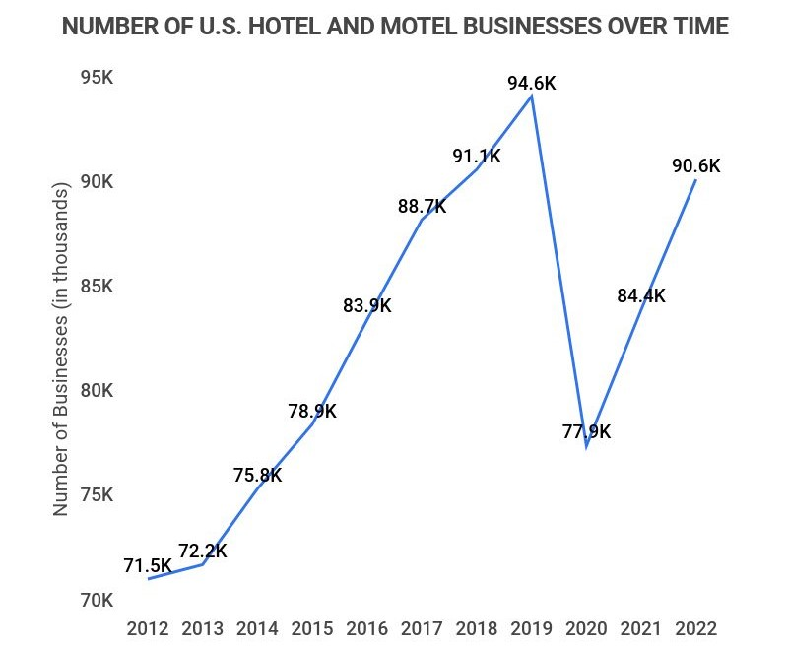
Source: (McCain, 2023)
Analysis
The hotel business number in the US has developed to 94.6k in 2019. Business also rose after the global pandemic to 96.5k from 77.9k in 2020. This can provide challenges in acquiring revenue as the hospitality industry fluctuates regularly. The McCall House, Oak Street has also faced issues in managing the monetary conditions which led to inadequate structure to satisfy consumers (McCain, 2023).
PESTLE Analysis
The influences of external factors on The McCall House can be understood by the PESTEL analysis of the selected organisation (Gonzalez et al., 2021).
Political Factors
- America is a country that possesses the oldest Democracy in the world and has positive economic power. The political climate is stable in America and thus does not affect the process that much in the hotel industry. The country belongs to the 16th position in corruption. Corruption in the country in a political field leads to disturbances in taxes and rates. Corruption provides challenges in maintaining the revenue of The McCall House and managing the processes effectively. This results in a high turnover of staff resulting in disturbances in managing the process. These policies of the Government impact The McCall House to manage the process effectively and provide satisfaction to the consumers by making the stay more expensive (Gonzalez et al., 2021).
Economic Factors
- America has the largest economy in the world with a GDP of 18.57 trillion USD. The economic condition of the country is stable and gathers strengths from the manufacturing industry. The labour of the country is costly and The McCall House found difficulties in finding the right talents for management. The management of the selected hotel gets the insufficiency of talent and, thus, puts challenges in the management of the process. Thus, economic dynamics can negatively impact The McCall House (Dzurenko et al., 2021).
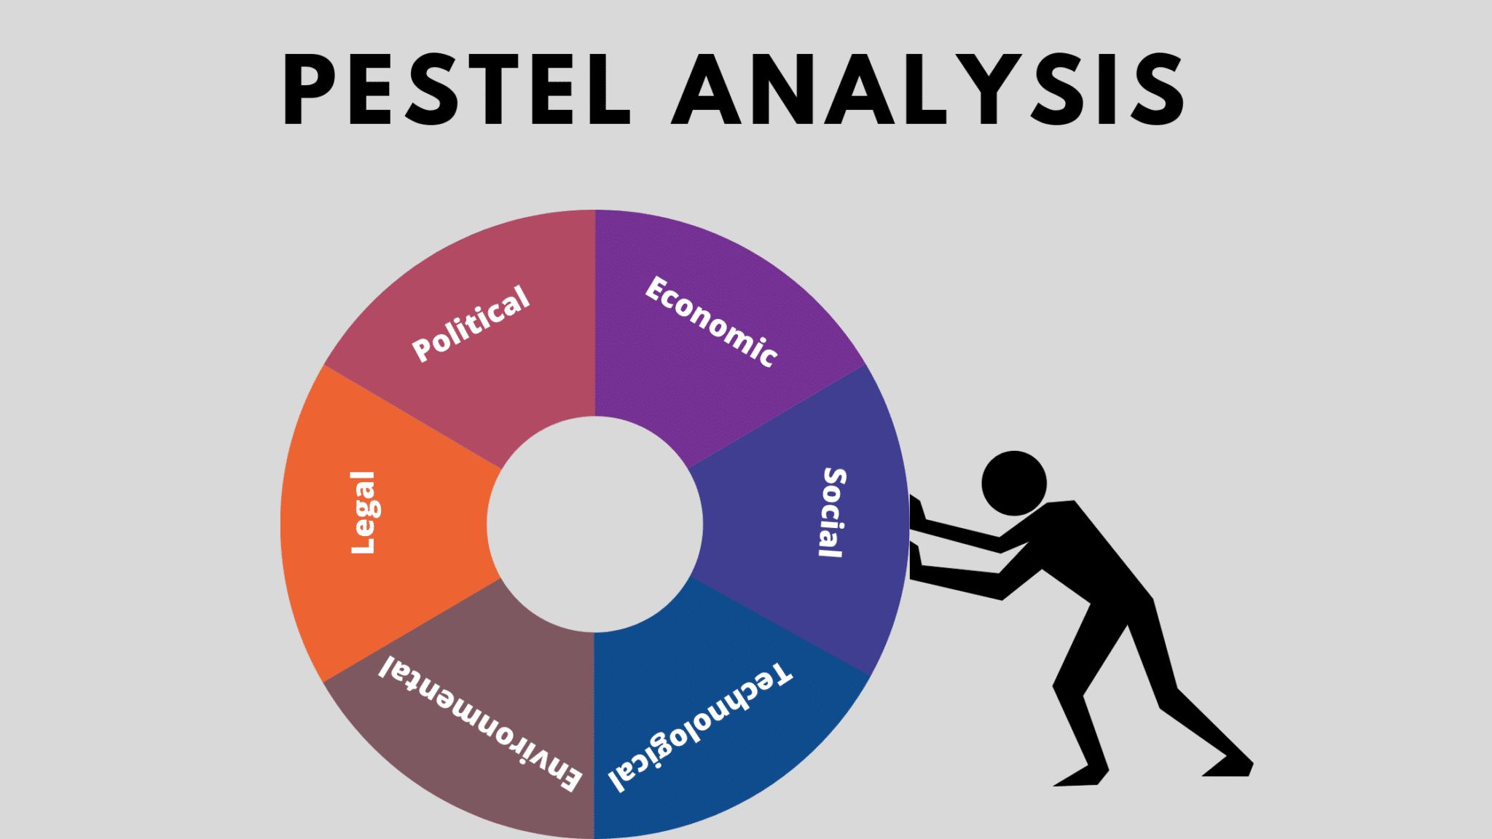
Source: (Kipping and Clark, 2012)
Social Factors
- Social factors influence the process of The McCall House in a wider range as America is also suffering from the problem of the ageing population. The ageing problem in the community leads to the shortage of labourers in the country. The McCall House, Oak Street faces the same issues and cannot maintain rigidity in the management process. The shortage of labourers in the country forced the organisation to make changes in the policies of labourers as the labourers are from outside America. This led to the challenges in maintaining the processes and managing them effectively (Dzurenko et al., 2021).
Technological Factors
- Technology is developing within the world by a huge margin in recent times. The budget of the American government has focused on the R&D by 58.3%. The McCall House, Oak Street has faced problems in adopting advanced technology and development. This makes them back from the competitors and also causes many issues in the management of The McCall House (Cox, 2021).
Environmental Factors
- The environment of America has diverse geographical conditions along with various climates. Natural disasters have been in America since 1980 and the country witnessed 218 disasters. In 2019, 15 weather dictators have been witnessed by the country with losses of $1 billion (£0.8015). The natural disaster caused The McCall House to acquire more security and changes in strategies. This led to a change in the processes and resulted in budget constraints (Subramaniam et al., 2011).
Legal Factors
- The legal factors in America are highly prospective in terms of maintaining rules and regulations. The restriction from foreign investment binds The McCall House to invest in foreign technological tools. This prevents the selected firm from managing the communication effectively and getting adequate support. The process in the hotel gets a wall to manage them properly, resulting in less satisfaction for customers (Kotter, 2012).

SWOT Analysis of The McCall House, Oak Street
- Overview of The McCall House
The McCall House is located in Oak Street, Ashland, United States. This hotel consists of 10 rooms for the guests. The hotel is offering some affordable rooms for potential consumers to gain more market expansion. This hotel was built in 1883 in the US (Splitter et al., 2024).
SWOT analysis
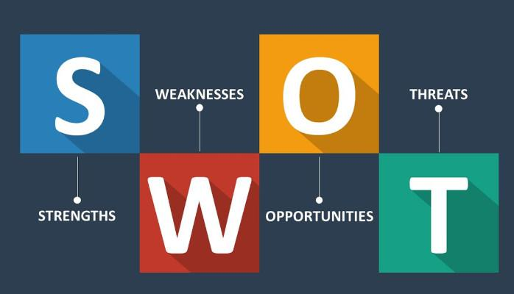
Source: (Leiber et al., 2020)

Strengths | Weaknesses
- Prime location is considered the strength of the hotel (Baron and Armstrong,2007).  - Unique styles suits and rooms execute the strength of the hotel  - Family-friendly  - Affordable price | - Less consumer satisfaction is considered a major weakness for the hotel. Several customer reviews notified about the less satisfactory customer service  - Advertisement challenge is also considered a weakness of the company (Newton, 2010).  - The sales proportion is decreasing for the hotel.
Opportunities | Threats
- More market expansion opportunities exist for the hotel in new regions  - The hotel can gain corporate-customer-oriented experience by improving its expertise in event management.  - Consumer engagement can be implemented by improving customer-based experience | - A high range of growing competition becomes a threat to the hotel.  - Less effectiveness in online promotion  - Market share is decreasing  - Less satisfactory customer service also becomes a threat to the overall reputation of the hotel (Brierley, 2006).

TOWS analysis for The McCall House, Oak Street
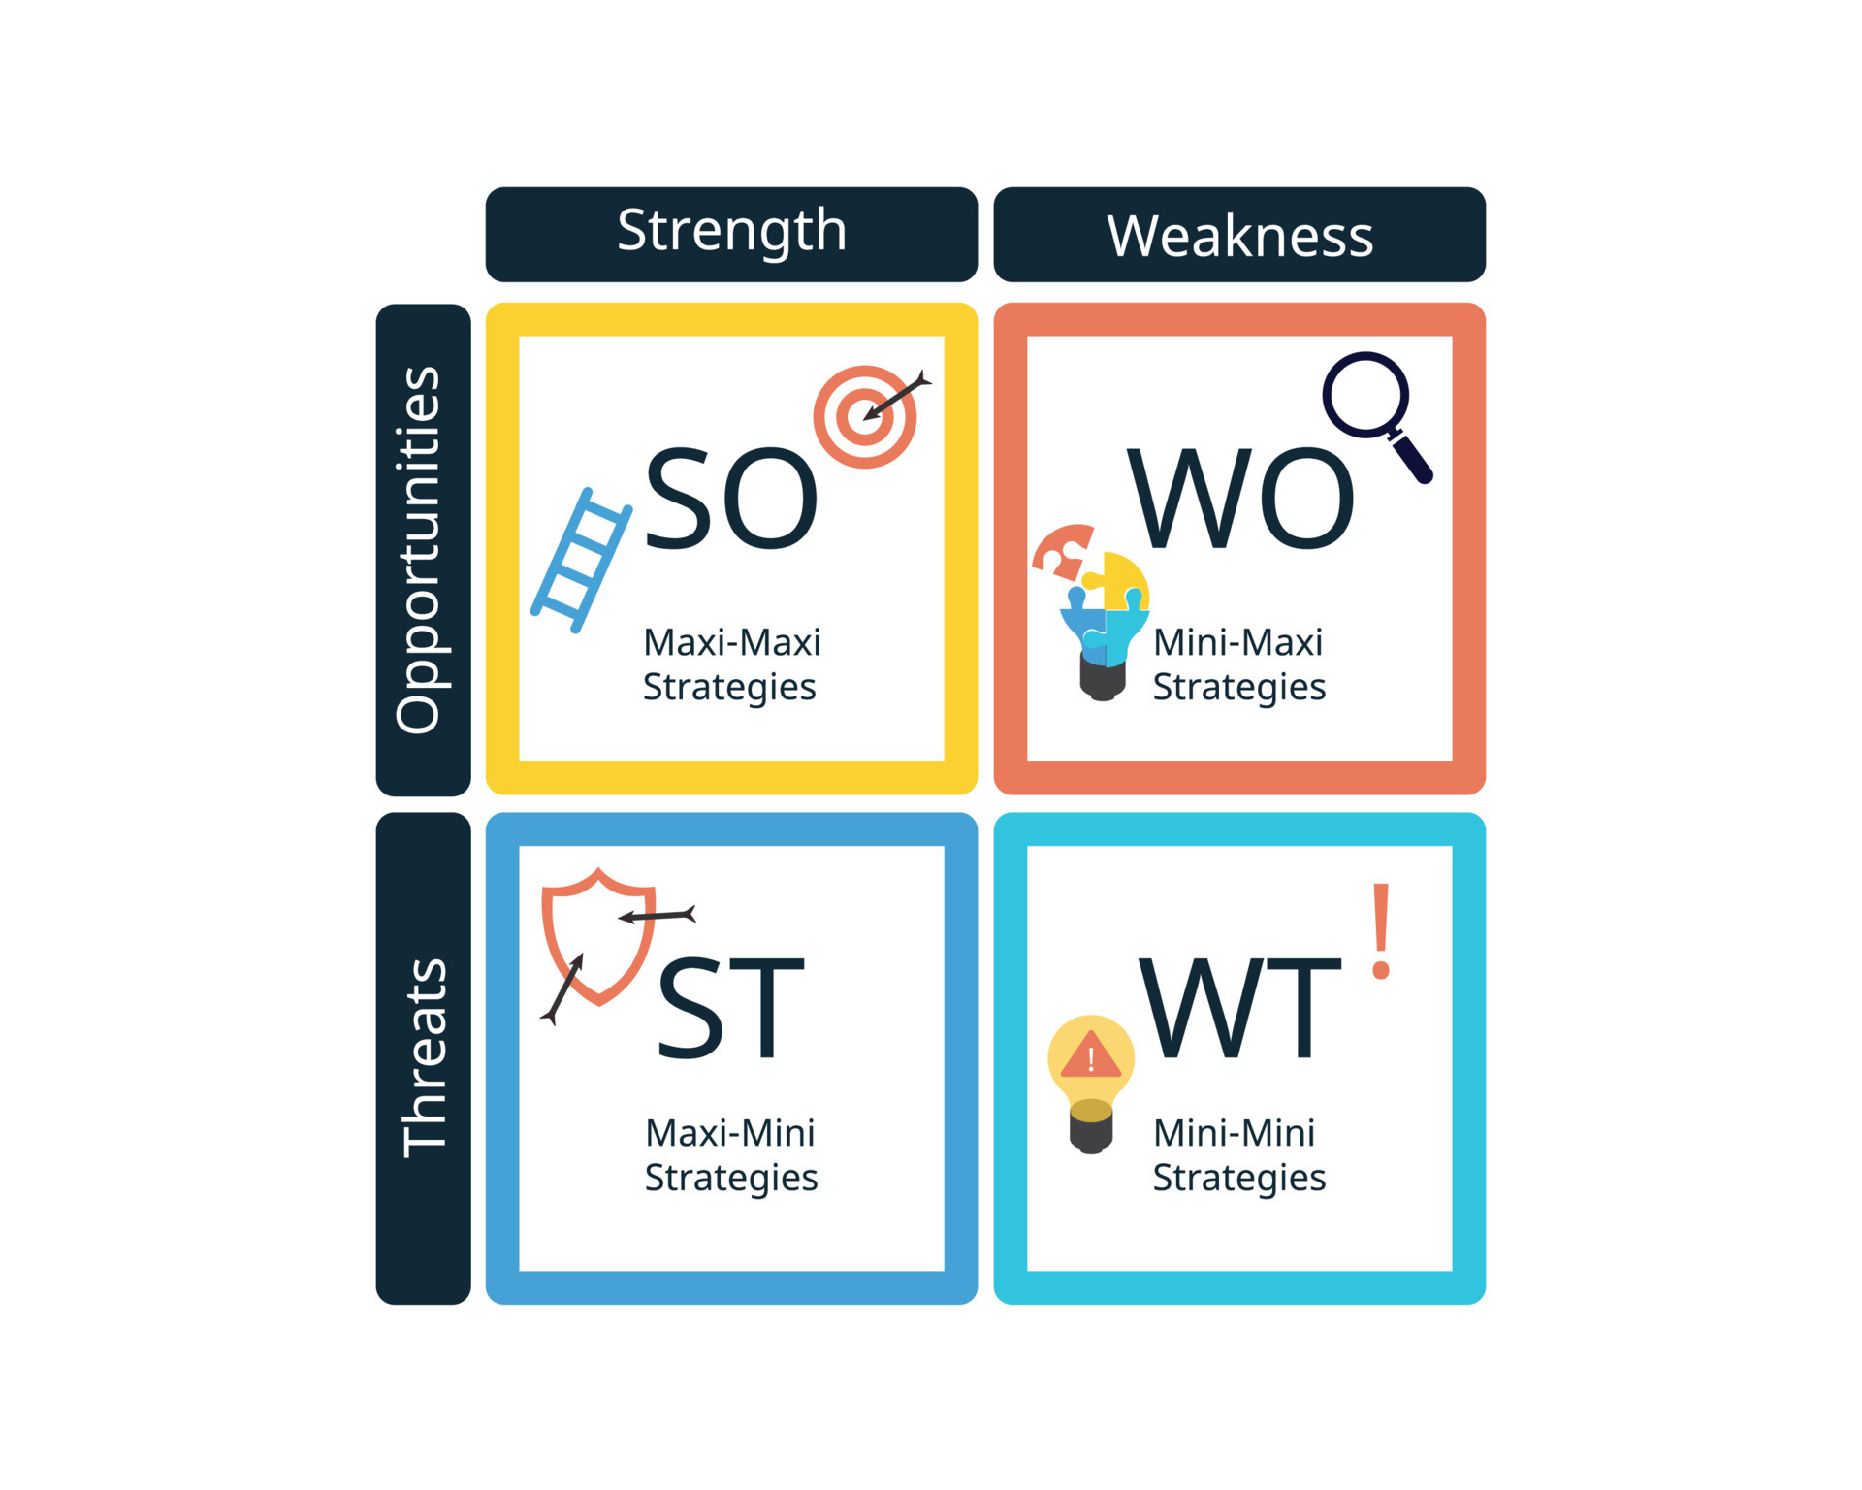
Source: (Kowalik, 2020)
Internal Factors
External Factors |  | Strengths  - Prime Location  - Affordable Price | Weaknesses  - Less consumer satisfaction
External Factors | Opportunities  - More market expansion  - Consumer engagement | SO-  The strengths of The McCall House include affordable prices and a prime location (Kowalik, 2020). This can give opportunities such as more market expansion and consumer engagement (Whittington et al., 2020). | WO-  The weaknesses of the selected hotel such as less consumer satisfaction can be overcome by creating opportunities for huge consumer engagement (Mavridopoulou and O’Mahoney, 2020).
External Factors | Threats  - Less revenue generates  - Less market shares | ST-  The strengths of The McCall House include setting up in a prime location that can minimise the threats of a low reputation in the market (Dandage et al., 2019). | WT-  Minimising threats and overcoming crucial weaknesses by turning the weaknesses into strengths (Fitriani, 2022). By providing better customer service, the weaknesses and threats can change into strengths (O’Mahoney, 2021).

Recommendation and Change Management

Identification of Recommendations
- After completing a comprehensive understanding of the issue that The McCall House is experiencing, it is essential to provide recommendations to the hotel to improve the situation. The organisation should maintain a comprehensive approach to cope with the risk management issues (Wood et al., 2020). The change in the management of the organisation is essentially needed. The implementation of positive changes will help The McCall House to prevent the situation of crisis. The staff operations, customer service, organisational culture and various other issues should be taken into account to get a comprehensive understanding of the issues. Improvising better change in those factors will help the organisation have a strong managerial process by mitigating the issues (Fisman and Sullivan, 2014).
Maintenance of Organisational Culture
- This is recommended to The McCall House that they should focus on the improvement of the organisational culture. The hotel should focus on having an empowering and positive organisational culture. This will provide a sense of value and motivation to the employees (Power, 2021). The organisation can achieve it by providing leadership development programs. The effective implementation of training programs for developing training skills among employees is needed. Courses on communication, team building and emotional intelligence of the employees will help the organisation to foster a better organisational culture (Whittington and Molloy, 2005).
Staff Training and Development Process
- This is suggested to the hotel to emphasise enhancing the knowledge, skill and ability of the existing employees. A larger number of knowledgeable and well-trained staff is essential for The McCall House to improve the customer service process. Conducting comprehensive training programs to provide training to different departments will increase the efficiency of the management process (Macke, J. and Genari, 2019). The organisation should focus on providing customer service training programs.
- The McCall House should also focus on providing technical skill training. Offering specialised training programs for specialised job functions (such as housekeeping, front desk operation and more) will help to get a betterment of the situation. The best practices of the industry, safety protocols and the proper usage of the technology and equipment are also essential to provide through this training program. The initiative of cross-section training could also encourage betterment in the management process. This will help to broaden the skill set of the employees. Improvement of the versatility of the employees will help the organisation to have possession over a more powerful management process. To achieve an uninterrupted service process, this will be essential for The McCall House (Panno, 2020).
Increase the Operational Efficiency
- The maximisation of efficiency and reduction of the organisation needs to focus on streamlining the operational efficiency. Thus, The McCall House is also recommended to focus on increasing the operational efficiency to optimise the workflow and the effective utilisation of resources. Possessing mapping could be an effective process that the organisation could implement in this context (Egan, D. and Haynes, 2019). A thorough review of the existing operations and identification of lacks and inefficiencies will help to increase efficiency. The visualisation of workflow and identification of opportunities will be more effective through the implementation of process mapping. The automation of the overall management process could be adopted by The McCall House through this (Marinakou and Giousmpasoglou, 2019).
- The focus should also be on the technological integration. Implementing technological solutions to get automation in repetitive tasks will help to improve the satisfaction rate of the guests. The organisation should include the implementation of a property management system, digital key system, automatic check-in an out process and more guest service problems.
- This will also help to decrease pressure on the employees. On the other hand, a more effective and smoother process will also be incorporated (Bacik et al., 2019). The organisation should also provide control over inventory management. Recovering from the losses of the pandemic period would be effective through this process. This will help to optimise the procurement process. Thus, The McCall House is recommended to use planning and forecasting tools. This will help to prevent a situation of crisis (Armas-Cruz et al., 2022).
- Considering the feedback of the employees is also essential in this context. The manager and leader should encourage the teams to have daily team meetings and feedback sessions. The celebration of accomplishment and focusing on strengthening the relationships between the employees and management would be helpful in the implementation of this process (Neupane and Khanal, 2022). The McCall House should anonymously focus on increasing the engagement of the employees. Finding ways to increase the engagement of the employees and increase the efficiency of the tasks would be helpful to increase the overall efficiency of the management (Fuentes-Moraleda et al., 2019).
Enhancement of Guest Experience
- To cope with the situation of crisis in the management process, this is essential for the organisation to focus more on the enrichment of the experiences of the guests. This will help to get a more loyal customer base. Thus, the organisation is suggested to focus more on creating memorable experiences for the guests. Providing personalised service to all the guests will help to do that.
- Employees are essentially needed to anticipate the exact needs and preferences of each guest. The improvisation of personal care, in the process of dealing with the guests would help the organisation to increase the customer service management process. Increased satisfaction of the guests will be the indicator of a better management process (Michopoulou and Moisa, 2019).
- The organisation is also recommended to emphasize the feedback of the guests. Thus, the conduct of post-stay surveys, social media listening, and review monitoring could help this process. Trying to modify the managerial process after analysing the demons of the guests will help the organisation implement a more effective process. The McCall House should focus on providing specialised services (Johnson, 2005).
Sustainable Initiatives
- This is essentially recommended to the organisation to take sustainable initiatives. In this age of increasing concern over the environmental impact, this initiative will help to increase the engagement of both the employees and the guests (Steinberg and Boettcher, 2023). Moreover, this will help the organisation to get a more effective planning process of business. The McCall House should invest in energy efficiency. The organisation should invest in installing HVAC systems and more applications that will help to reduce energy consumption and low utility costs. Encouraging the guests to participate in the energy-saving process will also help the management manage the costing process (Baum, 2019).
- The organisation should also focus on waste management and community engagement. Implementation of recycling programs throughout the hotel will help to manage the waste (SFilimonau and Delysia, 2019). The organisation should minimise the use of single-use plastics. On the other hand, increasing community engagement, in the process of running the business would help the organisation to focus more on increased efficiency (Morgan and Pritchard, 2019).
Focusing on stress management of the employees
- The organisation should also take care of the stress management and work and family life balance of the employees. The mismanagement of this aspect is one of the most essential aspects that leads to an increment in the turnover rate of triage organisations (Reidhead, 2020). To reduce the problem of staff storage, the organisation should focus on revising the organisational policies. Implementing the necessary changes in this management process will help the organisation to reduce the turnover rate. The McCall House should provide flexibility to its employees. Providing flexibility in the working hours of the employees will help the staff to make a proper balance in life. Thus, they would be able to be engaged and work with no stress (Walker, 2021).
- Emphasising consulting with consultancy firms is essential to improve the managerial process. Providing a further answer to essential problems of workforce shortage will be solved by the implementation of this process. The organisation should consider paying bounties to bring in new employees. Thus, this overall process of providing relief, flexibility and advantages to the employees would help the organisation to reduce the turnover rate. Implementation of time-tracking tools will help to provide the employees with perfect competition. This will help to build a bond of trust between the employees and management. Keeping track of the time would help to solve the current problem of management (Hayes et al., 2021).
- The organisation should also focus on not building ego in the process of management. Less ego will help to increase the quality and efficiency of the teams. This is the best method to be concerned about the problems of the employees (Figueroa-Domecq and Segovia-Perez, 2019).
Contingency Planning and crisis management
- The organisation now should focus on crisis management and contingency planning for the management. The maintenance of proper contingency planning will help the management of The McCall House to produce a more efficient managerial process (SFilimonau and Delysia, 2019). The organisation should focus on emergency preparation.
- The conduct of training drills regularly and the stimulation of preparation of the staff will help the organisation to cope with the situation of emergency. The employees will be familiar with the actions that should be taken in a situation of emergency. Thus, the efficiency and skills of the staff will be increased automatically. Assuring that all the employees and teams are familiar with the situation of emergency will help the organisation to focus more on increasing the managerial process of the organisation (Koseoglu et al., 2020).
- The McCall House should also focus on crisis communication and continuity planning for the business. This is essential to establish a clear communication protocol between the employees, guests and relevant stakeholders, especially during an emergency.
- The organisation should hire designated spokespersons and establish communication channels to get timely and accurate updates. The development of business continuity planning would also help the staff to ensure sustainable organisational planning. The mitigation of disruption in the crisis events will also be influenced. Thus, the procedure of key personnel and finding alternative arrangements will be easier. The organisation is asked to focus on this aspect to increase the efficiency of essential services and facilities (Walker, 2022).

Change Management Practices and Procedures
- The training process of the organisation could include encouragement towards creating communicational channels between the management and employees. The management will be able to incorporate the conduction of regular team meetings, feedback sessions, and a suggestion boxes system. This will help the organisation to have valuable insight into the concerns of the employees. The McCall House should also focus on providing employee recognition (O’Mahoney, 2021).
- The establishment of a formal employee recognition program will encourage a better organisational culture (Passmore et al., 2019). Thus, the organisation should provide employee recognition through incentives, awards and appraisals. The overall process of implementing change in the organisational culture will help to gain employee engagement. The turnover rate and communication issues will automatically be mitigated through improvising those changes (Law, 2019).
- Emphasising the ongoing training programs to the frontline staff is essential in this situation. This will increase the efficiency of problem-solving, and conflict resolution and help to get a better communication process. The scenario-based training could help the employees to develop practical skills in this aspect. The collaboration with volunteering opportunities, non-profit organisations and charitable initiatives would help to source products from the local market. Thus, the overall process will bring positive support and efficiency in the regulation of the management process (Hidalgo et al., 2022).
- Assisting the guests with a restaurant reservation, transport, free services and local recommendations will help to make their stay more comfortable. Hence, through the implementation of those changes in the management process, the organisation will be able to mitigate the management issues (Hoffman and Tadelis, 2021).
- Maintenance of a healthy environment at the workplace would be helpful by focusing on this aspect. Talent management and upskilling would be helpful for the organisation to cope with the situation of crisis. Retention is essential to reduce the labour shortage. Implementing competitive compensation, providing professional growth and opportunities and a positive work environment would help The McCall House to enhance the staff loyalty. This would also increase the satisfaction of the employees (Cabral and Jabbour, 2020).

Measuring Success
It is very important to measure the success of the implementation of the plan, as it can lead to mitigating challenges. This is essential as, by simply measuring the success of the recommendations, the hotel authority can make necessary changes to better utilize them. By analyzing the average price paid for a room or average daily rate, the hotel authority will be able to understand if there is a difference in their occupancy after implementing the recommendations. Looking at the gross operating profit will also help the authority to review and measure the success rate of the recommendations. This is because the gross operating profit incorporates all the streams of generating revenue and the business costs in order to show correct profitability.

Potential Benefits
By the effective implementation of all these strategies, the organisation would be able to address various management issues. This will help to enhance the overall performance, guest satisfaction and the morale of the employees. Providing continuous surveillance, evaluation, and adaptation is essential for the organisation to ensure effectiveness and sustainability. Hence, the organisation should commit to excellent and focused continuous performance. The McCall House would be positioning itself as a leader in the highly competitive field of hospitality management by implementing effective changes within the management process (Rossidis et al., 2021).

Costs Associated with The Recommendations
Considering the size of the property, the hotel should reserve a budget of $10,000 or nearly 8,000 GBP to successfully implement all the suggested recommendations. The hotel authorities must remember that they need to survive and pay all their bills during this implementation period, and that is why the expenditure should not exceed a certain parameter. The cost would allow the organisation to ensure that they keep ruining operations while implementing the recommendations and keep paying their bills with all their equipped staff in action.

Action Plan
Number | Problem | Solution | Desired Outcome | Time Scale | Completion Date | Planned Budget
1. | Poor Comminacton | Poor communication can be solved by providing mentorship programs, increasing communication skills and developing training programs for employees (Kipping and Clark, 2012). | The McCall House, Oak Street can get better communication support from all the staff as well as leaders. The training program on communication would provide them with effective communication for the employees. The hotel may aim to improve the management with fewer issues (Kipping and Clark, 2012). | The development of communication in The McCall House can be done in six months (Kipping and Clark, 2012). | 08-11-2024. | The budget required for the mentorship program is £500. The investment in The McCall House for the training of staff is £300.
2. | Poor Team-work | Poor teamwork can be solved by giving group tasks to the employees. The skills of managing the team would also be increased by presuming leaders with the skills of teamwork through training programs (Kipping and Clark, 2012). | The development of teamwork may help the selected business to become more prosperous and satisfactory to the consumers. Teamwork could develop the efficiency of tasks and manage the process (Kipping and Clark, 2012). | The time that would be taken for the development of teamwork is 4 months. | 08-09-2024. | The training programs for the leaders would cost £300 and the tasks for the group may cost £600.
3. | High Turnover | High turnover of the staff could be solved by prodigy them gifts for their good jobs.  The upliftment of the employee’s  satisfaction with the job may be provided by giving them training in professional skills (Kipping and Clark, 2012). | The McCall House aims to solve the issue of high turnover of staff and become a more effective business in the coming time (Kipping and Clark, 2012). | The satisfaction of the staff can be provided in 8 months by reducing the turnover. | 08-01-2025. | The training of the leaders may require the amount of £ 800 for the training of leaders. The rewards for the staff can be provided at the cost of £600.

Conclusion
The overall outcomes of the report have pointed out the major management challenge of The McCall House. The discussion has included a brief knowledge about the size, age, and location of the hotel for a better understanding. At the same time, concise information about the consultancy company has been disclosed to enhance a clear idea about the consultancy report.
However, the insights of the overall discussion of the consultancy report have determined that the management of the hotel has faced a key management challenge. This challenge has been discussed along with some relevant issues like customer service, lack of communication, and staff turnover. At the same time, the outcomes of the report have disclosed the impact of challenges on the business performance of The McCall House in the global market.
The insights of the consultancy report have determined that management has failed to implement effective teamwork and customer service. In addition, the findings of the report also illustrated that poor communication and customer service hurt the reputation of The McCall House, Oak Street. However, the hotel faced a high range of competition due to this management challenge.
The overall insights of the report have illustrated that customer engagement has been majorly affected due to the managing issue of customer service. Similarly, poor communication between team members affected the quality of customer service and generated negative customer feedback. The assignment has aided that the management has paying attention to planning some initiative action plans to deal with the issues.
The overall insights of the above consultancy report have suggested the hotel the implication of a strategic action plan. However, the findings of the report have highlighted the utility of SWOT, PESTLE, and TOWS analysis for the managing authority of the hotel to enhance future directions. Hence, the findings of the data analysis have focused on the implementation of high price rates and diminishing market share. Moreover, the outcomes of the report have disowned the possible strategic solutions to the managerial challenge. The report has also highlighted some essential change management practices for the management of the hotel.
The report sheds light on the work culture implementation practice. However, the findings have disclosed that certain changes in the work environment could help the hotel improve its customer service and enhance the quality of the service. Similarly, the concise report illustrated the need and significance of employee training and employee engagement. However, it could help the hotel to enhance customer satisfaction as well as market share.
Apart from this, the entire insights of the consultancy report have assessed that the hotel could have approached some sustainable environmental practices. This could help the hotel in reducing energy consumption. Thus, the management could strategically reduce the high price of the hotel rooms. Moreover, the report has focused on the initiative action plan. The discussion contained a mentorship program and, an effective training program for increasing professional skills among hotel staff. Throughout the discussion, the organisational consultancy has provided the foremost details through issues and suggestions.

References
acas, (2024). Business skills training courses. [Online] Available at: https://www.acas.org.uk/[Accessed 09 05 2024].
Armas-Cruz, Y., Gil-Soto, E. and Morini-Marrero, S., (2022). Monitoring hotel response management: A multidimensional approach. International Journal of Hospitality Management, 101, p.103127.
Bacik, R., Kmeco, L., Richard, F., Olearova, M. and Rigelsky, M., (2019). Marketing instrument of improving hotel management service: Evidence of Visegrad group countries. Маркетинг і менеджмент інновацій, (1), pp.208-220.
Baron, A. and Armstrong, M. (2007) Human Capital Management. London: Kogan Page.
Baum, T., (2019). Does the hospitality industry need or deserve talent?. International Journal of Contemporary Hospitality Management, 31(10), pp.3823-3837.
Bogicevic, V. et al., (2022). Overcoming the Talent Shortage in the US Hotel Industry. [Online]Available at: https://www.bcg.com/publications/2022/overcoming-the-talent-shortage-in-the-us-hotel-industry[Accessed 09 05 2024].
Brierley, E. (2006) Talent on tap: getting the best from freelancers, interims and consultants. London:
Burnes, B. (2014) 4th Edition, Managing Change, Great Britain, Prentice Hall
Buttrick, R. (2009) The Project Workout, London: Prentice Hall
Cabral, C. and Jabbour, C.J.C., (2020). Understanding the human side of green hospitality management. International Journal of Hospitality Management, 88, p.102389.
Cameron, E. and Green, M., (2019). Making sense of change management: A complete guide to the models, tools and techniques of organizational change. Kogan Page Publishers.
Cox, J., (2021). The higher education environment driving academic library strategy: A political, economic, social and technological (PEST) analysis. The Journal of Academic Librarianship, 47(1), p.102219.
Dandage, R.V., Mantha, S.S. and Rane, S.B., (2019). Strategy development using TOWS matrix for international project risk management based on prioritization of risk categories. International Journal of Managing Projects in Business, 12(4), pp.1003-1029.
Dogru, T., Hanks, L., Mody, M., Suess, C. and Sirakaya-Turk, E., (2020). The effects of Airbnb on hotel performance: Evidence from cities beyond the United States. Tourism Management, 79, p.104090.
Dzurenko, M., Ranger, C.M., Hulcr, J., Galko, J. and Kaňuch, P., (2021). Origin of non-native Xylosandrus germanus, an invasive pest ambrosia beetle in Europe and North America. Journal of Pest Science, 94, pp.553-562.
Egan, D. and Haynes, N.C., (2019). Manager perceptions of big data reliability in hotel revenue management decision making. International Journal of Quality & Reliability Management, 36(1), pp.25-39.
employment-studies, (2024). Institute for employment studies. [Online] Available at: https://www.employment-studies.co.uk/[Accessed 09 05 2024].
Figueroa-Domecq, C. and Segovia-Perez, M., (2019), December. Blockchain Implementation in Hotel Management. In Information and Communication Technologies in Tourism 2020: Proceedings of the International Conference in Surrey, United Kingdom, January 08–10, 2020 (p. 255). Springer Nature.
Filimonau, V. and Delysia, A., (2019). Food waste management in hospitality operations: A critical review. Tourism management, 71, pp.234-245.
Fisman, R. & Sullivan, T. (2014) The Org: How the Office Really Works, Murray, London
Fitriani, E., (2022). TOWS analysis on recissbar to increase its competitiveness. Revista CEA, 8(16), pp.e1876-e1876.
Fuentes-Moraleda, L., Lafuente-Ibáñez, C., Muñoz-Mazón, A. and Villacé-Molinero, T., (2019). Willingness to pay more to stay at a boutique hotel with an environmental management system. A preliminary study in Spain. Sustainability, 11(18), p.5134.
Gonzalez, F., Johny, J., Walker III, W.B., Guan, Q., Mfarrej, S., Jakše, J., Montagné, N., Jacquin-Joly, E., Alqarni, A.S., Al-Saleh, M.A. and Pain, A., (2021). Antennal transcriptome sequencing and identification of candidate chemoreceptor proteins from an invasive pest, the American palm weevil, Rhynchophorus palmarum. Scientific reports, 11(1), p.8334.
Hayes, D.K., Hayes, J.D. and Hayes, P.A., (2021). Revenue management for the hospitality industry. John Wiley & Sons.
Hidalgo, A., Martín-Barroso, D., Nuñez-Serrano, J.A., Turrión, J. and Velázquez, F.J., (2022). Does hotel management matter to overcoming the COVID-19 crisis? The Spanish case. Tourism Management, 88, p.104395.
Hoffman, M. and Tadelis, S., (2021). People management skills, employee attrition, and manager rewards: An empirical analysis. Journal of Political Economy, 129(1), pp.243-285.
hrmguide, (2024). Retaining Key Staff in Mergers and Acquisitions. [Online] Available at: https://www.hrmguide.co.uk/[Accessed 09 05 2024].
Johnson, M. (2005) The Independent Consultant’s Survival Guide, London, Chartered Institute of Personnel and Development.
Kipping, & Clark, T. (2012). The Oxford handbook of management consulting. Oxford University Press
Koseoglu, M.A., Law, R. and Dogan, I.C., (2020). Exploring the social structure of strategic management research with a hospitality industry focus. International Journal of Contemporary Hospitality Management, 32(2), pp.463-488.
Kotter, J (2012). Leading change. Harvard Business Review Press.
Kowalik, K., (2020). The SWOT-TOWS analysis as a tool of the PDCA cycle in improving the quality of the postal service. Journal of Education, Health and Sport, 10(6), pp.296-308.
Law, R., (2019). Evaluation of hotel websites: Progress and future developments (invited paper for ‘luminaries’ special issue of International Journal of Hospitality Management). International Journal of Hospitality Management, 76, pp.2-9.
Macke, J. and Genari, D., (2019). Systematic literature review on sustainable human resource management. Journal of cleaner production, 208, pp.806-815.
Marinakou, E. and Giousmpasoglou, C., (2019). Talent management and retention strategies in luxury hotels: evidence from four countries. International Journal of Contemporary Hospitality Management, 31(10), pp.3855-3878.
Mavridopoulou, & O’Mahoney, J. (2020). Elitism in Strategy Consulting: How Institutional Prestige Influences Recruitment. Management Consulting Journal, 3(1), 12–22.
McCain, A., (2023). 25 HOTEL INDUSTRY STATISTICS [2023]: HOTEL RATE TRENDS AND MARKET DATA. [Online] Available at: https://www.zippia.com/advice/hotel-industry-statistics/[Accessed 09 05 2024].
mccallhouse, (2024). About Us. [Online] Available at: https://mccallhouse.com/?gad_source=1&gclid=CjwKCAjwi_exBhA8EiwA_kU1MmfGn1JZN7c3zHOPnXSVQbCX8fBUS6qLPv6XlsiBrGO9VaOZ84ETlBoCqhUQAvD_BwE[Accessed 10 05 2024].
Michopoulou, E. and Moisa, D.G., (2019). Hotel social media metrics: The ROI dilemma. International Journal of Hospitality Management, 76, pp.308-315.
Morgan, N. and Pritchard, A., (2019). Gender Matters in Hospitality (invited paper for ‘luminaries’ special issue of International Journal of Hospitality Management). International Journal of Hospitality Management, 76, pp.38-44.
Neupane, R. and Khanal, T.R., (2022). Evaluation of The Impacts of Training on Employee Performance in The UK Hotel Industry: An Analysis of Employees’ Perspectives at Marriott International. International Journal of Research-GRANTHAALAYAH, 10(3), pp.57-85.
Newton, R (2010). The management consultant :mastering the art of consultancy. Financial Times.
Noordzife, G. (2014) Project Management of Hotel Opening Processes: Exploring Better Ways to Manage New Hotel Openings, CreateSpace
O’Mahoney, J. (2021). How Small Consultancies Grow: Challenging Problem-Based Theorising. Management Consulting Journal, 4(1), 5–20
Panno, A., (2020). Performance measurement and management in small companies of the service sector; evidence from a sample of Italian hotels. Measuring business excellence, 24(2), pp.133-160.
Pasmore, W., Winby, S., Mohrman, S.A. and Vanasse, R., (2019). Reflections: sociotechnical systems design and organization change. Journal of Change Management, 19(2), pp.67-85.
Power, A., (2021). Property before people: the management of twentieth-century council housing. Routledge.
Reidhead, C., (2020). Impact of organizational culture on employee satisfaction: A case of Hilton hotel, United Kingdom. Journal of Economics and Business, 3(1).
Rossidis, I., Belias, D. and Vasiliadis, L., (2021), June. Strategic human resource management in the international hospitality industry. An extensive literature review. In Culture and Tourism in a Smart, Globalized, and Sustainable World: 7th International Conference of IACuDiT, Hydra, Greece, 2020 (pp. 337-346). Cham: Springer International Publishing.
Rutherford, D.G., (2021). Hotel management and operations.
siteminder, (2024). Hotel star rating system: Meaning and how it works. [Online] Available at: https://www.siteminder.com/r/hotel-star-rating-systems/[Accessed 09 05 2024].
Splitter, V., Seidl, D. and Whittington, R., (2024). Getting heard? How employees learn to gain senior management attention in inclusive strategy processes. Strategic Management Journal.
statista, (2021). Hotels - United States. [Online] Available at: https://www.statista.com/outlook/mmo/travel-tourism/hotels/united-states[Accessed 09 05 2024].
Steinberg, R. and Boettcher, J.C., (2023). Special Issues in hospitality and tourism management journals. International Journal of Contemporary Hospitality Management, 35(9), pp.3154-3171.
Subramaniam, Collier, P., Phang, M., & Burke, G.(2011). The effects of perceived business uncertainty, external consultants and risk management on organisational outcomes. Journal of Accounting & Organizational Change, 7(2), 132–157.
Walker, J.R., (2021). Introduction to hospitality. Pearson.
Walker, J.R., (2022). Exploring the Hospitality Industry, 2/e. Pearson Education India.
Whittington, R. and Molloy E. (2005) HR’s role in organisation: shaping change. Research report. London: Chartered Institute of Personnel and Development.
Whittington, R. et al (2020) Exploring Strategy. Harlow: Pearson Education Limited
Wood, J., Oh, J., and Park, J., (2020). The relationship between work engagement and work–life balance in organizations: A review of the empirical research. Human Resource Development Review, 19(3), pp.240-262.

