Analysis of Results
For my research project I opted to use a survey that consisted of 25 multiple choice questions, the sample size for my survey was 30 – 50 participants and I have managed to gather 34 responses over a several days.
This chapter of my research project will achieve the 3rd objective of my research project which is to;
“Use the data collected from the research method to understand how the public perceive roads policing and mobile phone use”
There were three main themes associated with my survey:
Demographic
There was an equal number of male and female participants for this survey with there being 17 males and 17 females.
68% of participants were in the age range of 25 – 34, 21% were in the 35 – 44 age range and lastly only 12 % were in the 18 – 24 age range.
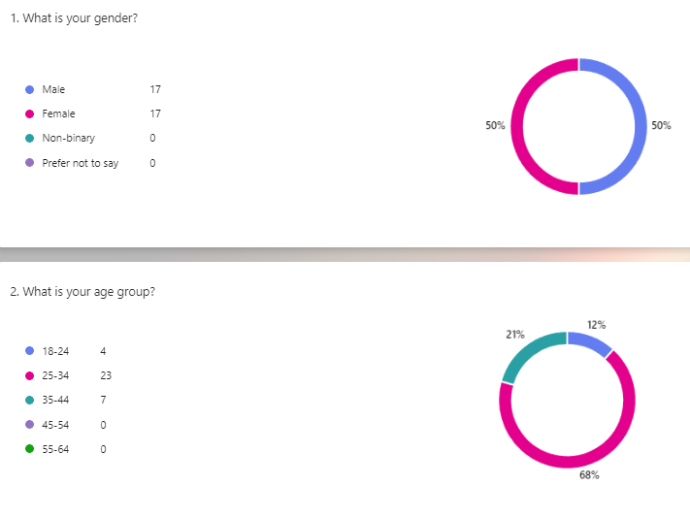

Out of these 34 participants 44 % held a UK driving license for 5- 10 years, 41% held a license for more than 10 years, 12 % held a license for 1 – 5 years and finally only 3 % never held a UK driving license.
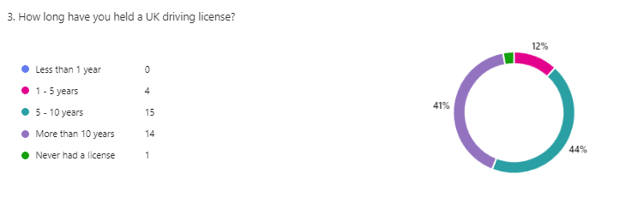
When completing the survey 50% of participants stated that male drivers were the most common and only 35% stated females were the most common. Looking at recent statistics published by the Department for Transport, male drivers were more likely to be observed using their mobile phones whilst driving (GOV.UK, 2023).
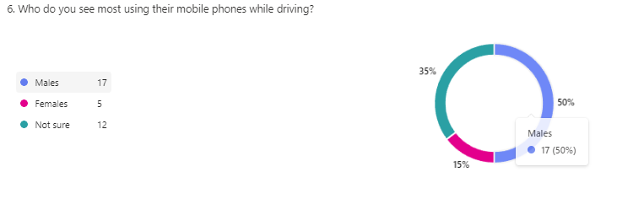
Attitude
When asked 82% of participants stated that mobile phone use whilst driving was “high risk” compared to 18 % considering it to be “moderate risk”, 5 female participants stated it was a moderate risk level compared to only one male participant stating the same.
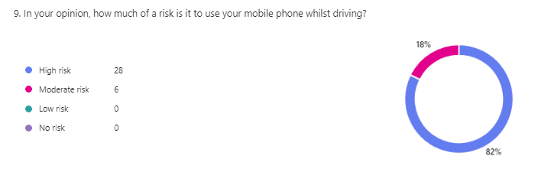
In comparison, previous studies have stated that male drivers normally associate less risk with mobile phone use behind the wheel (Sullman, et al, 2004) however my results show that female drivers associate less risk with mobile phone use and driving.

Within my survey female participants were also found to be less familiar with UK driving laws compared to male drivers.
When asked 47 % of participants stated that current penalties for mobile phone use were “sufficient enough” with 31 % stated they needed to be increased and 19 % stating they were “not strict enough”.
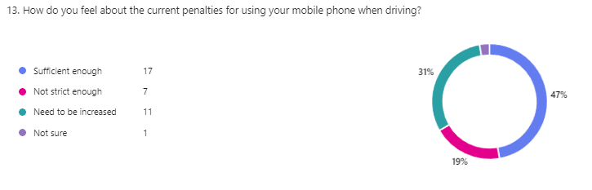
Enforcement
Participants were asked if they would be more supportive of police presence on UK roads and 91% agreed with more police presence. 91 % were also supportive of camera technology on roads, previous studies conducted on public opinion into camera technology also implied that people were more supportive of this technology and also called for greater police presence on roads (Stefanidis, et al. 2023).
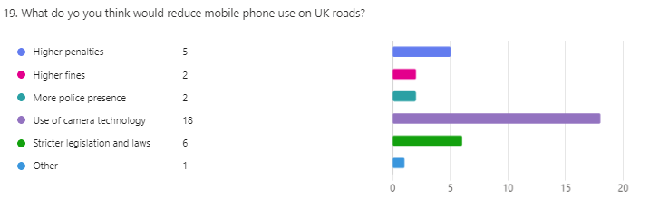
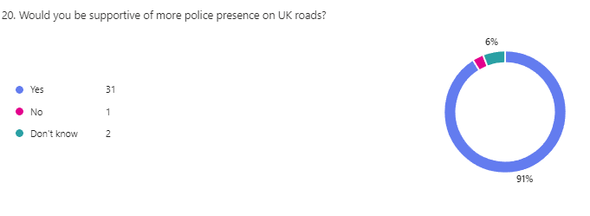
Participants were asked if they felt police were effective and stopping motorists using their mobile phones and 50% stated police were “somewhat effective” in achieving this with the other remainder feeling they were “neither effective or ineffective” and “somewhat ineffective”.
Finally, Participants were asked what they felt could improve police enforcement and the common themes for these answers were more usage of ANPR or camera systems as shown here;
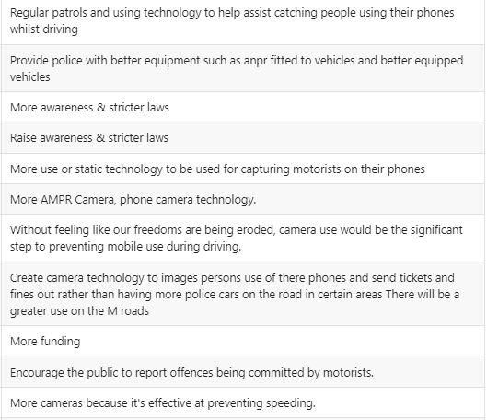

From this survey it shows that the public are supportive of police enforcement and consider mobile phone use to be high risk whilst driving.

