

LOCATION: Swansea | LLEOLIAD: abertawe
LEVEL 5 | LEFEL 5
EXAMINATION PERIOD | CYFNOD ARHOLIADAU
MAY 2024 | 2024

MODULE CODE: ACDC5009
Electromagnetic Radiation

TIME: 2 HOURS
answer all questions

Equipment or materials required – Calculator
Adnoddau neu ddefnyddiau sydd eu hangen - Cyfrifiannell

ANSWER ALL QUESTIONS
Question 1 [25 marks]
- A Laser emits light with a wavelength of 650nm. Calculate the frequency of the emitted light. (Hint: ${C=3×10}^{8}m/s$) [4 Marks]
Answer:
$f=\frac{c}{λ}$ [1 Mark]
$f=\frac{{3×10}^{8}}{{650×10}^{-9}}$ [2 Marks]
$f=461.538{×10}^{12}Hz$ [1 Mark]
- A light ray travelling in a medium with a refractive index of 1.6, strikes the surface of a block of glass at an angle of incidence of ${45}^{o}$. The block of glass has a refractive index of 1.5. Calculate the critical angle for total internal reflection at the interface. [5 Marks]
Answer:
Angle of incidence $={45}^{o}$
Critical angle $θ_{c}=\sin^{-1}\left(\frac{n_{glass}}{n_{m}}\right)$ [1 Mark]
$θ_{c}=\sin^{-1}\left(\frac{1.5}{1.6}\right)$ [2 Marks]
$θ_{c}={69}^{o}.64$ [2 Marks]
- Describe the following scattering theories with the aid of necessary diagrams.
- Rayleigh Scattering [6 Marks]
- Mie Scattering [6 Marks]
Answer:
- Rayleigh scattering
- This occurs when waves encounter particles or structures much smaller than the wavelength of the incident wave.
- The intensity of Rayleigh scattering is inversely proportional to the fourth power of the wavelength.
- Scattering takes place equally in all the direction.
- Rayleigh scattering is responsible for the blue colour of the sky, as shorter-wavelength blue light is scattered more than longer-wavelength red light.
[Each point carries 1 mark, maximum of 4 marks]
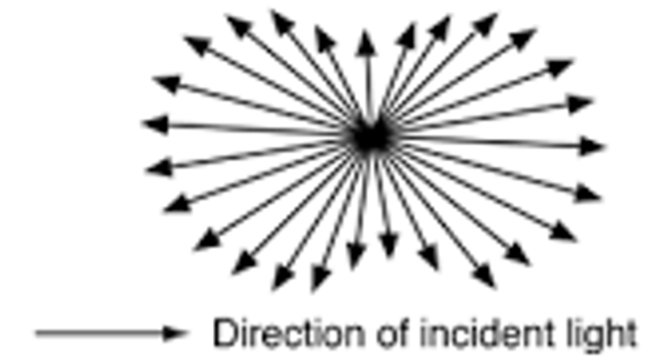
[2 Marks]

- Mie scattering
- Mie scattering occurs when waves interact with particles or structures that are comparable in size to the wavelength of the incident wave.
- It is more effective for larger particles and is not strongly wavelength-dependent.
- It is commonly observed in situations involving larger particles, such as water droplets in clouds.
- It influences the appearance of clouds and other aerosols. [Each point carries 1 mark, maximum of 4 marks]
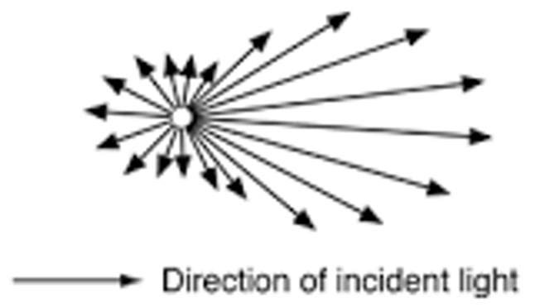
[2 Marks]
- Compare TE and TM Mode. [4 Marks]
Answer:
TE mode | TM Mode
Electric Field (E) vector is transverse or perpendicular to the Waveguide axis. | Magnetic field(H) vector is transverse or perpendicular to the Waveguide axis.
Magnetic fields is in the direction of Propagation | Electric fields is in the direction of Propagation
[Each point carries 2 mark, maximum of 4 marks]
Question 2 [25 marks]
- Describe the functions of each element in a Yagi-Uda Antenna. [10 marks]
Answer:
Driven Element: The Yagi antenna has one active element called the driven element, which is connected to the transmitter or receiver.
Parasitic Elements: The antenna also includes one or more passive elements known as parasitic elements. These are typically longer or shorter than the driven element and are arranged in a specific pattern.
Reflector Element: The rearmost parasitic element acts as a reflector. It reflects the incoming waves back towards the driven element, enhancing the overall antenna performance.
Director Elements: The parasitic elements in front of the driven element act as directors. They focus the electromagnetic waves in the desired direction, providing directionality to the antenna.
Boom: The element on which all these are placed is called a boom. It is a non-metallic structure which provides insulation, so that there will not be any short circuit between the other elements of the array.
[Each component 2 marks, maximum of 10 marks]
- An Optic Fiber has a Numerical aperture (NA) of 0.48, and the refractive index of the cladding is 1.45. Calculate the refractive index of the core and the acceptance angle, assuming the light enters the fiber from air. [8 Marks]
Answer:
NA=0.48
$n_{2}=1.45$
Refractive index of air (n)=1
$NA=\sqrt{n_{1}^{2}-n_{2}^{2}}$ [1 Mark]
$0.48=\sqrt{n_{1}^{2}-{1.45}^{2}}$ [1 Mark]
$n_{1}^{}=\sqrt{{1.45}^{2}+{0.48}^{2}}$ [1 Mark]
$n_{2}=1.53$ [2 Marks]
$θ_{a}={Sin}^{-1}\left(\frac{NA}{n}\right)$ [1 Mark]
$θ_{a}={Sin}^{-1}\left(\frac{0.48}{1}\right)={28}^{0}.69$ [2 Marks]
- What is signal modulation? Describe the benefits of modulating the signal in RF communication [7 Marks]
Answer:
Signal modulation is a technique used in communication systems to encode information on a carrier signal by varying its properties. The carrier signal is a high-frequency waveform that is modified or modulated to carry the information signal, which typically has a lower frequency. [3 Marks]
The Benefits are
- Frequency Utilisation
- Long-Distance Transmission
- Bandwidth Efficiency
- Noise Immunity [Each point 1 mark, maximum of 4 Marks]
Question 3 [25 marks]
- Determine the force exerted on charge $Q_{2}$ by charge $Q_{1}$ in free space. Charge $Q_{1}$ with a magnitude of $-16μC$ is positioned at point A(-5,4,6) and Charge $Q_{2}$ with a magnitude of $40μC$ is positioned at point B(4,8,-2). All distance are measured in meters. [15 Marks]
Answer:
${\overline{F}}_{Q_{1}Q_{2}}=\frac{Q_{1}Q_{2}}{4πε_{0}d_{AB}^{2}}{\overline{a}}_{AB}$
$\overline{A}=-5{\overline{a}}_{x}+4{\overline{a}}_{y}+6{\overline{a}}_{z}$ [1 mark]
$\overline{B}=4{\overline{a}}_{x}+8-2{\overline{a}}_{z}$ [1 mark]
${\overline{d}}_{AB}=\overline{B}-\overline{A}=9{\overline{a}}_{x}+4{\overline{a}}_{y}-8{\overline{a}}_{z}$ [2 marks]
$\left|{\overline{d}}_{AB}\right|=\sqrt{9^{2}+4^{2}+{(-8)}^{2}}=12.689$ [2 marks]
${\overline{a}}_{AB}=\frac{{\overline{d}}_{AB}}{\left|{\overline{d}}_{AB}\right|}=\frac{9{\overline{a}}_{x}+4{\overline{a}}_{y}-8{\overline{a}}_{z}}{12.689}=0.709{\overline{a}}_{x}+0.315{\overline{a}}_{y}-0.630{\overline{a}}_{z}$ [2 marks]
${\overline{F}}_{Q_{1}Q_{2}}=\frac{-16×{10}^{-6}×40×{10}^{-6}}{4π×8.85×{10}^{-12}×{12.689}^{2}}[0.709{\overline{a}}_{x}+0.315{\overline{a}}_{y}-0.630{\overline{a}}_{z}]$ [2 marks]
${\overline{F}}_{Q_{1}Q_{2}}=-0.0357[0.709{\overline{a}}_{x}+0.315{\overline{a}}_{y}-0.630{\overline{a}}_{z}]$ [2 marks]
${\overline{F}}_{Q_{1}Q_{2}}=-0.025{3\overline{a}}_{x}-0.0112{\overline{a}}_{y}+0.0225{\overline{a}}_{z}]$ N [1 mark]
$\left\lceil {\overline{F}}_{Q_{1}Q_{2}}\right\rceil =\sqrt{{(-0.0253)}^{2}+{(-0.0112)}^{2}+{(0.0225)}^{2}}=35.66mN$ [2 marks]
- A radar system transmits a signal with a frequency of 5 GHz. The system detects a moving target with a radial velocity of 1000m/s. Calculate the Doppler frequency shift. [5 marks]
Answer:
$v=\frac{λf_{Dop}^{}}{2}$
$f_{Dop}^{}=\frac{2v}{λ}$ [1 Mark]
$λ=\frac{c}{f}=\frac{3×{10}^{8}}{5×{10}^{9}}=0.06m$ [2 Marks]
$f_{Dop}^{}=\frac{2v}{λ}=\frac{2×1000}{0.06 }$ [1 Mark]
$f_{Dop}^{}=33333.33Hz=33.33kHz$ [1 Mark]
- A continuous wave radar system operates with a speed of light of velocity $3×{10}^{8}m/s$. If the Radar measures a time delay of $5×{10}^{-6}seconds$. Calculate the distance to the target. [5 Marks]
Answer:
$∆t=\frac{2R}{c}$
R- distance to the target
$R=\frac{∆t. c}{2}$ [2 Marks]
= $\frac{5×{10}^{-6}×3×{10}^{8}}{2}$ [2 Marks]
$R=750m$ [1 Mark]
Question 4 [25 marks]
- A Volume charge density is expressed as $ρ_{v}=10Z^{2}xsinπy$. Find the total charge inside the volume (-1$≤x≤2), (0≤y≤1)$and$(3≤Z≤3.6)$ [12 marks]
Answer:
$ρ_{v}=10Z^{2}xsinπy$
$Q=\int_{Vol}{ρ_{v}dv}$ [2 marks]
$Q=\int_{-1}^{2}{\int_{0}^{1}{\int_{3}^{3.6}{10Z^{2}xsinπy}dxdydz}}$ [4 marks]
$Q=10\left[{\left[\frac{x^{2}}{2}\right]}_{-1}^{2}{\left[\frac{Z^{3}}{3}\right]}_{3}^{3.6}{\left[\frac{-cosπy}{π}\right]}_{0}^{1}\right]$ [4 marks]
$Q=62.57C$ [2 marks]
- Describe the functionality of a 4 port Directional coupler used in microwave communication shown in figure 1. [7 marks]
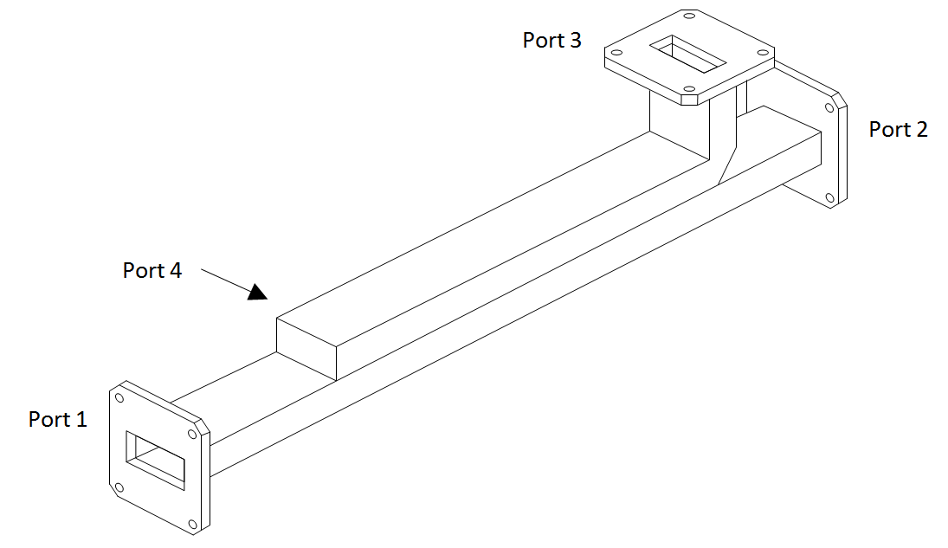
Fig 1: 4 Port Directional Coupler
Answer:
- It is a 4-port device, used to sample a small amount of input signal power for measurement purposes. [2 Marks]
- Port 1 is the input port, port 2 is the output port, port 3 is the coupled port and port 4 is the isolated/terminated port. [3 Marks]
- When an input signal travels from port 1 to port 2, a part of this signal is coupled to port 3. The portion of the power coupled to port 3 depends on the coupling value of the coupler being used. [2 Marks]
- Describe the primary types of radar used for tracking? [6 Marks]
Answer:
Pulse Radar: Uses timed pulses of radio waves to measure the range to a target and its relative motion. [2 Marks]
Continuous Wave (CW) Radar: Constantly transmits a signal and measures the Doppler shift in the return signal to determine the target's velocity. [2 Marks]
Phased Array Radar: Utilises multiple antenna elements to steer the beam direction electronically, allowing quick tracking of multiple targets simultaneously without moving the antenna physically. [2 Marks]

Diwedd/End

