Musical Performance Process Workbook - Vincent Catchpole

Since starting our Musical Performance Module I have learnt about many different ways to improve performance during singing. I was first introduced to the idea of status, in which a character can be either high status or low status. To put the idea into its simplest form, a high status character is more confident and lower status characters are more timid. It was important for me to remember that high status characters can still sing softly and low status characters can still belt notes in performance, but the important part was to keep their status in mind so that I could keep my characterisation clear and consistent.

A different acting technique we covered was surrounding the Circles of Attention. The circles represent a vague idea of who the song is aimed at, who you as the character are singing to. The first circle is interior, it is the singing equivalent of an internal monologue, you are singing your thoughts to no other characters but more so to the audience themselves without directly acknowledging them. The second circle is contact, a different character/entity that you are singing the song to, or you may even break the fourth wall and sing directly to the audience themselves. The third and final circle is singing to the Gods/universe, when you are singing you are trying to communicate with something greater than yourself, whether that be in anger, wonder, mourning or joy. I have found in performing that it is important to remember that when singing using the second circle, you have to make eye contact. If you have no partner to make eye contact with, then hold focus on a specific member of the audience, or class in this case. I find that this can be easy to forget and I often find myself staring blankly at an imaginary audience, and this can lose some of the performance’s effect.

The final acting technique we covered were the States of Tension, as follows:
- Exhaustion
- Californian
- Teenage
- Neutral
- Distraction
- Ice cream
- Virgin Mary
- Evil Mary
- Ticking bomb/Slow bomb
- Fast bomb
- Rigor mortis

These differing states offer opportunities to show different focuses in thought or emotion during a song. I find that each of these states are varied enough that they cover a wide range of emotion. I find these to be an incredibly helpful technique to ensure musical performance remains varied and interesting for an audience. I find these states useful because when I perform I often forget to act whilst singing, more specifically I struggle to convey emotion through singing itself, so I use these states as a mental image to help me show more character when I am singing.

We had also looked into the era of musical theatre known as the ‘Golden Age’, in which the Golden Age is known to be “the greatest period of growth for musical theatre as an art form” (Broadway World, 2022). The Golden Age is thought to have run roughly from 1943 to the 1960s. The beginning of the Golden Age came with the premiere of the Rodgers and Hammerstein musical ‘Oklahoma!’ In 1943. Oklahoma! Is regarded as the beginning to the Golden Age of Musicals because it was the first musical to use its musical numbers as a means of furthering the plot, rather than just using them as a break from the plot. Oklahoma! Was also “the first musical to blend comedy, drama, dance and song” (Oklahoma Historical Society, 2025) which was revolutionary to musical theatre. As for when the Golden Age ended there is much debate, some sources believe that the final golden age musical was ‘Fiddler On The Roof’ in 1964 (Broadway World, 2022) whereas others say that it was 1959’s ‘The Sound of Music’ (Rudetsky, S, 2023).

A very important aspect to singing that I would previously often overlook is the vocal warmup. We have had many vocal warmups as a group over the module and so have practiced many different methods of warming up. I have since compiled my own vocal warmup routine:
- I begin my warmup with a mix of different sounds, simple vowels, ‘A, E, I, O, U’ and I repeat this four times. After this I repeat the vowels, adding a specific consonant before each one. The consonants I use are B, V, K and H. I will then repeat each set of sounds twice. The purpose of this is to get my mouth used to making noises before progressing onto words.
- Once I have finished making individual sounds, I then repeat a tongue twister to help with my annunciation of full words. The tongue twister I prefer to use for vocal warmup is ‘The lips, the teeth, the tip of the tongue’ (Spirit Sound, 2020), because of its varied range of letter combinations and mouth shapes you make while saying it. I repeat this tongue twister four times in total before moving on.
- Next I force a smile, grit my teeth and push out a sort of buzzing ‘zzz’ sound. I do this to keep my lips tense and my vocal chords active. After buzzing, I do a lip trill, which helps to release the tension in my lips while still keeping my vocal chords active and warmed up.
- I then move on to focusing more on warming up my vocal chords specifically. To do this I keep my lips together and siren arpeggios. This way I can use my vocal chords and practice experimenting with my vocal range without straining my voice.
- Afterwards, I give my vocal chords a light rest without resting them completely by yawning in an exaggerated fashion. This helps to relax my neck and vocal chords and open up the windpipe, allowing for better air flow and therefore clearer singing.
- I then use the ‘sticky toffee’ method of warmup. It is a simple exercise in which you mime eating a sticky toffee, with exaggerated closed mouth movements to warm up the tongue and the cheeks. You can also incorporate a ‘mmm’ sound to keep your vocal chords active.
- Finally, to keep relaxed and to complete the warmup, I use breathing exercises. Specifically, I breathe in for four seconds through my nose, hold for six seconds and then control my exhale for eight seconds. This helps me to extend my lung capacity and helps me to practice controlling my breathing while singing. After a quick face massage to ensure my facial muscles are relaxed, I am ready to begin singing practice.

Something I struggled with was a particular singing technique that we covered in class, that being the ‘baby cry’. It is a loosely controlled high pitched crying sound, controlled enough that you do not move your voice into falsetto, that you then maintain and adjust into a note you want to sing. I struggled with this exercise and was not able to get it right in class but despite this I can feel the effect it is supposed to have on my voice. I will continue to practice it as I can see this technique being very valuable for practicing new songs in the future that require higher, more controlled notes without belting.

During rehearsals for our singing practical I wanted to experiment with my song choices, my chosen songs being ‘Can’t Help Falling in Love With You’ and ‘Empty Chairs at Empty Tables’. I chose these songs because I know they fit my singing voice well and offer both a more pop music style as well as classical musical theatre ballad. I annotated my sheet music to try and find changes in thought and feeling and to use my knowledge of the states of tension, circles of attention and status to help improve my performance. Upon reflection, I am not particularly happy with my song choices. While I have worked with both ‘Can’t Help Falling in Love With You’ and ‘Empty Chairs at Empty Tables’ for a very long time and was happy with the performances themselves, both songs play steadily at a slower tempo, both remain within low status throughout and both focused more on neutral states of tension. If I were to do my practical assessment again, I would change at least one of my songs to better represent a wider range of singing styles and more opportunity for differing acting choices.
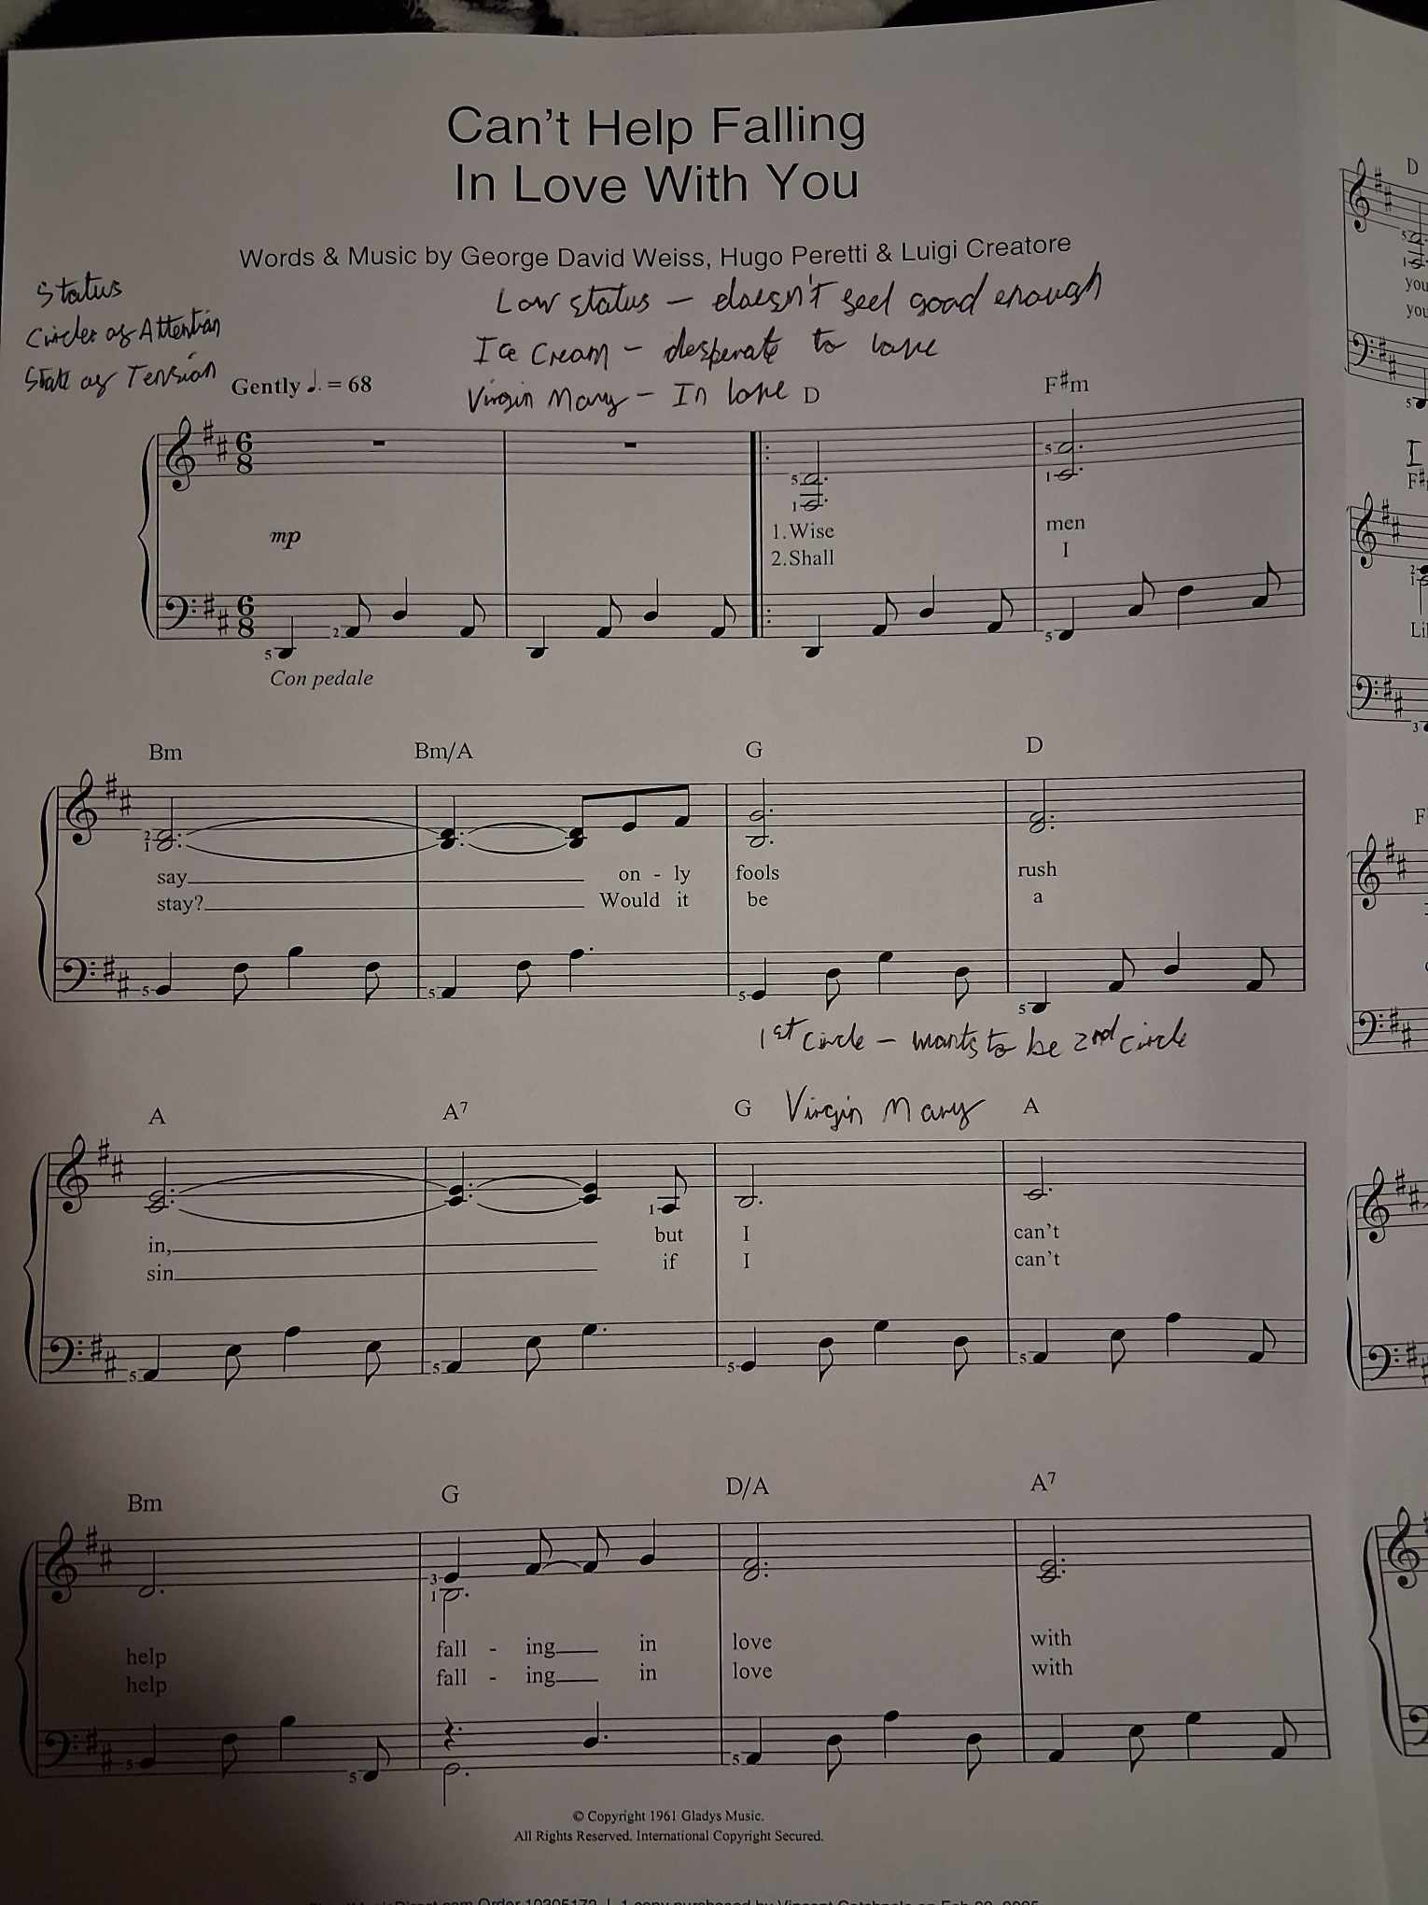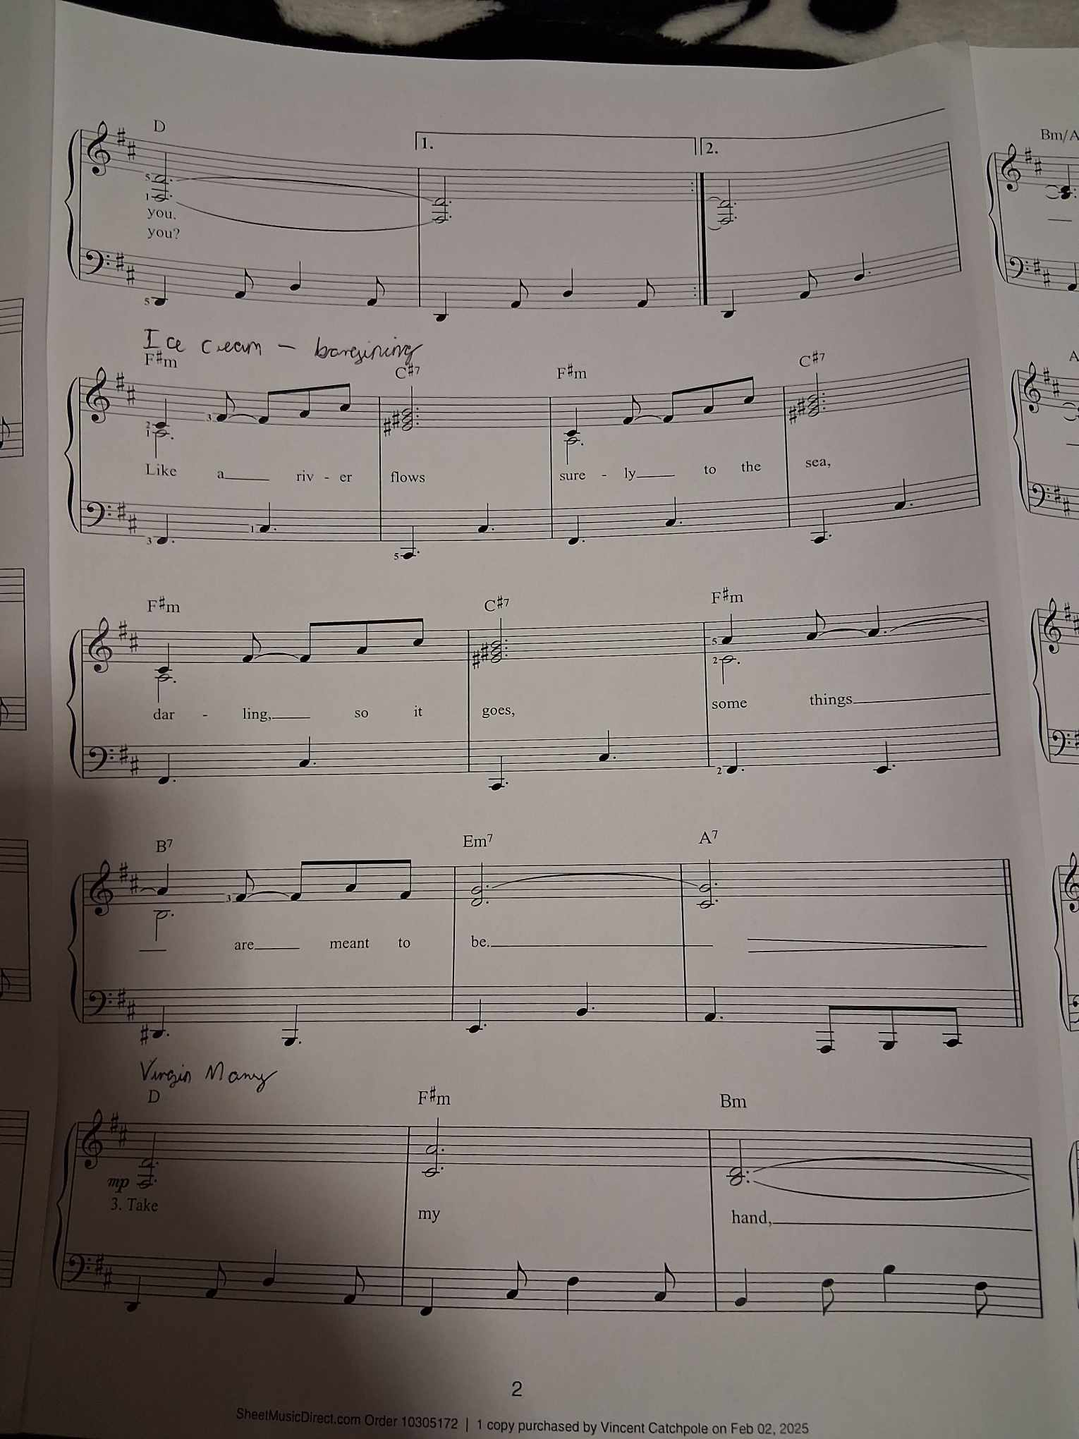
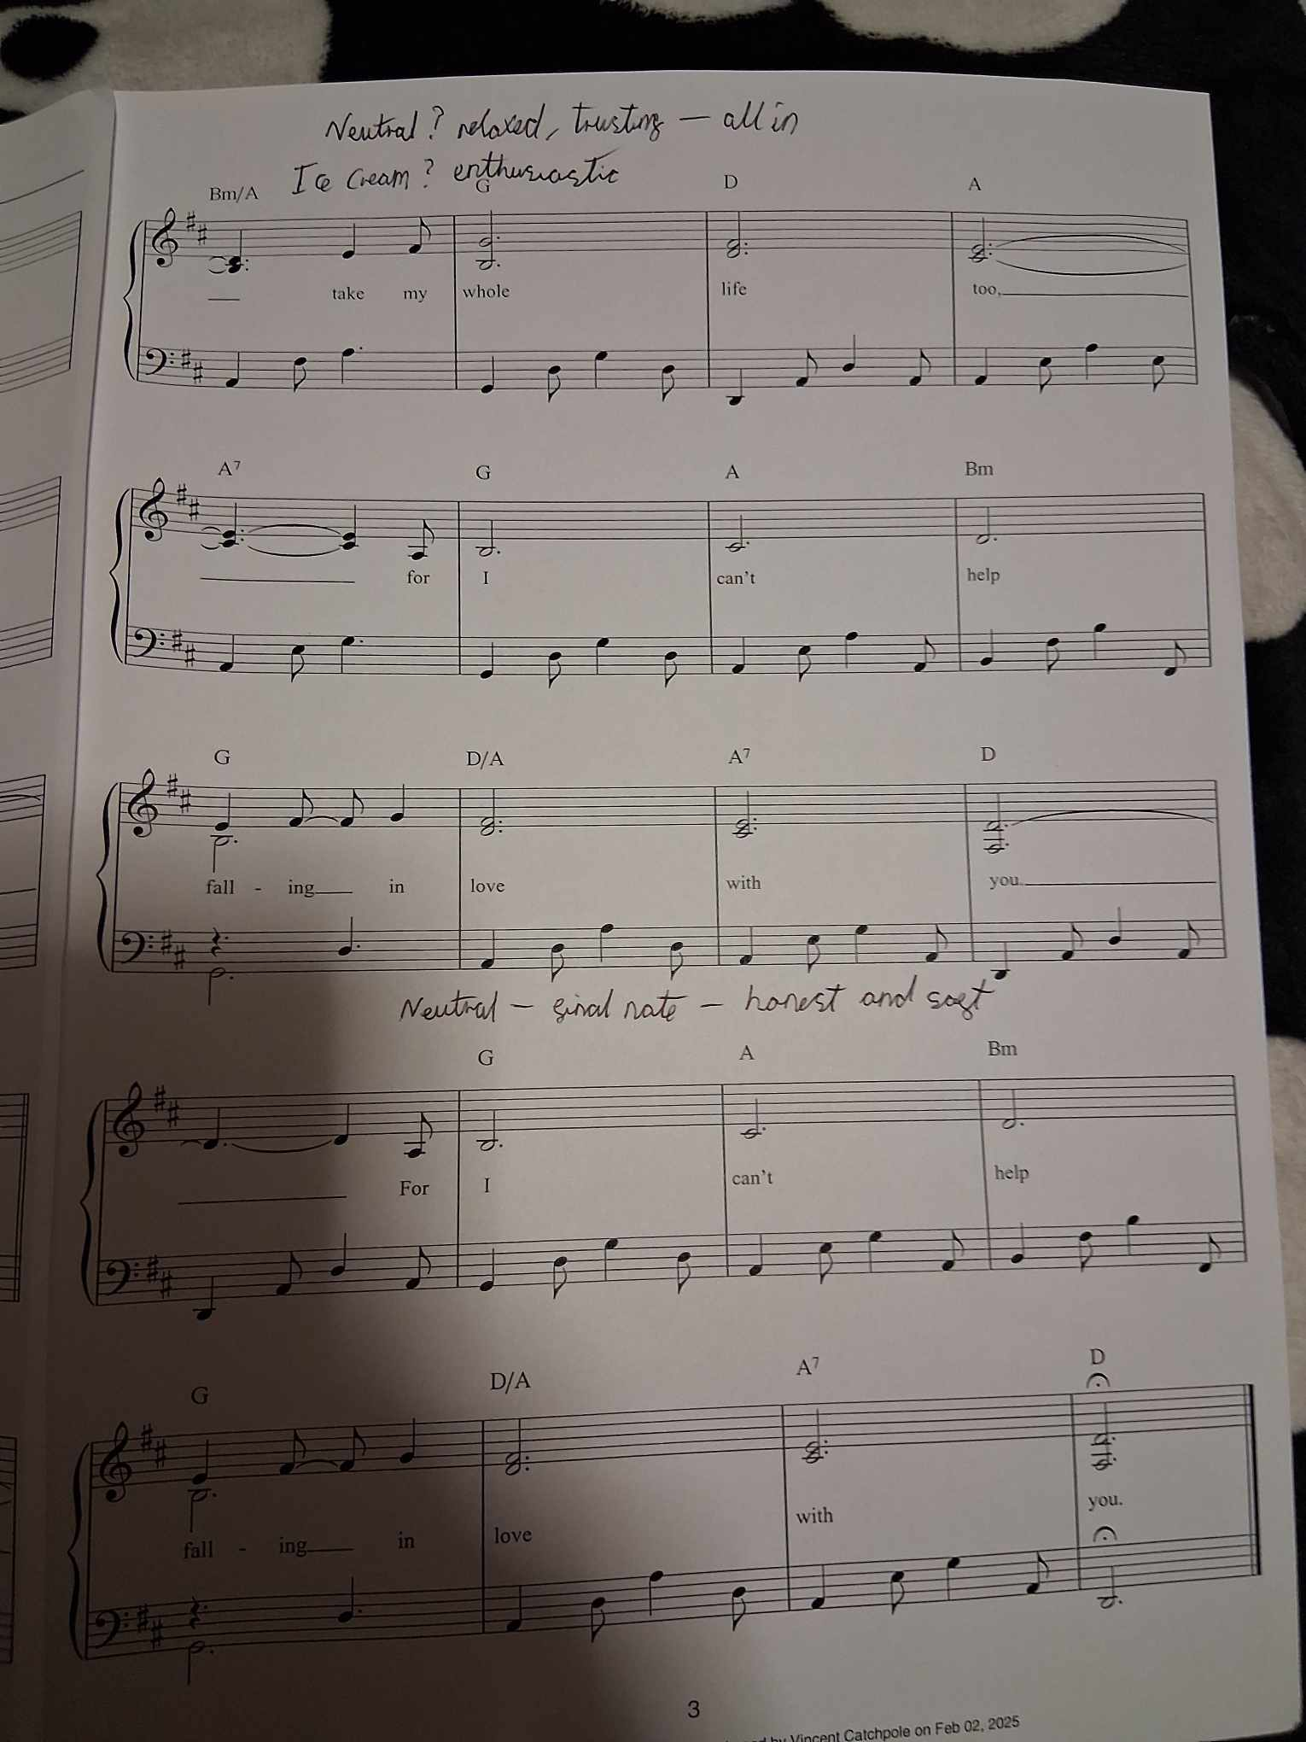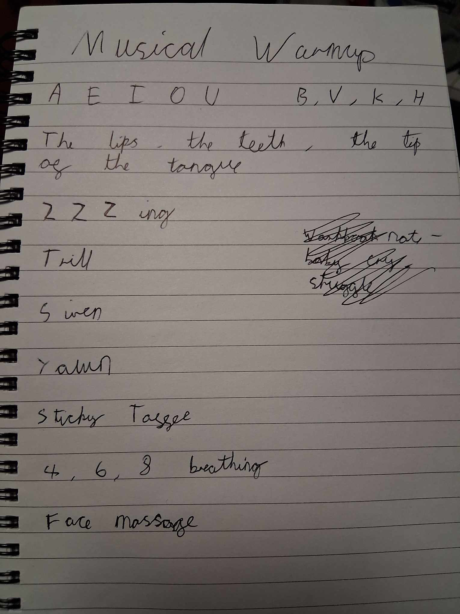

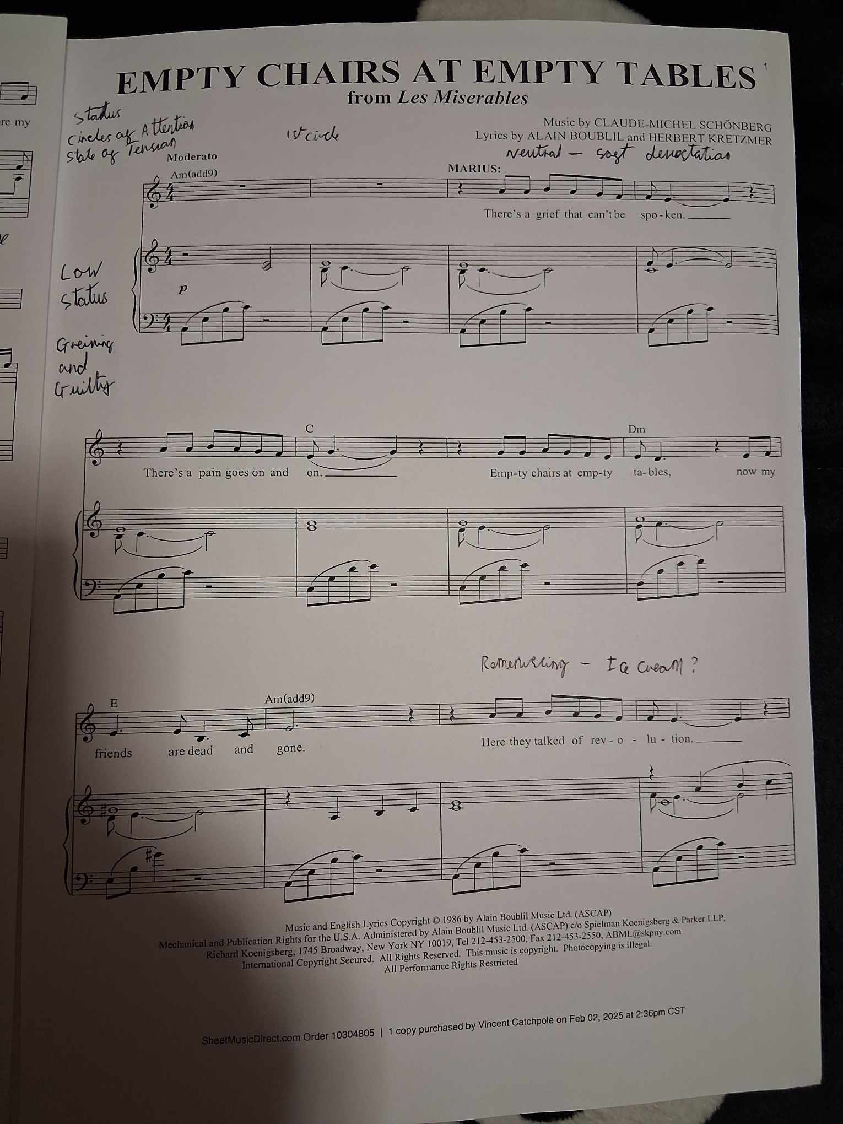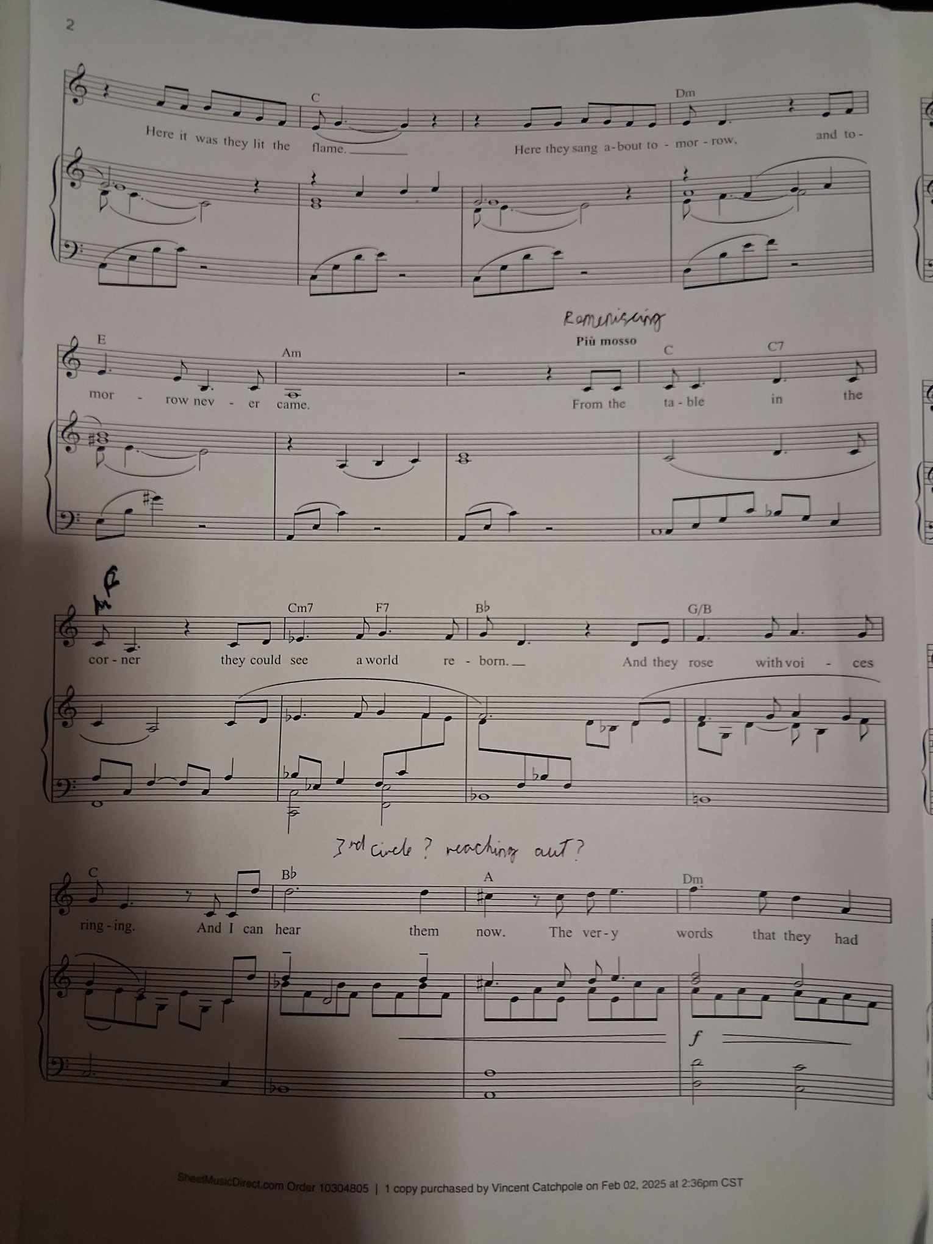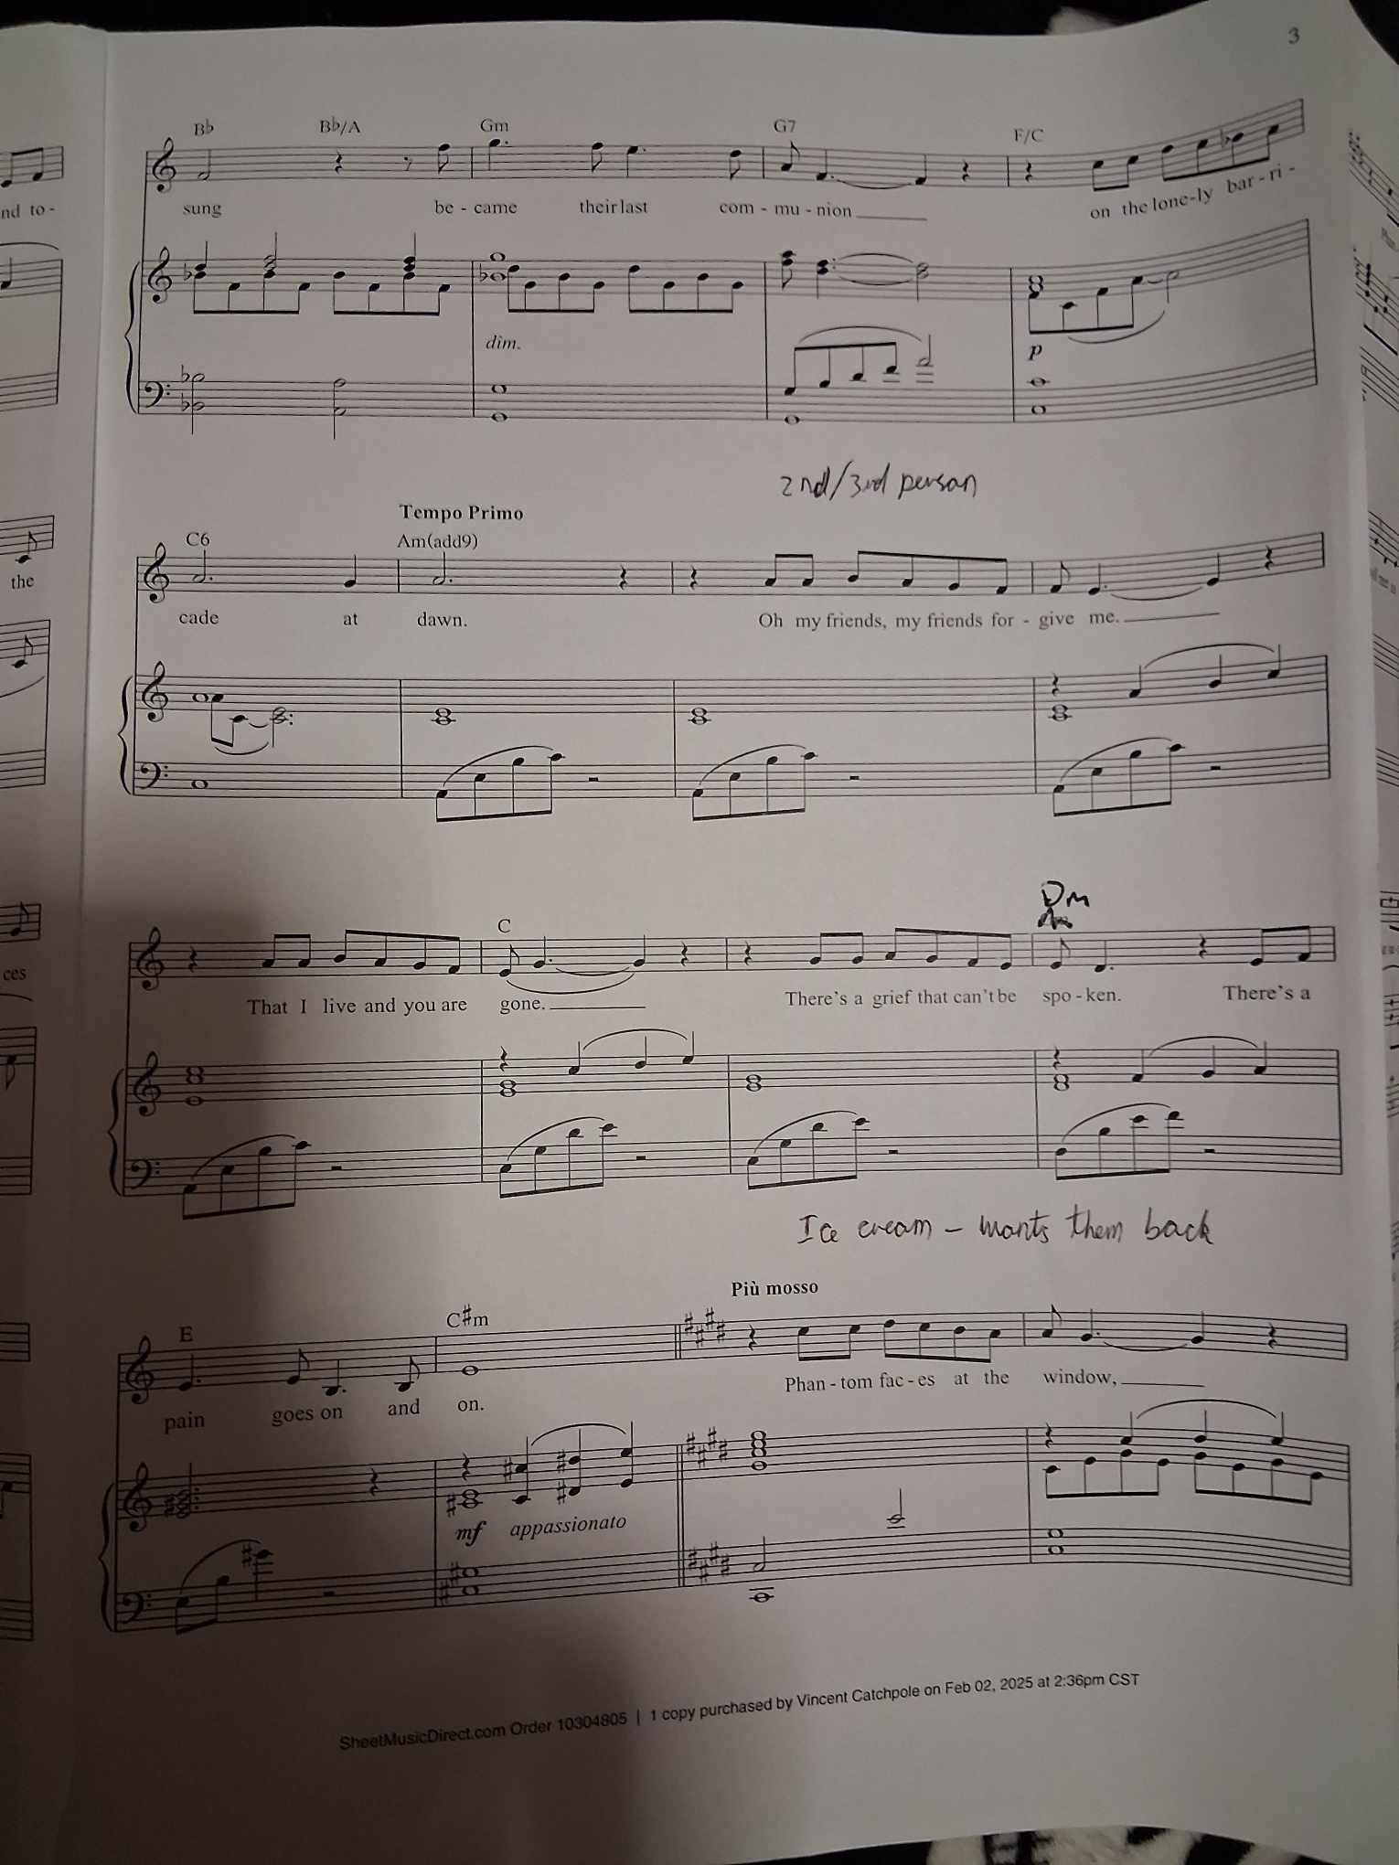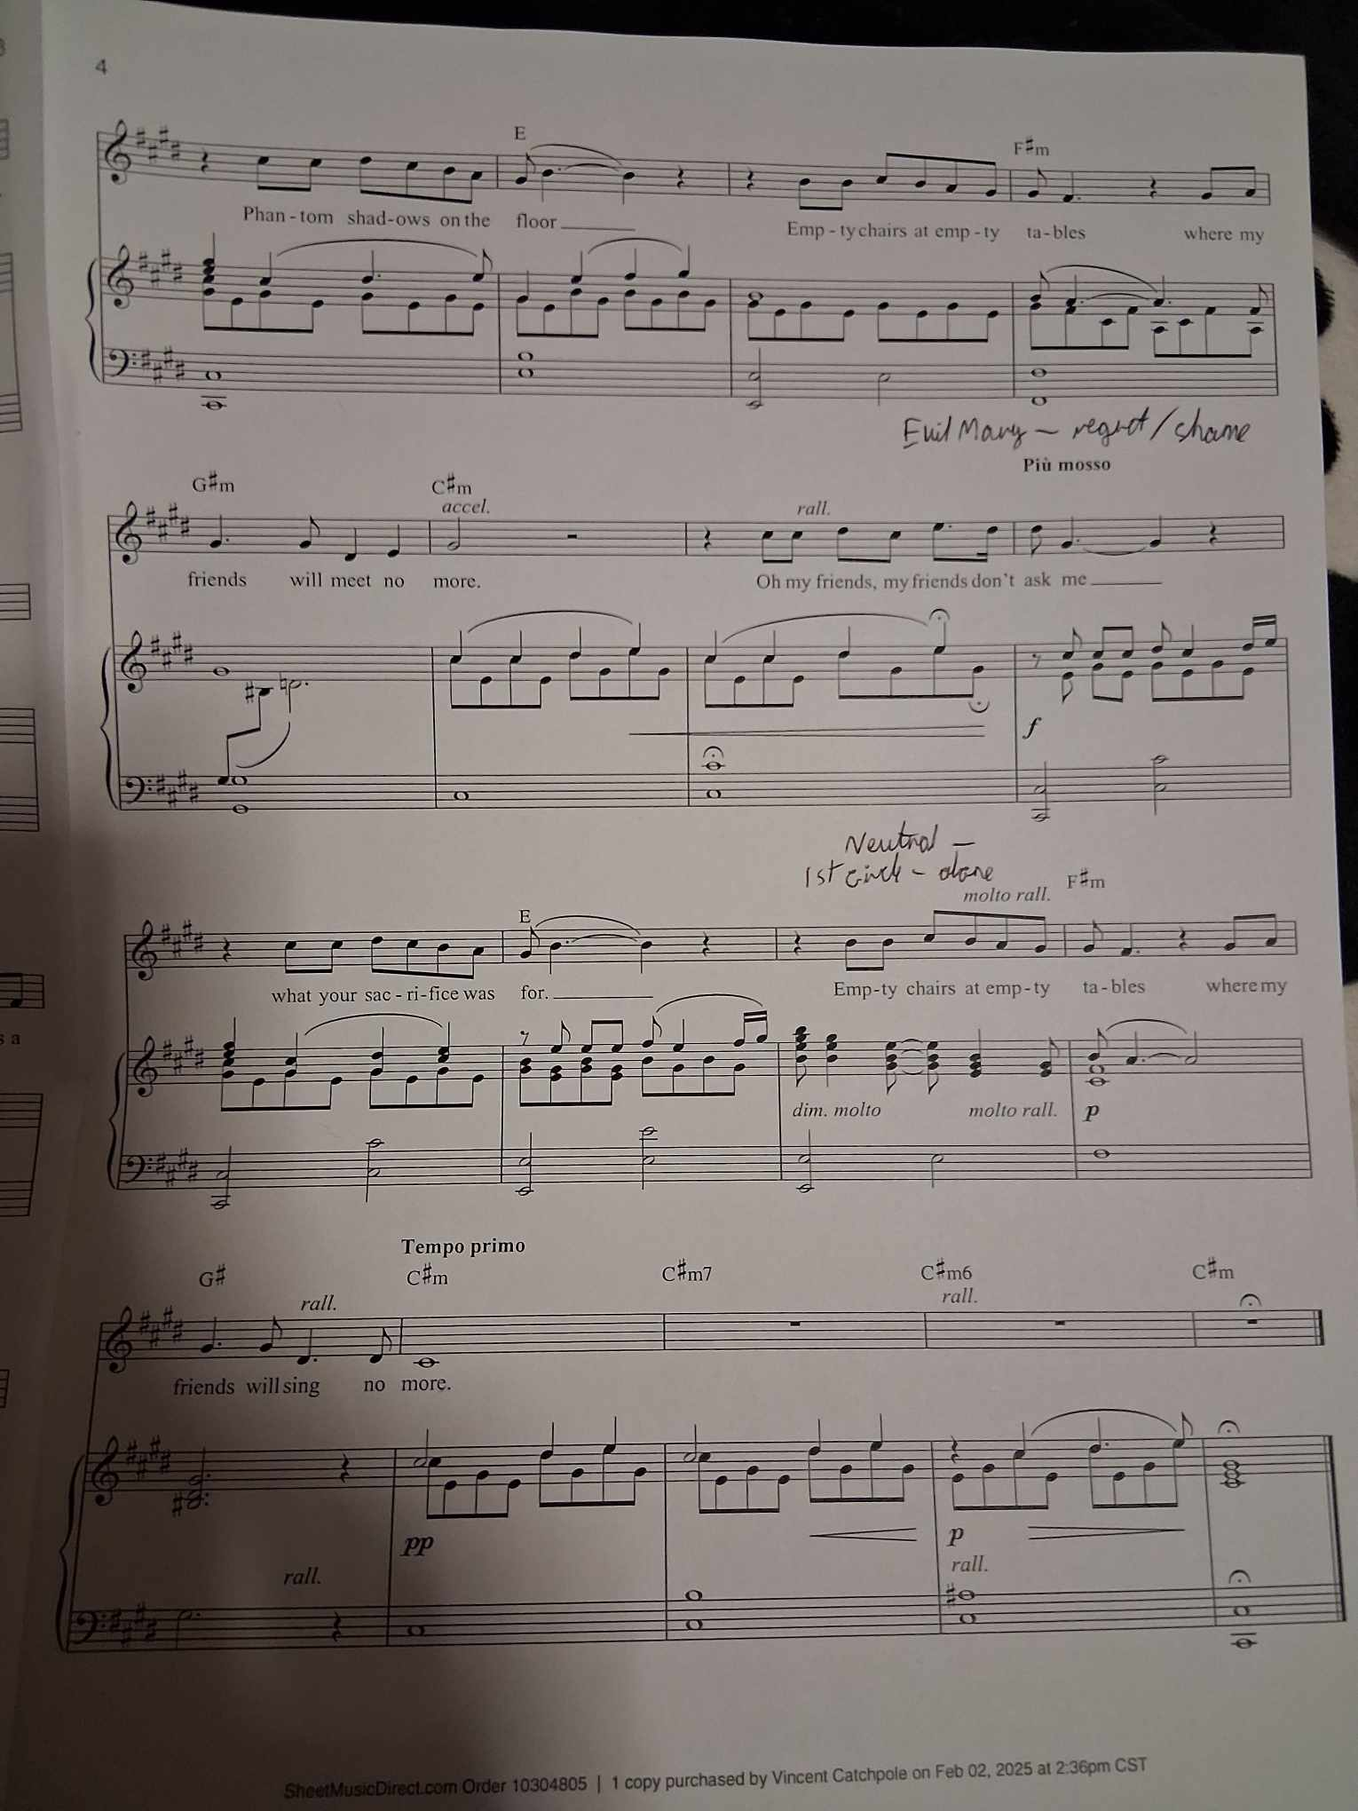

Bibliography:

Broadway World. (2022) What was the Golden Age of Broadway? Available from: https://www.broadwayworld.com/article/What-Was-the-Golden-Age-of-Broadway-20220219

Oklahoma Historical Society. (2025) Cultural Impact of Oklahoma! Available from: https://www.okhistory.org/learn/musical3#:~:text=Rodgers%20and%20Hammerstein's%20Oklahoma!&text=The%20original%20cast%20of%20the,revolutionized%20the%20theater%20business.

Rudetsky, S. (2023) What was the Golden Age of Broadway? Available from: https://www.dummies.com/article/academics-the-arts/performing-arts/what-was-the-golden-age-of-broadway-297863/

Spirit Sound. (2020) David Gordon’s Favourite Vocal Warmup Tongue Twisters. Available from: https://www.spiritsound.com/music/twisters.html

StageAgent. (2025) Golden Age of Musical Theatre. Available from: https://stageagent.org/guides/eras-movements/isxy9jibmnnpzxrspdagi

