
Design and Analysis of RF Antennas
By Alistair Lounds 2227990

Supervisor: Stalin Jacob

Project submitted as part of the requirements for the award of
BEng (Hons) Embedded Electronic Systems Design

May 2025

Table of Contents
Abstract 4
Introduction 4
TASK 1 4
Calculating Antenna Dimensions for Rectangular Microstrip Patch Antenna 4
Methodology for Calculating Microstrip Feed Line Width 5
Calculating Antenna Dimensions for Rectangular Microstrip Patch Antenna 5
Width of Microstrip Patch (W) 5
Effective Relative Permittivity of Microstrip Patch Antenna (ε_{reff}) 5
Actual Length of Microstrip Patch (L) 6
Width of Ground Plane (W_{g}) 6
Length of Ground Plane (L_{g}) 7
Overview of Microstrip Patch Antenna Parameters 7
Simulation Results for the Microstrip Patch Antenna 8
Analysis of Microstrip Patch Antenna Performance 11
TASK 2 11
RF Antenna Calculations 11
Antenna Design in MATLAB 12
Cylindrical Dipole Antenna 12
Folded Dipole Antenna 12
Horn Antenna 13
Helix Antenna 13
Antenna Simulation Results in MATLAB 14
Cylindrical Dipole Antenna 14
Folded Dipole Antenna 16
Horn Antenna 18
Helix Antenna 20
Analysis of Antenna Performance 22
Operating Frequency 22
How Impedance Matching Affects Antenna Performance 22
Antenna Choice 23
Evaluation of Societal and Environmental Factors 23
TASK 3 24
Helix Array Antenna Design 24
Helix Array Design in MATLAB 24
Helix Array Simulation Results in MATLAB 24
Analysis of Helix Array Performance 26
Benefits of using Array Antennas 26
Conclusion 27
Future Recommendations 27
References 27

Table of Figures
Figure 1 – Operating Frequency Formula – Rectangular Microstrip Patch Antenna 4
Figure 2 – Calculating Analytical Line Impedance for a Thin Microstrip Feed [1] 5
Figure 3 – Patch Width Formula [3] 5
Figure 4 – Effective Relative Permittivity Formula [3] 6
Figure 5 – Actual Patch Length Formula [4][3] 6
Figure 6 – Effective and Extension Length Formulas [4][3] 6
Figure 7 – Ground Plane Width Formula [5][6] 7
Figure 8 – Ground Plane Length Formula [5][6] 7
Figure 9 – Rectangular Microstrip Patch Antenna Design Specification 8
Figure 10 – Microstrip Patch Antenna Design in CST Studio Suite 8
Figure 11 - Microstrip Patch Antenna Far Field Plot of Radiation Field 9
Figure 12 - Smith Chart showing Impedance 9
Figure 13 – S-parameter Plot for Microstrip Patch Antenna 10
Figure 14 - VSWR of Microstrip Patch Antenna 10
Figure 15 – Microstrip Patch Antenna Far Field 1D Polar Plot 11
Figure 16 - Operating Frequency Formula – Cylindrical Dipole Antenna 11
Figure 17 – Operating Frequency Formula – Folded Dipole Antenna 12
Figure 18 – Operating Frequency Formula – Horn Antenna 12
Figure 19 – Operating Frequency Formula– Helix Antenna 12
Figure 20 – Cylindrical Dipole Design in MATLAB Antenna Designer 12
Figure 21 – Folded Dipole Design in MATLAB Antenna Designer 13
Figure 22 – Horn Design in MATLAB Antenna Designer 13
Figure 23 – Helix Design in MATLAB Antenna Designer 14
Figure 24 – Impedance Plot for Cylindrical Dipole Antenna 14
Figure 25 – S-Parameter Plot for Cylindrical Dipole Antenna 15
Figure 26 – 3D Radiation Plot for Cylindrical Dipole Antenna 15
Figure 27 – 2D Azimuthal (left) and Elevation (right) Plots for Cylindrical Dipole Antenna 16
Figure 28 – Impedance Plot for Folded Dipole Antenna 16
Figure 29 – S-Parameter Plot for Folded Dipole Antenna 17
Figure 30 – 3D Radiation Plot for Folded Dipole Antenna 17
Figure 31 – 2D Azimuthal (left) and Elevation (right) Plots for Folded Dipole Antenna 18
Figure 32 – Impedance Plot for Horn Antenna 18
Figure 33 – S-Parameter Plot for Horn Antenna 19
Figure 34 – 3D Radiation Plot for Horn Antenna 19
Figure 35 – 2D Azimuthal (left) and Elevation (right) Plots for Horn Antenna 20
Figure 36 – Impedance Plot for Helix Antenna 20
Figure 37 – S-Parameter Plot for Helix Antenna 21
Figure 38 – 3D Radiation Plot for Helix Antenna 21
Figure 39 – 2D Azimuthal (left) and Elevation (right) Plots for Helix Antenna 22
Figure 40 – Operating Frequency Formula – Helix Array 24
Figure 41 – Helix Array Design in MATLAB Antenna Array Designer 24
Figure 42 – Impedance Plots for Helix Array Elements 25
Figure 43 – S-Parameter Plot for Helix Array 25
Figure 44 - 3D Radiation Plot for Helix Array 26
Figure 45 – 2D Azimuthal (left) and Elevation (right) Plots for Helix Array 26

Table of Tables
Table 1 – Analysis of Resonant Frequencies [11] 22

Abstract
This report examines the radio frequency design, simulation, and analysis of Microstrip Patch, Dipole, Horn, and Helical antenna structures. Operating frequencies were determined using established antenna theory and computational techniques before performance analysis was conducted using Dassault Systemes CST Studio Suite 2024 and MATLAB R2024b Antenna Designer.
This experiment found that antennas operate most efficiently when their structures exhibit purely resistive characteristics, with the resistive component matching the characteristic impedance and the reactive component at zero. It was also observed that all simulated resonant frequencies were higher than the theoretical values calculated except for the Helix Array antenna.

Introduction
The Rectangular Microstrip Patch antenna was simulated using Dassault Systemes CST Studio Suite 2024, while the Cylindrical Dipole, Folded Dipole, Horn, Helix and Helix Array antennas were simulated using MATLAB R2024b Antenna Designer. [1][2]
Simulation data captured antenna configurations, detailing materials, dimensions, resonant frequencies, radiation patterns, and impedance characteristics. By analysing the findings of these simulations, insights are offered as to antenna selection criteria. This report also examines how Impedance matching effects antenna performance and the consideration of environmental and societal factors in antenna design.

TASK 1
Task 1 covers designing and modelling a Rectangular Microstrip Patch antenna using CST Studio Suite 2024, considering antenna theory. [1]

Calculating Antenna Dimensions for Rectangular Microstrip Patch Antenna
To design and simulate the Rectangular Microstrip Patch antenna I needed to determine its operating frequency. As instructed by the assignment, my student number of ‘2227990’ was considered:
Figure 1 – Operating Frequency Formula – Rectangular Microstrip Patch Antenna

Methodology for Calculating Microstrip Feed Line Width
The Microstrip Feed Width was calculated using the Analytical Line Impedance tool within CST Studio 2024; shown by Figure 2. This was modelled as a thin Direct Microstrip Feed, rather than an Inset Feed. The width was adjusted to achieve a Characteristic Impedance (Z_{o}) of 50 Ω for an epoxy FR4 dielectric substrate of 1.6 mm thickness, working at a 2.2 GHz operating frequency.
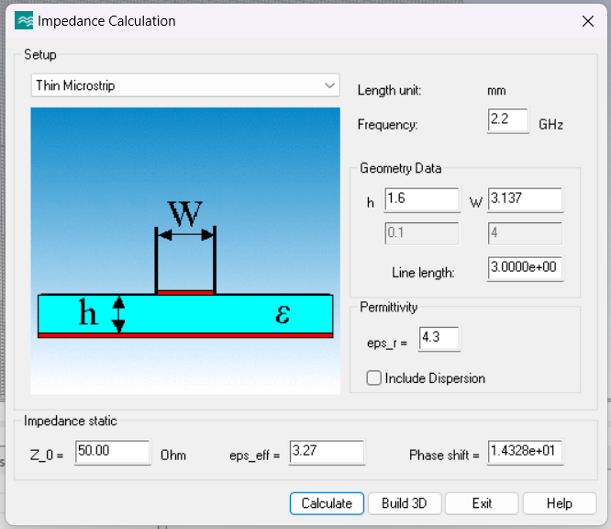
Figure 2 – Calculating Analytical Line Impedance for a Thin Microstrip Feed [1]

Calculating Antenna Dimensions for Rectangular Microstrip Patch Antenna

Width of Microstrip Patch (W)
The Patch Width was calculated using the formula in Figure 3:
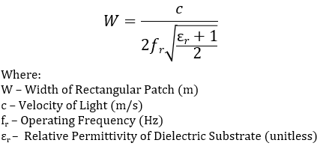
Figure 3 – Patch Width Formula [3]
Therefore:
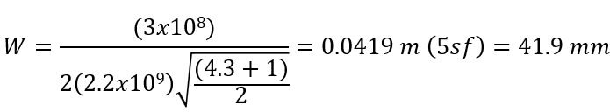

Effective Relative Permittivity of Microstrip Patch Antenna (ε_{reff})
The Effective Relative Permittivity was calculated using the formula in Figure 4:
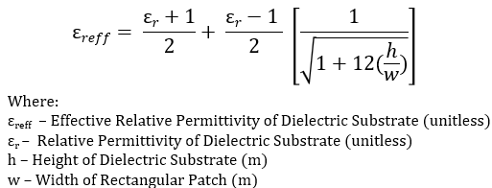
Figure 4 – Effective Relative Permittivity Formula [3]
Therefore:
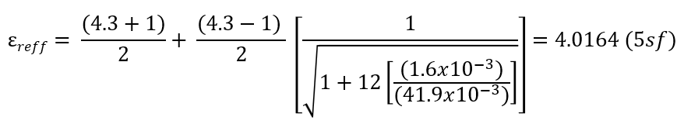

Actual Length of Microstrip Patch (L)
To calculate the Actual Patch Length (L) consider the formula in Figure 5:
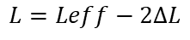
Figure 5 – Actual Patch Length Formula [4][3]
Figure 6 shows the components of this formula:

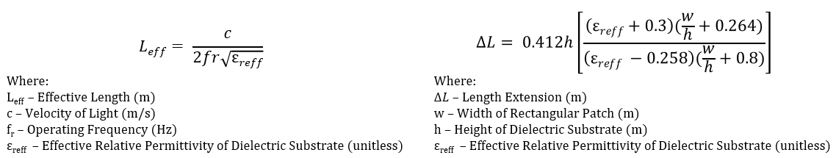
Figure 6 – Effective and Extension Length Formulas [4][3]
Therefore, the Actual Length was calculated from the follow equation:
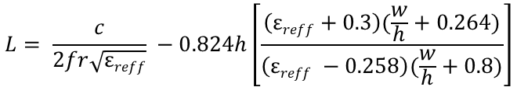
Therefore:

Width of Ground Plane (W_{g})
The Ground Plane Width was calculated using the Figure 7 formula:
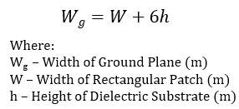
Figure 7 – Ground Plane Width Formula [5][6]
Therefore:

Length of Ground Plane (L_{g})
The Ground Plane Length was calculated using the Figure 8 formula:
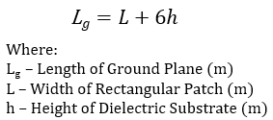
Figure 8 – Ground Plane Length Formula [5][6]
Therefore:

Overview of Microstrip Patch Antenna Parameters
Figure 9 shows an overview of the calculated parameters for the Rectangular Microstrip Patch antenna.
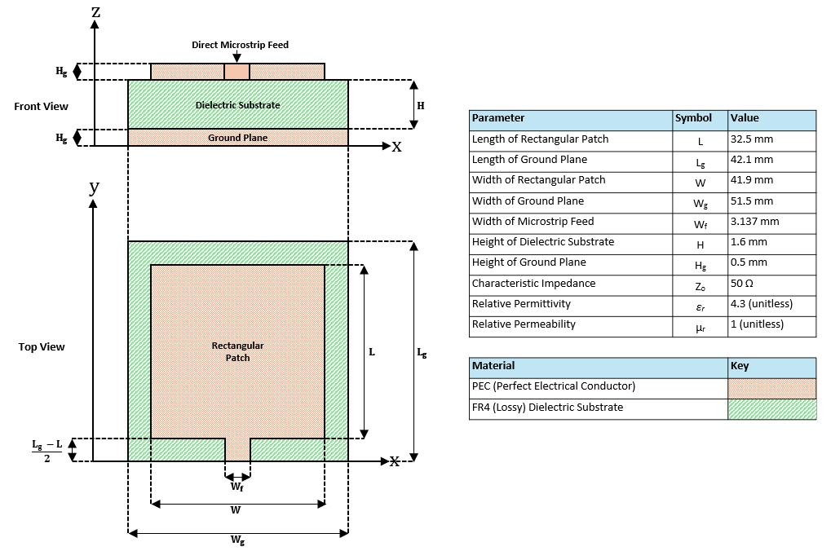
Figure 9 – Rectangular Microstrip Patch Antenna Design Specification

Simulation Results for the Microstrip Patch Antenna
CST Studio 2024 was used to categorise the antennas behaviour across the span of 1 to 8 GHz, generating the radiation pattern, impedance and S-parameter plots. [1] Figure 10 shows the Microstrip patch antenna design.
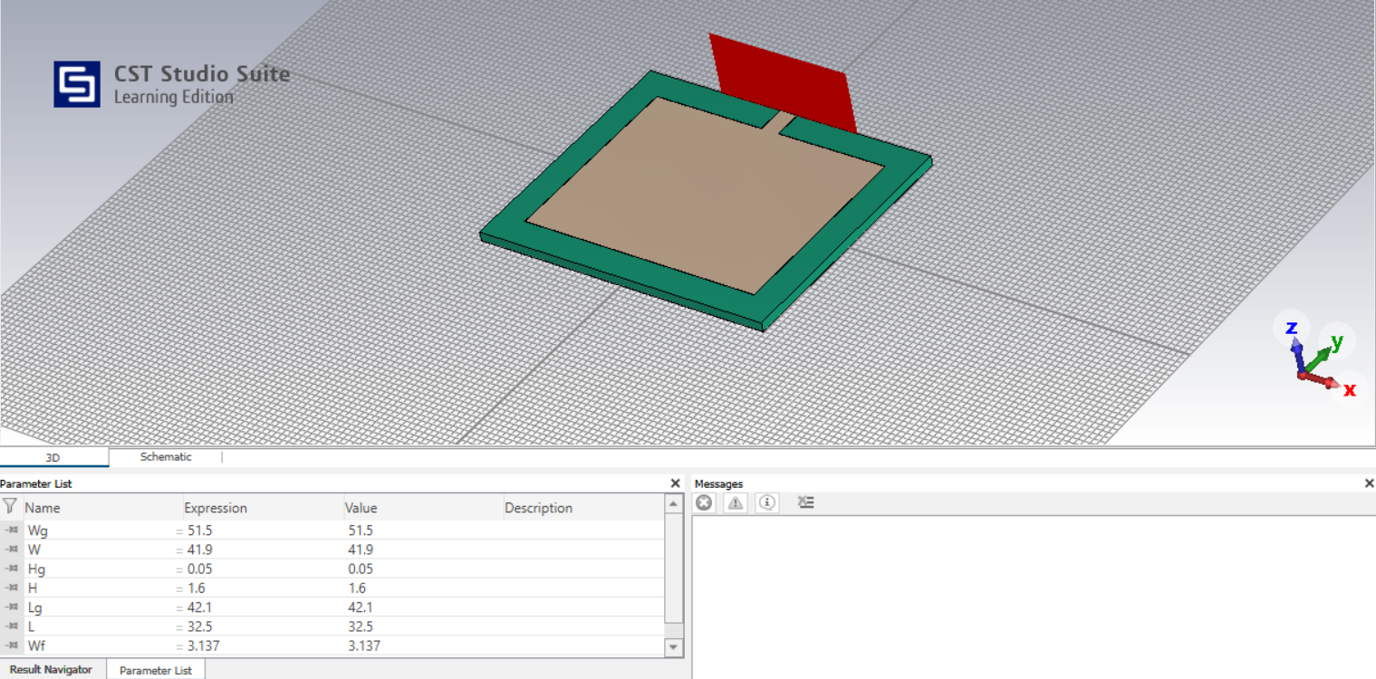
Figure 10 – Microstrip Patch Antenna Design in CST Studio Suite
Radiation Pattern
Figure 11 shows the Radiation Pattern as a Far Field Plot for the Microstrip Patch Antenna.
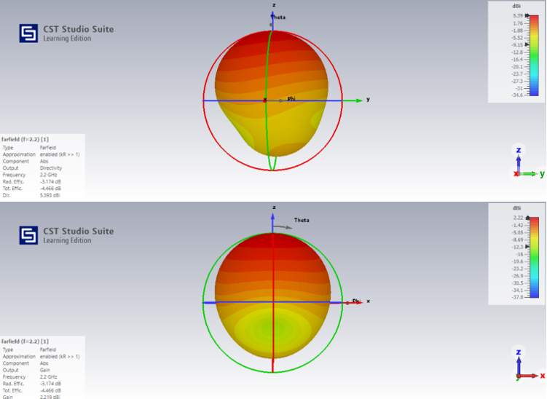
Figure 11 - Microstrip Patch Antenna Far Field Plot of Radiation Field
Impedance Plot
Figure 12 shows the Smith Chart for Microstrip Patch antenna.
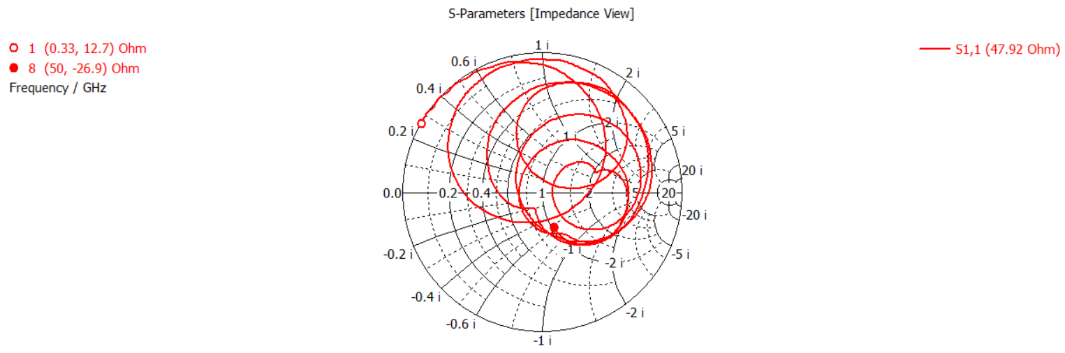
Figure 12 - Smith Chart showing Impedance
S-Parameter Plot
Figure 13 shows the S-Parameter plot displaying the Resonant Frequency of the Microstrip Patch antenna.
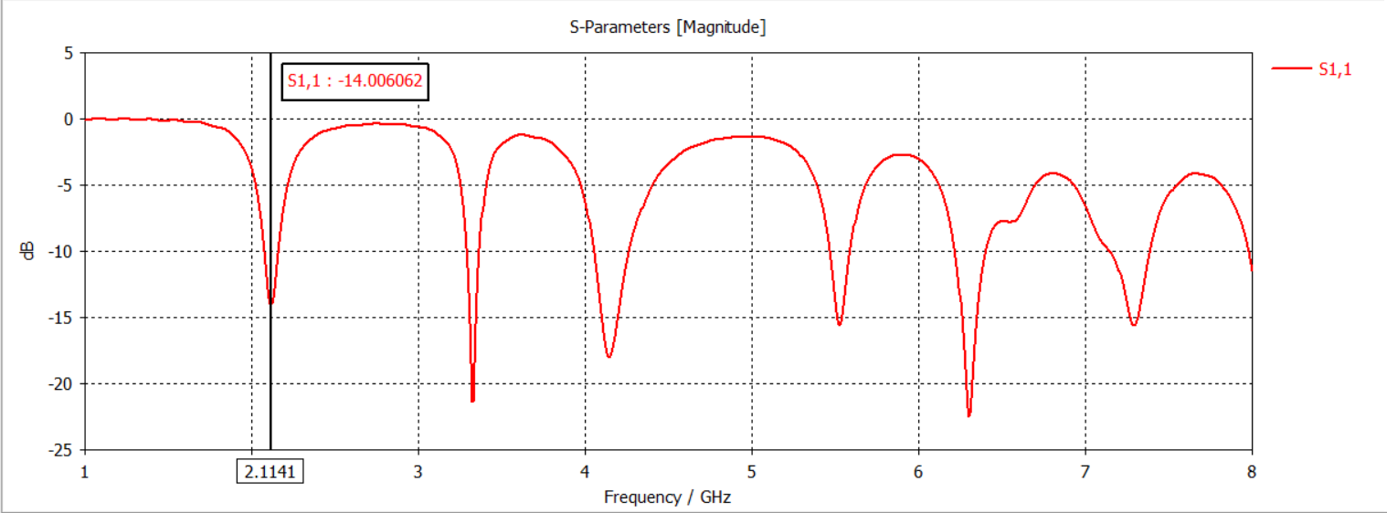
Figure 13 – S-parameter Plot for Microstrip Patch Antenna
VSWR
Figure 14 shows the Voltage Standing Wave Ratio (VSWR) of the Microstrip Patch antenna. VSWR is a measurement of how efficiently power is transmitted an antenna. This indicates how much energy is reflected due to impedance mismatching. [7]
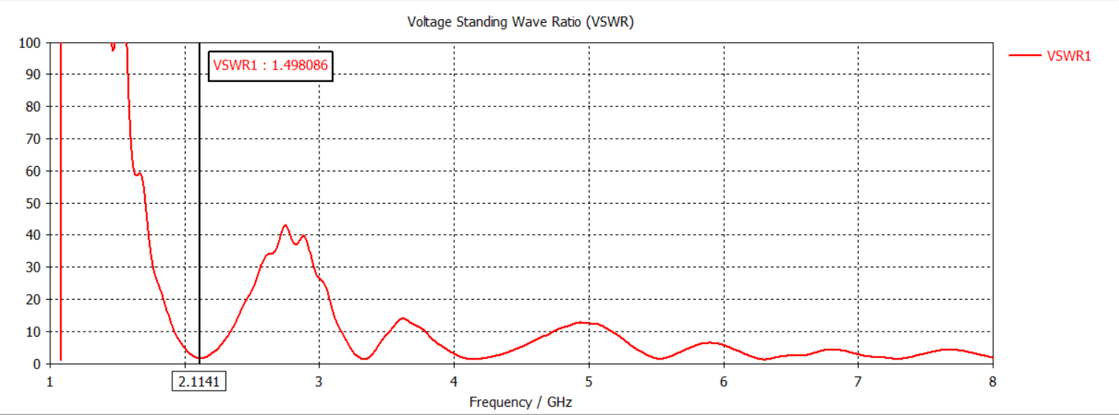
Figure 14 - VSWR of Microstrip Patch Antenna
1D Polar Plot
Figure 15 shows the 1-dimensional Polar Plot showing how energy is radiated by the Microstrip Patch antenna.
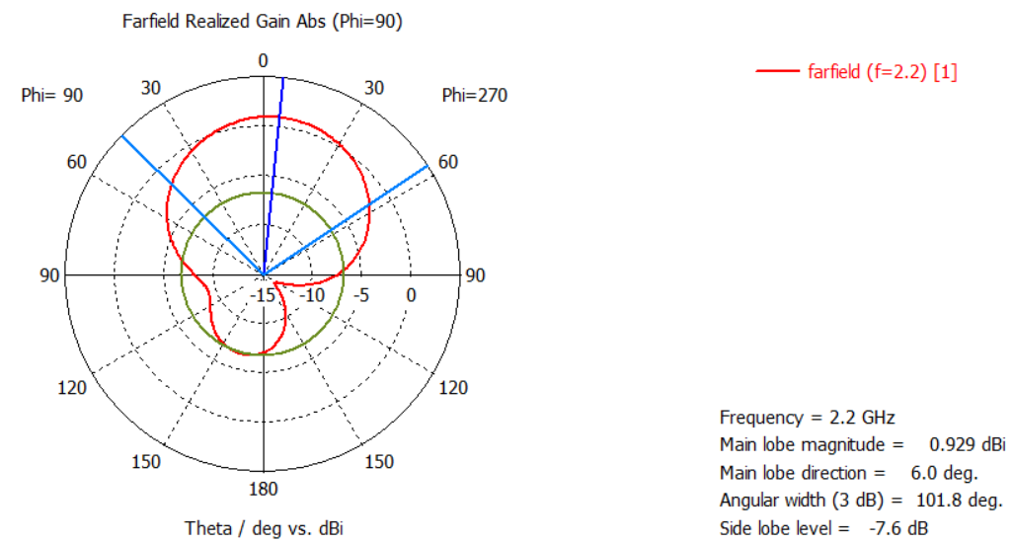
Figure 15 – Microstrip Patch Antenna Far Field 1D Polar Plot

Analysis of Microstrip Patch Antenna Performance
For this model, the theoretical resonance frequency was 2.2 GHz, while the simulated yielded 2.1141 GHz, showing a slight deviation, 3.9% below the desired value.
Figure 11 shows that the antenna has moderate gain, concentrating most of its radiated energy into its main lobe, having Directivity of 5.393 dBi. This would indicate it behaves slightly more directional than an omni-directional antenna. [8]
Figure 12 provides an S₁₁ value for the Microstrip Patch antenna of 47.92Ω. This identifies an impedance mismatch of 2.18Ω in terms of reflection coefficient, therefore showing reduced antenna efficiency. However, as the antenna has a VSWR of 1.498 the antenna only has a small portion of signal reflected, therefore being acceptable for most radio-frequency applications. [9]
The S-parameter plot in Figure 13 identifies that the antenna could be considered wideband having a Half-Power Bandwidth (-3dB) of 52.4 MHz, spanning from 2.0888 GHz to 2.1412 GHz. From this we can determine the Quality factor of the antenna, indicating sharpness of the frequency response being 40.35 (4sf). [10] Figure 15 also indicates that the antenna has a wide Half-Power Beamwidth (HPBW) of 101.8⁰.

TASK 2
MATLAB R2024b Antenna Designer was used to model and analyse four antenna types: Cylindrical Dipole, Folded Dipole, Horn, and Helix. [2] These simulations help understand their structure and performance.

RF Antenna Calculations
Theoretical operating frequencies were determined for the antenna structures. My student number of ‘2227990’ was considered to calculate these values.
Figure 16 - Operating Frequency Formula – Cylindrical Dipole Antenna
Folded Dipole Antenna:
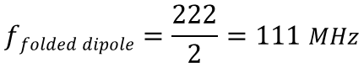
Figure 17 – Operating Frequency Formula – Folded Dipole Antenna
Horn Antenna:
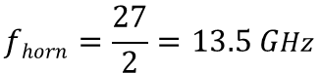
Figure 18 – Operating Frequency Formula – Horn Antenna
Helix Antenna:
Figure 19 – Operating Frequency Formula– Helix Antenna

Antenna Design in MATLAB
MATLAB R2024b Antenna Designer was used to model each of the specified antennas.

Cylindrical Dipole Antenna
Figure 20 shows the Cylindrical Dipole properties and design.
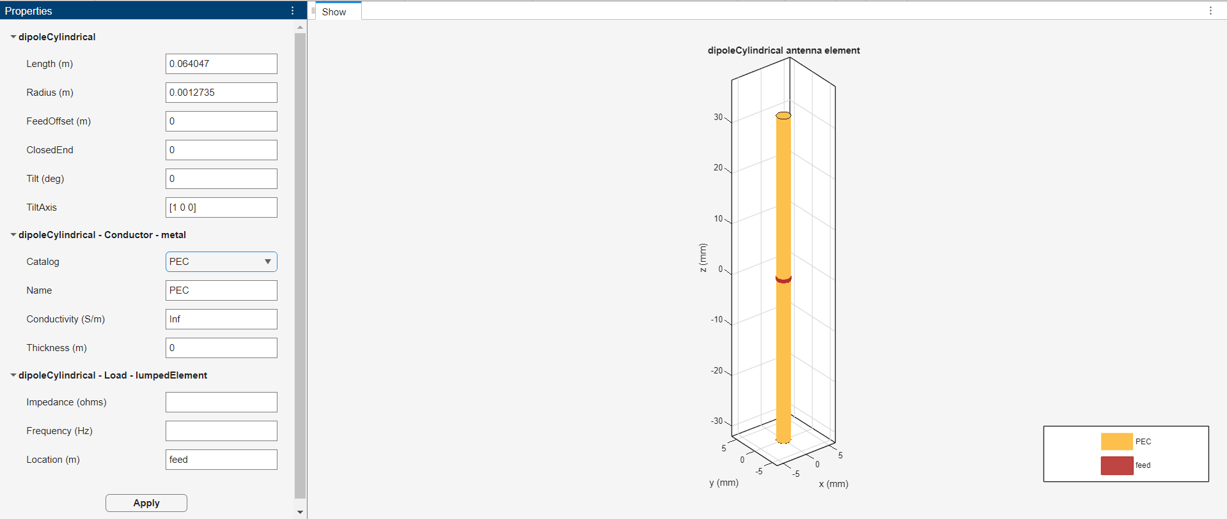
Figure 20 – Cylindrical Dipole Design in MATLAB Antenna Designer

Folded Dipole Antenna
Figure 21 shows the Folded Dipole properties and design.
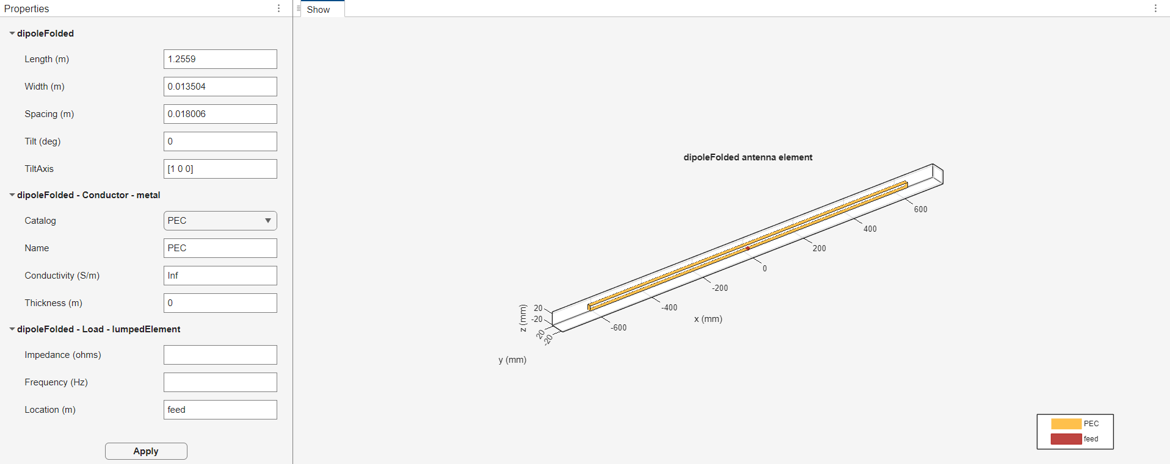
Figure 21 – Folded Dipole Design in MATLAB Antenna Designer

Horn Antenna
Figure 22 shows the Helix antenna properties and design.
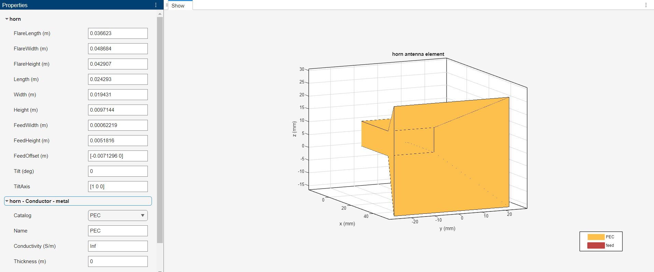
Figure 22 – Horn Design in MATLAB Antenna Designer

Helix Antenna
Figure 23 shows the Helix antenna properties and design.
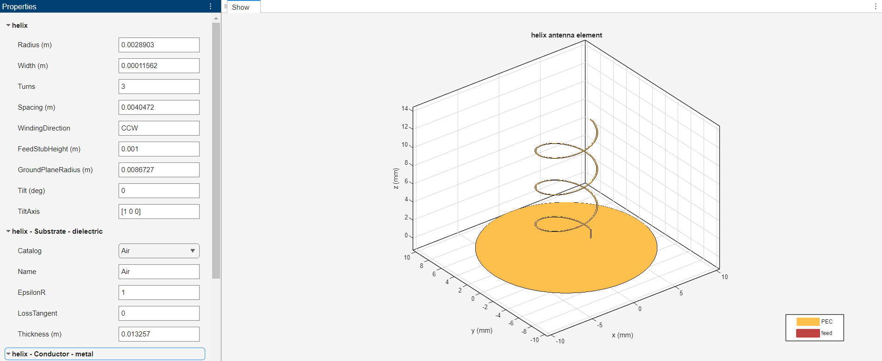
Figure 23 – Helix Design in MATLAB Antenna Designer

Antenna Simulation Results in MATLAB
For each of the antenna simulated using MATLAB antenna designer, details have been captured to verify and evaluate performance characteristics.

Cylindrical Dipole Antenna
Figure 24 shows the Cylindrical Dipole impedance characteristics.
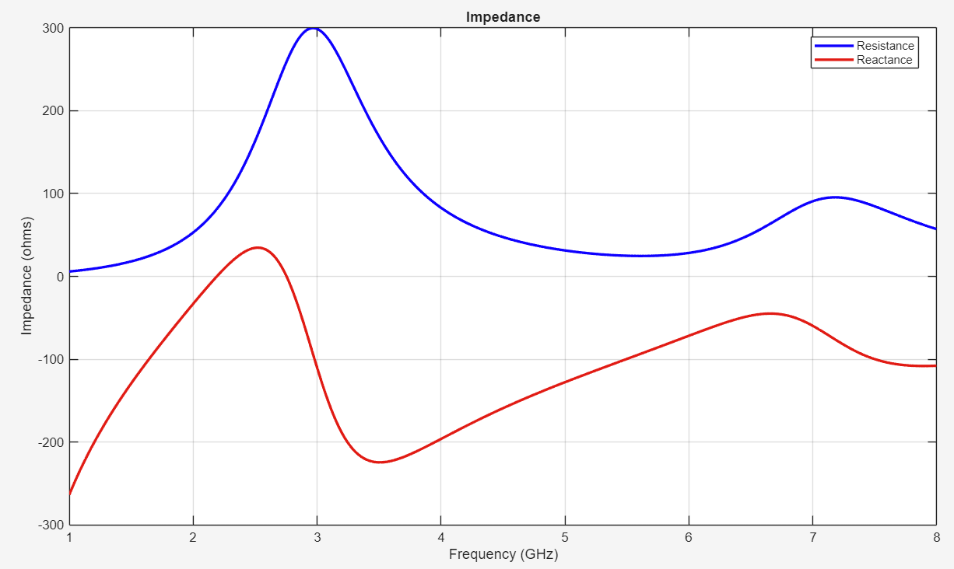
Figure 24 – Impedance Plot for Cylindrical Dipole Antenna
Figure 25 shows the Cylindrical Dipole S-parameter plot.
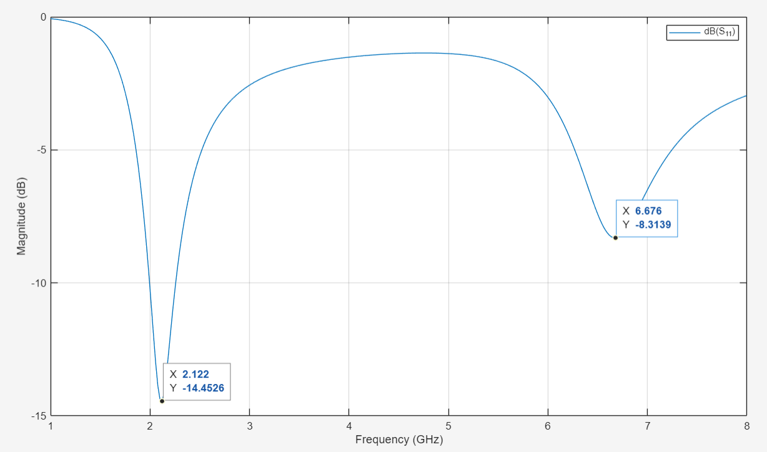
Figure 25 – S-Parameter Plot for Cylindrical Dipole Antenna
Figure 26 shows the 3-dimensional (3D) Radiation Pattern of the Cylindrical Dipole.
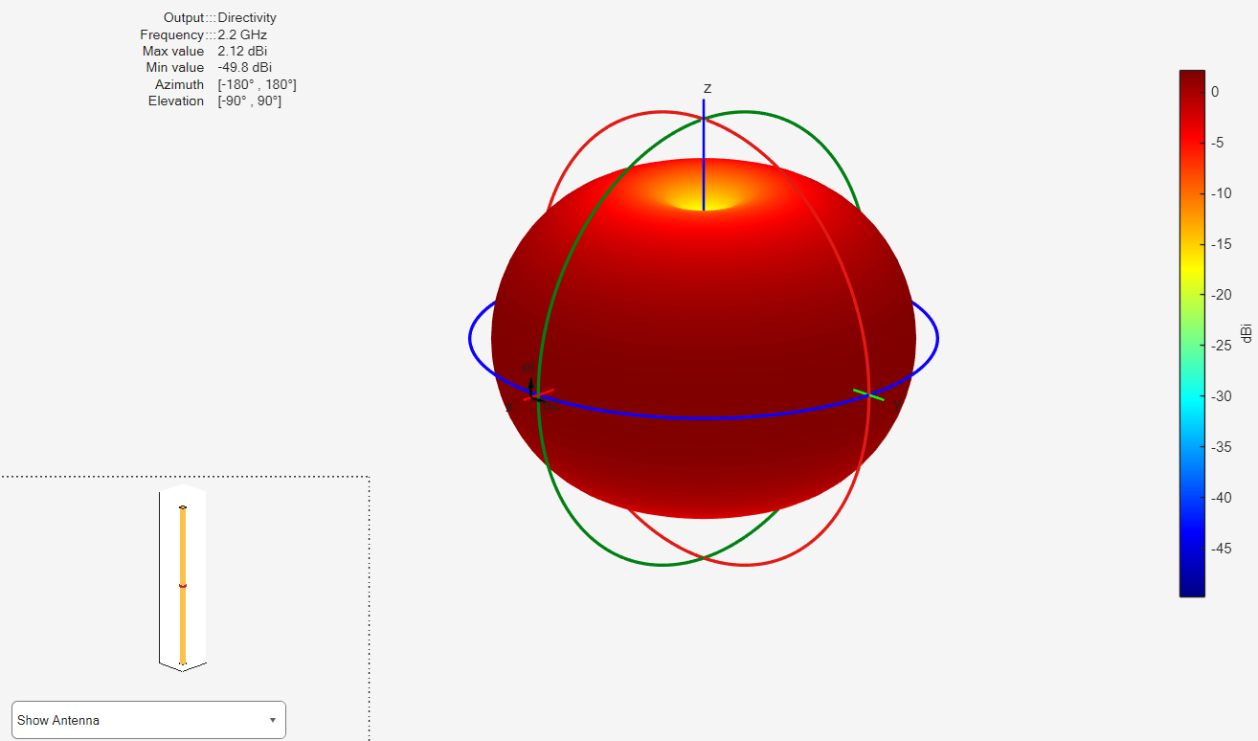
Figure 26 – 3D Radiation Plot for Cylindrical Dipole Antenna
Figure 27 shows the Azimuthal (H-plane) and Elevation (E-plane) polar plots for the Cylindrical Dipole.
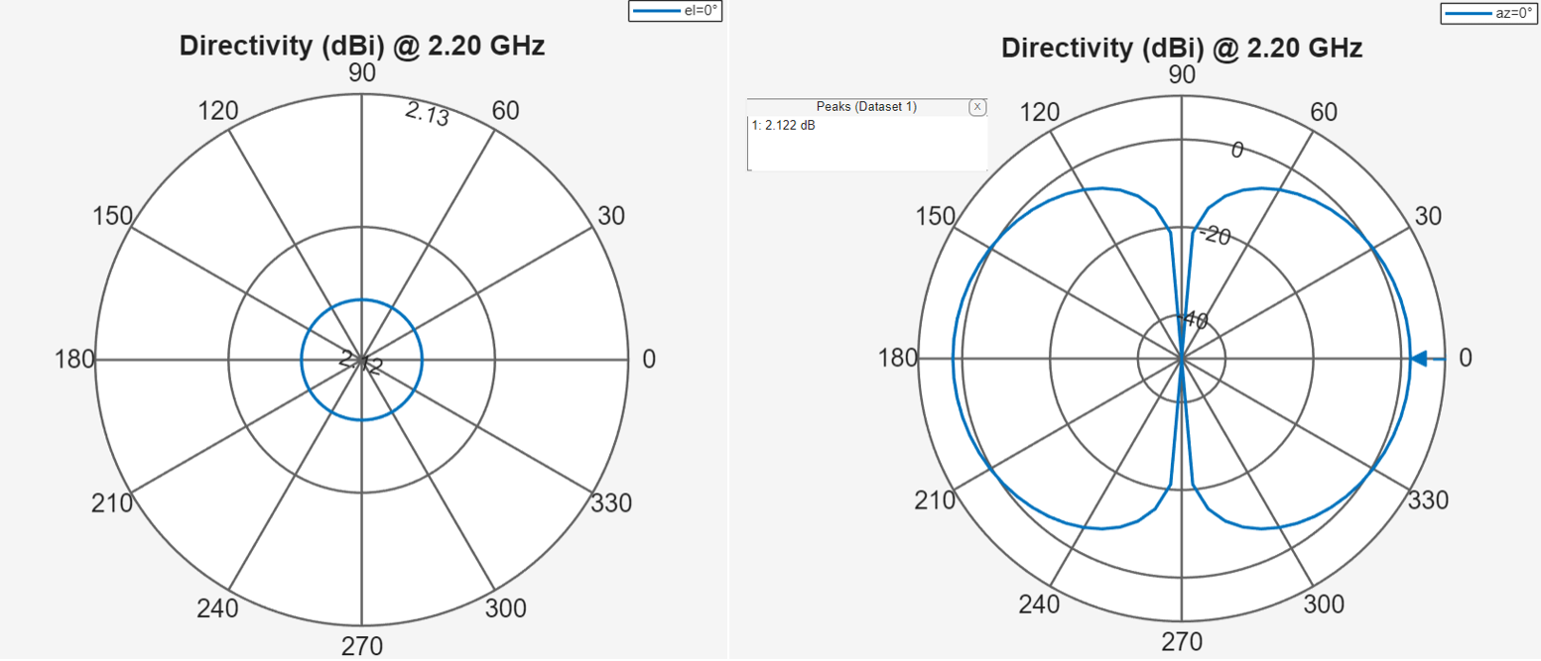
Figure 27 – 2D Azimuthal (left) and Elevation (right) Plots for Cylindrical Dipole Antenna

Folded Dipole Antenna
Figure 28 shows the Folded Dipole impedance characteristics.
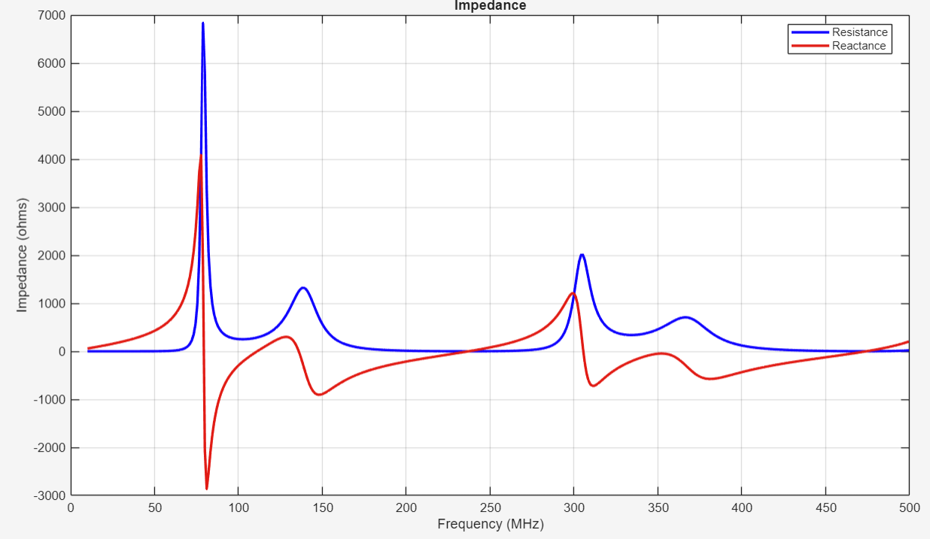
Figure 28 – Impedance Plot for Folded Dipole Antenna
Figure 29 shows the Folded Dipole S-parameter plot.
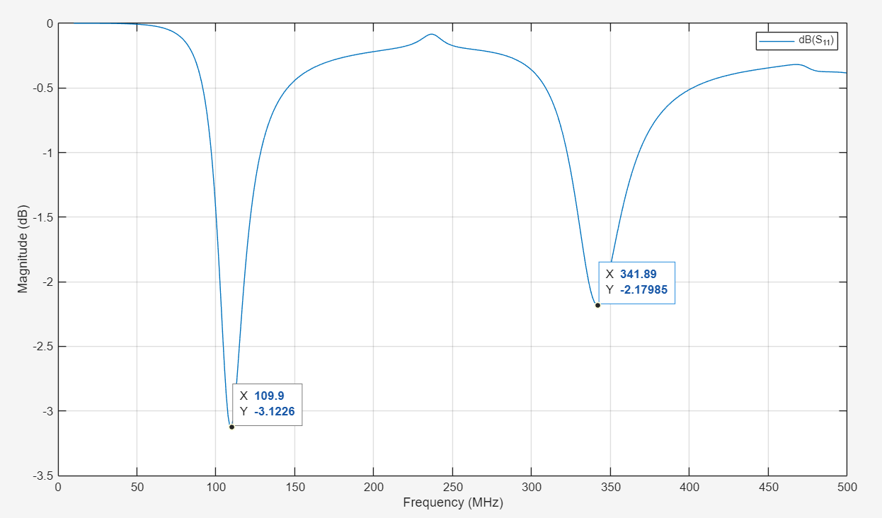
Figure 29 – S-Parameter Plot for Folded Dipole Antenna
Figure 30 shows the 3D Radiation Pattern of the Folded Dipole.
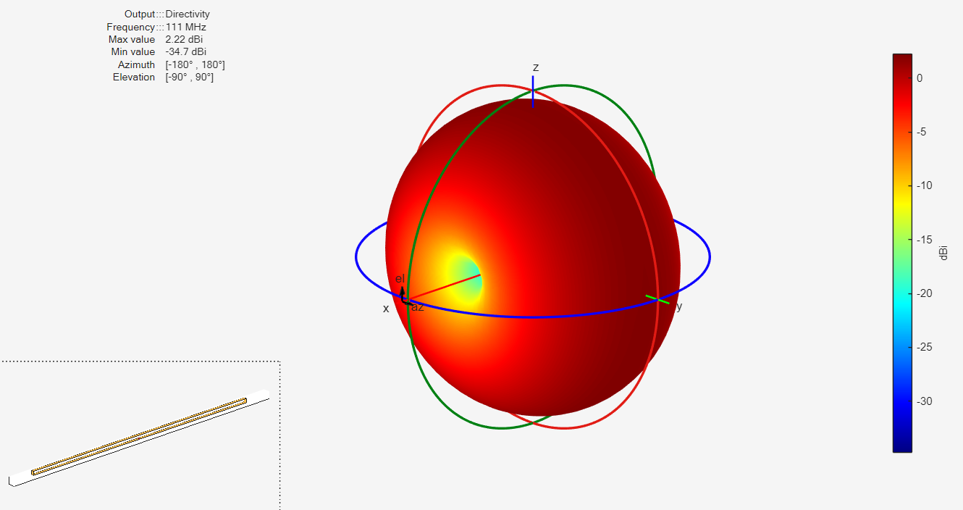
Figure 30 – 3D Radiation Plot for Folded Dipole Antenna
Figure 31 shows the Azimuthal and Elevation polar plots for the Folded Dipole.

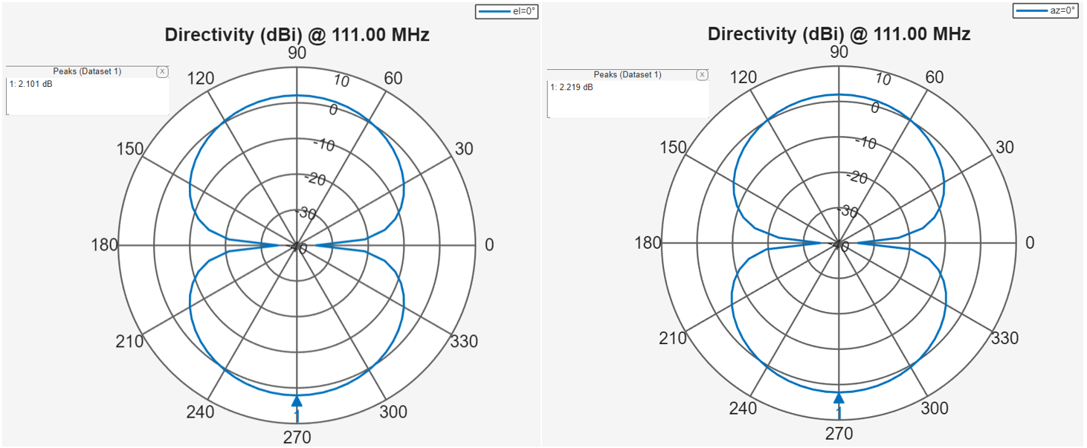
Figure 31 – 2D Azimuthal (left) and Elevation (right) Plots for Folded Dipole Antenna

Horn Antenna
Figure 32 shows the Horn antenna impedance characteristics.
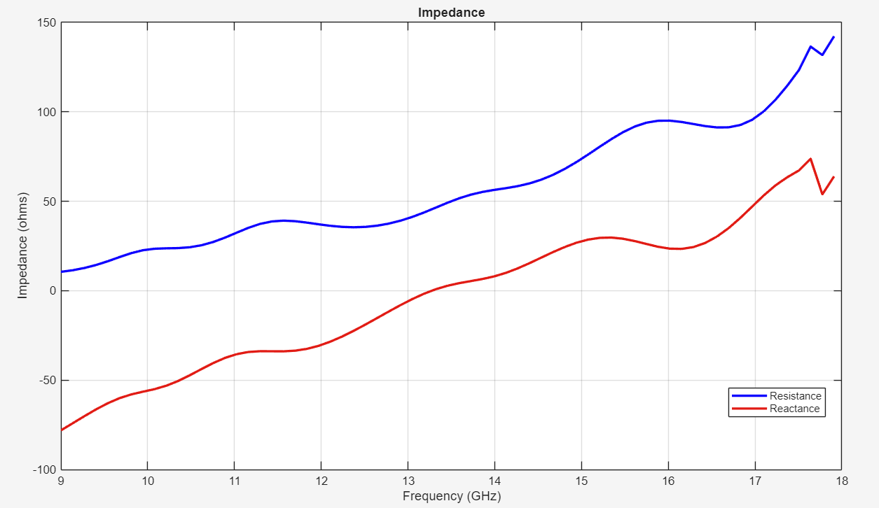
Figure 32 – Impedance Plot for Horn Antenna
Figure 33 shows the Horn antenna S-parameter plot.
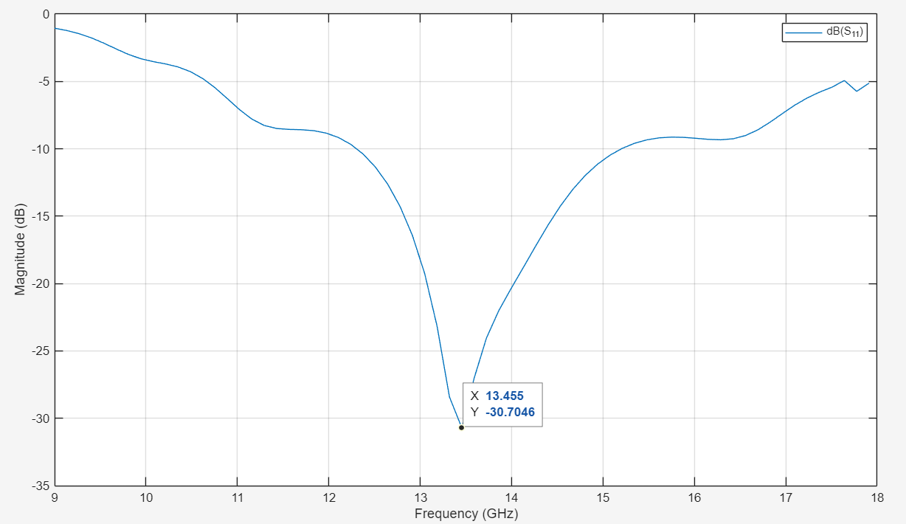
Figure 33 – S-Parameter Plot for Horn Antenna
Figure 34 shows the 3D Radiation Pattern of the Horn antenna.
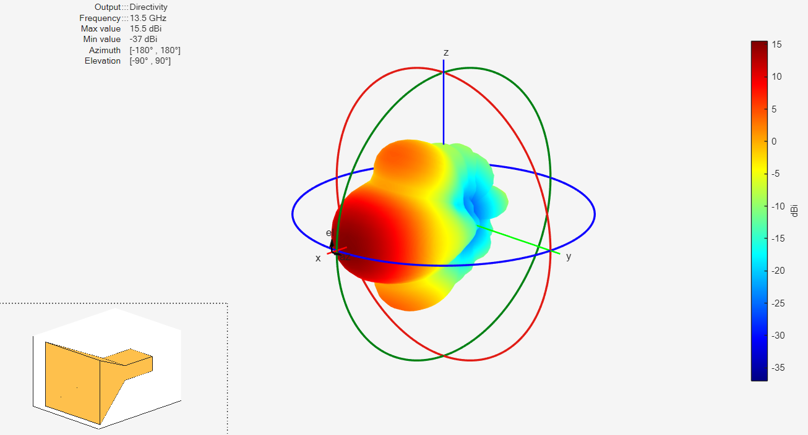
Figure 34 – 3D Radiation Plot for Horn Antenna
Figure 35 shows the Azimuthal and Elevation polar plots for the Horn antenna.

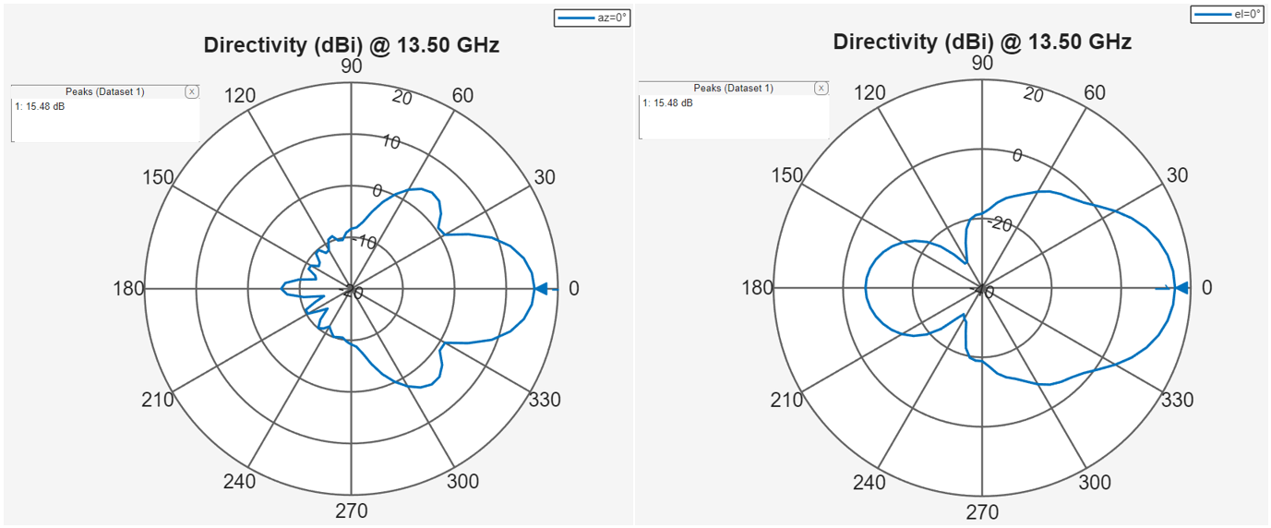
Figure 35 – 2D Azimuthal (left) and Elevation (right) Plots for Horn Antenna

Helix Antenna
Figure 36 shows the Helix antenna impedance characteristics.
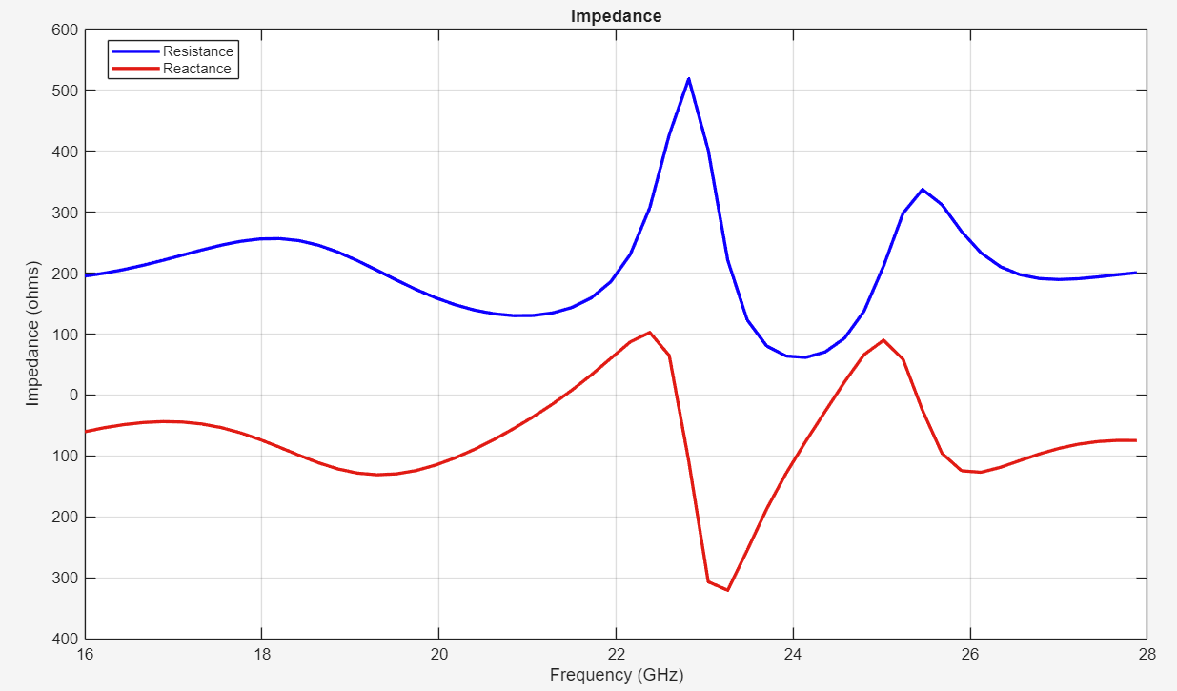
Figure 36 – Impedance Plot for Helix Antenna
Figure 37 shows the Helix antenna S-parameter plot.
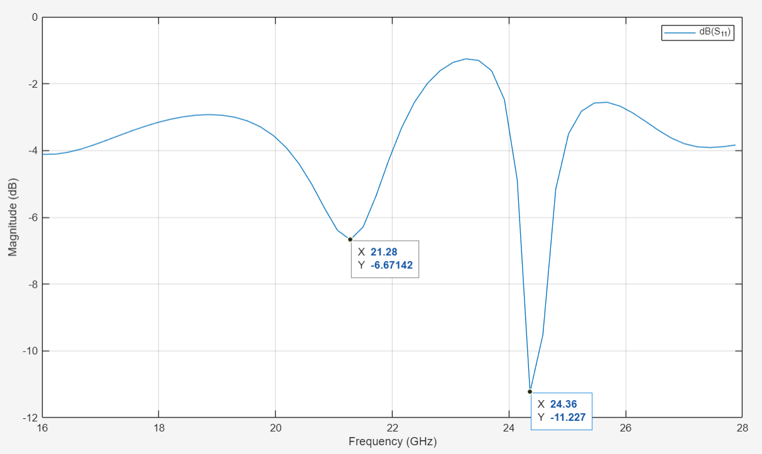
Figure 37 – S-Parameter Plot for Helix Antenna
Figure 38 shows the 3D Radiation Pattern of the Helix antenna.
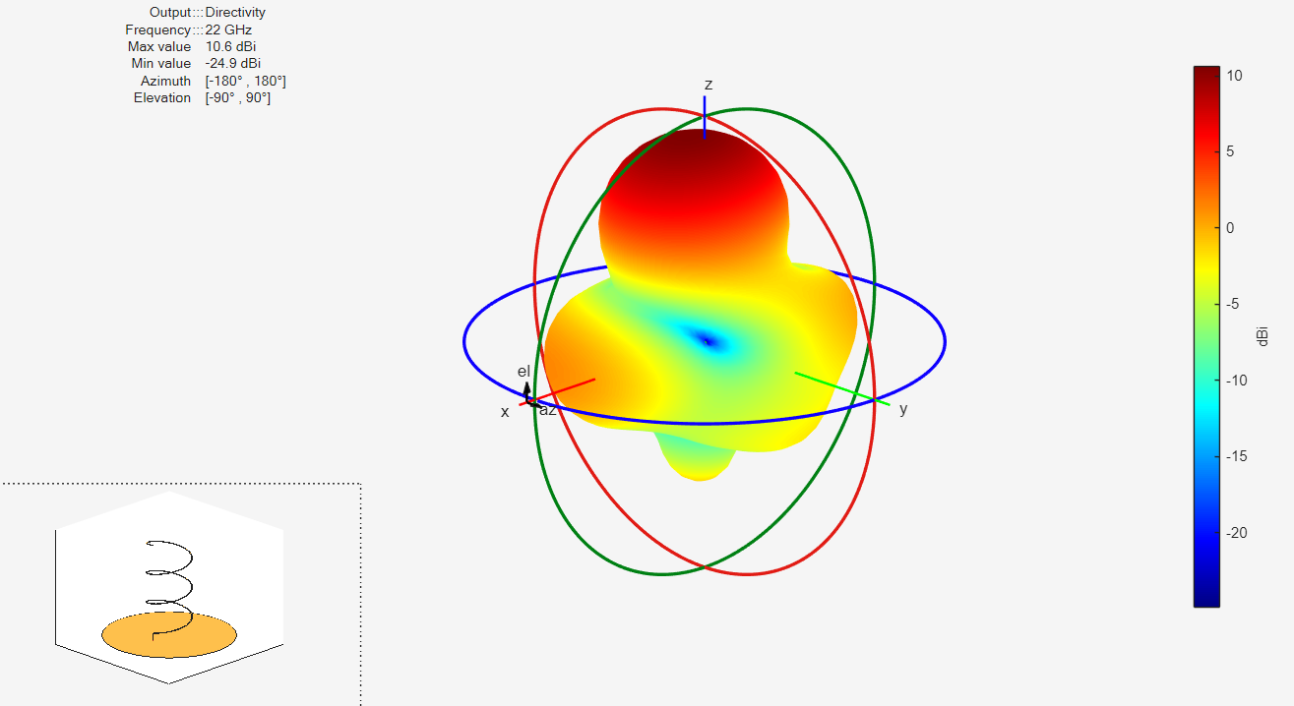
Figure 38 – 3D Radiation Plot for Helix Antenna
Figure 39 shows the Azimuthal and Elevation polar plots for the Helix antenna.
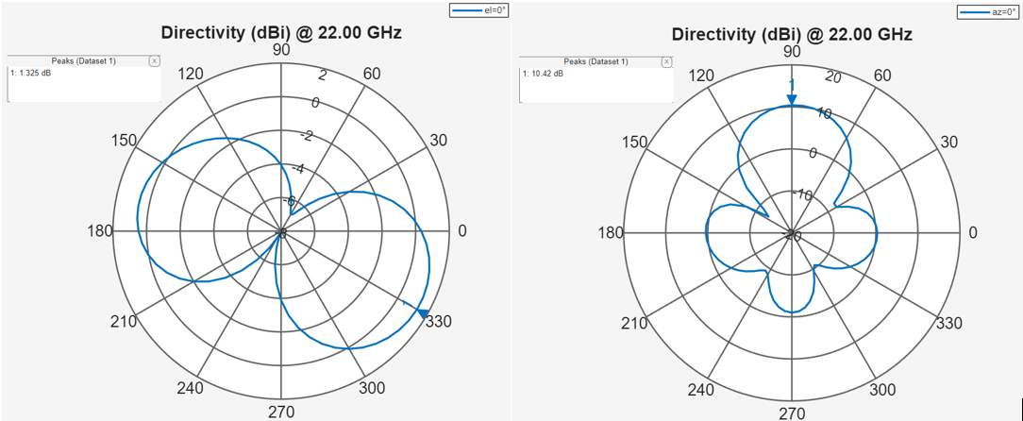
Figure 39 – 2D Azimuthal (left) and Elevation (right) Plots for Helix Antenna

Analysis of Antenna Performance

Operating Frequency
Table 1 displays the theoretical values calculated for resonant frequency of the antenna structures, compared with the values derived from the S-parameter plots in Figure 25, Figure 29, Figure 33 and Figure 37 respectively.
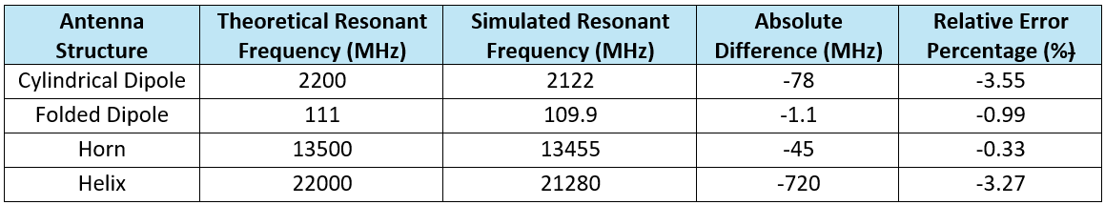Table 1 – Analysis of Resonant Frequencies [11]
Table 1 shows the simulated resonant frequency of each antenna. In evaluation, it has been observed that the theoretical values calculated were higher than that provided by the MATLAB antenna designer as simulation outputs.

How Impedance Matching Affects Antenna Performance
By analysing the impedance plots for the Cylindrical Dipole, Folded Dipole and Horn antennas, Figure 24, Figure 28 and Figure 32 respectively, we observe that reactance nears 0Ω and resistance nears 50Ω for the resonant frequencies shown in Table 1. This indicating good impedance matching. In contrast, Figure 36 shows the Helix Antenna has a higher resistive component, around 125Ω at its 21.28 GHz resonant frequency.
For perfectly matched antennas, feed impedance equals that of the transmission line and source, typically 50Ω or 75Ω, with a purely resistive characteristic and reactance at 0Ω [12]. This prevents inefficiencies like that from capacitive energy storage. Poor matching leads to signal reflections, reducing power transfer and causing standing waves, signal degradation, and distortion. This can be observed from the 3D radiation plots where impedance mismatching results in undesired side and back lobes, while polar plots show reduced gain and directionality. Higher SWR values, typically above 2, indicate worsened performance.

Antenna Choice
The MATLAB simulations for each antenna demonstrate that selection depends on specific application requirements, with key factors including Directivity, Beamwidth, Operating Bandwidth, and Efficiency.
Each antenna modelled exhibits unique directivity characteristics. Figure 26 and Figure 30 show the Cylindrical and Folded Dipole antennas have torus-shaped radiation patterns, indicating omnidirectional propagation characteristics. Figure 27 reveals the Cylindrical Dipole is linearly polarized in the Elevation Plane with nulls at 90⁰ and 270⁰, while Figure 31 shows the Folded Dipole is linearly polarized in the Azimuthal Plane with nulls at 0⁰ and 180⁰. These characteristics are suitable for IoT, wireless communication, and mobile applications.
Conversely, the Horn antenna is highly directional, with Figure 35 providing a Directivity of 15.48 dBi. Figure34 shows a strong main lobe in the Azimuthal Plane, with linear polarization. The S-parameter plot shows the resonant frequency of 13.445 GHz occurring when there is a high negative S₁₁ magnitude of -30.7 dB, indicating strong absorption and transmission, ensuring efficient energy transfer. These characteristics make Horn antennas suitable for satellite communications, radio astronomy, and radar.
From Figure 38 we can observe the Right-Hand Circularly Polarized (RHCP) propagation pattern exhibited by the Helix antenna. This is expected from its right-hand screw design. Its axial-mode operation focuses radiation along its vertical axis, appearing more polarized in the Elevation Plane. This behaviour aligns with its high-frequency design, operating at a 21.28 GHz resonant frequency.

Evaluation of Societal and Environmental Factors
When antennas are designed societal and environmental factors need to be considered to achieve compliance with regulations and make products more sustainable.
Antenna design must account for societal and environmental factors to ensure regulatory compliance and sustainability. Government guidelines, such as the Code of Practice for Wireless Network Development in England, aim to minimize disruption to wildlife and ecosystems, reducing environmental impact. For instance, when mobile network operators (MNOs) construct new infrastructure such as base stations. [13]
Spectrum management regulations require antennas to operate within approved frequency bands, as mandated by Ofcom under the 2003 Communications Act and 2006 Wireless Telegraphy Act, ensuring balanced spectrum use and mitigation of interference [14][15]. Additionally, systems must adhere to the International Commission on Non-Ionizing Radiation Protection (ICNIRP) guidelines, integrated into UK law, to maintain safe exposure limits [16].
Environmental factors include selecting materials that reduce reliance on non-renewable resources and hazardous substances. Designing with End-of-Life considerations improves recyclability, reducing Waste from Electrical and Electronic Equipment (WEEE) [17]. Energy-efficient antennas further enhance sustainability by lowering power consumption and minimizing resource wastage.

TASK 3

Helix Array Antenna Design
To construct and simulate a [3,3] Helix Array antenna operating frequency was determine using my student number of ‘2227990’:
Figure 40 – Operating Frequency Formula – Helix Array

Helix Array Design in MATLAB
Figure 41 shows the Helix Array Antenna design with a resonant frequency of 22 GHz.
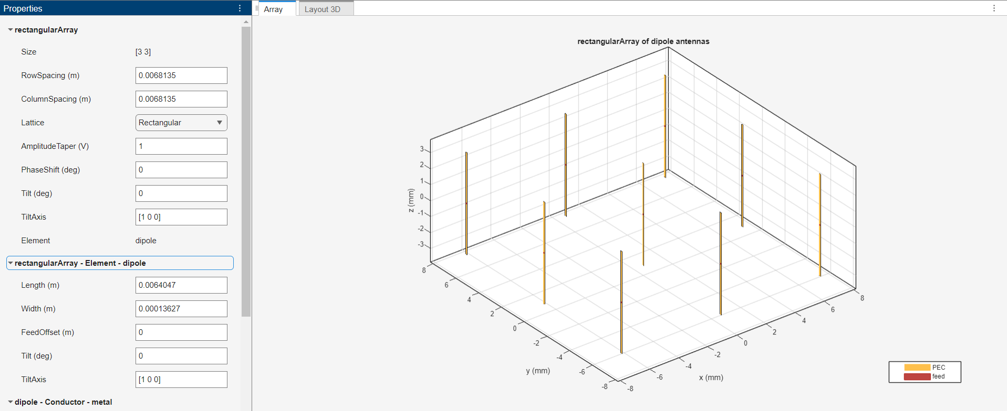
Figure 41 – Helix Array Design in MATLAB Antenna Array Designer

Helix Array Simulation Results in MATLAB
Details have been captured to verify and evaluate the performance characteristics of the Helix Array simulated using MATLAB antenna designer.
Figure 42 shows the Helix Arrays impedance characteristics.
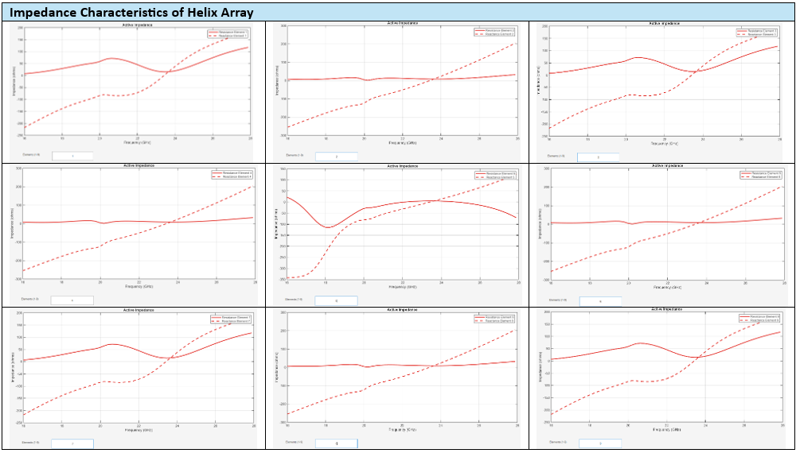
Figure 42 – Impedance Plots for Helix Array Elements
Figure 43 shows the Helix Arrays S-parameter plot.
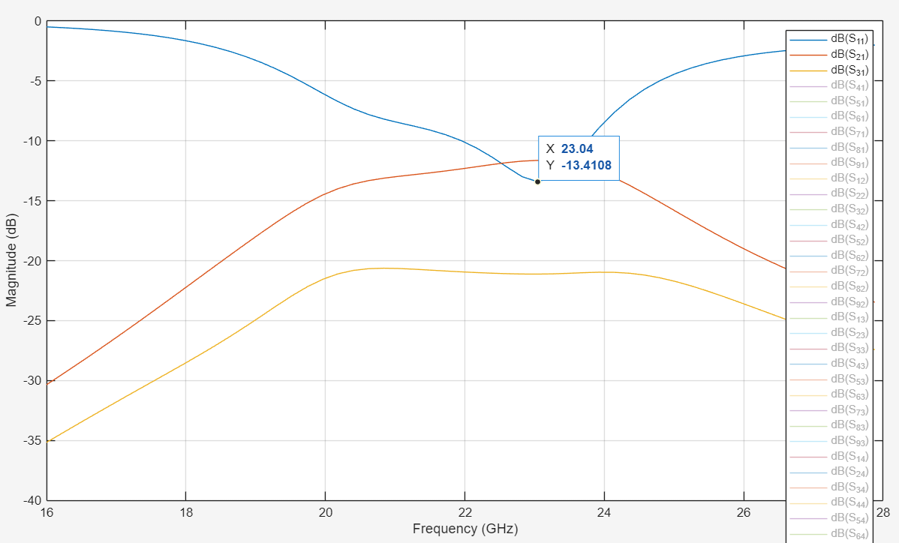
Figure 43 – S-Parameter Plot for Helix Array
Figure 44 shows the 3D Radiation Pattern of the Helix Array.

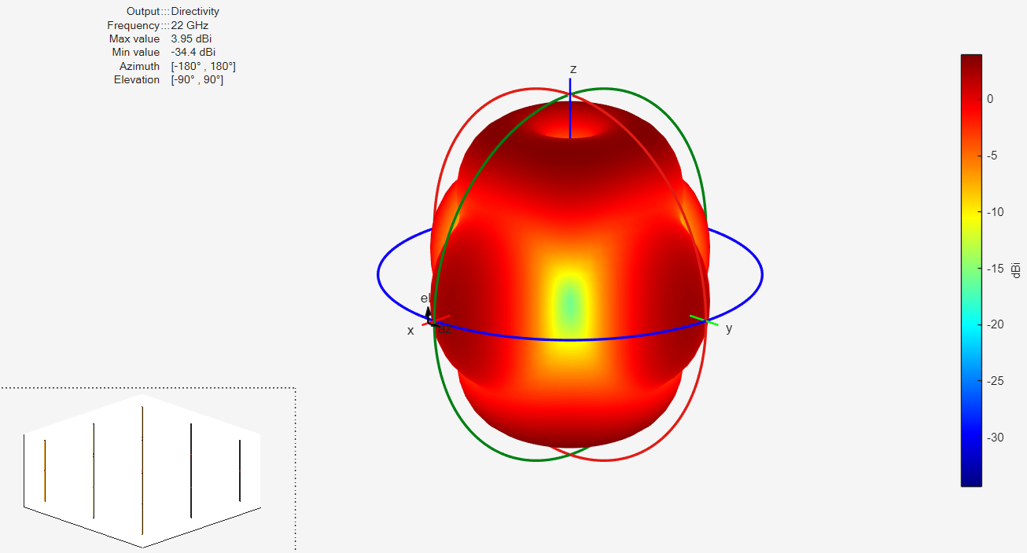
Figure 44 - 3D Radiation Plot for Helix Array
Figure 45 shows the Azimuthal and Elevation polar plots for the Helix Array.
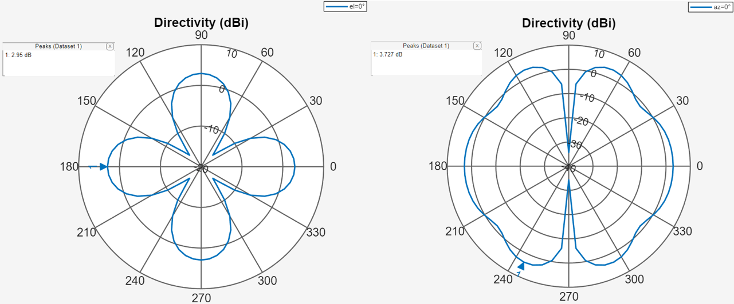
Figure 45 – 2D Azimuthal (left) and Elevation (right) Plots for Helix Array

Analysis of Helix Array Performance
When analysing the Helix Array performance, Figure 43 shows that the resonant frequency of the Helix Array is 23.04 GHz, being 1.04 GHz higher that of the theoretical resonant frequency. The Figure 45 plots shows that the Helix Array has narrow beam lobe, while exhibiting characteristics of circular polarisation. The 3D radiation plot in Figure 44 shows that Helix array Directivity of 3.95 dBi. This can be considered low for a Helix Array as they typically exhibit high directivity, often greater than 9dBi. This could be from poorly optimised spacing or the low amount of turns per helix element, as more turns correspond to increased directivity. [18] Therefore, in evaluation this antenna provides more effective propagation characteristics with design changes.

Benefits of using Array Antennas
Array antennas offer significant performance advantages in RF applications, providing higher directivity than single helix antennas, which enhances signal strength and efficiency in reception and transmission [19]. Unlike other designs, Arrays leverage digital signal processing and phase shifters for dynamic beam steering. Beamforming through constructive interference is valuable in radar and satellite communication, allowing target tracking over a broader horizon [11][20].
Beamforming and higher spatial resolution serve as a unique selling proposition for manufacturers, potentially increasing revenue. However, these arrays pose commercial challenges. Enhanced performance may come with cost asymmetry, as greater system complexity raises variable expenses and increases the likelihood of component failure (reduced robustness), necessitating more maintenance and system downtime. A thorough cost-benefit analysis is crucial to assessing the viability of this solution.

Conclusion
In this report it was determined that maximum power transfer occurs with good impedance matching, typically when antenna structures exhibit purely resistive characteristics. Specifically, when the resistive component equals the characteristic impedance and the reactive component is zero. This may be due to the capacitive and inductive properties of antennas; capacitance stores energy, while inductance causes phase shifting, leading to inefficiencies. These findings align with fundamental antenna theory. Additionally, all simulated resonant frequencies were higher than expected, except for the Helix Array antenna, likely due to modelling approximations, design choices, and material losses.

Future Recommendations
For further research, varying the mesh resolution in antenna designs could help analyse performance changes in simulations. Additionally, modelling with more realistic substrates and conductive materials instead of relying solely on Perfect Electrical Conductors (PEC) may improve accuracy. Physical testing in an RF chamber or Ramsey box could also provide more reliable data, addressing limitations of software simulations.

References
[1] Dassault Systemes, “CST STUDIO SUITE Learning Edition” in “3DExperience Edu”, Vélizy-Villacoublay, Paris: France, Apr. 2025, [Online] Available: https://www.3ds.com/edu/education/students/solutions/cst-le [accessed Apr 02. 2025]

[2] The MathWorks Inc, “R2023b Release Highlights - MATLAB and Simulink”, Massachusetts: United States, Sep. 2023, [Online] Available: https://uk.mathworks.com/products/new_products/release2023b.html [accessed Apr 05. 2025]

[3] Dr. M. Markovic, California State University Sacramento, “EEE 212 Modern Antenna Design Introduction to Patch Antenna Design and Simulations” in” Modern Antenna Design”, Sacramento, California: United States, Jan. 2020, [Online] Available: https://athena.ecs.csus.edu/~milica/EEE212/PROJ/Patch.pdf [accessed Apr 04. 2025] pp.5.

[4] H. Werfelli, K. Tayari, M. Chaoui, M. Lahiani, H. Ghariani, “III Design Rectangular Patch Antenna” in “Design of Rectangular Microstrip Patch Antenna”, Sfax: Tunisia, Mar. 2016, [Online] Available: https://www.researchgate.net/publication/305705158_Design_of_rectangular_microstrip_patch_antenna [accessed Apr 04. 2025]

[5] V. Kumar, Department of Engineering University of Cambridge, “Compact Patch Antenna for 2.4 GHz”, Cambridge: United Kingdom, 2017, [Online] Available: https://www.google.com/url?sa=t&source=web&rct=j&opi=89978449&url=https://www.repository.cam.ac.uk/bitstreams/4e04997a-da85-4b18-ab98-3204ca8da8f1/download&ved=2ahUKEwjnhN_K2byMAxUgbEEAHTkXBJYQFnoECBcQAQ&usg=AOvVaw2GO2qVefMiRyCh96JC0aMX [accessed Apr 03. 2025]

[6] M. S. Rabbani and H. Ghafouri-Shiraz, “Improvement of microstrip patch antenna gain and bandwidth at 60 GHz and X bands for wireless applications,” IET Microwaves, Antennas & Propagation, Aug. 2016, [Online] Available: https://doi.org/10.1049/iet-map.2015.0672 [accessed Apr 03. 2025] pp. 1167–1173

[7] Analog Devices Inc, “Voltage Standing Wave Ratio Definition and Formula”, Massachusetts: United States, Nov. 2012, [Online] Available: https://www.analog.com/en/resources/technical-articles/voltage-standing-wave-ratio-definition-and-formula.html [accessed May 05. 2025]

[8] A H Systems Inc, “Understanding Antenna Gain, Beamwidth, And Directivity”, California: United States, 2018, [Online] Available: https://www.ahsystems.com/articles/Understanding%20Antenna%20Gain,%20Beamwidth,%20And%20Directivity.pdf [accessed May 05. 2025]

[9] B. Kamo, S. Cakaj, V. Koliçi, E. Mulla, “Simulation and Measurements of VSWR for Microwave Communication Systems”, Tirana: Albania, Oct. 2012, [Online] Available: https://www.academia.edu/30647245/Simulation_and_Measurements_of_VSWR_for_Microwave_Communication_Systems [accessed May 05. 2025]

[10] M. Steer, North Carolina State University, “9.2: Q Factor” in “Fundamentals of Microwave and RF Design”, North Carolina: United States, Sept. 2019, [Online] Available: https://eng.libretexts.org/Bookshelves/Electrical_Engineering/Electronics/Book%3A_Fundamentals_of_Microwave_and_RF_Design_%28Steer%29/09%3A_Passive_Components/9.02%3A_Q_Factor [accessed May 05. 2025]

[11] C. Balanis, “Antenna Theory Analysis and Design (3rd. Edition)” John Wiley & Sons Inc, San Francisco: United States, Dec. 2015 [Online] Available: https://archive.org/details/Antenna.Theory.Analysis.and.Design3rd.Edition/page/n595/mode/2up [accessed May 05. 2025]

[12] C. Alexander, M. Sadiku, "Fundamentals of Electric Circuits – 5th Edition", Jun. 2022 [Online] Available: https://drive.google.com/file/d/0B1qRCmHVK0QYX0wza2ZkenBWV0U/view?resourcekey=0-Gg_WGIj4HgoQaZjmoh3nAg [accessed May 06. 2025]

[13] Department for Digital, Culture, Media and Sport (DCMS), “Policy paper: Code of practice for wireless network development in England”, London: England, Mar. 2022, [Online] Available: https://www.gov.uk/government/publications/code-of-practice-for-wireless-network-development-in-england/code-of-practice-for-wireless-network-development-in-england [accessed May 05. 2025]

[14] Office for Communication, “Rules on using radio equipment”, London: England, Jul. 2023, [Online] Available: https://www.ofcom.org.uk/spectrum/radio-equipment/radio-spectrum-and-the-law [accessed May 05. 2025]
[15] Department for Science, Innovation & Technology (DSIT), “Policy paper: Spectrum statement”, London: England, Apr. 2023, [Online] Available: https://www.gov.uk/government/publications/spectrum-statement/spectrum-statement [accessed May 05. 2025]

[16] Health and Safety Executive, “The Control of Electromagnetic Fields at Work Regulations (CEMFAW)”, Merseyside: England, May. 2016, [Online] Available: https://www.hse.gov.uk/radiation/nonionising/emf-regulations.htm [accessed May 05. 2025]

[17] European Commission, “Waste from Electrical and Electronic Equipment (WEEE)”, Brussels: Belgium, Mar. 2022, [Online] Available: https://environment.ec.europa.eu/topics/waste-and-recycling/waste-electrical-and-electronic-equipment-weee_en [accessed May 05. 2025]

[18] R. Koshti, S. Yadav, S. Sharma, “Performance Analysis of Helical Antenna for Different Physical
Structure”, Mumbai: India, 2018, [Online] Available: https://www.arcjournals.org/pdfs/ijirec/v5-i4/4.pdf [accessed May 06. 2025]

[19] RF Wireless World, “Helical Antenna: Advantages and Disadvantages”, 2025, [Online] Available: https://www.rfwireless-world.com/terminology/antenna-terms/helical-antenna-advantages-disadvantages [accessed May 06. 2025]

[20] The MathWorks Inc, “Helical Antenna Design” in “MATLAB R2024b”, Massachusetts: United States, Sep. 2024, [Online] Available: https://uk.mathworks.com/help/antenna/ug/helical-antenna-design.html [accessed May 06. 2025]

