Revision questions.

- Label the following diagram
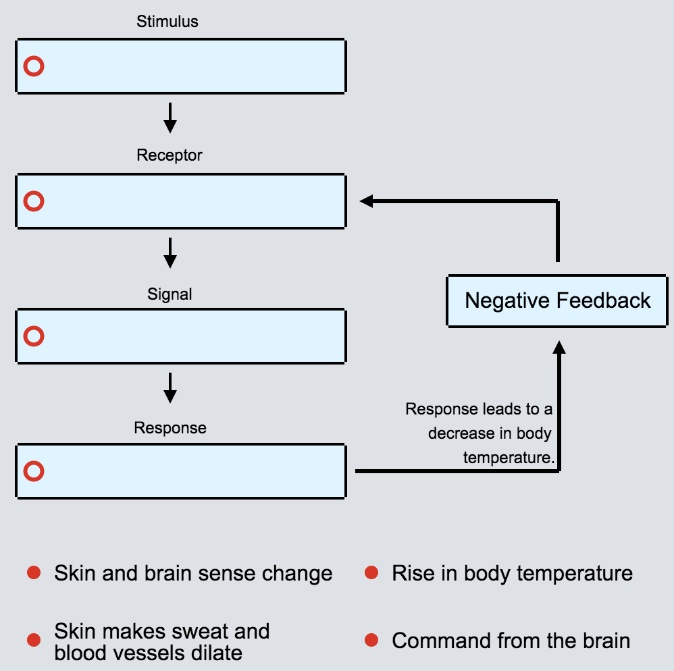

- Describe how the body maintains blood glucose levels ( 15 marks.)

- Label the following diagram.
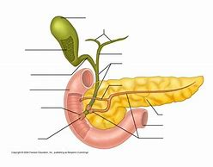

- Define homeostasis
- What should normal blood sugars be.
- Glucose is a simple sugar that is used as energy by your body and brain. Which hormone would be called into action if there was too much glucose in the blood?
- Insulin is released by what type of cells in the pancreas?
- Insulin promotes the following processes in the liver?
  - Glycogenesis
  - Glycogenolysis
  - Gluconeogensis
  - Gycolysis
- Fatty acids in the liver are transformed to glucose through gluconeogenesis?
  - True
  - False
- Label the following diagram
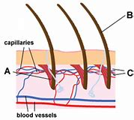

- How is thermoregulation an example of negative feedback?
- Describe thermoregulation ( 10 marks)

- Where are the temperature receptors found?
- Information about skin temperature is sent to the brain by?
- Which process cools the skin during sweating?
- The part of the brain which is involved with temperature control is called ?
- What is the normal core body temperature of humans?
- 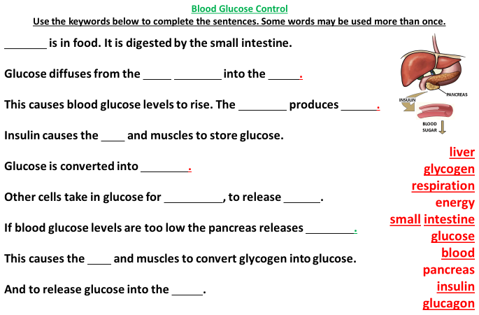

Our bodies have to keep three important matters balanced, they are:
- ______________________________________
- ______________________________________
- ______________________________________

Too hot/ Too cold!
Explain what happens to your body when you get too hot: __________________________________________________________________________________________________________________________________________________ _________________________________________________________________________
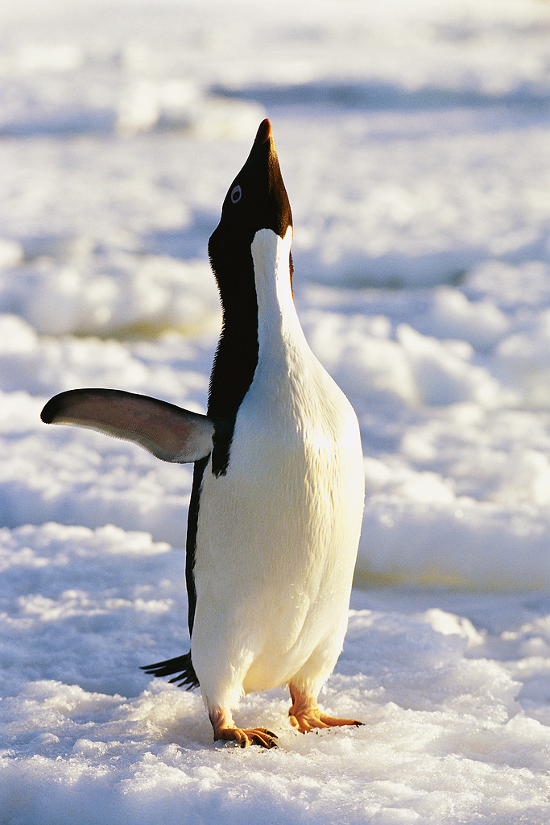
Explain what happens to your body when you get too cold: _________________________________________________________________________________________________________________________________________________________________________________________________________________________________

Fill in the gaps

Too Hot
Sweating, hairs lie flat, and increased blood flow to the skin leads to a ___________ in temperature

_____________________
in temperature

Negative
feedback

Core temperature Core temperature
_______ ⁰C _______ ⁰C

_____________________
In temperature
Shivering, hairs stand on end and decreased blood flow to the skin leads to an ___________ in temperature

Too Cold
How can the core body temperature be measured?
__________________________________________________________________________________________________________________________________________________________________________________________

Describe how the body maintains its fluid levels?

What is the role of the kidneys in balancing fluid levels in the body?

Describe how the body maintains it’s Ph levels.

Describe how the body maintains blood pressure if it is too low.

When there is too little water in the body, a sequence of events occurs. Fill in the missing words to complete the process:
Too little water in blood.
Detected by___(i)___.
More___(ii)___ released into blood by the ___(iii)___.
___(iv)___ reabsorbs more water.
Less ___(v)___ produced.
Blood water level not reduced further.

Humans use the nervous system to react to changes in the environment.
Which word means a change in the environment?
- Neuron
- Reflex
- Stimulus
Discuss how the structure of the kidney is related to (1) salt and water balancing (Osmoregulation) and (2) excretion.
Discuss the role of antidiuretic hormone (ADH) in Osmoregulation
Discuss how carbon dioxide levels are controlled in the blood.
What detects a change in water potential in the body.
Draw a flow chart to show osmoregulation.
Draw a flow chart to show glucose regulation
Draw a flow chart to show thermoregulation
Discuss how the body maintains the bodies blood pressure.
Discuss the role of the renin aldosterone system

