Title: Changemakers: Creativity and Value Creation
Student Name: Rakhmat Ulhaq
Student ID: 1918756
Module code: BMHP5014_BIRM
Assignment section: Part 1
Lecturer’s name: Dr Azora Hurd

Task 1
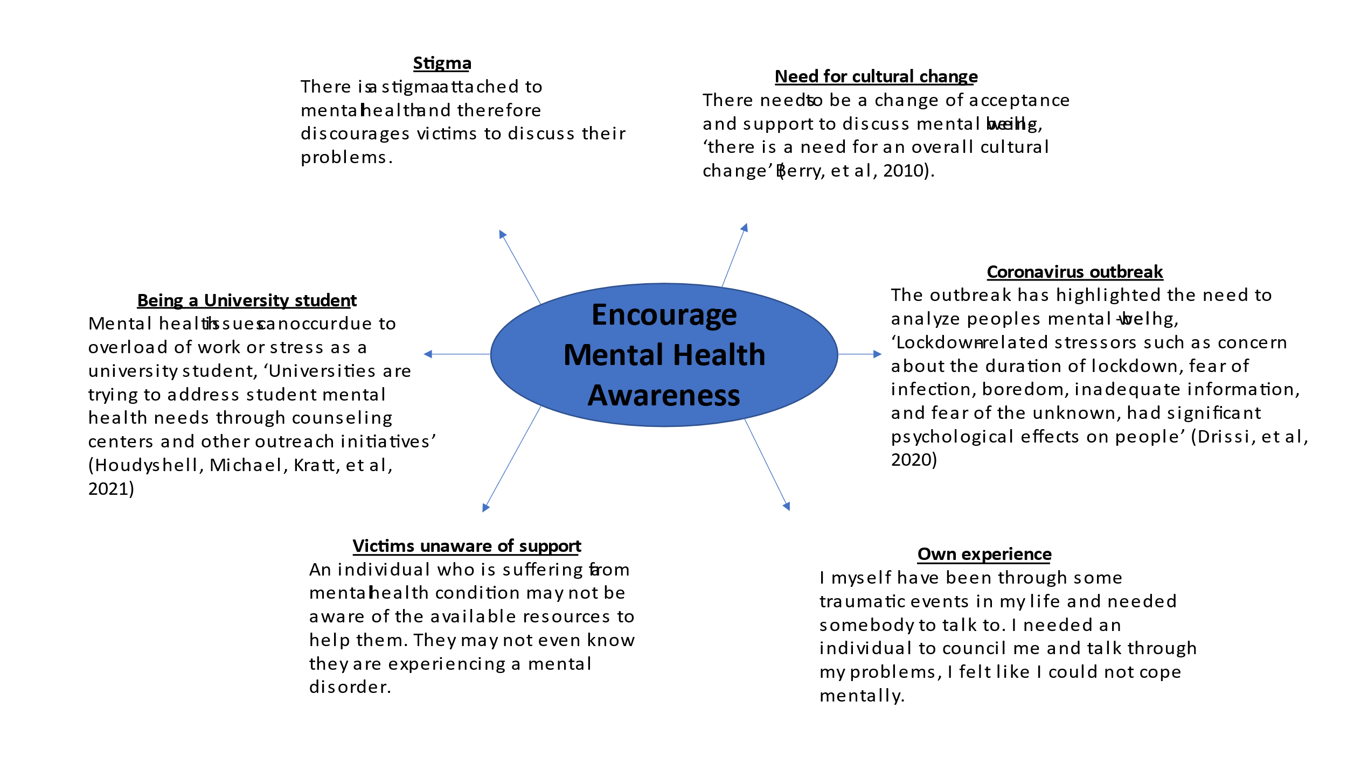
There is a lack of Mental Health Awareness globally and it is ‘well recognised as a significant public health issue and has been predicted to be a major contributor to the global burden of disease’ (Lock, et al, 2002. ‘A mental health condition or issue is one that can negatively impact academic performance, social interactions, or overall general well-being’ (Houdyshell, et al, 2021). Mental health ranges from high to low mental disorders. Iit can be as a minimum of depression or being overwhelmed or overworked. A positive mental well-being is essential for every individual and I recignise the importance of this. However, people are too afraid to discuss issues or eopn up about their problems due to the stigma which is attached to it. Victims of mental health avoid services and to not seek treatment due to the consequences of negative stigma and label of mental illness (Taghva, Arsia et al, 2017). It is important to understand that mental health does not mean an individual has a mental illness. Mental health is one form of lightening your chest and discussing internal isses which one may not be able to resolve themselves. It can be a form of counselling.
The coronovirus outbreak has allowed me to think about this project and encourage mental health awareness. Lockdown has had negative impacts on people, such as pchological effects, which have led to negative menta health implications for people. The idea was heightned in this climate, where I realised there was a lack of proffessional services for people to discuss their issues. Alongside this, victims of mental health might not know they have a mental health issue or may be too afraid to discuss this or even there may be a lack of proffessional support for them. ‘Many members of the public are ignorant about what they can do for prevention, people commonly delay or avoid seeking treatment and view recommended treatments with suspicion, and they are unsure how to assist others with mental disorders’ (Jorm, 2012). In order to get support the person needs to know about the proffessional services that are available to help and support them.
There needs to be a cultural change to mental health and needs to be looked at with an open mind avoiding all the negativity from the general public and victims who experience problems. I feel passionate about this project, as I myself was in a stage where I could not help myself, I needed an individual to talk to and counsel and guide me through my problems, therefore I know the importance of this. Finally, being a university student has highlighted this project more for me, as I acknowledge workload creates depression and these topics need to be discussed also for students.

Task 2
Summary of idea
Mental health awareness is key in todays society, especially after the Coronoavirus lockdown. Climates like these allow us to acknowledge the importance of positive mental well-being and the need for individuals to discuss and about any internal mental issues they are facing. It is reported that mental health affects ‘ 10-20% of children and adolescents worldwide’, (Kieling, et al, 2011). These are recorded, however I feel there is many more cases that are not documented and victims are not coming forward to seek help and support. It is noted that the ‘mental health needs of children and adolescents are neglected’ (Kieling, et al, 2011). Thus, it has added value and becomes more important to discuss today. Although, there is more enphasis on mental health ‘there has been increased attention to mental health and illness in the lay public discourse, particularly in the last decade’ (Mitha, Karim, 2020). There is still wide gap with victims of mental health coming forward due to the above reasons within the mindmap.
Mental health needs to be promoted, it should be fully intergrated into other health coverage and into the global response to other health prorities, the barriers and threats to mental health need to be addressed (Patel, et al, 2018). Mental health needs a bigger space in the global world, governments should try to include mental health within health policies in each country to highlight the significance and normalise the term within different societies. Investment and innovation should be carried out on new research facilities and growth for mental health. Investment should also be implemented on mental health programmes to support a range of individuals on their different problems. Further innovation is neccessry on programmes for mental health and facilities to support with their needs as ‘there is no treatment for their condition due to the limited access to mental health care facilities; the reduced availability of clinicians; the lack of awareness; and stigma, neglect, and discrimination surrounding mental disorders’ (Ramírez-Cifuentes, et al, 2020). Thus, mental health needs to be normaised within society.

Task 5
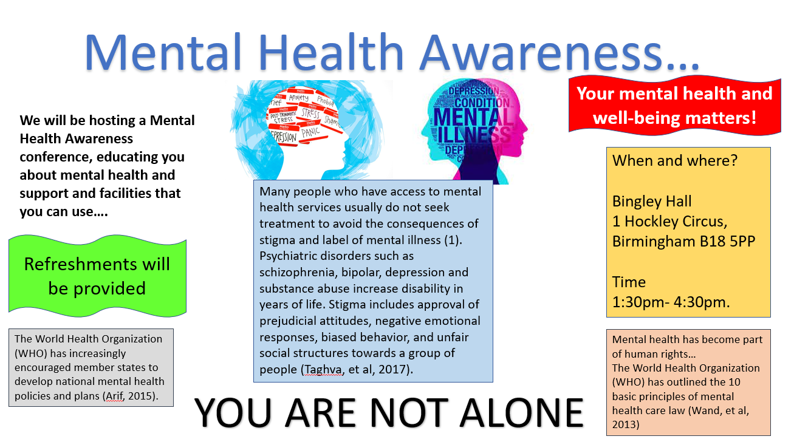

Task 6
Dear Mr Smith,
RE: Support for Mental Health Awareness Campaign
I am writing to you to ask support for my campaign on raising mental health awareness. I am intending to carry out a conference inviting the social public of all ages, from all backgrounds to learn more about Mental Health and spread awareness by normsalising the term. I intend to inform the general public about the different mental health conditions and the support that is available to them. I would like to invite victims of mental health to share their stories and experience and also discuss my own story. I will also invite Mental Health organisations who can explain their services to the people. I would need aid and assistance with funding for the venue and refreseahsments, etc to make it a pleasant event for the people.
Positive mental health is imperative for every individual and some may not recognise their condition. This conference will aid people to recognise any conditions or provide them with symptons of mental health they may experience. ‘Mental health should be included in all intiatives, programmes, and recommendations for standard care’ (Watson, et al, 2019).
Unfortunately, there is a lack of awareness in regards to mental health and lack of training and support to facilitate the remedies for mental health. ‘There is a lack of mental health awareness, education and training for all’ (Houdyshell, et al, 2011). Barriers need to be removed and there needs to be effective communication and increasing mental health literacy. There is a lack of mental health advocay groups and a lack of local research which acts as a barrier (Arif, 2015). A ‘wide range of stakeholders are needed within and beyond health’(Patel, et al, 2018) to embrace mental health and increase openness about the topic. I need you to be a stakeholder within this project and create a positive impact for generations to come. I need financial aid to support this beneficial and educational conference to teach people that it is okay to have these different issues.
Finally, there needs to be a cultural change within the globe, there is a need for ‘cultural competencey and an awareness of cultural approaches to mental health and illness within ethinic minority communities’ (Mitha, Karim, 2020) also. Mental health needs to be open in all communities and all different contexts and countries. There is a need for mental health to be as transparent as possible.
I plan to offer mental health services to the people to those who register with the services after the conference, and I plan to create further awareness in the future, as more people come forward. ‘In the UK, the governement has set out policies and action plans to promote mental well-being’ (Memon, et al, 2016). I will work alongside governement agencies to offer support services to individuals.
I need you support to make the world a more open and safe place where we can discuss our internal issues without being judged and labelled.
Yours sincerily,
Rakhmat Ulhaq

References
Berry, C et al., 2010. Expectations and illusions: a position paper on the relationship between mental health practitioners and social exclusion. Journal of psychiatric and mental health nursing, 17(5), pp.411–421.
Christian Kieling, Helen Baker-Henningham, Myron Belfer, Gabriella Conti, Ilgi Ertem, Olayinka Omigbodun, Luis Augusto Rohde, Shoba Srinath, Nurper Ulkuer, & Atif Rahman. (2011). Global Mental Health 2: Child and adolescent mental health worldwide: evidence for action. The Lancet (British Edition), 378(9801), 1515.
Drissi, Nidal et al., 2020. Investigating the Impact of COVID-19 Lockdown on the Psychological Health of University Students and Their Attitudes Toward Mobile Mental Health Solutions: Two-Part Questionnaire Study. JMIR formative research, 4(10), p.e19876.
Houdyshell, Michael, Kratt, Diane & Greene, Jackie, 2021. Student Teachers with Mental Health Conditions Share Barriers to Success: A Case Study. Qualitative report, 26(1), pp.1–26.
Jorm, A. F. (2012) ‘Mental health literacy: Empowering the community to take action for better mental health’, American Psychologist, 67(3), pp. 231–243. doi: 10.1037/a0025957.
Lock, C et al., 2002. Headroom : promoting the mental health of young people : a multimedia approach. Youth studies Australia, 21(2), pp.31–35.
Memon, Anjum et al., 2016. Perceived barriers to accessing mental health services among black and minority ethnic (BME) communities: a qualitative study in Southeast England. BMJ open, 6(11), p.e012337.
Mitha, Karim, 2020. Conceptualising and addressing mental disorders amongst Muslim communities: Approaches from the Islamic Golden Age. Transcultural psychiatry, 57(6), pp.763–774
Mohamed, Arif, 2015. Resuscitating the National Mental Health Policy in the Maldives. Australasian psychiatry : bulletin of the Royal Australian and New Zealand College of Psychiatrists, 23(6_suppl), pp.26–28.
Patel, Vikram et al., 2018. The Lancet Commission on global mental health and sustainable development. The Lancet (British edition), 392(10157), pp.1553–1598
Taghva, Arsia et al., 2017. Stigma Barriers of Mental Health in Iran: A Qualitative Study by Stakeholders of Mental Health. Iranian journal of psychiatry, 12(3), pp.163–171.
Ramírez-Cifuentes, Diana et al., 2020. Detection of Suicidal Ideation on Social Media: Multimodal, Relational, and Behavioral Analysis. Journal of medical Internet research, 22(7), p.e17758.
Wand, Anne & Wand, Timothy, 2013. ‘Admit voluntary, schedule if tries to leave’: placing Mental Health Acts in the context of mental health law and human rights. Australasian psychiatry : bulletin of the Royal Australian and New Zealand College of Psychiatrists, 21(2), pp.137–140.
Watson, Helen et al., 2019. A systematic review of ethnic minority women's experiences of perinatal mental health conditions and services in Europe. PloS one, 14(1), p.e0210587.

