Synthesize a solution to a potential real life scenario
Author: Dylan Thomas (2014801)
Network and Cyber Secrity Essentials (ACCA4024)
School of Applied Computing
Wales Institute of Science and Art
07/01/21 Date and Time of Submission

Abstract
This assignment looks at various threats to a network, and actions that can be taken by the organisation in order to prevent and deter potential cyber-attacks. Included is an implementation of network scanning via wireshark, which is one of many ways criminals can access network information.

Table of Contents

- Introduction………………………………………………………………………………………………………………….Page 4
- Related Work
2.1 Different Networks………………………………………………………………………………………………………..Page 4
2.2 Different Attacks and Threats to a Network…………………………………………………………………..Page 4
2.3 Mitigating tools, methods, policies to mitigate………………………………………………………………Page 5
- Design + Implementation
3.1 Che-Si’s Weak Points……………………………………………………………………………………………………..Page 7
3.2 Implementation of Wireshark Sniffing………………………………………………………………………….Page 7
3.3 Outcome of My Implementation……………………………………………………………………………….…..Page 7

- My Recommendations
  - Importance of Strategies, policies, and following policies …………………………………………….Page 7
  - Digital Signatures and Data Encryption……………………………………………………………….…….....Page 8
  - Conclusion and Recommendations………………………………………………………………….….………..Page 8
4.4 Annexure – Wireshark Implementation Screenshots.…………………………………………..…….Page 11

- Bibliography....................................................................................................................Page 14

- Figures.............................................................................................................................Page 16

- Glossary...........................................................................................................................Page 17

The purpose of a network is transporting information by establishing communication between two hosts, those hosts in this case being the stakeholders who need access from anywhere via any device. Che-Si just like any other 21st century organisation operates worldwide; not confined to a single location nor a single country. Due to the multitude of countries it operates in, its Network needs to be available 24/7. Having a network this open means Che-Si are leaving themselves open to their stakeholders/users, and to everyone and anyone including those with negative intentions that could take advantage of cyber security shortcomings.

2.1
Typically, there are 3 main types of networks, PAN, LAN and WAN. Within the LAN you can find the PAN which is a smaller network of personal devices which connect to the internet via a computer/Laptop. LAN is the smallest of the networks which is a collection of computers usually within a single building. WAN which is the biggest of the networks as it can span multiple countries/continents, all networks have the same purpose of establishing communication, with the help of devices that have their own functions. It should have the capacity of accommodating and transacting different forms of data.

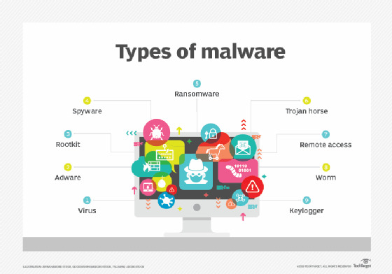
2.2
As can be seen from Figure 1 [1] there are many types of Malware. As defined by Oxford Dictionary, Malware is “Software that is specifically designed to disrupt, damage, or gain unauthorized access to a computer system.” [2]
The most common forms of Malware are virus, worm and Trojan horse. A virus spreads by inserting a copy of itself into another program. A viruses can spread by network shares, most commonly via Email. Viruses can spread in two ways, Horizontal where is corrupts equal level applications, or vertically where it directly attempts to corrupt the administrator.
The Trojan Horse is a software which gets its name from the ancient Greek assault on the city of troy, where soldiers were hidden inside a gift. It appears as legitimate software to users, but once deployed to the network it allows attackers access to the users system from within. It can be used to spy, disrupt or modify information. Due to the variety of actions they can perform, each Trojan is specifically classified.
A Worm will attack the system/network, then remain dormant in the background gathering information and then attack at a later date.
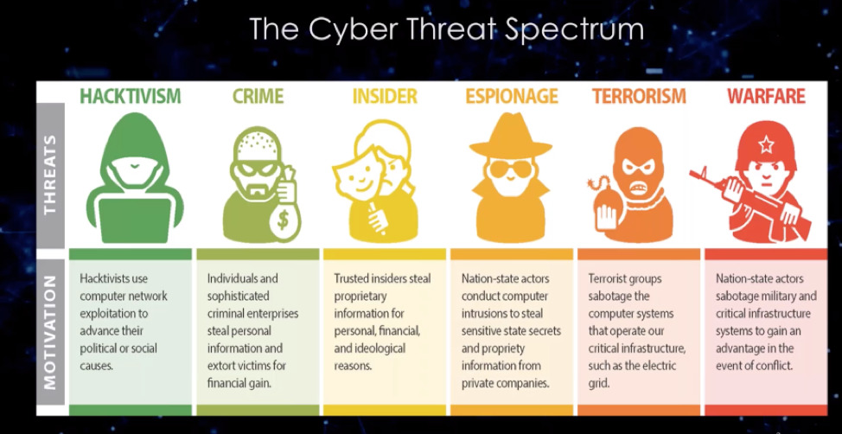
There are different actors that can pose a threat to an organisations network. As can be seen from Figure 2 [3] each actor have their own motivation for infiltrating a network, they are all similar in that they all have negative intentions towards the targeted network. All threats are after information from the target, categorised into PII, PHI and PSI.
Physical attacks that can be made on the network. And these attacks are not necessarily carried out by external forces. Sometimes these attacks can be accidental, with an employee unknowingly causing damage to the network. Other occasions they are carried out by disgruntled employees knowingly attacking the network, or by an attacker gaining access through a variety of deception tactics like tailgating, shoulder surfing, false credentials and others.

Deception can be used for cyber-attacks to gather information on a target. Social Engineering involves manipulating individuals into providing access to data. Phishing and SMiShing involves the sending of malicious links within an email and text respectively, which will trouble Che-Si due to the freedom for staff to use any device. Pretexting is another example, which involves lying in order to gain access to privilege data, an example of this can be the hoax calls which we all encounter daily with criminals posing as bank staff or government agencies in order to gain sensitive data which can be used to access further sensitive information of the victim.

2.3
The basic step any organisation can make is ensure all employees are as cyber aware as possible. This doesn’t have to be an expensive exercise, it can be as simple as providing in-house training, or directing staff to basic safety tips provided by the NCSC [4]. They provide guidance on a range of topics including Devices and Phishing which will be useful in Che-Si’s instance. The CSO website [5] is also a very useful resource for types of policies an organisation should implement, what they cover and even some high level examples of said policies.
ISO 27000 Directory provides information on a variety of Information System needs. ISO 27002 can “provide a guide for the development of organizational security standards" [6] which will help secure internal activities.
In order to prevent threats from accessing our private data there are some actions that can be taken. An excellent article on over-reliance on external security providers [6] pointing to the value of attack prevention rather than damage control. Educating all staff on Phishing, and to ignore the messages can prevent that avenue of threats to the network, thus not needing damage control.

System Hardening enhances the security of the system by strengthening its weaknesses. It could be a single computer, a networking system, internet system, intranet system but the purpose of risk reduction and eliminating avenues of attacks is the aim. It can be as simple as running the latest updates and patches, which can prevent threats. Having an excellent NOC could distribute the software updates to mitigate the effects of network attacks. Other functions of a NOC include monitor performance, troubleshooting issues, and managing devices. Though costly, it is an investment worth making.
Redundancy ensures no single point of failure. Redundancy isn’t just for data, but infrastructure too. If a router or a switch fails, there should be another route to the network. By making sure the network is redundant enough in the instance of an attack means less downtime, and keep the network functioning which is critical for Che-Si.

James Michael Stewart’s book [7] is useful in showing cyber security basics on different networks. It not only explains the threats, but also provides solutions to mitigate, particularly use of Firewalls and VPN’s. It covers the very basics, as with anything in life getting the basics correct is key. I have shown the essence of this research in my Topologies (P10).
Firewalls not only protect the network from unnecessary traffic, also the malware mentioned in Figure 1 from gaining access via the internet. There are both Hardware and Software firewalls, which protect networks and Operating systems respectively. It is useful to add further firewalls as an additional barrier of safety from attacks.
There are mitigating tactics that can be implemented to prevent or slow down Physical attacks on the network. These can be physical barriers and fences, or the use of biometrics like badges and access logs to make traceability easier following a physical attack. Increase of surveillance can give peace of mind, implementing video and electronic surveillance or even employing Security Guards are options.

3.1
Che-Si’s network needs to be available 24/7 to all devices, this is a strength for the business but this is a Network weakness. The highest availability achievable is the 5 9’s, 99.999%. In order to meet the five 9’s for a calendar year, there must be less than 1 second of downtime a day which leaves little opportunity for updates and system hardening. The Network being accessible to different devices is also an issue, due to the business encouraging remote working it’s likely that mobile devices will be used and can leave the network open to attacks. Construction is one of the top 5 sectors most at risk of being targeted by Cyber-attacks according to SecurIT [8]. This is due to the volume of sensitive information stored on the network.

3.2
Due to the openness of the network I will show how a man in the middle/packet sniffing attack can occur against the open network. My Wireshark example was run on a laptop, if I had a server/router to run this application on I would then be able to view traffic within internal networks which can help identify potential DDoS attacks. This is identifiable within Wireshark as the RST packages. Examples of which in my screenshots, show network is requesting the source to cease communication due to a potential threat. Wireshark is a great tool to help gather that information as seen in Annexure (P11).

3.3
As seen within the annexure, the actor is able to view the network traffic intercept the packets and view the information and credentials from the packet including source and destination. When done by an ethical hacker, preventative measures can be taken to prevent cyber criminals capitalising on flaws in the network to steal information. Without preventative measures of system hardening, data encryption, use of a VPN, limiting access with credentials and active NOC monitoring for suspicious activity. Cyber criminals could use tools like Wireshark to scan the network, to find weaknesses to infiltrate.

4.1
Having policies are important, but adhering to the policies and strategies more so. Without compliance, it renders the Che-Si policies worthless. Due to the openness of the Che-Si network, a Remote Access Policy to be followed by all is important, not only externally as staff are allowed to work remotely using any device. An up-to-date Remote Access Policy should be followed by all staff. Ensuring safe practice within is important, as staff will have access to further sensitive information that customers and vendors can’t access, if an active directory or role-based access is in place.
Information Security Policy though high level, is a useful policy to get all staff to sign. This will ensure they will adhere to rules regarding sharing of sensitive information, user responsibilities and basic preventative measures all staff can make to be cyber safe. As it is signed by staff it means they can be held accountable to any breaches which is powerful in ensuring compliance. According to a McAfee report on data exfiltration
“People inside organizations caused 43% of data loss, one-half of which was accidental. Improved cybersecurity policies can help employees and consultants better understand how to maintain the security of data and applications.” [9]

4.2
The sending of digital signatures can add security to correspondence. It allows us to see whether others have edited the message after sending. However adding the signature alone won’t prevent possible threats as they can be de-crypted, therefor use public and private keys in order to share information with the recipient. NMichaels.org [10] is a great tool to generate a digital signature, and de-crypt when receiving correspondence.
One way of encrypting information is the MAC technique, which allows us to confirm authenticity of the message sender and contents using the authentication code. Transforming the content into the cipher text will also prevent some tampering of the message.
Asymmetric Encryption involves use of two keys, Public and Private. The source and destination both have their own public and private keys. However, for Asymmetric method the source can’t be authenticated. This can be mitigated by locking the message with the sender’s private key, and sending to the receiver.
Dual Encryption is the most effective encryption method as you can confirm the sender and the message hasn’t been tampered. This involves encrypting the message with the Private sender key and then encrypted over by the public key of the receiver.

4.3
To Conclude, Cyber security is important to protect an organisations network, data and reputation. Without a secure network, up to date policies and practices from within, Che-Si will be unable to protect itself from external threat to the Network. Please see below recommendations for Che-Si to improve cyber security and mitigate weaknesses mentioned in this assignment. Some of the suggestions are visible in the Topologies I have created below, Figure 3 and Figure 4.

- Up-to-date and shared Information System Access Policy.
- Implement Role based access, thus keeping externals away from systems they shouldn’t be allowed to access certain physical and cyber areas of Che-Si.
- Staff working remotely must connect to network via VPN.
- Staff sign up to policies, and face consequences for failure to adhere. This will deter bad practice.
- Sign up to InfraGard [11] or NSCS communities. It’s a cyber-intelligence sharing community, the extra knowledge could be useful for Che-Si to defend against and prevent future attacks/threats.
- WAF’s to counteract Packet Sniffing danger.
- Suggest clients/vendors added to video conferencing/cloud storage when required, rather than always accessible. This will keep track of activities and allow only justified access to cloud storage.

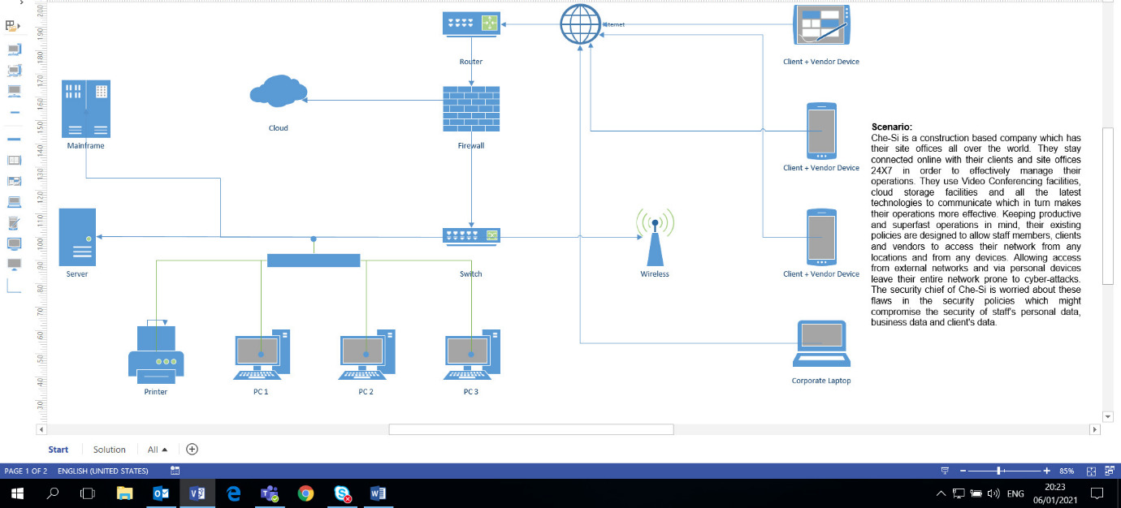
Figure 3,

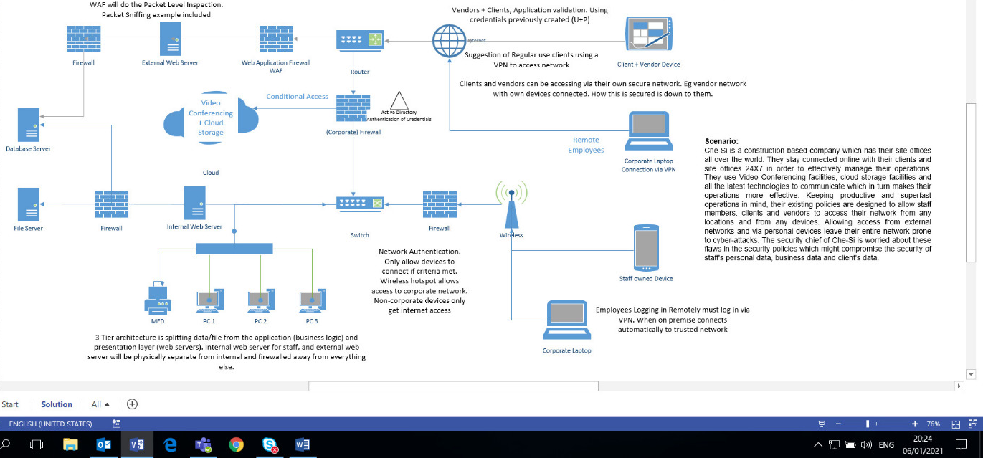
Figure4, Comments to benefits visible in black on topology.

4.4 Annexure
Below Step by step screenshots of implementation of packet sniffing simulation.
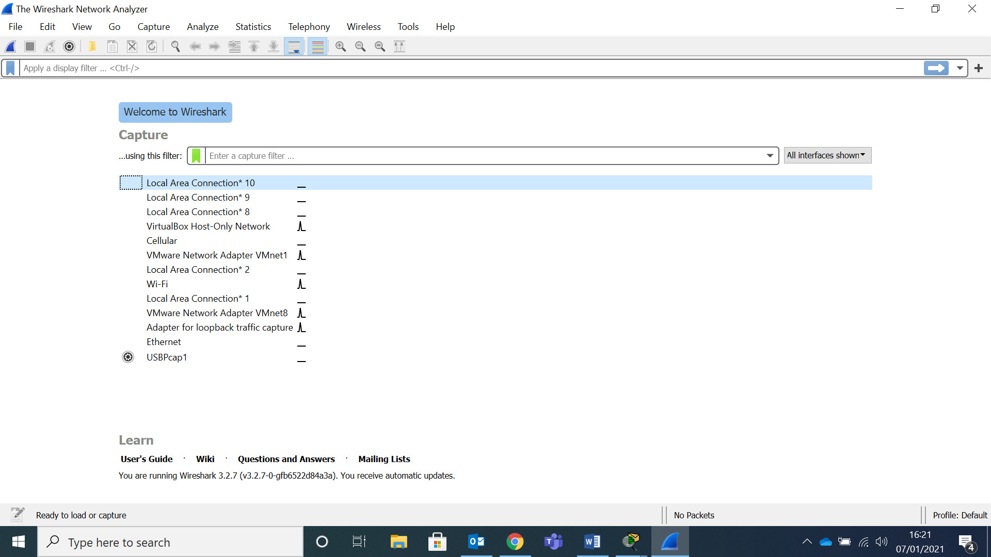
As can be seen the above screenshot is the homepage of wireshark. Following a right click on my selected network to monitor traffic I am provided with the below.
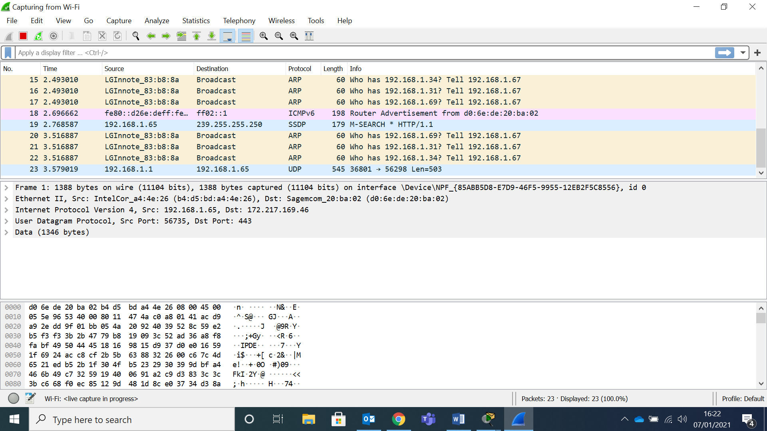
As more traffic is scanned it will appear as seen above. This includes multiple Protocols.
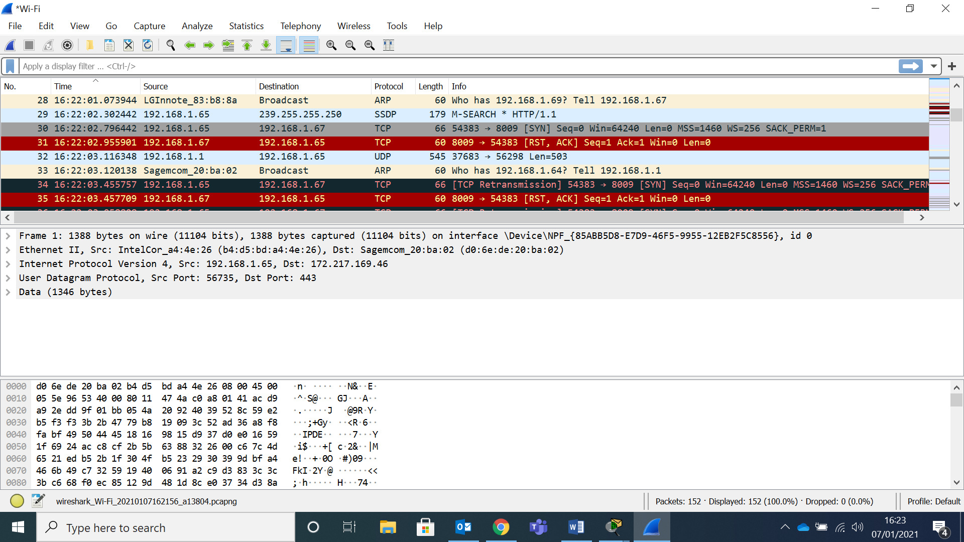
For the purposes of this demonstration I have shown the TCP protocol.

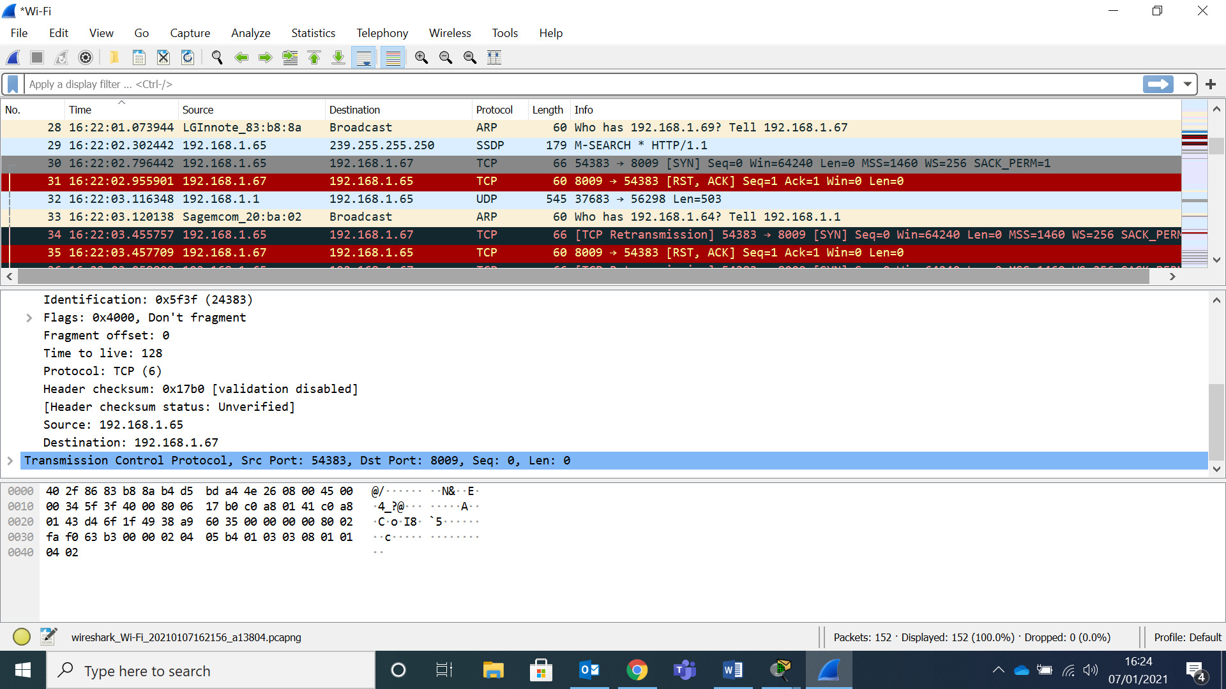
Source and Destination available when selecting the Internet Protocol Option. Destination IP 192.168.1.65 being the laptop used for this demonstration.
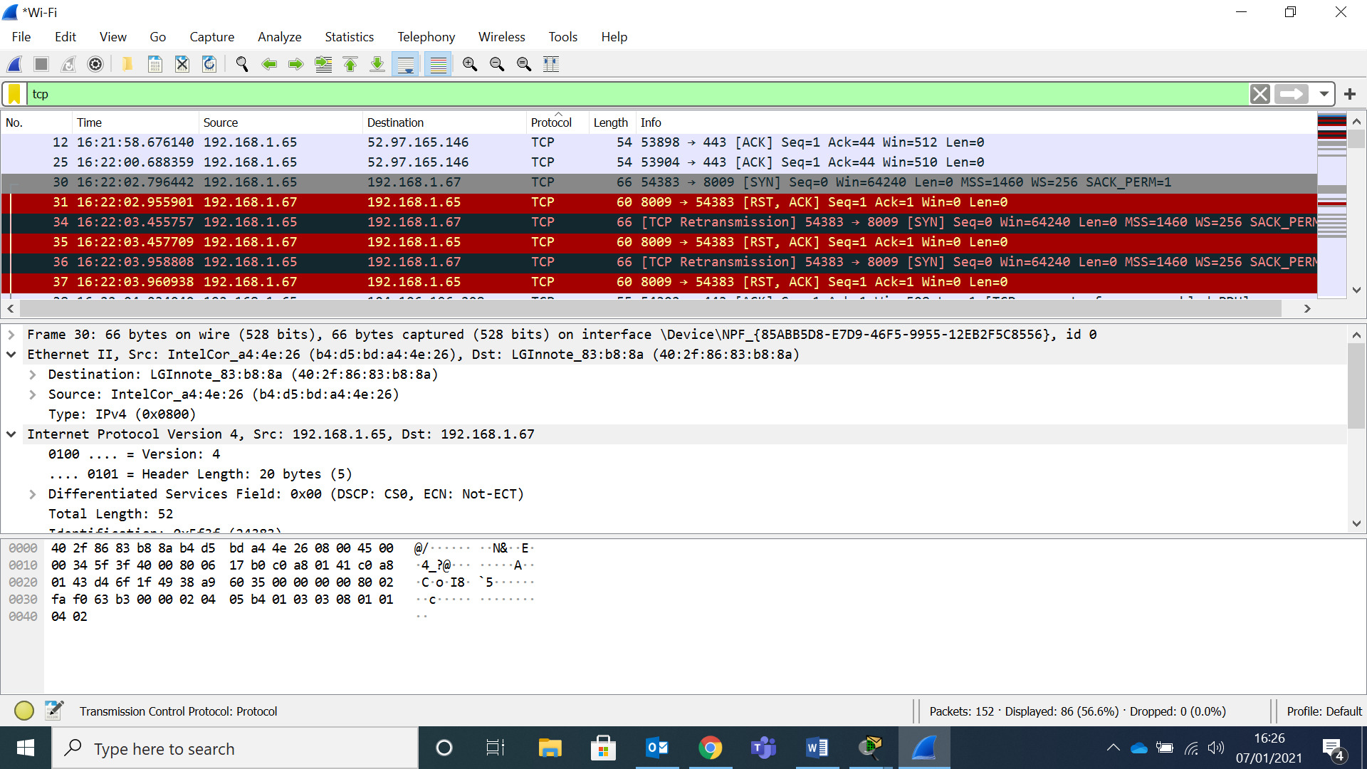
TCP filter added
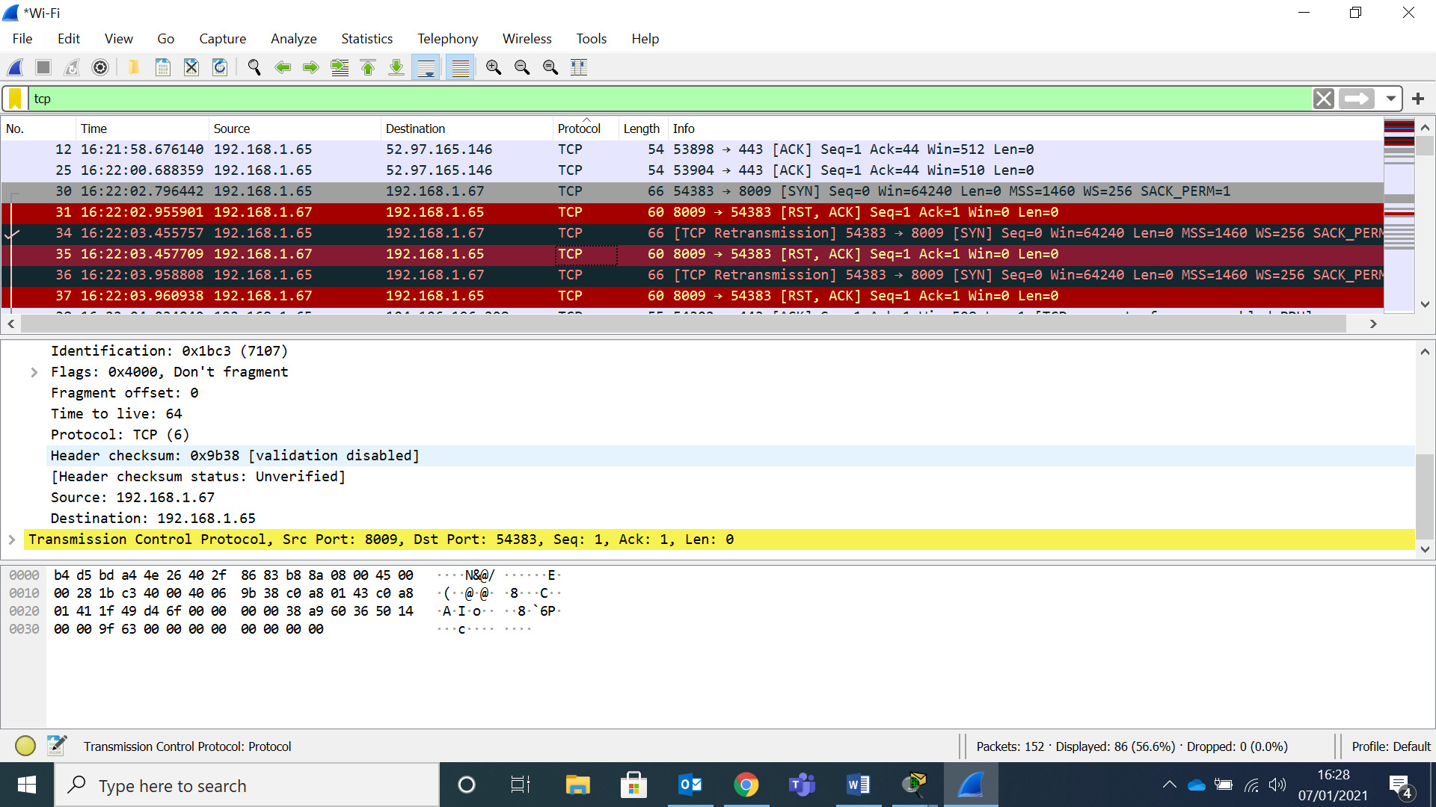
As can be seen, there are multiple conversations coming from Source 192.168.1.67 that my original Source has replied with an RST, to prevent this destination from communicating with me. This would usually mean a hacker is attempting to scan the network to see which Ports are listening in order to infiltrate.
This helps prevent against potential Malware infiltration. I can also use the source port IP in order to determine which application/computer is responding to the message in order to isolate issues.
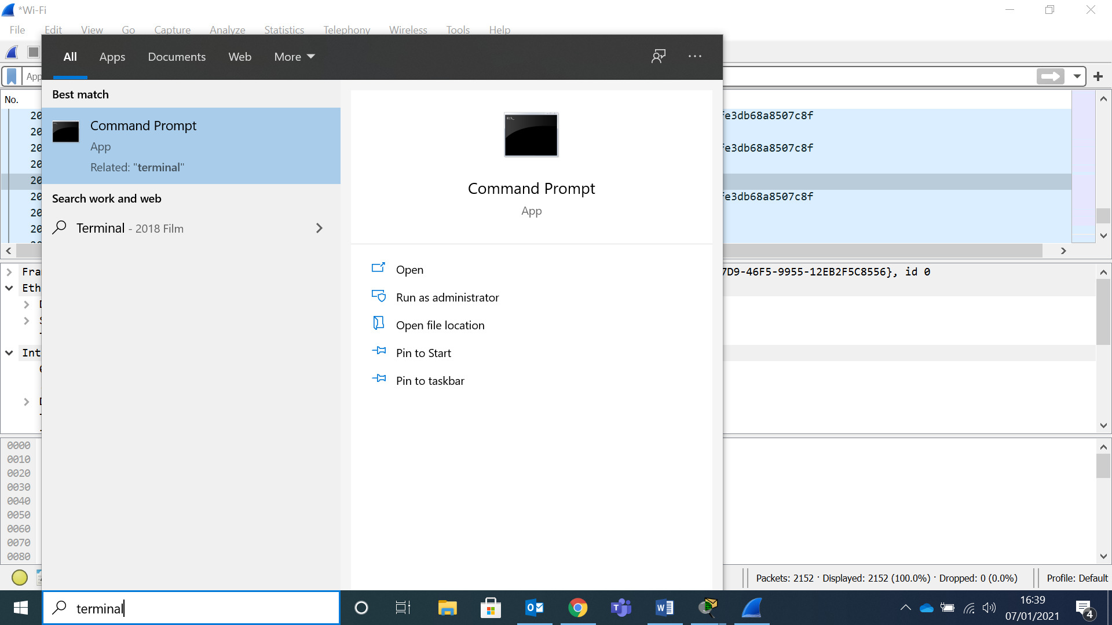
This can be done by opening up the terminal on the computer. As seen by below screenshot.
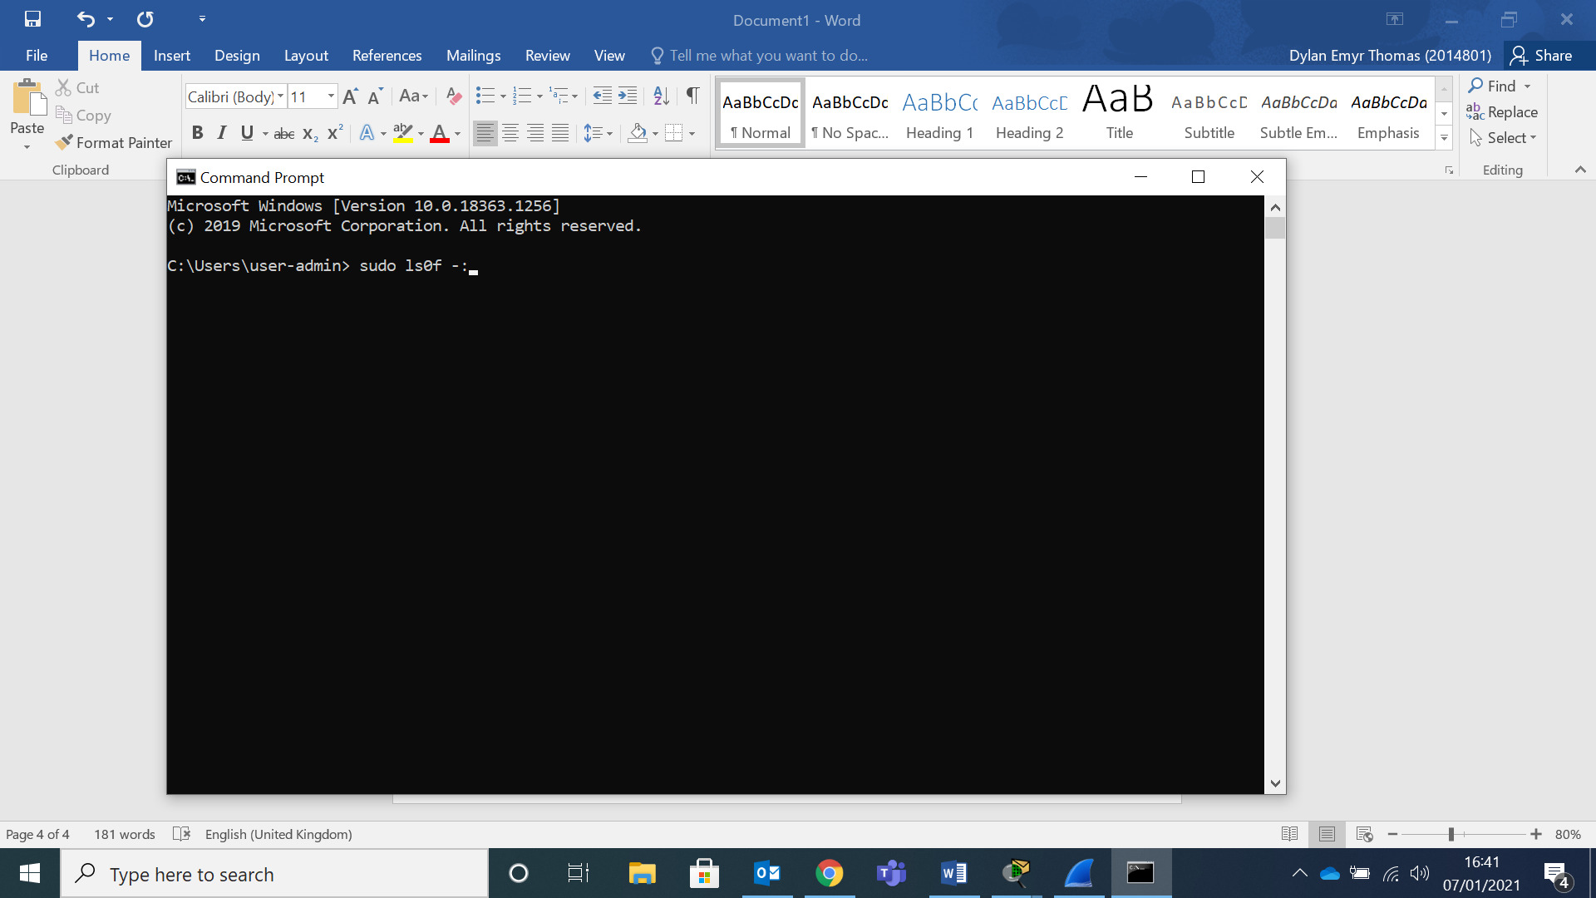
Then type the command sudo ls0f -: (Portnumber)
This can be used to narrow down the application or process sending the message. This can then be used to identify the process responding to the message. By gaining the Process Id this can then be prevented within activity Monitoring.

- Bibliography

[2]
Oxford Learners Dictionaries, “Malware definition,” 2018. [Online]. Available:
https://www.oxfordlearnersdictionaries.com/definition/english/malware?q=malware/. [Accessed: 01-Jan-2021]
[4]
NCSC “homepage”, 2020. [Online]. Available:
https://www.ncsc.gov.uk/. [Accessed: 01-Jan-2021]
[5]
G. Hayslip, “9 policies and procedures,” 2018. [Online]. Available:
https://www.csoonline.com/article/3263738/9-policies-and-procedures-you-need-to-know-about-if-youre-starting-a-new-security-program.html. [Accessed: 01-Jan-2021]
[6]
ISM, “ISO 27000 Standard ,” 2020. [Online]. Available:
http://www.27000.org/. [Accessed: 01-Jan-2021]
[7]
W. M. Lam, “Attack-prevention and damage-control investments in cybersecurity,” Information economics and policy, vol. 37, pp. 42–51, 2016, doi:10.1016/j.infoecopol.2016.10.003. Available:
https://www-sciencedirect-com.ezproxy.uwtsd.ac.uk/science/article/pii/S0167624516301263/. [Accessed: 01-Jan-2021]
[8]
J. M. Stewart, Network security, firewalls, and VPNs, Second edition. 2014.
[9]
“Key Industries Most Vulnerable to Cyber Attacks,” 2020. [Online]. Available:
https://www.securit.biz/key-industries-most-vulnerable-to-cyber-attacks-this-2020/. [Accessed: 01-Jan-2021]
[10]
“Grand Theft Data Report, a McAfee report on data exfiltration,” 2020. [Online]. Available:
https://www.mcafee.com/enterprise/en-us/assets/reports/rp-data-exfiltration.pdf/. [Accessed: 01-Jan-2021]
[11]
“RSA Encryptor/DeCryptor/Key Generator/Cracker,” 2020. [Online]. Available:
http://nmichaels.org/rsa.py/. [Accessed: 01-Jan-2021]
[12]
“InfraGuard, Cyber Intelligence website,” 2020. [Online]. Available:
https://www.infragard.org/. [Accessed: 01-Jan-2021]

- Figures
Figure 1 [1]
TechTarget, “What is Malware and How Does It Work?,” 2020. [Online]. Available:
https://searchsecurity.techtarget.com/definition/malware. [Accessed: 01-Jan-2021]
Figure 2 [3]
“Cyber threat actors,” 2020. [Online]. Available:
https://www.digitalshadows.com/blog-and-research/your-data-at-risk-fbi-cyber-division-shares-top-emerging-cyber-threats-to-your-enterprise/. [Accessed: 01-Jan-2021]
Figure 3 – Self Created basic Logical topology via Visio
Figure 4 – Self Created further secure Logical topology via Visio

- Glossary
LAN – Local Area Network
PAN – Personal Area Network
WAN – Wide Access Network
PII – Personal Identity Info
PHI – Protected Health Info
PSI – Personal Security Info
NOC – Network Operations Centre
MAC - Message Authentication Control
TCP - Transmission Control Protocol
RST – TCP Reset
WAF – Web Application Firewall

