Contents:
AI Declaration: Page 1
Portfolio Part 1: Page 2
Portfolio Part 2: Pages 3 – 7
Portfolio Part 3: Page 8
Portfolio Part 4: Sent via One Drive

AI Acknowledgement Format of AI Use
I acknowledge the use of Microsoft 365 Copilot on the 20th September 2026 to research study techniques.
- Can you tell me two methods to stop procrastination?
- Can In the role of an academic advisor, please provide two research-backed techniques for a first-year university student to avoid procrastination.
- Can you please source 3 books that reference these techniques?
- Can you source academically credible books on these topics from 2016 onwards please?
- Can you give me two techniques that aid with time management?
I can confirm I have not presented any AI generated text as my own work. I can confirm I have copies of my drafts, notes and any other resources I used before, and after the use of AI tools which I may be asked to provide as evidence.

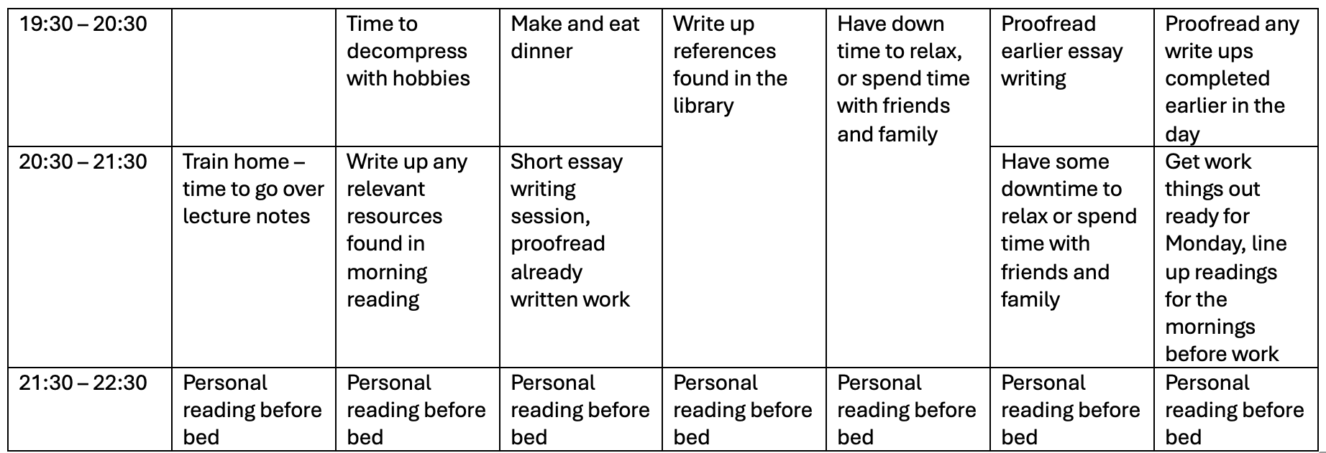
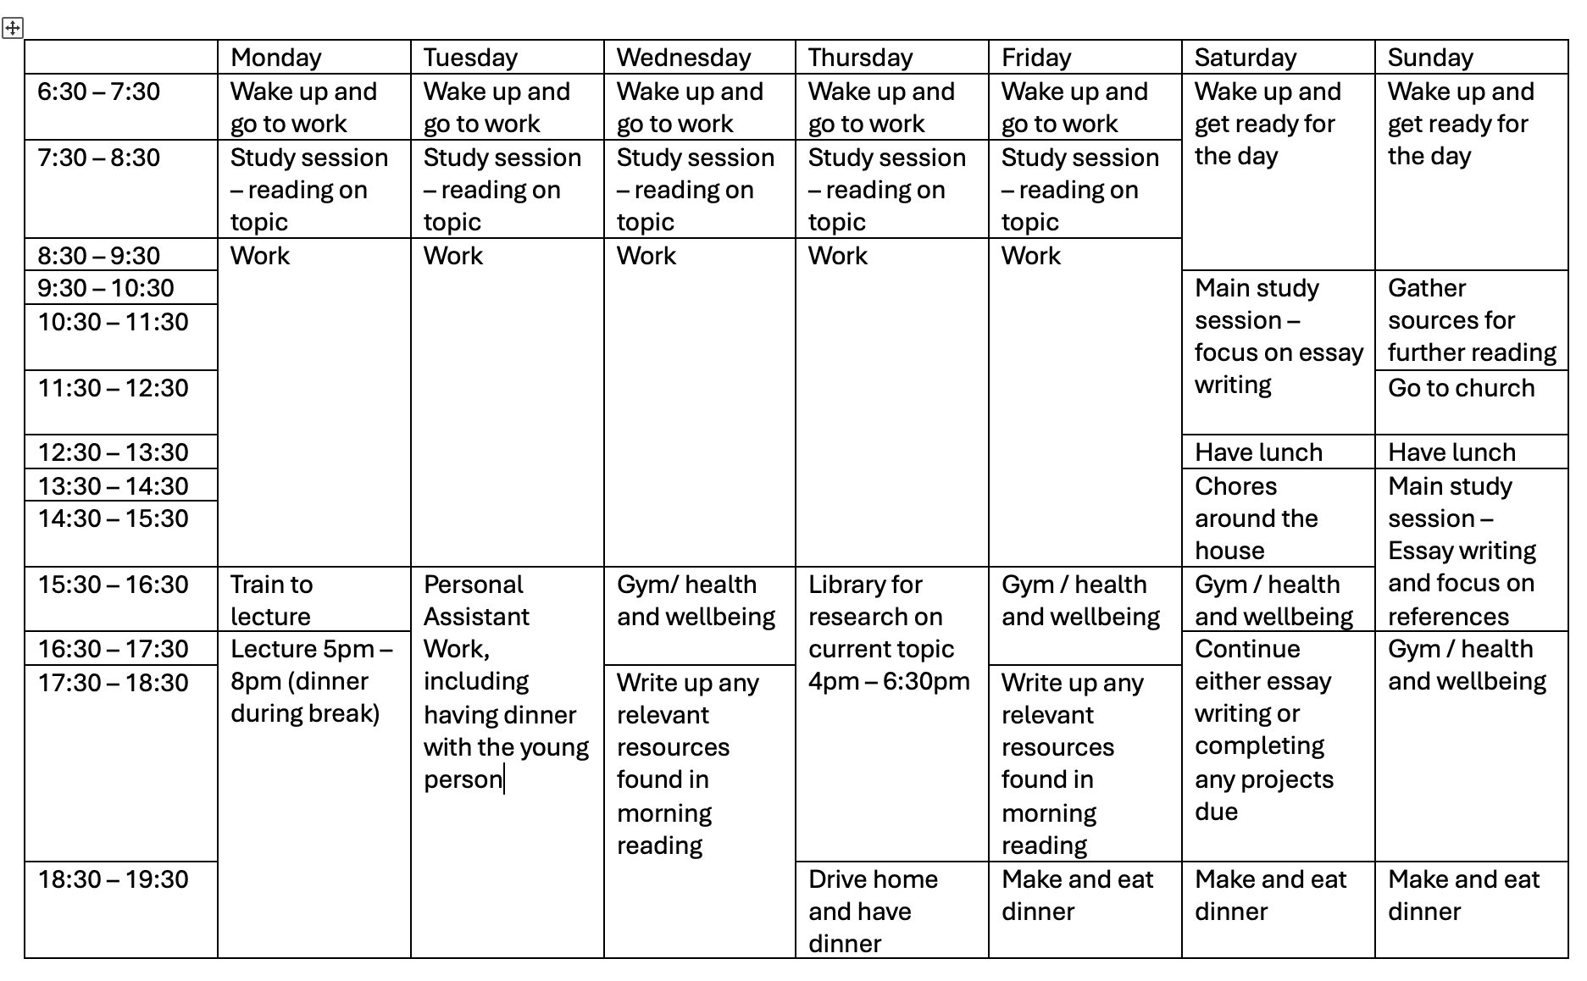
Portfolio Part 1: Weekly Study Schedule

Portfolio Part Two:
Initial prompts:
Can you tell me two methods to stop procrastination?
Can you give me two techniques that aid with time management?

Original output:
Yes. Two of the most effective, research-backed methods for reducing procrastination are:

1. Task Chunking (Break Large Tasks into Small Steps)
Procrastination often occurs when a task feels overwhelming. Breaking a large task into smaller, manageable actions reduces anxiety and makes it easier to get started.
Example: Instead of writing "Complete essay," break it into:
- Choose a topic
- Find three sources
- Create an outline
- Write the introduction
- Draft section one
Focusing on just the next small step lowers the mental barrier to action. Research suggests that people are more likely to begin and complete tasks when goals are specific and achievable.
How to use it:
- Identify the smallest possible next action.
- Make each step something that can be completed in 10-30 minutes.
- Tick off completed steps to create a sense of progress.

2. The Pomodoro Technique
The Pomodoro Technique involves working in short, focused bursts followed by brief breaks. This helps overcome the "I'll do it later" mindset because committing to 25 minutes feels less daunting than committing to several hours.
Basic method:
- Choose one task.
- Set a timer for 25 minutes.
- Work only on that task until the timer ends.
- Take a 5-minute break.
- After four rounds, take a longer break (15-30 minutes).
Why it works:
- Reduces distractions.
- Makes work feel more manageable.
- Builds momentum through repeated periods of focused effort.
- Helps maintain concentration without mental fatigue.

Using Both Together
These techniques work particularly well when combined:
- Break a large assignment into small chunks.
- Complete one chunk during a single Pomodoro session.
- Repeat until the task is finished.
For example, a university student might use one 25-minute Pomodoro to find sources, another to create an outline, and another to write the introduction.
This combination helps address both common causes of procrastination:
- Feeling overwhelmed → solved by task chunking.
- Difficulty getting started → solved by the Pomodoro Technique.

Refined and Stronger Prompt:
In the role of an academic advisor, please provide two research-backed techniques for a first-year university student to avoid procrastination.
Prompts to identify and validate sources:
Can you please source 3 books that reference these techniques?
Can you source academically credible books on these topics from 2016 onwards please?

Discussion of Two Techniques:
This essay will discuss two techniques that could support a first-year university student with reducing their procrastination levels. The first technique is called the Pomodoro technique (Cirillo, 2018) and the next technique is intention implementation (Maffia, 2011).
The Pomodoro Technique is used to break down tasks into short burst sessions. You study or write for 25 minutes with a timer to tell you when that time is up, you then take a five-minute break. This can be repeated numerous times with a longer break after four 25-minute stints. (Biwer et al, 2023)
As Biwer et al (2023) point out in their article as opposed to having extended focus time and minimal breaks, which can be unpredictable and not the most effective way to retain information, this method with its clear timed boundaries showed a positive correlation between productivity and the use of Pomodoro.
Moving forward, the second technique, intention implementation, aids learners with committing to a certain action if a predetermined occasion arises (Maffia, 2011). The aim of this technique is to identify steps in order for a learner to achieve their goal (Achtziger et al, 2025). For example: when I go to the library today, I will find 3 academic journal resources for my essay.
In conclusion, the Pomodoro technique is effective for breaking down studying into manageable sized time frames to help aid with focus and intention implementation helps the learner hold themselves accountable to achieve their goal through small steps. Both techniques have demonstrated they are effective at reducing procrastination and motivating learners.

Reflection on Using Copilot:
This essay will discuss my thoughts on using artificial intelligence (AI) in the form of Microsoft 365 Copilot in order to complete a university project. It will endeavour to discuss both positive aspects of the experience along with disadvantages of using the software and some discussion on the ethical use of AI.
Firstly, there were some advantages to using Copilot. It was able to acquire the information I needed swiftly with minimal adaptations to the prompts. Furthermore, it was able to offer answers I perhaps had not previously considered and provided research-backed evidence for all of its responses.
However, there were disadvantages that I encountered through my use of the software. While its speed and researched responses were impressive, a number of its sources were quite dated and therefore, additional work went into discovering sources that were more recent and relevant to the project.
Furthermore, there is discourse on the credibility and accuracy of using AI which led to additional verification, this cut into my study schedule as I wanted to guarantee the information I had found was correct. Moreover, while it increased my study time due to the checks, others who use AI may not be as thorough or rely on it too heavily and therefore, reduce their critical thinking skills (Gerlich, 2025).
In addition, I believe it is important to discuss the morality of using generative AI. The data centres that are used to run the systems are using up numerous natural resources such as land and drinking water (Gundeti, 2024). From an environmental perspective, I disagree with using AI as it is causing irreversible harm to nature.
In conclusion, while I can see the convenience of using AI to get quick answers to questions and perhaps support a person in broadening their knowledge or perspective on academic topics, I find the pejorative aspects outweigh the positives.

Reference List:
Achtziger, A., Doerflinger, J T., Gollwitzer, P M. (2025) Motivation and Volition in the Course of Action. In: Heckhausen, J., Heckhausen, H. (eds) Motivation and Action. Springer, Cham. https://doi.org/10.1007/978-3-031-87947-0_12
Biwer, F., Wiradhany, W., oude Egbrink, M. G. A., & de Bruin, A. B. H. (2023). Understanding effort regulation: Comparing ‘Pomodoro’ breaks and self-regulated breaks. British Journal of Educational Psychology, 00, 1–15. https://doi-org.uwtsd.idm.oclc.org/10.1111/bjep.12593
Cirillo, F. (2018) The Pomodoro Technique: The Acclaimed Time Management System That Has Transformed How We Work. 1st edn. Virgin Books.
Gerlich, M. (2025). AI Tools in Society: Impacts on Cognitive Offloading and the Future of Critical Thinking. Societies, 15(1), 6. https://doi.org/10.3390/soc15010006
Gundeti, R., Vuppala, K., & Kasireddy, V. (2024). The Future of AI and Environmental Sustainability: Challenges and Opportunities. In H. Kannan, R. Rodriguez, Z. Paprika, & A. Ade-Ibijola (Eds.), Exploring Ethical Dimensions of Environmental Sustainability and Use of AI (pp. 346-371). IGI Global Scientific Publishing. https://doi.org/10.4018/979-8-3693-0892-9.ch017
Karcz, A. (2020) Forbes Available at: https://www.forbes.com/sites/anthonykarcz/2020/03/31/try-one-of-these-5-pomodoro-timer-apps-to-help-you-stay-focused/ (Accessed: 27.09.26)
Maffia, C., 2011. The effects of implementation intentions on the high school procrastinator and perfectionist, Fordham University.
Rozanski, A. (2026) Dr Alan Rozanski Available at: https://alanrozanski.com/implementation-intentions/ (Accessed: 27.09.26)

Portfolio Part 3: Procrastination Poster


