professional carrer development
Augusto Puerta - 2008328
Module BMSW4005
professional cAreer development
silvia höfman

Contents
Introduction 2
Professional Career Development Plan 2
Personal Development Plan 3
Self-awareness 4
SWOT analysis 5
Plan 5
Role Play Feedback 7
Conclusion 7
References 7
Appendix 7

Professional Career Development Report

Introduction
In this report I am going to discuss all the steps to follow in order to achieve a professional goal. I will have to answer several questions in order to clarify and create a path towards the goal I wish to achieve, both in the medium term and in the long term.
Firstly, I need to understand and therefore explain what Professional Career Development is, bearing in mind that it is composed of a Personal Development Plan linked to my Career Development. To give a brief explanation, in my point of view, it is the planning that will allow me to improve skills, learn new ones and primarily focused on the goal I want to achieve in the near future, such as applying for a new job.
Then, address the main points and follow an orderly timeline so as not to lose focus and to achieve the optimal preparation that will enable me to apply for the job I am aiming for here in London.
The main points would be the following: decide my long-term goal, so I will have to give answers to several questions in order to have a clear vision of how to achieve that goal. In addition, set a short or medium-term goal or goals that will act as a bridge to reach the main goal. After this, we would move on to the next point, which is to carry out a self-analysis of my current situation and thus know where I am starting from in order to continue advancing in my goals. In this case, I will carry out a SWOT analysis to consider my strengths, threats, opportunities and risks. On the other hand, I will consider my skills, which ones I must improve, which ones I must develop from scratch and which ones I should not put so much emphasis on.
Throughout this process of personal and professional development and evolution, I will mention my learning process, giving a perspective from the VAK learning models.
I clarify that my Career Development is included in the Personal Development Plan (PDP), as this concept has to be linked to PDP in order to achieve my professional goal, as I also have to have an academic background.
Finally, I will reflect on the Role Play I did in the first assignment to make sense of everything explained and developed in the previous sections, as it is all related to the same objective I plan to achieve.

Professional Career Development Plan
To give meaning to Professional Career Development, I can draw three concepts from which it is composed.
The first one would be Personal Development which is the action of developing your own potential, it is not something that is always related to the work environment, it can be seen as activities that are carried out outside work and that serve to improve your socialisation skills, health and even for your own enjoyment.
Another concept that is extracted from here is Career Development, this would be a learning process in which it is born from the academic point of view, although it is related to the professional field, since I am going to focus my learning on the objective that I want to achieve professionally.
And finally, Professional Development, which is made up of the two previous concepts, as they complement each other to achieve this medium and long-term objective. The aim would be to succeed in the development of your career, through discipline, perseverance and organisation in order to have the appropriate and specific knowledge and skills for the job I plan to apply for. (Prajapati, 2021)

Personal Development Plan
The PDP is a good tool to coordinate my progression on the path of my goals. The main achievement that I want to have is being part of the customer service teamwork in the company Schneider Electric. To be selected in my application for this position I need to analyse myself and classify what skills I already have for this job position and which skills I need to train and improve to be suitable for be selected. For this reason, I planned short term goals to become the better candidate in the job interview.
- Long term goal: Work as a Customer Care Service in Schneider Electric is for me my big achievement after finishing my course in the University. This is my second year in London, and I was working in a different sector of the Logistic and transport. But even being different sector, I develop skills in how to manage stocks, give information to the customers, and organisational skills.
I already knew the company before coming to London because It was the same company where I worked in Barcelona. Also, the same area, in customer care and quality service.
With my background in the company and doing a research in LinkedIn because I found is the resource the company mostly use to share information about vacancies, I collected the information to know what they want for the future candidate in the job position.
What are your key responsibilities in the role?
- Accept inbound Emergency break fix calls from Schneider Electric customers, understand the customer requirements and ensure the call is logged and directed to the appropriate person for action.
- Accept ownership of the call to ensure completion.
- Perform an initial diagnostic to understand the customers issue
- Provide effective communication with internal and external stakeholders to ensure SLAs are achieved.
- Provide the Customer with regular updates via their preferred method of communication
- Log all Customer contacts in Salesforce, detailing the issues reported and all actions taken.
- Ensure all customer data is maintained.
- Accept and log incoming support requests from Field Service Engineers, assigning them to the correct in-house technical support team.
- Manage the administration tasks for the businesses multi-technology customers.
- Manage the administration tasks for global connected services, spanning across multiple time zones.
(LinkedIn, 2021)

- Middle term goal: finish the course, improve my English, improve computing skills.
In my middle term I want to finish the course in the University which is going to be a important milestone because I am learning new skills like how to communicate appropriate in a professional environment, my presentation and role play help me to improve my fluency and self-confidence. Besides, I learnt how to present reports which is very important to deliver the correct information for a specific theme.
My English communication and writing skills are the other milestone that are relevant points, I need to be clear in my speaking and with my grammatical aspect to give the correct information to the customers.
To do an extra push in my improvements, I am assisting an extras classes of English speaking and writing.
- Short-term: improve my English, improve communication skills.
As I explained in my middle term achievements also, is for a continuing and progressive improvement be better in my writing and in my speaking skills, this means that in my short-term achievement is important make the difference.

The way to measure my progress will be marked with my grades alongside the three terms in the course, also with the feedback that I will have from my teachers.
(Bectu, 2020)

Self-awareness
There is a set of skills that are required for the job according to the requirements that the company states in the job vacancy.
The most important skills to take into account are:
- Communication Skills
This skill is the most relevant because the mission of customer service is to keep informed and provide the correct information to the parties involved in the information process, whether internal to the company itself or to customers or suppliers.

- Teamwork skills
It is essential to know how to work in a team and to be able to cross-reference information between colleagues in the same department or other departments such as transport or warehousing.

- Problem solving ability
The ability to solve problems in the most satisfactory way for the stakeholders is a very important point in order to be indispensable in the company.

- Organisational Skills
Knowing how to plan all the tasks of the day to day, as well as of the week, will make the work more efficient and reduce the moments of pressure due to workload.

- The ability to work under pressure
Having the patience to cope with heavy workloads or unexpected moments that require a quick solution is a great complement to the other skills that make you a resilient and reliable person.

- Computing skills
Are essential to manage the multitask that you need to do during the day. But the company is giving constants trainings to know how to drive the different programs.

SWOT analysis
Make an own analysis is going to give me an idea of what are my Strengths, Opportunities, Threats and Witnesses.
Strengths: I consider myself as person who like face new challenges and I feel highly motivated to improve mi skills and get the job that I have like a goal here in London. My strong skill is ability of overcome and adaptability.
Witnesses: I do not feel totally ready to express myself in appropriate formal English to do the job, but I am on the way to be better and apply at the job position.
Opportunities: the opportunity that this country is giving to me to continue studying and having an economical support. I can feel more self-confident to keep improving my skills and knowledge to reach at my objective.
Threats: there is a risk to be stacked if I do not take action to improve my English. Therefore, I need to do extra classes to do not fall I a comfort zone with my current job.
In my learning process I can say that according to VAK's learning styles, I cannot define myself only by one style, instead, depending on the content to learn and the skills to improve, I can make use of the visual learning type in which I memorise according to the images or diagrams that the learning subject provides me with, for example to learn vocabulary, I can associate it with images, or to understand the composition of a structure, I can memorise it with the use of a diagram. On the other hand, if it is something that requires a more complex explanation, I need to listen in depth to what is the meaning or purpose of the subject to be learned, such as learning how to handle a new computer programme. However, I would already be mixing visual and auditory learning. Finally, Kinaesthetic leads me to put the knowledge into practice and not forget it so quickly, as I am practising and trying out how to use in this case the software I have to learn.

Plan
The plan will be reflected in some tables to make it clearer.
What are my milestones, how I plan to achieve them and the time frame I expect to achieve them?

 | Short-Term Time Frame  What do I want to  accomplish in the next  three months? | Mid-Term Time Frame  What do I want to  accomplish in the next  six months? | Long-Term Time Frame  What do I want to  accomplish in the next  year?
Section 1 - My Goals  What are my overall goals that I want to accomplish in this time period? | -Pass the term in the University.  -Learn more English vocabulary  -Lear more about office 365. | -Pass the next terms.  -Learn more English grammar and improve my listening.  -Upgrade my Knowledge in Power point and researching resources. | -Work in different team works  -Be a competent English speaker.  -Make a professional presentation online or in a meeting in a office.  - Be prepared to apply to the job of customer service.
Section 2 - Skills and Knowledge to be  Learned  What specifically do I need to learn? What project do I need to work on?  Example: Student advising;  Banner; Dreamweaver; develop a procedures manual | -How to apply an effective technic of problem solving and decision making.  -Know how to use the new programs of office 365 like One note.  -Use a more formal English vocabulary. | - Have an Office level knowledge in computer and digital skills, this means know how to use the Word, PowerPoint, Outlook, OneNote, Excel and Teams  -Along of the year keep going practicing the English speaking, listening and writing. | Be proactive, deliver all the assignments in group and individual on the course.  Research the information needed to be prepared in the interview.
Section 3 - Next Steps  How am I going to acquire the skills and knowledge? How am I going to do this project? | -Assisting at classes.  -Practicing for my own.  -Doing an extra English classes. | -Assisting at classes.  -Practicing for my own.  -Doing an extra English classes. | -Assisting at classes.  -Practicing for my own.  -Doing an extra English classes.

Role Play Feedback

In my Role Play I create a group of questions that are focused to find what my skills are and how they can match with the requirements that the company is looking for.
In my answers I explained that I already have experience working in the same job position for the same company in Spain. I did manage many situations where the customer asking fast solutions. Also, I gave the customer the peace of mind that I oversaw the situation and he will have resolved the issue.
In many situations I had to be calm and work with a tight deadline doing the correct researches to achieve the purpose of the issue.
I explained some examples. Also, I let the employee know that I am highly interested to grow up in the company and specialize in the points or programs that they need to be expert and do as better possible the job role.

Conclusion
In my point of view, I can identify the important steps to follow for achieve my goals, it is important to create an action plan that leads to the final objective, all this is achieved with discipline, perseverance and patience. I can say that I am on the way to achieving my goals, many times it may seem that I am not making progress but if I go ahead with my plans and set small goals, all of this will help me reach the final goal, which is long-term.

References
Bectu, P., 2020. careersmart. [Online]
Available at: https://careersmart.org.uk/your-career/career-development/professional-development
[Accessed 05 09 2021].
LinkedIn, 2021. LinkedIn. [Online]
Available at: https://www.linkedin.com/jobs/search/?currentJobId=2634228314&geoId=101165590&keywords=Schneider%20Electric
[Accessed 05 September 2021].
Prajapati, S., 2021. businessmanagementideas. [Online]
Available at: https://www.businessmanagementideas.com/human-resource-management-2/career-development/what-is-career-development/20203
[Accessed 05 September 2021].

Appendix

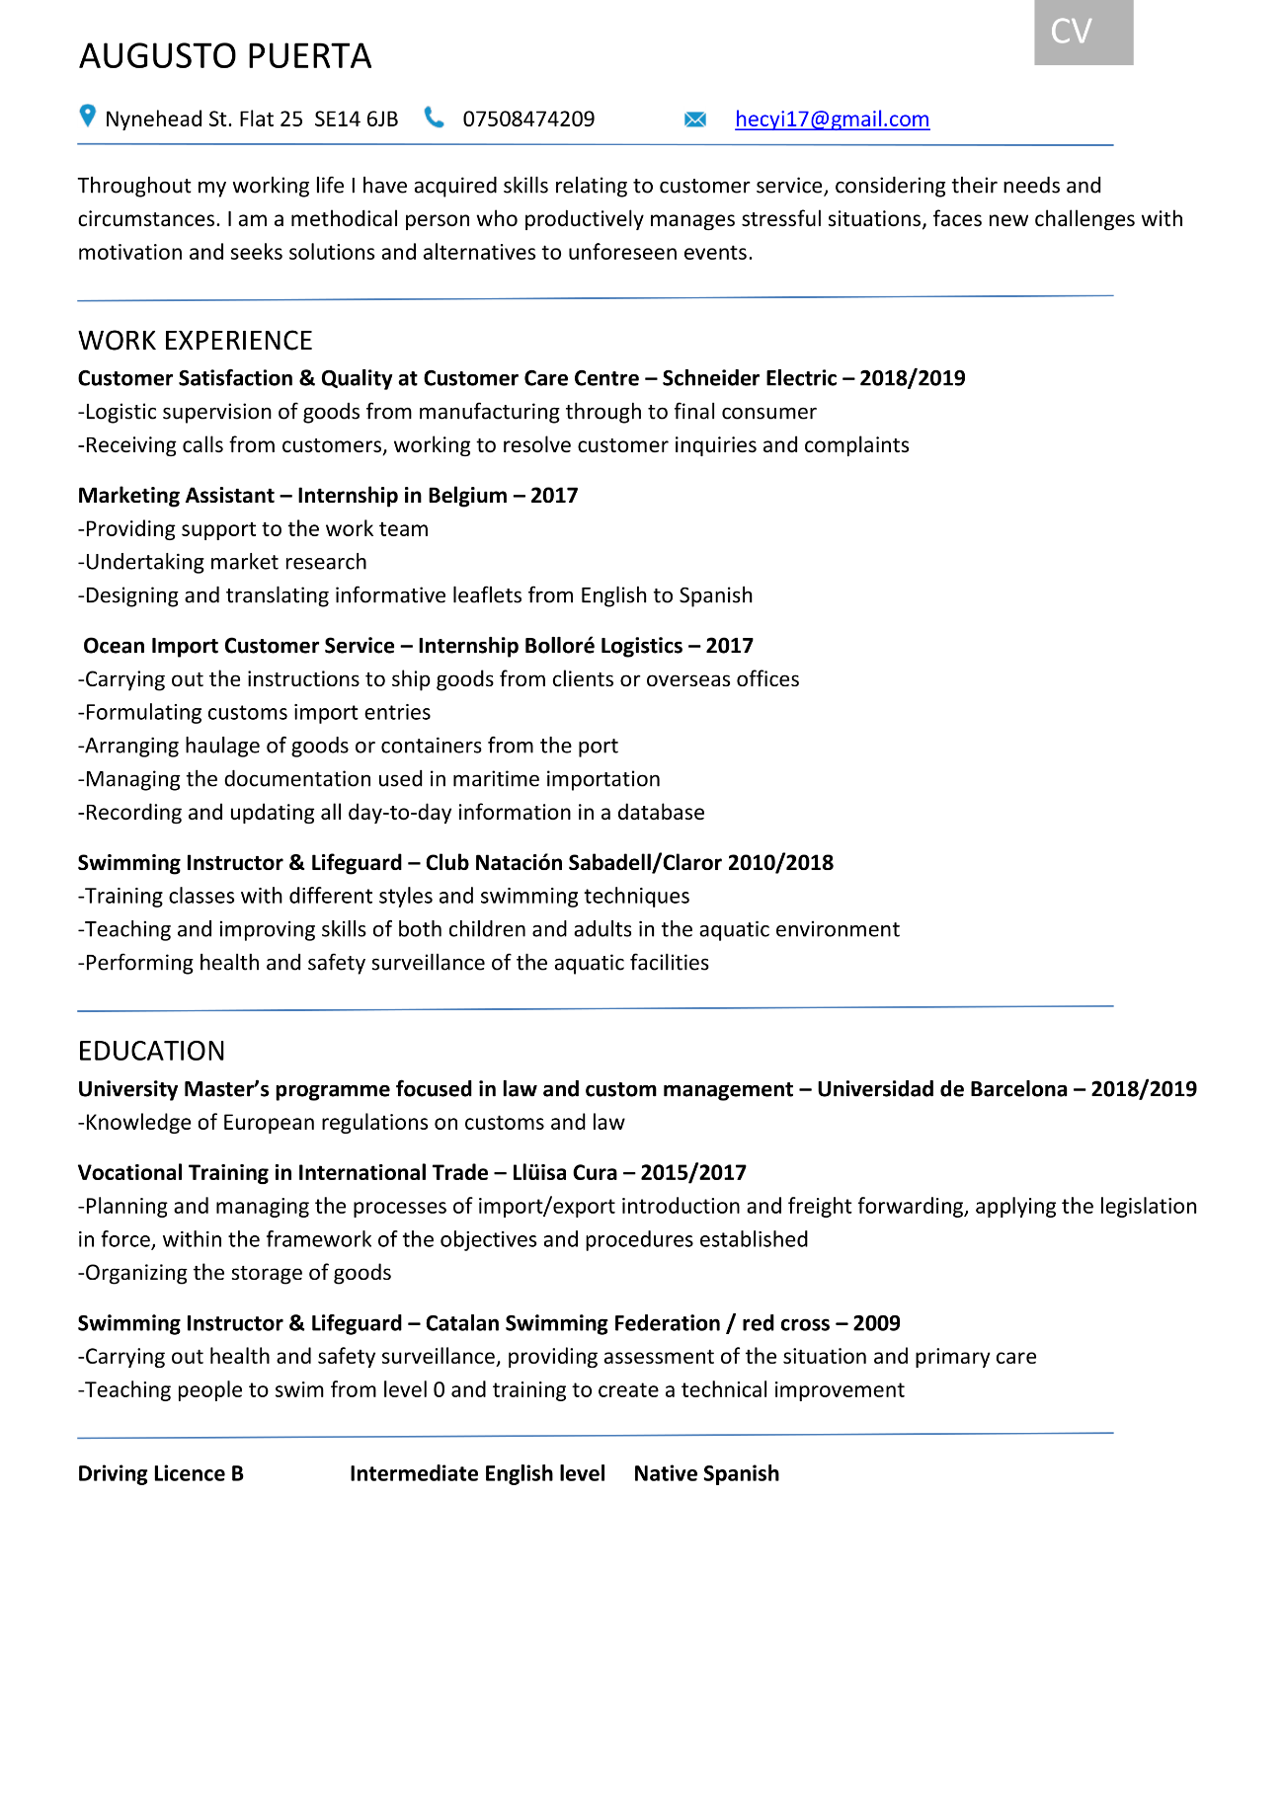
1 CV

