Appendices
Appendix 1: Letter to pupils
Appendix 2: Lesson plan
 | 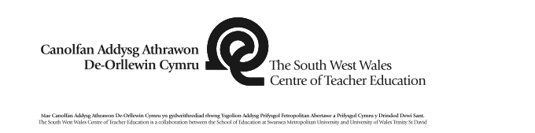 |  |  |  |  |  |  |  |  |  |  |  |  |  | 1B
 | Session Plan – Key Stage 2
 | Name of trainee: |  |  | Gemma Hayward |  |  |  | Session ref: |  |  | Geog1
 | Personal target(s) in relation to QTS:
 | Year group: |  | 3 |  | No. of learners: |  | 30 |  | ALN: | 3 children
 | Additional Adults: |  |  |  | 1 LSA
 | Learning objective(s):  Geog 5.4 Identify straightforward causes and consequences of change, and show some understanding of how people’s actions, including own, can improve or damage the environment.  Geog 5.3 Recognise that people have impacts on their environment. |  |  |  |  |  |  |  | Success criteria:  - Collate information from a range of sources to back up your argument.  - Construct an argument on your allocated point of view.  - Perform your debate with those of a different point of view.
 | Links to previous learning: Role play and real life heroes
Curriculum coverage (range, skills)
Geog 5.4 Identify straightforward causes and consequences of change, and show some understanding of how people’s actions, including own, can improve or damage the environment.
Geog 5.3 Recognise that people have impacts on their environment.

 | Literacy(LNF)  Y4: Explain information and ideas using supportive resources,  Y4: organise talk so that different audiences can follow what is being said, e.g. giving background information, providing a brief summary of main points  Y4: Keep in role and support others in role play  Y3: Explain information and ideas using relevant vocabulary  Y3: organise what they say so that listeners can understand, e.g. emphasising key points, sequencing an explanation  Y3: explore different situations through role play |  |  |  |  |  |  | Numeracy (LNF)  N/A
 | DCF  Develop strategies for finding information using different keywords and techniques. |  |  |  | Thinking  Identify and make links with prior skills and knowledge related to context. |  |  | ESDGC  Care for the environment and recognise its importance |  |  |  |  |  | YCC  Teaching through the medium of Welsh and using incidental in the life of the school.
 | Key vocabulary(English/Welsh):
Time |  | Session activities, organisation and management |  |  |  |  |  |  |  |  |  | Key questions & Assessment for Learning opportunities
 |  | Introduction  I will introduce the lesson by telling the children that todays’ topic has been influenced by my hero. I will play them a clip of David Attenborough’s voice to see if they recognise it. (2mins)  I will then ask if they are aware of what he does and why they think he could be my hero. (3mins)  During the lesson we will look at one his most prominent arguments, plastic pollution.  The class will be shown a quick clip of Blue Planet. (3 mins)  Myself and Mrs Kelso will then demonstrate a mini debate on the contrasting views of a photo of a plastic bag in the ocean. (2 mins)  I will explain today’s task then nominate a team representative who will later debate their group’s point of view at the end of the lesson. (2 mins) |  |  |  |  |  |  |  |  |  |  | - Does anyone recognise this voice?  - Do you know what he does and what he’s famous for?  - Why do you think he could be my hero?  - Does anyone have any questions?
Main activities
Groups will be split up into 4. Each group will receive a debate cards to inform them of their groups point of view and character.
1st point of view: One group will represent David Attenborough and argue how the use of plastic can ruin our oceans.
2nd point of view: One group will represent a sea animal of their choice and express their point of view on plastic pollution in the ocean.
3rd point of view: One group will represent a plastic manufacturer and how useful plastic is to society.
4th point of view: One group will represent a member of society, and they can decide on their own point of view.

Each group will receive debate sentence starter to assist them with their arguments.
They will all receive a sheet of QR codes to research relevant websites to back up their arguments.
Each group will also have a few sets of VR goggles to witness plastic pollution in the ocean.
 |  | Plenary  Each group’s representative will come to the front of the class and take a seat.  They will take it in turns to express their opinions and points of view. Once they have stated their point of view other debaters will have the opportunity to respond to it.  (10 mins)  Children will rag rate their learning by the fist to 5 strategy. |  |  |  |  |  |  |  |  |  |  | - Has the debate helped you learn and develop your skills today?  Children will rag rate their learning on their skill slips and give themselves a feedback and feed forward.  They will also rate their learning by using the fist to 5 strategy,

Appendix 3: Observation notes prior to role-play in School 1
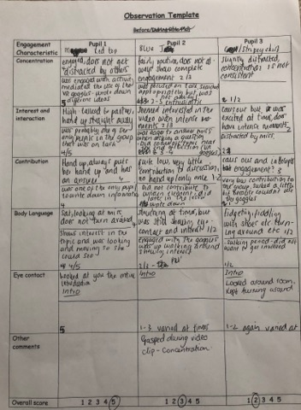
Appendix 4: Observation notes during role-play in school 1
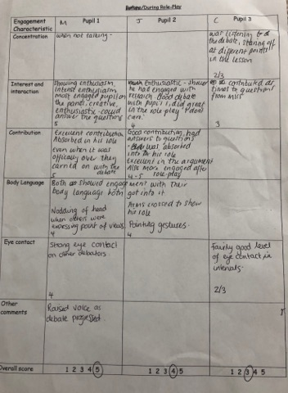

Appendix 5. Extract from interview with case pupils in School 1.
Me: What did you think of the role-play activity?
Child A: It was amazing
Me: Why was that?
Child A: The argument I had with the plastic manufacturer was interesting.
Child B: It was fun, and I got to be someone else and debate with Child A. We also to learnt about Child A’s experiences.
Me: Do you think you learnt from the role-play?
Child C: I learnt a lot from the lesson.
Child B: Yes, I will stop making plastic now, and this wasn’t even my point of view, I ended up agreeing with Child A’s point of view.

Appendix 6: Observation notes prior to role-play School 2
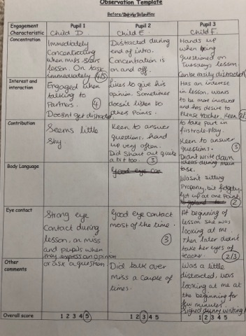

Appendix 7: Observation notes during second role-play activity in School 2
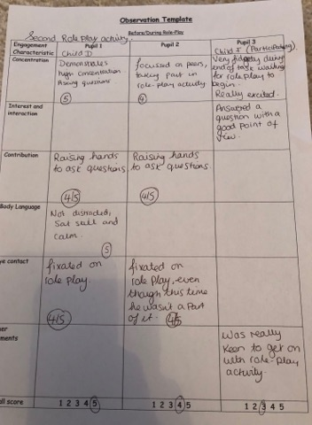

Appendix 8: Extract of interview with case pupils in School 2.
Colleague: How was it being a spectator of the role-play?
Child D: It was fun.
Colleague: What did you think of the role-play activity?
Child E: It was fun.
Colleague: Why was it fun?
Child E: Because I got to pretend to be someone else.
Child D: It looked fun, I would like to do it too.
Child F: I liked it when I was handcuffing everyone when I was the police officer.

Appendix 9: Reflection on Lesson Study 1

