
Component 1 - Portfolio
Changemakers: Building your Personal Brand for Sustainable Employment (BMHP5015_BIRM)

July 5, 2026
Tutor Name: Nouh Elmitwally
Syed Mudassar Hussain (2407258)

Contents
Task 1 – Personal Brand 2
Task 2 - Network Map and Rationale 3
Task 3- Blog 5
AI and the NHS Workforce: Tool or Threat? 5
Task 4- NHS Equality, Diversity and Inclusion Quiz 7
Task 5- A Letter to Yourself 10
Task 6- GANTT Chart 12
Task 7- Making Changes- Report 17
Implementation of an Electronic Medication Administration Record 17
References 19

Task 1 – Personal Brand
Write about your own person brand and how you could develop this to enable you to reach your employment goals (250 words- Minimum of 2 referenced sources)

Personal branding is a strategic method for communicating my unique professional value and skill set, helping me stand out in a competitive job market. Building one deliberately matters because a strong personal brand is now widely recognised as an important factor in career success and perceived employability (Gorbatov et al., 2021), especially within Artificial Intelligence (AI)-driven health and social care.
Currently, my personal brand is characterised by ethical awareness, reliability, and adaptability. Colleagues and classmates recognise me as diligent, trustworthy, and a critical thinker, qualities essential in healthcare contexts where cross-disciplinary collaboration is imperative for successfully integrating AI technologies (Ta’an et al., 2025). My ethical insight into data privacy and fairness is especially pertinent, as these principles are central to responsible AI practices in healthcare (Pham, 2025). I have strong skills in research, communication, and programming, especially in C/C++. Proficient with data management tools like Excel, I bridge the gap between technical and healthcare professionals to enhance collaboration and problem-solving. Motivated by curiosity and a commitment to learning, I seek to deepen my understanding of AI and healthcare technologies as they become integral to practice (Schneider-Kamp and Godono, 2025). Deepening this understanding will enhance my brand's credibility across my target roles.
I recognise significant gaps requiring attention. Professionals must have a strong grasp of machine learning, data literacy, and health informatics (Gazquez-Garcia, Sánchez-Bocanegra, and Sevillano, 2025). To address this, I plan to complete structured online courses, including the AI for Medicine Specialisation, and gain relevant placement experience. Ultimately, by merging technological expertise with compassionate, ethical practice, I aim to establish myself as a credible AI practitioner driving meaningful innovation in Health and Social Care (HSC).

Task 2 - Network Map and Rationale
Create a map of your own network considering career, support, social and community dimensions. Additionally you should provide a supporting rationale explaining and critically assessing this (250 words-Minimum of 2 referenced sources).
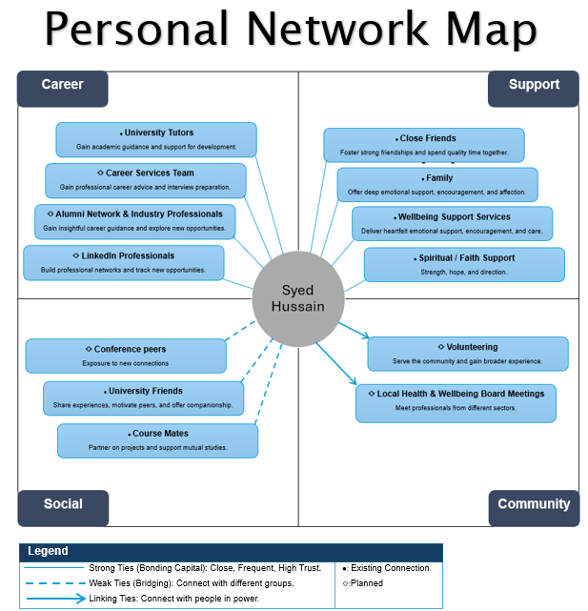

Figure 1: Personal Network Map
Source: Author's own

My network is predominantly hybrid rather than simply closed; while strong bonding ties dominate, I am actively seeking professional connections even where they do not yet exist. I maintain close bonds with family, friends, and faith and well-being support networks, providing reliable practical and emotional support (Torrejón and Martin-Matthews, 2022). However, the network narrows considerably beyond these core ties. Career contacts are limited mainly to university tutors, and community engagement remains absent. Critically, this inward focus reflects the structural constraints of student life, which restrict opportunities to build broader relationships (Ferlander, 2007). Moreover, bonding capital offers emotional strength, yet social capital can be "double-edged," as dense, exclusive ties risk social closure and may discourage engagement with new professional circles (Villalonga-Olives and Kawachi, 2017).
Two further weaknesses are apparent. First, I lack relationships across different professional sectors and social backgrounds, which Granovetter (1973) argues are essential for accessing new information through weak ties. Without bridging connections, I risk reinforcing an echo chamber that narrows my understanding of diverse populations: a direct concern in health and social care practice, where awareness of varied lived experiences is professionally essential. Second, linking capital is minimal; I have few connections with those in institutional authority, such as senior public health professionals, partly because my student status limits access to professional environments and formal networks (Woolcock, 2001).
To address these gaps, I intend to draw on tutors and career services to develop bridging capital through alumni events and conferences. Linking capital will be strengthened through Health and Wellbeing Board meetings, connecting me with those in institutional authority. LinkedIn will sustain both forms of capital strategically over time (Davis et al., 2020).

Task 3- Blog
Write a blog exploring a current topic or issue of your choice within the health and social care sector in the UK. The purpose of this is to inform a specific target audience of your choosing (400 words) Referencing of your sources of information is not a compulsory requirement but could be beneficial.

AI and the NHS Workforce: Tool or Threat?
What if healthcare professionals could spend less time on paperwork and more time with patients? With AI-powered tools automating clinical documentation and assisting with routine scan triage, this is becoming a reality. The NHS is rolling out AI technologies that could save over 500,000 staff an average of 2 days per month, improving efficiency and patient care (NHS, 2026), but also raising a serious question: is it a powerful tool or a threat to the workforce? As healthcare professionals, such as nurses and doctors, we need the right answers to do our work and ensure patient safety.
The case for "Tool"
The Topol Review suggested that AI should support clinicians by automating routine tasks, thereby allowing more time for patient care (NHS, 2019). By analysing patient data and offering evidence-based recommendations, AI-driven clinical decision support systems can help healthcare professionals make quicker, more informed decisions. This can enhance the quality and safety of patient care (Ford et al., 2021; NHS, 2023a). In this context, AI serves as a support mechanism for the workforce rather than as a replacement for staff.
Proceed with Caution
Despite the growing enthusiasm around AI, concerns remain. In 2026, major healthcare unions and professional bodies warned that the NHS workforce strategy may overestimate AI’s productivity benefits, emphasising that technology should support and complement qualified clinical staff rather than replace them (Royal College of Nursing, 2026). Concerns continue to circulate among healthcare professionals about the impact of AI on workload, professional well-being, and the dynamics of doctor-patient relationships (Allen et al., 2024). Furthermore, unresolved ethical issues such as algorithmic bias, data privacy, and the accountability of AI systems when errors occur pose significant challenges (Morley et al., 2020). These risks underscore that an overreliance on AI could endanger patient trust and compromise professional integrity.
Conclusion
The candid response is that the impact of AI depends largely on how it is deployed. The same technology can either free up time or be used as an excuse for understaffing. The Topol Review indicates that AI is most beneficial when it complements healthcare professionals rather than replaces them (NHS, 2019). The effects of AI on the NHS will be influenced by effective regulation, public trust, and ongoing human oversight (Ostridge, 2025). While AI can help alleviate workforce pressures and enhance efficiency, significant concerns regarding ethics, accountability, and patient safety remain. To fully harness its advantages, the NHS must invest in training, digital literacy, and robust governance. Ultimately, AI should serve to support healthcare professionals, ensuring that patient-centred care remains the foundation of practice.

Task 4- NHS Equality, Diversity and Inclusion Quiz (250 words equivalent)
- What is the primary goal of the NHS Equality, Diversity, and Inclusion Improvement Plan?
(Answer in one or two sentences.)
The plan aims to enhance equality, diversity, and inclusion in the NHS, strengthen belonging, improve the staff experience, and address discrimination for a fairer workplace (NHS, 2023b).

- How does the NHS EDI Improvement Plan propose to tackle the gender pay gap?
(Answer in one to two sentences.)
The plan tackles the gender pay gap through the Mend the Gap review recommendations, analysis of pay data by protected characteristic, and flexible working policies addressing structural barriers (NHS, 2023b).
- What is meant by the term ‘intersectionality’ as used in the NHS EDI Improvement Plan?
(Answer in one to two sentences.)
The plan treats intersectionality as overlapping protected characteristics compounding disadvantage, meaning single-characteristic approaches cannot fully address the combined barriers people experience (NHS, 2023b).

- Why is it important for the NHS to create a psychologically safe work environment?
(Answer in one to two sentences.)
A psychologically safe environment enables NHS staff to voice concerns, admit mistakes, and speak up, ultimately improving patient safety and care outcomes (NHS, 2023b).

- How does the NHS EDI Improvement Plan suggest improving the experience of internationally recruited staff?
(Answer in one to two sentences.)
The plan suggests comprehensive induction, pastoral support, equal development opportunities, and cultural awareness training for managers to help internationally recruited staff feel valued and integrated (NHS, 2023b).

- What role does leadership play in advancing EDI objectives according to the NHS Improvement Plan?
(Answer in one to two sentences.)
Leaders must have specific, measurable EDI objectives and be held accountable for them, as they set the tone and culture for an inclusive workplace (NHS, 2023b).

- Identify one way the NHS EDI Improvement Plan aims to reduce health inequalities within the workforce.
(Answer in one to two sentences.)
It seeks to reduce bullying and enhance civility, especially among staff with protected characteristics, to combat ill-health and absenteeism (NHS, 2023b).

- Why does the NHS EDI Improvement Plan emphasise the importance of collecting and analysing data on protected characteristics?
(Answer in one to two sentences.)
The NHS EDI Improvement Plan focuses on collecting and analysing protected characteristic data to identify inequalities, monitor progress, and improve staff experience while reducing discrimination (NHS, 2023b).

- Explain how flexible working policies can contribute to equality and inclusion in the NHS workforce.
(Answer in one to two sentences.)
Flexible working arrangements support work-life balance, enhance employee retention, and help reduce the gender pay gap and career obstacles for women and other groups (NHS, 2023b).

- What is one strategy mentioned in the NHS EDI Improvement Plan to combat bullying and harassment in the workplace?
(Answer in one to two sentences.)
Encouraging a comfortable environment for personnel to voice concerns aids in the early detection and management of bullying and harassment (NHS, 2023b).

Task 5- A Letter to Yourself
Think of a time in the past when you may have been experiencing issues or difficulties, and after considering what you have learned in this module about emotional intelligence and resilience write a letter to your younger self explaining how these attributes were important at that time and perhaps how developing these areas could have been useful (300 words)

Dear Younger Me,

I am writing with deeper insight, reflecting on the moment you began your university journey. I remember your self-doubt, believing that, as an immigrant, you were suited only to odd jobs, and fearing your dreams of higher education were out of reach. Despite your hard work, you struggled to see your own worth. Education had always mattered to you, and you urged your children to work hard. In time, you realised that, to expect this of them, you had to hold yourself to the same standard and pursue your goals.
What I understand now, which you could not see then, is that your struggles did not reflect a lack of ability but highlighted the need to develop emotional intelligence and resilience. Mayer, Salovey and Caruso (2008) define emotional intelligence as the ability to understand and manage emotions that influence thoughts and behaviour. At that time, fear and self-doubt shaped your decisions more than an honest assessment of your abilities. Greater emotional awareness could have helped you challenge these negative beliefs and recognise your academic potential. Goleman (2020) argues that self-awareness and self-motivation are key components of emotional intelligence, and that developing these skills earlier may have strengthened your confidence in pursuing higher education.
Your first year at university was challenging as you balanced academic, work and family responsibilities. Despite these pressures, you achieved a distinction in Level 4, showing that resilience involves adapting positively to adversity (Masten, 2001). However, resilience is not solely about personal determination. Seeking support earlier from family, friends and university services could have reduced stress and improved your well-being. True resilience is often rooted in the strength of relationships and support systems surrounding an individual.
You have always been enough. Resilience doesn't mean an absence of struggle, and emotional intelligence isn't about being free from fear; it's about confronting those challenges and moving forward regardless.

With love,
Your future self

Task 6- GANTT Chart
(200 words equivalent)
Compile a Gantt chart which illustrates the tasks you have to complete to achieve your future employment goals

Gantt Chart: Employment Plan
This Gantt chart was created by expanding the original template to encompass the entire duration of my employment goal, which spans from August 2026 to November 2027. The initial template covered only an eight-week timeframe, so I extended its daily timeline to outline all activities leading to the “Digital Health Project Officer” position on a continuous schedule. Since the timeline spans approximately 16 months, it cannot be displayed clearly in a single image; therefore, it is presented across four sequential images that together illustrate the complete plan.
The chart organises the work into three colour-coded phases: Skill Development, covering SQL, Python and machine learning; Coursework and Experience, covering the Level 6 course, a work placement and an initial CV; and Job Search, covering the updated CV, job applications, interview preparation, and securing the role. Horizontal bars show each task's duration, and overlapping bars show activities carried out in parallel.
The accompanying task table lists each activity with its start date, end date, duration and dependencies, which establish the logical order of the plan. Progress is shown as 0%, indicating this is a forward-looking plan rather than completed work.

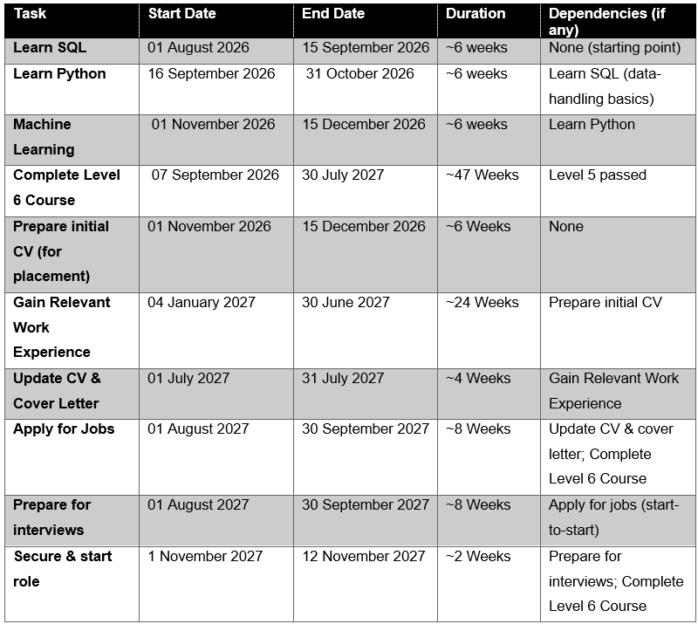
Task List and Dependencies
Figure 2
Source: Author's own

Gantt Chart: Timeline to Employment
Figure 3a
Source: Author's own

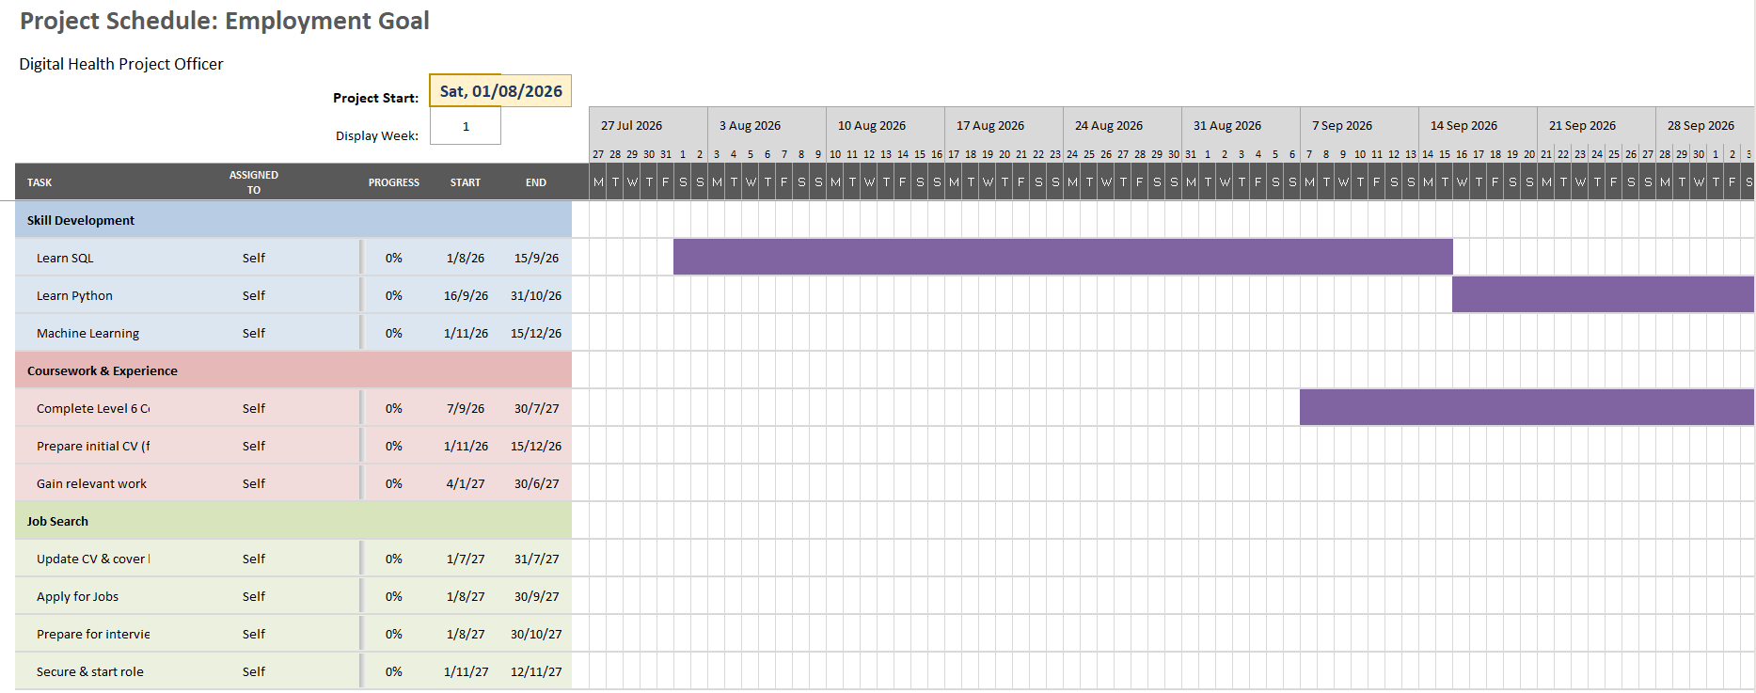
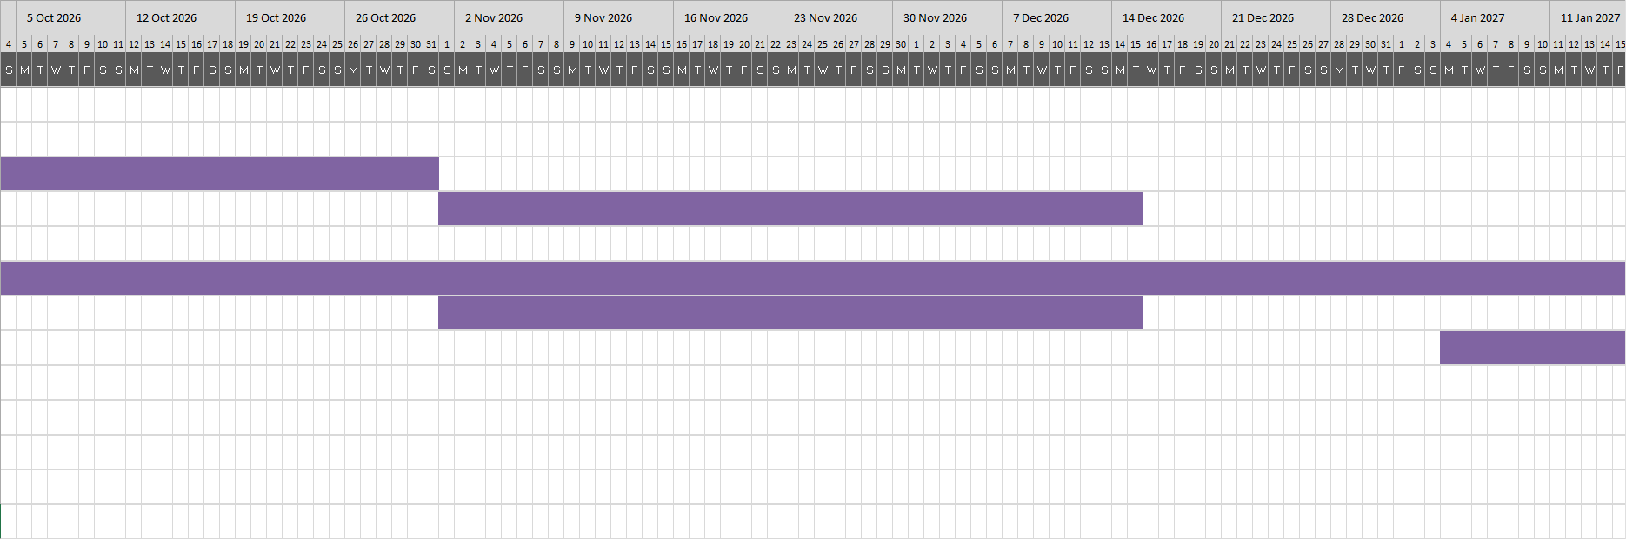
Figure 3b
Source: Author's own

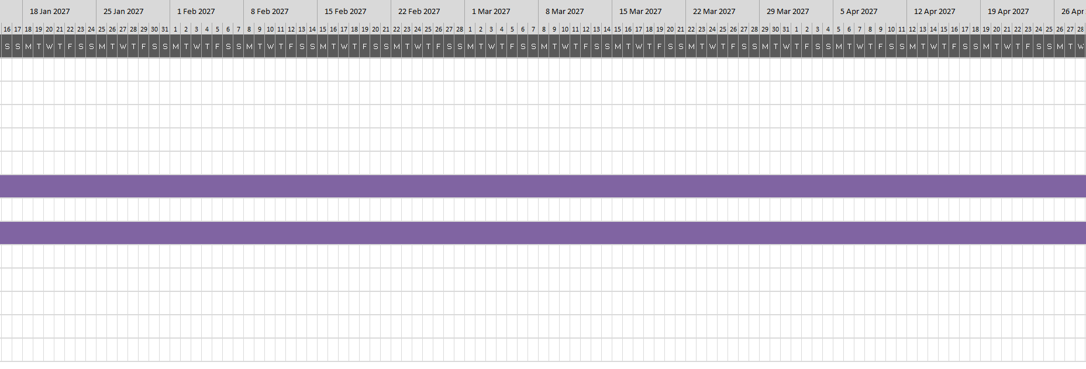
Figure 3c
Source: Author's own

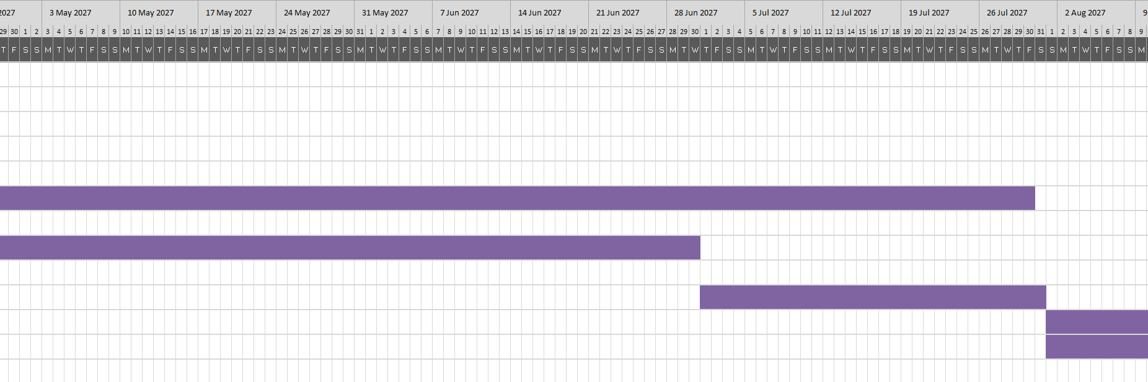
Figure 3d
Source: Author's own

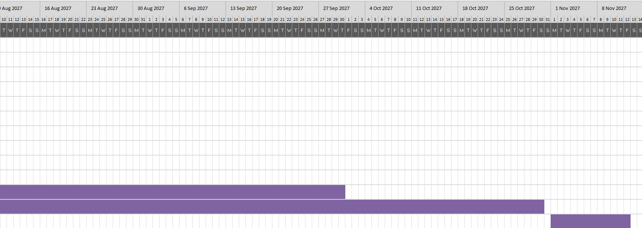
Figure 3e
Source: Author's own

Task 7- Making Changes- Report
You are the manager of a care home and want to make changes your workplace. Identify one specific change that you want to implement and write a brief report on how this is going to be achieved considering the necessary skills needed and addressing possible barriers to success. Relevant change models can be highlighted (350 words Minimum of - 3 referenced sources).

Implementation of an Electronic Medication Administration Record
1. Introduction
As a residential care home manager, I recommend adopting an Electronic Medication Administration Record (eMAR) system in place of paper-based records. Digital medication systems can reduce medication errors and improve documentation accuracy (Gates et al., 2021). Accurate, contemporaneous records are a key requirement in care home practice (NICE, 2014) and support safe, high-quality care (CQC, 2024).
2. Planning the Change
The eMAR system will digitise prescribing, administration, and stock records, with real-time alerts and audit trails, involving care staff, nurses, the pharmacy, and residents. Implementation will follow Lewin’s (1947) three‑stage model, as using a recognised framework increases the likelihood of successful change (Mitchell, 2013). During “unfreezing”, staff meetings that clarify the risks of paper records build readiness and reduce resistance to change. “Moving” involves selecting an assured supplier via the Digitising Social Care programme, training staff, and piloting on one unit (NHS, no date). The “refreezing” stage embeds eMAR into routine practice through updated policies, regular audits and ongoing staff support (CQC, 2023).
3. Skills Required
Leading this change requires clear communication of the rationale, strong leadership to develop and share a vision, and staff engagement throughout implementation (Kotter, 2013). New systems compete with routine work for limited time, so time management is essential (Hovland and Moltu, 2019). Conflict-resolution and coaching skills address staff concerns, while professional accountability, central to the Code (NMC, 2018), underpins safe practice.

4. Barriers and Solutions
- Staff resistance
Staff may lack confidence in new digital technology or view it as adding to their workload (Rodrigues et al., 2024); involving them in decision-making and offering hands-on training can help alleviate these concerns.
- Digital infrastructure barriers
These are recognised barriers to digital adoption in care homes (Johnston et al., 2022), but Digitising Social Care grants and approved suppliers can offset costs (NHS, no date).
- Technology limitations
Electronic systems can introduce new errors and may not reduce actual harm (Gates et al., 2021); thus, training and workflow integration remain critical. Embedding an open safety culture that learns from incidents further enhances safety (WHO, 2020).
5. Conclusion
Introducing an eMAR system provides a practical, evidence-informed step toward reducing medication errors and improving overall quality of care. Applying Lewin's (1947) framework, with decisive leadership and practical responses to obstacles, sustains change among residents and staff.

References
Allen, M.R., Webb, S., Mandvi, A., Frieden, M., Tai-Seale, M. and Kallenberg, G. (2024) 'Navigating the doctor-patient-AI relationship-a mixed-methods study of physician attitudes toward artificial intelligence in primary care', BMC Primary Care, 25(1), p.42. Available at: https://doi.org/10.1186/s12875-024-02282-y.
Care Quality Commission (CQC) (2024) Digital record systems: achieving good outcomes for people using adult social care services. Available at: https://www.cqc.org.uk/guidance-providers/adult-social-care/digital-record-systems-adult-social-care-services (Accessed: 29 June 2026).
Care Quality Commission (CQC) (2023) Electronic medicines administration records (eMAR) in adult social care. Available at: https://www.cqc.org.uk/guidance-providers/adult-social-care/electronic-medicines-administration-records (Accessed: 30 June 2026).
Davis, J., Wolff, H.G., Forret, M.L. and Sullivan, S.E. (2020) 'Networking via LinkedIn: An examination of usage and career benefits', Journal of Vocational Behavior, 118, p.103396. Available at: https://doi.org/10.1016/j.jvb.2020.103396.
Ferlander, S. (2007) 'The importance of different forms of social capital for health', Acta Sociologica, 50(2), pp.115-128. Available at: https://doi.org/10.1177/0001699307077654.
Ford, E., Edelman, N., Somers, L., Shrewsbury, D., Lopez Levy, M., Van Marwijk, H., Curcin, V. and Porat, T. (2021) 'Barriers and facilitators to the adoption of electronic clinical decision support systems: a qualitative interview study with UK general practitioners', BMC Medical Informatics and Decision Making, 21(1), p.193. Available at: https://doi.org/10.1186/s12911-021-01557-z.
Gates, P.J., Hardie, R.-A., Raban, M.Z., Li, L. and Westbrook, J.I. (2021) 'How effective are electronic medication systems in reducing medication error rates and associated harm among hospital inpatients? A systematic review and meta-analysis', Journal of the American Medical Informatics Association, 28(1), pp. 167–176. Available at: https://doi.org/10.1093/jamia/ocaa230.
Gazquez-Garcia, J., Sánchez-Bocanegra, C.L. and Sevillano, J.L. (2025) 'AI in the health sector: systematic review of key skills for future health professionals', JMIR Medical Education, 11(1), p.e58161. Available at: https://doi.org/10.2196/58161.
Goleman, D. (2020) Emotional intelligence: why it can matter more than IQ. 25th anniversary edn. London: Bloomsbury.
Gorbatov, S., Khapova, S.N., Oostrom, J.K. and Lysova, E.I. (2021) 'Personal brand equity: Scale development and validation', Personnel Psychology, 74(3), pp.505-542. Available at: https://doi.org/10.1111/peps.12412.
Granovetter, M.S. (1973) 'The strength of weak ties', American Journal of Sociology, 78(6), pp.1360-1380. Available at: https://www.jstor.org/stable/2776392 (Accessed: 23 May 2026).
Hovland, R.T. and Moltu, C. (2019) 'Making way for a clinical feedback system in the narrow space between sessions: Navigating competing demands in complex healthcare settings', International Journal of Mental Health Systems, 13(1), p.68. Available at: https://doi.org/10.1186/s13033-019-0324-5.
Johnston, L., Koikkalainen, H., Anderson, L., Lapok, P., Lawson, A. and Shenkin, S.D. (2022) 'Foundation level barriers to the widespread adoption of digital solutions by care homes: Insights from three Scottish studies', International Journal of Environmental Research and Public Health, 19(12), p.7407. Available at: https://doi.org/10.3390/ijerph19127407.
Kotter, J.P. (2013) Leading change. Boston, Massachusetts: Harvard Business Review Press.
Lewin, K. (1947) 'Frontiers in group dynamics: concept, method and reality in social science; social equilibria and social change', Human Relations, 1(1), pp. 5–41. Available at: https://doi.org/10.1177/001872674700100103.
Masten, A.S. (2001) 'Ordinary magic: Resilience processes in development', American Psychologist, 56(3), p.227. Available at: https://doi.org/10.1037/0003-066X.56.3.227.
Mayer, J.D., Salovey, P. and Caruso, D.R. (2008) 'Emotional intelligence: New ability or eclectic traits?', American Psychologist, 63(6), p.503. Available at: https://doi.org/10.1037/0003-066X.63.6.503.
Mitchell, G. (2013) 'Selecting the best theory to implement planned change', Nursing Management, 20(1), pp. 32–37. Available at: https://doi.org/10.7748/nm2013.04.20.1.32.e1013.
Morley, J., Machado, C.C.V., Burr, C., Cowls, J., Joshi, I., Taddeo, M. and Floridi, L. (2020) 'The ethics of AI in health care: A mapping review', Social Science & Medicine, 260, p.113172. Available at: https://doi.org/10.1016/j.socscimed.2020.113172.
National Institute for Health and Care Excellence (NICE) (2014) Managing medicines in care homes (SC1). Available at: https://www.nice.org.uk/guidance/sc1 (Accessed: 29 June 2026).
NHS (2019) The Topol Review. Available at: https://topol.digitalacademy.nhs.uk/the-topol-review (Accessed: 16 June 2026).
NHS (2023a) Supporting clinical decisions with health information technology. Available at: https://www.england.nhs.uk/long-read/supporting-clinical-decisions-with-health-information-technology (Accessed: 17 June 2026).
NHS (2023b) NHS equality, diversity, and inclusion improvement plan. Available at: https://www.england.nhs.uk/long-read/nhs-equality-diversity-and-inclusion-improvement-plan (Accessed: 19 June 2026).
NHS (no date) Digitising the frontline. Available at: https://www.england.nhs.uk/digitaltechnology/digitising-the-frontline (Accessed: 30 June 2026).
NHS (2026) 500,000 NHS staff to get new artificial intelligence tools to help free up more time for patients. Available at: https://www.england.nhs.uk/2026/06/500000-nhs-staff-to-get-new-artificial-intelligence-tools-to-help-free-up-more-time-for-patients (Accessed: 16 June 2026).
Nursing and Midwifery Council (NMC) (2018) The Code: professional standards of practice and behaviour for nurses, midwives and nursing associates. Available at: https://www.nmc.org.uk/standards/code (Accessed: 30 June 2026).
Ostridge, H. (2025) AI in the NHS. Available at: https://lordslibrary.parliament.uk/ai-in-the-nhs (Accessed: 18 June 2026).
Pham, T. (2025) 'Ethical and legal considerations in healthcare AI: innovation and policy for safe and fair use', Royal Society Open Science, 12(5), p.241873. Available at: https://doi.org/10.1098/rsos.241873.
Rodrigues, D.A., Roque, M., Mateos-Campos, R., Figueiras, A., Herdeiro, M.T. and Roque, F. (2024) 'Barriers and facilitators of health professionals in adopting digital health-related tools for medication appropriateness: a systematic review', Digital Health, 10, p.20552076231225133. Available at: https://doi.org/10.1177/20552076231225133.
Royal College of Nursing (2026) NHS workforce plan ‘must be paused’ over concerns it fails to safely grow staff numbers and over-relies on AI, say health unions and professional bodies. Available at: https://www.rcn.org.uk/news-and-events/Press-Releases/nhs-workforce-plan-must-be-paused-over-concerns-it-fails-to-safely-grow-staff-numbers (Accessed: 18 June 2026).
Schneider-Kamp, A. and Godono, A. (2025) 'The AI-extended professional self: user-centric AI integration into professional practice with exemplars from healthcare', AI & Society, 40(7), pp.5469-5480. Available at: https://doi.org/10.1007/s00146-025-02319-5.
Ta’an, W.A., Damrah, S., Al-Hammouri, M.M. and Williams, B. (2025) 'Professional identity and its relationships with AI readiness and interprofessional collaboration', PLOS ONE, 20(5), p.e0322794. Available at: https://doi.org/10.1371/journal.pone.0322794.
Torrejón, M.J. and Martin-Matthews, A. (2022) 'A qualitative approach to bridging and bonding social capital: Experiences of a cohort of Chilean older people', Social Science & Medicine, 296, p.114710. Available at: https://doi.org/10.1016/j.socscimed.2022.114710.
Villalonga-Olives, E. and Kawachi, I. (2017) 'The dark side of social capital: A systematic review of the negative health effects of social capital', Social Science & Medicine, 194, pp.105-127. Available at: https://doi.org/10.1016/j.socscimed.2017.10.020.
Woolcock, M. (2001) 'The place of social capital in understanding social and economic outcomes', Canadian Journal of Policy Research, 2(1), pp.11-17. Available at: https://www.researchgate.net/publication/269576288 (Accessed: 23 May 2026).
World Health Organization (WHO) (2020) Patient safety incident reporting and learning systems: technical report and guidance. Available at: https://www.who.int/publications/i/item/9789240010338 (Accessed: 01 July 2026).

