ASSESSMENT 1: RESEARCH, BUILD AND DEPLOY A VIRTUALISED ENTERPRISE NETWORK
Lecturer: MD. Sadeque Imam Shaikh Student: Virgil Stanciu ID number: 2411552 Modul code: ACCA 5023 Networks Operate Systems and Services
Contents
Task 1 2
1.1 Types of Hypervisors 2
1.2 IP Addressing 3
1.3 Routing 3
1.4 Network Services: Essential Components for Modern IT Infrastructures 4
Task 2: Configuring Virtual Networks with Oracle VirtualBox 5
1. Choosing the Hypervisor 5
2. Preparing the Work Environment 5
3. Installing Operating Systems 8
4. Network Configuration 9
5. Connectivity Testing 12
6. Testing Connectivity Between Networks 16
Task 3 Reflection on Virtual Environment Configuration Documentation 17

Task 1

1.1 Types of Hypervisors
Type 1 Hypervisor (Bare-Metal) runs directly on physical hardware without a host operating system. It offers superior performance and reduced overhead, making it ideal for enterprise servers and data centers. Examples include VMware ESXi, Microsoft Hyper-V, and KVM.
Type 2 Hypervisor (Hosted) functions as an application running on top of an existing operating system. It is easier to install and configure but delivers lower performance due to the additional layer. It is suitable for development, testing, and personal use. Examples include VMware Workstation, VirtualBox, and Parallels Desktop.
Key Difference: Type 1 accesses hardware directly (maximum performance), while Type 2 depends on the host OS (greater flexibility).
Oracle VirtualBox Hypervisor
Oracle VirtualBox is an open-source, cross-platform Type 2 (hosted) hypervisor that enables simultaneous execution of multiple operating systems on a single physical computer. Originally developed by Innotek GmbH in 2007 and acquired by Oracle Corporation in 2010, VirtualBox has become one of the most popular virtualization solutions for individual users and development environments.
Main Features
VirtualBox operates as a software layer between physical hardware and guest operating systems, enabling the creation and management of virtual machines (VMs). It supports a wide range of guest operating systems, including Windows, Linux, macOS, Solaris, and BSD. Notable features include: snapshots (VM state captures), shared folders (for file exchange between host and guest), USB support, configurable virtual networks, and seamless integration between guest and host systems.
Advantages and Limitations
Primary advantages include: free cost, intuitive interface, cross-platform portability (Windows, Linux, macOS), and relatively modest hardware requirements. As a Type 2 hypervisor, VirtualBox is ideal for software testing, development, education, and running legacy applications.
However, performance is inferior to Type 1 (bare-metal) hypervisors such as VMware ESXi or Microsoft Hyper-V because it depends on the host operating system. It is not recommended for enterprise production environments or intensive workloads requiring direct hardware access.

1.2 IP Addressing
Data transmission on the Internet represents a complex process involving sophisticated addressing and routing mechanisms. When a computer initiates communication, data is segmented into packets containing source and destination IP addresses in their headers, similar to a postal address enabling precise delivery. IPv4 addressing uses a 32-bit format represented in dotted decimal notation, where a subnet mask determines the portion of the address belonging to the network and the portion dedicated to hosts.
IPv6 was developed to replace IPv4, offering 128-bit addresses that generate trillions of unique addresses, substantially exceeding IPv4 capacity. This massive expansion of address space supports the growing number of devices and simplifies the subnetting process by eliminating the need for careful address resource conservation.
Subnetting and IP addressing efficiency constitute essential mechanisms for optimizing network resource utilization. In IPv4, network planners must carefully balance the number of subnets against the number of host addresses per subnet to avoid IP address waste, often requiring the use of Variable Length Subnet Masks (VLSM). The formula 2^n determines the number of possible subnets, where n represents bits borrowed from the host portion.

1.3 Routing
Routing protocols constitute the foundation of router communication, facilitating efficient data transmission through complex networks. Static routing uses a single preconfigured route to send traffic to destinations, while dynamic routing offers multiple available routes to destinations. This fundamental difference determines the applicability of each approach in specific network contexts.
Static Routing
Static routing represents the process by which administrators manually configure routes in routing tables. Static routers do not update, maintain, or create routing tables automatically—these tasks are completed by a network administrator. Advantages include enhanced security, reduced overhead on the router's CPU, and no bandwidth consumption between links for updates. However, administrators must know how each router is connected, and this option is not ideal for large networks because it is time-consuming, and whenever a link fails, the entire network may stop.
Dynamic Routing
Dynamic routing uses sophisticated protocols for automatic updating of routing information. Dynamic routing protocols allow routers to communicate with each other, exchange routing information, and dynamically adjust network routing tables based on real-time changes in network conditions. Protocols are classified into distance vector (RIP, IGRP) and link state (OSPF, IS-IS), each using distinct algorithms for calculating optimal routes.
Optimal Approach for Current Topology
For the current topology, a hybrid approach constitutes the optimal solution. Hybrid systems typically use static configuration for access networks and dynamic protocols for distribution and core networks. Given the Debian server's role as a DHCP Relay requiring defined static routes to communicate between managed subnets and the main DHCP server, combined with Windows Server connectivity benefiting from dynamic adaptability for redundancy and failover in the Active Directory environment, this hybrid configuration offers necessary stability for critical services while maintaining flexibility for topological changes. Static routing ensures predictable paths for essential inter-VLAN traffic, while dynamic protocols like OSPF can manage redundant connectivity and rapid convergence in case of link failure.

1.4 Network Services: Essential Components for Modern IT Infrastructures
Network services represent the foundation of secure and efficient IT infrastructures, each with specific roles and particular implementation requirements.
VPN (Virtual Private Network) creates secure connections through encrypted tunnels between clients and corporate networks. In Always On VPN on Windows Server, IP address allocation is performed through DHCP or static pools, with the VPN server managing address blocks on behalf of clients. Optimal implementation integrates Active Directory Certificate Services for certificate-based authentication, offering superior security compared to traditional methods.
DHCP (Dynamic Host Configuration Protocol) automates network configuration and IP address allocation. It represents a fundamental technology that must function correctly alongside TCP/IP v4, Active Directory, DNS, and NPS. In complex topologies with DHCP Relay, configuration must ensure proper propagation between VLAN subnets.
Active Directory Domain Services (AD DS) constitutes the backbone for enterprise identity and policy management, integrating Certificate Services for PKI, Group Policy for centralized configuration, and authentication. Implementation requires careful planning of topology and replication strategy.
Certificate Authorities (CA) manage organizational PKI infrastructure. AD CS offers centralized certificate management, eliminating dependence on third-party authorities and reducing costs. Two-level hierarchies are recommended: offline Root CA for security, subordinate CA for daily operations.
Integration of these services is crucial for Always On VPN, with automatic enrollment offering significant advantages in authentication and secure communications.
Essential Aspects: up-to-date documentation, incremental testing, proactive monitoring, VLAN segmentation, regular backups, and use of troubleshooting tools (ping, traceroute, nslookup, Wireshark).

Task 2: Configuring Virtual Networks with Oracle VirtualBox

1. Choosing the Hypervisor
Following research conducted, Oracle VirtualBox was selected as the hypervisor to fulfil task requirements.

2. Preparing the Work Environment
2.1 Downloading Applications and Operating Systems
Before configuring the virtual environment, the following components must be downloaded from official websites:
Hypervisor:
- Oracle VirtualBox from virtualbox.org (Windows version)
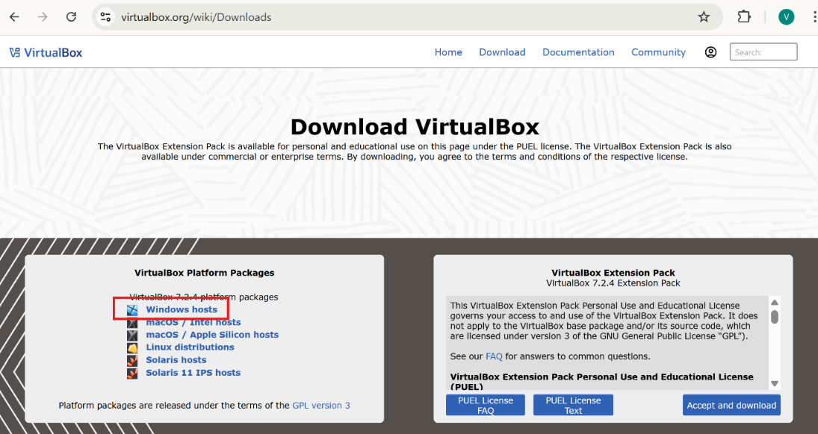

Instal Oracle VirtualBox
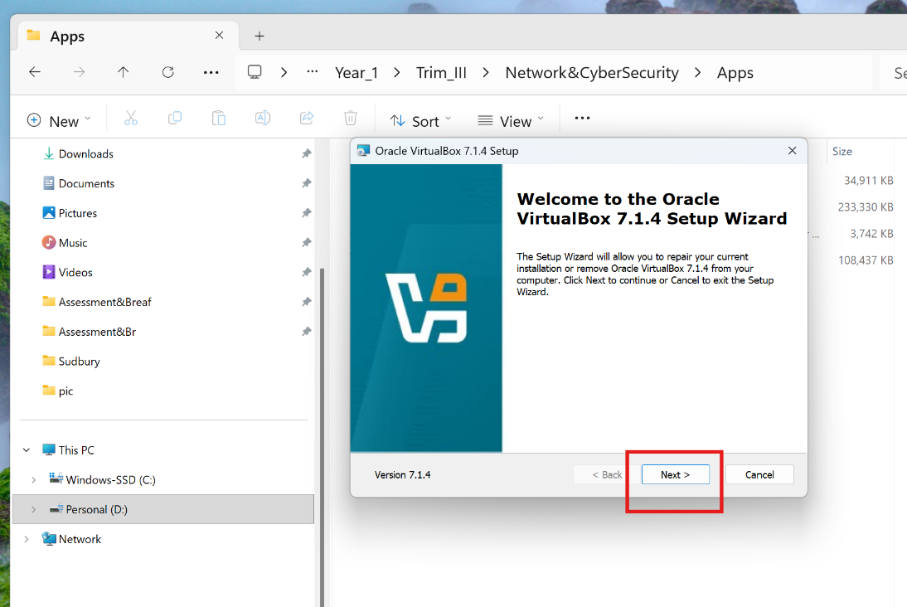

Operating Systems (ISO format):

- Windows Server 2019 (from official Microsoft website)

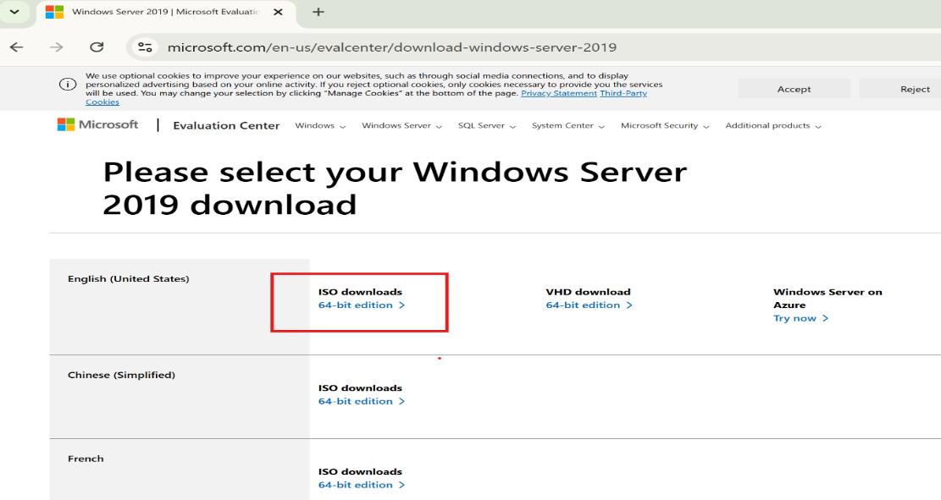

- Windows 11 (from official Microsoft website)

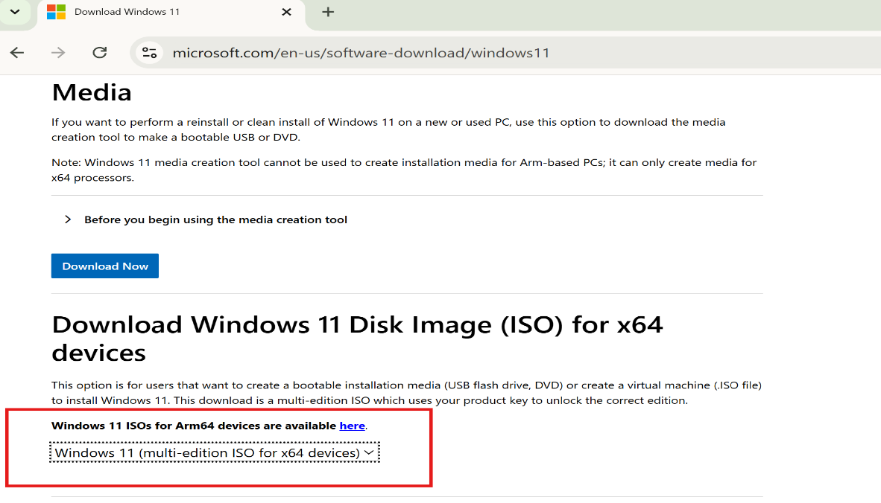
- Debian Linux 13 (for Debian Client) and Debian Linux 12 (for Debian Server)

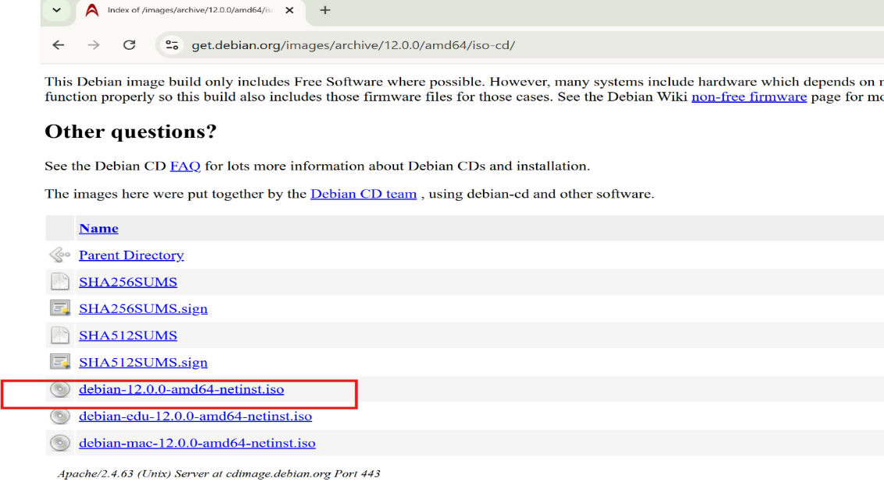

Note: All operating systems must be downloaded in ISO disk image format for VirtualBox compatibility.

3. Installing Operating Systems

Operating systems will be installed in the following order:
- Windows Server 2019
- Windows 11 (configured as Client)
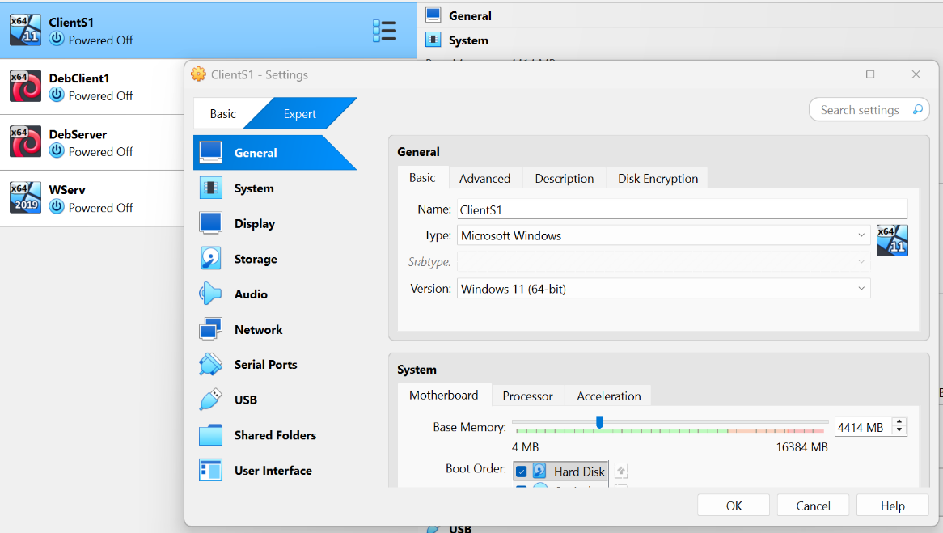

- Instal Debian Linux 12
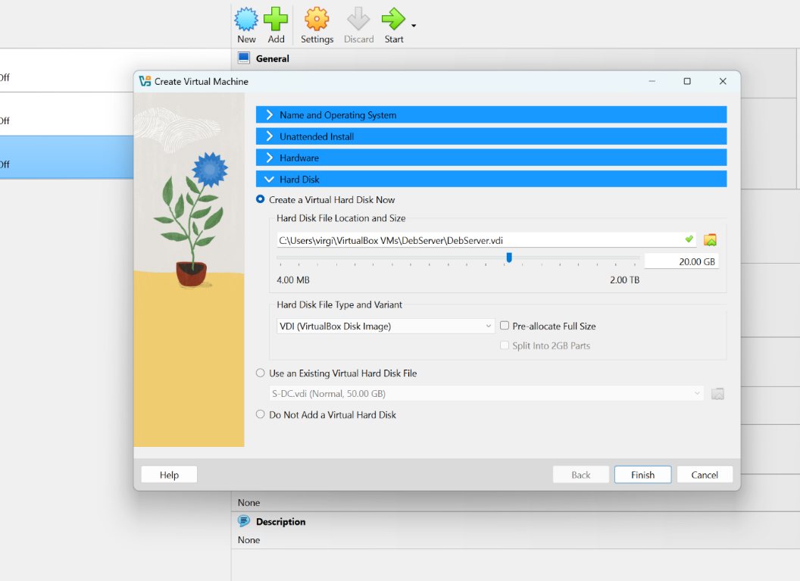
(configured as Server)
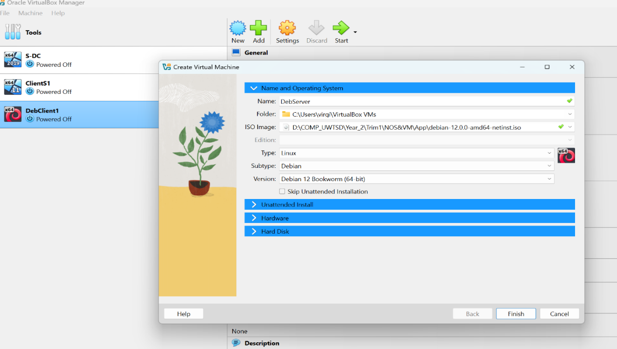
- Debian 13 (configured as Client)

4. Network Configuration
4.1 Configuring Internal Networks
Two separate internal networks will be created:
- Internal Network Swansea - for Windows Server and Windows Client
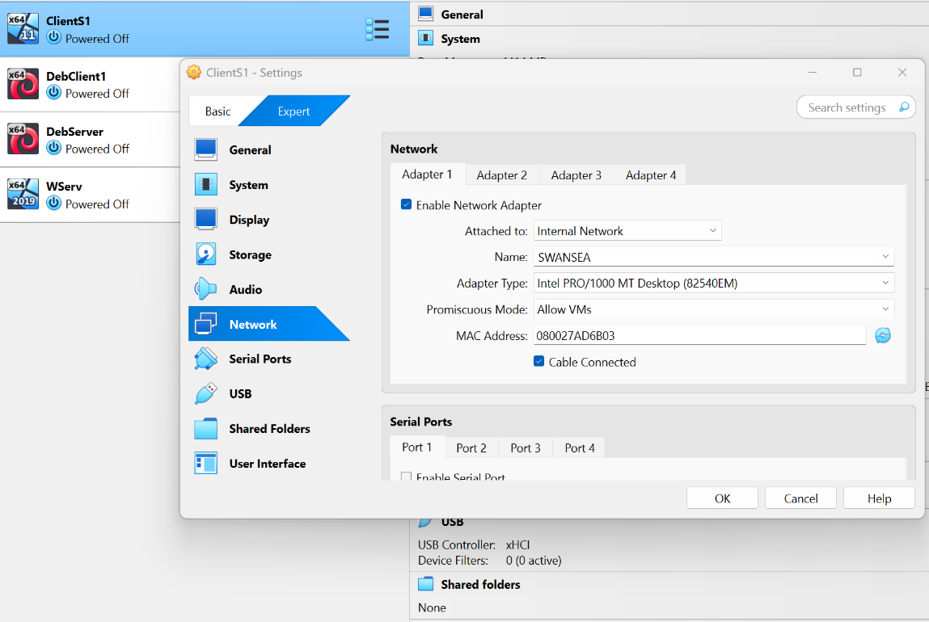

- Internal Network UWTSD - for Debian Server and Debian Client

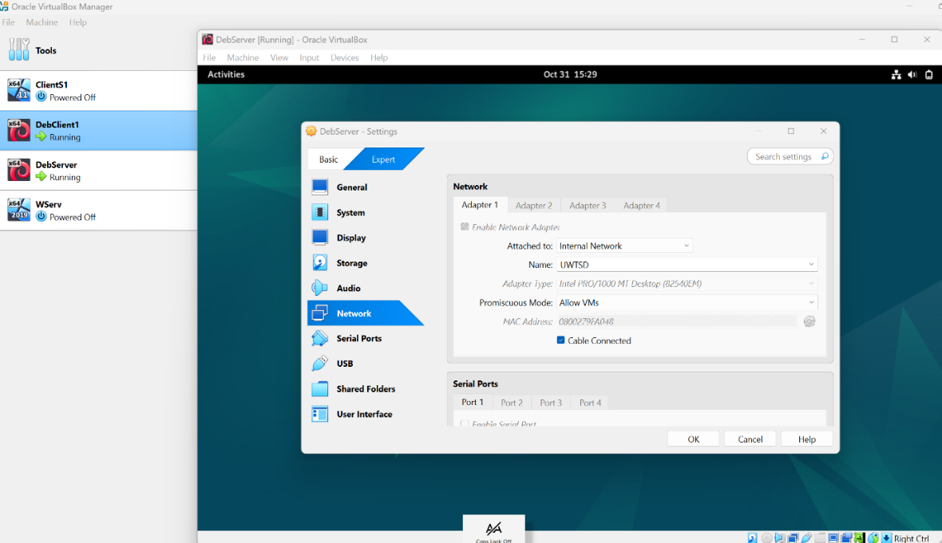

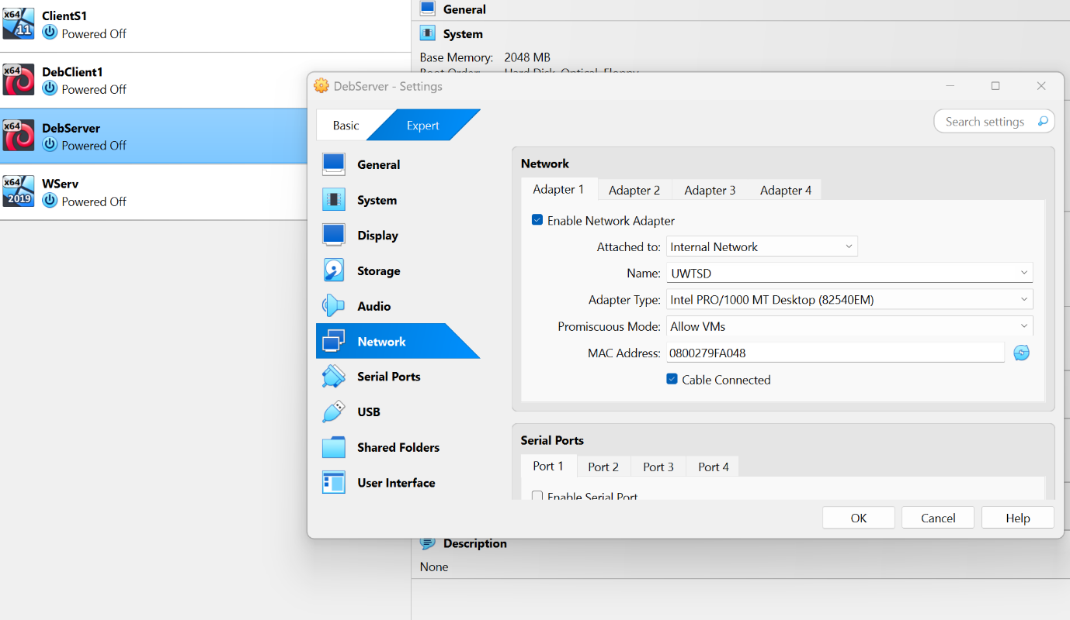

4.2 Manual IP Address Configuration
According to assessment brief requirements, IP addresses will be allocated as follows:
Windows Network (Swansea):
- Windows Server: 192.168.1.1
- Windows Client: 192.168.1.10
Debian Network (UWTSD):
- Debian Server: 192.168.2.1
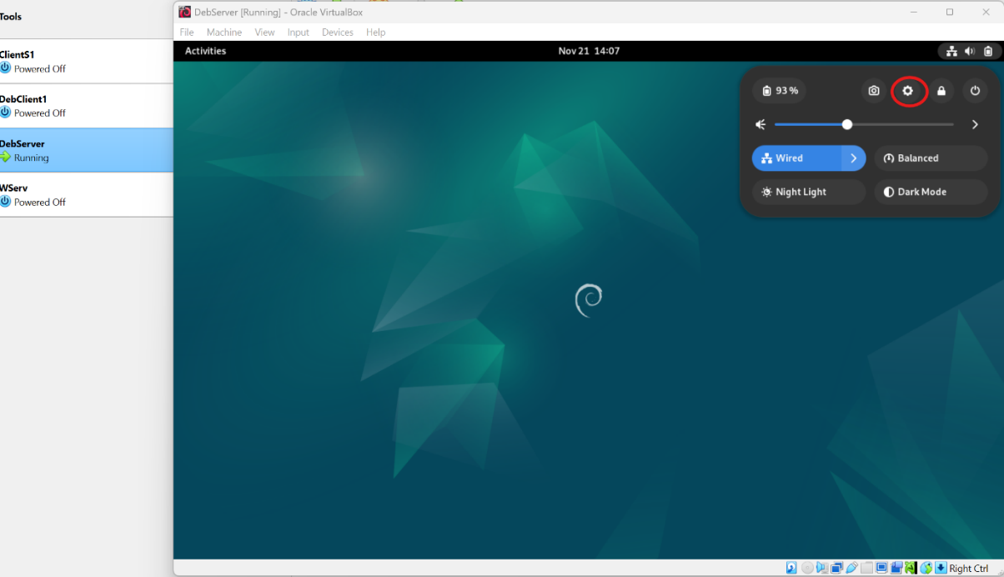

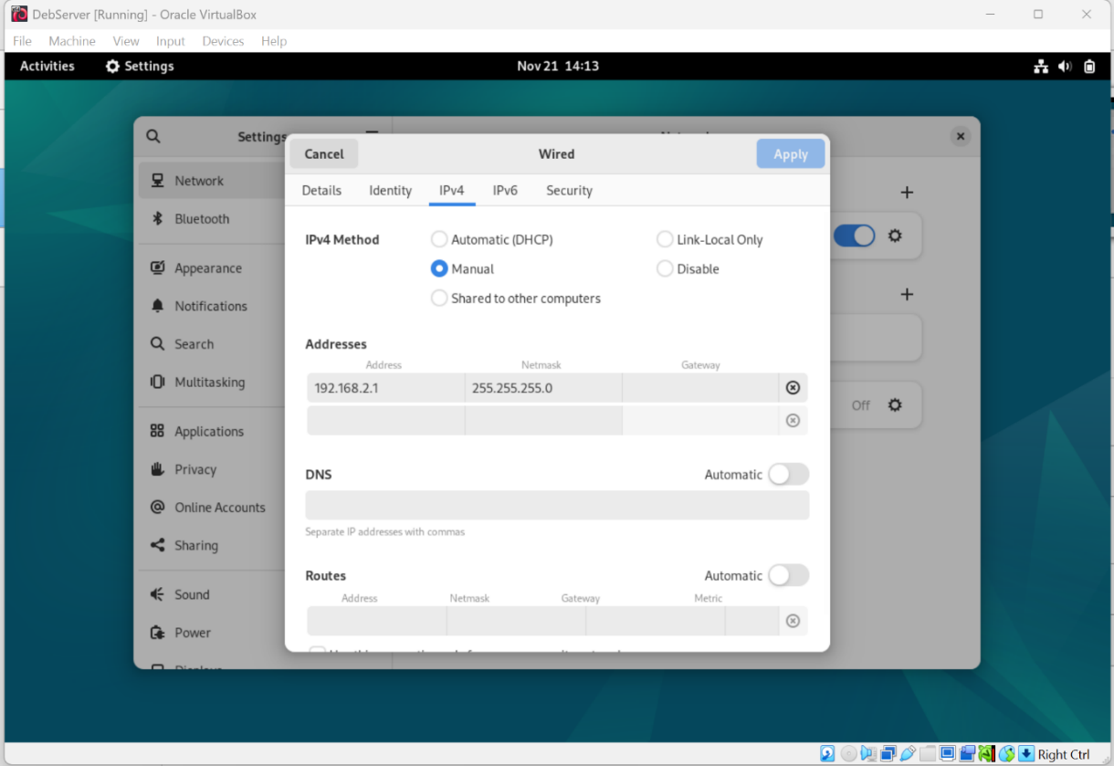

- Debian Client: 192.168.2.10
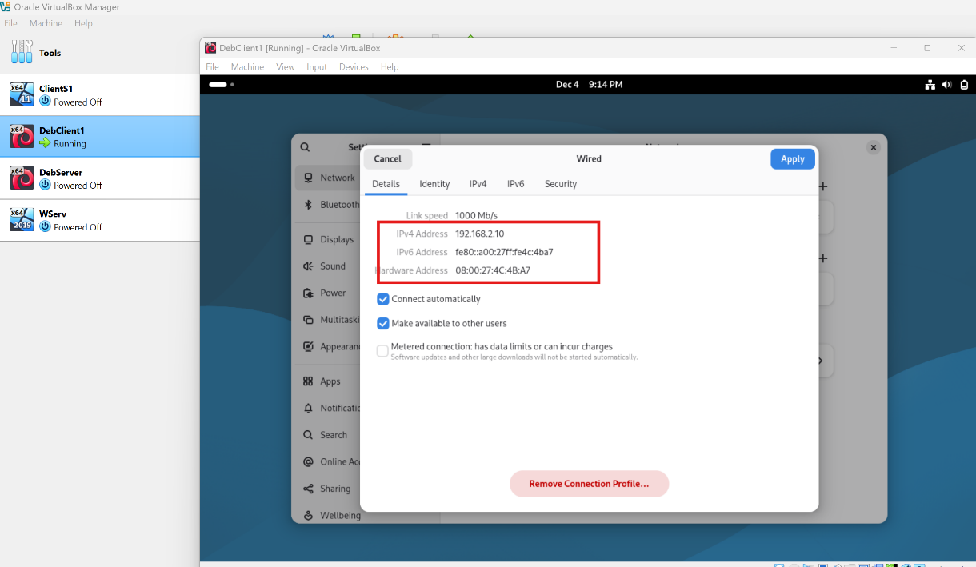

5. Connectivity Testing
5.1 Verifying Connectivity in Windows Network
On Windows:
- Open Command Prompt
- Execute command: ping 192.168.1.1 (from Windows Client to Windows Server)
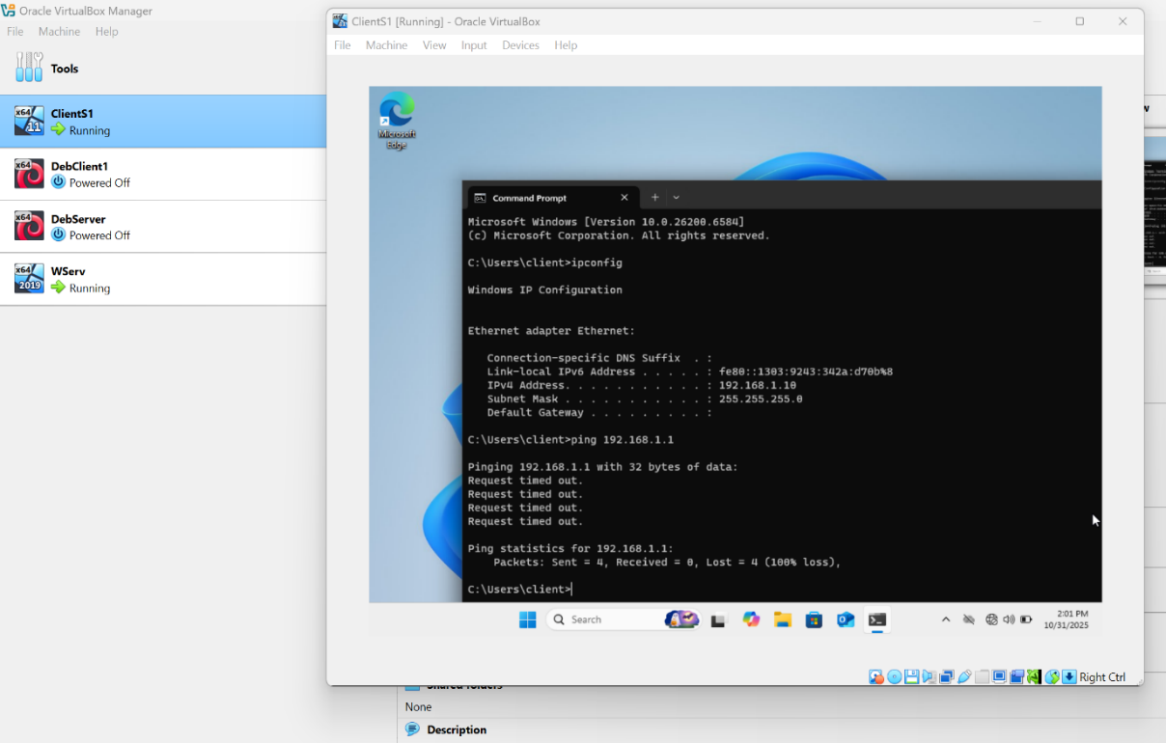
- Execute command: ping 192.168.1.10 (from Windows Server to Windows Client)
- During initial testing, packets will be lost due to active firewall.

5.2 Resolving Firewall Issues
Disabling Windows Defender Firewall:
- Access Server Manager
- Navigate to Dashboard
- Disable Windows Defender Firewall State

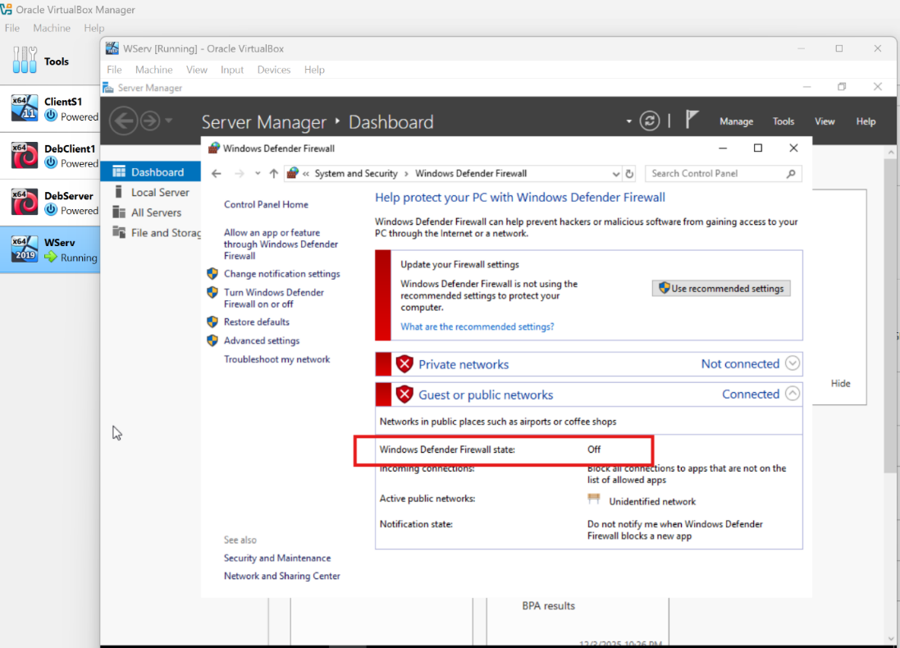

After disabling the firewall, re-execute ping commands to verify that all packets are transmitted and received correctly.

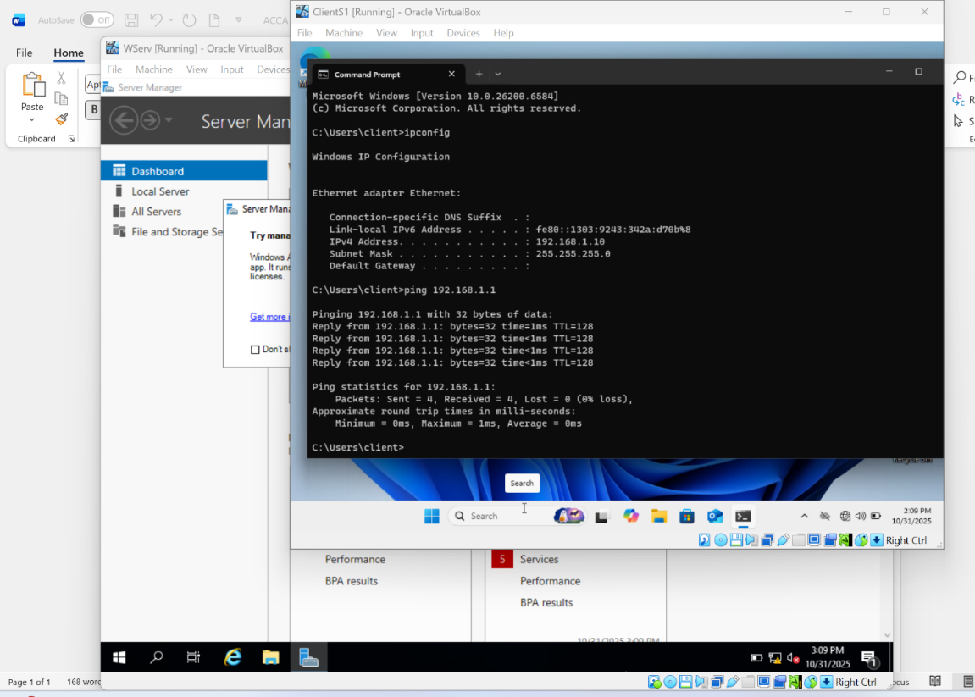

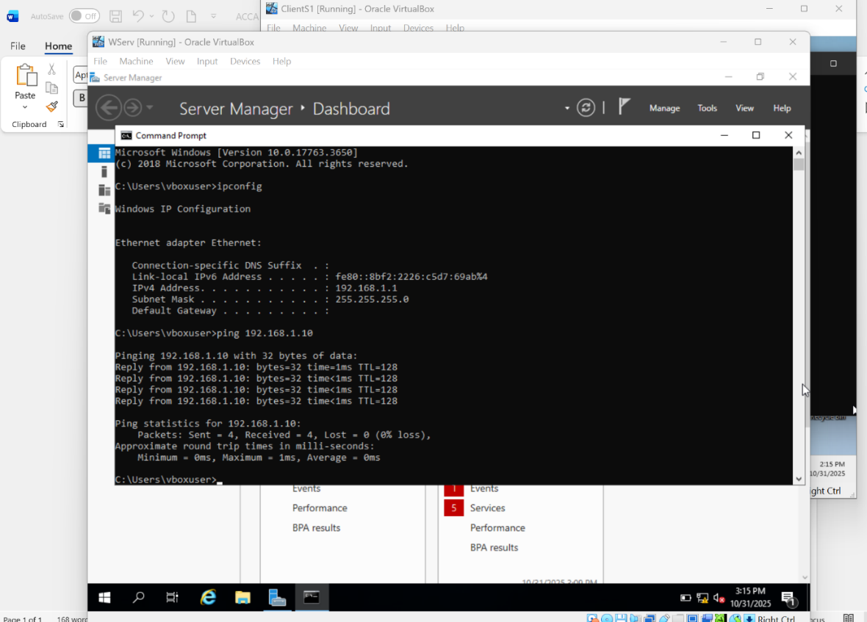

5.3 Verifying Connectivity in Debian Network
On Debian:
- Open Terminal
- Execute command: ping 192.168.2.1 (from Debian Client to Debian Server)
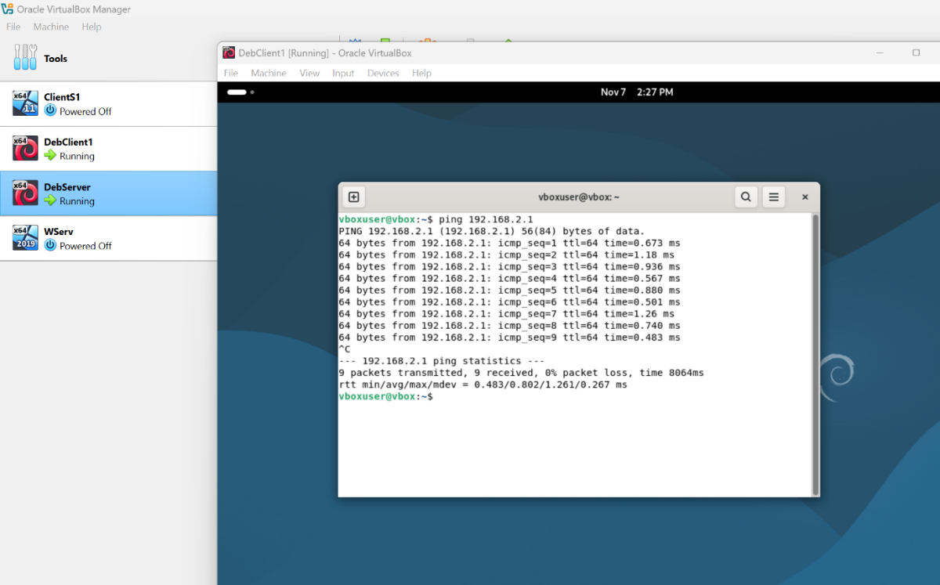

- Execute command: ping 192.168.2.10 (from Debian Server to Debian Client)

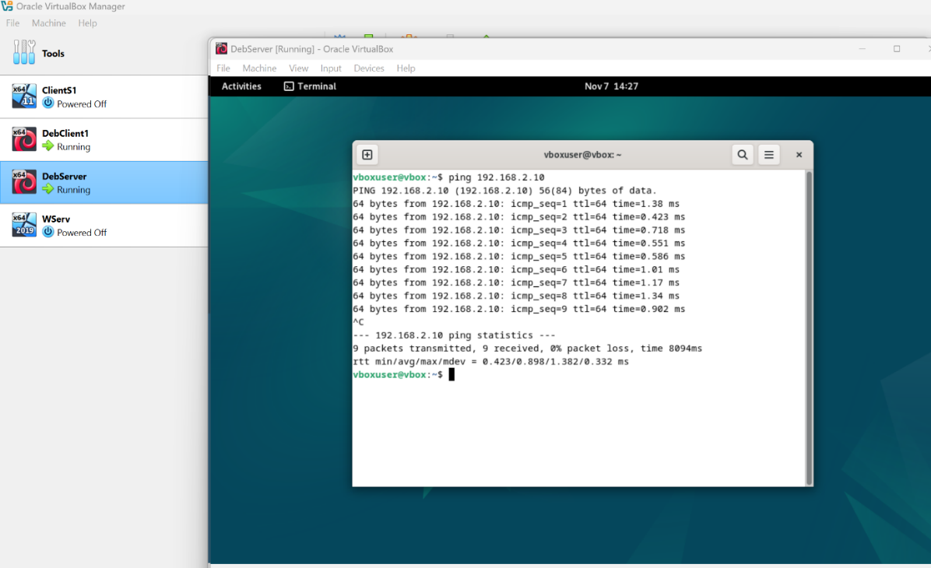

6. Testing Connectivity Between Networks

6.1 Verifying Windows-Debian Connectivity
Execute command ping 192.168.2.10 from Windows Client to Debian Client.

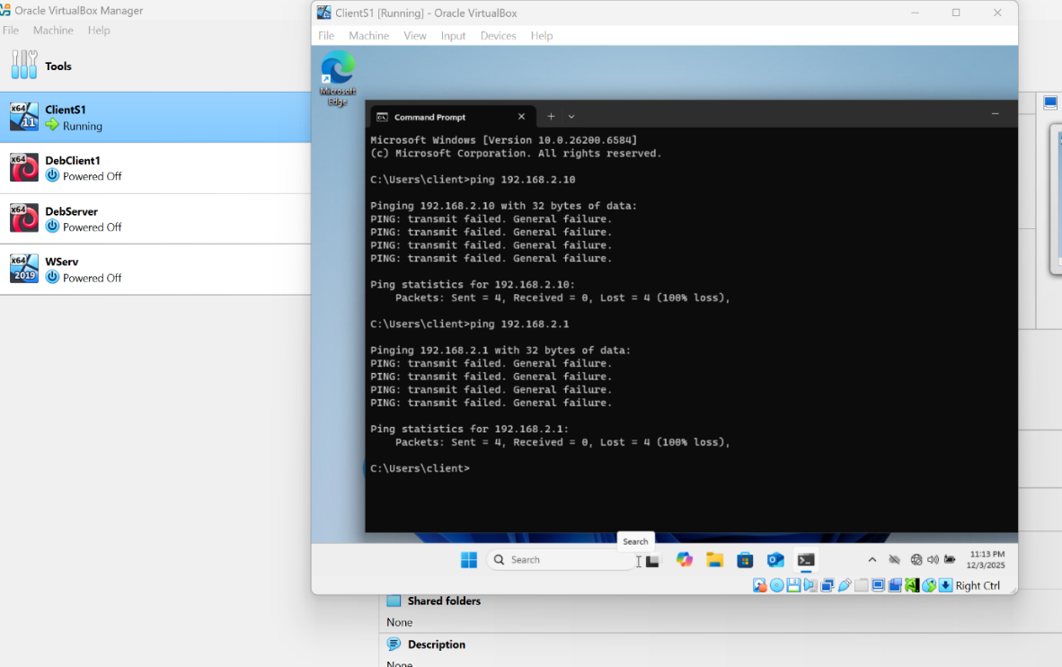

Expected Result: Packets will not be received because the two internal networks (Swansea and UWTSD) are isolated.

6.2 Conclusion
To enable connectivity between the two separate internal networks, it is necessary to configure Windows Server and Debian Server as routers/gateways to connect the Swansea and UWTSD networks.

Task 3 Reflection on Virtual Environment Configuration Documentation
The document presents a methodical and well-structured approach to creating a virtual testing environment using Oracle VirtualBox. The choice of this hypervisor is justified through prior research, demonstrating an informed decision based on analysis of available alternatives.
The logical structure of the process – from resource preparation to final testing – reflects a solid understanding of systems administration principles. The order of operating system installation and configuration of separate internal networks demonstrates careful planning, essential in avoiding compatibility or conflict issues.
A notable aspect is the practical approach to IP addressing scheme. Using two distinct networks (192.168.1.x for Windows and 192.168.2.x for Debian) ensures clear separation of environments, facilitating troubleshooting and management. This segmentation reflects real scenarios from enterprise infrastructures, where network isolation is crucial for security and organization.
The section dedicated to connectivity testing highlights the importance of methodical verification. Anticipating firewall problems and providing concrete solutions demonstrates practical experience. However, complete disabling of Windows Defender Firewall should be accompanied by security warnings – a better alternative would be configuring specific rules to allow ICMP traffic.
The final connectivity test between networks, which confirms their isolation, validates the configuration's correctness and offers a valuable lesson about network segmentation. This verification demonstrates that the environment functions according to specifications, ensuring that each internal network remains isolated, a fundamental aspect in testing and security scenarios.
The documentation serves as a comprehensive guide for replicating the environment, demonstrating significant pedagogical value for students or professionals in the field of systems administration.

