Assignment – Site Investigation Case Study
When working on a construction project, the ground conditions will change the plan depending on what the results are. The project team must be able to design and confront the problems that come with the construction phase. This includes scenarios such as underground obstructions and groundwater.

Before the construction phase takes place, a ground investigation needs to take place to determine the condition of the ground that will be constructed on. Ground testing investigations are in place to determine:
- Faults and voids underground
- Water table level
- Soil types
- Thickness of the ground layers

The idea to create a new restaurant and ice-cream parlour (with manager’s apartment) on Swansea foreshore, in the position indicated. The site is located between County Hall and the Marriot Hotel and is illustrated on the attached images.
When the Swansea Marina, previously known as the South Dock, opened in 1859 it was during the time that Swansea was experiencing an industrial boom. The major activity of the Lower Tawe Valley at the time was copper smelting, this was due to the abundance of high-quality coal. The copper was brought into the docks from Cornwall, Anglesey and other places.
The Swansea Marriot, which started construction in the early 1980’s, is situated not far from the river basin. This could indicate that the water table may be quite high
My recommendations for the site investigation would be to first of all do a walk over of the site, his is to insure there are not any major problems before you even start digging and excavating. Special considerations should be evaluated for the surrounding area this could be for monuments, gardens, parks etc. Building this cannot effect any withstanding historic or green based sites that are protected.
Preliminary Site Investigation
This preliminary site investigation incorporates gathering information, for example, the sort of structure to be developed and its future use, the requirements of neighbourhood construction laws, and the column and load bearing wall loads.
Significant savings in the exploration program can now and again be acknowledged if the geotechnical engineer responsible for the project thoroughly reviews the current data with respect to the subsoil conditions at the site under consideration. Valuable data can be obtained from the following sources.
- Geologic survey maps.
- County soil survey maps prepared by the U.S. Department of Agriculture and the soil conservation service.
- Soil manuals published by the state highway department.
- Existing soil exploration reports prepared for the construction of nearby structures.
The inspection of the site and the surrounding area should be undertaken by the engineer personally. The information gathered could end up being invaluable for the planning of the future project, and is the case for many developments. In some instances, the time of subsoil that is going to be encountered may be affected by the type of vegetation at a site. The presence of expansive clay soils could be identified by a crack in walls already standing at nearby structures or developments.
Investigation techniques are carried out to minimise the projects risk and to foresee how a ground will react to a construction project taking place. If ground investigation didn’t take place then the costs of repairs when things go wrong would cost a company a lot of money and jeopardise the project. Types of techniques used are :
Trial pits and trenches
This is when you investigate shallow ground conditions. This is to understand the type of condition within the soil. This generally gets excavated to a depth of 3.5 to 4.5 meters. This can prove to be more cost effective than other methods.
Window sampling and dynamic probing
This is seen to be a fast way of getting soil samples. This is carried on by putting tubes of different lengths in the ground. Mostly in shallow areas, also by sloping areas. Dynamic probing is for strength of soil for underground structures to be involved e.g. gas, water wells etc.
Light cable boreholes
This would be used in a case of if a site has bad access or low headroom. Tripod rigs get used to drill boreholes 460mm in diameter and up to 70 meters in depth. You see this being used where the soil is weaker and high quality samples are needed.
Rotary Boreholes
This can be used when drilling needs to take place through solid structure such as rock. Depths can be seen going as far as 100m. Bedrock samples can then be taken.
Sonic Drilling
Sonic drilling is a soil penetration technique that strongly reduces friction on the drill string and drill bit due to liquefaction, inertia effects and temporary reduction of porosity of the soil. The combination makes penetrating for a large range of soils easy for our Sonic rigs and tooling.
https://www.designingbuildings.co.uk/wiki/Ground_investigation
From these soil investigation techniques I highly recommend that the following are used for definite are trial pit and trenches and Light cable boreholes.
Detailed Site Investigation
The detailed site investigation comprises of making several test holes in the ground of the site. The engineer will then collect disturbed and undisturbed soil samples from different depths for visual investigation and laboratory tests. There is no guidance as to where the holes are created, or to show how deep the holes should be, therefore most engineers will create a hole at each corner of the site and one directly in the centre. Additional holes can then be mad depending on the results of the original 5 test holes. This type of investigation should be carried out throughout all foundations to firm soil layers.
Supplementary Investigation and Construction Control
A supplementary investigation should be carried out to determine the risk of damage to the soil of the site if unforeseen events were to take place in the future. These include events such as:
- The possibility of earthquake, factors of climate change, which will increase in likeliness in the future, such as flooding, seasonal swelling, and shrinkage, permafrost or soil erosion.
- How easily available local construction materials are such as concrete aggregates, building stones and water. The quality of local materials will also need to be determined.
- For river structures and surrounding water, tide timings, extreme high and low tidal ranges, seasonal changes to marina levels and the velocity of the tide will all need to be predetermined.
- Soil and rock samples, that are relating to the foundation of the project, will need to be tested and the results analysed for any constructional problems.
- Results of chemical analysis of soil, fill materials, and groundwater to determine possible deleterious effects on foundation structures.
- Any toxic effects on foundation structures will need to be predetermined to ensure there will be no future effect on the soil, groundwater or fill materials. This will need to be carried out to ensure there are no risks to the workers’ health or safety.
Building regulations and Constraints
Access restrictions should be considered when obtaining the equipment for a project as the ground conditions may make it unstable for heavy equipment. The width and height should also be considered as some equipment may not fit and therefore would be unsuitable. Obstructions and access should be assessed before a project begins as the following factors could cause issues and delays.
1. Soft or marshy ground, uneven ground, sloping ground.
2. Breaks in slope
3. Possible flooding
4. Buildings, gateways
5. Trees and mature shrubs.
An investigation should be carried out to ensure the area has adequate space for working, storing tools and stockpiling excavated materials.

There may be some issues in urban areas, in terms of physical constraints, that may affect the placement of the investigation, which include:
- Existing buildings adjacent to the area being investigated.
- The existing structures may have overhanging structural elements that extend further than the apparent footprint.
- Width and headroom should be taken into consideration when thinking about the access needed to travel between and around existing buildings to access investigation points.
- A thorough investigation should be carried out into the stability of the existing structures (e.g. retaining walls, pipes, shallow tunnels) before any ground investigation is carried out to ensure the safety of all staff involved. The investigation should focus on parts of a structure that may have a drilling rig or other plant used against it.
Utility Constraints
Situating the utilities should be carried out by desk study, specialist search, on-site search survey, on-site location and inspection holes, as appropriate.
The originator of the investigation should identify the location of utilities prior to any investigation taking place; this task may be delegated to the contractor.
Depending on the intended investigation techniques, certain utilities may impose minimum distance criteria for the investigation to ensure the safety of workers with access to the site. For example, there is a restriction on the distance of a rig mast from an overhead power line.
Underground utility detection of varying levels of detail should be carried out in accordance with PAS 128.
Environmental Constraints
On any brownfield site and on many greenfield sites e.g. agricultural land, there is a possibility that agents or substances potentially harmful to humans, or other potential receptors such as local flora and fauna, the water environment or structures, might be present.
Sites of Special Scientific Interest (SSSI) Seasonal constraints such as fields being ploughed, planted or harvested or animals' breeding seasons should be taken into account. With the project being next to the sea there maybe certain animals living around the area.
https://geotechnicaldesign.info/bs5930-2015/g19-1.html
Foundations
After weighing up all the observations I have made my recommendations for the foundation that should be used is a Pile foundation. I have come up with this as I feel that the location where the project is situated right on the shoreline the water table will be quite high and there could be a high possibility that the soil type is sandy. Dry compact gravel, or gravel and sand subsoils are usually adequate for Pile foundations. Sand holds together reasonably well when damp, compacted and uniform, but trenches may collapse and so sheet piling is often used to retain the ground in trenches until the concrete is poured.
Pile foundations are principally used to transfer the loads from superstructures, through weak, compressible strata or water onto stronger, more compact, less compressible and stiffer soil or rock at depth, increasing the effective size of a foundation and resisting horizontal loads.
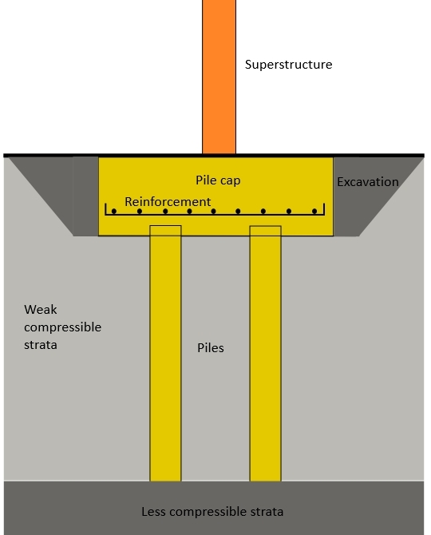
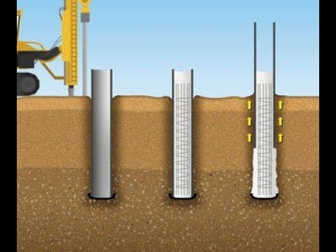

Friction piles are put in place to support the foundation where most of the pile-bearing capacity is developed by shear stresses along the sides of the pile, and are suitable when harder layers are too deep. It works by the pile transmitting the load to surrounding soil by causing friction between the surface of the pile and soil, which in effect lowers the bulb of pressure. This type of construction is typically used for larger structures, and in situations where soil is not suitable to prevent excessive settlement such as loose gravels and sands.
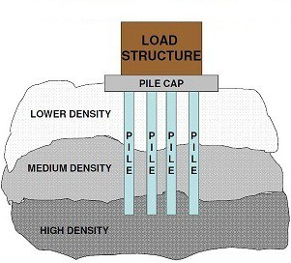
Equipment used for pile foundations
- Percussion drivers: hammers driven by compressed air or diesel.
- Hydraulic drivers: hydraulic rams push piles into the ground.
- Vibratory drivers: piles are vibrated into the ground.
- Rotary augers: used to screw replacement piles into the ground.
https://www.designingbuildings.co.uk/wiki/Piles

Depending on the results of the soil investigation another foundation that could be used is Raft are formed by reinforced concrete slabs of uniform thickness typically 150 mm to 300 mm that cover a wide area, often the entire footprint of a building, and are suitable where ground conditions are poor, settlement is likely, or where it may be impractical to create individual strip or pad foundations for a large number of individual loads.
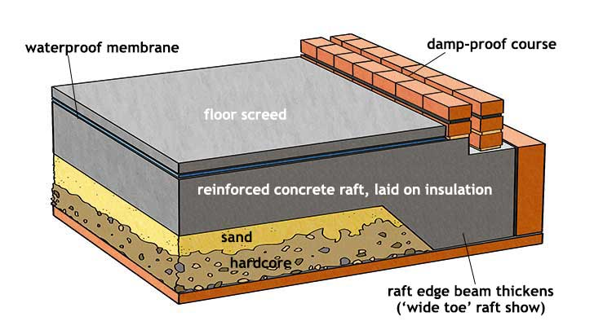

They spread the load imposed by a number of columns or walls over the area of foundation, and can be considered to ‘float’ on the ground as a raft floats on water.

