Digital Skill and Research Methods

Student Name: | Ionela Stefan
Student ID: | 1811818
Module Name: | Digital Skills and Research Method
Module ID: | BMSK4003
Lecturer: | Balendran Kandasamy

Table of Contents
Introduction 3
Use of modern technologies within the workplace 4
Aims and objectives 5
Exploring the social media as a mode of marketing, gathering and communication within the workplace 6
Evidence of my presence to social media 9
Conclusion 11
References 12

Introduction
Advanced in technology has significant influence on business. By using modern technology, business organisation improve workplace environment. It is effective to establish effective communication among the employees of the organisation. Moreover, it provides the scope to build relationship with the stakeholders of the organisation. In the competitive business environment, it is essential to have proper data to make appropriate decision and take initiatives to grab business opportunities or tackle business challenges. Social media has provided the opportunity to keep constant communication within and outside the organisation to understand the trends of business environment. It provides the scope to communicate with customers to collect information about their preferences and choices. This is very crucial and highly competitive for business. As a competitive industry, retail industry has been benefited from social media as well as modern digital technology. It has been observed that retail companies have been using digital media and modern technology to understand and evaluate market properly. Therefore, this research has been conducted to investigate the effectiveness of modern technology and social media as a tool for marketing, information gathering and communication within the workplace in retail industry in the UK from.

Use of modern technologies within the workplace
Digital technology is used to develop communication system. It is crucial to develop effectiveness of communication system. Improvement of internet facilities has increased communication system such as video conferencing, audio conferencing, cloud storage, social media, web based technology etc. In order to survive in the extreme market competition, it is essential to have sound knowledge and skills to utilise modern technology. There are different social media platform such as twitter, instagram, LinkedIn, facebook etc. However, I am going to provide a comparative analysis between twitter and instagram. Twitter and instagram are poplar social media platform to share information. However, there are some specific difference between Twitter and Instagram which are stated below:
Point of difference | Twitter | Instagram
Character Limit | Twitter has limited character to make a post which is 140. | Instagram has no character limit to make post
Post Style | It provides the scope of different post styles such as text, picture, video, gip and polls | It provides only picture, video and Gifs style to make post.
Direct Messages | It allows up to 50 people in one chat | It allows up to 15 people in one chat
Stories | There is no option of stories | Stories disappear after 24 hours
Figure 1: Difference between Twitter and instagram
Another important modern technology is cloud technology. Cloud technology is used to store information securely with less cost. Huge information can be stored in cloud storage. It provides the scope to accurate information and facility to make prompt decision. There are different cloud storage systems such as drop box, google drive, one drive, iCloud etc. Dropbox is independent company whereas google drive is a subsidiary product of google incorporation, onedrive is provided by Microsoft Corporation and iCloud is provided by Apple. Google drive is a popular cloud storage system providing free space facility up to 25 GB whereas drop box has been providing 2 GP free spaces with a provision of 500MB referral bonus. However, google drive does not provide offline service whereas Dropbox provide offline service. Despite this, google drive and dropbox are two most popular cloud storage system in the world.

Aims and objectives
The aim of the study is to critically evaluate how modern technologies increase efficiency of workplace within business as well as explore social media a tool for marketing, information gathering and communication within the workplace. This has been conducted in the context of retail industry to evaluate such as Instagram and Twitter. In order to achieve research aim, three specific objectives have been developed which are stated below:
- To identity modern technologies within the workplace such as Instagram and Twitter
- To evaluate the effectiveness of modern technologies such as Instagram and Twitter in workplace of retail companies in the UK
- To evaluate social media such as Instagram and Twitter as a tool for marketing, information gathering and communication within the workplace

Exploring the social media as a mode of marketing, gathering and communication within the workplace
Instagram and Twitter are crucial social media tools used in retail industry. Both are used to reach target customers with updated information. However, there are differences between Instagram and Twitter. Instagram focuses on media content whereas Twitter focuses on text and information. However, reachability of Twitter information is higher than Instagram because users can group message up to 50 people on Twitter and up to 15 on Instagram. Both platforms allow ads and affiliate links, and Instagram also provides a Shop Now button.
According to digital technology refers to the use of computer based equipment as well as internet technology in business. It has significant influence on business. It has been observed that digital technology is effective to improve business efficiency. It is crucial to develop a good working environment. Supporting this Feng and Xie (2015) states that effective adoption and implementation of technology in workplace has increased employees productivity in the organisation. Moreover, it is effective to increase organisational monitoring system, storage system. Computer system is effective to improve business administration because it enabled to keep record of employees’ database as well as monitor their activities in the organisation. Supporting this Rayburn and Hoch (2015) state that computer system improved business administration in the organisation. It has been observed that it provided the scope to maintain proper balance between organisation needs and employees activities. In addition to that cloud storage system is effective to improve data storage system in the organisation. On the other hand, study conducted by Fuller-Love (2012) showed that mobile technology enabled to improved business communication. This is crucial to establish instant communication system. However, there are risks of modern technology in the organisation. Failure to use modern digital technology or any lacking could be dangerous for the normal activities of the organisation. Therefore, it is crucial to follow proper strategy and techniques to use digital technology in the organisation to improve workplace efficiency of employees.
According to Zhang (2016) social media is an internet platform which enabled to establish relationship among same minded people belonging to same community or not. It enabled to express users’ opinion in the social media platform which emerged as influential digital technology to establish effective communication. On the other hand, Han et al (2015) showed that digital technology might be used to achieve unethical market advantage. It has been observed that people might create rumour in social media to distract or mislead other people. So, sometimes it created misinformation in the market. However, by being vigilant about market information, business organisation is able to overcome negative consequence of social media. Social media has emerged as important tools of marketing, communication and data collection. The study shows that Social media of Retail companies is effective to provide updated information to customers and stakeholders.
Study conducted by Morgan and Stoltman (2013) showed that social media has significant implication to business organisation. It has created significant business opportunity in the market. By availing the business opportunity, business organisation is able to get competitive advantage. Friedman and Friedman (2011) state that social media sites of business enabled organisation to reach target customers properly. It has been found that people spent significant amount of time in social media. Moreover, they followed official social media site of renowned business organisation because it enabled to know about offers, new products etc. In addition to that Cohen (2015) states that social media has provided the opportunity to conduct comparative analysis to make better purchase decision. Hence, social media has significant influence on business purchase decision by customers. This is crucial for business to understand the customer desirable products.
According to Venkatraman (2015) social media is an effective marketing tool because it enabled to provide advertisement in social media platform to reach target customers. In the age of digital revolution, almost every people have social media account and log in to social media account to know what is happening around him. In addition to that it also enabled to know what is happening around the world. Supporting this Schmidt (2015) states that social media has provided the scope to inform target customers with social media advertisement system. Sponsored social media is effective to reach target customers. So, it is an important platform to reach customers and informed about updated products, service and offers. Information has been collected and analysed from the perspective Retail companies in retail industry of the UK. It shows that computer system is effective to increase business administration of Retail companies. Therefore, it has been stated that social media is crucial to effective marketing system.
Social media is also effective to information gathering. According to Oncioiu (2013) social media has enabled to collect user’s preferences, choices and demographic profile to understand desired products and services. By using big data analytics, business organisation is able to analyse large customers’ information to make accurate decision. User’s likes, comments, sharing, post etc in social media are important indicator to understand their preferences. Supporting this, Han et al (2015) states that social media is crucial to gather sufficient information to make valid and accurate decision. Moreover, study conducted by Morgan and Stoltman (2013) shows that social media is crucial to improve internal communication system in the organisation. By creating closed chat group or social media page, business organisation is able to connect its al employees effectively. Therefore, it has been stated that social media is significant for marketing, information gathering and communication within the workplace.

Evidence of my presence to social media
LinkedIn profile is used to professional link up. I have a LinkedIn account. This account is very much effective to me to build relationship with professional figure. Moreover, it provides the scope to make relationship with professional persons, follow their post. It provides the scope to overview of jobs in the market. In addition to that it is effective to get a job because recruiter provides emphasise on LinkedIn profile to recruit employee.
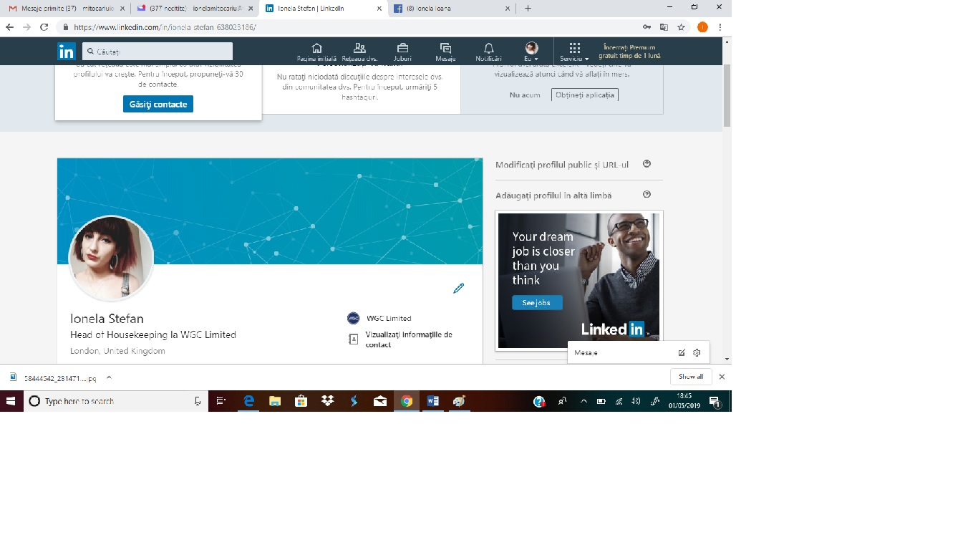Figure 2: LinkedIn profile [Source: https://www.linkedin.com/in/ionela-stefan-638023186/]

I have also twitter account. Twitter account is effective to increase social networking. This provides the scope to express feelings, ideas, thoughts etc to similar community and people. I have been able to build a strong network by using Twitter account. However, twitter has little or not professional use. Despite this it is important social media communication.
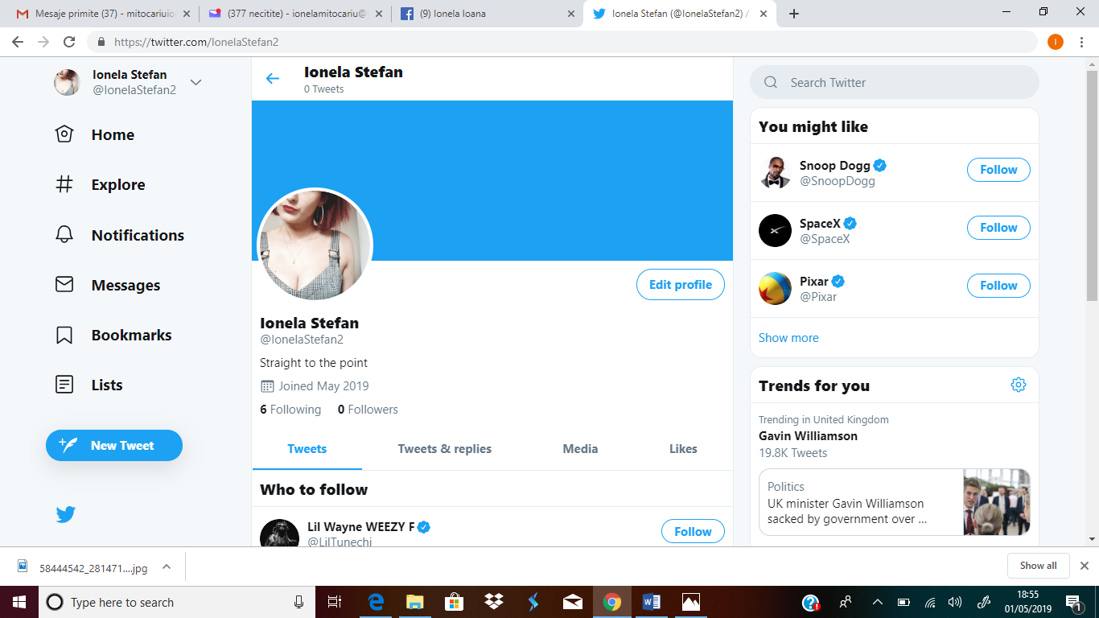
Figure 3: Twitter profile [Source: https://twitter.com/IonelaStefan2]
Facebook is the most popular social media platform to communicate with similar minded people. It has become popular day by day. I have facebook account which enables me to keep effective and proper communication with my fellow mates, relatives etc. Moreover, it provides the scope to be acquainted with new persons and develop new relationship with them. Facebook provides the opportunity to make relationship based on suggesting friend features. It provides the scope to express personal feelings, thoughts, ideas etc in detail form. Moreover, it has live streaming facility which enables to go live to telecast real time happening around us. Hence, facebook has become a popular platform.
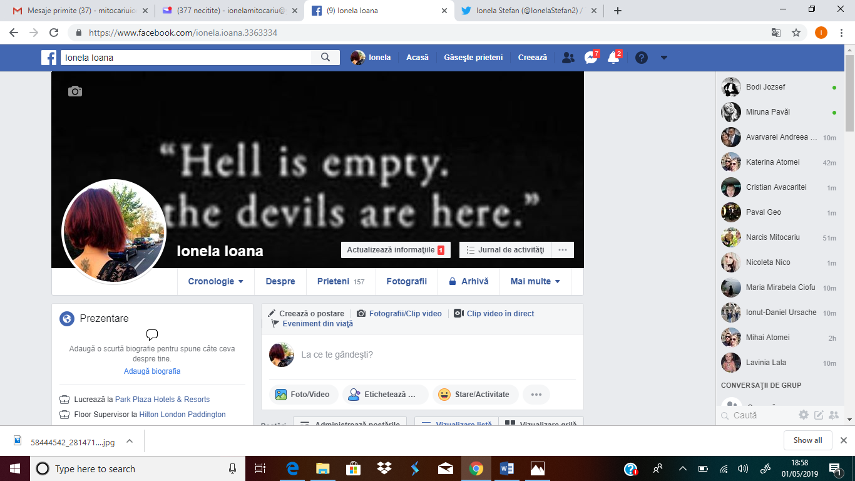Figure 4: Facebook Profile [Sourcehttps://www.facebook.com/ionela.ioana.3363334]

Conclusion
The study has been conducted to evaluate the effectiveness of modern technology in workplace as well as explore social media as a tool for marketing, information gathering and communication within the workplace. I have collected information from 20 employees of Retail companies based on convenience sampling through close ended survey questionnaire and analysed the data by applying Microsoft excel and descriptive statistics. The study shows that Computer system, cloud storage and mobile technology are important modern technology used in workplace and improved effectiveness of business efficiency. On the other hand, it shows that social media is an important tool for marketing, communication and data collection.

References


