ACBA4007: Structural calculations

  - By Ben Kneeshaw 1902457

Table of contents

1. Introduction…………………………………………………………………Page 2
2. Material properties…………………………………………………………Pages 2-3
2.1 Concrete…………………………………………………………………..Page 2
2.2 Steel……………………………………………………………………….Pages 2-3
2.3 Timber……………………………………………………………………..Page 3
3. Beam calculations………………………………………………………...Pages 3-4
4. Conclusions………………………………………………………………..Page 4
5. List of references………………………………………………………….Page 5
6. Appendix A – concrete calculations…………………………………….Pages 6-7
7. Appendix B – Steel calculations………………………………………...Page 7
8. Appendix C – Timber calculations………………………………………Pages 8-9

Introduction

The function of this report is to outline the most appropriate form of beam for the proposed patio roof. The beams considered will be: reinforced concrete, timber and steel. The various properties of these materials will also be outlined in detail.

Material properties

2.1 Concrete

Concrete is the most widely used construction material in the world and has been in use since the times of the Roman Empire. It is comprised of a mixture of: cement, water, aggregates, and in some cases admixture. It is highly versatile as it can be cast into almost any shape and produce any desired surface texture (civildigital.com, 2013). Planete-tp.com (2008) cite that concrete is particularly resistant to the physical-chemical attack emanating from the environment; this makes it an ideal material for exposed structures such as bridges and other civil works.
Concrete has a high compressive strength but a low tensile strength, generally 7 to 10 percent of its compressive strength (Alam, 2020). This makes it an ideal material for structural components such as columns and foundations where compressive strength is paramount. As such compressive strength is the only engineering property that is routinely specified, this provides a basis for estimating most other mechanical properties (Bamforth et al, 2008, p.11). When used in structural components such as beams, tensile strength is of high importance so as to prevent the beam from failing. In this case reinforcement is introduced in the form of steel, a material with high tensile strength, so as to alter the inherent properties of the beam. This is often more cost-efficient than using ‘all steel’ beams due to the lower amount of steel required. It is generally more economical to use steel to increase the tensile strength as opposed to increasing the tensile strength of the concrete itself. This is because ‘higher tensile strength’ concrete requires an increased minimum steel ratio in order to accommodate the higher stress transferred to the steel, due to the higher concrete weight, when a crack occurs (Bamforth et al, 2008, p.17).

2.2 Steel

Steel is a modern material that can be manufactured to exhibit many different properties; this makes it a highly versatile material for modern construction. Stainless steel for example is manufactured in such a way that it is resistant to corrosion (totalmateria, 2020).
Steel has high tensile and yield strength, although the yield strength is not as high as concrete. This is because steel tends to bend under intense strain whilst concrete simply cracks. As such, ductility is an important factor to consider with steel, this can show the point at which the steel will not return to its original shape after bending, due to its low elasticity. Another factor to consider with steel is its high thermal conductivity. This means allowances must be built into a steel framed building in order to allow for thermal expansion, more so than most other materials. It also means steel will lead to issues with thermal bridging if not properly enclosed within the structure.

2.3 Timber

Timber is a traditional building material with many useful properties that have allowed it to stand the test of time. It can be produced from a number of suitable trees and is a moniker for the planks and beams produced from said trees.
Unlike steel and concrete, timber has a high elasticity. This means it can bend and return to its original shape unlike steel (theconstructor.org, 2020). However it will shear if bent too far. As such it is important to calculate shear force as well as maximum bending moment when producing calculations for this material, unlike steel and concrete, this gives us information on the materials limit state (TRADA, 2008). It is a material with moderate yield and tensile strength, with the yield strength not being as high as concrete and the tensile strength not as high as steel. A factor to consider with timber is its inherent flammability due to being produced from wood, although this can be reduced using certain paints or even harder wood types which will burn slower.

Beam calculations

The first beam to be considered is one of reinforced concrete, the calculations are shown in appendix A. The specified concrete strength is C40/50. The calculations showed a minimum of 51.9mm squared of steel will be required as reinforcement. This can be achieved using either one 10mm bar or two 6mm bars, with two 6mm bars being the preferred option as it meets the requirements using less steel making it the cheaper option.
The second beam to be considered is one of steel, the calculations are shown in appendix B. The calculations for this showed the section modulus required to be 12.106cm squared. A suitable option for this then is ‘UB 127x76x13’, this beam has a section modulus of 14.7mm squared making it more than capable of supporting the specified loads.
The final beam to be considered is one of timber, the calculations are shown in appendix C. The specified strength for the timber is C16. The calculations for this beam showed the bending strength to be less than the bending stress applied, this means it would bend an uncomfortable amount when in use. However the calculations showed the shear strength to be higher than shear stress meaning it would not break under the stress applied.

Conclusions

The timber beam proposed would be unsuitable for use due to the large amount of bending it would undergo if in use, this would make it uncomfortable to walk across. As such the best option is between the reinforced concrete and steel beams. This makes it an issue of cost versus space. If cost is the main factor for the client then the reinforced concrete beam will be the most suitable option, due to being lower in cost than the steel beam. However if space is the main factor then the steel beam will be most appropriate, due to having a lower cross-sectional area than that of the reinforced concrete beam. Both beams would be suitable for supporting the specified loads comfortably.

List of references

- T Alam (2020) Main properties of concrete for construction. Available at: https://civiltoday.com/civil-engineering-materials/concrete/338-properties-of-concrete Accessed on: 22.05.20
- P Bamforth et al (2008) Properties of concrete for use in Eurocode 2. Available at: https://moodle.uwtsd.ac.uk/pluginfile.php/360986/mod_resource/content/0/Concrete%20Deisgn%20Book.pdf Accessed: 25.05.20
- Civildigital.com (2013) What is concrete and what are the properties of concrete. Available at: https://civildigital.com/concrete-properties-concrete/ Accessed: 22.05.20
- Planete-tp.com (2008) The properties of hardened concrete. Available at: http://www.planete-tp.com/en/the-properties-of-hardened-concrete-a233.html Accessed: 22.05.20
- Theconstructor.org (2020) Properties of timber – qualities of good timber & wood. Available at: https://civiltoday.com/civil-engineering-materials/timber/182-properties-of-timber Accessed: 22.05.20
- Totalmateria (2020) Steel properties. Available at: https://www.totalmateria.com/page.aspx?ID=SteelProperties&LN=EN Accessed: 22.05.20
- TRADA (2008) GD 3 Timber materials - Properties & associated
design procedures with Eurocodes. Available at: https://moodle.uwtsd.ac.uk/pluginfile.php/360982/mod_resource/content/0/Trada%20Timber.pdf Accessed on: 25.05.20

Appendix A – Reinforced concrete calculations
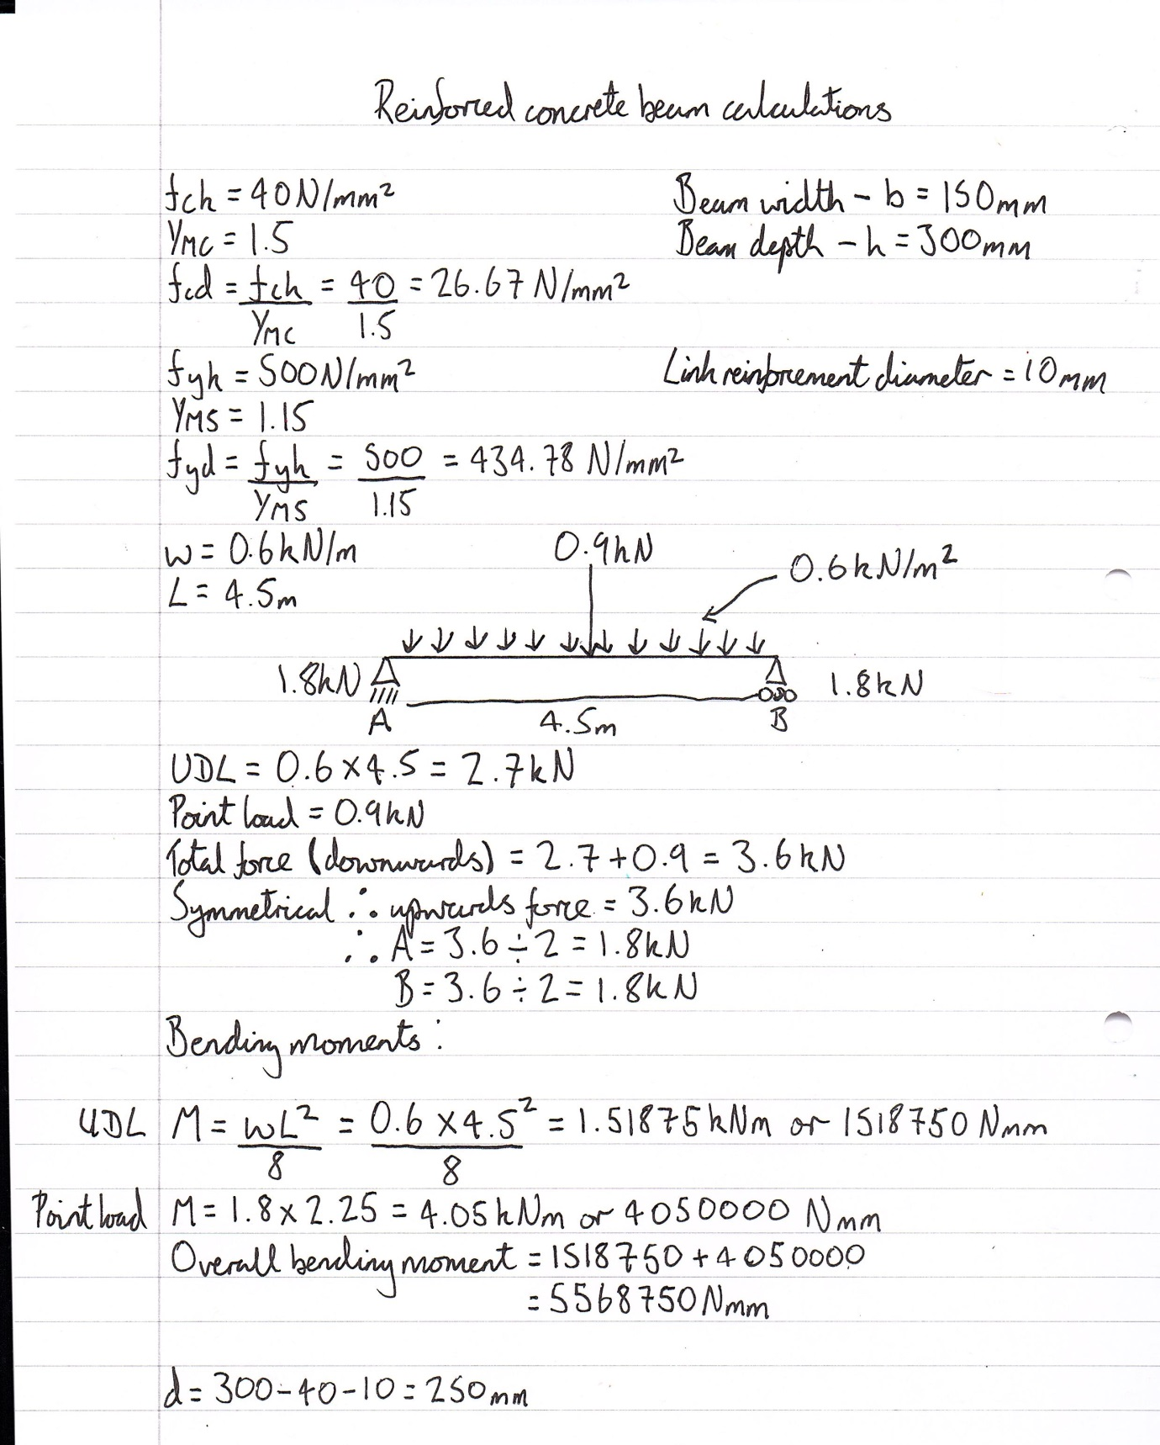

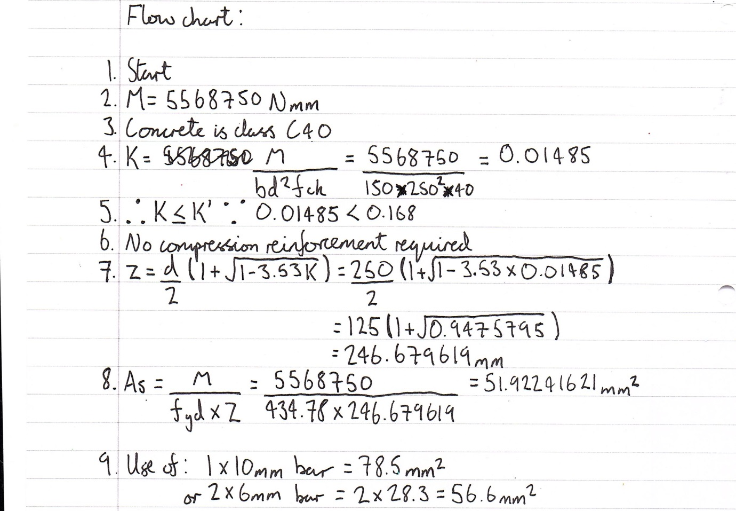

Appendix B – Steel calculations
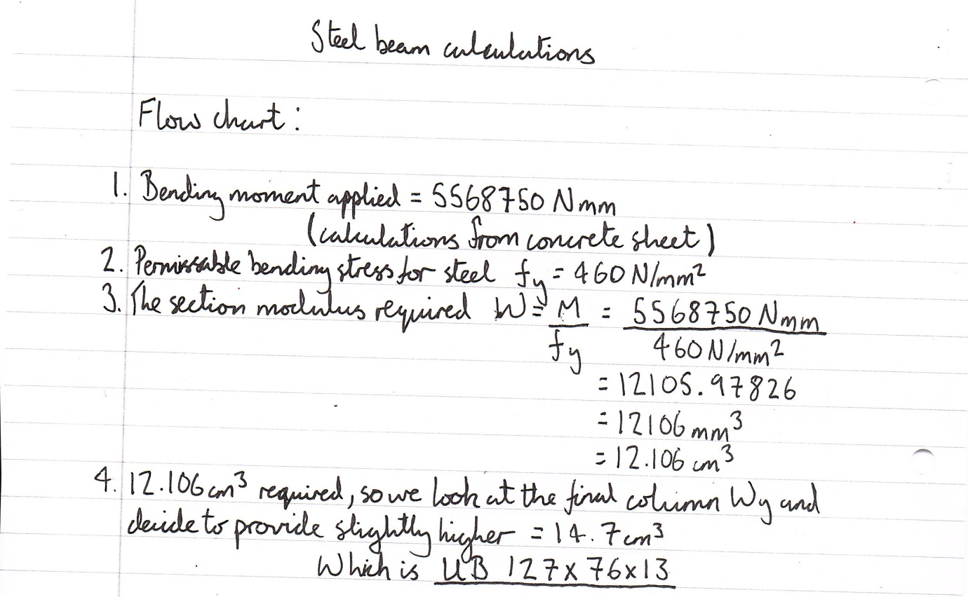

Appendix C – Timber calculations


