
digital skills
[Document subtitle]

[Date]
[Company name]
[Company address]
Nicola aprea110379 26/05/2026

Bright Way Café: Digital Tools Integration Report

Executive Summary
Bright Way Café can significantly enhance its efficiency, customer engagement, and long-term growth by adopting a strategic suite of digital tools.
- Operational efficiency
- Customer experience and loyalty
- Brand visibility and revenue growth
Digital transformation is no longer optional for cafés competing in the UK

1. Digital Tools for Operations
Digital systems can simplify day-to-day tasks, reduce errors, and free staff to focus on customer service.

1.1 Point-of-Sale Systems
A modern POS system such as Square, Lightspeed, or Toast enables:
- Fast, accurate order processing
- Real-time sales tracking
- Integrated card/contactless payments
- Inventory monitoring to reduce waste
This improves speed during peak hours and provides data for smarter purchasing decisions.

- Track stock levels automatically
- Predict shortages
- Analyse ingredient costs
- Reduce over-ordering
This leads to better cost control and less food waste.

1.3 Staff Scheduling Tools
Platforms such as Deputy or Rotacloud help managers:
- Create fair, efficient rotas
- Track attendance
- Communicate shift changes instantly
This reduces scheduling conflicts and improves staff satisfaction.

2. Digital Tools for Customer Experience
Customers expect convenience, speed, and personalisation. Digital tools help Bright Way Café deliver all three.

2.1 Online Ordering & Click-and-Collect

From places like uber eats diliveroo
- Customers can pre-order drinks
- Reduce queue times
- Increase lunchtime sales
This is especially valuable in busy city areas like Swansea Cardiff london

2.2 Loyalty Apps
Digital loyalty systems such as loyalty cards will have benefits and offers and loyalty points

2.3 Wi-Fi Analytics
Offering free Wi-Fi with a branded login page enables:
- Customer email collection
- Table service without getting out of your seat
- Targeted promotions
This turns casual visitors into long-term customer
- Schedule posts
- Analyse engagement
- Maintain consistent branding
Platforms such as Instagram and TikTok are especially effective for cafés.

3.2 Website & SEO
A professional website with menu, hours, and online ordering improves:
- Discoveries could be found on the internet google
SEO ensures the café appears in searches like “best café inswansea Cardiff or london

3.3 Email
- Monthly newsletters
- Promotions for new menu items
- Automated welcome emails
Email remains one of the highest-ROI marketing channels.

Decision Making
Digital tools generate valuable insights. Bright Way Café can use analytics to:
- Identify peak hours
- Track best-selling items
- Adjust staffing levels
- Optimise menu pricing
This transforms intuition-based decisions into evidence-based strategy.

Conclusion
Integrating digital tools will position Bright Way Café as a modern, efficient, and customer-focused business. By combining operational systems, customer-facing technology, and data-driven marketing, the café can increase revenue, improve service quality, and build a strong, recognisable brand in sawnsea,Cardiff,londons competitive café market. Brightwave cafe Collective is a globally loved café franchise known for its signature coffee blends, welcoming atmosphere, and community-first spirit. With locations across major cities and small neighbourhoods alike, brightwave cafe Collective brings the same comforting experience to every corner of the world —
Every café features warm, modern design, handcrafted beverages made from ethically sourced beans, and a menu of fresh pastries and light bites tailored to regional tastes. Whether it’s a quick morning espresso, a slow afternoon latte, or a cosy evening meet-up, BrewHouse Collective offers a space where people can connect, unwind, and feel at home.
Driven by a commitment to sustainability, the franchise partners with responsible growers, reduces waste through eco-friendly packaging, and supports community initiatives in every city it serves. It’s more than a café — it’s a global gathering place built on quality, comfort, and connection.
If you want, I can tailor this description to a specific vibe — more luxury, more casual, feeling at the cafeet Bias and limitations shape how you interpret an event. Ethical reflection requires naming them so your conclusions are fair, proportionate, and professionally grounded.

🔍 Key Biases to Consider in Your Reflection
Each item begins with a Guided Link so you can explore any concept further if you want.
- Confirmation bias — You may have noticed behaviour that fit an expectation you already held (e.g., “this place has poor service”), causing you to interpret neutral actions as negative.
- Attribution bias — You might attribute staff behaviour to their personality (“they’re rude”) rather than situational pressures (stress, understaffing, unclear policies).
- Observer bias — Your interpretation is shaped by where you were sitting, what you could hear, and what you paid attention to.
- Cultural bias — Norms around politeness, tone, or customer service vary; what feels abrupt to you may be normal in another context.
- Emotional bias — If you were tired, stressed, or already irritated, your emotional state could colour your judgement.
- Hindsight bias — Reflecting after the event may make the situation seem more predictable or obvious than it was in the moment.

🧭 Professional Limitations to Acknowledge
These help keep your reflection ethically grounded and proportionate.
- Limited information — You only saw a snapshot of the café’s operations; you don’t know staff workload, training, or internal issues.
- Role boundaries — Your professional position (student, observer, customer, practitioner) shapes what you can ethically do or say.
- Lack of context — You may not know the history between staff and customers, or whether there were prior incidents.
- Single perspective — You didn’t hear the staff member’s explanation or the customer’s full experience.
- Time constraints — Quick observations can lead to quick judgements.
- Professional distance — You may not have been able to ask questions or clarify what you saw, limiting the accuracy of your interpretation.

🧠 Why acknowledging bias matters
Recognising bias isn’t about undermining your reflection — it strengthens it. It shows:
- ethical self-awareness
- fairness in evaluating others
- professionalism in avoiding assumptions
- reflective maturity
It also prevents your reflection from becoming a judgement of individuals rather than an analysis of practice, systems, or ethics.

🔎 Want to deepen this reflection?
You can explore:
- ethical frameworks
- professional boundaries
- how to write a full reflective analysis
If you want, I can also help you integrate these biases into a full Gibbs or Driscoll reflection tailored to your Red Wave Café scenario.
Bias and limitations shape how you interpret an event. Ethical reflection requires naming them so your conclusions are fair, proportionate, and professionally grounded.
🔍 Key Biases to Consider in Your Reflection
Each item begins with a Guided Link so you can explore any concept further if you want.
- Confirmation bias — You may have noticed behaviour that fit an expectation you already held (e.g., “this place has poor service”), causing you to interpret neutral actions as negative.
- Attribution bias — You might attribute staff behaviour to their personality (“they’re rude”) rather than situational pressures (stress, understaffing, unclear policies).
- Observer bias — Your interpretation is shaped by where you were sitting, what you could hear, and what you paid attention to.
- Cultural bias — Norms around politeness, tone, or customer service vary; what feels abrupt to you may be normal in another context.
- Emotional bias — If you were tired, stressed, or already irritated, your emotional state could colour your judgement.
- Hindsight bias — Reflecting after the event may make the situation seem more predictable or obvious than it was in the moment.
🧭 Professional Limitations to Acknowledge
These help keep your reflection ethically grounded and proportionate.
- Limited information — You only saw a snapshot of the café’s operations; you don’t know staff workload, training, or internal issues.
- Role boundaries — Your professional position (student, observer, customer, practitioner) shapes what you can ethically do or say.
- Lack of context — You may not know the history between staff and customers, or whether there were prior incidents.
- Single perspective — You didn’t hear the staff member’s explanation or the customer’s full experience.
- Time constraints — Quick observations can lead to quick judgements.
- Professional distance — You may not have been able to ask questions or clarify what you saw, limiting the accuracy of your interpretation.
🧠 Why acknowledging bias matters
Recognising bias isn’t about undermining your reflection — it strengthens it. It shows:
- ethical self-awareness
- fairness in evaluating others
- professionalism in avoiding assumptions
- reflective maturity
It also prevents your reflection from becoming a judgement of individuals rather than an analysis of practice, systems, or ethics.
🔎 Want to deepen this reflection?
You can explore:
- ethical frameworks
- professional boundaries
- how to write a full reflective analysis
If you want, I can also help you integrate these biases into a full Gibbs or Driscoll reflection tailored to your Red Wave Café scenario.

s in a sector where ethical issues commonly arise, including:
- Fair labour — wages, scheduling, workload
- Sustainability — sourcing, waste, carbon footprint
- Community impact — inclusivity, accessibility, local engagement
- Marketing ethics — authenticity vs. greenwashing
Brightwave’s choices sit within this broader ethical tension.

g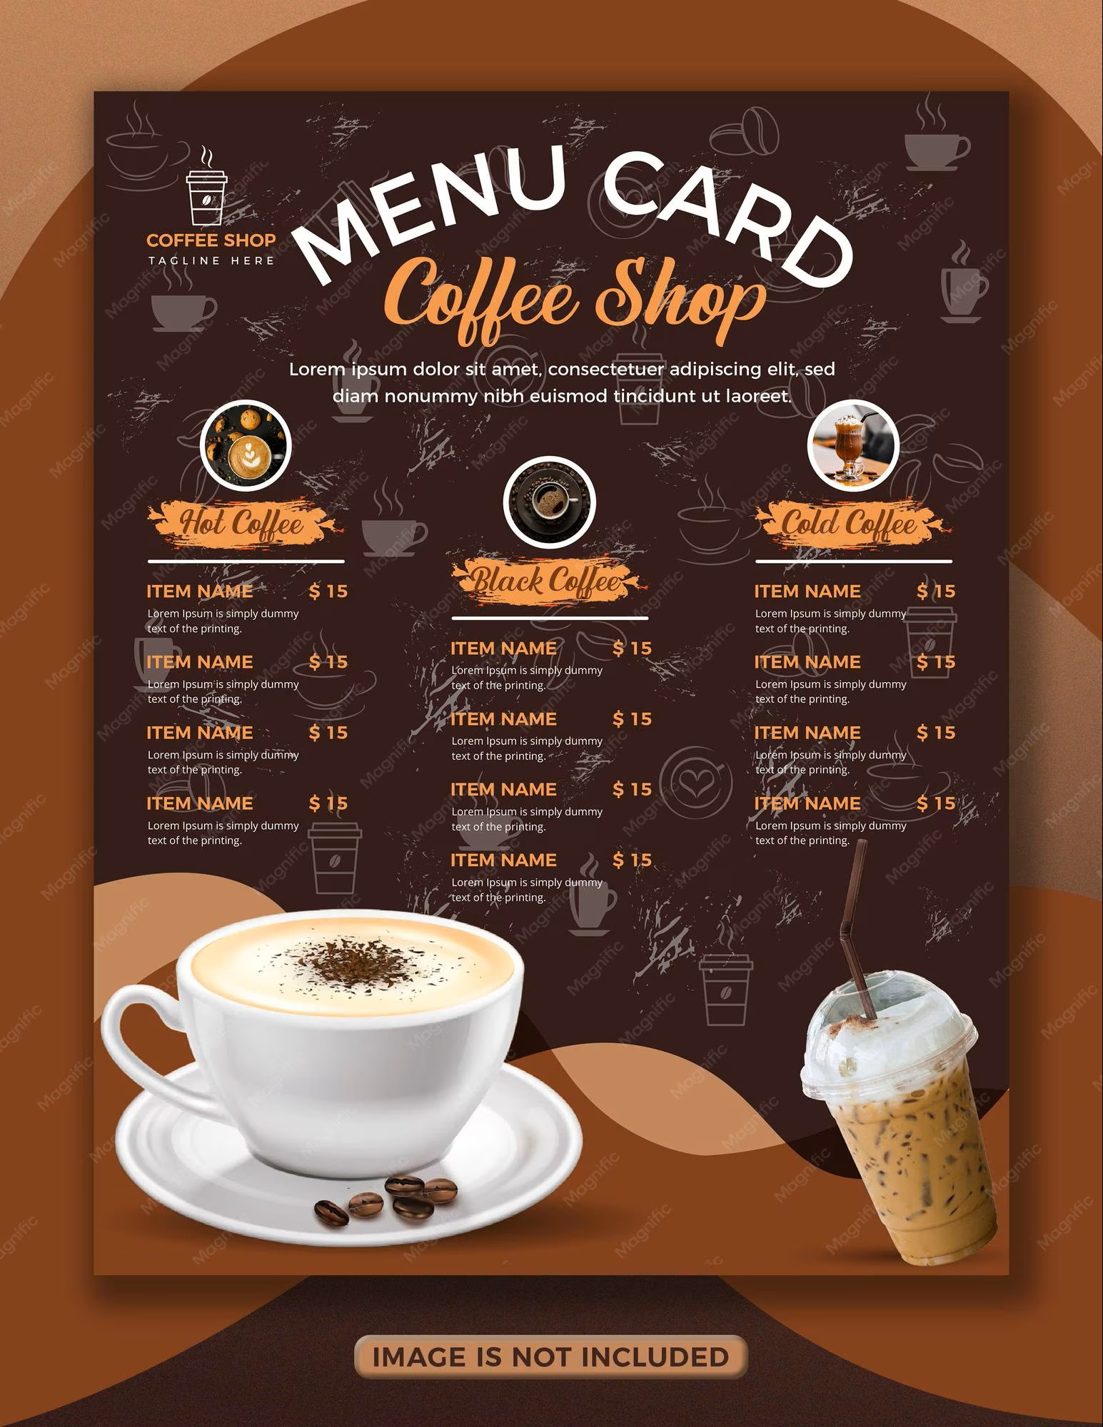google chat gb ai café articles

