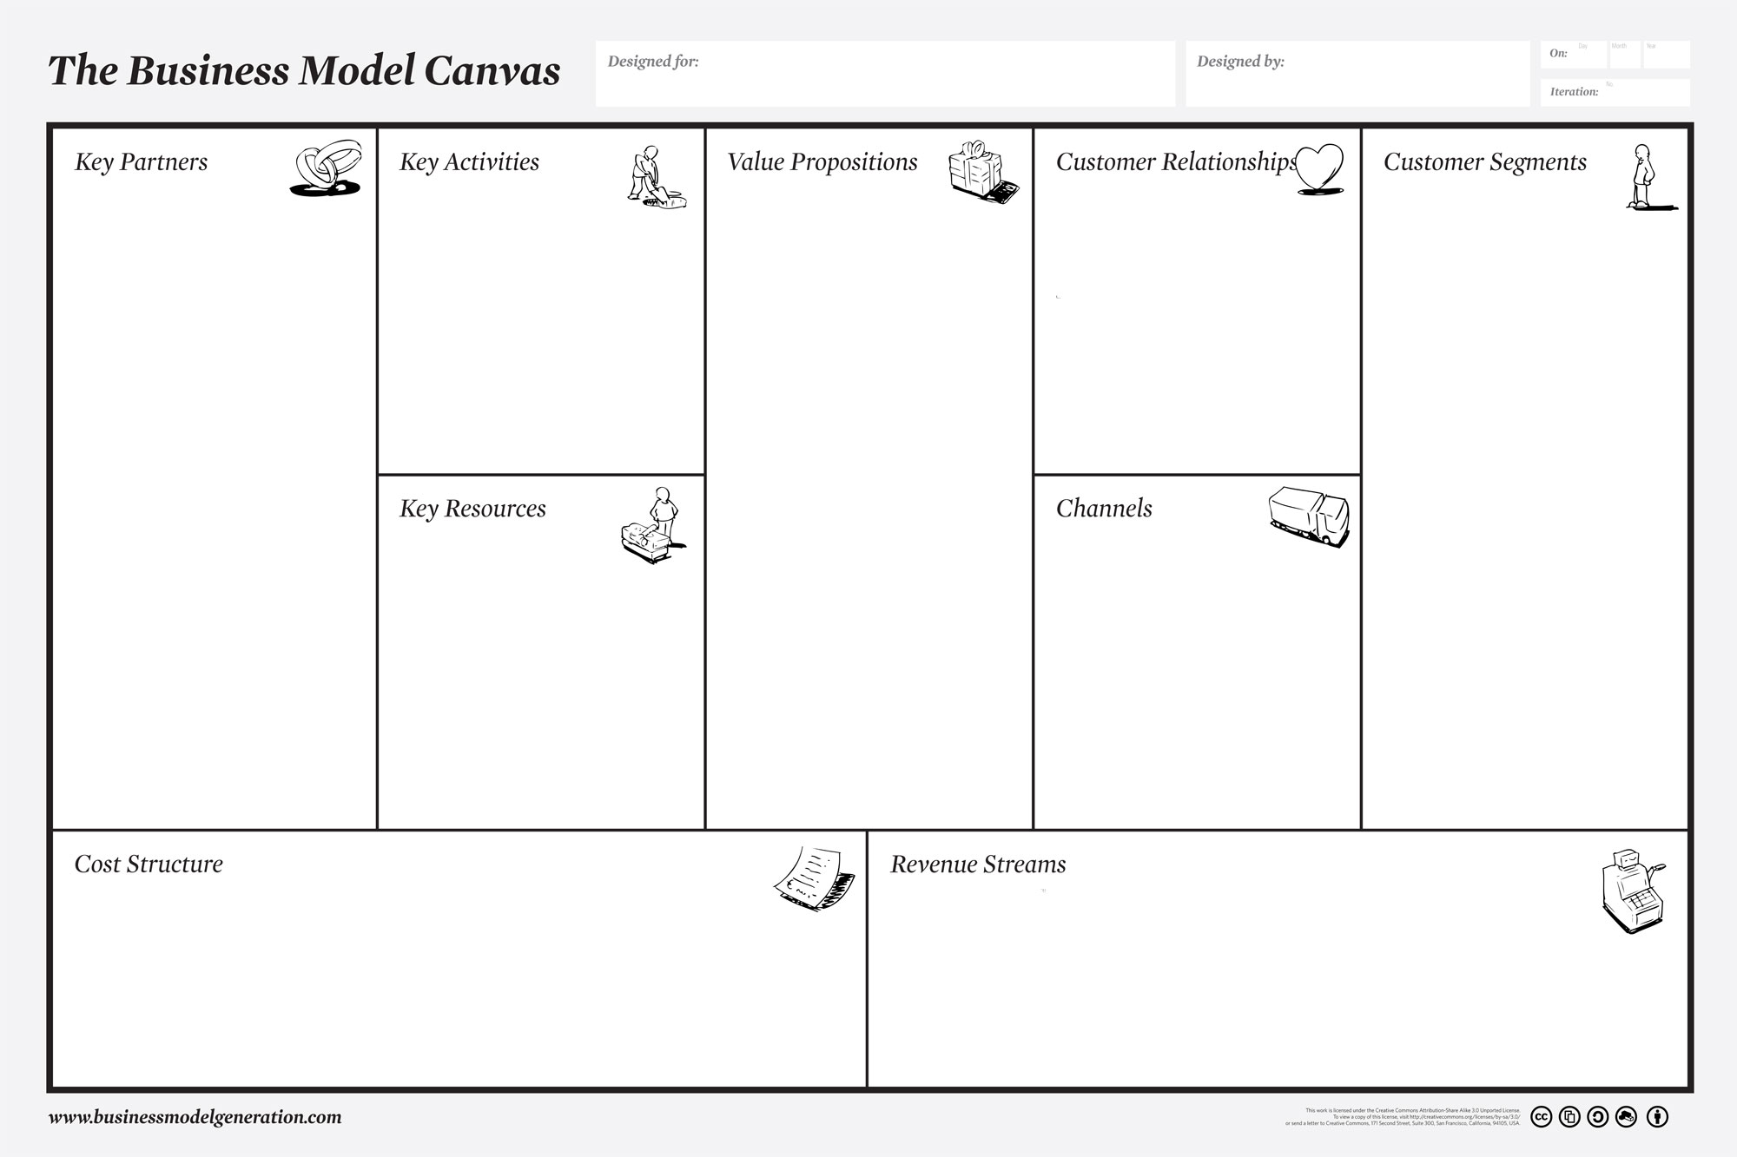
Experimenting various recipes
Updating advertisements
Creation of loyalty cards
Promotion of personal brownies and gift baskets
Fair trade and the environment
Monitoring finances
Recording and analyzing finances
Recipe/ ingredients- different types
Online Platforms
Deliveroo
Stalls
Resources for packaging
Loyalty incentives
Financial Resources
Cost Structure
* Rent & rates - £600pcm
* Kitchen fitted - £2000-£4000
* Website and app design - £495
* Wages – Minimum wage (£7.83), hours dependent on demand.
* Ingredients – Baked in batches of 10. Costing £2.88 in ingredients. Therefore, each brownie costing £0.28, selling each brownie at £1 resulting in a 72% profit margin per brownie.
* Delivery costs – Deliveroo, we will cover costs within 5mile radius. Further than this delivery costs will be added to the customers receipt.
* Stalls at food festivals & Website and app maintenance – these two costs are ad-hoc and will be difficult to forecast for however budgeting will be prudent in order to absorb these costs.
-HIGH QUALITY PRODUCT AND 100% RECYCABLE PACKAGING
-AVERAGE PRICE ACROSS LEADING BRANDS
-RETAIL SECTORS, MONTHLY SUBSCRIPTIONS
-ONE OFF QUICK TRANSACTIONS
-MULTIPLE REVENUE STREAMS
Dividing the markets

LACK OF SUPPLY FOR CUSTOMERS WITH ALLERGEN AND DIETRY NEEDS

BUNDLE DISCOUNTS AND MONTHLY SUBSCRIPTIONS

HIGHEND LUXURY PRODUCT WITHOUT THE HIGHEND PRICE TAG
Three different customer segments:
1)Students, cheaper product / loyalty cards

2)Customers in local coffee shops, shop would take cut of the sale

3)General public through gift giving / deliveries – main segment
Universities to set up stalls- competitor strategic partnership

Local run businesses, coffee shops/ cafes- Strategic alliance between non-competitors

Main supplier – supermarkets, easy access whilst the business is small

Customer relationships
Target Audience – General public, Students
Public – Personal relationship – Customer retention and upselling
Stalls – Automated – Acquisition/Recognition
Ethical Company – Environmentally friendly – Socially responsible
Channels – communication, distribution and sales
Communication – social media/facebook, google business, WalesOnline
Distribution – Deliveroo, Pop-up stalls
Sales – Loyalty cards
William Spencer, James de Kerckhove, Ryan Price, Liam Jeffreys and Emily Miller
Delicious Treats

References
Customer Segments
Cohn, C., 2017. How to segment leads and customers to provide better experiences. [Online]
Available at: https://www.forbes.com/sites/chuckcohn/2017/03/20/how-to-segment-leads-and-customers-to-provide-better-experiences/#5246ac7f6eaa
[Accessed 2 November 2018].

Key partners
Zwilling, M., 2014. Win-Win: Strategically Partner with Your Top Competitors. [Online]
Available at: https://www.entrepreneur.com/article/234522
[Accessed 2 November 2015].

Cost Structure
(Zoopla, 2018)
(Prime Location, 2018)
(Web Creations UK, 2018)
(Tesco, 2018)
(B&Q, 2018)

Channels
WalesOnline, 2018. How do I advertis on WalesOnline?. [Online] Available at: <https://www.walesonline.co.uk/special-features/advertise-for-free-2023534> [Accessed 2nd November 2018].

Customer Relationships
Magatef, S.G. and Tomalieh, E.F., 2015. The Impact of Customer Loyalty Programs on Customer Retention. International Journal of Business and Social Science, Vol. 6, No 8(1).

Value Propositions
https://trends.google.com/trends/explore?q=%2Fm%2F05wvs&date=all&geo=GB

Revenue Streams
these taste awful - so chemically that if you close your eyes and eat it you wouldn't know it was supposed to be chocolate."(Myprotein.com, 2018)

Key Resources
“The components of Deliveroo’s revenue come from users in the form of delivery fees at £2.50 and commission fees from restaurants. The commission they charge is generally 10% of the order, with the average order being around £30”- https://thebusinessoftech.wordpress.com/2016/05/08/deliveroo/

Key Activities
“Are you thinking about making your business future proof? Biodegradable packaging can make a huge difference to your business”- http://www.greenne.com/five-reasons-that-biodegradable-packaging-is-the-future/

