Importance of Improving Employee Well-being

Human Resource Management
BMMB 7007
Student Name: Jianmei, Liu
Student Number: 2234055
Report Date: March 25, 2023

Executive Summary
Nowadays, employee well-being matters much more than ever before, which plays a vital role in helping organizations attract more talented people and achieve business success. However, due to Covid 19, both the employers and employees are going through major workplace disruption and volatility. Many employees suffer from layoffs and salary cuts as well as serious mental illness. It is crucial to redefine employee well-being in this post-pandemic world and make it as a top priority. This paper takes New Future Education Company, one of the education training organizations in China as an example to discuss the major components of employee well-being and what benefits a company can achieve by improving this human resource management area. Findings about this topic in this case study can be summarized below:
- Employee well-being refers to an overall work-life state involved with physical health, financial security, good relationships, career satisfaction and community connections.
- People are the most valuable wealth of a company. Employee well-being should be deemed as a priority.
- Improving employee well-being provides an all-win outcome.
In addition, this paper provides a few suggestions to New Future Education Company according to its current HRM challenges and state of operation, focusing on the priority area of employee well-being.

Table of Contents
1.0 Introduction 1
2.0 Overview of New Future Education Company 1
3.0 The Role of Employee Well-being 2
3.1 Importance of Improving Employee Well-being 2
3.2 Main Current Problems 4
3.3 Impact on Performance of the Company 4
3.4 Benefits of Improving Employee Well-being 5
4. Recommendations 8
4.1 Offer rest room and fitness area. 8
4.2 Ensure employee income and social medical security. 8
4.3 Create an employee well-being strategy. 9
4.4 Gather and respect feedback from employees. 9
Reference List 10

List of Figures
Figure 1: Seven Pillars of Employee Well-being 2
Figure 2. Benefits of Improving Employee Wellbeing to Company 6
Figure 3. Overview of Benefits from Employee Well-being Improvement 7

1.0 Introduction
According to a survey in The Future Workplace 2021 HR Sentiment, a finding suggests that 68% of senior HR leaders have recognized the importance of employee well-being and mental health and consider it as a top priority (Meister, J., 2021). Why such numerous HR leaders attach great importance to employee being? Undoubtedly, people contribute to the success of a company. In other words, the future of a company or an organization depends on its employee. Unfortunately, a great number of people around the world are under tremendous mental stress which leads to their poor performance at work. According to a recent study conducted by CMI, about 56% managers thought the mental health of their employees suffered from the impact of pandemic (CMI, 2021). Recently, New Future Education Company have encountered great challenges in human resource management. Some core employees applied for resignation, while others also showed job burnout. This paper will discuss the above employee well-being issue in detail and some tips will be found in the end.

2.0 Overview of New Future Education Company
New Future Education Company was founded in Shandong Province, China, with a registered capital of 100 million RMB. With 5,000 square meters occupied, this company is a one-stop training base for students upgrading from junior college to university, which offers services including accommodation and training to students. This company aims at helping junior college students to enter their dream universities (New Future Education Company, no date). This company has more than 100 employees divided into 3 working teams, including a teaching team, an administration team and an enrolling team.
Miss Hu is a dedicated HR specialist, who takes in charge of staff recruitment, staff attendance management, employee performance assessment, as well as making payrolls and distribution of salaries. Miss Hu reports directly to the administration director. There is no well-developed human resource management system in place. Managers in this company haven’t recognized the vital role that HR plays in the development of the company. As a result, there are a lot of HRM problems in New Future Education Company. This paper will focus on employee well-being of this company.

3.0 The Role of Employee Well-being

3.1 Importance of Improving Employee Well-being
Gallup, one of the most famous pollsters, declared expressly that employee well-being is crucial to boost workplace productivity (Gallup, Inc., 2022). This paper will provide some suggestions for improving employee well-being in workplace. The world needs talented people, so does a company. People will be more productive and creative when they feel satisfied with work and life. Gallup also concluded in its most recent global analytics that an organization can create a thriving workforce by engaging the employee in work (Clifton, J. and Harter, J., 2021). It’s the high time for HR to ensure employee well-being and take it as a priority area.
When it comes to employee well-being, people usually think of physical or mental health. Actually, employee well-being has expanded to all aspects of life, which includes physical, mental, financial, career, social, community and purpose. These areas have been identified by Future Workplace as seven pillars of employee well-being (shown in Figure 1) (Meister, J., 2021).
Figure 1: Seven Pillars of Employee Well-being
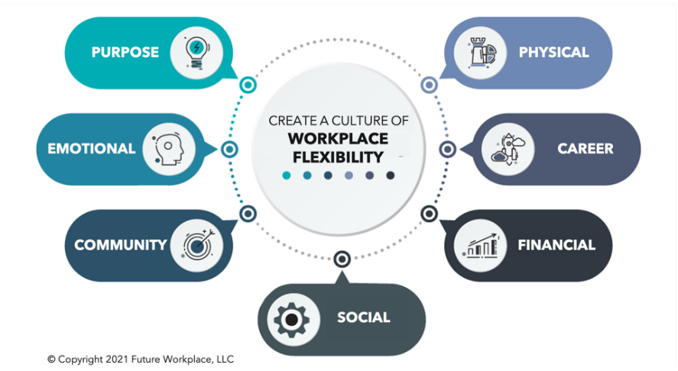
(Meister, J., 2021).
From the above figure, it can be concluded that employee well-being has a broad definition covering the physical, mental, financial and emotional health of the employees. There are several influence factors, such as workplace safety, their relationships with colleagues, working hours and salaries, job satisfaction and sense of belonging. As shown in a recent employee well-being study (Alight, 2022), the portion of U.S. employees who are satisfied with their overall well-being is less than half. Most of the employees spend the majority of their waking time at work. Good feeling about their work can positively affect their lives, and wonderful life certainly motivates them to work effectively (Access, no date). The HR of New Future Group recently received a lot of complains from their employees caused by not being paid on time and not being covered by social security insurance. They said their basic life cannot be guaranteed and felt like having an uncertain life. Some of them even want to resign.
As we all know, employees will perform better when they feel good and vice versa. Therefore, it can be concluded that employee well-being is the foundation of high-performance work, which leads to a business success. In this paper, the HR leader in New Future Group needs to promote the employee well-being and make it a priority. This paper includes several tips for New Future Group to implement, for example, identifying the problems, evaluating the causes, developing a well-being program and giving practical well-being support (HiBob, 2022).
Great performance of employee well-being can not only benefit the employees, but also the organization and other organizational stakeholders. It can lead to numerous benefits, such as better employee engagement, high productivity and profitability, excellent performance and a more inclusive culture (CIPD, 2022). Every organization has to take it as a priority, including New Future Group.
A well-developed employee well-being strategy can make employees feel that they are valued and supported at workplace, which can improve their engagement and motivate them to make joint efforts. In addition, according to an interesting research conducted by University of Oxford, workers can be 13% more productive when they feel happy (University of Oxford,2019). This study shows the first causal field evidence for the link between happiness and productivity. Besides, a great employee well-being can help the company avoid losing talents (Wrike,2021).

3.2 Main Current Problems
Although New Future Education Company is a small organization, it is not an excuse for lack of managing employee well-being. The current shortfalls are as following:
- People sometimes cannot get their salary on time. All the staff have not received their salary for the recent two months without any reason being told. Some of them even could not afford their housing loans.
- There is less communication and cooperation between different working teams, such as teaching and enrolling teams. Few team building activities are provided to give the employee opportunities to know each other and build strong relationship.
- Most of the employees do not have a clear career planning. The company do not provide a competitive salary or great development opportunity for the staff.
- The company only provides the lowest level social security and medical care insurance to employees.
- Employees often feel tired after work because they don’t have space for lunch break, so they have to nap at desk. In addition, since no working meals are provided, they usually order take-out food. All the above problems are bad for the employees’ physical health.
Due to New Future’s poor practice of ensuring employee well-being, most of the employees lose their enthusiasm and motivation for their job. Every company needs to set up and maintain a workplace culture, in order to provide sense of security and belonging to employees. When it’s effectively implemented, there will be lower employee burnout and higher involvement (Marinaki, A., 2022).

3.3 Impact on Performance of the Company
Although there are several problems in human resource management of New Future, employee well-being should be taken as the priority area. Generally speaking, the employees do not engage actively and have no clear career planning. It is worth mentioning that the pandemic impacted the education industry tremendously because of the lockdown policy issued by China government in order to stop the spread. Their employees even have not received their salaries for two months. The employees’ daily life has been seriously influenced. Some of them have submitted resignation letters to HR, including some core teachers with rich experience and specialized knowledge and teaching skills. A wave of departures will destroy the normal operation of the company. As New Future Company is planning to enlarge their enrollment scale, teachers play the most important role. It becomes extremely urgent for New Future to promote the employee well-being.
As students learned about the above situation, they said this was unbelievable. Their negative comments about the company have a huge damaging impact on the reputation of the company. Many students lose trust in the company and they are not willing to recommend the company to their classmates or students. Some of them even quit the course.
According to a meta-analysis of 339 independent studies in the Gallup client database, a major and strong positive correlation is found between employees’ satisfaction and employee productivity with lower staff turnover. It is concluded that higher well-being at workplace is likely to help the company achieve higher profitability (Krekel, C., Ward, G. and De Neve, J.-E., 2019). However, poor employee well-being, especially poor financial well-being can have a strong impact on employee health, causing higher levels of stress and anxiety, which affects employee productivity in turn. Every employer needs to support employee well-being. For New Future Education Company, financial well-being needs to be paid more attention. Otherwise, the company is likely to face poor performance and even more management problems (IEC, no date).

3.4 Benefits of Improving Employee Well-being
As shown in the above context, we can see the strong impact that poor employee well-being has on New Future Education Company, which is associated with loss of enthusiasm, reduced productivity, increased turnover, bad reputation and poor performance. Employee well-being is closely related to all the aspects of an employee’s life, which finally determines the company’s future. Improving employee well-being can not only bring benefits to the employees, but also to the company and other organizational stakeholders (Perkbox, 2021). The following context will make a detailed discussion about the benefits.
a) For the company:
Supporting employee well-being will retain those talented teachers who are planning to leave because of poor financial well-being. As the development of New Future, more talents will be needed. This can help attract more talented people who can contributes to the business performance of the company.
When people feel happy and safe at work, they perform their best. Teachers can be more creative and innovative in preparing lessons which attract the students and help them improve their scores. Enrolling representatives can be more energetic and passionate to improve their performance. Happy workers are more productive and profitable (Sodexo, no date).
Figure 2. Benefits of Improving Employee Wellbeing to Company
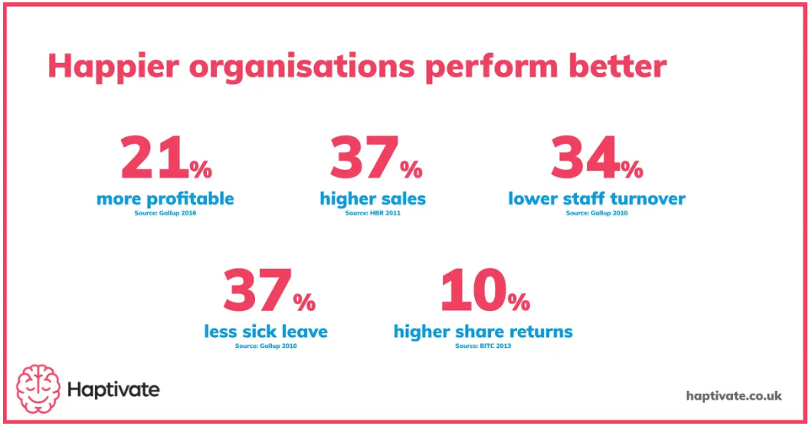
(Manners, J., 2023)
b) For the employees
They will feel safe and happy if the company can ensure their pay and social security and medical insurance. They just need to commit themselves into their work and do not need to worry about living security.
Improving employee well-being can help to reduce the stress and anxiety in the workplace, which can improve the employees’ physical health and mental health. They will be more productive and their absenteeism rate will go down. With passion for their work, they will develop better career planning and make great achievement.
c) For other organizational stakeholders
As an education train company, main customers of New Future are the students who need to enter universities from junior colleges. By improving employee well-being, all staff are dedicated to execute their respective duties. Therefore, students can have professional lessons and better learning experience, including comfortable learning environment, excellent course management and great progress in study (McKinsey, 2021).
The following Figure 3 gives an overview of benefits generated from improving employee well-being.
Figure 3. Overview of Benefits from Employee Well-being Improvement
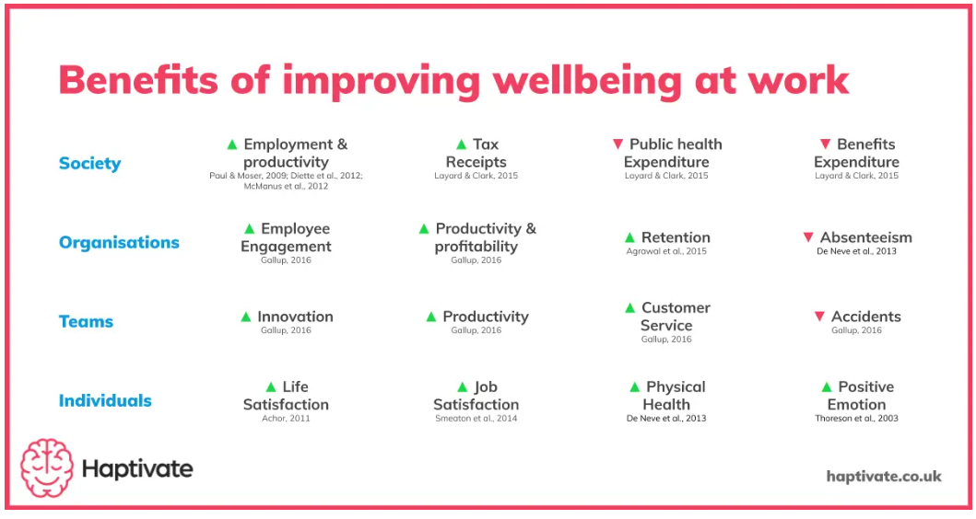
(Manners, J., 2023)

4. Recommendations

4.1 Offer rest room and fitness area.
Put a top priority on the health of employees. It is too exhausting for employees to sit at the desk working from 8:30 am to 17:30 pm. New Future can provide a rest room or just provide nap chairs for employees to replenish energy after lunch. In addition, the company can offer a fitness area equipped with a few fitness facilities such as running machines, exercise bicycles and Ping-pong tables. Encourage employees take care of their health both at workplace and outside of working hours. When employees feel being cared about by the company, they are more willing to care about their job and the development of their company (Hasson, G. and Butler, D., 2020). Compared to peers in upgrading education training, other education companies provide more comfortable and healthier workplace with complete office, rest, fitness, reading areas.

4.2 Ensure employee income and social medical security.
Employees need to be able to afford their daily life. Employers are responsible to pay employees on time and provide social medical security according to the labor law. According to CIPD research, it is said that over 25% of employees in UK think that money worries have a negative impact on their ability to work (CIPD).

4.3 Create an employee well-being strategy.
According to 2018 Global Human Capital Trends survey, 61 percent of employers said employee productivity and bottom-line business results are improved with a well-being strategy (Deloitte). New Future must create an employee well-being strategy and make it part of their company culture.

4.4 Gather and respect feedback from employees.
Ask current employees some questions, such as what the obstacles that make them feel unmotivated in the workplace, what aspects of employee well-being they want the company to focus on, what the current challenges they are urgent to settle, what can keep them productive at work. Always get the employees involved when the company try to launch an employee well-being program or create an employee well-being strategy. Involvement also can make the employees feel valued and recognized (Doyle, O., 2020).
4.5 Provide flexible working conditions.
In developed countries, flexible working conditions have been increasingly popular. There is no doubt that good employee well-being has a positive impact on the employees’ engagement and performance. Flexible working plays an important role in improving employee well-being. According to searches conducted by Durham University and other partners which covered 12 databases, it was concluded that flexible working is likely to positively impact employee health outcomes (Joyce, K. et al., 2010). Flexible Working can bring several benefits for New Future. For example, teachers can reduce the commute time and cost by working from home when during the days with no lessons. This is especially helpful to employees in enrolling team. They do not need to strictly follow the attendance system. They can make arrangements that they think are suitable for engaging the potential student customers (Timewise, 2022).

Reference List
2021 Employee Well-being Mindset Study (2022). Available at: https://www.alight.com/Thought-Leadership/2021-employee-well-being-mindset-study.
2021 HR Sentiment Survey – Future Workplace® (no date). Available at: https://futureworkplace.com/ebooks/2021-hr-sentiment-survey/.
Clifton, J. and Harter, J. (2021) Well-being at Work. Simon and Schuster.
Doyle, O. (2020) 4 Ways to Create an Employee Well-Being Strategy. Available at: https://www.occupop.com/blog/4-ways-to-create-an-employee-well-being-strategy.
Gallup, Inc. (2022) Help employees improve well-being and performance - Gallup. Available at: https://www.gallup.com/workplace/215924/well-being.aspx.
Happy workers are 13% more productive | University of Oxford (2019). Available at: https://www.ox.ac.uk/news/2019-10-24-happy-workers-are-13-more-productive.
Hasson, G. and Butler, D. (2020) Mental Health and Well-being in the Workplace: A Practical Guide for Employers and Employees. John Wiley & Sons.
HiBob (2022) What is employee well-being? | HiBob. Available at: https://www.hibob.com/hr-glossary/employee-well-being/.
Importance of employee well-being (no date). Available at: https://www.theaccessgroup.com/en-gb/hr/resources/well-being-mental-health-in-workplace/importance-of-employee-well-being/.
Innovating employee health: Time to break the mold? (2021). Available at: https://www.mckinsey.com/industries/healthcare/our-insights/innovating-employee-health-time-to-break-the-mold.
Joyce, K. et al. (2010) “Flexible working conditions and their effects on employee health and well-being,” The Cochrane Library, 2010(2). Available at: https://doi.org/10.1002/14651858.cd008009.pub2.
Krekel, C., Ward, G. and De Neve, J.-E. (2019) “Employee Well-being, Productivity, and Firm Performance,” Social Science Research Network [Preprint]. Available at: https://doi.org/10.2139/ssrn.3356581.
Kropp, B. (2023) 11 Trends that Will Shape Work in 2022 and Beyond. Available at: https://hbr.org/2022/01/11-trends-that-will-shape-work-in-2022-and-beyond.
Marinaki, A. (2022) Employee well-being: Caring for your people. Available at: https://resources.workable.com/stories-and-insights/employee-well-being-caring-for-your-people.
Meister, J. (2021) The Future Of Work Is Employee Well-Being. Available at: https://www.forbes.com/sites/jeannemeister/2021/08/04/the-future-of-work-is-worker-well-being/?sh=7f7825194aed.
Manners, J. (2023) Benefits Of Wellbeing At Work: What The Research Says. Available at: https://haptivate.co.uk/blog/the-benefits-of-wellbeing-at-work-where-to-start-what-works/#h.n2vh7vbercew.
Mental health support a top priority for managers as employees return to the workplace - CMI (2021). Available at: https://www.managers.org.uk/about-cmi/media-centre/press-office/press-releases/mental-health-support-a-top-priority-for-managers-as-employees-return-to-the-workplace/.
New Future Education Group (no date). Available at: http://www.xinweilai100.com/col/101.html.
Perkbox (2021) The what, why and how of workplace well-being | Perkbox. Available at: https://www.perkbox.com/uk/platform/perks/the-what-why-and-how-of-workplace-well-being.
Reward Management Survey | Reports | CIPD (no date). Available at: https://www.cipd.co.uk/knowledge/strategy/reward/surveys.
Sodexo (no date) 7 Business Benefits of Employee Well-being. Available at: https://www.sodexoengage.com/blog/7-business-benefits-of-employee-well-being.
The impact of poor employee financial well-being: why and how employers can help | Institute for Employment Studies (IES) (no date). Available at: https://www.employment-studies.co.uk/news/impact-poor-employee-financial-well-being-why-and-how-employers-can-help.
Timewise (2022) How flexible working supports employee engagement and well-being - Timewise. Available at: https://timewise.co.uk/article/how-flexible-working-supports-employee-engagement-and-well-being/.
Well-being at Work | Factsheets | CIPD (no date). Available at: https://www.cipd.co.uk/knowledge/culture/well-being/factsheet#gref.
Well-being: A strategy and a responsibility (no date). Available at: https://www2.deloitte.com/us/en/insights/focus/human-capital-trends/2018/employee-well-being-programs.html.
What is Employee Well-being and Why Does it Matter? | Wrike (2021). Available at: https://www.wrike.com/blog/what-is-employee-well-being-why-does-it-matter/.

