

Student name: marcelly moquete
Student ID:2510498

Module name: introduction to Health and Social Care
Module code: LCH4003
Lecturer name .muhamma aliyu
Content page

Element 1 …………………………………………………………….. page
RESIDENTIAL CARE
Marcelly moquete, introduction to health and social care, marcellymoquete@gmail.com

Most people living in care homes have multiple health care needs and this may include sight or hearing loss, ‘frailty’ and limited mobility. Age UK report that 70% of people in care homes have dementia or severe memory problems and 60% have a mental health problem. Older people living in a care home are likely to have a high level of dependency and require support with activities of daily living. 

Staffing Shortages And Long Working Hours
In 2022, studies saw a roughly 4.5 times higher monthly growth in the healthcare sector than in 2021. But still, staffing shortages remain a major concern in the industry.
Even the World Health Organization has shown concern that there can be a global 10 million health worker shortfall by 2030.
Ultimately, it leads to the long working hours of the staff and fuels high turnover rates. Overnight shifts and twelve-hour workdays- these are the just common scheduling challenges healthcare workers face.
Moreover, high turnover rates and burnout also challenge the staffing efforts of healthcare organizations.
Different healthcare organizations implement different types of strategies to confront this challenge. However, a recent Becker’s Healthcare article recommends five strategies to reduce burnout due to staffing shortages.
Offer ‘gig’ shifts to full-time and part-time healthcare workers.
Promote open positions on billboards.
Use effective recruiting and staffing apps to find out the top candidates that match the open positions.
Hire high school students as support staff.
Hire the former employees who have left their jobs during a pandemic.

2. Burnout and Mental Health Issues
Actually, burnout is physical, mental, and emotional exhaustion. It is mainly caused by prolonged stress and long work hours. We’ve already touched on this point earlier. Let’s get to know more about the realities!
A 2023 study found that almost half of the healthcare workers, about 46%, say feeling burnout in the workplace. And 44% of them want to leave their jobs for a new one as a result of mental stress.
The healthcare workers, according to the study report, are likely to have few mental health issues if they get to work in a supportive environment. Like
Participation in the decisions of the workplace
Mutual trust between the workers and the management
Helpful supervisors who can promote psychological health and stress prevention.
Other effective strategies that the organizations can follow to face the challenge are
Implement workload management techniques
Offer stress management programs
Promote the initiative for work-life balance.

3. Financial Pressures
Financial pressure is also a major problem in the healthcare system that challenges the workers in this sector.
BLS report shows that technical and healthcare practitioners like doctors, nurses, and dental hygienists have annual median salaries higher than the average. For about $80,820 in May 2023.
However, healthcare support workers such as occupational therapy assistants, home health and personal care aides, and medical transcriptionists have lower earnings than the average.
They had a median annual salary of $36,140 in May 2023. They are an essential workforce in healthcare but are underpaid! America compromises 7 million healthcare support workers engaged in low-paid health jobs.
This financial pressure due to low salaries makes it difficult for healthcare workers to even afford their daily necessities. For instance, food, housing, transportation, and healthcare costs. They are overworked but underpaid!
Quora responders suggest that a good place to start to confront this challenge is to hire more healthcare workers. So everyone can have time to do their job safely and take care of themselves.
Moreover, you see many healthcare systems are underfunded. It results in poor patient outcomes and a lack of resources for providing quality care.
In this case, the healthcare worker must find ways to offer quality care to their patients despite the financial crisis.

4. Workplace Violence

Workplace violence is another major concern in the healthcare industry. A BLS report shows that healthcare workers experience five times more violence in the workplace than employees in any other sector.
Concerns are even there that the actual incidents can be three times higher because some cases are underreporting.
This violence in the workplace leads to severe psychological and physical effects on healthcare workers. Sometimes even beyond words!
So, the organization should take active measures to combat this violence in the workplace. Some steps can include-

i) Training programs
The hospitals or healthcare employers should provide regular training to the staff on how to recognize, de-escalate, and respond to violent situations. It will empower the healthcare workers and ensure their security in the workplace.

ii) Security measures
Security personnel- hiring them is a good way to prevent trouble even before it happens. Moreover, surveillance systems can also help to enhance the monitoring to ensure a safe environment. The employer should provide emergency plans to provide quick help when needed.

iii) Support system
The management needs to fully support the safety initiatives in the workplace and everyone should be involved. They should clearly delegate the duties and responsibilities to ensure critical support is always available whenever required. Committees can also be set up to ensure full organization compliance.

5. Too much-limited patient-provider time
As mentioned in the survey data of Statista, about 33% of US physicians spend 17 to 20 minutes with their patients and the rest are even less than that!
Indeed it is also for a number of reasons. For instance,
High patient load
Excess administrative duties
Time constraints set by healthcare organizations
Moreover, they also have to spend their additional time on too many bureaucratic tasks. On one side it affects patient care, and on the other side, it also causes burnout among healthcare workers as they feel the burden of non-essential paperwork.
Additionally, the doctors and the nurses have to balance the quality care of the patients with efficiency. It leads to shorter consultations and makes it further challenging for healthcare professionals to address the concerns of the patients thoroughly.
Healthcare organizations need to implement system-wide changes to change the situation. However, there are some ways in which you can improve your administrative time. For instance,
You can create templates for repeated information.

Residential care home provides accommodation and 24 hour personal care and support to people aged 65 and over and those find it difficult to manage daily life home. Residential home provide residents with a safe place where they are looked after according to their needs. They can get help with washing dressing, toileting, administering, medication and mobility. The word residential means people can treat the sitting at home. They can live there with access to a number of services onsite, the purpose of a residential care home is to ensure people who cannot live independently, but do not need nursering care, are well looked after

The history of care home in the uk begins in 936, when the first know almshouse was in York. The history goes that king aethelstan, at thetime king of the English, provided funding for it after seeing clergymen of an older incarnation of York minster using their money to care for the elderly. The 1834 Poor Law Amendment Act (or New Poor Law) put stricter methods in place for helping the poor. It got rid of ‘outdoor relief’, i.e. providing food and clothing to poor people. Instead, it made the workhouse the main source of aid for anyone unable to work.
Workhouses were grim and designed as a deterrent, making conditions so bad people would do anything to avoid them. Older people would be made to work for 11 hours a day to earn their keep. Elderly women often worked as nurses to other inmates, despite having no medical training whatsoever.

The first state pension
The twentieth century saw significant reforms in care for older people. The 1908 Old Age Pensions Act brought in the first pension for anyone over 70 years old. It was means-tested and deliberately low. This was to encourage people to save privately towards their retirement. It included a behavioural test in order to redeem it. The 1925 Widows, Orphans and Old Age Contributory Pensions Act introduced the first contributory-pension. This was where some of the person’s wages went into their pension pot, as opposed to solely the employer contributing.
In 1927, parliament passed the Nursing Homes Registration Act, with Scotland following suit in 1938. At this time, as defined by the latter, a ‘nursing home’ meant a home “providing of nursing for persons suffering from any sickness, injury, or infirmity, and includes a maternity home”. These laws made it compulsory to register nursing homes so they could be inspected, and introduced penalties for those who failed to do so. Homes also now had to keep proper records of every patient.

Labour’s post-war reforms
The Second World War brought a need for a new solution for housing for the elderly. Many were still confined to hospitals, but the huge number of casualties, both of soldiers and citizens during air raids, meant that hospitals were crowded. At this time, medical care was still privatised and with men away fighting, affording it was extremely difficult.

New standards for the new millennium
In 2000, the Care Standards Act, though not enforced until 2002, replaced the Registered Homes Act and for the first time considered nursing homes to be a form of care homes for the elderly. The legislation also established care councils in England and Wales, regulated the training of care workers and introduced a new set of minimum standards that all forms of care home were legally obliged to comply with.
The Health and Social Care Act of 2008 aimed to combine the three existing regulatory bodies into one all-powerful inspectorate. This resulted in the Care Quality Commission (CQC), that inspects medical practices and care homes in England, beginning in 2009. In 2011, Scotland introduced the Care Inspectorate, but both lagged behind Wales, who had had the Care and Social Services Inspectorate Wales (CSSIW) in place since 2002. In 2018, the CCSIW changed its name to Care Inspectorate Wales.
The landscape for care homes is still changing. According to an IPPR thinktank report, 84% of care home beds occupied by older residents are in for-profit homes, while 13% provided by the voluntary sector with just 3% offered by local councils.

Luxury care homes
In recent years there has been a push from developers for more luxury care homes, with the number of small care homes falling. These large builds offer luxury living with fine dining at every meal, facilities like salons, spas and cinemas and services like chauffeur-driven cars. Some even have built-in high streets to provide a safe community for their residents.

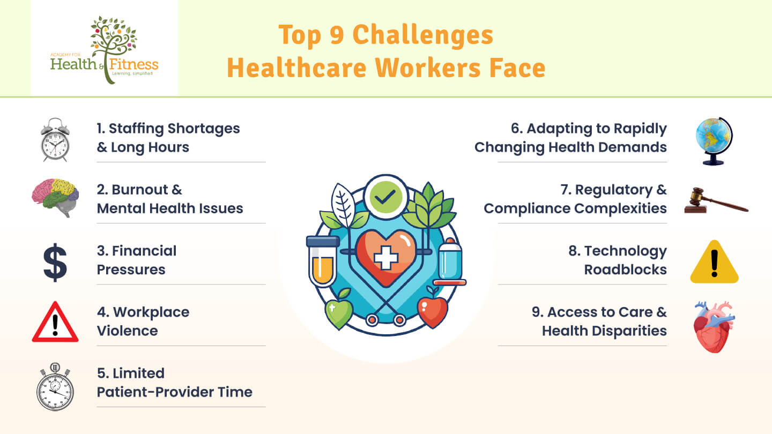

AMBULANCE SERVICES
Post war reorganisation led to the national health services Act of 1948. As part of this, for the first time, there was a requeriment for ambulances to be available for all those who needed them.
By now, a more recognisable service was beginning to take shape. In the 1950s the London country councils ambulance services moved to headquarters at waterloo road, but it was already clear this wouldn’t be large enough.
By the early 1960s it was agreed a new headquarters would be built further up waterloo road.
A London wide service was created in 1965 when one ambulance services was formed in London from parts of nine existing service.it comprised nearly1,000 vehicles and 2,500 staff.
The UK ambulance service evolved from late 19th-century volunteer-led, horse-drawn stretchers into a professionalised, 24/7 NHS service. Founded in 1874 in Burslem, the service was later formalized by the 1948 NHS Act, providing universal access. Motorized ambulances appeared around 1904, with 999 services introduced in 1937.
Key Historical Developments
Late 19th Century: Voluntary ambulance services were introduced to tackle industrial injuries. The Order of St John established its first ambulance station in 1888.
1900s–1930s: Horse-drawn vehicles were gradually replaced by petrol vehicles (first in 1904).
World War II: An auxiliary service, heavily staffed by women, managed high-pressure rescue during the Blitz.
1948 - NHS Integration: The National Health Service Act required ambulance availability for all, bringing the service under local authority control and transforming it into a cohesive national system.
1960s–1970s: The "Miller Report" (1967) modernized the service, shifting focus from merely transporting patients to providing in-vehicle treatment, introducing intensive training and better equipment.
Modern Era: Modern emergency ambulances (like the Mercedes-Benz Sprinter) have replaced old models, and paramedics are now trained at degree level.
Northampton General Hospital +6
London Ambulance Service (LAS) Specifics
Formation: Created in 1965 from the merger of nine smaller services.Growth: In 1960, the service handled roughly 1 million calls; by 2017, this rose to over 1.9 million.
Technology: The service now uses electric vehicles and advanced digital equipment.

References
(No date a) NHS choices. Available at: https://www.londonambulance.nhs.uk/about-us/our-history/our-history-a-timeline/ (Accessed: 22 March 2026).
(No date b) The history of the Ambulance Service. Available at: https://www.northamptongeneral.nhs.uk/About/OurHistory/History-of-Ambulance.pdf (Accessed: 22 March 2026).
(No date c) NHS choices. Available at: https://www.londonambulance.nhs.uk/about-us/our-history/our-history-a-timeline/ (Accessed: 22 March 2026).
(No date d) NHS choices. Available at: https://www.londonambulance.nhs.uk/about-us/commercial-services/london-ambulance-service-historic-collection/ (Accessed: 22 March 2026).
(No date e) Open access government | government | Health & Social Care | Research. Available at: https://www.openaccessgovernment.org/ (Accessed: 22 March 2026).
(No date f) NHS choices. Available at: https://www.england.nhs.uk/community-health-services/ehch/#:~:text=The%20Enhanced%20health%20in%20care%20homes%20framework%20has%20been%20updated,living%20in%20a%20care%20home. (Accessed: 21 March 2026).
Find A residential care home: CHS Healthcare (2025) CHS Healthcare | Carehome Selection. Available at: https://carehomeselection.co.uk/care-homes/residential-care-homes/ (Accessed: 21 March 2026).
Johnson, J., Rolph, S. and Smith, R. (2010) Uncovering history: Private Sector Care Homes for Older People in England: Journal of Social Policy, Cambridge Core. Available at: https://www.cambridge.org/core/journals/journal-of-social-policy/article/abs/uncovering-history-private-sector-care-homes-for-older-people-in-england/755E1B3FDDE7D39221E4523C621E05F0 (Accessed: 21 March 2026).
Training Express and Lawrence, R. (2026) What is effective communication in Health and Social Care?, Training Express. Available at: https://trainingexpress.org.uk/effective-communication-in-health-and-social-care/ (Accessed: 22 March 2026).

