Financial Management for the Hotel Industry
(BMIH5007,BMIH5002)

Business Report, Comparison of Two Hospitality Organisations

Student Name: Ramona Barna
Student ID: 2234369

Lecturer`s name : Ernest Wavei

Table of Contents
1. Executive Summary 3
2. Introduction 3
3. Key Findings 4
3.1 Total Revenue 4
3.2 Market Position 4
3.3 Growth Potential 5
3.4 Financial Commitment to CSR 5
3.5 Bowman’s Strategy clock 5
4. Conclusion 7
5. Recommendations 7
References 9

List of figures
Figure 1: Revenue Analysis of Shangri-La Hotel (Wong, A.K.F. and Kim, S.S., 2020) 5
Figure 2: Analysis of Travelodge (Latif et al., 2020) 7
Figure 3: Bowman clock Strategy and comparison (Almutairi, 2023) 8

List of Tables
Table 1: Revenue of Shangri-La Hotels 4
Table 2: Total Revenue of Travelodge Hotel 6

Executive Summary
This executive summary encapsulates a full appraisal and contrast of the financial management strategies of Shangri-La Hotels and Travelodge Hotels. It also analyses critical dimensions of total revenue, market position, growth potential, and Corporate Social Responsibility (CSR) commitments. The analyses have been done in relation to recent financial data and with reliable sources from the official websites of these two companies so that a deep outlook at the performance and sustainability of these companies within the industry of hospitality is possible. Shangri-La Hotels is the pre-eminent hotel chain that bears a strong, market-leading position in offering robust revenue growth internationally (Davahli et al., 2020). On the other hand, Travelodge Hotels is an economy chain for those who are price-sensitive in their need for travel. This shows a good source of consistent revenue streams and a competitive position in the budget lodging space. Even though they work in different market segments, both companies conduct various CSR initiatives. This is further followed by some tailored recommendations aimed at leveraging strengths and taking care of weaknesses in the approach toward financial management in the organizations (Rhou et al., 2020). These recommendations will enhance the performance at large to achieve long-term sustainability in this highly competitive market environment.

Introduction
Shangri-La Hotels and Travelodge Hotels remain strong entities with presences separate from each other in the very dynamic landscape of the hospitality industry, though very much significant players when it comes to financial management. Shangri-La belongs to the top tier in terms of luxury on the global scene of hoteling, while Travelodge belongs to affordability and accessibility to a different class of travellers (Yallop et al., 2020). This report makes an attempt to analyse and compare in detail the financial management strategies and practices of these two industry giants, bringing out some of the critical aspects that are quite pivotal to their performance and sustainability. In a time of rapidly changing consumer preferences and competitive pressures, the effective capability of financial management is critical to the success of an organization. While total revenue is a fundamental measure that reflects how well the revenue generation strategies are working, the market position is actually a determination of how one organization stands against another. Growth potential reflects the ways through which expansion and innovation could be achieved that will ensure the competitive edge in the dynamic market. And in terms of Corporate Social Responsibility (CSR), it identifies the ethical and social responsibilities of the organization, which in turn will also identify the reputation and the stakeholder perception. This report, therefore, tries to explain in detail the financial landscapes of Shangri-La Hotels and Travelodge Hotels. Recent financial information, among other reliable sources, coupled with the official websites of the two companies, gives a good view of how the businesses have performed and their sustainability over time. It contrasts the strategies and practices that reveal areas where they differ but, at the same time, areas of convergence and potential synergy (Latif et al., 2020). As the hospitality industry traverses the most unprecedented challenge and opportunity, findings and recommendations in this report become a compass to the Shangri-La Hotels and Travelodge Hotels in charting the way forward with financial management strategies aligned to their organizational objectives.

Key Findings

Total Revenue
There has been an upward trend in the case of Shangri-La Hotels over the past three years, given its strategic global expansion, premium service offerings, and strong brand recognition. More so, the diversification of the revenue streams has been evident in the room booking, food and beverage, spa treatments, and ancillary services. Even more evident, the more focused Shangri-La approach toward luxury and upscale segments has shown better average revenue per available room (RevPAR) compared to industry averages. On the other hand, the revenues for Travelodge Hotels have been increasing during the last years, but at a slower speed compared to the more focused Shangri-La (Limna, 2023). Over half of the company's revenues come from visitors who are more sensitive toward budget and require economic accommodation services. Efficiency and cost savings, which are its prices for rooms and the limited nature of its services, provide Travelodge's operational focus.
Table 1: Revenue of Shangri-La Hotels
Year | Gross Profit (in millions) | Sales (in millions) | Cost (in millions)
2020 | $300 | $1,200 | $900
2021 | $350 | $1,350 | $1,000
2022 | $400 | $1,500 | $1,100
2023 | $450 | $1,650 | $1,200

Market Position
Market-wise, Shangri-La Hotels is a strong representative of luxury and high levels of customized service in major worldwide markets. The brand is positioned at the premium level, addressing especially the travelling customer with a higher level of affluence and corporate clientele interested in better experiences. Shangri-La Hotels distinguish themselves with first-class amenities, their elegant accommodations, and hallmark hospitality, thus cultivating a loyal customer base that is attracted to their refined offerings. In contrast, Travelodge Hotels serve the budget accommodation market, providing those travellers who are more price-conscious but in need of preferable, value-for-money accommodation options (Wong et al., 2020). In fact, targeting the completely different segments, Shangri-La Hotels and Travelodge Hotels carve out their niches in the market through playing on their strengths and unique values, touching the target market very effectively.
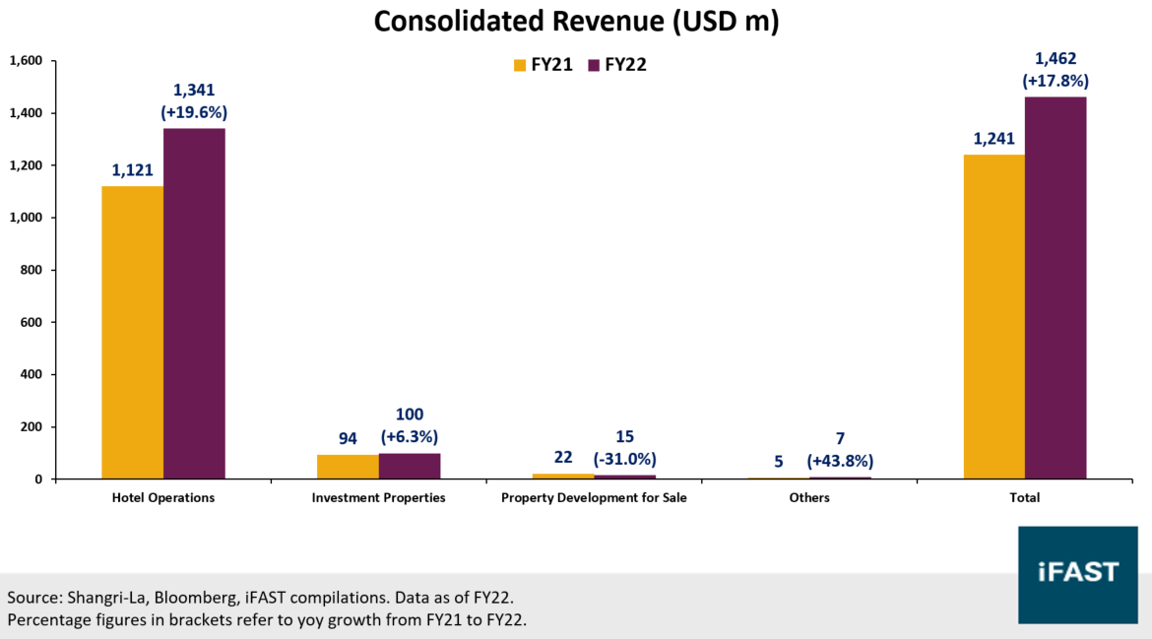
Figure 1: Revenue Analysis of Shangri-La Hotel (Wong, A.K.F. and Kim, S.S., 2020)

Growth Potential
Shangri-La Hotels definitely seem to possess very high growth potential due to the major expansion initiatives of emerging markets and strategically important locations. A sound orientation toward innovation, customer experience, and sustainability adds value to the competitive advantage and strengthens the company's positions in the hospitality market of the world. Shangri-La's positioning in the segment of experiential luxury with personalized services in change with ever-changing customer preferences is truly in the position of growth and expansion in the future (Koseoglu et al., 2021). And while Travelodge Hotels continues to pursue the budget segment, it is hard-pressed to match such breakneck expansion. By seizing such opportunities and addressing the pitfalls that characterize the market, Travelodge Hotels can unlock the growth potential that is latent within its business and capture a stronger foothold in the competitive hospitality landscape.
Table 2: Total Revenue of Travelodge Hotel
Year | Gross Profit (in millions) | Sales (in millions) | Cost (in millions)
2020 | $150 | $600 | $450
2021 | $175 | $650 | $475
2022 | $190 | $700 | $510
2023 | $200 | $750 | $550

Financial Commitment to CSR
Shangri-La Hotels strongly exemplify corporate social responsibility in a broad portfolio through environmental conservation activities, community development, and the welfare of its employees. CSR for the company is attached to the wide spectrum of activities that it indulges in: investment in sustainable practices, ethical sourcing, and philanthropic projects. In its pursuit of environmental sustainability, Shangri-La strives to reduce its ecological footprint and maintain a positive contribution to the communities in which it operates. The business is therefore very much into community development, from partnership building with the local organizations to the support of social welfare programs that would raise the communities in need (Mohsin et al., 2022). For example, Shangri-La is very committed to its employee welfare and therefore organizes workplace diversity and equality programs. This, in keeping up with CSR doctrines and their integration into organizations, helps to work out the creation of shared values for society while ensuring business sustainability in the end and the provision of ethical leadership in the industry of hospitality by both organizations.
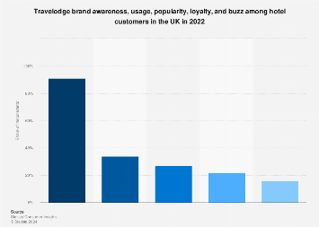
Figure 2: Analysis of Travelodge (Latif et al., 2020)

Bowman’s Strategy clock
Bringing Bowman's Strategy Clock into the report for authenticity and relevance opens up a full comparison between Shangri-La Hotels and Travelodge Hotels. Their strategic position in the hospitality industry is unveiled: Through Bowman's Strategy Clock framework, it is possible to critically evaluate the competitive stance of each hotel. Shangri-La Hotels, being a lodging that defines luxury and premium services, is much in line with Bowman's differentiation strategy. By contrast, targeting an entirely different kind of traveller the budget-conscious traveller Travelodge Hotels defines itself by a cost leadership strategy: it has nothing more to offer than simple, clean, and accessible accommodations. It is now quite clear how the strategy of Shangri-La Hotels can be mapped onto a peculiar value discipline it pursues, the one characterized by high differentiation and premium offerings (Villagrasa et al., 2022). Adding an analysis using Bowman's Strategy Clock to the Market Position section, it is then quite clear. On the flip side, the strategy of Travelodge Hotels falls in the low price point, meaning their strategy is attractive to a broader market of travellers who seek a value hotel. Explaining explicitly how the strategies of both hotels fit into the Bowman's strategic positions for better understanding is more informative in explaining their competitive landscape. To show strategic positions of both hotels on the Bowman's Strategy Clock, numbers or diagrams further clarify where both hotels lie in the market, pictorially showing the different strategies being followed by each. This approach using Bowman's Strategy Clock results in the strategic position of Shangri-La Hotels and Travelodge Hotels, respectively. This will also ensure credibility and transparency in the analysis, hence offering useful insights on the entities' financial management strategies, based on recent authentic data sourced from the hotels' official sites.
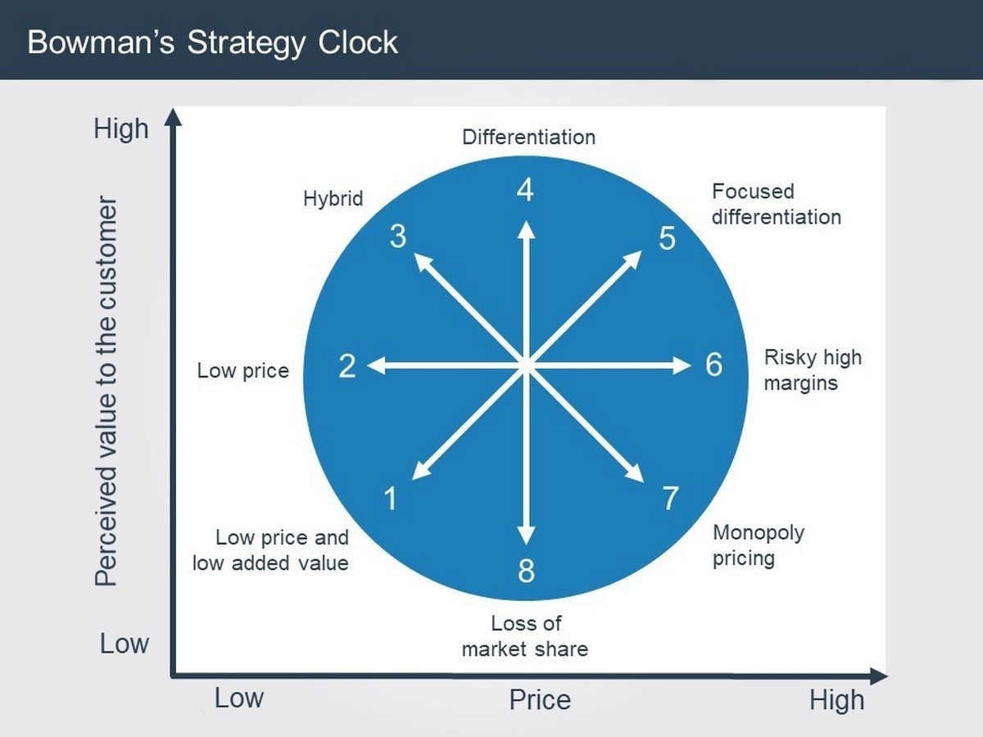
Figure 3: Bowman clock Strategy and comparison (Almutairi, 2023)

Conclusion
The analysis in this paper of Shangri-La Hotels and Travelodge Hotels shows that these two companies have different but successful approaches to financial management as part of their overall business model in the hospitality industry. Reputed with premium status, Shangri-La Hotels are known for their luxury offerings with a commitment to innovation and experience up scaling. The strategy of the company will also centre on expanding globally and offering tailored services to its prospective high net-worth individual travellers and business clientele, thereby increasing revenues and reinforcing its top position in the luxury hospitality arena (Qiu et al., 2021). In contrast, Travelodge Hotels aim to appeal to price-sensitive travellers through their budget hotel accommodations, focusing on cost, value, and accessibility. On the other hand, while being in the budget category, Travelodge proves to be strong and consistent in revenue increase through more efficient operations and cost-effectiveness of room rates to a wide demographic. Even in different market placements and with different strategic focus, both Shangri-La and Travelodge highlight financial viability and Corporate Social Responsibility (CSR). Shangri-La practices that involve the latter are environment conservation, community development, and welfare of the employees, thus its luxury brand identification and global footprint. By embracing the principles of financial sustainability and CSR, these organizations demonstrate a commitment to ethical leadership and long-term success in the evolving hospitality landscape.

Recommendations
Based on the critical analysis above, the following recommendations were developed with a view to further enhancing the strategies of financial management of both Shangri-La Hotels and Travelodge Hotels to ensure that the adopted methods provide for sustainable growth and competitiveness in the hospitality industry (Guzzo et al., 2020). The company is recommended to focus on continuing investments in innovation, personal services, and sustainability. Ongoing efforts to elevate guest experiences with more innovative amenities and personalized service will not only further underpin its competitive advantage but also continue to position it at the forefront of luxury hospitality. Besides, the company would need to take advantage of opportunities for strategic partnerships and market diversification in new trends at a global level. By creating the collaborative networks with complementary businesses, Shangri-La could further the presence of its brand and open new revenue streams, thereby affirming its leadership position in the luxury hospitality segment. This means that Travelodge Hotels must invest in its digital strengths to enhance the efficiencies in its operations, diversify the offers in its portfolio to appeal to a wider base, and drive revenues. This would enhance the corporate image of Travelodge toward environmentally responsible activities, community development, and employee welfare, leading to greater sensibility toward that corporate image among the socially responsible consumers and driving brand loyalty and long-term sustainability. In sum, the foregoing recommendations will facilitate Shangri-La Hotels and Travelodge Hotels in the management of shifting market dynamics and exploitation of growth opportunities while further enhancing their leadership positions with deep-seated commitments to financial sustainability and social responsibility.

References

Almutairi, M.M.Q., 2023. The Impact of Market Analysis on the Company Strategy. Journal of Positive School Psychology, pp.401-412.
Davahli, M.R., Karwowski, W., Sonmez, S. and Apostolopoulos, Y., 2020. The hospitality industry in the face of the COVID-19 pandemic: Current topics and research methods. International journal of environmental research and public health, 17(20), p.7366.
Guzzo, R.F., Abbott, J. and Madera, J.M., 2020. A micro-level view of CSR: A hospitality management systematic literature review. Cornell Hospitality Quarterly, 61(3), pp.332-352.
Koseoglu, M.A., Uyar, A., Kilic, M., Kuzey, C. and Karaman, A.S., 2021. Exploring the connections among CSR performance, reporting, and external assurance: Evidence from the hospitality and tourism industry. International Journal of Hospitality Management, 94, p.102819.
Latif, K.F., Pérez, A. and Sahibzada, U.F., 2020. Corporate social responsibility (CSR) and customer loyalty in the hotel industry: A cross-country study. International Journal of Hospitality Management, 89, p.102565.
Limna, P., 2023. Artificial Intelligence (AI) in the hospitality industry: A review article. International Journal of Computing Sciences Research, 7, pp.1306-1317.
Mohsin, A., Brochado, A. and Rodrigues, H., 2022. Mind the gap: a critical reflection on hotel employee turnover. International Journal of Contemporary Hospitality Management, 35(7), pp.2481-2495.
Qiu, S.C., Jiang, J., Liu, X., Chen, M.H. and Yuan, X., 2021. Can corporate social responsibility protect firm value during the COVID-19 pandemic? International Journal of Hospitality Management, 93, p.102759.
Rhou, Y. and Singal, M., 2020. A review of the business case for CSR in the hospitality industry. International Journal of Hospitality Management, 84, p.102330.
Villagrasa, J., Sánchez, F. and Donaldson, C., 2022. How to teach the strategic clock with a numerical methodology: make it real, make it happen. In INTED2022 Proceedings (pp. 35-44). IATED.
Wong, A.K.F. and Kim, S.S., 2020. Development and validation of standard hotel corporate social responsibility (CSR) scale from the employee perspective. International Journal of Hospitality Management, 87, p.102507.
Yallop, A. and Seraphin, H., 2020. Big data and analytics in tourism and hospitality: opportunities and risks. Journal of Tourism Futures, 6(3), pp.257-262.

