Discussion of Handwritten digit recognition

Student Name: Huang Xudong
Student id: 2011454
Course Name and Code:Artificial Intelligence(ACCA7026)
Contents
1.Introduction 2
2.Preliminary discussion on handwritten digit recognition 3
2.1.Handwritten number recognition process 3
3.Handwriting recognition experiment based on MNIST 5
3.1.MNIST profile 5
3.2.Common handwriting recognition classifiers 5
3.3.1.K-NearestNeighbor(KNN) 6
3.3.2Naive Bayes 6
3.3.3. Support Vector Machines 7
3.4. The result of the codes 8
3.4.1. KNN 8
3.4.2. Naive Bayes 11
3.4.3. SVM 12
3.5. The results discussion 12

Abstract.The main purpose of this paper is to carry out a preliminary exploration and practice of handwriting recognition based on MNIST database and three different basic machine learning handwriting recognition classifiers. In addition to comparing the handwriting recognition accuracy of the models trained by the three, the characteristics of the three models should be recognized based on the analysis methods such as confusion matrix. The result is that the model trained by SVM has the highest handwriting recognition accuracy and the highest model quality, but it takes a lot of time to train. KNN performs well in simple handwriting recognition, but a larger K value is more likely to lead to model misjudgment. Naive Bayes trains a subpar model at breakneck speed.

1.Introduction
With the continuous accumulation and breakthrough of AI technology and the increasing requirements for big data processing capabilities, as a concept proposed in the early days of computer invention, artificial intelligence plays an increasingly important role in today's scientific research and daily life. At the beginning, machine learning with the ability to acquire knowledge was proposed based on hard-coded knowledge system, and then deep learning was proposed to express complex representation through simpler representation in order to solve the core problem of representation learning [3]. As one of the most important problems in the application of various aspects of AI, handwriting recognition technology has been paid attention to by researchers. Handwriting recognition involves data mining, pattern recognition and many other artificial intelligence applications.

As a branch of the luxuriant tree of artificial intelligence, handwritten number recognition technology undoubtedly plays an increasingly important role in the rapid development of artificial intelligence today and develops far beyond the past. While not a member of the top technology field, but as one of the most important issues in data mining, machine learning, pattern recognition along with many other disciplines of artificial intelligence [8]. Handwriting recognition technology will continue to gain new impetus from the development of artificial intelligence like other branches of artificial intelligence.

2.Preliminary discussion on handwritten digit recognition

2.1.Handwritten number recognition process

According to the different selection of pattern features and discriminant decision methods, pattern recognition methods can be roughly divided into five categories.

(1)Statistical pattern method
This is a recognition method based on similar patterns having the same attributes. The parameters used to describe the attributes of things are called features, which can be extracted according to certain criteria after statistical analysis of the measured values of multiple samples of the pattern.

- Syntactic structure method
Syntactic structure method is a recognition method based on similar structure of similar patterns. Structure refers to the relationships between the basic units (primitives) that make up a pattern. Based on this principle, the "dictionary" in the recognition system of spread-out words should include letters and the rules for the formation of characters into words. When identifying a word, we should first extract the tiny letter and analyze its structure, and then compare it with all the known words in the dictionary one by one, so that we can determine which word to be recognized and which known word belongs to the same category. This method is undoubtedly a highly trained method of identification. This recognition method is very suitable for the recognition of the continuity of the identified elements with close logic.

- Logical feature method
That is, the selection of its features is unique to the class pattern recognition problem, that is, in the class problem only one pattern has a certain logical feature (or a combination of 1), this method establishes a complete system about knowledge representation and organization, target search and matching; It has a good effect on the problem of identifying the target through reasoning of many rules, but for handwriting recognition, which is easily confused and random, the effectiveness of this method is often greatly reduced.

- Fuzzy mode method
Fuzzy pattern method is introduced in the process of pattern recognition of certain scattered pattern recognition with a certain characteristic of fuzzy set, due to the characteristics of fuzzy sets itself only concentrated embodiment of a more diversified, so will not be too much negative effects on the pattern recognition, it can strengthen the ability of pattern recognition of anti-interference and distortion resistance, However, to what extent fuzzy set itself should be achieved is still a content to be studied.

- Neural network method
This algorithm is the neural network enhanced version of pattern recognition. It can effectively deal with some problems that have great influence on some links, have more noise and are difficult to make clear inference rules. The neural network method allows the sample to have large defect and distortion, and it has fast running speed, good adaptive performance and high resolution [10].

These five recognition methods can achieve handwriting recognition to a certain extent, but the main handwriting recognition is often the use of neural network recognition method, for some simple handwriting recognition, structure method is more intuitive, can better reflect the structural characteristics of things。

2.2.Common process of handwriting recognition
As researchers continue to deepen the research on handwriting recognition technology, handwriting recognition process is also constantly improved, and finally formed the current handwriting recognition process. The current general identification operation process is image acquisition, pre processing, segmentation, feature extraction, classification, post processing. Among them, data preprocessing, feature extraction and classification are the most frequently paid attention to by researchers, and handwriting recognition is also the direction of continuous improvement [7]. For the pretreatment of the handwriting recognition, because the handwriting paper, writing quality factors such as interference and image input font position and so on factors, often can make a big noise, image input when handwriting recognition so need good ability of data preprocessing, the commonly used methods of binarization, character segmentation, smoothing, noise, standardization and refinement, etc.[10]

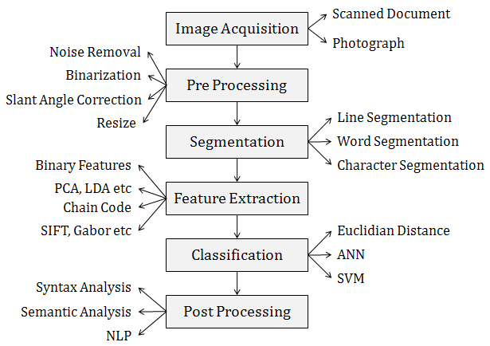
Fig. 1 Block diagram of image recognition process [7]

In handwritten digit recognition, element extraction and classification undoubtedly determine the quality of the whole recognition results [5]. In general, the characters to be recognized in the image are linearly mapped to the standard plane by interpolation/extrapolation. In standardization, due to the input image, easy to cause the entered character image sizes after processing difficulties, so to input character image size and position of control, to ensure the identification characters recognition points are on the background of the same size, convenient classifier recognition response from the model class [6]. For handwritten digit recognition, there are several commonly used feature extraction methods: template matching, feature statistics, structure feature and transformation feature [10].

When the feature extraction application is completed, the extracted features will be submitted to the classifier as input to the trained classifier. As the most important part of handwriting recognition as element extraction, the quality of classifier directly determines the time of handwriting recognition and the accuracy of conclusion. The classifier compares the features of the input with the trained model, selects the most suitable class for the input value, and then outputs the recognition result. he function of the classifier is to divide the feature space into different regions according to the source class, or to divide the class features into corresponding positions in the feature space. The most effective classifiers are statistical techniques and neural networks [5,7].

3.Handwriting recognition experiment based on MNIST

3.1.MNIST profile
MNIST database is built on the basis of the original NIST database. All numbers contained in the MNIST database have been normalized, are of the same size, and are fixed in the center of a fixed size feature space. The dimension of each image sample vector is 28*28, and each element is binary. This is for beginners who want to do machine learning and pattern recognition on some real-world data. MNIST is equivalent to a database of handwritten recognition applications that have already been preprocessed and formatted[2].

Since the data of MNIST database has been preprocessed and normalized, the main focus of this experiment should be the influence of different classifiers on handwriting recognition.

3.2.Common handwriting recognition classifiers
According to what is said about classifiers in this paper, classifiers can be divided into two kinds of classifiers with completely different principles. One is a statistical classifier and one is a neural classifier. The main difference between the two is that neural network classifier has certain advantages for separating different modes in supervised training. If the neural network structure design is reasonable and the training sample is large, the neural network can give higher accuracy to the newly added test data than the statistical classifier.

There are many methods to construct classifier, here are some common machine learning related classifiers:

- nearest Neighbors (KNN) algorithm is a classification algorithm. The idea of this algorithm is that a sample is most similar to k samples in the data set, and if most of the K samples belong to a certain category, the sample also belongs to this category.

Decision tree is a kind of tree probability analysis graph method which is made up of simple judgment. This property can also be used in image recognition.

Naive Bayes classifier is a series of simple probability classifiers based on the application of Bayes' theorem under the assumption of strong (naive) independence between features. It has similar characteristics with decision tree, but its mathematical basis and classification efficiency are more stable than decision tree.

Support vector machine(SVM) is a set of supervised learning methods, common terms classification, regression and outlier detection. And successfully in sub-solution function regression and a class of classification problems.

Convolutional neural network(CNN) is a kind of feedforward neural network with deep structure and convolution computation. The advantages of this algorithm include hidden feature extraction, local field and shared weight.

BP algorithm is a supervised learning algorithm, the main idea is: input learning samples, using the back propagation algorithm to the network weights and biases to adjust repeatedly training, to make the output vector and expect vector nearly as much as possible, when the error sum of squares of the network output layer is smaller than the specified error when training is complete, save the network weights and biases.
3.3.The experimental method
According to the above classifiers, KNN is one of the most basic classifiers, while naive Bayes classifier may have a better application in some complicated practical problems. SVM is the most effective classifier in machine learning. Therefore, this paper chooses KNN, Naive Bayes and SVM classifier for experiment and comparison.

3.3.1.K-NearestNeighbor(KNN)
KNN genetic algorithm is a very common supervised learning algorithm. It has a very simple working principle, that is, the sample is proposed, and then the K "neighbors" closest to the detection sample are calculated according to a certain distance form to select the labels to be added to the sample. Compared with the most basic pattern matching, KNN is more adaptable to more random data. In the classifier, KNN has three key elements, a set of labeled objects, a distance or similar measure to calculate the distance between objects and K value, and the number of objects closest to each other. KNN marks unmarked objects by calculating the number of nearest neighbors between unmarked objects and marked objects [4].

3.3.2Naive Bayes
Naive Bayes is a widely used classification algorithm, which has great influence on classification. Bayesian classifier (BC) is a standard and measurable classifier. They are used to predict class registration probabilities, that is, the likelihood that an instance has a probability of belonging to a particular class. Bayes method has become one of the most eye-catching methods because of its unique expression form of uncertain knowledge, rich expression ability of probability, and incremental learning characteristic of integrating prior knowledge.

The Bayesian method provides a probabilistic means of reasoning. It assumes that the variables to be examined follow some probability distribution and can be inferred from these probabilities and observed data to make optimal decisions. Not only can the Bayesian method calculate explicit hypothesis probabilities, but it also provides an effective means to understand most other methods. But it is important to note that naive Bayes is a simple classifier that relies on two important simplifying assumptions for efficient classification. Like decision tree, it is a classifier that can handle complex events by stacking simple independent event probabilities. Whether this classifier can effectively train the model in handwritten digit classification needs further observation [1].

3.3.3. Support Vector Machines
Support vector machine (SVM) is a classical supervised machine learning method, which contains a variety of technical knowledge, such as maximum interval hyperplane, Mercer kernel, convex quadratic programming and relaxation variables, and can be used to solve binary classification problems. In the case of linearly separable samples, the interval maximization method can be used for classification. However, the nature of SVM determines that SVM can only divide different things into two categories, which poses a very severe test for the application of SVM in real life. Fortunately, two methods, one to one (OneVSOne, OVO) and one to one (Onevs Rest, OVR), are commonly used to convert SVM dichotomies to multi-classification. The OVO algorithm solves the problem by assuming that there are n categories of classification tasks, and combining these n categories in pairs produces n (n-1) *2 dichotomous tasks. In the testing process, new samples are submitted to all classifiers at the same time, so that n (n-1) *2 results can be obtained, and the final test result will combine all results, and the most predicted categories will be the most final classification result. OVR algorithm selects a sample of a class as a positive example in each training and sets all the samples of other classes as negative examples to train N classifiers. If only one classifier is predicted to be positive, the corresponding category will be marked as the final classification result [9].

3.4. The result of the codes

3.4.1. KNN
(1)K=9
The calculation took 2158.459237 seconds. Accuracy = 0.9597

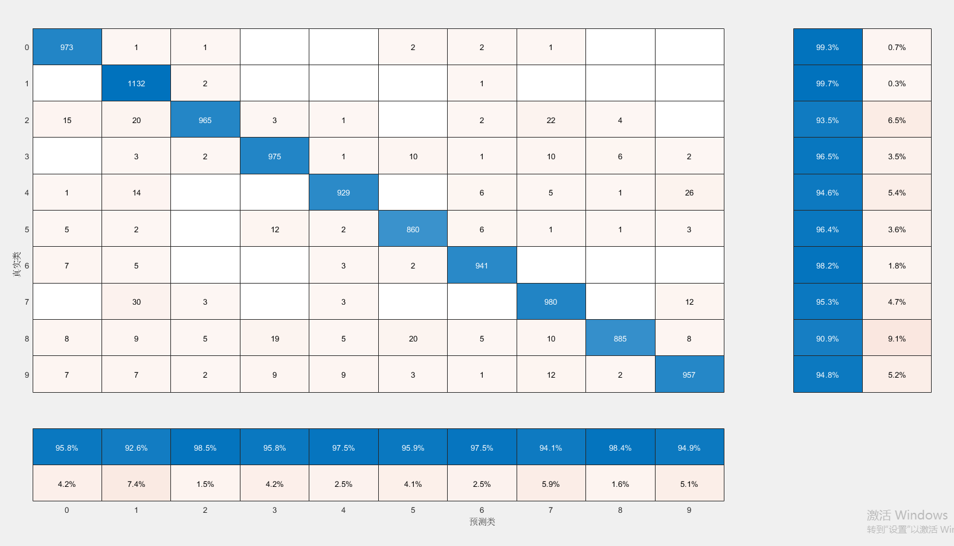
Fig.1 Confusion matrix(KNN,K=9)
(2)K=6

The calculation took 2206.6687 seconds. Accuracy = 0.9618
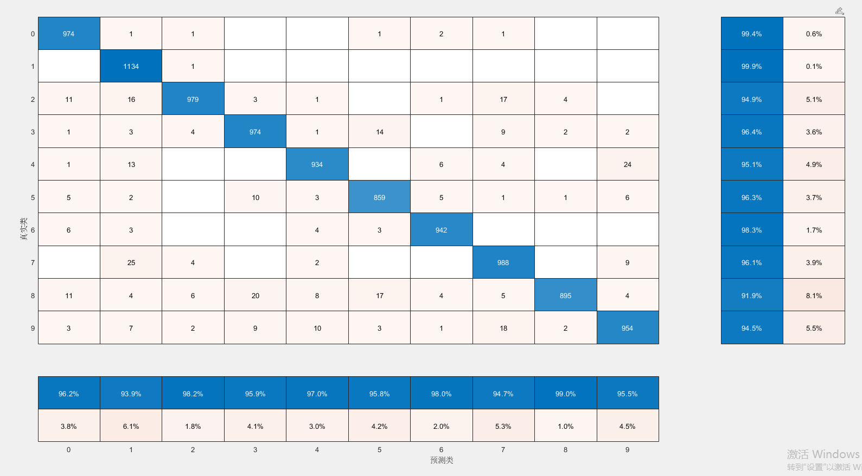
Fig.2 Confusion matrix(KNN,K=6)

- K=3

The calculation took 2207.7012 seconds. Accuracy = 0.9633

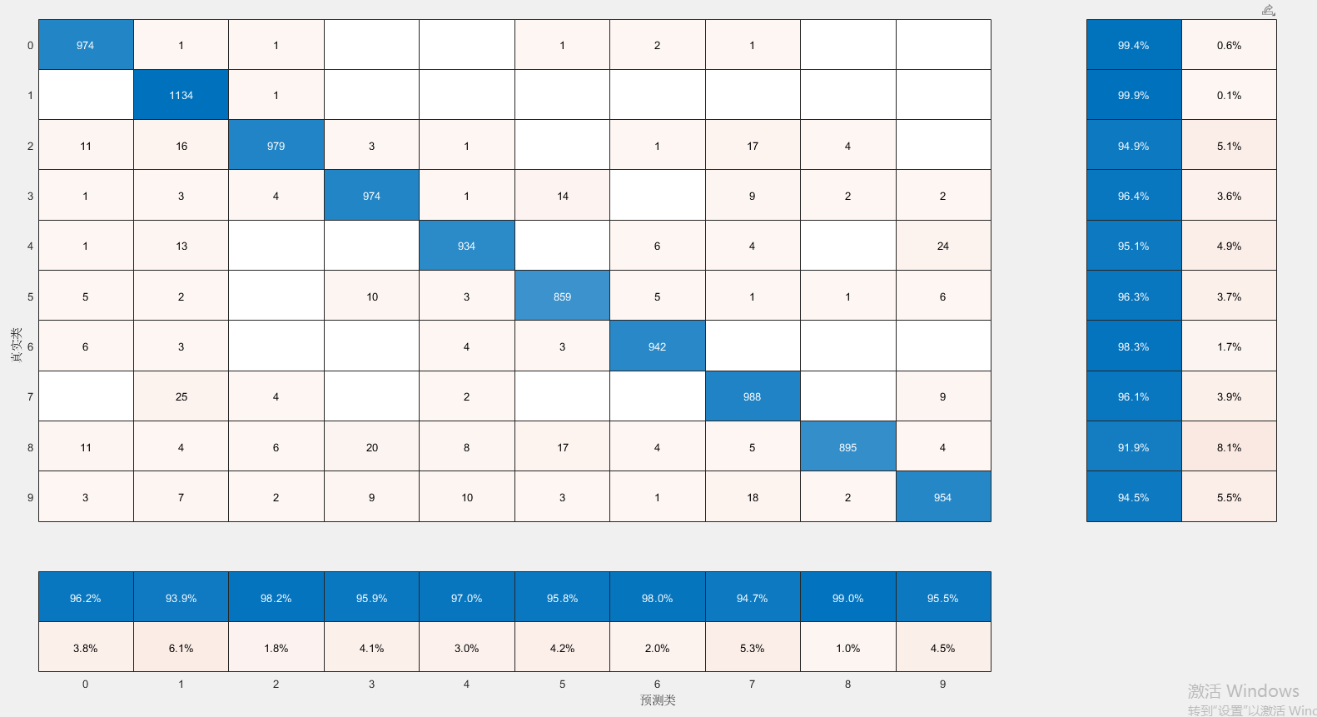
Fig.3 Confusion matrix(KNN,K=3)

3.4.2. Naive Bayes

The calculation took 188.3391 seconds. Accuracy = 0.8443

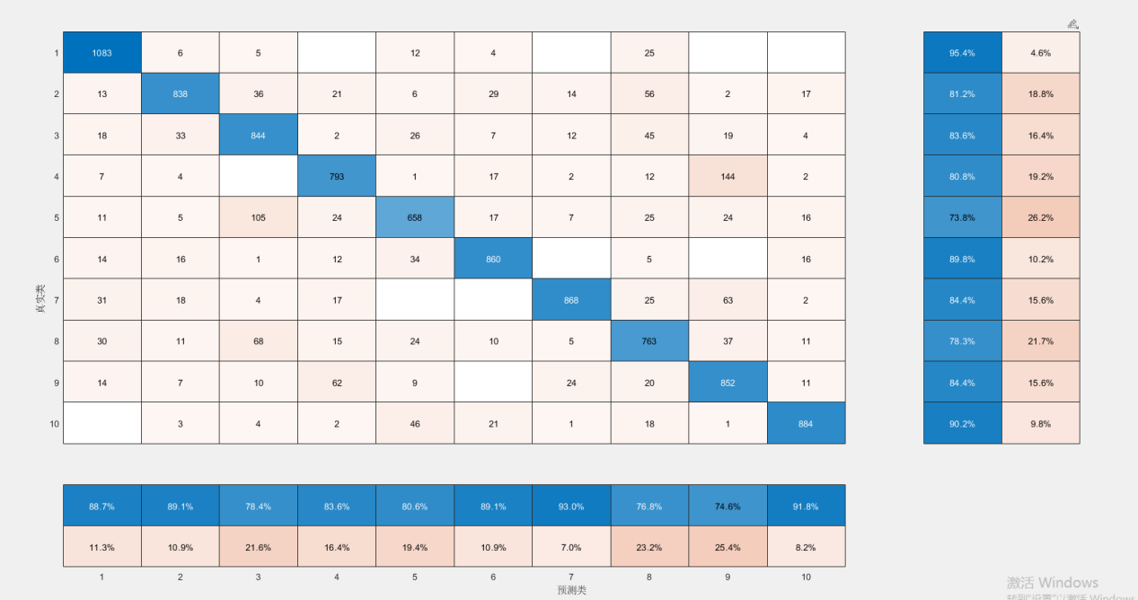
Fig.4 Confusion matrix(NB)

3.4.3. Support Vector Machines

The calculation took 23733.7020 seconds. Accuracy = 0.9665

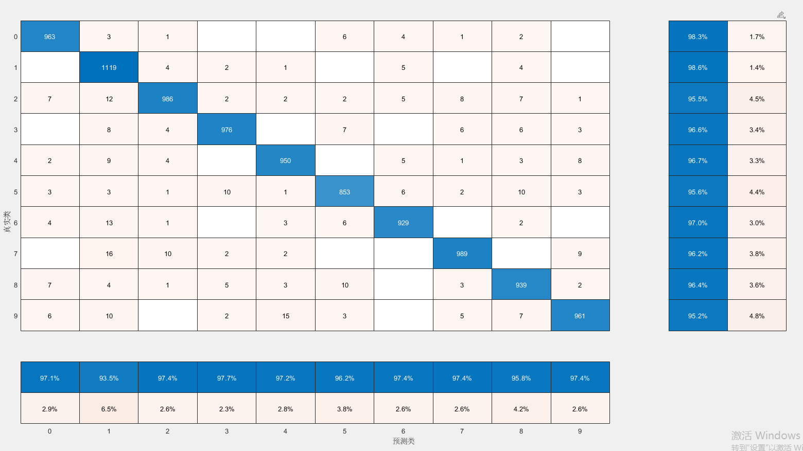
Fig.5 Confusion matrix(SVM)

3.5. The results discussion
The recall value and Precision value of each model can be intuitively obtained from the above conclusions, that is, the F-measure value of each model can be easily calculated.
Table 1 Confusion matrix data analysis
 | KNN(K=9) | KNN(K=6) | KNN(K=3) | Naive Bayes | SVM
Recall | 95.92 | 96.28 | 96.28 | 84.19 | 96.61
Precision | 96.1 | 96.42 | 96.42 | 84.57 | 96.71
F-measure | 96.01 | 96.35 | 96.34 | 79.66 | 96.66
Accuracy | 95.97 | 96.18 | 96.33 | 84.43 | 96.68

It is not difficult to see from the above table that Navie Bayes performs poorly in both quality and accuracy of MNIST-based handwritten model recognition. As described above, naive Bayes, as a classifier that classifies by calculating the probability of basically unrelated independent variables, has relatively poor performance compared with other classifiers when applied to handwritten numbers with strong correlation between partial variables. The handwriting recognition model trained by SVM stands out among the three machine learning algorithms, with the highest quality and accuracy of the model. For KNN, K value is the value that has the greatest influence on the model trained by KNN. In this experiment, the MODEL quality and accuracy of KNN algorithm are the highest when K value is 3. It can be seen that, to a certain extent, for KNN, the larger the K value is, the more likely it is to be affected by some discriminatory orientation.

Table 2 Single digit recognition rate per model
 | KNN | KNN | KNN | NB | SVM
0 | 99.3 | 99.4 | 99.4 | 95.4 | 98.3
1 | 99.7 | 99.9 | 99.9 | 81.2 | 98.6
2 | 93.5 | 94.9 | 94.9 | 83.6 | 95.5
3 | 96.5 | 96.4 | 96.4 | 80.8 | 96.6
4 | 94.6 | 95.1 | 95.1 | 73.8 | 96.7
5 | 96.4 | 96.3 | 96.3 | 89.8 | 95.6
6 | 98.2 | 98.3 | 98.3 | 84.4 | 97.0
7 | 95.3 | 96.1 | 96.1 | 78.3 | 96.2
8 | 90.9 | 91.9 | 91.9 | 84.4 | 96.4
9 | 94.8 | 94.5 | 94.5 | 90.2 | 95.2

In terms of the recognition rate of a single character, these three algorithms generally have low recognition accuracy for 2,4, and 8 characters. Naive Bayes, compared with other algorithms, has a great decline in the recognition accuracy of 1,3,7, but has a relatively good recognition accuracy of 0,5, and 9. The recognition accuracy of KNN and SVM for character 0,1,6 is very significant. In terms of overall recognition accuracy, the accuracy of single character recognition of SVM is mostly maintained at 95%, while the accuracy of KNN is improved to some extent after adjusting K=3.

In terms of the time used for training models of these three classifiers, SVM grew into the classifier with the longest time with 23733.702,047 seconds. However, the three K values of KNN have no obvious influence on the time of KNN itself, and Navie Bayes is the fastest classifier of the training model.

4.Conclusion
This paper first gives a preliminary review of handwritten character recognition systems developed from image recognition, and then studies three different basic machine learning classifiers based on the knowledge reviewed. The model precision and confusion matrix of the three kinds of classifier training are analyzed.

The results show that among the three basic machine learning classifiers, support vector machine has the highest recognition accuracy and the best quality of trained model. However, training time is the biggest disadvantage of support vector machines. However, KNN can reduce the influence of non-essential elements on input elements when K is smaller in standardized simple handwriting model recognition. Naive Bayes is the fastest trained basic machine learning classifier, but its accuracy and quality of trained models are not good enough.

References:
[1] Abdulrazzaq, Maiwan Bahjat, and Jwan Najeeb Saeed. (2019) ‘A comparison of three classification algorithms for handwritten digit recognition’, International Conference on Advanced Science and Engineering (ICOASE). Zakho - Duhok Iraq, 2-4th Apr. IEEE Xplore.
[2] Ding, Yu Xin. et al. (2017). ‘Study on the handwritten numeral recognition system based on matlab’, Wireless Internet Technology, (18), pp56-57.
[3] Goodfellow, Ian, Yoshua Bengio, and Aaron Courville.（2016） Deep learning. Massachusetts: MIT press.
[4] Kaensar, Chayaporn. （2013）‘A comparative study on handwriting digit recognition classifier using neural network, support vector machine and k-nearest neighbor’, The 9th International Conference on Computing and InformationTechnology (IC2IT2013). Deir El-Balah, Palestine. 16-17th Oct. Berlin, Heidelberg, Springer.
[5] Liu, C.-L. et al. (2003) ‘Handwritten digit recognition: benchmarking of state-of-the-art techniques’, Pattern recognition, 36(10), pp. 2271–2285.
[6] Liu, C.-L. et al. (2004) ‘Handwritten digit recognition: investigation of normalization and feature extraction techniques’, Pattern recognition, 37(2), pp. 265–279.
[7] Shah, Mansi, and Gordhan B. Jethava. (2013). ‘A literature review on hand written character recognition’, Indian Streams Research Journal, 3(2), pp1-19.
[8] Shamim, S. M., et al. (2018). Handwritten digit recognition using machine learning algorithms, Global Journal Of Computer Science And Technology, 18(1), pp. 17-23.
[9] Tuba, Eva, Milan Tuba, and Dana Simian. (2016). ‘Handwritten digit recognition by support vector machine optimized by bat algorithm’, WSCG 2016 - 24th Conference on Computer Graphics, Visualization and Computer Vision 2016. Plzen 17-20th May. WSCG.
[10] Zhang Jie. (2004) Research and Application of Handwritten Digit Recognition. Unpublished PhD thesis. Xi 'an University of Architecture and Technology.

