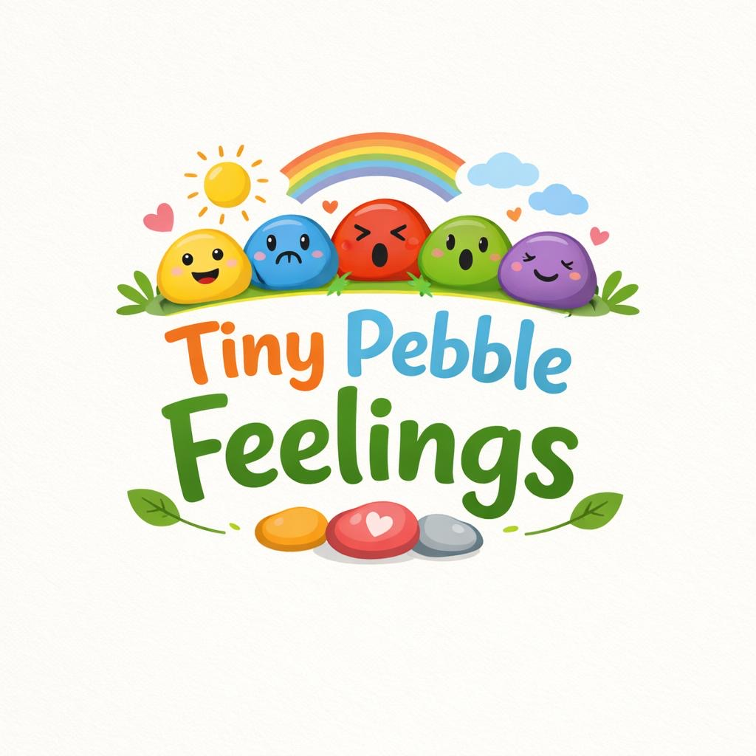

Supporting little voices to be heard and understood.

Page 1 – Logo
Page 2 – Contents page
Page 3 and 4 – Information pamphlet
Page 5 – 10 – Part 2 – Written piece
Page 11 - 13 – Reference list

I have used AI for this assignment, but only to design my logo for my business idea.

What I wrote into AI’s Chat GBT - “Can you make me a logo for emotional pebbles for children to express their feelings”

How to Use Tiny pebble feelings  - Morning check in  Children can pick up a pebble as soon as they get to nursery/school.  - Group discussions/sessions  Children can choose and share their pebbles and feelings with each other.  - Art and craft session  Children can decorate and create their own emotional pebbles as part of an activity.  - Calm area  Having a basket of the pebbles in the calm corner, so children can go and feel, choose their emotions.  - Universal communication aid  Beneficial for those who are non-verbal or resistant to speak.  Why Me?  This idea is especially personal to me. My personal journey growing up along with now working with children and seeing their struggle with emotion daily. I know and see the importance of supporting children with their emotional needs. Tiny Pebble Feelings ensure that no children stay silent unable to express themselves.  Market Need  The concerns surrounding children’s mental wellbeing are on the rise (NHS Digital, 2022). It is very well known that early intervention is crucial (EIF, 2018)  An increasing necessity for.  - Affordable mental health resources  - Effective educational tools  - Trauma sensitive materials  - Strategies supportive of ALN  Tiny pebble feelings fulfil this requirement through.  - Cost effectiveness  - Ease of use  - Limited training necessary  - Flexibility of a range of age ranges | Why Emotional Expression Matters in Early Years?  Research shows that emotional literacy in early years develops several things:  - Strong attachments (Bowbly, 1969)  - Self regulation development (Shonkoff and Phllips 2000)  - Better social skills (Denham, 2006)  - Better mental health outcomes (WHO, 2021)  - Being ready for school (DfE, 2021)  Children who can see and name their feelings are able to manage their behaviour much better, be able to make connections easier, and ask for help or support when needed (Goleman, 1995; Salovey & Mayer, 1990)  Several children have difficulty with explaining and expressing their emotions verbally, especially children with.  - Additional Learning Needs (ALN)  - Speech and Language needs  - Autism Spectrum Disorder (ASD)  - Trauma background  Tiny pebble feelings are a gentle, play based communication resource that is aligned with a child centred approach (Rogers, 1951)  Our objective  To deliver a friendly, useful, budget friendly emotional communication tool and activity to.  Foster emotional understanding  Stimulate self-expression.  Advocate emotions  Correspond with the Early Years curriculum.  Our learning foundation  Tiny pebble feelings go hand in hand with important early childhood development principles.  - Attachment Theory (Bowbly, 1969)  Children need a safe, caring adults and resources to be able to articulate emotional needs.  - Social and Emotional Learning (CASEL, 2020)  Emotional consciousness is essential for wellbeing.  - Vygotsky’s Social Development Theory (1978)  Emotional comprehension builds through social engagement and support.  - Play centred learning (Woord, 2010)  Children convey meaning through play and their chosen symbolic items.  -Early Years Foundation (DfE, 2021)  - Curriculum for Wales (Welsh Government, 2022)  - UNICEF rights of the Child (UNCRC, 1989) | 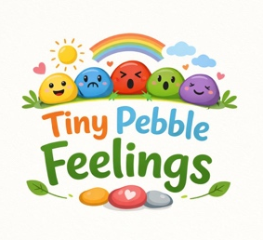  .  Our story  Tiny Pebble feelings is very personal to me and is a business that is close to my heart due to my own experiences growing up. Growing up I had a very hard time showing and expressing my own emotions. I often felt very overburdened with emotions due to my Additional Learning needs, I lacked the words, self-reassurance, and resources to show and display my feelings. Like several children, I battled in silence with this difficulty. That experience and feeling has stayed with me and has been my biggest influence to promote the emotional wellbeing and development of children. The idea of emotional pebbles is that all children should and can have a safe, easy, and creative way to express and communicate their emotions.  What are Tiny Pebble feelings?  Tiny pebble feelings are smooth, bright pebbles, drawn with different emotions on each of them.  Tired  Frustrated  Happy  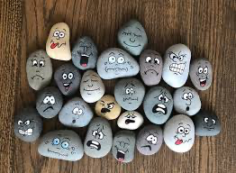  Calm  Angry  Excited  Etsy.com, 2019  Confused  Sad  Each pebble is visual and physical. Children can choose 1 pebble to show how they are feeling, or they can choose more than one, depending on how they feel that day. Tiny pebble feelings can also be made by the children themselves as an activity.

Introduction

Emotional development during early childhood is important for future health, school success, and getting along with others. (Team 2025) Research shows that strong emotional foundations formed in these early years significantly influence a child's ability to navigate social situations, build relationships, and manage stress later in life. (Mcgarvie, 2024) More and more children are experiencing higher levels of emotional distress and behavioural issues, highlighting the urgent need for effective support systems. The increase of anxiety and sadness within young children can come down to a range of factors, including society pressures, changes in family dynamics, and the impact of technology. (Local.gov.uk, 2020) That’s why early intervention programs that encourage emotional understanding are important. Play is a crucial role in equipping children with the tools they need to recognize and express their feelings appropriately. By creating an environment where emotions can be openly discussed and understood, practitioners and educators can help children develop resilience and problem-solving skills, which are vital as they grow. Also, these programs can guide parents and teachers in recognizing signs of emotional distress, allowing for timely support that can make a profound difference in a child’s life. (Ateroid health, 2025) Investing in emotional development today paves the way for a healthier, more connected future generation.

This essay shows a critical analysis of the proposed business ‘Tiny Pebble Feelings’ and shows its potential benefits for the early year’s development, connecting these findings to theory, research, and practice.

The importance of emotional Literacy
Emotional literacy is the skill of identifying, comprehending, expressing, and managing emotions (Goleman, 1995). According to Salovey and Mayer (1990), emotional intelligence is fundamental for adaptive functioning throughout life. In the early years of childhood, emotional competence is closely associated with several key areas of development. Research shows that it significantly impacts relationships with peers, as indicated by Denham (2006), and plays a vital role in the regulation of behaviour, as noted by Blair and Raver (2015). Additionally, emotional literacy contributes to school readiness, as emphasized by the Department for Education in its 2021 report and is linked to positive outcomes related to mental health, as highlighted by the World Health Organization (WHO, 2021)
Children who don't possess a strong emotional vocabulary may struggle to articulate their feelings effectively, often leading to challenging behaviours as a result. This difficulty in expression can be particularly distressing for them and may hinder their ability to form positive relationships with others. (Perry, 2006) Emotional Pebbles seeks to create a solid communication link. By fostering emotional vocabulary and understanding, it aims to empower children to articulate their feelings, navigate social interactions, and enhance their overall emotional well-being. (Colliver and Veraksa, 2021) This initiative not only benefit individual children but can also lead to a more harmonious and supportive community in educational settings.

Theoretical Foundations

Attachment Theory

Bowlby (1969) highlighted that secure attachment bonds foster emotional security, which is crucial for healthy relationships throughout life. The significance of these bonds can be profound, as they help individuals navigate emotional challenges and foster resilience. Emotional Pebbles might serve as a helpful tool in promoting secure interactions between adults and children, encouraging open communication and deeper connections. By using tiny pebble feelings, Practitioners can create an environment for children where feelings are taken into account and explored, strengthening the trust, and understanding within their relationships. This approach not only enhances emotional awareness but also cultivates a nurturing atmosphere conducive to healthy development.

Social Constructivism

Vygotsky (1978) emphasized that children gain understanding primarily through social interactions with their peers and adults. He believed that learning is a socially mediated process, where the support provided by more knowledgeable individuals plays a crucial role. Facilitated emotional conversations involving simple objects, such as pebbles, can significantly aid in scaffolding within the Zone of Proximal Development. By engaging in discussions about feelings and thoughts associated with these objects, children can explore concepts in a tangible way. This approach helps them internalize new knowledge while developing critical thinking and communication skills that are essential for their overall cognitive growth.

Person-Centred Theory

Rogers (1951) promoted the idea of unconditional positive regard and empathetic understanding, emphasizing the importance of accepting individuals for who they are without judgment. This concept fosters a safe environment for personal growth, allowing individuals to explore their feelings openly. Similarly, Tiny Pebbles feelings encourage a non-judgmental way of expressing oneself, serving as a tool for individuals to articulate their emotions freely. By reflecting on one's feelings through the process of using Tiny Pebble Feelings, people can gain deeper insights into their emotional state. This practice not only enhances self-awareness but also nurtures healthier relationships with others, reinforcing the value of empathy and understanding in communication.

Neuroscientific Perspectives

The early stages of brain development are influenced significantly by emotional experiences, as highlighted by the Centre on the Developing Child in 2016. Chronic stress, especially when coupled with a lack of emotional support, can negatively impact the formation and functioning of neural pathways, as noted by Shonkoff et al. in 2012. In this context, Tiny Pebble feelings could serve as a crucial protective resource in building and maintaining healthy relationships. By fostering emotional connections and providing support, these tools could help mitigate the adverse effects of stress, ultimately promoting more positive outcomes for children's cognitive and emotional development throughout their formative years.

Policy and Curriculum Links

Tiny Pebble Fellings aligns seamlessly with several key educational frameworks and guidelines designed to support the overall development of children. It corresponds with the Early Years Foundation Stage (DfE, 2021), specifically focusing on Personal, Social, and Emotional Development (PSED), which is fundamental for helping young learners build essential life skills. Furthermore, it follows the Curriculum for Wales (Welsh Government, 2022), particularly in the Health and Wellbeing Area, reinforcing the importance of mental and emotional health. The initiative is also in accordance with UNCRC (1989) Article 12, emphasizing children's rights to express their views freely, fostering a sense of agency. Additionally, the ALN Code (Welsh Government, 2021) promotes inclusive practices in education, ensuring that all children have equal opportunities to engage and thrive. It also aligns with the SEND Code of Practice (DfE & DoH, 2015), which advocates for supportive measures tailored to meet the diverse needs of all learners.
By implementing a communication strategy that is inclusive and accessible the initiative aligns with statutory requirements regain wellbeing and voice.

Benefits for Early Years Development

Emotional Regulation
Children who show their feelings show better emotional control, as noted by Denham in 2006. Recognizing their emotions allows them to express themselves more effectively, leading to healthier interactions with peers and adults alike. Introducing items like pebbles into their activities provides sensory experiences but also plays an essential role in aiding emotional co-regulation. These pebbles can be used as tools for reflection, allowing children to physically, to manipulate them as they articulate their thoughts and feelings. This practice fosters a deeper connection to their emotions, enhancing their social skills and overall emotional intelligence in many different scenarios.

Inclusivity

Children experiencing speech and language delays, autism spectrum disorder (ASD), or a history of trauma might find visual and feeling resources more helpful for their development and communication needs (Ashburner et al., 2008). These resources provide a multisensory approach to learning, allowing children to engage with language in a more intuitive and less stressful way. Tiny Pebble Feelings can help speech stress by offering a different, fun, and successful way for children to express their feelings and thoughts easier. By changing and using these tools in child therapy sessions or educational settings, practitioners and educators can create a more supportive environment that helps children to communicate effectively and confidently, making sure of emotional well-being and social interaction.

Trauma-Informed Practice

Perry (2006) notes the importance of relational safety in the process of trauma recovery, emphasizing that feeling safe in relationships is important to individuals especially of those in early years, as they develop and navigate through their healing journey. Tiny Pebble Feelings play an important role, as they create a safe and supportive environment where children can openly share their emotions without fear of judgment or rejection. This safe and care space encourages connection, letting children to express their feelings and experiences freely. By creating such a safe, creative space, Tiny Pebble Feelings let’s children to building trust and resilience, essential components in overcoming the challenges associated with trauma recovery.

Peer Empathy

Peer empathy is very important in developing social skills and emotional intelligence among children. Working on group activities not only promotes empathy but also enhances perspective-taking abilities, allowing children to understand and appreciate different views and feelings. According to Durlak et al. (2011), engaging in tasks encourages children to interact with one another, promoting deeper connections and communication. As they go through challenges together, they learn to recognize the feelings and needs of their peers. This shared experience not only strengthens their empathy but also builds a supportive community where individuals feel valued and understood, making sure no child goes ignored and unheard when it comes to their emotions.

Barriers and Challenges
While it has its benefits, there are several potential drawbacks to consider. One big concern is the dependence on the tool without the guidance of an adult, which can lead to misunderstandings or misuse. Also, there is the danger of superficial implementation, where the core values of the practice may be overlooked. It is also important to handle sensitive disclosures with care, as mishandling could have serious repercussions. Cultural expressions of emotion vary significantly (Mesquita & Walker, 2003). Challenges related to financial scaling and maintaining high production quality persist. Therefore, proper training and reflective practices are crucial to ensuring the effectiveness of any initiative (Schön, 1983).

Financial and practical considerations play a very important role in the success of this initiative. It is budget-friendly; however, it necessitates a strong commitment to key aspects. First, quality assurance must be maintained to ensure that the products meet high standards. Also, working with health and safety regulations is essential to protect both consumers and the business. Ethical advertising practices contribute to building trust with the audience, while data protection measures will become increasingly important if the initiative expands into the digital realm. To support funding efforts, it is possible to explore educational grants, wellness funds, or small business programs. Scaling could also involve adopting workshop formats in addition to focusing primarily on product sales, which would enhance community engagement and provide additional revenue streams.

Future development opportunities include a comprehensive pilot study grounded in evidence gathered from various educational settings. This business aims to explore effective symbol sets specifically tailored for Alternative Learning Needs (ALN) children, ensuring that these resources meet their unique requirements. Additionally, packs designed to engage parents in the educational process will be created, fostering stronger home-school connections. Digital reflection journals will also be introduced to encourage self-assessment and personal growth among children. Working with educational psychologists will play an important role in ensuring these tools. Long-term research is planned to evaluate the impact of these initiatives on behaviour referrals, emotional resilience, and overall child well-being.

Conclusion

Tiny Pebble feelings signifies a modest yet potentially significant intervention that aligns with recognized developmental theories, policy frameworks, and research on well-being. While it is not intended to substitute therapeutic interventions, it serves as a preventative and easily accessible tool for emotional literacy.
In today's fast-paced world, the emotional and mental well-being of all children is more important than ever. By using and introducing Tiny Pebble feelings into educational and home environments, caregivers and educators can create a space where children feel safe to express their feelings. This tool encourages open communication, allowing children to understand and use their emotions better. The application of tiny pebble feelings also allows for playful engagement, making the learning experience enjoyable and more memorable. Through these interactions, children not only develop emotional literacy but also learn essential interpersonal skills that can enhance their relationships with peers and adults in their life. As research shows more and more the importance of social and emotional learning, activities and items like Tiny Pebble Feelings become important components of a comprehensive approach to child development. Investing time into understanding and addressing emotional needs lead to many benefits, equipping children with the tools to work their way through life's challenges.

Ashburner, J. et al. (2008) ‘Sensory processing and classroom functioning’, American Journal of Occupational Therapy, 62(5), pp. 564–573
Blair, C. and Raver, C. (2015) ‘School readiness’, Annual Review of Psychology, 66, pp. 711–731…
Bowlby, J. (1969) Attachment and Loss

CASEL (2020) Core SEL Competencies

McGarvie, S. (2024). Attachment theory, Bowlby’s stages & attachment styles. [online] Positive Psychology. Available at: https://positivepsychology.com/attachment-theory/.
Center on the Developing Child (2016) From Best Practices to Breakthrough Impacts.
Denham, S. (2006) ‘Social-emotional competence’, Early Education and Development, 17(1), pp. 57–89

DfE (2021) Statutory Framework for the Early Years Foundation Stage
DfE & DoH (2015) SEND Code of Practice.
Asteroidhealth.com. (2025). Asteroid Health. [online] Available at: https://asteroidhealth.com/blog/how-to-build-emotional-resilience-in-children.
Durlak, J. et al. (2011) ‘The impact of enhancing students’ social and emotional learning’, Child Development, 82(1), pp. 405–432
EIF (2018) Realising the Potential of Early Intervention.

Etsy.com. (2019). Hand-Painted Feelings Stones: Montessori Learning Resource. [online] Available at: https://www.etsy.com/uk/listing/831269706/hand-painted-feelings-stones-montessori [Accessed 27 Feb. 2026].

Goleman, D. (1995) Emotional Intelligence. New York: Bantam.
Mesquita, B. and Walker, R. (2003) ‘Cultural differences in emotions’, Psychological Bulletin, 129(6), pp. 777–796
Colliver, Y. and Veraksa, N. (2021). Vygotsky’s contributions to understandings of emotional development through early childhood play. Early Child Development and Care, [online] 191(7-8), pp.1–15.

NHS Digital (2022) Mental Health of Children and Young People in England.
Perry, B. (2006) ‘Fear and learning’, in Working with Traumatized Youth.
Rogers, C. (1951) Client-Centered Therapy.

Local.gov.uk. (2020). Children and young people. [online] Available at: https://www.local.gov.uk/topics/children-and-young-people [Accessed 21 Feb. 2026].

Salovey, P. and Mayer, J. (1990) ‘Emotional intelligence’, Imagination, Cognition and Personality, 9(3), pp. 185–211
Salovey, P. and Mayer, J. (1990) ‘Emotional intelligence’, Imagination, Cognition and Personality, 9(3), pp. 185–211
Schön, D. (1983) The Reflective Practitioner.
Shonkoff, J. and Phillips, D. (2000) From Neurons to Neighborhoods.
Shonkoff, J. et al. (2012) ‘The lifelong effects of early childhood adversity’, Pediatrics, 129(1), pp. e232–e246
UNCRC (1989) United Nations Convention on the Rights of the Child.

Vygotsky, L. (1978) Mind in Society. Cambridge,
Welsh Government (2021) Additional Learning Needs Code.
Welsh Government (2022) Curriculum for Wales.

WHO (2021) Guidelines on Mental Health Promotion.

Wood, E. (2010) ‘Developing integrated pedagogical approaches’, Early Child Development and Care, 180(5), pp. 633–651.

Team, H.D. (2025). Understanding Emotional Development in Early Childhood: A Complete Overview. [online] Hatching-dragons.com. Available at: https://www.hatching-dragons.com/blog/emotional-development-in-early-childhood-stages-activities.
‌

