
Applied Computing

Wales Institute of Science and Art (WISA)

Networks and Cybersecurity Essentials (ACCA4024)

Lab 9: The art of ensuring Integrity
(Digital Signatures)



n.kaliyamurthy@uwtsd.ac.uk 1

Objectives
Using open source password cracking tool to recover the password.
Use of Digital Signatures.
Tasks
1. Use John the ripper tool to recover the passwords of Alice, Bob, Eve and Eric 2. Create digital Signatures to validate the document
Required Resources
- PC with Ubuntu 16.0.4 LTS installed in a VirtualBox or VMware virtual machine. (Alternatively, Any Linux Platform)
- Internet Connection to refer the outcomes o References:
- John the Ripper: http://www.openwall.com/john/ o Digital Signatures: http://nmichaels.org/rsa.py

Task 1
- Login as User Cisco.
- Go to Terminal and Type the following commands and examine
- Run John the Ripper (Hint: Change your directory to Downloads/ John-
1.8.0/run)
▪ cisco@ubuntu:~/Downloads/john-1.8.0/run$ sudo ./unshadow /etc/passwd /etc/shadow > mypasswd o This command will combine the /etc/passwd file where user accounts are stored, with the /etc/shadow file where user passwords are stored, into a new file called “mypasswd”.

  - Recover Passwords: Type the following command in terminal:
    - cisco@ubuntu:~/Downloads/john-1.8.0/run$ ./john --show mypasswd
There are no cracked passwords at this point. Why?
There are no cracked passwords as the mypasswd document has only just been made.

  - Type the following command in terminal:
    - cisco@ubuntu:~/Downloads/john-1.8.0/run$ ./john -wordlist=password.lst --rules mypasswd --format=crypt o The program, John the Ripper, uses a predefined dictionary called password.lst with a standard set of predefined “rules” for handling the dictionary and retrieves all password hashes of both md5crypt and crypt type.
  - The results should display the passwords for each account. To check the passwords and evidence them, open the file you have created to see the passwords cracked

There are cracked passwords. List the outcome.
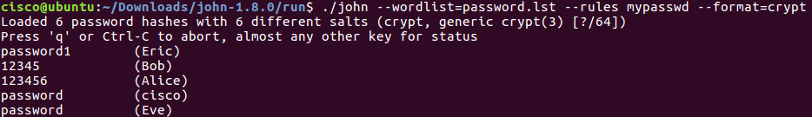

Task 2

Using Digital Signatures
In this part, you will use a website to verify a document signature between Alice and Bob. Alice and Bob share a pair of private and public RSA keys. Each of them uses their private key to sign a legal document. They then send the documents to each other. Both Alice and Bob can verify each other’s signature with the public key. They must also agree on a shared public exponent for calculation.
Table 1 - RSA Public and Private Keys
Public RSA Key | d94d889e88853dd89769a18015a0a2e6bf82bf356fe14f251fb4f5e2df0d9f 9a94a68a30c428b39e3362fb3779a497eceaea37100f264d7fb9fb1a97fbf 621133de55fdcb9b1ad0d7a31b379216d79252f5c527b9bc63d83d4ecf4 d1d45cbf843e8474babc655e9bb6799cba77a47eafa838296474afc24be b9c825b73ebf549
Private RSA Key | 47b9cfde843176b88741d68cf096952e950813151058ce46f2b048791a2  6e507a1095793c12bae1e09d82213ad9326928cf7c2350acb19c98f19d3  2d577d666cd7bb8b2b5ba629d25ccf72a5ceb8a8da038906c84dcdb1fe6  77dffb2c029fd8926318eede1b58272af22bda5c5232be066839398e42f5 352df58848adad11a1
Public Exponent | 10001
Sign the Document.
Alice signs a legal document and send it to Bob using the RSA public and private keys shown in the table above. Now Bob will have to verify Alice’s digital signature in order to trust the authenticity of the electronic document.
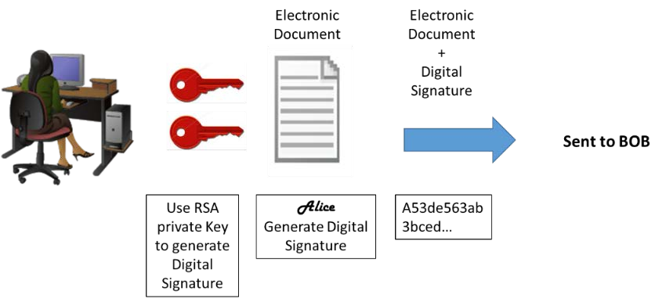
Verify Digital Signature.
Bob receives the document with a digital signature shown in the table below.
Table 2 - Alice's Digital Signature
Alice’s Digital Signature
0xc8 0x93 0xa9 0x0d 0x8f 0x4e 0xc5 0xc3 0x64 0xec 0x86 0x9d 0x2b 0x2e 0xc9 0x21 0xe3 0x8b 0xab 0x23 0x4a 0x4f 0x45 0xe8 0x96 0x9b 0x98 0xbe 0x25 0x41 0x15 0x9e 0xab 0x6a 0xfb 0x75 0x9a 0x13 0xb6 0x26 0x04 0xc0 0x60 0x72 0x28 0x1a 0x73 0x45 0x71 0x83 0x42 0xd4 0x7f 0x57 0xd1 0xac 0x91 0x8c 0xae 0x2f 0x3b 0xd2 0x99 0x30 0x3e 0xe8 0xa8 0x3a 0xb3 0x5d 0xfb 0x4a 0xc9 0x18 0x19 0xfd 0x3f 0x0c 0x0a 0x1f 0x3d 0xa4 0xa4 0xfe 0x02 0x9d 0x96 0x2f 0x50 0x34 0xd3 0x95 0x55 0xe0 0xb7 0x2a 0x46 0xa4 0x9e 0xae 0x80 0xc9 0x77 0x43 0x16 0xc0 0xab 0xfd 0xdc 0x88 0x95 0x05 0x56 0xdf 0xc4 0xfc 0x13 0xa6 0x48 0xa3 0x3c 0xe2 0x87 0x52 0xc5 0x3f 0x0c 0x0d
Click http://nmichaels.org/rsa.py to use the online RSA tool to verify the authenticity of Alice’s digital signature.
Table 3 - Online Digital Signature Tool
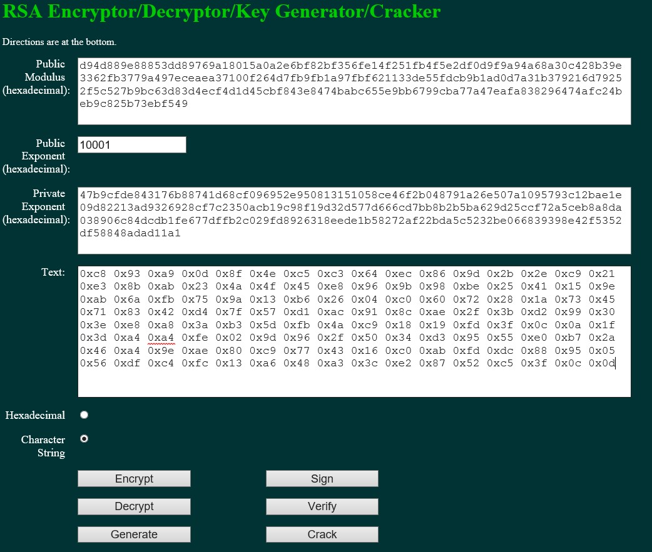
Copy and paste the public and private keys from Table 1 above into the Public Modulus and Private Exponent boxes on the website as shown in the picture above.
Make sure the Public Exponent is 10001.
Paste Alice’s digital signature from Table 2 in the box labeled text on the website as shown above.
Now BOB can verify the digital signature by clicking the Verify button near the bottom center of the website.
Whose signature is identified?
Alice
Generate a Response Signature.
Bob receives and verifies Alice’s electronic document and digital signature. Now Bob creates an electronic document and generates his own digital signature using the private RSA Key in Table 1 (Note: Bob’s name is in all capital letters).
Table 4 - BOB Digital Signature
BOB’s Digital Signature
0x6c 0x99 0xd6 0xa8 0x42 0x53 0xee 0xb5 0x2d 0x7f 0x0b 0x27 0x17 0xf1 0x1b 0x62
0x92 0x7f 0x92 0x6d 0x42 0xbd 0xc6 0xd5 0x3e 0x5c 0xe9 0xb5 0xd2 0x96 0xad 0x22
0x5d 0x18 0x64 0xf3 0x89 0x52 0x08 0x62 0xe2 0xa2 0x91 0x47 0x94 0xe8 0x75 0xce
0x02 0xf8 0xe9 0xf8 0x49 0x72 0x20 0x12 0xe2 0xac 0x99 0x25 0x9a 0x27 0xe0 0x99
0x38 0x54 0x54 0x93 0x06 0x97 0x71 0x69 0xb1 0xb6 0x24 0xed 0x1c 0x89 0x62 0x3d
0xd2 0xdf 0xda 0x7a 0x0b 0xd3 0x36 0x37 0xa3 0xcb 0x32 0xbb 0x1d 0x5e 0x13 0xbc
0xca 0x78 0x3e 0xe6 0xfc 0x5a 0x81 0x66 0x4e 0xa0 0x66 0xce 0xb3 0x1b 0x93 0x32
0x2c 0x91 0x4c 0x58 0xbf 0xff 0xd8 0x97 0x2f 0xa8 0x57 0xd7 0x49 0x93 0xb1 0x62
Bob sends the electronic document and digital signature to Alice.
Verify Digital Signature.
Copy and paste the public and private keys from Table 1 above into the Public Modulus and Private Exponent boxes on the website as shown in the picture above.
Make sure the Public Exponent is 10001.
Paste Bob’s digital signature from Table 4 in the box labeled text on the website as shown above. Now Alice can verify the digital signature by clicking the Verify button near the bottom center of the website.
Whose signature is identified?
BOB

Verify this Digital Signature

Table 5 – Your lecturer’s Digital Signature
Public RSA Key | d639edcb90b508fba5005ed5f6e2b06f885e7a2ad5f6babbde7b0481e8b7 af73f4a821951757f797  6e2b8a925b6940e930a4bab189ccb93a9e81f74829140e767ec2ef3acad 7afecb3d1a114498524cd  084f9ae54a7ffd1f35c50ebdb24abb95dd5d8dfcd3ee7dd06630c831877b ee8549a1c2b615e53098  8f5cee0255a75f71
Private RSA Key | 63cf1d91885c30513e310bfe584689b98d29a775a9b6888ddb3c297f753 38f9550d9bcbbbfe28642  915bcbf6208ccb6759f885db0dbeca561b5fa61c82b70b7d2337c28ce193 4fc7ad035c87367a089a  24d2eca2583822fd5a7505bb76a7c3fd8486989ef8876617488a07330ca e414fce708b1c7278151d e92a994a639b85b9
Public  Exponent | 10001
Text | 0x8d 0x2d 0xcc 0x0c 0x12 0xdf 0xa2 0xbe 0x16 0x51 0x6e 0x5a 0x6a 0xf3 0x02 0xb9 0xf4 0x26 0x90 0xbe 0xfb 0x8f 0x3e 0x42 0xf4 0x59 0x60 0x6c 0xb5 0x44 0xbb 0x89 0xe1 0x8e 0x34 0x7f 0xa4 0x00 0xcf 0x30 0x12 0x89 0xb8 0x44 0x7f 0xde 0x23 0x70 0xad 0x92 0xdb 0xf9 0x77 0x87 0xf4 0x8e 0xe9 0xd2 0xd0 0xcc 0xa0 0x85 0x43 0x21 0xd1 0xcf 0x9b 0x51 0x11 0x39 0xe7 0xd2 0x6f 0xa3 0x1a 0x32 0xa6 0xed 0xe4 0x2d 0xbc 0x98 0xe9 0x69 0xaf 0xb7 0x4b 0x21 0xfe 0x62 0x38 0x10 0xfd 0x3e 0x79 0x90 0x75 0x08 0x14 0x0f 0x43 0x9b 0xb2 0xa5 0xe1 0x72 0xee 0x41 0xee 0x0d 0x2c 0xfb 0x2c 0x36 0x28 0x32 0xed 0xac  0x19 0x60 0x23 0x88 0x1d 0xd8 0x74 0xee 0x47 0xa0

Whose signature is identified?
Nitheesh Murugan 101

Create Your Own Digital Signature
Now that you see how digital signatures work, you can create your own digital signature.
Generate a New Pair of RSA Keys.
Go to the website tool and generate a new set of RSA public and private keys.
Delete the contents of the boxes labeled Public Modulus, Private Modulus and Text. Just use your mouse to highlight the text and press the delete key on your keyboard. Make sure the “Public Exponent” box has 10001.
Why should you have the Public Exponent as 10001? Research and
document your reflections here.
10001 is a small public exponent, which is more efficient for public-key operations, like the operation we have just done, by using a public modulus, and private exponent.

Generate a new set of RSA keys by clicking the Generate button near the bottom right of the website.
Copy the new keys in Table 6.
Table 6 - New RSA Keys
Public Key
Public Key |  | A string of 256 hexadecimal characters will be displayed for both
Public Key |  | the public and private keys. The keys will be different from one
Public Key |  | another. | a1f5649c1e8f28d6ea11c18a8ea00789e4e72a1ef48a1afa1c927625df404bb5ee14de7d5482233d  4ed26582ef36f07509b081e51431c4894a6a11945da3618685b807f7057deb244ec36eaa542e5e0e  00b542ec9e7fc4f1a3991d0a678c6e62a76d729c45ec84bcc0278cf19c0d89033d47a87c0f2c83d6  6b80fbd0fe83e187
Private key
Private key |  | A string of 256 hexadecimal characters will be displayed for both
Private key |  | the public and private keys. The keys will be different from one
Private key |  | another. | 4161c8690229370a73da1130f75d014e18bb7d949b91f94c0926d34d7cafff2085e9a4dc21b69bb5  4f51beab3a190abfa4d6bdc995fa75661b4570ad5d93ec7576b21ab29d9a2194e48c00f981438ebc  f103f80b7329f0d942e8089dfa67f87fca5b51a87f10eae6075c7f106e3383351a3476afc47cba7f  d46d0a124b5eb4a1
Now type in your full name into the box labeled Text and click Sign.
Table 7 - Personal Digital Signature
Personal  Digital  Signature
  A string of characters with this format will be displayed. 0x23
  0x90 ……. | 0x6e 0x90 0x03 0x4c 0x87 0x5d 0x0c 0xb7 0xce 0x66 0x80 0x64 0xa2 0xef 0x4b 0x34 0x82 0xa0 0x3d 0x78 0x48 0x9d 0xed 0xd1 0x76 0xec 0xbb 0xc6 0x64 0xb6 0xfb 0x75 0xfc 0x5f 0x03 0x6e 0x6d 0xcf 0x8b 0x2e 0x55 0xb3 0x67 0x74 0xb8 0xac 0xb1 0xf3 0x86 0x15 0x3c 0x84 0xca 0x7f 0x71 0x53 0x15 0xea 0x30 0x4f 0xb9 0xc5 0xa0 0x7a 0x50 0x92 0x9d 0xdb 0xad 0x20 0x69 0x3d 0xa5 0xe2 0xe9 0x5a 0xb6 0x71 0x94 0xc1 0x2e 0xfc 0x19 0xea 0x1a 0x27 0x77 0xc6 0x3e 0xae 0xb1 0x7d 0xad 0xd4 0x10 0xc2 0x1d 0x7e 0x22 0xa1 0xad 0x55 0xb8 0x18 0x41 0x92 0x01 0xc6 0x5e 0xa6 0x20 0x26 0x2e 0x0d 0xf5 0x0c 0x21 0x17 0x68 0xcf 0x4d 0xff 0xb1 0xfa 0x72 0xc7 0x77 0x6c

Exchange and Verify Digital Signatures
Now you can use this digital signature.
Exchange your new public and private keys in Table-6 with your lab partner.
Record your lab partner’s public and private RSA keys from their Table-6.
Record both keys in the table below.
Table 8- Lab Partners RSA Keys
Public key
Public key |  | A string of 256 hexadecimal characters will be displayed for
Public key |  | both the public and private keys. The keys will be different
Public key |  | from one another. | 9f0c475561a5c272c85bf1408cc849a082280a8973251a3a3658bbd54a69b2dbddef3fac3a4c215a  d738e09f89bbd4166b9999eb45c97d50306714673d23ad96968798f5804560bd85b22edd70eac93c  b3819665185a360b8c655ca653c21a87dcfcf02c8120f85b5f3b8888fb1669e14ad82d7177e58e84  3096baf85a9f50a5
Private key
Private key |  | A string of 256 hexadecimal characters will be displayed for
Private key |  | both the public and private keys. The keys will be different
Private key |  | from one another. | 199ba8809ed04996a19bec243086af1420e0c1918ff091607e0f9b6ea424909fc60417846b7e8680  51d6de93d16164ac97768bc9cddabb4a860092d06c8faa0b2bc305f5943af4e10be08058a41dd751  3cbbfc32b2fabbb56ff12ed13cc669252a48c3d28cc0aaf9814f4c352ad870eb8fc914b789485a5c  6f2cef6f19e9a5a1
Now exchange their digital signature from their Table-6. Record the digital signature in the table below.

Lab Partner’s  Digital  Signature
  A string of characters with this format will be displayed. 0x23
  0x90 ……. | 0x91 0x75 0xc8 0xb9 0xda 0x82 0x19 0x36 0xf4 0xea 0x7c 0x7f 0x45 0xc5 0xa4 0xe9 0xc5 0x75 0xcb 0x42 0xc9 0xf1 0xeb 0x26 0x3c 0xd5 0x5a 0x02 0xce 0xbf 0xee 0x28 0x16 0x0e 0x57 0xbc 0x84 0xc3 0x1e 0xe6 0xfe 0xef 0xaf 0x94 0x66 0xe6 0x01 0x57 0x1f 0x1e 0x50 0xe4 0xee 0x6c 0x5d 0xcf 0x58 0x6f 0x0e 0xf3 0xb3 0x94 0xaf 0x63 0x75 0x6f 0xe7 0xd7 0xc2 0x36 0xea 0x83 0xda 0xc8 0x87 0x54 0x69 0xac 0x3b 0xba 0xef 0xcb 0xea 0x33 0x11 0x16 0xbc 0x1d 0x51 0xa0 0xf4 0xe3 0x4b 0x1a 0x3e 0x89 0xe6 0x76 0xd2 0xf3 0x96 0x02 0xc4 0x23 0x30 0x0b 0xba 0xbc 0x89 0x8a 0x20 0x12 0x1d 0xc1 0x7b 0x0b 0x1b 0x27 0x16 0x2f 0xc8 0xc7 0xb6 0x04 0xa4 0x99 0x1c 0x1d
Verify Lab Partners Digital Signature
To verify your lab partner’s digital signature, paste his or her public and private keys in the appropriate boxes labeled Public and Private modulus on the website.
Now paste the digital signature in the box labeled Text.
Now verify his or her digital signature by clicking the button labeled verify.

What shows up in the Text box?
Gary Thomas (Note: I did this exercise with a friend, I don’t think there’s a Gary Thomas in our class.)

Learnings from tutorials so far:
Part 1 (Packet Tracer, Host Machines)
- Build a home Network
- Understand and configure IP Address
- Use Ping/ Trace route Utility to check the connection status
- Use ipconfig /all command to determine the MAC address of a Windows computer on an Ethernet network.
- Analyze a MAC address to determine the manufacturer.
- Analyze the Wired and Wireless Network connection.
- Analyze Address Resolution Protocol (ARP).
- Connect to a Wireless Router and configure the basic settings in a wireless router and add security features.
- Use nslookup command to understand the url to ip conversion.
- Configure basic connectivity settings in Intermediate devices (Switch/ Router).
- Work with SBA Packet Tracer Files/ environment
- Configure ftp, web, email, dns, ntp and aaa Servers Part 2
- Set up a virtual lab environment
- Troubleshooting the virtual lab environment
- Working with virtual machines
- Authentication, Authorization and Accounting
- Threats and Vulnerabilities – Using NMAP
- Hide and Seek – Use Steghide to hide a data file within an image file ✓ Password Cracking using John the Ripper ✓ Digital Signatures – Creating and Verifying.

