

Programme: Master of Business Administration

Module: Financial Management
Module code: LCMB7002

Student name: VAISHALI SAJAN MODHWADIYA
Student ID number: 2527761
Total word : 5106
Table of contents
Introduction 3
1. Financial Health Check 4
1.1 Financial analysis of Volkswagen (Five-Year Review) 4
1.1.1 Income statement analysis 4
1.1.2 Balance sheet analysis 4
1.2 Liquidity Ratios 5
1.3 Efficiency Analysis 6
1.4 Profitability Analysis 7
1.5 Gearing (Solvency) Analysis 9
1.6 Investment Ratios 10
1.7 Cash Flow Position 11
2. Working Capital Management Analysis 13
2.1 Access Cash Operating Cycle 13
2.1.1 Inventory outstanding 13
2.1.2 Sales outstanding 13
2.1.3 Payables Period 14
2.1.4 Net Operating Cycle Evaluation 14
2.2 Improving working capital 15
2.3 Short-Term vs. Long-Term Financing Options 16
2.3.1 Short-Term Options 16
2.3.2 Long-Term Options 16
3. Strategic Financial Restructuring Plan 18
3.1 Financial Problems Faced by Volkswagen 18
3.2 Financial restructuring Options 19
3.3 Restructuring option 20
3.4 International and Ethical Considerations 23
4. Investment Appraisal and Capital Budgeting 25
4.1 Three proposed investment techniques 25
4.2 Critical Evaluation of the Efficiency of Projects 25
4.2.1 Project A 25
4.2.2 Project B 26
4.2.3 Project C 26
4.3 Justification of project best through Capital Rationing 27
4.4 Recommendation for managing financial performance 28
4.5 Non-financial risk associated with the project 29
Conclusion 30
References 31
Appendices 38
Appendix 1: Ratio analysis 38
Appendix 2: Investment appraisal 42

Introduction
The report aims to address the financial performance of Volkswagen by addressing its core financial problem and adoption of a proposed strategy enhances improvement in business. The report highlights working capital, investment appraisal and corporate restructuring of Volkswagen through strategic adjustment.

1. Financial Health Check

1.1 Financial analysis of Volkswagen (Five-Year Review)

1.1.1 Income statement analysis
Volkswagen had a revenue of about $364.212B in 2025 and €250.2 billion sales revenue in 2021, which led to increases of 12.3% (MacroTrends, 2025; Volkswagen, 2021). The revenue of Volkswagen encountered a significant shift, leading to high rises in vehicle prices, and showcases its consistent recovery and delivery of products after the post-pandemic situation. The operating income is about €19.275 billion in 2021 to €13.615bn in 2025 (MarketScreener, 2026). The 2.8% decline in operating margin in 2025 is due to high rises of structuring expenses affecting the overall product line.

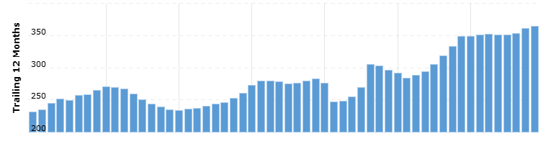
Figure 1: Revenue of Volkswagen
(Source: MacroTrends, 2025)

1.1.2 Balance sheet analysis
Volkswagen increased its total assets to about €497 billion in 2021 which is expected to rise high in 2025 to about €644.5 billion (MacroTrends, 2025b). The major expansion is due significant investment for managing technology, financial services and significant changes in currency fluctuation. In 2025, the volatility in North America and in the Chinese market affect Volkswagen through significant weakening of product prices. The company has enhanced its net cash position by its ability to manage its profitability, which in terms threatens its resilience in the market.

1.2 Liquidity Ratios
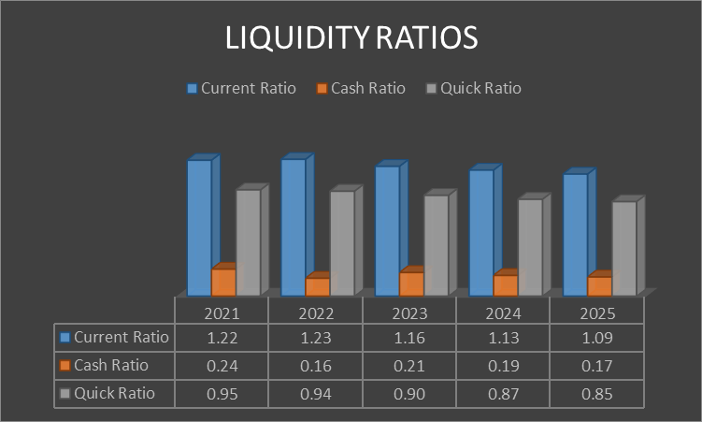
Figure 2: Liquidity Ratios
(Source: Volkswagen AG, 2021; Volkswagen AG, 2023; Volkswagen AG, 2025)
Trend
As per the above analysis, Volkswagen has reduced its current ratio by 10.6% in 2025 as compared to 2021. The lowering of the assets has hampered the operational stability of the organisation. For example, the organisation has reduced its production volume from 2.13m in 2024 to around 2.8m in 2025 (Global Data, 2026) The decline in the product demand of Volkswagen has adversely influenced its competitive advantage level on other organisations. On the other hand, the organisation has also reduced its cash ratio from 0.24 in 2021 to around 0.17 in 2025. The lowering of the financial resources has increased the occurrence of operational delays for the automobile company. Volkswagen has reduced its revenue to €321.91bn due to the existence of business tariffs in 2025 (Global Data, 2026a). The lowering of the business investment has adversely influenced the operational efficiency of the organisation. Volkswagen has also reduced its quick ratio value by 10.5% in 2025 (Volkswagen AG, 2025). The decline in the financial assets has reduced the product popularity of Volkswagen among other organisations.
Strength
The lowering of the production volume has helped Volkswagen in monitoring its business expenses.
Weakness
The decline in the business investments has hampered the operational productivity of the automobile company.

1.3 Efficiency Analysis
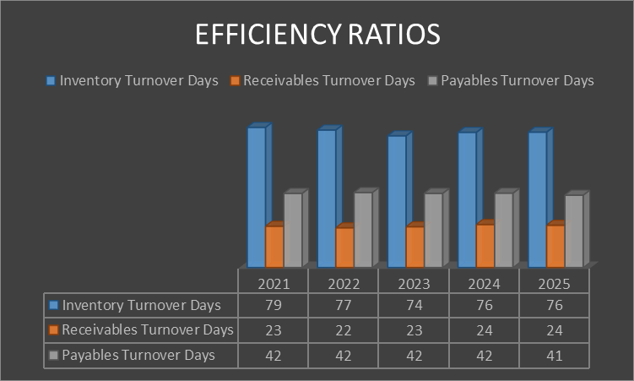
Figure 3: Efficiency Ratios
(Source: Volkswagen AG, 2021; Volkswagen AG, 2023; Volkswagen AG, 2025)
Trend
The efficiency ratio has the ability to manage business operations, which is more reliable for dealing with significant revenue generation. The inventory turnover days gradually decrease 3.80% from 2022 to 2025 which in turn streamlines operational efficiency through better demand forecasting and adoption of the Just-In-Time method (Volkswagen AG, 2025). The receivable turnover days are expected to increase in 2024 and in 2025, which is about 4.35%, leading to significant improvement at vehicle production and offer long credit facilities for the customer to enhance overall business sales. Volkswagen managed its overall cash through significant investment and cost-cutting strategies, which in due to a sharp decline in operating margin. The payable turnover days remain the same in 2021, 2022, 2023, and 2024, and steadily decrease in 2025 by about 2.38%. This in turn leads to strategic movement of the cash flow, lending to suppliers, taking a longer time for significant cash.
Strength
Volkswagen showcases its significant investment leading to the growth of EV services which in term showcases significant transition in the market.
Weakness
The complex manufacturing process at Volkswagen leads to lower profitability due to its presence of competitors in the market.

1.4 Profitability Analysis
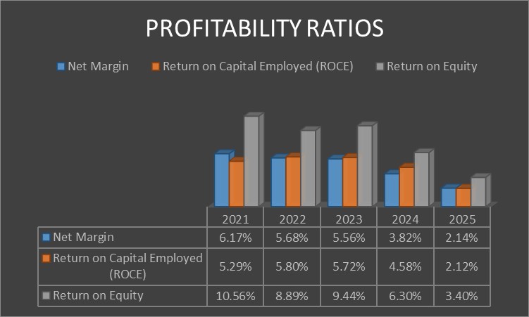
Figure 4: Profitability Ratios
(Source: Volkswagen AG, 2021; Volkswagen AG, 2023; Volkswagen AG, 2025)
Trend
The key profitability ratios of Volkswagen are also attributed to a downtrend throughout the time period of five years associated with 2021-2025. Total of 65.3% declining rate also be modified in net profit margin from 6.17% in 2021 to 2.14% in 2025. On the other hand, revenue potentilaity of organistaion increasing 28.6% from €250,200m to €321,913m also inform bias balance sheet structure of organization (Yahoo Finance, 2026). Thus, total reduction of net profit about 55.2% also indicated rising profitability and weakening firm efficiency towards converting sales into earnings.
On the other hand, 59.9% also verified in ROCE from 5.29% in 2021 to 2.12% in 2025 (Volkswagen AG, 2025). Thus, declining operating profit of 53.9% also negatively influenced key asset growth of 21.9%. ROE also significantly dropped about 67.8% from 10.56% in 2021 to 3.40% in 2025 while rising equity €146,154m to €203,054m made Volkswagen a biased earning case. This is also indicated that lower return value of shareholders diluted financial performance of Volkswagen effectively.
Strength
Volkswagen shows strong revenue growth and expanding asset base supporting long-term operational capacity.
Weakness
The key declining profitability trends also indicate inefficiency, rising costs, and reduced shareholder returns over time.

1.5 Gearing (Solvency) Analysis
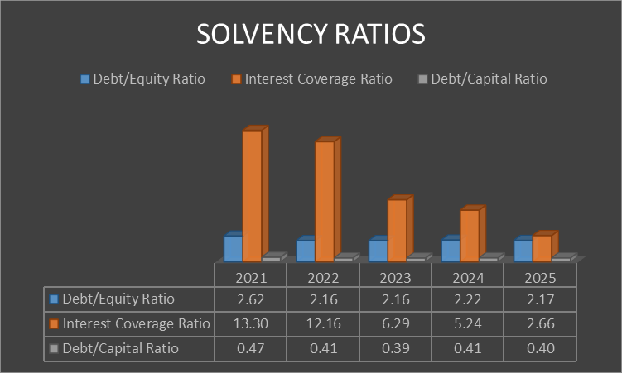
Figure 5: Solvency Ratios
(Source: Volkswagen AG, 2021; Volkswagen AG, 2023; Volkswagen AG, 2025)
Trend
Volkswagen has reduced its debt/equity value from 2.62 in 2021 to around 2.17 in 2025 (Volkswagen AG, 2025). The organisation has focused on diversifying its business investments to enhance its product quality. For example, Volkswagen has collaborated with Octo worth $3bn for enhancing the design of its models such as “Škoda, Seat, Cupra and Audi” in 2025 (Business Wire, 2026). The enhancement in the product quality has helped the organisation in increasing its goodwill among customers. On the other hand, Volkswagen has also increased its debt capital value by 2.5% in 2025 as compared to 2023 (Volkswagen AG, 2025). The improvement in the financial resources has helped the organisation in ensuring the timely completion of its business operations. Volkswagen has achieved a financial grant worth £37000 from the UK government with an intent to increase the production volume of “VW ID.4 EV models” in 2025 (Barnard, 2025). The investment has also helped the organisation in improving the popularity of the products among customers.
Strength
The enhancement in the internal investments has helped Volkswagen in meeting the financial requirements of its business operations.
Weakness
The lowering of the interest value has also hampered the operational productivity of Volkswagen.

1.6 Investment Ratios
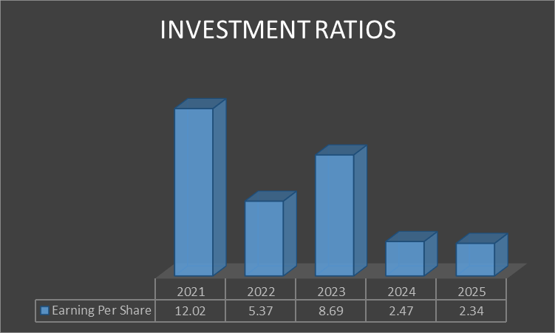 Figure 6: Investment Ratios
(Source: Volkswagen AG, 2021; Volkswagen AG, 2023; Volkswagen AG, 2025)
Trends
The investment ratio has a significant impact in reducing net asset value, which in term erodes the overall compounding growth of the business. The fluctuation of R&D expenses is about 11% and 13% from 2021 to 2023, which is due to disciplined investment and a strategic shift in EV, which affects the business portfolio. The earnings per share are expected to decrease from 2022 to 2025 by about 80.53%, leading to high rises in revenue and through outstanding shares through buyback programmes (Volkswagen AG, 2025). Volkswagen in 2026 assured 75% for the “buyback program” which offers residual value, by addressing intense competition to showcase volatility in the market (Volkswagen Group, 2026). The operating profit of Volkswagen Group declined about 50% due to high rises of US tariff rate, stiff competition in the Chinese market and cost-cutting due to Electric vehicles (Meredith, 2026). This, in turn, leads to low down income that is based on managing each share through significant movement of stock.
Strength
The substantial investment leads to high rates of decarbonisation in turn showcasing long-term value creation by the ability to meet strict regulations in managing carbon emissions.
Weakness
The high capital requires for EV transition which in term creates pressure for managing operating margin due to slow decision-making.

1.7 Cash Flow Position
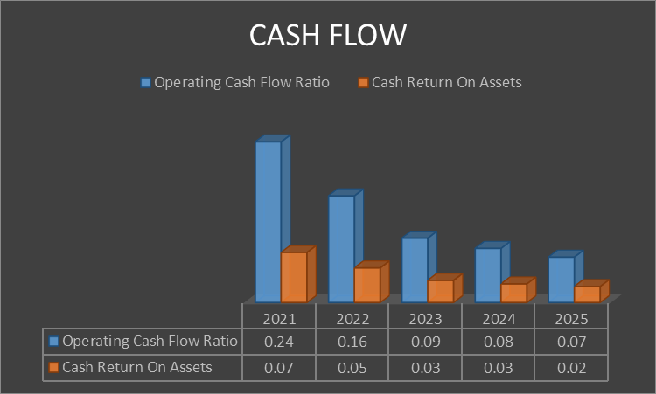
Figure 7: Cash Flow Analysis
(Source: Volkswagen AG, 2021; Volkswagen AG, 2023; Volkswagen AG, 2025)
Trend
The declining trend is also identified in managing cash flow optimisation ratios of Volkswagen associated with five consecutive years. Cash flow ratios were also reduced 70.8% from 0.24 in 2021 to 0.07 in 2025. Thus, a total of 61.1% decreasing rate asserted in operating cashflow from 0.24 in 2021 to 0.07 in 2025 (Volkswagen AG, 2025). This consistent decreasing rate illustrated the rising liabilities pressure of organizations that weakened cash generating capacity effectively. Hence, total liabilities also increased from €164,393m to €226,525m with a total increment of 37.8% (Financial Times, 2026).
On the other hand, 71.4% decrease rate also identified “Cash return on assets” from 0.07 in 2021 to 0.02 in 2025. However, besides this reduction total assets will also be effectively growing by 21% from €528,609m to €644,467m in 2025. Hence, it is indicating improper utilizing of asset potential for management cash optimisation in Volkswagen.
Strength
Volkswagen maintains positive operating cash flow, supporting ongoing operations despite declining cash generation trends.
Weakness
The deprivation of cash flow ratios reflects weak liquidity, inefficient asset use, and rising financial pressure.

2. Working Capital Management Analysis

2.1 Access Cash Operating Cycle

2.1.1 Inventory outstanding
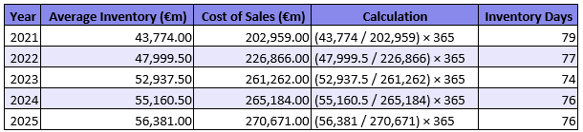
Figure 8: Outstanding Inventories
(Source: Self-Developed)
As per the above evaluation, Volkswagen has reduced its inventory days value by 3.79% in 2025 as compared to 2021. The organisation has focused on adopting digitalisation techniques for strengthening its supply chain operations. For example, Volkswagen has collaborated with Amazon Web Services for developing the “Digital Production Platform” with an intent to monitor the volume of raw material consumption in 2025 (Amazon Web Service, 2025). The adoption of digital partnerships has helped Volkswagen improve its product quality and strengthening consumer relationships.

2.1.2 Sales outstanding
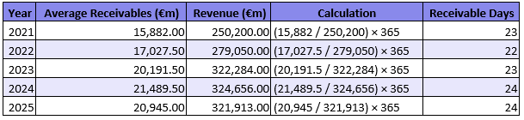
Figure 9: Sales Outstanding
(Source: Self-developed)
The receivable days are expected to increase 4.35% by addressing a significant shift in inventory maintenance, enhancing improvement in the supply chain and restructuring costs. The significant investment is based on renewing the strategic portfolio, investing on digitalisation and significant improvement in Electric Vehicles, which in turn showcases operational efficiency in business. The overall cash flow is expected to rise about EUR 3 billion and EUR 6 billion, leading to a rise in the automotive division through solid financing (Volkswagen, 2026). The substantial capital investment has a direct impact in managing EV production and cash flow maintenance.

2.1.3 Payables Period
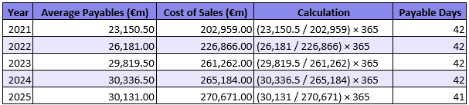
Figure 10: Payable period
(Source: Self-developed)
The payable days are expected to decrease in 2025 which is about 2.38%, leading to a significant reduction of the profit and immense pressure to deal with restructuring in business. The decreases in Payable outstanding have its negative impact over significant cash flow of business. This in term reduces the liquidity by paying suppliers with high interest rates which is more effective to hold significant cash. The company had faced pressure in managing its cash flow which is about €11bn in 2026 leading to cutting of organic sales growth and an increase in inventory, which affect operational efficiency of the business (Thakur, 2025).

2.1.4 Net Operating Cycle Evaluation
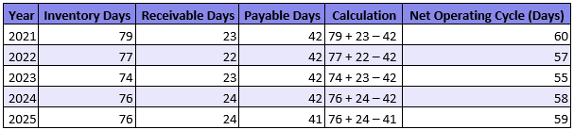
Figure 11: Net Operating Cycle
(Source: Self-Developed)
Volkswagen has reduced its net operating cycle value by 1.66% in 2025 as compared to 2021. The organisation has emphasised on acquiring investment opportunities with an intent to meet the financial requirements of its business operations. For example, Volkswagen has invested €100m in companies such as DTCP for strengthening its cyber-defence activities in 2026 (More and Wissenbach, 2026).The investment has also helped the automobile company in improving its operational efficiency. On the other hand, Volkswagen has also increased its production volume of EV models from 130 in 2024 to 160 in 2025 (Rose, 2026). The improvement in the product quality has assisted Volkswagen in overcoming market competition.

2.2 Improving working capital
Expansion of Business Investments
Volkswagen has emphasised on expanding its financial resources for ensuring timely completion of its business operations. For example, the organisation has invested around $186bn for developing the "Porsche Model” in China (Reuters , 2025). In addition, the expansion of the product line has also helped the automobile company in improving its brand value among the customers. Volkswagen has increased its revenue from €25000m in 2021 to €30000m in 2025 (MarketScreener, 2026). The enhancement in the business income has helped the organisation in acquiring competitive advantage over other organisations.
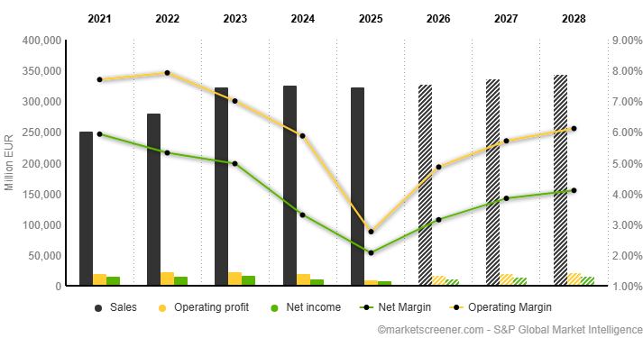
Figure 12: Sales Value of Volkswagen
(Source: MarketScreener, 2026)
Strengthening of Inventory Management Services
Volkswagen has also focused on improving its inventory management operations for enhancing its product quality. For example, the organisation has invested $1.2bn in including technologies such as Artificial Intelligence in its supply chain activities in 2025 (Reuters , 2025b). In addition, the investment has also helped the company in monitoring the requirements of its inventory operations. On the other hand, Volkswagen also increased its production value to around $600m due to enhancement in product demand in China (Campbell, 2026). The enhancement in revenue has helped Volkswagen in improving its product quality.

2.3 Short-Term vs. Long-Term Financing Options

2.3.1 Short-Term Options
Trade credit
Volkswagen showcases its financial stability by revolving with credit, which is about €12.5 billion to enhance significant improvement in business operations (Volkswagen group, 2026). Increases in investments strengthen Volkswagen finance through significant transformation and facilitation with technologies. The significance of the credit lines is to make significant investments towards future technologies, support transformation, and refinancing with risk, which in turn offers long-term flexibility of business. Volkswagen has secured 2.3 billion credit lines for “Brazil development,” which in term boost EV leads to enhanced improvement in Brazil operations (Reuters Staff, 2025). This fund helps to develop hybrid vehicles that were manufactured in 2026, to enhance improvement in business operations. The impact of these credit lines enhances improvement in business operations by offering flexibility to enhance improvement in business operation.

2.3.2 Long-Term Options
Bonds
Volkswagen has utilized green bonds by showcasing its strategic transition towards electric vehicles in achieving net-zero targets. The company invested EUR 1.5 billion for the launch of a green bond, which has a high demand in the market to showcase its competition in the market. The impact of these green bonds is due to the leasing of electric vehicles, which have its strategic alignment in integrating sustainability in business. The issuing of the green bond is more effective in achieving the "Mobility2030" strategy has a significant impact on improving business operations (Volkswagen group, 2025). The reduction of long-term cost improves overall operating margin by ability to deal with competitive pressure, which is more effective for managing bonds. Thus, the maturation of short-term bonds is due to volatility in the market, shift in trade policy and geopolitical issues. This shift in green finance due to high demand for EVs leads to a shift in business operations.

3. Strategic Financial Restructuring Plan

3.1 Financial Problems Faced by Volkswagen
- Decline in profitability
The collapse of Volkswagen's post-tax profit fell by 44% in 2025, leading to the cutting of 50,000 jobs (Wright, 2026). The impact of this hit is due to intense competition due to the presence of rivals, transition towards electric vehicles, and changes in US tariff rates, which in turn lead to stress on the overall cost of business. The impact of a high traffic rate has a significant impact on the overall profitability of a business through efficient cost reduction to deal with efficient competition in the market. This in turn leads to stagnant revenue with its operating profit being half of about €8.9bn (Schad, 2026). The impact of this collapse is due to significant slowdown of engine production, which hampers overall business profit. This in turn leads to rise of operating margin pressure by significant adoption of cost-cutting measures, which simplify business processes.
- Increase in Operational expenses
The enhancement in the product cost has been a critical issue for Volkswagen that has hampered its brand popularity among customers. For example, the organisation has increased its operational expenses by $1.5bn due to the occurrence of business tariffs in 2025. The enhancement in the developmental cost has hampered the brand popularity of the organisation. Volkswagen has reduced its automobile revenue value from €75bn in 2024 to €65bn in 2025 (S&P Global, 2025). The lowering of the income has also hampered the financial stability of the company. On the other hand, Volkswagen has also increased its business taxes to $1.4bn due to the occurrence of evasion issues in 2025 (Kalra, Shah and Ohri, 2025). The enhancement in the taxation value for Volkswagen has hampered its operational stability.
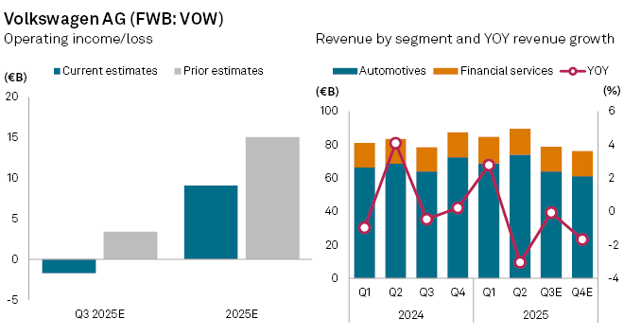
Figure 13: Segmental Revenue of Volkswagen
(Source: S&P Global, 2025)

3.2 Financial restructuring Options
- Merger and Acquisition
Volkswagen has focused upon adopting merger and acquisition techniques for expanding its business operations and meeting the changing demands of its customers. For example, the company has acquired Rivian Automotives worth $5.8bn for expanding its e-vehicle models in 2025 (Sriram and Roy, 2025). In addition, the acquisition has also helped the company in improving its brand loyalty. Volkswagen has increased its consumer loyalty score to around 82% in 2025 (Comparably, 2025). The expansion of the product line has helped Volkswagen in enhancing its operational productivity. On the other hand, Volkswagen has also brands such as Porsche for reducing its debt value by $13bn in 2025 (Mishra, 2024). The adoption of merger and acquisition activities has helped Volkswagen in overcoming market uncertainties.
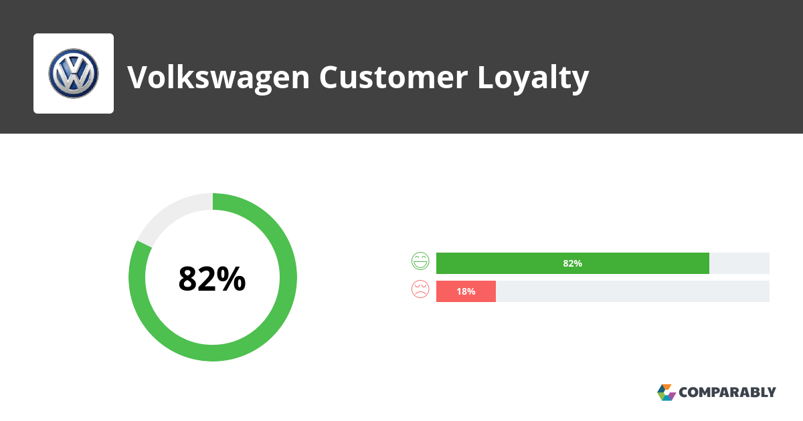
Figure 14: Consumer Loyalty Score of Volkswagen
(Source: Comparably, 2025)
- Equity injection
Volkswagen showcases its capital investment of about $1 billion by developing a joint venture for Rivian Automotive, which in turn accelerates improvement in business operations (Volkswagen Group, 2025). The significant investment is due to the restructuring of expenses encountered significant shortfall of operating margin. The company continued to invest in R & D and the ability to expand for electric vehicles, which in turn showcases the regional growth of the business. Volkswagen has adopted significant restructuring measures, which is about €1.3 billion, to achieve long-term profitability (Greenfield, 2025). This in turn leads to a decline in overall profit, leading to a rise in the automotive division by about €6 billion. Thus, the company strengthens its strategic investment ability to deal with a significant drop in managing a challenging environment.

3.3 Restructuring option
Shareholder Value
Volkswagen has focused on strengthening its investor relationship to improve its operational productivity. For example, the organisation has enhanced its dividend value from €7 in 2024 to €7.5 in 2025 (Market Screener, 2026). The improvement in the investment income has helped the automobile company in increasing its goodwill among the shareholders. On the other hand, Volkswagen has also increased its equity capital to $1281bn due to an improvement in its segmental revenue in 2025 (Investing News, 2026). The improvement in the investor income has helped Volkswagen in achieving financial stability.
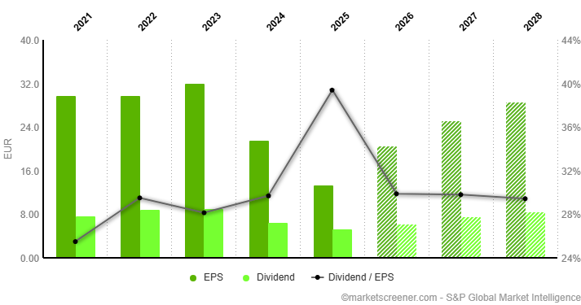
Figure 15: Dividend of Volkswagen
(Source: Market Screener, 2026)
Debt structure

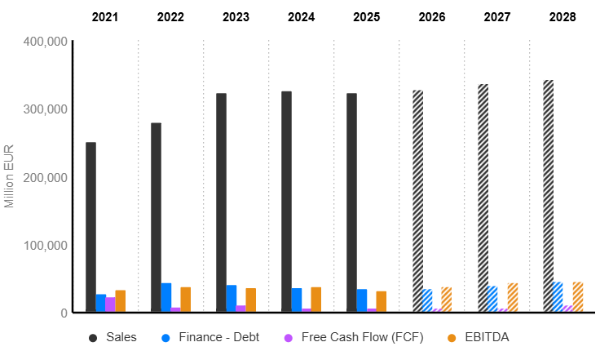
Figure 16: Debt structure
(Source: MarketScreener, 2026)
The net debt of Volkswagen is about EUR 26,685m in 2021, to EUR 34,497m in 2025 (MarketScreener, 2026). The impact of the high rise of debt in terms of decline in the overall profitability of the business, leading to the closing of the plant in Germany. As high rises of debt pressure, the company has ability to manage cash flow by showing continued investment at €6.4 billion which in term leads to 32% rises in significant growth of business. Management of debt overload has been addressed through significant cost reduction and the ability to manage credit rating through dealing with macroeconomic challenges.
Operational flexibility
The operational flexibility at Volkswagen varies based on managing the production network, developing the platform, and regional adaptability, enhancing the efficiency of the business. Volkswagen has the ability to invest $5.8 billion in the Rivian partnership showcases a significant transition in business operations by ability to invest on EV technology and software (Volkswagen Group, 2024). This in term showcases its regional presence in the US and in China by strengthening the development of EV brands and showcasing its significant launching in the market.

3.4 International and Ethical Considerations
CSR
Volkswagen has focused on improving its CSR activities for enhancing its goodwill among the local communities. For example, the organisation has reduced its carbon emissions by 1000m tonnes in 2025 (EV Report, 2025). In addition, the organisation has also emphasised on achieving “Net Zero GHG Emissions” by 2040. The lowering of the footprint value has assisted Volkswagen in enhancing its operational sustainability and product quality.
Currency Risk
Volkswagen Group faced significant currency fluctuation challenges due to the strengthening of the Euro against the Yen, British dollar and Pound. This price fluctuation affects the operating profit of Volkswagen, leading to high rises of exchange rate, which in term affect overall business cash flow. The currency movement leads to a decline in operating margin due to volatility in the market. The adoption of natural hedging, as gross currency, set significant exposure due to the production of vehicles in China, Brazil, and Mexico.
Inflation
The inflation rate has also been a critical factor that has influenced the product consumption of Volkswagen. In Germany, the cost index value has declined from 12% in 2022 to 2% in 2025 (Schroers, 2025). The lowering of product inflation has helped in improving the commodity demand for Volkswagen among the customers.
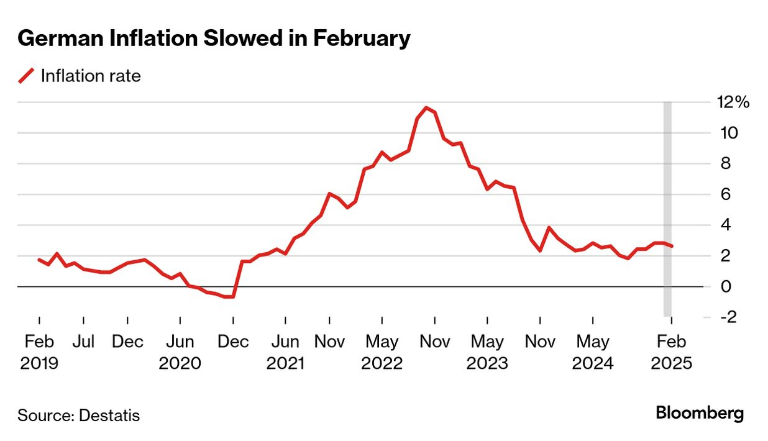
Figure 17: Inflation Rate in Germany
(Source: Schroers, 2025)
Taxation Value
In 2025, the rise of the US tariff rate by about $1.5 billion massively affects the overall profitability of the business (More, 2025). This in term affects overall global earnings of the business by dragging down recurring and tariff maintenance. This in term leads to significant cost cutting address through potential job cuts affect business operation.

4. Investment Appraisal and Capital Budgeting

4.1 Three proposed investment techniques
The proposed investment scenario is also associated with Volkswagen for a maximum conversion period of about five years to generate return potential effectively. Thus, in this case three different project scenarios are also modified for the organization to ensure a smooth profitability aspect with generating higher IIR value through the time period. Hence, project A, B and C are three of the investment criteria that are associated with initial investment of £50m. Also, selected cash flows for each project are different due to fixed out enable discounting rate 10%. Project A is generally attributed £54m over five years and reject B is generally ensured about £55m. However project C is also assured £65m. Overall, use of capital budgeting technique used for applying this project scenario suitability and generating return potentiality of Volkswagen with feeble long term investment of project.

4.2 Critical Evaluation of the Efficiency of Projects

4.2.1 Project A
The first investment project scenario for Volkswagen is project A that assured total investment cost of £50m and it is also to be generated with cash inflows of £54m over five years. Hence, a total of more than 8% nominal increasing value can also be identified as comparison between invested and nominal cash flow returns associated without fixed discounting rate. On the other hand, assumption of a fixed discounting rate of 10% also ensured total PV inflows of £41.32m [Refer to appendix 2]. Hence, the selected discounting rate generated more than 17.4% downfall associated with actual value of PV of project A. In addition, negative NPV of -£8.68m also indicates that the project will also be more unbiased for shareholders to ensure minimal return capital potentiality throughout the five year period. This sudden cash flow drawdown also ensured less long term capability of the project with weak financial growth for Volkswagen.
As per the view of Kagan (2026), the payback period is generally defined as the actual time period required for investors to cover initial invested value in generating positive return from the project. Hence, in this case investment value can also be recovered in 4.33 years as it is ensured to be covered all over the time of inverted projects that reduce its efficacy as a growth project. On the other hand, ARR value is also lower than the industry benchmark of 1.60% and IRR stands at 2.72% [Refer to appendix 2]. Hence, lower value potential apart from 10% discounting rate ensures risk of long term investment opportunity for investors.

4.2.2 Project B
The annual cash flow is also stable in case of project B associated with initial investment cost of £50m. Hence, stability of inflow also generated a total of £55m over five years with accumulated 10% nominal increasing range of cash flows. Hence, in this case the disputing rate will also be fixed by 10% that indicates a negative NPV range of -£8.30m [Refer to appendix 2]. As per the view of Sekhar et al. (2025), the NPV is the most significant financial matrix that is helpful for capital budgeting techniques in predicted profit through future cash flow projection. Thus, a shortfall of NPV range is also identified with 16.6% that also reduces PV value £41.70m and abruptly impacts future return of project.
According to Hayes (2025), cash flow is the most important parameter for illustrating cash and cash equivalents movement in an organization for a particular period of time. Thus, recognition of cash flow is also most significant for investors towards modifying its reliable trading growth pattern effectively. Hence, cash inflow also decreased about 37.7% from £10.00m in Year 1 to £6.83m in Year 5 [Refer to appendix 2]. As a result, it is biased about time value of money concept and riskier project parameters for long term run for Volkswagen.
In first year analysis it is also identified that a moderate cash flow generation capacity for organization from £10m to £14m with 40% increasing potentiality of project. However, year wise deprivation was highest in the last consecutive year with a 42.9% decrease from the peak value identified in the second consecutive year. The positive cumulative flow identified at the end of year of year 5 resulted in a payback period of 4.55 years. This higher payback period is also riskier for investors with weak profitability indicators of ARR of 2% and an IRR of 3.3%.

4.2.3 Project C
The project is also associated with a total investment cost scenario of £50m that effectively performs towards generating total cash inflows of £65m over five years. Hence, this particular project is also associated with a total of more than 30% nominal increasing rate of cash flow within the stipulated time period. In this case a higher variation of cash flow optimization was also observed from £5m in Year 1 and rising sharply to £25m in Year 4 [Refer to appendix 2]. In project C the shortfall of NPV was 3.96% with approximately value negative NPV of -£1.98m within 10% fixed discounting rate. A total of more than 400% increasing rate is also observed at the end of project life that attracts large investors of Volkswagen to generate return from this project scenario accumulation with long term growth. In 5th consecutive year dropping rate of 80% also be observed that also be recover the key investment scenario in previous year effective manner.
As per the view of Fernando (2026), DCF is the most effective method for analysing key opportunities of a project with interpreting the time value of money concept. Hence, discounting cash flow position associated with 275% growth from £4.55m in Year 1 to £17.08m in Year 4 [Refer to appendix 2]. This effectively reduces the key payback period of the project and completes recovery in 3.6 years. The profitability indicator was also strong with an ARR of 6% and an IRR of 8.6% that are much closer to the 10% discounting rate fixed for the project.

4.3 Justification of project best through Capital Rationing
In this case, the most suitable project identification necessary with a particular investment cost of £100m constraint. The key industry benchmark also illustrates NPV value and makes less riskier investment potential with generating more cashflow through project time period. Thus, project A and B combination assured a -£16.98m that highest negative NPV value through a time period of five years [Refer to figure 18 ]. On the other hand, project A and C also be assorted with NPV range of -£10.66m with assured second highest negative NPV range in cumulative project. However, project B and C are also associated with higher NPV range of -£10.28m compared to higher than 39.5 and 3.6% respectively [Refer to figure 18 ]. Overall, project B and C is the most suitable project combination associated with investment constraint value of £100m for organization.
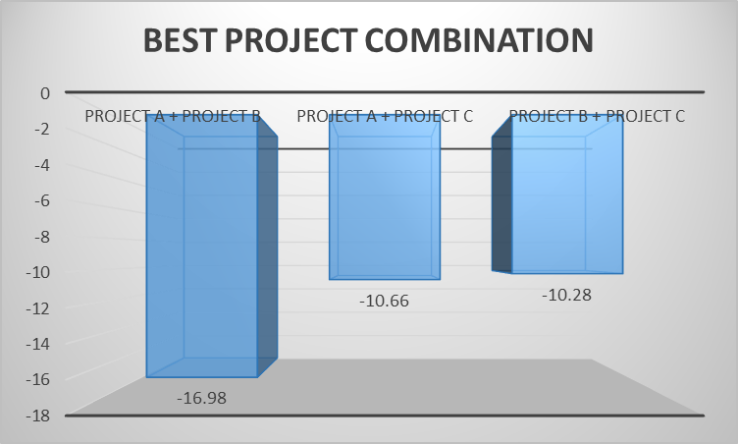
Figure 18: Investment scenario
(Source: Self-developed)

4.4 Recommendation for managing financial performance
Volkswagen needs to diversify its financial resources for meeting the investment value of project C worth £50m. For example, the organisation has increased its sales value by €4m due to enhancement in demand for e-vehicles in 2025 (Reuters, 2026). The improvement in the business income will help Volkswagen in meeting the operational requirements of its business projects. In addition, the enhancement in the revenue will also assist the automobile company in increasing the average profit of project C to £3m in 2025. The improvement in the sales value has also assisted Volkswagen in achieving operational stability.
Project C manages its liquidity through significant generation of cash flow and ability to recover capital by reinvesting in funds which is more effective for significant growth of business. The recommended invest is based on short payback period, high ARR and IRR to deal with challenging situations. Project C showcases its substantial profit which is more effective in managing asset bases and ability to recover initial capital by minimizing its overall loss.

4.5 Non-financial risk associated with the project
Consumer Loyalty
As per the above evaluation, Project C has reduced its NPV value to around £-1.98. The lowering of the revenue has adversely influenced the popularity of the business plan among the organisation. Volkswagen has reduced its profit to €3bn due to the occurrence of delay in the development of EV models in 2025 (S&P Global, 2025). The decline in the project income has also reduced the goodwill of Volkswagen among customers.
Political risk
The Project C has a long payback period which is due to political shifts by showcasing disruption in cash flow. The political instability hampering the reputation of the firm leads to delay in investment on upfront cost (Nguyen, Huong and Nguyen, 2025). The ARR of Project C is about 6% that showcases significant political risk by reducing overall profitability through initial investment. This uncertainty encounters faster recovery by enhancing improvement in cash flow maintenance.

Conclusion
Volkswagen has reduced its profitability, solvency, and market investment ratio that has hampered its brand growth among customers. On the other hand, the company has improved its current asset value with an intent to meet the monetary requirements of its business operations. The enhancement in market investments has helped Volkswagen in increasing its product quality.

References
Amazon Web Service (2025). More Efficient, Smarter, More Resilient: Volkswagen Group collaborates with AWS to help transform production for the age of AI. [online] Volkswagen Group. Available at: https://www.volkswagen-group.com/en/press-releases/more-efficient-smarter-more-resilient-volkswagen-group-collaborates-with-aws-to-help-transform-production-for-the-age-of-ai-19774.
Barnard, T. (2025). Volkswagen ID.4 and ID.5 prices cut to qualify for government grant. [online] Electrifying.com. Available at: https://www.electrifying.com/blog/article/volkswagen-tweaks-id-4-and-id-5-prices-to-qualify-for-government-grant [Accessed 21 Apr. 2026].
Business Wire (2026). OCTO and Volkswagen Group Info Services AG Form Partnership for Fleet Data Integration. [online] Yahoo Finance. Available at: https://finance.yahoo.com/sectors/technology/articles/octo-volkswagen-group-services-ag-090000082.html [Accessed 21 Apr. 2026].
Campbell, J. (2026). Volkswagen ends U.S. EV output, triggering $600 million financial hit. [online] CBT News | #1 Source for Automotive News & Dealership Intelligence. Available at: https://www.cbtnews.com/volkswagen-triggers-600-million-financial-hit/.
Comparably (2025). Volkswagen NPS & Customer Reviews. [online] Comparably. Available at: https://www.comparably.com/brands/volkswagen.
EV Report (2025). Volkswagen Commercial Vehicles Cuts 100,000 Tonnes CO2. [online] The EV Report. Available at: https://theevreport.com/volkswagen-commercial-vehicles-cuts-100000-tonnes-co2.
Fernando, J. (2026). Discounted Cash Flow (DCF) Explained with Formula and Examples. [online] Investopedia. Available at: https://www.investopedia.com/terms/d/dcf.asp.
Financial Times (2026). Volkswagen AG | Financial Times. [online] www.ft.com. Available at: https://www.ft.com/stream/616d18a5-b3b0-4586-b4b3-dd0cfc625b1a.
Global Data (2026a). Volkswagen FY25 earnings drops 44.3% as operating result slumps. [online] Yahoo Finance. Available at: https://finance.yahoo.com/news/volkswagen-fy25-earnings-drops-44-175033272.html [Accessed 22 Apr. 2026].
Global Data (2026b). Volkswagen Q1 deliveries fall as US and China drag on volumes. [online] Yahoo Finance. Available at: https://finance.yahoo.com/markets/stocks/articles/volkswagen-q1-deliveries-fall-us-112433785.html [Accessed 21 Apr. 2026].
Greenfield, S. (2025). An expensive course correction at subsidiary Porsche AG dealt Volkswagen Group a hefty blow in the third quarter, resulting in a 1.3-billion-euro ($1.5 billion) operating loss and piling billions more in costs on top of pressure from U.S. [online] LinkedIn. Available at: https://www.linkedin.com/posts/stevegreenfield416_an-expensive-course-correction-at-subsidiary-activity-7390037841495433218-RA76 [Accessed 20 Apr. 2026].
Hayes, A. (2025). Cash Flow: What It Is, How It Works, and How to Analyze It. [online] Investopedia. Available at: https://www.investopedia.com/terms/c/cashflow.asp.
Investing News (2026). Who Owns Volkswagen ST? VOWG Shareholders - Investing.com IN. [online] Investing.com India. Available at: https://in.investing.com/equities/volkswagen-ag-ownership [Accessed 21 Apr. 2026].
Kagan, J. (2026). Payback period: Definition, formula, and calculation. [online] Investopedia. Available at: https://www.investopedia.com/terms/p/paybackperiod.asp.
Kalra, A., Shah, A. and Ohri, N. (2025). Volkswagen’s $1.4 billion India tax tussle rekindles foreign investor fears. Reuters. [online] 13 Feb. Available at: https://www.reuters.com/sustainability/boards-policy-regulation/volkswagens-14-billion-india-tax-tussle-rekindles-foreign-investor-fears-2025-02-12/.
MacroTrends (2025a). Volkswagen AG Revenue 2006-2019 | VWAGY. [online] www.macrotrends.net. Available at: https://www.macrotrends.net/stocks/charts/VWAGY/volkswagen-ag/revenue.
MacroTrends (2025b). Volkswagen AG Total Assets 2006-2019 | VWAGY. [online] www.macrotrends.net. Available at: https://www.macrotrends.net/stocks/charts/VWAGY/volkswagen-ag/total-assets.
Market Screener (2026). MarketScreener. [online] MarketScreener. Available at: https://www.marketscreener.com/quote/stock/VOLKSWAGEN-AG-436737/valuation-dividend/ [Accessed 22 Apr. 2026].
MarketScreener (2026). MarketScreener India. [online] MarketScreener India. Available at: https://in.marketscreener.com/quote/stock/VOLKSWAGEN-AG-436737/finances-income-statement/ [Accessed 21 Apr. 2026].
Meredith, S. (2026). Volkswagen flags a tough year ahead as 2025 profit halves on tariffs, China competition. [online] CNBC. Available at: https://www.cnbc.com/2026/03/10/volkswagen-earnings-full-year-2025.html.
Mishra, P. (2024). Corporate Merger between Volkswagen and Porsche. [online] Ijraset.com. Available at: https://www.ijraset.com/research-paper/corporate-merger-between-volkswagen-and-porsche [Accessed 20 Apr. 2026].
More, R. (2025). Volkswagen cuts 2025 guidance after $1.5-billion tariff hit in first half. Reuters. [online] 25 Jul. Available at: https://www.reuters.com/business/autos-transportation/volkswagen-cuts-2025-guidance-after-15-billion-tariff-hit-first-half-2025-07-25/.
More, R. and Wissenbach, I. (2026). Volkswagen’s biggest investor increases defence focus after earnings slump. Reuters. [online] 26 Mar. Available at: https://www.reuters.com/business/volkswagen-owner-porsche-se-reports-blow-2025-earnings-2026-03-26/.
Nguyen, M.H., Huong, T. and Nguyen, T.D. (2025). Corporate Investment and Political Stability: Role of an Enormous Anti-Corruption Campaign, Ownership Structure, and Financial Constraints in An Emerging Economy. SAGE Open, 15(2). doi:https://doi.org/10.1177/21582440251340546.
Reuters (2026). Volkswagen to cut capacity further by one million cars, CEO tells Manager Magazin. [online] MarketScreener India. Available at: https://in.marketscreener.com/news/volkswagen-to-cut-capacity-further-by-one-million-cars-ceo-tells-manager-magazin-ce7f59dad188f320 [Accessed 21 Apr. 2026].
Reuters (2025a). Volkswagen to invest $186 billion through 2030, CEO says. Reuters. [online] 6 Dec. Available at: https://www.reuters.com/sustainability/boards-policy-regulation/volkswagen-invest-186-billion-through-2030-ceo-says-2025-12-06/.
Reuters (2025b). Volkswagen to invest up to a billion euros in AI by end of decade. Reuters. [online] 9 Sep. Available at: https://www.reuters.com/business/autos-transportation/volkswagen-invest-up-billion-euros-ai-by-end-decade-2025-09-09/.
Reuters Staff (2025). Volkswagen secures credit lines from Brazil’s BNDES to boost hybrids. Reuters. [online] 31 Oct. Available at: https://www.reuters.com/business/finance/volkswagen-secures-credit-lines-brazils-bndes-boost-hybrids-2025-10-31/.
Rose, T. (2026). Volkswagen retains clear leadership of UK new car market. [online] Am-online.com. Available at: https://www.am-online.com/news/volkswagen-retains-clear-leadership-of-uk-new-car-market.
S&P Global (2025). Volkswagen faces profit slump after Porsche EV rethink. [online] S&P Global Market Intelligence. Available at: https://www.spglobal.com/market-intelligence/en/news-insights/research/2025/10/volkswagen-faces-profit-slump-after-porsche-ev-rethink1.
Schad, V. (2026). Volkswagen slashes 50,000 jobs after profits collapse by nearly half. [online] Yahoo Finance. Available at: https://uk.finance.yahoo.com/news/volkswagen-slashes-50-000-jobs-094150207.html [Accessed 21 Apr. 2026].
Schroers, M. (2025). Germany Inflation Revised Down to 2.6% in Positive Sign For ECB. [online] Bloomberg.com. Available at: https://www.bloomberg.com/news/articles/2025-03-14/german-inflation-revised-down-to-2-6-in-positive-sign-for-ecb.
Sekhar, S.C., Krapa Sunayana, Ray, H., Gantasala Aparna and Ravuri Madhurima Sri (2025). Reassessing the Role of Net Present Value in Capital Budgeting Decisions. INTERNATIONAL JOURNAL OF RESEARCH AND ANALYTICAL REVIEWS, 12(3). doi:https://doi.org/10.56975/ijrar.v12i3.321114.
Sriram, A. and Roy, A. (2025). Volkswagen raises investment in Rivian to $5.8 billion. Reuters. [online] 12 Nov. Available at: https://www.reuters.com/business/autos-transportation/rivian-volkswagen-group-launch-58-billion-joint-venture-2024-11-12/.
Thakur, P. (2025). Volkswagen faces pressure-driven reset in 2026 after a difficult year. [online] Investing.com India. Available at: https://in.investing.com/news/stock-market-news/volkswagen-faces-pressuredriven-reset-in-2026-after-a-difficult-year-5128372 [Accessed 21 Apr. 2026].
Volkswagen (2021). Results of Operations. [online] Volkswagen Group Annual Report 2021. Available at: https://annualreport2021.volkswagenag.com/group-management-report/results-of-operations-financial-position-and-net-assets/results-of-operations.html.
Volkswagen (2026). Volkswagen Group strengthens financial resilience in 2025 – strong fourth quarter in a challenging environment. [online] Volkswagen Group. Available at: https://www.volkswagen-group.com/en/press-releases/volkswagen-group-strengthens-financial-resilience-in-2025-strong-fourth-quarter-in-a-challenging-environment-20202.
Volkswagen group (2025). Volkswagen AG resolves on investment by Volkswagen of initially 1 billion USD in Rivian Automotive, Inc., and intends to establish a joint venture. [online] Volkswagen Group. Available at: https://www.volkswagen-group.com/en/ad-hoc/volkswagen-ag-resolves-on-investment-by-volkswagen-of-initially-1-billion-usd-in-rivian-automotive-inc-and-intends-to-establish-a-joint-venture-18468.
Volkswagen AG (2021). Annual Report 2021 | Volkswagen Group. [online] Volkswagen-group.com. Available at: https://www.volkswagen-group.com/en/publications/more/annual-report-2021-1791.
Volkswagen AG (2023). Volkswagen Group - AnnualReports.com. [online] www.annualreports.com. Available at: https://www.annualreports.com/Company/volkswagen-group.
Volkswagen AG (2025). Available at: https://uploads.vw-mms.de/system/production/documents/cws/003/212/file_en/41966a4270c8a0a4185b3ab69eaa433cf6892168/annual-report-2025-volkswagen-group.pdf?1773224256.
Volkswagen Group (2024). Faster, Leaner, More Efficient: Rivian and Volkswagen Group Announce the Launch of their Joint Venture. [online] Volkswagen Group. Available at: https://www.volkswagen-group.com/en/press-releases/faster-leaner-more-efficient-rivian-and-volkswagen-group-announce-the-launch-of-their-joint-venture-18828.
Volkswagen Group (2026). Volkswagen India launches the new Taigun, introduces a new 75% Assured Buyback Program. [online] Volkswagen.co.in. Available at: https://www.volkswagen.co.in/en/discover-volkswagen/news/news-and-updates/the-new-taigun-introduces-a-new-75-perecnt-assured-buyback-program.html [Accessed 20 Apr. 2026].
Volkswagen group (2025). VW FS report solid first quarter of 2024. Vwfs.com. [online] doi:https://doi.org/10.1105520.0006961826.
Volkswagen group (2026). Volkswagen Group Expands Syndicated Credit Facility. [online] Volkswagen Group. Available at: https://www.volkswagen-group.com/en/volkswagen-group-expands-syndicated-credit-facility-19142.
Wright, G. (2026). Volkswagen to cut 50,000 jobs as profits drop. [online] 10 Mar. Available at: https://www.bbc.com/news/articles/c4gqyyly9v8o.
Yahoo Finance (2026). Report: Annual statement. [online] Available at: https://finance.yahoo.com/quote/VWAGY/financials/.

Appendices

Appendix 1: Ratio analysis
Profitability Ratios:
Particulars | Details | 2021 | 2022 | 2023 | 2024 | 2025
Revenue (€m) | A | 250,200.00 | 279,050.00 | 322,284.00 | 324,656.00 | 321,913.00
Operating Profit/(Loss) (€m) | B | 19,275.00 | 22,109.00 | 22,576.00 | 19,060.00 | 8,868.00
Net Profit/(Loss) €m | C | 15,428.00 | 15,852.00 | 17,928.00 | 12,394.00 | 6,904.00
Total Assets (€m) | D | 528,609.00 | 564,013.00 | 600,338.00 | 632,905.00 | 644,467.00
Current Liabilities (€m) | E | 164,393.00 | 182,723.00 | 205,874.00 | 217,039.00 | 226,525.00
Equity (€M) | F | 146,154.00 | 178,328.00 | 189,912.00 | 196,731.00 | 203,054.00
Net Margin | C/A | 6.17% | 5.68% | 5.56% | 3.82% | 2.14%
Return on Capital Employed (ROCE) | B/(D-E) | 5.29% | 5.80% | 5.72% | 4.58% | 2.12%
Return on Equity (ROE) | C/F | 10.56% | 8.89% | 9.44% | 6.30% | 3.40%
Liquidity Ratios:-
Particulars | Details | 2021 | 2022 | 2023 | 2024 | 2025
Current Assets (€m) | A | 200,347.00 | 224,159.00 | 239,644.00 | 245,231.00 | 247,865.00
Inventories (€m) | B | 43,725.00 | 52,274.00 | 53,601.00 | 56,720.00 | 56,042.00
Current Liabilities(€m) | C | 164,393.00 | 182,723.00 | 205,874.00 | 217,039.00 | 226,525.00
Cash (€m) | D | 39,723.00 | 29,172.00 | 43,449.00 | 40,296.00 | 38,801.00
Current Ratio | A/C | 1.22 | 1.23 | 1.16 | 1.13 | 1.09
Quick Ratio | (A-B)/C | 0.95 | 0.94 | 0.90 | 0.87 | 0.85
Cash Ratio | D/C | 0.24 | 0.16 | 0.21 | 0.19 | 0.17
Gearing Ratios:-
Particulars | Details | 2021 | 2022 | 2023 | 2024 | 2025
Total Liabilities (€m) | A | 382,455.00 | 385,684.00 | 410,426.00 | 436,173.00 | 441,412.00
Total Equity (€m) | B | 146,154.00 | 178,328.00 | 189,912.00 | 196,731.00 | 203,054.00
Operating Profit/(Loss) (€m) | C | 19,275.00 | 22,109.00 | 22,576.00 | 19,060.00 | 8,868.00
Interest Expense (€m) | D | 1,449.00 | 1,818.00 | 3,592.00 | 3,640.00 | 3,330.00
Shareholders capital (€m) | E | 146,154.00 | 178,328.00 | 189,912.00 | 196,731.00 | 203,054.00
Total Debt (€m) | F | 131,618.00 | 121,737.00 | 122,323.00 | 137,061.00 | 137,214.00
Debt/Equity Ratio | A/B | 2.62 | 2.16 | 2.16 | 2.22 | 2.17
Interest Coverage Ratio | C/D | 13.30 | 12.16 | 6.29 | 5.24 | 2.66
Debt/Capital Ratio | F/(F+E) | 0.47 | 0.41 | 0.39 | 0.41 | 0.40
Efficiency Ratios:-
Particulars | Details | 2021 | 2022 | 2023 | 2024 | 2025
Revenue (€m) | A | 250,200.00 | 279,050.00 | 322,284.00 | 324,656.00 | 321,913.00
Cost of Sales (€m) | B | 202,959.00 | 226,866.00 | 261,262.00 | 265,184.00 | 270,671.00
Opening Inventories (€m) | C | 43,823.00 | 43,725.00 | 52,274.00 | 53,601.00 | 56,720.00
Closing Inventories (€m) | D | 43,725.00 | 52,274.00 | 53,601.00 | 56,720.00 | 56,042.00
Average Inventories (€m) | E=(C+D)/2 | 43,774.00 | 47,999.50 | 52,937.50 | 55,160.50 | 56,381.00
Opening Receivables (€m) | F | 16,243.00 | 15,521.00 | 18,534.00 | 21,849.00 | 21,130.00
Closing Receivables (€m) | G | 15,521.00 | 18,534.00 | 21,849.00 | 21,130.00 | 20,760.00
Average Receivables (€m) | H=(F+G)/2 | 15,882.00 | 17,027.50 | 20,191.50 | 21,489.50 | 20,945.00
Opening Payables (€m) | I | 22,677.00 | 23,624.00 | 28,738.00 | 30,901.00 | 29,772.00
Closing Payables (€m) | J | 23,624.00 | 28,738.00 | 30,901.00 | 29,772.00 | 30,490.00
Average Payables (€m) | K=(I+J)/2 | 23,150.50 | 26,181.00 | 29,819.50 | 30,336.50 | 30,131.00
Inventory Turnover Days | 365/(B/E) | 79 | 77 | 74 | 76 | 76
Receivables Turnover Days | 365/(A/H) | 23 | 22 | 23 | 24 | 24
Payables Turnover Days | 365/(B/K) | 42 | 42 | 42 | 42 | 41
Investment Ratios:-
Particulars | Details | 2021 | 2022 | 2023 | 2024 | 2025
No Of Share (m) | A | 1,283.00 | 2,950.00 | 2,062.00 | 5,012.00 | 2,950.00
Net Income (€m) | B | 15,428.00 | 15,852.00 | 17,928.00 | 12,394.00 | 6,904.00
Earning Per Share | B/A | 12.02 | 5.37 | 8.69 | 2.47 | 2.34
Cash Flow Ratios:-
Particulars | Details | 2021 | 2022 | 2023 | 2024 | 2025
Cash Flow From Operation (€m) | A | 38,633.00 | 28,496.00 | 19,356.00 | 17,151.00 | 15,009.00
Current Liabilities (€m) | B | 164,393.00 | 182,723.00 | 205,874.00 | 217,039.00 | 226,525.00
Total Assets (€m) | C | 528,609.00 | 564,013.00 | 600,338.00 | 632,905.00 | 644,467.00
Operating Cash Flow Ratio | A/B | 0.24 | 0.16 | 0.09 | 0.08 | 0.07
Cash Return On Assets | A/C | 0.07 | 0.05 | 0.03 | 0.03 | 0.02

Appendix 2: Investment appraisal


