Change makers: building your personal brand for sustainable employment BMHP5015_BIRM
By
Halema Begum 1816637
Lecturer: Chloe Harris

Contents
Introduction 2
Unit 1 2
Unit 1 topic 1 Ambition is critical 2
Unit 1 topic 1 notions of authentic choice and freedom 2
Unit 1 topic 2 Goal Set and Goal through 2
Unit 1 topic 3 vice or virtue 3
Unit 2 it’s a small world topic 2 Variety is the spice of life 3
Unit 2 topic 2,2 creative minds Don’t think alike 4
Unit 2 topic 2.3 varietys the very spice of life that gives it all its flavour 4
Unit 3 topic 1 creating your own luck 4
Unit 3 topic 1.2 Blind luck 4
Unit 3 topic 1.3 fishing for luck 5
Unit 4 the pursuit to happiness topic 1 future me 5

Introduction
This assignment will look at the topics that were covered in this module changemakers, creativity and value. There were many areas covered, and I shall look at the areas that appealed to me more in depth. What makes this subject different and more cultivating is that it is made up of many subtopics that does in fact cover a whole array or topics and it’s in depth.

Unit 1
This unit as a whole talks about Ambition and how it is critical to set yourself goals it also talks about what drives you and what is your motivator (Faulkner, 2008). The unit then extends to boundaryless career and skills but what we will be focusing on is unit 1 topic one which is ambition is critical.

Unit 1 topic 1 Ambition is critical
The usual introduction of a topic is very mediocre, but this was different it gave a lot of angles to think about. One term that stands out to me is you should have ambition until you die.

Unit 1 topic 1 notions of authentic choice and freedom
What makes you unique? Or stand out from others in a similar stance as yourself? What makes one unique is to have a unique flare about them or if it is a product to have something different that no one else has thought of as this allows people to also aspire to be authentic by investing in the change (Guignon and Crowe, 2006). Many people like following the crowd but there are some that like to stand out from the crowd. Following your gut and choices may lead to uncertain times but you can only know the outcome if you make the choice. A study by Aldous (1974) suggest that ambition is deeper than the individual it also includes childhood upbringing ethnicity to name a few.

Unit 1 topic 2 Goal Set and Goal through
This topic focuses on setting out plans and following through, but this can only happen depending on the type of person you are. Do idealist get jobs done at a speedier rate or try and negotiate an ideal situation or is it that realist understand the situation better and therefore get the job done rather than pondering what maybe. There are situations where individuals can set out the ideal goal but also a realistic one that is doable and aim to accomplish that (Calkins, 1911). The actual title of this topic goal set and goal through talks about having an aim and doing everything to achieve the ultimate results but also setting new goals whilst currently working through the ones set. Achievements and triumphs do not always have to be big, small victories are also achievements in themselves

Unit 1 topic 3 vice or virtue
The person we are defines the actions that we take and possibly our future actions. Could ambition be taken negatively? In research by Annas (2021) states that vice and virtues are equally as intense as the other. Ambition should never end or there is no purpose of living.

Unit 2 it’s a small world topic 2 Variety is the spice of life
This topic focuses on how to enhance and develop positive professional relationships that maybe out of one’s comfort zone but will allow growth in a professional capacity. The illustration below has been taken from the actual framework and shows how barriers are broken to achieve the ultimate goal for oneself. This can be referring to your social or even your professional circle, if you are confined by what you know then you will not experience the beauty of the unknown.

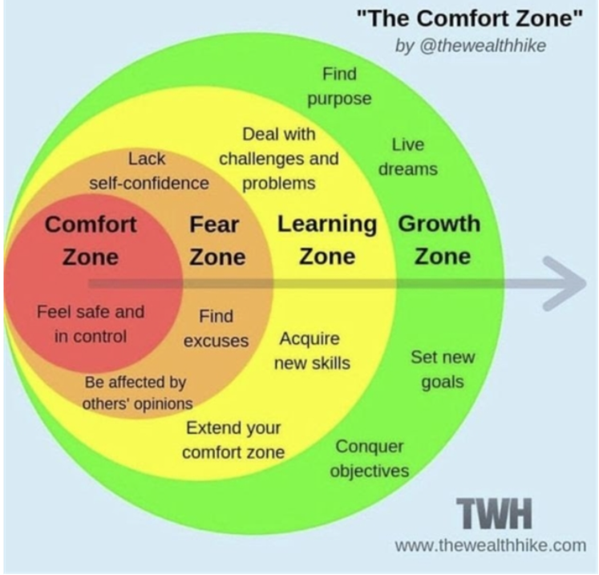

Expanding your social network will also open one up to new prospective and allow to break free of social isolation which will then enable you to be where you want to be.

Unit 2 topic 2,2 creative minds Don’t think alike
When someone challenges you, you will either go into fight or flight mode by doing this you will possibly give up during the first hurdle or you will excel at what you want to do because you have been challenged. This idea stems from the medici effect by author fran Johansson and the idea of intersectional thinking which suggests two unrelated sections of the working world merge to create new innovative ideas Stuckey, J. (2004). If you are surrounded by like minded people there will be a lot of rivalry and competition as you are essentially in combat for the same goal.

Unit 2 topic 2.3 varietys the very spice of life that gives it all its flavour
Your opinion may be held in high stance in your network but how it is said may impact the receiver negatively. Many people have different lived experience due to culture, upbringing and firsthand experience. Having a variety of influences broadens your horizon as it allows you to grow in so many areas that will only benefit you (Lu and Churchill, 2012). Challenging yourself is not only work related if someone challenges your ability or makes you think outside the box this adds value as this situation itself is making you think something that you otherwise wouldn’t.

Unit 3 topic 1 creating your own luck

Opportunity knocks at the most unpredictable times but because it is unfamiliar and unknown many shy away as there is no guarantee but there are some that are curious enough to delve deeper by doing this they are creating their own luck. Blind luck is something that not all of us are graced with as it happens by chance like playing the lottery (McKinnon, 2014). Taking an active role in your network can add monumental value in so many aspects that it will only benefit you if the commitment is there. Curiosity is such a beautiful trait as it allows you to step away from the ordinary and explore new avenues of ideas and thoughts

Unit 3 topic 1.2 Blind luck
Blind luck can happen to any one and in any given situation but there is no guarantee and can only happen by chance. Some people may consider certain opportunities as luck but reject any involvement as the situation has no guarantee. The Cynefin Framework was developed to put a scenario in four different scenarios and give a more realistic sense of the situation. Every aspect of life can not be planned as situations do occur but its how one manages the unpredictable situations that shows the persons skillset and perseverance (Gray, 2017).

Unit 3 topic 1.3 fishing for luck
To find an opportunity it must present itself, but some curious people put themselves in situations where it is present or becomes apparent, when referring to fishing for luck, this essentially states a person in each situation puts themselves in multiple situations to predict what may occur and whilst doing so finding opportunities that arise that otherwise would not have

Unit 4 the pursuit to happiness topic 1 future me
Many people have critics but regarding growth we are our biggest critics. And to break out of a mindset can be very untoward and but once out of that mindset it can be very freeing. Limiting one’s abilities can be like second nature, but this is where the art of possibility occurs. The art of possibility by Zander (2006) talks about how one should break free from self-limiting beliefs and believe in themselves to enable someone to see the endless possibilities and instead of comparing yourself to others live your life so you can draw on them experiences.

Conclusion
This whole topic is very eye opening as it makes the person taking the course delve deeper into the how’s, the whys even the what ifs but also looks at the end results the possibilities and the consequences of not following up what they set out. But a route is never without twists and turns and only you know what is important to you. I really enjoyed the focus on the network you keep and how they can essentially shape your future and add value to it as it allows for growth.

Part 2 build a personal development plan
Personal development plan: respite manager
Long term goal
Respite manager for Sen provision

Short term goal
Improve managerial skills and customer service skills

Goal | Objective | Resources | Measurement | Target date
Improve customer service skills | Work to improve customer services and remain professional at all times regardless of situations that present themselves. Listen to employee and service user preferences to provide remarkable service | Service user interactions and regular meetings with employees | Feedback from service users and their families | On going
Improve training and communication | Have up to date training material for new recruits | Time set aside every week/month to action changes | Review of training materials by management | On going
Get further up to date training on SEN and learn about the legislations | To further improve and enhance knowledge of disabilities to enable a comfortable stay for service users | Training every 3 months | In house training and certified training workshops | On going

Bibliography
Aldous, J. (1974). International bibliography of research in marriage and the family. U of Minnesota Press.
‌
Annas, J. (2021) The Virtue of Ambition | 1 | Neglected Virtues | Julia Annas | Taylor. Available at: https://www.taylorfrancis.com/chapters/edit/10.4324/9780429435201-1/virtue-ambition-julia-annas.
Calkins, M.W. (1911). The Idealist to the Realist. The Journal of Philosophy, Psychology and Scientific Methods, 8(17), p.449. doi:10.2307/2012399.
‌

Faulkner, R., 2008. The case for greatness: Honorable ambition and its critics. Yale University Press.
Gray, B. (2017). The Cynefin framework: applying an understanding of complexity to medicine. Journal of Primary Health Care, 9(4), p.258. doi:10.1071/hc17002.
‌

Guignon, C.B. and Crowe, B.D. (2006). Why Authenticity Matters. Heidegger Circle Proceedings, 40, pp.31–43. doi:10.5840/heideggercircle2006404.

‌ Lu, J. and Churchill, D. (2012). The effect of social interaction on learning engagement in a social networking environment. Interactive Learning Environments, 22(4), pp.401–417. doi:10.1080/10494820.2012.680966.
‌
McKinnon, R. (2014). You Make Your Own Luck. Metaphilosophy, 45(4-5), pp.558–577. doi:10.1111/meta.12107.
‌
Stuckey, J. (2004). Review of ‘The medici effect: Breakthrough insights at the intersection of ideas, concepts & cultures’ by Frans Johansson, Harvard Business School Press , Boston, 2004. Ubiquity, 2004(November), pp.1–1. doi:10.1145/1040582.1041060.

Zander, R.S. and Zander, B. (2009). Learning the Art of Possibility. NHRD Network Journal, 2(4), pp.85–86. doi:10.1177/0974173920090419.
‌

‌

