Lewis Christopher
1909572
Control Technology
ACMA6001
Assignment 2

Main OB1 Program

These below 2 rungs fo the program are to link the program to allow the simulation to take place and then the second rung is a latch circuit for the start and stop operation of the system. This includes the start and stop buttons along with the emergancy stop and the alarm stop signals also.
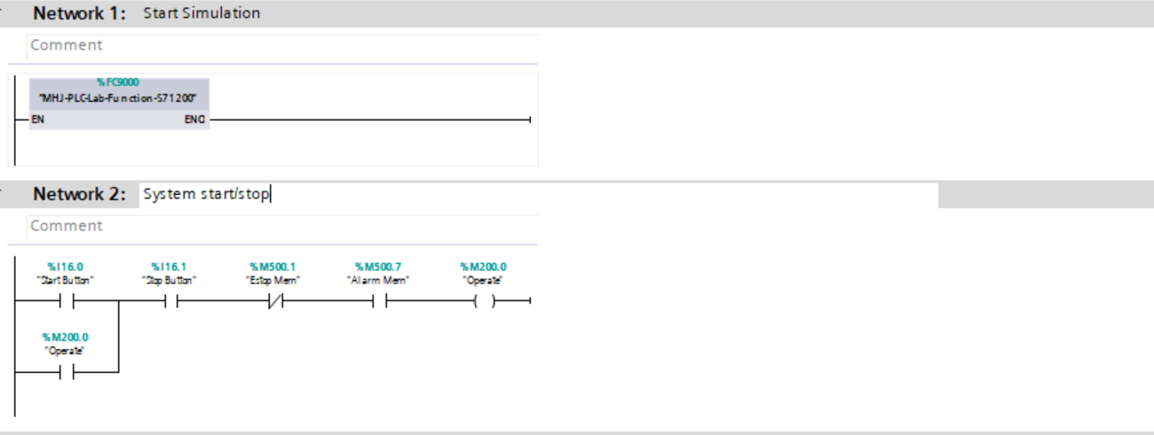
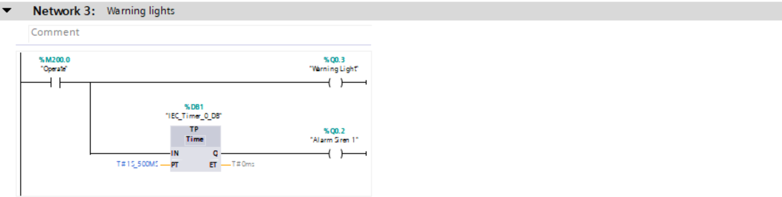
This next rung is to sound an alarm before the system starts, this is to alert workers who are around the area that the conveyors will move, from a safety point of view.

The next rung is the starting of the belts and the and the machinery centres. The timers in this instance are used so they all start up sequentially in order to limit the current being drawn which would trip the unit and shut it down.

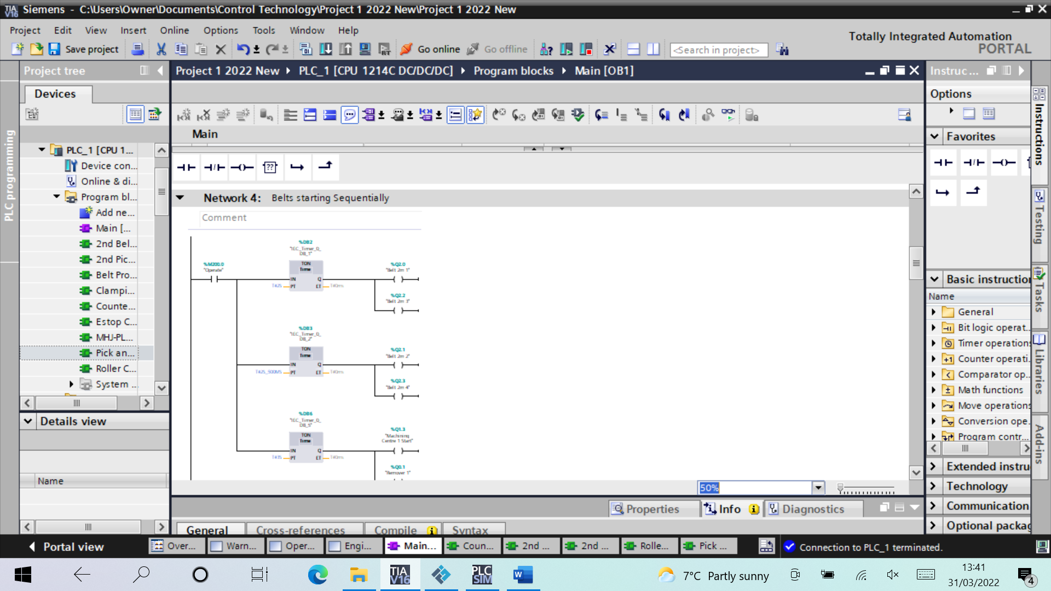
The emitters are started next and they are on timers so that they will emit the same part are set intervals. This is at a random rate but they are also interlocked so they will not emit another part if there is anything in the infeed to the machining centre, this is to limit a back log of unmachined pieces.
The next rung shows that if the M200.0 is broken then to shut down the units. This input will be broken if any of the parts in rung 2 are activated, such as the stop button, estop or the alarm.
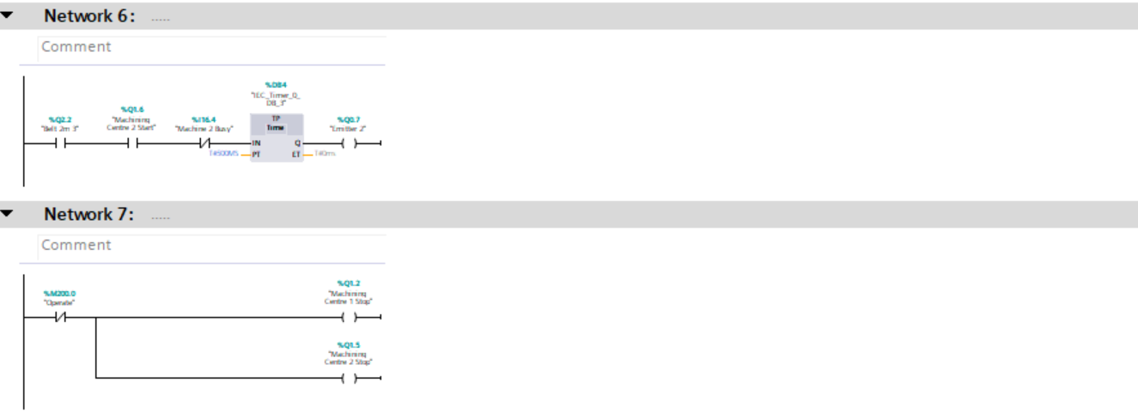

This rung controls what each machining centre is producing. By doing a reset on one and a set on the other it ensures that they will always be producing opposite parts.
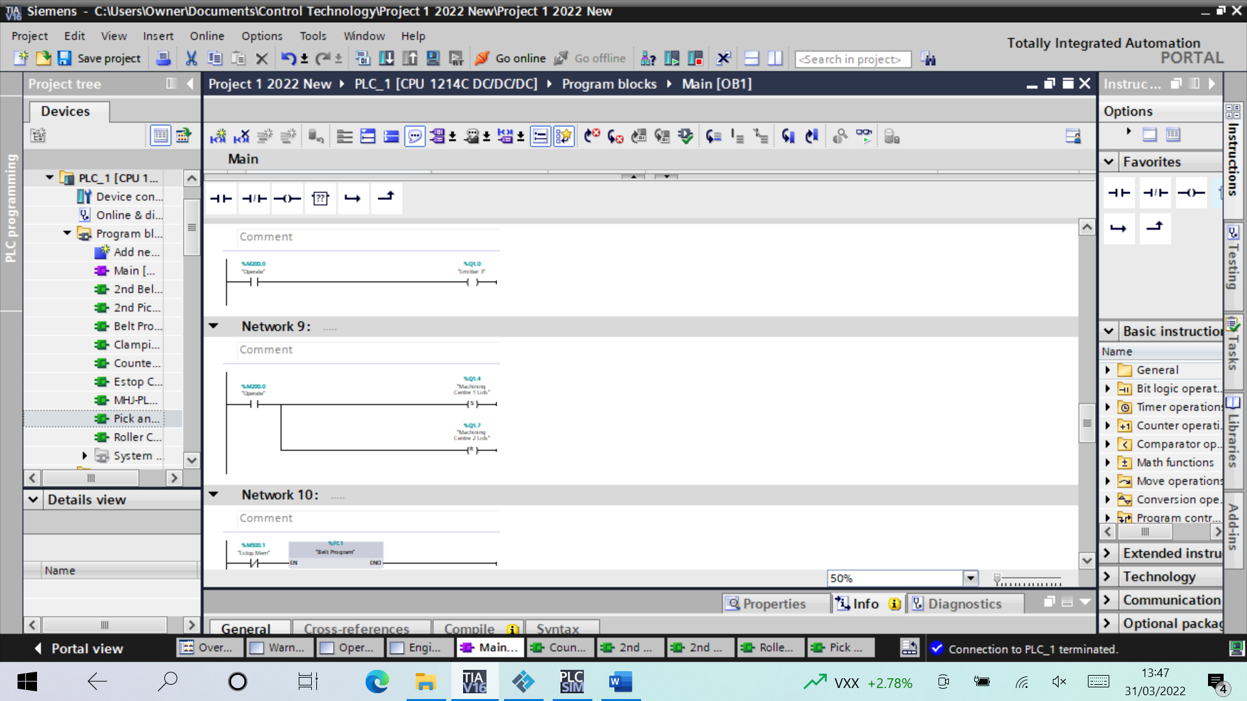
The final rungs of this section are all just activating different program blocks that I have used. The reason for using numerous program blocks is that it allows for much easier fault finding and makes the logic easier to read. For example, if there is an issue with the pick and place unit, I can go directly to that program block to find the issue, rather than having to scroll though all the code to find one rung.

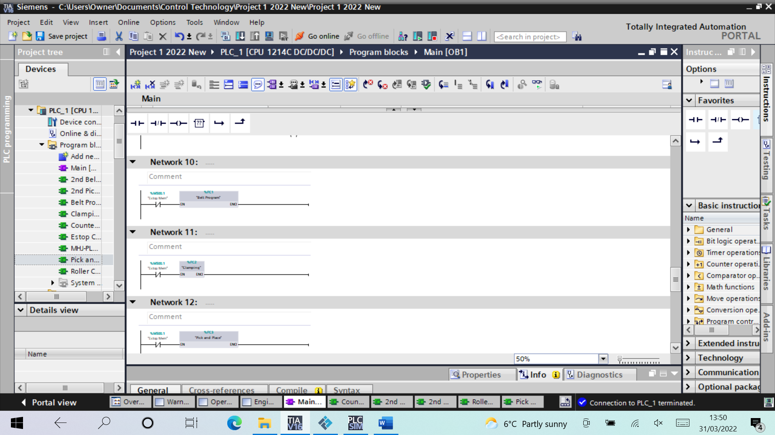
Emergency Stop Function Block
This function block used to control the emergancy stop circuit. The normally closed button is used so that when it is hit the circuit is broken. The system can then not be reset until this button has been made health again by pulling the button out and remaking the circuit but also the emergancy stop reset is needed which is both on the panel and on the engineering page. These 2 buttons are reuqired to ensure that no one starts the machine back up accidentaly if there could be a haard present.
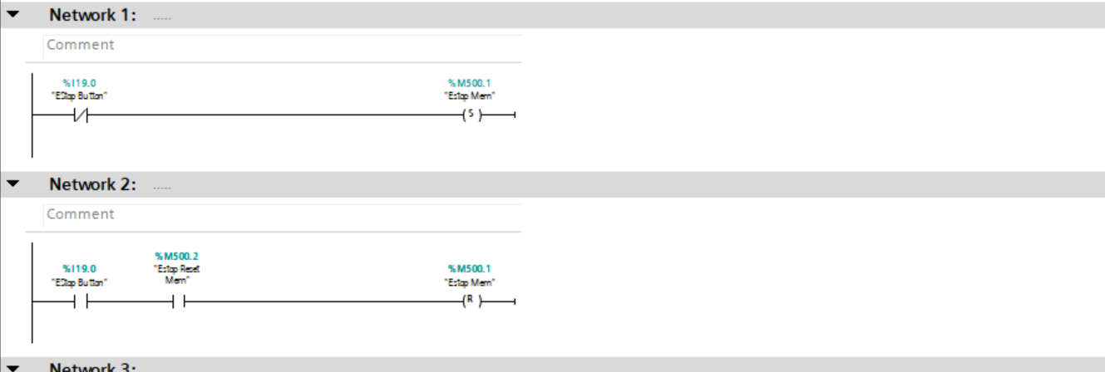
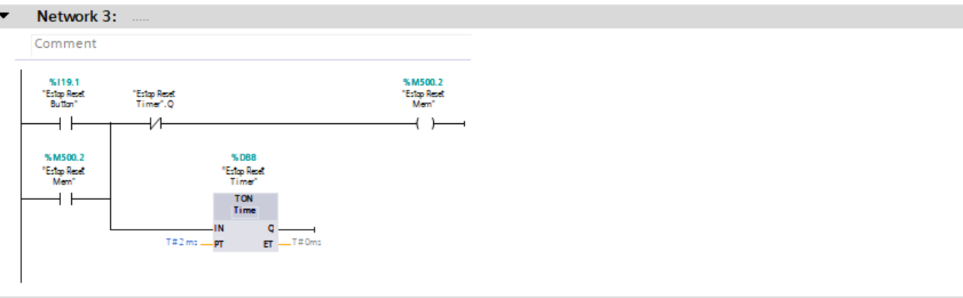
Also includes in this function block is al of the stack lights which are used as a viual indicator of what state the system is in. These stack lights are also replicated on the HMI operating page.

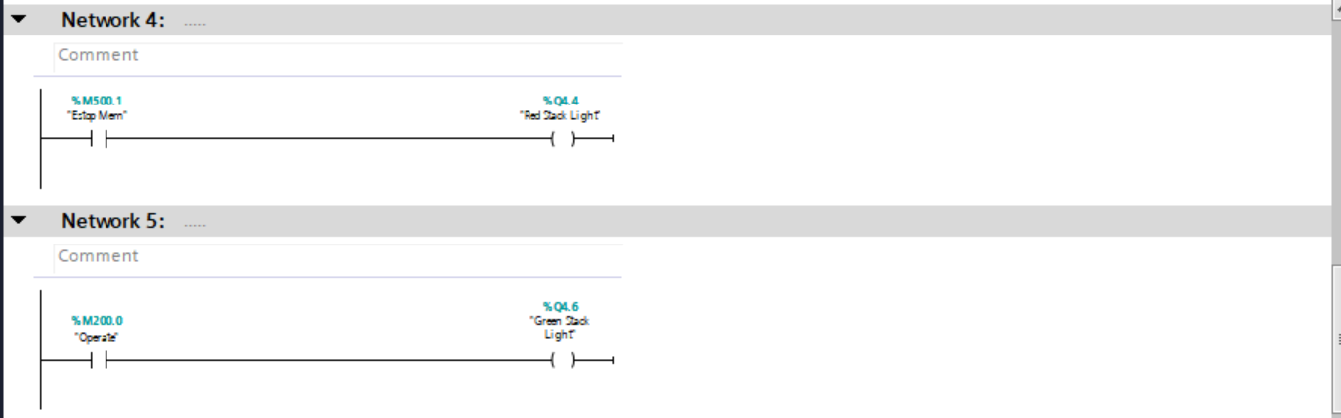

Initial Belt Function Block

The first two 4m belts after the machining centres are started initially by the start button when the system is initially made live. They need to be started and stopped often depending on the state of the pick and place so instead of a normal output a ‘set’ has been used. As rung 2 shows, once the belts are set again to continue moving once the clamp is lifted, which allows the belt to restart and the complete assembly to be moved on to the next conveyor. This set up is exactly the same for both belt but only one is shown in the screen shot.
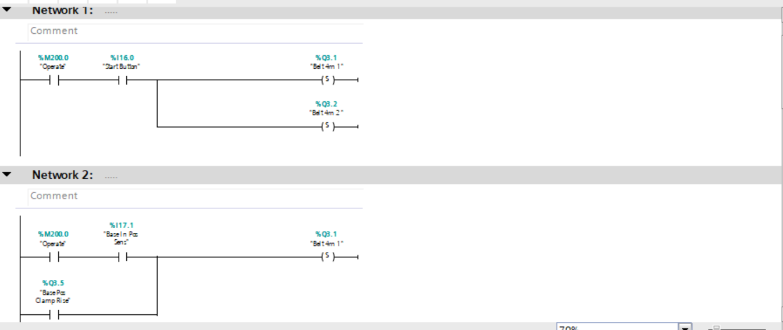
The reset function of the belts is activated by the parts hitting the sensors on either conveyor which tell the belts to stop, as the part is in the correct position to be collected by the pick and place unit.
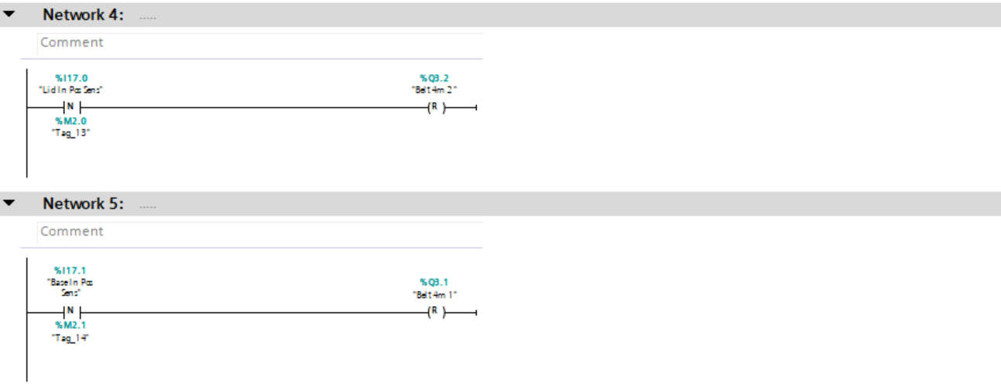

Although not part of the belt system, this rung is included as it is used to reset the clamps when the part has been passed off the frist 4m conveyor, onto the second one and has hit the ‘part assembled sensor’ positioned just behind the clamp.
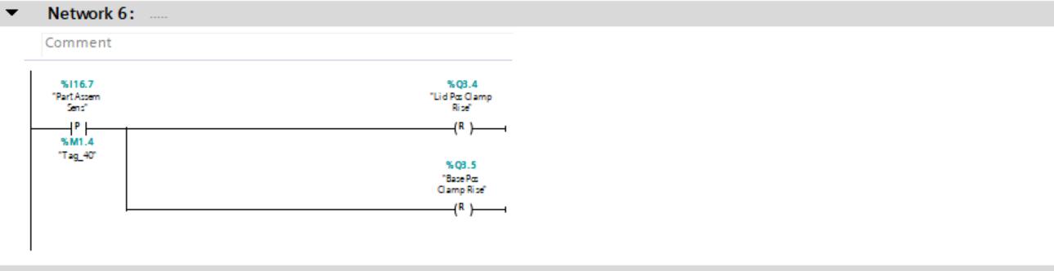

Clamping Function Block
The first rungs of this block are used to set the clamps, this is done when the same sensor which is used to stop the belts is activated. When the clamp has activated it then gives an input to say it has finished its stoke and then it is reset. As this resets it also sets the alignment which is used as an input for the pick and place. The same process is copied in rungs 3 and 4 to complete the same action of the opposite clamp.
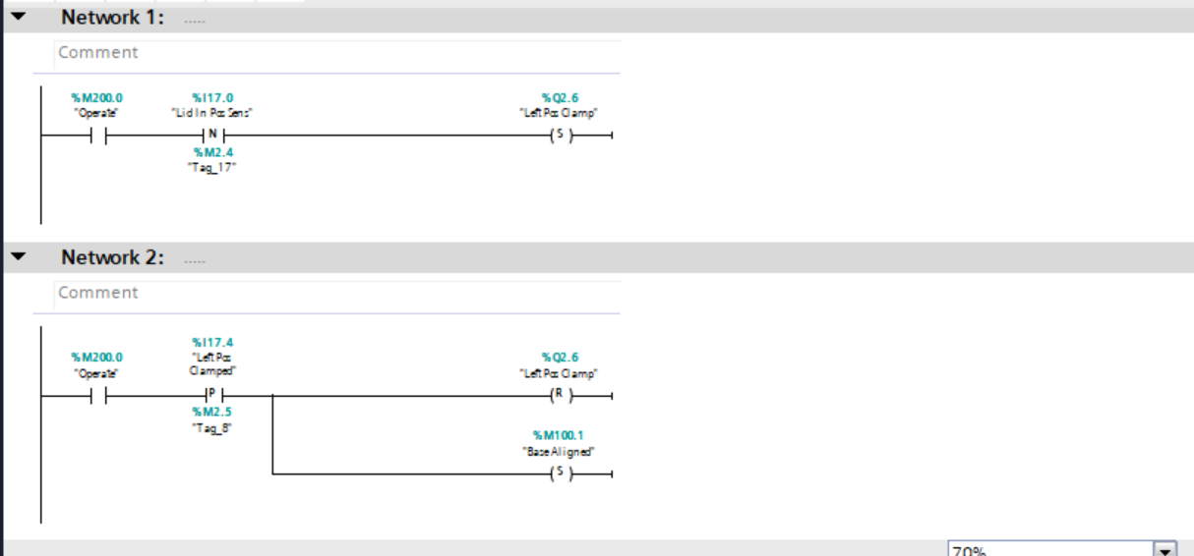

Pick and Place Function Block
The pick and palce as mentioned used the alignment of the lid to initally set the z axis movement, this ensures that the part is always in position before the pick and place starts to activate. As well as the output, a memory bit is also used this is done as there is multiple times the z axis will move so the memory output can be used for an input further on, where as if it was just the output then it wouldn’t be possible to keep using the same input to do separate tasks. Thd next rung is to say that with the z axis moving and the part detected, to give the output to grab the part.
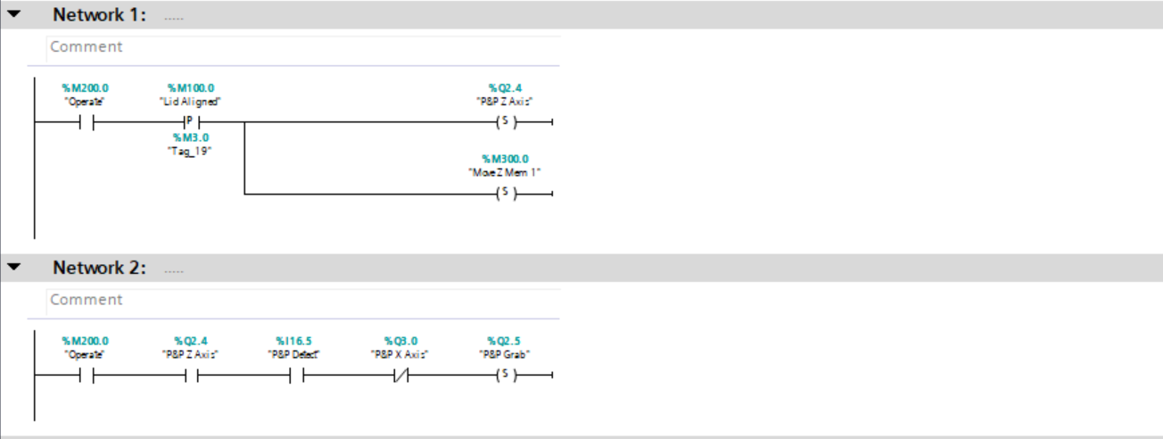
Once the part has been grabbed this sets off a timer and once the timer is done, the z axis is reset, along with the memory bit and the lid alignment.
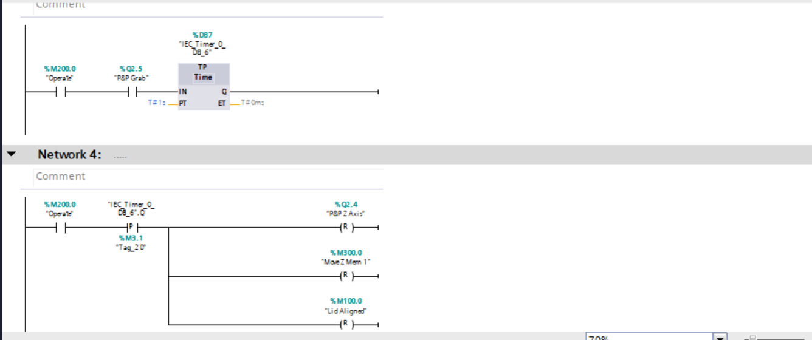

This next rung is responsible for setting the x axis to take the part to the next conveyor but it can only be doing so if the z axis is not moving and the part is still being grabbed, which are therefore used as inputs on this rung. Once the x axis has completed its travel the z axis is then set again alogn with another memory bit in order to drop the part down on the base.
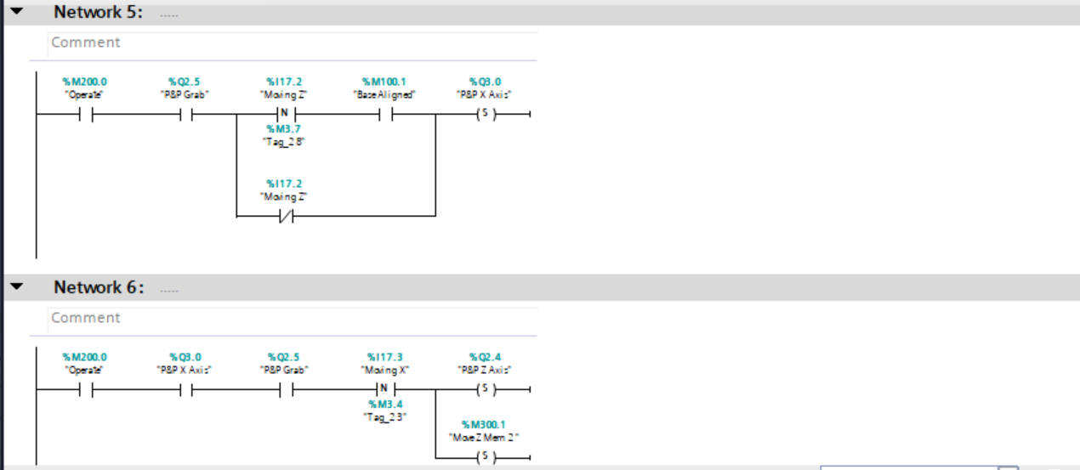
The memory bit is used to set the timer which once ativated, after 2 seconds then releases the grab of the part by resetting it and it also resets the x and the z axis to allow them to resert to the home position. As well as this it sets another memory bit, which can then be used to activate another timer function.
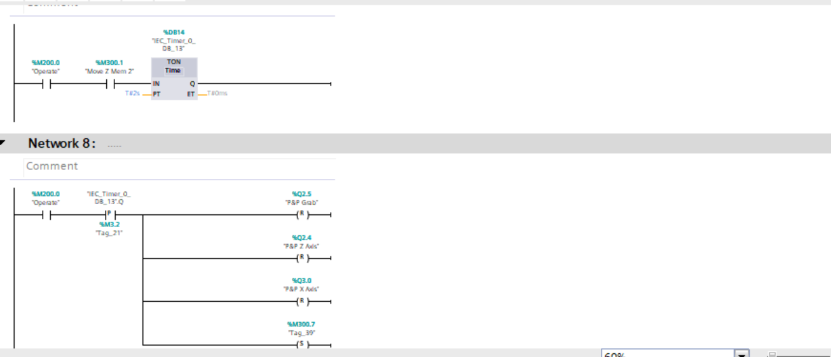

This memory bit is used to set the timer again and once the timer has timed out, it will set the clamp to raise to allow the part to pass through. As mentioned previosuly, this clamp raising is reset by the sensor as shown in the previus function block.
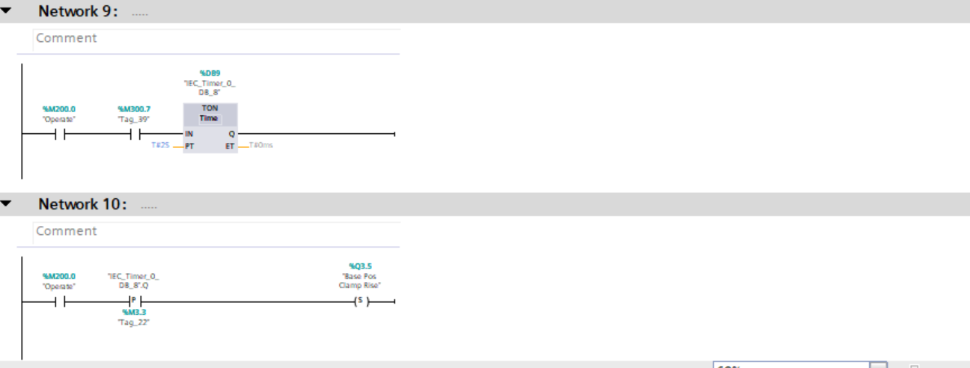

2nd Belt Program Function Block
This block works in the same way as the previous belt program, it is started when the system starts by the start button to set the belt. It is then reset when the diffuse senser at the end of the belt is activated ready for the second pick and place to collect it. Once this sense is healthy again, the belt will be set again.

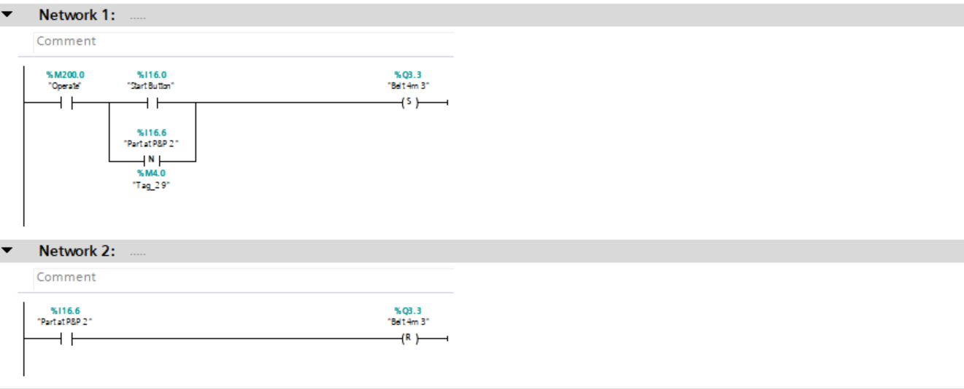

Second Pick and Place Function Block
This block is similar to the initial pick and place but works in reverse to collect first. When the part is detected by the diffuse sensor it sets the x axis. Once the x axis has stopped moving, the z axis is also set, along with a memory bit for the same reason as previously.
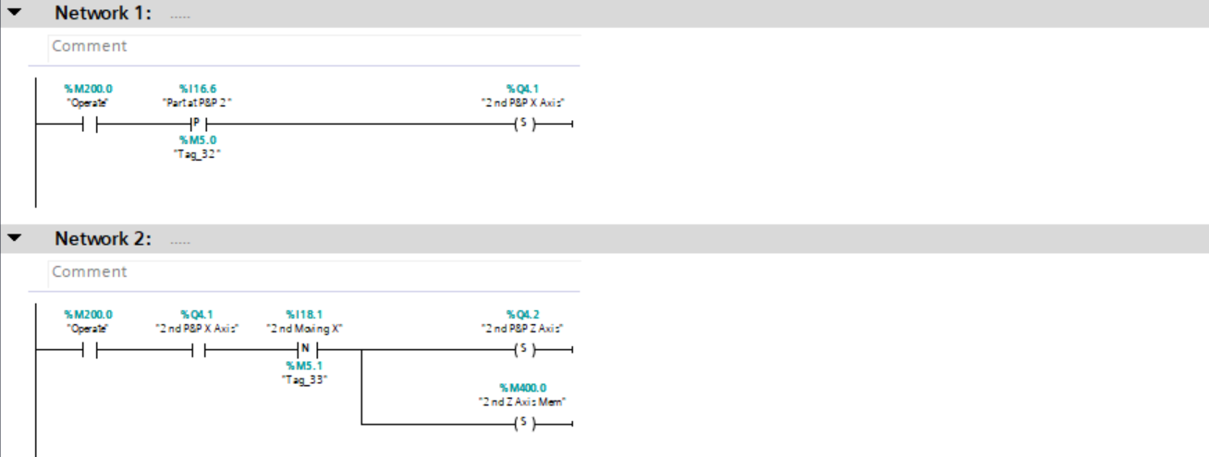
Once the z axis has been set and the part has been detected, this will then activate the grabber as in the previous case. The grabber will set off a timer which is use to ensure the part is correctly gripped betfore moving.
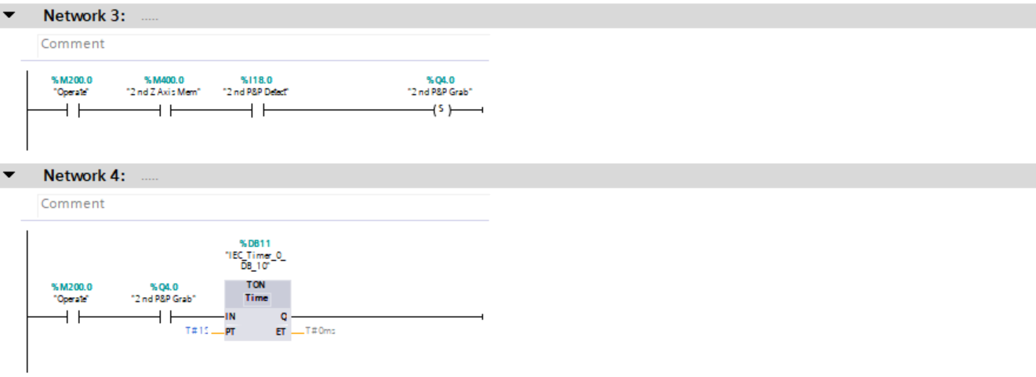

Once the timer has counted up to 2 seconds, the z and x axis are then both reset, this takes the part back to the home position above the waiting box.
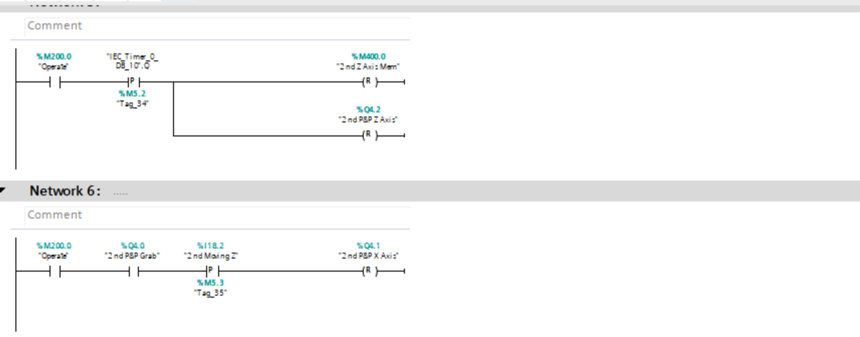
With the part still gripped and the x axis back in the home position, the z axis is again set, with a separate memory bit to allow it to set off another timer. The timer is used to ensure that the part has been reseased before the next stage will take place.
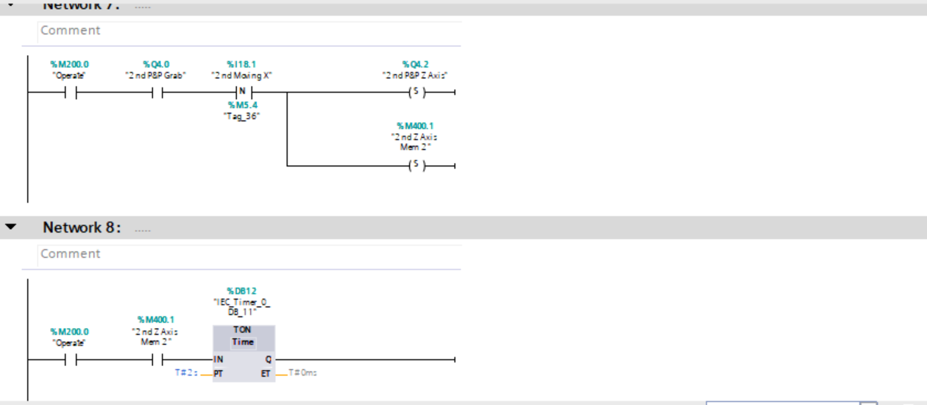
Once the timer has counted up the grabber and the z axis are both reset to release the part and return to the home position. The memory bit is also reset to allow it to be reused on the next cycle.
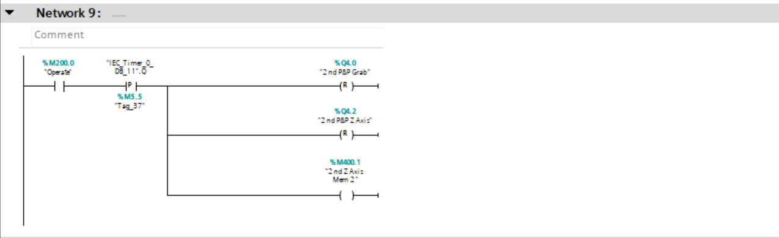

Roller Conveyor Function Block
As with the other conveyors, once started, this will continue to run until the sensor under the pick and place is activated to allow the box to receive a part. It is also set through a counter in the next function block to ensure the correct amount of parts are filling the box.
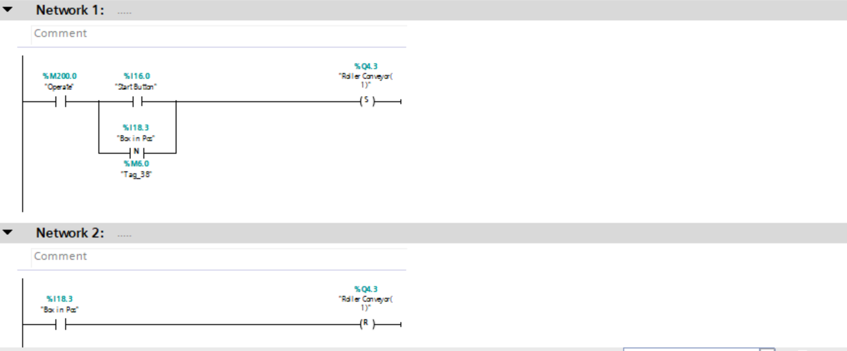

Counters/Alarms Function Block

The below network is repeated for each of the different counters used. It used an input from the user which is given in the HMI, it will then count up through the use of the diffuse sensors in the various locations. Once the warning limit has been reached it will give the warning output of a light. If the alarm limit is reached which is again given by the user and uses the comparator then the alarm output is given.
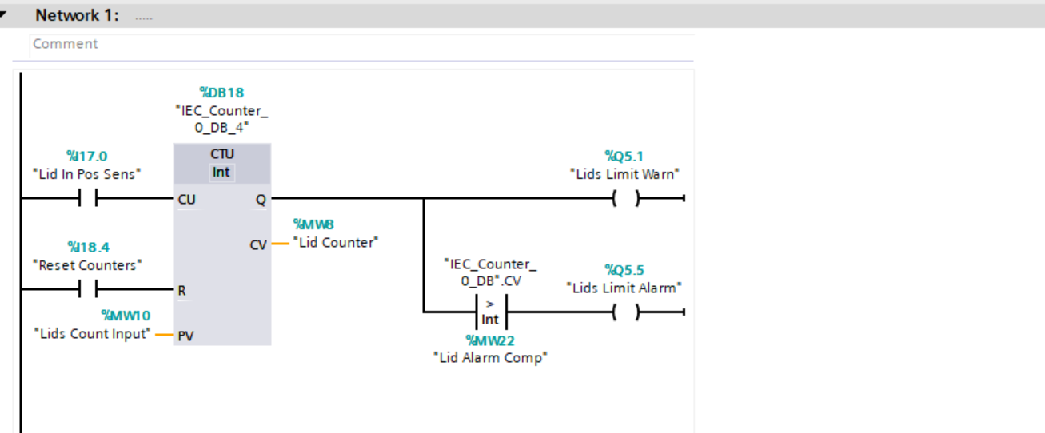
This counter is used to dictate how many parts go in each box. The same type of counter is used and the diffuse sensor is used to count up to the given input by the user. Once the limit is reached, the conveyor will then be set to allow the next box to move into position. As well as this the counter is then reset, this is done to start the count from zero again in order to get the correct amount of parts in the next box.
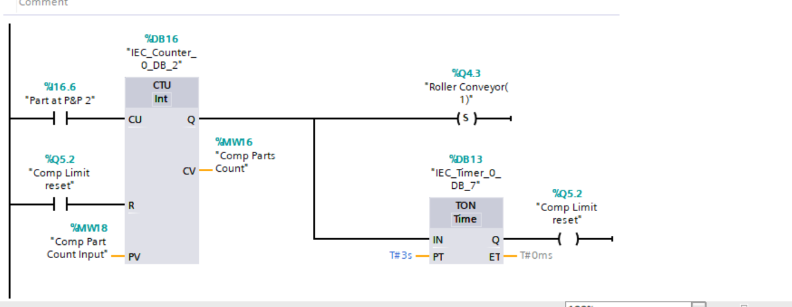

As the alarms for high level can be more serious, this memory bit is given as an output if any of the alarm limits are reached. This memory bit is in the initial line of the code and if it is made healthy then the M200.0 will be cut out, hence stopping the system. In order to restart it the counters must be reset manually in the HMI engineering screen.



