
ASSIGNMENT CYMRAEG
Aaya Aldulaimi (1903726)

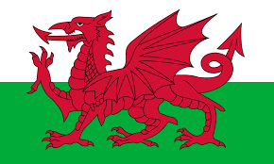
Reflection and the promotion of reflective practice have been broadly emphasised in the teacher training and preparation programmes. This paper reflects on my experience with the use of Welsh in school.
In 2017 the Welsh Government published the Future Trend report, according to the study the percentage of children who now speak Welsh has doubled since 1981. This is remarkable as between 2001 and 2011 there was a decline of over 20,000 school children speaking Welsh. In Wales, the Welsh language is a compulsory curriculum subject up to GCSE level in Wales even in English-medium schools. Welsh is introduced as a second language in Year 3 but is given more weight than a second language normally would otherwise. The Welsh Government recognised the important part that the early years sector plays in the development of children’s Welsh language skills, combined with a solid progression into further and higher education.
Currently, the curriculum in Wales is under development, with new announcements due in 2022. The main aim of improving education is defined as “universal access to, and acquisition of, the experiences, knowledge and skills that young people need for employment, lifelong learning and active citizenship”. As a key part of this, the Welsh Government has set out an action plan for 2017–21, addressing the development of compulsory Welsh-medium and Welsh language education over the next four years, in line with the vision of Cymraeg 2050: A million Welsh speakers.
Cymraeg 2050 is the long-term vision for a sustainable and thriving Welsh language. It sets out a number of key changes that the education sector will need to make as well as a three-pronged approach to achieving this goal. This includes increasing the proportion of children in schools receiving Welsh-medium education, changing the delivery methods for Welsh teaching and increasing the number of primary school teachers who are able to deliver Welsh-speaking lessons. In addition to this, intensive Welsh language training for teachers and teaching assistants is now being planned to ensure they can deliver the changes coming in from 2022.

During my PGCE course, I attended several classes to improve my understanding and use of Welsh. These classes included sessions about learning the Welsh letters, numbers, days, and months that are useful in schools. Also, we learned about common phrases for example meeting and greeting, answering simple questions. The classes also focussed on pronunciation to help with welsh speaking and reading skills.
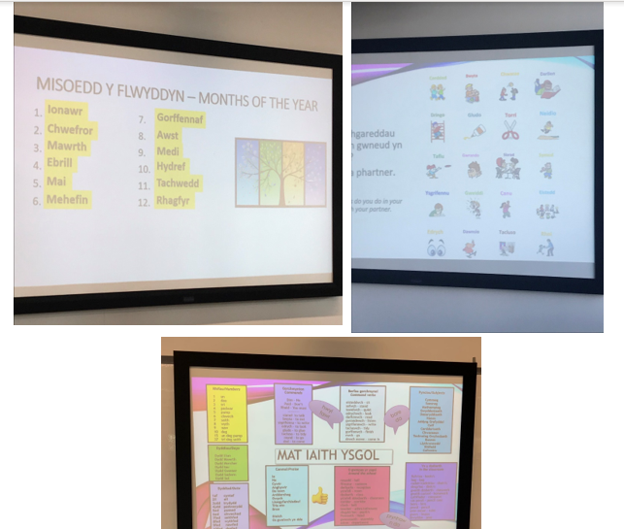

During my teaching experience in school, I had the benefit in experiencing the use of Welsh language across the mathematics department. School policy visual displays in each class and around the school acted as helpful reminders for teachers and other supported staff about the school policy about how to start and end the lesson with the implementation of Welsh.

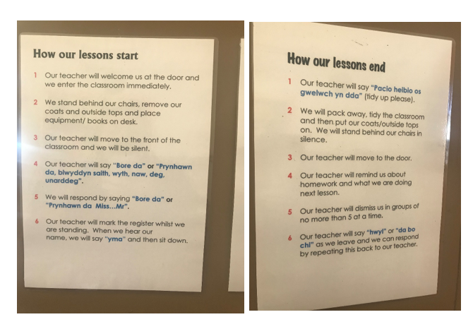

By following my placement school policy, Welsh was embedded in the lessons in three main ways. Firstly, through the use of Welsh phrases for example (Gwaith Dosbarth, Nod y wers, and the date) which students made a note of in their books. The following picture showed part of my lesson where I used the Welsh phrases.
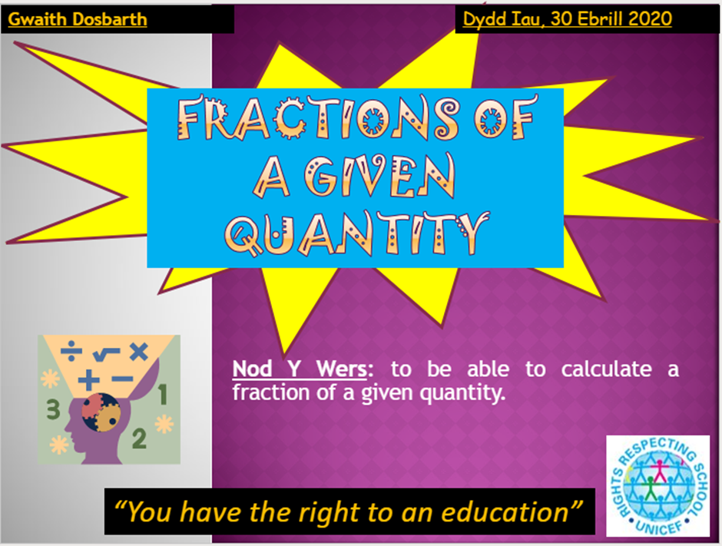

Secondly, it was paired with behaviour management strategies, for example by counting down in Welsh to bring class focus and greeting the students or rewarding an achievement during the lesson. The following pictures are screenshots of my mentor lesson observations where I have been using Welsh during the lessons at entry level.
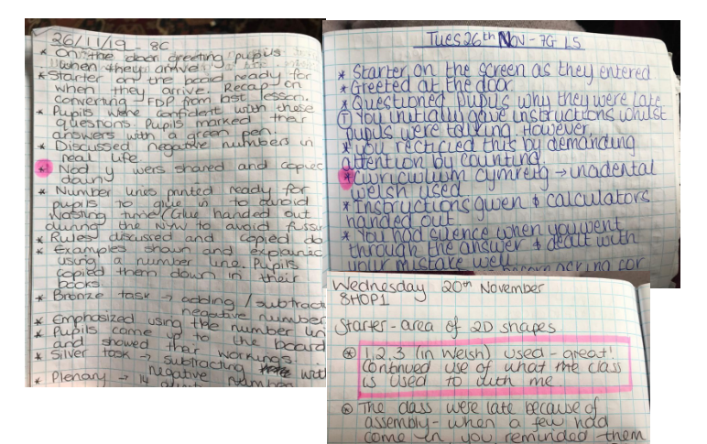

Eisteddfod Maths competition 2020 was another opportunity that I was able to use to engage with Welsh language and culture through teaching. The maths competition is based on a festival of music and poetry in Wales.
This activity included using coordinates to draw a picture that represents Wales or Welsh identity for example, a rugby ball, leeks or a Welsh dragon. The activity included class discussions about Welsh symbols history and background about the use of each one. The competition offers points to the schoolhouses, increasing the engagement and the competition level between students.

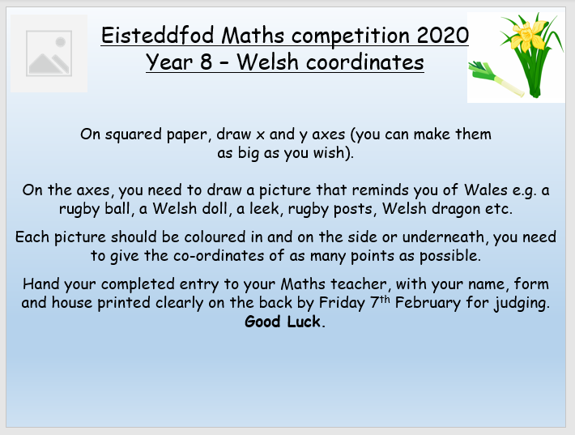
During delivering this competition I was able to explain and discuss with learners about many Welsh symbols and the history behind them for example. I found this experience extremely valuable to my own teaching and learning experience. I found it supports students' understanding of the topic in a different way and supports the delivery of a normal lesson in a class set. As well as providing evidence of integrating Welsh in a Maths lesson as recommended by Donaldson’s main purposes of the new curriculum in Wales.

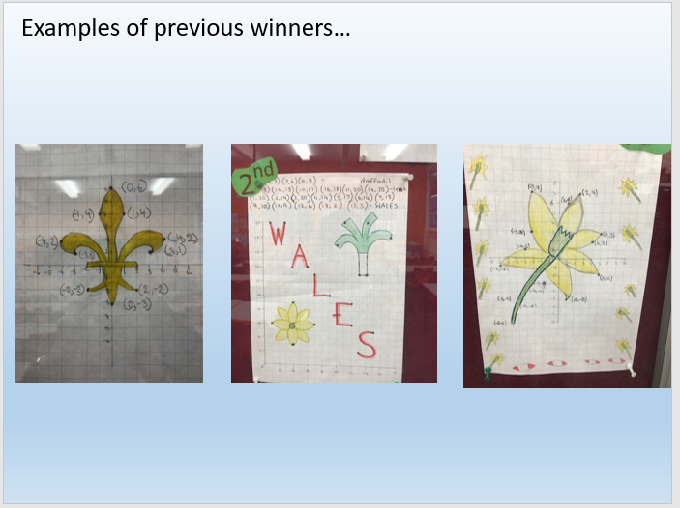

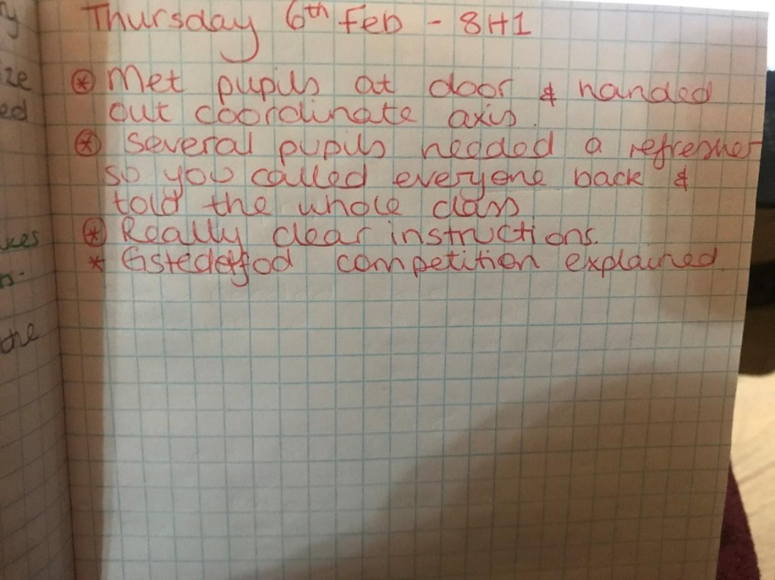

Finally, I observed within each department in school, teachers including several posters that link their subject with Welsh as well as Welsh themes, symbols, authors. On my elective I chose to do one week at a special facility at my placement school. This facility includes students who cannot adjust to mainstream schooling and need extra help. One lesson I observed was a Science lesson which tied in Roald Dahl as a Welsh author by comparing their experiment for the day to George’s Marvellous Medicine, in celebration of the World Book Day 2020. I found that the lesson atmosphere and the linked themes (Science, Literacy and Cymraeg) were really effective pupils were engaged and it certainly brought a sense of Welsh identity.
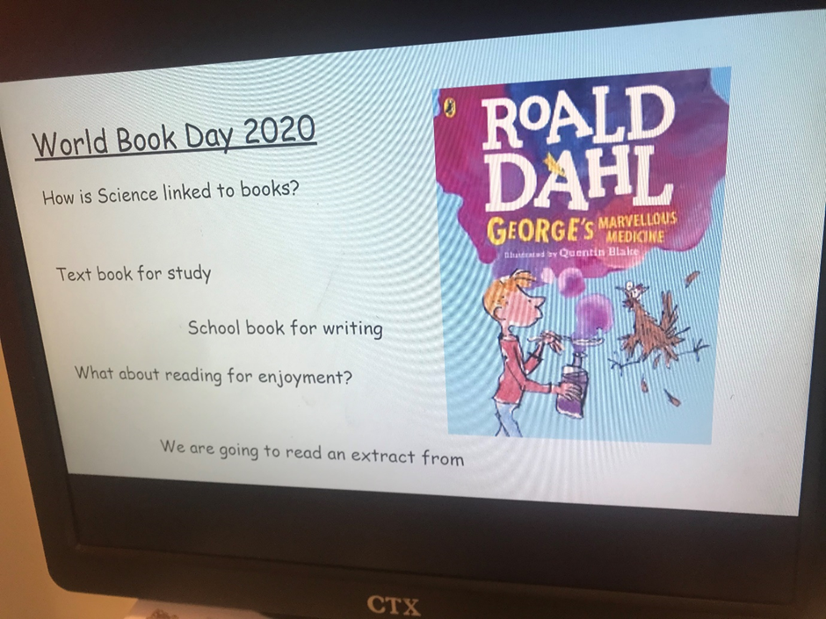

To conclude, as part of my teacher training, I have engaged in Welsh language and cultural awareness as much as possible. The opportunities that I found the most interesting and fruitful were cross-curricular. I think that this is summarised well by the Welsh Government recommendation:
“While it would be up to schools to decide how they approach this, they would need to think about opportunities for learners to listen, read, speak and write in Welsh – this might be through use in different parts of the curriculum or outside the classroom". (Wightwick, 2019)

Reference
- Wightwick, A. (2019) ‘The subject of second-language Welsh is being abolished in schools in Wales’, Wales Online, 18 January.

