Showreel and Business Card
(Showreel submitted via We Transfer)

Business Card:
Template:


Final:
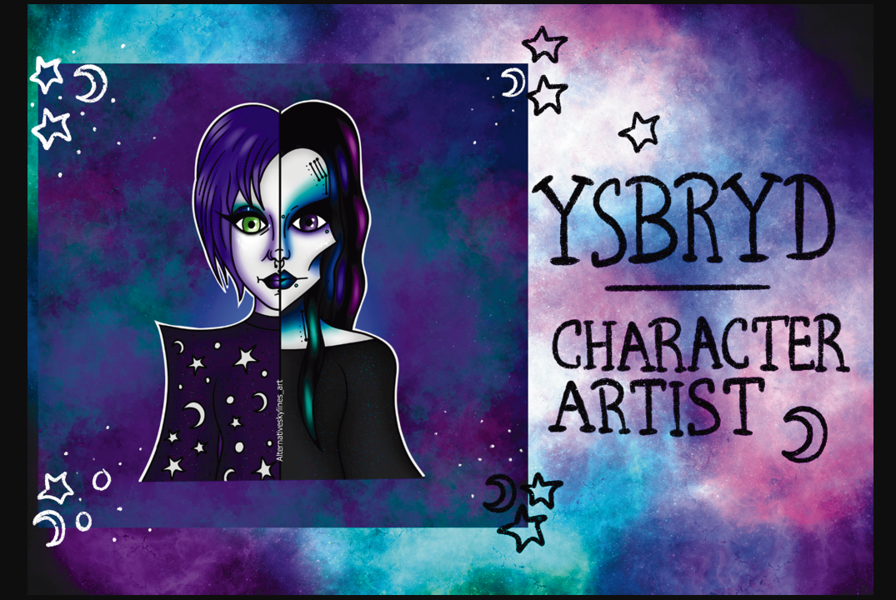
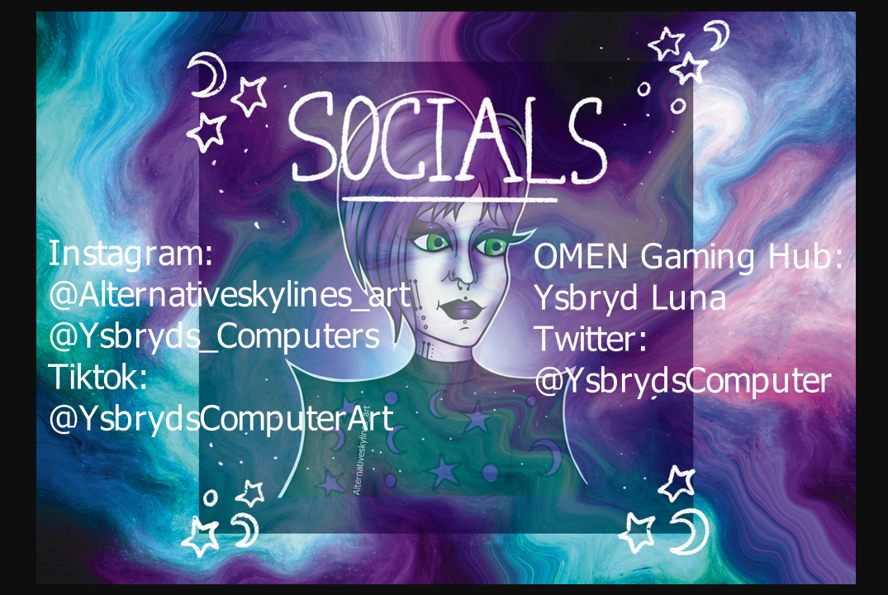

References
Sam Hampton-Smith “How to design a business card: 7 top tips” 21 February 2022 [Online] Available: https://www.creativebloq.com/graphic-design/how-design-business-card-10-top-tips-9134291 [Accessed May 2022]
Jean-Denis Haas “Pro Tips: Making a great animation demo reel” 8 May 2017 [Online] Available: https://www.artella.com/index.php/2017/05/08/pro-tip-series-what-makes-a-great-animation-demo-reel/#:~:text=Basic%20things%20to%20cover%20would,first%20shot%20on%20your%20reel. [Accessed May 2022]

