“Fit For You uniforms and clothing’s” business concept
Emilia Ramona Sipos
Student ID 2211874
Module: Entrepreneurship BMIH5001
Wordcount: Essay-1473 words, reflective essay- 470 words
Lecturer: Ben Chong

This essay illustrates the business concept for the company “Fit for you uniforms and clothing’s” (please see appendix 1) established in United Kingdom, Northampton, that provides working clothes, work uniforms, and personal protective equipment, with the uniqueness that all the clothing’s are not just within the standard measures XS to XXL, they are custom tailored- customers can address themselves to the physical location where their measures are taken, or if they are not located elsewhere in the country, they can take their own measurements using the guide available on the company’s website, send them across via WhatsApp and from there the tailors will process the information received and then contact customers if any other details are required. This feature is the core of the brand, as it implies several advantages, such as differing the business from competition- which only provides standard measures, brings added value for customers- being at work for eight, ten, or any other hours depending on their shift, in clothing that are not comfortable day after day can be such a struggle, or being a person that is in between sizes, or having a shape of body that requires smaller size for the upper part of the body and a larger one for the bottom one, or vice versa, or having shorter hands than the average, or being taller, these are all real issues that workers face daily and it should not be a reason for them to feel frustrated, therefore having the option to benefit from a custom tailored working uniform is so significant and can change so much positively the quality of their work life. Another main aspect is that by using this business services customers will be able to save time and cost in addition to already enumerated advantages; normally, they would have to either alter the clothes themselves at home, which can be a challenge and implies costs like time, sewing machine, electricity, etc., or, address themselves to alteration specialists, which can be hustle because it takes anywhere between a week and six weeks (depending on their previous orders volume) to have the uniform altered and meanwhile they wouldn’t have with what to present themselves to work, and on top of that it would be the cost of this service. Also, the business offers wrinkle free materials, and that is another main pilar, as it has the advantage of saving customers costs like time, energy, and ultimately money, as they won’t have to iron, therefore they will not use electricity, thus solving their time management issue and saving money issue at the same time. “Fit for you uniforms and clothing’s” has another important key feature which is represented by the competitive prices offered; the business is able to run lower prices because of the fact that it purchases fabrics from a small local business, which brings along an advantage for the community as well. To continue enumerating the features that fall under value proposition section, the business brings added value to it’s customers by offering a significant discount of 15% to large companies, mainly hotels, that order a number higher than 100 units- this is a strategy to increase sales and therefore revenues whilst offering the large business the possibility to save cost, thus equilibrating the added value for the customers with the added value for the business, all in one transaction. To continue, as opposed to competitors, “Fit for you uniforms and clothing’s” offers the option for a quicker service- there is a special fee that customers can pay if they require their order in less than 14 days (which is the standard waiting time) and the company uses those money to pay for staff overtime, rather than prioritizing the orders for the existing orders disadvantage, ensuring that are not delayed, therefore an added value is brought to employees with this occasion. For the ones that do not wish to pay this fee, alternatively, they can opt for delivery via their preferred carrier company. Lastly, a key feature in adding value is the option to choose delivery via the company’s personal van- it is matter of fact that carrier companies can be pricey when transporting large amounts of merchandise, for example a hotel order 500 uniforms for housekeeping staff, these would need to be packed, and shipped, and the price would be calculated per item weight, and depending on their route, there is a chance that the packages need to be transferred from a truck to another one, thus the alternative to use the company’s van would far cheaper and safer, as the packages would not be split and mixed with other packages- this brings along value for the customers but also it is beneficial for the business as it increases the number of revenue streams. To continue, customers section will be discussed. “Fit for you uniforms and clothing’s” targets customers that are in the working field and their employers, mainly hotels; reason being that it benefits the business to aim for hotels as the tourism industry is one where every single staff requires a uniform, regardless of the department they work in, from housekeeping, food and beverage, to reception and managerial staff, and also is constantly hiring new staff, therefore the demand will always be high, which implies profitability. According to Gov UK official statistics (2023), working population age in UK is between 16 and 64, however 85% of all working citizens are aged 35 to 49, thus the reason why the business targets this group (as appendix 1 illustrates, at ‘customer profile’ section). Also, Northamptonshire residents are targeted, as the physical location is in
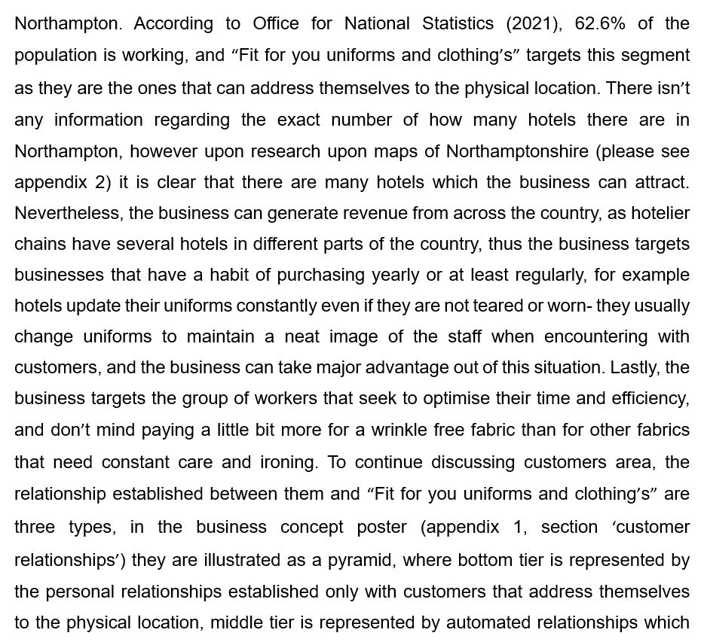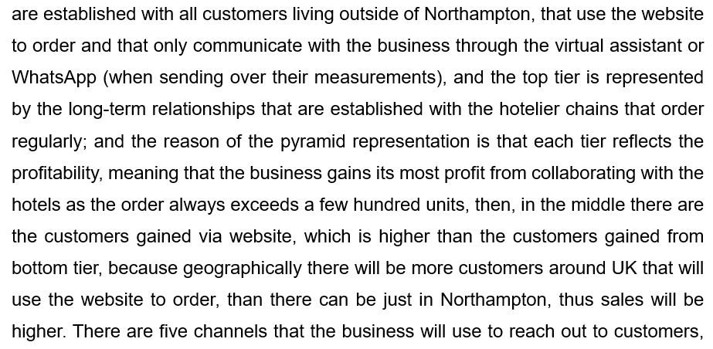

the main one is the website- which will ensure sales, secondly comes the catalogue- although it is quite old-fashioned, it will be useful for the customers that wish to see exactly how a pattern will look when finished, thirdly there is social media- business will be advertised on platforms such as Facebook, Instagram, and Tik Tok, as according to Sprout Social (2022) statistics show that 68% of consumers make at least one purchase via social media channels, and that is a segment that “Fit for you uniforms and clothing’s” can exploit to increase revenues, then fourthly, radio and TV commercials will run to make consumers more aware of the brand, however that will happen just on weekends, reason being that working staff are mainly free during weekends, and, lastly, there is the physical location as a channel to gain more customers. To continue, sections ‘key activities’ and ‘key resources’ will be discussed, and the reason that they are not treated separately is that the two are interconnected. Having professional tailor is both a resource and an activity as they represent the core of production, uniform wouldn’t be completed without them, and it is an activity because they need to be hired in order to become a resource for the business. Website, physical store, and social media presence are key resources as they are the channels through which revenues are ensured (as discussed previously). Fabric is another item pertaining to both categories, as it first needs to be purchased- that’s the activity, and then it will become a resource- as the wrinkle free fabric will generate more profit that a normal fabric (point already discussed at value proposition section). Designing, product developing, and inventory control are key activities as it is impetuous necessary for the uniforms to be designed according to what the business promises to its customers, as well as developing the product to meet high standards so that the customer will the difference between wearing a uniform designed by “Fit for you uniforms and clothing’s” and another brand, and also a special attention needs to be given to inventory- that is to ensure that the business doesn’t suffer an overstock or an understock. However, it is important to mention that all of the above are just the key one, not the only ones, obviously there are other resources and activities, all having the purpose to deliver value to customers and profit to the business, and as Fox (2020) states, it is important to outline the key ones, otherwise any business can be jeopardised. Cost structure, on the same level, illustrates just the key ones , and they are fabric, salaries, advertising, distribution, and personal van of the company- 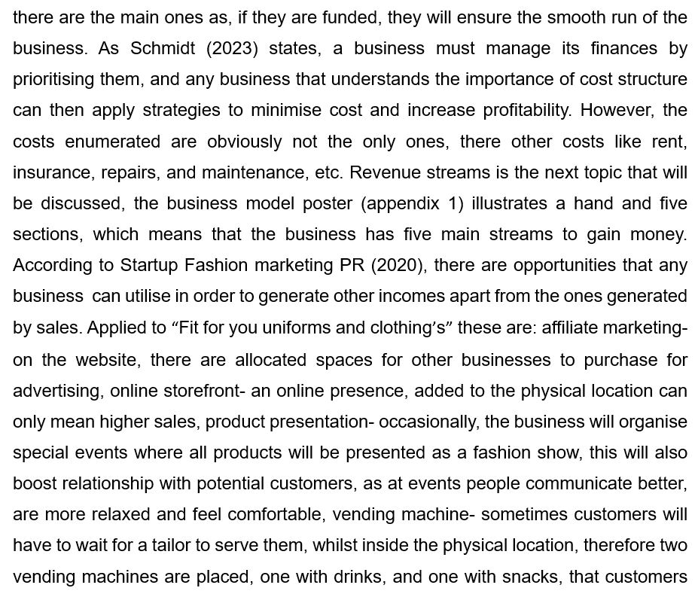 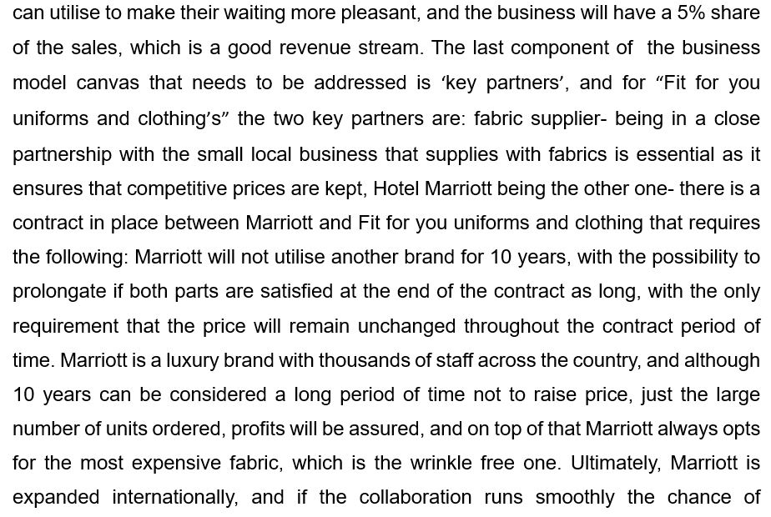 supplying outside the country hotels can arise, which would mean business international expand in just 10 years, which for other businesses is not achievable, and that is the logic behind agreeing to this exceptional partnership. On a last note, according to De Backer and Rinaudo (2019), “strong partners set a clear foundation for business relationships and nurture them, and they are mutually beneficial”- this quote reinforces the reason behind the decision to collaborate with Marriott by offering them a price deal in the exchange of having such an impressive partner.

Reflective essay
Upon testing my entrepreneurial skills, via Get2Test Enterprise rating (please see appendix 3), I have found out about myself that I am ‘occasionally enterprising’, and that result surprised me as I already run a business that I have grown from zero and it is successful and in the process of expanding (a venue for celebrations and parties), however I soon took the result and turned into an opportunity. Using Gibb’s reflective cycle, I will ensure to have a positive outcome out of this situation that initially upset me, therefore there will be six stages discussed (appendix 4). First stage consist in describing- during class we were required to perform a test by answering a few questions to find out exactly how enterprising we are, and my results were not the ones expected, I was assuming I have strong entrepreneurial skills for the reason already mentioned above. Second stage of the Gibb’s reflective model consists in describing the feelings resulted from the situation- in my example, I felt surprised, disappointed on some level, however my main feeling was one of frustration; all these feelings flooded me and were mix for the entire rest of the day, and by the evening I was starting to feel like I should just accept the situation and use it to my advantage, I was cross-examining myself if there is anything I am already doing wrong in my business and I am not even aware of, and as soon as that thought passed through my mind a feeling of curiosity stepped in, now I was feeling eager to find out the areas where I can improve. Third stage consists in evaluating the positive and the negative of the situation- I strongly believe that this is a relevant example for the saying ‘every bad situation has a good thing behind it’ as I can use it as a tool to help me in achieving better results as an entrepreneur. Fourth stage consists in the description of what one can do- I believe the best thing I can do is to carefully read my results and identify exactly what areas I should improve. Fifth stage consists in concluding- to be honest I am now happy of the opportunity given by my University, through Entrepreneurship module, and specifically of this particular test and I wouldn’t want to change it by all means. Sixth and last stage is to build an action plan- this is the best part, as it is exactly what I plan to apply in real life, and the actions I will take are: I will take the advice given in the result and enrol myself in business courses, that will support my entrepreneurial skills by gaining new knowledge in the business field and I am sure that I will also strengthen the skills I already possess.

Bibliography
Abraham, N., J., 2024, Linkedin, How do you build partnerships with others? Available at: https://www.linkedin.com/advice/3/how-do-you-build-partnerships-others-skills-relationship-building (Accessed on 4th February 2024).
Academia editorial, 2000, Experential learning: Experience as the source of learning and development. Available at: (PDF) Experiential learning: Experience as the source of learning and development | Daewon Go - Academia.edu (Accessed on 5th February 2024).
Acquire, 2021, How to create strong customer relationships. Available at: https://acquire.io/blog/building-customer-relationships (Accessed on 4th February 2024).
Barnhart, B., 2023, Sprout Social, The complete guide to social media for business. Available at: https://sproutsocial.com/insights/social-media-for-business/ (Accessed on 2nd February 2024).
Cote, C., 2020, Harvard Business School Online, How to create an effective value proposition. Available at: https://online.hbs.edu/blog/post/creating-a-value-proposition (Accessed on 1st February 2024).
De Backer, R., Rinaudo, E., K., 2019, McKinsey and Company, Improving the management of complex business partnerships. Available at: https://www.mckinsey.com/capabilities/strategy-and-corporate-finance/our-insights/improving-the-management-of-complex-business-partnerships (Accessed on 1st February 2024).
Eko, S., 2020, I Brand Studio, Creating the business model for a clothing store. Available at: https://ibrandstudio.com/articles/creating-the-business-model-canvas-for-clothing-store#:~:text=Key%20partners%20refer%20to%20the%20suppliers%2C%20vendors%2C%20and,accessories%2C%20and%20service%20providers%20such%20as%20alteration%20specialists. (Accessed on 4th February 2024).
Farmiloe, B., 2023, score for the life of your business, 8 ways to develop and create new revenue streams in a small business. Available at: https://www.score.org/resource/blog-post/8-ways-develop-create-new-revenue-streams-a-small-business#:~:text=Here%20are%20eight%20tips%20for%20small%20businesses%20to,Courses%20Sublet%20Your%20Office%20Space%20Seize%20Potential%20Opportunities (Accessed on 2nd February 2024).
Fox, G., Business model, 2020, The business model for beginners. Available at: https://www.garyfox.co/business-model/key-resources/ (Accessed on 4th February 2024).
Gov UK, 2023, Working age population. Available at: https://www.ethnicity-facts-figures.service.gov.uk/uk-population-by-ethnicity/demographics/working-age-population/latest/ (Accessed on 4th February 2024).
Gov UK, 2024, Set up a business. Available at: Set up a business - GOV.UK (www.gov.uk) (Accessed on 1st February 2024).
Microsoft Bing, 2024, Northamptonshire County map with hotels. Available at: https://www.bing.com/search?q=Northamptonshire%20County%20Map%20with%20hotels&pc=0P566&ptag=C999N1550A1C89D6EF69&form=PCF555&conlogo=CT3210127 (Accessed on 4th February 2024).
Milne, J., 2021, Klipfolio, Why building customer relationships is so important. Available at: https://www.klipfolio.com/blog/why-building-customer-relationships-is-so-important#:~:text=Developing%20customer%20relationships%20can%20be%20done (Accessed on 4th February 2024).
Office for National Statistics, 2021, How life has changed in Northamptonshire: Census 2021. Available at: https://www.ons.gov.uk/visualisations/censusareachanges/E06000061/ (Accessed on 4th February 2024).
Pingrey, J., 2023, Fit Small Business, How to create a customer profile. Available at: https://fitsmallbusiness.com/customer-profile-template-examples/ (Accessed on 1st February 2024).
Sapardic, J., 2024, Tidio, What is customer relations? Definition, benefits, and tips. Available at: https://www.tidio.com/blog/customer-relationship/ (Accessed on 3rd February 2024).
Schmidt, J., 2023, Corporate Finance Institute, What is cost structure? Available at: https://corporatefinanceinstitute.com/resources/accounting/cost-structure/ (Accessed on 4th February 2024).
Sprout Social, 2022, Social shopping in 2022: consumer behaviours in the social shopping cart. Available at: https://sproutsocial.com/insights/data/social-shopping-2022/#:~:text=The%20future%20of%20social%20commerce%20is%20already%20here,one%20purchase%20directly%20from%20social%20media%20in%202021. (Accessed on 4th February 2024).
Startup Fashion, 2020, 8 ways to add more revenue streams to your fashion business. Available at: https://startupfashion.com/revenue-streams-fashion-business/ (Accessed on 4th February 2024).
StartUp, 2024, Essential guide to writing a business plan. Available at: Essential guide to writing a business plan | Start Up Donut (Accessed on 1st February 2024).
Watenpaugh, N., 2018, Forbes, Better Together: The 10 ingredients of successful partnerships. Available at: https://www.forbes.com/sites/forbessanfranciscocouncil/2018/10/24/better-together-the-10-ingredients-of-successful-partnerships/?sh=27fe6501b46e (Accessed on 3rd February 2024).
West, C., 2022, Visme, How to create an expert business model: a detailed guide and templates. Available at: https://visme.co/blog/business-model-template/ (Accessed on 1st February 2024).

Appendix 1
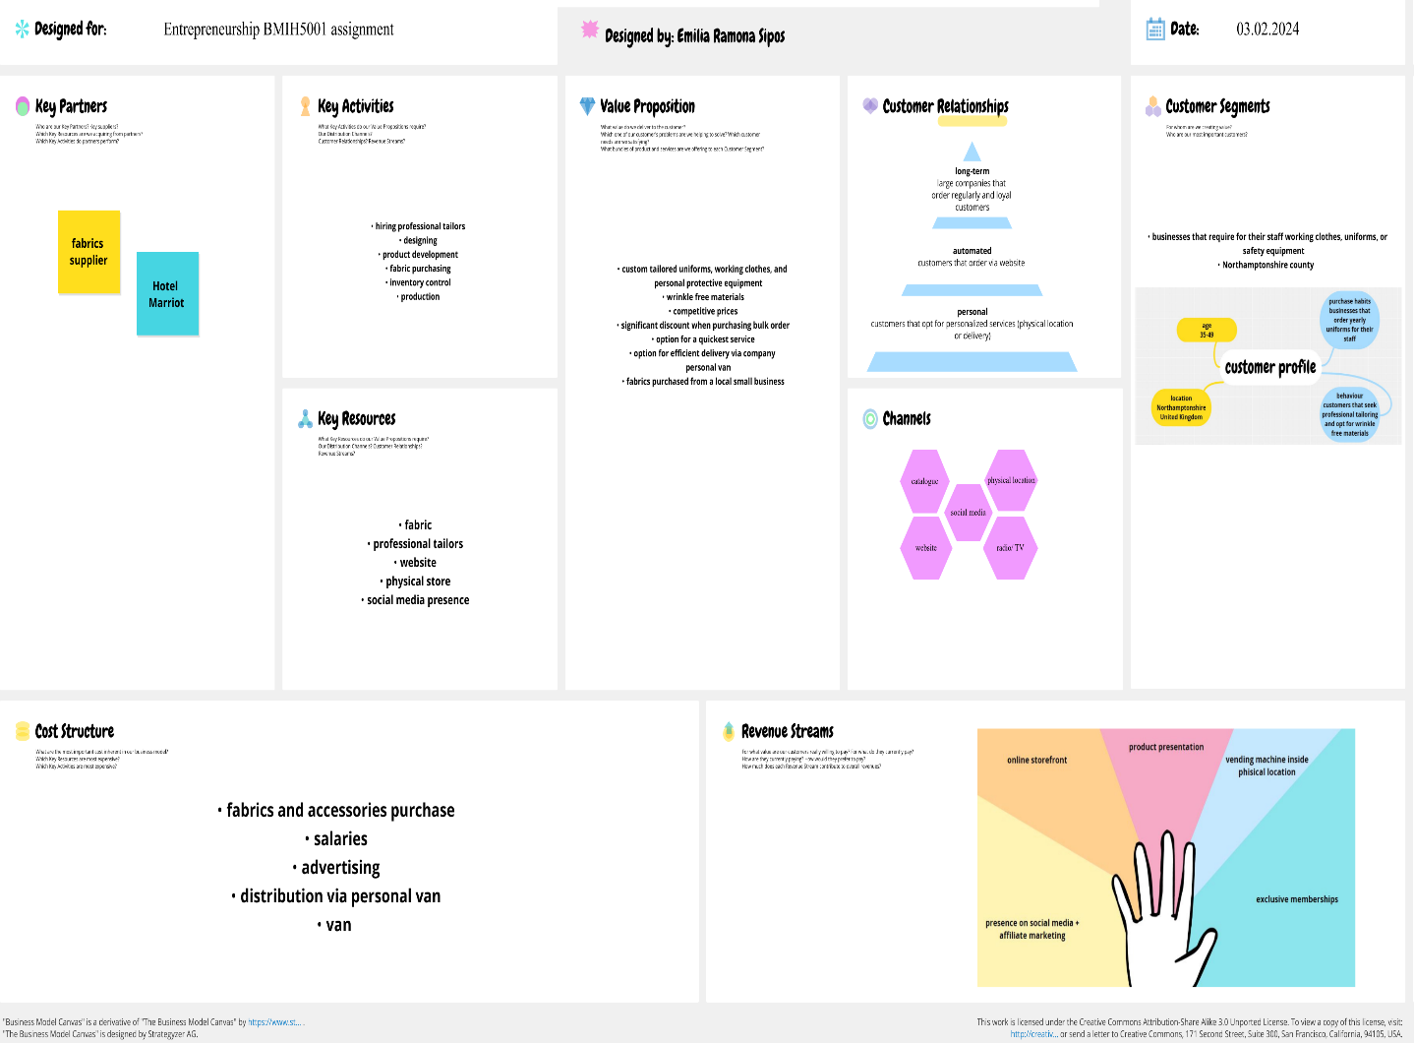
Also available at: https://app.conceptboard.com/board/6p9u-20zx-g9yr-pn2a-outq

Appendix 2
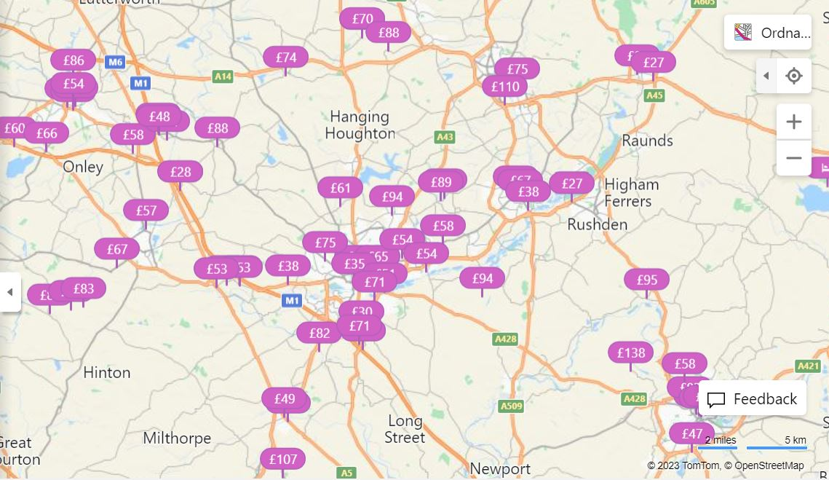
Source: https://www.bing.com/search?q=Northamptonshire%20County%20Map%20with%20hotels&pc=0P566&ptag=C999N1550A1C89D6EF69&form=PCF555&conlogo=CT3210127
Appendix 3
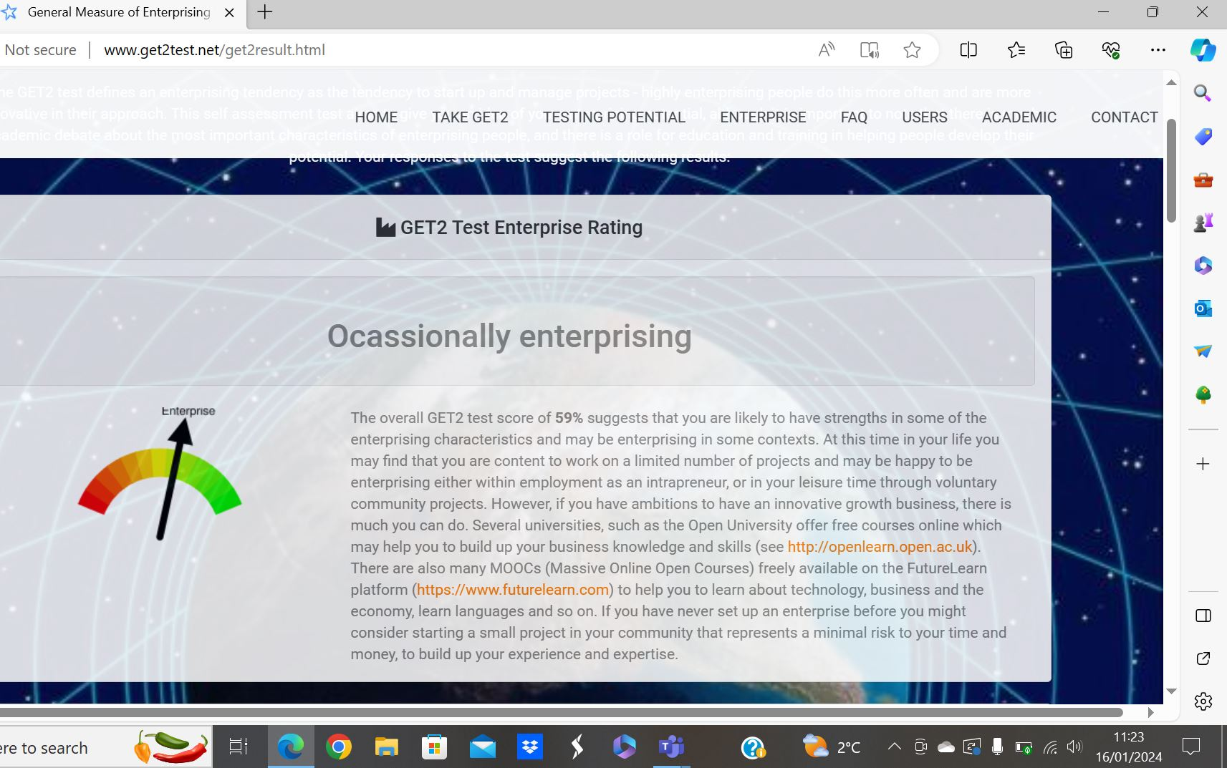

Appendix 4
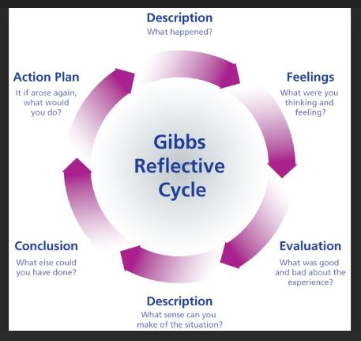
Source: Gibb’s Reflective Cycle | Sarah Stewart's Eportfolio (glowscotland.org.uk)

