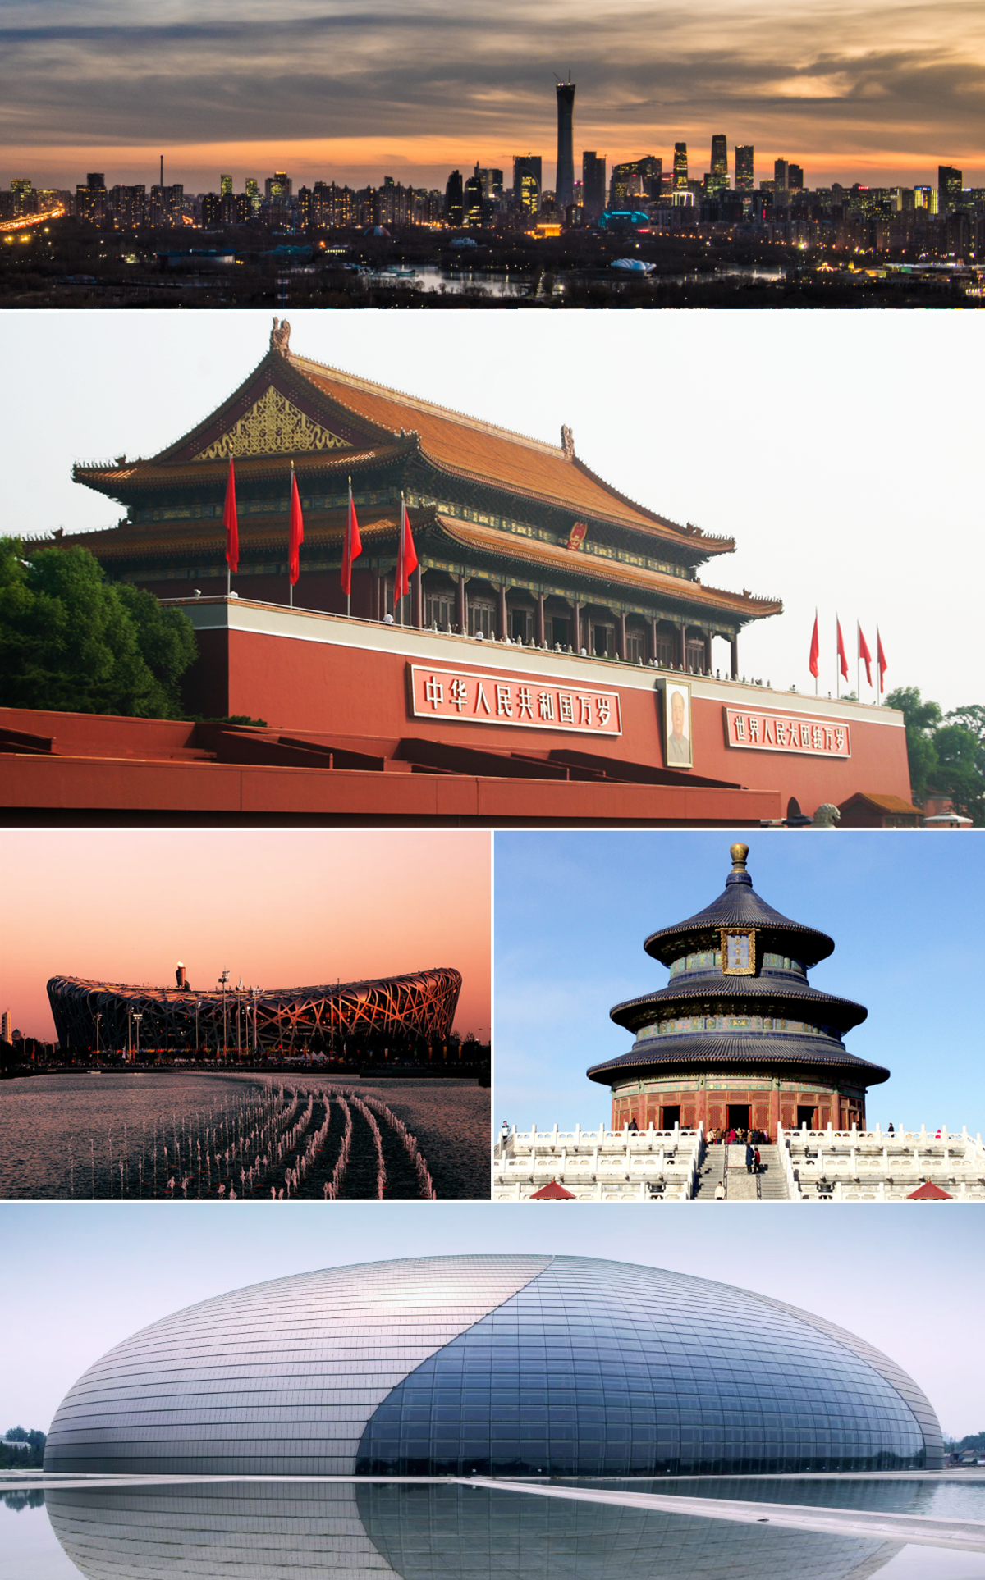  Cultural background on the tourist experience  Caroline Jawad | Intercultural Communication (M5X02108)  Tracey Davies 1806963

Beijing tourism has increased rapidly from the exposure of hosting the Olympic games. Estimated during the time of the Olympics that Beijing alone would receive over 600, 000 foreign visitors and 2.5 million domestic Chinese tourists during the games. (China Business Review, 2008).
The results for a study into the impact on the tourism industry’s movement since the Beijing Olympics confirmed that returning oversees tourists were most interested in famous traditional attractions. Noting that the tourists focused their movements in the central area of Beijing. (Leung, Wang et al, 2012).
Following the Beijing Olympic Games, tourism has indeed grown exponentially, it is enriched with deep culture and heritage sustaining tourism, using the Beijing travel agencies visualising a better structure ensuring rapid development and growth within the industry.
Confirmed by the government Beijing as the political centre, cultural centre based on famous ancient cities culture and heritage, (China Tourism Statistics, 2019).
A new era of tourism highlighting deep and magnificent cultural elements has been opened for tourism in Beijing, tourists again became aware of the ancient city. (Beijing guide, 2019).

2019 China Tourism Facts & Figures

Prediction of 2019 China Tourism Statistics

 | Expected Goal in 2019 | Increasing Rate over 2018
Inbound Tourism Arrivals | 143 million | 1%
Inbound Tourism Revenue | USD 129.6 billion | 2%
Outbound Tourism Trips | 166 million | 11%
Domestic Tourism | 6.06 trillion | 9.5%
Domestic Tourism Revenue | CNY 5.6 trillion | 10%
Total Revenue | CNY 6.52 trillion | 9.3%

Statistics of Beijing Inbound Tourism by Travel Agencies in the First Quarter

 | Statistics | Increasing Rate over the Same Time Period of 2018 (%)
Total Inbound Tourist Arrivals | 136,324 | -18.1
Foreign Tourists | 119,780 | -18.3
From Hong Kong | 8,211 | -18.3
From Macau | 1,189 | 34.4
From Taiwan | 7,144 | -20

With the focus being on culture and heritage to Beijing, we have highlighted History, Art and Festivals, having a plethora of ancient history and culture to choose from we have only highlighted a small selection.
The Great wall of China dates to 220BC Under Chinas first emperor Quin Shin Huang, later in history forming a united defence against invasion from the North, which continued until the Ming dynasty.
The wall was to end more than 250 years if regional fighting between several independent states and united China in 221BCE. Shin wanted to maintain power and position and birthed the idea of the creation of the wall. Placing it along Chinas northern border to keep out raiders from the northern territories. The construction of the wall continued into the Han and Ming dynasty, during these periods’ additions of the watchtower and garrisons were added. (O’ Neil, 2009).
The addition of The Forbidden City was built between 1406 and 1420, by the Ming emperor Yongle, to house imperial power which lasted for over 500 years. (Travel Guide, 2019).
“Built in the early 17th century, the Forbidden City and its fabled 9,999 rooms cover 74 hectares (183 acres) surrounded by a moat to the north of Tiananmen Square. It became a UNESCO World Heritage Site in 1987.
“Visitors posed no threat to the site for most of its history. Commoners or foreigners could not enter without permission, on penalty of death.” (Huang, 2013).
颐和园​
SUMMER PALACE


Iuan,(2019).
The terracotta army were built to guard the Chinese first emperor and are over 2000 years old, their discovery was not until 1974. (Travel Guide, 2019).

Why do travellers decide to return to Beijing, according to Cooper and Hall, activities at the destination, recollection of the trip. (Cooper, Hall. 2008).
Chinese Tourism statistics during the Chinese New Year in 2019, inbound tourism reported 415 million with a growth of 7.6% over the 218 Spring festival. Reaching a rate of increase at 8.2%over 2018. (Travel China, 2019).
With highlights on the arts in Beijing Moran stated, “Cultural sensitivity should teach us that culture and behaviour are relative and that we should be more tentative, and less absolute, in human interaction” (Moran, 2007).

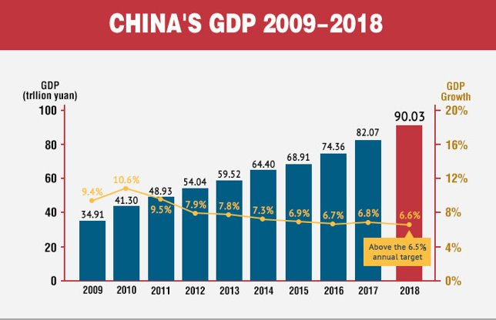
Considering cultural sensitivity, tourism saw growth in both visitors and revenue during the Spring Festival Holiday, recording a total of 415 million tourist. An increase on tourism of 8.2% respectively year on year. Due to better infrastructure Chinese people also opted to travel during the Spring Holiday. (Blanchard, 2019).
The arts in Beijing are also a further attraction, Kung fu requires training, physical and mental discipline. Each style of martial art has its own style which is unique, philosophy and ethics. A traditional saying in martial arts “Train both Internal and External. External training includes the hands, the eyes, the body and stances. Internal training includes the heart, the spirit, the mind, breathing and strength.” (Theatre Beijing, 2019).

The Chines New Year and Spring festivals represent positivity, happiness, vitality beauty and luck. During these festivals’ red is considered a lucky colour and almost everything is coloured red. Decorations are hung outside people’s homes, including lanterns and red paper cuttings. Traditionally red envelopes are given as a way to send good wishes and luck
(China Highlights, 2019).

Chinese New Year, in ancient times a monster named Nian would come up from the sea and feast on animals. A beggar promised to chase Nian away, he decorated the home in red and let off firecrackers, scaring the monster away. To this day the Chinese let off firecrackers to keep Nian away.

References
Blanchard, B, (2019), Beijing overwhelmed by tourism, [Online], https://www.reuters.com/article/us-china-museum/beijings-overwhelmed-forbidden-city-to-limit-visitors, (Accessed 12th January 2020).
China Tourism Statistics, (2019), China tourism statistics Beijing, [Online], www.travelchinaguide.comtourism/2019statistics/ (Accessed 23rd December 2019).
Chinese New Year, (2019), Chinese New Year, [Online], https://chinesenewyear.net/zodiac/rat. (Accessed 9th January 2020).
Chinese New Year, (2019), Chinese New Year, [Online], https://www.nationalgeographic.com/travel/destinations/asia/celebrate-chinese-new-year/, (Accessed 9th January 2020).
Chinese New Year, (2019), Chinese New Year, [Online}, https://chinesenewyear.net/myths/, (Accessed 13th January 2020).
Cooper, C and Hall, C.M. (2008) Contemporary Tourism: An International Approach, Oxford: Butterworth-Henman
Images of forbidden city, (2019), The Forbidden City , [Online], https://www.lonelyplanet.com/china/beijing/attractions/forbidden-city/a/poi/sig/368617/355905, (Accessed 24th December 2019).
Images of Tai Chi, (2020), Tai Chi in Beijing, [Online], https://www.energyarts.com/benefits-of-tai-chi/, (Accessed 9th January 2020).
Iuan, Y. (2019), PTT3, PowerPoint, Chinese Tourism, M5X02108, University of Wales Trinity Saint David, (Delivered 14th November 2019).
Kozar, S., 1995. Enduring traditions, ethereal transmissions: recreating Chinese New Year celebrations on the Internet. Journal of Computer-Mediated Communication, 1(2), p.JCMC126.
Kung fu in Beijing, (2019), Kung Fu in Beijing, [Online], http://theatrebeijing.com/shows/kung, (Accessed 9th January 2020).

Leung, X.Y., Wang, F., Wu, B., Bai, B., Stahura, K.A. and Xie, Z., 2012. A social network analysis of overseas tourist movement patterns in Beijing: The impact of the Olympic Games. International Journal of Tourism Research, 14(5), pp.469-484.
Terracotta Army, (2020), Terracotta Army Information and Heritage, [Online], https://www.chinahighlights.com/xian/terracotta-army/how-to-visit.htm, (Accessed 9th January 2020).

