Setting up a database using SQL

Scenario
A local hospital ‘Makeusbetter’, specialises in the treatment of serious illnesses. It has twenty wards and one operating theatre. The wards are categorised as general, pre-op, post-op and isolation.

The hospital has 12 wards each with 16 beds, 1 pre-op ward with 4 beds, 2 post-op wards each with 8 beds and 5 isolation wards with 1 bed each. Each ward is identified by its block and room number. All patients admitted to the hospital are assigned to a particular ward. However during their stay they may be transferred to different wards

Patients are admitted for treatment for the treatment of one or more diseases. Treatment may require surgery, in which case and operation is scheduled. All operations will be classified as either scheduled or emergency, and will be performed by one or more surgeons. Surgeons will be assigned to a scheduled operation in advance. The hospital keeps records of each disease which it treats, including the symptoms of the disease and recommended treatment.

Patients are referred to the hospital from their GP’s. They are then diagnosed, and if necessary admitted immediately or arrangements are made for future admission. Patients are sent notification of scheduled admissions one week in advance, and a bed is reserved in their appropriate ward for their arrival.

- Identify all the entities in the above, and describe the attributes which will be required for each entity.
- Draw an E-R diagram, showing all of the entities and the relationships between them.

The ERD in Access
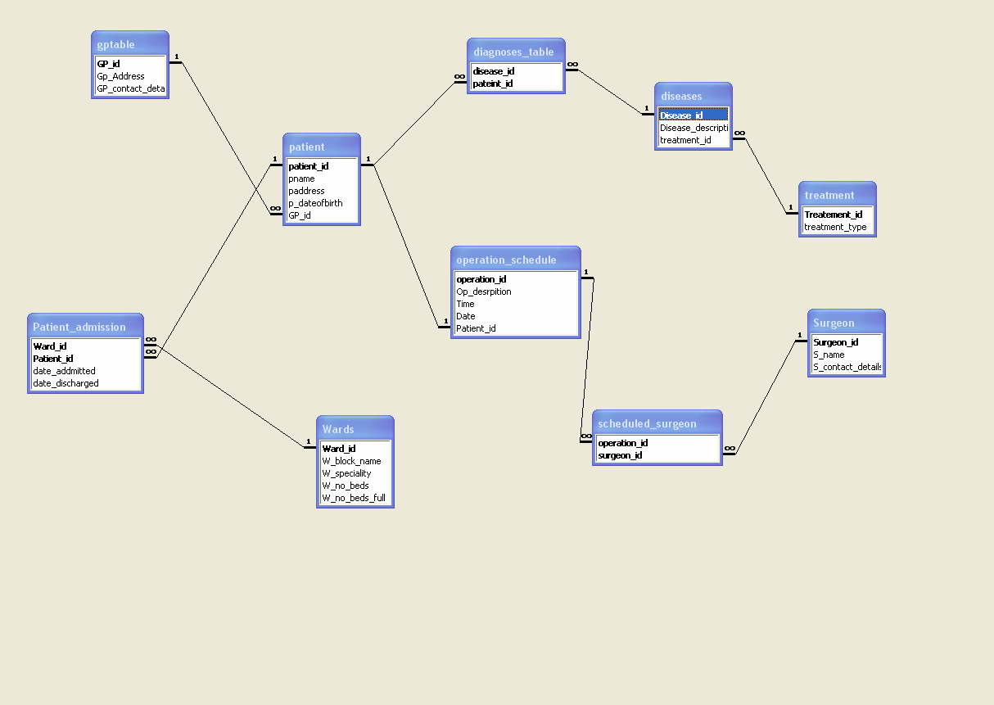

Note the square brackets this will allow for spaces in the field name definitions
Example 1

CREATE TABLE [Diagnosis Table](
[Disease ID] INTEGER,
[Patient ID] INTEGER,
CONSTRAINT diagnosis_pk PRIMARY KEY ([Disease ID], [Patient ID]),
CONSTRAINT diagnosis_disease FOREIGN KEY ([Disease ID]) REFERENCES Disease ([Disease ID]),
CONSTRAINT diagnosis_patient FOREIGN KEY ([Patient ID]) REFERENCES Patient ([Patient ID]))
Also we now include constraints for the foreign keys this will now build the relationships links for us

CREATE TABLE Disease (
[Disease ID] AUTOINCREMENT,
[Disease Description] TEXT(50),
[Treatment ID] INTEGER,
CONSTRAINT disease_pk PRIMARY KEY ([Disease ID]),
CONSTRAINT disease_treatment_fk FOREIGN KEY([Treatment ID]) REFERENCES Treatment([Treatment ID]))

CREATE TABLE [GP Table] (
[GP ID] AUTOINCREMENT,
[GP Address] VARCHAR(30),
[GP Contact Details] VARCHAR(30),
CONSTRAINT pk_GP PRIMARY KEY ([GP ID]))

CREATE TABLE Patient(
[Patient ID] AUTOINCREMENT,
[Patient Name] TEXT(20),
[Patient Address] TEXT(30),
[Patient DOB] DATE,
[GP ID] INTEGER,
CONSTRAINT patient_pk PRIMARY KEY ([Patient ID]),
CONSTRAINT patient_gp_fk FOREIGN key ([GP ID]) REFERENCES [GP Table]([GP ID]))

Example 2

Here we are using the underscore therefore no space or need for square brackets

CREATE TABLE Diagnosis_table(
Disease_ID TEXT(10),
Patient_ID TEXT(20),
CONSTRAINT cd_pk PRIMARY KEY (Disease_ID, Patient_ID),
CONSTRAINT cn_fk FOREIGN KEY (Disease_ID) REFERENCES Diseases (Disease_ID),
CONSTRAINT dn_fk FOREIGN KEY (Patient_ID) REFERENCES Patient (Patient_ID));

CREATE TABLE diseases (Disease ID TEXT(10) CONSTRAINT disease_ID_pk PRIMARY KEY,
Disease_Description TEXT(40),
Treatment_ID TEXT(40) CONSTRAINT fk_Treatment_ID REFERENCES Treatment (Treatment_ID));

Create table GPTable (GP_ID Text (15) Constraint GP_ID_pk primary key,
GP_Address TEXT(50),
GP_Contact_Details text(25));

Create table Operation_Schedule(
Operation_ID Text(15) constraint Operation_ID_pk primary Key,
Op_Description Text(20),
Op_Time Text(20),
Op_Date Date,
Patient_ID Text(15) CONSTRAINT fk_Patient_ID REFERENCES Patient (Patient_ID));

Create Table Patient(
Patient_ID Text(20) constraint Patient_ID_pk primary Key,
Patient_Name Text(25),
Patient_Address Text(50),
Patient_DOB Date,
GP_ID Text(25) constraint fk_GP_ID References GPTable (GP_ID ));

CREATE TABLE Patient_Admission(
Ward_ID TEXT(10),
Patient_ID TEXT(20),
Date_Admitted DATE,
Date_Discharged DATE,
CONSTRAINT cd_pk PRIMARY KEY (Ward_ID, Patient_ID),
CONSTRAINT cr_fk FOREIGN KEY (Ward_ID) REFERENCES Wards (Ward_ID),
CONSTRAINT dr_fk FOREIGN KEY (Patient_ID) REFERENCES Patient (Patient_ID));

CREATE TABLE Scheduled_Surgeon(
Operation_ID TEXT(15),
Surgeon_ID TEXT(20),
CONSTRAINT cd_pk PRIMARY KEY (Operation_ID, Surgeon_ID),
CONSTRAINT ct_fk FOREIGN KEY (Operation_ID) REFERENCES Operation_Schedule (Operation_ID),
CONSTRAINT dt_fk FOREIGN KEY (Surgeon_ID) REFERENCES Surgeon (Surgeon_ID));

Create table Surgeon
(Surgeon_ID Text(20) constraint Surgeon_ID_pk Primary Key,
S_Name Text(20),
S_Contact_Details Text(20));

Create table Treatment (Treatment_ID Text (15) Constraint Treatment_ID_pk primary key,
Treatment_Type TEXT(50));

Create Table Wards (
Ward_ID Text(10) constraint Ward_ID_pk primary Key,
W_Block_name Text(20),
W_Speciality Text(25),
W_No_Beds Integer,
W_No_Beds_Full Integer);

