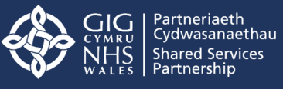
Adding Value Through Partnership

BMHR7004
Human Resource Management in Context

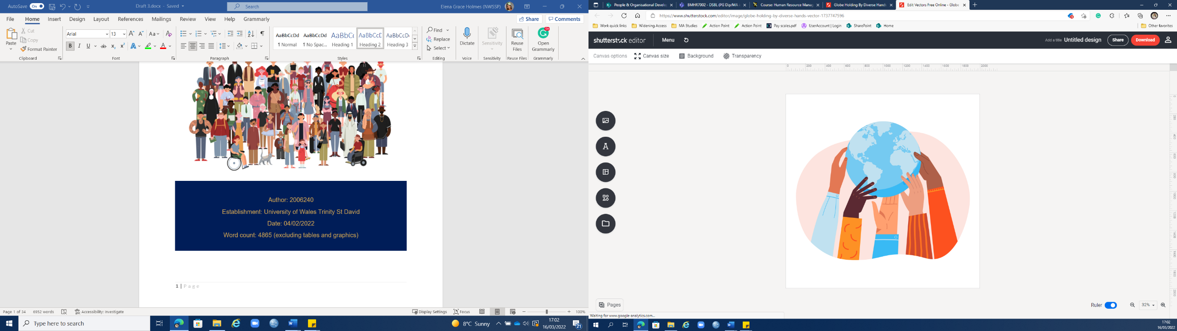
The major environmental factors affecting organisations

Author: 2006240
Establishment: University of Wales Trinity St David
Date: 04/02/2022
Word count: 2198 (excluding figures and tables)

Glossary of Terms

NWSSP - NHS Wales Shared Services Partnership
POD - People and Organisational Development
PESTLE - Politics, Economics, Social, Technology, Legal and Environmental
SLG - Senior Leadership Group
HCS - Health Courier Service
WG - Welsh Government
HR - Human Resources
PEST - Political, Economics, Social and Technology
STEEPLE - Socio-Cultural, Technological, Economic, Environmental, Political, Legal and Ethical.
RTM - Resource and Talent Management
RTW- Right to Work
PEC - Pre-Employment Check
OD - Organisational Development

Executive Summary

The following report will evaluate the PESTLE tool as a method for businesses to analyse the managerial and business environment when strategically planning. Other evaluation tools will be explored, such as PEST, SWOT and STEEPLE as part of the critical analysis.
After an introduction, the report will argue that ‘Politics’ and ‘Technology’ are two of the most influential factors impacting NWSSP today. Consequently, PESTLE will be used to explore the ‘Political’ impact on NWSSP’s remote working, decarbonization and resource and talent management strategy, followed by ‘Technologies’ impact on working culture and recruitment strategies.
A brief conclusion will follow, covering the key observations on the impact of the business environment on NWSSP’s Corporate and HR strategy.
To complete the report, recommendations will be put forward relating to the future of NWSSP’s agile working and resource and talent management strategy. They will be covered in order of importance with an accompanying action plan, including costs to the organisation, accessible in the appendices.

Table of Contents
Glossary of Terms 2
Executive Summary 2
Table of Figures 5
Table of Tables 5
1 Introduction 6
1.1 NWSSP 6
1.2 The PESTLE Tool 7
2 The External Environment 12
2.1 Political 12
2.1.1 Remote Working 12
2.1.2 Decarbonization Strategy 14
2.1.3 Resource and Talent Management (RTM) 15
2.2 Technological 18
2.2.1 Working Culture 18
2.2.2 Recruitment 20
3 Conclusion 21
4 Recommendations 22
4.1 External Publicization of Agile Working Strategy 22
4.2. Development of RTM strategy 22
5 Reference List 24
6 Appendices 30
Appendix A: Action Plan and Costings 30

Table of Figures
Figure 1: Report Aims 5
Figure 2: Selection of Services at NWSSP adapted from NWSSP (2022b). 6
Figure 3: PESTLE Tool - Adapted from Heubel (2021) 7
Figure 4: STEEPLE Tool - Adapted from Farnham (2010). 8
Figure 5: NWSSP's Agile Working Toolkit (NWSSP, 2022e) 11
Figure 6: NWSSP investment in electric vehicles - Adapted from Griffiths (2022). 13
Figure 7: 7 Well-being Goals of the Future Generations Act (2015) - Taken from Welsh Government (2022). 15
Figure 8: NWSSP's investement in Microsoft Packages from 2020. 17
Figure 9: New POD structure at NWSSP (2021b). 20

Table of Tables
Table 1: Evaluation of PESTLE Tool 9
Table 2: Benefits to organisations participating in the Kickstart Scheme. 14

Introduction
This report has been developed for the consideration of NHS Wales Shared Services Partnership’s (NWSSP) People and OD (POD). This report will (see figure 1 below):

Figure 1: Report Aims

NWSSP
Established in 2011, NWSSP is an All-Wales, independent organisation, committed to ‘Adding Value through Partnership, Innovation, and Excellence’ (NWSSP, 2022a). NWSSP is a diverse organisation with a variety of services that work closely with health boards, trusts and the Welsh Government (WG) to deliver an effective ‘Once for Wales’ service. Some of these services include (see figure 2 below):

Figure 2: Selection of Services at NWSSP adapted from NWSSP (2022b).

The PESTLE Tool
Ulrich (2020) urged HR professionals and business leaders to evaluate how today’s actions and the external environment could affect the organisation. Evaluating the external environment is not a new concept. Berger and Luckmann (1967) encouraged organisations to evaluate internal and external influencing factors, to avoid potential inability to respond and adapt. But how could organisations do this effectively?
Aguilar (1967) introduced the PESTLE tool (see figure 3 below).

Figure 3: PESTLE Tool - Adapted from Heubel (2021)
The PESTLE tool supports businesses to assess the external environment and implement effective HR and Corporate strategies to mitigate potential challenges (Farham, 2010). Adaptations of the tool have emerged, including, PEST, STEEP and STEEPLE. Whilst PEST is a simplified version of PESTLE, STEEPLE has notable variations (see figure 4 below).

Figure 4: STEEPLE Tool - Adapted from Farnham (2010).
Additional Ethical and Socio-Cultural considerations within STEEPLE, arguably make the tool more relevant today when compared to PESTLE. Peter Cheese recently noted that the ethical decisions made by organisations are important to people when considering employment (People Management Magazine, 2021). Further, the CIPD (2021) Professions Map has placed Ethical Practice as one of their core behaviours, encouraging HR professionals and businesses to prioritise ethical practice. In juxtaposition, the additional factors for businesses to consider, arguably make the STEEPLE model more time consuming and complex when compared to PESTLE (Super Business Manager, 2022).
Despite the argument that STEEPLE is more relevant today, PESTLE remains a popular and well-used tool for organisations. An evaluation of PESTLE can be found in table 1 below.
Table 1: Evaluation of PESTLE Tool
PESTLE Tool | Strengths | Weaknesses
PESTLE Tool | It is a simple framework for organisations to follow (CIPD, 2021c). | The argument that the tool over-simplifies a complicated external environment and its unpredictable nature (CIPD, 2021c)
PESTLE Tool | Allows organisations to evaluate their environment and develop plans to mitigate risks/threats (Buye, 2021). | Focus on the macro-environment means it fails to consider the micro-environment and the impact of internal factors (Buye, 2021).
PESTLE Tool | Allows businesses to identify opportunities for their businesses to capitalize (CIPD, 2021c). | To be effective requires regular review and consideration from organisations, which could be costly (CIPD, 2021c).
When using tools such as PESTLE, evaluating the strengths, weaknesses, opportunities, and threats (SWOT) in tangent, encourages organisations to conduct an in-depth analysis to safeguard their business by implementing HR and corporate strategies (Ahmad, 2016). Whilst PESTLE is widely known and utilised, the ongoing coronavirus pandemic proves that unexpected factors can significantly impact businesses in VUCA environments that no amount of planning and evaluation can foresee. Consequently, businesses must be aware that tools like PESTLE do have their limitations, as our ever evolving and complex world (Mudhi, 2021) can bring about changes to businesses that are unpredictable.

The External Environment
To support NWSSP’s understanding of the most influential external factors, the report will utilise the PESTLE tool. Arguably, the most poignant external factors for NWSSP are currently Political and Technological. Below, an analysis of how NWSSP has responded to the Political and Technological environment will be evaluated.

Political
As a government-funded organisation, NWSSP is heavily influenced by politics and decisions made by the elected political party. Below, some of the most poignant political factors impacting NWSSP’s and HR's strategic direction, are analysed.

Remote Working
The CIPD (2020b) found that in early 2020 only 24% of UK workers worked remotely The CIPD findings are reflective of NWSSP from 2011 to March 2020, as NWSSP’s workforce worked from business-owned sites. Following the pandemic, Welsh Government (2021a) released a plan with a target for 30% of Welsh workers to work remotely by 2026. As a public sector organisation, NWSSP's strategic direction is influenced by the goals and targets of the Welsh Government. Consequently, NWSSP’s Annual Plan outlines that one of its Corporate Goals is to support and enable staff to work agile (NWSSP, 2021a). To support staff in NWSSP strategic change, an ‘Agile Working Toolkit’ (NWSSP, 2022e) was developed to support staff and embed an agile working culture. NWSSP is not alone as 63% of employers surveyed revealed that they also intended to implement a long-term hybrid working strategy, with contingencies in place (CIPD, 2021). However, others have gone further; Slater and Gordon have implemented a full working from home policy (Hyde, 2020). Arguably, their motivation was financially driven, as opposed to NWSSP’s which was politically and socially driven.
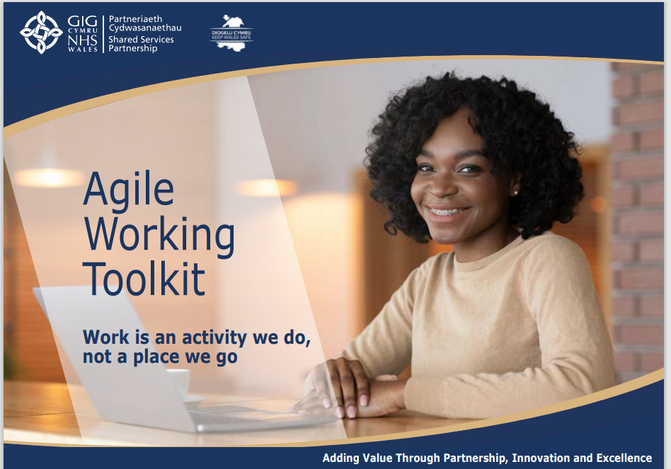
Figure 5: NWSSP's Agile Working Toolkit (NWSSP, 2022e)

The ongoing Coronavirus pandemic has resulted in an increased proportion of people in the UK working from home. 42% of US workers and 38% of UK workers have revealed they would consider quitting their job if agile working was not offered (World Economic Forum, 2021). The ‘Great Resignation’ is thought to be caused by an increase in staff burnout (The Guardian, 2021). NWSSP’s offering of a corporate hybrid working strategy could mitigate the risk of losing talent and attract new employees to the organisation.
Whilst NWSSP's development of an Agile Working Strategy could mitigate the risk of losing talent, at present, NWSSP does not publicise its agile working approach externally (NWSSP, 2022d). Consequently, whilst this may limit the risk of staff leaving the organisation, the strategy is not being utilised to attract new talent (see recommendations).

Decarbonization Strategy
Arguably, NWSSP’s agile working strategy has also been influenced by The Environment (Wales) Act 2016, and its goal to reduce emissions by 80% by 2050 (Future Generations, 2022). NWSSP has independently produced the NHS Wales Decarbonization Strategy (Welsh Government, 2021b), in line with political targets. The strategy, details NHS Wales’s aim to be net-zero on carbon emissions by 2030.
NWSSP’s Annual Plan 2021 commits to:
- Investing in solar panels,
- Switching HCS vehicles to electric
- Embedding agile working (NWSSP, 2022e).
Between April 2021 and 2022, NWSSP had already significantly reduced its carbon footprint (see figure 6 below) through its investment in electric vehicles.
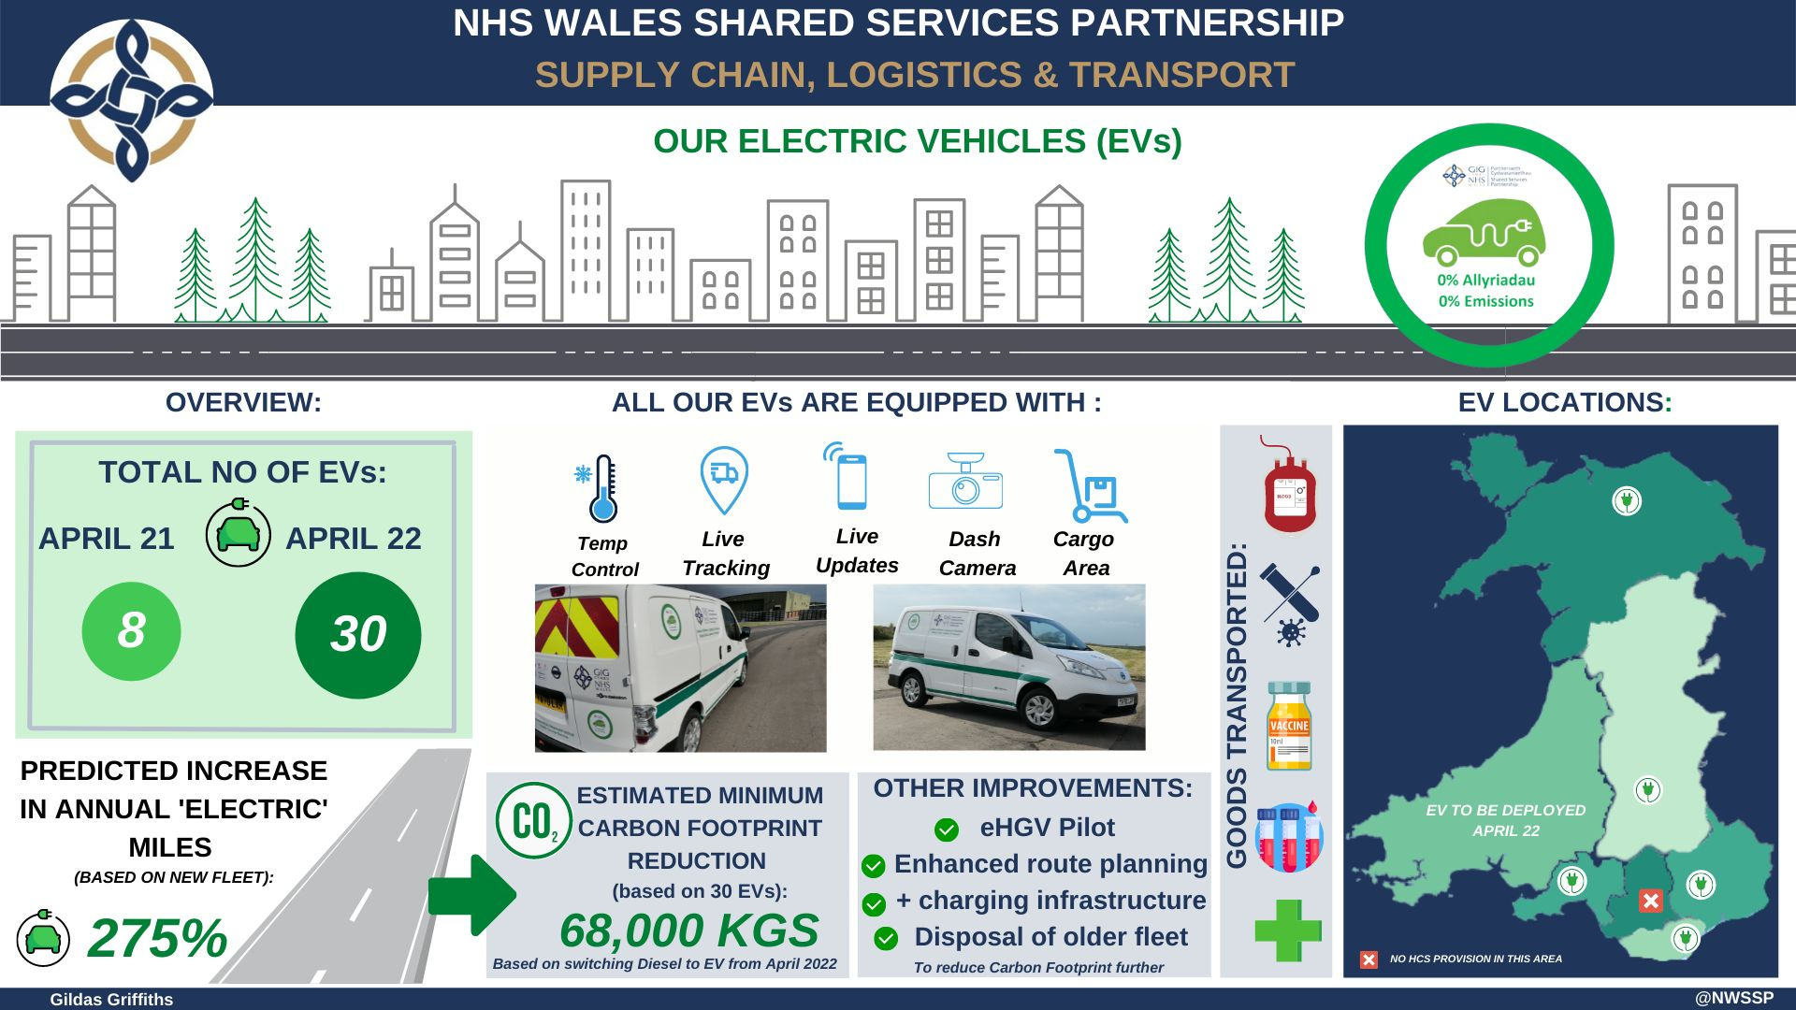
Figure 6: NWSSP investment in electric vehicles - Adapted from Griffiths (2022).
Failure to implement a Decarbonization Strategy could risk opposing The Well-Being of Future Generations Act (2015), where a duty is placed on organisations to make better choices to safeguard the environment (Welsh Government, 2022). Further, People Management Magazine (2021) noted that today's talent is less likely to take up employment with organisations if they are not acting to safeguard the environment. By not acting, NWSSP could risk a loss of future talent, causing future RTM issues.

Resource and Talent Management (RTM)
In 2021, the UK government launched Kickstart, a scheme that offers 16–24-year-olds paid employment for 6 months (UK Government, 2022). There are several benefits to participating organisations (see table 2 below).
Table 2: Benefits to organisations participating in the Kickstart Scheme.
1 | The government will pay for the National Insurance Contributions of all Kickstart employees (HM Government, 2022).
2 | The government will pay for the wages of the Kickstart employees; up to National Minimum Wage (HM Government, 2022).
3 | Participating organisations will receive a £1500 grant, per Kickstart employee, to support set-up, and learning and development costs (HM Government, 2022).
4 | Provides organisations with an opportunity to promote their organisation and widen access to their organisation.
5 | Contribute to the skills and experience of future generations.

Before Kickstart, NWSSP utilised Apprenticeships. CIPD (2020a) found that public sector organisations were most likely to participate. A subsequent survey found that the offerings of apprenticeships by organisations had reduced from the previous year (CIPD, 2021b). To date, NWSSP has applied for and advertised (NWSSP, 2022c) 55 kickstart employees since December 2021 and no new apprentices since the creation of Kickstart.
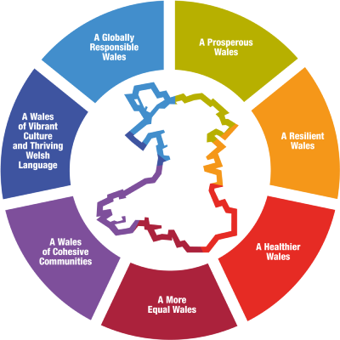
Failure to take part in Kickstart could have risked valuable promotion of NWSSP through the government portals, and limited their ability to attract talent to the organisation. In addition, it is arguable that NWSSP had a moral duty to take part in the scheme. The Well-Being of Future Generations Act (2015) is a Welsh law encouraging businesses to act to protect the planet, health, economy, and cultures, to safeguard future generations (Welsh Government, 2022c).

Figure 7: 7 Well-being Goals of the Future Generations Act (2015) - Taken from Welsh Government (2022c).

The demographic eligible for this scheme meant that by not part-taking, NWSSP could have negatively contributed to the economic and social demise of future generations. By providing opportunities for young people in Wales, NWSSP arguably mitigated the risks of young people failing to gain valuable work experience and financial stability, positive contributions to a more prosperous Welsh future.
Whilst NWSSP increased the volume of new starters through Kickstart, the lack of dedicated resources within NWSSP for RTM resulted in a reduced focus on Apprenticeships throughout 2021/22. NWSSP's actions to favour Kickstart, which was a short-term, over a long-term strategy, could negatively impact their future RTM strategy (see recommendations).

Technological
In 2016, The Five Trends Shaping the Future of Work (2016) identified technology as one of the future influencers of how we would work. Four years later, the coronavirus pandemic forced many non-essential businesses to close or adapt (CIPD, 2020). NWSSP is classed as an essential business, utilising technology, and innovation to work throughout the pandemic safely and efficiently. Below, some of the most poignant technological factors impacting NWSSP’s and HR strategic direction, are analysed.

Working Culture
The CIPD (2020b) found that in early 2020 only 24% of UK workers worked remotely. By April 2020, this rose to 46.6%, with 86% claiming this was directly impacted by the pandemic (ONS, 2020). This research is reflective of NWSSP as, until March 2020, NWSSP’s workforce worked from business sites. With coronavirus infections on the rise in early 2020, NWSSP invested in new IT equipment, including laptops rather than desktops, and software (see figure 8 below) enabling staff across the organisation to work safely from home.

Figure 8: NWSSP's investment in Microsoft Packages from 2020.
NWSSP’s investment in technology led to their new agile working strategy (NWSSP, 2022e), assisting flexible working whilst also meeting the demands of customers and partners. This HR strategy would not have been developed without NWSSP's increased investment in technology since 2020.
However, the implementation of instant technology has contributed to an ‘always available’ working culture at NWSSP. NWSSP is not alone as a recent survey found that workforces are increasingly suffering from digital burnout (World Economic Forum, 2021). To mitigate this risk, NWSSP must continue to develop its health and well-being strategy to ensure staff are taking regular breaks and appropriately utilising technology to mitigate burnout.

Recruitment
On the 6th of April 2020, the government announced a ‘grace period’ for organisations conducting right to work (RTW) checks (Personnel Today, 2022). Overnight, NHS Wales’ Pre-Employment Checks (PEC) were conducted virtually for the first time (GOV.UK, 2022c). NWSSP’s investment in MS teams meant that their capacity to undertake PECs increased as the barrier of travel was removed for staff and applicants. In December 2021, it was announced that Identification Technology would be introduced permanently, allowing NWSSP to conduct PECs virtually (GOV.UK, 2021).
NWSSP is currently procuring a permanent digital ID solution and will implement it before the 6th of April, in-line with government (2022b) deadlines. Whilst a technological solution must be found by organisations by April 2022, NWSSP can and will continue to conduct PECs via MS Teams until September 2022 (GOV.UK. 2022a) whilst plans are made. This change will enable NWSSP to develop a long-term strategy, and other organisations, as it is recognised the approach enables organisations to recruit more efficiently, reducing the risk of losing talent (HR Magazine, 2022).

Conclusion
As a public sector organisation, NWSSP is heavily influenced by Government and Politics. NWSSP has adapted its strategic approach to widening access and decarbonization and introduced new corporate strategies to meet the targets set by the government. The pandemic has accelerated NWSSP’s utilisation of technology to develop an agile working culture and strategy. NWSSP’s investment in technology has enabled staff to connect across Wales and for accessibility barriers to be removed during recruitment.
Whilst NWSSP has evaluated the external environment, allowing them to introduce new, or nurture existing HR strategies, to survive, this report has identified areas of improvement.

Recommendations
The following recommendations relating to future corporate and HR strategy will aid NWSSP in reacting to the external influencers, paying particular attention to the political and technological environment.

External Publicization of Agile Working Strategy
Whilst this report has shown NWSSP have developed an agile working strategy, their failure to promote this externally could hinder external applicants from applying for a role within the organisation. In 2021, ONS (2021) found that 85% of UK adults wished to maintain a ‘hybrid’ working approach in the long term. Businesses are reacting to these findings, with 90% of a survey’s participants claiming that they didn’t have to relocate for a new role due to remote reworking options (De Smet et al., 2021). Whilst there is no financial incentive for the publicization of this strategy, the attraction of new talent to the organisation could significantly increase. To compete with other organisations in the current tight labour market, it is highly recommended that NWSSP externally publicize their agile strategy (see appendix for action plan and costings).

Development of RTM strategy
This report has identified that NWSSP understands the importance of RTM and widening access, the benefits can bring to people and the organisation. However, the lack of resources and RTM strategy in NWSSP, has made it challenging for NWSSP to push the agenda forward, despite government support.
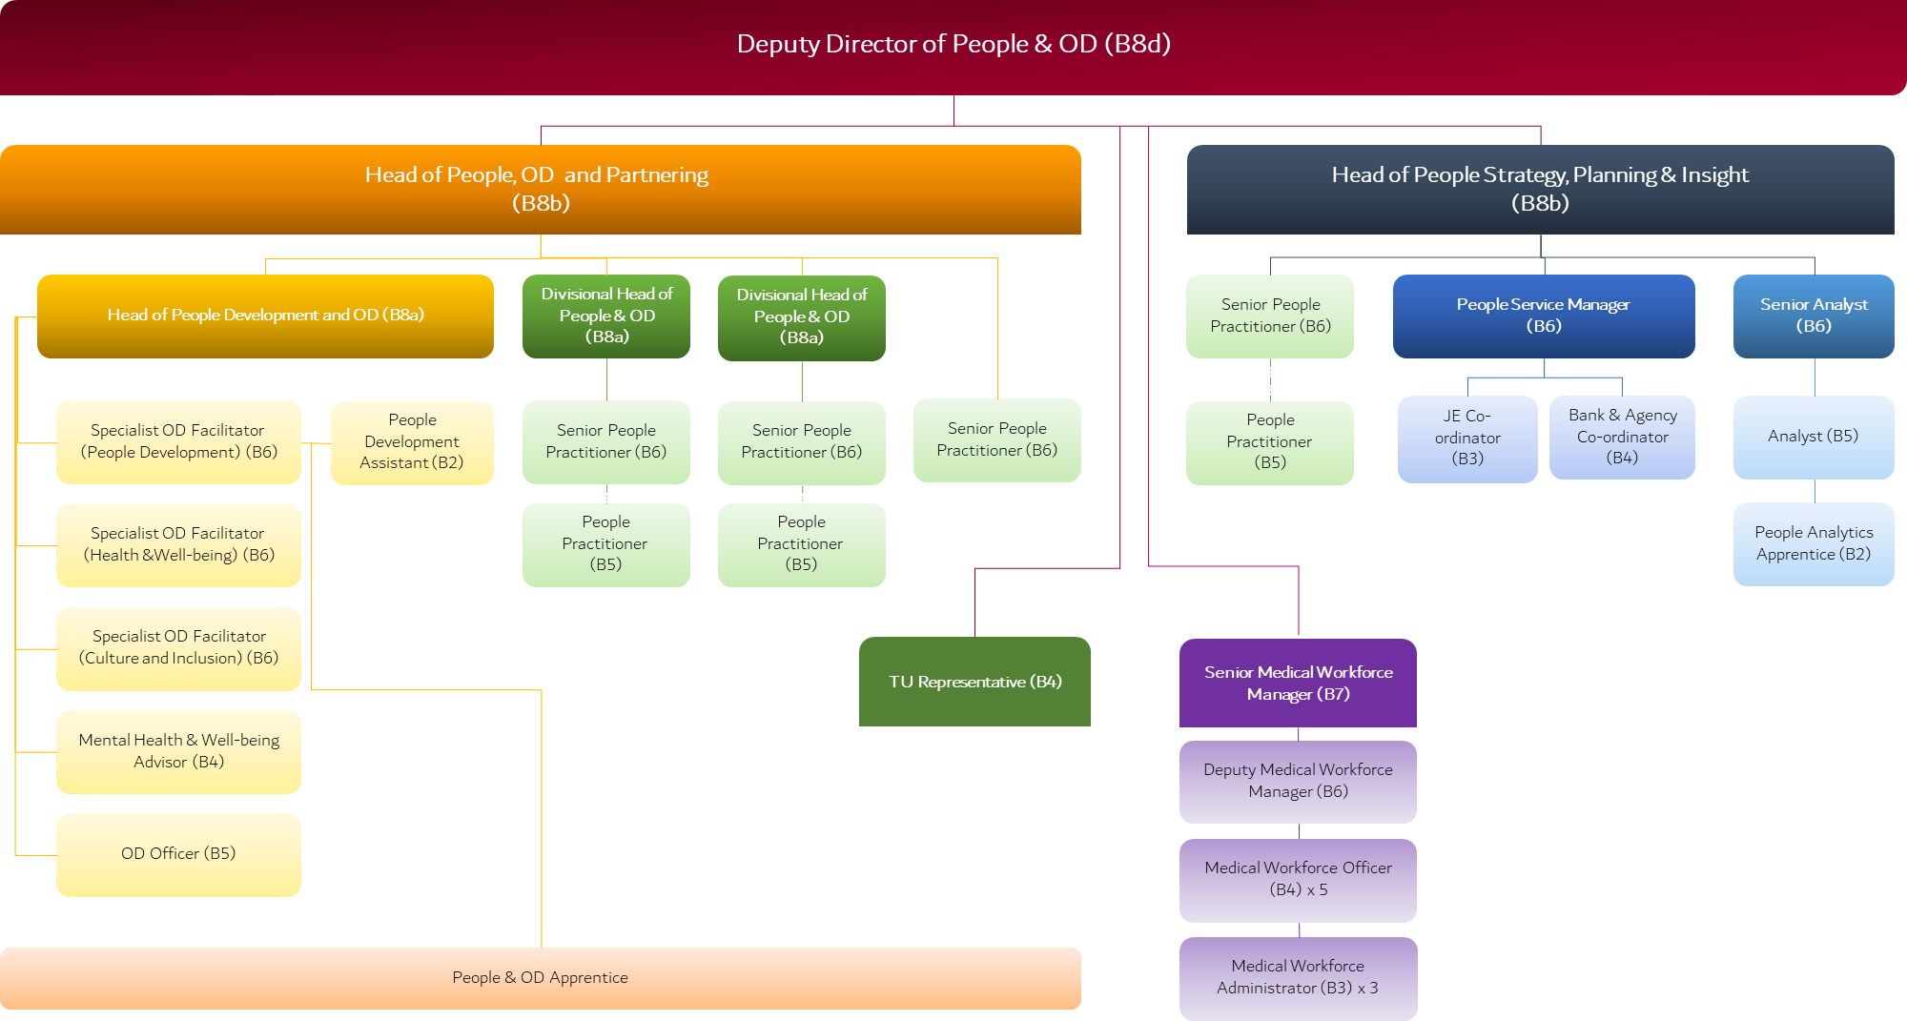
In 2021, POD at NWSSP had an internal restructure (see figure 9 below).
Figure 9: New POD structure at NWSSP (2021b).

Four Specialist OD Facilitator posts are derived from the new structure. Whilst the facilitators cover people development, health and well-being and culture and inclusion, there is no post across the team dedicated to RTM and widening access. Further, there is no resourcing and talent planning strategy for NWSSP. The CIPD (2021e) encourage organisations to implement an RTM strategy so that prioritises can be identified for NWSSP, that align with its corporate strategies as well as government expectations.
To enable NWSSP to respond more efficiently to government initiatives to increase resourcing, it is recommended that NWSSP develops an RTM strategy and appoints a Specialist OD Facilitator for widening access (see appendix for action plan and costings).

Reference List
‘The Five Trends Shaping the Future of Work’ (2016). YouTube, 16th September. Available at: The 5 Trends Shaping the Future of Work - YouTube (Accessed: 16 March 2022).
Aguilar, F., (1967). Scanning the Business Environment. New York: Macmillan.
Ahmed, Mohammadpourfard., (2016). ‘Difference between SWOT, PEST, STEEP and STEEPLE Analysis’, LinkedIn, October 3rd. Available at: (1) Difference between SWOT, PEST, STEEP and STEEPLE Analysis (http://pestleanalysis.com) | LinkedIn (Accessed: 17 March 2022).
Berger, P. and Luckmann, T., (1967). The Social Construction of Reality: A Treatise in the Sociology of Knowledge. New York: Doubleday.
Buye, Ronald., (2021). ‘Critical Examination of the PESTEL Analysis Model’, Research Gate. Available at: (PDF) Critical examination of the PESTEL Analysis Model (researchgate.net) (Accessed: 17 March 2022).
CIPD (2020). Coronavirus and the workforce: working from home in the new ‘new normal. Available at: Coronavirus and the workforce: working from home in the 'new normal' | CIPD (Accessed: 16 March 2022).
CIPD (2020a). Resourcing and talent planning survey 2020. London: Chartered Institute of Personnel and Development.
CIPD (2020b). Working from home: What’s driving the rise in remote working? London: Chartered Institute of Personnel and Development.
CIPD (2021a). Explore the Profession Map. Available at: Profession Map | CIPD Profession Map (Accessed: 6 January 2022).
CIPD (2021b). Resourcing and talent planning survey 2021. London: Chartered Institute of Personnel and Development. Available at: Resourcing and talent planning survey 2021 (cipd.co.uk) (Accessed: 1 February 2022).
CIPD (2021c). PESTLE Analysis. Available at: PESTLE Analysis | Factsheets | CIPD (Accessed: 15 March 2022).
CIPD (2021d). Flexible Working: lessons from the pandemic. Available at: Flexible working – lessons from the pandemic | CIPD (Accessed: 14 March 2022).
CIPD (2021e). Talent Management. Available at: Talent Management | Factsheets | CIPD (Accessed: 24 March 2022).
De Smet, A., Dowling, B, Mugayar-Baldocchi, M., and Schaninger, B. (2021). ‘”Great Attribution” or ‘Great Attraction”? The choice is yours.’ McKinsey Quaterly. Available at: Future of Work | McKinsey & Company (Accessed: 16 November 2021).
Farnham, David., (2010). Human Resource Management in Context: Insights, Strategy and Solutions, 3rd edition. London: Chartered Institute for Professional Development.
Future Generations (2022). Decarbonisation is a cross-cutting issue central to all our work and vital for future generations. Available at: Decarbonisation – The Future Generations Commissioner for Wales (Accessed: 9 March 2022).
GOV.UK (2021). Digital identity document validation technology (IDVT). Available at: Digital identity document validation technology (IDVT) - GOV.UK (www.gov.uk) (Accessed: 10 March 2022).
GOV.UK (2022a). Coronavirus (COVID-19): right to work checks. Available at: Coronavirus (COVID-19): right to work checks - GOV.UK (www.gov.uk) (Accessed: 10 March 2022).
GOV.UK (2022b). Digital identity certification for right to work, right to rent and criminal record checks. Available at: Digital identity certification for right to work, right to rent and criminal record checks - GOV.UK (www.gov.uk) (Accessed: 10 March 2022).
GOV.UK (2022c). Right to work checks: an employer’s guide. Available at: Right to work checks: an employer's guide - GOV.UK (www.gov.uk) (Accessed: 10 March 2022).
Griffiths, G., (2022). We are increasing our fleet of electric vehicles. Available at: LinkedIn (Accessed at: 23 March 2022).
Heubel, M., (2021). ‘PESTLE Analysis: The Macro-Environmental Analysis Explained’, Consulterce, 4th April. Available at: PESTLE Analysis: The Macro-Environmental Framework Explained (consulterce.com) (Accessed: 17 March 2021).
HM Government (2022). Kickstart Scheme: You take on a young person. We take on their wages. Available at: Kickstart Scheme – Find out more about the Kickstart scheme (campaign.gov.uk) (Accessed: 26 January 2022).
HR Magazine (2022). Digital right to work checks to be introduced from April. Available at: HR Magazine - Digital right to work checks to be introduced from April (Accessed: 10 March 2022).
Hyde, J. (2020). ‘Slater and Gordon to close London office as home working becomes norm’, The Law Society Gazette, 27th May. Available at: https://www.lawgazette.co.uk/practice/slater-and-gordon-to-close-london-office-as-remote-working-becomes-norm/5104404.article?fbclid=IwAR3aqWEodrqZ8btFAzzYSL8DJTZa4_rH91-Qkxr-dxGnSsKm_R--0YyRoG8 (Accessed: 1st March 2022).
Mudhi, L. (2021) ‘The LACE framework: How to effectively respond to a rapidly changing business environment.’ Innovation. Available at: The LACE framework: How to respond to a VUCA environment - I by IMD (Accessed: 6 January 2022).
NWSSP (2021a). NHS Wales Shared Services Partnership Annual Plan for 2021-22: Including a forward look to 2022-2024. Available at: https://nwssp.nhs.wales/corporate-documents/corporate-integrated-medium-term-plan-imtp/nwssp-annual-plan-for-2021-22-including-a-forward-look-to-2022-2024/ (Accessed: 8 March 2022).
NWSSP (2021b). Staff Consultation Paper February 2021: Proposal to Restructure NWSSP Internal Workforce and OD Function. Unpublished.
NWSSP (2022a). About Us. Available at: About Us - NHS Wales Shared Services Partnership (Accessed: 8 March 2022).
NWSSP (2022b). Our Services. Available at: ourservices - NHS Wales Shared Services Partnership (Accessed: 9 March 2022).
NWSSP (2022c). NHS Wales Shared Services Partnership - Adding Value Through Partnership. Available at: https://www.linkedin.com/posts/nhs-wales-shared-services-partnership_nwssp-are-excited-to-be-taking-part-in-the-activity-6895312199905005568-k-0I (Accessed: 9 March 2022).
NWSSP (2022d). Working for us. Available at: Working for us - NHS Wales Shared Services Partnership (Accessed: 13 March 2022).
NWSSP (2022e). Agile Working Toolkit. Available at: Agile Working Toolkit Latest 28.04.2021.pdf (Accessed: 25 January 2022).
ONS (2020). Coronavirus and homeworking in the UK: April 2020. Available at: Coronavirus and homeworking in the UK - Office for National Statistics (ons.gov.uk) (Accessed: 15 March 2022).
ONS (2021). Business and individual attitudes towards the future of homeworking, UK: April to May 2021. Available at: Business and individual attitudes towards the future of homeworking, UK - Office for National Statistics (ons.gov.uk) (Accessed: 23 March 2022).
People Management Magazine (2021). ‘How to be an employer of choice’, No one is immune to the talent crisis: Here is how to solve it, December 2021-January 2022.
Personnel Today (2022). Employers given more time to prepare for digital right-to-work checks. Available at: Employers given more time to prepare for digital right-to-work checks - Personnel Today (Accessed: 10 March 2022).
Super Business Manager (2022). The STEEPLE Analysis – A Business Tool to Assess the External Environment. Available at: The STEEPLE Analysis – A Business Tool to Assess the External Environment — Super Business Manager (Accessed: 17 March 2022).
UK Government (2022). Kickstart Scheme. Available at: Kickstart Scheme - JobHelp (campaign.gov.uk) (Accessed: 26 January 2022).
Ulrich, D., (2020). ‘HR’s Role In Crisis’, Linkedin. Available at: HR's Role in Crisis | LinkedIn (Accessed: 1 November 2021).
- Well-being of Future Generations Act (2015). Available at: well-being-of-future-generations-wales-act-2015-the-essentials.pdf (gov.wales) (Accessed: 17 March 2022).
- Welsh Government (2021a). Welsh Government Programme for Government: Update. Available at: Welsh Government Programme for government: update [HTML] | GOV.WALES (Accessed: 8 March 2022).
- Welsh Government (2021b). NHS Wales Decarbonisation Strategic Delivery Plan 2021-2030. Available at: NHS Wales Decarbonisation Strategic Delivery Plan (gov.wales) (Accessed: 8 March 2022).
- Welsh Government (2022c). The Well-Being of Future Generations. Available at: The Well-being of Future Generations | GOV.WALES (Accessed: 17 March 2022).
- World Economic Forum (2021). Survey: 40% of employees are thinking of quitting their jobs. Available at: 40% of employees are thinking of quitting their jobs, says survey | World Economic Forum (weforum.org) (Accessed: 17 March 2022).

Appendices

Appendix A: Action Plan and Costings

Action | Who | What | When | Where | Costings
Externally publicize the NWSSP Agile Working Strategy | The internal communications team at NWSSP, based in the Corporate and Finance Directorate. | By externally publicising NWSSP’s existing agile working strategy, this could attract more people to the organisation and ensure an agile working culture is embedded from the point of onboarding; as outlined in the strategy.  If new starters know an agile working strategy exists when they join the organisation, it is more likely they will utilise it. | June 2022. | - Included on the staff benefits and about us sections of NWSSP’s external facing internet  - Listed as an attachment to when vacancies are published live on the intranet  - This could be publicised through NWSSP’s social media channels; LinkedIn, Twitter and YouTube. | There will be no cost associated as the strategy will be shared via free channels already existing at NWSSP.
Recruit a Specialist OD facilitator within POD to look after RTM and widening access. | A HR professional with experience in strategy development and an interest in RTM. | To develop the RTM strategy with an emphasis on widening access.  The recruitment of this new post is essential for the development of the RTM strategy, future assisting strategies and overseeing widening access initiatives.  As a government funded organisation, financial gain is not prioritised. However, the role will improve NWSSP career entry routes diversity. Over time, this will attract more talent to the organisation and contribute to succession planning. | A business case will need to be submitted after April 2022 evidencing the business need for the role and the value it could bring.  Following approval, advertisement and recruitment, the vacancy will likely be in post by September 2022. | The new post will be based at NWSSP’s HQ, and the base of the POD team; Nantgarw.  However, agile working will be available, allowing the postholder to work flexibly. | £32,306-£39,027 per annum.
Develop an RTM and widening access strategy for NWSSP. | The newly appointed Specialist OD Facilitator will be responsible for the development of this strategy.  They will be supported by colleagues within POD. | The strategy will identify the key resourcing priorities for NWSSP.  It will identify  - resource currently available and needed in the future  - key RTM initiatives  - vision for the future of RTM at NWSSP  - succession planning,  - internal people development  - employee engagement  - employee retention (CIPD, 2021e) | This will be a priority for the new OD facilitator once they are in post. They will begin formulating the strategy from September 2022 and have it published by January 2023. | This will be developed internally and published via the internal intranet and through internal communication channels. | The costings will be included as part of the annual salary (as noted above).

