DS 1 Template

My Screenshots/Photos
- Please add 4–6 screenshots or photos of your digital life.
- You can use your phone or laptop.
- For each screenshot, write one or two sentences explaining what it shows.

Screenshot/Photo 1
[Insert Photo/Screenshot below]
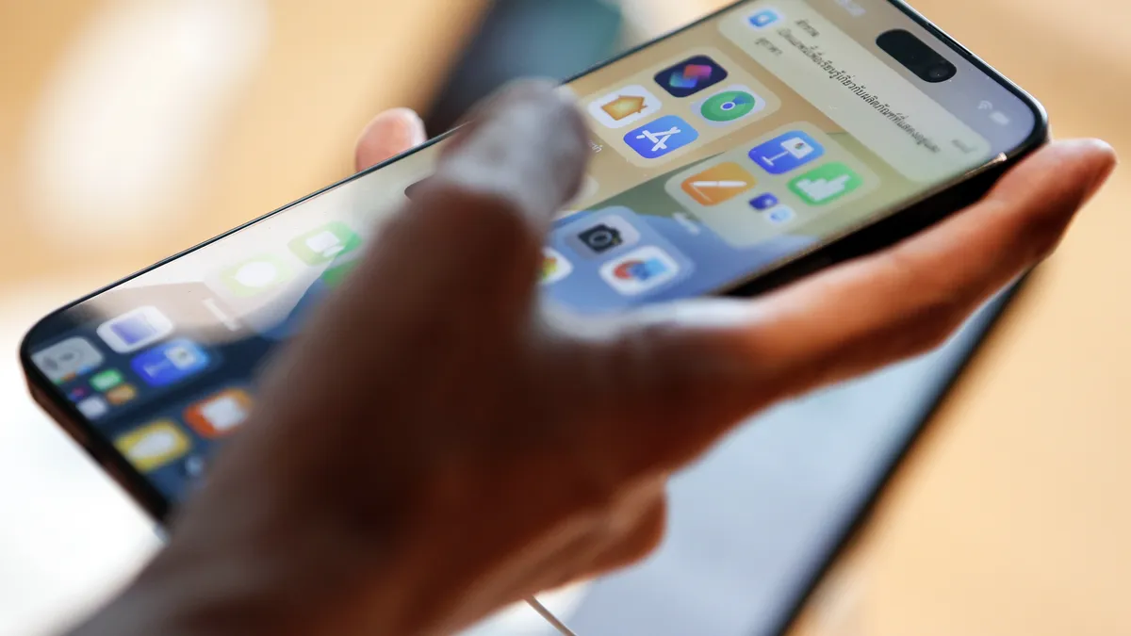
The image shows a smart phone which has become very important in everyday life for connecting with friends and family and also for gathering information and shopping it also has smart features for answering calls and editing text messages drawing or writing on screen to take notes for Samsung users . (Citizens' Handbook, n.d.)

Screenshot/Photo 2
[Insert Photo/Screenshot below]

A laptop is very useful for work at home and on the go, it is also great for web search for work related or casual information can also be used for learning purposes for both adults and teenagers can also be used to store pictures and videos of special moments. (Mak, 2026)

Screenshot/Photo 3
[Insert Photo/Screenshot below]
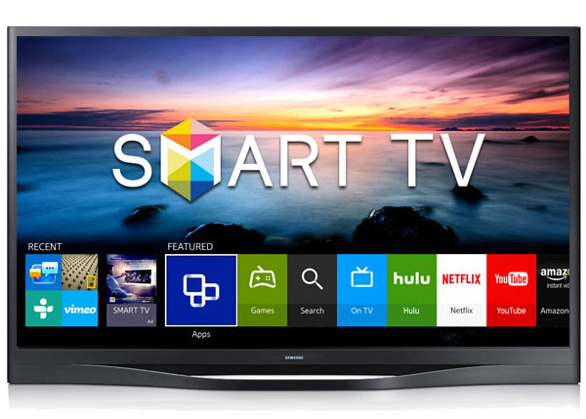
Smart tv is excellent for downloading movie apps and to connect to Alexa and connecting to internet via Wi-Fi or hot spots and the picture quality is very enhanced for viewing pleasure with bright crisp picture. It can also be used for family time such as watching movies/ shows with each other. (Philips, 2025)

Screenshot/Photo 4
[Insert Photo/Screenshot below]

Digital camera is good for capturing enhanced pictures and can be stored in modern models it uses AI to enhance pictures. The various pictures that can be taken on digital cameras can be stored in added internal SD cards which can hold all special memories within. (Machado, 2025)

Screenshot/Photo 5
[Insert Photo/Screenshot below]
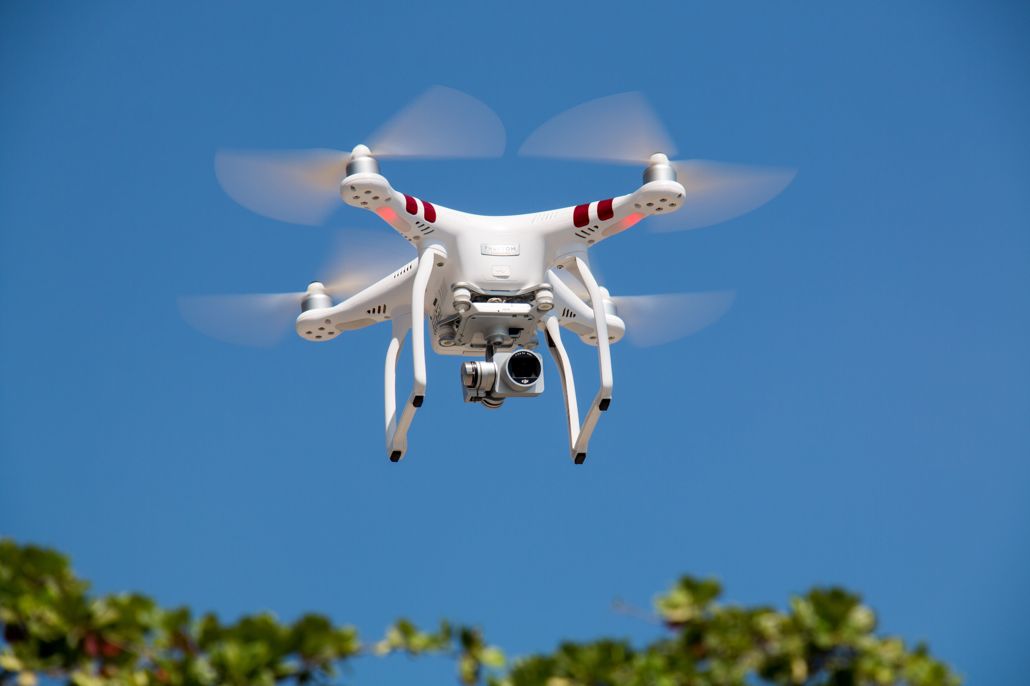
Drones are very fun and good for capturing and recording especially for special moments. Through drones, you can take many videos that cant be taken on foot and capture a wide range of land. (Social, economic, and environmental implications of drones in marketing, 2025)

Screenshot/Photo 6
[Insert Photo/Screenshot below]

Xbox is very powerful console for gaming and connecting with friends online for playing group or individual games. You can play various games with friends or even alone it generates endless fun with those who have a passion for gaming or just want to have a day off and relax. (Thomas, 2026)

My Short Reflection
- Write 5–8 simple sentences about your digital life.
- You can use the sentence starters below if helpful.
It helps me connect with friends and family and find information. Apps such as WhatsApp I used to connect with my friends and family. It helps me maintain a strong bond with those in my life. My personal phone I use everyday to call friends and family and to answer calls, it helps me find out information and able to plan trips to places and keep up with social norms and trends. Digital skills are important to me due to the fact that all technology nowadays is being modernized and for the older generation its harder to keep up with as old mobile phones/ platforms are slowly becoming obsolete now that new social media is coming out. I also use digital tools on my phone to edit and make my pictures look better and cleaner. I can use my phone to record special moments that I can keep forever and take videos of moments with friends and family.

Sentence starters
- I use digital tools to …
- I feel confident when I …
- I want to improve …
- I often use these tools: …
- I sometimes feel nervous about …
- I hope this module will help me …
- Digital skills are important for me because …
You can write more if you want.

Submission Checklist
Before you submit, please check:
​​​ ☒ I added 4–6 screenshots
☒ I wrote short sentences for each screenshot
☒ I wrote my short reflection
☒ My work is my own
☒ My file opens correctly
​​☒ My file opens correctly
Referencing
Citizens' Handbook (n.d.) Smartphones. Available at: https://citizenshandbook.org/smartphone.html (Accessed: 18 October 2026).
Mak, J. (2026) Schools are rethinking whether every student needs a laptop. The Conversation, 30 July. Available at: https://theconversation.com/schools-are-rethinking-whether-every-student-needs-a-laptop-287549 (Accessed: 21 October 2026)
Philips (2025) What is a smart TV? Key features explained. Available at: https://www.philips.co.uk/c-e/tv-buying-guide/tv-101/what-is-a-smart-tv (Accessed: 21 October 2026).
Lara Machado (2025) Why the rise of digital cameras? Cherwell, 29 April. Available at: https://cherwell.org/2025/04/29/why-the-rise-of-digital-cameras/ (Accessed: 21 October 2026).
ocial, economic, and environmental implications of drones in marketing: A framework of safeguards for sustainable technology implementation (2025) Journal of Business Research, March. Available at:
https://www.sciencedirect.com/science/article/pii/S0148296325000748 (Accessed: 21 October 2026)
Thomas, J. (2026) Xbox ‘Business Strategist’ claims video game industry is ‘pretending to not use AI,’ deletes Twitter account after deluge of replies. IGN, 20 October. Available at: https://www.ign.com/articles/xbox-business-strategist-claims-video-game-industry-is-pretending-to-not-use-ai-deletes-twitter-account-after-deluge-of-replies (Accessed: 21 October 2026).

