

Applied Computing
Wales Institute of Science and Art (WISA)

Network Operating Systems and Services (NOSS)
(ACCA5023)

Component 1

Build, deploy, configure, and manage a Type 2 Hypervisor platform based Virtualized network

By:
Ethan Matthews - 2117013

Team Name: GECA
Team Members:

Student Name | Student ID
Ethan Matthews | 2117013
Geminiano Aguilar | 2001127
Cameron Brown | 2004688
Jack Kennedy | 2003924

Team Evaluation

 | Ethan | Geminiano | Cameron | Jack
Ethan | 5
Geminiano | 5
Cameron | 5
Jack | 1

Student 1 (Ethan Matthews/Myself):
Overall I have given myself a mark of 5 which is an excellent contribution as I feel like I contributed to the work and to the team really well.
Student 2 (Geminiano Aguilar):
I have also given Gio a 5 as he contributed well to the work ethic and provided some valuable information and screenshots when and if we needed them. Gio also communicated well within the team.
Student 3 (Cameron Brown):
Cameron’s score was also a 5 as he also contributed well within the team and provided us with information and screenshots and communicated well. Cameron was also the one to help us set up the VMs due to his previous experience.
Student 4 (Jack (Ava) Kennedy):
Jack has the lowest score within the group due to the fact that he only attended one of the lectures with the group. Due to his absence there was no contribution to the work and barely enough communication.

Page of Contents

Contents | Page Number
Student Evaluation | Pages 2 - 3
Introduction | Page 4
Task 1 | Pages 5 - 14
Task 2 | Pages 15 - 25
Task 3 | Pages 26 - 28
Appendix | Pages 28 - 29

Introduction

This assignment is a group based assignment that was tasked with building, deploying, configuring and managing a type 2 Hypervisor platform-based Virtualized network. During the course of this report, two tasks will be documented. Task 1 is the Practical side of things where we are required to perform the above scenario. The second task being an observational task detailing the things that we have come across during the time of the practical work.

Task 1: BUILDING A VIRTUAL LAN USING TYPE 2 HYPERVISOR MANAGEMENT SOFTWARE

TASK 1 - 1.1 (VM Creation and Operating System Installation)

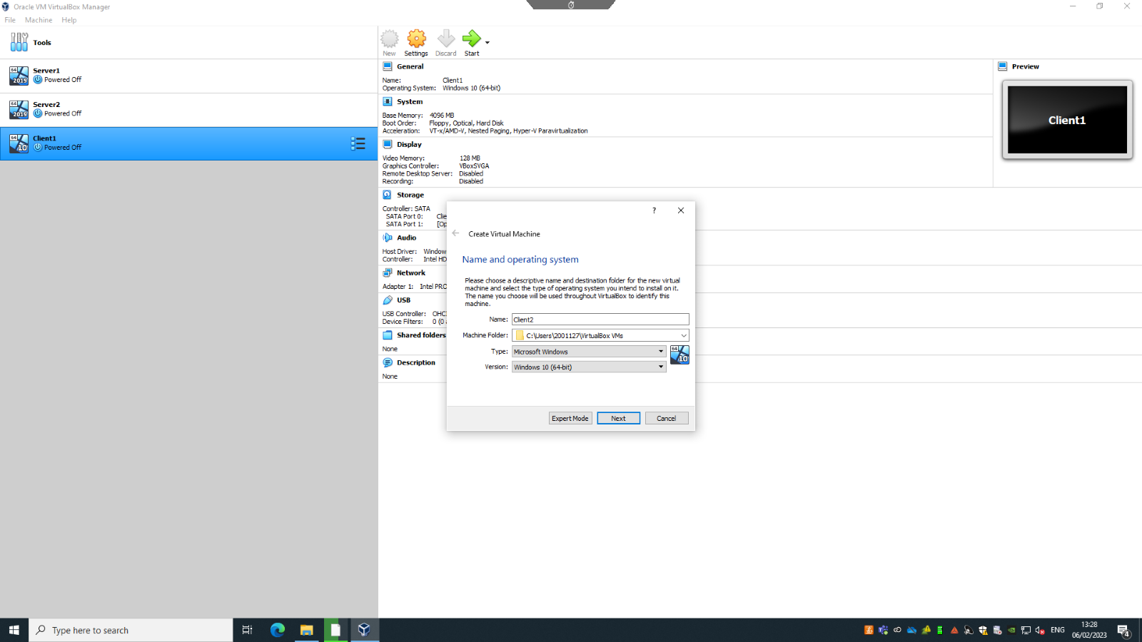

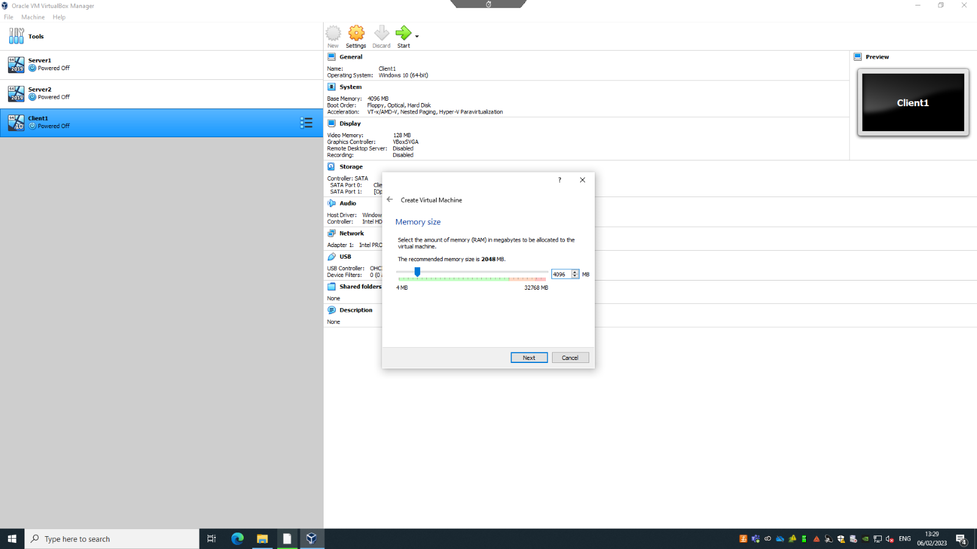
This is the creation of the Client 2 virtual machine that the user made out of the 4 that were/are going to be created. In the above photos the only difference that would be made would be the name of them as the memory size between all four of the virtual machines is the same.
As a side note, the storage for both servers would be different compared to the storage of the client virtual machines (25gb for server and 20gb for client). Also the operating systems installed on them are different as shown in the first photo. For client two we have selected the Windows 10 operating system but for the servers it would be Windows Server 2019.
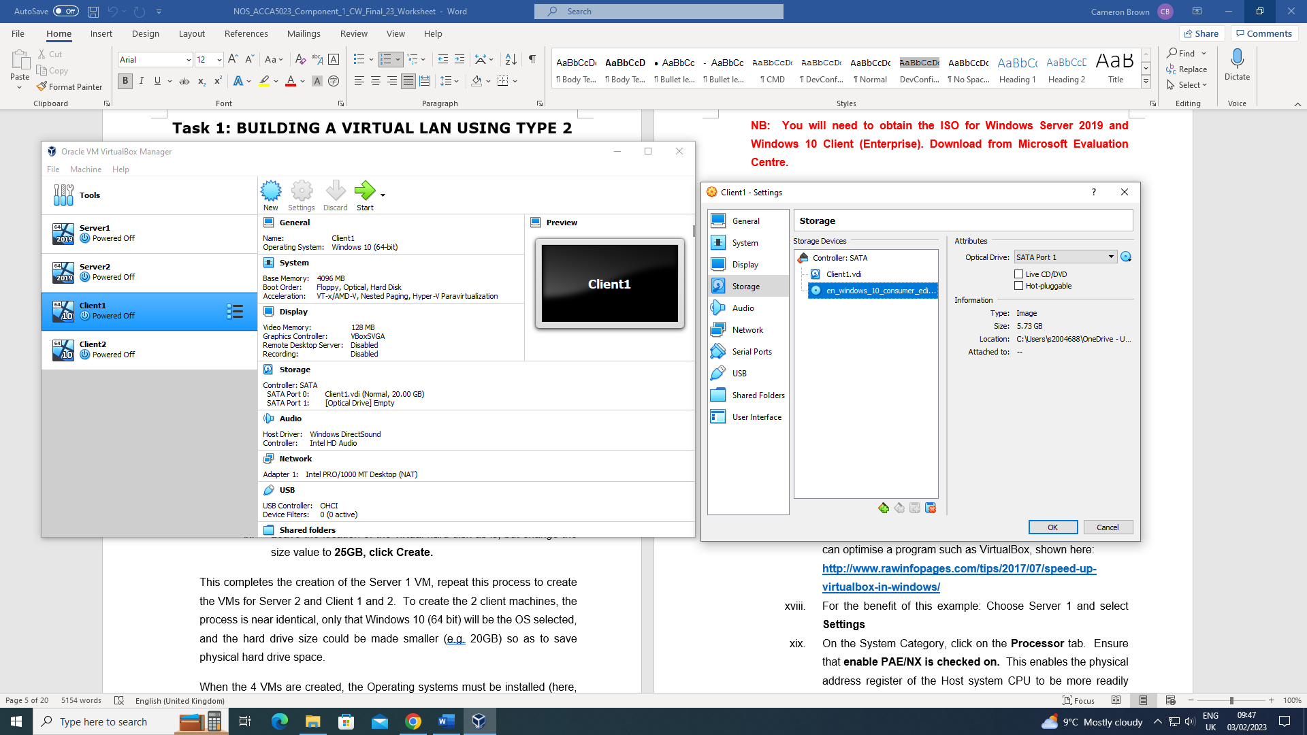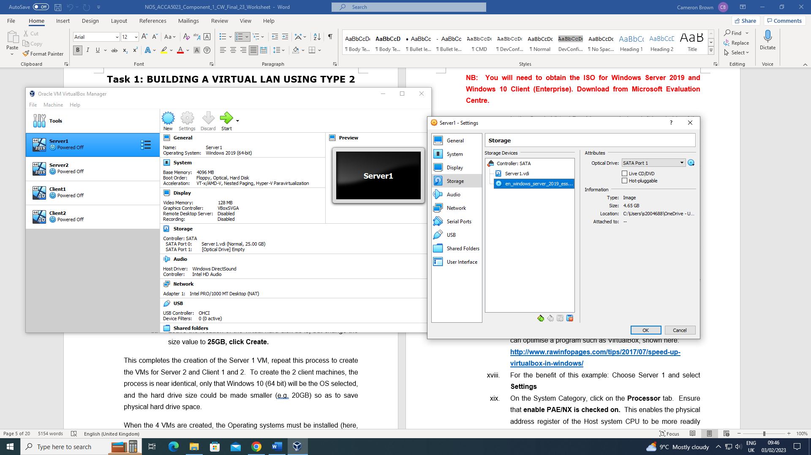
Here are the installations of the ISOs to the selected servers and clients, as you can see between both photos one has the Windows 10 ISO and the other has a Windows Server 2019 ISO, this allows the user to properly install the required operating systems and run the software.
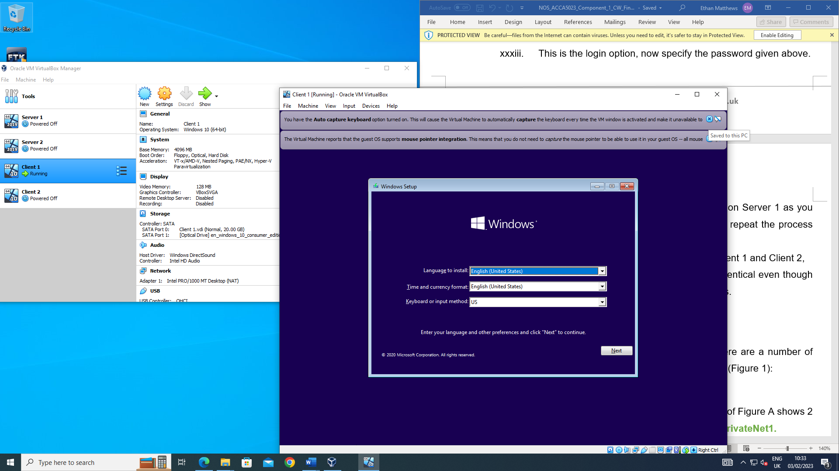
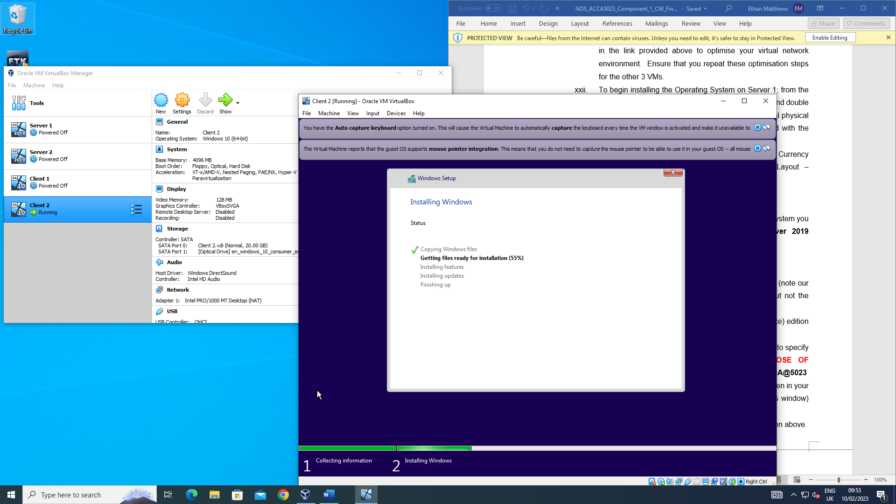
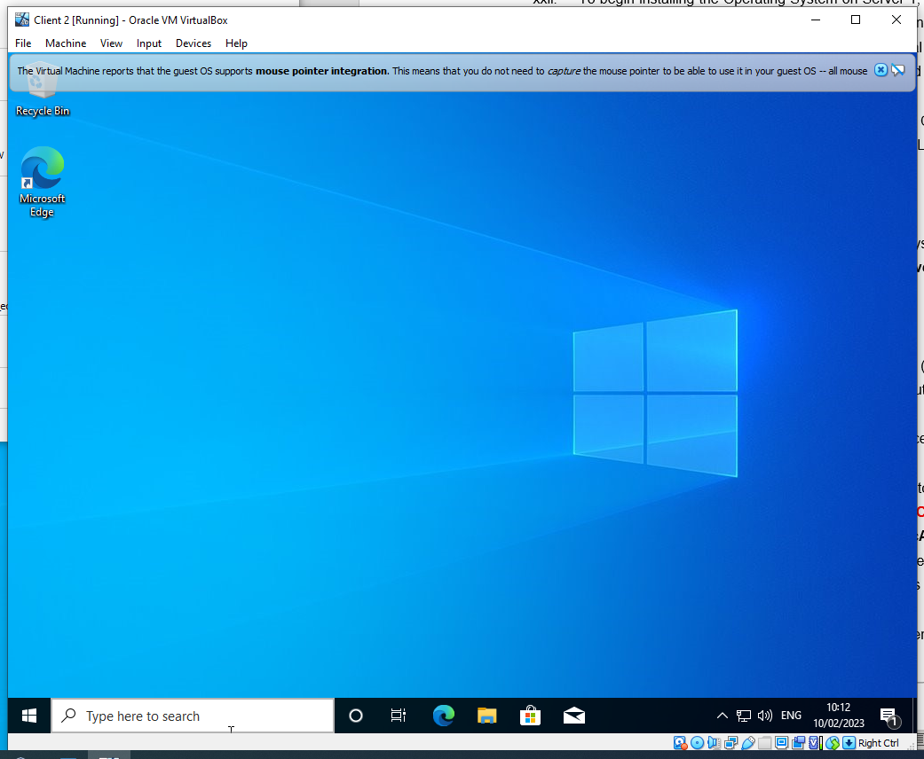
Here in the above three photos would be the installation for the Windows 10 operating system that appears on client two. Client two is the only one included here as the procedure to install the operating system on the servers is exactly the same process as the clients, the only difference in selecting the right operating system (Windows Server 2019 & Windows 10 (Client) Enterprise).

TASK 1 - 1.2 (Virtual Network Configuration)

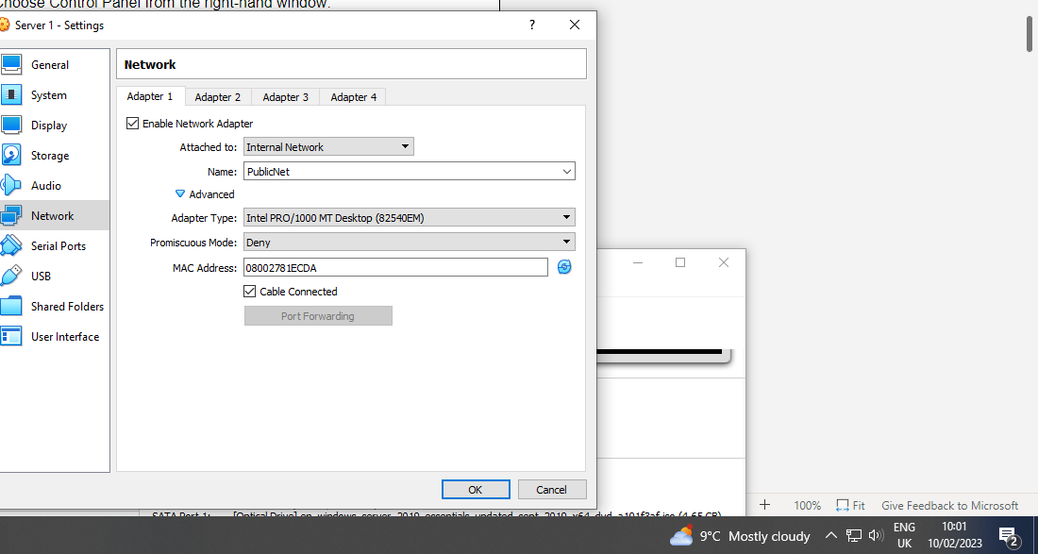
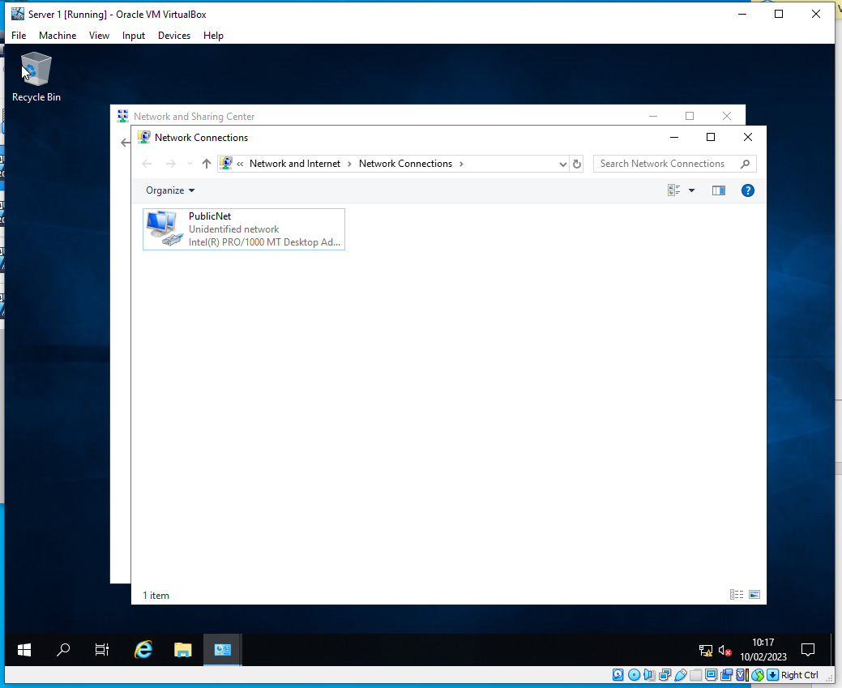
For task 1.2 (Virtual Network Configuration), the internal network for all VM’s were updated. Client 1 and Server 1 were on the same network, and Client 2 and Sever 2 were on the same network. Both servers belong to the same network called PublicNet, they both also have their own network, Server 1 has one called PrivateNet1 and Server 2 has one called PrivateNet2. Client 1 and Client 2 are each connected to one PrivateNet respectively.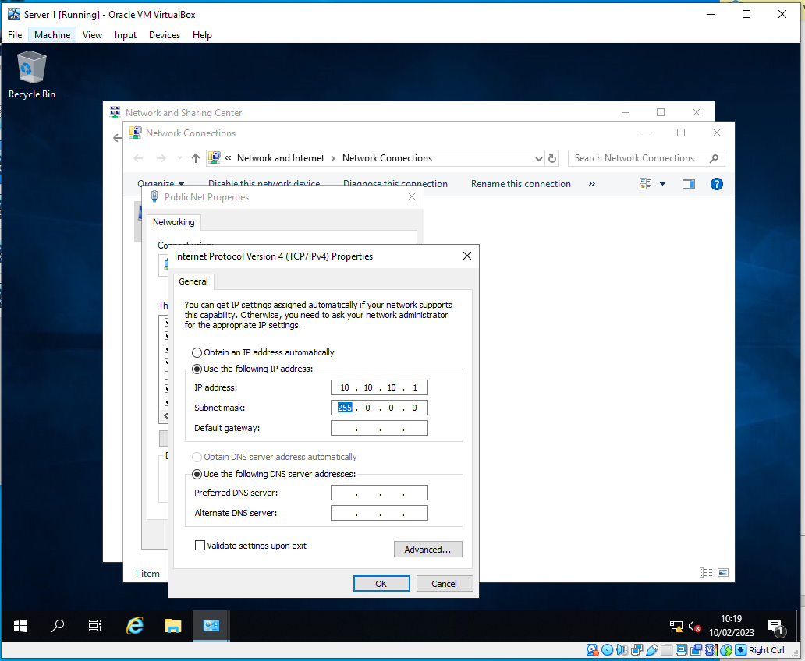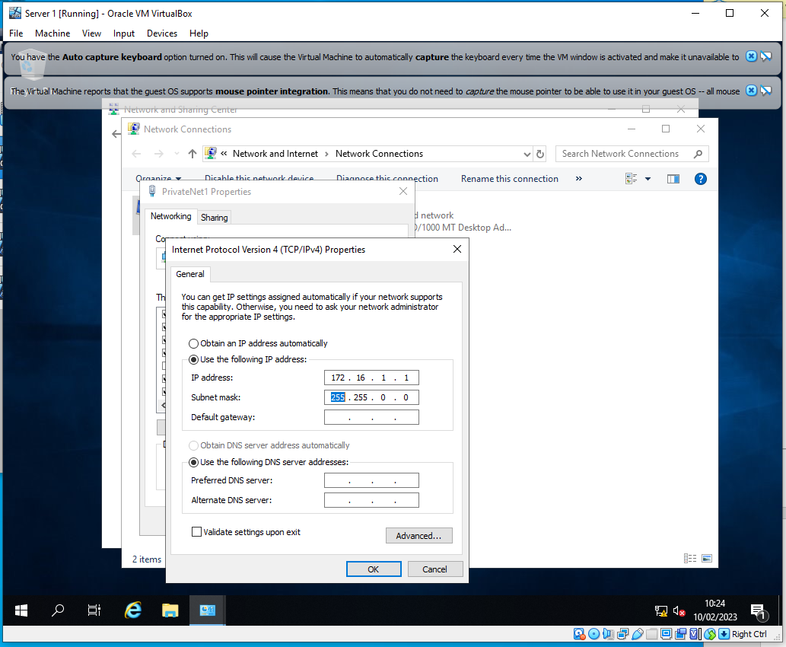

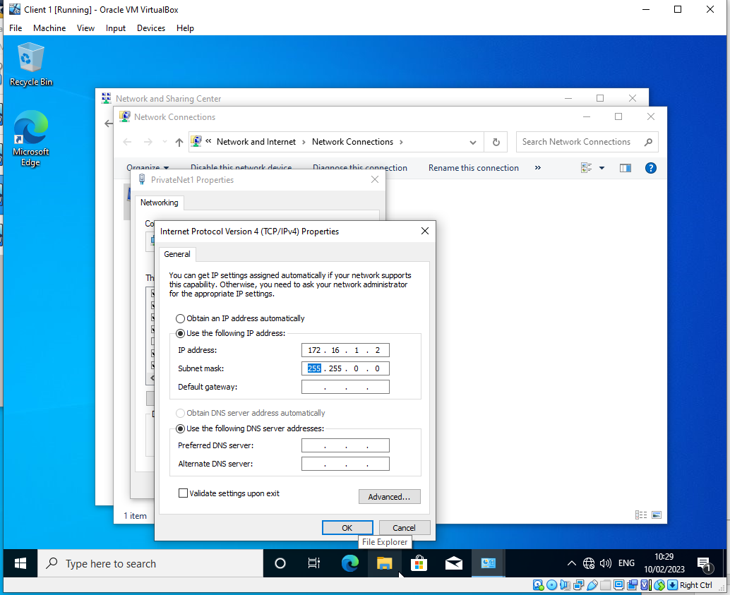

The IP addresses have been configured for Client 1 and Server 2 according to the specifications stated in the worksheet - Client 1 (172.16.1.2) - Server 1 (172.16.1.1) and Client 2 (172.16.2.2) - Server 2 (172.16.2.1). The PublicNet for the servers were also configured as shown on the diagrams above. Server 1’s PublicNet network was configured to 10.10.10.1 and Server 2 was configured to 10.10.10.2.
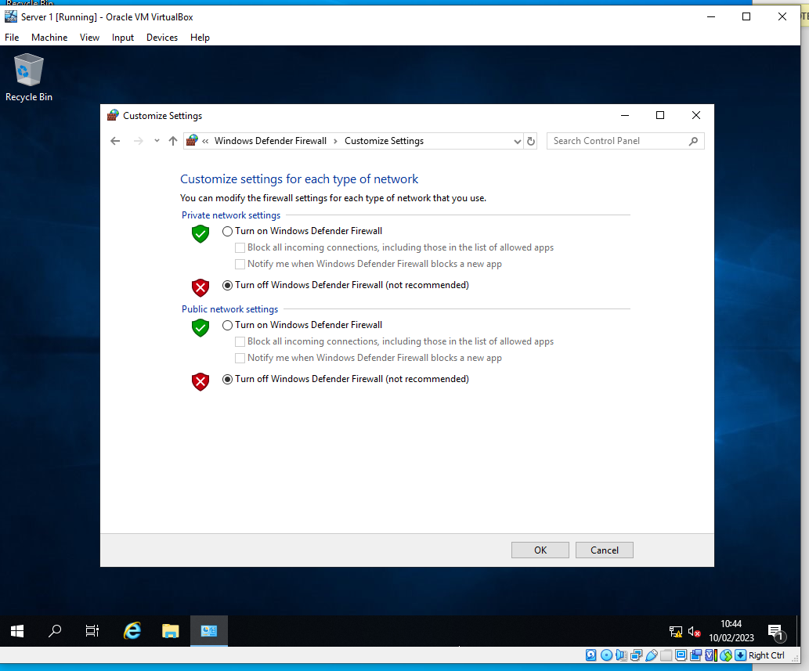
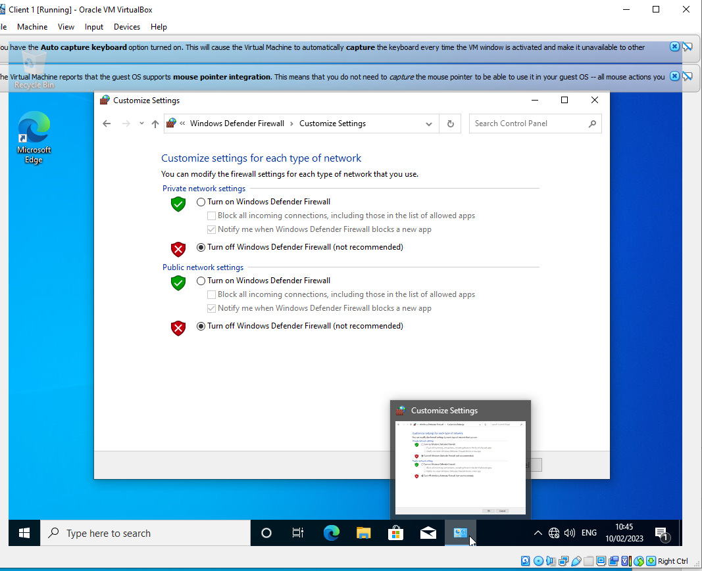

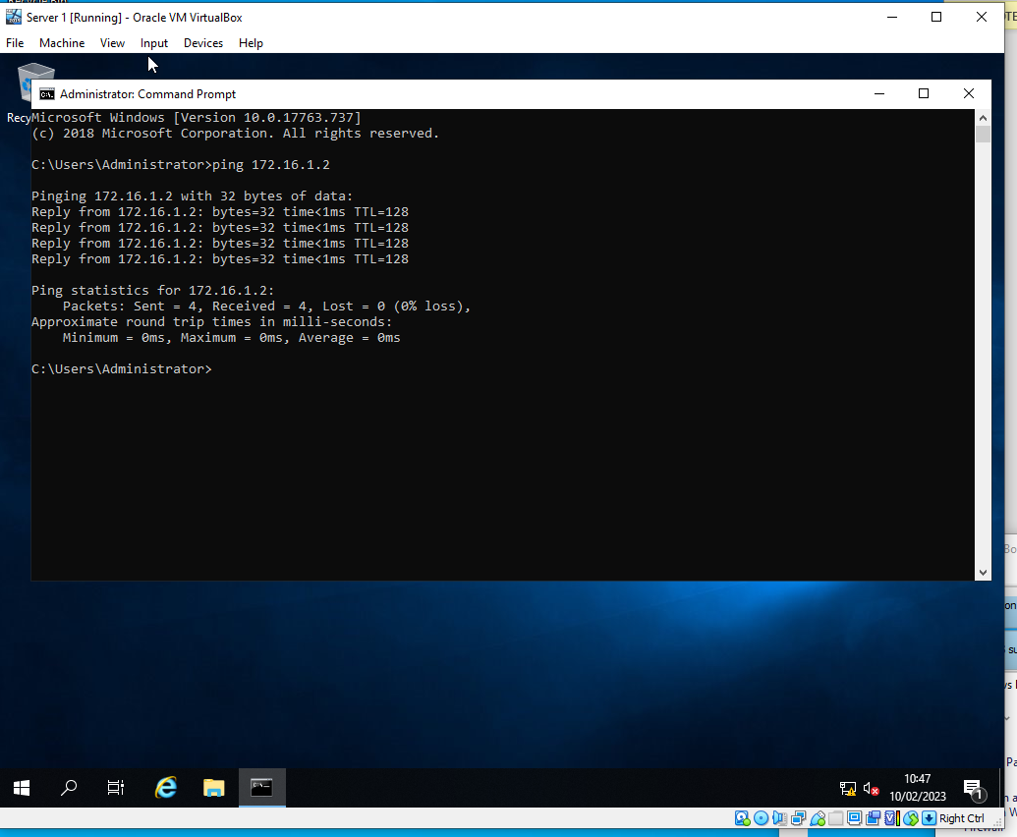
Due to the OOBE for the VMs rejecting ICMP requests, the firewalls had to be disabled on both clients and both servers. Then in order to test that the networks were set up correctly, a ping request between the different networks was done. In which a successful attempt can be seen above.

Task 2: DEPLOYING A NETWORK DIRECTORY SERVICE AND CREATING AND UNDERSTANDING ACTIVE DIRECTORY NETWORK OBJECTS

Task 2 - 2.1 (Prerequisite)

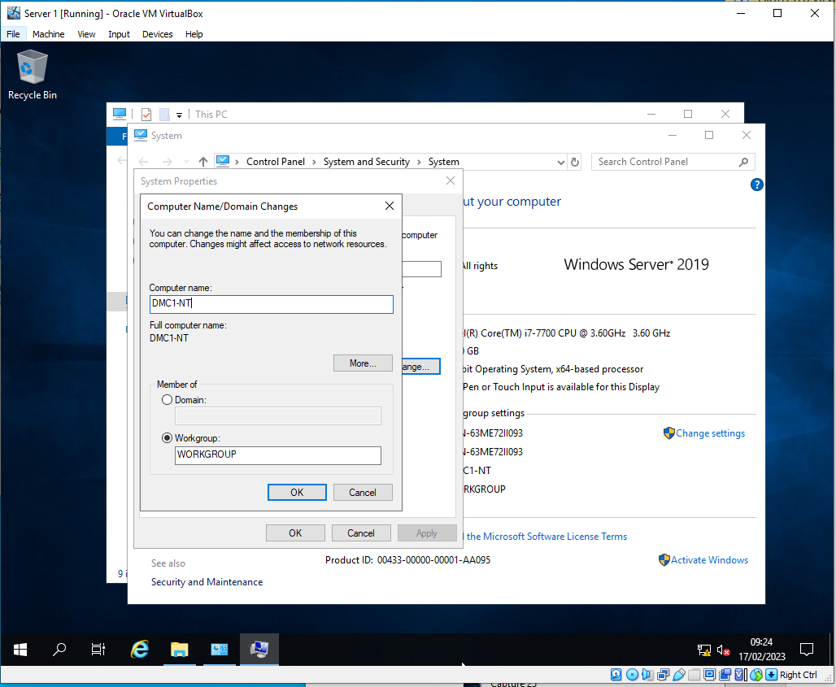
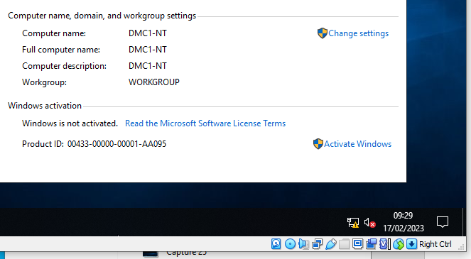

Here in these above two screenshots we can see the user rename the computer to DMC1-NT as a prerequisite before the user starts the second part to this. The reason as to why it was renamed as it is going to be set up as the Domain Controller which will then mean it's going to be the most important server/service.

2.2 - Deploying Active Directory

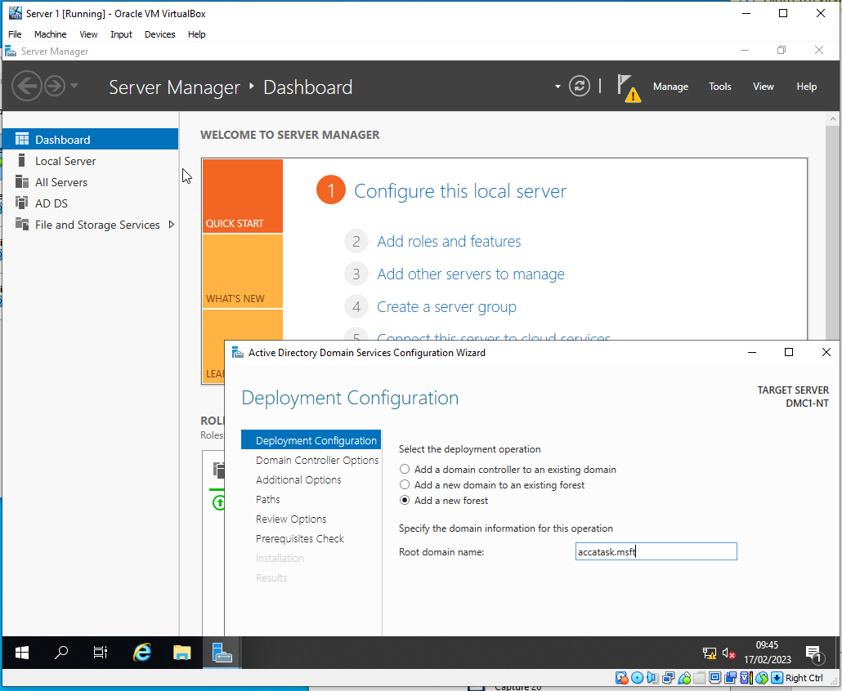
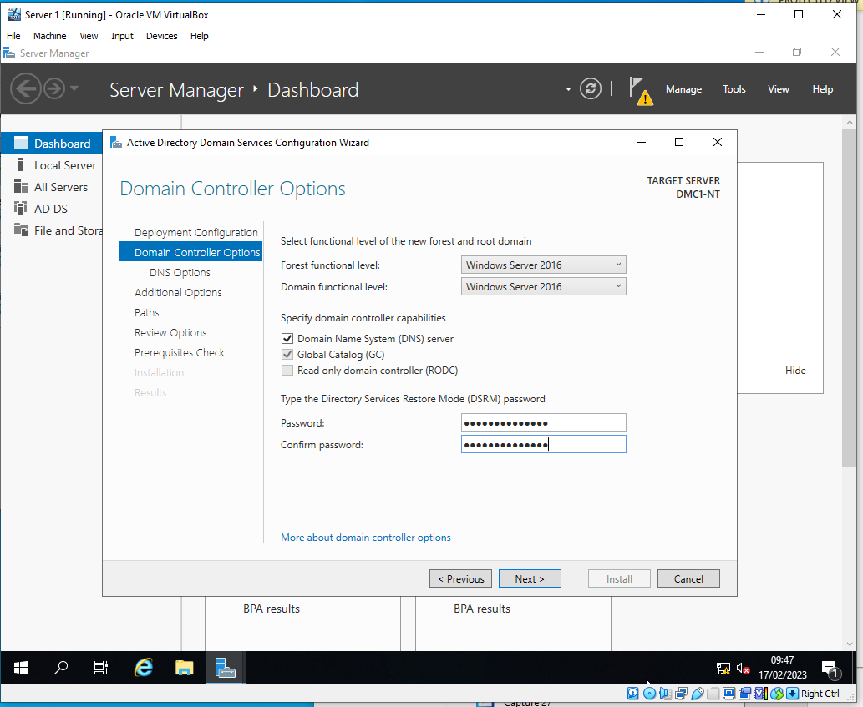
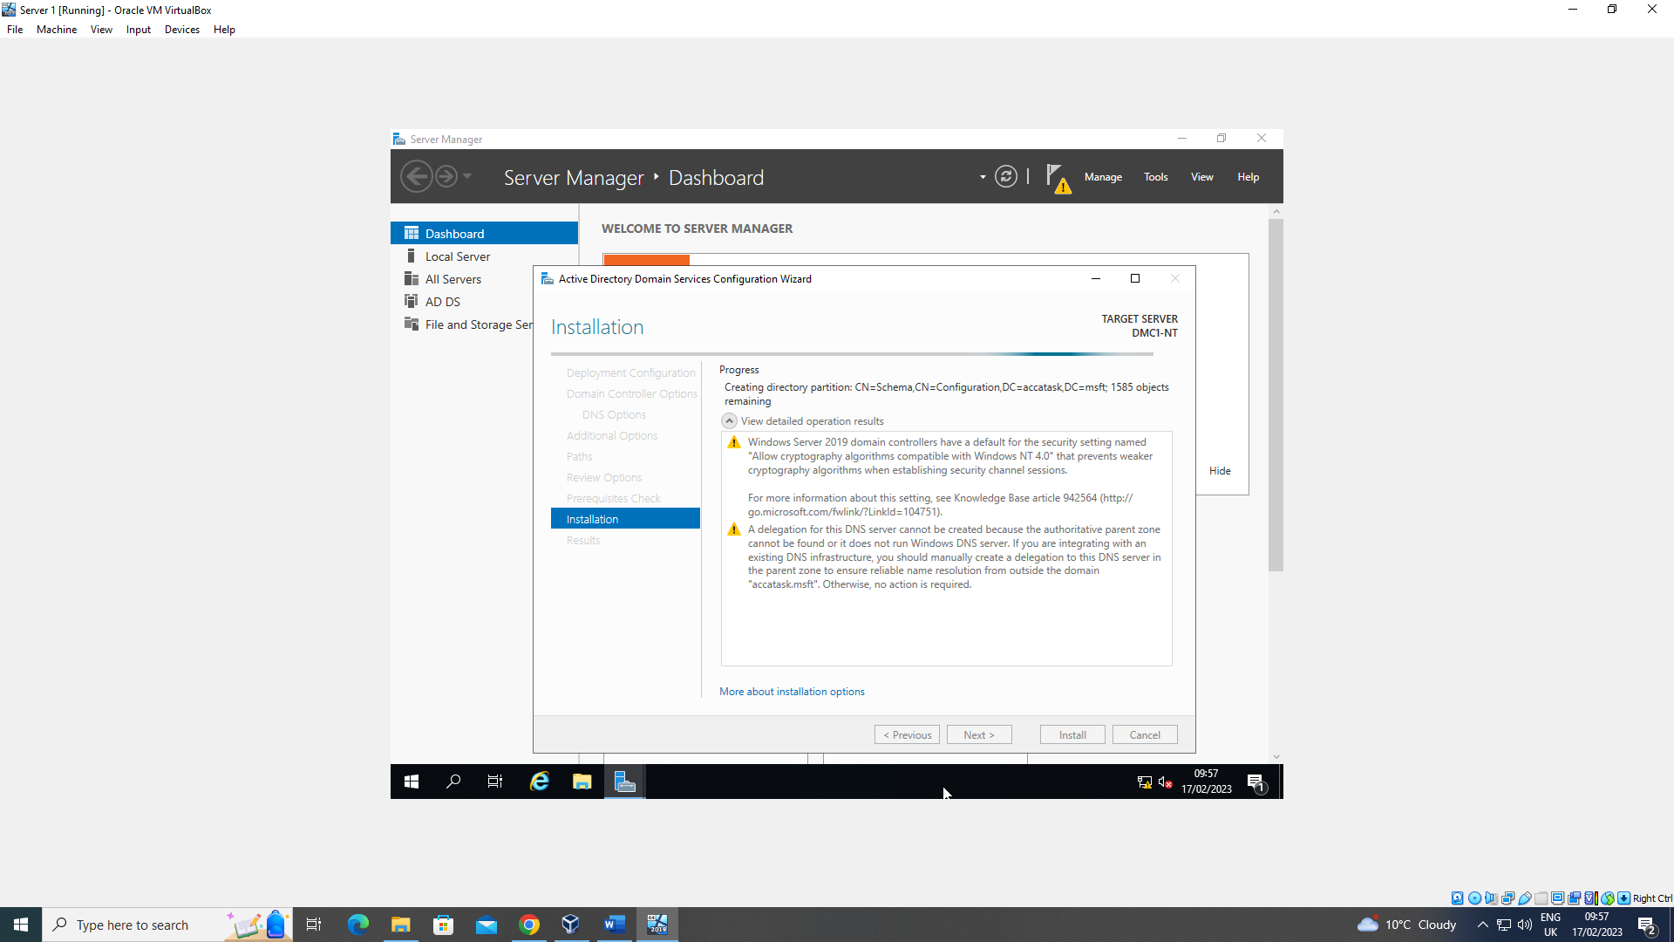

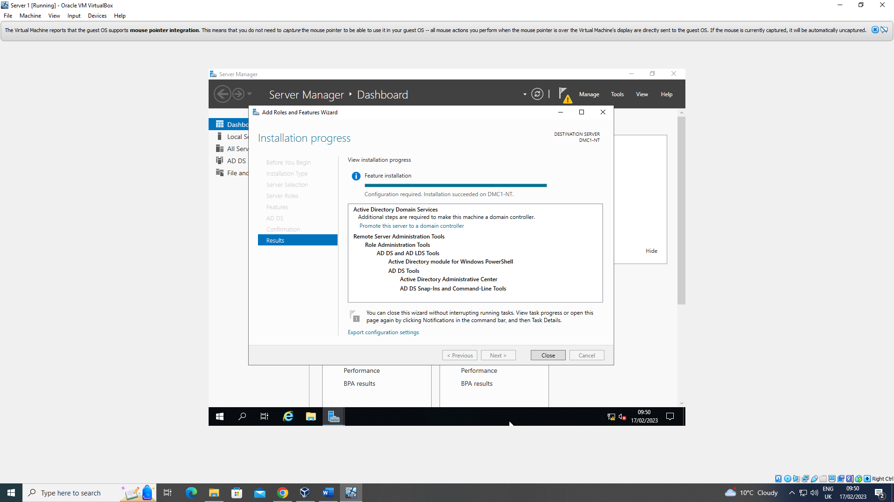
In these above screenshots we can see the user start to deploy an active directory. This is especially useful in a network as it acts as a sort of register within the network and holds all the resources such as people or policies. The user is making it easier for themselves as it also simplifies more tasks for them.

2.3 - Creating user account objects using Active Directory Users and Computers snap-in console.
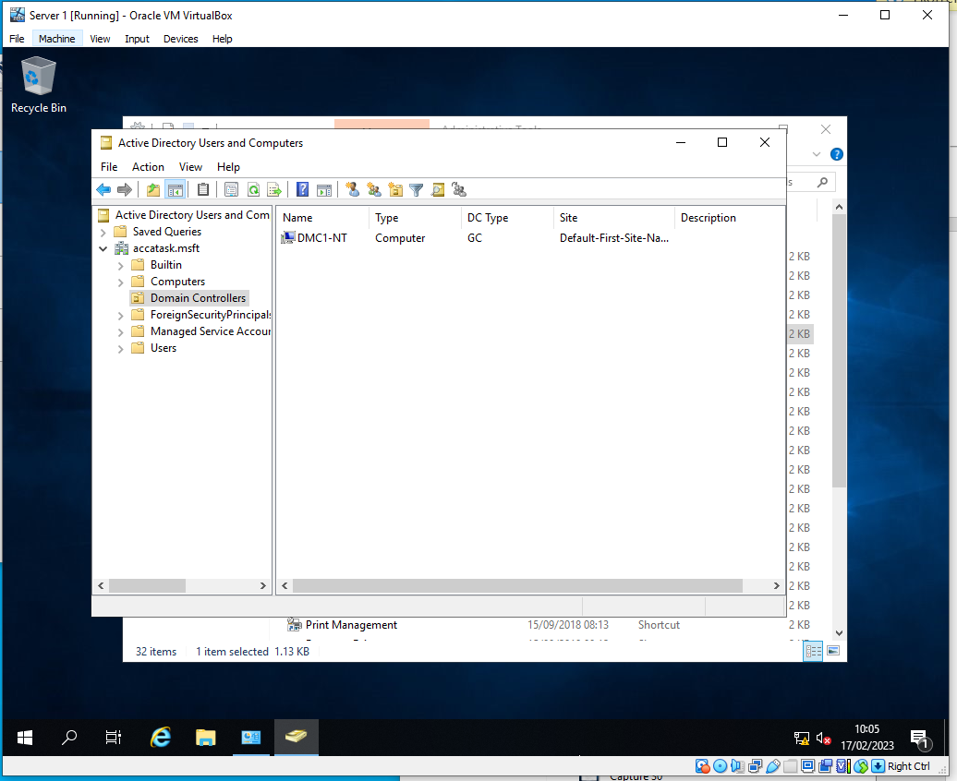
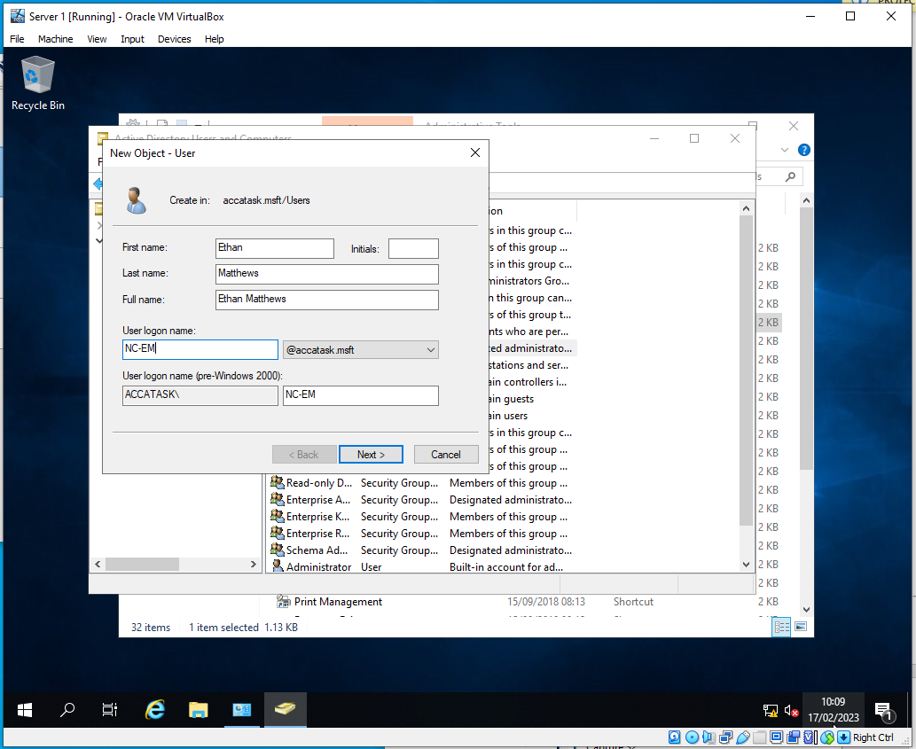
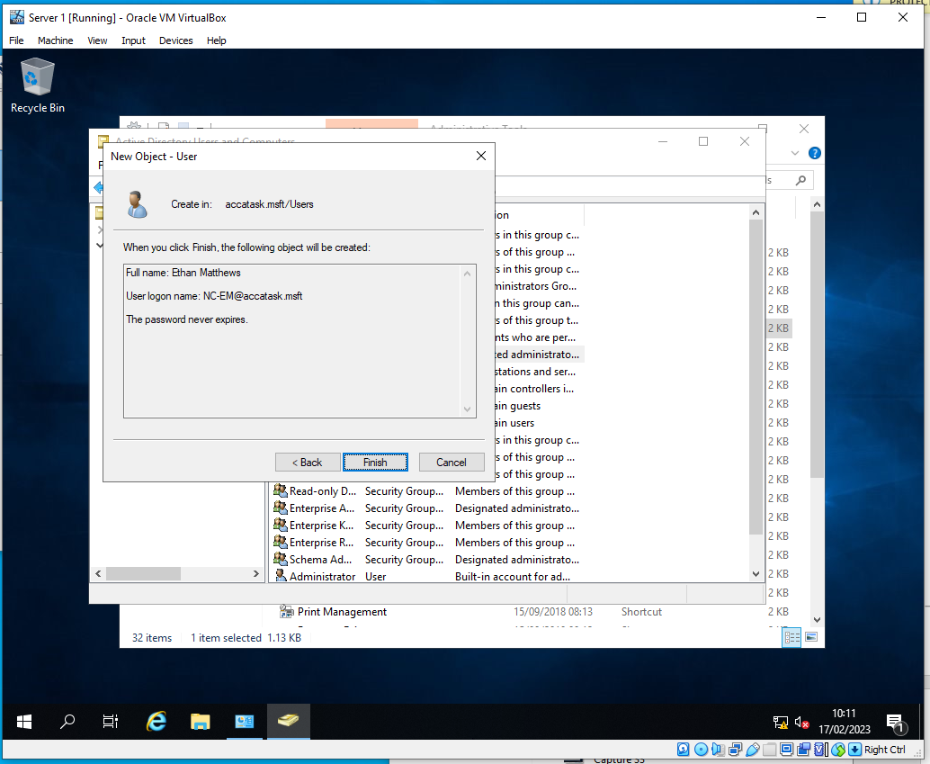
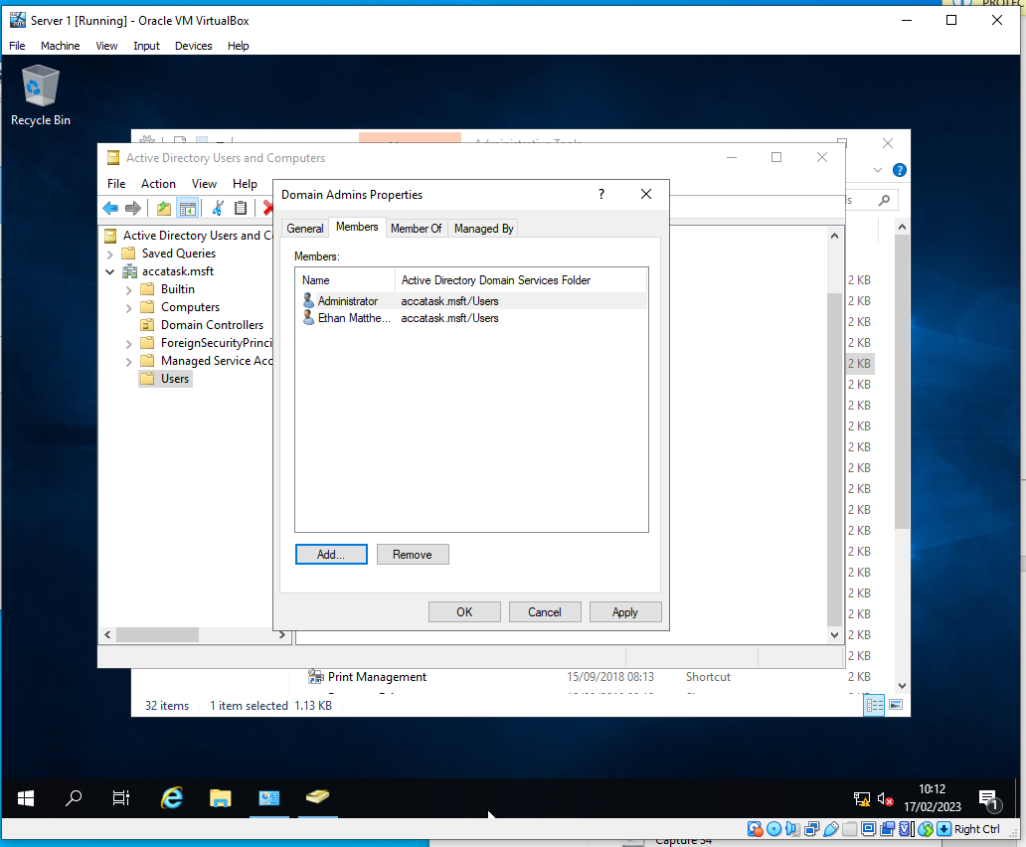
Here in the screenshots above we can see the user creating his user account for the domain. Complying with Microsoft’s Minimum complexity requirements we can see the user use their initials in the username. As well as this, the user also adjusts some interests with the password making it to never expire.

2.4 - Object attributes of interest.

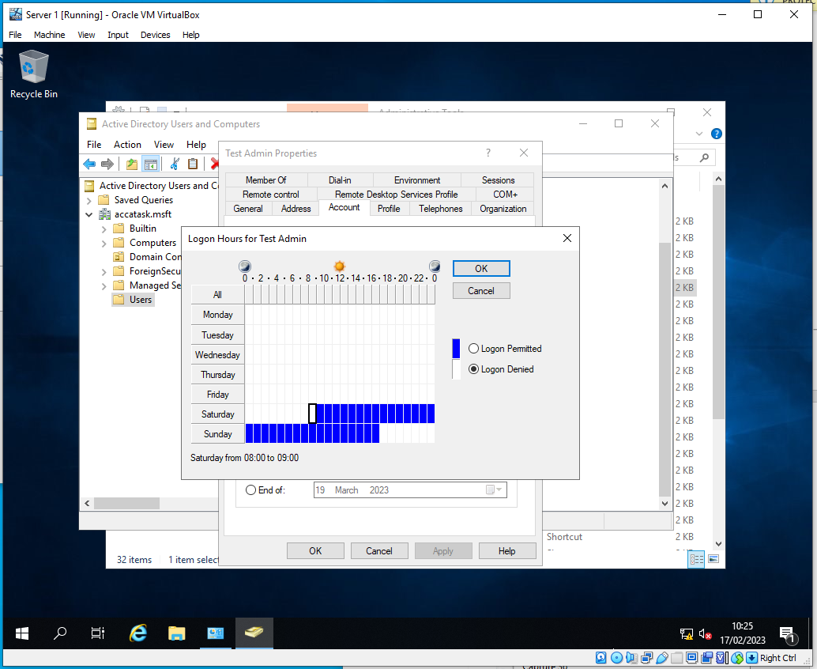
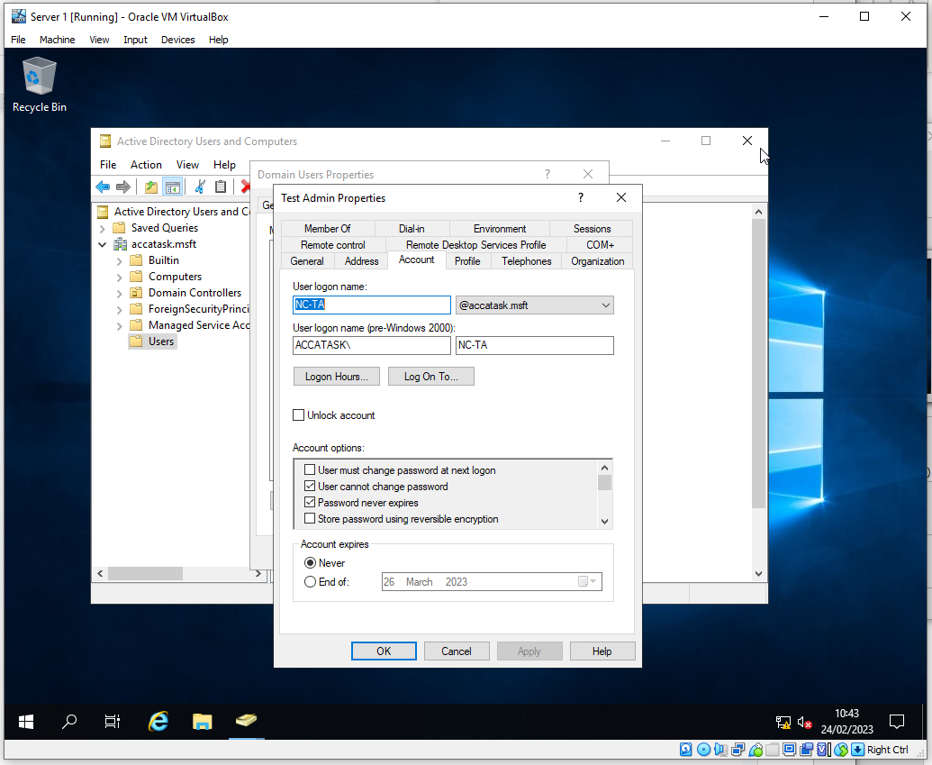
In these above screenshots we can see that the user has made a secondary test account and we can see the user changing some objects of interest. We can see that the user has limited the amount of hours that this account has access to.

2.5 - Adjoining the domain and testing user logins.

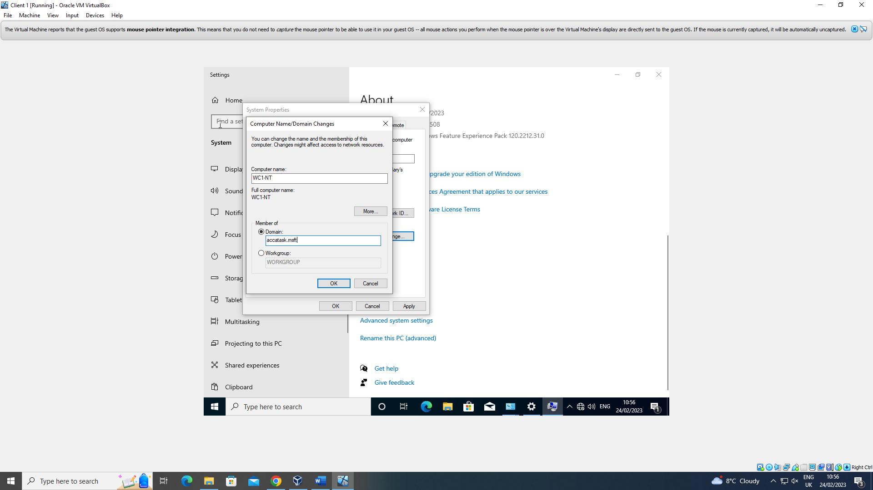
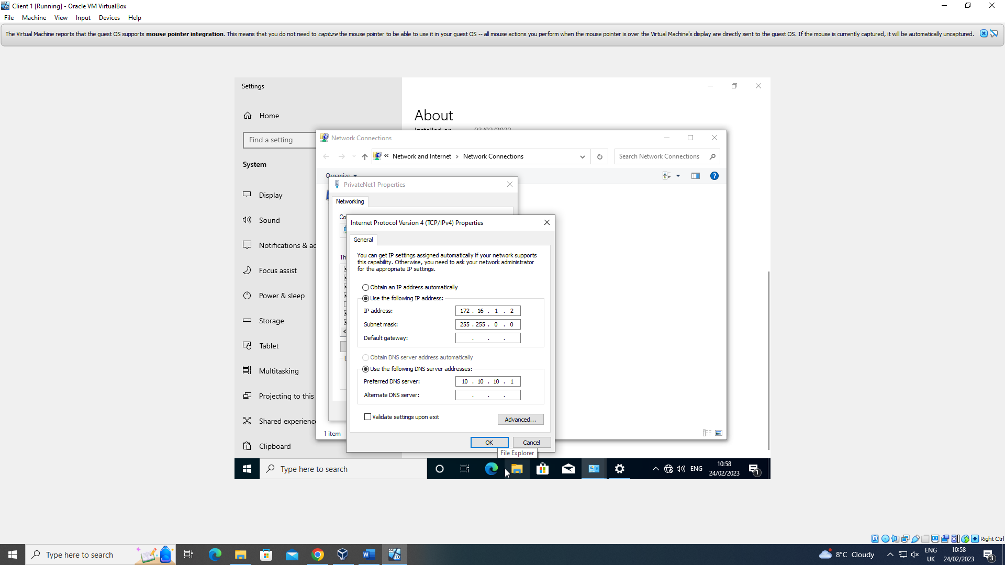
In these we can see the user making a start on joining the server and client Virtual Machines up. The user starts by renaming the client 1 vm and joins the server 1 domain.

(As a side note, there were no more screenshots of progress from the user as there were error messages and we could not obtain anymore).

Task 3: Observations

- Why was a type 2 Hypervisor used?
Personally here I would say a type 2 hypervisor was used as they are most commonly used to be creating and testing virtual machines and new software on a personal computer. “IT organisations typically use Type 2 hypervisors to create virtual desktops” (Bigelow 2021).
Following on from this, type 1 hypervisors would generally be used in big enterprise environments like apple or even google as they have a vast array of multiple tech devices in its infrastructure.
What about the benefits and drawbacks of both hypervisors?

Type 1 |  | Type 2
Benefits | Drawbacks | Benefits | Drawbacks
VM Mobility | Limited functionality | Easy to Manage | Less flexible Resource Management
Security | Complicated Management | Convenient | Performance
Resource Over Allocation | Price | More productivity tools | Security
Above information in the table belongs too (Pheonixnap 2022).
- DHCP - What is it?
Dynamic Host Configuration Protocol, DHCP for short, is a networking protocol used for automatically providing an IP address and a variety of other bits of information like a subnet mask and a default gateway.
A significance of DHCP is that “DHCP minimises configuration errors caused by manual IP address configuration, such as typographical errors, or address conflicts caused by the assignment of an IP address to more than one computer at the same time” (Microsoft 2021).

- Active Directory
According to Microsoft “Active Directory stores information about objects on the network and makes this information easy for administrators and users to find and use. Active Directory uses a structured data store as the basis for a logical, hierarchical organisation of directory information” (Microsoft 2022).
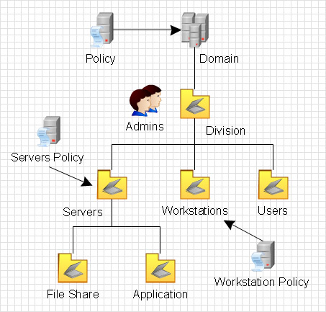
- After the task
Overall after completing this, at times the task appeared to be difficult, coming from someone with little to no experience with this, but working well as a team overcame all of this and proved how successful it is to work in a team and help one another progress on the work and help each other when we all need it.

References
Bigelow, Stephen J. 2021. “What's the difference between Type 1 vs. Type 2 hypervisor?” TechTarget. https://www.techtarget.com/searchitoperations/tip/Whats-the-difference-between-Type-1-vs-Type-2-hypervisor.

Microsoft. 2021. “Dynamic Host Configuration Protocol (DHCP).” Microsoft Learn. https://learn.microsoft.com/en-us/windows-server/networking/technologies/dhcp/dhcp-top.

Microsoft. 2022. “Active Directory Domain Services Overview.” Microsoft Learn. https://learn.microsoft.com/en-us/windows-server/identity/ad-ds/get-started/virtual-dc/active-directory-domain-services-overview.

Pheonixnap. 2022. “What is a Hypervisor? Types of Hypervisors Explained (1 & 2).” phoenixNAP. https://phoenixnap.com/kb/what-is-hypervisor-type-1-2.

