

5G+UWB combined high-precision indoor positioning algorithm

by
Zhiqiang Geng

Supervisor: Dr Carlene Campbell

Project submitted as part of the requirements for the award of MSc Software Engineering

September 2023

DECLARATION

I, Zhiqiang Geng declare that I am the sole author of this Project; that all references cited have been consulted; that I have conducted all work of which this is a record, and that the finished work lies within the prescribed word limits.

This work has not previously been accepted as part of any other degree submission.

Signed : ........ ...........

Date : ......... 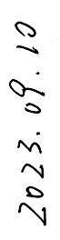...........

FORM OF CONSENT

I Zhiqiang Geng hereby consent that my Project, submitted in candidature for the MSc Software Engineering degree, if successful, may be made available for inter-library loan or photocopying (subject to the law of copyright), and that the title and abstract may be made available to outside organisations.

Signed : ........ ...........

Date : ......... ...........

Abstract
With people's increasing demand for location services in life and production, research on high-precision positioning technology has become an inevitable trend. However, a single positioning method is limited by the shortcomings of the technology itself, and it is often difficult to meet high-precision requirements in complex scenarios. To this end, this article uses Ultra-Wide Band (UWB) positioning technology as a research point, uses 5G technology as an auxiliary to conduct research on combined positioning technology, and uses UWB to position in a Line-of-Sight (LOS) environment. The advantages of high accuracy and that 5G positioning does not rely on external information and can obtain high-resolution multi-dimensional information overcome the large positioning errors of UWB in non-line-of-sight (NLOS) environments and the poor positioning accuracy of 5G. Defects affected by environmental changes to improve the overall positioning accuracy of the system. In the final hybrid positioning stage, the probabilistic error models of the two methods are obtained, and the probabilistic error model is used to determine which positioning method can be used to obtain more accurate positioning results. The final experimental results show that the positioning accuracy of this method can reach less than 0.4m, which can meet the accuracy requirements of most indoor positioning scenarios.

Keywords: indoor positioning; 5G; UWB; integrated positioning
Catalog
Abstract 3
1 introduction 6
1.1 Research background and significance of the topic 6
1.2 Research status and literature review 8
1.2.1 indoor positioning technology 8
1.2.2 5G Positioning Technology 10
1.2.2 Research status of UWB positioning technology 14
1.3 Article structure 17
2 UWB positioning implementation method 19
2.1 UWB positioning 19
2.1.1 UWB positioning principle 19
2.1.2 Factors affecting UWB positioning 22
2.1.3 Improved Chan-Taylor positioning algorithm 25
2.1.3 Improved Chan-Taylor cascade positioning algorithm based on simulated annealing algorithm 28
2.2 UWB positioning environment identification and error suppression based on multi-layer perceptron model 29
2.2.1 Scene layout 29
2.2.2 Location recognition based on multi-layer perceptron 32
3 Positioning method based on 5G 34
3.1 Fingerprint-based positioning method 34
3.1.1 Principle of fingerprint positioning technology 36
3.1.2 Beamforming technology in 5G 38
3.1.3 5G multi-beam fingerprint positioning method 39
3.1.4 Feature selection - CSI-RS and other signals 40
3.1.5 Establish fingerprint database in offline stage 41
3.1.6 Initial fingerprint library analysis 44
3.2 network model 47
3.2.1 convolutional neural network 47
3.2.2 Application and development of convolutional neural networks 52
3.2.3 Online positioning using residual networks 54
3.2.4 Positioning based on ResNet custom network 58
3.2.5 Evaluation index 61
3.3 Simulation experiment design and experimental results 62
3.3.1 Simulation model design 62
4 combination positioning 68
4.1 5G+UWB integrated positioning system architecture design 68
4.1.1 Design and implementation of spatio-temporal unified sub-unit 69
4.1.2 4.1.2 Design of fusion positioning sub-unit 71
4.2 5G+UWB verification experiment 72
5 Conclusion and future plans 76
5.1 conclusion 76
5.2 future outlook 77
References 78

1 introduction

Research background and significance of the topic
With the rapid development of Internet technology and communication technology, people's demand for high-precision location services is also growing, such as in vehicle navigation, smart homes, logistics transfers, smart manufacturing and other scenarios, and even in military operations and search and rescue. Use high-precision positioning. At the same time, with the rapid development of Internet of Things technology, the accuracy and real-time requirements for positioning services in different scenarios have become more stringent. Therefore, more and more scholars have conducted in-depth research on high-precision positioning technology.
In an open environment, the Global Navigation Satellite System (GNSS) can provide efficient, reliable and accurate position services [1]. However, in many complex scenes, even in some simple indoor environments, a single satellite positioning system will be difficult to achieve high-precision positioning due to factors such as multipath effects, insufficient number of visible satellites, and signal attenuation. In recent years, with the development of wireless sensing technology, many scholars have begun to turn to the use of wireless sensing technology to achieve positioning research. Common wireless positioning technologies include Wi-Fi positioning, Radio Frequency Identification (RFID), Bluetooth positioning, ultrasonic positioning, and UWB ultra-wideband positioning.
Wi-Fi based positioning technology is very popular due to its early development, simple installation of hardware equipment, and wide coverage in short and medium distances. However, Wi-Fi signal attenuation is severe and the multipath effect has a greater impact [2], making its positioning accuracy low. Similarly, RFID radio frequency identification has poor anti-interference ability, resulting in unstable positioning accuracy. The Bluetooth positioning method has also become the focus of research due to its low power consumption. However, due to the narrow bandwidth of the Bluetooth signal, its attenuation is very serious, and the most fatal thing is that the Bluetooth signal has short communication distance and slow transmission rate. The disadvantage is that it is only suitable for positioning within a small range. The positioning accuracy of ultrasonic positioning is higher than the previous positioning methods, but ultrasonic equipment is expensive and the positioning cost is too high. At the same time, it is also susceptible to NLOS propagation and multipath effects.
With the widespread deployment of 5G base stations and the large-scale opening of 5G millimeter wave frequency bands in the future, due to the setting of ultra-dense cells, a large number of 5G base stations and micro base stations will be deployed near buildings or even in buildings. At that time, 5G will Comprehensive coverage both outdoors and indoors; at the same time, the latest 5G R18 standard also clearly emphasizes the independent indoor positioning framework [3] in the 5G network architecture, which is intended to highlight the significant impact that the new generation of wireless communication systems will have on indoor positioning. Therefore, the 5G indoor positioning system has a very broad application prospect and will inevitably become the mainstream indoor positioning method in the future.
At the same time, UWB communicates by emitting nanometer-level pulse signals, so it has the advantages of higher resolution, stronger anti-interference ability, and better ability to resist multipath effects. Under line-of-sight conditions, UWB positioning accuracy can reach centimeter level, and the cost of UWB equipment is low, so it is widely used in indoor positioning. However, the positioning accuracy of UWB in the NLOS environment is low, so a lot of research has been done at home and abroad to eliminate the NLOS error of UWB. Taking into account positioning accuracy and cost performance, UWB positioning is an economical and practical positioning technology.
Positioning technologies based on UWB and 5G have their own advantages, but a single positioning technology is often difficult to meet people's positioning accuracy needs in complex scenarios. Therefore, the high positioning accuracy of UWB in LOS environment can be used to overcome the shortcomings of error accumulation in INS positioning; the short-term reliable positioning characteristics of 5G can also be used to overcome the shortcomings of large NLOS errors in UWB positioning. Utilizing UWB/5G combined positioning method can greatly improve the accuracy, reliability and stability of the positioning system.
Through the above analysis, the research on the combination of two positioning technologies based on UWB and 5G technology research has practical significance. This article has carried out a series of research work on this.

Research status and literature review

indoor positioning technology
With the popularization of wireless networks, there are now a large number of wireless network devices in indoor environments, which provides a great opportunity for indoor positioning.
Applications provide convenience. The following are the existing more common indoor positioning technologies.
1) Infrared positioning
Infrared positioning technology first requires the installation of an infrared transmitting device and an optical sensing device in the indoor environment. When the infrared transmitting device emits infrared rays, the optical sensing device receives the infrared rays for positioning. The AT&T Laboratory of the University of Cambridge developed the Active Badge System positioning system [5], which is the first indoor positioning system that uses infrared rays for positioning. However, infrared rays have inherent shortcomings such as large attenuation with distance, weak penetrating ability, and vulnerability to interference from the external environment, which makes this technology severely limited in complex indoor environments and large spaces.
2) Ultrasonic positioning
Ultrasonic positioning is a method of distance measurement and positioning that relies on the reflected wave of an object. The positioning system first needs to measure the time difference between the ultrasonic emission wave and the echo reflected from the target object, and then use this time difference to calculate the sending end and The physical distance between the positioning targets is determined, and finally the physical position of the target node to be located is calculated using the trilateral positioning method. The ultrasonic positioning system is less affected by the external environment and has strong penetration ability of ultrasonic waves. However, because its positioning system requires the installation of special equipment and the equipment used is more expensive than other methods, it can only be used in rare cases. Choose to use an ultrasonic positioning system.
3) Radio Frequency Identification (RFID) positioning
The Radio Frequency Identification (RFID) positioning system can measure the user's specific location by using the identification and reading method of radio signals when fishing equipment comes into contact. It can quickly respond to the target position within millimeter level, its positioning accuracy is generally centimeter level, and it has the advantages of signal covering a large range and low cost. However, its actual positioning range is much smaller than its coverage range, and there are still many problems such as insufficient theoretical models, unprotected user security and privacy, and insufficient international standards.
4) Bluetooth positioning
Currently, there are two mainstream Bluetooth positioning methods: ranging positioning and fingerprint positioning, both of which are based on received signal strength (RSS). The positioning accuracy is 2~3m. During system positioning, the distance between the signal sending end and the receiving end is estimated through the received signal strength measured by the receiving end, and trilateral positioning is used to infer the position of the receiving end; fingerprint positioning is to establish a fingerprint library of signal strength to achieve positioning purposes. Bluetooth positioning equipment is small in size, low in energy consumption, and easy to integrate, but has poor stability, short propagation distance, and is susceptible to interference in multi-signal environments. Therefore, Bluetooth positioning technology is rarely used in real life.
5) Ultra Wide Band (UWB) positioning
Ultra-wideband positioning technology has ultra-high accuracy in both time and spatial resolution, which allows UWB to obtain precise information about the time and angle of the target to be located, so as to calculate the distance between the receiving end and the transmitting end through time information, and combine the three sides Geometric methods such as positioning and triangulation methods are used to obtain the true physical position of the target to be located. Ultra-wideband communication transmits data using GHz-level bandwidth and nanosecond-level extremely narrow pulses. It has strong penetrating ability and performs well in multipath environments. In addition, its security is higher than other technologies, and The system has low complexity and can achieve centimeter-level positioning effects [6].
6) 5G positioning
Because 5G communications are characterized by high speed, low latency, and large connections, and include key technologies such as large-scale antenna arrays, ultra-dense networking, new multi-access, full-spectrum access, and new network architectures, they are constantly evolving standards. During the evolution, 5G itself has also added the function of high-precision positioning. The principle of 5G positioning is similar to that of UWB. It uses the advantages of high bandwidth and low latency to obtain extremely high-precision time difference and angle information, thereby obtaining the distance between the target point and the transmitter, and then obtains the target point to be measured through collective positioning. The position can reach sub-meter level positioning accuracy.
7) Wi-Fi positioning
Positioning technology based on Wi-Fi is a popular solution in the current indoor positioning field. The RADAR system [7], Weyes system [8] and Horus system [9] are all currently effective Wi-Fi positioning systems. Wi-Fi devices are widely distributed, cheap, and Wi-Fi signals have long transmission distances, so Wi-Fi-based positioning systems are becoming more and more popular among researchers. Most current indoor positioning systems based on Wi-Fi can achieve meter-level positioning accuracy. However, Wi-Fi signals are greatly affected by changes in the surrounding environment, and multipath fading of the signal will also affect its positioning accuracy. How to reduce or overcome the impact of the environment on Wi-Fi signals in applications will become one of the key points to improve the accuracy of Wi-Fi positioning methods.

5G Positioning Technology
The next generation of mobile communications technology - 5G is increasingly anticipated. 5G will not only greatly increase the transmission rate of mobile communications, but also provide new services in different fields: Augmented Reality (AR), Internet of Things (IOT), Internet of Vehicles, IOV), Device to Device communications (D2D), electronic medical care, Machine to Machine communications (M2M), financial technology, etc. [10]. Under joint research from industry and academia, 5G systems are expected to meet eight needs:
1) Data transmission rate of 1-10Gbps in the actual network: This is almost a 10-fold increase on the theoretical peak rate of the current 4G network (150Mbps);
2) 1ms round-trip delay: one-tenth of the current 4G round-trip delay of 10ms;
3) High bandwidth per unit area: It is necessary to ensure that there are a large number of connected devices with higher bandwidth in a specific area for a long time;
4) A large number of connected devices: In order to realize IOT, the 5G network needs to ensure the simultaneous connection of thousands of devices;
5) 99.999% network availability: 5G network needs to ensure that it is always available during actual use;
6) Almost 100% coverage: 5G network ensures coverage no matter where users are;
7) Energy consumption reduced by 90%: The development of green technology has become an important consideration in the formulation of 5G standards, and energy consumption is more important than data transmission rate and massive number of connections;
8) Extension of battery life: For 5G, reducing device energy consumption is also very important;
Such demands require 5G systems to innovate in many aspects such as network architecture, physical layer, and protocol layer. Since the network architecture, protocol layer and other contents are not very relevant to the research content of this article, they will not be described in detail here. Next, we will briefly introduce the innovation of the physical layer. Literature [10] believes that physical layer innovations include: millimeter wave communication, adaptive beamforming, beam switching, Massive MIMO, and full-duplex radio technology. Combining the three key technologies proposed in literature [11], it can be seen that millimeter wave Communications and Massive MIMO have always been regarded by researchers as key technological innovations for 5G. On the other hand, the downlink in the 4G system uses OFDM technology. In March 2016, 3GPP agreed to study multiple parameters of OFDM as a 5G air interface technology before the emergence of other waveforms with obvious effects, and evaluated OFDM in different applications. link (uplink, downlink, secondary link, backhaul link) performance, and concluded that OFDM is indeed an excellent choice for 5G air interface technology [12,13]. It can be seen that in 5G, OFDM will not only It is applied in downlink and will be comprehensively applied in different links.
Traditional ranging-based positioning methods and non-ranging positioning methods can only solve small-scale indoor positioning problems and cannot solve the positioning problem of wide-area continuous coverage. In order to solve this problem, researchers have proposed a method based on channel state information. The indoor positioning method [14], combined with the existing 4G OFDM technology, provides the possibility to achieve indoor positioning with large-scale continuous coverage. However, most researchers only use channel state information as a more accurate fingerprint than RSSI, and also use non-ranging positioning methods for positioning. As a result, existing indoor positioning methods based on channel state information still have low positioning accuracy. question. Considering that indoor positioning technology in 5G systems requires high accuracy, the ranging-based positioning method that uses channel state information for distance estimation is a more feasible method to achieve high-precision, wide-area continuous coverage indoor positioning. And for the key technologies of 5G, the channel estimation algorithm for extracting channel state information and the positioning method based on ranging are facing greater challenges.
Before the concept of MIMO was proposed, communication systems mainly used single-input single-output antenna systems. According to Shannon's theorem: C=Wlog2(1+S/N), where C is the channel capacity, W is the channel bandwidth, and S is the average Signal power, N is the average noise power, and S/N is the signal-to-noise ratio. This kind of system where both the transmitter and the receiver are both single antennas has a theoretically unbreakable upper limit of transmission rate, which can only be infinitely approximated and cannot be exceeded. Since the number of antennas in this antenna system is only 1 at both the transmitting and receiving ends, the traditional optimization algorithm can estimate the channel with high accuracy. However, with the introduction of the MIMO concept, the channel vector lengths at the transmitter and receiver have increased significantly. Assuming that there are L paths between the transmitter and the receiver, the channel vector h∈L×1 of the early single-input single-output system, and assuming that the number of transmitter antennas is M and the number of receiver antennas is N, then the channel of the MIMO system Vector h∈MNL×1, the length of the channel vector increases with the number of antennas at the transmitting and receiving ends. Especially in Massive MIMO technology, the number of antennas may reach hundreds or thousands, which will cause the length of the channel vector to become very large, causing the channel The calculation time of the estimation algorithm has been greatly increased, and the increase in the number of antennas has increased the number of reference signals required by the traditional channel estimation algorithm, which will cause the transmission rate to decrease. However, the combination of the sparse characteristics of wireless channels and compressed sensing theory allows the channel estimation algorithm to use a small number of reference signals for channel estimation. However, the sparsity of the channel in actual scenarios is uncertain, and the accuracy of the channel estimation algorithm based on compressed sensing theory will be affected. Influence. In addition, although the channel estimation algorithm based on compressed sensing theory can perform channel estimation in the presence of a small number of reference signals, such channel estimation algorithms will also face the problem that when the number of antennas increases significantly, the running time of the algorithm will increase significantly.
On the other hand, the traditional ranging-based positioning method that uses distance estimation calculates the straight-line distance between the anchor node and the node to be located during the position calculation process, and then estimates the location of the node to be located through the straight-line distance and the coordinates of the anchor node. position, and when the ranging error caused by non-line-of-sight propagation (non-direct path is judged as a direct path) exists, most of these positioning methods use an optimization algorithm to estimate the position of the node to be positioned or directly discard the nodes with large errors. The ranging value [15], but neither method can effectively identify the situation of non-line-of-sight propagation, and thus cannot fundamentally eliminate the errors introduced by non-line-of-sight propagation. In addition, there are both direct paths and other multipaths in the channel between an anchor node and the node to be located. However, the traditional ranging-based positioning method only selects one of the multipaths to participate in the positioning solution without using other multipath information. In order to more accurately calculate the straight-line distance between the anchor node and the node to be located, it is necessary to accurately identify whether the signal direct path exists, and formulate corresponding positioning methods for the two situations where the direct path exists and the direct path does not exist. In addition, traditional indoor positioning technology has offline requirements for the number of anchor nodes. Two-dimensional indoor positioning requires at least three anchor nodes with known positions for positioning, and three-dimensional indoor positioning requires at least four anchor nodes with known positions. Nodes. In future 5G networks, due to the weak penetrating ability of millimeter waves and the limited number of base stations deployed in a room, there is no guarantee that there will be at least three base stations connected to users in a single room at the same time. In this case, multiple base stations will need to be used. How to use multi-path information to achieve positioning when the number of anchor nodes is small will be another focus of this study.
To sum up, in the future 5G system, high-precision indoor positioning technology that effectively combines new technologies such as millimeter wave and Massive MIMO is indispensable. The new indoor positioning technology needs to take into account both accuracy and wide-area continuous coverage; subsequently Since then, new problems and challenges have also emerged. Specifically, it mainly includes two aspects:
Channel estimation algorithm for Massive MIMO: When the number of Massive MIMO antennas increases significantly, the traditional channel estimation algorithm requires a large number of reference signals; on the other hand, although the compressed sensing theory can effectively utilize a small number of reference signals when the channel is sparse, Reference signals are used for channel estimation, but changes in channel sparsity in the actual process will affect the accuracy of the algorithm, and the computational complexity of the channel estimation algorithm based on compressed sensing is not reduced compared to the traditional channel estimation algorithm, so the algorithm calculation time will be is another challenge faced by compressed sensing-based channel estimation algorithms; we can consider using neural networks to solve related problems.
Ranging-based indoor positioning systems for dense deployment and high-frequency bands: how to effectively utilize channel state information for distance estimation; in addition, traditional ranging-based positioning methods cannot effectively identify and utilize multipath information; and in the future 5G In the system, although ultra-dense cell deployment results in a large number of base stations with known locations in the indoor environment, the problem of weak wall penetration capabilities of high-frequency millimeter waves will cause the number of base stations that users can connect to indoors to be insufficient for positioning. If necessary, how to effectively use multipath information to achieve high-precision positioning even when the number of anchor nodes is insufficient is a key issue that needs to be solved.

1.2.2 Research status of UWB positioning technology
UWB technology was first used for military communications in the United States, and the technology was kept secret for a long time. Therefore, in the early days of the technology's birth, the development speed was very slow. It was not until the early 21st century that the United States lifted the confidentiality restrictions on UWB technology, so UWB technology developed rapidly in the past 20 years. my country's research on UWB technology started relatively late. In the late 1990s, my country only began to invest in UWB technology research. In 2019, Apple released the U1 chip based on UWB positioning technology, which uses UWB technology to realize the object search function, once again bringing this technology into everyone's lives. More and more companies have begun to pay attention to and focus on this technology. positioning technology. This section will provide a detailed explanation of the development and research status of UWB positioning technology theory in recent years.
First, a specific elaboration will be given on the research level of UWB positioning algorithm. Huang J et al. [16] proposed a robust genetic algorithm with good optimization effect based on arrival time difference technology. This method uses genetic algorithms to have better global search capabilities and does not fall into local optima, speeding up the positioning solution. Experiments have proven that the proposed method can effectively improve the positioning accuracy of the system and improve the positioning system. stability and effectiveness. Leng J et al. [17] studied a two-stage UWB positioning algorithm for indoor mobile robots with time difference based on TDOA technology, and proposed a two-stage UWB positioning algorithm that improves time difference ranging and weighted position calculation. In the time difference ranging stage, the clock distribution measurement model and Gaussian filtering are used to calculate the measured value of the arrival distance difference. In the weighted position calculation stage, the final target position coordinates are calculated based on multiple measurement values ​​and ranging point coordinates, which effectively reduces the time error caused by clock measurement. Bottigliero S et al. [18] proposed a new low-cost real-time positioning system based on unilateral ranging, which does not require time synchronization between different sensors and uses a one-way communication scheme to reduce the cost and complexity of tags. sex. The system is able to predict the location of a large number of tags by calculating the arrival time differences of UWB pulse sequences received by at least three sensors. Hao Zhanjun et al. [19] proposed a UWB high-precision positioning method using the weighted adaptive Kalman filter algorithm to achieve TDOA in order to solve the problems of low positioning accuracy and poor anti-interference ability of traditional Kalman filter in complex scenes. The algorithm first uses wireless clock synchronization technology to eliminate errors caused by clock non-synchronization, then recursively updates the noise covariance and dynamically adjusts the filter parameter weights to improve filter stability. Experiments have proven that this algorithm can effectively reduce the positioning error of mobile tags and improve the accuracy and robustness of the entire positioning system. Yedida V et al. [20] used a hybrid particle swarm optimization algorithm to improve it based on the Chan algorithm. The Chan algorithm is improved by utilizing the ensemble learning particle swarm optimization algorithm and the backpropagation neural network algorithm through particle swarm optimization. Experimental results prove that this method has higher accuracy than traditional methods. Wang S et al. [21] conducted research on UWB positioning in a dense multipath environment with multi-user interference, and proposed a JToAe algorithm based on the Time of Arrival (TOA) algorithm. This algorithm can also achieve higher ranging accuracy in low signal-to-noise ratio and multi-user situations.
Secondly, domestic and foreign scholars have also done a lot of research on the identification and error suppression of NLOS environments in UWB positioning. Zai Changfeng et al. [22] aimed at the signal offset phenomenon caused by UWB signals when passing through walls, deduced the signal penetration formula and established a wireless signal logarithmic attenuation model to fuse UWB data, and used the signal attenuation model to reduce This reduces the energy loss of UWB signals when they pass through walls. Finally, the least square method is used to reduce the ranging error and improve the positioning accuracy. The improved positioning accuracy in non-line-of-sight situations can reach 0.28m. Liu A et al. [23] proposed a simple method to identify NLOS environments caused by walls and reduce errors. This method first detects NLOS through sliding windows and can identify about 90% of NLOS scenes in complex indoor environments. Then, a delay model is designed to suppress the error of UWB signal propagation through walls. Finally, the mobile UWB tag position is calculated using ordinary least squares or weighted least squares. Zhou J et al. [24] aimed at the problem of large ranging errors for ultra-wideband in non-line-of-sight environments. First, they performed non-line-of-sight identification of ultra-wideband based on the position difference between the first path and the strongest path and the difference between the received signals. . Then, an NLOS error suppression method based on the fusion of signal reception intensity and arrival time based on biased Kalman filtering and maximum likelihood estimation algorithm is proposed. Finally, experiments are conducted under dynamic and static scenarios to validate the proposed algorithm. Experimental results show that the method’s recognition accuracy for NLOS is 95.42%. In the static ranging scenario, compared with the original data and the KF algorithm, the ranging accuracy of this method is improved by an average of 74.82% and 71.73% respectively. In the dynamic positioning scenario, the average distance error of this method is 0.09m, which improves the positioning accuracy by 62.5% compared with the original data and KF. Yu K et al. [25] proposed a NLOS identification and suppression method that is less environment-dependent and independent of prior knowledge. Based on identifying channel information, a rule for selecting appropriate NLOS range for position estimation is proposed. At the same time, a robust least squares technique based on equality-constrained Taylor series is proposed to suppress the distance error caused by NLOS by introducing robustness into the Taylor series least squares method. Chen C et al. [26] proposed a method for base station selection in ultra-wideband indoor positioning based on channel quality assessment. In this method, the weighted equation related to the channel quality and channel impulse response (CIR) characteristics between the unknown node and the base station node is used to evaluate, and the base station node with higher quality is adaptively selected for positioning.

Article structure
This article analyzes and sorts out the research status of UWB indoor positioning technology, 5G indoor positioning technology, and neural network algorithms, based on the signal system characteristics of 5G and UWB. This article uses a special ResNet network for training and prediction based on the characteristics of 5G multi-beam signals. It improves the accuracy of 5G fingerprint positioning and improves the accuracy of UWB positioning. And in the subsequent fusion algorithm, the positioning accuracy also reached expectations.
Chapter 1, Introduction: This chapter points out the background and significance of the topic of this article by sorting out the existing indoor positioning methods and their shortcomings, and introduces the current research status of 5G technology and UWB technology at home and abroad respectively.
Chapter 2, the implementation and improvement of UWB positioning: introduces the classification and characteristics of UWB positioning technology, as well as the current technical specifications, ranging methods and technical advantages. At the same time, relevant positioning experiment arrangements were carried out.
Chapter 3, Implementation and improvement of 5G positioning: Introduces the principle and usability of 5G positioning, explains the advantages of this method, and conducts dynamic and static simulation positioning experiments and analysis on the simulation platform.
Chapter 4, 5G+UWB fusion positioning system design: This chapter introduces commonly used indoor positioning algorithms, and gradually designs the ideas of 5G positioning sub-unit, UWB positioning sub-unit, and spatio-temporal unified sub-unit, achieving the final 5G+UWB fusion The sub-units were positioned, and the factors affecting the accuracy of the fusion system were analyzed.
Chapter 6 combs and summarizes the work done in this article, and discusses the direction of further detailed research in the future.

UWB positioning implementation method

UWB positioning

UWB positioning principle
Ultra-wideband communication technology, as the name suggests, is a carrier-free wireless communication technology with a large bandwidth. It communicates by emitting nanometer-level pulse signals, so it also has higher resolution, stronger anti-interference ability and better The ability to resist multipath effects. Based on the above advantages, UWB systems are often used for positioning research. According to the international definition of UWB signals, the absolute bandwidth of the UWB signal should not be less than 500MHz, or the relative bandwidth of the signal should not be less than 25% [27]. The absolute bandwidth refers to the difference between the maximum frequency and the minimum frequency within the operating frequency band, while the relative bandwidth is the ratio of the absolute bandwidth and the center frequency within the operating frequency band. The relative bandwidth calculation method is shown in formula (2-1).
$$B_{f}=2×\frac{f_{H}-f_{L}}{f_{H}+f_{L}}$$ | (2-1)
In formula (2-1), Hf represents the maximum frequency of the operating frequency band, and Lf represents the minimum frequency of the operating frequency band. Since the UWB signal has a large bandwidth, it may share the same frequency band with other wireless communication systems, causing mutual interference with other signals. Therefore, the U.S. Federal Communications Commission stipulates that the spectrum of UWB signals must be limited to less than 41.3dBm/MHz, and the bandwidth must be between 3.1GHz~10.6GHz. The performance of the UWB system has a great relationship with the pulse signal it chooses. Usually the pulse signal of the UWB positioning system uses Gaussian pulse or its second derivative [28]. The expression of Gaussian pulse is shown in formula (2-2).
$$p(t)=\frac{A}{\sqrt{2πσ^{2}}}e^{-\frac{t^{2}}{{2σ}^{2}}}$$ | (2-2)
In formula (2-2), $σ^{2}$ represents the variance. If $β^{2}=4πσ^{2}$, then formula (2-2) can be further transformed into formula (2-3).
$$p(t)=\frac{\sqrt{2}A}{β}e^{\frac{2πt^{2}}{β^{2}}}$$ | (2-3)
where $β$ represents the pulse shaping factor. According to formula (2-3), the first derivative of the Gaussian pulse can be calculated as shown in formula (2-4).
$$p^{(1)}(t)=\frac{4\sqrt{2}πt^{2}A}{β^{3}}e^{-\frac{2π^{2}}{β^{2}}}$$ | (2-4)
Further derivation of formula (2-4), the second-order derivative of the Gaussian pulse is obtained as shown in formula (2-5).
$$p^{(2)}(t)=B(\frac{4πt^{2}}{β^{2}}-1)e^{-\frac{2πt^{2}}{β^{2}}}$$ | (2-5)
Among them, $B=8πA/(\sqrt{2}β^{3})$, It affects the amplitude of the waveform. At the same time, the larger the pulse shaping factor , the wider the pulse. Wireless positioning methods can generally be divided into ranging-based and non-ranging-based methods. UWB positioning technology is a ranging-based positioning method that uses ultra-wideband communication technology. UWB realizes the positioning of spatial tags by measuring the distance between tags and different base stations. Classic UWB ranging algorithms include the following:
(1) TOA positioning algorithm
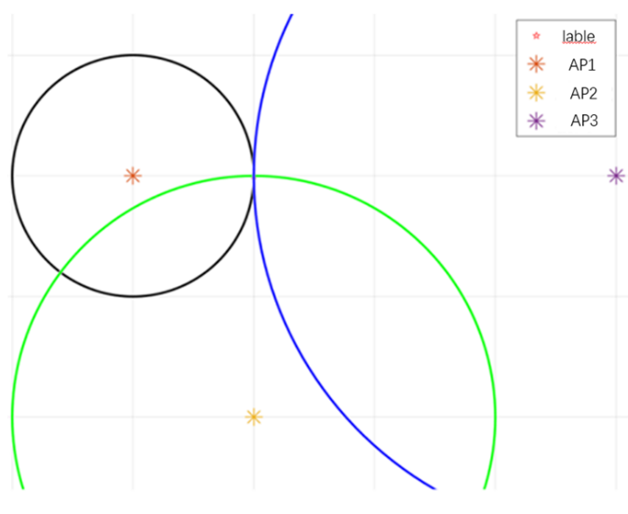
The key to the TOA algorithm is to measure the propagation time of the signal from the base station to the tag, and then multiply it by the propagation speed of the electromagnetic wave to indirectly measure the distance from the tag to the base station [41]. In space, TOA algorithm must be used to achieve positioning，Then at least the distance between the tag and three base stations needs to be measured. The original positioning of this algorithm is shown in Figure 2-1.
Figure 2-1 Schematic diagram of TOA positioning principle
Assume that there are base stations A1, A2,..., An in the plane area, and the coordinate positions of these base stations are $A_{i}=(x_{i},y_{i})$, where i = 1,2, …, n. The measured signal flight time from the tag to each base station is t1-tn, and the distance d1-dn between the tag and the base station can be calculated. Assuming there is no measurement error, draw a circle with each base station as the center and the measured distance from the base station to the tag as the radius. All circles will intersect at one point, which is the position coordinate T (x, y) of the tag to be found. . The calculation method is shown in formula (2-6).
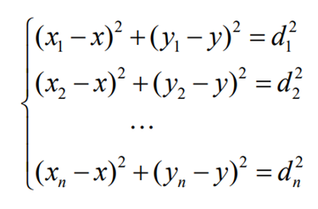 | (2-6)
Through the simultaneous formula (2-6), the coordinates to be positioned T (x, y) can be calculated.
(1) TDOA positioning algorithm
The TDOA algorithm is based on measuring the propagation time of the signal from the tag to each base station, and then calculating the time difference between any two base stations receiving the signal, thereby indirectly calculating the distance difference between the tag and the two base stations [30]. According to the definition of a hyperbola, a hyperbola can be drawn by taking the position coordinates of the two base stations as the focus and the distance difference to the focus as a constant value. In the same way, when the number of base stations reaches more than 3, the distance difference between the tag and multiple base stations can be calculated, and multiple hyperbolas can be drawn. Under ideal circumstances, the intersection point formed by multiple hyperbolas is the undetermined The position of the bit label. The solution method of TDOA algorithm is shown in formula (2-7).
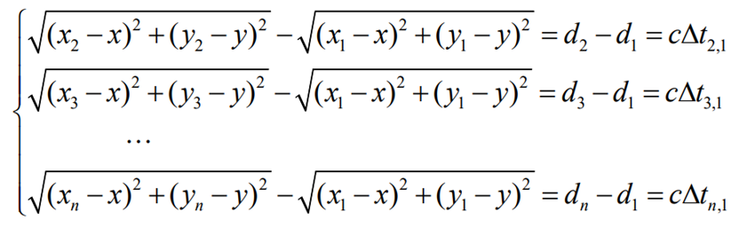 | (2-7)
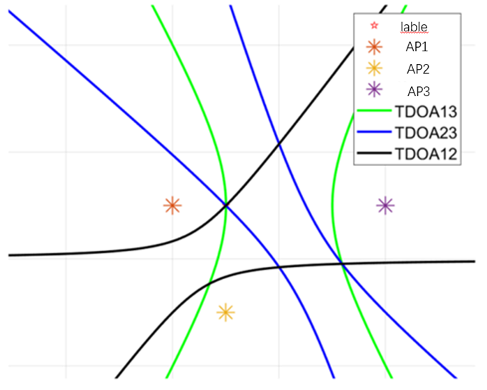
The principle of TDOA algorithm is shown in Figure 2-2.
Figure 2-2 TDOA algorithm principle diagram

Factors affecting UWB positioning
Since the UWB positioning algorithm is often based on measuring the flight time of the signal and multiplying it by the propagation speed of the electromagnetic wave to indirectly measure the distance from the tag to each base station, and the propagation speed of the electromagnetic wave is equal to the speed of light, when there is a slight error in the measured time, it will cause UWB Positioning accuracy deteriorates sharply. Therefore, it is important to study the influencing factors of UWB positioning accuracy. Common influencing factors include the following:
(1) Impact of non-line-of-sight error
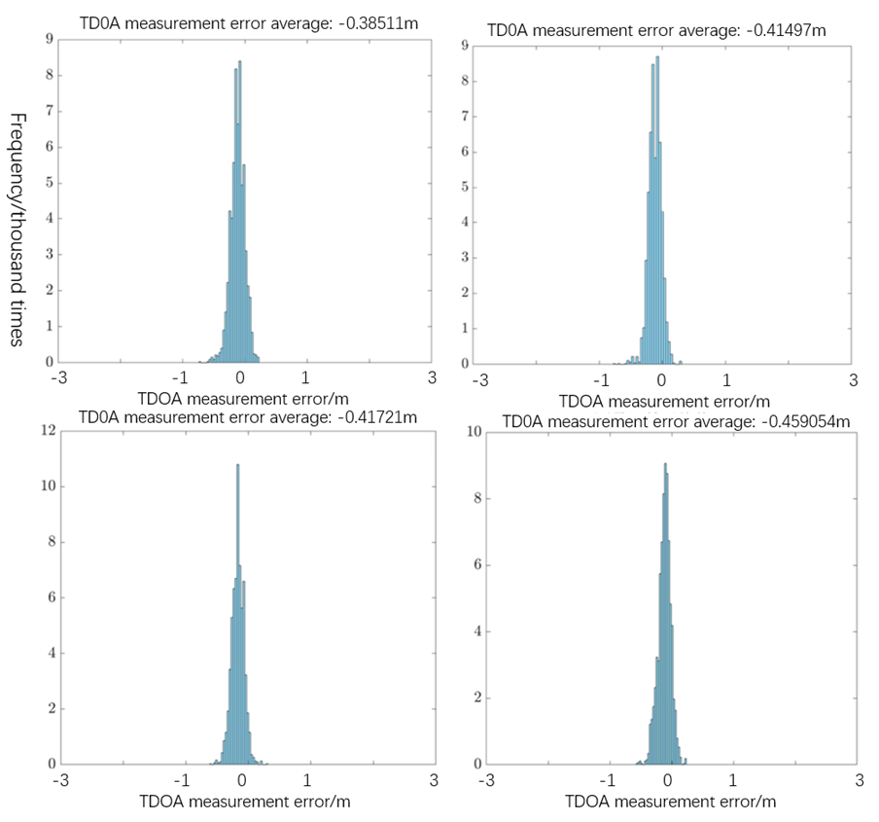
The signal propagation environment can generally be divided into two categories: line-of-sight LOS and non-line-of-sight NLOS. As the name suggests, line-of-sight communication means direct point-to-point communication between the signal transmitter and receiver in the communication system, while non-line-of-sight means that there are obstacles blocking the signal propagation process [31]. Common non-line-of-sight situations include wall obstruction and obstruction by obstacles. Signal attenuation occurs when the signal is blocked by obstacles. Non-line-of-sight error is the most common in UWB positioning systems and is one of the most critical factors affecting positioning accuracy. Therefore, many current studies focus on how to identify non-line-of-sight scenes in UWB positioning and correct the positioning results through the corresponding NLOS error elimination algorithm to improve the positioning accuracy of the system. Aiming at the impact of non-line-of-sight errors, a public UWB positioning data set was selected for experiments. This data set contains the results of line-of-sight and non-line-of-sight TDOA positioning of two base stations by tags at different locations under multiple base stations. The tags measured thousands of sets of TDOA values at each location. Multiple sets of data were selected for experiments based on this data set, and TDOA measurements were performed on the labels in the LOS environment. The experimental results are shown in Figure 2-3.
Figure 2-3 TDOA measurement in LOS environment

(2)Multipath effect (Multipath-Effect, MP) impact
The general positioning environment is complex and changeable. In actual positioning, due to the existence of obstacles in the space, signals will be reflected and scattered on these obstacles. After the signal is reflected and scattered by obstacles, it reaches the receiving end in multiple paths. The signal phases on these different paths are often different. If the phases of the multi-channel signals are the same, it will lead to an enhancement of the signal strength at the receiving end. If the phases are different, it will lead to an attenuation of the signal strength [32]. At the same time, if the signal reaches the receiving end through reflection, it will inevitably cause a delay in signal propagation time. The enhancement and attenuation of signal strength and time delay caused by the superposition of multiple signals mentioned above are called multipath effects.
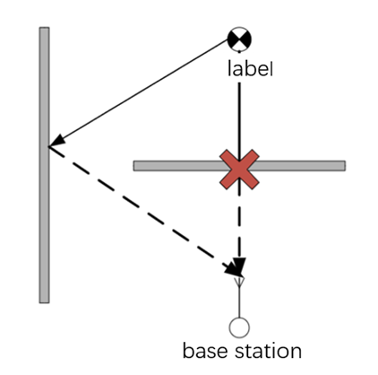
Common scenarios of multipath effects are shown in Figure 2-4. It can be observed from Figure 2-4 that there are two UWB signals from the tag to the base station, and the shortest straight-line propagation path is blocked by the wall, which may cause delay. If the first path signal received by the base station is a signal reflected from the wall, the propagation time of the signal in space after reflection must be greater than the time required for straight-line propagation, and the propagation speed of electromagnetic waves is extremely fast, and a slight time delay Both can bring large ranging errors. Therefore, this phenomenon will also seriously affect the positioning accuracy of UWB.
图 2-4 多径效应场景图
(3) Effect of clock offset
The TOA positioning method achieves positioning by measuring the signal flight time from the tag to each base station, so the clocks between different base stations are required to maintain strict synchronization. The TDOA positioning method does not have as high requirements for clock synchronization accuracy between base stations as the TOA method. Generally, each UWB positioning base station has a crystal oscillator inside, and these crystal oscillators provide accurate clock signals for the base station. However, crystal oscillators are often affected by changes in the working environment and attenuation of long-term working performance. Frequency deviations may occur, resulting in time desynchronization between base stations and subsequent increase in positioning errors. To address this problem, Kalman filtering is generally used for optimization to reduce the impact of increased positioning error caused by clock offset.

2.1.3 Improved Chan-Taylor positioning algorithm
The positioning principle of TDOA is to directly solve the nonlinear hyperbolic equations. The Chan algorithm first linearizes the nonlinear hyperbolic equations, and then estimates the optimal value of the label's position to complete the positioning.
The Taylor algorithm is a relatively efficient algorithm for solving nonlinear equations such as TDOA. It is also called the Taylor series expansion method. The main process of Taylor algorithm is as follows.
1) Select the position estimate as the initial value for iteration, which must be closest to the initial position;
2) Select the positioning accuracy according to the actual situation. The positioning accuracy affects the number of iterations;
However, since the Chan positioning algorithm involves two position estimates, and the accuracy of the first position estimation directly affects the final position estimation result, it is considered to introduce an optimization algorithm in the first position estimation to improve the accuracy of the estimate. As a classic optimization algorithm, the simulated annealing algorithm is widely used because of its advantages of relatively simple algorithm and strong robustness. The simulated annealing algorithm is borrowed from the annealing process of solids. When the solid is at a high temperature, the molecules inside the solid are in high-speed motion. If the solid continues to cool down, the motion of the internal molecules will also slow down. When the solid temperature drops to normal temperature, the motion of the molecules tends to be stable. The simulated annealing algorithm is to randomly find the global optimal solution of the objective function in the solution space by simulating the process of solid annealing. The schematic diagram of the simulated annealing algorithm is shown below.The positioning principle of TDOA is to directly solve the nonlinear hyperbolic equations. The Chan algorithm first linearizes the nonlinear hyperbolic equations, and then estimates the optimal value of the label's position to complete the positioning.
The Taylor algorithm is a relatively efficient algorithm for solving nonlinear equations such as TDOA. It is also called the Taylor series expansion method. The main process of Taylor algorithm is as follows.
1) Select the position estimate as the initial value for iteration, which must be closest to the initial position;
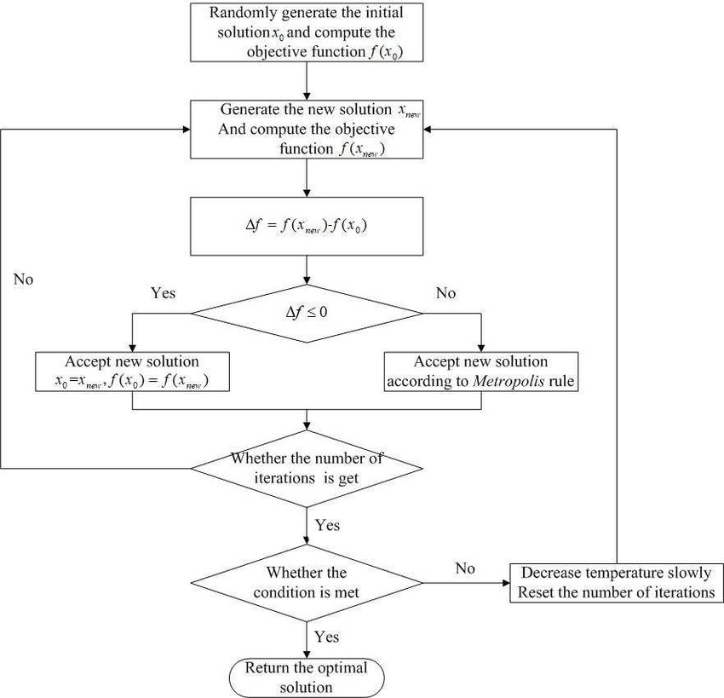
2) Select the positioning accuracy according to the actual situation. The positioning accuracy affects the number of iterations;
Figure 2-5 Principle diagram of simulated annealing algorithm
However, since the Chan positioning algorithm involves two position estimates, and the accuracy of the first position estimation directly affects the final position estimation result, it is considered to introduce an optimization algorithm in the first position estimation to improve the accuracy of the estimate. As a classic optimization algorithm, the simulated annealing algorithm is widely used because of its advantages of relatively simple algorithm and strong robustness. The simulated annealing algorithm is borrowed from the annealing process of solids. When the solid is at a high temperature, the molecules inside the solid are in high-speed motion. If the solid continues to cool down, the motion of the internal molecules will also slow down. When the solid temperature drops to normal temperature, the motion of the molecules tends to be stable. The simulated annealing algorithm is to randomly find the global optimal solution of the objective function in the solution space by simulating the process of solid annealing. The schematic diagram of the simulated annealing algorithm is shown below.
The main implementation steps of this algorithm are as follows:
(1) Set the algorithm parameters: cooling rate r, initial temperature $T_{0}$, lower temperature limit $T_{e}$ ;
(2) Randomly generate the initial solution$S_{0}$ and calculate the objective function value$J\left(S_{0}\right)$;
(3) Set the iteration initial value $u=0$ ;
(4) Randomly perturb the current solution and generate a new solution $s_{1}$;
(5) Calculate the objective function value $J\left(S_{1}\right)$, and calculate the increment $ΔJ=J\left(S_{1}\right)-J\left(S_{0}\right)$;
(6) Determine whether the increment ΔJ is less than 0. If ΔJ<0, accept $S_{1}$ as the new current solution; if ΔJ>0, perform optimization according to the Metropolis criterion. The Metropolis criterion is shown in formula (2-8).
(7) Determine whether the end condition of the current temperature iteration is met. If u<L, u=u+1, proceed to step 4, otherwise continue to step 8;
(8) Determine whether the current temperature is less than the set lower temperature limit $T_{e}$. If the current temperature is less than the lower temperature limit, output the optimal solution and the simulated annealing algorithm ends here; otherwise, use formula (2-37) for cooling processing, and then execute Step (3).
The Metropolis criterion is the key to the simulated annealing algorithm being able to converge to the global optimal solution. Assume that the current state of the system is X(n). After being disturbed, the state changes to X(n+1), and the energy also changes from E(n) to E(n+1). When the system changes from state X(n) to X(n+1), the reception probability p is calculated as shown in formula (2-8).
$$p=\left\{\begin{aligned}1, E(n+1)<E(n) \\ e^{\frac{E(n+1)-E(n)}{-T}},E(n+1)≥E(n)\end{aligned}\right.$$ | (2-8)
T in formula (2-36) is the current temperature. When a state transition occurs, if the energy decreases, the transition is accepted; conversely, if the energy increases, it means that the system is getting farther and farther away from the global optimal position. At this time, the transfer is not directly rejected, but is judged based on probability. First, a random number ε is generated in the range [0,1]. If the value of the random number is less than the reception probability p, the transfer will be accepted; if the value of the random number is greater than the reception probability p, the transfer will be rejected. . This criterion can be used to jump out of the local optimum with a certain probability to find the global optimal solution when falling into the local optimum. Since the value of p is related to the change in energy and T, the value of p changes dynamically.

Improved Chan-Taylor cascade positioning algorithm based on simulated annealing algorithm
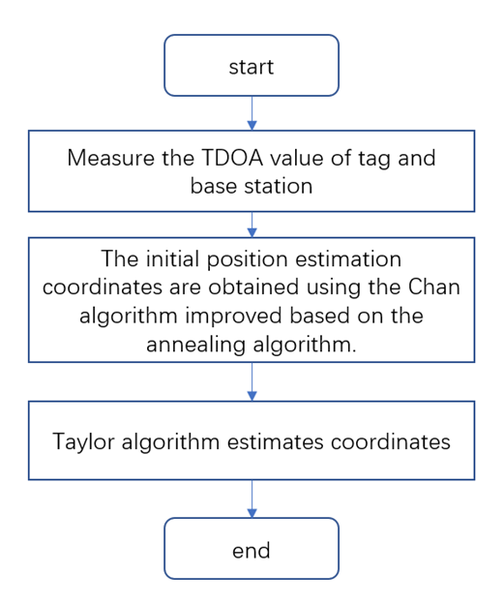
Since the estimated value of the initial position has a great influence on the Taylor positioning algorithm, if the error of the initial position estimate is large, it will lead to an increase in the Taylor positioning error. The higher the accuracy of the initial position estimate, the lower the positioning accuracy of the Taylor positioning algorithm. will increase accordingly. In the previous section, the simulated annealing algorithm was introduced to improve the position estimation accuracy of the Chan algorithm. Therefore, this section considers cascading the improved Chan algorithm with the Taylor algorithm, using the improved Chan algorithm to optimize the initial position,
Figure 2-6 Improved Chan-Taylor cascade positioning algorithm
and then the optimized The initial position is substituted into the Taylor algorithm for iterative positioning, thereby improving the accuracy of the Taylor algorithm and further improving the positioning accuracy of the entire system. The flow chart of the Chan-Taylor cascade positioning algorithm based on the simulated annealing algorithm is shown in Figure 2-6.
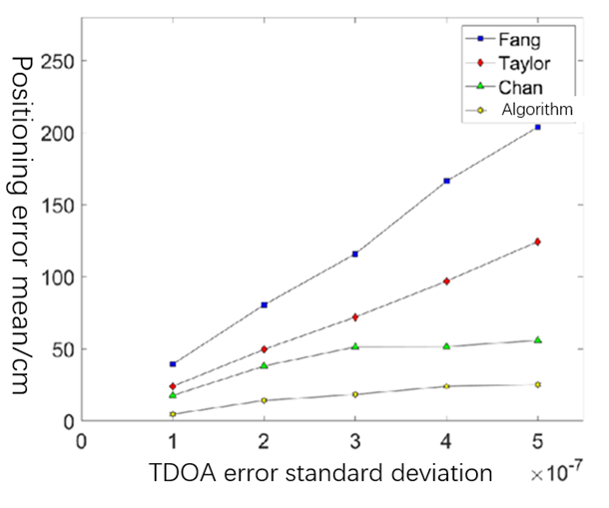
The Chan-Taylor cascade positioning algorithm designed above based on the simulated annealing algorithm is simulated. The number of base stations is set to 4. It is assumed that the measurement errors obey the standard deviations of 0.1, 0.2, 0.3, 0.4 and 0.5s respectively, and the average value is for the ideal Gaussian distribution of 0, select the initial temperature $T_{0}$=50, the lower temperature limit $T_{e}$=10, the number of iterations 20, and the cooling coefficient r =0.9. At the same time, the proposed algorithm is compared and analyzed with Fang algorithm, Chan algorithm and Taylor algorithm. The simulation results are shown in Figure 2-7。
Figure 2-7 Error comparison of different positioning algorithms
It can be seen that the positioning error of the algorithm proposed in this article is greatly reduced compared with the Chan algorithm and Taylor algorithm, which proves the effectiveness of the proposed algorithm.

UWB positioning environment identification and error suppression based on multi-layer perceptron model

2.2.1 Scene layout
Through analysis, the error value of UWB signals in the NLOS environment is much larger than that in the LOS environment. In order to optimize the positioning effect of the UWB/INS combination, it is particularly important to suppress the non-line-of-sight error in UWB ranging. This section will use machine learning methods to use various UWB signal parameter strengths collected by UWB devices in line-of-sight and non-line-of-sight environments to build and train models to identify LOS and NLOS situations between tags and each base station. . After completing the identification of LOS and NLOS, base stations can be selected in a targeted manner, and base stations under line-of-sight can be selected for positioning, thereby improving positioning accuracy. Therefore, UWB data collection and data set production were carried out using the UWB equipment in the laboratory. The equipment used for this data collection is LinkPG2.5 from Guangzhou Network Technology Co., Ltd. This set of equipment has 1 tag and 4 base stations. Base station A is the main base station and needs to be connected to the computer through the serial port. The other base stations and tags The entire system is powered by a power bank. According to the official documentation of LinkPG2.5, the operating bandwidth of the device is between 3.5GHz and 6.5GHz, and the power spectral density is -41.3dBm/MHz, which complies with international standards for UWB devices. The equipment used for this data collection is shown in Figure 3-1. According to the official documentation of LinkPG2.5, in addition to collecting distance information between tags and base stations, the device can also measure signal parameters such as channel impulse response CIR.
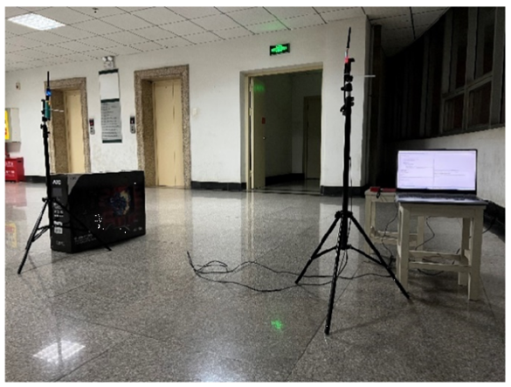
The layout of the data collection site is shown in Figure 2-8.
Figure 2-8 Data collection site layout
Among them, the main content of the data is: the maximum noise value of the UWB signal, the noise standard deviation, the first path peak, the second path peak, the third path peak, the maximum impulse response of the channel, the number of received preambles, and the first path reception strength. and information on signal reception strength.
Among them, the first path receiving strength First-Path-Power and the signal receiving strength Rss are not directly measured by the device, but calculated through formulas. The calculation method of the first path receiving strength is as shown in formula (2-9).
$$First_Path_{-}Power=10*\log_{10}⁡(\frac{F_{1}^{2}+F_{2}^{2}+F_{3}^{2}}{N^{2}})-A$$ | (2-9)
In formula (3-1), F1, F2 and F3 represent the first path peak, the second path peak and the third path peak respectively, N is the number of received preambles, and A is a fixed value of 121.74. The unit of received strength of each path is dBm.
The calculation of signal reception strength Rss is shown in formula (2-10).
$$R_{SS}={10}^{*}log⁡(\frac{C^{*}2^{17}}{N^{17}})-A$$ | (2-10)
C in formula (3-2) uses the maximum impulse response of the channel max_growth_CIR. Other variables are the same as in formula (3-1). The signal reception strength unit is dBm.
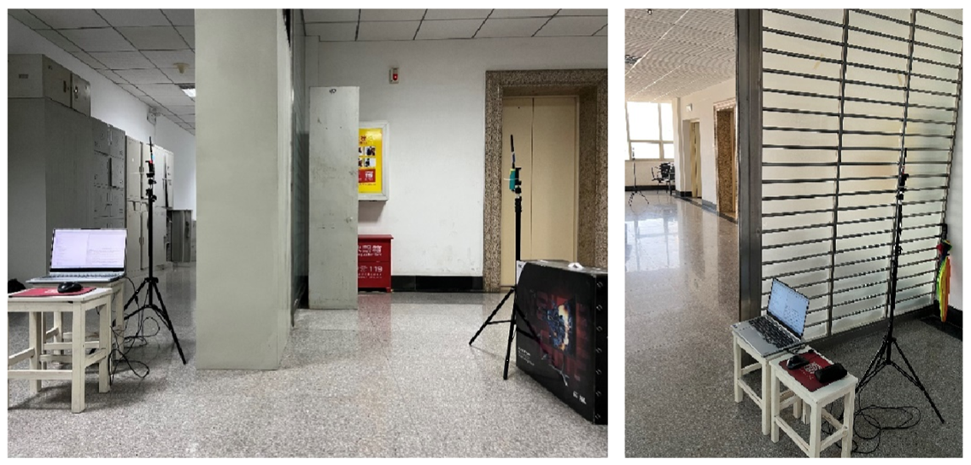
For data collection in the NLOS environment, iron bookshelves and glass doors were selected as obstacles. The data collection layout in the NLOS environment is shown in Figure 2-9.C in formula (3-2) uses the maximum impulse response of the channel max_growth_CIR. Other variables are the same as in formula (3-1). The signal reception strength unit is dBm.
Figure 2-9 Non-line-of-sight scene layout
For data collection in the NLOS environment, iron bookshelves and glass doors were selected as obstacles. The data collection layout in the NLOS environment is shown in Figure 2-9.
In this data collection work, 160 locations were collected in the LOS environment, and UWB signals at 215 locations were collected in the NLOS environment. The NLOS environment includes situations where glass is blocked and iron bookshelf blocks. 200 sets of data were collected at each position, for a total of 75,000 sets of data.

2.2.2 Location recognition based on multi-layer perceptron
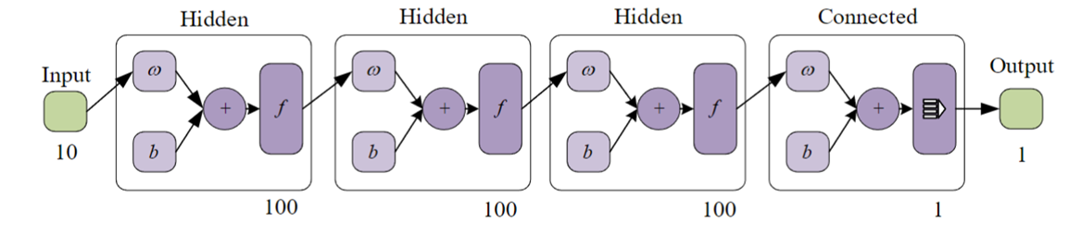
The training model built is a 6-layer multi-layer perceptron model, which contains 3 hidden layers. The structural diagram of the model is shown in Figure 2-10. The input layer reads the 10-dimensional feature matrix, inputs the 10-dimensional data into the first hidden layer, and the first hidden layer outputs 100-dimensional data. The input and output dimensions of the second and third hidden layers are set. is 100, the fourth fully connected layer processes 100-dimensional data and outputs 1-dimensional data. Finally, the recognition result is output through the output layer.
Figure 2-10 Multi-layer perceptron model built
When training with the above two models, the data set is divided into a training set and a validation set at a ratio of 8:2. Select the label column as the label and set the maximum number of cycles to 20,000. When the loss value does not decrease after 100 rounds, the training will be terminated. Both models adopt a dynamic learning rate mechanism, with the initial learning rate set to 0.001. When the training cycle reaches 300 and 1200 times, the learning rate is reduced to 0.1 times the previous one, allowing the network to accelerate convergence in the right direction. Among them, each hidden layer uses ReLU as the activation function, and Batch Normalization is used for batch normalization processing. And weight decay is introduced in the second multi-layer perceptron model for L2 regularization to prevent overfitting. When the loss value decreases, save the model until the end of training.
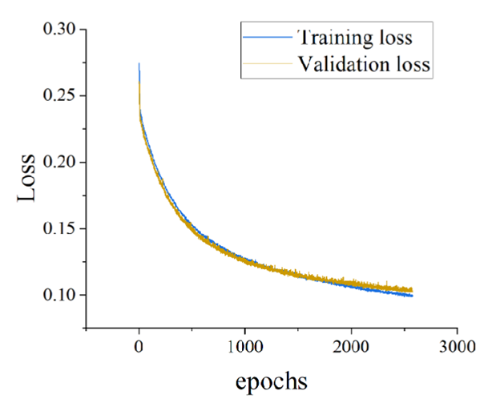
Use the built multi-layer perceptron network to perform LOS/NLOS identification on the verification set. The loss curves of the training set and verification set of Model 1 are shown in Figure 2-11.
Figure 2-11 Model 2LOS/NLOS recognition training set and validation set loss values
The average positioning accuracy error was finally calculated to be below 0.45m, and the loss finally tended to converge. It can be seen that the accuracy of the model is high, which is enough to verify the feasibility of the model.

Positioning method based on 5G

3.1 Fingerprint-based positioning method
For positioning based on the signal propagation model, according to the characteristics of the signal propagating in space and attenuating with distance, a wireless ranging model can be established, and then the received signal (RSS or CSI) is brought into the model to estimate the distance between the receiver and the transmitter distance. Wireless ranging models are usually based on a large number of RSS or CSI measurement values, combined with mathematical modeling methods to establish mathematical expressions of received signals and distances. The basic assumption of the simplest propagation model is that the propagation path loss of a wireless signal is inversely proportional to the square of the propagation distance. However, there are many obstacles in the complex internal environment of buildings, resulting in multiple transmission paths with varying degrees of delay, attenuation and phase between the receiver and transmitter. Usually the RSS in the indoor monitoring area is measured, and an accurate loss model is fitted by adding an error correction amount. The commonly used attenuation factor model is
$$P=P_{0}+10nlog⁡(\frac{d+v}{d_{0}})+ξ$$ | (3-1)
Among them, P is the received signal strength, d0 is generally taken as 1 meter, P0 is the received signal strength at a distance of 1 meter, d is the distance from the receiver to the transmitter, ξ is the shadowing factor with a mean value of 0, and n is different environments The loss factor in , v is the distance estimation error with a mean value of 0.
During positioning, based on the collected RSS signals, the signal propagation model is used to calculate the distance between the node to be positioned and the known node. If the distance to three different nodes can be obtained, the trilateral positioning method can be used to calculate the coordinates of the moving target. Most devices that communicate through wireless methods can easily extract RSS, so RSS-based propagation model positioning can be integrated on existing portable mobile terminals. However, obstruction by indoor obstacles or walls will cause non-line-of-sight propagation and multipath effects of indoor signals, causing RSS at certain locations to not comply with the propagation model. Since the accurate signal arrival time and angle of arrival cannot be measured, the accuracy of the positioning method based on the signal propagation model is greatly reduced.
The positioning method based on the fingerprint database can solve the problem of inaccurate distance or arrival angle measurement and improve the positioning effect to a certain extent. The fingerprint method uses the RSS or other features of the received signal at different locations as fingerprints, establishes the mapping relationship between spatial location and fingerprint, uses machine learning and other methods to build an indoor positioning model, matches the collected signals with the location, and estimates the location of the target to be located. Location. As shown in Figure 3-1, the fingerprint-based positioning method can be divided into an offline training stage and an online testing stage. Replacing methods based on geometric measurements and propagation models with fingerprint methods can overcome the negative impact of multipath effects.
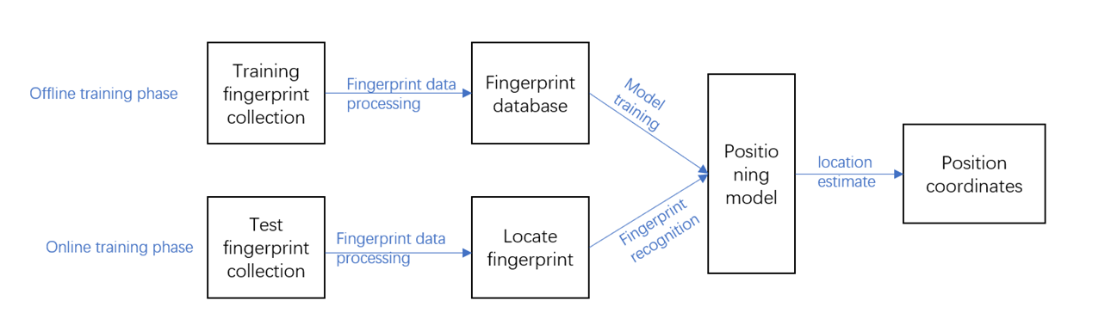
Figure 3-1 Positioning method based on fingerprint database
In the offline training phase, multiple reference points (RP) are first set up in the area to be positioned, and wireless signals or other features are collected at each RP, usually RSS, CSI, geomagnetic signals or images. After data processing such as removing abnormal points and noise, a unique fingerprint for each RP is formed, and a positioning fingerprint database is constructed. Finally, use these fingerprints to train machine learning and other positioning models and save them. In the online testing phase, new signal features are first collected at different locations. After data processing, the saved positioning model is used to match the fingerprints to be located with the fingerprints in the fingerprint database. Based on the most similar fingerprints, the target to be located is predicted. Possible location.
The most critical positioning method based on fingerprint database is the fingerprint matching process, which is mainly divided into three categories: K nearest neighbor algorithm [33], Bayesian classification algorithm [34] and convolutional neural network algorithm. The fingerprint positioning algorithm based on KNN usually takes the first K similar predicted positions, and estimates the position of the target to be located by calculating the average of these position coordinates. The Bayesian classification algorithm calculates the posterior probability that the relevant features received by the target to be located appear at each position, and obtains the positioning result according to Bayes' theorem. Convolutional neural network avoids the process of artificial feature design and can efficiently extract features from high-dimensional data through weight sharing. It is the most commonly used method for fingerprint matching.

3.1.1 Principle of fingerprint positioning technology
Because of its high positioning accuracy, fingerprint-based Wi-Fi positioning methods are gradually favored by more and more researchers [35]. In previous fingerprint positioning systems, Received Signal Strength (RSS) was often the first choice to serve as a fingerprint due to its simplicity of principle and lower requirements for hardware [36]. For example, Radar is a deterministic algorithm whose fingerprint is based on RSS and is the first fingerprint system to use radio frequency (Radio Frequency, RF) for positioning. Subsequently, the Horus system uses the received signal strength to estimate the target position using a probabilistic method [37]. This RSS-based approach has two disadvantages. First, none of them can avoid the effects of multipath fading and shadowing. For a fixed location, the RSS value usually changes greatly over time. Even for fixed equipment, such high variability can lead to large positioning errors. In a normal indoor environment, the RSS value changes from -88 dBm to -58 dBm, with a maximum fluctuation range of 30 dBm. Even after filtering, ripple values can reach 10 dBm [38]. This shows that even small changes in the signal on one path can have a large impact on the sum of all links. Secondly, the RSS value is rough information. In an Orthogonal Frequency Division Multiplexing (OFDM) system, the RSS value does not utilize many subcarriers to obtain richer multipath information. Therefore, the fingerprint positioning method based on received signal strength has poor positioning performance and low positioning accuracy. Therefore, it is particularly important to find more efficient information as fingerprints. Wang et al. used the signal-to-noise ratios (SNRs) of various locations in indoor space as fingerprints to achieve higher-precision positioning [39].
As a new measurement indicator, Channel State Information (CSI) is a kind of fine-grained physical layer (Port Physical Layer, PHY) information that can provide detailed CSI at the subcarrier level, which has attracted the attention of researchers. Some existing works have been focused on and have been completed to solve the CSI-based indoor positioning problem. Channel state information, which is a promising positioning property, has gradually been used as an enhanced channel metric in indoor positioning schemes. Research shows that the accuracy of indoor position estimation based on CSI is significantly higher than RSS [38]. Jin et al. [39] proposed using the vector of the Approximate Channel Impulse Response (ACIR) amplitude as a fingerprint, and applied the Nonparametric Kernel Regression (NKR) method to position estimation. Song et al. [40] used the amplitude value of CSI as a fingerprint, used Multidimensional Scaling (MDS) to reduce the dimension, and used the K Nearest Neighbor (KNN) algorithm for positioning. The above methods all achieved performance far exceeding that of RSS fingerprints. Some network cards that comply with the IEEE 802.11n standard can express the received signal in the form of CSI, which can provide users with the amplitude and phase values of each subcarrier of the signal at the subcarrier level, which provides us with data collection. convenient. And with the rise of 5G communication networks, Massive MIMO (MaMIMO), as an emerging technology used in 5G communications, can greatly improve the spectrum efficiency of wireless systems. This technology combines a large number of base station (BS) antennas with based on measured The channel state information (CSI) signal processing is combined to further improve the expressive ability of the CSI signal [41]. To sum up, this article decided to use an indoor positioning system based on the CSI fingerprint database.
Although the fingerprint positioning solution has the advantage of high positioning accuracy, the work of building a fingerprint database is indeed quite time-consuming and laborious. In order to solve this dilemma, many engineers have also conducted a lot of research. Some researchers have proposed a fingerprint data recovery method, which uses compressed sensing to recover the complete fingerprint database data information from incomplete fingerprint data at the cost of minor errors [42]. There is also a Gmap method, which can measure the relatively stable RSSI value near the target position and use the gradient value of the RSSI to construct a gradient fingerprint database [43]. In addition, there is a special fingerprint collection technology that detects the wireless access point (AP) of the Wi-Fi transmitter and uses the signal information collected from the ZigBee interface to form a special Wi-Fi fingerprint [44]. There is an iUpdater positioning system, which is a device-free positioning system based on RSSI fingerprints. It can continuously measure based on a fingerprint database with missing data on the premise that there are few reference positions, and continuously update using newly measured RSSI data. Fingerprint database, this method can significantly reduce the manpower required to collect data. In addition, the system can use updated data to further continuously improve positioning accuracy [45]. In addition, some scholars have proposed a method called Ac Mu, which uses a trajectory matching algorithm to locate moving user targets [46].

3.1.2 Beamforming technology in 5G
In short, beamforming in 5G uses two key innovations to differentiate it from traditional beamforming methods: Massive MIMO and the application of millimeter wave frequency bands.
In 5G, denser antenna arrays are introduced, often numbering more than 100 [47]. This equates to hundreds of independent channels for users, an innovation that significantly reduces the likelihood of signal fading. At the same time, the combination with millimeter wave technology further improves signal quality and coverage. Massive MIMO technology introduces more beam options to 5G, which not only improves the gain of the signal, but also greatly reduces the probability of multiple channels fading at the same time. This is crucial for improving the signal quality of reference signals (such as Positioning Reference Signal, PRS) in 5G, especially for indoor positioning. In addition, more antennas mean more channels, which means that the receiving end device can extract more channel information from the transmitting end, such as CSI-RS, which facilitates the subsequent extraction of advanced information.
To sum up, 5G beamforming technology uses Massive MIMO and millimeter wave bands to provide users with more independent channels, improve signal quality, expand coverage, and provide stronger support for applications such as indoor positioning. It has the following advantages:
Higher transmission speeds: By using large-scale antenna arrays, 5G can achieve higher transmission speeds. This means users can download and upload large volumes of data in less time, providing a smoother experience for a variety of applications, such as HD video streaming, virtual reality and cloud computing.
Anti-interference capability: Beamforming technology can selectively point at the signal source, thereby reducing the impact of external interference. This enables 5G signals to perform well in high-density, high-interference urban environments, improving communication reliability and stability.
Indoor positioning and navigation: 5G beamforming provides powerful support for indoor positioning and navigation. Through more accurate signal transmission and positioning technology, 5G can achieve precise positioning in indoor environments, providing new possibilities for indoor navigation, IoT applications, and security monitoring.
Enhanced network capacity: Massive MIMO technology and beamforming can increase network capacity several times, which is critical to cope with growing data demands. 5G can better meet the communication needs of large-scale connections, IoT devices, and high-density users.
The future of mobile communications: Beamforming is one of the cores of 5G technology [47] and the foundation of future mobile communications networks. It not only improves network performance, but also provides more potential for the development of 5G and its subsequent versions, such as 6G. This will promote the continuous evolution of communication technology to meet the needs of the future digital society.

3.1.3 5G multi-beam fingerprint positioning method
The fingerprint positioning process of this algorithm can be divided into two main stages to meet the challenges of indoor positioning. The first stage is an offline stage, aiming to build a multi-beam CSI-RS signal fingerprint database, which will be used for model training and verification. The second stage is the online positioning stage.
In the field of indoor positioning, traditional fingerprint positioning methods are usually based on WIFI fingerprint positioning. However, WIFI fingerprint positioning technology is limited by the performance of indoor WIFI repeaters, including insufficient bandwidth, low signal gain, limited coverage, and poor real-time performance. Especially in complex indoor environments, the WIFI fingerprint indoor positioning method may produce large positioning errors. In addition, when multiple devices need to be positioned, there may be insufficient bandwidth to meet various indoor positioning needs.
On the other hand, traditional wireless communication technologies, such as LTE, suffer from severe signal attenuation in indoor environments due to problems such as antenna power and transmission distance, and can hardly meet positioning requirements.
In order to deal with the above problems, this paper adopts a multi-beam fingerprint positioning method based on dense array hybrid beamforming technology. This method uses dense array beamforming technology in 5G signals to provide high-gain millimeter wave signals, providing a high-quality signal basis for indoor positioning. In addition, compared with LTE, 5G can receive more beams at the receiving end or device end, which greatly enriches the offline fingerprint database, thereby improving the accuracy of the model and achieving more accurate positioning results. At the same time, thanks to the deployment of 5G ultra-dense cells, the receiving end can receive signals from multiple transmitting ends at the same time, which not only obtains a large amount of useful information, but also ensures signal continuity, further improving positioning reliability. This comprehensive approach effectively overcomes the limitations of traditional methods and provides an innovative solution for indoor high-precision positioning.

3.1.4 Feature selection - CSI-RS and other signals
Nowadays, the OFDM [48] system is widely used in the communication field. The application of OFDM allows CSI to express the amplitude and phase of different subcarrier signals, and penetrate the signal into the subcarrier level, thereby having better expression capabilities. In order to obtain CSI information in the form of subcarrier amplitude and phase, some standard vendors obtain this information by using commercial wireless network cards that comply with the IEEE 802.11n standard coupled with corresponding software applications. The most common method now is to use the fine-tuning mode of the Intel5300 network card and use a dedicated software receiving package to obtain the CSI data received by the network card.
For the CSI signal matrix under the OFDM system, amplitude and phase are the two most valuable types of information. However, because the amplitude is relatively stable and easy to process at the sub-carrier level and the phase changes greatly due to environmental influences, most of the current Fingerprint positioning research based on CSI only uses subcarrier signal amplitude values as positioning information. This approach itself is a waste of existing information resources and cannot fully utilize the full value of CSI information. With the development of machine learning and the powerful computing power of deep learning, it is no longer difficult to incorporate the phase information of CSI into fingerprint information indicators.
Massive MIMO (MaMIMO) is an emerging technology used in 5G communication networks [49], which can greatly improve the spectral efficiency of wireless systems. This technology is achieved by combining a large number of base station (BS) antennas with signal processing based on measured channel state information (CSI), which is estimated during uplink transmission using pilot sequences. of [50]. The combination of a large number of antennas and precise CSI allows the BS to multiplex users in the spatial domain. At the same time, the signal will be affected by the surrounding environment during propagation, and this signal with spatial multiplexing properties will reflect the environment during the propagation process. will be more obvious, so using it as a fingerprint can differentiate the environment to a greater extent. OFDM is orthogonal frequency division multiplexing technology. It is a kind of multi-carrier modulation technology. It uses frequency division multiplexing method to divide a frequency channel into multiple independent and orthogonal sub-channels. This This method realizes parallel transmission of high-speed serial data and has strong anti-interference ability. Since each subcarrier has different frequency characteristics, and the fading characteristics also have different manifestations in different frequency bands, the subcarriers have different amplitude and phase characteristics, which is also the basis for CSI information to be used for fingerprint positioning.
OFDM and MIMO are both applied in the IEEE 802.11n standard. Although MIMO technology improves the diversity of spatial expression of channel information, it does not effectively improve the problem of frequency selective fading. OFDM technology takes advantage of the characteristics of frequency selective fading to improve the diversity of signal frequencies. The CSI signal that combines these two technologies can simultaneously reflect the frequency characteristics and spatial characteristics of the signal physical layer, and can better reflect the physical environment of signal propagation. For RSSI data, CSI can reflect signal information from a more subtle perspective. It provides amplitude information and phase information on each subcarrier of the signal, which reliably guarantees the positioning accuracy of indoor positioning methods based on CSI information.

3.1.5 Establish fingerprint database in offline stage
In the first phase of the project, the first priority was to build an offline fingerprint database. When collecting database sample points, we can use two main methods: uniform sampling and random sampling. It is particularly worth noting that for the 5G communication system, we have adopted ultra-dense networking technology, which allows ultra-dense cells to be deployed more flexibly. In addition, 5G introduces the D2D (device-to-device) communication mode, allowing indoor devices with up to standard performance to act as relay nodes in dense networks, thereby increasing the diversity and information continuity of fingerprint samples.
We use multi-beam CSI-RS (Channel State Information Reference Signal) of multiple gNBs (5G base stations) to construct these fingerprint sample points. Therefore, this algorithm integrates multiple key technologies of 5G wireless communication, including millimeter wave communication, hybrid beamforming technology, and ultra-dense networking. The main information of each fingerprint sample comes from the CSI-RS signal, which contains three key measurement values: CSI Reference Signal Received Power (CSI-RSRP): used to represent the average contribution of the antenna port resource element power within the measurement bandwidth value. This measurement is critical for channel estimation. CSI Received Signal Strength Indicator (CSI-RSSI): Represents the linear average of the total received power observed on OFDM (Orthogonal Frequency Division Multiplexing) symbols in the presence of CSI-RS. It includes factors such as interference from the power supply and thermal noise. CSI Reference Signal Received Quality (CSI-RSRQ): This measurement is critical for evaluating channel quality, especially in high-speed mobile environments. Therefore, the CSI-RS signal is a very suitable sample for building a fingerprint database because it contains most of the key information required for channel estimation.
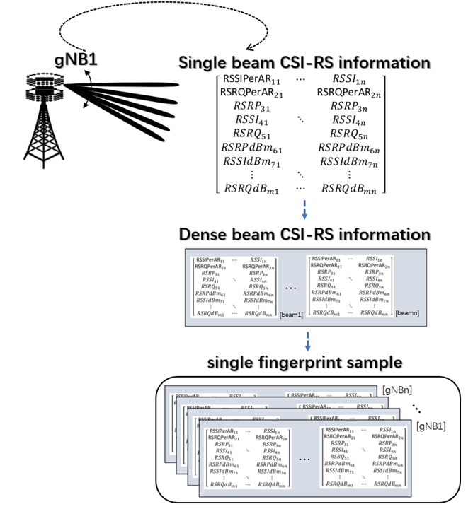
To sum up, the samples of our fingerprint database are supported by millimeter wave technology and dense array hybrid beamforming technology, and are three-dimensional vector groups composed of multiple base stations and multi-beam CSI-RS signals in ultra-dense networks. The collection process of each fingerprint sample is shown in Figure 3-2. This database will provide important support for subsequent location identification and communication optimization.
Figure 3-2 Single fingerprint sample collection process and sample form
From the above figure, we can observe that in signal base stations or network nodes in ultra-dense networks, technology with very large antenna arrays is used to send multiple beams at the same time. Each beam contains complete CSI-RS (Channel State Information Reference Signal) signal information, and its format is shown in formula (3-2). These CSI-RS information are not only used to construct fingerprint samples, but also can be used to create channel precoding matrices for signal estimation, which provides necessary information for subsequent 3D hybrid beamforming. When each base station transmits dense beams, we carefully select the top n beams with the strongest impulse response amplitude and combine them into dense beam CSI-RS information. This strategy not only significantly increases the information content of a single fingerprint sample, but also ensures higher signal gain for signals from multiple beams. After obtaining the dense beam CSI-RS information, considering that there are multiple base stations or network nodes in ultra-dense networking, we select the m nearest gNBs (5G base stations) to collect the dense beam CSI-RS information and combine it into a single fingerprint sample points. Normally, when the number of gNBs reaches 4, it is enough to use the fingerprint positioning method to achieve higher positioning accuracy. In order to ensure the training speed of the network model, the number of gNBs is generally limited to no more than 20. This set of strategies and processes makes full use of the characteristics of 5G technology, including ultra-dense networking, multi-beam transmission and channel estimation, to build high-quality fingerprint samples and provide a solid foundation for applications such as indoor positioning and communication optimization.
$$CSIRS_{matrix}= \left[\begin{matrix}RSSI_{11} & ⋯ & RSSI_{n1} \\ ⋮ & ⋱ & ⋮ \\ RSRQ_{1} & ⋯ & RSRQ_{n}\end{matrix}\right]$$ | (3-2)
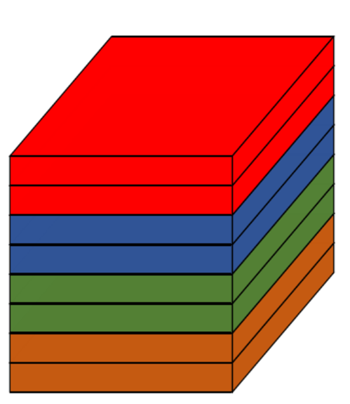
The above method obtains various values, and after connection, it can be visualized as shown in Figure 3-3 below.：
Figure 3-3 Schematic diagram of CSI fingerprint structure

3.1.6 Initial fingerprint library analysis
The diversity of the fingerprint database is very important for the accuracy of indoor positioning. The higher the diversity of data in the fingerprint database, the more locations the data can distinguish, and the stronger the expressive ability of the database. In order to ensure that the initial fingerprint database can meet the needs of subsequent positioning, it is necessary to conduct diversity analysis on the initial fingerprint database. This paper borrows the idea of the Average hash algorithm (AHA) [60], which is commonly used in image similarity comparison, to conduct fingerprint diversity analysis. The mean hashing algorithm calculates the hash fingerprint of the image and compares it with other images to obtain the Hamming distance to obtain the similarity between the two images. The process of the mean hashing algorithm is as follows: first reduce the size of the image to 8×8. The purpose of this step is to remove the high-frequency features and related details of the image, and only retain the light and dark features of the overall structure of the image; then convert the reduced image into 64 level grayscale value image, so that the entire image can only be represented by 64 colors, which simplifies the color of the picture; then calculate the average of the grayscale values ​​of these 64 pixels to obtain the average grayscale value of this picture; then Compare the 64 grayscale values of the picture with the average grayscale value just obtained. If the grayscale value is greater than the average grayscale value, set it to 1; if the grayscale value is less than the average grayscale value, set it to 0; finally, these The results of the comparison are combined to form a 64-bit integer, which represents the hash value of the image. To compare the similarity of two images, just compare the different number of digits (Hamming distance) of the hash values of the two images. The larger the Hamming distance means the greater the difference between the two pictures, the smaller the similarity. The smaller the Hamming distance means the smaller the difference and the greater the similarity between the two pictures.
The CSI fingerprint constructed in this article is very different from the picture. Although it has a similar three-dimensional data structure, it does not have the unique characteristics of the picture such as outline, light and shade, color, etc., but has its own unique antenna and subcarrier characteristics. Therefore, the steps and methods of the mean hashing algorithm cannot be copied in the analysis method of this fingerprint. We can only use its ideas to identify CSI fingerprints. Due to the particularity of the CSI fingerprint structure, its three dimensions represent the real and imaginary characteristics of the antenna, subcarriers and each transformation respectively. It can be clearly seen that each layer of data in the third dimension has obvious differences in terms of the relationship between data and the size of the values. Therefore, when judging fingerprint similarity, it is more appropriate to divide the data based on the third dimension for comparison. method.
Therefore, the CSI fingerprint similarity discrimination algorithm based on mean hashing is as follows:
Step 1: Divide the CSI fingerprint data into 8 independent data layers based on the third dimension, and calculate the overall average value of each layer {avg1 ~ avg8} in the format of 1×8.
Step 2: Divide these 8 independent layers again by the first dimension, which is the antenna dimension, and perform an average calculation every 4 rows, so that each layer has 16 different average values {avg1.1…avg1.16…1vg8 .16}, the format is 16×8.
Step 3: Compare the 16 values of each layer with the overall average value in step 1. If it is greater than the average value, it is set to 1, if it is less than the average value, it is set to 0. After the comparison is completed, the comparison results of the 8 layers are spliced together. , a 128-bit result can be obtained, which is the hash string iHashStr corresponding to the CSI fingerprint.
Step 4: Compare the hash string of the CSI fingerprint with the hash string jHashStr of other fingerprints in the fingerprint database bit by bit. The number of different bits (Hamming distance) represents the similarity between the fingerprint and the initial fingerprint database. The smaller the Hamming distance, the higher the similarity of the CSI fingerprints, and the smaller the gap; the larger the Hamming distance, the lower the similarity of the CSI fingerprints, and the larger the gap.
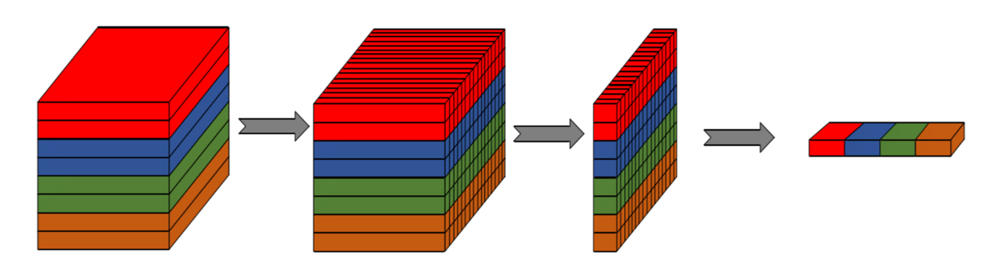
Figure 3-4 Flowchart of fingerprint similarity discrimination algorithm
Through experiments, it was found that nearly half of the digits differ between each set of fingerprints and the initial fingerprint database, which means that there is a huge difference between each set of data in the fingerprint database. The difference is obvious and the initial fingerprint database has good diversity. A high-diversity initial fingerprint database is the basis for high-precision positioning by subsequent fingerprint positioning methods, so it is particularly important to ensure the diversity of the fingerprint database.

3.2 network model

3.2.1 convolutional neural network
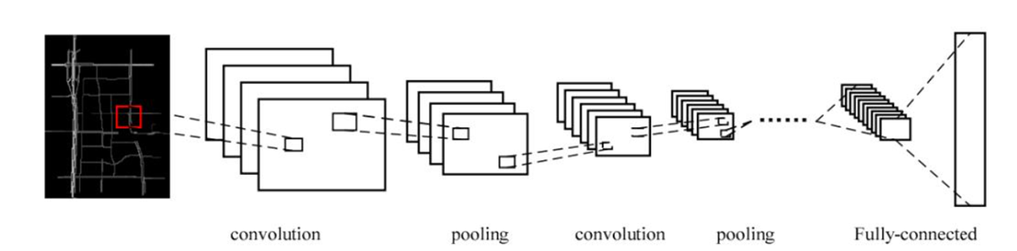
Convolutional Neural Networks (CNN) is a feedforward neural network with a deep structure. It is currently the main algorithm of machine learning [51] and is widely used in the field of image recognition. Through the application of convolution layer and pooling layer in the hidden layer, the convolutional neural network can learn the characteristics of the input image step by step. Extract and convert low-latitude features into high-latitude features. The convolutional neural network structure mainly consists of the following parts: input layer, convolutional layer, pooling layer, fully connected layer, and output layer. ). These neural layers will be introduced in detail below. The network architecture of the convolutional neural network is shown in Figure 3-5.
Figure 3-5 Schematic diagram of convolutional neural network structure
(1) Input layer
The data size in the input layer remains basically the same as the original data. However, before entering the input layer, the data will be preprocessed to make the units of the input data uniform. This is because if the units of the input data are not uniform, it will seriously affect the performance of the convolutional neural network and make the convergence speed of the neural network slower. slow and reduced convergence efficiency, resulting in low efficiency of the entire network; in addition, if the data range of part of the input data is too large compared to other data, this will cause the data to occupy a considerable proportion in network operations, causing the network to be easily The influence of other data with a smaller range is ignored; in addition, the restriction of the input value range also needs to be completed in the preprocessing operation before subsequent training can be carried out.
(2) Convolution layer
The convolutional layer is the most important core structure in CNN. The main function of the convolutional layer is to use filters (convolution kernels) to extract features from the input image, and gradually scan the input image through the sliding window mechanism to extract image features. Using different convolution kernels for convolution operations can obtain a variety of different feature information, which can better train the target to extract important information.(2) Convolution layer
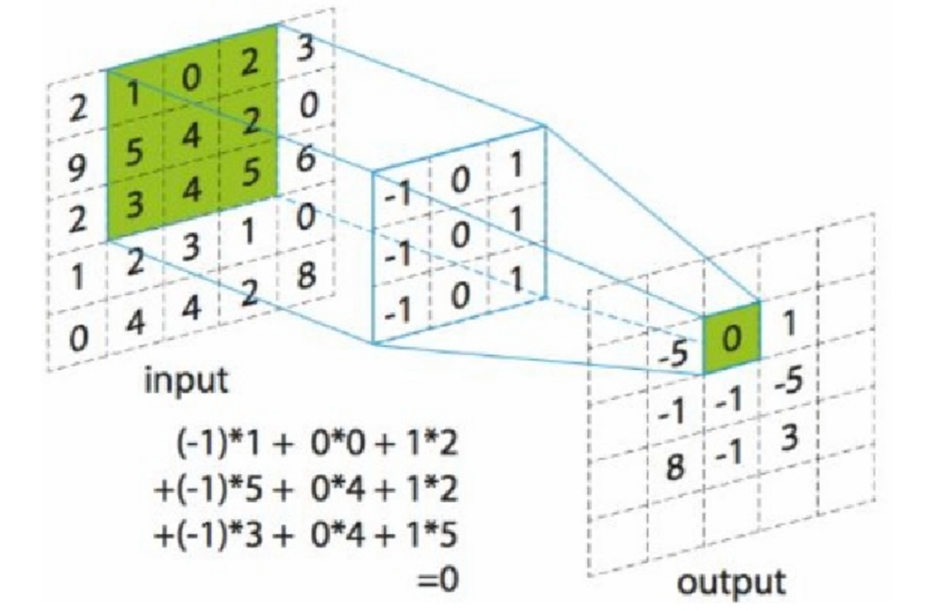
The convolutional layer is the most important core structure in CNN. The main function of the convolutional layer is to use filters (convolution kernels) to extract features from the input image, and gradually scan the input image through the sliding window mechanism to extract image features. Using different convolution kernels for convolution operations can obtain a variety of different feature information, which can better train the target to extract important information.
Figure 3-6 Schematic diagram of convolution operation
(3) Pooling layer
The pooling layer is generally followed by the convolution layer. It uses the correlation features of the input data to perform sampling operations on the data from the previous layer to extract new sampling features. Its most important function is to reduce the input image. Dimensional processing ignores unimportant subtle features in the data, that is, selects the feature information that best represents the data in the local area. When the input data size is large, the amount of data to be processed by the next convolution layer can be effectively reduced through the operation of the pooling layer, thereby preventing the network from overfitting. The main feature of the pooling operation is that if only small scaling, translation or rotation operations are performed on the image, these operations will not affect the pooling output of the image. There are two main methods of pooling, one is maximum pooling and the other is mean pooling.
Figure 3-7 is a schematic diagram of maximum pooling. The left side of the figure is an input data matrix of size 4×4, and the pooling filter used is a 2×2 matrix. Let the moving step size be 2, that is, the filter performs the corresponding operation after every two data values are moved, then the output data at this time is a matrix of size 2×2. In the max pooling operation, the data area mapped by the filter only retains its maximum value, which effectively reduces the parameters of the input data.
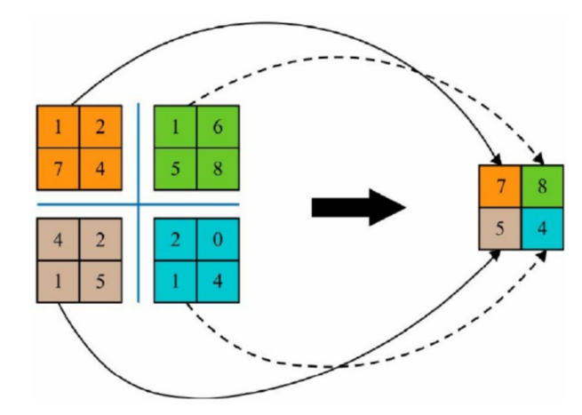
Figure 3-8 is a schematic diagram of average pooling. Its principle is similar to max pooling, but the difference is that max pooling takes the maximum value among the data points in the filter mapping range, and average pooling takes the filter mapping range. Take the average of the data points
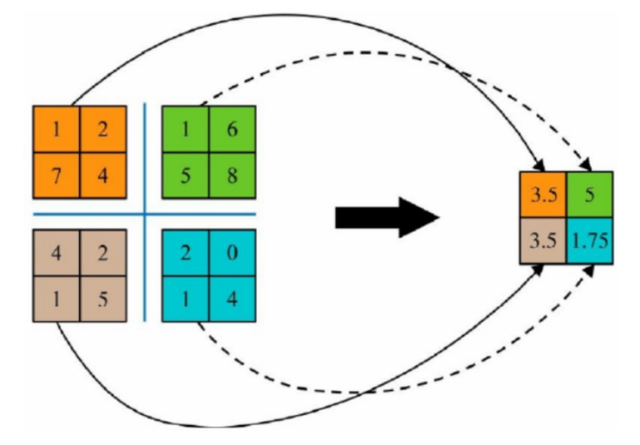
Figure 3-7 Schematic diagram of max pooling
Figure 3-8 Schematic diagram of average pooling
(4) Activation layer The main function of the activation function is to introduce linear features into the model, complete the nonlinear transformation of the data, and solve the problem of insufficient expression and classification capabilities of the linear model. This is because if no activation function is added after the network layer, then all network layers in the neural network can only perform linear operations, and the next layer will always be a linear transformation of the previous layer. This is the working principle of the perceptron. , after using the activation function, the neurons will be given the ability to change nonlinearly by the activation function. At this time, the neural network will have the ability to fit any complex nonlinear function. This will improve the data expression ability of the network. Greatly improve.
The most commonly used activation functions are ReLU function, Tanh function and Sigmoid function。
- ReLu function
$$ReLu\left(x\right)=max⁡(0,x)$$
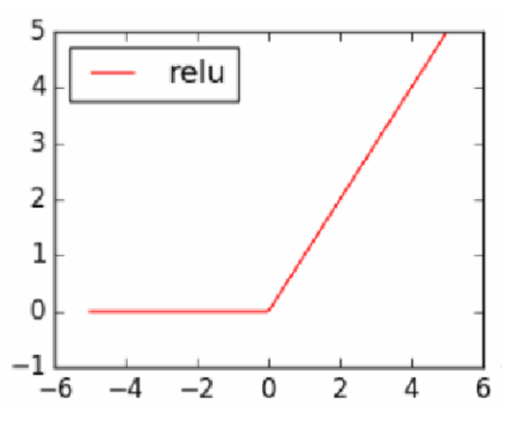
The function image is as follows：
Figure 3-9 ReLU function diagram
- Tanh
$$Tanh\left(x\right)=\frac{e^{x}-e^{-x}}{e^{x}+e^{-x}}$$
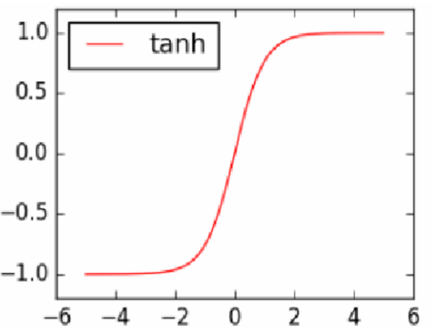
The function graph is shown in Figure 2.11.
Figure 3-10 Tanh function diagram
3) Sigmoid function
$$Sigmoid\left(x\right)=\frac{1}{1+e^{-x}}$$
The function graph is shown in Figure 2.12.
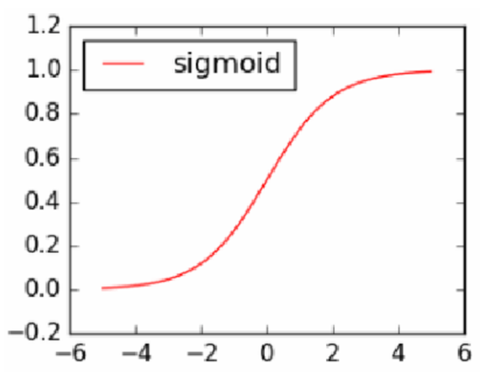
图3-11 Sigmoid函数图
(5) Fully connected layer
The fully connected layer brings together all the previous weighted data, maps multi-dimensional vectors into one-dimensional vectors, brings together the features of all data learned by previous convolution and pooling, and maps the integrated feature information to output space, and finally give the classification result in the output space. Generally speaking, a convolutional neural network requires at least two fully connected layers to connect. The first fully connected layer is used to map the weighted data obtained in the previous convolutional layer and pooling layer to the sample label space. The second fully connected layer The fully connected layer uses a certain activation function to obtain the final predicted classification result.

3.2.2 Application and development of convolutional neural networks
LeCun proposed Le Net in 1998. Although LeNet is only a very small network compared to current technology, it is indeed the originator of all convolutional neural networks in the future. It is the first time to completely analyze the structure of convolutional neural networks. Definition, establish its structure as a convolutional layer, a pooling layer, and a fully connected layer connected in sequence.
In 2012, Krizhevsky and Hinton jointly proposed the AlexNet [52] model, and won the championship of the ILSVRC (ImageNet Large-Scale Visual Recognition Challenge) competition that year with an excellent score of 10.9% higher than the second place. This event caused many scholars to A few years later, interest in deep learning arose here, and more and more researchers began to come into contact with deep learning and continue to explore, and deep learning has flourished since then.
In 2013, Wan first proposed the dropconnect network model [53]. This model has performed well on various data sets. The most outstanding result is its application on the MINIST data set. Its error rate in identifying handwritten images is only 0.28%. In 2014, Simonyan and Zisserman proposed the VGG [54] series of models, and won the second place in the classification task and the first place in the localization task in the ImageNet Challenge that year. For other networks in previous years, VGG is a very deep network model because it has a network depth of 19 layers (although GoogleNet in the same year has reached a network depth of 22 layers). This is a very big breakthrough because it has a network depth of 19 layers. Theoretically speaking, the deeper the depth of a network, the stronger the data model fitting ability of the model. The emergence of VGG marks the beginning of the development of neural networks to a deeper level.
In the same year, Google proposed the Inception network structure [55] and created GoogleNet based on it (the reason why the network was named this way is to pay tribute to Le Net). In the classification and detection (Detection) tasks of the ImageNet Challenge in 2014 Achieved first place. This model is also called InceptionNet V1, and has been gradually upgraded over the next two years through batch normalization (BN), convolution decomposition and other technologies. The latest version is currently Xnception.
In 2015, Kaiming He proposed the ResNet[56] network structure, which won the best paper award at CVPR in 2016. Its emergence solved the network degradation problem (Degrade Problem) that has troubled engineers for years, that is, when neural networks After the number of layers reaches a certain level, its fitting ability not only does not improve but becomes worse and worse, causing the network training error to become very high. At the same time, the network won the ILSVRC and COCO competitions that year, winning first place in five projects including classification, positioning, detection, and segmentation tasks.
In 2017, Huang G proposed the DenseNet [57] network structure. Unlike other networks, DenseNet no longer uses methods to increase network depth or increase network width to improve network performance, but instead takes a different approach to focus on the characteristics of the data. Through the method of feature reuse and bypass setting, it can not only reduce the parameters of the network, but also make the network less prone to the problem of gradient disappearance. Therefore it won the CVPR2017 Best Paper Award.
Today's deep learning models can easily handle a variety of real-life image recognition tasks. With the development of computer hardware, especially graphics processing units (GPUs), the performance of deep learning models has also kept pace with rapid improvements. This has enabled deep learning models to develop rapidly in the field of image recognition and greatly reduced the number of image features. The manpower required for analysis and extraction.
Although there are many image classification models based on convolutional neural networks in the field of computer vision, these models also perform very well in tasks such as image classification and recognition. However, there are still some basic problems lacking effective solutions so far. For example, when adjusting network parameters, it still requires manual exploration and debugging many times to finally find the best optimization algorithm and parameters, sometimes even if it takes a lot of time. Human power cannot find suitable parameters either. In addition, the selection of initialization parameters and the application of optimization algorithms will also greatly affect the training status of the neural network. Once improperly selected, it is extremely easy to cause the network to overfit, underfit, fall into local solutions and other problems.

3.2.3 Online positioning using residual networks
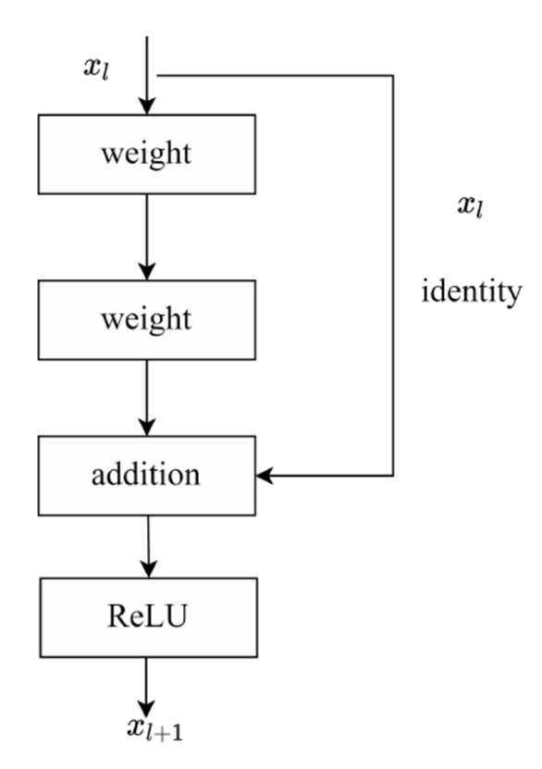
A large number of theories and practices have proven that the performance of network models is inevitably related to network depth. By deepening the depth of network models, more complex expression features can be learned, thereby improving the accuracy of model target tasks. However, when the network depth reaches a certain value, the performance of the model not only does not improve, but over-fitting occurs due to over-training, and problems such as gradient explosion, gradient disappearance or network degradation occur. Based on the above problems, He et al. proposed the Residual Neural Network (ResNet) in 2015. As soon as this network came out, it won the ImageNet ILSVRC championship with excellent performance. The residual neural network is composed of multiple residual modules with identity mapping, as shown in Figure 3-12。
Figure 3-12 Residual module structure
The mathematical expression of the residual module is as follows: (3-3):
$$x_{l+1}=f(x_{l}+F(x_{l},W_{l}))$$ | (3-3)
Among them, $x_{l}$ is the l-th residual unit input, $f$ is the activation function, $F(x_{l},W_{l})$ is the residual function, and $W_{l}$ is the weight matrix.
In the residual unit structure, the learned target mapping is decomposed into the form of a linear mapping and a nonlinear mapping. The linear mapping is called identity mapping. If identity mapping is the optimal learning strategy during the learning process of the model, the weight of the nonlinear mapping will tend to zero. At this time, identity mapping is much easier to learn than nonlinear mapping, and does not introduce additional parameters and increase the computational complexity of the model. The shortcut connection method can prevent the performance of the deep network from decreasing as the depth increases. This It is also contrary to traditional CNN. The residual network can be regarded as a collection of paths. This method can integrate low-level feature information and high-level feature information, and at the same time alleviate to a certain extent the problem of gradient disappearance or gradient explosion that occurs when the network is too deep, making deeper networks more powerful. expression ability.
Due to ResNet's superior performance and the advantage of increasing network depth without network degradation, the number of layers of residual neural networks is also increasing, from ResNet-18, ResNet-34, ResNet-50 to ResNet-101, ResNet-152, can even reach deeper depths. At the same time, researchers have proposed different residual modules based on different network depths, one is the basic residual module and the other is the bottleneck residual module. When the model depth is less than or equal to 34 layers, the basic residual module is used, as shown in Figure 3-13(a). The residual module uses two 3×3 convolutions for residual learning, and completes the identity through shortcut connection. Mapping, and then the result of the addition of the two is mapped by the ReLU activation function and output. When the model depth is too large, the network training speed is reduced due to the huge number of parameters involved in the model, so an improved residual module, that is, a bottleneck residual module, is used. As shown in Figure 3-13(b), this module first completes feature dimensionality reduction through a 1×1 convolution, then learns features through a 3×3 convolution, and finally increases the feature dimension through a 1×1 convolution. This process reduces the number of parameters of deep networks to the same dimensions as the input.In the residual unit structure, the learned target mapping is decomposed into the form of a linear mapping and a nonlinear mapping. The linear mapping is called identity mapping. If identity mapping is the optimal learning strategy during the learning process of the model, the weight of the nonlinear mapping will tend to zero. At this time, identity mapping is much easier to learn than nonlinear mapping, and does not introduce additional parameters and increase the computational complexity of the model. The shortcut connection method can prevent the performance of the deep network from decreasing as the depth increases. This It is also contrary to traditional CNN. The residual network can be regarded as a collection of paths. This method can integrate low-level feature information and high-level feature information, and at the same time alleviate to a certain extent the problem of gradient disappearance or gradient explosion that occurs when the network is too deep, making deeper networks more powerful. expression ability.
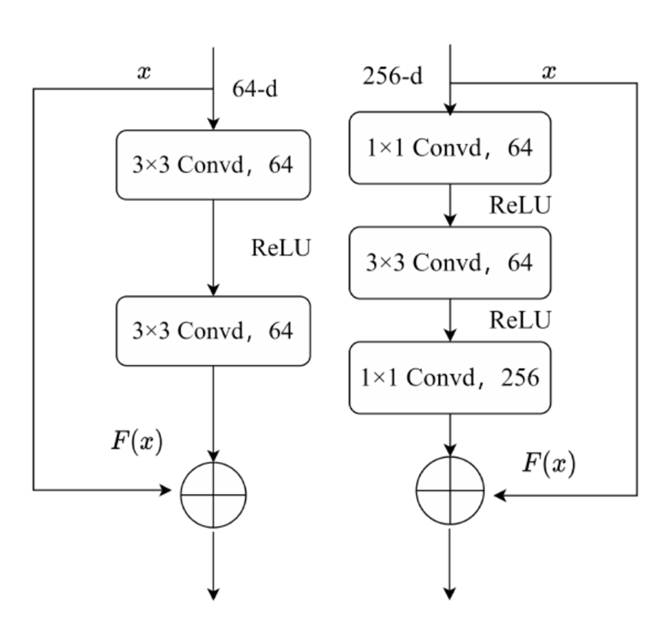
Due to ResNet's superior performance and the advantage of increasing network depth without network degradation, the number of layers of residual neural networks is also increasing, from ResNet-18, ResNet-34, ResNet-50 to ResNet-101, ResNet-152, can even reach deeper depths. At the same time, researchers have proposed different residual modules based on different network depths, one is the basic residual module and the other is the bottleneck residual module. When the model depth is less than or equal to 34 layers, the basic residual module is used, as shown in Figure 3-13(a). The residual module uses two 3×3 convolutions for residual learning, and completes the identity through shortcut connection. Mapping, and then the result of the addition of the two is mapped by the ReLU activation function and output. When the model depth is too large, the network training speed is reduced due to the huge number of parameters involved in the model, so an improved residual module, that is, a bottleneck residual module, is used. As shown in Figure 3-13(b), this module first completes feature dimensionality reduction through a 1×1 convolution, then learns features through a 3×3 convolution, and finally increases the feature dimension through a 1×1 convolution. This process reduces the number of parameters of deep networks to the same dimensions as the input.
(a) Basic residual module (b) Bottleneck residual module
Figure 3-13 Two different residual modules
In a deep convolutional neural network, the superposition of model layers will change the input data distribution of the upper layer due to the update of the parameters of each layer. The input distribution of the higher layers will become more intense. Therefore, the upper network needs to continuously adjust to adapt to changes in the input data distribution, which results in a reduction in training speed; for backpropagation, this phenomenon leads to gradient dispersion. So Google proposed Batch Normalization (BN) in 2015. The main idea is to make each layer of the input batch feature matrix satisfy the distribution law of mean 0 and variance 1. Through batch normalization, The input data of each layer is normalized to stabilize its data distribution, thereby greatly alleviating the problems of gradient dispersion and training speed reduction during the training process.
Batch normalization abandons the disadvantages of preprocessing only the input layer and can normalize the input data of each layer in the middle. The mathematical expression is as follows: (3-4)：
$${\hat{x}}^{(k)}=\frac{x^{(k)}-E[x^{(k)}]}{\sqrt{[\sqrt{Va}r[x^{(k)}]}}$$ | (3-4)
where $x^{\left(k\right)}$ is the k-th dimension activation value, $E[x^{\left(k\right)}]$is the mean of the k-th dimension data, $Var$ is the k-th dimension data variance,${\hat{x}}^{\left(k\right)}$ is Normalized activation value.

3.2.4 Positioning based on ResNet custom network
At different stages of fingerprint positioning technology, there are a series of important steps that need to be completed in sequence. First, in the offline stage, a complete fingerprint database must be constructed. However, this is only part of the process. Afterwards, this fingerprint database is needed to train the network model. This training process is critical because it provides the basis for subsequent online positioning. When the network model training is completed, we can enter the second stage, which is the online positioning stage.
During the online positioning process in the second stage, the device first collects a single fingerprint sample consistent with the previous stage. In this process, the device will center on its location and select the nearest gNB (5G base station) to receive multi-beam CSI-RS signals. Then, in a single base station, the device will select the beam with the largest impulse response amplitude among the first n beams, and combine the collected fingerprint samples with the trained model to obtain the predicted coordinates of the device location.
It needs to be emphasized that in the process of fingerprint positioning, it is crucial to choose an appropriate model for training and prediction, because this will directly affect the final fingerprint positioning accuracy. In this algorithm, we consider four different network models, which are support vector machine (SVM), multilayer perceptron (MLP), convolutional neural network (CNN) and residual network (ResNet).
When the sample size of the fingerprint database is large, SVM may not be the best choice because its training process involves quadratic programming, which consumes a lot of machine memory and computing time. In addition, since the online stage requires a large number of classification results, and SVM is not effective in handling large-scale classification tasks, it is not suitable for this situation.
Although MLP is an effective model, the number of parameters in the middle hidden layer is large, resulting in large resource consumption when training the network model. CNN solves the problem of too many parameters in MLP through the use of convolutional layers, but as the depth of the network model increases, it may cause the model to deviate from the optimal state.
Therefore, in order to take into account the advantages of MLP and CNN, we introduce the residual network (ResNet), which ensures that the network model always moves towards the optimal state during the training process by superimposing residual blocks. This method of comprehensively considering the advantages and disadvantages can help improve the accuracy and performance of fingerprint positioning.
The overall structure is shown in the figure belowAt different stages of fingerprint positioning technology, there are a series of important steps that need to be completed in sequence. First, in the offline stage, a complete fingerprint database must be constructed. However, this is only part of the process. Afterwards, this fingerprint database is needed to train the network model. This training process is critical because it provides the basis for subsequent online positioning. When the network model training is completed, we can enter the second stage, which is the online positioning stage.
During the online positioning process in the second stage, the device first collects a single fingerprint sample consistent with the previous stage. In this process, the device will center on its location and select the nearest gNB (5G base station) to receive multi-beam CSI-RS signals. Then, in a single base station, the device will select the beam with the largest impulse response amplitude among the first n beams, and combine the collected fingerprint samples with the trained model to obtain the predicted coordinates of the device location.
It needs to be emphasized that in the process of fingerprint positioning, it is crucial to choose an appropriate model for training and prediction, because this will directly affect the final fingerprint positioning accuracy. In this algorithm, we consider four different network models, which are support vector machine (SVM), multilayer perceptron (MLP), convolutional neural network (CNN) and residual network (ResNet).
When the sample size of the fingerprint database is large, SVM may not be the best choice because its training process involves quadratic programming, which consumes a lot of machine memory and computing time. In addition, since the online stage requires a large number of classification results, and SVM is not effective in handling large-scale classification tasks, it is not suitable for this situation.
Although MLP is an effective model, the number of parameters in the middle hidden layer is large, resulting in large resource consumption when training the network model. CNN solves the problem of too many parameters in MLP through the use of convolutional layers, but as the depth of the network model increases, it may cause the model to deviate from the optimal state.
Therefore, in order to take into account the advantages of MLP and CNN, we introduce the residual network (ResNet), which ensures that the network model always moves towards the optimal state during the training process by superimposing residual blocks. This method of comprehensively considering the advantages and disadvantages can help improve the accuracy and performance of fingerprint positioning.
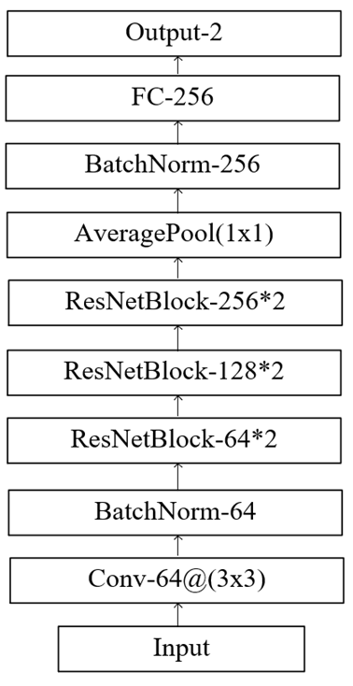
The overall structure is shown in the figure below：
Figure 3-14 Network structure used in the positioning phase

3.2.5 Evaluation index
(1) Accuracy
The model in this article uses classification accuracy Accuracy as one of the evaluation indicators to measure model performance. Each sample in the single-label classification task has only one definite category. If the category is predicted, it means the classification is correct. If it is not predicted, it means the classification is wrong. Therefore, it is the most intuitive The indicator is Accuracy, which is the accuracy rate.
Accuracy=(TP+TN)/(TP+FP+TN+FN), which represents the probability that all samples are correctly classified, can use different thresholds T.
The Accuracy indicators used in ImageNet include Top_1 Accuracy and Top_5 Accuracy. Top_1 Accuracy is the Accuracy calculated previously.
Let the category of sample xi be yi, the category type be (0,1,…,C), and the prediction category function be f, then the calculation method of Top-1 is as follows：

$$Top_1Acc=\frac{\sum_{i=0}^{N-1}{((f\left(x_{i}\right)==y_{i})}}{N})$$ | (3-5)
If the five prediction categories with the highest probability are given, as long as the real categories are included, the prediction is judged to be correct, and the calculated indicator is Top-5.
(2) Precision and Recall
If we only consider the indicators of positive samples, there are two very commonly used indicators, precision and recall. The precision rate of positive samples is: Precision=TP/(TP+FP), which indicates how many of the samples recalled as positive samples are truly positive samples. The recall rate of positive samples is: Recall=TP/(TP+FN), which indicates how many samples are recalled.
Of course, if you are interested in negative samples, you can also calculate the corresponding precision rate and recall rate. Remember to distinguish the difference between precision rate and accuracy rate. Generally, the higher the recall rate, the lower the precision. The Recall-Precision curve can be drawn according to different values.
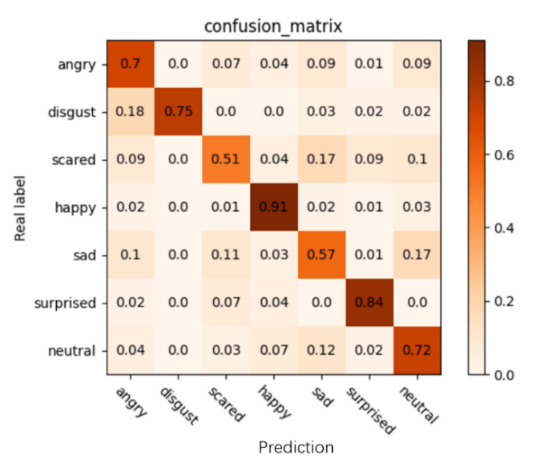
(3) confusion matrix
Figure 3-15 Confusion matrix diagram
The confusion matrix is a valuable table used to check the performance of a machine learning classification algorithm by comparing the predicted results with the actual results on the test data set. The table has dimensions NxN, where N is the number of classification categories.
In the confusion matrix, as shown above, there are four terms used to describe the prediction results, they are:
True Positive (TP): Name given when both predicted and actual classes are positive.
True Negative (TN): Name given when both predicted and actual classes are negative.
False Negative (FN): Name given when the predicted class is negative, but the actual class is positive.
False Positive (FP): The name given when the predicted class is positive but the actual class is negative.

3.3 Simulation experiment design and experimental results

3.3.1 Simulation model design
To evaluate the performance of the algorithm proposed in this paper, we conducted a series of simulation experiments using an office scene containing multiple obstacles and considering both line-of-sight and non-line-of-sight propagation paths. This scenario was chosen to verify the effectiveness of our fusion algorithm in complex environments. In this complex scenario, signal propagation will be affected by a variety of factors, including multipath interference and shadow fading, which will adversely affect signal transmission and reception.
Our goal is to demonstrate that our algorithm is able to achieve good positioning accuracy despite severe signal interference in this complex environment. In order to conduct simulation experiments, we chose the Matlab platform combined with Pytorch, where Matlab is used to complete all tasks except fingerprint positioning network model construction, training and prediction. Specifically, we used the Matlab 2021B version, and the combination of Pytorch 1.9.1 and cuda11.1. Our computer hardware platform is Intel(R) Core(TM) i5-7200U CPU @ 2.50GHz, the memory capacity is 8GB, and the graphics card is Tesla K80 (11GB video memory).
Through this series of simulation experiments, we aim to demonstrate the feasibility and robustness of our algorithm in complex environments in the real world, as well as its strong performance under various interference situations. These experiments will help prove the reliability of our algorithm in practical deployments and provide a solid foundation for further research and applications.
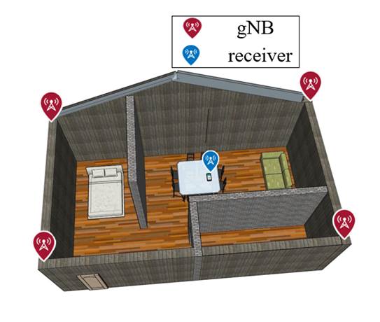
The experimental simulation data in this article are all generated on the Matlab platform. We used a specific room model with length, width and height of 10 meters, 6 meters and 2 meters respectively. In this model, the house has brick walls and wood floors. In the simulation, we distributed four gNBs (5G base stations) around the house. This setting took into account the ultra-dense cell scenario. At the same time, we do not consider the impact of macro base stations on received signals in the simulation, because macro base stations are usually far away from the receiving equipment, and we can use specific filtering algorithms to eliminate interference that may be introduced by macro base stations. In order to better demonstrate the structure of the simulation experiment, you can refer to the three-dimensional structural diagram in Figure 3-16 below. In this simulation experiment, we arranged these four micro base stations outside the four corners of the building to simulate the complex signal propagation environment in the real world. This setup allows us to test taking into account multiple signal paths and reflections to validate the performance of our algorithm in more challenging environments. These simulation experiments are designed to simulate real-world signal propagation situations in order to evaluate the feasibility and robustness of our proposed algorithm in different situations. This will help us better understand and optimize the performance of 5G-based positioning systems and provide strong support for practical applications
Figure 3-16 Schematic diagram of the 3D structure of the simulation structure
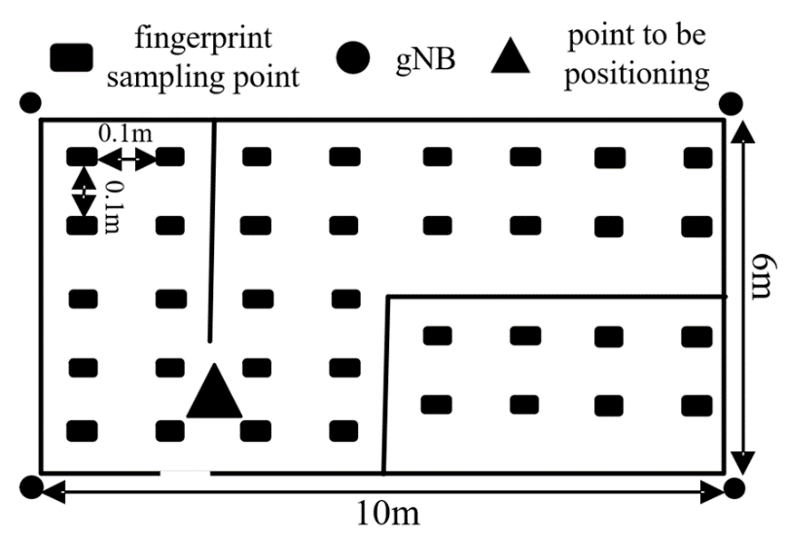
In the offline stage, we established the fingerprint database, as shown in Figure 3-17. This diagram clearly shows the user equipment (UE) receiving signals from four different base stations. It should be noted that in actual 5G communication systems, network nodes are deployed very densely, forming ultra-dense cells, which further enriches the information content of fingerprint samples. This also means that we can obtain more signal samples to improve the performance of the fingerprint positioning algorithm. In our fingerprint positioning algorithm, we collect fingerprint samples with a sampling interval of 0.1 meters. Considering that the length and width of an office environment are 10 meters and 6 meters respectively, our fingerprint sample database contains a total of 6000 sample points. These sample points cover the entire office area to ensure that the positioning accuracy of our algorithm in different locations can be effectively verified. This intensive sample collection and database construction is to ensure that our fingerprint positioning algorithm can show excellent performance in different environments. By using signal samples from multiple base stations and taking into account the complex network structure of ultra-dense cells, our algorithm is able to provide higher accuracy and reliability, providing strong support for various practical applications. The establishment of this fingerprint sample database is a key step in our research, and it provides a solid foundation for our experiments and verification.
Figure 3-17 Schematic diagram of fingerprint sample collection in a room scenario
In the stand-alone use stage of the fingerprint positioning algorithm, it is crucial to correctly select the appropriate model, because this will directly affect the performance and accuracy of the algorithm. In this algorithm, we conducted extensive model exploration and considered four different network models: Support Vector Machine (SVM), Multi-Layer Perceptron (MLP), and Convolutional Neural Network (Convolutional Neural Network, CNN), and residual network (Residual Network, ResNet). Each model has its own unique strengths and weaknesses. For example, SVM may perform well in certain situations but may not perform well when handling large-scale classification tasks. MLP has too many parameters in the middle hidden layer, which may lead to increased resource consumption. CNN processes data through convolutional layers, but when the model is deepened, there may be a problem that it is far from the optimal model. After careful weighing and comparison, we finally selected the improved ResNet-18 as the network model for our fingerprint positioning algorithm. ResNet-18 combines the advantages of MLP and CNN, and ensures that the model can reach the optimal state faster during the training process through the superposition of residual blocks. This choice was made to improve the performance of the fingerprint algorithm, enabling it to achieve excellent positioning accuracy in a variety of different scenarios and applications.
When conducting experiments using the fingerprint positioning algorithm alone, we took a sensible approach by dividing the fingerprint database into a training set and a test set, with a ratio of 80% training set and 20% test set. This step aims to evaluate the performance and generalization ability of the algorithm to ensure its feasibility in real-world applications. In addition, we conducted multiple sets of comparative experiments to compare with other network models, including multilayer perceptron (MLP), support vector machine (SVM), and convolutional neural network (CNN). In all experiments, we adopted the mean square loss function as the loss function to measure the performance of the model. Finally, the experimental results are shown in Table 2. These results reveal an obvious trend: using the improved ResNet in this article as the network model for the fingerprint positioning stage is the wisest choice. This is because ResNet exhibits higher accuracy, stronger generalization performance, and at the same time the model complexity is relatively low. In this algorithm, we pay special attention to the selection of ResNet model because it can ensure low prediction delay, which is crucial for real-time positioning applications.
Table 1 Performance of fingerprint data sets on different models
 | Test accuracy (%) | Loss | avg accuracy (m)
MLP | 90.98 | 6.04 | 1.7
SVM | 89.44 | 4.81 | 1.5
CNN | 91.17 | 2.33 | 1.2
ResNet | 97.45 | 0.62 | 0.8
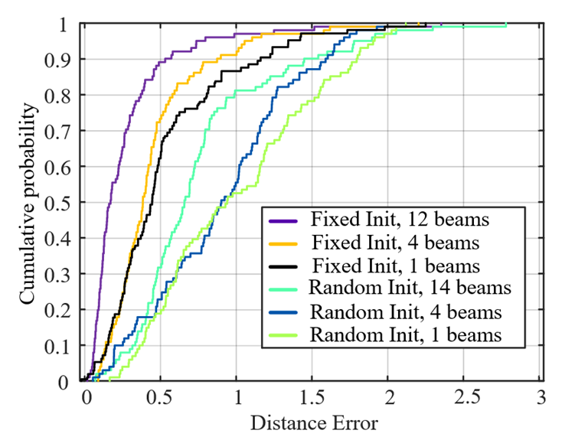
In order to further verify the potential value of multi-beam CSI-RS signals in our algorithm, and to verify the impact of beam fixed initialization on fingerprint positioning accuracy, we conducted a series of experiments. These experiments are designed to explore the information richness of multi-beam signals in fingerprint positioning and to evaluate the contribution of beam fixed initialization to algorithm performance. In Figure 3-18, we show the positioning error when using different numbers of beams (12 beams, 4 beams and single beam) as fingerprint samples under two initialization methods (beam fixed initialization and random initialization). Accumulation situation. The experimental results clearly show that when the beam direction is fixed for initialization, the fingerprint of multi-beam CSI-RS signals can significantly improve the prediction accuracy. This finding highlights the importance of multi-beam CSI-RS signals in fingerprint positioning. These signals provide additional information that can help us determine the location of the device more accurately. Furthermore, by employing beam-fixed initialization, we are able to better exploit the potential of multi-beam signals and further improve the accuracy of fingerprint positioning. These experimental results have important practical significance because they provide a strong basis for the improvement of fingerprint positioning technology. By deeply studying the impact of multi-beam signals and initialization strategies, we can optimize the algorithm and improve performance in complex environments. This also helps us better understand the application potential of multi-beam technology in 5G communication systems.
Figure 3-18 Comparison of fingerprint algorithms under initialization method and different number of beams
By observing the experimental results, we can clearly see that after adopting the fixed beam initialization strategy, the accuracy of fingerprint positioning is significantly better than that of random beam initialization. This finding shows that choosing an appropriate beam initialization method has an important impact on the performance of fingerprint localization algorithms. Furthermore, we can also observe that increasing the number of beams helps to improve the resolution and richness of fingerprint information to a great extent. This means that a larger number of beams can capture more subtle signal changes, further improving the overall fingerprint positioning accuracy. This discovery has broad application prospects, especially in 5G communication systems. By optimizing the beam configuration and initialization strategy, we can achieve higher-precision device positioning to meet the needs of various application scenarios, such as indoor navigation, IoT device tracking, etc. This not only helps improve user experience, but also provides strong support for future development in areas such as smart cities and smart transportation. In summary, it can be concluded that beam fixed initialization and increasing the number of beams are effective means to improve fingerprint positioning accuracy.

combination positioning

4.1 5G+UWB integrated positioning system architecture design
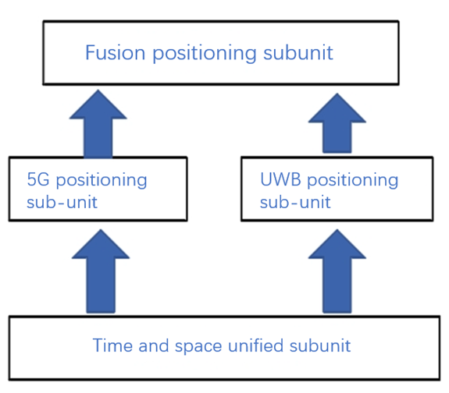
The 5G+UWB integrated positioning system consists of four parts: 5G positioning sub-unit, UWB positioning sub-unit, space-time unified sub-unit and integrated positioning terminal sub-unit. The system composition diagram is shown in Figure 4-1.
Figure 4-1 5G+UWB integrated positioning system architecture
The spatiotemporal unified subunit ensures time synchronization between all base stations in each subsystem, thereby improving the accuracy of the TOA output by the fused positioning terminal subunit. At the same time, the unified spatial coordinate system also greatly reduces the calculation time of the fused positioning terminal when solving coordinates. the complexity. The joint setting of 5G positioning sub-units and UWB positioning sub-units increases the number of base stations, which satisfies the situation where the number of independent positioning sub-units is insufficient in certain scenarios to prevent positioning. The fused positioning terminal sub-unit realizes the fusion of TOA data of different types of positioning sub-units, improving the robustness of positioning results.

Design and implementation of spatio-temporal unified sub-unit
Before integration, the 5G indoor positioning system and the UWB system have their own specific time base and spatial coordinate base.
In terms of time reference: Each 5G and UWB base station is connected to the slave end of the time synchronization system, and the slave end of the time synchronization system directly receives the standard time-frequency signal from the master end to ensure the unity of time and frequency among each base station.
Spatial reference: If the system uses different coordinate systems, it will have a greater impact on the positioning results of the joint system. Therefore, at the beginning of the design of the integrated positioning system, it is necessary to make the 5G indoor positioning system and the UWB positioning system share a set of spatial coordinates. system.
As an important benchmark for indoor positioning, the time unified system plays a decisive role in calculating the position relationship between the base station and the mobile terminal, pseudo-range and phase observation values, etc. In order to enable the fused positioning system to operate efficiently, conveniently and correctly , connect the main signal of the time unified system to the 5G base station and UWB base station respectively to ensure that all positioning base stations in the system use the same set of time base.
The time master-slave end transmits 1PPS, 10MHz time-frequency signals, using time synchronization technology based on the White Rabbit protocol. This technology combines synchronous Ethernet, precision timing protocol (IEEE1588 v2) and digital phase measurement technology to achieve sub-nanosecond accuracy. Clock synchronization allows the network structure to be flexibly set based on system stability and reliability. The network topology is shown in Figure 4-2.Before integration, the 5G indoor positioning system and the UWB system have their own specific time base and spatial coordinate base.
In terms of time reference: Each 5G and UWB base station is connected to the slave end of the time synchronization system, and the slave end of the time synchronization system directly receives the standard time-frequency signal from the master end to ensure the unity of time and frequency among each base station.
Spatial reference: If the system uses different coordinate systems, it will have a greater impact on the positioning results of the joint system. Therefore, at the beginning of the design of the integrated positioning system, it is necessary to make the 5G indoor positioning system and the UWB positioning system share a set of spatial coordinates. system.
As an important benchmark for indoor positioning, the time unified system plays a decisive role in calculating the position relationship between the base station and the mobile terminal, pseudo-range and phase observation values, etc. In order to enable the fused positioning system to operate efficiently, conveniently and correctly , connect the main signal of the time unified system to the 5G base station and UWB base station respectively to ensure that all positioning base stations in the system use the same set of time base.
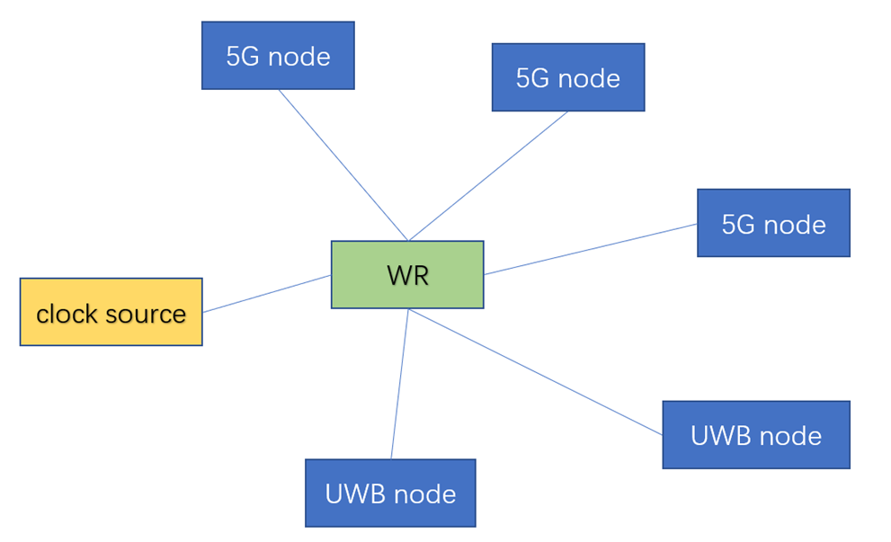
The time master-slave end transmits 1PPS, 10MHz time-frequency signals, using time synchronization technology based on the White Rabbit protocol. This technology combines synchronous Ethernet, precision timing protocol (IEEE1588 v2) and digital phase measurement technology to achieve sub-nanosecond accuracy. Clock synchronization allows the network structure to be flexibly set based on system stability and reliability. The network topology is shown in Figure 4-2.
Figure 4-2 Space synchronization network topology architecture diagram
After solving the problem of time unification, it is also necessary to solve the problem of spatial unification, because if the 5G positioning sub-unit and the UWB positioning sub-unit use different local coordinate systems, it will complicate the solution process of the positioning results of the fused positioning system, and two The subsystem establishes a universal Cartesian local coordinate system.
As the spatial benchmark of the test scene, the Cartesian local coordinate system directly affects the positioning results of the final test. The credibility of the Cartesian local coordinate system is mainly determined by the accuracy of the total station, so experiments on the total station are required. , to evaluate whether its performance indicators meet experimental needs

4.1.2 Design of fusion positioning sub-unit
The fusion positioning sub-unit here mainly uses a decision mechanism to judge relevant content. For example, we can find the average positioning error probability function produced by the current positioning method in the same indoor environment, so that we can derive the probability error models of different methods. , the specific probability error model is shown in the figure below. Then a discrimination mechanism can be introduced later to select the correct positioning method based on the margin error model.

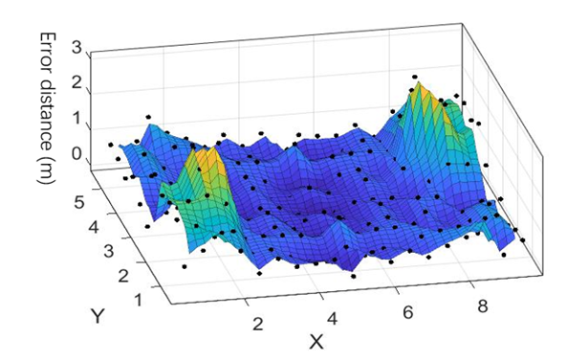
Figure 4-3 Probabilistic error model
We can first obtain the positioning information of 5G and UWB, and then calculate the respective positioning position coordinates (x_5G, y_5g) and (x_uwb, y_uwb). Although the positioning result at this time is not the most accurate result, it is relatively Accurate results, so after bringing it into the probabilistic error model to obtain the results and make a judgment, it can ensure that the final positioning result is more accurate in most cases.
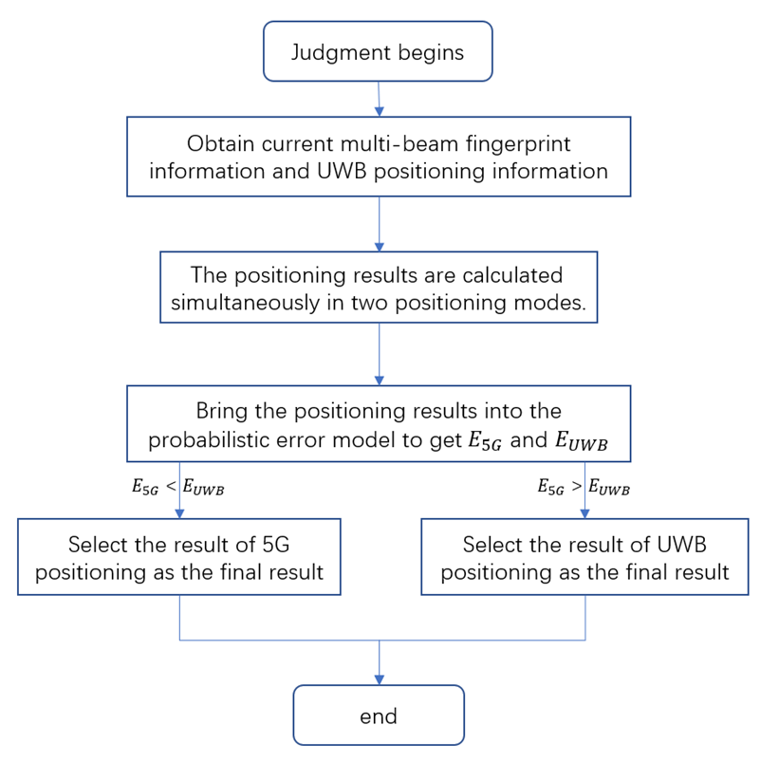
Then the positioning coordinates are brought into the respective probabilistic error models ErrorModel_5G and ErrorModel_UWB of 5G and UWB, and then the approximate error results E_5G and E_UWB are obtained. For more error results, choose the smaller one, and use the device positioning coordinates as the final result. The overall decision process is shown in Figure 4-4.
Figure 4-4 Combined positioning decision process

5G+UWB verification experiment
19 static test points were randomly and evenly selected in the test site to verify the static positioning effect of the obtained model. The locations of the selected points are shown in Figure 4-3, where the green points are verification points and the red points are sample points.
Among them, stationA~stationD are 5G node, UWB node, 5G node, and UWB node respectively.
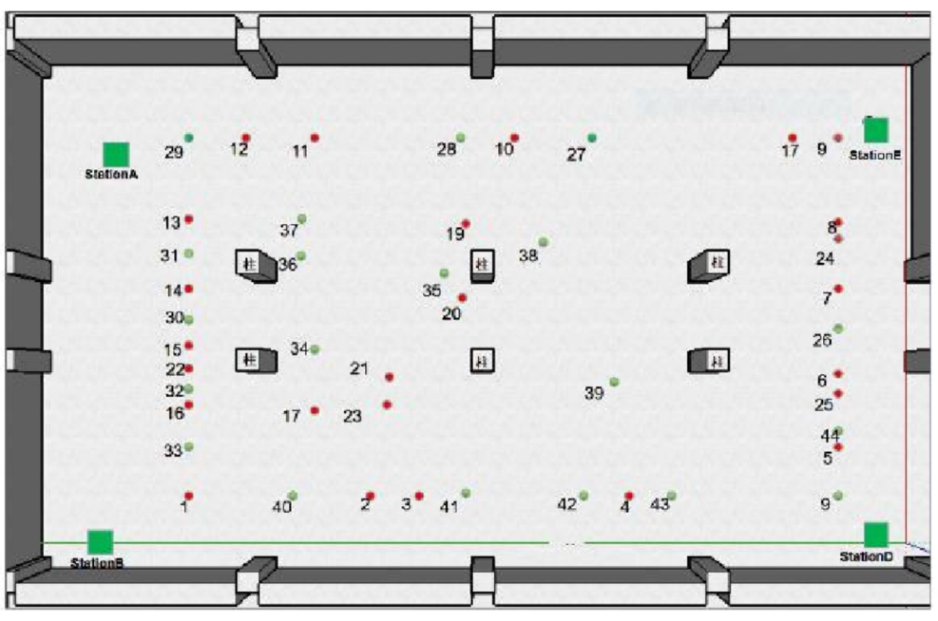
Figure4-3 The distribution plan of the points to be measured
During fusion positioning, the device UE to be positioned first collects the fingerprint information of the current location, then inputs the fingerprint information into the trained network to predict and obtain the position coordinates of the fingerprint positioning; executes the UWB positioning algorithm to obtain another set of position coordinates; and finally Two sets of coordinates and corresponding distance error probability density distribution functions are used as decision input, and the decision maker is executed to obtain accurate two-dimensional position information. In experiments, it was found that multi-beam set fingerprints under 5G communication conditions can still achieve high positioning accuracy within the non-visual distance range in complex environments. However, the fingerprint algorithm will cause range errors in fingerprint matching when the environment changes significantly. The UWB positioning algorithm in this article has higher accuracy under visible distance, but when there is severe occlusion, the accuracy will decrease due to multipath propagation phenomenon; this makes the distance error probability density distribution function of the two algorithms have a higher Independence, that is, the two algorithms can complement each other, and fusing the two algorithms will significantly improve the positioning accuracy.
In the experiment, data collection (static measurement) was carried out for each sample point, and 200 sets of repeated collection work were performed for each sample point. Fingerprint samples and UWB positioning samples were collected according to the aforementioned method, and outliers were eliminated. Differences are made separately to eliminate the clock difference between the base station and the receiver. A total of 8 experiments were conducted, and the results of the eight experiments were relatively balanced. There was no significant fluctuation in positioning accuracy. Finally, the average value of the 8 experiments was used to calculate the cumulative probability of distance error, and the final result was 4-4.
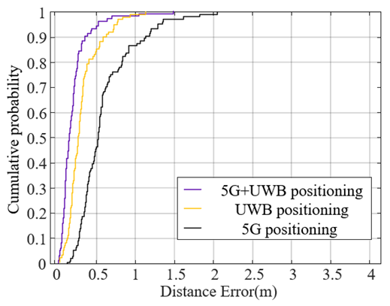
It can be seen that the results of fusion positioning are better. When positioning alone, the positioning accuracy of UWB is better than that of 5G positioning. For example, in complex indoor scenes such as offices, due to the presence of more occlusions and severe multipath effects, the positioning accuracy of UWB positioning will decrease; however, fingerprint positioning performs relatively well in complex scenes, but when indoors When the environment changes, the channel information at the changed location may change to a certain extent, causing errors in the matching of fingerprint information; however, after the two positioning results are fused using Kalman filtering, there is a distance error probability distribution function of the positioning results of the two methods. With high independence, the overall positioning accuracy will be greatly optimized.
Figure4-4 Comparison of static positioning results
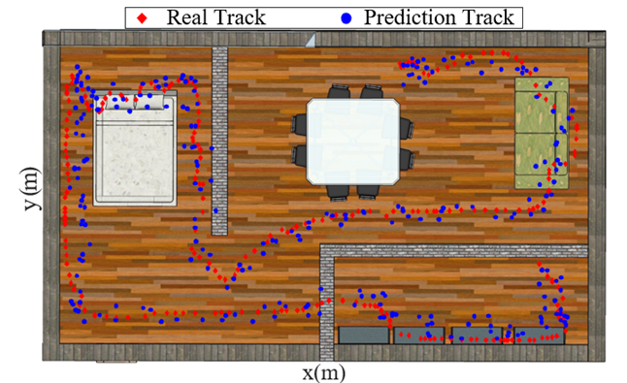
To further verify the effectiveness of the algorithm, a moving trajectory is set in an indoor environment and the algorithm of this article is used for prediction. As can be seen from the figure, the algorithm of this article can be used to achieve precise positioning of moving targets.
Figure 4-5 Trajectory prediction of mobile devices by this algorithm
It can be seen that the overall positioning accuracy can maintain a high level during the entire movement, so the mobility of the positioning algorithm is also highly guaranteed.

Conclusion and future plans

5.1 conclusion
This paper proposes an indoor fusion positioning algorithm based on 5G communication technology and UWB, which integrates the UWB positioning method and the fingerprint positioning method using a custom decision algorithm. This algorithm uses beamforming technology and larger SCS in 5G to enhance the quality of the reference signal and reduce the delay difference of TOA. It uses multiple beams to provide more high-dimensional information for fingerprint sample features and improves the fingerprint quality. The information richness of the positioning database; proposed the Chan-Taylor cascade positioning algorithm based on the simulated annealing algorithm, produced a UWB signal data set and proposed a machine learning-based UWB line-of-sight and non-line-of-sight identification method; subsequent combination algorithm Improved the robustness of the overall algorithm. During the algorithm testing phase, the fingerprint algorithm and the hyperbolic algorithm alone were significantly improved compared to traditional methods. At the same time, the experimental results showed that the accuracy after using the algorithm to fuse the two algorithms reached less than 0.8 meters. Compared with 5G-based positioning algorithms in recent years, the method in this article not only meets the high-precision positioning requirements, but the robustness of the algorithm in this article is significantly improved compared to other algorithms. After the widespread deployment of 5G equipment and the opening of millimeter wave frequency bands, this method can meet the vast majority of indoor positioning application scenarios. The main work of this paper is as follows:
(1) The positioning principle of UWB and the classic UWB positioning algorithm were studied, and a Chan-Taylor cascade positioning algorithm based on the simulated annealing algorithm was proposed. UWB data collection was carried out in different environments, and a multi-layer perceptron model for LOS/NLOS recognition was built using machine learning methods. Finally achieve higher accuracy.
(2) Analyzed commonly used fingerprint positioning methods and 5G positioning methods, used 5G multi-beam information with high resolution and higher signal quality to construct high-resolution and high-sensitivity fingerprint information, and designed a network model based on ResNet . Finally, by building an offline fingerprint database and online positioning, good positioning results can be obtained.
(3) A combined positioning method based on an error probability model was determined to make the final positioning accuracy more accurate.

5.2 future outlook
First of all, this article mainly studies indoor 2D positioning. In the future, more information can be obtained to achieve indoor 3D position estimation. Secondly, although this article tried to select representative sample data in a concise and balanced manner during the point selection process, it did not discuss the optimal number of selected points and the distribution rules of the selected points in the experimental scenario. The optimal sample point selection rules can be further explored in the future to improve Neural network training efficiency and even model output accuracy.

References
[1] Zafari F, Gkelias A, Leung K K. A survey of indoor localization systems and technologies[J]. IEEE Communications Surveys & Tutorials, 2019, 21(3): 2568-2599.
[2] Poulose A, Han D S. Hybrid deep learning model based indoor positioning using Wi-Fi RSSI heat maps for autonomous applications[J]. Electronics, 2020, 10(1): 2.
[3] Afif Osseiran, Jose F, Monserrat, Patrick Marsch. 5G Mobile and Wireless Communications Technology[M]. Chen Ming, BeiJing: People's Posts and Telecommunications Press, 2017: 22-44.
[4] Huang J, Zhang K, Shen C, et al. Indoor Location of UWB-TDOA Based on Genetic Algorithm[C]//2021 IEEE 21st International Conference on Communication Technology (ICCT). IEEE, 2021: 393-396.
[5] Want R, Hopper A, Falcao V, et al. The active badge location system[J]. ACM Transactions on Information Systems (TOIS), 1992, 10(1): 91-102.
[6] Li Xiaohui, Liu Ya, Zhang Lirong. Ultra-wideband indoor positioning system[J]. Measurement and Control Technology, 2007, 26(7): 1-2.
[7] Bahl P, Padmanabhan V N. RADAR: An in-building RF-based user location and tracking system[C]//Proceedings IEEE INFOCOM 2000. Conference on computer communications. Nineteenth annual joint conference of the IEEE computer and communications societies (Cat. No. 00CH37064). Ieee, 2000, 2: 775-784.
[8] Kaemarungsi K, Krishnamurthy P. Modeling of indoor positioning systems based on location fingerprinting[C]. Joint Conference of the IEEE Computer and Communications Societies. IEEE, 2004:1012-1022 vol.2.
[9] Youssef M, Agrawala A. The Horus WLAN location determination system[C]//Proceedings of the 3rd international conference on Mobile systems, applications, and services. 2005: 205-218.
[10] AGIWAL M,ROY A,SAXENA N.Next Generation 5G Wireless Networks: A Comprehensive Survey[J].IEEE Communications Surveys&Tutorials,2016, 18(3):1617–1655.
[11] ANDREWS J G,BUZZI S,WAN C,et al.What Will 5G Be?[J].IEEE Journal on Selected Areas in Communications,2014,32(6):1065–1082.
[12] 3GPP.Study on New Radio Access Technology Physical Layer Aspects[J].TR 38.802,2017,14(2).
[13] ZAIDI A A, BALDEMAIR R, TULLBERG H,et al.Waveform and Numerology to Support 5G Services and Requirements[J].IEEE Communications Magazine, 2016,54(11):90–98.
[14] WU K, XIAO J, YI Y,et al.CSI-Based Indoor Localization[J].IEEE Transactions on Parallel&Distributed Systems,2013,24(7):1300–1309.
[15] ZEKAVAT R, BUEHRER R M.Handbook of position location:Theory,practice and advances[M].Vol.27.Hoboken,New Jersey,USA:John Wiley&Sons,2012.
[16] Huang J, Zhang K, Shen C, et al. Indoor Location of UWB-TDOA Based on Genetic Algorithm[C]//2021 21st International Conference on Communication Technology (ICCT). IEEE, 2021:393-396.
[17] Leng J, Ma G, Zhu J, et al. Improved TDOA Two-Stage UWB Localization Algorithm for Indoor Mobile Robot[C]//2021 International Conference on Recent Advances in Systems Science and Engineering (RASSE). IEEE, 2021:1-5.
[18] Bottigliero S, Milanesio D, Saccani M, et al. A Low-Cost Indoor Real-Time Locating System Based on TDOA Estimation of UWB Pulse Sequences[J]. IEEE Transactions on Instrumentation and Measurement, 2021, 70(10):1-11.
[19] Hao Zhanjun, An Ying, Chen Honghong, et al. Weighted adaptive Kalman filter indoor positioning algorithm based on UWB [J]. Sensors and Microsystems, 2022, 41(9):116-120.
[20] Lakshmi Y, Singh P, Abouhawwash M, et al. Improved Chan Algorithm Based Optimum UWB Sensor Node Localization Using Hybrid Particle Swarm Optimization[J]. IEEE Access, 2022, 10(10):32546-32565.
[21] Wang S, Mao G, Zhang J. Joint Time-of-Arrival Estimation for Coherent UWB Ranging in Multipath Environment with Multi-User Interference[J]. IEEE Transactions on Signal Processing, 2019, 67(14):3743-3755.
[22] Zai Changfeng, Guo Ying, Ye Jin, et al. Optimization method of NLOS error in UWB through-wall positioning [J]. Electronic Measurement Technology, 2021, 44(19):128-133.
[23] Liu A, Lin S, Wang J, et al. A Succinct Method for Non-Line-of-Sight Mitigation for Ultra- Wideband Indoor Positioning System[J]. Sensors, 2022, 22(21):8247-8264.
[24] Zhou J, Li W, Jiang S. NLOS Identification and Ranging Error Mitigation for UWB Signal[C]//2022 International Conference on Networking, Sensing and Control (ICNSC). IEEE, 2022:1-5.
[25] Yu K, Wen K, Li Y, et al. A Novel NLOS Mitigation Algorithm for UWB Localization in Harsh Indoor Environments[J]. IEEE Transactions on Vehicular Technology, 2018, 68(1):686-699.
[26] Chen C, Huang Z, Wang J, et al. Channel-Quality-Evaluation-Based Anchor Node Selection for UWB Indoor Positioning[J]. Electronics, 2022, 11(3):436-450.
[27] Cao Bo. Research on coal shearer inertial navigation and ultra-wideband fusion positioning method [D]. China University of Mining and Technology, 2022.
[28] Wang Rongrong. Research on ultra-wideband communication and imaging technology based on time reversal[D]. Nanjing University of Posts and Telecommunications, 2016.
[29] Krishnaveni B, Reddy K, Reddy P. An Introduction to the TOA Measurement for UWB Indoor Localization Systems[C]//2021 5th Conference on Information and Communication Technology (CICT). IEEE, 2021:1-4.
[30] Zou Y, Liu H. TDOA Localization with Unknown Signal Propagation Speed and Sensor Position Errors[J]. IEEE Communications Letters, 2020, 24(5):1024-1027.
[31] Zhou J, Li W, Jiang S. NLOS Identification and Ranging Error Mitigation for UWB Signal[C]//2022 IEEE International Conference on Networking, Sensing and Control (ICNSC). IEEE, 2022:1-5.
[32] Nie Rui. Research on an error suppression TDOA algorithm based on UWB positioning[D]. Hainan University, 2020.
[33] Xie Y, Wang Y, Nallanathan A, et al. An improved K-nearest-neighbor indoor localization method based on spearman distance[J]. IEEE signal processing letters, 2016, 23(3): 351-355.
[34] Wu Z, Xu Q, Li J, et al. Passive indoor localization based on csi and naive bayes classification[J]. IEEE Transactions on Systems, Man, and Cybernetics: Systems, 2017, 48(9): 1566-1577.
[35] He S, Chan S H G, Yu L, et al. Fusing noisy fingerprints with distance bounds for indoor localization[C]//2015 IEEE conference on computer communications (INFOCOM). IEEE, 2015:
2506-2514.
[36] Chen L, Yang K, Wang X. Robust cooperative Wi-Fi fingerprint-based indoor localization[J]. IEEE Internet of Things Journal, 2016, 3(6): 1406-1417.
[37] Youssef M, Agrawala A. The Horus WLAN location determination system[C]//Proceedings of the 3rd international conference on Mobile systems, applications, and services. 2005: 205-218.
[38]Xin-Di L, Wei H, Zeng-Shan T. The improvement of RSS-based location fingerprint technology for cellular networks[C]//2012 International Conference on Computer Science and Service System. IEEE, 2012: 1267-1270.
[39] Jin Y, Soh W S, Wong W C. Indoor localization with channel impulse response based fingerprint and nonparametric regression[J]. IEEE Transactions on Wireless Communications, 2010, 9(3):
1120-1127.
[40] Song Q, Guo S, Liu X, et al. CSI amplitude fingerprinting-based NB-IoT indoor localization[J]. IEEE Internet of Things Journal, 2017, 5(3): 1494-1504.
[41] Vieira J, Leitinger E, Sarajlic M, et al. Deep convolutional neural networks for massive MIMO fingerprint-based positioning[C]//2017 IEEE 28th Annual International Symposium on Personal, Indoor, and Mobile Radio Communications (PIMRC). IEEE, 2017: 1-6.
[42] Sung C K, de Hoog F, Chen Z, et al. Interference mitigation based on Bayesian compressive sensing for wireless localization systems in unlicensed band[J]. IEEE Transactions on Vehicular Technology, 2017, 66(8): 7038-7049.
[43] Shu Y, Huang Y, Zhang J, et al. Gradient-based fingerprinting for indoor localization and tracking[J]. IEEE Transactions on Industrial Electronics, 2015, 63(4): 2424-2433.
[44] Niu J, Wang B, Shu L, et al. ZIL: An energy-efficient indoor localization system using ZigBee radio to detect WiFi fingerprints[J]. IEEE Journal on Selected Areas in Communications, 2015, 33(7): 1431-1442.
[45] Chang L, Xiong J, Wang Y, et al. iUpdater: Low cost RSS fingerprints updating for device-free localization[C]//2017 IEEE 37th International Conference on Distributed Computing Systems (ICDCS). IEEE, 2017: 900-910.
[46] Wu C, Yang Z, Xiao C. Automatic radio map adaptation for indoor localization using smartphones[J]. IEEE Transactions on Mobile Computing, 2017, 17(3): 517-528.
[47] Afif Osseiran, Jose F, Monserrat, Patrick Marsch. 5G Mobile and Wireless Communications Technology[M]. Chen Ming, BeiJing: People's Posts and Telecommuni cations Press, 2017: 22-44.
[48] Zhang Haibin, Communication Technology. Basic principles and key technologies of orthogonal frequency division multiplexing[M]. National Defense Industry Press, 2006.
[49] Lin Yun, He Feng. MIMO technology principles and applications[M]. People's Posts and Telecommunications Press, 2010.
[50] Vieira J, Leitinger E, Sarajlic M, et al. Deep convolutional neural networks for massive MIMO fingerprint-based positioning[C]//2017 IEEE 28th Annual International Symposium on Personal, Indoor, and Mobile Radio Communications (PIMRC). IEEE, 2017: 1-6.
[51] Goodfellow I, Bengio Y, Courville A. Deep learning[M]. MIT press, 2016.
[52] Krizhevsky A, Sutskever I, Hinton G E. Imagenet classification with deep convolutional neural networks[J]. Advances in neural information processing systems, 2012, 25.
[53] Chen Z, Zou H, Yang J F, et al. WiFi fingerprinting indoor localization using local feature-based deep LSTM[J]. IEEE Systems Journal, 2019, 14(2): 3001-3010.
[54] Simonyan K, Zisserman A. Very deep convolutional networks for large-scale image recognition[J]. arXiv preprint arXiv:1409.1556, 2014.
[55] Szegedy C, Liu W, Jia Y, et al. Going deeper with convolutions[C]//Proceedings of the IEEE conference on computer vision and pattern recognition. 2015: 1-9.
[56] He K, Zhang X, Ren S, et al. Deep residual learning for image recognition[C]//Proceedings of the IEEE conference on computer vision and pattern recognition. 2016: 770-778.
[57] Huang G, Liu Z, Van Der Maaten L, et al. Densely connected convolutional networks[C]//Proceedings of the IEEE conference on computer vision and pattern recognition. 2017: 4700-4708.

