

Research on Tourism website and
Design and Implementation of a Tourism Website called ‘Cloud Map’

by
Lang Yan

Supervisor: Gaynor Thomas
Second Marker: None

Project submitted as part of the requirements for the award of MSc Master of Science

September 2023
Abstract 1
Chapter 1 Preface Overview 2
1.1 Topic Selection Basis 2
1.2 Recent Developments 5
1.3 Subject Content 8
Chapter 2 Requirement Analysis 10
2.1 Functional Requirements 11
2.2 Performance Requirements 15
2.3 Fault Tolerance Requirements 16
Chapter 3 System Design 17
3.1 Framework Design 17
3.1.1 Architecture Design 17
3.1.2 Technical Implementation Design 19
3.1.3 System Function 20
3.2 Database Design 22
3.2.1 Conceptual Model 22
3.2.2 Database Table Structure 24
3.2.3 Database Implementation 26
Chapter 4 System Implementation 27
4.1 General User Module 27
4.2 Code Optimization 31
4.3 Route Display Module 32
4.4 Collection Function 37
4.5 Administration Page Implementation 37
4.6 Module Rapid Development 38
4.7 Permission Control Implementation 39
Chapter 5 System Testing 42
5.1 Purpose Of Testing 42
5.2 Techniques Of Testing 43
5.3 Programs Of Testing 43
Chapter 6 Conclusion 47
References 48
DECLARATION 50

Abstract

With the continuous development of society and economy, people are more and more familiar with getting all kinds of information on the Internet.Choosing a visite place, choosing a hotel and choosing a way to travel becomes easy without leaving their homes. The design and implementation of “Cloud Map” tourism network is my project topic.
This system uses the browser-server architecture and Java development language, at the same time to use AdminLTE and SSM as the main framework. It mainly realize the user login registration, route tour, collection interaction, route information maintenance, authority management and other functions. It also Basically has achieved the expected target, and meet the needs of users.
Firstly, the paper analyzes the needs of the tourism website, and then designs the system level of the whole tourism website, and realizes the website function by combining the specific needs analysis and design. Finally, it proves the correctness of the software through testing, and focuses on the discussion of the system design and implementation process.
Key words: Tourism website; Development; Permission management

- Preface Overview
1.1 Topic Selection Basis
The rapid development of computer information technology in recent years the development of the tourism industry has brought a great impact on the traditional way of tourism, information is not developed and backward, has been more and more unable to meet the requirements of consumers, the tourism industry for the processing of information technology has been more and more high. So what is the informationization of tourism? The simplest explanation is the use of modern computer technology, information technology and other related high-tech means and modern communication media, tourism information resources, tourism production factors and other resources for deep-level management.
The rapid development of information technology in recent years has brought great impact to the traditional tourism industry. In the traditional tourism in the past, the underdevelopment and backwardness of the information, has been more and more unable to meet the requirements of consumers, the tourism industry to carry out the reform of information technology has been increasingly high. What is the informationization of tourism? Generally speaking, it is the use of modern computer technology, information technology and other related high means and modern communication media resources, tourism information resources, tourism production factors and other resources to carry out in-depth management, distribution, combination, processing, dissemination, sales, in order to promote the traditional tourism industry to the modern tourism industry to accelerate the development of tourism. Improve the productivity of tourism, etc.
As society and the economy continue to rapidly evolve, there is a growing interest in leisure travel. Following the COVID19 pandemic, the economy has transitioned from a standstill to a positive trajectory, with the tourism industry gradually recovering. People are slowly returning to their holiday travel habits, and governments are adjusting holiday policies to accommodate longer vacations that cater to travel needs.
Around the world, governments are recognizing tourism as a future economic pillar and are promoting the "Internet+" concept. However, travelers are now faced with an abundance of tourist attractions and merchant information, requiring them to make informed choices. This is where travel websites come into play, connecting various travel suppliers, agencies, and travelers, providing more options, enhancing business transparency, reducing costs, and emphasizing the personalization and informatization of travel products.
These online platforms also improve the efficiency of business promotion and information dissemination, reduce merchants' labor costs, and align with the trend toward paperless offices. Tourism is a vital component of the tertiary industry, and the development of tourism websites serves its growth by offering businesses and customer service a better experience.
Tourism websites consolidate diverse service resources in the industry, ranging from food and accommodation to travel, shopping, and entertainment. These platforms streamline the user's selection process, reducing time costs, and help businesses minimize hidden costs associated with selling their products.
Furthermore, tourism websites create a close connection between customers and businesses through online platforms. Customers can access various resources and products on the website, while businesses gain an additional channel for marketing and promotion. With the increasing popularity of the Internet and the proliferation of online screen names, businesses are increasingly focusing on online publicity to reach a wider audience.Tourism website construction not only attracts customers to enterprises but also enhances customer service, making it a mutually beneficial system.
Tourism resources are very rich, however the informationization infrastructure of tourism has been lagging behind. How to quickly and rationally develop rich tourism resources, manage more tourism information, and strengthen tourism quality and awareness to attract tourists at home and abroad, and better provide satisfactory services for travelers is important. As well as to strengthen the quality and awareness of tourism, to attract a large number of tourists at home and abroad, and to better provide satisfactory service for travelers is very important. Therefore, to develop a website system of tourism service is expected by the general public and domestic and foreign tourists.
In the development of network technology until today, with the arrival of WEB2.0 era, Ajax, Api and Web Services and other technologies are gradually mature, so that the development of a modern tourism information system with the Internet and other related functions no longer need to repeat the cost of huge financial and material resources, in the effective integration of the existing web services on the basis of a short period of time, it will be able to develop a functional and complete tourism information system, suitable for different regions. Based on the effective integration of existing web services, it is possible to develop in a relatively short period of time a well-functioning tourism information system suitable for different regions.
The design and development of tourism information system is mainly based on adapting to the needs of social development. In the Internet era, it can meet the needs and demands of different users. In the network era, the use of relevant network technology, and then be able to apply different network technologies to the website system, so that in the network to realize the query of tourism information and other related functions, as well as line booking and other actions, greatly enriching the improvement and use of tourism business.
At the same time, the rapid development of information technology has brought great impact to the traditional tourism industry. In the past, tourism information resources are scarce, slow means of information exchange, as in the rush in the "paramilitary" trip. Tourism information lag has become more and more unable to meet the needs of tourism consumers, more consumers emphasize the comfort of tourism, autonomy, freedom.
Tourism information is mainly the use of modern computer technology, communication technology and other high-tech means and modern media technology, tourism resources, transportation resources, geographic resources, such as deep excavation, combined processing, resource integration, transformation of traditional tourism to promote modern tourism, accelerate the pace of development of modern tourism, improve the productivity of tourism.
In recent times, in Europe and the United States vigorously advocate the tourism industry at the same time, some small island countries rely only on tourism to develop into an economic powerhouse. For the vast territory of China, the development of tourism has a natural advantage coupled with the strong momentum of the contemporary development of information technology, the development of domestic tourism informatization has shown a rapid progress in the form of it can be said that the domestic tourism website is now in a fragmented state, but in the ever-increasing competition, some of the premier sites stand out. Generally speaking, China's tourism construction and informatization have shown the following momentum:
1. Increasing competitive momentum. Due to the rapid development of the tourism industry, tourism informatization has become a national development goal. There are more than 800 original and new tourism websites, and in order to occupy the tourism e-commerce market, websites with strong capital have invested heavily in the construction of tourism websites. In order to occupy the tourism e-commerce market as soon as possible, websites with strong capital have invested heavily in the construction of tourism websites.
2. Diversified industries join. If the aviation industry can pull the development of China's high-tech industry, then the development of tourism will lead to the development of all aspects of all levels of industry, the most typical industries include transportation (civil aviation, live cars, cars and even rentals), lodging, construction, food industry, and this paper is in the information technology industry and so on. In today's information technology, tourism information technology will become the first choice of people traveling and tourism
3. The internal refinement of the industry within the tourism industry itself. It is not surprising that there are industries derived from the tourism industry, such as the early tourism marriage.
4. The higher the degree of industry integration. This includes close links with the transmission industry and the growing links with new industries. The future tourism industry will be a comprehensive industry that integrates all major industries (including primary and secondary industries).
5. The wider the scope of radiation. Early China's domestic tourism development is mainly concentrated in Jiangsu, Zhejiang, Shanghai and Guangzhou, etc. In recent years, the development of tourism has been developed to various small and medium-sized cities, and more and more county-level cities have been developed by the tourism industry.
How to rationally develop rich tourism resources, manage numerous tourism information, strengthen tourism service quality and awareness, attracting the vast number of tourists at home and abroad, and better providing satisfactory services for travelers are particularly urgent. Therefore The development of a convenient online tourism information system is expected by the general public and domestic and foreign tourism.

1.2 Recent Developments
Global e-commerce has witnessed rapid growth, particularly in the travel sector, with online travel sales surging to $63 billion in 2000. There were around 300,000 businesses operating online, serving over 200 million people through travel websites. An increasing number of travel product suppliers have established their online presence to promote their offerings and facilitate direct sales. Various travel products such as hotel reservations, airline services, car rentals, and travel itineraries are readily available for purchase online. Booking transactions have also seen substantial growth, posing challenges to traditional travel agencies that serve as intermediaries.
In the United States, the overall revenue of the travel market faced declines of 8% and 4% in the first half of 2001 and 2003, respectively. However, the online travel market experienced remarkable growth, increasing from $18.6 billion to $27 billion. The sales channel for travel e-commerce shifted from direct supplier sales to online agents. Notably, six prominent travel online booking sites have secured partnerships with nine out of the ten most visited websites.
In Europe, the travel e-commerce market witnessed substantial growth, with sales rising from $2.9 billion in 2000 to $10.9 billion in 2002. Globally, travel e-commerce has maintained a consistent growth rate exceeding 350% for five consecutive years, with over 170,000 travel enterprises providing online tourism services. More than 85 million tourists have availed themselves of these services.
While the United States and the European Union have led the way in e-commerce development, Asia, as a newcomer to the scene, presents substantial market potential. However, its development pace and market share have not been as ideal in recent years, indicating the need for continuous growth and development in global e-commerce.
In summary, according to CNN's data, global tourism e-commerce has grown at an impressive rate over five years, with total e-commerce sales exceeding $140 billion in 1999. Tourism e-commerce alone accounted for over $27 billion of these sales, representing more than one-fifth of the global e-commerce market. With over 170,000 tourism enterprises operating online and more than 85 million people utilizing tourism websites, it is evident that significant opportunities for growth exist in the tourism e-commerce sector.
With the development of the domestic Internet, tourism has also become a hot topic on the Internet, and tourism e-commerce sites have been established. However, the content of many sites is still limited to the release and introduction of tourism information, while the development of the combination of the Internet and the tourism industry should obviously not be limited to this. Users are no longer satisfied with seeing static pages through the browser, but hope to generate more flexible and vivid dynamic pages according to the requirements. Dynamic web pages contain interactive features, characterized by: database technology as the basis, can greatly reduce the workload of website maintenance; the use of dynamic web page technology website can achieve more functions, such as administrator user login, background management and other functions: is not independent of the existence of the server's web page files, only when the user requests the server to return to a complete web page. One of the most important aspects is to use it to deliver and send information to better present themselves. This tourism website is to use the computer network to release tourism information to the tourists; tourists through the computer network message to express their opinions and suggestions. There is no limitation of time and space in this tourism website, so it can realize the information inquiry, reservation or communication remotely.
From a global perspective, information in the tourism industry has gained worldwide attention. According to the level of IT informationization, the development of tourism information technology can be roughly divided into three stages.
1. The budding stage: the United States airlines and business computer companies in the 1960s jointly developed the world's first use of computers can be global positioning system.
2. The growth stage: in the 1970s the United States introduced air traffic control (air traffic control to cancel the bill), the purchase of airline tickets for travelers can choose a number of airlines, so that the scope of aviation management is getting bigger and bigger at that time, an effective sales and booking mechanism needs to be set up, the demand for this need for the joint computer technology and communications technology, the booking system will be extended to the travel agency. In 1982 almost 82% of the travel agencies in the United States are using the computer reservation system, the early 1990s computer reservation system developed into a variety of business, including not only airline tickets, but also hotel room reservations, car rental, etc., the scope of sales is getting bigger and bigger.
3. Heyday stage: the mid-1990s, the United States of America began to appear in the new e-ticket and the implementation of ticketless travel, which marks the arrival of a new era of tourism information technology. At the same time, a variety of computerized reservation systems have sprung up, all for the convenience of the customer's travel information system was established. They have thus developed a good reputation socially and economically through the high quality of their services to customers.
The development of China's tourism informatization is basically the same as that of the world's tourism information system, which can also be divided into three stages according to the level of application of information technology in the tourism industry:.
1. Embryonic period: from the perspective of information technology application, computer technology in China's tourism enterprises used in the 1980s. In the early eighties, China National Travel Service began to use ultra-small computer systems for tourism management, management scope includes: tourism information collection, statistical data, management of financial services, data processing, etc.; 1984 Shanghai, a well-known hotel to use the United States CONIC computer management system, mainly used for the hotel room reservations, user inquiries, customer account processing. Since then, air ticket booking system, computer network office automation system for tourism enterprises, gradually began to expand in the tourism industry.
2. The growth stage: the 1990s is the golden stage of the development of information technology in China's tourism industry. National Tourism Administration in order to adapt to the development of information technology in the tourism industry and with the international tourism industry in line with the 1990s from the investment of more than 10 million park for computer room renovation and related equipment updates. The National Tourism Administration mainly focuses on the construction of information management and management centers, and establishes some tourism-related networks and information service sites according to the needs.
3. Growing stage: the end of the last century to the present, more and more companies and even individuals to establish related tourism information service platform, website site a large number of emergence, tourism information intelligence, integration further deepened into the tourism information explosion.

1.3 Subject Content
Nowadays, with the global integration of the economy, the competition among enterprises is becoming more and more intense. The most competitive enterprises generally believe that the degree of information technology is the key to the success of an enterprise. With the development of various technologies, an enterprise that uses new information technology can reduce costs, improve efficiency, and increase the core competitiveness of the enterprise. However, the application of new technologies can also bring risks to the enterprise, not only the risks brought by the technology itself, but also the incorrect understanding of the new technology, or unreasonable application can hinder the promotion and application of the new technology. This system is in such a background, through the examination and analysis of the regional tourism industry market, found that if we want to vigorously develop the tourism industry in the region, it is very necessary to establish a regional tourism resources information platform. The main task of this project is to design and develop a tourism service website system based on JAVA Web technology based on the above analysis.
This paper is to establish a network as the basis, on the basis of which all tourist customers and tourist media tourism information, tourism management system, tourism enterprises to provide first-hand information resources, resource allocation for tourism enterprises and tourism services management functions to provide auxiliary decision-making functions, more tourists to provide convenient, timely, accurate and detailed, tourism services and information. Through the tourism product as the core of the development of modern tourism, tourism product innovation model and digital assistive technology research and development, as well as the development and application of related auxiliary systems, to strengthen the tourism management sector industry on the macro-control of tourism and the ability to provide services to achieve the structure of tourism products, optimize the resources to improve overall competitiveness.
Nowadays, people's living standards improve and more and more people take advantage of the holidays to travel. At the same time, the competition between travel agencies is also increasingly fierce, the traditional means of publicity can not fully meet the needs of competition. Through the Internet to create travel services site, you can publicize travel agency routes and other products, recruiting more tourists to sign up for group tours, thus bringing more economic benefits for travel agencies. The use of travel online service sites can also save labor costs for travel agencies, improve work efficiency, thereby enhancing the competitiveness of enterprises.
In the process of conceptualization, I will draw inspiration from existing tourism websites in the market to develop and implement the 'Cloud Web Tourism Website.' This website will encompass all the fundamental features commonly found in tourism platforms. Additionally, it will be designed to be easily customizable and expandable, allowing for modifications and new additions as needed. The website will consist of two main components: the front-end display and the back-end management.
The front-end will serve as the primary interface for customers, offering a diverse range of travel route information categorized for ease of navigation. This categorization ensures that information is organized efficiently, preventing information overload. Users will also have access to a search feature, enabling them to quickly find their desired travel route information. Furthermore, they can save or bookmark routes they find interesting for future reference or action.On the other hand, the back-end will be primarily responsible for managing the information displayed on the front-end. It will also administer user permissions for individuals who access and operate the back-end of the system.
This conceptualization lays the foundation for a versatile and user-friendly 'Cloud Web Tourism Website,' drawing from best practices in the industry while providing flexibility for future enhancements and adaptations.
AdminLTE framework is an interface framework built on Bootstrap and JQuery, which provides responsive, reusable components and includes multiple template pages; supports enterprise-level permission management. Admin subsystem using AdminLTE to the front-end display part , you can save the handwritten CSS , and beautiful interface . SpringMVC, Spring, MyBatis framework (SSM) , with good performance and faster development efficiency , is gradually becoming a combination of mainstream web application development framework , SSM framework can also be well integrated with other frameworks. The use of SSM in the management subsystem, which provides a large number of basic functions, allows coding centered on business logic processing, improves data access efficiency and stability point, and makes the whole system easier to maintain and extend.

- Requirement analysis
Requirements analysis plays a pivotal role in the software design process. It involves the identification and documentation of the specific needs and functionalities that the customer expects from the system. This phase also entails ongoing communication with the customer to resolve any ambiguities and ensure a clear understanding between the developer and the customer regarding various features.

In this chapter, we will delve into a comprehensive analysis of the implemented travel website. This analysis will focus on two crucial aspects: user use case analysis and system functionality analysis.
User Use Case Analysis:
Understanding the users' interaction with the travel website is fundamental to its success. This involves identifying and documenting various use cases, or scenarios, in which users will engage with the platform. These use cases can range from searching for travel routes, making bookings, reviewing itineraries, leaving feedback, and more. Each use case should be thoroughly examined to ensure that the website meets the users' expectations and serves their needs effectively.
System Functionality Analysis:
The functionality of the travel website is the cornerstone of its design. It encompasses a wide range of features and capabilities that the system must provide to cater to both customers and administrators. This analysis will delve into the specific functionalities, such as route management, user authentication, payment processing, content management, and customer support. Ensuring that all these functionalities are well-defined and align with the customer's requirements is crucial for the success of the website.
By conducting a meticulous analysis of user use cases and system functionalities, we can create a robust foundation for the development of the travel website. This process not only helps in clarifying ambiguities but also serves as a blueprint for the development team, guiding them in implementing a system that meets and exceeds the customer's expectations. Additionally, it paves the way for effective communication between the development team and the customer throughout the project's lifecycle, ensuring that any changes or updates can be seamlessly integrated into the final product.
2.1 Functional requirements
The normal user role within the system offers a range of essential functionalities to enhance the user's experience and interaction with the travel website. These features are designed to cater to the user's preferences and provide a seamless experience in exploring, collecting, and managing routes. Let's take a closer look at these functionalities:

User Registration and Activation: Normal users have the ability to register on the platform. After registration, an email activation process is in place to verify their email address and activate their user status. This ensures the security and authenticity of user accounts.
Viewing Routes: Users can access a variety of routes available on the platform. These routes are organized into categories for easy navigation. Users can explore routes through different views, including category view, exact view (providing detailed information), and fuzzy query (searching with broad criteria). Additionally, users can perform ranking queries to discover popular routes.
Collecting Routes: Users have the option to collect routes they find interesting or appealing. This feature allows users to create a personalized list of their favorite routes. The relationship between users and routes is established as a many-to-many relationship, meaning a route can be collected by multiple users, and a user can collect different routes.
Managing Favorite Routes: Users can conveniently view and manage their list of favorite routes. This provides an efficient way for users to keep track of routes they've collected over time.
The user use case analysis, as depicted in the figure below, illustrates the various interactions and actions a user can perform within the system. This visual representation helps ensure that the system's functionality aligns with the user's needs and expectations. It serves as a valuable reference for both developers and users, fostering a clear understanding of how the system operates and how users can make the most of their experience on the travel website.
This user-centric approach enhances user satisfaction and engagement, making the travel website a valuable resource for individuals seeking travel information and inspiration.

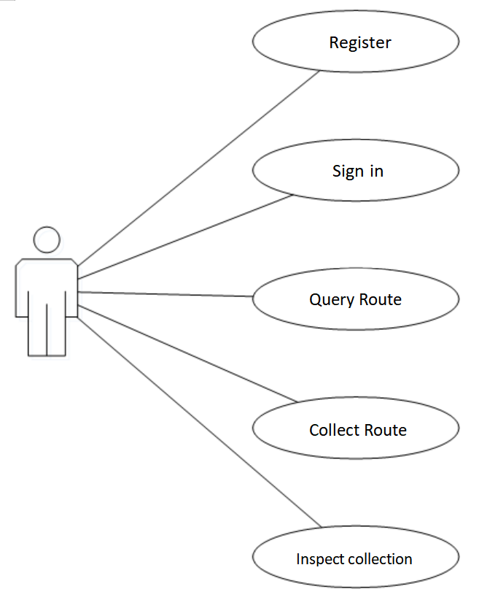
Administrative users play a pivotal role in the system's operation and maintenance, with a focus on managing the route information accessible to general users. Their responsibilities encompass maintaining all route-related data in the background, including details about the businesses associated with the routes. Additionally, administrative users have the authority to manage route categories, creating a hierarchical structure for organizing routes.
Analysis of Ordinary User Use Cases
Several key aspects of administrative user functionalities and system management include:
Route Management: Administrative users oversee the entire lifecycle of routes. This includes adding, editing, and deleting route information, ensuring that the content is accurate and up-to-date for general users to access.
Merchant Information: Administrative users maintain comprehensive information about businesses integrated into route details. This includes contact information, descriptions, and any updates related to these businesses.
Category Management: Administrative users are responsible for managing route categories. They can create, edit, or remove categories to keep the route organization logical and user-friendly.
Rights Management: To ensure controlled access and actions within the backend system, a robust rights management system is in place. Different roles are assigned to users based on their responsibilities. A user can have multiple roles, creating a many-to-many relationship between users and roles. Roles are used to control access to different system modules, each representing specific functionalities or operations.
Module Management: Modules represent various operations and functionalities within the system. Administrative users can define these modules and assign URL addresses to them. Different modules can be combined to create roles, enabling fine-grained control over user access and permissions. The relationship between modules and roles is also many-to-many, providing flexibility in configuring user roles.
User Management: The highest authority role within the system, typically assigned to top-level administrative users, has the capability to manage other users, roles, and modules. This ensures that the back-end user ecosystem is well-maintained and organized.
The user use case analysis for administrative users involves defining the specific actions and interactions they can perform within the system. This analysis helps ensure that administrative functionalities align with the needs of system management and user access control. It also facilitates the assignment of roles and permissions to different users, allowing for efficient and secure back-end operations.
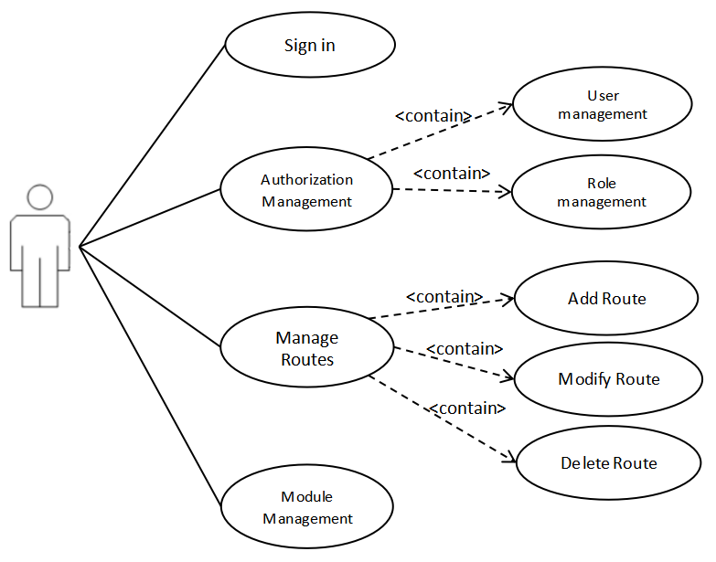
By implementing a robust administrative user system with role-based access control and module management, the travel website can maintain data accuracy, user security, and efficient system administration. This approach enhances the overall functionality and user experience of the platform.
Manage User Use Case Analysis
The analysis of the functional requirements of the front-end subsystem and the back-end subsystem was conducted to confirm the use case analysis of the front-end users and the back-end users, but in addition to the functional requirements required by the users, the system needs other functions also supplemented to ensure the normal use of the system.

System functional analysis table
System management | Functional requirement name | Basic needs
Display subsystem | User module | Implement registration, login, and logout for front-end users
 | Route module | Rough and detailed query of route information under various conditions
 | Interactive module | Front end users can interact with routes
Management subsystem | System management module | Background user management, role management, module management
 | Product management module | Management of routes, merchants, and classifications
 | Customer management module | Management of customers(also known as front-end registered users)

2.2 Performance Requirements
The overall system architecture is composed of two distinct sub-systems: the display sub-system and the management sub-system. Each of these sub-systems comprises three modules, which serve specific functions and features of the travel website.
The display sub-system, which is externally facing, places a high emphasis on user experience. It must be user-friendly, provide quick response times, and offer an intuitive interface. To achieve these goals, both the front-end and back-end components utilize static page asynchronous requests. This approach allows for the loading of only necessary page resources, reducing server load and enhancing the user's experience when accessing the website.
In addition to optimizing resource usage, the system leverages Redis in conjunction with MySQL. Redis acts as a supplement to MySQL, particularly for managing 'Hotspots' or frequently accessed data. This combination minimizes resource wastage and ensures efficient data retrieval, further enhancing the user experience.
Conversely, the management sub-system primarily serves internal users and typically experiences lower access volumes. It employs JSP as the page technology for development, making it straightforward to work with. The management interface benefits from the customization of the AdminLTE framework, resulting in a fully responsive and graphically intuitive management template. This design choice optimizes operational efficiency for system administrators.
Upon completing the development of the two sub-systems separately, the final step involves integrating these systems seamlessly. The resulting system interface is designed to be clean, straightforward, and user-friendly. Users can easily navigate the website, understanding the content through clear visuals and descriptive text. Even first-time users can quickly become familiar with the platform, thanks to its intuitive design and usability.
In summary, the travel website's architecture combines the best of both worlds: efficient and responsive front-end design for an excellent user experience and a user-friendly back-end management system for system administrators. The integration of these two sub-systems ensures a smooth and effective operation of the entire platform, ultimately delivering a simple, clear, and user-friendly interface that caters to both end-users and administrators.
2.3 Fault tolerance requirements
While the display subsystem of the website generally requires minimal manual data entry from users, it incorporates robust form verification mechanisms during data submission to ensure the accuracy and integrity of information. These verification processes enhance the user experience and maintain data quality. Here are some examples of how form verification is implemented:
Login Verification: When users attempt to log in with their account credentials, the system verifies the account and password. If there are errors in the account or password, appropriate error messages are displayed. In cases of prolonged inactivity or when sensitive operations are initiated, the system may prompt the user to enter a verification code for added security.
Registration Verification: During the registration process, each piece of information entered by the user is subject to validation. Red and green colors are used to visually indicate whether the provided information is correct and meets the required criteria. This visual feedback helps users ensure they enter accurate details.
Access Restrictions: Some pages within the display subsystem may require users to log in before accessing certain features or performing specific actions. Pop-up prompts are employed to guide users through the login process and ensure they meet the necessary authentication requirements.

In the management subsystem, where significant data management takes place, stringent verification measures are in place, particularly for critical information and sensitive operations. Here's how the management subsystem ensures data integrity and user accountability:
Non-Empty Checks: Important information, particularly data that is crucial for system operation or decision-making, undergoes non-empty checks. Users are prompted to provide mandatory data to avoid incomplete or erroneous entries.
Permission Control: A comprehensive permission control system is implemented to regulate access and actions within the management subsystem. Different user accounts are assigned varying levels of permissions. Some users may have add, delete, and modify permissions, while others may only have viewing rights. This system ensures data security and prevents unauthorized access to sensitive functions.
Confirmation and Reminder: When users perform critical operations, especially deletion actions, the system prompts them with confirmation dialogs and reminders. This step helps prevent accidental data loss and ensures that users are fully aware of the implications of their actions.
By incorporating these verification and permission control mechanisms, the travel website not only enhances user experience but also safeguards data integrity and security. These measures contribute to a smoother and more reliable user interaction with the platform while maintaining the necessary checks and balances in the management subsystem.

- System design
The overall design of the system is based on requirements analysis and is described relative to the overall design in two areas: system architecture design and technical implementation design.
3.1 Framework design
3.1.1 Architecture design
The architectural design of the travel website system is truly comprehensive, emphasizing modularity and scalability throughout. It is structured to provide a clear separation of concerns between different layers and components, ensuring an efficient and flexible system. Let's briefly expand on a few additional points to highlight the advantages of this design:
Scalability: The modular approach and clear separation of front-end and back-end functions make it easier to scale the system. As the user base and features grow, the architecture can accommodate new modules and functionalities seamlessly.
Plug-in Development: By structuring the system with layers and promoting plug-in development, the website can quickly adapt to emerging technologies or integrate with third-party services, resulting in a more versatile and competitive platform.
Security: Separating front-end and back-end functions enhances security. Sensitive business logic and data operations are isolated in the back-end, reducing the risk of security vulnerabilities and unauthorized access.
Maintainability: The modular design simplifies code maintenance. Developers can work on specific modules independently, making it easier to identify and resolve issues or add new features without disrupting the entire system.
Resource Efficiency: Centralized resource management through the file system reduces redundancy and optimizes resource usage. This approach ensures efficient storage and retrieval of common files like images.
Interoperability: The interface layer's ability to interact with external platforms, such as email sending services, enhances interoperability. This allows the system to leverage external tools and services seamlessly.
Database Interaction: Limiting interactions to the database level reduces coupling between business logic and data storage. This adherence to separation principles ensures that data is handled consistently and securely.
In summary, the architectural design provides a robust and adaptable foundation for the travel website system. It aligns with modern enterprise development practices, promoting flexibility, maintainability, security, and scalability. This thoughtful approach is instrumental in delivering a high-quality user experience while efficiently managing system resources and interactions.
The network architecture layer is divided into a display subsystem and a management subsystem, and the two subsystems are implemented in the system functionality layer, and the specific functional design will be discussed in the next subsection. The interface layer of the subsystem is designed to provide services to the outside world and to be able to refer to external interfaces, for example, the email sending platform needs to be accessed in the interface layer. Both subsystems share a common database, mainly using MySQL, and use a file system to manage their common resource files, such as images.
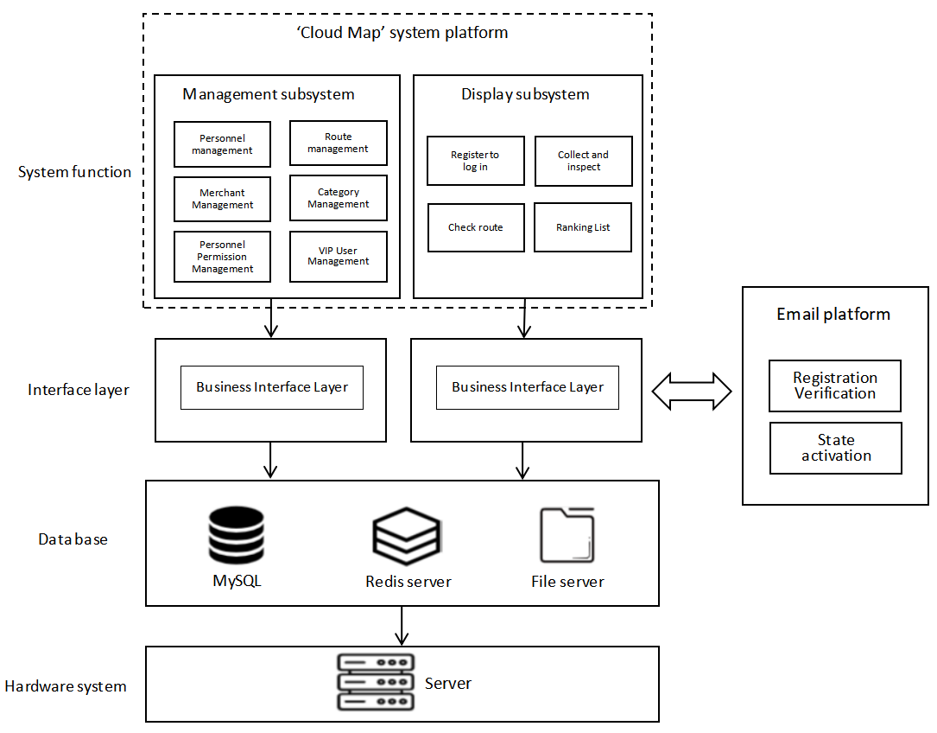
System architecture design
3.1.2 Technical Implementation Design
The whole system, which will be divided into five levels to introduce the technologies they use, as shown in the following figure, are the technology on the page side, which is the front-end technology, and Controller, Service, Dao, and DB. where Controller, Service, and Dao are the commonly used three-tier architecture technologies, and these five levels basically contain all the front- and back-end These five layers basically contain all the technical aspects of the front and back ends.
AdminLTE is not used in the display subsystem because AdminLTE is implemented based on JSP, and for a large number of external users to access, the whole page has to be refreshed every time it is loaded, and the user-friendliness is low, and all Html and Ajax are used as the pages of the display subsystem.
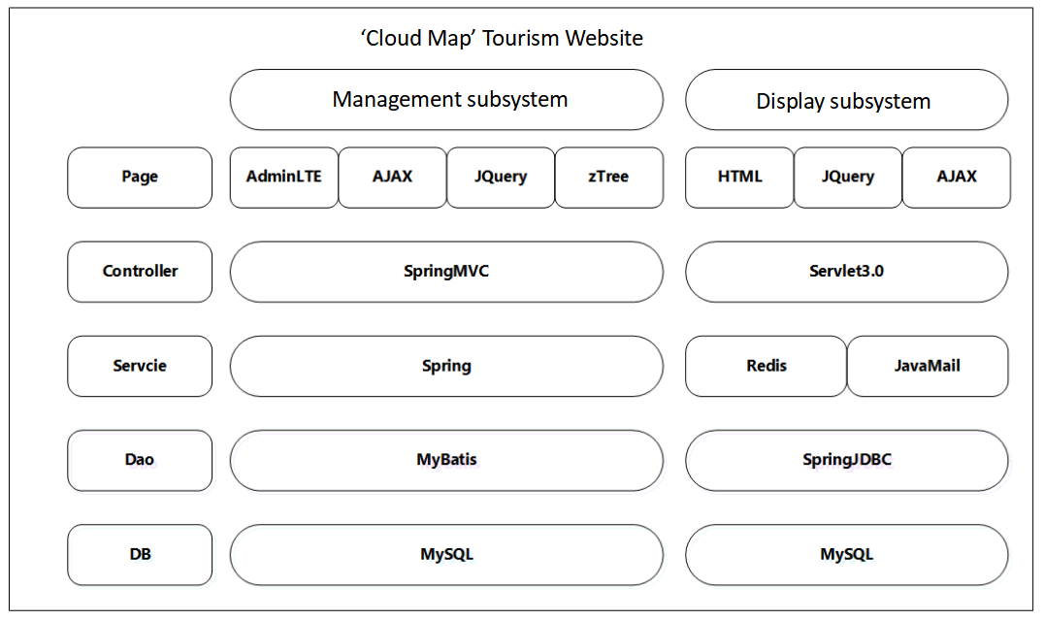
Technical architecture design
3.1.3 System function
The system functional design is a critical step in translating system requirements into a structured plan for implementation. It provides a detailed outline of the specific functions that the system will deliver and how these functions are organized into modules. This functional design aims to ensure that the system's capabilities align with the identified requirements and that the modules work cohesively to achieve the desired functionality. Here are some key aspects of the system functional design:
Module Division: The system is divided into modules, each with its defined set of responsibilities and functions. This division helps in organizing and managing the complexity of the system. For example, the management module in the backend system is responsible for adding, deleting, checking, and changing data.

Interconnected Modules: Modules often have interdependencies and work in conjunction with each other. For instance, the permission control module supports user management, role management, and module management functions, ensuring that they operate seamlessly together.
Information Flow: The functional design also clarifies how information is transferred between modules. For example, the commodity module in the backend system manages information related to the route module in the frontend system. This helps define the interface for data exchange during the design process.
User Roles: The design may incorporate user roles and permissions, defining what actions different types of users can perform within the system. This is essential for maintaining security and access control.
Data Management: The design may outline how data is stored, retrieved, and managed within the system, including database schemas, data models, and storage solutions.
Integration Points: If the system interfaces with external services or platforms, these integration points are identified in the functional design. It specifies how the system communicates with these external entities.
Functional Dependencies: The design may specify functional dependencies between modules, helping developers understand the sequence of actions required to accomplish specific tasks.
By providing a well-structured functional design, development teams can work efficiently, with a clear roadmap for building the system's features and ensuring that they meet user requirements. This design also serves as a valuable reference point for system testing, quality assurance, and future enhancements. It is a critical component in the overall development lifecycle, ensuring that the final product aligns with the original vision and objectives.

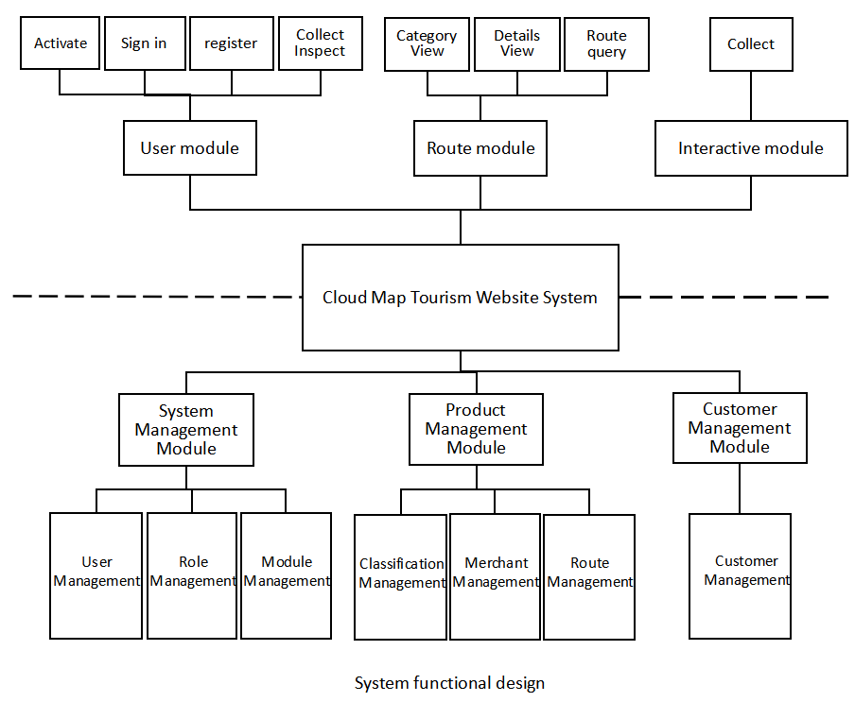

3.2 Database design
The operation of the program will definitely involve the problem of data, how to store the data is the most important. In software development design, a good database design can avoid half of the problems in development. In this system, the front and back user information, route information and various module information, etc., can not make every time after the server starts to need to enter their own data. A well-designed database allows important information to be stored securely during server operation, and the system is designed for front and back-end operations, with front-end and back-end users, so the database tables are designed differently.
3.2.1 Conceptual model
The conceptual model is introduced as follows.
The core of E-R diagram is entity, attribute, and linkage, which are the three parts, but E-R diagram drawing needs to mark all table attributes, in the following figure a rough design of the database in this system, only the rough relationship between entity and entity is analyzed and the attributes of the entity are streamlined and the specific attributes will probably be placed in the fields of table design for display. There are one-to-one (1:1), one-to-many (1:N) and many-to-many (m:n) connections between tables. There are three entities in the backend administration section, namely roles, modules, and users, all of which have many-to-many relationships with each other.
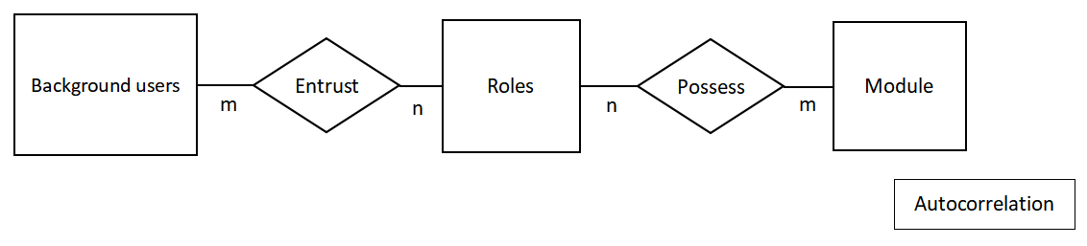
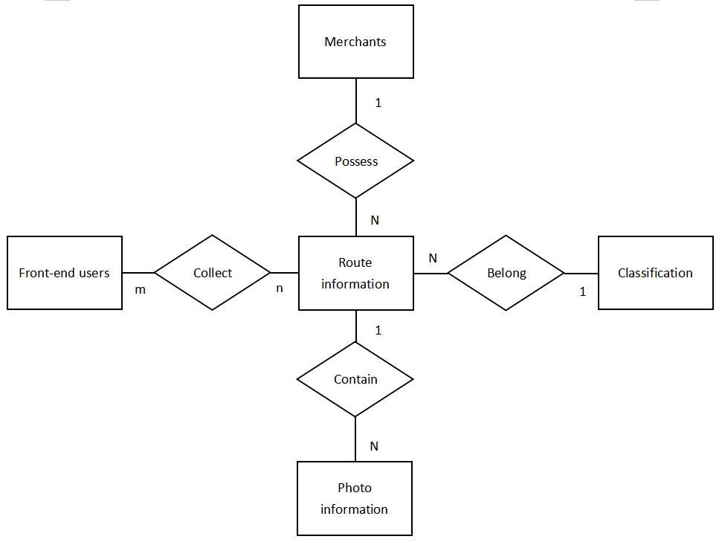
There are five entities in the foreground display section, namely, route information, categories, foreground users, merchants, and pictures. The connection between the entities is shown in the figure below, where the front-end user and the route information are in a many-to-many relationship, which is reflected in the database using intermediate tables to manage.
Background database table relationships
Frontend database table relationships

3.2.2 Database table structure
After confirming the relationship between the tables in the database, the fields in the tables are discussed. The main table data structure of the "Cloud Map" tourism system is as follows, and the main data table structure will be listed and the fields will be explained.
- Merchant table, tab_seller table, which stores the attributes of the merchants that provide routes, is described in the following table.
Field name | Data type | Clarification
sid | int | Merchant id, primary key incremented
sname | varchar | Merchant name
consphone | varchar | Merchant phone number
address | varchar | Merchant address
tab_seller table
- The general user table, tab_user table, stores the attributes of the general user, as described in the following table.
Field name | Data type | Clarification
uid | int | Merchant id, primary key incremented
username | varchar | Username, Account
password | varchar | Password
name | varchar | Real Name
birthday | date | Date of Birth
sex | char | 0: Male, 1: Female
telephone | varchar | Phone number
email | varchar | E-mail
status | char | Activation Status
code | varchar | Activation Code
tab_user table
- The route table, tab_route table, which stores route attributes, is described in detail in the following table.
Field name | Data type | Clarification
rid | int | Merchant id, primary key incremented
rname | varchar | Route Name
price | double | Price
routeIntroduce | varchar | Route introduction
rdate | varchar | Last operation time
cid | int | Category, foreign key association
tab_route table

- The collection table, tab_route table, which stores the routes collected by users, serves as an intermediate table in the many-to-many relationship between the general user table and the route table, as detailed in the following table.
Field name | Data type | Clarification
rid | int | Route id, foreign key association
date | date | Favorite time
uid | int | User id, foreign key association
tab_route table
- Picture table, tab_route_img, stored pictures are complementary to the route information, unified in a table, easy to manage, the detailed description is shown in the following table.
Field name | Data type | Clarification
rgid | int | Picture number, primary key self-incrementing
rid | int | Route id, foreign key associative
bigPic | varchar | Detailed product display image
smallPic | varchar | Detailed product thumbnail
tab_route_img
- The role table, ss_role table, serves as a role for permission definitions to be granted to different users, as detailed in the following table.
Field name | Data type | Clarification
role_id | varchar | Character primary key id, use uuid
name | varchar | Role name
remark | varchar | Detailed description of the role
ss_role table
- The administrative users table, ss_user table, stores data about the users in the administrative backend, as detailed in the following table.
Field name | Data type | Clarification
user_id | varchar | User's primary key id, use uuid
email | varchar | Email, use as login account
user_name | varchar | Real name
password | varchar | Password
gender | char | Gender, 0: male, 1: female
telephone | varchar | Phone number
birthday | varchar | Birthday
ss_user table

- The classification table, tab_category table, stores the classification attributes of a route, as described in the following table.
Field name | Data type | Clarification
cid | int | The number of the category, primary key self-increment
cname | varchar | Category name
tab_category table
- The module table, ss_module table, stores URL addresses and corresponding descriptions, as detailed in the following table.
Field name | Data type | Clarification
module_id | varchar | Module primary key id, use uuid
parent_id | varchar | Parent module to which the module belongs
name | varchar | Module name
curl | varchar | Module link
ctype | decimal | Module type 0 primary, 1, secondary, 2 button
ss_module table
- Role module table, ss_role_module table, as an intermediate table between the role and module many-to-many relationship between the embodiment of the table field information is stored in the role id and module id, the detailed description of the table as follows.
Field name | Data type | Clarification
role_id | varchar | Role id, foreign key association
module_id | varchar | Module id, foreign key association
ss_role_module table
- The role user table, ss_role_user table, is an intermediate table that reflects the many-to-many relationship between roles and users, and stores the information of the table fields, which are the id of the role and the id of the user, as shown in the following table.
Field name | Data type | Clarification
role_id | varchar | Role id, foreign key association
user_id | varchar | User id, foreign key association
ss_role_user table

3.2.3 Database implementation
This development uses Navicat graphical operation of the database, can be very intuitive and convenient to design the general structure of the data and add the relationship between the table, so as to reduce the writing of SQL table construction statement will occur in the error. After the completion of the table design and relationship design, it is directly using the graphical tools to generate the database model, you can not directly write the SQL table construction statement. The implementation is shown in the figure below.
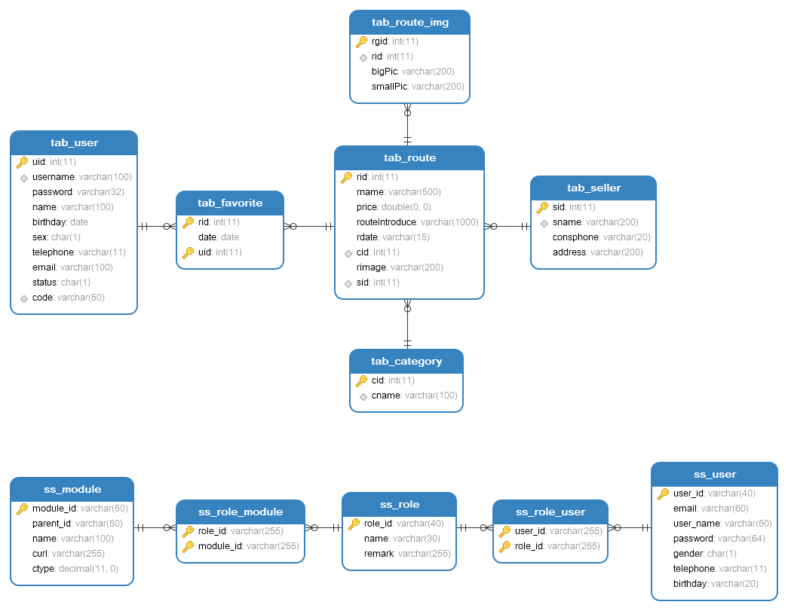

- System Implementation
Explains the entire front and back office code implementation of the system and the flow of the logical business part, the front office and back office for data interaction using to technology, specific functions to achieve the business logic.
4.1 General User Module
Ordinary users do not need to log in when visiting the page, but when he operates on the front-end page information, or to access the personal data information portal will need to log in, if the user has an account can be logged in directly if the user does not have an account will need to register. Login, registration are separate pages, the process is analyzed as shown in the following figure.
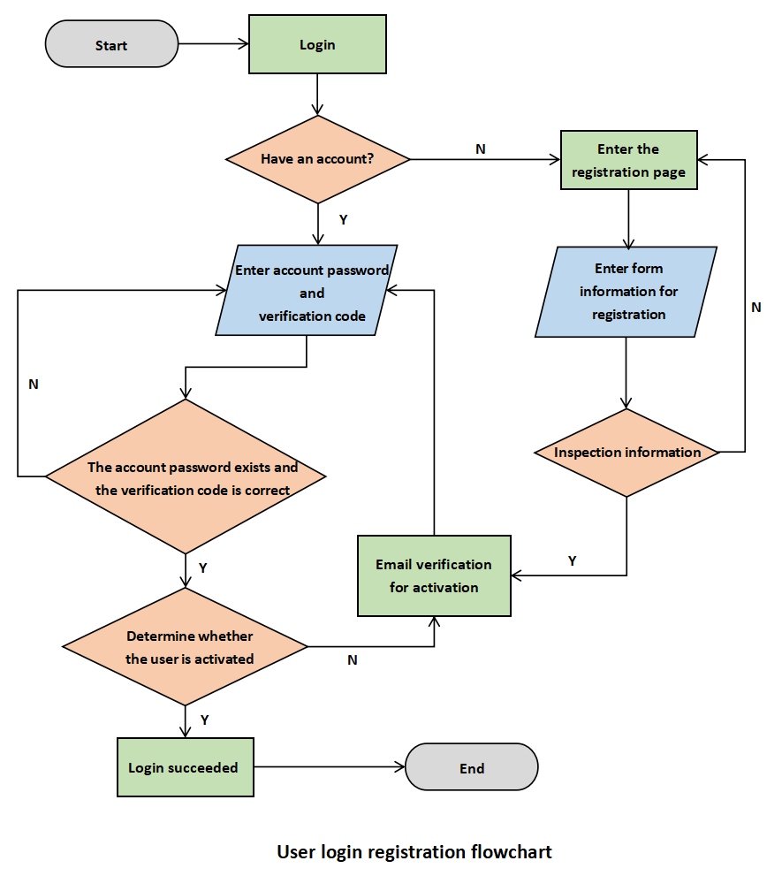
First of all, the specific implementation of the registration function is shown in the following figure "registration function analysis diagram". First use js on the front-end page to complete the form validation, and then use Ajax to complete the submission of the form to send a request to the back-end. In the back-end Servlet layer to distribute the request to the UserServlet, get the data in the request, encapsulate the data into the User object, call the method in the UserService layer to complete the registration, and according to the return of the service, to the front-end prompt information, all the information is returned in json format. In the UserService to first call the Dao layer to query the user name when it exists, if it exists directly return false, if it does not exist, then call the method of the Dao layer to save the user's information and return true. in the Dao layer is to operate the database, and return the corresponding information. Finally, it will return to the front-end page information to prompt or jump to the page. The effect of the realization of the picture as shown in the figure "registration page effect".
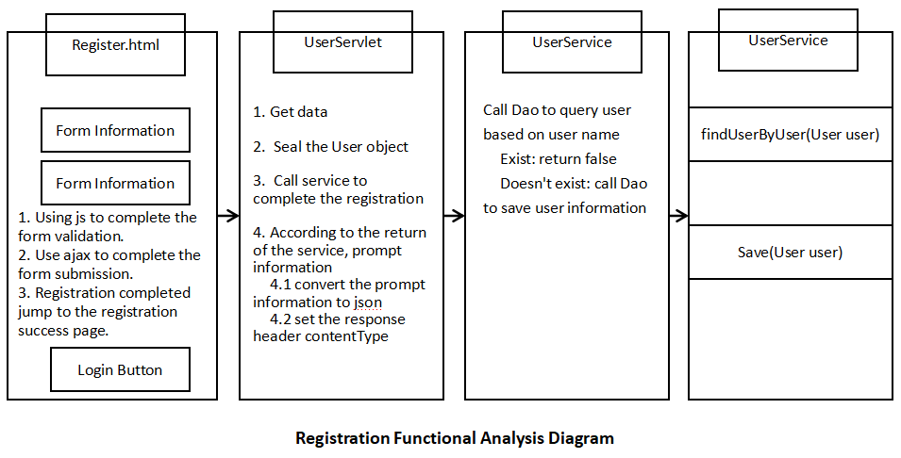 In the registration function, if the test is passed, it will store the user information and send an activation email to the user's mailbox requesting the user to go to the mailbox for activation, the specific method of implementation is to use MailUtils, which is a tool class written by someone else, as long as it is written into the introduced method, the local mailbox to send the email is defined in the tool class, and the recipient's mailbox is passed in the call method, as well as the text and mail The recipient's email address and text and the title of the email can be passed in the call method.
After the user receives the mailbox, the operating system actually needs to change the user's status field in the database to 'Y'. After the user clicks on the jump link in the mailbox content, the back-end servlet layer will first get the activation code from the front-end page link. Then, it will check whether there is a corresponding user in the database, if there is a corresponding user, it will call the service layer to change the user's activity status to 'Y'. After the modification is done, the back-end will pass the information to the front-end to make the corresponding jump.
The user login function is realized as shown in the first figure below. Front-end users in the login, but also the use of js first form data validation, if the validation passes to send a request to the back-end, the back-end receives the data, the first verification code to determine. CAPTCHA is generated in the server back-end code, every time the front-end page access to the part of the need to have a CAPTCHA will send a request to the back-end to generate the CAPTCHA image and string resources, and the string resources are saved in the session domain of the request. When the user logs in, the user will first get the CAPTCHA stored in the session domain from the server to compare it with the CAPTCHA transmitted by the user in the front-end page, and the String in the session domain will be destroyed every time it is acquired to ensure that the CAPTCHA will not be reused to improve security, and if it is not equal to the CAPTCHA, it will return a response to the front-end, which encapsulates the status information and reminder information. If the authentication code is passed, the account number and password will be encapsulated and the selectByUnPs method will be called to query the corresponding object through the account number and password in the Service layer. If the query returns the correct status information, the page jumps, if the query fails to return the corresponding status information, and prompts the user. After the front-end user has successfully logged in, the page submission will be changed, and the user name of the logged-in user will be displayed in the upper-right corner of the page, and then actions such as logging out of my favorites will also be visible. The second figure below shows the front-end prompt information.
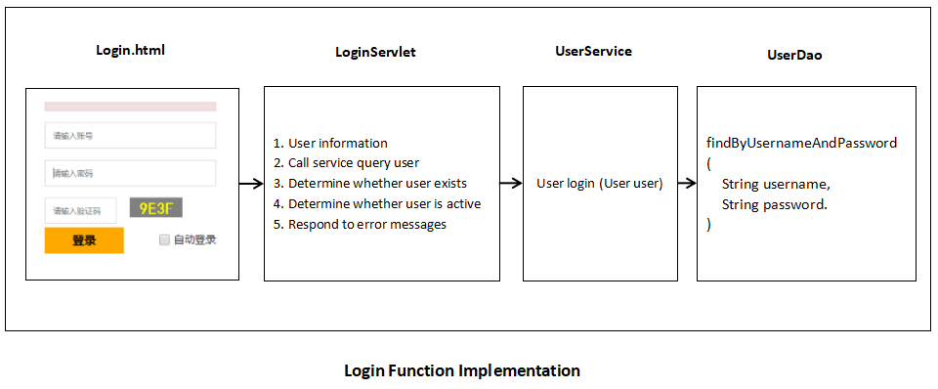
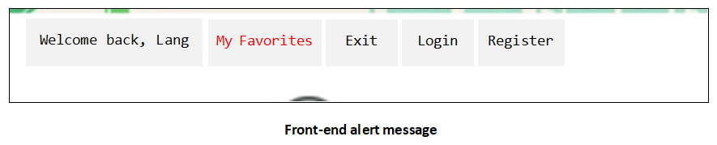
Now that logging out is mentioned, the concept of logging in is involved. Logging in means that the user object exists in the session domain linked to the browser, and the data in the session domain will be automatically saved for a certain period of time (which can be set when obtaining the Seesion object, and the default is 30min). So if the user wants to quit after using one end of time, how to ensure the safety of the user becomes a problem. Therefore, the essence of user exit is to destroy the session domain.
4.2 Code Optimization
When the code is written to show the subsystem to complete the user module, the implementation of the user's login, registration, exit function, my approach is to write a method to implement a Servle class , so that the Servlet layer under the Web package has been very bloated , not conducive to the subsequent development and management. So I optimize the Servlet integration , so that a servlet can provide different methods to handle the front-end page to transfer the request . Designed to use reflection technology to achieve the model diagram as follows BaseServlet implementation, create a BaseServlet class inherited into the HttpServlet rewrite the Service method, which is a Servlet class out of the core of the service, each request will be accessed on the arrival of this method, where you can face the distribution of the request processing This is the core of the Servlet class external service, every request will access this method, where the request can be distributed and processed, so that they are executed by the corresponding class methods.

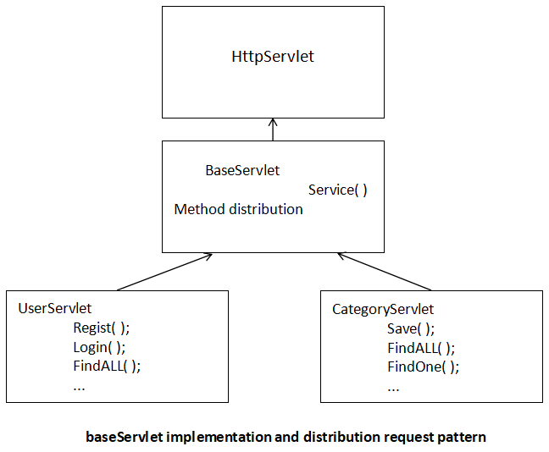

First of all, the designer needs to understand the concept that HttpServlet is inherited from Servlet, and Servlet's life cycle of service () method, every time the Servlet is accessed will be executed, will be executed many times. After writing classes and methods in this way, the same module under the different methods can be integrated into a class, the specific implementation of the process, for example, in the front-end page to write asynchronous requests for the url user/loginUser, and after the integration of UserServlert class using @webServlet ("/user/*") so used in the UserServlert class, the user can use the service ("/user/") method. ") so that the use of the user's request will be captured by this class, and in the UserServlert class is inherited from the BaseServlet class, only this class has a Service method to provide services to the outside world. This method uses reflection to get to the object of the other methods, so that only through a basic class in the Service method can call all the other methods.
4.3 Route display module
At the beginning of the implementation of this part of the function is to enter the home page, no matter logged in users or non-logged in users will send a request to the back-end to get the category information in the header section, which can be followed by the category information is a "hotspots" information, if the number of visitors surge, each user will enter to the back-end database If there is a surge in traffic, each user will send a request to the back-end database to query the categorized data, which is obtained from MySQL via IO and puts a lot of pressure on the server.
This is why the idea of using Redis technology came to mind. The analysis shows that the classified information data is re-requested by the database each time the page is loaded, which puts a lot of pressure on the database, and the classified information data does not change often, so Redis can be used for caching.
After the front-end request is sent to the back-end, the request is first distributed through the BaseServlet class, which is written to the corresponding CategoryServlet class for processing, and the Servlet layer is used to scope the Service layer to obtain data, and the main business logic is placed in the Service layer for processing. When the corresponding method in the Service layer is called, it will first access whether the data is available in Redis, and if so, return the data directly to the front-end. If not, the Dao layer is called to access the database and return the data to the front-end, where it is then stored in the Redis database. This way the data is retrieved from Redis for the next N visits.The specific flow chart is shown below.
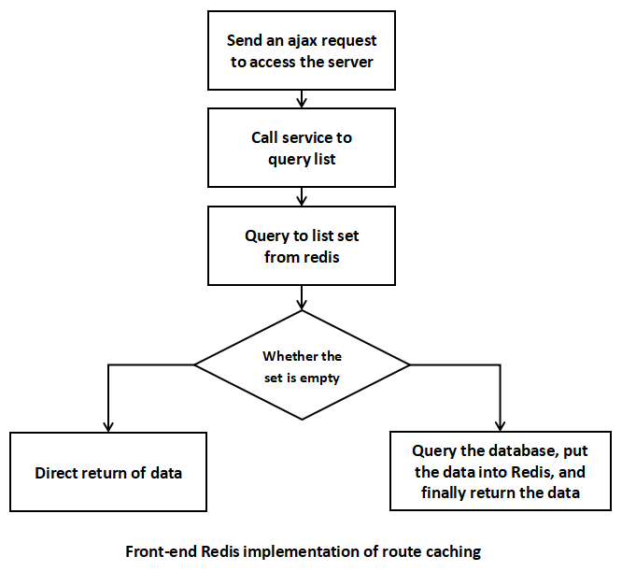
Paging function of the realization of the steps, the first thing to be done is how to achieve a paging page in the front-end page, and the page number column can achieve and Baidu search page number column similar effects, the following chart paging effect. If the query data is less than ten pages on the direct display, if more than ten pages to optimize the display, a total of ten pages to display, to achieve the effect of five pages in front of the back of four pages, if the front does not meet the five pages, the back of the ten pages to make up for it, if the back of the four pages do not meet the front to make up for the ten pages. The front-end needs to send a request to paging query the information under the corresponding classification, then the Ajax request needs to be classified id number, the page number of the page, sent to the back-end, you need to carry out the corresponding processing, access to the corresponding data and check, in the business layer of the paging logic processing, call Dao layer to query the database, and all the front-end need to paging information, such as total number of pages, total number of data entries, query the data, the number of pages, total number of data entries, the number of pages, total number of pages, total number of pages, total number of data entries, total number of pages, total number of pages. number , the total number of data , query the corresponding data , etc. are encapsulated into an object into a Json data format passed to the front-end , and finally back to the front-end header needs to be transmitted to the back end of the data processing , to be in accordance with the front-end of the format defined by the show .
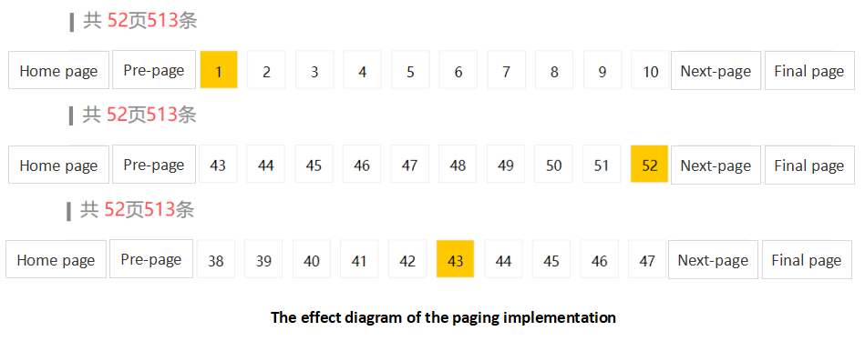
Front-end paging code, the entire business logic is more complex, first confirm the effect to be achieved after the analysis of the process, so that when writing the code more ideas, not because of forgetting those processes and interruptions in writing, as shown in the following chart. In clear data, to the form of string splicing this part of the code spliced together in the same front-end selector to change the corresponding container, this part should pay special attention to because of the use of string splicing in the form of writing process is not highlighted or VScode code prompts, after writing and do not know the front-end code spliced together with the need to debug their own repeatedly there is no error. Although the amount of code is not much, but this way to write html on the personal experience is very difficult, often appear comma or quote problems caused by the front-end formatting errors. The above is the completion of the front-end code part.
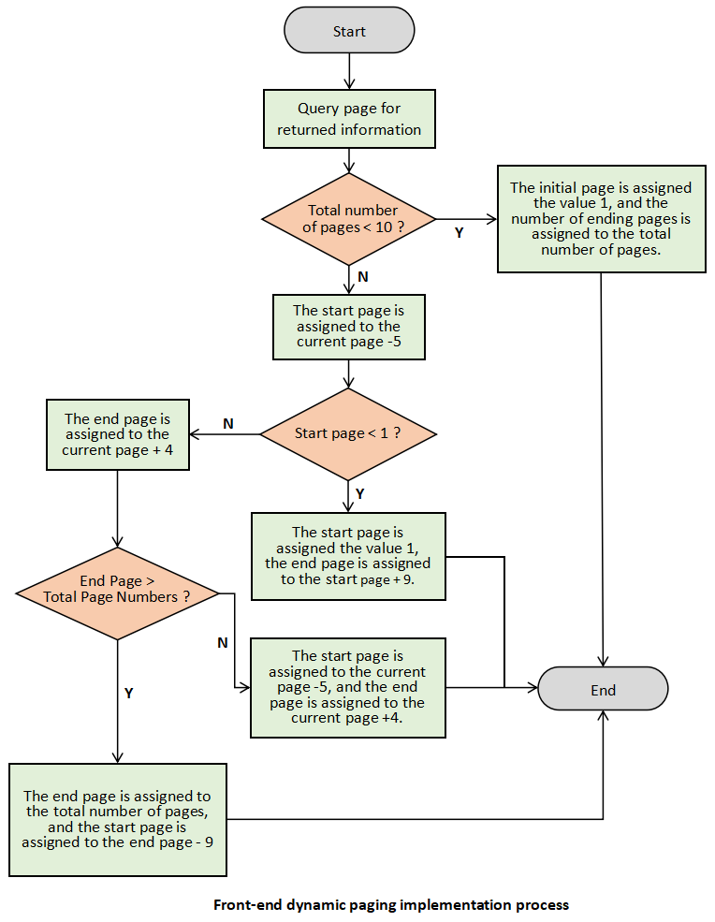
The back end is more important is, how to calculate the query through the page number of those data, the specific implementation of the SQL statement used in the limit field, paging algorithm, you can pass the number of the current page number of code, calculated by the index to start querying the location of the query, and the query how many is the front in the front-end has been confirmed in the display of 10 pieces of information per page. If the query result set does not have 10 articles will have a few articles to store a few articles. This information (total number of data, the total number of pages, the number of current page code, the number of articles per page display, the corresponding route data) is encapsulated into the object will be returned to the Servlet layer to convert the format returned to the front-end page. service layer paging algorithm is as follows:
First of all, the details page to show the data to analyze, to show the picture resource, route name, route details introduction, provide route merchants, route price, etc., these information data to query three tables (tab_route, tab_seller, tab_route_img), but also at present the first time I encountered a page of information data composition requires the support of the three table Implementation, so will focus on the implementation of the process here, the flow chart is shown in the following figure.
This module also shows the number of routes to be collected, which is directly with the rid query corresponding to the tab_favorite table, the use of aggregated query function Count(*) can be queried to the number of a rid corresponding to the collection.
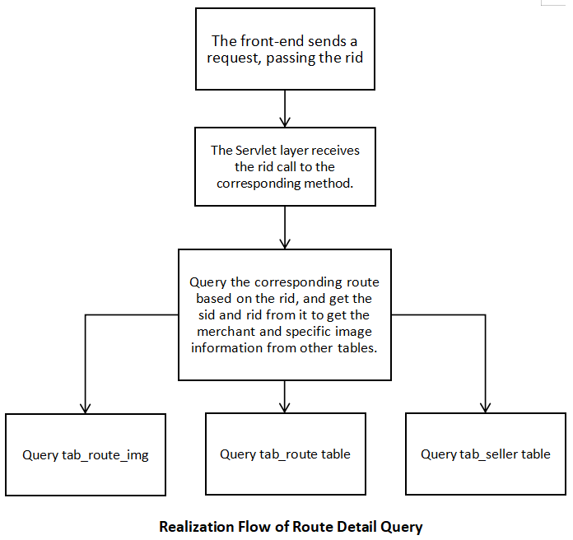
After analyzing the source of the data, it is necessary to determine how to query. In the classified information to show the route of the page, the user can click on the route of interest to enter to view the details, this involves how to confirm that the user clicks on the route (this step in the classification to show the route of the information is completed), how to send the corresponding request to the back-end, the transmission of the route of the id can be distributed through the BaseServlet to execute the corresponding control layer methods, will be called in the method route information in the table design is to tab_seller, tab_route_img id as a foreign key, so that you can directly query through their ids to the corresponding relationship, in order to reflect this relationship in the design of the entity class, in the route of the entity class contains the type of the seller and img. and img. This part of the Service layer code is:

4.4 Collection function
User favorite, cancel favorite, this part is relatively simple, the essence is the tab_favorite table increase and change operations. The other part is that the user has to check all the routes he has collected, first analyze the theory, after the user clicks "my collection", the server will first judge whether the user has logged in, if not logged in, the user will be asked to log in after the operation, then the user's uid will be used to query all the routes first. ridd collection, and then use the data in this collection to query all the route collective data information. In fact, this place should be written in the business logic in the Service layer, but at that time did not take this into account, this part of the code written to the Dao layer of logical judgment, although the back of this part of the code want to modify, but I feel that this place is used in the embodiment of the dynamic SQL is particularly good, there is no change. Business logic in fact, there are not many difficult places, the realization of dynamic SQL will be shown, because the use of JdbcTemplate, a lightweight database connectivity technology, dynamic SQL splicing and the use of strings to achieve the same html splicing are very unfriendly to developers. Specific realization of the effect is shown in the figure below.
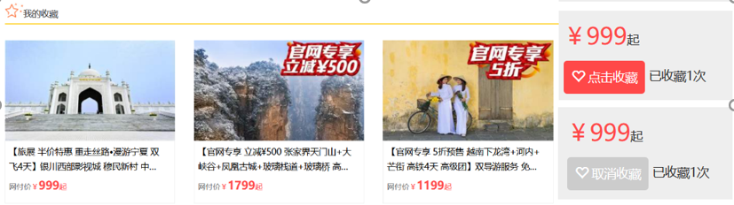
User actions to favorite routes

4.5 Administration page implementation
After completing the development of the display subsystem, I had a better understanding of the technical aspects and drawbacks of the whole project and was more aware of the inadequacy of the technology, so I continued to plan the management subsystem after acquiring some new technology and knowledge. The backend system will use a lot of development framework technology, which saves development time and is better for the safety, stability and aesthetics of the system. At this stage y expect to use AdminLTE as the framework for the front-end pages. AdminLTE is based on Bootstrap, jQuery, which not only has a large number of components and container resources of Bootstrap but also integrates these resources, which is very convenient for the development of enterprise back-end systems.
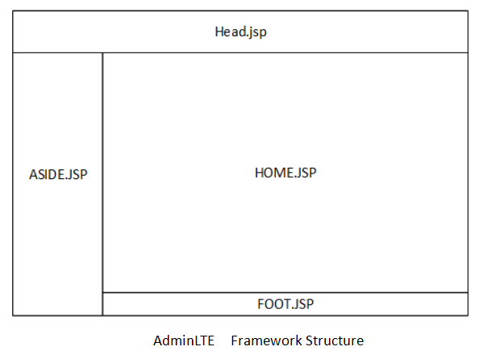
As the background is developed as a management system, and does not need to show the first subsystems that deal with functionality outside but also to emphasize the beauty of the use of AdminLTE is the benefit of it to the main.jsp as the program into the page, a page is divided into four different areas are the left menu bar aside.jsp, the top of the navigation header.jsp, the middle of the main work area home.jsp, the bottom of the copyright information display area footer.jsp. The main work area home.jsp, the bottom of the copyright information display area footer.jsp, and these areas have a separate page to provide support as shown above. This can only focus on the main part of the hom.jsp part of the change, the layout of the other location is unchanged.
4.6 Module Rapid Development
The management subsystem uses the SSM framework as the overall structure of the project. These techniques can save a lot of business logic that human beings need to deal with, such as writing SQL in the front-end, realizing the corresponding Service and Dao classes, extracting the commonality of the code for integration, and separating many configuration types of code from the main business program. Because Mybatis supports the Dao layer , so you can separate the SQL statement and Java code , the writing of SQL statements more friendly , and it has a corresponding plug-in MyBatisX can directly generate the corresponding entity classes , interface classes , mapping files and so on. Users from the many repetitive class creation operations to liberate , it can make the interface in the Dao layer does not need their own implementation of the class but points directly to the mapping file . Spring can create objects from the hands of the developer turned over to the container , so that the realization of the method does not have to go to their own Service service = new ServiceImpl such a way! through the upward transformation to achieve the corresponding method interface, while Spring another major feature is AOP, mainly the Service layer in the management of the transaction using the AOP approach, just need to open the transaction in the configuration file on the line, the focus is on the management of the class of the writing. the introduction of SpringMVC, you do not have to implement any interfaces, all the methods request @ RequestMapping to solve , and receive parameters do not need to use request.getParameter () to achieve , it will provide the Controller layer Servlet code into the ordinary Java code as concise .
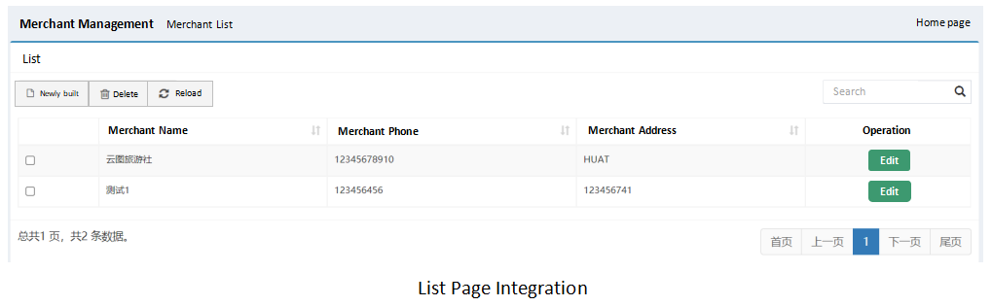
4.7 Permission control implementation
A privilege system is a system that sets the relationship between users and operable modules. By setting the relationship between users and operable modules, it can control the users to perform business within a certain range. Role-based access control (RBAC: role-BasedAccessControl) is used in this system. Users are assigned different roles, and different roles are bound to different functional modules; when a user logs in, the user's associated roles and corresponding functional modules are queried, so that different users can see different functional modules. By materializing different modules, the characteristics of these modules, for example, modules in this system are distinguished by method names and links. So after these modules are constructed, different roles appear when different modules are integrated together, and privilege control is realized when different roles are given to different users.
Permission system of the front-end support is required to use the zTree as a file is a tree structure, you can learn its official website to operate the guide, only need to focus on the front-end components to pass the data should be what. zTree is a responsive component, you can point to the option to automatically display their tree structure as shown in the figure below. Modules in the database when entering the time to consider their tree structure to display , can be used directly in this place , as shown in the figure below. zTree is a responsive component , you can point to the sub-option to automatically bind the parent option , the structure of this display is also similar to the menu bar .
And this part of the granting and un-granting of permissions, in the Service layer is a business logic, ordinary add, delete, check and change and can not achieve this authorized operation, in the front-end check on these permissions, click to save is actually submitted to the background of the data, a checked corresponding to the permissions of the id array, to get to the Service layer after the call to the method, because each time it is Because each time is a new selection, it is not possible to determine whether the user has added or deleted data. So it is straightforward to delete all the existing relationships and then add the data from the front-end. Similarly, when granting roles to users, the same operation is performed, first deleting all the data in the relationship table, and then adding the data based on the incoming array.
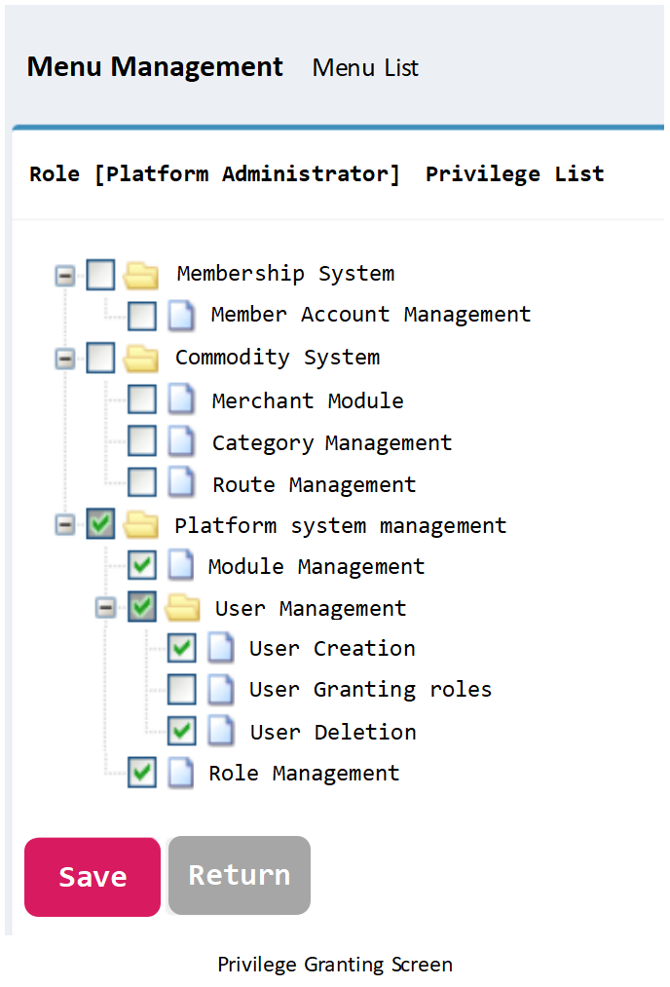
After binding the permissions to the roles, it is to give different roles to the users, this part and give permissions to the roles are similar, except that in the display of all the roles is not to use the zTree component, but directly use the form of the checkboxes to achieve the following picture shows.
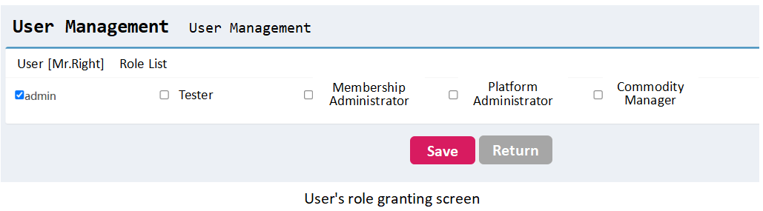
At this time the user-role-module correspondence has been established, something to do is to reflect this relationship in the front-end, each user corresponding to the role into the system to see the information is not the same, directly in the front-end to hide or not show, so in the user login time through the user's id to get the corresponding role, in the role to get their corresponding module information, pass this field to the front-end page for data traversal, so that the menu bar in the front-end page is generated according to the data queried in the database. So when the user logs in, we need to get the corresponding role by the user's id, and then get their corresponding module information by the role, and pass this field to the front-end page to traverse the data, so that the menu bar in the front-end page is generated according to the data queried in the database. This is the part that is written in the server to store the acquired information in the Session field so that the front-end JSP page can get this data directly from the field.
front-end code is nested through two loops, the first loop first to find all the first-level menu, if cypte = 0 that is a menu, and then the first loop in the cycle, if this layer of the cycle, the menu is to facilitate the parent menu and the outer loop id the same on the formation of a hierarchical relationship, so that the user logs in after loading the page on the time of the privilege control. At the same time this use of c:forEach and c:if to control the logic of the front-end, at the same time c:if is hidden directly in the code level, rather than comments. In this way, even in the front-end page can not see the corresponding logic, to ensure the security of the front-end page.

Permission control in this place can only guarantee the display of the first level menu and the second level menu, and the third level menu is the control of the button needs to be entered into each module of the list collection to show the comparison of the string to control the button appears or not with c:if, unified logic code here will not be rendered by the browser loaded into the front-end, as shown below.
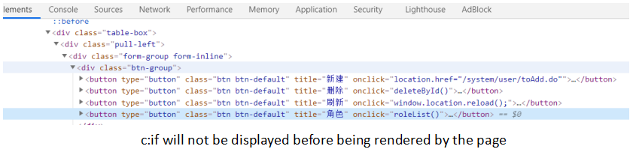

- System Testing
System testing is a system in the development is completed, the system function of acceptance, system testing is the development of the last step, but also the most critical step, only through the system testing to test the development process of the bugs, after the completion of the repair of the system has stability and correctness.
5.1 Purpose of testing
In software development testing is also a very important part of the end of the system development, you need to test the function of the installed modules, modify the code to complete the system. This is to ensure that the final quality of software products, but also to detect whether the system in accordance with the needs of the completion of the various functional modules, whether there are bugs, in the testing process to find and find out as much as possible the loopholes in the design of the system, and then these Bugs for a special analysis in the go to modify the code to improve the system, the test is to prove that there is a mistake in the program, and can not guarantee that the program does not have a mistake. Strictly speaking, software testing sessions are very rigorous, are carried out by independent reviewers or centers, but the individual development process lacks these things, can only conduct their own testing, as much as possible to find out the existence of bugs in the program.

5.2 Techniques of testing
Testing is categorized into black box testing and white box testing. Black box testing does not involve writing code, inputting values, seeing if the program is able to output the expected values, or looking for errors on the page, while white box testing involves writing code and paying attention to the exact execution of the program. This test will be a black box test, which will operate on each of the actual modules in the front-end system to see if they function well and have the expected results.
5.3 Programs of testing
According to the requirements analysis of the system process testing, you can get the system is able to meet the expectations of the requirements analysis, but also on the various modules of the addition, deletion, checking and alteration of the business logic to ensure the robustness of the data and the stability of the system. This project according to the business requirements of the system has been tested, covering all the modules and buttons, are successfully tested on the machine, the defects found have been repaired and retested.
1. The user module in the front-end system is tested first, to test whether the user can register, activate, log in, and whether there are friendly user prompts in the operation process, the following table shows its test cases, and the following figure shows the display results.
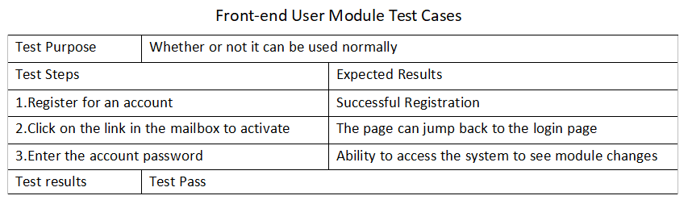
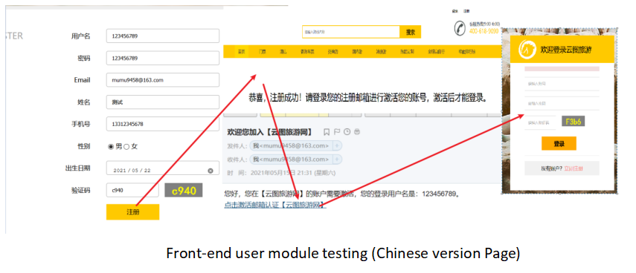
2. Clicked on the categorized view, fuzzy query through the route name and clicked on these to find the rough information for the details to show the test test cases are shown in the table below, and the test results are shown in the figure below.
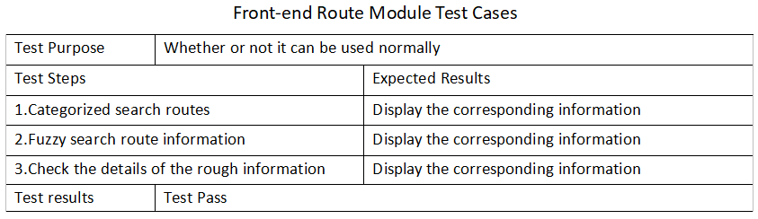
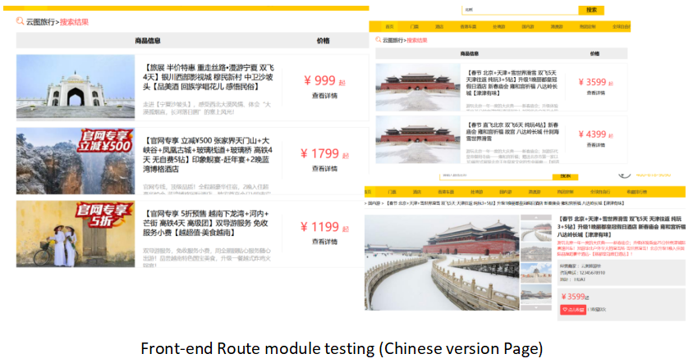
- Test the user and route interaction module, the user can click on the collection, cancel the collection, you can view all of their own collection, the test cases are shown in the table below, the results of the figure shown in the figure below.
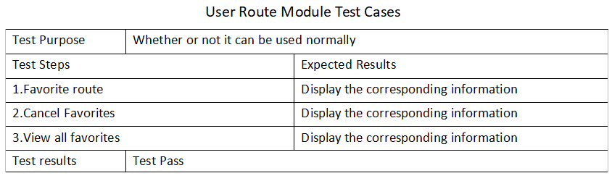
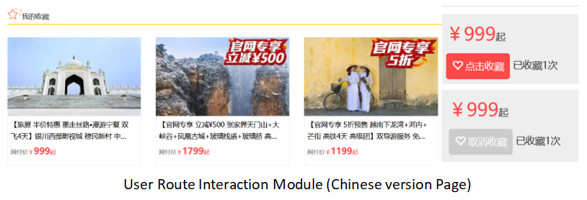
4. The test of background user login and authority control, each user is given different roles to enter the system to see different interfaces, the test cases are shown in the following table, the results are shown in the following figure.
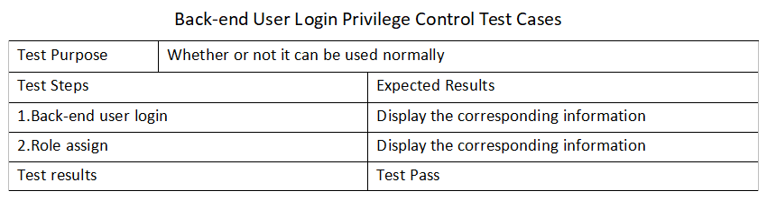
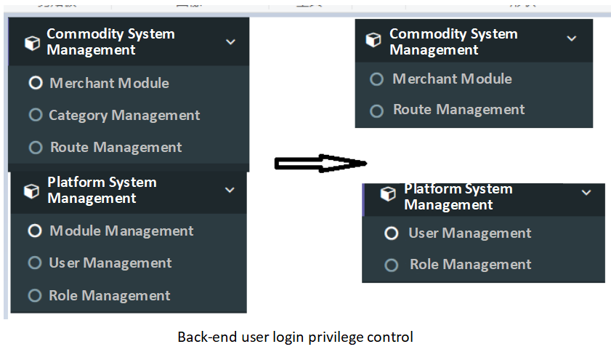

5. Commodity management module, the ability to classify, merchants, routes to add, delete, check and change the operation, to complete the intended objectives, the test cases are shown in the table below, the results of the chart as shown in the following two graphs.
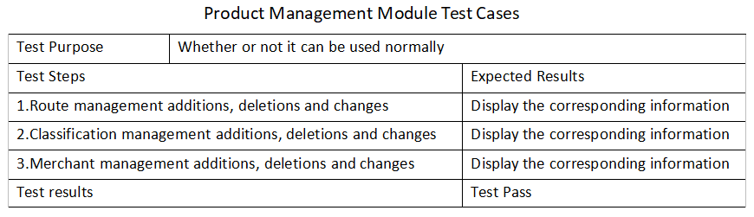

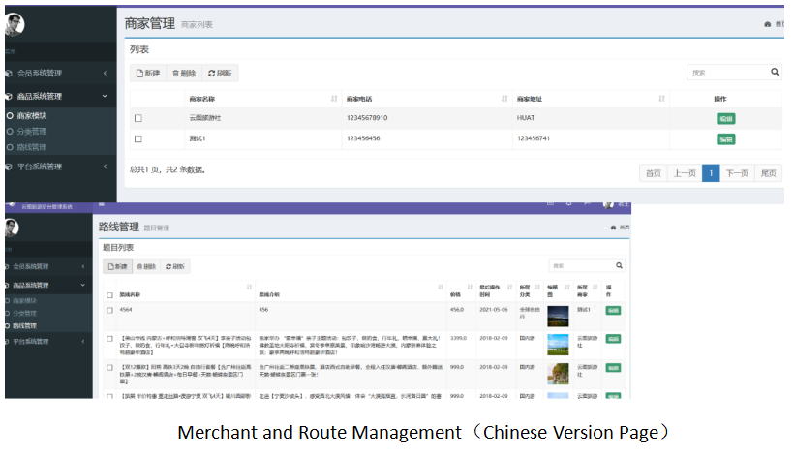
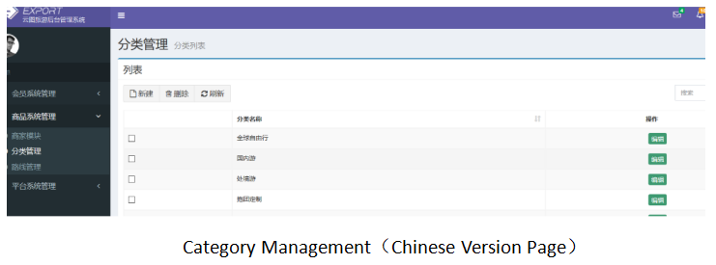

- Conclusion
This system design, the front-end general user interface is mainly used to HTML, AJAX, management user interface using zTree components, AdmainLTE framework. General user interface focuses more on access speed, interface beautification, the use of HTML, AJAX can be realized asynchronous access, each request will only refresh part of the data in the page, will not be the whole page are refreshed, at the same time in the asynchronous sending request at the same time, the user can also carry out other operations. The management user interface is mainly for internal staff, while the access is small, more focused on the display of information to facilitate management, and AdmainLTE is a front-end framework developed specifically for enterprise-level websites.
On the back-end, the display subsystem completed at the beginning did not use to SSM framework, it is a native JavaWeb project, just introduced JDBCTemplate to connect to the MySQL database, which reduces a large number of dozens of code, for example, to create a connection, close the connection, etc., and at the same time, the use of Redis to supplement the MySQL database to reduce the MySQL server's pressure on the MySQL server. After the introduction of MyBatis, the main decoupling of the code, the SQL statement extracted to the configuration file, it and entity class mapping is more flexible. The use of Spring is mainly its two core, container and AOP, will create objects from the hands of the programmer to the container for management. MySQL native business management, each business logic processing through try-catch to open the business, submit (rollback business), and AOP can be directly on this part of the common code is extracted to the configuration file for unified management.
The use of these techniques to basically realize the functional development, but the whole system is not the most perfect. Common operations in the two subsystems, such as some operations on the route entity class, should be extracted to a common module for management. In terms of permission control, there is no verification of chain stealing, and identity information should be extracted into the request header separately and verified for each access. At the same time, the handling of resource file servers does not allow the file resources in the two subsystems to be shared. Although the development of the functional requirements is basically completed, there are still areas for improvement.
References
From my own personal course report from ‘Research Methods, Design, and Analysis(ACFA7004)’, named ‘Research Methods, Design, and Analysis (ACFA7004) Research on Tourism Website and Design and Implementation of a Tourism Website_Lang Yan (2200468)’.

[1]Benmoussa K.,Laaziri M.,Khoulji S.,Kerkeb M.L. & Yamami A.E..(2019).A new model for the selection of web development frameworks: Application to PHP frameworks. International Journal of Electrical and Computer Engineering(1).
DOI:10.11591/ijece.v9i1.pp.695-703.

[2]Daries Natalia,CristobalFransi Eduard & FerrerRosell Berta.(2020).Implementation of Website Marketing Strategies in Sports Tourism: Analysis of the Online Presence and E-Commerce of Golf Courses. Journal of Theoretical and Applied Electronic Commerce Research(3). DOI:10.3390/JTAER16030033.

[3]Ip, C. , Lee, H. , & Law, R. . (2012). Profiling the users of travel websites for planning and online experience sharing. Journal of Hospitality & Tourism Research, 36(3), 418-426.
DOI:10.1177/1096348010388663.

[4]Jamal ,Yamani ,Mundzir ,Vidy ,Idris Nasruddin Bin,Rosita Isa & Gunawan.(2021).Design and Implementation of Web Application for Attendance List of Lecturers Using Codeigniter and Bootstrap Framework. Journal of Physics: Conference Series(1). DOI:10.1088/1742-6596/1807/1/012030.

[5]Jian-fei Tu Faculty of Mechanical Engineering and Mechanics Ningbo University Ningbo,China Rui-feng Guo Faculty of Mechanical Engineering and Mechanics Ningbo University Ningbo,China.(2011).The Application Reseach of Mixed Program Structure based on Client-Server,Browser-Server and Web Service..(eds.)Proceedings of 2011 International Conference on Business Management and Electronic Information(BMEI 2011) VOL.01(pp.220-222). Institute of Electrical and Electronics Engineers,Inc..

[6]José Alberto Martínez-González, & Lvarez-Albelo, C. D. . (2021). Influence of site personalization and first impression on young consumers' loyalty to tourism websites. Sustainability, 13.DOI:10.3390/su13031425.

[7]Li Gaoguang & Shahraki Abdol Aziz.(2022).Tourism Enterprises Marketing Management and Upgrading Situation of Tourist Sites to Achieve Sustainable Regional Economic Development. Sustainability(23). DOI:10.3390/SU142315913.

[8]Sheshadri Chatterjee, Dipasree Majumdar, Sanjay Misra & Robertas Damasevicius.(2022).The determinants of e-tourism websites for tourists while selecting a travel destination. International Journal of Electronic Marketing and Retailing(3). DOI:10.1504/IJEMR.2022.123942.

[9]Zengyu Cai,Yuanbo Liu,Yong Gan... & Yuan Feng.(2019).Design and Implementation of Online Mall System based on Java Web. International Journal of Performability Engineering(12). DOI:10.23940/ijpe.19.12.p15.32373244.

[10](2019).Intelligent Tourist Guide System using Web Development. International Journal of Engineering and Advanced Technology(2). DOI:10.35940/ijeat.b2627.129219.

DECLARATION

I, ............................................Lang Yan………………………………… declare that I am the sole author of this Project; that all references cited have been consulted; that I have conducted all work of which this is a record, and that the finished work lies within the prescribed word limits.

This work has not previously been accepted as part of any other degree submission.


Signed : .............................................

Date : ...............14/9/2023.................

FORM OF CONSENT

I ............................................Lang Yan………………………………… hereby consent that my Project, submitted in candidature for the Software Engineering degree, if successful, may be made available for inter-library loan or photocopying (subject to the law of copyright), and that the title and abstract may be made available to outside organisations.

Signed : ...............................................

Date : .................14/9/2023..................

