INSTRUMENTATION & CONTROL
CONTROL SYSTEM DESIGN
Mr Finn Mallon
Contents

Introduction 2
Simulation 1 Setup 4
Simulation 1 Results 8
Simulation 2 Setup 11
Simulation 2 Results 13
Discussion 15
Conclusion 16
References 16

Introduction

What is a Control System?
A control system is a collection of mechanical or electronic components that uses control loops to regulate other components or systems. Control systems are typically computerised. In many sectors, control systems play a crucial role in production and distribution. In these systems, automation technology has a significant impact. Industrial control systems, such as supervisory control and data acquisition systems and distributed control systems, are examples of the control loops that govern these activities. [1]
What is the purpose of control systems?
In various industries, control systems are utilised to increase productivity, effectiveness, and safety: [1]
- Agriculture.
- Chemical factories.
- Paper and pulp factories.
- Quality control in manufacturing and industry.
- Power plant operations and boiler controls.
- Environmental management.
- Treatment facilities for sewage and water.
- Food production and processing.
- Mines and metal.
- Production of pharmaceuticals.
- Refinement of sugar.
The following are specific instances of how industrial processes use control systems:
- Power plant and heating system boiler controls.
- Pipeline surveillance.
- Systems for distributing water.
- Systems for treating wastewater.
- Systems for distributing electricity.

What main categories of control systems exist? [1]
Open-loop and closed-loop systems are the two most used forms of control systems
Open loop-
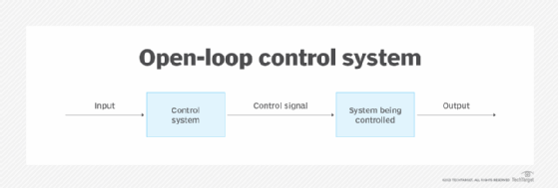
Human input is required to operate these control systems. The control procedure is unrelated to the result. A washing machine is an example of an open-loop system in a home setting since someone must select one of the settings before it operates. The timing of the stop, go, and caution lights must be determined by traffic engineers in a time-based traffic light system, which is an industrial example of an open-loop control system.

(Figure 1 - In an open loop control system a human operator provides the input and assesses the output) [1]

Closed loop- [1]
These systems can be actively managed or configured to function on their own. They operate automatically and maintain particular settings or a desired state devoid of human intervention by using feedback signals from the system. It is possible to switch between closed and open modes for some control loops. A switchable loop can be entirely automated while it is closed, but it requires manual control when it is open.
An illustration of a closed-loop system is a thermostat. Based on the signals it receives from sensors that track the air's temperature, it turns the heating system on and off. Controlling the temperature is a crucial aspect of keeping a healthy data centre environment.
In Figure 2, the technician takes charge of a remotely controllable system. The device receives input signals from the technician on frequently, and through a feedback loop and a sensor that monitors the equipment, it also delivers output signals. The technician receives an alarm message from the sensor when the device sends an error signal, and the technician responds with any necessary instructions to the device to counter the negative feedback.
An additional feedback control method is shown in Figure 2. To operate the device, the control system needs feedback data.

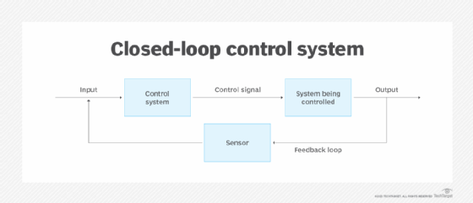

(Figure 2 – In closed-loop control systems sensors and a feedback loop make it possible for the system to function both with and without human intervention) [1]

Simulation 1 Setup
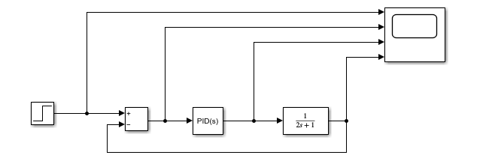
(Figure 3 – Closed loop control system)

$$G\left(s\right)= \frac{1}{2s+1}$$

The equation above shows the transfer function of an angular positioning system attached to an automatic CIWS turret. (Figure 3) above is a closed loop control system that has been designed to capably control this process. Included in the closed loop control system above as shown in (Figure 3) is a Step block, a Sum block, a PID Controller, a Transfer Function and finally a scope to show the results of the system.
The jobs of the parts included in the closed loop control system is listed below:
- The Step block, at a certain time, provides a step between two defined levels. The block's output is the Initial value parameter value if the simulation time is smaller than the Step time parameter value. The output is the parameter value for the Final value when the simulation time is more than or equal to the Step time. [2]
- The Sum block adds or subtracts the values it receives. The blocks for Add, Subtract, Sum of Elements, and Sum are interchangeable. The inputs to this block can be scalar, vector, or matrix. Additionally, it has the ability to collapse a signal's components and sum them. [3]
- For the Simulink PID Controller blocks, PID Tuner offers an efficient and broadly applicable single-loop PID tuning approach. This technique allows you to adjust the PID controller's parameters to produce a reliable design with the required reaction time. [4]
- A transfer function is a useful tool for visualising the input-output relationship of a linear, time-invariant system. It is produced by performing a Laplace transform on the differential equations that describe the dynamics of the system while assuming initial conditions of zero. A transfer function can also be calculated using measurable input-output data in the absence of these equations. [5]

Step-
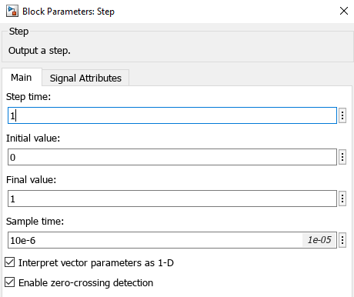

(Figure 4 – Block Parameters: Step) [5]
Within the Step parameters the Sample time was changed from 1 to 10e^-6 so the output is displayed in micro-seconds rather than seconds as shown in (Figure 4) above.

Sum-
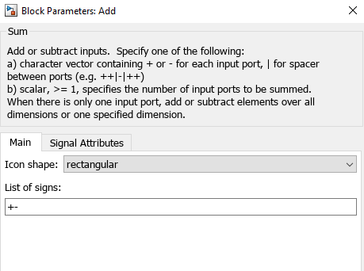

(Figure 5 – Block Parameters: Add) [3]

Within the sum block the input ports were changed to +- as shown in (Figure 5) above.

PID Controller-
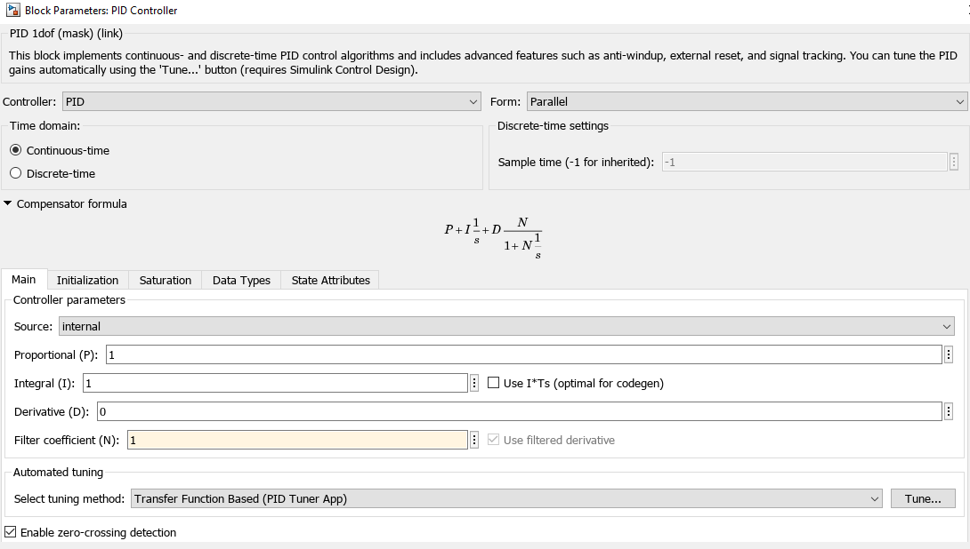

(Figure 6 – Block Parameters: PID Controller) [4]
Within the PID Controller the Proportional parameter was set to 1, the Integral parameter was set to 1, the Definitive parameter was set to 0 and finally the Filter Coefficient was set to 1 as shown in (Figure 6) above.
Transfer Function-

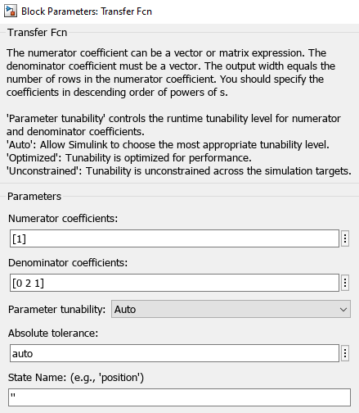

(Figure 7 – Block Parameters: Transfer Function) [2]

Finally, the transfer function parameters were set to match the last 3 digits of the student’s identification number. In this case they were 0, 2 and 1. The Numerator stays as one and the denominator changes to match the last three digits of the students identification number as shown in (Figure 7) above.
Once all of the parameters had been set in each component used in the closed loop control system. The system was then ran to see what results were obtained. A screengrab of the graph created showing the results was taken before the PID Controller Tuning began. This can be seen from (Figure 8) below:
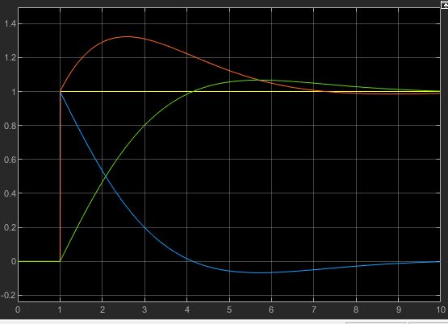
(Figure 8 – Showing the results from the closed loop control system before the PID Controller tuning took place)

Simulation 1 Results

The PID Controller Tuning was then started and the following results were obtained. As per the assignment brief the control system had to bring the process under control within 2 seconds with an overshoot of less than 5%. (Figures 9, 10 and 11) below show the results gathered once the requirements mentioned in the assignment brief were tried to be met. As can be seen in (Figure 10) the settling time was less than two seconds however, after adjusting to try and meet both requirements the requirement for the overshoot to be less than 5% couldn’t be met. The adjustments were changed for around 1 hour to try and meet both requirements however, only one could be met in this case. This was the lowest percentage achievable with the student numbers 0 2 and 1 that were used in the transfer function. As can be seen in (Figure 10), the settling time was adjusted to 1.79 seconds and the lowest achievable overshoot was 7.8%.
After the tuning and adjusting to try and meet the requirements, the PID Controller parameters had changed from the original P=1, I=1, D=0 and N=1 to P=11.3734, I=17.7379, D=0.3638 and N= 16.3582 as shown in (Figure 10) where Block shows the old parameters and Tuned shows the new parameters.
The system was then ran again after all of the results were obtained and as can be seen in (Figure 12) the PID Controller parameters were now fully changed. These results will be used in the second simulation allowing them to be compared against one another.

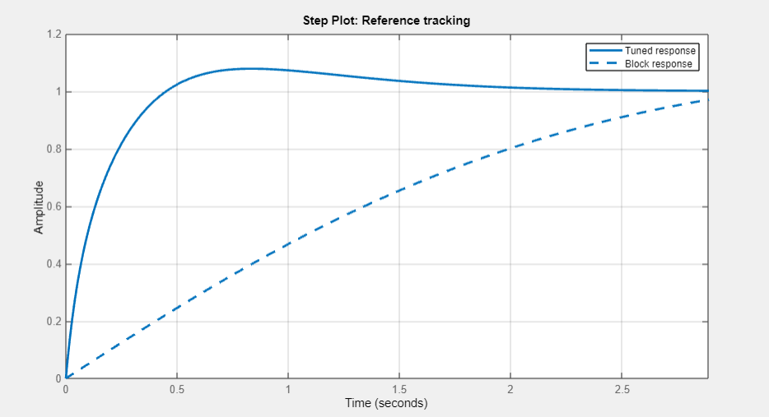
(Figure 9 – results from PID Controller Tuning)

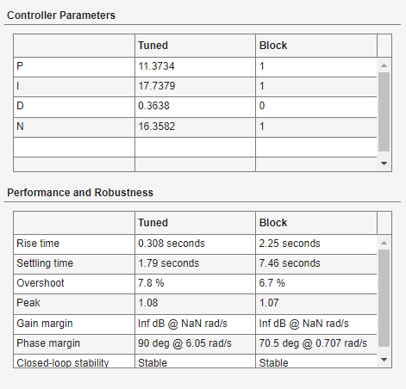

(Figure 10 – results from PID Controller Tuning)

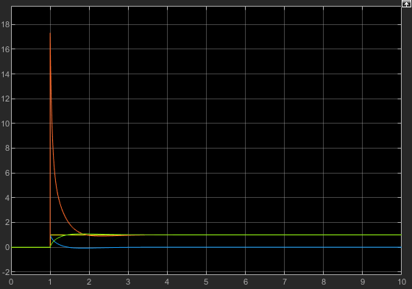

(Figure 11 – results from PID Controller Tuning)
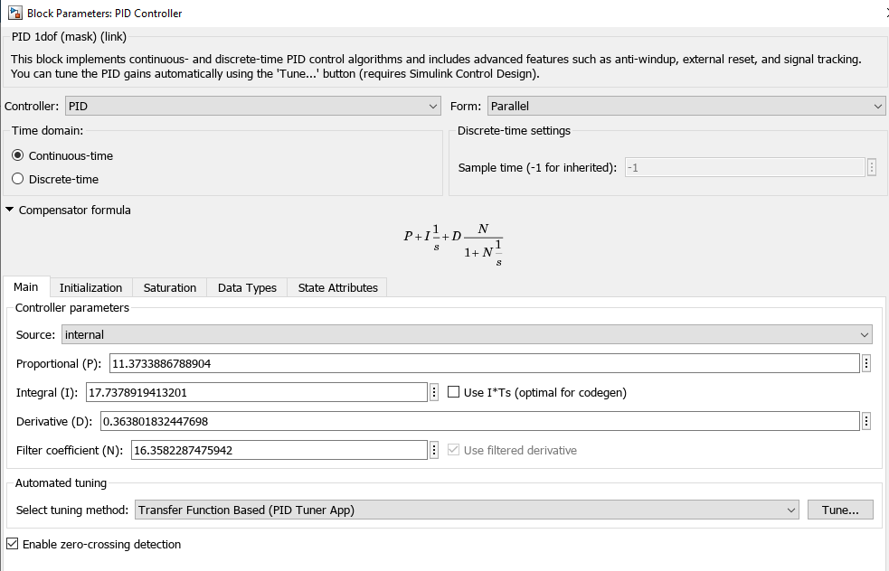

(Figure 12 – New Block Parameters after Tuning) [4]

Simulation 2 Setup

To be able to create the second simulation some calculations were needed to enable the PID parameters in the PID Controller to be changed. The following Formula was used to get the information:
$$\frac{KDS^{2}+KPS+KI}{S}$$
The students’ identification number was used yet again to do these calculations as well as the PID Controller values calculated from the PID Controller tune done on Simulation 1. The student identification number and new PID Controller parameters are shown below as well as the method used to calculate the new Transfer Function inputs:

Student Number: 2031021

Proportional (P) = 11.3733
Integral (I) = 17.7378
Derivative (D) = 0.3638

$$\frac{KDS^{2}+KPS+KI}{S}$$
$\frac{{0.3638}^{2}+11.3733+17.7378}{S}$ $×$ $\frac{1}{2S+1}$
$$\frac{\left(\frac{{0.3638S}^{2}+11.3733S+17.7378}{2S+1}\right)}{1+ \left(\frac{{0.3638S}^{2}+11.3733S+17.7378}{2S+1}\right) ×1}$$

$$\frac{\left(\frac{{0.3638S}^{2}+11.3733S+17.7378}{2S+1}\right)}{ \left(\frac{{2S + 1.3638S}^{2}+12.3733S+17.7378}{2S+1}\right) }$$
$$\frac{{0.3638S}^{2}+11.3733S+17.7378}{{2.3638S}^{2}+12.3733S+17.7378}$$

Once the calculations had been completed the result above was obtained. This was then inputted into the transfer function of the closed loop control system as shown below in (Figures 13 & 14).
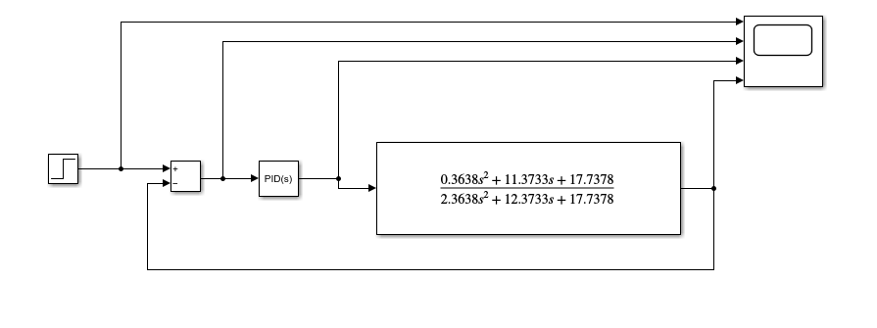
(Figure 13 – Simulation 2 Closed Loop Control System with new transfer function parameters entered)
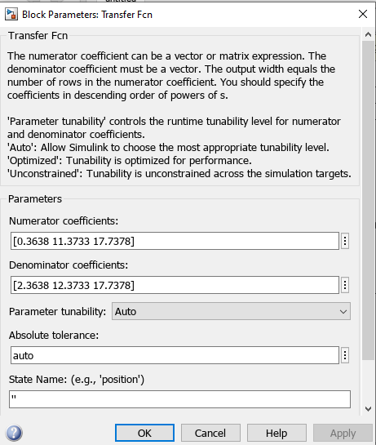

(Figure 14- Updated Transfer function parameters to match results obtained in calculations)

The results were inputted into the Transfer function the same way the final answer was written. The Numerators were entered into Numerator Co-efficient box and the Denominators were entered into the Denominator Co-efficient box.
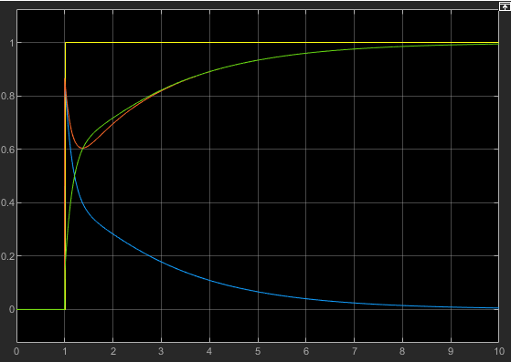
The system was then run again and the results shown in (Figure 15) below were obtained.

(Figure 15 – Results obtained after running the system with new parameters entered before tuning began)

The PID Controller Tuning was then started with the new parameters in place as shown from the results obtained below in the Simulation 2 Results section.

Simulation 2 Results

Yet again as per the assignment brief the control system had to bring the process under control within 2 seconds with an overshoot of less than 5%. (Figures 16, 17 and 18) below show the results gathered once the requirements mentioned in the assignment brief were met. This time around both requirements were met after the parameters were adjusted. The settling time was 2 seconds and the overshoot was 0%.

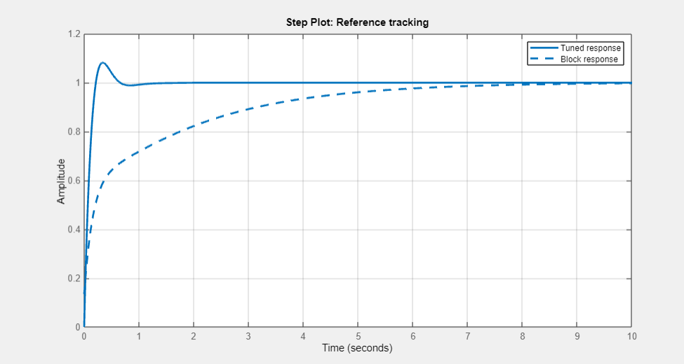
(Figure 16 – Results from second PID Controller tuning)

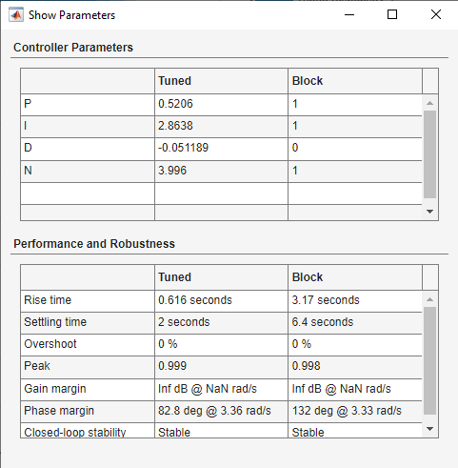

(Figure 17 – Results from second PID Controller tuning)

Discussion

After undertaking both tests it is clear that both set of results obtained are different to one another.
From the first simulation the settling time was less than two seconds however, after adjusting to try and meet both requirements the requirement for the overshoot to be less than 5% couldn’t be met. As previously mentioned, the adjustments were changed for around 1 hour to try and meet both requirements however, only one could be met in this case. This was the lowest percentage achievable with the student numbers 0 2 and 1 that were used in the transfer function. As can be seen in (Figure 10), the settling time was adjusted to 1.79 seconds and the lowest achievable overshoot was 7.8%. However, in the second simulation both requirements were met after the parameters were adjusted. The settling time was 2 seconds and the overshoot was 0%. Giving a difference of 7.8% overshoot with a difference of 0.21 seconds.
From the results obtained in Simulation 1 it can be seen from (Figure 9) that the difference between the Tuned response and the Block response is widely spread out and they don’t share many similarities. As the Time and Amplitude results don’t match p at all at any point in the graph. Whereas, the difference between the Tuned Response and Block response in (Figure 16) for simulation 2 are a lot closer and share more similarities where from around 6 seconds onwards the Amplitude is around the same all the way to 10 seconds.
The difference in overshoot- In the first simulation the PV moves further past the SP by 7.8% however, in the second simulation the PV doesn’t move past the SP at all as the overshoot is 0%. This could be down to “too much integral and/or not enough proportional”. [6]

Conclusion

After undertaking these tests it can be seen how a closed loop control system works. The parameters entered into each component of the control system play a big part in the results obtained. It has been discovered in this report and from the tests conducted that sometimes the requirements set are hard to meet even with tuning and adjusting the PID Controls. It was a shock to see that not all requirements were met and it was something that was not expected to happen. However, this gave a bigger scope to explain how the results were different too one another and shown what is achievable and what is not.

References

[1] | P. Kirvan, “WhatIs.com,” [Online]. Available: https://www.techtarget.com/whatis/definition/control-system#:~:text=A%20control%20system%20is%20a,Typically%2C%20control%20systems%20are%20computerized.. [Accessed 10 July 2023].
[2] | Mathworks, “Mathworks,” [Online]. Available: https://uk.mathworks.com/discovery/transfer-function.html. [Accessed 10 July 2023].
[3] | Mathworks, “Mathworks,” [Online]. Available: https://uk.mathworks.com/help/simulink/slref/add.html. [Accessed 10 July 2023].
[4] | C. Tutorials, “Control Tutorials for Matlab & Simulink,” [Online]. Available: https://ctms.engin.umich.edu/CTMS/index.php?example=Suspension&section=ControlPID. [Accessed 15 July 2023].
[5] | Mathworks, “Mathworks,” [Online]. Available: https://uk.mathworks.com/help/simulink/slref/step.html. [Accessed 10 July 2023].
[6] | Cross, “Cross,” [Online]. Available: https://www.crossco.com/resources/technical/how-to-tune-pid-loops/#:~:text=Overshoot%20%3D%20when%20the%20PV%20moves%20further%20past%20the%20SP%20than%20desired.. [Accessed 18 July 2023].

